This text was adapted by The Saylor Foundation under a Creative Commons Attribution-NonCommercial-ShareAlike 3.0 License without attribution as requested by the work’s original creator or licensee.

Preface

Brief, Focused, Essential
Student learning styles continue to evolve as we move into the twenty-first century. Students want to learn accounting in the most efficient way possible, balancing coursework with personal schedules. They tend to focus on their studies in short intense segments between jobs, classes, and family commitments. Meanwhile, the accounting industry has endured dramatic shifts since the collapse of Enron and WorldCom, causing a renewed focus on ethical behavior in accounting.

Core Themes
This book is aimed squarely at the new learning styles evident in today’s students and addresses accounting industry changes as well. Accordingly, three core themes lie at the foundation of this text:
Focused. Students want to be as efficient as possible in their learning. This book adopts a concise, jargon-free, and easy-to-understand approach. Key concepts are provided in short segments with bullet points and step-by-step instructions to simplify concepts. A thoughtful, stepwise approach helps students avoid distractions and focuses attention on the big picture.
Reinforcement. Review Problems at the end of each major section offer practical opportunities for students to apply what they have learned. These Review Problems allow students to immediately reinforce what they have learned and are provided within the body of the chapter along with the solutions.
Relevance. Students perform better when they can answer the “why” question. Why is managerial accounting important? Meaningful references to companies throughout the chapters help students tie the concepts presented in each chapter to real organizations.
In addition, realistic managerial scenarios present an issue that must be addressed by the management accountant. These pique student interest and are designed to show how issues can be resolved using the concepts presented in the chapter.
Finally, Business in Action features in this text link managerial decision making to real business decisions.

Other Key Features
A focus on decision making. This book focuses on the essential managerial accounting concepts used within organizations for decision-making purposes and covers these concepts in 13 straightforward and concise chapters. Knowing that the majority of students taking managerial accounting at the introductory level are general business majors and will not become accountants, this text was written to help students make informed business decisions using managerial accounting concepts.
Thorough end-of-chapter coverage. The Exercises, Problems, and Cases were developed to give student a wide range of reinforcement at different levels of complexity and to help build critical thinking skills.
Ethics coverage. The importance of ethics is evident from the outset since the book begins with an entire segment on ethical issues facing the accounting industry. This segment includes the Institute of Management Accountants’ revised standards of ethical conduct and describes professional codes of conduct provided by the American Institute of Certified Public Accountants, Financial Executives International, and International Federation of Accountants. Ethics questions and cases are included throughout the text.
Group projects. The accounting industry and business in general have made it clear employees must be able to work effectively and efficiently in groups. In addition, studies show students learn concepts more effectively when working in groups. To reinforce this idea, we have included group projects throughout the book.
Spreadsheet applications. Computer Application features and End-of-Chapter Exercises emphasize the importance of using Excel spreadsheets for analytical purposes.

Chapter 1

What Is Managerial Accounting?
Dana Matthews is the president of Sportswear Company, a producer of hats and jerseys for fans of several professional sports teams. Imagine you are the accountant in charge of all accounting functions at Sportswear. Dana just reviewed the financial statements for the most recent fiscal year for the first time and has the following conversation with you:
President (Dana): | I just reviewed our most recent financial statements, and I noticed we did not do as well as we had planned. I would like to look more closely at the profitability of each of our products to determine exactly what happened, but I don’t have this information in the financial statements. Is there a reason we don’t include this in the financial statements?
Accountant: | Yes, the financial statements are prepared following U.S. Generally Accepted Accounting Principles (U.S. GAAP) and are intended for outside users, such as owners, banks, and suppliers. U.S. GAAP does not require us to disclose profitability by product, and we prefer not to make this information public. Product profitability information stays in-house and is prepared by our managerial accountant, Dave Hicks.
President: | That makes sense. Can you have Dave pull together product profitability information for the past year so we can take a close look at which products are doing well and which are not?
Accountant: | You bet. We’ll have the information for you early next week.

1.1 Characteristics of Managerial Accounting

LEARNING OBJECTIVE
- Compare characteristics of financial and managerial accounting.

Question: The issue facing the president at Sportswear is a common one. Companies prefer not to disclose more information than is required by U.S. GAAP, but they would like to have more detailed information for internal decision-making and performance-evaluation purposes. This is why it is important to distinguish between financial and managerial accounting. What is the difference between information prepared by financial accountants and information prepared by managerial accountants?

Answer: Financial accounting focuses on providing historical financial information to external users. External users are those outside the company, including owners (e.g., shareholders) and creditors (e.g., banks or bondholders). Financial accountants reporting to external users are required to followU.S. Generally Accepted Accounting Principles (U.S. GAAP), a set of accounting rules that requires consistency in recording and reporting financial information. This information typically summarizes overall company results and does not provide detailed information.

Managerial accounting focuses on internal users—executives, product managers, sales managers, and any other personnel within the organization who use accounting information to make important decisions. Managerial accounting information need not conform with U.S. GAAP. In fact, conformance with U.S. GAAP may be a deterrent to getting useful information for internal decision-making purposes. For example, when establishing an inventory cost for one or more units of product (each jersey or hat produced at Sportswear Company), U.S. GAAP requires that production overhead costs, such as factory rent and factory utility costs, be included. However, for internal decision-making purposes, it might make more sense to include nonproduction costs that are directly linked to the product, such as sales commissions or administrative costs.

Question: It’s clear that financial accounting focuses on reporting to outside users while managerial accounting focuses on reporting to inside users. What specific characteristics would we expect to see in managerial accounting information?

Answer: Managerial accounting often focuses on making future projections for segments of a company. Suppose Sportswear Company is considering introducing a new line of coffee mugs with team logos on each mug. Management would certainly need detailed financial projections for sales, costs, and the resulting profits (or losses). Although historical financial accounting data from other product lines would be useful, preparing projections for the new line of mugs would be a managerial accounting function.

Another characteristic of managerial accounting data is its high level of detail. As noted in the opening dialogue between the president and accountant at Sportswear Company, the financial information in the annual report provides a general overview of the company’s financial results but does not provide any detailed information about each product. Information, such as product profitability, would come from the managerial accounting function.

Finally, managerial accounting information often takes the form of nonfinancial measures. For example, Sportswear Company might measure the percentage of defective products produced or the percentage of on-time deliveries to customers. This kind of nonfinancial information comes from the managerial accounting function.

Table 1.1 "Comparison of Financial and Managerial Accounting" summarizes the characteristics of both managerial and financial accounting.

Table 1.1 Comparison of Financial and Managerial Accounting
 | Managerial Accounting | Financial Accounting
Users | Inside the organization | Outside the organization
Accounting rules | None | U.S. Generally Accepted Accounting Principles (U.S. GAAP)
Time horizon | Future projections (sometimes historical if in detail) | Historical information
Level of detail | Often presents segments of an organization (e.g., products, divisions, departments) | Presents overall company information in accordance with U.S. GAAP
Performance measures | Financial and nonfinancial | Primarily financial

Follow-Up at Sportswear Company

Question: What did the president at Sportswear Company learn about product profitability from the information provided by the managerial accountant?

Answer: The president at Sportswear, Dana Matthews, learned that the hats product line was much more profitable than expected, accounting for 55 percent of the company’s profits even though initial estimates were that the hat segment would account for 40 percent of company profits. Conversely, the jerseys product line was much less profitable than expected, accounting for 45 percent of the company’s profits.

There are many issues associated with determining product profitability, including how to allocate costs that are not easily traced to each product and whether the product revenue and cost information is accurate enough to make important managerial decisions. These important issues will be addressed throughout the book.

KEY TAKEAWAY
- Financial accounting provides historical financial information for external users in accordance with U.S. GAAP. Managerial accounting provides detailed financial and nonfinancial information for internal users who use the information for decision making, planning, and control purposes.

REVIEW PROBLEM 1.1
- Suppose you are the co-owner and manager of a retail store that sells and repairs mountain bikes. Provide one example of a financialaccounting report that would be useful to you and your co-owner. Provide two examples of managerial accounting reports that would be useful to you as the manager.
- Provide two examples of nonfinancial measures used by a pizza eatery that serves food in the restaurant and offers delivery services.
- For each report listed in the following, indicate whether it relates to financial or managerial accounting. Explain the reasoning behind your answer for each item.
  - Projected net income for next quarter by division
  - Defective goods produced as a percentage of all goods produced
  - Income statement for the most current year, prepared in accordance with U.S. GAAP
  - Monthly sales broken down by geographic region
  - Production department budget for the next quarter
  - Balance sheet at the end of the current year, prepared in accordance with U.S. GAAP
Solution to Review Problem 1.1
- Financial accounting reports provided to owners typically include the income statement, statement of owners’ equity, balance sheet, and statement of cash flows. All are prepared in accordance with U.S. GAAP. Managerial accounting reports prepared for managers might include a quarterly budget for revenues and expenses for each segment of the business (e.g., bike sales and bike repairs), returns for defective merchandise as a percent of total monthly sales, income projections to be used in deciding whether to open a new store, and projected sales for each bike model. (There are many correct answers to this problem. Use Table 1.1 "Comparison of Financial and Managerial Accounting" as a guide in determining the accuracy of your answer.)
- Examples of nonfinancial measures include percentage of on-time deliveries, percentage of burned pizzas, average time required to prepare pizza for restaurant customers (from taking a customer’s order to providing the pizza at the customer’s table), and results of customer satisfaction surveys. (These are just a few examples. There are many correct answers to this problem.)
- The answers appear as follows. Be sure you explained your answers.
  - Managerial accounting—information is for future projections and involves segments of the company
  - Managerial accounting—nonfinancial detailed measure of defective products
  - Financial accounting—historical information prepared in accordance with U.S. GAAP
  - Managerial accounting—detailed information provided monthly
  - Managerial accounting—information is for future projections and involves a segment of the company
  - Financial accounting—historical information prepared in accordance with U.S. GAAP

1.2 Planning and Control Functions Performed by Managers

LEARNING OBJECTIVE
- Describe the planning and control functions performed by managers.

Question: Managers of most organizations continually plan for the future, and after the plan is implemented, managers assess whether they achieved their goals. What are the two functions that enable management to go through the process of continually planning and evaluating?

Answer: The two important functions that enable management to continually plan for the future and assess implementation are called planning and control. Planning is the process of establishing goals and communicating these goals to employees of the organization. The controlfunction is the process of evaluating whether the organization’s plans were implemented effectively.

Planning
Question: Continually planning for the future is an important quality of many successful organizations, such as Southwest Airlines (discussed in Note 1.11 "Business in Action 1.1"). How do organizations formalize their strategic plans?

Answer: Organizations formalize their plans by creating a budget, which is a series of reports used to quantify an organization’s plans for the future. For example, Ernst & Young, an international accounting firm, plans for the future by establishing a budget indicating the labor hours required to perform specific services for each client. The process of creating a budget for each client enables the firm to plan for future staffing needs and communicate these needs to employees of the company. Rather than simply hoping it all works out in the end, Ernst & Young projects the labor hours required in the future, hires accounting staff based on these projections, and schedules the staff required for each client.
A budget can take a variety of forms. A budgeted income statement indicates a profit plan for the future. A capital budget shows the long-term investments planned for the future. A cash flow budget outlines cash inflows and outflows for the future. We provide more information about how budgets can be used for planning purposes in later chapters.

Business in Action 1.1
Plans for the Future
Review the annual report or 10K for just about any company, and you are likely to find information regarding plans for the future. Here are some examples:
- Southwest Airlines. A low-fare, short-haul carrier that targets business commuters as well as leisure travelers states in its annual report, “We are focused on four big initiatives: the AirTran integration, the All-New Rapid Rewards program, the addition of the Boeing 737–800 in 2012, and the replacement of our reservations system.”
- Sears Holdings Corporation. A multiline retailer that offers a wide array of merchandise and related services states in its 10K report, “We will continue to invest in our online properties. By integrating our vast store network with our online properties, we believe that Sears Holdings will succeed in the rapidly evolving retail environment.”
- Nordstrom, Inc. A fashion specialty retailer indicates in its 10K report that its “strategic growth plan includes opening new Nordstrom full-line and Nordstrom Rack stores, with 6 announced Nordstrom full-line and 18 announced Nordstrom Rack store openings, the majority of which will occur by 2012.”
As these companies go through the process of making decisions about the future, developing plans based on their decisions, and controlling the implementation of their plans, managerial accounting information will play a key role in all phases of the process.
Sources: Southwest Airlines, “Annual Report, 2010,”http://www.southwest.com; Sears Holdings Corporation, “10K Report, 2010,” http://www.searsholdings.com; Nordstrom, Inc., “10K Report, 2010,” http://www.nordstrom.com.

Control

Question: Although planning for the future is important, plans are only effective if implemented properly. How do organizations assess the implementation of their plans?

Answer: The control function evaluates whether an organization’s plans were implemented effectively and often leads to recommendations for the future. Many organizations compare actual results with the initial plan (or budget) to evaluate performance of employees, departments, or the entire organization.

For example, assume Ernst & Young creates a budget indicating the labor hours needed to perform tax services for a particular client (this is theplanning function). After the work is performed, actual labor hours used to complete the work are compared to budgeted labor hours. This analysis is then used to evaluate whether employees were able to complete the work within the budgeted time and often results in recommendations for the future. Recommendations might include the need for adding more labor hours to the budget or obtaining better support documents from the client.

Planning and controlling operations are critical functions within most organizations. In today’s business environment, effective planning and control by managers can be the key to survival.

KEY TAKEAWAY
- Managers continually plan and control operations within organizations. Planning involves establishing goals and communicating these goals to employees of the organization. The control function assesses whether goals were achieved and is often used to evaluate the performance of employees, departments, and the organization as a whole.

REVIEW PROBLEM 1.2
Assume you are preparing a personal budget of all income and expenses for next month.
- Describe the planning and control functions of this process.
- What benefits might be derived from performing the planning and control functions for a personal budget?
Solution to Review Problem 1.2
- The planning function would involve establishing income and expense goals for next month. Possible sources of income include wages, scholarships, or student loans. Expenses might include rent, textbooks, tuition, food, entertainment, and transportation.
The control function occurs after the end of the month and involves comparing actual income and expenses with budgeted income and expenses. This allows for the evaluation of whether income and expense goals were achieved.
- There are several benefits to using a planning and control process. The planning function establishes income and expense goals and helps to identify any deviations from these goals. For example, planned expenditures are clearly outlined in the budget and provide guidelines for making expenditure decisions throughout the month. Without clear guidelines, money might be spent on items that are not needed.
The control function allows for an evaluation of how well you met the goals established in the planning process. Perhaps some goals were achieved (e.g., food expenditures were close to what was budgeted) while other goals were not (e.g., transportation expenditures were higher than what was budgeted). The control function identifies these areas and leads to refined goals in the future. For example, the decision might be made to carpool next month to save on transportation costs or to earn more income to pay for transportation by working additional hours.

1.3 Key Finance and Accounting Personnel

LEARNING OBJECTIVE
- Describe the functions of key finance and accounting personnel.

Question: From the previous discussion, we know that planning and control functions are often designed to evaluate the performance of employees and departments of an organization. This often includes employees overseeing financial information. Thus it is important to understand how most large companies organize their accounting and finance personnel. What are the accounting and finance positions within a typical large company, and what functions do they perform?

Answer: Let’s look at an example to answer this question. Suppose you are the president of Sportswear Company, mentioned earlier in the chapter, which produces hats and jerseys for fans of professional sports teams. Assume this is a large public company. (The term public company refers to a company whose shares of stock are publicly traded—that is, the general investing public can purchase and sell ownership in the company.) As president of Sportswear, you ask the following questions:
- How much will we owe the government in income taxes for the year?
- What was total net income for the last fiscal year?
- Should we expand into new geographic markets?
- If we do decide to expand into new markets, should we obtain financing by issuing bonds, obtaining a loan from a bank, or issuing common stock?
- How profitable is each segment of our business (hats and jerseys)?
- How effective are our internal controls over cash?

The challenge is to determine who within Sportswear would be best suited to answer each of these questions. An organization chart will help in finding a solution.

Organizational Structure

Figure 1.1 "A Typical Organization Chart" is a typical organization chart; it shows how accounting and finance personnel fit within most companies. The personnel at the bottom of the chart report to those above them. For example, the managerial accountant reports to the controller. At the top of the chart are those who control the company, typically the board of directors (who are elected by the owners or shareholders). Review Figure 1.1 "A Typical Organization Chart" before moving on to the detailed discussion of each important finance and accounting position.
Figure 1.1 A Typical Organization Chart
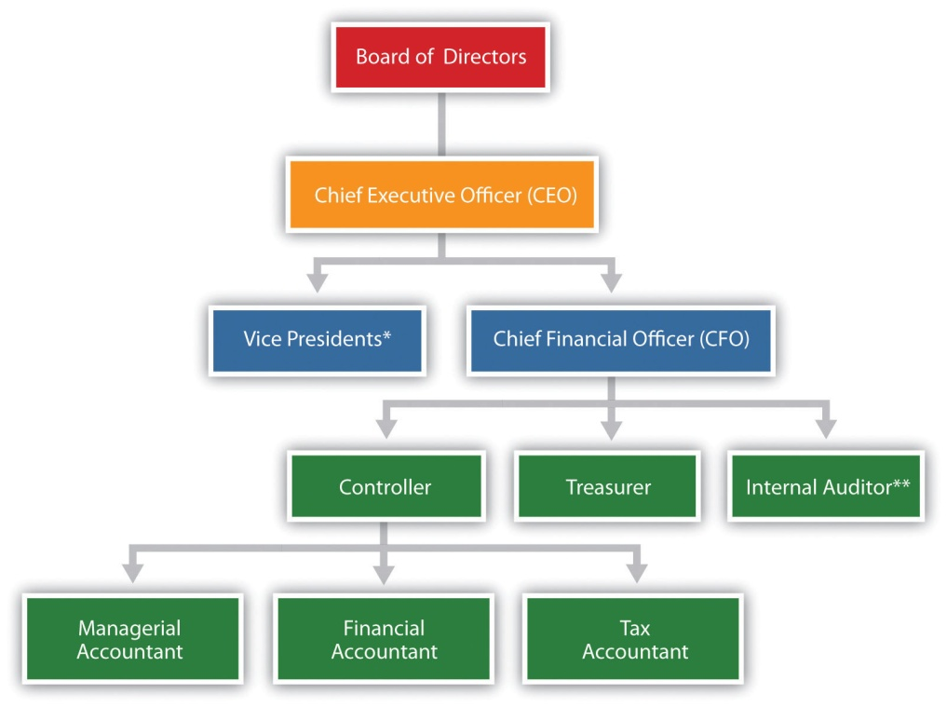

*Represents vice presidents of various departments outside of accounting and finance such as production, personnel, and research and development.

**In addition to reporting to the chief financial officer, the internal auditor typically reports independently to the board of directors and/or the audit committee (made up of select members of the board of directors).

Chief Financial Officer

The chief financial officer (CFO) is in charge of all the organization’s finance and accounting functions and typically reports to the chief executive officer.

Controller

The controller is responsible for managing the accounting staff that provides managerial accounting information used for internal decision making, financial accounting information for external reporting purposes, and tax accounting information to meet tax filing requirements. The three accountants the controller manages are as follows:
- Managerial accountant. The managerial accountant reports directly to the controller and assists in preparing information used for decision making within the organization. Reports prepared by managerial accountants include operational budgets, cost estimates for existing products, budgets for new product lines, and profit and loss reports by division. (Note that some people use the term cost accountantinterchangeably with managerial accountant. Others consider cost accounting a specific function of managerial accounting that focuses on measuring costs. In this text, we use the term managerial accountant and assume that cost accountants focus on measuring costs.)
- Financial accountant. The financial accountant reports directly to the controller and assists in preparing financial information, in accordance with U.S. GAAP, for those outside the company. Reports prepared by financial accountants include a quarterly report filed with the Securities and Exchange Commission (SEC) that is called a 10Q and an annual report filed with the SEC that is called a 10K.
- Tax accountant. The tax accountant reports directly to the controller and assists in preparing tax reports for governmental agencies, including the Internal Revenue Service.

Treasurer

The treasurer reports directly to the CFO. A treasurer’s primary duties include obtaining sources of financing for the organization (e.g., from banks and shareholders), projecting cash flow needs, and managing cash and short-term investments.

Internal Auditor

An internal auditor reports to the CFO and is responsible for confirming that the company has controls that ensure accurate financial data. The internal auditor often verifies the financial information provided by the managerial, financial, and tax accountants (all of whom report to the controller and ultimately to the CFO). If conflicts arise with the CFO, an internal auditor can report directly to the board of directors or to the audit committee, which consists of select board members.

Not All Organizations Are Alike!

Question: The organization chart in Figure 1.1 "A Typical Organization Chart" is intended to serve as a guide. However, all organizations are not the same, particularly smaller organizations. How might the organizational structure differ for a small organization?

Answer: Smaller organizations tend to have only one or two key finance and accounting personnel who perform the functions described previously. For example, one accountant might perform the financial and managerial accounting duties while another takes care of the tax work (or the tax work might be contracted out to a tax firm). Instead of employing its own internal auditor, an organization might hire one from an outside consulting firm. Some organizations may not have a CFO, or they may have a CFO but not a controller. An organization’s structure depends on many different factors, including its size and reporting requirements, as indicated in the Note 1.23 "Business in Action 1.2".

Business in Action 1.2
The Organizational Structure of a Not-for-Profit Symphony
Financial limitations prevent a small not-for-profit symphony in California from hiring full-time finance and accounting employees. In spite of having annual revenues approaching $200,000, all financial transactions are processed and recorded by a part-time bookkeeper hired by the symphony. The bookkeeper also inputs budget information and provides monthly financial reports to the treasurer. The treasurer, a volunteer member of the board of directors, is responsible for establishing the annual budget and providing monthly financial reports to the board of directors. An outside firm prepares and processes all tax filings, assembles annual financial statements, and performs a review of the accounting operations at the end of each fiscal year.
Notice how the symphony does not have any of the formal positions identified in Figure 1.1 "A Typical Organization Chart", with the exception of the treasurer. This illustrates how financial constraints and reporting requirements may require an organization to be creative in establishing its organizational structure.

KEY TAKEAWAY
- It is important to understand the key accounting and finance positions within a typical company and how each position fits into the organizational structure. The chief financial officer (CFO) oversees all accounting and finance personnel, including the controller, treasurer, and internal auditor. The controller is responsible for the managerial, financial, and tax accounting staff.

REVIEW PROBLEM 1.3
For each of the six questions listed at the beginning of this section for Sportswear Company, determine who within the company would be responsible for providing the appropriate information. Assume Sportswear has the same organizational structure as the one shown inFigure 1.1 "A Typical Organization Chart".
Solution to Review Problem 1.3
- The tax accountant is responsible for determining the income taxes to be paid to various government agencies.
- The financial accountant prepares the annual report, which includes the income statement where net income can be found.
- Although several personnel would likely be involved, the managerial accountant is responsible for providing financial projections. However, the financial accountant might provide historical information for existing geographic segments, which would form the basis for the managerial accountant’s estimates.
- The treasurer handles financing decisions.
- Detailed financial information that goes beyond what is required by U.S. GAAP may be provided by the managerial accountants.
- The internal auditors are responsible for evaluating the effectiveness of internal controls.

1.4 Ethical Issues Facing the Accounting Industry

LEARNING OBJECTIVE
- Use standards of ethical conduct to resolve ethical conflicts facing accountants.

Imagine you are the accountant for Drive Write, a company that produces computer disk drives, and you are in charge of all accounting functions within the company. The president has informed you that if the company’s profits grow by 20 percent this year, you will receive a $20,000 bonus, and she will receive a $50,000 bonus. No bonuses will be awarded if profit growth is less than 20 percent. Because the company’s profits have grown 20 percent annually for the last 10 years, investors have come to expect significant growth from one year to the next. Near the end of this fiscal year, the president and you have the following conversation:
President: | We are awfully close to hitting our numbers and getting to the 20 percent target. With two weeks remaining, projections show we will come in at 18 percent for the year. What can we do on the accounting side to increase current year profits?
Accountant: | Well, I’m not sure there is anything we can do. Our accounting is squeaky clean, as confirmed by our independent auditors. Perhaps our sales will improve next year.
President: | There has to be something we can do—I could sure use the bonus money, and our investors would appreciate an increase in their investment! I know we have a large customer order to be filled the first week of next year. Why not include that sale in this year’s numbers?
Accountant: | I’m not comfortable recording sales in the wrong fiscal year.
President: | We’re only talking about moving sales by a few days! I would like you to consider this carefully. If you can’t do this, I may have to find an accountant who can! Let’s talk about our options later this week.

Question: The situation at Drive Write creates a serious ethical dilemma. (The Drive Write example is based on a real company called MiniScribe Corporation, subsequently purchased by a competitor.) Companies are constantly under pressure to meet sales and profit goals. Employees who succeed in meeting these goals often reap huge monetary rewards; those who fail may be penalized with lower pay or may even lose their jobs. What would you do if asked to record information in a way that distorts the company’s financial results?

Answer: As the accountant for Drive Write, your response to the president’s request would likely affect your reputation as a professional and your future as an accountant. The unethical behavior at corporations like Xerox,Enron, and WorldCom in recent years makes it imperative that we know both how to act ethically and how to resolve ethical conflicts.

To help guide accounting professionals through ethical dilemmas like the one at Drive Write, the Institute of Management Accountants (IMA) has established a Statement of Ethical Professional Practice, which appears in . The standards outlined in this statement are guidelines that can help accountants choose an ethically acceptable course of action. As you review , notice that the IMA specifies four core responsibilities (competence, confidentiality, integrity, and credibility) as well as guidelines on how to resolve ethical conflicts. The “Resolution of Ethical Conflict” section provides specific guidance on how to resolve the conflict at Drive Write.
Figure 1.2 IMA Statement of Ethical Professional Practice
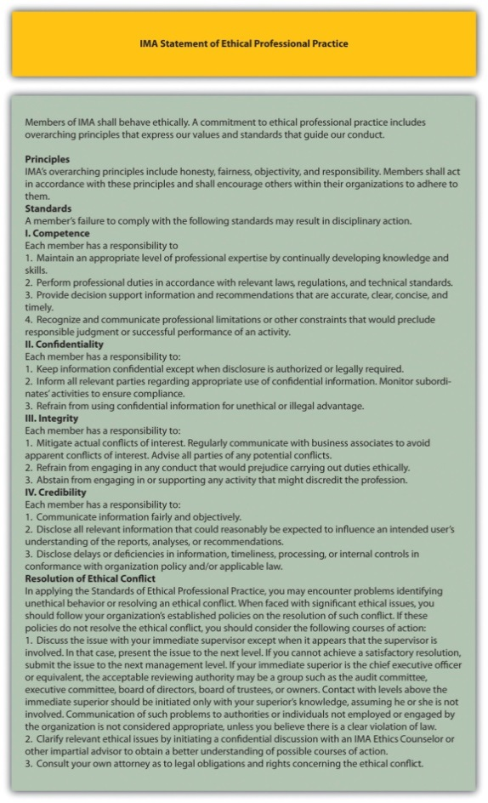
Source: Adapted from the Institute of Management Accountants,http://www.imanet.org.

Question: The IMA is just one of many professional accounting organizations.Do other professional accounting organizations also provide guidance regarding ethics in accounting?

Answer: Yes, other professional organizations do provide ethical guidance. Several are listed as follows:
- The American Institute for Certified Public Accountants (AICPA) has aCode of Professional Conduct (see http://www.aicpa.org).
- Financial Executives International provides a Model Code of Ethical Conduct for Financial Managers (seehttp://www.financialexecutives.org).
- The International Federation of Accountants has a Code of Ethics and Statement of Policy Implementation & Enforcement of Ethical Requirements(see http://www.ifac.org).
- The Securities and Exchange Commission (SEC), in compliance with the Sarbanes-Oxley Act of 2002, requires a company to disclose whether it has adopted a code of ethics (see http://www.sec.gov).
- The Institute of Management Accountants even provides an ethics help line to give financial professionals a resource to provide guidance in making the right decisions (see http://www.imanet.org).
- Because of alleged wrongdoing, such as that reported in the , improving ethics is a top priority for most businesses as shown in the . As a result, professional organizations like those we have cited have become instrumental in providing ethical guidelines.

Business in Action 1.3
Production Firm Employees Charged with Fraud
The Securities and Exchange Commission (SEC) filed three actions against Diebold, Inc., a manufacturer and seller of automated teller machines, for improperly inflating earnings over a five-year period. Three former employees—the CFO, controller, and director of accounting—were accused of improperly inflating revenue on factory orders, improperly recognizing revenue on a lease transaction, manipulating reserves and accruals, improperly capitalizing expenses, and improperly increasing the value of inventory. These actions allegedly resulted in over 40 misstated annual, quarterly, and other reports filed with the SEC, along with numerous inaccurate press releases.
The company agreed to pay a $25,000,000 civil penalty, and the three former employees remain in litigation. Although the CEO was not accused of wrongdoing, he settled with the SEC and agreed to pay back cash bonuses, stock, and stock options received during the periods when the financial fraud was committed.
Source: Securities and Exchange Commission, “SEC Charges Diebold and Former Executives with Accounting Fraud,” news release, June 2, 2010.

Business in Action 1.4
The Code of Ethics at Home Depot and Hewlett-Packard
Ethics policies are becoming increasingly important to organizations.Home Depot, Inc., has an ethics code that “provides the basic principles for associates to make business decisions consistent with how Home Depot operates” and “forms the groundwork for our ethical behavior.”
Hewlett-Packard Company has established “business ethics guided by enduring values.” The company states it is committed to the following principles: honesty, excellence, responsibility, compassion, citizenship, fairness, and respect.
Sources: Home Depot, “Home Page,” http://www.homedepot.com; Hewlett-Packard, “Home Page,” http://www.hp.com.

KEY TAKEAWAY
- Should you encounter ethical conflicts during your career, use the resources provided by internal company policies, by professional organizations such as the IMA and AICPA, and by governmental organizations such as the SEC as a guide to ethical behavior and the resolution of ethical conflicts.

REVIEW PROBLEM 1.4
- Describe the four key standards of ethical conduct for IMA members outlined in .
- What steps does the IMA recommend for resolving ethical conflicts?
- Using as a guide, discuss your options as the accountant at Drive Write.
Solution to Review Problem 1.4
- The four key standards shown in are outlined as follows:
  - Competence. Members of the IMA must maintain an adequate level of skill to perform duties in an accurate and professional manner.
  - Confidentiality. Members of the IMA must not disclose confidential information for any reason unless legally obligated to do so.
  - Integrity. Members of the IMA must avoid any actual or apparent conflict of interest, including receiving gifts or favors, and must not engage in any activity that would discredit the profession.
  - Credibility. Members of the IMA must disclose all relevant information fairly and objectively.
- Several options exist for resolving ethical conflicts. The IMA suggests the following courses of action:
  - Follow the policies of the organization involving the resolution of ethical conflicts.
  - If following the organization’s policies does not effectively resolve the conflict, discuss the problem with your immediate supervisor unless the supervisor is involved.
  - If the immediate superior cannot reach a satisfactory resolution, the problem should be presented to the next higher managerial level.
  - If all higher levels of management do not reach a satisfactory resolution, an acceptable reviewing authority may be a group, such as the audit committee, executive committee, board of directors, board of trustees, or owners.
  - Another option includes consulting an objective advisor (e.g., IMA ethics counseling service or an attorney).
- Several options are available. The IMA suggests first following the organization’s policies with regard to resolving ethical conflicts. If Drive Write does not have policies in place or if following the organization’s policies does not resolve the conflict, the next step is to discuss the conflict with the immediate supervisor. However, the president of Drive Write (the immediate supervisor) is involved in the conflict, so approaching the president’s superiors would be best. This could be the audit committee, executive committee, board of directors, or owners. If after pursuing these different courses of action the ethical conflict still exists, it may be appropriate to consult an objective advisor (e.g., the IMA helpline) and perhaps consult an attorney as to legal obligations and rights concerning the ethical conflict. (Many would argue that regardless of the outcome, one would not want to work for a company where this type of unethical behavior occurs at the top, or anywhere within the organization, and that resigning is the best course of action.)

1.5 Computerized Accounting Systems

LEARNING OBJECTIVE
- Understand how accounting systems can help organizations.

Question: Many companies today are growing out of their accounting systems. In the old days, accounting systems were designed primarily to track daily transactions and provide reports to external users on a monthly, quarterly, or annual basis. But times have changed, and companies now need more information internally to make good decisions. Accounting systems are currently used for both external reporting (financial accounting) and internal reporting (managerial accounting). Even relatively small accounting packages, such as QuickBooks and Peachtree, provide features that are important for managerial accounting. However, most agree that no single accounting system will meet the needs of every organization and that two important factors must be considered when choosing a system. What are the two factors that must be considered when deciding on an accounting system?

Answer: The two factors are (1) the size of the organization and (2) the information needs of the organization. Each factor is discussed next.

How Big Is Your Company?

Accounting software is designed to serve different-sized companies. The size of a company is commonly measured in sales revenue. Experts express varying opinions on what constitutes a small, midsized, or large company. Some believe that small companies have sales up to $10,000,000, midsized companies have sales up to $100,000,000, and large companies have sales greater than $100,000,000. Others prefer different amounts. Regardless of the number used, the goal is to find an accounting system that best meets the needs of the organization, and the size of the organization plays a big part in finding the best-fitting system.

What Information Is Needed?

Before selecting an accounting system, an organization must determine its accounting needs. Some organizations simply need the equivalent of a check register, which provides easy tracking of expense codes as checks are issued and makes bank reconciliations a snap. Other organizations require more than a check register; they may demand a system that can create invoices, process payroll, and track inventory. More complex organizations will want the ability to perform more advanced functions. Such organizations might need to customize reports (e.g., create an income statement by division or customer), modify input screens, send financial reports via e-mail, export reports to spreadsheet software such as Excel, and create reports with graphics (e.g., tables, pie charts, and line charts).

Enterprise Resource Planning System

Question: Clearly the size and information needs of a company will drive the selection of an accounting system for the company. As the need for accounting data has become more complex, accounting systems have been developed that perform a wide variety of tasks. These systems are called enterprise resource planning systems. What is an enterprise resource planning system, and how does this system help companies utilize accounting data?

Answer: Enterprise resource planning (ERP) systems are designed to record and share information across functional areas (e.g., accounting, marketing, human resources, and shipping) and across geographical areas (e.g., from a sales office in California to headquarters in Hong Kong). ERP systems continually update information to provide real-time data to all users, and the data can be organized in different formats to meet the needs of internal and external users. For example, in his book Onward, Howard Schultz describes how as CEO of Starbucks he reviews comparative financial data for Starbucks stores daily. This information comes from the ERP system at Starbucks.

The idea behind ERP software, and a central theme in managerial accounting, is that accurate and up-to-date financial information will help organizations make better decisions. Better decisions typically lead to improvements in profitability, efficiency, and customer satisfaction.

ERP systems are expensive. Annual costs for large organizations can easily exceed $10,000,000. However, smaller systems for midsized companies are available at a much lower cost. Most ERP software is offered in modules for functional accounting areas, such as accounts receivable, accounts payable, payroll, inventory, and job costing. The more modules included, the higher the cost will be. Popular makers of ERP systems include Microsoft, Oracle, and SAP Corporation.

In deciding whether to upgrade to an ERP system, organizations must be sure that the benefits of using the data from a new system outweigh the costs of implementing the system. If management does not intend to use the information to improve planning and decision making, then going with a less sophisticated accounting system may be the better approach.

Using Spreadsheet Software

Question: ERP systems commonly provide a means to download data to spreadsheets for further analysis. How can spreadsheet software help us to analyze financial information?

Answer: Since managers make extensive use of spreadsheets to organize and analyze data, most computerized accounting systems are designed to export data to spreadsheet software programs such as Excel. For example, Figure 1.3 "Excel Spreadsheet for Southwest Airlines" shows how a spreadsheet was used to import data directly from Southwest Airlines’ 2010 annual report. This allows the user to analyze the data more easily. Notice that inFigure 1.3 "Excel Spreadsheet for Southwest Airlines" the total operating revenue increased over the three years shown. We could use Excel to quickly determine the exact percentage increase from 2008 to 2009 and from 2009 to 2010.

Figure 1.3 Excel Spreadsheet for Southwest Airlines
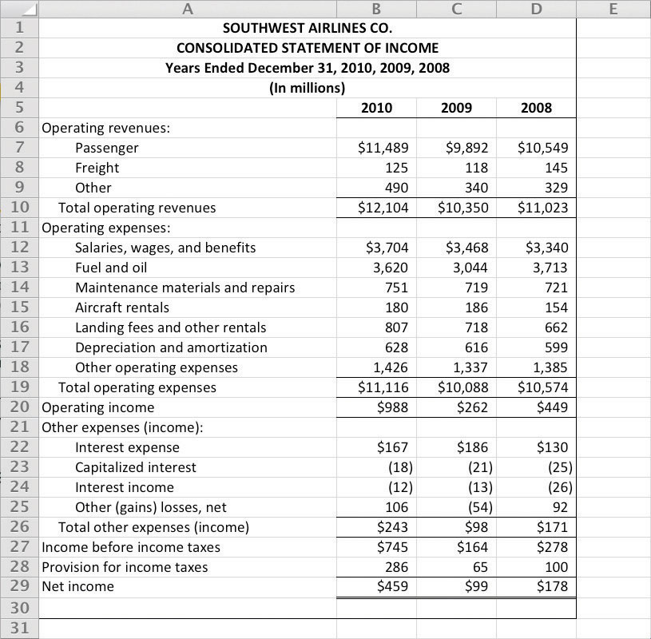

Question: Let’s assume you are asked to prepare an income statement showing revenue and expense projections for next year. How might you use Excel to prepare your projections?

Answer: You could start by exporting this year’s results from the accounting system to an Excel spreadsheet. Then you could set up a new column to show estimates for next year. You would likely discuss different aspects of the income statement with various personnel in the organization—making changes as you go—before finalizing your projections.

Imagine the work involved if you did not use a computer but instead had to write the information down by hand. If there were any changes to the information, you would have to make time-consuming calculations, and once the data were finalized, you would be faced with the manual preparation of formal reports. With the relatively recent advances in business technology, the days of preparing information manually are over. Most organizations require their accounting and finance personnel to have advanced computer spreadsheet skills. Our goal is to provide you with an opportunity to use spreadsheets in a way that mirrors the real world.

KEY TAKEAWAY
- Throughout this text, you will learn about different methods of recording, sorting, analyzing, and reporting financial information for internal users. Before deciding to implement one of these methods, ask yourself the following question: Will the benefits derived from a new system, such as an ERP system, exceed the costs of putting the system in place? If the answer is “yes,” then go for it! If the answer is “no,” consider other alternatives.

REVIEW PROBLEM 1.5
Assume you are the CFO for an electronics consulting firm with annual revenues of $30,000,000 and annual profit of $5,000,000. The current accounting system is used for basic functions, such as issuing checks, creating invoices, and processing payroll. The company is considering upgrading its accounting system by purchasing an ERP system. Describe the factors to be considered by the company in making this decision.
Solutions to Review Problem 1.5
This company is a midsized company with $30,000,000 in revenues, although some would argue that this is a small company. Going to an ERP system is probably not appropriate if management is simply looking for a few reports beyond what most financial accounting systems can provide.
If management has a need for more detailed and complex financial information—other than processing checks, invoices, and payroll—then a low-end ERP system might be appropriate. However, the benefits derived from such a system must outweigh the costs.

1.6 Cost Terminology

LEARNING OBJECTIVE
- Understand the terms used for costing purposes.

Question: Much of what we discuss in this book relates to companies that manufacture products, such as Nike and Apple, and terminology is a key component of accounting for manufacturing companies. The challenge is in classifying costs correctly for items such as production materials, production labor, marketing department labor, rent for production facilities, and rent for the administrative services facilities. These costs must be classified accurately so that they appear correctly in company financial reports. The starting point for learning how to classify costs correctly is in understanding two broad categories of costs. What are the two broad terms used to categorize cost information in a manufacturing setting?

Answer: The two broad categories of costs are manufacturing costs andnonmanufacturing costs. Each category is described in detail as follows.

Manufacturing Costs

All costs related to the production of goods are called manufacturing costs; they are also referred to as product costs. A manufacturer purchases materials, employs workers who use the materials to assemble the goods, provides a building where the materials are stored and goods are assembled, and sells the goods. We classify the costs associated with these activities into three categories: direct materials, direct labor, and manufacturing overhead.

To help clarify which costs are included in these three categories, let’s look at a furniture company that specializes in building custom wood tables called Custom Furniture Company. Each table is unique and built to customer specifications for use in homes (coffee tables and dining room tables) and offices (boardroom and meeting room tables). The sales price of each table varies significantly, from $1,000 to more than $30,000. Figure 1.4 "Direct Materials, Direct Labor, and Manufacturing Overhead at Custom Furniture Company" shows examples of production activities at Custom Furniture Company for each of the three categories (we continue using this company as an example in Chapter 2 "How Is Job Costing Used to Track Production Costs?").

Direct Materials

Question: Raw materials used in the production process that are easily traced to the product are called direct materials. What materials used in the production process at Custom Furniture would be classified as direct materials?

Answer: The wood used to build tables and the hardware used to attach table legs would be considered direct materials. Small, inexpensive items like glue, nails, and masking tape are typically not included in direct materials because the cost of tracing these items to the product outweighs the benefit of having accurate cost data. These minor types of materials, often calledsupplies or indirect materials, are included in manufacturing overhead, which we define later.

Direct Labor

Question: Workers who convert materials into a finished product and whose time is easily traced to the product are called direct labor. Who represents direct labor at Custom Furniture?

Answer: Direct labor would include the workers who use the wood, hardware, glue, lacquer, and other materials to build tables.

Manufacturing Overhead

Question: All costs associated with the production process other than direct material costs and direct labor costs are called manufacturing overhead. Terms synonymous with manufacturing overhead include factory overhead, factory burden, and overhead. What items are included in manufacturing overhead?

Answer: Manufacturing overhead consists of the following:
- Indirect material costs. The cost of materials necessary to manufacture a product that are not easily traced to the product or not worth tracing to the product.
- Indirect labor costs. The cost of workers who are involved in the production process but whose time cannot easily be traced to the product. For example, supervisors in the production process who oversee several different products and are responsible for hiring employees, scheduling employees, and ordering materials are considered indirect labor.
- Other manufacturing costs. These are all other costs for items associated with the factory, including equipment maintenance, insurance, utilities, and depreciation.

Table 1.2 "Manufacturing Costs at Custom Furniture Company" provides several examples of manufacturing costs at Custom Furniture Company by category.
Table 1.2 Manufacturing Costs at Custom Furniture Company
Direct Materials
- Wood: cherry, maple, oak, and mahogany
- Hardware: drawer handles
Direct Labor
- Workers who cut, plane, and glue wood
- Workers who fill and sand tables
- Workers who stain and finish tables
Manufacturing Overhead
- Indirect materials: glue, screws, nails, sandpaper, stain, and lacquer
- Indirect labor: factory supervisors
- Other manufacturing costs: equipment maintenance, equipment depreciation, factory utilities, factory insurance, factory building depreciation, and factory property taxes

Note 1.43 "Business in Action 1.5" details the materials, labor, and manufacturing overhead at a company that has been producing boats since 1968.

Business in Action 1.5
Photo courtesy of Brian Miller,http://www.flickr.com/photos/13233728@N00/5155012186/
Manufacturing Costs at MasterCraft
MasterCraft produces boats for water skiers and wake boarders. Each boat produced incurs significant manufacturing costs. MasterCraftrecords these manufacturing costs as inventory on the balance sheet until the boats are sold, at which time the costs are transferred to cost of goods sold on the income statement.
Examples of direct materials for each boat include the hull, engine, transmission, carpet, gauges, seats, windshield, and swim platform. Examples of indirect materials (part of manufacturing overhead) include glue, paint, and screws. Direct labor includes the production workers who assemble the boats and test them before they are shipped out. Indirect labor (part of manufacturing overhead) includes the production supervisors who oversee production for several different boats and product lines.
Manufacturing overhead includes the indirect materials and indirect labor mentioned previously. Other manufacturing overhead items are factory building rent, maintenance and depreciation for production equipment, factory utilities, and quality control testing.
Source: MasterCraft, “Home Page,” http://www.mastercraft.com.

Nonmanufacturing Costs

Costs that are not related to the production of goods are callednonmanufacturing costs; they are also referred to as period costs. These costs have two components—selling costs and general and administrative costs—which are described next. Examples of nonmanufacturing costs appear in Figure 1.5 "Examples of Nonmanufacturing Costs at Custom Furniture Company".

Selling Costs

Question: Costs incurred to obtain customer orders and provide customers with a finished product are called selling costs. (They are also often called marketing costs or selling and advertising costs.) What activities would be classified as selling costs at Custom Furniture?

Answer: Examples of selling costs include advertising, sales commissions, salaries for marketing and advertising personnel, office space for marketing and advertising personnel, finished goods storage costs, and shipping costs paid by the seller for products shipped to customers.

General and Administrative Costs

Question: Costs related to the overall management of an organization are calledgeneral and administrative costs. What activities would be classified as general and administrative costs at Custom Furniture?

Answer: Examples include personnel and support staff in the following areas: accounting, human resources, legal, executive, and information technology. Depreciation of office equipment and buildings associated with these areas would also be included as general and administrative costs. General and administrative costs are often simply called administrative costs.
Figure 1.5 Examples of Nonmanufacturing Costs at Custom Furniture Company

Although selling costs and general and administrative costs are considered nonmanufacturing costs, managers often want to assign some of these costs to products for decision-making purposes. For example, sales commissions and shipping costs for a specific product could be assigned to the product. This does not comply with U.S. GAAP because, under U.S. GAAP, only product costs can be assigned to products. However, as we noted earlier, managerial accounting information is tailored to meet the needs of the users and need not follow U.S. GAAP.

Distinguishing between manufacturing and nonmanufacturing costs is not always simple. For example, if legal staff works on an issue associated with production personnel and if human resources staff hires assembly line workers, are the costs involved manufacturing or nonmanufacturing costs? It is up to each organization to determine how to handle such costs for product costing purposes. The advantage of managerial accounting over financial accounting is that costs can be organized in any manner that helps managers make decisions. However, in this chapter, to avoid ambiguity, we follow the definitions provided by U.S. GAAP.

Presentation of Manufacturing and Nonmanufacturing Costs in Financial Statements

Question: At this point, you should be able to distinguish between manufacturing costs and nonmanufacturing costs. Why is it important to make this distinction?

Answer: Distinguishing between the two categories is critical because the category determines where a cost will appear in the financial statements. All manufacturing costs (direct materials, direct labor, and manufacturing overhead) are attached to inventory as an asset on the balance sheet until the goods are sold, at which point the costs are transferred to cost of goods sold on the income statement as an expense. As we indicated earlier, nonmanufacturing costs are also called period costs; that is because they are expensed on the income statement in the time period in which they are incurred.

Table 1.3 "Manufacturing Versus Nonmanufacturing Costs" clarifies the relationship between manufacturing and nonmanufacturing costs. It also describes the point at which these costs are recorded as expenses on the income statement. (Remember that the terms manufacturing cost andproduct cost are interchangeable, as are the terms nonmanufacturing costand period cost.)
Table 1.3 Manufacturing Versus Nonmanufacturing Costs
Manufacturing Costs (Also Called Product Costs) | Nonmanufacturing Costs (Also Called Period Costs)
- Direct materials  - Direct labor  - Manufacturing overhead | - Selling  - General and administrative
Timing of expense: Costs are expensed when goods are sold. | Timing of expense: Costs are expensed during the time period incurred.

Note 1.48 "Business in Action 1.6" provides examples of nonmanufacturing costs at PepsiCo, Inc.

Business in Action 1.6
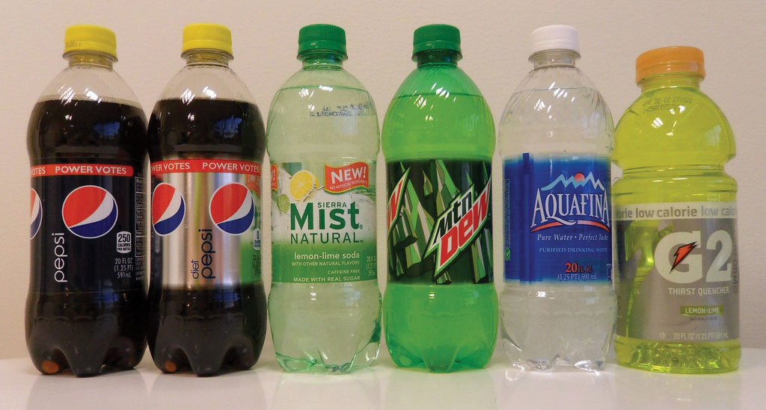
Source: Photo courtesy of JeffBedord,http://www.flickr.com/photos/jeffbedford/6218820224/in/photostream/.
Nonmanufacturing Costs at PepsiCo
PepsiCo, Inc., produces more than 500 products under several different brand names, including Frito-Lay, Pepsi-Cola, Gatorade, Tropicana, and Quaker. Net sales for 2010 totaled $57,800,000,000, resulting in operating profits of $6,300,000,000. Cost of sales represented the highest cost on the income statement at $26,600,000,000. The second highest cost on the income statement—selling and general and administrative expenses—totaled $22,800,000,000. These expenses are period costs, meaning they must be expensed in the period in which they are incurred.
Examples of selling costs for PepsiCo include television advertising (probably the biggest piece of the $22,800,000,000), promotional coupons, costs of shipping products to customers, and salaries of marketing and advertising personnel.
Examples of general and administrative costs include salaries and bonuses of top executives and the costs of administrative departments, including personnel, accounting, legal, and information technology.
Source: PepsiCo, “PepsiCo 2010 Annual Report,”http://www.pepsico.com.

KEY TAKEAWAY
- All manufacturing costs that are easily traceable to a product are classified as either direct materials or direct labor. All other manufacturing costs are classified as manufacturing overhead. All nonmanufacturing costs are not related to production and are classified as either selling costs or general and administrative costs.

REVIEW PROBLEM 1.6
- The following manufacturing items are for a construction company working on several custom homes. Identify whether each item should be categorized as direct materials, direct labor, or manufacturing overhead.
  - Nails
  - Lumber
  - Drywall
  - Workers building the house frame
  - Supervisor responsible for three homes
  - Light bulbs
  - Cabinets
  - Depreciation of construction equipment
- Identify whether each item in the following should be categorized as a product (manufacturing) cost or as period (nonmanufacturing) cost. Also indicate whether the cost should be recorded as an expense when the cost is incurred or as an expense when the goods are sold.
  - Advertising
  - Shipping costs for raw materials coming from a supplier
  - Shipping costs for goods shipped to a customer
  - Chief executive officer’s salary
  - Production supervisor’s salary
  - Depreciation on production equipment
  - Raw materials used in production
  - Paper used by the accounting staff
  - Commissions paid to salespeople
  - Janitorial services provided for production facility
  - Supplies used by human resources personnel
  - Utility costs for retail store
  - Insurance costs for production facility
  - Assembly line workers
  - Clerical support for chief executive officer
  - Maintenance of production equipment
- Identify whether each item listed in item 2 should be categorized as direct materials, direct labor, manufacturing overhead, selling cost, or general and administrative cost.
Solution to Review Problem 1.6

  - Manufacturing overhead
  - Direct materials
  - Direct materials
  - Direct labor
  - Manufacturing overhead
  - Manufacturing overhead (You might call this a direct material, but the benefit of tracking this item as a direct material probably does not outweigh the cost.)
  - Direct materials
  - Manufacturing overhead

  - Period cost, expensed when incurred
  - Product cost, expensed when goods are sold
  - Period cost, expensed when incurred
  - Period cost, expensed when incurred
  - Product cost, expensed when goods are sold
  - Product cost, expensed when goods are sold
  - Product cost, expensed when goods are sold
  - Period cost, expensed when incurred
  - Period cost, expensed when incurred
  - Product cost, expensed when goods are sold
  - Period cost, expensed when incurred
  - Period cost, expensed when incurred
  - Product cost, expensed when goods are sold
  - Product cost, expensed when goods are sold
  - Period cost, expensed when incurred
  - Product cost, expensed when goods are sold

  - Selling
  - Direct materials or manufacturing overhead, depending on if the materials are easily traced to the product (direct) or not (indirect manufacturing overhead)
  - Selling
  - General and administrative
  - Manufacturing overhead
  - Manufacturing overhead
  - Direct materials or manufacturing overhead, depending on if the materials are easily traced to the product (direct) or not (indirect manufacturing overhead)
  - General and administrative
  - Selling
  - Manufacturing overhead
  - General and administrative
  - Selling
  - Manufacturing overhead
  - Direct labor
  - General and administrative
  - Manufacturing overhead

1.7 How Product Costs Flow through Accounts

LEARNING OBJECTIVE
- Identify how costs flow through the three inventory accounts and cost of goods sold account.

Question: Custom Furniture Company’s direct materials include items such as wood and hardware. Direct labor involves the employees who build the custom tables. Manufacturing overhead includes items such as indirect materials (glue, screws, nails, sandpaper, and stain), indirect labor (production supervisor), and other manufacturing costs, such as factory equipment maintenance and factory utilities. What accounts are used to record the costs associated with these items, and where do these accounts appear in the financial statements?

Answer: All the costs mentioned previously for Custom Furniture are product costs (also called manufacturing costs). Product costs are recorded as an asset on the balance sheet until the products are sold, at which point the costs are recorded as an expense on the income statement. To record product costs as an asset, accountants use one of three inventory accounts: raw materials inventory, work-in-process inventory, or finished goods inventory. The account they use depends on the product’s level of completion. They use one expense account—cost of goods sold—to record the product costs when the goods are sold.

Summarizes the accounts used to track product costs. Shows how product costs flow through the balance sheet and income statement. Lastly, provides an example of how the accounts shown in and appear in financial statements. Take time to review these items carefully. Your understanding of them will help clarify how product costs flow through the accounts and where product costs appear in the financial statements. The following discussion provides further clarification.

Product Costs on the Balance Sheet

Question: What is the difference between raw materials inventory, work-in-process inventory, and finished goods inventory?
Answer: Each of these accounts is used to record product costs depending on where the product is in the production process, and each account is an asset account on the balance sheet.

Raw Materials

The raw materials inventory account records the cost of materials not yet put into production. For Custom Furniture Company, this account includes items such as wood, brackets, screws, nails, glue, lacquer, and sandpaper.

Work in Process

The work-in-process (WIP) inventory account records the costs of products that have not yet been completed. Suppose Custom Furniture Company has eight tables that are still in production at the end of the year. All manufacturing costs associated with these incomplete eight tables—direct materials, direct labor, and manufacturing overhead—are included in the WIP inventory account.

Once goods in WIP inventory are completed, they are transferred into finished goods inventory. The cost of completed goods that are transferred out of WIP inventory into finished goods inventory is called thecost of goods manufactured.

Finished Goods

The finished goods inventory account records the manufacturing costs of products that are completed and ready to sell. Suppose Custom Furniture Company has five completed tables at the end of the year (in addition to the eight partially completed tables in work-in-process inventory). The manufacturing costs of these five tables—direct materials, direct labor, and manufacturing overhead—are included in the finished goods inventory account until the tables are sold. (For the purposes of this example, assume the tables are “sold” when delivered to the customer.)

Product Costs on the Income Statement

Question: The costs of materials not yet put into production are included in raw materials inventory. The costs associated with products that are not yet complete are included in WIP inventory. And the costs associated with products that are completed and ready to sell are included in finished goods inventory.What happens to the product costs in finished goods inventory when the products are sold?

Answer: When completed goods are sold, their costs are transferred out of finished goods inventory into the cost of goods sold account. Cost of goods sold is an expense account on the income statement that represents the product costs of all goods sold during the period.

For example, suppose Custom Furniture Company sells one table that cost $3,000 to produce (i.e., direct materials, direct labor, and manufacturing overhead costs incurred to produce the table total $3,000). The $3,000 cost is in finished goods inventory until the entry is made to record the sale, at which time finished goods inventory is reduced by $3,000 (the table is no longer in inventory) and cost of goods sold is increased by $3,000.
Table 1.4 Accounts Used to Record Product Costs
Account Name | Description | Financial Statement
Raw materials inventory | Cost of unused production materials | Balance sheet (asset)
Work-in-process inventory | Cost of incomplete products | Balance sheet (asset)
Finished goods inventory | Cost of completed products not yet sold | Balance sheet (asset)
Cost of goods sold | Cost of products sold | Income statement (expense)

Figure 1.6 Flow of Product Costs through Balance Sheet and Income Statement Accounts
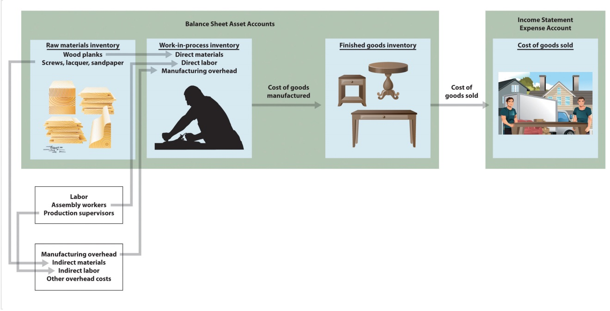

Business in Action 1.7
Source: Photo courtesy of Matthew Rutledge,http://www.flickr.com/photos/rutlo/4252743250//.
Presentation of Product Costs at Advanced Micro Devices
Advanced Micro Devices (AMD), a producer of microprocessors and flash memory devices for personal and networked computers, has annual revenues of $6,500,000,000. A summarized version of AMD’sbalance sheet appears as follows (all amounts are in millions). Notice that three inventory accounts, totaling $632,000,000, support the total inventory amount that appears in the asset section of the balance sheet. The raw materials inventory account ($28,000,000) is used to record the cost of materials not yet put into production. The work-in-process inventory account ($441,000,000) is used to record costs associated with microprocessors and flash memory devices in the production process that are not yet complete. The finished goods inventory account ($163,000,000) is used to record the product costs associated with AMD’s products that are completed and ready to sell.
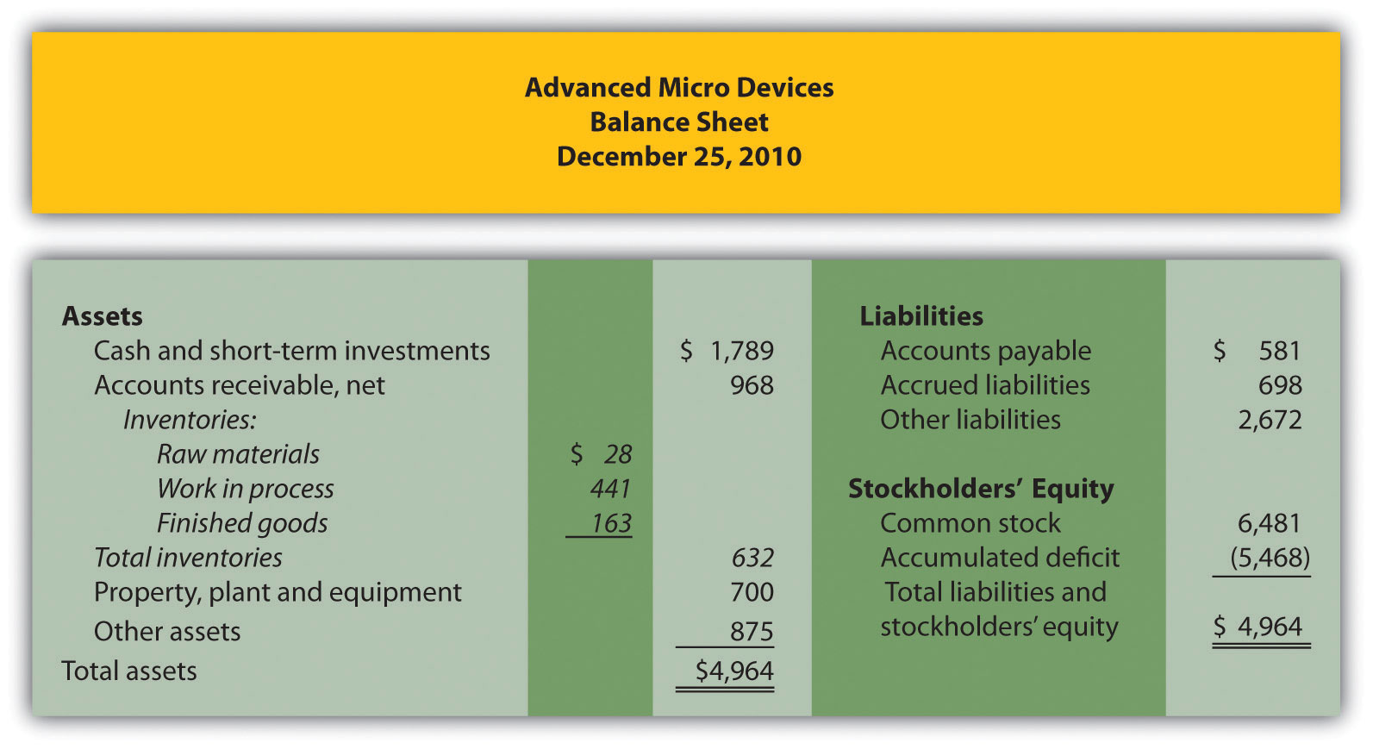
When AMD sells finished goods, the cost of these goods is transferred out of finished goods inventory into the cost of goods sold account, which this company calls cost of sales, as many companies do. The operating portion of AMD’s income statement follows—again, all amounts are in millions. Notice that cost of sales appears below net sales and above all other operating expenses.
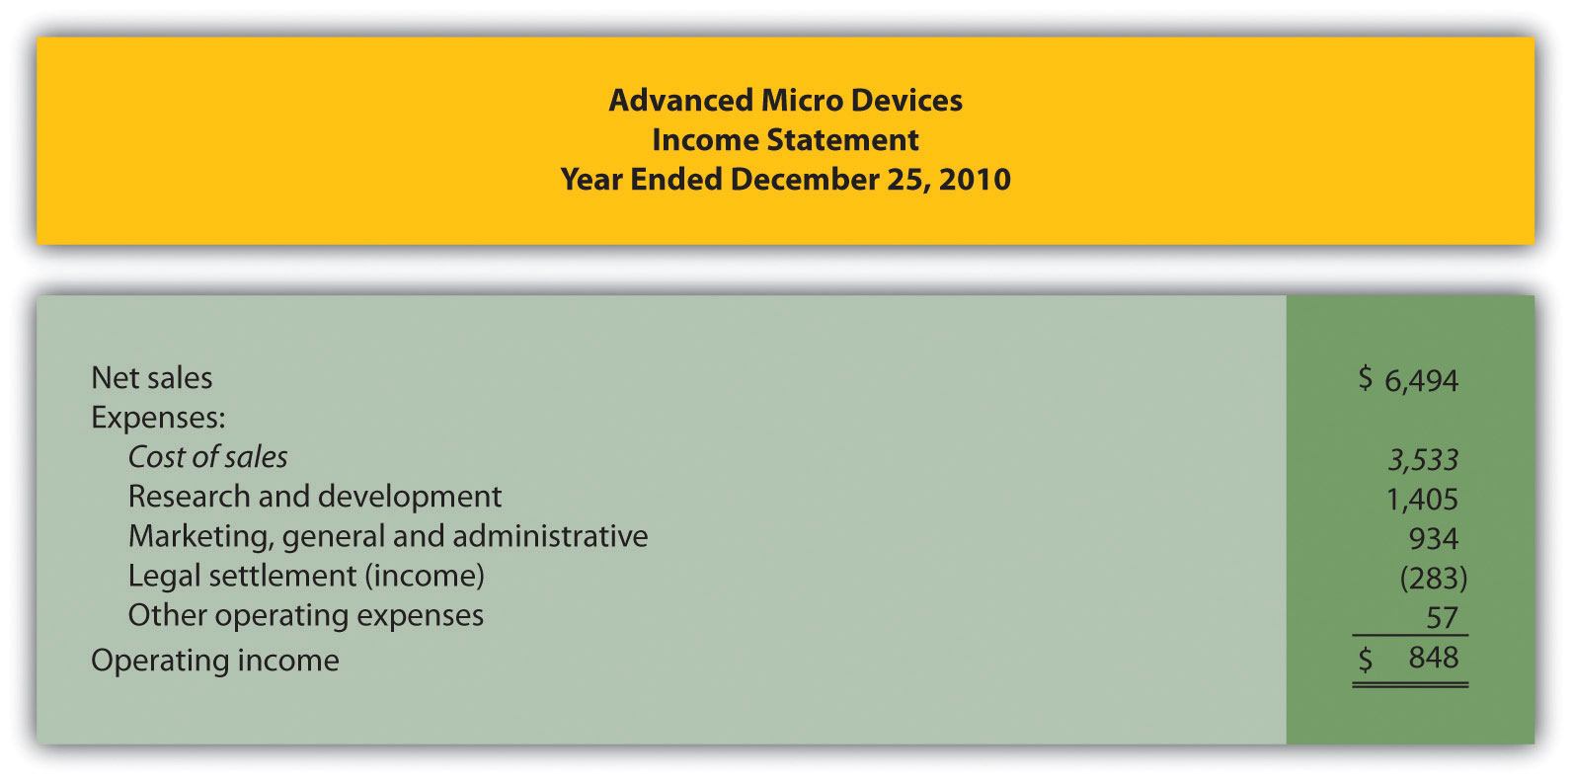
Source: Advanced Micro Devices, “Advanced Micro Devices 2010 Annual Report,” http://www.amd.com.

KEY TAKEAWAY
- The raw materials inventory account is used to record the cost of materials not yet put into production. The work-in-process inventory account is used to record the cost of products that are in production but that are not yet complete. The finished goods inventory account is used to record the costs of products that are complete and ready to sell. These three inventory accounts are assets accounts that appear on the balance sheet. The costs of completed goods that are sold are recorded in the cost of goods sold account. This account appears on the income statement as an expense.

REVIEW PROBLEM 1.7
Match each of the following accounts with the appropriate description that follows.
- _____ Raw materials inventory
- _____ Work-in-process inventory
- _____ Finished goods inventory
- _____ Cost of goods sold
- Used to record product costs of goods that are completed and ready to sell
- Used to record product costs of goods that have been sold
- Used to record product costs of goods that are still in production
- Used to record the cost of materials not yet put into production
Solutions to Review Problem 1.7
Raw materials inventory | 4. Used to record cost of materials not yet put into production.
Work-in-process inventory | 3. Used to record product costs associated with incomplete goods in the production process.
Finished goods inventory | 1. Used to record product costs associated with goods that are completed and ready to sell.
Cost of goods sold | 2. Used to record product costs associated with goods that are sold.

1.8 Income Statements for Manufacturing Companies

LEARNING OBJECTIVE
- Describe how to prepare an income statement for a manufacturing company.

Question: Companies that provide services, such as Ernst & Young(accounting) and Accenture LLP (consulting), do not sell goods and therefore have no inventory. The accounting process and income statement for service companies are relatively simple. Merchandising companies (also called retail companies) like Macy’s and Home Depot buy and sell goods but typically do not manufacture goods. Since merchandising companies must account for the purchase and sale of goods, their accounting systems are more complex than those of service companies. Manufacturing companies, such as Johnson & Johnson and Honda Motor Company, produce and sell goods. Such companies require an accounting system that goes well beyond accounting solely for the purchase and sale of goods. Why are accounting systems more complex for manufacturing companies?

Answer: Accounting systems are more complex for manufacturing companies because they need a system that tracks manufacturing costs throughout the production process to the point at which goods are sold. Since income statements for manufacturing companies tend to be more complex than for service or merchandising companies, we devote this section to income statements for manufacturing companies. Understanding income statements in a manufacturing setting begins with the inventory cost flow equation.

Inventory Cost Flow Equation

Question: How do companies use the cost flow equation to calculate unknown balances?

Answer: We can use the basic cost flow equation to calculate unknown balances for just about any balance sheet account (e.g., cash, accounts receivable, and inventory). The equation is as follows:

Key Equation
Beginning balance (BB) + Transfers in (TI) – Ending balance (EB) = Transfers out (TO)

We will apply this equation to the three inventory asset accounts discussed earlier (raw materials, work in process, and finished goods) to calculate the cost of raw materials used in production, cost of goods manufactured, and cost of goods sold.

Raw materials used in production shows the cost of direct and indirect materials placed into the production process. Cost of goods manufacturedrepresents the cost of goods completed and transferred out of work-in-process (WIP) inventory into finished goods inventory. Cost of goods sold represents the cost of goods that are sold and transferred out of finished goods inventory into cost of goods sold.

Accountants need all these amounts—raw materials placed in production, cost of goods manufactured, and cost of goods sold—to prepare an income statement for a manufacturing company. We describe how to calculate these amounts using three formal schedules in the following order:
- Schedule of raw materials placed in production
- Schedule of cost of goods manufactured
- Schedule of cost of goods sold

Question: The basic cost flow equation can be used in three supporting schedules to help us determine the cost of goods sold amount on the income statement for manufacturing companies. What information is included in these schedules, and what do they look like for Custom Furniture Company?

Answer: Figure 1.7 "Income Statement Schedules for Custom Furniture Company" shows these three schedules for Custom Furniture Company for the month of May. As you review these schedules, note that each schedule provides information required for the next schedule, as indicated by the arrows. Remember the inventory cost flow equation is used for each schedule. This is why you see abbreviations for each element of the equation: beginning balance (BB), transfers in (TI), ending balance (EB), and transfers out (TO).

The goal of going through the process shown in Figure 1.7 "Income Statement Schedules for Custom Furniture Company" is to arrive at a cost of goods sold amount, which is presented on the income statement. Custom Furniture Company’s income statement for the month ended May 31 is shown in Figure 1.8 "Income Statement for Custom Furniture Company". As you review Figure 1.7 "Income Statement Schedules for Custom Furniture Company" and Figure 1.8 "Income Statement for Custom Furniture Company", look back at Figure 1.6 "Flow of Product Costs through Balance Sheet and Income Statement Accounts" to see how costs flow through the three inventory accounts and the cost of goods sold account.

In Chapter 2 "How Is Job Costing Used to Track Production Costs?", we provide the detailed information necessary to prepare the schedules and income statement presented in Figure 1.7 "Income Statement Schedules for Custom Furniture Company" and Figure 1.8 "Income Statement for Custom Furniture Company". At this point, your job is to understand how we use the inventory cost flow equation to calculate raw materials placed in production, cost of goods manufactured, and cost of goods sold. (Note: Companies using a perpetual inventory system do not necessarily prepare these formal schedules because perpetual systems update records immediately when inventory is transferred from one inventory account to another. However, these companies take a physical count periodically to ensure the accuracy of inventory accounts and use the cost flow equation and similar schedules to ensure their perpetual system balances are accurate. Note 1.62 "Business in Action 1.8" shows how the cost flow equation can be used to analyze the effects of fraud that was allegedly committed at Rite Aid.)
Figure 1.7 Income Statement Schedules for Custom Furniture Company
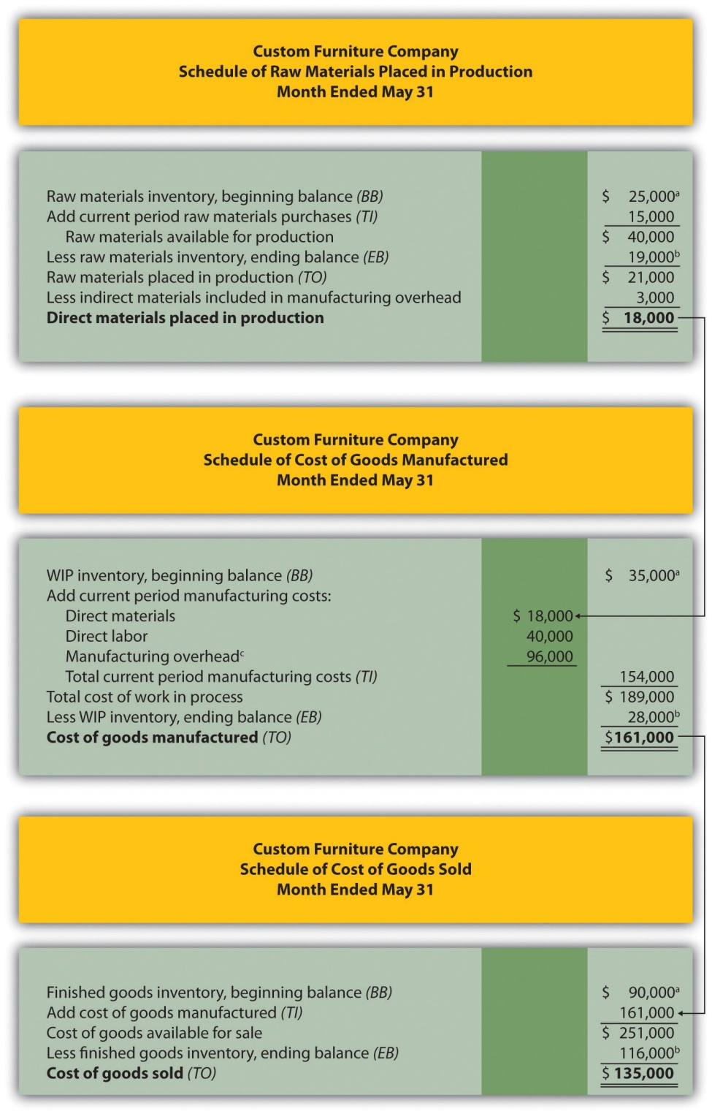
ª From the company’s balance sheet at April 30 (April 30 ending balance is the same as May 1 beginning balance).
^{b} From the company’s balance sheet at May 31.
^{c} This is actual manufacturing overhead for the period and includes indirect materials, indirect labor, factory rent, factory utilities, and other factory-related expenses for the month. In Chapter 2 "How Is Job Costing Used to Track Production Costs?", we look at an alternative approach to recording manufacturing overhead called normal costing.
Figure 1.8 Income Statement for Custom Furniture Company
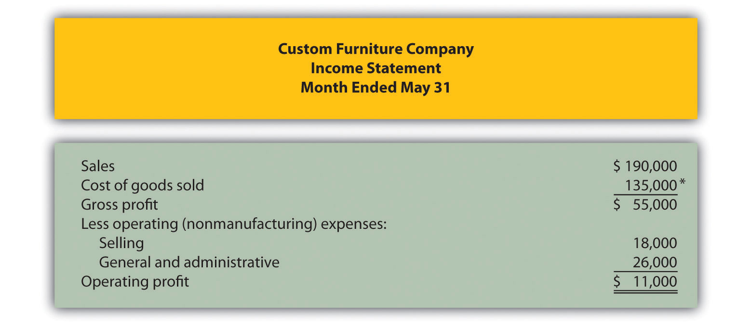

*$135,000 comes from the schedule of cost of goods sold in Figure 1.7 "Income Statement Schedules for Custom Furniture Company".

Business in Action 1.8
Using the Cost Flow Equation to Analyze Fraud
Rite Aid Corporation operates 3,400 drug stores in the United States. In 2002, the Securities and Exchange Commission (SEC) filed accounting fraud charges against several former executives of Rite Aid. The SEC complaint alleged that Rite Aid had significantly overstated income for several years.
According to the complaint, Rite Aid executives committed financial fraud in several areas, one of which involved inventory. At the end of the company’s fiscal year, the physical inventory count showed $9,000,000 less than Rite Aid’s inventory balance on the books, presumably due to physical deterioration of the goods or theft. Rite Aidexecutives allegedly failed to record this shrinkage, thereby overstating ending inventory on the balance sheet and understating cost of goods sold on the income statement.
Using the cost flow equation, you can see how failing to record the $9,000,000 loss would understate cost of goods sold.
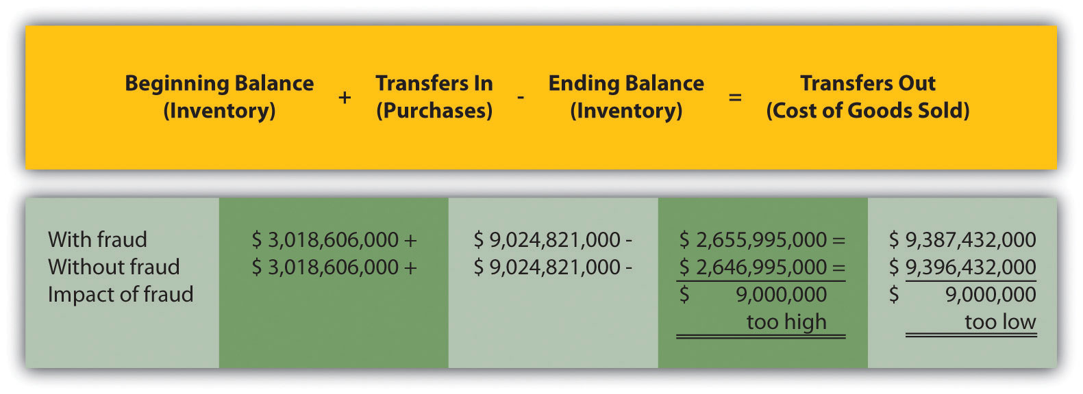
By failing to record the inventory loss, Rite Aid overstated inventory (an asset) on the balance sheet by $9,000,000 and understated cost of goods sold (an expense) by $9,000,000 on the income statement. This ultimately increased profit by $9,000,000 because reported expenses were too low.
This inventory fraud was a relatively small part of the fraud allegedly committed by Rite Aid executives. In fact, Rite Aid’s net income was restated downward by $1,600,000,000 in 2002. Several former executives pled guilty to conspiracy charges. The former chief executive, Martin Grass, was sentenced to eight years in prison and the former chief financial officer, Franklyn Bergonzi, was sentenced to 28 months in prison. Rite Aid’s stock fell from a high of $50 per share to $5 per share in 2003.
Sources: Securities and Exchange Commission, “Release 2002–92,” news release, http://www.sec.gov; AP wires dated July 10, 2003, and May 27, 2004.

Manufacturing Versus Merchandising Income Statements

Question: Manufacturing companies clearly have more complex accounting systems to account for all the costs involved in producing products. However, the income statement for a manufacturing company is not all that much different than the income statement for a merchandising company. What are primary differences between manufacturing and merchandising company income statements?

Answer: The primary differences are as follows:
- Merchandising companies do not calculate the raw materials placed in production or cost of goods manufactured (shown in the top section ofFigure 1.7 "Income Statement Schedules for Custom Furniture Company").
- Merchandisers purchase goods from suppliers instead of manufacturing goods. The cost of these purchases from suppliers is often called net purchases in the income statement, in contrast to cost of goods manufactured in a manufacturer’s income statement. The net purchases line consists of purchases, purchases returns and allowances, purchases discounts, and freight in.
- Merchandisers do not use the schedule of cost of goods manufactured (and related schedule of raw materials placed in production).
- Merchandisers use an account called merchandise inventory, or simply inventory, instead of finished goods inventory. This reflects that merchandisers do not produce goods.

Table 1.5 "Income Statement Terminology in Manufacturing and Merchandising Companies" summarizes the differences in income statement terminology between manufacturing companies and merchandising companies.

Table 1.5 Income Statement Terminology in Manufacturing and Merchandising Companies
The following terms are used by manufacturing and merchandising companies:sales, cost of goods available for sale, cost of goods sold, operating expenses, selling,general and administrative, and operating profit.
Finished goods inventory is used by manufacturing companies. | Merchandise inventory is used by merchandising companies.
Cost of goods manufactured is used by manufacturing companies. | Net purchases is used by merchandising companies.

Figure 1.9 "Merchandising Company Income Statement for Fashion, Inc."presents an income statement for Fashion, Inc., a retail company that sells clothing. Notice that the schedule of cost of goods manufactured (and related schedule of raw materials placed in production) is not needed for merchandising companies, and the terms merchandise inventory and net purchases are used instead of finished goods inventory and cost of goods manufactured. Also, the schedule of cost of goods sold is simply included in the income statement. Many companies prefer this approach because it means they do not have to prepare a separate schedule.
Figure 1.9 Merchandising Company Income Statement for Fashion, Inc.
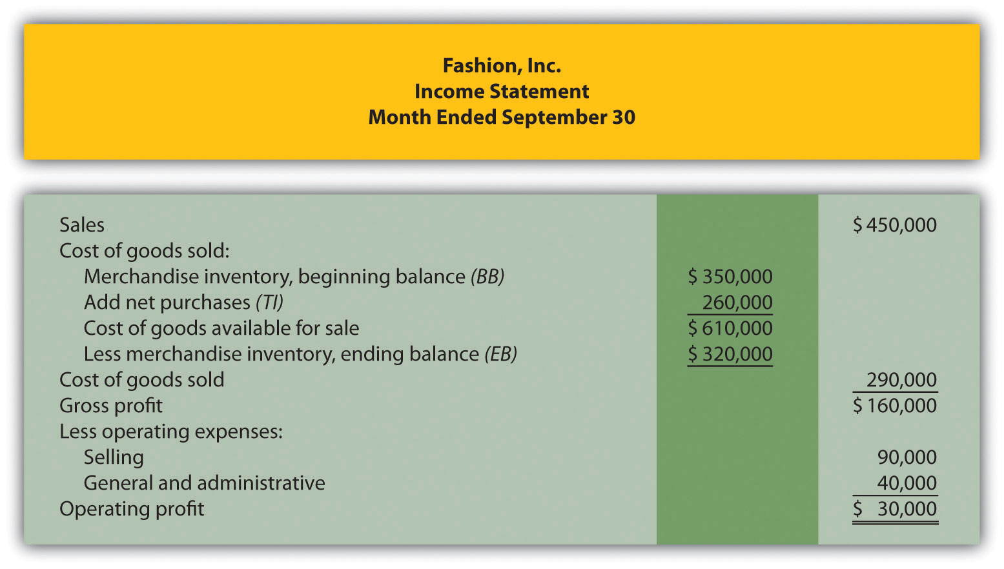

KEY TAKEAWAYS
- Three schedules are necessary to prepare an income statement for a manufacturing company, in the following order:
  - Schedule of raw materials placed in production, which shows cost of direct materials added to work-in-process inventory and cost of indirect materials added to manufacturing overhead
  - Schedule of cost of goods manufactured, which shows cost of goods completed and transferred out of work-in-process inventory into finished goods inventory
  - Schedule of cost of goods sold, which shows cost of goods sold and transferred out of finished goods inventory into cost of goods sold
- The income statements of merchandising companies differ from those of manufacturing companies in several areas. Merchandising companies do not use a schedule of raw materials placed in production or a schedule of cost of goods manufactured, and they use a merchandise inventory account instead of a finished goods inventory account. In addition, they use the term net purchases instead of cost of goods manufactured and often include the schedule of cost of goods sold in the income statement rather than presenting it separately.

REVIEW PROBLEM 1.8
Fine Cabinets, Inc., produces custom cabinets. The following inventory balances appeared on its balance sheet. (Note that the most current financial information is presented in the first column.)
 | December 31, 2012 | December 31, 2011
Raw materials inventory | $ 8,000 | $ 10,000
Work-in-process inventory | 600,000 | 550,000
Finished goods inventory | 350,000 | 410,000
Fine Cabinets had $1,265,000 in sales for the year ended December 31, 2012. The company also had the following costs for the year:
Selling | $ 90,000
General and administrative | $240,000
Raw materials purchases | $100,000
Direct labor used in production | $125,000
Manufacturing overhead | $630,000
Of the total raw materials placed in production for the year, $12,000 was for indirect materials and must be deducted to find direct materials placed in production.
Required:
- Prepare the schedules listed in the following for the year ended December 31, 2012. Use the format shown in Figure 1.7 "Income Statement Schedules for Custom Furniture Company". (Note that Figure 1.7 "Income Statement Schedules for Custom Furniture Company" shows information for a month and this review problem presents information for a year.)
  - Schedule of raw materials placed in production
  - Schedule of cost of goods manufactured
  - Schedule of cost of goods sold
- Prepare an income statement for the year ended December 31, 2012. Use the format shown in Figure 1.8 "Income Statement for Custom Furniture Company".
- Assume Fine Cabinets, Inc., is a merchandising company that purchases its cabinets from a manufacturer. Use the information from the schedule of cost of goods sold prepared in requirement 1and the income statement prepared in requirement 2 to prepare an income statement. Use the format shown in Figure 1.9 "Merchandising Company Income Statement for Fashion, Inc.".
Solution to Review Problem 1.8

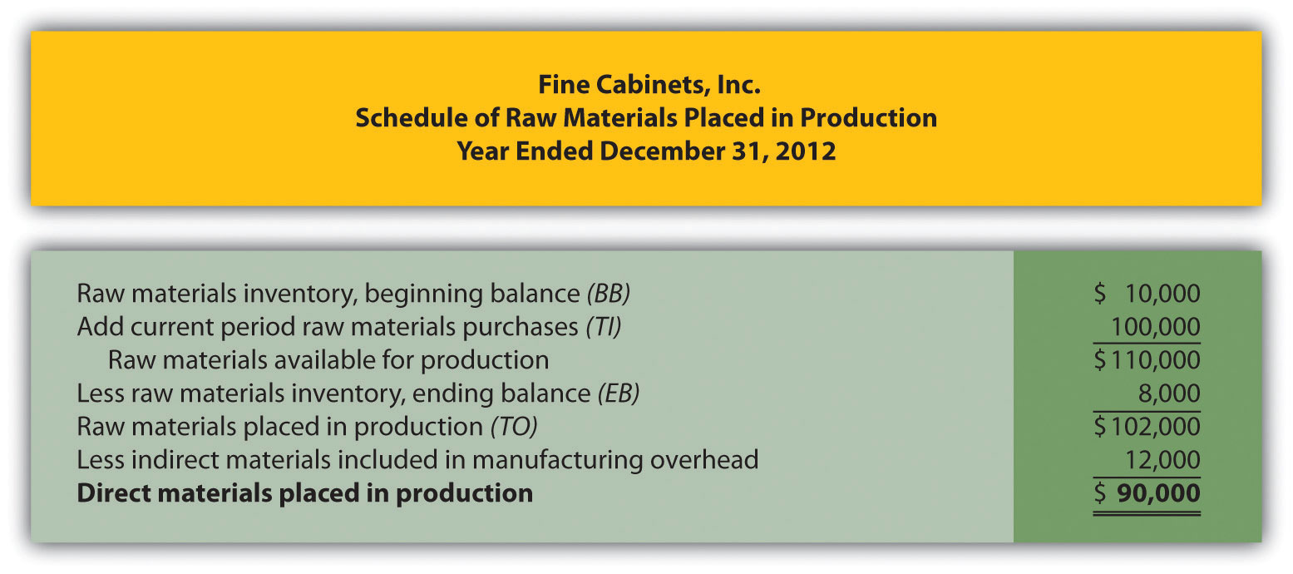

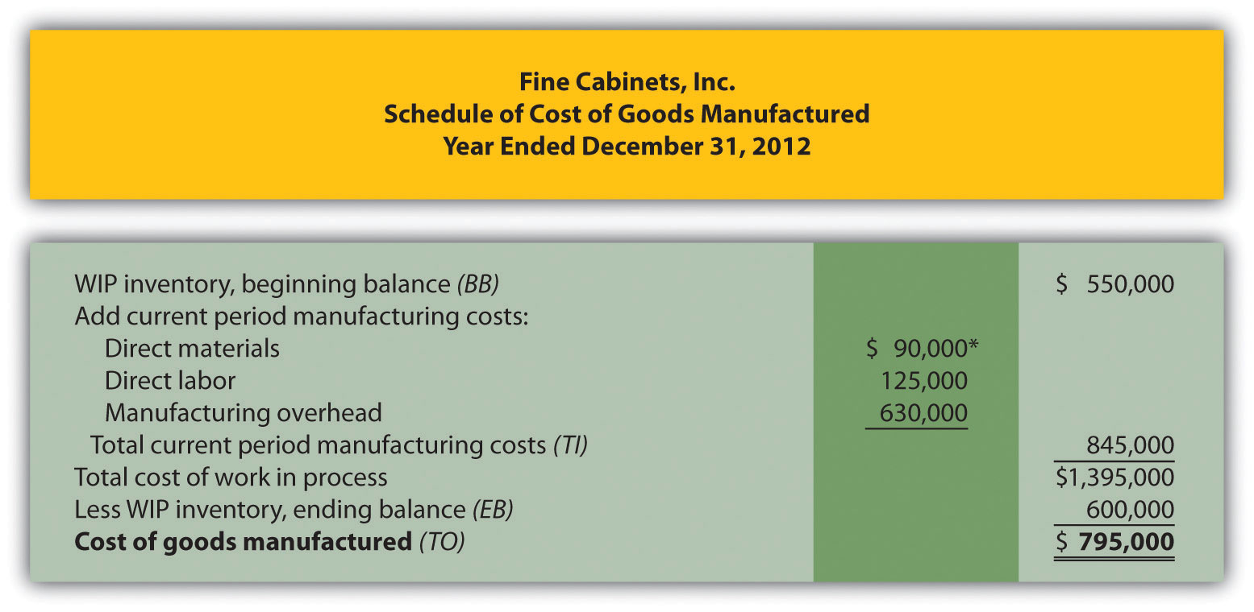
*$90,000 comes from the direct materials placed in production in part 1a.

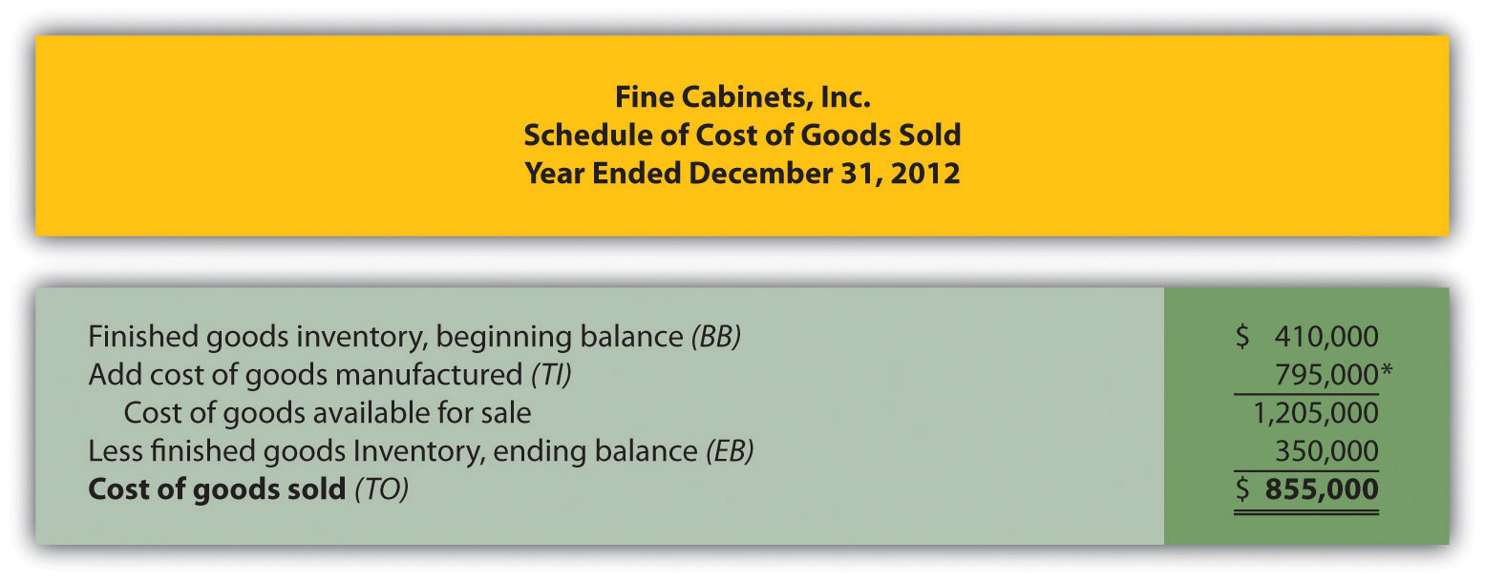
*$795,000 comes from the cost of goods manufactured (TO) in part 1b.

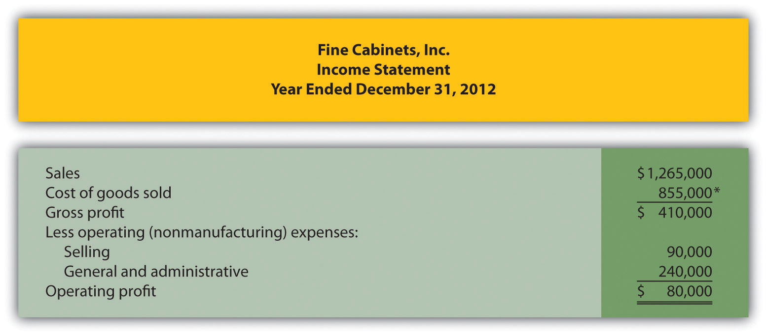
*$855,000 comes from the cost of goods sold (TO) in part 1c.

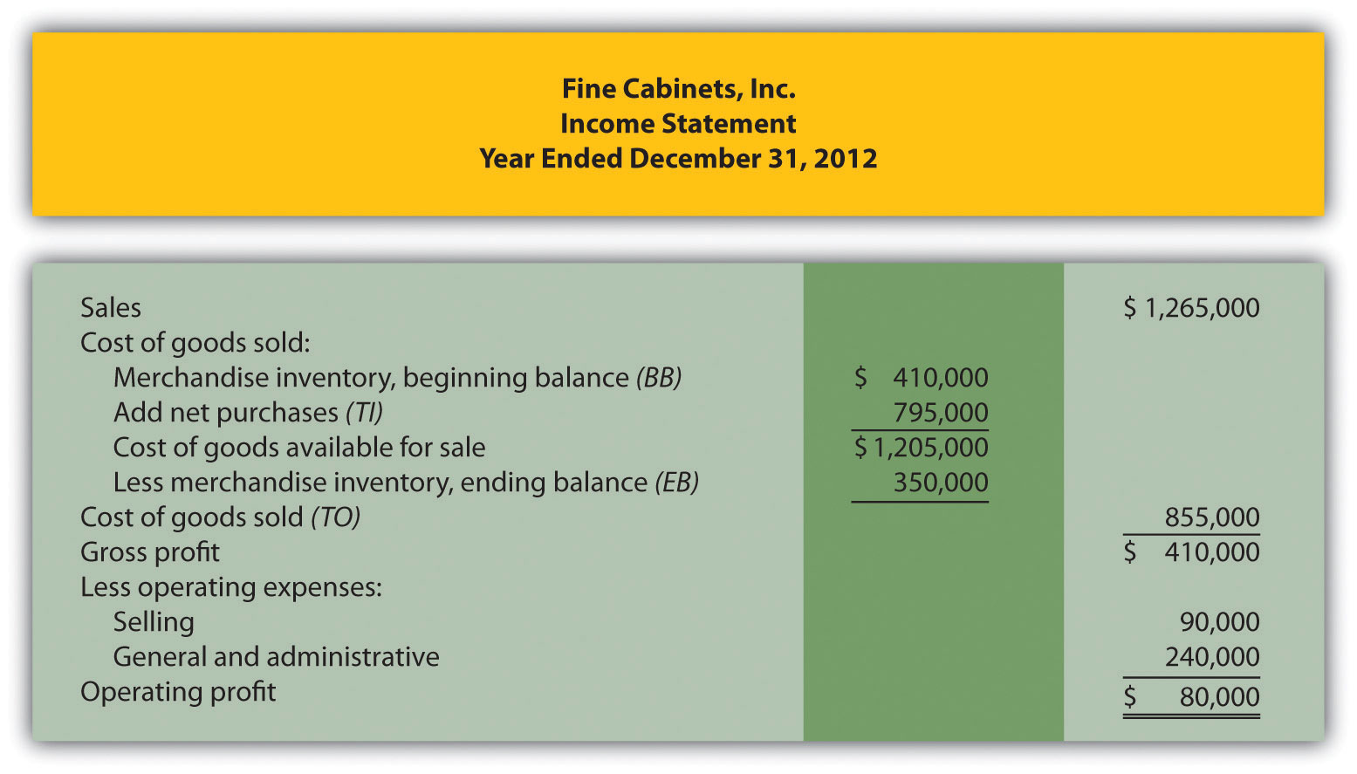

END-OF-CHAPTER EXERCISES
Questions
- Describe the characteristics of managerial accounting and financial accounting.
- What are nonfinancial measures of performance? Provide several examples.
- Which accountant (financial or managerial) would prepare each of the following reports:
  - Income statement for the Chevrolet division of General Motors
  - Balance sheet for PepsiCo prepared in accordance with U.S. GAAP
  - The Boston Symphony Orchestra’s budgeted income statement for next quarter
  - Defect rate of computer chips produced by Intel
  - Statement of cash flows for Hewlett-Packard prepared in accordance with U.S. GAAP
- Describe the planning and control functions performed by most managers.
- What is the controller’s primary responsibility?
- How do the treasurer’s responsibilities differ from those of the controller?
- Explain why ethical behavior is so important for finance and accounting personnel.
- Briefly summarize the Institute of Management Accountants (IMA)Statement of Ethical Professional Practice shown in Figure 1.2 "IMA Statement of Ethical Professional Practice". What is the purpose of this statement?
- Review Note 1.27 "Business in Action 1.3" Why would the company’s former employees improperly record information as described here?
- Review Note 1.28 "Business in Action 1.4" Why is improving ethics a top priority for businesses, such as Home Depot and Hewlett-Packard?
- What is an enterprise resource planning system?
- Why do manufacturing companies use product costing systems to track costs throughout the production process?
- Describe manufacturing costs and nonmanufacturing costs. Provide examples of each.
- Describe the difference between direct materials and direct labor versus indirect materials and indirect labor.
- Why are the terms product costs and period costs used to describe manufacturing costs and nonmanufacturing costs?
- How does the timing of recording expenses differ between product and period costs?
- Review Note 1.43 "Business in Action 1.5" Why are items such as the hull, engine, transmission, carpet, and seats classified as direct materials and items such as glue, paint, and screws classified as indirect materials?
- Review Note 1.48 "Business in Action 1.6" Provide two examples of selling costs and two examples of general and administrative costs at PepsiCo.
- Describe the three inventory accounts used to record product costs.
- What are the three categories of product costs that flow through the work-in-process inventory account? Describe each one.
- When is the cost of goods sold account (often called cost of sales) used, and how is the dollar amount recorded in this account determined?
- Review Note 1.57 "Business in Action 1.7" What are the names and dollar amounts of the inventory accounts appearing on the balance sheet? What is the total amount of product costs recorded as an expense on the income statement for the year ended December 31, 2010?
- Describe the inventory cost flow equation and how it applies to the three schedules shown in Figure 1.7 "Income Statement Schedules for Custom Furniture Company".
- How does a merchandising company income statement differ from a manufacturing company income statement?
Brief Exercises
- Accounting Information at Sportswear Company. Refer to the dialogue between the president and accountant at Sportswear Company presented at the beginning of the chapter. Why can’t the president find information for each product line (hats and jerseys) in the financial statements? Who within the company typically provides this type of information?
- Financial Versus Managerial Accounting. Maria is the loan officer at a local bank that lends money to Old Town Market, a small grocery store. She requests several quarterly financial reports on an ongoing basis to assess the store’s ability to repay the loan. Provide one example of a financial accounting report and two examples of managerial accounting reports that Maria might request.
- Planning and Control. Two college graduates recently started a Web page design firm. The first month was just completed, and the owners are in the process of comparing budgeted revenues and expenses with actual revenues and expenses for the month. Would this be considered part of the planning function or the control function? Explain.
- Finance and Accounting Personnel. Determine whether the chief financial officer, controller, treasurer, internal auditor, managerial accountant, financial accountant, or tax accountant would perform the following tasks. (Hint: Some job titles may be used more than once, and others may not be used at all.)
  - Prepares annual reports for shareholders and creditors
  - Provides a quarterly summary of financial results to the CEO and board of directors
  - Provides profit and loss reports by product line
  - Calculates estimated quarterly tax payments
  - Oversees the treasurer and internal auditor
  - Obtains sources of financing and manages short-term investments
  - Verifies that annual report financial information is accurate
- Enterprise Resource Planning (ERP) System. Enterprise resource planning (ERP) systems are designed to record and share information across functional and geographical areas on a real-time basis. However, these systems tend to be costly to purchase and maintain. Why do organizations continue to invest millions of dollars in ERP systems in spite of the cost?
- Manufacturing Cost Terms. Indicate whether each of the following costs associated with production would be classified as direct materials, direct labor, or manufacturing overhead.
  - Salaried supervisor responsible for several product lines
  - Hourly workers assembling goods
  - Grease used to maintain machines
  - Maintenance personnel
  - Bike frame used to build a racing bike
  - Factory property taxes
  - Glue used to assemble toys
- Manufacturing Cost Terms. Indicate whether each of the following costs associated with production would be classified as direct materials, direct labor, or manufacturing overhead.
  - Depreciation on production equipment
  - Paint used to produce wagons
  - Accounting staff performing tax services for a client
  - Nails used to assemble cabinets
  - Fiberglass used to produce a custom boat
  - Hourly workers assembling goods
  - Factory utilities
- Manufacturing and Nonmanufacturing Cost Terms. Burns Company incurred costs for the following items.
  - Salary of chief financial officer
  - Factory insurance
  - Salary for salespeople
  - Raw materials used in production easily traced to the product
  - Computer equipment depreciation for accounting department
  - Insurance for headquarters building
  - Production line workers
  - Clerical support for production supervisors
Required:
  - Indicate whether each item should be categorized as a product or period cost.
  - Indicate whether each item should be categorized as direct materials, direct labor, manufacturing overhead, selling, or general and administrative.
- Manufacturing and Nonmanufacturing Cost Terms. Leighton, Inc., incurred costs for the following items.
  - Janitorial services in the production facility
  - Personnel department supplies
  - Shipping costs for raw materials purchased from a supplier, easily traced to the product
  - Newspaper advertisements
  - Supervisor of several production lines
  - Insurance for factory equipment
  - Production line workers
  - Clerical support for sales staff
Required:
  - Indicate whether each item should be categorized as a product or period cost.
  - Indicate whether each item should be categorized as direct materials, direct labor, manufacturing overhead, selling, or general and administrative.
- Accounts Used to Record Product Costs. Match each of the following accounts with the appropriate description that follows.
  - _____ Raw materials inventory
  - _____ Work-in-process inventory
  - _____ Finished goods inventory
  - _____ Cost of goods sold
  - Used to record product costs associated with goods that are sold
  - Used to record the cost of materials not yet put into production
  - Used to record product costs associated with goods that are complete and ready to sell
  - Used to record product costs associated with incomplete goods in the production process
- Income Statement Terminology: Manufacturing Versus Merchandising. Match each of the following terms used in a manufacturing company’s income statement with the equivalent term used in a merchandising company’s income statement.

Manufacturing Company
  - _____ Cost of goods manufactured
  - _____ Work-in-process inventory
  - _____ Finished goods inventory
  - _____ Cost of goods sold

Merchandising Company
  - Merchandise inventory
  - Same term is used by a merchandising company
  - Net purchases
  - Not applicable for a merchandising company.
Exercises: Set A
- Financial Versus Managerial Accounting (Manufacturing). The income statement from Ford’s annual report appears as follows in summary form. (This information was obtained from the company’s Web site, http://www.ford.com.)
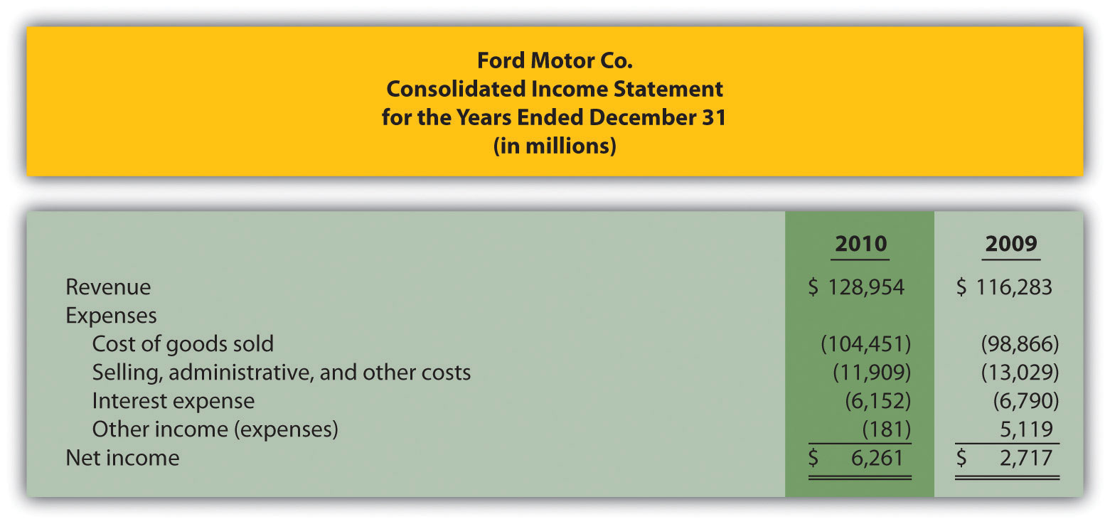
Required:
  - The financial information in the company’s annual report was prepared primarily for shareholders and creditors in accordance with U.S. Generally Accepted Accounting Principles (U.S. GAAP). Does the income statement provide enough detailed information for managers atFord? Explain.
  - Provide at least three additional detailed pieces of financial information that would help managers evaluate performance at Ford.
  - Provide at least two nonfinancial measures that would help managers evaluate performance at Ford.
- Organizational Structure. The following list of personnel within organizations comes from Figure 1.2 "IMA Statement of Ethical Professional Practice".
  - Board of directors
  - Chief financial officer
  - Controller
  - Managerial accountant
  - Financial accountant
  - Tax accountant
  - Treasurer
  - Internal auditor
Required:
Match each previous item with the most accurate description as follows.
  - Assists in preparing information used for decision making within the organization
  - Assists in preparing tax reports for governmental agencies, including the Internal Revenue Service
  - Responsible for confirming that controls within the company are effective in ensuring accurate financial data, and serves as an independent link with the board of directors
  - Responsible for all finance and accounting functions within the organization and typically reports to the chief executive officer
  - Elected by the shareholders of the company
  - Oversees the managerial accountant, financial accountant, and tax accountant
  - Responsible for obtaining financing for the organization, projecting cash flow needs, and managing cash and short-term investments
  - Assists in preparing financial information, usually in accordance with U.S. GAAP, for those outside the company
- Schedule of Raw Materials Placed in Production. The balance in Sedona Company’s raw materials inventory account was $110,000 at the beginning of September and $135,000 at the end of September. Raw materials purchased during the month totaled $50,000. Sedona used $8,000 in indirect materials for the month.
Required:
Prepare a schedule of raw materials placed in production for the month of September.
- Schedule of Cost of Goods Manufactured. The balance in Reid Company’s work-in-process inventory account was $300,000 at the beginning of March and $320,000 at the end of March. Manufacturing costs for the month follow.
Direct materials (from the schedule of raw materials placed in production) | $ 40,000
Direct labor | $ 70,000
Manufacturing overhead | $200,000
- Required:
- Prepare a schedule of cost of goods manufactured for the month of March.
- Schedule of Cost of Goods Sold. The balance in Blue Oak Company’s finished goods inventory account was $25,000 at the beginning of September and $28,000 at the end of September. Cost of goods manufactured for the month totaled $17,000.
Required:
Prepare a schedule of cost of goods sold for the month of September.
- Income Statement. Auto Products, Inc., had the following activity for the month of October.
Sales revenue | $1,100,000
Selling expenses | $ 300,000
General and administrative expenses | $ 230,000
Cost of goods sold | $ 475,000
- Required:
- Prepare an income statement for the month of October.
Exercises: Set B
- Financial Versus Managerial Accounting (Merchandising). Home Depot’s annual report appears as follows in summary form. (This information was obtained from the company’s Web site,http://www.homedepot.com.)
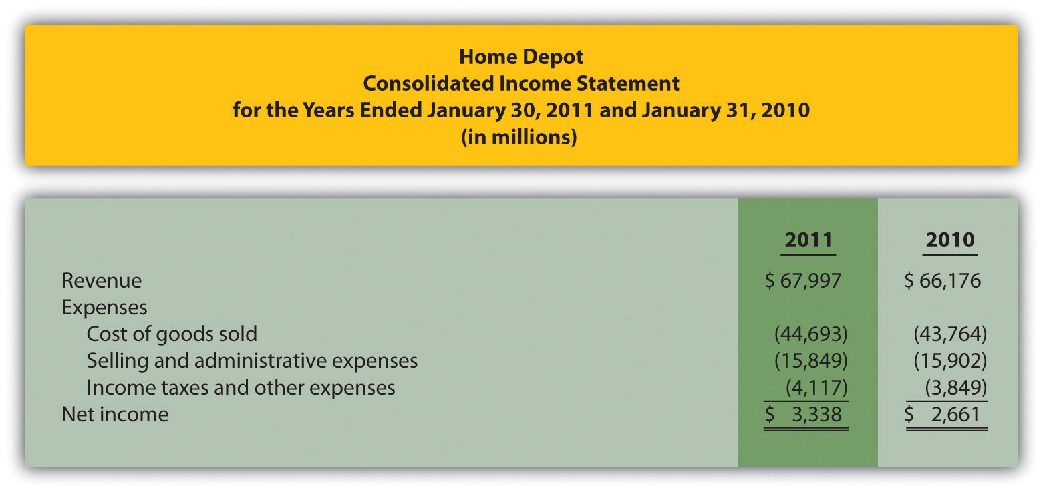
Required:
  - The financial information in the company’s annual report was prepared primarily for shareholders and creditors in accordance with U.S. GAAP. Does the income statement provide enough detailed information for managers atHome Depot? Explain.
  - Provide at least three additional detailed pieces of financial information that would help managers evaluate performance at Home Depot.
  - Provide at least two nonfinancial measures that would help managers evaluate performance at Home Depot.
- Organizational Structure. The following list of personnel within organizations comes from Figure 1.2 "IMA Statement of Ethical Professional Practice".
  - Board of directors
  - Chief financial officer
  - Controller
  - Managerial accountant
  - Financial accountant
  - Tax accountant
  - Treasurer
  - Internal auditor
Required:
Match each previous item with the most accurate description as follows:
  - Responsible for hiring and overseeing the chief executive officer
  - Assists in preparing financial information for those outside the company, such as shareholders and bondholders
  - Responsible for reviewing internal controls within the company and ensuring accurate financial data
  - Responsible for controller, treasurer, and internal auditor functions within the organization
  - Responsible for projecting cash flow needs and managing cash and short-term investments
  - Oversees the managerial accountant, financial accountant, and tax accountant
  - Prepares profit information by product, which is used for decision making within the organization
  - Assists in establishing tax strategies for the organization
- Schedule of Raw Materials Placed in Production. The balance in Clay Company’s raw materials inventory account was $45,000 at the beginning of April and $38,000 at the end of April. Raw materials purchased during the month totaled $55,000. Clay used $14,000 in indirect materials for the month.
Required:
Prepare a schedule of raw materials placed in production for the month of April.
- Schedule of Cost of Goods Manufactured. The balance in the work-in-process inventory account of Verdi Production, Inc., was $900,000 at the beginning of May and $750,000 at the end of May. Manufacturing costs for the month follow.
Direct materials (from the schedule of raw materials placed in production) | $340,000
Direct labor | $810,000
Manufacturing overhead | $660,000
- Required:
- Prepare a schedule of cost of goods manufactured for the month of May.
- Schedule of Cost of Goods Sold. The balance in Posada Company’s finished goods inventory account was $650,000 at the beginning of March and $625,000 at the end of March. Cost of goods manufactured for the month totaled $445,000.
Required:
Prepare a schedule of cost of goods sold for the month of March.
- Income Statement. Game Products, Inc., had the following activity for the month of June.
Sales revenue | $800,000
Selling expenses | $100,000
General and administrative expenses | $200,000
Cost of goods sold | $360,000
- Required:
- Prepare an income statement for the month of June.
Problems
- Financial Versus Managerial Accounting (Service). The income statement from the annual report of United Parcel Service (UPS)appears as follows in summary form. (This information was obtained from the company’s Web site, http://www.ups.com.)
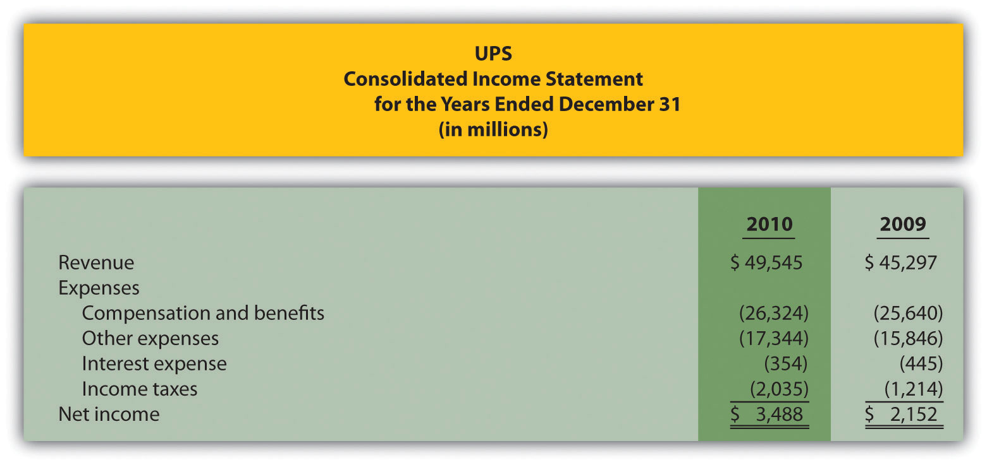
Required:
  - The financial information in the company’s annual report was prepared primarily for shareholders and creditors in accordance with U.S. GAAP. Does the income statement provide enough detailed information for managers atUPS? Explain.
  - Provide at least three additional detailed pieces of financial information that would help managers evaluate performance at UPS.
  - Provide at least two nonfinancial measures that would help managers evaluate performance at UPS.
- Income Statement and Supporting Schedules. The following financial information is for Industrial Company. (Note that the most current financial information is presented in the first column.)
 | December 31, 2011 | December 31, 2010
Raw materials inventory | $ 24,000 | $ 30,000
Work-in-process inventory | 1,800,000 | 1,650,000
Finished goods inventory | 1,050,000 | 1,230,000
- Of the total raw materials placed in production for the year, $36,000 was for indirect materials. Industrial had $3,795,000 in sales for the year ended December 31, 2011. The company also had the following costs for the year:
Selling | $ 270,000
General and administrative | $ 720,000
Raw materials purchases | $ 300,000
Direct labor used in production | $ 375,000
Manufacturing overhead | $1,890,000
- Required:
  - Prepare a schedule of raw materials placed in production for the year ended December 31, 2011.
  - Prepare a schedule of cost of goods manufactured for the year ended December 31, 2011.
  - Prepare a schedule of cost of goods sold for the year ended December 31, 2011.
  - Prepare an income statement for the year ended December 31, 2011.
  - Describe the three types of costs included in cost of goods sold on the income statement. (Dollar amounts are not necessary in your descriptions.)
- Income Statement and Supporting Schedules. The following financial information is for Danville Company. (Note that the most current financial information is presented in the first column.)
 | December 31, 2011 | December 31, 2010
Raw materials inventory | $ 8,000 | $ 10,000
Work-in-process inventory | 600,000 | 550,000
Finished goods inventory | 350,000 | 410,000
- Of the total raw materials placed in production for the year, $12,000 was for indirect materials. Danville had $1,265,000 in sales for the year ended December 31, 2011. The company also had the following costs for the year:
Selling | $ 90,000
General and administrative | $240,000
Raw materials purchases | $100,000
Direct labor used in production | $125,000
Manufacturing overhead | $630,000
- Required:
  - Prepare a schedule of raw materials placed in production for the year ended December 31, 2011.
  - Prepare a schedule of cost of goods manufactured for the year ended December 31, 2011.
  - Prepare a schedule of cost of goods sold for the year ended December 31, 2011.
  - Prepare an income statement for the year ended December 31, 2011.
  - Describe the three types of costs included in cost of goods manufactured. (Dollar amounts are not necessary in your descriptions.)
- Income Statement and Supporting Schedules. The following information is for Ciena, Inc., for the year ended December 31, 2011.
Raw materials inventory beginning balance | $ 15,000
Raw materials inventory ending balance | $ 12,000
Work-in-process inventory beginning balance | $ 825,000
Work-in-process inventory ending balance | $ 900,000
Finished goods inventory beginning balance | $ 615,000
Finished goods inventory ending balance | $ 525,000
Raw material purchases | $ 150,000
Direct labor used in production | $ 187,500
Manufacturing overhead | $ 945,000
Selling costs | $ 135,000
General and administrative | $ 360,000
Sales revenue | $1,897,500
- Of the total raw materials placed in production for the year, $18,000 was for indirect materials.
- Required:
  - Prepare a schedule of raw materials placed in production for the year ended December 31, 2011.
  - Prepare a schedule of cost of goods manufactured for the year ended December 31, 2011.
  - Prepare a schedule of cost of goods sold for the year ended December 31, 2011.
  - Prepare an income statement for the year ending December 31, 2011.
- Income Statement and Supporting Schedules. The following information is for Diablo, Inc., for the year ended December 31, 2011.
Raw materials inventory beginning balance | $ 60,000
Raw materials inventory ending balance | $ 48,000
Work-in-process inventory beginning balance | $3,300,000
Work-in-process inventory ending balance | $3,600,000
Finished goods inventory beginning balance | $2,460,000
Finished goods inventory ending balance | $2,100,000
Raw material purchases | $ 600,000
Direct labor used in production | $ 750,000
Manufacturing overhead | $3,780,000
Selling costs | $ 540,000
General and administrative | $1,440,000
Sales revenue | $7,590,000
- Of the total raw materials placed in production for the year, $72,000 was for indirect materials.
- Required:
  - Prepare a schedule of raw materials placed in production for the year ended December 31, 2011.
  - Prepare a schedule of cost of goods manufactured for the year ended December 31, 2011.
  - Prepare a schedule of cost of goods sold for the year ended December 31, 2011.
  - Prepare an income statement for the year ending December 31, 2011.
One Step Further: Skill-Building Cases
- Ethics: Accounting for Obsolete Inventory. High Tech, Inc., is a public company that produces laser and ink jet printers. Jorge is an accounting staff member who works for the company’s controller and is involved in preparing the annual report. One of High Tech’s competitors developed a superior color laser jet printer using a less costly production process. Jorge realizes that High Tech’s substantial inventory of color laser jet printers is effectively obsolete and will have to be written down to its net realizable value in accordance with U.S. GAAP. This means higher expenses and lower profits.
Jorge’s boss, the controller, is aware of the situation but the chief financial officer is not. In fact, the controller told the CFO that High Tech does not have any obsolete inventory. Both Jorge’s boss and the CFO receive bonuses tied to the company’s profits. The outside auditors are completing the audit and are unaware of the obsolete inventory.
Required:
How should Jorge handle this situation? Use the IMA’sStatement of Ethical Professional Practice shown in Figure 1.2 "IMA Statement of Ethical Professional Practice" as a guide to answering this question.
- Internet Project: Institute of Management Accountants. Go to the Web site of the Institute of Management Accountants (http://www.imanet.org). Review various parts of the site (e.g., About IMA or Certification) and write a one-page summary of your findings.
- Internet Project: American Institute of Certified Public Accountants. Go to the Web site of the American Institute of Certified Public Accountants (AICPA; http://www.aicpa.org). Review various parts of the site (e.g.,About the AICPA or Professional Resources) and write a one-page summary of your findings.
- Internet Project: Sarbanes-Oxley Act of 2002. Go to the Securities and Exchange Commission’s Web site (http://www.sec.gov) and click on Laws and Regulations. Click on the full text of the Sarbanes-Oxley Act of 2002.
Required:
  - Go to section 302, Corporate Responsibility for Financial Reports, and summarize the six requirements in this section. Assume you are the chief financial officer of a public company. What concerns might you have about these requirements?
  - Go to section 404, subsection a, Management Assessment of Internal Controls. Assume you are an executive officer of a public company. What two items are you required to present in the annual report?
- Ethics: Companies Accused of Committing Fraud. Using a source like The Wall Street Journal, BusinessWeek, or an Internet search engine, find an article about an organization accused of committing accounting fraud. Write a one-page summary of your findings. Include a copy of the article with your summary.
- Internet Project: Finding Company with Ethics Policy. Using the Internet, find a company that has standards for ethical behavior. (Some companies refer to these standards as a “code of ethics”; others may use different terminology.) Write a one-page summary of your findings.
- Group Activity: Inventory Accounts for Manufacturing Company. In groups of two to four students, use the Internet to find a manufacturing company that presents three inventory accounts on the balance sheet or in the notes to the financial statements. Include a printout of your findings, and explain what each account and related dollar amount represents.
Comprehensive Case
- Ethics: Accounting for Revenues and Expenses. Equipment Group produces excavating equipment for contractors. Equipment Group is working on the annual financial statements for its shareholders, who are expecting profits of $200,000,000 for the year ending December 31. The controller (Jeff) and CFO (Kathy) will receive bonuses totaling 50 percent of their salaries if company profits exceed $200,000,000. Sarah is a staff accountant who works for the controller. One week before the end of the fiscal year, a customer decides to delay a significant purchase of equipment until March of the next year. As a result, Equipment Group’s profits will decrease by $2,000,000 to $198,000,000 for the year.
Jeff, the controller, approaches Sarah and asks her to think of a way to increase profits by $2,500,000. He suggests looking at sales occurring in early January and perhaps moving them up to December. He also hints that some December expenses could be pushed back and recorded in January.
Required:
  - Is there a problem with the controller’s request? Explain your answer.
  - How should Sarah handle this situation? There are many possible steps, as described in the IMA’s Statement of Ethical Professional Practice shown in Figure 1.2 "IMA Statement of Ethical Professional Practice".
  - What are the potential consequences for Sarah if she agrees to do what Jeff suggests?

Chapter 2

How Is Job Costing Used to Track Production Costs?

Dan Stevens recently started Custom Furniture Company, a manufacturing company that specializes in building custom wood tables for individuals and organizations. Each table is unique and built to customer specifications for use in homes (coffee tables and dining room tables) and offices (boardroom and meeting room tables). The sales price of each table varies significantly, from $1,000 to more than $30,000. (Note that this is the same company as the example in the last part of Chapter 1 "What Is Managerial Accounting?". Although not required, you may find it helpful to refer to the Chapter 1 "What Is Managerial Accounting?" discussion of Custom Furniture Company.)

When Dan received the company’s income statement for May, he was surprised by the lack of profits. Because sales prices are based on a markup of estimated costs, Dan is questioning the accuracy of his estimates. He approaches Leslie, the full-time accountant for Custom Furniture Company, to get more information.
Dan: | Leslie, last month’s income statement shows we are struggling to make a decent profit. I’m not sure why this is happening, especially since we price our furniture 70 percent above estimated production costs.
Leslie: | Basing prices on estimated costs is a good approach, but it only works if your estimates are accurate. Have you compared the actual cost of each table with your original estimates?
Dan: | No, but I like the idea. Where do I start?
Leslie: | We use a job cost accounting system that tracks costs for each table you produce. I can pull together the information for you. How far back do you want to go?
Dan: | Let’s start by looking at actual product costs for the three costliest tables produced in May. It would be helpful to break these costs out for direct materials, direct labor, and manufacturing overhead. I would also like to see the gross profit generated by each table.
Leslie: | No problem, I’ll have the information for you by the end of the day.

We use Custom Furniture Company as an example throughout the chapter to explain how a job costing system works and to provide information that will address Dan’s concerns.

2.1 Differentiating Job Costing from Process Costing

LEARNING OBJECTIVE
- Distinguish between job costing and process costing.

Question: Financial accounting classes cover how merchandising companies, such as Sears and Lowe’s, account for the cost of the goods that they purchase from a supplier and later sell to a customer. These companies simply record the cost of the purchase in an inventory account and account for any returns and allowances, discounts, and shipping costs. Once the merchandise is sold, the related inventory costs are transferred to cost of goods sold. However, manufacturing companies are different. How do manufacturing companies account for inventory at different stages of production?

Answer: Manufacturing companies like Custom Furniture Company, Ford, and IBM don’t have it quite as easy as merchandising companies. They must account for the materials, labor, and other manufacturing costs that go into building the product. The process of accounting for manufacturing costs depends on which costing system a company uses—job costing or process costing.

Job Costing

Question: We define a job as an activity that produces a unique product—one that can be easily distinguished from other products. For example, building a custom home is a job because the home is unique and easy to distinguish from other homes. An accounting firm’s provision of tax services to a client is another example of a job. How does a job costing system help companies that produce unique products or jobs?

Answer: A job costing system records revenues and costs for each job. Because each job at Custom Furniture Company results in a unique product and has different material and labor requirements, the company uses a job costing system.

Tracking revenues and costs for each job is important for several reasons:
- Like Dan at Custom Furniture, managers want to assess the accuracy of cost estimates. This is particularly important when prices are based on estimated costs.
- Managers want to review actual revenues and costs for each job to see if the job is profitable.
- Managers want to compare actual costs with estimated costs throughout a project so they can identify unexpected changes as early in the project as possible. For example, if the cost of mahogany wood increases by 50 percent, Custom Furniture might renegotiate the price of a mahogany table with the customer. If it’s too late to renegotiate the price of a current job, the cost increase could be built into the pricing of future jobs.

Process Costing

Question: Job costing may work for builders of custom furniture and tax professionals, but does job costing make sense for a company that produces soft drinks? Imagine trying to track costs for each can of soda produced. A job costing system would not be appropriate for this type of company. A different costing system, called process costing, would be a better fit. Which types of companies use this type of system?

Answer: Companies that produce identical units of product in batches using a consistent process track costs with a process costing system. Table 2.1 "Job Costing Versus Process Costing" lists some products and services that require the use of process costing versus job costing, and Figure 2.1 "Examples of Job Costing and Process Costing" shows an example of each. This chapter focuses on job costing. We explore process costing further inChapter 4 "How Is Process Costing Used to Track Production Costs?".

Table 2.1 Job Costing Versus Process Costing
Job Costing | Process Costing
Custom homes | Oil
Custom vans | Chemicals
House painting services | Paint
Movies | Lumber
Airplanes | Milk
Bridges | Pencils
Legal services | Paper
Figure 2.1 Examples of Job Costing and Process Costing

KEY TAKEAWAY
- Job costing systems record revenues and costs for unique products; ones that can be easily distinguished from other products. Process costing systems record revenues and costs for batches of identical units of product. When deciding whether to use a job costing or process costing system, we must understand a company’s products and production processes.

REVIEW PROBLEM 2.1
Identify whether each company listed in the following would use job costing or process costing.
- Coca-Cola Company
- Kelly Moore Paint
- Volkswagen—custom campers
- Universal Studios—movie division
- Chevron Corporation
- Michelin
- Boeing Co.
- Ernst & Young—tax division
Solutions to Review Problem 2.1
- Process costing
- Process costing
- Job costing
- Job costing
- Process costing
- Process costing
- Job costing
- Job costing

2.2 How a Job Costing System Works

LEARNING OBJECTIVE
- Understand how direct materials and direct labor costs are assigned to jobs.

Question: Now that we know a job costing system records revenues and costs for each unique job, we can determine whether this type of system would be appropriate at Custom Furniture Company. Recall that Custom Furniture produces high-quality custom wood tables that are sold for between $1,000 and $30,000. A job costing system is a perfect fit for this type of company. How would Custom Furniture Company use a job costing system to track production costs?

Answer: We use financial information for the month of May at Custom Furniture Company to illustrate how a job costing system works. Refer toChapter 1 "What Is Managerial Accounting?", as needed, for a refresher on manufacturing cost terms and how the three different inventory accounts are used by manufacturing companies. Let’s start our example with the purchase of raw materials.

Purchasing Raw Materials

Question: Recall from Chapter 1 "What Is Managerial Accounting?" that raw materials are the items necessary to build a product. For Custom Furniture Company, this includes items such as wood, brackets, screws, nails, glue, lacquer, and sandpaper. How do we record the purchase of raw materials?

Answer: The accountants at Custom Furniture record the cost of raw materials purchased in the raw materials inventory account. Assume Custom Furniture Company purchased $4,500 in raw materials on May 2. All purchases are on account. The journal entry to reflect this transaction is as follows:

This purchase of raw materials is further illustrated in the T-accounts shown in the following. Assume the beginning balance for raw material inventory is $25,000. Beginning balances are only provided for inventory accounts since the focus of this chapter is on manufacturing costs that flow through these accounts.

Introductory financial accounting texts discuss the rules for double-entry accounting in detail. Recall that the following account categories areincreased with a debit (and are therefore decreased with a credit): assets, dividends, and expenses. Conversely, the following account categories areincreased with a credit (and decreased with a debit): liabilities, stockholders’ equity, and revenues. Also note that the individual transactions shown throughout this chapter represent one example of many similar transactions that occurred throughout the month of May. A summary of activity for the entire month of May is presented in Figure 2.7 "Custom Furniture Company’s Journal Entries for May" and Figure 2.8 "Custom Furniture Company’s T-Accounts".

Assigning Direct Material Costs to Jobs

Question: The next step is to move raw materials from the storeroom to production. How does the company track this information, and how is this transaction recorded in the general journal?

Answer: A materials requisition form tracks materials taken out of raw materials inventory and placed in production. This form specifies the type, quantity, and cost of materials being requested, as well as the number of the job in which the materials will be used. Figure 2.2 "Materials Requisition Form for Custom Furniture Company" shows a materials requisition form that Custom Furniture Company used to transfer $370 in direct materials out of raw materials inventory into production.
Figure 2.2 Materials Requisition Form for Custom Furniture Company
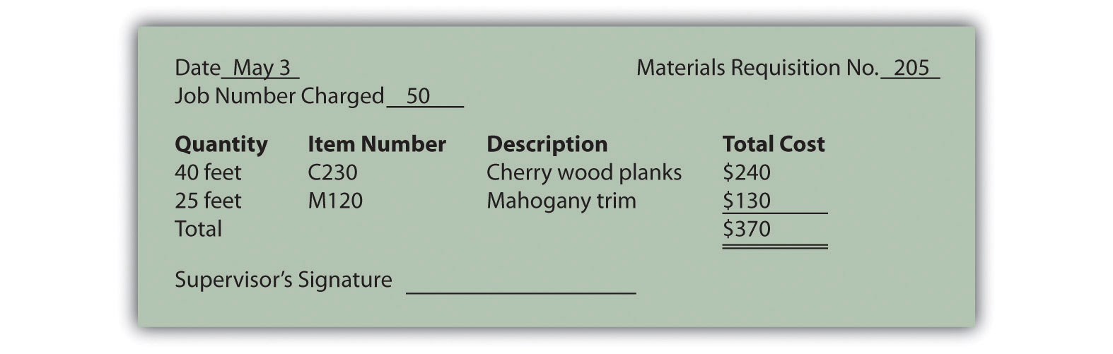

The journal entry to reflect this transfer is as follows:

This flow of direct materials from one account to another is further illustrated in the T-accounts that follow. Assume the beginning balance for work-in-process inventory is $35,000.
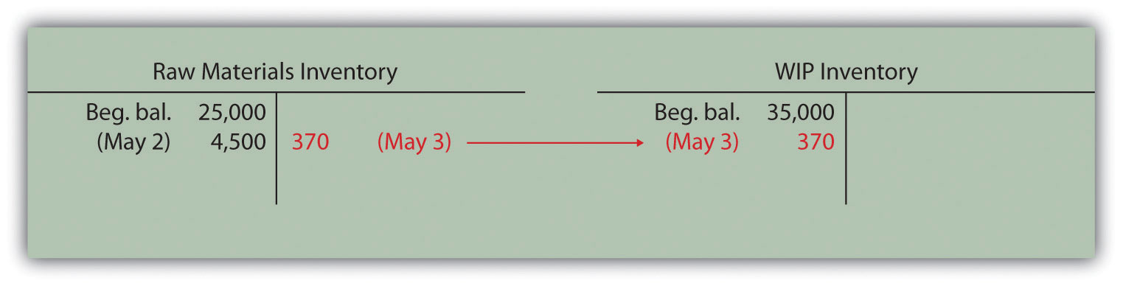

Using a Job Cost Sheet

Question: The next step is to post the information shown on the materials requisition form to the appropriate job cost sheet. Because the work-in-process (WIP) inventory account tracks manufacturing costs in total, a separate subsidiary ledger is necessary to track manufacturing costs for each job. The total of all WIP inventory subsidiary ledgers matches the WIP inventory account shown on the balance sheet. What does a WIP inventory subsidiary ledger look like, and how is it used?

Answer: The WIP inventory subsidiary ledger typically comprises many individual job cost sheets. A job cost sheet simply accumulates manufacturing costs incurred for each job. Figure 2.3 "Job Cost Sheet for Custom Furniture Company" shows a job cost sheet for Custom Furniture Company. Notice how the materials requisition in Figure 2.2 "Materials Requisition Form for Custom Furniture Company" is a line item in the job cost sheet for job 50.
Figure 2.3 Job Cost Sheet for Custom Furniture Company
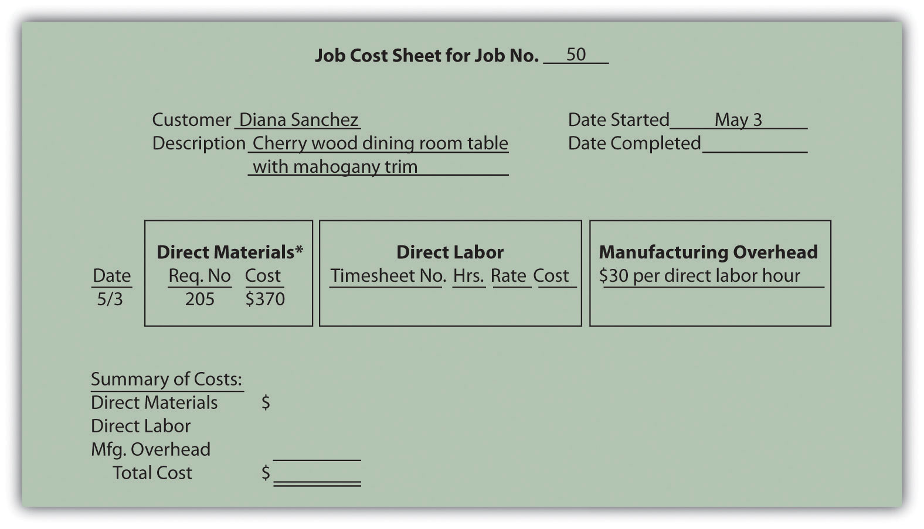

*$370 comes from the total in Figure 2.2 "Materials Requisition Form for Custom Furniture Company".

Assigning Direct Labor Costs to Jobs

Question: Recall from Chapter 1 "What Is Managerial Accounting?" that direct labor is defined as workers who convert materials into a finished product and whose time is easily traced to the product or job. Manufacturing companies, such as Custom Furniture Company, must keep track of the hours each worker spends on any given job. How do companies track this information, and how is this information recorded in the general journal?

Answer: Workers use a timesheet to track the hours spent on each job. The timesheet is often called a time card, time ticket, or job ticket. The worker is responsible for completing the timesheet, including the date, job number, and hours worked on each job.

Figure 2.4 "Timesheet for Custom Furniture Company" provides an example of a timesheet used at Custom Furniture Company to track direct labor costs of $120 related to jobs 50 and 51 for Tim Wallace. The journal entry to reflect this is as follows:

Recording these direct labor costs is further illustrated in the T-accounts that follow. Again, beginning balances are only provided for inventory accounts since the focus of this chapter is on manufacturing costs that flow through these accounts.

Figure 2.4 Timesheet for Custom Furniture Company
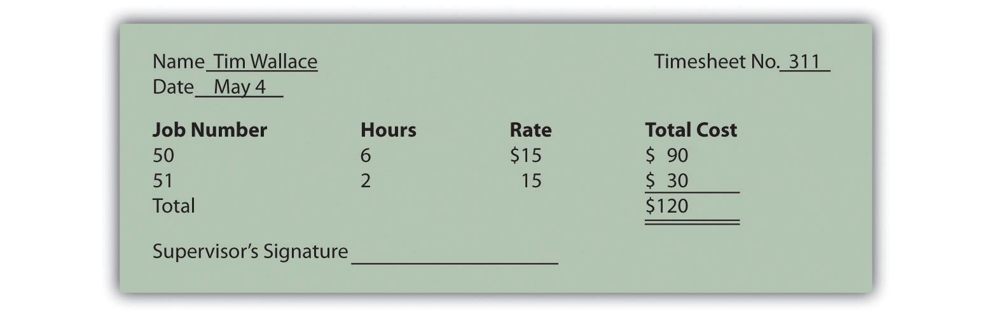

The next step is to post the information shown on the timesheet to the appropriate job cost sheet, just as we did with direct materials. This is done for job 50 in Figure 2.5 "Direct Labor Costs for Custom Furniture Company’s Job 50".
Figure 2.5 Direct Labor Costs for Custom Furniture Company’s Job 50
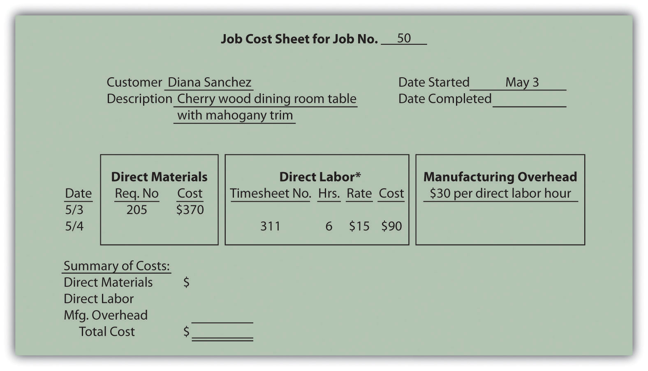
*Direct labor information carried over from Figure 2.4 "Timesheet for Custom Furniture Company".

KEY TAKEAWAY
- A materials requisition form tracks materials taken out of raw materials inventory and placed in production. It identifies the job in which the materials will be used. A timesheet tracks the hours that workers spend on each job. The information from both the materials requisition forms and timesheets is recorded on each job cost sheet. A job cost sheet accumulates manufacturing costs for each job and serves as a subsidiary ledger for the work-in-process inventory account.

REVIEW PROBLEM 2.2
- Provide the journal entry to record each of the following transactions:
  - Raw materials totaling $40,000 are purchased on account.
  - Direct materials totaling $5,000 are requisitioned and placed into production.
  - Timesheets submitted by employees reflect direct labor costs of $2,000, to be paid the next week.
- Which of the previously stated entries must also be recorded on the appropriate job cost sheet? Why?
Solutions to Review Problem 2.2

  - Entries b and c must be recorded on the appropriate job cost sheet. Direct materials (entry b) and direct labor (entry c) are by definition easily traceable to the job and therefore must be recorded on the job cost sheet when the cost is incurred.

2.3 Assigning Manufacturing Overhead Costs to Jobs

LEARNING OBJECTIVE
- Understand how manufacturing overhead costs are assigned to jobs.

Question: We have discussed how to assign direct material and direct labor costs to jobs using a materials requisition form, timesheet, and job cost sheet. The third manufacturing cost—manufacturing overhead—requires a little more work. How do companies assign manufacturing overhead costs, such as factory rent and factory utilities, to individual jobs?

Answer: Recall from Chapter 1 "What Is Managerial Accounting?" that manufacturing overhead consists of all costs related to the production process other than direct materials and direct labor. Because manufacturing overhead costs are difficult to trace to specific jobs, the amount allocated to each job is based on an estimate. The process of creating this estimate requires the calculation of a predetermined rate.

Using a Predetermined Overhead Rate

The goal is to allocate manufacturing overhead costs to jobs based on some common activity, such as direct labor hours, machine hours, or direct labor costs. The activity used to allocate manufacturing overhead costs to jobs is called an allocation base. Once the allocation base is selected, a predetermined overhead rate can be established. Thepredetermined overhead rate is calculated prior to the year in which it is used in allocating manufacturing overhead costs to jobs.

Calculating the Predetermined Overhead Rate

Question: How is the predetermined overhead rate calculated?

Answer: We calculate the predetermined overhead rate as follows, using estimates for the coming year:

Key Equation
Predetermined overhead rate=Estimated overhead costs*Estimated activity in allocation base**
*The numerator requires an estimate of all overhead costs for the year, such as indirect materials, indirect labor, and other indirect costs associated with the factory. Custom Furniture Company estimates annual overhead costs to be $1,140,000 based on actual overhead costs last year.
**The denominator requires an estimate of activity in the allocation base for the year. Custom Furniture uses direct labor hours as the allocation base and expects its direct labor workforce to record 38,000 direct labor hours for the year.

The predetermined overhead rate calculation for Custom Furniture is as follows:

Predetermined overhead rate=$1,140,000 estimated overhead costs38,000 estimated direct labor hours=$30 per direct labor hour

Thus each job will be assigned $30 in overhead costs for every direct labor hour charged to the job. The assignment of overhead costs to jobs based on a predetermined overhead rate is called overhead applied. Remember that overhead applied does not represent actual overhead costs incurred by the job—nor does it represent direct labor or direct material costs. Instead, overhead applied represents a portion of estimated overhead costs that is assigned to a particular job.

Question: Now that we know how to calculate the predetermined overhead rate, the next step is to use this rate to apply overhead to jobs. How do companies use the predetermined overhead rate to apply overhead to jobs, and how is this information recorded in the general journal?

Answer: As shown on the timesheet in Figure 2.4 "Timesheet for Custom Furniture Company", Tim Wallace charged six hours to job 50. Because manufacturing overhead is applied at a rate of $30 per direct labor hour, $180 (= $30 × 6 hours) in overhead is applied to job 50. The journal entry to reflect this is as follows:

Recording the application of overhead costs to a job is further illustrated in the T-accounts that follow.
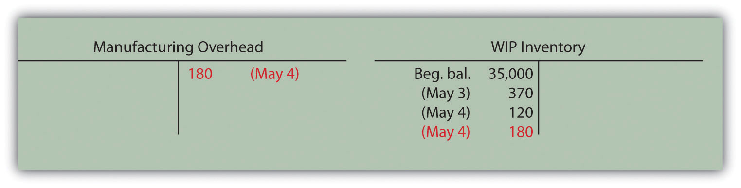

When this journal entry is recorded, we also record overhead applied on the appropriate job cost sheet, just as we did with direct materials and direct labor. Figure 2.6 "Overhead Applied for Custom Furniture Company’s Job 50" shows the manufacturing overhead applied based on the six hours worked by Tim Wallace. Notice that total manufacturing costs as of May 4 for job 50 are summarized at the bottom of the job cost sheet.

Figure 2.6 Overhead Applied for Custom Furniture Company’s Job 50
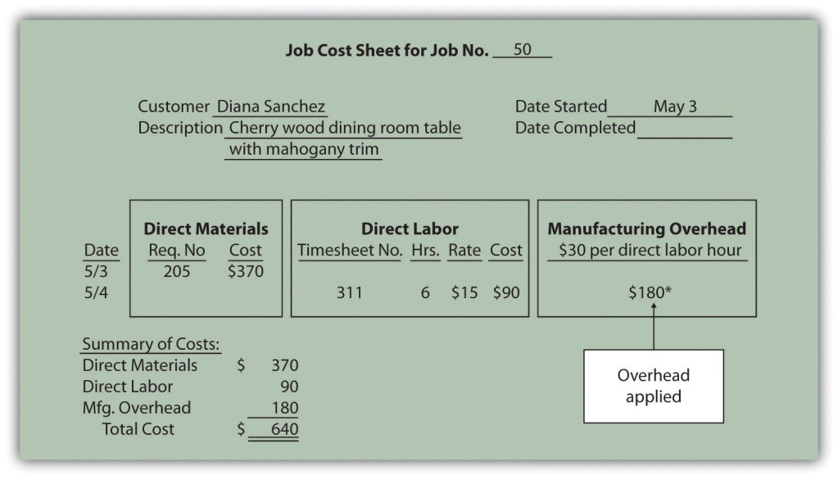
*$180 = $30 per direct labor hour × 6 direct labor hours.

Selecting an Allocation Base

Question: Although we used direct labor hours as the allocation base for Custom Furniture Company’s predetermined overhead rate, organizations use various other types of allocation bases. The most common allocation bases are direct labor hours, direct labor costs, and machine hours. What factors do companies consider when deciding on an allocation base?

Answer: Companies typically look at the following two items when determining which allocation base to use:
- Link to overhead costs. The goal is to find an allocation base that drives overhead costs, often called a cost driver. For example, if a company’s production process is labor intensive (i.e., it requires a large labor force), overhead costs are likely driven by direct labor hours or direct labor costs. The more direct labor hours worked, the higher the overhead costs incurred. Thus direct labor hours or direct labor costs would be used as the allocation base.

If a company’s production process is highly mechanized (i.e., it relies on machinery more than on labor), overhead costs are likely driven by machine hours. The more machine hours used, the higher the overhead costs incurred. Thus machine hours would be used as the allocation base.

It may make more sense to use several allocation bases and several overhead rates to allocate overhead to jobs. This approach, calledactivity-based costing, is discussed in depth in Chapter 3 "How Does an Organization Use Activity-Based Costing to Allocate Overhead Costs?".
- Ease of measurement. An allocation base should not only be linked to overhead costs; it should also be measurable. The three most common allocation bases—direct labor hours, direct labor costs, and machine hours—are relatively easy to measure. Direct labor hours and direct labor costs can be measured by using a timesheet, as discussed earlier, so using either of these as a base for allocating overhead is quite simple. Machine hours can also be easily measured by placing an hour meter on each machine if one does not already exist.

Why Use a Predetermined Overhead Rate?

Question: The use of a predetermined overhead rate rather than actual data to apply overhead to jobs is called normal costing. Most companies prefer normal costing over assigning actual overhead costs to jobs. Why do most companies prefer to use normal costing?

Answer: Companies use normal costing for several reasons:
- Actual overhead costs can fluctuate from month to month, causing high amounts of overhead to be charged to jobs during high-cost periods. For example, utility costs might be higher during cold winter months and hot summer months than in the fall and spring seasons. Maintenance costs might be higher during slow periods. Normal costing averages these costs out over the course of a year.
- Actual overhead cost data are typically only available at the end of the month, quarter, or year. Managers prefer to know the cost of a job when it is completed—and in some cases during production—rather than waiting until the end of the period.
- The price charged to customers is often negotiated based on cost. A predetermined overhead rate is helpful when estimating costs.
- Bookkeeping is simplified by using a predetermined overhead rate. One rate is used to record overhead costs rather than tabulating actual overhead costs at the end of the reporting period and going back to assign the costs to jobs.

Using a Manufacturing Overhead Account

Question: Using a predetermined overhead rate to apply overhead costs to jobs requires the use of a manufacturing overhead account. How is the manufacturing overhead account used to record transactions?

Answer: The manufacturing overhead account tracks the following two pieces of information:

First, the manufacturing overhead account tracks actual overhead costs incurred. Recall that manufacturing overhead costs include all production costs other than direct labor and direct materials. The actual manufacturing overhead costs incurred in a period are recorded as debits in the manufacturing overhead account. For example, assume Custom Furniture Company places $4,200 in indirect materials into production on May 10. The journal entry to reflect this is as follows:

Other examples of actual manufacturing overhead costs include factory utilities, machine maintenance, and factory supervisor salaries. All these costs are recorded as debits in the manufacturing overhead account when incurred.

Second, the manufacturing overhead account tracks overhead costs applied to jobs. The overhead costs applied to jobs using a predetermined overhead rate are recorded as credits in the manufacturing overhead account. You saw an example of this earlier when $180 in overhead was applied to job 50 for Custom Furniture Company. We repeat the entry here.

The following T-account summarizes how overhead costs flow through the manufacturing overhead account:

The manufacturing overhead account is classified as a clearing account. A clearing account is used to hold financial data temporarily and is closed out at the end of the period before preparing financial statements.

Underapplied and Overapplied Overhead

Question: Because manufacturing overhead costs are applied to jobs based on an estimated predetermined overhead rate, overhead applied (credit side of manufacturing overhead) rarely equals actual overhead costs incurred (debit side of manufacturing overhead). What terms are used to describe the difference between actual overhead costs incurred during a period and overhead applied during a period?

Answer: Two terms are used to describe this difference—underapplied overhead and overapplied overhead.

Underapplied overhead occurs when actual overhead costs (debits) arehigher than overhead applied to jobs (credits). The T-account that follows provides an example of underapplied overhead. Note that the manufacturing overhead account has a debit balance when overhead is underapplied because fewer costs were applied to jobs than were actually incurred.
Overapplied overhead occurs when actual overhead costs (debits) arelower than overhead applied to jobs (credits). The T-account that follows provides an example of overapplied overhead. Note that the manufacturing overhead account has a credit balance when overhead is overapplied because more costs were applied to jobs than were actually incurred.

Business in Action 2.1
Source: Photo courtesy of prayitno,http://www.flickr.com/photos/34128007@N04/5293183651/.
Job Costing at Boeing
Boeing Company is the world’s leading aerospace company and the largest manufacturer of commercial jetliners and military aircraft combined. Boeing provides products and services to customers in 150 countries and employs 165,000 people throughout the world.
Since most of Boeing’s products are unique and costly, the company likely uses job costing to track costs associated with each product it manufactures. For example, the costly direct materials that go into each jetliner produced are tracked using a job cost sheet. Direct labor and manufacturing overhead costs (think huge production facilities!) are also assigned to each jetliner. This careful tracking of production costs for each jetliner provides management with important cost information that is used to assess production efficiency and profitability. Management can answer questions, such as “How much did direct materials cost?,” “How much overhead was allocated to each jetliner?,” or “What was the total production cost for each jetliner?” This is important information when it comes time to negotiate the sales price of a jetliner with a potential buyer like United Airlines or Southwest Airlines.
Source: Boeing, “Home Page,” http://www.boeing.com.

Closing the Manufacturing Overhead Account

Question: Since the manufacturing overhead account is a clearing account, it must be closed at the end of the period. How do we close the manufacturing overhead account?

Answer: Most companies simply close the manufacturing overhead account balance to the cost of goods sold account. For example, if there is a $2,000 debit balance in manufacturing overhead at the end of the period, the journal entry to close the underapplied overhead is as follows:

If manufacturing overhead has a $3,000 credit balance at the end of the period, the journal entry to close the overapplied overhead is as follows:

Alternative Approach to Closing the Manufacturing Overhead Account

Question: Although most companies close the manufacturing overhead account to cost of goods sold, this is typically only done when the amount is immaterial (immaterial is a common accounting term used to describe an amount that is small relative to a company’s size). The term material describes a relatively large amount. How do we close the manufacturing overhead account when the amount is material?

Answer: If the amount is material, it should be closed to three different accounts—work-in-process (WIP) inventory, finished goods inventory, and cost of goods sold—in proportion to the account balances in these accounts.

For example, suppose a company has $2,000 in underapplied overhead (debit balance in manufacturing overhead) and that the three account balances are as follows:

The $2,000 is closed to each of the three accounts based on their respective percentages. Thus $1,200 is apportioned to WIP inventory (= $2,000 × 60 percent), $600 goes to finished goods inventory (= $2,000 × 30 percent), and $200 goes to cost of goods sold (= $2,000 × 10 percent). The journal entry to close the $2,000 underapplied overhead debit balance in manufacturing overhead is as follows:

Although this approach is not as common as simply closing the manufacturing overhead account balance to cost of goods sold, companies do this when the amount is relatively significant.

KEY TAKEAWAYS
- Most companies use a normal costing system to track product costs. Normal costing tracks actual direct material costs and actual direct labor costs for each job and charges manufacturing overhead to jobs using a predetermined overhead rate. The predetermined overhead rate is calculated as follows:
Predetermined overhead rate=Estimated overhead costsEstimated activity in allocation base
- A manufacturing overhead account is used to track actual overhead costs (debits) and applied overhead (credits). This account is typically closed to cost of goods sold at the end of the period.

REVIEW PROBLEM 2.3
- Chan Company estimates that annual manufacturing overhead costs will be $500,000. Chan allocates overhead to jobs based on machine hours, and it expects that 100,000 machine hours will be required for the year. Calculate the predetermined overhead rate.
- Why might Chan Company use machine hours as the overhead allocation base?
- Chan Company received a bill totaling $3,700 for machine parts used in maintaining factory equipment. The bill will be paid next month. Make the journal entry to record this transaction.
- Job 153 used a total of 2,000 machine hours. Make the journal entry to record manufacturing overhead applied to job 153. What other document will include this amount?
- Assume Chan Company incurs actual manufacturing overhead costs of $470,000 and applies overhead of $510,000 for the year. Account balances are as follows: WIP inventory, $25,000; finished goods inventory, $25,000; and cost of goods sold, $50,000.
  - Is overhead overapplied or underapplied? Explain your answer.
  - Make the journal entry to close the manufacturing overhead account assuming the balance is immaterial.
  - Make the journal entry to close the manufacturing overhead account assuming the balance is material.
Solutions to Review Problem 2.3
- The predetermined overhead rate is calculated as follows:
Predetermined overhead rate=Estimated overhead costsEstimated activity in allocation base=$500,000 estimated overhead costs100,000 machine hours= $5 per machine hour
- If Chan’s production process is highly mechanized, overhead costs are likely driven by machine use. The more machine hours used, the higher the overhead costs incurred. Thus there is a link between machine hours and overhead costs, and using machine hours as an allocation base is preferable.
Machine hours are also easily tracked, making implementation relatively simple.

- A total of $10,000 (= $5 per machine hour rate × 2,000 machine hours) will be applied to job 153 and recorded in the journal as follows:
This amount will also be recorded on the job cost sheet for Job 153.

  - Overhead is overapplied because actual overhead costs are lower than overhead applied to jobs. Also, the manufacturing overhead account has a credit balance.

*Amounts are calculated as follows. Allocation amount = percent of total × the overapplied balance of $40,000.
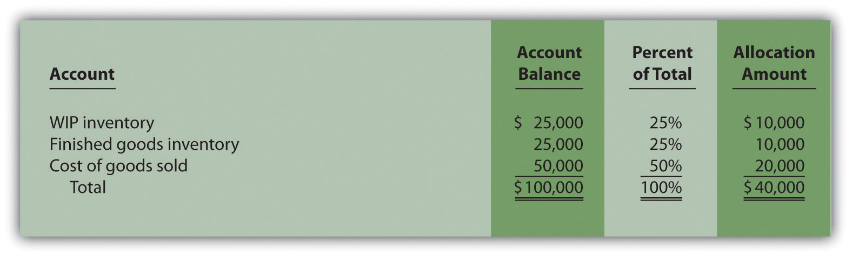

2.4 Job Costing in Service Organizations

LEARNING OBJECTIVE
- Apply job costing methods to service organizations.

Question: Although this chapter has focused on job costing in a manufacturing setting, many service organizations use job costing as well. Electricians, accountants, and auto mechanics are examples of service providers that use job costing. Electricians track costs by project (e.g., a new building or a kitchen remodel), accountants track costs by client (e.g., an individual or a corporation), and auto mechanics track costs by job (e.g., replacing a drive belt on a company truck). How does job costing work in a service company setting?

Answer: Job costing in service organizations is the same as in manufacturing organizations, except that service organizations tend to use fewer materials. There are also minor differences in the accounts that these types of organizations use, as shown in Table 2.2 "Accounts Used in Service Organizations and Manufacturing Organizations".
Table 2.2 Accounts Used in Service Organizations and Manufacturing Organizations
Manufacturing Organization Account Name | Service Organization Account Name | Financial Statement
Raw materials inventory | Parts inventory or supplies | Balance sheet (asset)
Work-in-process inventory | Work in process* | Balance sheet (asset)
Finished goods | (Not applicable) | Balance sheet (asset)
Cost of goods sold | Cost of services (or other expense accounts) | Income statement (expense)
Manufacturing overhead | Overhead (or service overhead) | None (clearing account)
*Some service companies do not use a work-in-process account but instead simply charge costs directly to expense accounts.

Service organizations use a job cost sheet like the one discussed earlier to track direct materials, direct labor, and overhead.

Direct Materials

Question: How do service organizations track direct materials using job costing?

Answer: Many service organizations do not track direct materials for each job because the cost of the materials is negligible. For example, accountants and attorneys use low-cost materials, such as binders and paper. These materials, often called supplies, are included in overhead rather than tracked by job.

Some service organizations track direct materials for each job because the cost of the materials is significant. Consider auto mechanics, who track the parts needed to perform repairs for each job, or electricians, who track the materials needed to wire a new building. Materials may be requisitioned from parts inventory or supplies, similar to raw materials inventory in a manufacturing setting, or may be purchased directly from a supplier, depending on the nature of the business. The process of recording this information in the journal and job cost sheet is exactly the same as for a manufacturing company (refer back to Figure 2.3 "Job Cost Sheet for Custom Furniture Company" for an example).

Direct Labor

Question: How do service organizations track direct labor using job costing?

Answer: Direct labor tends to be the most significant cost for service organizations. The process of tracking labor using a timesheet and recording labor costs in the journal and job cost sheet is exactly the same as for a manufacturing company (refer back to Figure 2.4 "Timesheet for Custom Furniture Company" and Figure 2.5 "Direct Labor Costs for Custom Furniture Company’s Job 50" for examples).

Overhead

Question: Like manufacturing companies, service organizations often use a predetermined overhead rate to apply overhead. What allocation bases are most commonly used by service organizations to apply overhead costs to jobs?

Answer: Because overhead is typically driven by direct labor hours in a service organization, direct labor hours or direct labor cost is the most common allocation base. Again, the process of recording this information in the journal and job cost sheet is exactly the same as for a manufacturing company (refer back to Figure 2.6 "Overhead Applied for Custom Furniture Company’s Job 50" for an example).

Business in Action 2.2
Job Costing at Movie Studios
Studios that produce costly movies, such as 20th Century Fox,Universal Studios, and Warner Brothers, incur a variety of costs that are tracked using a job costing system. For example, the production of a Harry Potter movie requires direct labor in the form of actors, directors, editors, and the film crew. The direct materials category includes costumes, extensive sets, and props. Overhead costs include items such as depreciation of film production equipment, utilities in the editing studio, and executive salaries for those overseeing the production of several films concurrently.
Determining the production costs of movies and related profitability is important for this industry since actors, directors, and others involved in the film are often compensated based on a percentage of profits. Disagreements sometimes arise between studios and actors regarding the accuracy of costs for movies, particularly in the area of overhead. Some studios have been accused of allocating too much overhead to individual films to drive down the reported profitability of each film, thereby reducing the amount owed to those receiving a portion of the profits.

KEY TAKEAWAY
- Job costing systems in service organizations are similar to those used by manufacturing companies. However, service organizations use fewer materials than manufacturing organizations, the account names they use are slightly different, and they often track costs by customer rather than by product.

REVIEW PROBLEM 2.4
Describe the similarities and differences in how service companies and manufacturing companies account for direct materials, direct labor, and overhead.
Solutions to Review Problem 2.4
The similarities and differences in how service companies and manufacturing companies account for direct materials, direct labor, and overhead are as follows:
- Direct materials. The cost of direct materials for many service companies, such as accounting and law firms, is insignificant. These companies therefore do not track direct materials for each job. However, service companies that use costly materials, such as an auto repair shop, do track direct materials for each job. Because direct materials tend to be costly for manufacturing firms, these firms typically track direct materials for each job.
- Direct labor. Because direct labor tends to be the most significant cost for service companies, these companies track costs by job using a timesheet and job cost sheet, just as manufacturing companies do.
- Overhead. Service and manufacturing firms track overhead costs in a similar way. Both often use a predetermined overhead rate to charge overhead costs to jobs. Because overhead is typically driven by direct labor hours in a service company, direct labor hours are often used as the allocation base. The process of recording overhead costs in the journal and job cost sheet is the same for both types of firms.

2.5 Chapter Wrap-Up: Summary of Cost Flows at Custom Furniture Company

LEARNING OBJECTIVE
- Use a job costing system to track costs and evaluate profitability for each job.

Question: The goal of this section is to pull it all together for Custom Furniture Company. We begin by looking at revenue and cost information for May, including manufacturing and nonmanufacturing costs. Why is it important for companies like Custom Furniture Company to correctly classify and record costs such as direct materials (e.g., wood used for each table), salaries of administrative personnel, and rent on the factory?

Answer: Companies must be able to evaluate the profitability of each job and on a broader scale, evaluate the overall profitability of the company. This requires that all manufacturing and nonmanufacturing costs be classified and recorded correctly in the general journal. The following information shows how to accomplish this with transactions for the month of May at Custom Furniture Company.

Revenue and Cost Information for Custom Furniture Company

Question: How are the typical transactions for a manufacturing company recorded in the general journal?

Answer: Figure 2.7 "Custom Furniture Company’s Journal Entries for May"shows Custom Furniture Company’s journal entries for May. Figure 2.8 "Custom Furniture Company’s T-Accounts" presents the same information in T-account format. (Note that each entry shows the total dollar amount for the month rather than individual transaction amounts.) If you understand how to make an entry summarized in total, you know how to make each individual (perhaps daily) entry. Beginning balances for raw materials inventory ($25,000), work-in-process inventory ($35,000), and finished goods inventory ($90,000) are shown in the T-accounts in Figure 2.8 "Custom Furniture Company’s T-Accounts". Although it is not necessary to refer back to Chapter 1 "What Is Managerial Accounting?" at this point, we should note that the beginning balance and transaction amounts used here for these three inventory accounts tie back to the three schedules presented in Chapter 1 "What Is Managerial Accounting?" (schedule of raw materials placed in production, schedule of cost of goods manufactured, and schedule of cost of goods sold).

Figure 2.7 Custom Furniture Company’s Journal Entries for May
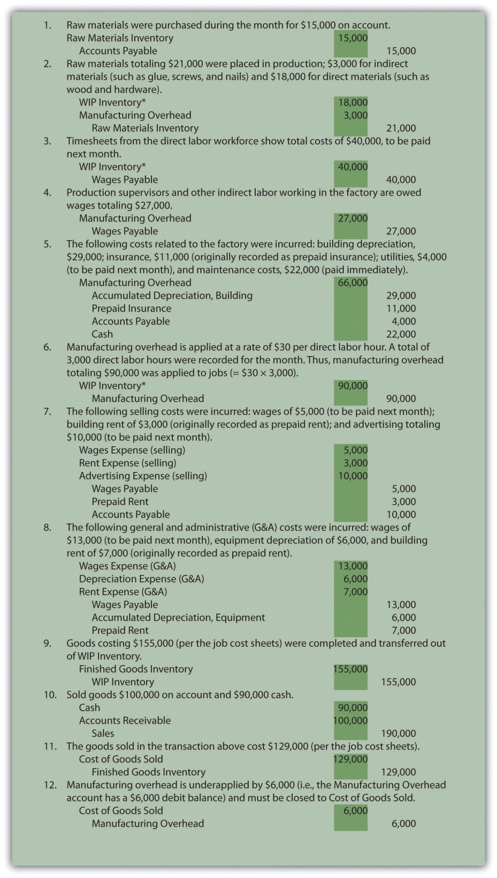
*All debit amounts to work-in-process inventory are also recorded on the appropriate job cost sheets.

Figure 2.8 Custom Furniture Company’s T-Accounts
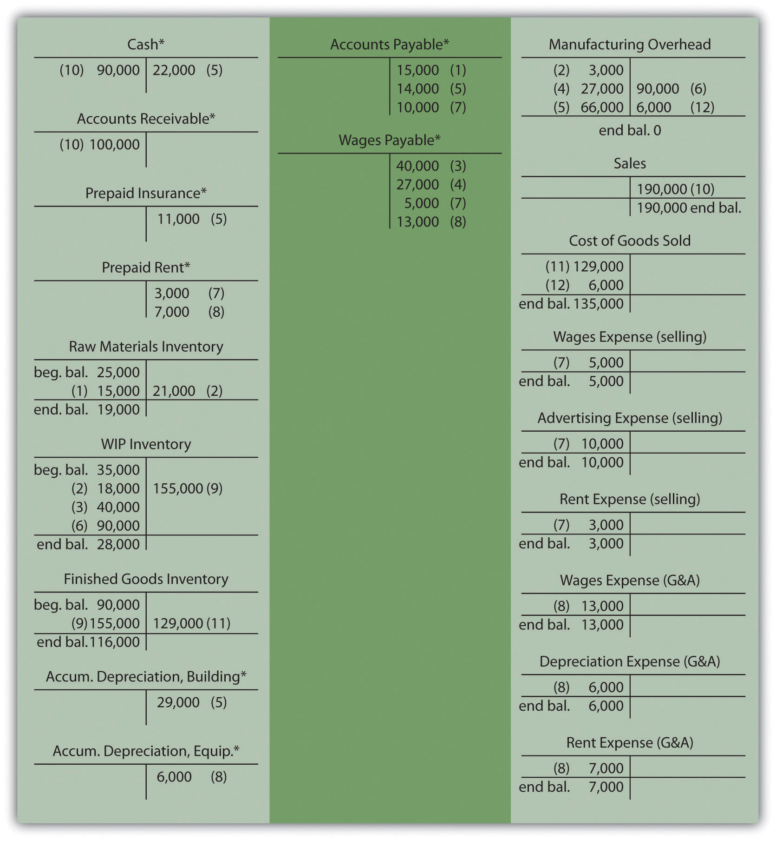
*Beginning and ending balances are only provided for inventory accounts since the focus of this chapter is on manufacturing costs that flow through the inventory accounts.

Question: Now that the information for the month of May has been recorded for Custom Furniture Company, we need to summarize this information to evaluate the profitability of the company and the profitability of jobs. How profitable was Custom Furniture for the month of May?

Answer: Custom Furniture Company’s income statement for the month of May, shown in Figure 2.9 "Custom Furniture Company’s Income Statement", indicates the company had operating profit of $11,000. This information comes directly from the T-accounts shown in Figure 2.8 "Custom Furniture Company’s T-Accounts".
Figure 2.9 Custom Furniture Company’s Income Statement
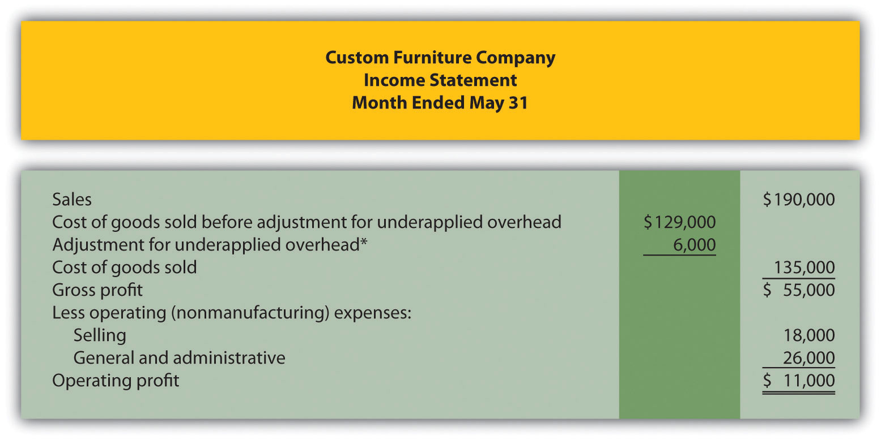
*See entry 12 in Figure 2.7 "Custom Furniture Company’s Journal Entries for May" and Figure 2.8 "Custom Furniture Company’s T-Accounts" for this adjustment. This represents the amount of overhead underapplied to jobs and closed out to cost of goods sold at the end of May. An alternative presentation is to simply show the cost of goods sold amount of $135,000 directly under sales.

Analysis of Job Profitability at Custom Furniture Company

Recall from the beginning of the chapter that Dan Stevens, the owner of Custom Furniture Company, is concerned about the company’s profitability. Although Dan prices his furniture at 70 percent above estimated production costs, the company had only $11,000 in profits for the month of May, as shown in Figure 2.9 "Custom Furniture Company’s Income Statement". Dan asked Leslie (the accountant) to look into the accuracy of his estimates by reviewing actual production costs for the three costliest tables produced in May. As you read Leslie’s comments, be sure to look at the income statement in Figure 2.9 "Custom Furniture Company’s Income Statement" and the job cost estimates and actual results in Figure 2.10 "Job Cost Estimates Versus Actual Results for Custom Furniture Company".
Figure 2.10 Job Cost Estimates Versus Actual Results for Custom Furniture Company
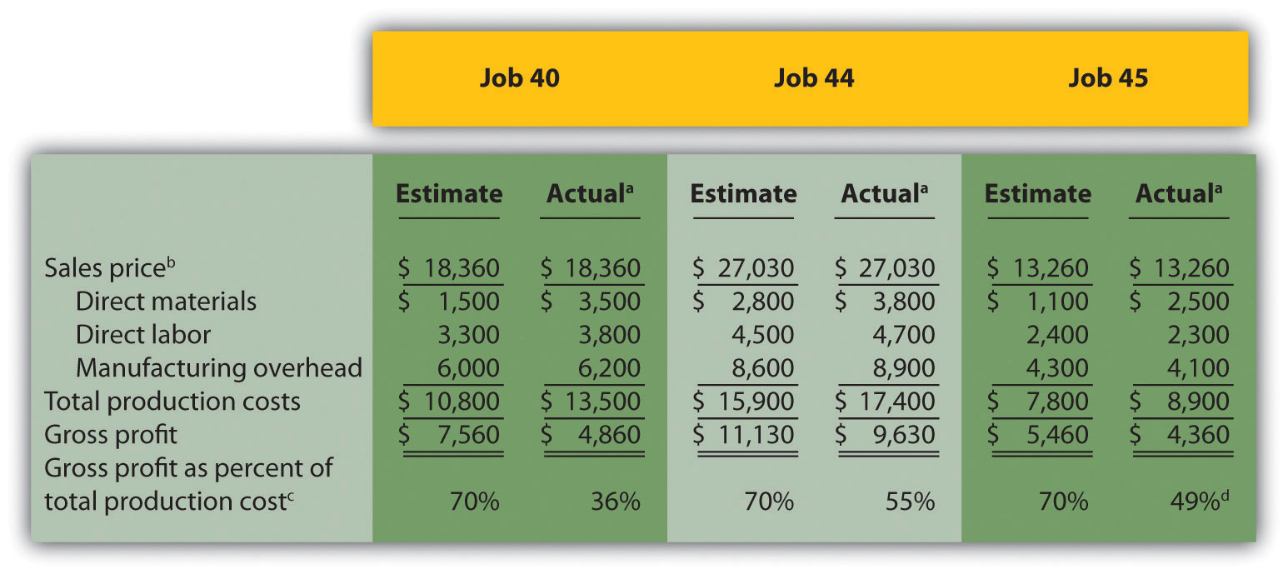
ª Product costs are from the job cost sheet, and the sales price is based on the original bid.
^{b} Based on 70 percent markup of estimated total production costs. For example, job 40’s sales price of $18,360 = $10,800 × 170 percent.
^{c} Equals gross profit divided by total production costs. Company target is 70 percent.
^{d} Rounded.
Leslie: | Dan, I have the production cost information you requested.
Dan: | Great! What did you find out?
Leslie: | Well, first I looked at the income statement for May. If you establish prices based on a 70 percent markup of production costs, then sales revenue should be 170 percent of cost of goods sold, and the resulting gross profit should be 70 percent of cost of goods sold.
Dan: | Sounds reasonable. Are we anywhere near these numbers?
Leslie: | Not really. Cost of goods sold for May total $135,000, so sales should be closer to $229,500 (that would be $135,000 times 170 percent), and gross profit should be closer to $94,500, which is $135,000 times 70 percent. As you can see on the income statement, we didn’t get very close to these numbers.
Dan: | Do you have any idea why?
Leslie: | I pulled together production cost information from our job costing system for the three highest-cost tables produced in May as you requested.
Dan: | And?
Leslie: | I compared the job cost sheet information for each item with your original estimates, and here’s what I found. It looks as if the problem is with direct materials. All three jobs show that direct material costs were significantly higher than you estimated. Direct labor and manufacturing overhead costs were pretty close.
Dan: | Wow, I’m surprised that direct material costs were so high. I’ll have to check into this further. I do recall wood costs increasing over the last couple of months, but not to this extent.
Leslie: | There are lots of potential causes for the increase in direct materials. Perhaps materials were wasted as a result of machine problems or because of inexperienced employees.
Dan: | Let’s try to nail down why my estimates are so far off so I can do a better job of estimating costs in the future.
Leslie: | Good idea—I’ll look into the direct materials costs and get back to you later this week.

Question: Figure 2.10 "Job Cost Estimates Versus Actual Results for Custom Furniture Company" provides an in depth view of the costs associated with each job and the resulting profitability. How does this information help Custom Furniture Company plan for the future?

Answer: This information helps managers assess the profitability of individual jobs. Custom Furniture Company was able to identify areas of concern by comparing information from job cost sheets with Dan’s estimates. Dan and Leslie will have to do more research to find the cause of the high material costs. If changes cannot be made to the production process to reduce these costs, Dan may have to consider revising his estimates and raising prices on future jobs. The goal is to provide enough information for the company to make informed decisions about areas of concern, such as direct materials costs, and how much to charge for future jobs.

KEY TAKEAWAYS
- Job costing systems can do more than simply track the costs of each job. Companies also use these systems to track revenue and the resulting profit for each job.
- A job costing system can be used to identify areas of concern by comparing the cost estimate prepared before starting the job with information on the completed job cost sheet. This type of analysis often leads to changes in the production process and revised estimates for future jobs.

REVIEW PROBLEM 2.5
Farm Equipment, Inc., produces tractors and other farm machinery. Each piece of equipment is built to customer specifications. During May, its first month of operations, Farm Equipment, Inc., began working on three customer orders: jobs 1, 2, and 3. The following transactions occurred during May:
- Purchased production materials on account totaling $450,000
- Processed material requisitions for the following items:
- Processed timesheets showing the following:
- Applied overhead using a predetermined rate of 160 percent of direct labor cost
- Completed job 1 and transferred it to finished goods
- Delivered job 1 to the customer and billed her $140,000. (Hint: Two entries are required—one for the cost of the goods and another for the revenue.)
Required:
- Calculate the production costs incurred in May for each of the three jobs.
- Make the appropriate journal entry for each item described previously. Assume all payments will be made next month. (Hint: UseFigure 2.7 "Custom Furniture Company’s Journal Entries for May" as a guide.)
- How much gross profit did Farm Equipment, Inc., earn from the sale of job 1?
- Assuming selling costs totaled $4,000 and general and administrative costs totaled $11,000 in May, prepare an income statement for Farm Equipment, Inc., for the month. (Assume there is no adjustment to cost of goods sold for underapplied or overapplied overhead.)
Solutions to Review Problem 2.5

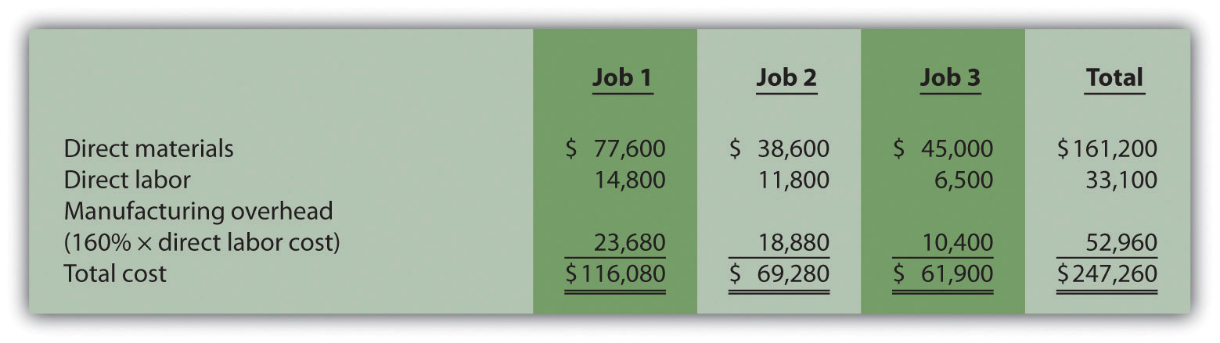

*$161,200 comes from the total for direct materials in part a.
*$33,100 comes from the total for direct labor in part a.
*$52,960 comes from the total for manufacturing overhead in part a.
- Farm Equipment, Inc., made $23,920 in gross profit from the sale of job 1 ($23,920 = $140,000 revenue – $116,080 cost).

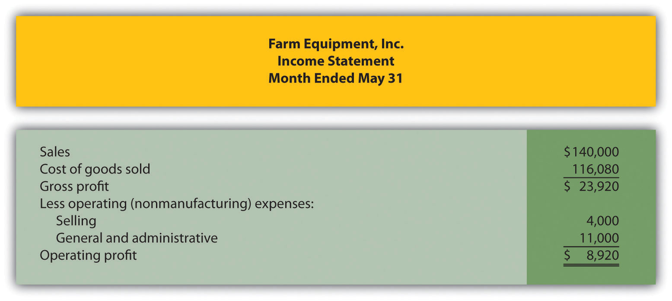

END-OF-CHAPTER EXERCISES
Questions
- Describe the characteristics of companies likely to use a job costing system. Explain how these characteristics differ from companies likely to use a process costing system.
- What information is included on the materials requisition form?
- What is the purpose of a job cost sheet? Describe the information typically included on a job cost sheet.
- What information is included on a timesheet?
- What is the purpose of using a predetermined overhead rate?
- Review Note 2.23 "Business in Action 2.1" Explain why Boeing likely uses a job costing system. How does the information that comes from a job costing system help Boeing make better decisions?
- What is a normal costing system, and why do companies tend to use a normal costing system to apply overhead to jobs rather than using actual overhead costs?
- Describe the two important factors in selecting an overhead allocation base.
- What cost information is recorded on the debit side of the manufacturing overhead account, and what information is recorded on the credit side?
- When is manufacturing overhead underapplied? When is it overapplied?
- What two options are available when closing the manufacturing overhead account at the end of the period, depending on the significance of the balance?
- How might a job costing system used by a service organization differ from a job costing system used by a manufacturing organization?
- Review Note 2.27 "Business in Action 2.2" Why is it important for movie studios to have accurate costs for each movie produced?
- How does a job costing system help a company evaluate the profitability of jobs?
Brief Exercises
- Product Costs at Custom Furniture Company. Refer to the dialogue between Dan and Leslie at Custom Furniture Company that appears at the beginning of the chapter. What is Dan concerned about, and how did Leslie propose to help?
- Job Costing Versus Process Costing. Indicate whether each of the firms listed in the following would use job costing or process costing.
  - Oil refinery
  - Builder of pools
  - Cereal producer
  - Legal firm
  - Upholstery repair shop
  - Sport drink producer
  - Toner cartridge producer
  - Landscape design firm
- Job Costing Versus Process Costing. Indicate whether each of the firms listed in the following would use job costing or process costing.
  - Custom home builder
  - Dairy farm
  - Surgical unit of hospital
  - Candy bar producer
  - Auto body repair shop
  - Producer of basketballs
  - Producer of T-shirts
  - Plumber
- Recording Purchase and Transfer of Raw Materials in T-Accounts.The following transactions occurred during the month of October:
October 5 | Raw materials totaling $15,000 were purchased on account.
October 8 | Direct materials totaling $6,000 were placed in production.
October 10 | Indirect materials totaling $1,000 were placed in production.
- Required:
  - Set up T-accounts for raw materials inventory, work-in-process inventory, manufacturing overhead, and accounts payable.
  - Use the T-accounts established in part a to record the transactions for October.
- Calculating Predetermined Overhead Rate. Manufacturing overhead costs totaling $1,000,000 are expected for this coming year. The company also expects to use 20,000 in direct labor hours. Calculate the predetermined overhead rate and provide a one-sentence description of how the rate will be used in a job costing system.
- Service Organization Accounts. Provide the account name commonly used by service companies for each of the following accounts used in a manufacturing environment.
  - Raw materials inventory
  - Work-in-process inventory
  - Finished goods inventory
  - Cost of goods sold
  - Manufacturing overhead
- Evaluating Profitability of Jobs. Refer to the job cost information inFigure 2.10 "Job Cost Estimates Versus Actual Results for Custom Furniture Company". Why is Custom Furniture Company comparing estimated product costs to actual product costs for each of the three jobs? Briefly summarize the results of this comparison.
Exercises: Set A
- Raw Materials Inventory Journal Entries. The balance in Sedona Company’s raw materials inventory account was $110,000 at the beginning of September. Raw materials purchased during the month totaled $50,000. Sedona used $17,000 in direct materials and $8,000 in indirect materials for the month.
Required:
  - Prepare separate journal entries to record the following items:
    - Raw materials purchased for the month, assuming all purchases were on account
    - The transfer of direct materials into production
    - The transfer of indirect materials into production
  - Prepare a T-account for raw materials inventory and include the beginning balance for September. Post the appropriate items from the journal entries in part a to this account, and calculate the ending balance in raw materials inventory.
- Work-in-Process Inventory Journal Entries. The balance in Reid Company’s work-in-process inventory account was $300,000 at the beginning of March. Manufacturing costs for the month are as follows:
Direct materials | $ 40,000
Direct labor | $ 70,000
Manufacturing overhead applied | $200,000
Cost of goods manufactured | $290,000
- Required:
  - Prepare separate journal entries to record the following items. (Hint: Use Figure 2.7 "Custom Furniture Company’s Journal Entries for May" as a guide.)
    - Direct materials placed in production for the month
    - Direct labor used during the month, assuming employees will be paid next month
    - Manufacturing overhead applied for the month
    - Transfer of cost of goods manufactured to finished goods
  - Prepare a T-account for Work-in-process inventory and include the beginning balance for March. Post the appropriate items from the journal entries in part a to this account, and calculate the ending balance in work-in-process inventory.
- Cost of Goods Sold Journal Entries. The balance in Blue Oak Company’s finished goods inventory account was $25,000 at the beginning of September. Cost of goods manufactured for the month totaled $17,000, and cost of goods sold totaled $14,000.
Required:
  - Prepare separate journal entries to record the following items. (Hint: Use Figure 2.7 "Custom Furniture Company’s Journal Entries for May" as a guide.)
    - Cost of goods manufactured for the month
    - Cost of goods sold for the month
  - Prepare a T-account for finished goods inventory and include the beginning balance for September. Post the appropriate items from the journal entries in part a to this account, and calculate the ending balance in finished goods inventory.
- Income Statement (with cost of goods sold adjustment). Rambler Company had the following activity for the year ended December 31.
Sales revenue | $2,050,000
Selling expenses | $ 575,000
General and administrative expenses | $ 330,000
Cost of goods sold (before adjustment) | $ 700,000
Underapplied overhead | $ 23,000
- Required:
- Prepare an income statement for year ended December 31.
- Manufacturing Overhead Allocation Base and Calculating the Cost of Jobs. Pyramid Company expects to incur $3,000,000 in manufacturing overhead costs this year. During the year, it expects to use 40,000 direct labor hours at a cost of $600,000 and 80,000 machine hours.
Required:
  - Prepare a predetermined overhead rate based on direct labor hours, direct labor cost, and machine hours.
  - Why might Pyramid Company prefer to use machine hours to allocate manufacturing overhead?
  - Using each of the predetermined overhead rates calculated in part a and the data that follows for job 128, determine the cost of job 128.
Direct materials | $6,000
Direct labor | $4,000 (200 hours at $15 per hour) + (100 hours at $10 per hour)
Machine time | 700 hours
Exercises: Set B
- Raw Materials Inventory Journal Entries. The balance in Clay Company’s raw materials inventory account was $45,000 at the beginning of April. Raw materials purchased during the month totaled $55,000. Clay used $48,000 in direct materials and $14,000 in indirect materials for the month.
Required:
  - Prepare separate journal entries to record the following items:
    - Raw materials purchased for the month, assuming all purchases were on account
    - The transfer of direct materials into production
    - The transfer of indirect materials into production
  - Prepare a T-account for raw materials inventory and include the beginning balance for April. Post the appropriate items from the journal entries in part a to this account, and calculate the ending balance in raw materials inventory.
- Work-in-Process Inventory Journal Entries. The balance in the work-in-process inventory account of Verdi Production, Inc., was $900,000 at the beginning of May. Manufacturing costs for the month are as follows:
Direct materials | $ 340,000
Direct labor | $ 810,000
Manufacturing overhead applied | $ 660,000
Cost of goods manufactured | $1,960,000
- Required:
  - Prepare separate journal entries to record the following items. (Hint: Use Figure 2.7 "Custom Furniture Company’s Journal Entries for May" as a guide.)
    - Direct materials placed in production for the month
    - Direct labor used during the month, assuming employees will be paid next month
    - Manufacturing overhead applied for the month
    - Transfer of cost of goods manufactured to finished goods
  - Prepare a T-account for work-in-process inventory and include the beginning balance for May. Post the appropriate items from the journal entries in part a to this account, and calculate the ending balance in work-in-process inventory.
- Cost of Goods Sold Journal Entries. The balance in Posada Company’s finished goods inventory account was $650,000 at the beginning of March. Cost of goods manufactured for the month totaled $445,000, and cost of goods sold totaled $470,000.
Required:
  - Prepare separate journal entries to record the following items. (Hint: Use Figure 2.7 "Custom Furniture Company’s Journal Entries for May" as a guide.)
    - Cost of goods manufactured for the month
    - Cost of goods sold for the month
  - Prepare a T-account for finished goods inventory and include the beginning balance for March. Post the appropriate items from the journal entries in part b to this account, and calculate the ending balance in finished goods inventory.
- Income Statement (with cost of goods sold adjustment). Statton Company had the following activity for the year ended December 31.
Sales revenue | $4,000,000
Selling expenses | $ 825,000
General and administrative expenses | $ 470,000
Cost of goods sold (before adjustment) | $1,900,000
Overapplied overhead | $ 109,000
- Required:
- Prepare an income statement for year ended December 31.
- Manufacturing Overhead Allocation Base and Calculating the Cost of Jobs. Elko Company expects to incur $800,000 in manufacturing overhead costs this year. During the year, it expects to use 10,000 direct labor hours at a cost of $200,000 and 4,000 machine hours.
Required:
  - Prepare a predetermined overhead rate based on direct labor hours, direct labor cost, and machine hours.
  - Why might Elko Company prefer to use direct labor hours or direct labor costs, rather than machine hours, to allocate manufacturing overhead?
  - Using each of the predetermined overhead rates for Elko Company calculated in part a and the data that follows for job 15B, determine the cost of job 15B.
Direct materials | $1,750
Direct labor | $860 (30 hours at $12 per hour) + (50 hours at $10 per hour)
Machine time | 20 hours
Problems
- Actual and Applied Manufacturing Overhead. Marine Products, Inc., incurred the following actual overhead costs for the month of June.
Indirect materials | $20,000
Indirect labor | $18,000
Rent | $ 3,000
Equipment depreciation | $ 6,500
- Overhead is applied based on a predetermined rate of $12 per machine hour, and 5,100 machine hours were used during June.
- Required:
  - Prepare a journal entry to record actual overhead costs for June. Assume that labor costs will be paid next month and that rent was prepaid.
  - Prepare a journal entry to record manufacturing overhead applied to jobs during June.
  - Create a T-account for manufacturing overhead, post the appropriate information from parts a and b to this account, and calculate the ending balance.
  - Is manufacturing overhead overapplied or underapplied? Using the balance in the manufacturing overhead account calculated in part c, prepare the journal entry to close manufacturing overhead to cost of goods sold.
- Actual and Applied Manufacturing Overhead. Quincy Company incurred the following actual overhead costs for the month of February.
Indirect materials | $335,000
Indirect labor | $275,000
Factory depreciation | $ 18,000
Factory utilities | $ 9,500
- Overhead is applied based on a predetermined rate of $2 per direct labor dollar (200 percent of direct labor cost), and direct labor costs were $300,000 for the month.
- Required:
  - Prepare a journal entry to record actual overhead costs for February. Assume indirect labor costs and utilities will be paid next month.
  - Prepare a journal entry to record manufacturing overhead applied to jobs during February.
  - Create a T-account for manufacturing overhead, post the appropriate information from parts a and b to this account, and calculate the ending balance.
  - Is manufacturing overhead overapplied or underapplied? Using the balance in the manufacturing overhead account calculated in part c, prepare the journal entry to close manufacturing overhead to cost of goods sold.
- Calculating the Cost of Jobs, Making Journal Entries, and Preparing an Income Statement. Racing Bikes, Inc., produces custom bicycles for professional racers. Each bike is built to customer specifications. During July, its first month of operations, Racing Bikes began production of four customer orders—jobs 1 through 4. The following transactions occurred during July.
  - Purchased bike parts totaling $14,400
  - Processed material requisitions for the following items:
  - Processed timesheets showing the following:
  - Applied overhead using a predetermined rate of $30 per direct labor hour
  - Completed and transferred to finished goods jobs 1, 2, and 3
  - Delivered jobs 1 and 2 to customers, billing them $6,000 for job 1 and $3,500 for job 2 (Hint: Two entries are required—one for the cost of the goods and another for the revenue.)
Required:
  - Calculate the production costs incurred in July for each of the four jobs.
  - Make the appropriate journal entry for each transaction described previously (1 through 6). Assume all payments will be made next month. (Hint: Use Figure 2.7 "Custom Furniture Company’s Journal Entries for May" as a guide.)
  - How much gross profit did Racing Bikes, Inc., earn from the sale of job 2?
  - Assume selling costs totaled $1,000 and that general and administrative costs totaled $2,200. Prepare an income statement for Racing Bikes for the month of July. (Assume there is no adjustment to cost of goods sold for underapplied or overapplied overhead.)
- Calculating the Cost of Jobs, Making Journal Entries, and Preparing an Income Statement. Classic Boats, Inc., produces custom wood boats. Each boat is built to customer specifications. During April, its first month of operations, Classic Boats began production of three customer orders—jobs 1 through 3. The following transactions occurred during April.
  - Purchased production materials totaling $225,000
  - Processed material requisitions for the following items:
  - Processed timesheets showing the following:
  - Applied overhead using a predetermined rate of 160 percent of direct labor cost
  - Completed job 1 and transferred it to finished goods
  - Delivered job 1 to the customer and billed her $70,000. (Hint: Two entries are required—one for the cost of the goods and another for the revenue.)
Required:
  - Calculate the production costs incurred in April for each of the three jobs.
  - Make the appropriate journal entry for each of the six transactions described previously. Assume all payments will be made next month. (Hint: Use Figure 2.7 "Custom Furniture Company’s Journal Entries for May" as a guide.)
  - How much gross profit did Classic Boats earn from the sale of job 1?
  - Assume selling costs totaled $2,000 and general and administrative costs totaled $5,500. Prepare an income statement for Classic Boats for the month of April. (Assume there is no adjustment to cost of goods sold for underapplied or overapplied overhead.)
- Calculating the Cost of Jobs and Making Journal Entries for a Service Company. Sampson & Associates provides accounting services. It began jobs 1 through 3 in the first week of January. The following transactions occurred that week.
  - Purchased supplies on account totaling $1,500
  - Used supplies totaling $800 for various jobs
  - Processed timesheets showing the following:
  - Applied overhead using a predetermined rate of $10 per direct labor hour.
  - Completed job 1 and billed the customer $3,000. (Hint: Two entries are required—one for the cost of services and another for revenue.)
Required:
  - Calculate the costs incurred in January for each of the three jobs.
  - Make the appropriate journal entry for each item described previously. Assume all payments will be made next month. (Hint: Use Figure 2.7 "Custom Furniture Company’s Journal Entries for May" as a guide.)
  - How much gross profit did Sampson & Associates earn from job 1?
- Calculating the Cost of Jobs and Making Journal Entries for a Service Company. Management Consulting, Inc., provides consulting services and began operations on September 1. It began jobs 1 through 4 during the first half of September. The following transactions occurred during that time.
  - Purchased supplies on account totaling $6,000
  - Used supplies totaling $3,200 for various jobs
  - Processed timesheets showing the following:
  - Applied overhead using a predetermined rate of 120 percent of direct labor cost
  - Completed jobs 1 and 2 and billed the customers $20,000 and $21,000, respectively. (Hint: Two entries are required—one for the cost of services and another for revenue.)
Required:
  - Calculate the costs incurred in September for each of the four jobs.
  - Make the appropriate journal entry for each item described previously. Assume all payments will be made next month. (Hint: Use Figure 2.7 "Custom Furniture Company’s Journal Entries for May" as a guide.)
  - How much gross profit did Management Consulting, Inc., earn from job 1 and job 2?
  - What is the amount in work in process at the end of the first half of September?
- Closing Manufacturing Overhead: Two Approaches. Olympia Company incurred actual manufacturing overhead costs of $630,000 during the year ended December 31, 2012. A total of $570,000 in overhead was applied to jobs. At December 31, 2012, work-in-process inventory totals $200,000, and finished goods inventory totals $400,000. Cost of goods sold before adjustments totals $1,400,000 for the year.
Required:
  - Is overhead underapplied or overapplied?
  - Close the manufacturing overhead account, assuming the balance is immaterial.
  - Close the manufacturing overhead account, assuming the amount is material.
- Closing Manufacturing Overhead: Two Approaches. Placer Company incurred actual manufacturing overhead costs of $260,000 during the year ended December 31, 2012. A total of $350,000 in overhead was applied to jobs. At December 31, 2012, work-in-process inventory totals $100,000, and finished goods inventory totals $300,000. Cost of goods sold before adjustments totals $600,000 for the year.
Required:
  - Is overhead underapplied or overapplied?
  - Close the manufacturing overhead account, assuming the balance is immaterial.
  - Close the manufacturing overhead account, assuming the amount is material.
One Step Further: Skill-Building Cases
- Ethics: Shifting Hours Using Job Costing. Shawney Accountancy Corporation provides accounting services. It uses a job costing system to track each client’s revenues and costs. The firm is currently working on two jobs. The first job, preparing tax returns for Bantem Corporation, was bid at $25,000 and had budgeted costs of $18,000. The second job, performing a review of internal controls for Maxum Company, was bid at 50 percent above actual costs. The following conversation took place between Kelly (a manager) and Ron (senior staff working for Kelly).
Kelly: | Ron, I just reviewed timesheets for the two jobs we’re working on, and it appears we are quickly approaching the budget of $18,000 for the Bantem job.
Ron: | Yes, we’re having trouble completing the Bantem job in the hours budgeted.
Kelly: | This is the first year on the Bantem job, and budgeting for first-year clients is always difficult.
Ron: | I’m sure we can retain this job next year with a little bump in the bid—perhaps to $29,000.
Kelly: | That’s fine for next year, but I have to answer to my boss for this year’s results. Why don’t we take some of the pressure off by charging some time from the Bantem job to the internal control project we have with Maxum Company? We’re under budget with the Maxum job, and they are paying us based on actual costs plus a 50 percent markup.
Ron: | Can we do that?
Kelly: | We don’t do it often, but in cases like this, we have to get creative.
- Required:
  - Why is there an incentive to inflate the hours charged to the Maxum job?
  - What should Ron do? (You may want to refer to the IMA’s ethical standards discussed in Chapter 1 "What Is Managerial Accounting?".)
- Internet Project: Automation and Overhead Allocation. Over the past several decades, manufacturing companies have tended to move away from direct labor and more toward automation (i.e., using machinery rather than people to produce products).
Required:
  - Use the Internet to find several examples of companies that have made the shift toward an automated production environment. Write a one-page summary of your findings, and include specific information indicating what type of automation is being used.
  - How might this shift to automation affect the allocation base used to allocate overhead to products?
- Group Project: Labor Costs at General Motors and Toyota. BothGeneral Motors (GM) and Toyota have production facilities in Texas. GM’s plant was built in 1956 on a 249-acre site and has since undergone billions of dollars in renovations. Toyota’splant was built in 2006 on 2,000 acres. Each plant has a production capacity of 200,000 vehicles per year. GM averages close to 22 assembly labor hours per vehicle (no data on labor hours per vehicle are available for Toyota). The labor cost per vehicle is $1,800 for GM, which uses a unionized labor force, and $800 for Toyota, which uses nonunion labor. (Based on Lee Hawkins Jr. and Norihiko Shirouzu, “A Tale of Two Auto Plants,” Wall Street Journal, May 24, 2006.)
Required: Form groups of two to four students and respond to the following items:
  - Provide at least two reasons for the significant difference in assembly labor cost per vehicle for GM and Toyota.
  - What other production costs should be considered in evaluating the efficiency of each plant?
Comprehensive Cases
- Journal Entries, Closing Manufacturing Overhead, and Preparing an Income Statement. Benning, Inc., is a defense contractor that uses job costing. Because the firm uses a perpetual inventory system, the three supporting schedules to the income statement (the schedule of raw materials placed in production, the schedule of cost of goods manufactured, and the schedule of cost of goods sold) are not necessary. Inventory account beginning balances at January 1, 2012, are listed as follows.
Raw materials inventory | $ 500,000
Work-in-process inventory | $ 700,000
Finished goods inventory | $1,800,000
- You will be recording the following transactions, which summarize the activities that occurred during the year ended December 31, 2012:
  - Raw materials were purchased for $300,000 on account.
  - Raw materials totaling $420,000 were placed in production, $60,000 for indirect materials and $360,000 for direct materials.
  - The raw materials purchased in transaction 1 were paid for.
  - A total cost of $800,000 for direct labor, shown on the timesheets, was recorded as wages payable.
  - Production supervisors and other indirect labor working in the factory were owed $540,000, recorded as wages payable.
  - Wages owed, totaling $1,200,000, were paid. (These wages were previously recorded correctly as wages payable.)
  - The costs listed in the following related to the factory were incurred during the period. (Hint: Record these items in one entry with one debit to manufacturing overhead and four separate credits):
Building depreciation | $580,000
Insurance (prepaid during 2012, now expired) | $220,000
Utilities (on account) | $ 80,000
Maintenance (paid cash) | $440,000
  - Manufacturing overhead was applied at a rate of $20 per machine hour, and 90,000 machine hours were utilized during the year. (Hint: No need to calculate the predetermined overhead rate since it is already given to you here.)
  - Miscellaneous selling costs totaling $430,000 were paid. These costs were recorded in an account called selling expenses.
  - Miscellaneous general and administrative costs totaling $265,000 were paid. These costs were recorded in an account called G&A expenses.
  - Goods costing $2,030,000 (per the job cost sheets) were completed and transferred out of work-in-process inventory.
  - Goods were sold on account for $3,800,000.
  - The goods sold in transaction 12 had a cost of $2,570,000 (per the job cost sheets).
  - Payments totaling $3,300,000 from credit customers related to transaction 12 were received.
Required:
  - Prepare T-accounts for raw materials inventory, work-in-process inventory, finished goods inventory, manufacturing overhead, and cost of goods sold. Enter the beginning balances for the inventory accounts. (Manufacturing overhead and cost of goods sold are temporary accounts and thus do not have a beginning balance.)
  - Prepare a journal entry for each transaction from 1through 14 in a format like the one in Figure 2.7 "Custom Furniture Company’s Journal Entries for May", and where appropriate, post each entry to the T-accounts set up in requirement a. Note that these entries reflect the flow of costs through the inventory and cost of goods sold accounts for the year. Label each entry in the T-accounts by transaction number, include a short description (e.g., direct materials and manufacturing overhead applied), and total each T-account.
  - Based on the balance in the manufacturing overhead account prepared in requirement b, prepare a journal entry to close the manufacturing overhead account to cost of goods sold.
  - Prepare an income statement for the year ended December 31, 2012. Remember to adjust cost of goods sold for any underapplied or overapplied overhead.
  - Why is cost of goods sold adjusted upward on the income statement?
- Journal Entries, Closing Manufacturing Overhead, and Preparing an Income Statement. Sierra Nursery Company grows a variety of plants and sells them to local nurseries. Raw materials consist of such items as seeds and the fertilizer required to grow plants from the seedling stage to a viable, saleable plant. Sierra Nursery uses a job costing system to track revenues and costs associated with customer orders. Because the firm uses a perpetual inventory system, the three supporting schedules to the income statement (the schedule of raw materials placed in production, the schedule of cost of goods manufactured, and the schedule of cost of goods sold) are not necessary. Inventory account beginning balances at January 1, 2012, are as follows:
Raw materials inventory | $50,000
Work-in-process inventory | $60,000
Finished goods inventory | $90,000
- You will be recording the following transactions, which summarize the activities that occurred during the year ended December 31, 2012:
  - Raw materials were purchased for $30,000 on account.
  - Raw materials totaling $41,000 were placed in production, $5,000 for indirect materials and $36,000 for direct materials.
  - The raw materials purchased in transaction 1 were paid for.
  - A total cost of $140,000 for 9,000 hours of direct labor, shown on the timesheets, was recorded as wages payable.
  - Production supervisors and other indirect labor working in the nursery were owed $134,000, recorded as wages payable.
  - Wages owed totaling $180,000 were paid. (These wages were previously recorded correctly as wages payable.)
  - The costs listed in the following related to the nursery were incurred during the period. (Hint: Record these items in one entry with one debit to manufacturing overhead and four separate credits):
Equipment depreciation | $22,000
Rent (prepaid during 2012) | $36,000
Utilities (on account) | $33,000
Maintenance (paid cash) | $19,000
  - Manufacturing overhead was applied at a rate of $30 per direct labor hour. (Hint: No need to calculate the predetermined overhead rate since it is already given to you here.)
  - Miscellaneous selling costs totaling $63,000 were paid. These costs were recorded in an account called selling expenses.
  - Miscellaneous general and administrative costs totaling $18,000 were paid. These costs were recorded in an account called G&A expenses.
  - Goods costing $478,000 (per the job cost sheets) were completed and transferred out of work-in-process inventory.
  - Goods were sold on account for $780,000.
  - The goods sold in transaction 12 had a cost of $415,000 (per the job cost sheets).
  - Payments totaling $380,000 from credit customers related to transaction 12 were received.
Required:
  - Prepare T-accounts for raw materials inventory, work-in-process inventory, finished goods inventory, manufacturing overhead, and cost of goods sold. Enter the beginning balances for the inventory accounts. (Manufacturing overhead and cost of goods sold are temporary accounts and thus do not have a beginning balance.)
  - Prepare a journal entry for each transaction from 1through 14 in a format like the one in Figure 2.7 "Custom Furniture Company’s Journal Entries for May", and where appropriate, post each entry to the T-accounts set up in requirement a. Note that these entries reflect the flow of costs through the inventory and cost of goods sold accounts for the year. Label each entry in the T-accounts by transaction number, include a short description (e.g., direct materials and manufacturing overhead applied), and total each T-account.
  - Based on the balance in the manufacturing overhead account prepared in requirement b, prepare a journal entry to close the manufacturing overhead account to cost of goods sold.
  - Prepare an income statement for the year ended December 31, 2012. Remember to adjust cost of goods sold for any underapplied or overapplied overhead.
  - Why is cost of goods sold adjusted downward on the income statement?

Chapter 3

How Does an Organization Use Activity-Based Costing to Allocate Overhead Costs?

Cindy Hall is the owner and chief executive officer of SailRite Company. SailRite builds two models of sailboats that are sold at hundreds of retail boat showrooms throughout the world. At its inception several years ago, the company produced only the Basic model, which is 12 feet long and designed for two sailors. Very few options are available for this model, and the production process is relatively simple. Because many owners of the Basic model wanted to move to a bigger, more sophisticated boat, SailRite developed the Deluxe model two years ago. The Deluxe model is 14 feet long and designed for three sailors. Many additional features are available for this model, and the production process is more complex than for the Basic model. Last year, SailRite sold 5,000 units of the Basic and 1,000 units of the Deluxe.

Although sales of both models increased last year over the year before, company profits have steadily declined. Cindy, the CEO, is concerned about this trend and discusses her concerns with John Lester, the company’s accountant; Mary McCann, the vice president of marketing; and Bob Schuler, the vice president of production.
Cindy (CEO): | Ever since we introduced the Deluxe model our profits have taken a beating. I need some input on what we should do to get this turned around.
Mary (Marketing Vice President): | I’m not sure you can blame our salespeople. We’ve asked them to push the Deluxe model because of the high profit margins, and our sales force has really responded. Sales have steadily increased over the last couple of years, and customers seem to love our sailboats.
Bob (Production Vice President): | I don’t think the problem is with our products, and using our current costing system, we make $320 in profit for each Basic model and $850 for each Deluxe model. We need to take a close look at how the cost of each boat is determined. Overhead costs have increased significantly since we started producing the Deluxe boat—to about 45 percent of total production costs—and yet we use only one overhead rate based on direct labor hours to allocate these costs. I don’t see how this can lead to an accurate cost, and I assume we set the price based on the cost of each boat.
Cindy: | We certainly considered the cost in our pricing structure. Are you telling me the cost information I have isn’t accurate?
John (Accountant): | No, the cost information you have is fine for financial reporting, but not for pricing products. When we were producing only the Basic model, overhead allocation wasn’t an issue. All overhead costs were simply assigned to the one product. Now that we have two products, overhead is allocated based on direct labor hours as Bob stated. We are required to allocate overhead for financial reporting purposes, but I wouldn’t use this cost information for internal pricing purposes.
Bob: | I can tell you that the production process for the Deluxe model is much more complicated than the one for the Basic model, so I would expect to see significantly higher costs attached to the Deluxe boat.
John: | What I’m hearing is that we need better cost information. I think it’s time we move to a more sophisticated costing system called activity-based costing. Give me time to do some research. Let’s meet next week.

This dialogue between the accountant and top management emphasizes the importance of having accurate cost information for decision-making purposes. Very few costing systems provide “perfect” product cost information. Overhead (indirect manufacturing costs) can be allocated in a number of different ways and result in a number of different costs for the same product. The goal is to find a system of allocation that best approximates the amount of overhead costs caused by each product. Sophisticated costing systems are expensive, however. Organizations like SailRite must continually ask the question: Will the benefits of having improved cost information outweigh the costs of obtaining the information?

Several options are available to allocate overhead costs. Before we discuss these options, it is important to understand why overhead costs are allocated at all.

3.1 Why Allocate Overhead Costs?

LEARNING OBJECTIVE
- Understand why organizations allocate overhead costs to products.

Question: Recall that costs for direct labor and direct materials are easily traced to products. When SailRite produces a sailboat, the direct materials include items such as fiberglass to build the hull, mast, sails, and rope. Direct labor includes the employees building the boat. Accounting for these costs is fairly simple. Indirect manufacturing costs (also called manufacturing overhead or overhead) include electricity to run the factory, rent for the factory building, and factory maintenance. These costs are not easily traced to products and pose a much more complicated challenge for SailRite. Accounting for indirect manufacturing costs typically requires allocating overhead using predetermined overhead rates. Why do managers insist on allocating overhead costs to products?

Answer: Three important reasons that managers allocate overhead costs to products are described in the following:

Provide information for decision making. Setting prices for products is one example of a decision that must be made by management. Prices are often established based on the cost of products. It is not enough to simply include direct materials and direct labor. Overhead must be considered as well.

Promote efficient use of resources. Several different activities are performed to produce a product, such as purchasing raw materials, setting up production machinery, inspecting the final product, and repairing defective products. All of these activities consume resources (consuming resources is another way of stating that a cost is associated with each of these activities). If products are charged for the use of these activities, managers will have an incentive to be efficient in utilizing the activities.

Comply with U.S. Generally Accepted Accounting Principles (U.S. GAAP). U.S. GAAP requires that all manufacturing costs—direct materials, direct labor, and overhead—be assigned to products for inventory costing purposes. This requires the allocation of overhead costs to products.

KEY TAKEAWAY
- Overhead costs are allocated to products to provide information for internal decision making, to promote the efficient use of resources, and to comply with U.S. Generally Accepted Accounting Principles.

REVIEW PROBLEM 3.1
For each scenario listed as follows, identify which of the three important reasons presented in this section best explains why managers choose to allocate overhead costs to products.
- Financial statements are prepared for the annual report that is provided to shareholders.
- Management is considering the addition of a new product line.
- The production manager decides to decrease the frequency of raw materials purchases to reduce the allocated portion of the purchasing department’s costs.
- Profits are calculated for each product so management can decide which products to promote.
- Quality control inspections are reduced to cut down on the allocated portion of the quality control department’s costs.
- Financial statements are prepared for the company’s bondholders.
- Management asks for cost information to assist in bidding for a contract.
Solutions to Review Problem 3.1
- Comply with U.S. GAAP
- Provide information for decision making
- Promote efficient use of resources
- Provide information for decision making
- Promote efficient use of resources
- Comply with U.S. GAAP
- Provide information for decision making

3.2 Approaches to Allocating Overhead Costs

LEARNING OBJECTIVE
- Compare and contrast allocating overhead costs using a plantwide rate, department rates, and activity-based costing.

Question: Managers at companies such as Hewlett-Packard often look for better ways to figure out the cost of their products. When Hewlett-Packardproduces printers, the company has three possible methods that can be used to allocate overhead costs to products—plantwide allocation, department allocation, and activity-based allocation (called activity-based costing). How do managers decide which allocation method to use?

Answer: The choice of an allocation method depends on how managers decide to group overhead costs and the desired accuracy of product cost information. Groups of overhead costs are called cost pools. For example,Hewlett Packard’s printer production division may choose to collect all factory overhead costs in one cost pool and allocate those costs from the cost pool to each product using one predetermined overhead rate. Or Hewlett Packard may choose to have several cost pools (perhaps for each department, such as assembly, packaging, and quality control) and allocate overhead costs from each department cost pool to products using a separate predetermined overhead rate for each department. In general, the more cost pools used, the more accurate the allocation process.

Plantwide Allocation

Question: Let’s look at SailRite Company, which was presented at the beginning of the chapter. The managers at SailRite like the idea of using the plantwide allocation method to allocate overhead to the two sailboat models produced by the company. How would SailRite implement the plantwide allocation method?

Answer: The plantwide allocation method uses one predetermined overhead rate to allocate overhead costs. [1] One cost pool accounts for all overhead costs, and therefore one predetermined overhead rate is used to apply overhead costs to products. You learned about this approach inChapter 2 "How Is Job Costing Used to Track Production Costs?" where one predetermined rate—typically based on direct labor hours, direct labor costs, or machine hours—was used to allocate overhead costs. (Remember, the focus here is on the allocation of overhead costs. Direct materials and direct labor are easily traced to the product and therefore are not a part of the overhead allocation process.)

Using SailRite Company as an example, assume annual overhead costs are estimated to be $8,000,000 and direct labor hours are used for the plantwide allocation base. Management estimates that a total of 250,000 direct labor hours are worked annually. These estimates are based on the previous year’s overhead costs and direct labor hours and are adjusted for expected increases in demand the coming year. The predetermined overhead rate is $32 per direct labor hour (= $8,000,000 ÷ 250,000 direct labor hours). Thus, as shown in Figure 3.1 "Using One Plantwide Rate to Allocate SailRite Company’s Overhead", products are charged $32 in overhead costs for each direct labor hour worked.

Figure 3.1 Using One Plantwide Rate to Allocate SailRite Company’s Overhead
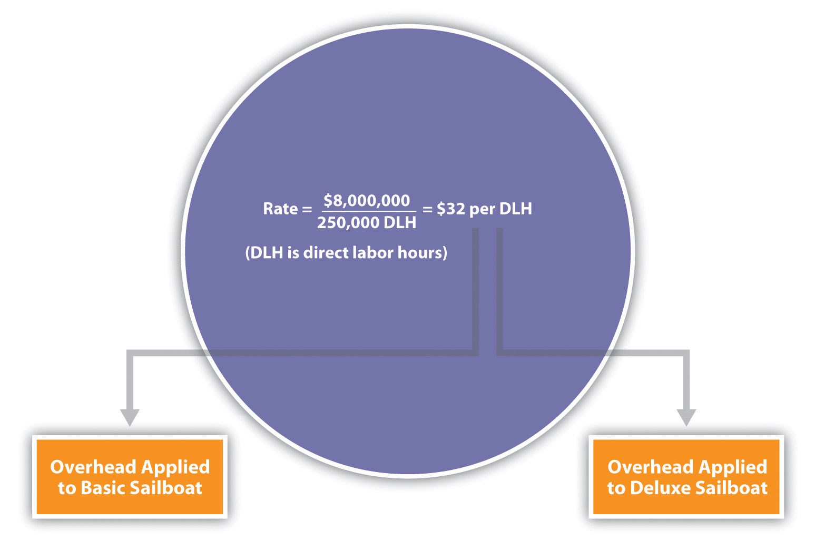

Product Costs Using the Plantwide Allocation Approach at SailRite

Question: Assume SailRite uses one plantwide rate to allocate overhead based on direct labor hours. What is SailRite’s product cost per unit and resulting profit using the plantwide approach to allocate overhead?

Answer: The calculation of a product’s cost involves three components—direct materials, direct labor, and manufacturing overhead. Assume direct materials cost $1,000 for one unit of the Basic sailboat and $1,300 for the Deluxe. Direct labor costs are $600 for one unit of the Basic sailboat and $750 for the Deluxe. This information, combined with the overhead cost per unit, gives us what we need to determine the product cost per unit for each model.

Given the predetermined overhead rate of $32 per direct labor hour calculated in the previous section, and assuming it takes 40 hours of direct labor to build one Basic sailboat and 50 hours to build one Deluxe sailboat, we can calculate the manufacturing overhead cost per unit. Manufacturing overhead cost per unit is $1,280 (= $32 × 40 direct labor hours) for the Basic boat and $1,600 (= $32 × 50 direct labor hours) for the Deluxe boat. Combine the manufacturing overhead with direct materials and direct labor, as shown in Figure 3.2 "SailRite Company Product Costs Using One Plantwide Rate Based on Direct Labor Hours", and we are able to calculate the product cost per unit.
Figure 3.2 SailRite Company Product Costs Using One Plantwide Rate Based on Direct Labor Hours
*$1,280 = 40 direct labor hours per unit × $32 rate.
**$1,600 = 50 direct labor hours per unit × $32 rate.

The average sales price is $3,200 for the Basic model and $4,500 for the Deluxe. Using the product cost information in Figure 3.2 "SailRite Company Product Costs Using One Plantwide Rate Based on Direct Labor Hours", the profit per unit is $320 (= $3,200 price – $2,880 cost) for the Basic model and $850 (= $4,500 price – $3,650 cost) for the Deluxe. Recall from the opening dialogue that SailRite’s overall profit has declined ever since it introduced the Deluxe model even though the data shows both products are profitable.
Question: The managers at SailRite like the idea of using the plantwide allocation approach, but they are concerned that this approach will not provide accurate product cost information. Although the plantwide allocation method is the simplest and least expensive approach, it also tends to be the least accurate.In spite of this weakness, why do some organizations prefer to use one plantwide overhead rate to allocate overhead to products?

Answer: Organizations that use a plantwide allocation approach typically have simple operations with a few similar products. Management may not want more accurate product cost information or may not have the resources to implement a more complex accounting system. As we move on to more complex costing systems, remember that these systems are more expensive to implement. Thus the benefits of having improved cost information must outweigh the costs of obtaining the information.

Department Allocation

Question: Assume the managers at SailRite Company prefer a more accurate approach to allocating overhead costs to its two products. As a result, they are considering using the department allocation approach. How would SailRite form cost pools for the department allocation approach?

Answer: The department allocation approach is similar to the plantwide approach except that cost pools are formed for each department rather than for the entire plant, and a separate predetermined overhead rate is established for each department. Remember, total estimated overhead costs will not change. Instead, they will be broken out into various department cost pools. This approach allows for the use of different allocation bases for different departments depending on what drives overhead costs for each department. For example, the Hull Fabrication department at SailRite Company may find that overhead costs are driven more by the use of machinery than by labor, and therefore decides to use machine hours as the allocation base. The Assembly department may find that overhead costs are driven more by labor activity than by machine use and therefore decides to use labor hours or labor costs as the allocation base.

Assume that SailRite is considering using the department approach rather than the plantwide approach for allocating overhead. The cost pool in the Hull Fabrication department is estimated to be $3,000,000 for the year, and the cost pool in the Assembly department is estimated at $5,000,000. Note that total estimated overhead cost is still $8,000,000 (= $3,000,000 + $5,000,000). Machine hours (estimated at 60,000 hours) will be used as the allocation base for Hull Fabrication, and direct labor hours (estimated at 217,000 hours) will be used as the allocation base for Assembly. Thus two rates are used to allocate overhead (rounded to the nearest dollar) as follows:
- Hull Fabrication department rate: $50 per machine hour (= $3,000,000 ÷ 60,000 hours)
- Assembly department rate: $23 per direct labor hour (= $5,000,000 ÷ 217,000 hours)

As shown in Figure 3.3 "Using Department Rates to Allocate SailRite Company’s Overhead", products going through the Hull Fabrication department are charged $50 in overhead costs for each machine hour used. Products going through the Assembly department are charged $23 in overhead costs for each direct labor hour used.
Figure 3.3 Using Department Rates to Allocate SailRite Company’s Overhead
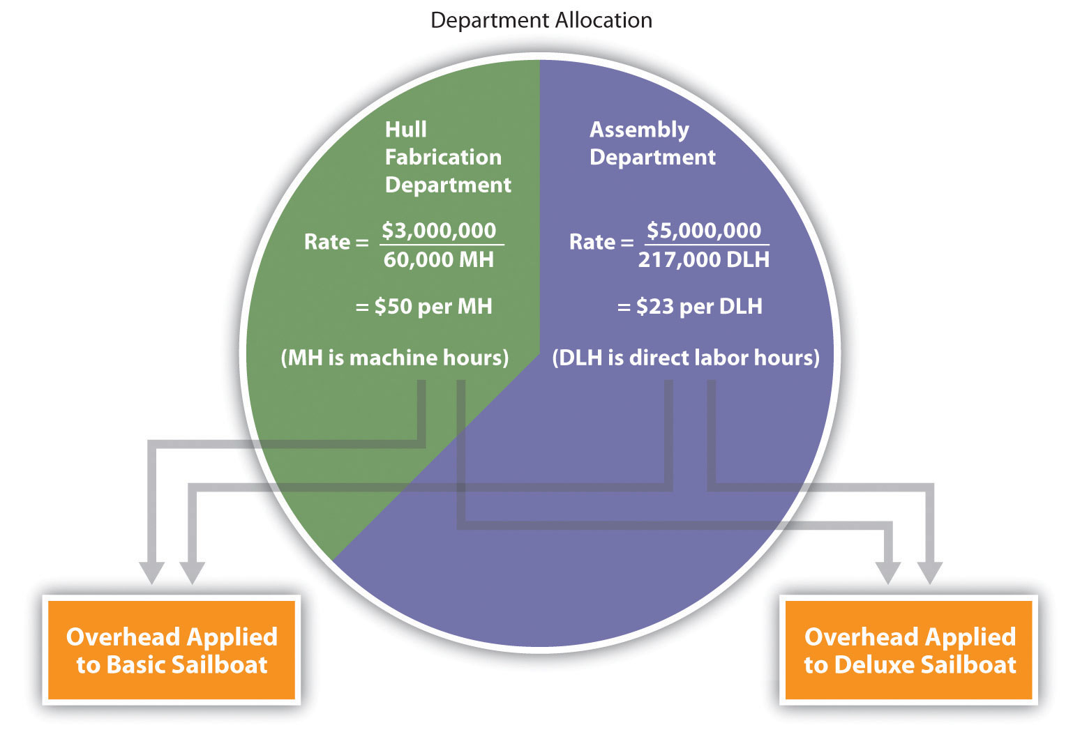

The department allocation approach allows cost pools to be formed for each department and provides for flexibility in the selection of an allocation base. Although Figure 3.3 "Using Department Rates to Allocate SailRite Company’s Overhead" shows just two rates, many companies have more than two departments and therefore more than two rates. Organizations that use this approach tend to have simple operations within each department but different activities across departments. One department may use machinery, while another department may use labor, as is the case with SailRite’s two departments. This approach typically provides more accurate cost information than simply using one plantwide rate but still relies on the assumption that overhead costs are driven by direct labor hours, direct labor costs, or machine hours. This assumption of a causal relationship is increasingly less realistic as production processes become more complex.

The plantwide and department allocation methods are “traditional” approaches because both typically use direct labor hours, direct labor costs, or machine hours as the allocation base, and both were used prior to the creation of activity-based costing in the 1980s.

KEY TAKEAWAY
- Regardless of the approach used to allocate overhead, a predetermined overhead rate is established for each cost pool. The plantwide allocation approach uses one cost pool to collect and apply overhead costs and therefore uses one predetermined overhead rate for the entire company. The department allocation approach uses several cost pools (one for each department) and therefore uses several predetermined overhead rates.

REVIEW PROBLEM 3.2
Kline Company expects to incur $800,000 in overhead costs this coming year—$200,000 in the Cut and Polish department and $600,000 in the Quality Control department. Total annual direct labor costs are expected to be $160,000. The Cut and Polish department expects to use 25,000 machine hours, and the Quality Control department plans to utilize 50,000 hours of direct labor time for the year.
Required:
- Assume Kline Company allocates overhead costs with the plantwide approach, and direct labor cost is the allocation base. Calculate the rate used by the company to allocate overhead costs.
- Assume Kline Company allocates overhead costs with the department approach. Calculate the rate used by each department to allocate overhead costs.
Solutions to Review Problem 3.2
- The plantwide rate is calculated as follows:
Predetermined overhead rate=Estimated overhead costsEstimated activity in allocation base=$800,000$160,000=$5 per $1 in direct labor cost (or 500 percent of direct labor cost)
- The department rates are calculated using the same formula as the plantwide rate. However, overhead costs and activity levels are estimated for each department rather than for the entire company, and two separate rates are calculated:
Cut and Polish department=$200,00025,000 machine hours=$8 per machine hour
Quality Control department=$600,00050,000 direct labor hours=$12 per direct labor hour
[1] Regardless of the approach used to allocate overhead, a predetermined overhead rate is established for each cost pool. The predetermined overhead rate is calculated as follows (from Chapter 2 "How Is Job Costing Used to Track Production Costs?"):

Predetermined overhead rate=Estimated overhead costsEstimated activity in allocation base

When activity-based costing is used, the denominator can also be called estimated cost driver activity.

3.3 Using Activity-Based Costing to Allocate Overhead Costs

LEARNING OBJECTIVE
- Understand how to use the five steps of activity-based costing to determine product costs.

Question: Suppose the managers at SailRite Company decide that the benefits of implementing an activity-based costing system would exceed the cost, and thus the company should use activity-based costing to allocate overhead. What are the five steps of activity-based costing, and how would this method work for SailRite?

Answer: Activity-based costing (ABC) uses several cost pools, organized by activity, to allocate overhead costs. (Remember that plantwide allocation uses one cost pool for the whole plant, and department allocation uses one cost pool for each department.) The idea is that activities are required to produce products—activities such as purchasing materials, setting up machinery, assembling products, and inspecting finished products. These activities can be costly. Thus the cost of activities should be allocated to products based on the products’ use of the activities.

ABC in Action at SailRite Company

Five steps are required to implement activity-based costing. As you work through the example for SailRite Company, once again note that total estimated overhead costs remain at $8,000,000. However, the total is broken out into different activities rather than departments, and an overhead rate is established for each activity. The five steps are as follows:

Step 1. Identify costly activities required to complete products.

An activity is any process or procedure that consumes overhead resources. The goal is to understand all the activities required to make the company’s products. This requires interviewing and meeting with personnel throughout the organization. Companies that use activity-based costing, such as Hewlett Packard and IBM, may identify hundreds of activities required to make their products. The most challenging part of this step is narrowing down the activities to those that have the biggest impact on overhead costs.

After meeting with personnel throughout the company, SailRite’s accountant identified the following activities as having the biggest impact on overhead costs:
- Purchasing materials
- Setting up machines
- Running machines
- Assembling products
- Inspecting finished products
Step 2. Assign overhead costs to the activities identified in step 1.

This step requires that overhead costs associated with each activity be assigned to the activity (i.e., a cost pool is formed for each activity). For SailRite, the cost pool for the purchasing materials activity will include costs for items such as salaries of purchasing personnel, rent for purchasing department office space, and depreciation of purchasing office equipment.

The accountant at SailRite developed the following allocations after careful review of all overhead costs (remember, these are overhead costs, not direct materials or direct labor costs):
*We should note that this is not the direct labor cost. Instead, this represents overhead costs associated with assembling products, such as supplies and the factory space being used for assembly.

At this point, we have identified the most important and costly activities required to make products, and we have assigned overhead costs to each of these activities. The next step is to find an allocation base that drives the cost of each activity.

Step 3. Identify the cost driver for each activity.

A cost driver is the action that causes (or “drives”) the costs associated with the activity. Identifying cost drivers requires gathering information and interviewing key personnel in various areas of the organization, such as purchasing, production, quality control, and accounting. After careful scrutiny of the process required for each activity, SailRite established the following cost drivers:
Activity | Cost Driver | Estimated Annual Cost Driver Activity
Purchasing materials | Purchase requisitions | 10,000 requisitions
Setting up machines | Machine setups | 2,000 setups
Running machines | Machine hours | 90,000 hours
Assembling products | Direct labor hours | 250,000 hours
Inspecting finished products | Inspection hours | 20,000 hours

Notice that this information includes an estimate of the level of activity for each cost driver, which is needed to calculate a predetermined rate for each activity in step 4.

Step 4. Calculate a predetermined overhead rate for each activity.

This is done by dividing the estimated overhead costs (from step 2) by the estimated level of cost driver activity (from step 3). provides the overhead rate calculations for SailRite Company based on the information shown in the previous three steps. It shows that products will be charged $120 in overhead costs for each purchase requisition processed, $800 for each machine setup, $30 for each machine hour used, $6 for each direct labor hour worked, and $50 for each hour of inspection time.
Figure 3.4 Predetermined Overhead Rates for SailRite Company
]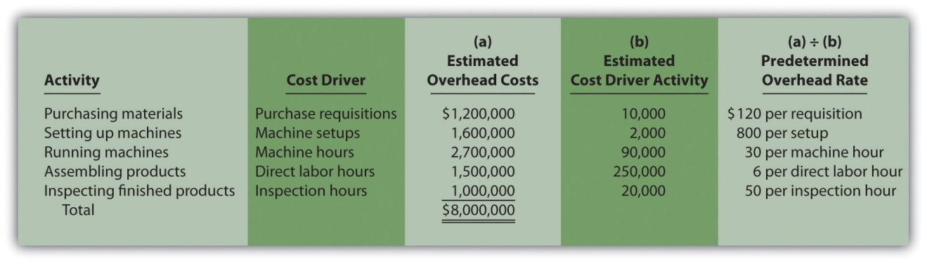

Step 5. Allocate overhead costs to products.

Overhead costs are allocated to products by multiplying the predetermined overhead rate for each activity (calculated in step 4) by the level of cost driver activity used by the product. The term applied overhead is often used to describe this process.

Assume the following annual cost driver activity takes place at SailRite for the Basic and Deluxe sailboats: [1]
Activity | Basic Sailboat | Deluxe Sailboat | Total
Purchasing materials | 7,000 requisitions | 3,000 requisitions | 10,000 requisitions
Setting up machines | 1,100 setups | 900 setups | 2,000 setups
Running machines | 50,000 hours | 40,000 hours | 90,000 machine hours
Assembling products | 200,000 hours | 50,000 hours | 250,000 direct labor hours
Inspecting finished products | 12,000 hours | 8,000 hours | 20,000 inspection hours

shows the allocation of overhead using the cost driver activity just presented and the overhead rates calculated in . Notice that allocated overhead costs total $8,000,000. This is the same cost figure used for the plantwide and department allocation methods we discussed earlier. Activity-based costing simply provides a more refined way to allocate the same overhead costs to products.
Figure 3.5 Allocation of Overhead Costs to Products at SailRite Company
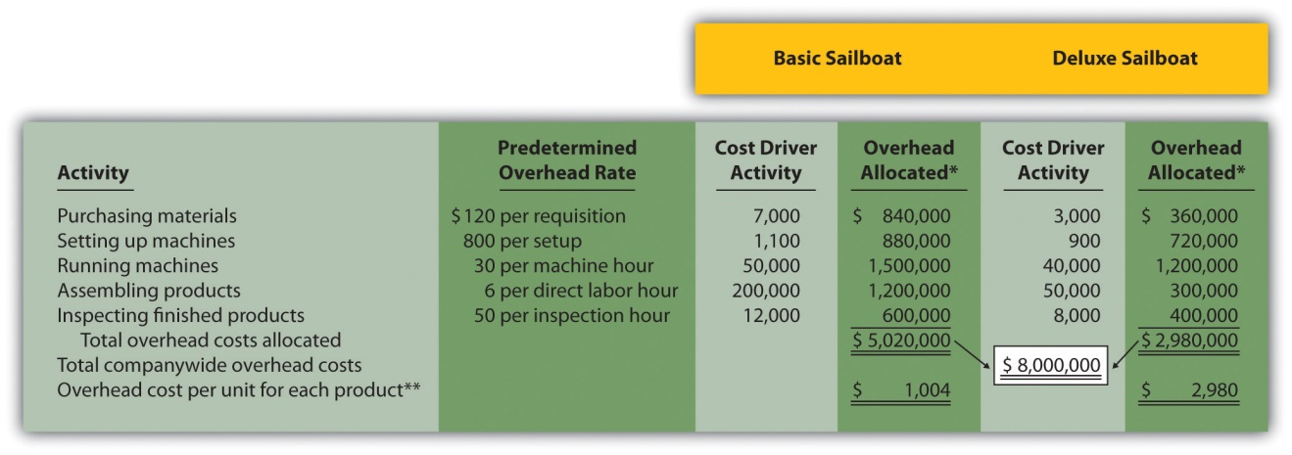
*Overhead allocated equals the predetermined overhead rate times the cost driver activity.
**Overhead cost per unit for the Basic model equals $5,020,000 (overhead allocated) ÷ 5,000 units produced, and for the Deluxe model, it equals $2,980,000 ÷ 1,000 units produced.

The bottom of shows the overhead cost per unit for each product assuming SailRite produces 5,000 units of the Basic sailboat and 1,000 units of the Deluxe sailboat. This information is needed to calculate the product cost for each unit of product, which we discuss next.

Product Costs Using the Activity-Based Costing Approach at SailRite

Question: As shown in , SailRite knows the overhead cost per unit using activity-based costing is $1,004 for the Basic model and $2,980 for the Deluxe.Now that SailRite has the overhead cost per unit, how will the company find the total product cost per unit and resulting profit?

Answer: Recall from our discussion earlier that the calculation of a product’s cost involves three components—direct materials, direct labor, and manufacturing overhead. Assume direct materials cost $1,000 for the Basic sailboat and $1,300 for the Deluxe. Direct labor costs are $600 for the Basic sailboat and $750 for the Deluxe. This information, combined with the overhead cost per unit calculated at the bottom of , gives us what we need to determine the product cost per unit for each model, which is presented in . The average sales price is $3,200 for the Basic model and $4,500 for the Deluxe. Using the product cost information in , the Basic model yields a profit of $596 (= $3,200 price – $2,604 cost) per unit and the Deluxe model yields a loss of $530 (= $4,500 price – $5,030 cost) per unit.
Figure 3.6 SailRite Company Product Costs Using Activity-Based Costing

As you can see, overhead is a significant component of total product costs. This explains the need for a refined overhead allocation system such as activity-based costing.

Comparison of ABC to Plantwide Costing at SailRite

After going through the process of allocating overhead using activity-based costing, John Lester (the company accountant) called a meeting with the same management group introduced at the beginning of the chapter: Cindy Hall (CEO), Mary McCann (vice president of marketing), and Bob Schuler (vice president of production). As you read the following dialogue, refer to , which summarizes John’s findings.
Cindy: | What do you have for us, John?
John: | I think you’ll find the results of our most recent costing analysis very interesting. We used an approach called activity-based costing to allocate overhead to products.
Bob: | I recall being interviewed last week about the activities involved in the production process.
John: | Yes, here’s what we found. The old allocation approach indicates that the Basic boat costs $2,880 to build and the Deluxe boat costs $3,650 to build. Our average sales price for the Basic is $3,200 and $4,500 for the Deluxe. You can see why we pushed sales of the Deluxe boat—it has a profit of $850 per boat.
Cindy: | John, from your analysis, it looks as if we were wrong about the Deluxe boat being the most profitable.
John: | We do have some startling results. Using activity-based costing, an approach I think is much more accurate, the Deluxe boat is not profitable at all. In fact, we lose $530 for each Deluxe boat sold, and the profits from the Basic boat are much higher than we thought at $596 per unit.
Cindy: | I see direct materials and direct labor are the same no matter which costing system we use. Why is there such a large variation in overhead costs?
John: | Good question! When we used our old approach of one plantwide rate based on direct labor hours, the Deluxe process consumed 20 percent of all direct labor hours worked—that is, 50,000 Deluxe hours divided by 250,000 total hours. Therefore the Deluxe model was allocated 20 percent of all overhead costs. Using activity-based costing, we identified five key activities and assigned overhead costs based on the use of these activities. The Deluxe process consumed more than 20 percent of the resources provided for every activity. For example, running machines is one of the most costly activities, and the Deluxe model used about 44 percent of the resources provided by this activity. This is significantly higher than the 20 percent allocated using direct labor hours under the old approach.
Bob: | This certainly makes sense! Each Deluxe boat takes a whole lot more machine hours to produce than the Basic boat.
Cindy: | Thanks for this analysis, John. Now we know why company profits have been declining even though sales have increased. Either the Deluxe sales price must go up or costs must go down—or a combination of both!
Figure 3.7 Activity-Based Costing Versus Plantwide Costing at SailRite Company
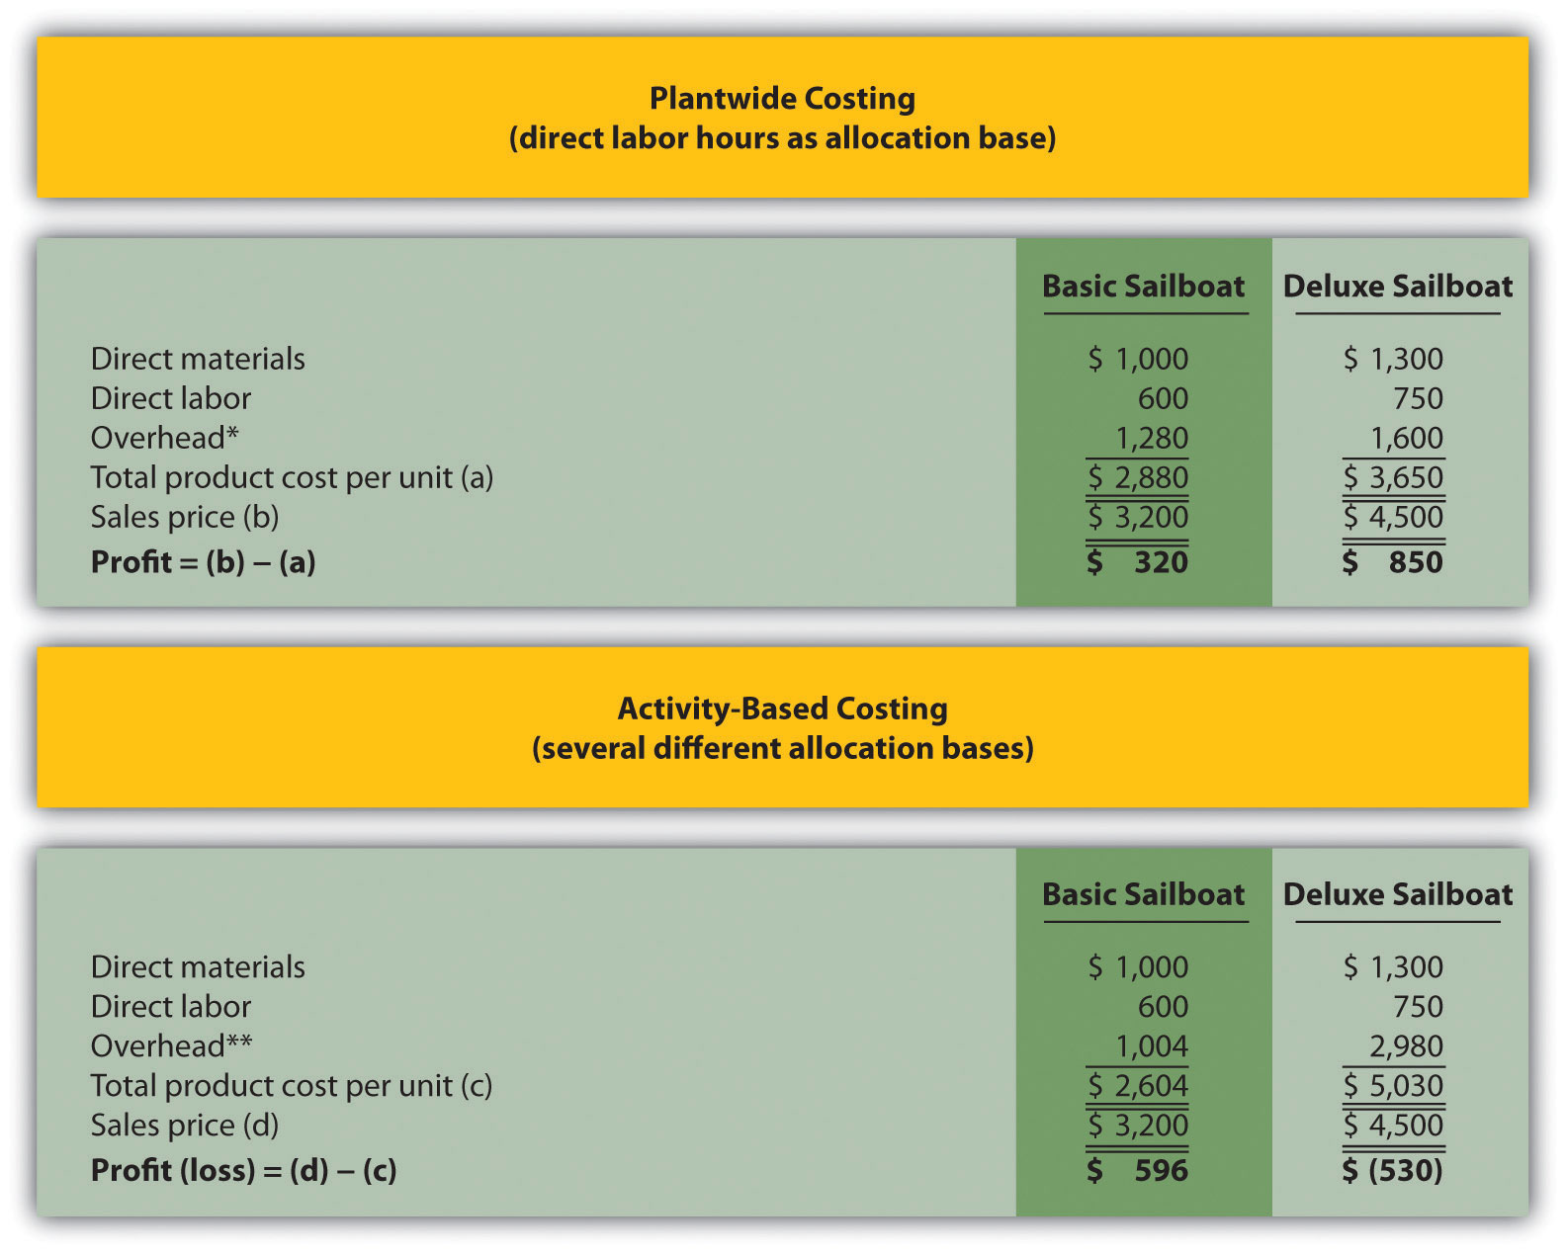
*From .
**From .

Question: SailRite has more accurate product cost information using activity-based costing to allocate overhead. Why is the overhead cost per unit so different using activity-based costing?

Answer: provides a more thorough look at how the Deluxe product consumes a significant share of overhead resources—much higher than the 20 percent that was being allocated based on direct labor hours. Let’s look at in detail:
- The ABC column represents overhead costs allocated using the activity-based costing shown back in .
- The DLH (direct labor hours) column represents overhead costs allocated using direct labor hours as the allocation base where 80 percent was allocated to the Basic boat (= 200,000 hours ÷ 250,000 total hours) and 20 percent allocated to the Deluxe boat (= 50,000 hours ÷ 250,000 total hours).
- The Diff. (difference) column shows the difference between one allocation method and the other. Notice the shift in the allocation of overhead costs using activity-based costing. A total of $1,380,000 in overhead costs shifts to the Deluxe sailboat, which amounts to $1,380 per boat (= $1,380,000 ÷ 1,000 boats).
Figure 3.8 Detailed Analysis of Overhead Allocations at SailRite Company
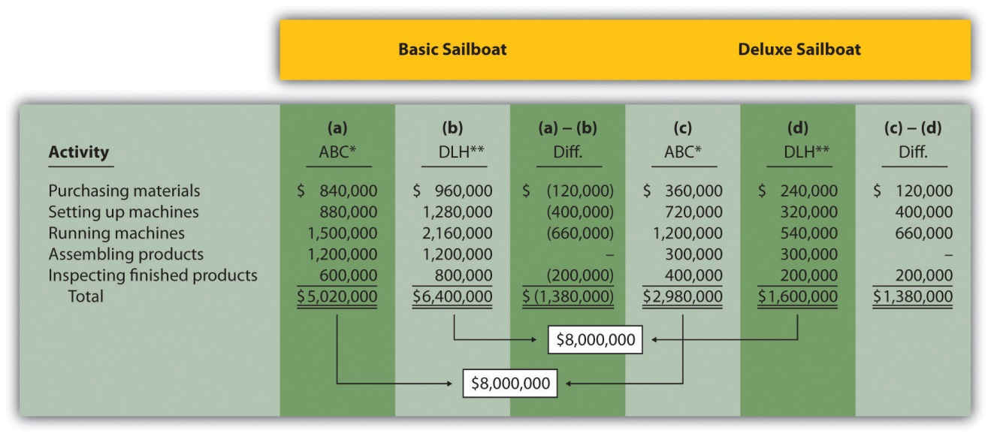
*Amounts in this column come from .
**Amounts in this column are calculated by multiplying 80 percent for the Basic boat (20 percent for the Deluxe) by the total overhead cost for the activity. For example, the total overhead cost for purchasing materials is $1,200,000 (see ) and $1,200,000 × 80 percent = $960,000. Using the plantwide approach (one plantwide rate based on direct labor hours), $960,000 is the amount allocated to the Basic sailboat for this activity, and $240,000 is the amount allocated to the Deluxe boat.

The primary reason that using activity-based costing shifted overhead costs to the Deluxe sailboat is that producing each Deluxe boat requires more resources than the Basic boat. For example, the Basic boat requires 50,000 machine hours to produce 5,000 boats, and the Deluxe boat requires 40,000 machine hours to produce 1,000 boats. The number of machine hours required per boat produced is as follows:

You can see from this analysis that the Deluxe boat consumes four times the machine hours of the Basic boat. At a rate of $30 per machine hour, the Deluxe boat is assigned $1,200 per boat for this activity ($30 rate × 40 machine hours) while the Basic boat is assigned $300 per boat ($30 rate × 10 machine hours).

Advantages and Disadvantages of ABC

Question: Activity-based costing undoubtedly provides better cost information than most traditional costing methods, such as plantwide and department allocation methods. However, ABC has its limitations. What are the advantages and disadvantages of using activity-based costing?

Answer: The advantages and disadvantages of ABC are as follows:

Advantages

More accurate cost information leads to better decisions. The cost information provided by ABC is generally regarded as more accurate than the information provided by most traditional costing methods. This allows management to make better decisions in areas such as product pricing, product line changes (adding products or eliminating products), and product mix decisions (how much of each product to produce and sell).

Increased knowledge of production activities leads to process improvements and reduced costs. ABC requires identifying the activities involved in the production process (step 1) and assigning costs to these activities (step 2). This provides management with a better view of the detailed activities involved (purchasing materials, machine setups, inspections, and so forth) and the cost of each activity. Managers are more likely to focus on improving efficiency in the most costly activities, thereby reducing costs.

Disadvantages

ABC systems can be costly to implement. ABC systems require teamwork across the organization and therefore require employees to take time out from their day-to-day activities to assist in the ABC process (e.g., to identify costly activities). Assigning costs to activities takes time, as does identifying and tracking cost drivers. And assigning costs to products requires a significant amount of time in the accounting department. Imagine having 15 cost pools (activities), each with a predetermined overhead rate used to assign overhead costs to the company’s 80 products—not an unrealistic example for a large company. The accounting costs incurred to maintain such a system can be prohibitively high.

Unitizing fixed costs can be misleading. Product costing involves allocating costs from activity centers to products and calculating a product cost per unit. The problem with this approach is that fixed costs are often a large part of the overhead costs being allocated (e.g., building and machinery depreciation and supervisor salaries). Recall that fixed costs are costs that do not change in total with changes in activity.

Looking back to the SailRite example using activity-based costing, the Deluxe sailboat cost $5,030 per unit to produce based on production of 1,000 units (as shown in ). If SailRite produces 2,000 units of the Deluxe boat, will the unit cost remain at $5,030? Probably not. A significant portion of overhead costs are fixed and will be spread out over more units, thereby reducing the cost per unit. We address this issue at length in later chapters. The point here is that managers must beware of using per unit cost information blindly for decision making, particularly if a significant change in the level of production is anticipated.

The benefits may not outweigh the costs. Companies with one or two products that require very little variation in production may not benefit from an ABC system. Suppose a company produces one product. The overhead costs can be divided into as many cost pools as you like, but all overhead costs will still be assigned to the one product. (We should mention, however, that management would benefit from understanding the activities involved in the process and the costs associated with each activity. It’s the allocation to the one product—steps 4 and 5 of ABC—that would provide little useful information in this scenario.)

Companies that produce several different products may believe that the benefits of implementing ABC will outweigh the costs. However, management must be willing to use the ABC information to benefit the company. Companies like Chrysler Group LLC have been known to try ABC, only to meet resistance from their managers. Until managers are willing to use the ABC information to make improvements in the organization, there is no point in implementing such a system.

Business in Action 3.1
Characteristics of Companies That Use Activity-Based Costing
A survey of 130 U.S. manufacturing companies yielded some interesting results. The companies that used activity-based costing (ABC) had higher overhead costs as a percent of total product costs than companies that used traditional costing. Those using ABC also had a higher level of automation. The complexity of production processes and products tended to be higher for those using ABC, and ABC companies operated at capacity more frequently.
It is important to note that the differences between companies using ABC and companies using traditional costing systems in all these areas—overhead costs, automation, complexity of production, and frequency of capacity—were relatively small. However, users of ABC indicated their systems were more adequate than traditional systems in providing useful information for performance evaluation and cost reduction.
Source: Susan B. Hughes and Kathy A. Paulson Gjerde, “Do Different Cost Systems Make a Difference?” Management Accounting Quarterly, Fall 2003.

ABC Cost Flows

Question: How are overhead costs recorded when using activity-based costing?

Answer: We presented the flow of costs for a job costing system in , including how to track actual overhead costs and how to track overhead applied using a separate manufacturing overhead account. The cost flows are the same for an activity-based costing system, with one exception. Instead of using one plantwide overhead rate to allocate (or apply) overhead to products, an ABC system uses several overhead rates to allocate overhead. The entry to record this allocation—whether it involves one rate or multiple rates—is the same as the entry in . Simply debit work-in-process inventory and credit manufacturing overhead for the amount of overhead applied. (Some companies use separate work-in-process inventory and manufacturing overhead accounts for each activity. For the sake of simplicity, we do not use separate accounts.)

For example, assume production of SailRite’s Basic sailboats has the following cost driver activity for one week of operations:
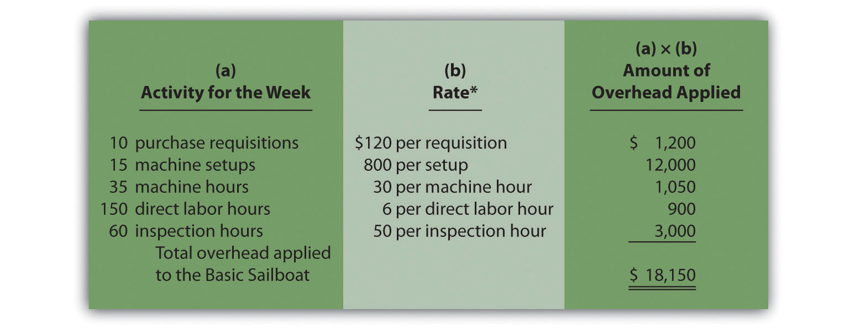
*From .

The entry to record overhead applied to the Basic sailboats for the week is as follows:

Recall from that the manufacturing overhead account is closed to cost of goods sold at the end of the period. If actual overhead costs are higher than applied overhead, the resulting underapplied overhead is closed with a debit to cost of goods sold and a credit to manufacturing overhead. If actual overhead costs are lower than applied overhead, the resulting overappliedoverhead is closed with a debit to manufacturing overhead and a credit to cost of goods sold.

Recap of Three Allocation Methods

We have discussed three different methods of allocating overhead to products—plantwide allocation, department allocation, and activity-based costing. Remember, total overhead costs will not change in the short run, but the way total overhead costs are allocated to products will change depending on the method used.

Presents the three allocation methods, using SailRite as an example. Notice that the three pie charts in the illustration are of equal size, representing the $8,000,000 total overhead costs incurred by SailRite.
Figure 3.9 The Three Methods of Overhead Allocation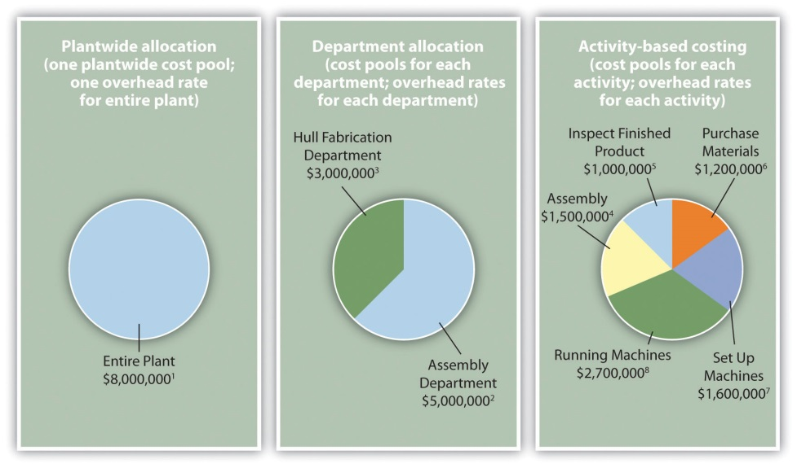
Overhead Rates:
¹ Allocated based on direct labor hours (DLH): $8,000,000 ÷ 250,000 DLH = $32 per DLH.
² Allocated based on direct labor hours (DLH): $5,000,000 ÷ 217,000 DLH = $23 per DLH.
³ Allocated based on machine hours (MH): $3,000,000 ÷ 60,000 MH = $50 per MH.
⁴ Allocated based on direct labor hours (DLH): $1,500,000 ÷ 250,000 DLH = $6 per DLH.
⁵ Allocated based on inspection hours (IH): $1,000,000 ÷ 20,000 IH = $50 per IH.
⁶ Allocated based on purchase requisitions (PR): $1,200,000 ÷ 10,000 PR = $120 per PR.
⁷ Allocated based on machine setups (MS): $1,600,000 ÷ 2,000 MS = $800 per MS.
⁸ Allocated based on machine hours (MH): $2,700,000 ÷ 90,000 MH = $30 per MH.

KEY TAKEAWAY
- Activity-based costing focuses on identifying the activities required to make products, on forming cost pools for each activity, and on allocating overhead costs to the products based on their use of each activity. ABC systems and traditional systems often result in vastly different product costs. But even if the resulting product costs are not much different, ABC provides managers with a better understanding of the production activities required for each activity and the associated costs, which often leads to improved efficiency and reduced costs.

Business in Action 3.2
Using Activity-Based Costing to Argue Predatory Pricing
BuyGasCo Corporation, a privately owned chain of gas stations based in Florida, was taken to court for selling regular grade gasoline below cost, and an injunction was issued. Florida law prohibits selling gasoline below refinery cost if doing so injures competition. Using a plantwide approach of allocating costs to products, the plaintiff’s costing expert was able to support the allegation of predatory pricing. The defendant’s expert witness, an accounting professor, used activity-based costing to dispute the allegation.
Both costing experts had to allocate costs to each of the three grades of gasoline (regular, plus, and premium) to determine a total cost per grade of fuel and a cost per gallon for each grade. Sales of regular grade fuel were significantly higher (63 percent of total sales) than the other two grades. Using the plantwide approach, the plaintiff‘s expert allocated all costs based on gallons of gas sold. Using the activity-based costing approach, the defendant‘s expert formed three activity cost pools—labor, kiosk, and gas dispensing. The first two cost pools allocated costs using gallons of gas sold and therefore were allocated as they would be with the plantwide approach (63 percent for regular grade, 20 percent for plus, and 17 percent for premium). The third cost pool (gas dispensing) allocated costs equally to each grade of fuel (i.e., one-third of costs to each grade of fuel). The gas dispensing pool included costs for storage tanks, all of which were the same size, as well as gas pumps and signs.
Compared with the plantwide approach, activity-based costing showed a lower cost per gallon for regular gas and a higher cost per gallon for the other two grades of fuel. Once the ABC information was presented, the case was settled, and the initial injunction was lifted.
Sources: Thomas L. Barton and John B. MacArthur, “Activity-Based Costing and Predatory Pricing: The Case of the Petroleum Retail Industry,” Management Accounting, Spring 2003; All Business, “Home Page,” http://www.allbusiness.com.

REVIEW PROBLEM 3.3
Parker Company produces an inkjet printer that sells for $150 and a laser printer that sells for $350. Last year, total overhead costs of $1,050,000 were allocated based on direct labor hours. A total of 15,000 direct labor hours were required last year to build 12,000 inkjet printers (1.25 hours per unit), and 10,000 direct labor hours were required to build 4,000 laser printers (2.50 hours per unit). Total direct labor and direct materials costs for the year were as follows:
 | Inkjet Printer | Laser Printer
Direct materials | $540,000 | $320,000
Direct labor | $600,000 | $400,000
The management of Parker Company would like to use activity-based costing to allocate overhead rather than use one plantwide rate based on direct labor hours. The following estimates are for the activities and related cost drivers identified as having the greatest impact on overhead costs.
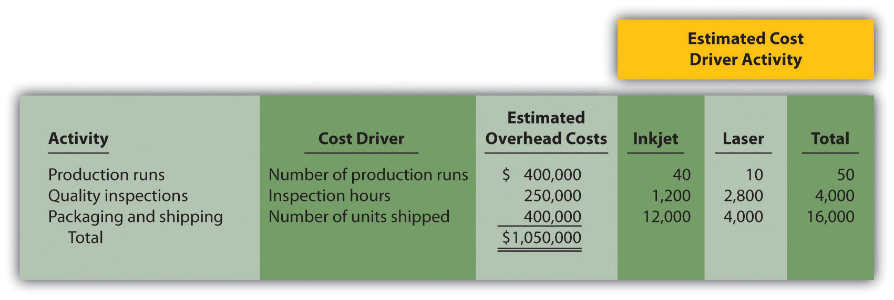
Required:
- Calculate the direct materials cost per unit and direct labor cost per unit for each product.

  - Using the plantwide allocation method, calculate the predetermined overhead rate and determine the overhead cost per unit for the inkjet and laser products.
  - What is the cost per unit for the inkjet and laser products?

  - Using the activity-based costing allocation method, calculate the predetermined overhead rate for each activity. (Hint: Step 1 through step 3 in the activity-based costing process have already been done for you; this is step 4.)
  - Using the activity-based costing allocation method, allocate overhead to each product. (Hint: This is step 5 in the activity-based costing process.) Determine the overhead cost per unit. Round amounts to the nearest dollar.
  - What is the product cost per unit for the inkjet and laser products?
- Calculate the per unit profit for each product using the plantwide approach and the activity-based costing approach. Comment on the differences between the results of the two approaches.
Solutions to Review Problem 3.3
- The cost per unit for direct materials is as follows:
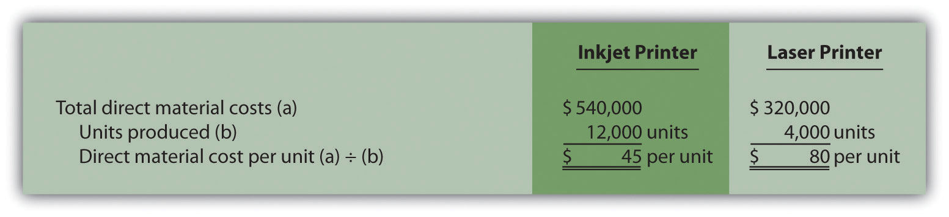
The cost per unit for direct labor is as follows:
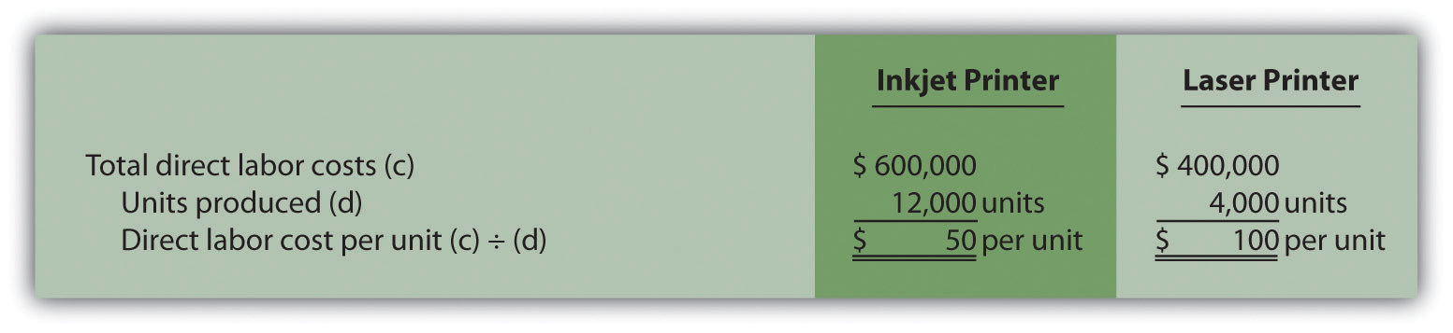

  - The plantwide allocation used by Parker Company is based on direct labor hours. The predetermined overhead rate is calculated as follows:
Estimated overhead costEstimated activity in allocation base=$1,050,00025,000 hours=$42 per direct labor hour
Because the inkjet printer requires 1.25 direct labor hours to build and the laser printer takes 2.50 direct labor hours to build (both figures are provided in the problem data), $52.50 in overhead is allocated to 1 unit of the inkjet product (= $42 rate × 1.25 hours) and $105 in overhead is allocated to 1 unit of the laser product ($42 rate × 2.50 direct labor hours).
  - Per unit product costs are as follows:

Direct materials and direct labor determined from Question 1.
*$52.50 = 1.25 direct labor hours per unit × $42 rate.
**$105 = 2.50 direct labor hours per unit × $42 rate.

  - Predetermined overhead rates are calculated for each activity as follows:
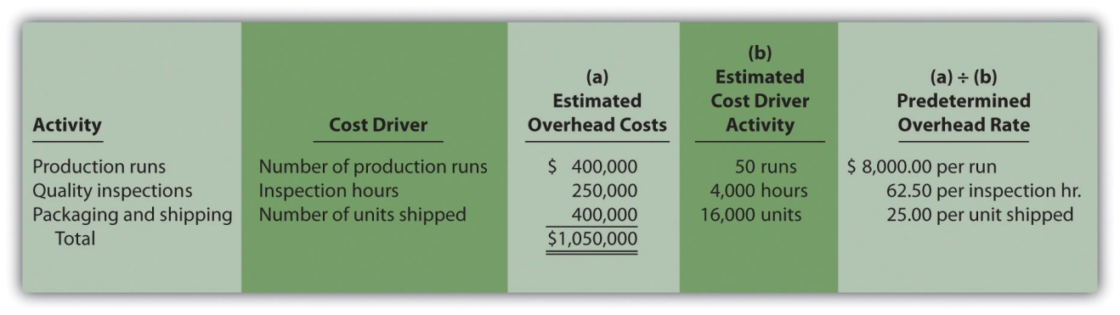
  - Overhead costs are allocated as follows:
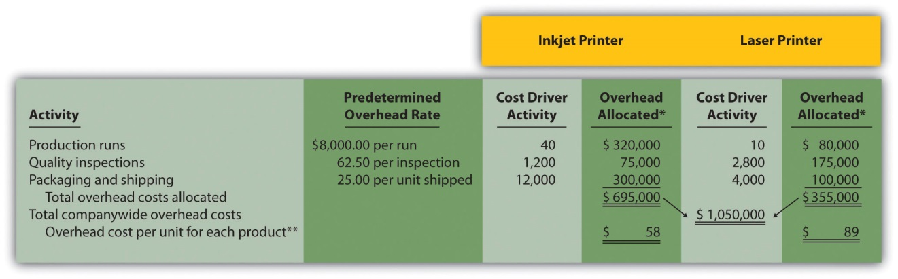

*Overhead allocated equals the predetermined overhead rate times the cost driver activity.
**Overhead cost per unit for the inkjet printer equals $695,000 (overhead allocated) ÷ 12,000 units produced, and for the laser printer, $355,000 ÷ 4,000 units produced. Amounts are rounded to the nearest dollar.
  - Per unit product costs are as follows:
Direct materials and direct labor determined from Question 1. Overhead determined from Question 3b.

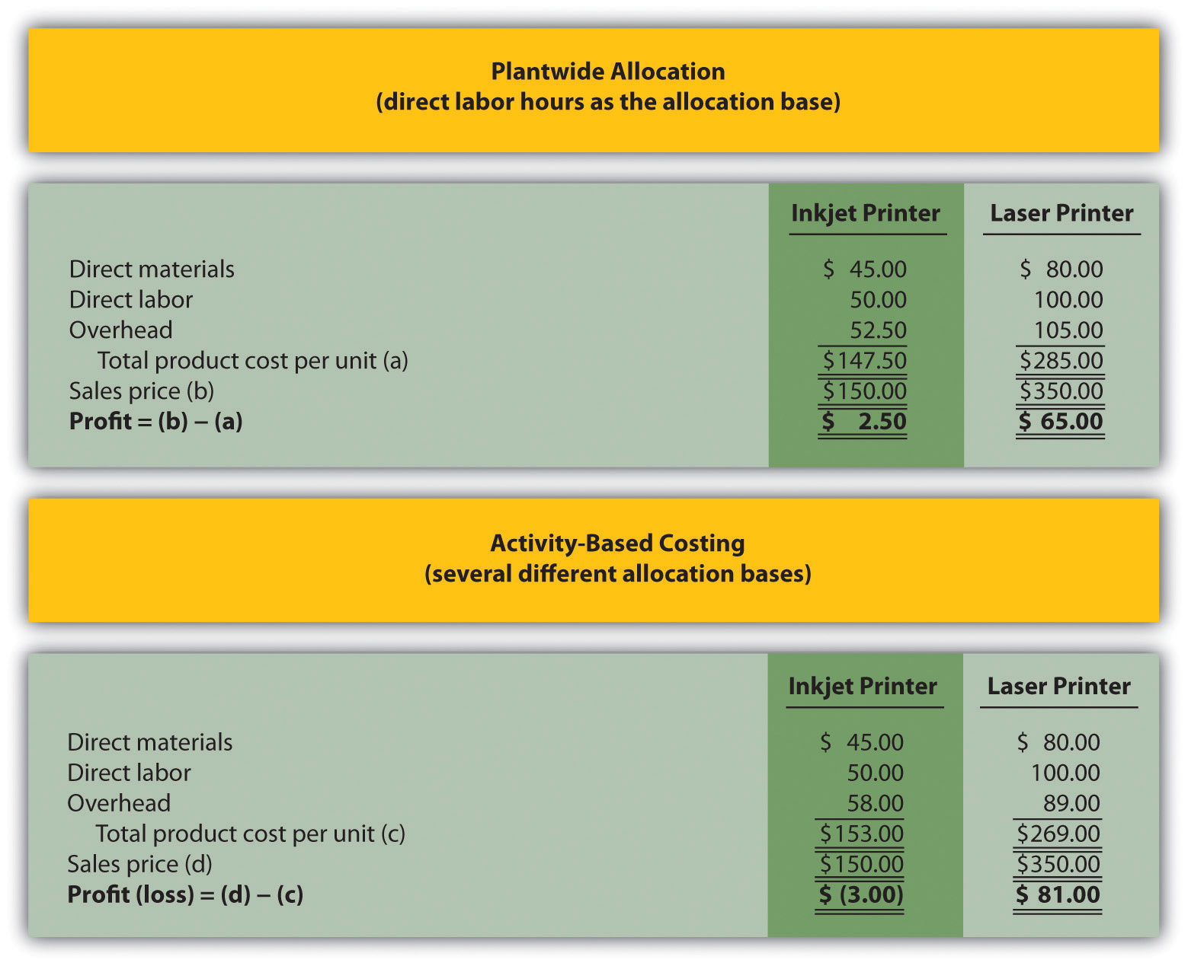
Although unit product costs do not change significantly for the inkjet printer when activity-based costing is used (from $147.50 to $153), the cost increases enough to result in a $3 loss for each unit. Conversely, the laser printer costs decrease significantly from $285 to $269 per unit when using activity-based costing, resulting in a profit of $81 per unit.
The shift in overhead costs to the inkjet printer is primarily a result of the inkjet printer using 80 percent of the production run resources and thus being assigned 80 percent of the overhead costs associated with production runs. The plantwide rate approach only assigned 60 percent of all overhead costs to the inkjet printer, including those related to production runs (60 percent = 15,000 inkjet direct labor hours ÷ 25,000 total direct labor hours).
[1] Notice that the total activity levels presented here match the estimated activity levels presented in step 4. This was done to avoid complicating the example with overapplied and underapplied overhead. However, a more realistic scenario would provide actual activity levels that are different thanestimated activity levels, thereby creating overapplied and underapplied overhead for each activity. We described the disposition of overapplied and underapplied overhead in .

3.4 Using Activity-Based Management to Improve Operations

LEARNING OBJECTIVE
- Understand the concept of activity-based management.

Question: Activity-based costing is helpful in providing relatively accurate product cost information. However, the value of activity-based costing information goes beyond accurate product costing. When activity-based costing is used in conjunction with activity-based management, organizations are often able to make dramatic improvements to operations. How does activity-based management help an organization reduce costs and become more efficient?

Answer: Activity-based management (ABM) provides three steps for managers to use that lead to improved efficiency and profitability of operations.

Step 1. Identify activities required to complete products.

This involves interviewing personnel throughout the company. Recall that activity-based costing also requires the identification of key activities. However, ABM allows for a more detailed analysis because the estimation of costs and related overhead rates are not required when using ABM.

Step 2. Determine whether activities are value-added or non-value-added.

Activities that add to the product’s quality and performance are calledvalue-added activities. Activities that do not add to the product’s quality and performance are called non-value-added activities. Examples of value-added activities at SailRite include using materials and machines to produce hulls and assembling each sailboat. Examples of non-value-added activities include storing parts in a warehouse and letting machinery sit idle.

Step 3. Continuously improve the value-added activities and minimize or eliminate the non-value-added activities.

Even if an activity is identified as value-added, ABM requires the continuous improvement of the activity. For example, SailRite’s assembly process (a value-added activity) may require workers to shift back and forth between Basic and Deluxe sailboats throughout the day, each of which uses different parts and requires different tools. Perhaps the efficiency of this process could be improved by assembling the boats in batches—one day working on Basic boats, another day working on Deluxe boats.

Activities that are non-value-added should be minimized or eliminated. For example, storing parts in a warehouse at SailRite (a non-value-added activity) might be minimized by moving to a just-in-time system that requires suppliers to deliver parts immediately before they are needed for production.

The next time you visit a fast-food restaurant, go to a clothing store, or stand in line at a college bookstore, try to identify value-added and non-value-added activities. Think about ways the organization can eliminate non-value-added activities and improve value-added activities.

KEY TAKEAWAY
- Activity-based management provides a three step process that shows management how to use the cost information obtained from an activity-based costing system to improve the efficiency and profitability of operations.

Business in Action 3.3
Why Use Activity-Based Costing (ABC) and Activity-Based Management (ABM)?
A survey of 296 users of activity-based costing and activity-based management showed that the top four objectives of using ABC and ABM were as follows:
- To provide product costing (58 percent)
- To analyze processes (51 percent)
- To evaluate performance (49 percent)
- To assess profitability (38 percent)
All these objectives are important to most organizations and can be achieved with the help of ABC and ABM systems.
Source: Mohan Nair, “Activity-Based Costing: Who’s Using It and Why?”Management Accounting Quarterly, Spring 2000.

REVIEW PROBLEM 3.4
Label each of the following activities as value-added or non-value-added:
- Placing customers who call to order a pizza on hold
- Assembling desks to be sold to customers
- Storing raw materials to be used in production the next month
- Designing a car to maximize comfort
- Scrapping defective production materials
- Waiting for a phone call from a customer
- Moving raw materials from one end of a factory to the other
Solutions to Review Problem 3.4
- Non-value-added activity
- Value-added activity
- Non-value-added activity
- Value-added activity
- Non-value-added activity
- Non-value-added activity
- Non-value-added activity

3.5 Using Activity-Based Costing (ABC) and Activity-Based Management (ABM) in Service Organizations

LEARNING OBJECTIVE
- Apply activity-based costing and activity-based management to service organizations.

Question: To this point, we have presented ABC and ABM examples in a manufacturing setting. However, service organizations, such as banks, hospitals, airlines, and government agencies, also use ABC and ABM. [1]In fact, a recent survey indicates that 75 percent of companies that use ABC are in the public sector, a service industry, or a consulting industry. [2]How can ABC help service organizations get better product cost information?

Answer: The same five steps used in manufacturing organizations can also be used in service organizations. To understand how ABC could be used in a service organization, let’s look at how ABC can be used to determine the cost of loan products at a financial institution.

Service Organization Example of ABC

Imagine you are the chief financial officer of Five Star Bank. You are interested in implementing an activity-based costing system to evaluate the cost of different loan products, such as auto loans and home equity loans, offered by the bank. The five steps of activity-based costing we presented earlier still apply. Let’s look at how these steps might work when evaluating the cost of bank loans.

Step 1. Identify costly activities.

Processing loans includes activities such as meeting with customers, reviewing customer applications, and running credit reports.

Step 2. Assign overhead costs to the activities identified in step 1.

Costs assigned to the activity of reviewing customer applications include items such as wages of personnel reviewing applications, depreciation of computer equipment used to review online applications, and supplies needed for the review process.

Step 3. Identify the cost driver for each activity.

Activity cost drivers are shown as follows:
Activity | Cost Driver
Meeting with customers | Hours of meeting time
Reviewing customer applications | Number of applications reviewed
Running credit reports | Number of credit reports run

Step 4. Calculate a predetermined overhead rate for each activity.

This is done by dividing estimated overhead costs for each activity by the estimated cost driver activity. For the activity meeting with customers, this calculation results in a rate per hour of meeting time. For the activityreviewing customer applications, the calculation results in a rate per application reviewed, and for running credit reports, a rate per credit report run.

Step 5. Allocate overhead costs to products.

Overhead is allocated, or applied, to products (auto loans and home equity loans in this example) based on the use of each activity’s cost driver. If a loan officer reviews 30 auto loan applications, an amount equal to the rate per application reviewed times 30 applications is allocated to the auto loans product.

Service Organization Example of ABM

Question: Managers at Five Star Bank are not only interested in product cost information; they would also like to scrutinize the activities involved in processing loans and make the process more efficient. How can the management of Five Star Bank use activity-based management to become more efficient?

Answer: Managers and accountants can apply the three steps of activity-based management to Five Star Bank as follows:
- Identify activities required to complete the product. This involves interviewing personnel throughout the company to capture all the activities involved in processing loans.
- Determine whether activities are value-added or non-value-added. An example of a value-added activity is the quick approval of a loan. An example of a non-value-added activity is time spent waiting for credit reports.
- Continuously improve the value-added activities and minimize, or eliminate, the non-value-added activities. Five Star Bank should continually strive to improve its ability to approve loans quickly (a value-added activity). While waiting for credit reports (a non-value-added activity), perhaps the bank can find other value-added activities that bank personnel can perform (e.g., responding to customer questions or processing other loan applications).

Business in Action 3.4
Activity-Based Costing at Blue Cross and Blue Shield of Florida (BCBSF)
Management at Blue Cross and Blue Shield of Florida realized it needed more sophisticated cost information to make better decisions. Given the highly competitive nature of the health care insurance industry and the need to minimize costs, BCBSF’s management decided to implement an activity-based costing system. Management’s primary concern was how to allocate administrative costs totaling $588,000,000 (21 percent of revenue) to the products and services the organization provides.
The benefits of implementing an activity-based costing and management system at BCBSF are as follows:
- Product pricing is improved as a result of having better cost information (prices are based on cost).
- Regional management is able to identify the cost of services provided by headquarters and make more efficient use of costly services.
- Product managers use the cost information to design products in a way that is most cost-effective.
As stated by the product director and cost accounting manager atBCBSF, “The goal is to provide the right information at the right time to the right people in a cost-efficient way.”
Source: Kenneth L. Thurston, Dennis M. Kelemen, and John B. MacArthur, “Cost for Pricing at Blue Cross and Blue Shield of Florida,”Management Accounting Quarterly, Spring 2000.

KEY TAKEAWAY
- Activity-based costing and activity-based management techniques are not limited to manufacturing companies. Virtually all organizations—including service, nonprofit, retail, and governmental—can benefit from implementing some form of ABC and ABM.

REVIEW PROBLEM 3.5
Menzies and Associates provides two products to its clients—tax services and audit services. Last year, total overhead costs of $1,000,000 were allocated based on direct labor hours. A total of 10,000 direct labor hours were required last year for tax clients at a cost of $350,000, and 30,000 direct labor hours were required for audit clients at a cost of $1,200,000. Direct materials used were negligible and are included in overhead costs. Sales revenue totaled $720,000 for tax services and $2,200,000 for audit services.
Management of Menzies and Associates would like to use activity-based costing to allocate overhead rather than use one plantwide rate based on direct labor hours (perhaps the term “officewide” rate would be more appropriate here). The following estimates are for the activities and related cost drivers identified as having the greatest impact on overhead costs.
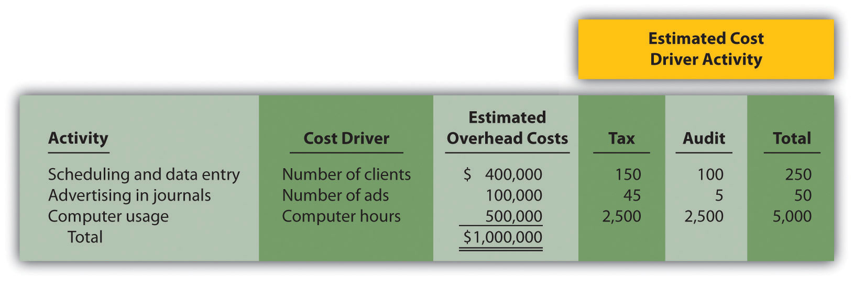
Required:

  - Using the plantwide allocation method, calculate the total cost for each product. (Hint: Product costs for this company include overhead and direct labor.)
  - Calculate the profit for each product using this approach. Also calculate profit as a percent of sales revenue for each product.

  - Using activity-based costing, calculate the predetermined overhead rate for each activity. (Hint: Step 1 through step 3 in the activity-based costing process have already been done for you; this is step 4.)
  - Using activity-based costing, calculate the amount of overhead assigned to each product. (Hint: This is step 5 in the activity-based costing process.)
  - Calculate the profit for each product using this approach. Also calculate profit as a percent of sales revenue for each product.
- Comment on the results of using activity-based costing compared to plantwide allocation.
Solutions to Review Problem 3.5

  - The plantwide allocation used by Menzies and Associates is based on direct labor hours. The rate is calculated as follows:
Estimated overhead costEstimated activity in allocation base=$1,000,00040,000 hours= $25 per direct labor hour
Total product costs are as follows:
*$250,000 = 10,000 direct labor hours × $25 rate.
**$750,000 = 30,000 direct labor hours per unit × $25 rate.

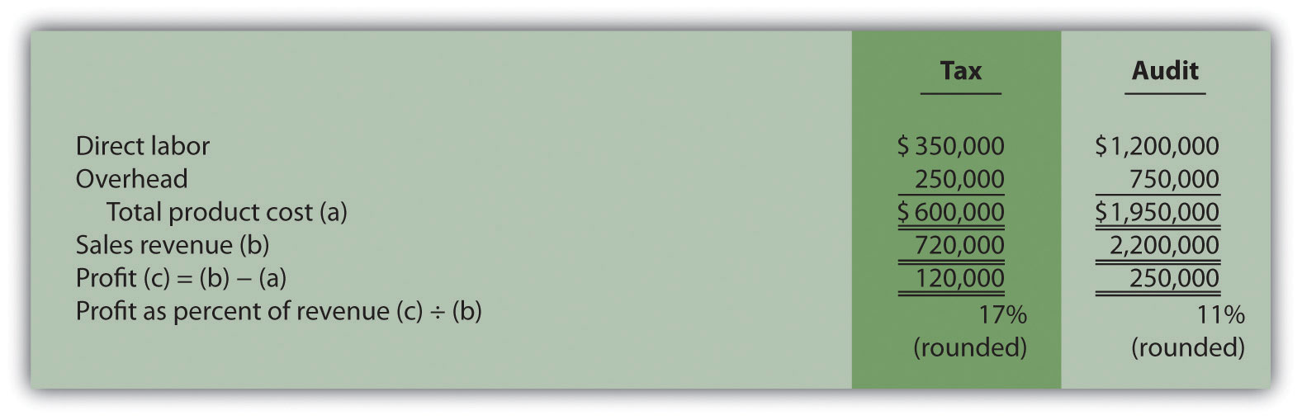

  - Predetermined overhead rates are calculated for each activity as follows:
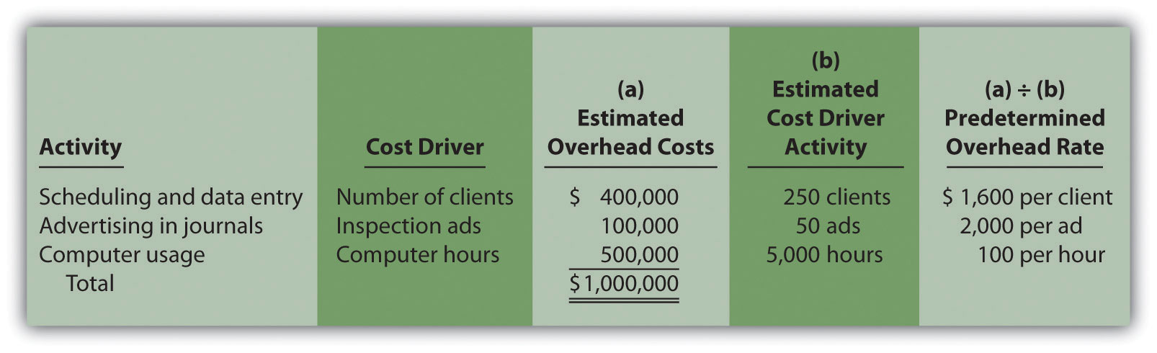
  - Overhead costs are allocated as follows:
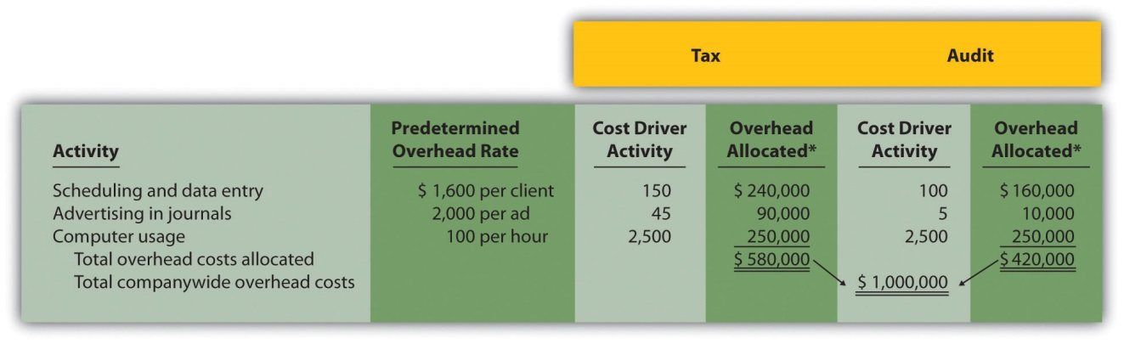
*Overhead allocated equals the predetermined overhead rate times the cost driver activity.
  - The profit and profit as a percent of sales revenue are calculated as follows:
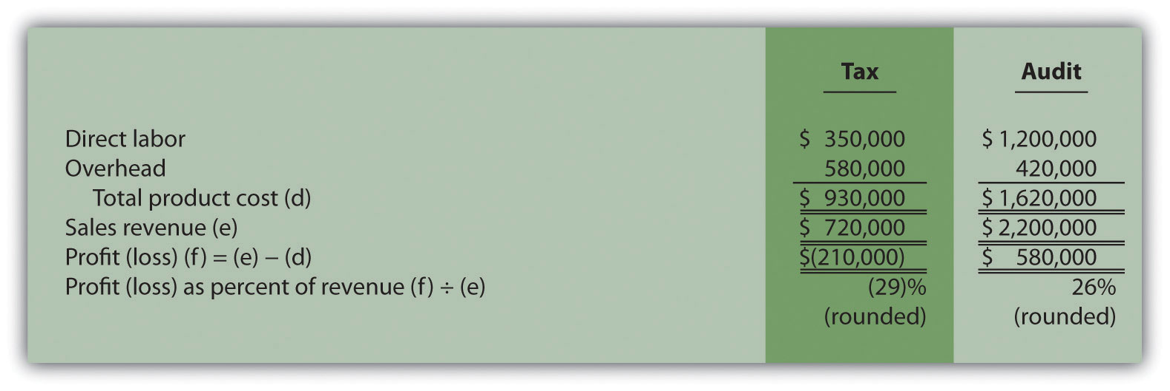
- Activity-based costing results in a significant increase of overhead costs allocated to the tax product and a decrease of overhead costs allocated to the audit product. The plantwide allocation approach allocates overhead based on direct labor hours, which results in 25 percent of all overhead costs being allocated to tax (= 10,000 direct labor hours in tax ÷ 40,000 total direct labor hours) and 75 percent to audit. However, ABC shows that tax uses 60 percent of scheduling and data entry resources (= 150 tax clients ÷ 250 total clients), 90 percent of advertising resources (= 45 tax ads ÷ 50 total ads), and 50 percent of computer resources (= 2,500 tax computer hours ÷ 5,000 total computer hours). Thus tax is allocated more overhead costs using ABC than using one plantwide rate based on direct labor hours. Note that total profit of $370,000 is the same regardless of the overhead cost allocation approach used. Using the plantwide allocation approach, $370,000 = $120,000 + $250,000. Using the ABC approach, $370,000 = ($210,000) + $580,000.
Management must use this information to make improvements to the company’s operations. It would probably be unwise to eliminate tax services because of the connection they have with audit services (i.e., audit clients may appreciate the convenience of also having tax services available to them). However, management can look for ways to make the process more efficient by focusing on costly activities identified in the ABC analysis.
Note that when calculating product costs for service organizations, it is difficult, if not impossible, to calculate a product cost per unit. Most service organizations do not have an easily defined unit of measure because services vary so much from one customer to another. One alternative is to calculate total profit as a percent of total sales revenue. This allows for a comparison of profitability between different types of services, similar to comparing the profitability for units of product.
[1] Some specialists refer to activity-based costing and activity-based management as activity-based costing and management, or ABCM.
[2] Mohan Nair, “Activity-Based Costing: Who’s Using It and Why?” Management Accounting Quarterly, Spring 2000, 29–33.

3.6 Variations of Activity-Based Costing (ABC)

LEARNING OBJECTIVE
- Expand the use of activity-based costing.

Question: The primary focus of activity-based costing thus far has been on allocating manufacturing overhead costs to products. Although this is important for external reporting purposes, we can expand ABC to include costs beyond manufacturing overhead. Also, we can organize costs in different ways to help managers evaluate performance. What different approaches can be used to organize cost data in a way that helps managers make better decisions?

Answer: Cost data can be organized in a number of ways to help managers make decisions. Four common approaches are addressed in this section:
- Expanding ABC to include nonmanufacturing costs
- Allocating service department costs to production departments
- Using the hierarchy of costs to organize cost information
- Measuring the costs of controlling and failing to control quality

External Reporting and Internal Decision Making

Question: U.S. Generally Accepted Accounting Principles require the allocation of all manufacturing costs to products for inventory costing purposes. The choice of an allocation method is not critical to this process. Companies that use direct labor hours, machine hours, activity-based costing, or some other method to allocate overhead costs to products are likely to be in compliance with U.S. GAAP. Throughout this chapter, we have illustrated how ABC is used to allocate manufacturing overhead costs. However, organizations often use ABC for purposes that go beyond allocating costs solely for external reporting.How might ABC be used to help companies in areas other than external reporting?

Answer: Commissions paid to sales people for the sale of specific products (often called selling, general, and administrative) are included as an operating expense in financial reports prepared for external users as required by U.S. GAAP. However, many organizations may assign commission costs to specific products for internal decision-making purposes. This treatment is not in compliance with U.S. GAAP, but it is perfectly acceptable for internal reporting purposes and may be done using activity-based costing. It is important to understand that managers have ultimate control over which costs should be allocated to products for internal reporting purposes, and this allocation often involves going beyond overhead costs.

Table 3.1 "Examples of Costs Allocated to Products" provides examples of costs that could be allocated to products. It also includes cost categories—product, selling, and general and administrative (G&A)—and indicates whether the cost allocation complies with U.S. GAAP for external reporting. As you can see in the far right column, all costs can be allocated to products for internalreporting purposes.
Table 3.1 Examples of Costs Allocated to Products
Cost | Cost Category* | OK to Allocate to Products for External Reporting (U.S. GAAP)? | OK to Allocate to Products for Internal Reporting?
Direct materials | Product | Yes | Yes
Direct labor | Product | Yes | Yes
Manufacturing overhead** | Product | Yes | Yes
Sales commissions | Selling | No | Yes
Shipping products to customers | Selling | No | Yes
Product advertising | Selling | No | Yes
Legal costs for product lawsuit | G&A | No | Yes
Processing payroll for production personnel | G&A | No | Yes
Company president’s salary | G&A | No | Yes
Costs of implementing ABC | G&A | No | Yes
*See Chapter 2 "How Is Job Costing Used to Track Production Costs?"for information about category definitions.
**Includes all manufacturing costs other than direct labor and direct materials, such as factory related costs for supervisors, building rent, machine maintenance, utilities, and indirect materials. See Chapter 2 "How Is Job Costing Used to Track Production Costs?" for more detail.

Allocating Service Department Costs Using the Direct Method

Question: Most companies have departments that are classified as either service departments or production departments. Service departments provide services to other departments within the company and include such functions as accounting, human resources, legal, maintenance, and computer support.Production departments are directly involved with producing goods or providing services for customers and include such functions as ordering materials, assembling products, and performing quality inspections. Why do companies often allocate a share of service department costs to production departments for internal reporting purposes even though U.S. GAAP generally does not allow it for external reporting?

Answer: Companies allocate service department costs to production departments for several reasons:
- The services provided by departments within a company are not free, and they should be used as efficiently as possible. Managers of production departments that use these services thus have an incentive to minimize their use.
- To minimize costs, Hewlett Packard and other large companies often “outsource” services like building maintenance and legal support (i.e., they have other companies provide the services for them). This creates an incentive for the company’s service departments to provide services at a reasonable cost.
- Organizations often include service department costs when determining product costs for internal decision-making purposes, as described earlier (refer to Table 3.1 "Examples of Costs Allocated to Products" for examples).
Question: How do companies allocate service department costs to production departments and how might this be done at SailRite?

Answer: Several methods of allocating service department costs to production departments are available. We introduce the simplest approach—the direct method—here (complex approaches are presented in more advanced cost accounting texts). The direct method allocates service department costs directly to production departments but not to other service departments.

For example, assume that SailRite Company has two service departments—Human Resources and Computer Support. Costs associated with Human Resources and Computer Support total $90,000 and $150,000, respectively. Recall that SailRite has two production departments—Hull Fabrication and Assembly. The goal is to allocate service department costs to the two production departments, as shown in Figure 3.10 "Allocating Service Department Costs to Production Departments at SailRite Company: Direct Method (Before Allocations)".

Figure 3.10 Allocating Service Department Costs to Production Departments at SailRite Company: Direct Method (Before Allocations)
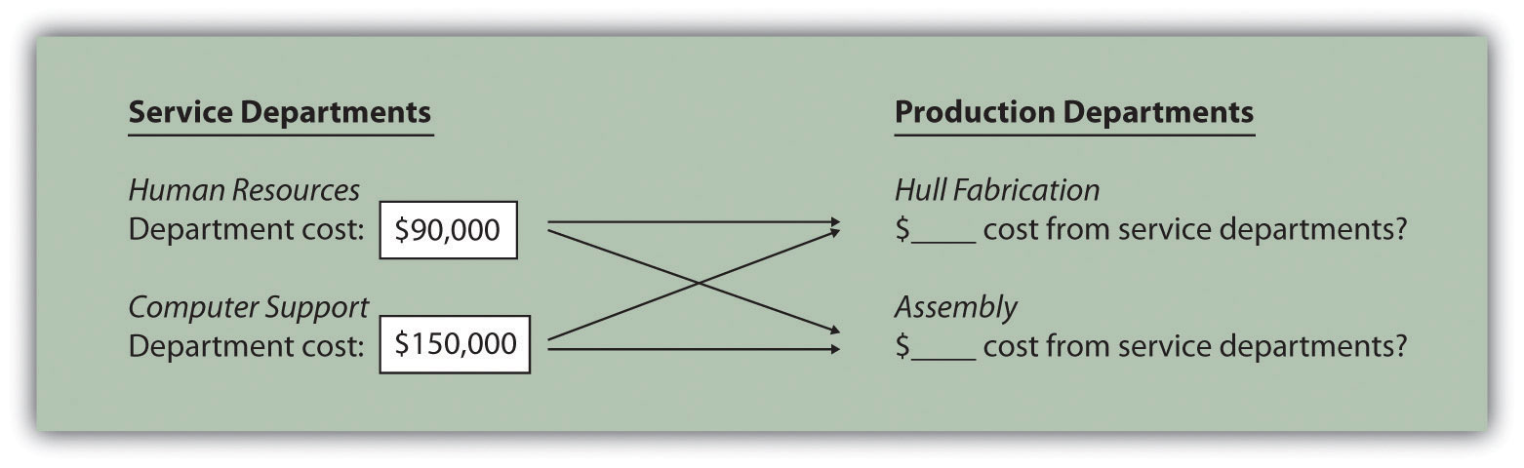

SailRite would like to allocate service department costs using an allocation base that drives these costs. Assume management decides to use the number of employees as the allocation base to allocate Human Resources costs, and the number of computers as the allocation base to allocate Computer Support costs. Allocation base activity for each production department is as follows:
 | Hull Fabrication | Assembly | Total
Number of employees | 35 | 85 | 120
Number of computers | 42 | 33 | 75

The allocation rate for human resource services is $750 per employee (= $90,000 department costs ÷ 120 employees). The allocation rate for computer support services is $2,000 per computer (= $150,000 ÷ 75 computers). Thus the Hull Fabrication department receives an allocation of $26,250 in human resource costs (= 35 employees × $750 rate) and $84,000 in computer support costs (= 42 computers × $2,000 rate). The Assembly department receives an allocation of $63,750 in human resource costs (= 85 employees × $750 rate) and $66,000 in computer support costs (= 33 computers × $2,000 rate).

The allocations to production departments are shown in Figure 3.11 "Allocating Service Department Costs to SailRite’s Production Departments: Direct Method (After Allocations)". If management chooses to allocate service department costs to production departments as described here, there must be some benefit to going through the process. Should these costs be assigned to activity cost pools for the purpose of costing products (activity-based costing)? Should production department managers be evaluated based on the use of these services? Should actual service department usage be compared to budgeted usage for each production department? The answers to these questions vary from one organization to the next. However, one point is certain—the benefits of implementing this allocation system must outweigh the costs!
Figure 3.11 Allocating Service Department Costs to SailRite’s Production Departments: Direct Method (After Allocations)
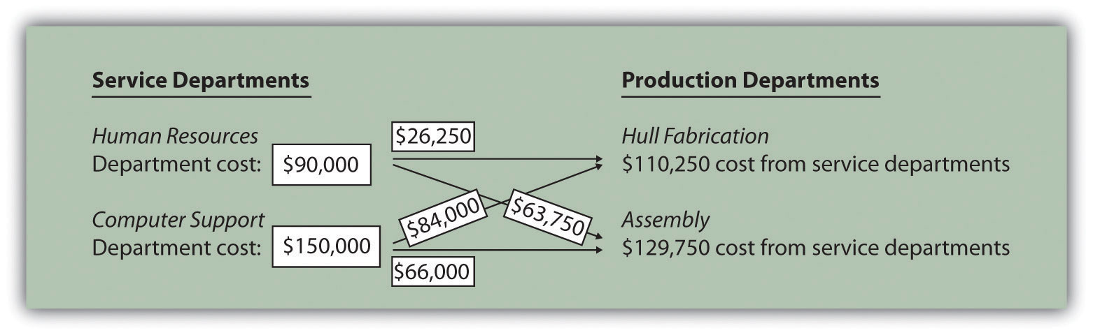

The Hierarchy of Costs

Question: Some organizations group activities into four cost categories, called the hierarchy of costs, to help managers form cost pools for activity-based costing purposes. The cost hierarchy [1]groups costs based on whether the activity is at the facility level, product or customer level, batch level, or unit level. What is the difference between each of these categories, and how does this information help managers?

Answer: Each category within the cost hierarchy is described as follows:
- Facility-level activities (or costs) are required to sustain facility operations and include items such as building rent and management of the factory. These costs are generally changed over long time horizons and are incurred regardless of how many product-, batch-, or unit-level activities take place.
- Product-level activities (or customer-level activities) are required to develop, produce, and sell specific types of products. This category includes items such as product development and product advertising. These costs can be changed over a shorter time horizon than facility-level activities and are incurred regardless of the number of batches run or units produced.
- Batch-level activities are required to produce batches (or groups) of products and include items such as machine setups and quality inspections. These costs can be changed over a shorter time horizon than product- and facility-level activities and are driven by the number of batches run rather than the number of units produced. For example, a batch can consist of producing 5 units or 10,000 units. The costs in this category are driven by the number of batches, not the number of units in each batch.
- Unit-level activities are required to produce individual units of product and include items such as energy to run machines, direct labor, and direct materials. These costs can be changed over a short time horizon based on how many units management chooses to produce.

The cost hierarchy serves as a framework for managers to establish cost pools and determine what drives the change in costs for each cost pool. It also provides a sense of how quickly (or slowly) costs change based on decisions made by management. Examples of activities often identified by companies using activity-based costing, and how these activities fit in the cost hierarchy, appear in Table 3.2 "Cost Hierarchy Examples".
Table 3.2 Cost Hierarchy Examples
Cost Hierarchy Category | Activity/Cost
Facility-level | Plant depreciation
 | Building rent
 | Management of facility
Product/customer-level | New product development
 | Product engineering
 | Product marketing and advertising
 | Maintaining customer records
Batch-level | Machine setups
 | Processing purchase orders
 | Batch quality inspections
Unit-level | Energy to run production machines
 | Direct labor
 | Direct materials

Measuring the Costs of Controlling and Improving Quality

Question: The hierarchy of costs is not the only approach organizations use to group costs. Managers are also concerned about measuring the costs associated with quality. Quality-related costs can be organized into four categories. The first two categories—prevention and appraisal—are costs incurred to control and improve quality. The final two categories—internal failure and external failure—are costs incurred as a result of failing to control and improve quality. What is the difference between these cost categories, and how does this information help managers improve quality?

Prevention costs are costs incurred to prevent defects in products and services. Examples include designing production processes that minimize defects, providing quality training to employees, and inspecting raw materials before they are placed in production.
- Appraisal costs (often called detection costs) are costs incurred to detect defective products before they are delivered to customers. The cost of finished goods inspections falls in this category.
- Internal failure costs are the costs incurred as a result of detecting defective products before they are delivered to customers. Examples include the reworking of defective products, the scrapping of defective products, and the machine downtime resulting from process problems that cause defects.
- External failure costs are the costs incurred as a result of delivering defective products to customers. Examples include warranty repairs, warranty replacements, and product liability resulting from unsafe defective products.

Companies that measure these costs of quality typically calculate the costs in each category as a percent of total revenue. The goal is to steadily shift costs toward the prevention and appraisal categories and away from the internal and external failure categories. As organizations concentrate more on preventing defects, total quality costs as a percent of revenue tends to decline and product quality improves. Table 3.3 "Summary of Quality Costs" provides a summary of the four classifications of quality-related costs.
Table 3.3 Summary of Quality Costs
Quality Cost Category | Description
Prevention cost | Cost of activities that prevent defects in products, such as quality training and raw materials inspections
Appraisal cost | Cost of activities that detect defective products before they are delivered to customers, such as finished goods inspections and field inspections
Internal failure cost | Cost of activities that result from detecting defective products before they are delivered to customers, such as rework and scrap
External failure cost | Cost of activities that result from delivering defective products to customers, such as warranty repairs and warranty replacements

KEY TAKEAWAY
- Activity-based costing is not simply used to allocate manufacturing overhead costs to products for external reporting purposes; it is also often used to allocate selling, general, and administrative costs to products for internal decision-making purposes. A number of methods can be used to assist in the cost allocation process. For example, the cost of service departments can be allocated to production departments using the direct method. Also the cost hierarchy can be used to help establish cost pools and identify cost drivers used to allocate costs. Organizations are also concerned with measuring and reducing the cost of quality by categorizing quality costs into four categories—prevention, appraisal, internal failure, and external failure.

REVIEW PROBLEM 3.6
Fill in the following table to identify if the cost item can be included in the cost of products for external reporting purposes and/or internal reporting purposes. The first item is completed for you.
Cost | OK to Allocate to Products for External Reporting (U.S. GAAP)? | OK to Allocate to Products for Internal Reporting?
Direct materials | Yes | Yes
Salaries of sales people
Indirect materials used in production
Rent for headquarters building
Product promotions
Direct labor
Legal costs for patent applications
Processing payroll for human resource personnel
Depreciation of factory equipment
Marketing vice president’s salary
Depreciation of administrative department equipment
Solution to Review Problem 3.6
Cost | OK to Allocate to Products for External Reporting (U.S. GAAP)? | OK to Allocate to Products for Internal Reporting?
Direct materials | Yes | Yes
Salaries of sales people | No | Yes
Indirect materials used in production | Yes | Yes
Rent for headquarters building | No | Yes
Product promotions | No | Yes
Direct labor | Yes | Yes
Legal costs for patent applications | No | Yes
Processing payroll for human resource personnel | No | Yes
Depreciation of factory equipment | Yes | Yes
Marketing vice president’s salary | No | Yes
Depreciation of administrative department equipment | No | Yes

END-OF-CHAPTER EXERCISES
Questions
- Why do managers allocate overhead costs to products?
- Describe the three methods of allocating overhead costs.
- What is a cost pool, and how does it relate to allocating overhead to products?
- What is the difference between an activity and a cost driver?
- How do cost flows using activity-based costing differ from cost flows using one plantwide rate?
- Describe the five steps required to implement activity-based costing.
- What are some advantages of using an activity-based costing system?
- What are some disadvantages of using an activity-based costing system?
- Review Note 3.14 "Business in Action 3.1" What were the two common characteristics of the 130 U.S. manufacturing companies that used activity-based costing?
- Explain how to record the application of overhead to products using activity-based costing.
- Describe the three steps required to implement activity-based management.
- How does activity-based management differ from activity-based costing?
- What is the difference between a value-added activity and a non-value-added activity? Provide two examples of non-value-added activities for each of the following:
  - Fast-food restaurant
  - Clothing store
  - College bookstore
- Review Note 3.16 "Business in Action 3.2" How did activity-based costing help BuyGasCo Corporation settle its predatory pricing case?
- Review Note 3.23 "Business in Action 3.3" What did the survey of 296 users of ABC and ABM show were the top two objectives in using these systems?
- Review Note 3.26 "Business in Action 3.4" What was management’s primary concern in deciding to implement an activity-based costing system?
- What selling costs and general and administrative costs might be allocated to products using activity-based costing? Why do some managers prefer allocating these costs to products?
- What are service departments? Why do some managers allocate service department costs to production departments?
- Describe the four categories included in the hierarchy of costs.
- What is the difference between a facility-level cost and a unit-level cost?
- How does the hierarchy of costs help managers allocate overhead costs?
- Describe the four categories related to the costs of quality. How might the allocation of quality costs to these four categories help managers?
Brief Exercises
- Product Costing at SailRite. Refer to the dialogue presented at the beginning of the chapter and the follow-up dialogue before Figure 3.7 "Activity-Based Costing Versus Plantwide Costing at SailRite Company".
Required:
  - In the opening dialogue, why was the owner concerned about the product costs for each of the company’s boats?
  - In the follow-up dialogue before Figure 3.7 "Activity-Based Costing Versus Plantwide Costing at SailRite Company", what did the company’s accountant discover about the profitability of each boat using activity-based costing? (Refer to Figure 3.7 "Activity-Based Costing Versus Plantwide Costing at SailRite Company" as you prepare your answer.)
- Calculating Plantwide Predetermined Overhead Rate.Manufacturing overhead costs totaling $5,000,000 are expected for this coming year. The company also expects to use 50,000 direct labor hours and 20,000 machine hours.
Required:
  - Calculate the plantwide predetermined overhead rate using direct labor hours as the base. Provide a one-sentence description of how the rate will be used to allocate overhead costs to products.
  - Calculate the plantwide predetermined overhead rate using machine hours as the base. Provide a one-sentence description of how the rate will be used to allocate overhead costs to products.
- Calculating Department Predetermined Overhead Rates.Manufacturing overhead costs totaling $1,000,000 are expected for this coming year—$400,000 in the Assembly department and $600,000 in the Finishing department. The Assembly department expects to use 4,000 machine hours, and the Finishing department expects to use 30,000 direct labor hours.
Required:
  - Assume this company uses the department approach for allocating overhead costs. Calculate the predetermined overhead rate for each department, and explain how these rates will be used to allocate overhead costs to products.
  - Why do different departments use different allocation bases (e.g., direct labor hours or machine hours)?
- Identifying Cost Drivers. Ehrman Company identified the activities listed in the following as being most important (step 1 and step 2 of activity-based costing), and it formed cost pools for each activity.
  - Purchasing raw materials
  - Inspecting raw materials
  - Storing raw materials
  - Maintaining production equipment
  - Setting up machines to produce batches of product
  - Testing finished products
Required:
Perform step 3 of the activity-based costing process by identifying a possible cost driver for each activity.
- Identifying Cost Drivers: Service Company. McHale Architects, Inc., designs, engineers, and supervises the construction of custom homes. The following activities were identified as being most important (step 1 and step 2 of activity-based costing), and cost pools were formed for each activity.
  - Meeting with customers
  - Coordinating inspections with the building department
  - Consulting with contractors
  - Maintaining office equipment
  - Processing customer billings (invoices)
Required:
Perform step 3 of the activity-based costing process by identifying a possible cost driver for each activity.
- Value-Added and Non-Value-Added Activities. Novak Corporation manufactures custom-made kayaks and accessories. The company performs the following activities.
  - Storing parts and materials
  - Queuing orders before beginning production
  - Assembling kayaks
  - Waiting for materials to arrive to continue production
  - Painting kayaks
  - Designing kayaks to maximize comfort
  - Scrapping defective materials
Required:
Label each activity as value-added or non-value-added.
- Allocation Base for Service Departments. Valencia Company has 15 production departments and produces hundreds of products. Service department costs are allocated to production departments using the direct method. Five service departments provide the following services to the production departments.
  - The Computer Technology department provides computer support.
  - The Personnel department posts job openings, hires employees, and coordinates employee benefits.
  - The Accounting department processes accounting data, provides financial reports, and performs general accounting duties.
  - The Maintenance department maintains buildings and equipment.
  - The Legal department provides legal services.
Required:
  - For each service department, provide a possible allocation base. Explain why the base you chose for each service department is reasonable.
  - Does the direct method provide for allocations from one service department to another? Explain.
Exercises: Set A
- Plantwide Versus Department Allocations of Overhead. San Juan Company expects to incur $600,000 in overhead costs this coming year—$100,000 in the Cutting department, $300,000 in the Assembly department, and $200,000 in the Finishing department. Direct labor hours worked in all departments are expected to total 40,000 (used for the plantwide rate). The Cutting department expects to use 20,000 machine hours, the Assembly department expects to use 25,000 direct labor hours, and the Finishing department expects to incur $100,000 in direct labor costs (this information will be used for department rates).
Required:
  - Assume San Juan Company uses the plantwide approach for allocating overhead costs and direct labor hours as the allocation base. Calculate the predetermined overhead rate, and explain how this rate will be used to allocate overhead costs.
  - Assume San Juan Company uses the department approach for allocating overhead costs. Calculate the predetermined overhead rate for each department, and explain how these rates will be used to allocate overhead costs.
- Computing Product Costs Using Activity-Based Costing. Stillwater Company identified the following activities, estimated costs for each activity, and identified cost drivers for each activity for this coming year. (These are the first three steps of activity-based costing.)
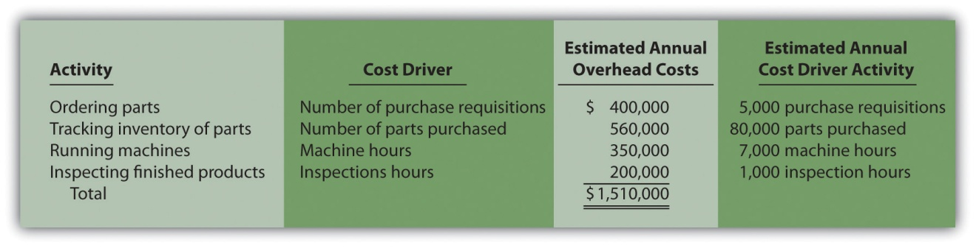
The company produces three products, Z1, Z2, and Z3. Information about these products for the month of January follows:
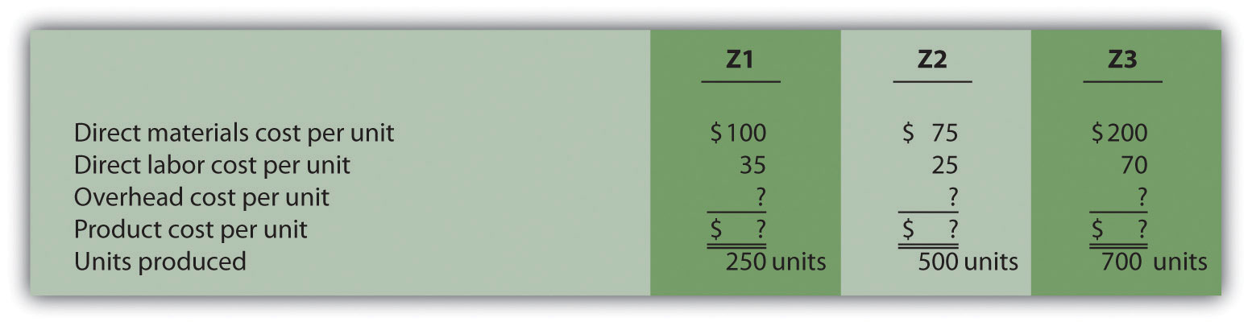
Actual cost driver activity levels for the month of January are as follows:
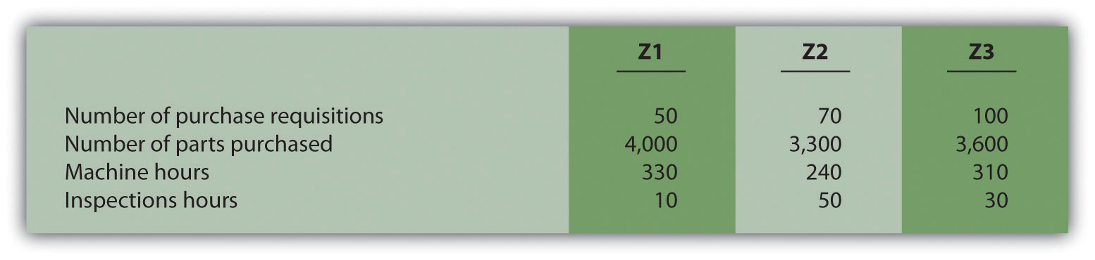
Required:
  - Using the estimates for the year, compute the predetermined overhead rate for each activity (this is step 4 of the activity-based costing process).
  - Using the activity rates calculated in requirement a and the actual cost driver activity levels shown for January, allocate overhead to the three products for the month of January (this is step 5 of the activity-based costing process).
  - For each product, calculate the overhead cost per unit for the month of January. Round results to the nearest cent.
  - For each product, calculate the product cost per unit for the month of January. Round results to the nearest cent.
- Journal Entry to Apply Overhead. Caspian Company is deciding which of three approaches it should use to apply overhead to products. Information for each approach is provided in the following.
  - One plantwide rate. The predetermined overhead rate is 150 percent of direct labor cost.
  - Department rates. The Machining department uses a rate of $55 per machine hour, and the Assembly department uses a rate of $35 per direct labor hour.
  - Activity-based costing rates. Three activities were identified and rates were calculated for each activity.
Purchase requisitions | $15 per requisition processed
Production setup | $50 per setup
Quality control | $70 per inspection
  - Required:
  - Direct labor costs for the year totaled $80,000. Using the plantwide method, calculate the amount of overhead applied to products and make the appropriate journal entry.
  - During the year, the Machining department used 1,000 machine hours, and the Assembly department used 1,200 direct labor hours. Using the department method, calculate the amount of overhead applied to products and make the appropriate journal entry.
  - During the year, 900 purchase requisitions were processed, 1,300 production setups were performed, and 400 products were inspected. Using the activity-based costing approach, calculate the amount of overhead applied to products, and make the appropriate journal entry.
- Allocating Service Department Costs. Crandall Company has two production departments (P1 and P2) and three service departments (S1, S2, and S3). Service department costs are allocated to production departments using the direct method. The $400,000 costs of department S1 are allocated based on the number of employees in each production department. The $600,000 costs of department S2 are allocated based on the square footage of space occupied by each production department. The $300,000 costs of department S3 are allocated based on hours of computer support used by each production department. Information for each production department follows.
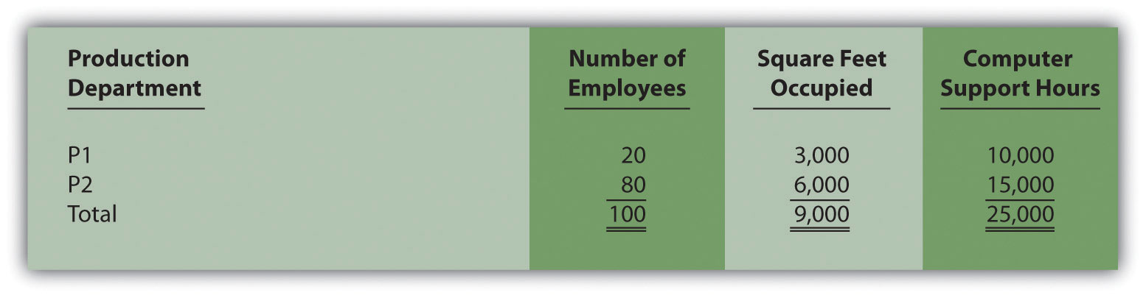
Required:
  - Calculate the service department costs allocated to each production department.
  - In general, do U.S. Generally Accepted Accounting Principles allow for the allocation of service department costs to production departments for the purpose of valuing inventory?
- Cost Hierarchy. The following activities and costs are for Tanaka Company.
  - Direct materials used by workers to assemble products
  - Purchase requisitions issued for raw materials
  - Machines set up to produce groups of products
  - New product research and development
  - Maintenance performed on the factory building
  - Direct labor assembling products
  - Product designed for a specific customer
  - Factory building rent
Required:
  - Determine whether each item is a facility-level, product- or customer-level, batch-level, or unit-level cost.
  - Provide one example of an appropriate allocation base for each item. (For instance, an appropriate allocation base for item 1 is the quantity of direct materials used.)
Exercises: Set B
- Plantwide Versus Department Allocations of Overhead: Service Company. Chan and Associates provides wetlands design and maintenance services for its customers, most of whom are developers. Billing is based on costs plus a 30 percent markup. Thus costs are allocated to customers rather than to products.
Total overhead costs this coming year are expected to be $2,000,000 ($600,000 in the Design department and $1,400,000 in the Wetlands Maintenance department). Direct labor costs are expected to total $800,000 (used for the plantwide rate). The Design department expects to incur direct labor costs of $500,000, and the Wetlands Maintenance department expects to work 30,000 direct labor hours (this information is used for the department rates).
Required:
  - Assume Chan and Associates uses the plantwide approach to allocating overhead costs and direct labor costs as the allocation base. Calculate the predetermined overhead rate, and explain how this rate will be used to allocate overhead costs. Round results to the nearest cent.
  - Assume Chan and Associates uses the department approach for allocating overhead costs. Calculate the predetermined overhead rate for each department, and explain how these rates will be used to allocate overhead costs. Round results to the nearest cent.
  - What are two possible interpretations of the term costs in the following statement? “Customers are billed based on costs plus a 30 percent markup.”
- Computing Product Costs Using Activity-Based Costing. Petrov Company identified the following activities, estimated costs for each activity, and identified cost drivers for each activity for this coming year. (These are the first three steps of activity-based costing.)
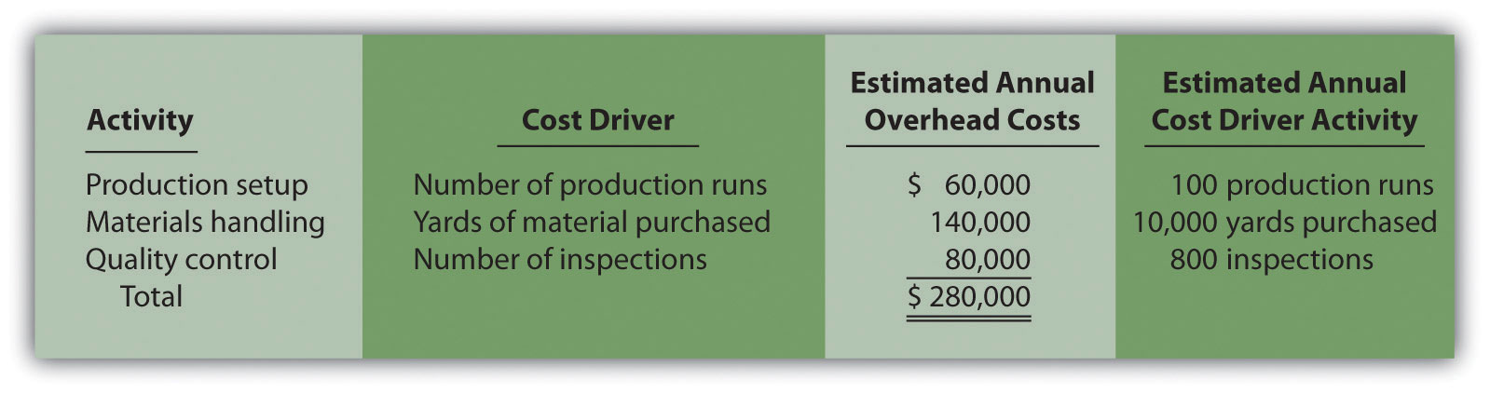
The company produces two products, MX1 and MX2. Information about these products for the month of March follows:
Actual cost driver activity levels for the month of March are as follows:
Required:
  - Using the estimates for the year, compute the predetermined overhead rate for each activity (this is step 4 of the activity-based costing process).
  - Using the activity rates calculated in requirement a and the actual cost driver activity levels shown for March, allocate overhead to the three products for the month of March (this is step 5 of the activity-based costing process).
  - For each product, calculate the overhead cost per unit for the month of March. Round results to the nearest cent.
  - For each product, calculate the product cost per unit for the month of March. Round results to the nearest cent.
- Journal Entry to Apply Overhead, Closing Overhead Account.Premium Products, Inc., is deciding which of three approaches it should use to apply overhead to products. Information for each approach is provided as follows.
  - One plantwide rate. The predetermined overhead rate is $130 per direct labor hour.
  - Department rates. The Cutting department uses a rate of 200 percent of direct labor cost, and the Finishing department uses a rate of $50 per machine hour.
  - Activity-based costing rates. Three activities were identified, and rates were calculated for each activity.
Materials handling | $8 per pound of material purchased
Production setup | $60 per setup
Quality control | $110 per batch inspected
  - Required:
  - Direct labor hours totaled 2,000 for the year. Using the plantwide method, calculate the amount of overhead applied to products, and make the appropriate journal entry.
  - During the year, the Cutting department incurred $80,000 in direct labor costs, and the Finishing department used 1,800 machine hours. Using the department method, calculate the amount of overhead applied to products, and make the appropriate journal entry.
  - During the year, 6,000 pounds of material were purchased, 1,600 production setups were performed, and 1,300 batches of products were inspected. Using the activity-based costing approach, calculate the amount of overhead applied to products, and make the appropriate journal entry.
  - Premium Products, Inc., closes overapplied or underapplied overhead to the cost of goods sold account at the end of each year. Prepare the journal entry to close the manufacturing overhead account at the end of the year for each of the following independent scenarios assuming the company made the journal entry to apply overhead in requirement c.
    - The company recorded $302,500 in actual overhead costs for the year.
    - The company recorded $243,000 in actual overhead costs for the year.
- Allocating Service Department Costs. Southwest, Inc., has two production departments (P1 and P2) and three service departments (S1, S2, and S3). Service department costs are allocated to production departments using the direct method. The $800,000 costs of department S1 are allocated based on the number of employees in each production department. The $300,000 costs of department S2 are allocated based on the square footage of space occupied by each production department. The $600,000 costs of department S3 are allocated based on hours of computer support used by each production department. Information for each production department follows.
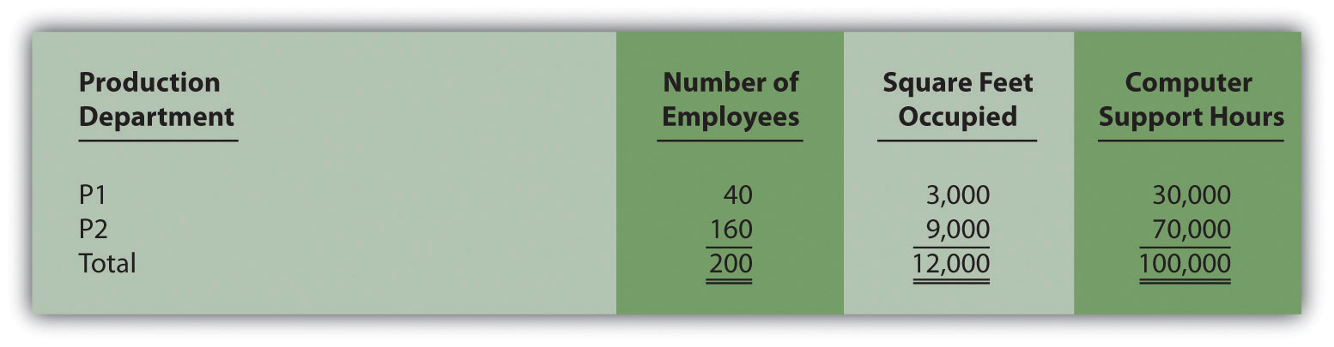
Required:
  - Calculate the service department costs allocated to each production department.
  - In general, do U.S. Generally Accepted Accounting Principles allow for the allocation of service department costs to production departments for the purpose of valuing inventory?
- Cost Hierarchy. The following activities and costs are for Rios Corporation.
  - Salary of a supervisor responsible for one product line
  - Moving groups of products to the finished goods warehouse upon completion
  - New product design
  - Factory building depreciation
  - Direct materials used by workers to assemble products
  - Machines set up to produce groups of products
  - Product designed for a specific customer
  - Maintenance performed on the factory building
Required:
  - Determine whether each item is a facility-level, product- or customer-level, batch-level, or unit-level cost.
  - Provide one example of an appropriate allocation base for each item.
Problems
- Activity-Based Costing Versus Traditional Approach. Techno Company produces a regular computer monitor that sells for $175 and a flat panel computer monitor that sells for $300. Last year, total overhead costs of $3,675,000 were allocated based on direct labor hours. A total of 63,000 direct labor hours were required last year to build 36,000 regular monitors (1.75 hours per unit), and 42,000 direct labor hours were required to build 12,000 flat panel monitors (3.50 hours per unit). Total direct labor and direct materials costs for last year were as follows:
 | Regular Monitor | Flat Panel Monitor
Direct materials | $1,908,000 | $ 900,000
Direct labor | $1,728,000 | $1,200,000
- The management of Techno Company would like to use activity-based costing to allocate overhead rather than one plantwide rate based on direct labor hours. The following estimates are for the activities and related cost drivers identified as having the greatest impact on overhead costs.
- 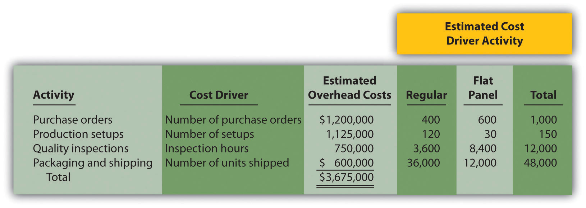
- Required:
  - Calculate the direct materials cost per unit and direct labor cost per unit for each product.

    - Using the plantwide allocation method, calculate the predetermined overhead rate and determine the overhead cost per unit allocated to the regular and flat panel products.
    - Using the plantwide allocation method, calculate the product cost per unit for the regular and flat panel products. Round results to the nearest cent.

    - Using the activity-based costing allocation method, calculate the predetermined overhead rate for each activity. (Hint: Step 1 through step 3 in the activity-based costing process have already been done for you; this is step 4.)
    - Using the activity-based costing allocation method, allocate overhead to each product. (Hint: This is step 5 in the activity-based costing process.) Determine the overhead cost per unit. Round results to the nearest cent.
    - What is the product cost per unit for the regular and flat panel products?
  - Calculate the per unit profit for each product using the plantwide approach and the activity-based costing approach.
  - How much did the profit per unit change for each product when moving from the plantwide approach to the activity-based costing approach? What caused this change?
- Activity-Based Costing Versus Traditional Approach, Activity-Based Management. Quality Furniture, Inc., produces a wood desk that sells for $500 and a wood table that sells for $900. Last year, total overhead costs of $6,000,000 were allocated based on direct labor costs. Direct labor costs totaled $2,000,000 last year, and Quality Furniture produced 15,000 desks and 5,000 tables. Total direct labor and direct materials costs by product for last year were as follows:
 | Desk | Table
Direct materials | $1,575,000 | $950,000
Direct labor | $1,200,000 | $800,000
- The management of Quality Furniture would like to use activity-based costing to allocate overhead rather than one plantwide rate based on direct labor costs. The following estimates are for the activities and related cost drivers identified as having the greatest impact on overhead costs.
- 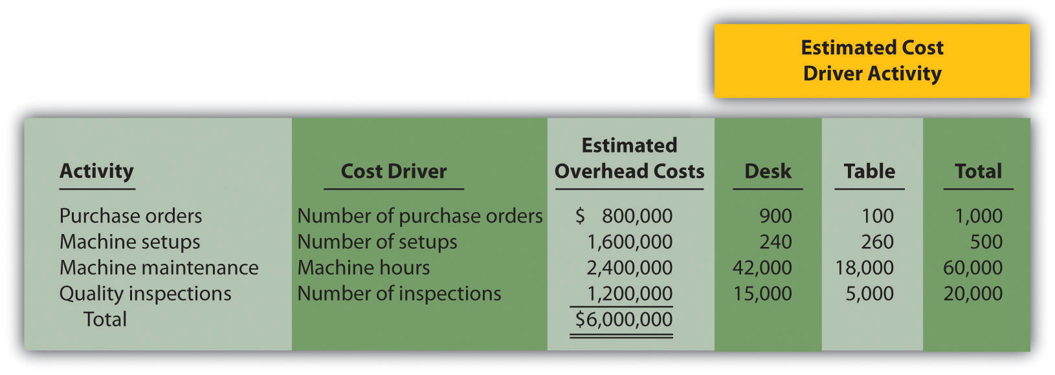
- Required:
  - Calculate the direct materials cost per unit and direct labor cost per unit for each product.

    - Using the plantwide allocation method, calculate the predetermined overhead rate and determine the overhead cost per unit allocated to the desk and table products.
    - Using the plantwide allocation method, calculate the product cost per unit for the desk and table products. Round results to the nearest cent.

    - Using the activity-based costing allocation method, calculate the predetermined overhead rate for each activity. (Hint: Step 1 through step 3 in the activity-based costing process have already been done for you; this is step 4.)
    - Using the activity-based costing allocation method, allocate overhead to each product. (Hint: This is step 5 in the activity-based costing process.) Determine the overhead cost per unit. Round results to the nearest cent.
    - What is the product cost per unit for the desk and table products?
  - Calculate the per unit profit for each product using the plantwide approach and the activity-based costing approach. How much did the per unit profit change when moving from one approach to the other?
  - Refer to the estimated cost driver activity provided. Calculate the percent of each activity consumed by each product (e.g., the desk product issued 900 of the 1,000 purchase orders issued in total and therefore consumes 90 percent of this activity). These percentages represent the amount of overhead costs allocated to each product using activity-based costing. Using the plantwide approach, 60 percent of all overhead costs are allocated to the desk and 40 percent to the table. Compare the activity-based costing percentages to the percentage of overhead allocated to each product using the plantwide approach. Use this information to explain what caused the shift in overhead costs to the desk product using activity-based costing.
- Calculating and Recording Overhead Applied. Assume Quality Furniture, Inc., discussed in Problem 41, uses activity-based costing.
Required:
  - Using the data presented at the beginning of Problem 41, calculate the predetermined overhead rate for each activity.
  - The following activity associated with the desk product was reported for the month of March.
Number of purchase orders processed | 40
Number of machine setups | 22
Number of machine hours | 2,425
Number of quality inspections | 890
  - Using the predetermined overhead rates calculated in requirement a, determine the amount of overhead applied to the desk product for the month of March.
  - Make the journal entry to record overhead applied to the desk product for the month of March.
  - Assume you are the manager of the desk product line and would like to reduce the amount of overhead costs being applied to your products. Which activity would you focus on first? Why?
- Computing Product Costs Using Activity-Based Costing, Service Company. Roseville Community Bank uses activity-based costing to assign overhead costs to two different loan products—student loans and auto loans. The bank identified the following activities, estimated costs for each activity, and identified cost drivers for each activity for this coming year. (These are the first three steps of activity-based costing.)
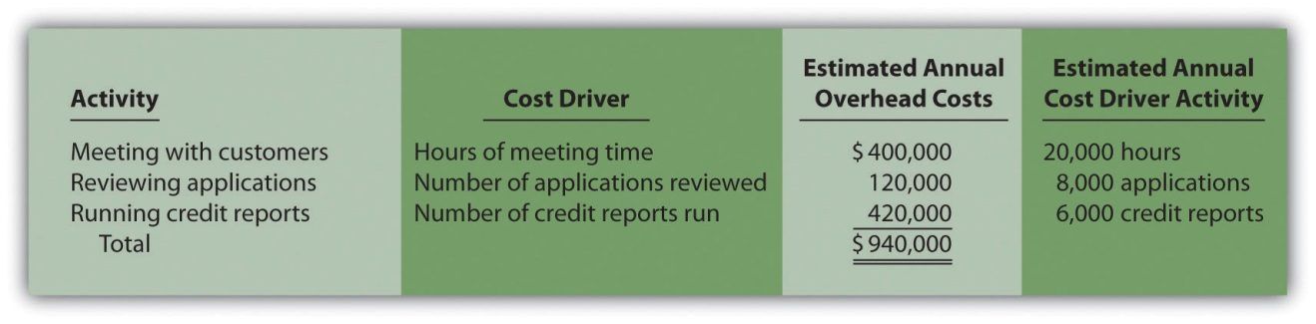
The following information for the two loan products offered by Roseville Community Bank is for the month of July:
Actual cost driver activity levels for the month of July are as follows:
Required:
  - Using the estimates for the year, compute the predetermined overhead rate for each activity (this is step 4 of the activity-based costing process).
  - Using the activity rates calculated in requirement a and the actual cost driver activity levels shown for July, allocate overhead to the two products for the month of July.
  - For each loan product, calculate the overhead cost per loan approved for the month of July. Round results to the nearest cent.
  - For each loan product, calculate the total cost per loan approved for the month of July. Round results to the nearest cent.
  - Assume you are the manager of the auto loans product line and would like to reduce the amount of overhead costs being applied to your products. Which activity would you focus on first? Why?
- Activity-Based Costing Versus Traditional Approach: Service Company, Activity-Based Management. Hodges and Associates is a small firm that provides structural engineering services for its clients. The company performs structural engineering services for both residential and commercial buildings. Last year, total overhead costs of $330,000 were allocated based on direct labor costs. A total of $300,000 in direct labor costs were incurred in the following areas: $120,000 in the residential segment and $180,000 in the commercial segment. Direct materials used were negligible and are included in overhead costs. Sales revenue totaled $450,000 for residential services and $330,000 for commercial services.
The management of Hodges and Associates would like to use activity-based costing to allocate overhead rather than a plantwide rate based on direct labor costs. The following estimates are for the activities and related cost drivers identified as having the greatest impact on overhead costs.
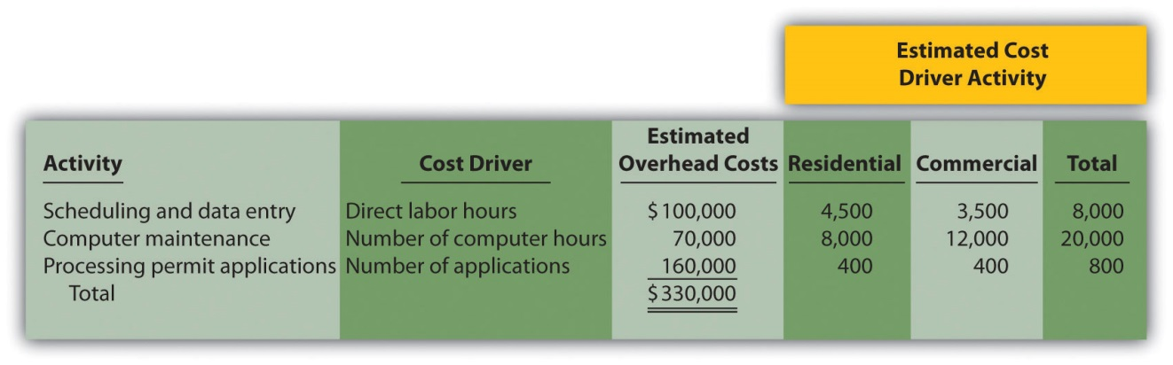
Required:

    - Using the plantwide allocation method, calculate the total cost for each product. (Hint: Product costs for this company include overhead and direct labor.)
    - Using the plantwide approach, calculate the profit for each product. Also calculate profit as a percent of sales revenue for each product (round to the nearest tenth of a percent).

    - Using activity-based costing, calculate the predetermined overhead rate for each activity. (Hint: Step 1 through step 3 in the activity-based costing process have already been done for you; this is step 4.) Round results to the nearest cent.
    - Using activity-based costing, calculate the amount of overhead assigned to each product. (Hint: This is step 5 in the activity-based costing process.)
    - Using activity-based costing, calculate the profit for each product. Also calculate profit as a percent of sales revenue for each product (round to the nearest tenth of a percent).
  - What caused the shift of overhead costs to the residential product using activity-based costing? How might management use this information to make improvements within the company?
- Calculating and Recording Overhead Applied: Service Company.Assume Hodges and Associates, discussed in Problem 44, uses activity-based costing.
Required:
  - Using the data presented at the beginning of Problem 44, calculate the predetermined overhead rate for each activity. Round results to the nearest cent.
  - The following activity associated with the commercial product was reported for the month of September.
Number of direct labor hours | 350
Number of computer hours | 960
Number of applications | 50
  - Using the predetermined overhead rates calculated in requirement a, determine the amount of overhead applied to the commercial product for the month of September.
  - Make the journal entry to record overhead applied to the commercial product for the month of September.
  - Assume you are manager of the commercial product line and would like to reduce the amount of overhead costs being applied to your products. Which activity would you focus on first? Why?
- Allocating Service Department Costs. Szabo Industries has two production departments (Finishing and Painting) and three service departments (Maintenance, Computer Support, and Personnel). Service department costs are allocated to production departments using the direct method. Maintenance allocates costs totaling $3,000,000 based on the square footage of space occupied by each production department. Computer Support allocates costs totaling $4,000,000 based on hours of computer support used by each production department. Personnel allocates costs totaling $2,500,000 based on number of employees in each production department. Information for each production department follows.
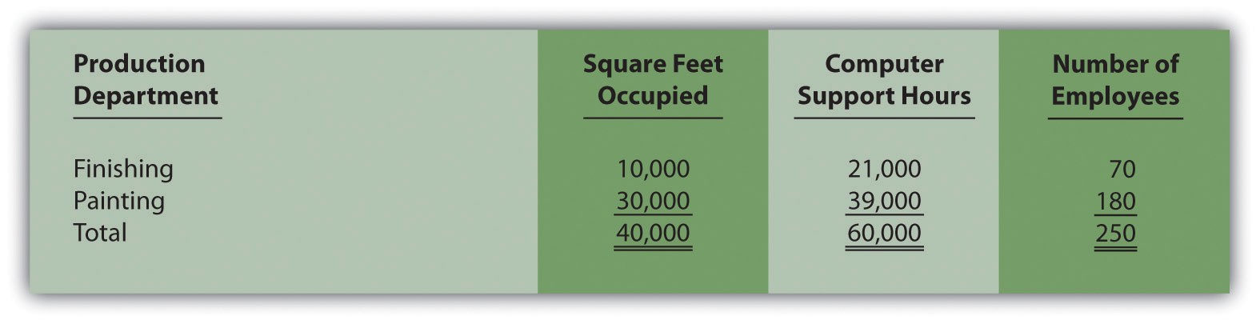
Required:
  - Calculate the service department costs allocated to each production department.
  - Why do companies allocate service department costs to production departments?
- Selecting an Allocation Base for Service Costs. Winstead, Inc., is looking for an appropriate allocation base to allocate personnel costs totaling $5,000,000. Service department costs are allocated to three production departments: Assembly, Sanding, and Finishing. Management is considering two allocation bases.
Possible Allocation Base | Assembly | Sanding | Finishing
Number of employees | 30 | 20 | 50
Square feet of space occupied | 25,000 | 15,000 | 10,000
- Required:
  - Calculate the amount of personnel department costs allocated to production departments using each allocation base.
  - Which allocation base do you think is most reasonable? Why?
One Step Further: Skill-Building Cases
- Overhead Allocation. Do you agree with the following statement? Explain your answer.
Total estimated overhead costs will vary depending on whether we use the plantwide method, department method, or activity-based costing to allocate overhead.
- Cost Allocation Issues. Assume you rent a house with two friends. The total monthly rent is $1,500. Your bedroom is the smallest of the three bedrooms, and each of the others has a bathroom attached. You and your friends are trying to decide how to divide up the rent. Two possibilities are being discussed.
  - Share the cost equally among the three of you.
  - Determine rent based on square feet occupied (the attached bathrooms would be part of the square footage measurement).
Required:
  - Which approach do you think is most fair for all involved? Why?
  - Which approach is easiest? Why?
  - Suggest another approach to dividing up the cost of rent.
- Activity-Based Costing and Activity-Based Management. A colleague states, “We produce one product, and our operations are relatively simple. Activity-based costing and activity-based management would be a waste of time for our company!” Do you agree with this statement? Explain.
- Product Costs. The company president makes the following statement: “Product costs are straightforward. Whatever costs are incurred to produce a product are assigned to that product.” Do you agree with this statement? Explain.
- Changing Plantwide Allocation Rate at SailRite. Recall from the chapter discussion that SailRite uses one plantwide rate based on direct labor hours to allocate manufacturing overhead costs to the company’s two sailboat products—Basic and Deluxe. Management was concerned about the inaccuracy of overhead costs being assigned to each product and decided to calculate product costs using activity-based costing. Product cost and profit results are summarized in the following for the plantwide allocation approach (based on direct labor hours) and activity-based costing approach. This information was presented in the chapter in Figure 3.7 "Activity-Based Costing Versus Plantwide Costing at SailRite Company".
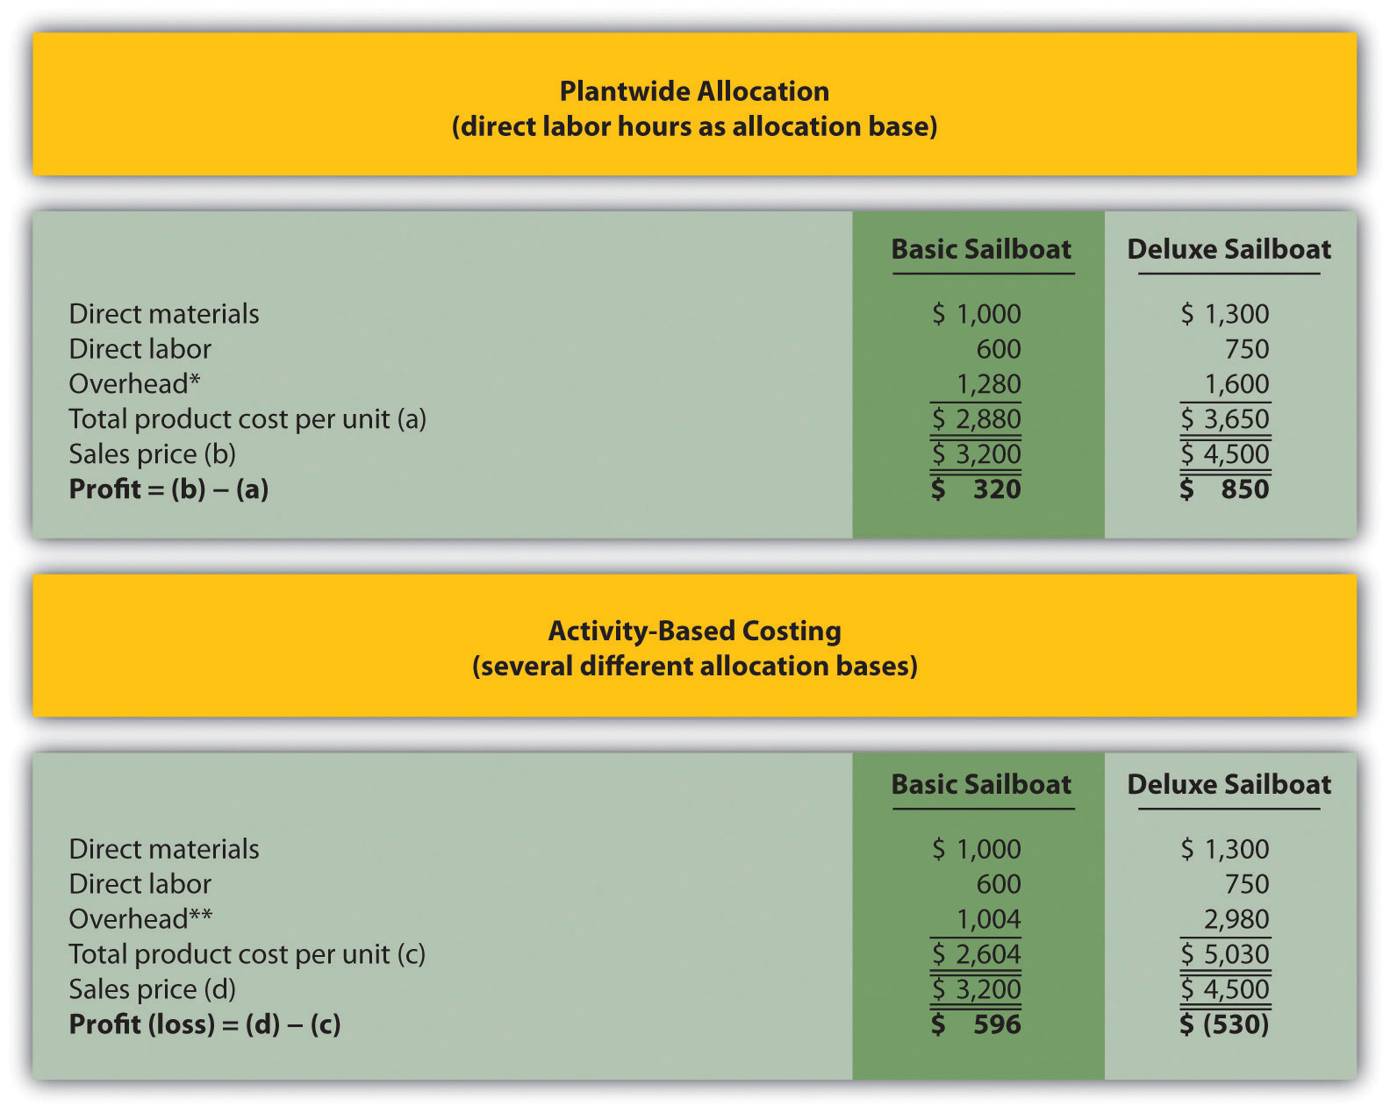
*Overhead taken from Figure 3.2 "SailRite Company Product Costs Using One Plantwide Rate Based on Direct Labor Hours".
**Overhead taken from Figure 3.5 "Allocation of Overhead Costs to Products at SailRite Company".
Although management of SailRite prefers the accuracy of activity-based costing, the cost of maintaining such an accounting system for the long term is prohibitive. John, the accountant, has proposed going back to using one plantwide rate, but he would like to allocate overhead costs using machine hours rather than direct labor hours.
Recall that overhead costs totaled $8,000,000. A total of 90,000 machine hours were used for the period: 50,000 for Basic sailboats and 40,000 for Deluxe sailboats. The company produced 5,000 units of the Basic model and 1,000 units of the Deluxe model. Thus the Basic model uses 10 machine hours per unit (= 50,000 machine hours ÷ 5,000 units) and the Deluxe model uses 40 machine hours per unit (= 40,000 machine hours ÷ 1,000 units).
Required:
  - Calculate the predetermined overhead rate using machine hours as the allocation base, and determine the overhead cost per unit allocated to the Basic and Deluxe sailboats. Round results to the nearest cent.
  - For each product, calculate the unit product cost and profit using the same format presented previously. Round results to the nearest cent.
  - Compare your results in requirement b to the results using direct labor hours as the allocation base and activity-based costing.
  - Provide at least two reasons why management might prefer machine hours as the overhead allocation base rather than direct labor hours or activity-based costing.
- Service Department Cost Allocation. Biotech, Inc., recently began providing cafeteria services to its employees. Because revenue from the sale of food at the cafeteria does not fully cover cafeteria expenses, Biotech must pay for the shortfall. These costs are allocated to production departments based on employee usage. That is, the company tracks which employees use the cafeteria and allocates costs to production departments accordingly.
Sarah Kolster, manager of the quality testing department, is not happy with receiving cafeteria cost allocations. She is evaluated based on meeting a cost budget established at the beginning of the fiscal year, which does not include the cafeteria allocation, and she clearly has an incentive to minimize costs.
When Sarah met with the company’s accountant, Dan, regarding this issue, she said, “Dan, I like the idea of providing cafeteria service to our employees, but the costs allocated to my department are killing my budget. Last month alone, I was allocated $3,000 in costs related to the new cafeteria. I have no choice but to require my employees to go elsewhere for food.”
Dan responded, “I understand your concern, Sarah. Management’s intent was to provide a service to our employees that would improve productivity and reward employees for their hard work. If you tell your employees to stop using the cafeteria, more costs will be allocated to other departments, and the other departments might also stop using the cafeteria. My belief is that the cafeteria will be self-sufficient within a year if more employees are encouraged to use it. This translates into no more cost allocations to departments within a year. I’ll discuss your concerns with top management later this week.”
Required:
  - Why does Biotech, Inc., allocate cafeteria costs to departments?
  - What recommendations would you make to top management regarding the way cafeteria costs are allocated to departments?
Comprehensive Case
- Activity-Based Costing, Journal Entries, T-Accounts, and Preparing an Income Statement. This problem is an adaptation of the example presented at the end of Chapter 2 "How Is Job Costing Used to Track Production Costs?" for Custom Furniture Company. The only difference is that this problem uses activity-based costing to allocate overhead costs rather than one plantwide rate. Recall that inventory beginning balances were $25,000 for raw materials inventory, $35,000 for work-in-process inventory, and $90,000 for finished goods inventory.
Management of Custom Furniture Company would like to use activity-based costing to allocate overhead costs totaling $1,140,000 rather than one plantwide rate based on direct labor hours. The following estimates are for the activities and related cost drivers identified as having the greatest impact on overhead costs.
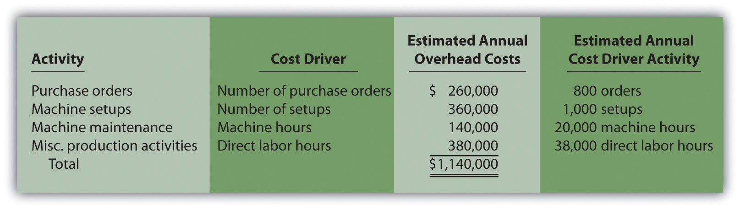
Transactions for the month of May are shown as follows:
  - Raw materials were purchased during the month for $15,000 on account.
  - Raw materials totaling $21,000 were placed in production: $3,000 for indirect materials (glue, screws, nails, and the like) and $18,000 for direct materials (wood planks, hardware, etc.).
  - Timesheets from the direct labor workforce show total costs of $40,000, to be paid the next month.
  - Production supervisors and other indirect labor working in the factory are owed wages totaling $27,000.
  - The following costs were incurred related to the factory: building depreciation of $29,000, insurance of $11,000 (originally recorded as prepaid insurance), utilities of $4,000 (to be paid the next month), and maintenance costs of $22,000 (paid immediately).
  - Manufacturing overhead is applied to products based on the following cost driver activity for the month:
Number of purchase orders | 75
Number of machine setups | 120
Machine hours | 1,850
Direct labor hours | 3,240
  - The following selling costs were incurred: wages of $5,000 (to be paid the next month), building rent of $3,000 (originally recorded as prepaid rent), and advertising totaling $10,000 (to be paid the next month).
  - The following general and administrative (G&A) costs were incurred: wages of $13,000 (to be paid the next month), equipment depreciation of $6,000, and building rent of $7,000 (originally recorded as prepaid rent).
  - Completed goods costing $155,000 were transferred out of work-in-process inventory.
  - Sold goods for $100,000 on account and $90,000 cash.
  - The goods sold in the previous transaction had a cost of $129,000.
  - Closed the manufacturing overhead account to cost of goods sold.
Required:
  - Calculate the predetermined overhead rate for each activity.
  - Prepare T-accounts for the following accounts: cash, accounts receivable, prepaid insurance, prepaid rent, raw materials inventory, work-in-process inventory, finished goods inventory, accumulated depreciation (building and equipment), accounts payable, wages payable, manufacturing overhead, sales, cost of goods sold, advertising expense (selling), rent expense (selling), wages expense (selling), depreciation expense (G&A), rent expense (G&A), and wages expense (G&A). Enter beginning balances in T-accounts for the inventory accounts (raw materials, work in process, and finished goods).
  - Prepare a journal entry for each of the transactions 1through 11, and post each entry to the T-accounts set up in requirement b. Label each entry in the T-accounts by transaction number, and total each T-account.
  - Is overhead underapplied or overapplied for the month of May? Based on the balance in the manufacturing overhead T-account prepared in requirement c, prepare a journal entry for transaction 12.
  - Prepare an income statement for the month of May. (Hint: Be sure to include the adjustment made to cost of goods sold in requirement d.)
[1] Credit for developing the cost hierarchy is generally given to R. Cooper and R. S. Kaplan, “Profit Priorities from Activity-Based Costing,” Harvard Business Review, May 1991, 130–35.

Chapter 4

How Is Process Costing Used to Track Production Costs?

Ann Watkins owns and operates a company that mass produces wood desks used in classrooms throughout the world. Ann’s company, Desk Products, Inc., maintains an advantage over its competitors by producing one desk in large quantities—4,000 to 8,000 desks per month—using a universally accepted design. This enables the company to buy materials in bulk, often leading to volume price discounts from suppliers. Because the exact same desk is produced for all customers, Desk Products purchases precut wood materials from suppliers. As a result, Desk Products can limit the production process to two processing departments—Assembly and Finishing. The Assembly department requisitions precut materials and hardware from the raw materials storeroom, assembles each desk, and moves the assembled desks to the Finishing department. The Finishing department sands and paints each desk and moves completed desks to the finished goods warehouse.

A new competitor recently began producing a similar desk, and Ann is concerned about whether Desk Products’ production costs are reasonable. In particular, Ann is concerned about the costs in the Assembly department since this department is responsible for the majority of the company’s production costs. Ann talks with the accountant at Desk Products, John Fuller, to investigate.

Ann: | John, as you know, we have a new competitor that is aggressively going after our customers. It looks as if we will have to focus on keeping costs low to compete. The Assembly department is my biggest concern, and it would help if I knew the cost of each desk that goes through this department.
John: | Although we don’t track production costs for each desk individually, we do use a process costing system that assigns costs to each batch of desks produced. This system enables us to calculate a cost per unit as the products move through the Assembly department.
Ann: | Excellent! Can you get me the cost information for the Assembly department for last month?
John: | Sure, I’ll put together a production cost report for you by the end of the week.

We return to Desk Products, Inc., throughout the chapter to explain how process costing systems work.

4.1 Comparison of Job Costing with Process Costing

LEARNING OBJECTIVE
- Compare and contrast job costing and process costing.

Question: A process costing system is used by companies that produce similar or identical units of product in batches employing a consistent process. Examples of companies that use process costing include Chevron Corporation(petroleum products), the Wrigley Company (chewing gum), and Pittsburgh Paints (paint). A job costing system is used by companies that produce unique products or jobs. Examples of companies that use job costing systems include Boeing (airplanes), Lockheed Martin (advanced technology systems), and Deloitte & Touche (accounting). What are the similarities and differences between job costing and process costing systems?

Answer: Although these systems have marked differences, they are also similar in many ways. (As you read through this section, refer to Chapter 1 "What Is Managerial Accounting?" for a review of important terms if necessary.) Recall the three inventory accounts that accountants use to track product cost information—raw materials inventory, work-in-process inventory, and finished goods inventory. These three inventory accounts are used to record product cost information for both process costing and job costing systems. However, several work-in-process inventory accounts are typically used in a process costing system to track the flow of product costs through each production department. Thus each department has its own work-in-process inventory account. (For the purposes of this chapter, assume each department represents a production process. This explains the term process costing because we are tracking costs by process.) The sum of all work-in-process inventory accounts represents total work in process for the company.

Recall the three components of product costs—direct materials, direct labor, and manufacturing overhead. Assigning these product costs to individual products remains an important goal for process costing, just as with job costing. However, instead of assigning product costs to individual jobs(shown on a job cost sheet), process costing assigns these costs to departments (shown on a departmental production cost report).

Figure 4.1 "A Comparison of Cost Flows for Job Costing and Process Costing"shows how product costs flow through accounts for job costing and process costing systems. Table 4.1 "A Comparison of Process Costing and Job Costing"outlines the similarities and differences between these two costing systems. Review these illustrations carefully before moving on to the next section.

Figure 4.1 A Comparison of Cost Flows for Job Costing and Process Costing
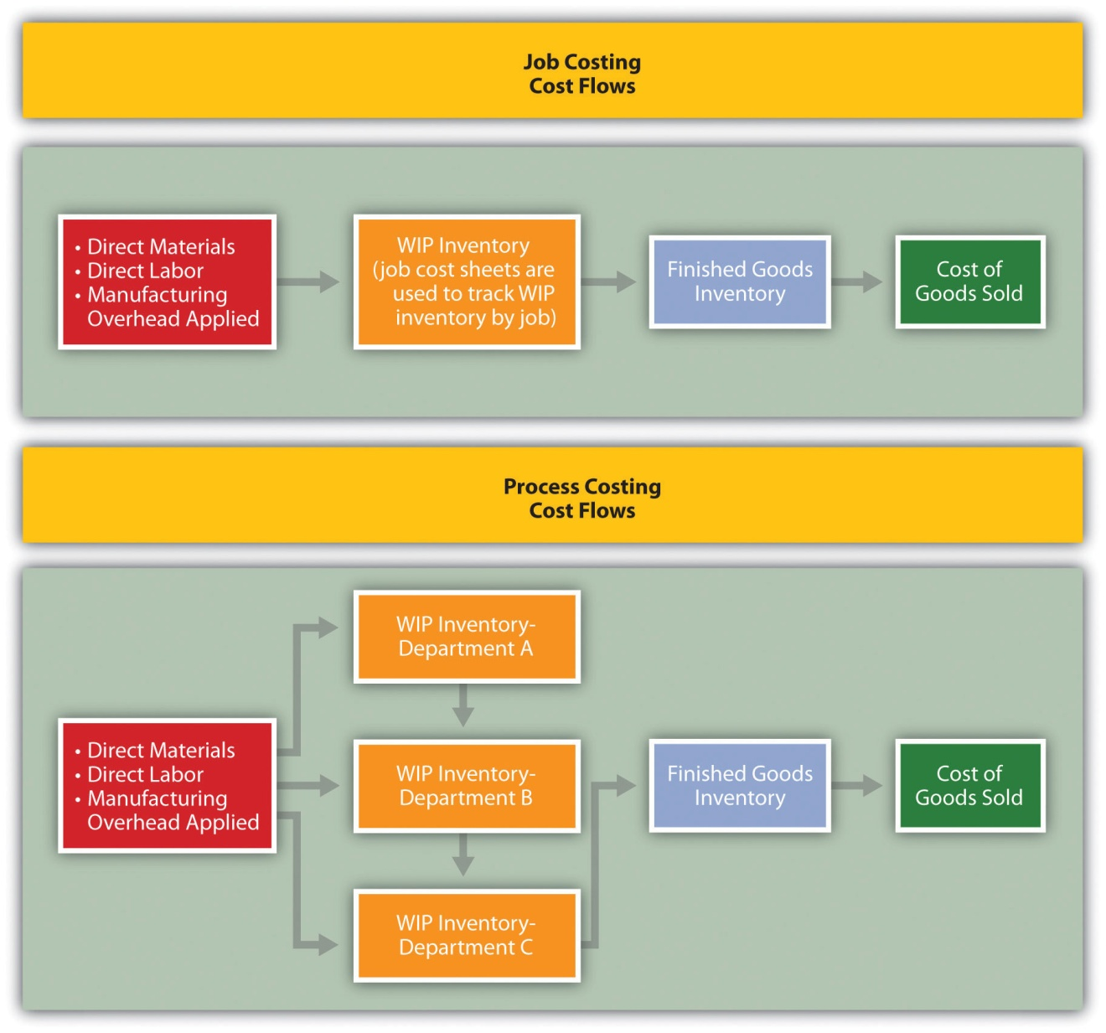
Table 4.1 A Comparison of Process Costing and Job Costing
Product Costs
Similarities | Product costs consist of direct materials, direct labor, and manufacturing overhead.
Differences | Process Costing | Job Costing
 | Product costs are assigned to departments (or processes). | Product costs are assigned to jobs.
Unit Cost Information
Similarities | Unit cost information is needed by management for decision-making purposes.
Differences | Process Costing | Job Costing
 | Unit cost information comes from the departmental production cost report. | Unit cost information comes from the job cost sheet.
Inventory Accounts
Similarities | Inventory accounts include raw materials inventory, work-in-process inventory, and finished goods inventory.
Differences | Process Costing | Job Costing
 | Several different work-in-process inventory accounts are used—one for each department (or process). | One work-in-process inventory account is used—job cost sheets track costs assigned to each job.

Business in Action 4.1
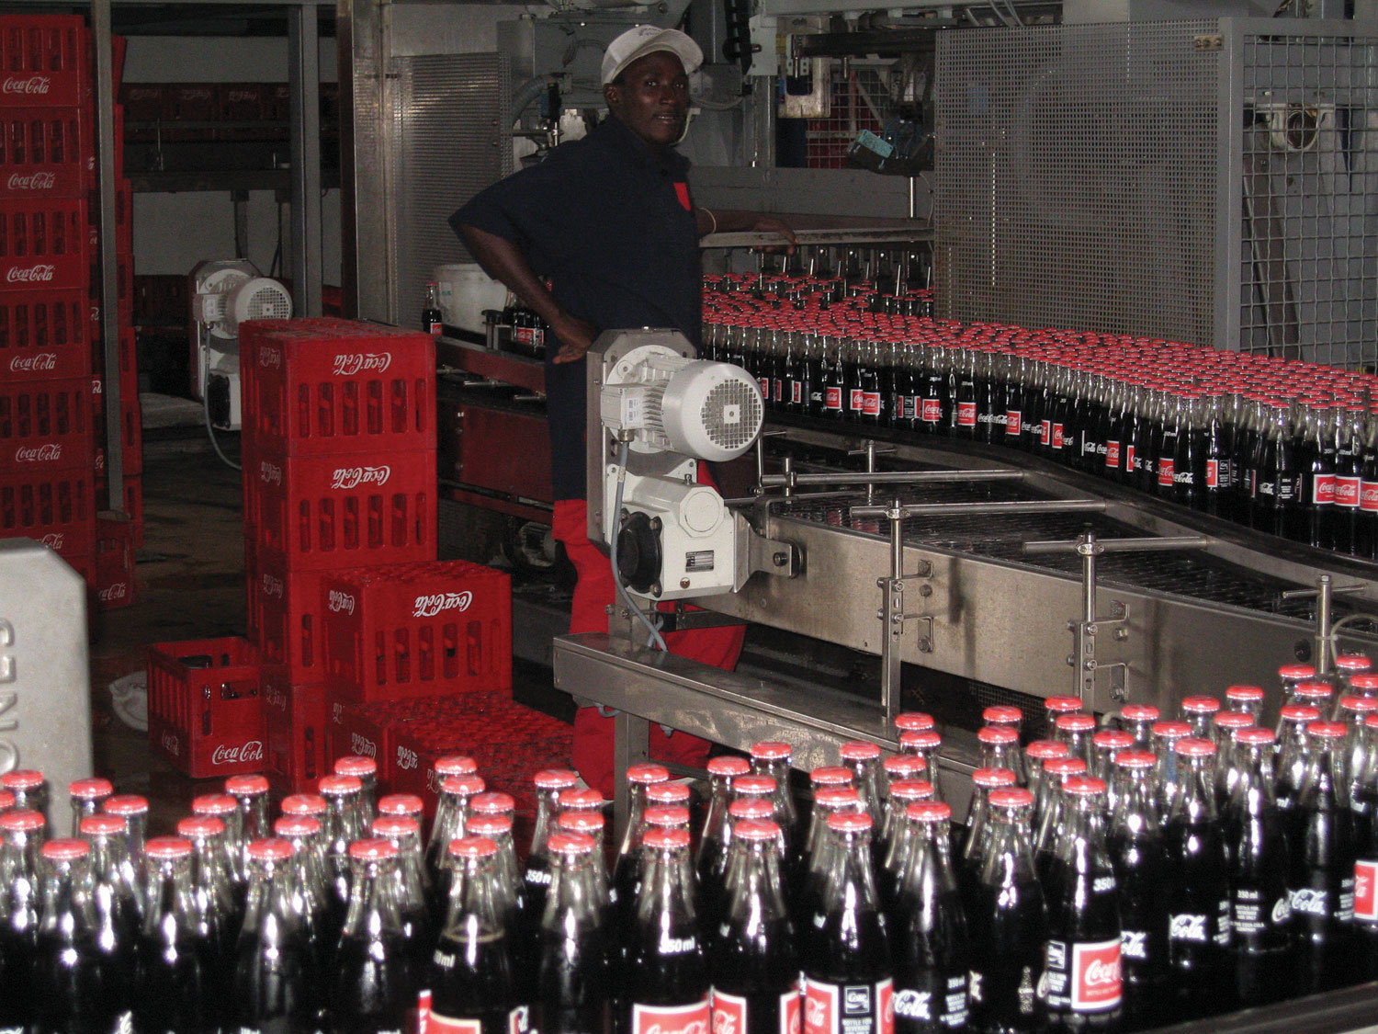
Source: Photo courtesy of Simon Berry,http://www.flickr.com/photos/bezznet/3105213435/.
The Production Process at Coca-Cola
The Coca-Cola Company is one of the world’s largest producers of nonalcoholic beverages. According to the company, more than 11,000 of its soft drinks are consumed every second of every day.
In the first stage of production, Coca-Cola mixes direct materials—water, refined sugar, and secret ingredients—to make the liquid for its beverages. The second stage includes filling cleaned and sanitized bottles before placing a cap on each bottle. In the third stage, filled bottles are inspected, labeled, and packaged.
Work in process begins with the first stage of production (mixing and blending), continues with the second stage (bottling), and ends with the third stage (inspecting, labeling, and packaging). When products have gone through all three stages of production, they are shipped to a warehouse, and the costs are entered into finished goods inventory. Once products are delivered to retail stores, product costs are transferred from finished goods inventory to cost of goods sold.
Source: Coca-Cola Company, “Home Page,” http://www2.coca-cola.com/ourcompany/bottlingtoday.

KEY TAKEAWAY
- A process costing system is used by companies that produce similar or identical units of product in batches employing a consistent process. A job costing system is used by companies that produce unique products or jobs. Process costing systems track costs by processing department, whereas job costing systems track costs by job.

REVIEW PROBLEM 4.1
Identify whether each business listed in the following would use job costing or process costing.
- Trash bag manufacturer
- Custom furniture manufacturer
- Shampoo manufacturer
- Automobile repair shop
- Sports drink manufacturer
- Antique boat restorer
Solution to Review Problem 4.1
- Process costing
- Job costing
- Process costing
- Job costing
- Process costing
- Job costing

4.2 Product Cost Flows in a Process Costing System

LEARNING OBJECTIVE
- Identify how product costs flow through accounts using process costing.

As products physically move through the production process, the product costs associated with these products move through several important accounts as shown back in Figure 4.1 "A Comparison of Cost Flows for Job Costing and Process Costing". In this section, we present a detailed look at how product costs flow through accounts using a process costing system. Later in the chapter, we explain how dollar amounts are established for product costs that flow through the accounts. As you review each of the following cost flows for a process costing system, remember that product costs are now tracked by department rather than by job.

Direct Materials

Question: In a process costing setting, direct materials are often used by several production departments. How do we record direct materials costs for each production department?

Answer: When direct materials are requisitioned from the raw materials storeroom, a journal entry is made to reduce the raw materials inventory account and increase the appropriate work-in-process inventory account. For example, assume the Assembly department of Desk Products, Inc., requisitions direct materials to be used in production. The journal entry to reflect this is as follows:

The use of direct materials is not limited to one production department. Suppose the Finishing department requisitions direct materials for production. The journal entry to reflect this is as follows:

Notice that two different work-in-process inventory accounts are used to track production costs—one for each department.

Direct Labor

Question: Each production department typically has a direct labor work force.How do we record direct labor costs for each production department?

Answer: Direct labor costs are recorded directly in the production department’s work-in-process inventory account. Assume direct labor costs are incurred by the Assembly department. The journal entry to reflect this is as follows:

As with direct materials, the use of direct labor is not limited to one production department. Suppose direct labor costs are incurred by the Finishing department. The journal entry to reflect this is as follows:

Manufacturing Overhead

Question: Manufacturing overhead costs are typically assigned to products using a predetermined overhead rate using a normal costing system as discussed in Chapter 2 "How Is Job Costing Used to Track Production Costs?"(job costing) and Chapter 3 "How Does an Organization Use Activity-Based Costing to Allocate Overhead Costs?" (activity-based costing). How do we record manufacturing overhead costs for each department?

Answer: Assume manufacturing overhead costs (often simply calledoverhead costs) are being applied to products going through the Assembly department. The journal entry to reflect this is as follows:

The journal entry to reflect manufacturing overhead costs being applied to products going through the Finishing department is as follows:

Transferred-In Costs

Question: At this point, we have discussed how to record product costs (direct materials, direct labor, and manufacturing overhead) related to each production department. As you review Figure 4.1 "A Comparison of Cost Flows for Job Costing and Process Costing", notice that products often flow from one production department to the next. Transferred-in costs are the costs associated with products moving from one department to another. How do we record transferred-in costs for each department?

Answer: Assume the Assembly department at Desk Products, Inc., completes a batch of desks and moves the desks to the Finishing department. The costs associated with these desks must be transferred from the work-in-process inventory account for the Assembly department to the work-in-process inventory account for the Finishing department. Thus these costs are beingtransferred in to the Finishing department. The journal entry to reflect this is as follows:

Finished Goods

Question: Goods are completed and ready to sell once they have gone through the final production department. The final production department at Desk Products, Inc., is the Finishing department. How do we record production costs for products moved from the final production department to the finished goods warehouse?

Answer: When goods go through the final production department and are completed, the related costs are moved to the finished goods inventory account. The journal entry to reflect this is as follows:

Cost of Goods Sold

Question: How do we record production costs for goods that have been sold?

Answer: Once the completed goods are sold, the related costs are moved out of the finished goods inventory account and into the cost of goods sold account. The journal entry to reflect this is as follows:

Figure 4.2 "Flow of Product Costs in a Process Costing System" summarizes the flow of product costs through T-accounts for each of the journal entries presented in this section. Note that when goods are sold and production costs are moved from finished goods inventory to cost of goods sold, an additional entry is made to record the revenue associated with this transaction. We do not show this entry because the focus of this section is on the flow of production costs rather than revenues.
Figure 4.2 Flow of Product Costs in a Process Costing System
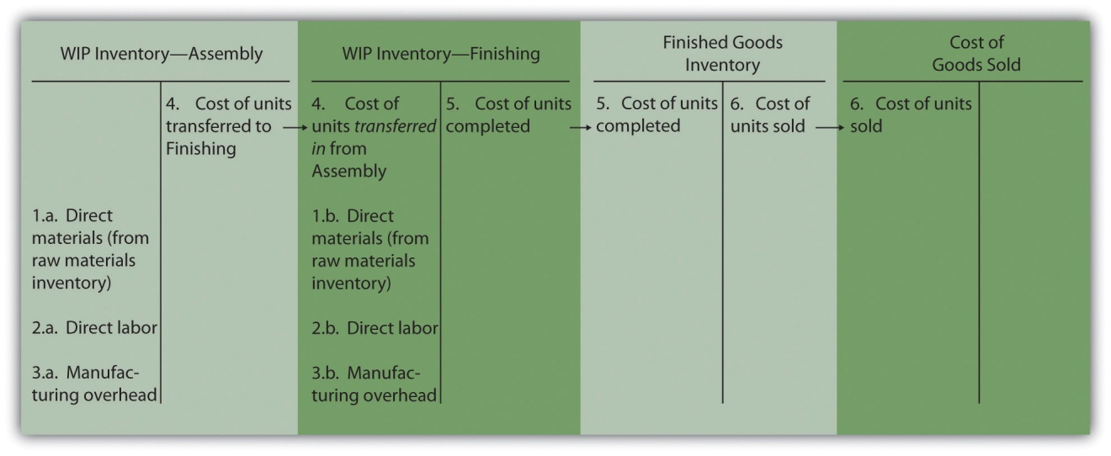

Business in Action 4.2
Source: Photo courtesy of Mykl Roventine,http://www.flickr.com/photos/myklroventine/3471836813/.
The Production Process for Wrigley’s Gum
The Wrigley Company has 14 factories located in various parts of the world, including North America, Europe, Africa, India, and the Asia/Pacific region. The gum produced by these factories is sold in 150 countries. According to Wrigley Company, 50 percent of Americans chew gum, and on average, each person consumes 190 sticks per year. The number drops to 130 sticks per person in the United Kingdom and to 100 sticks per person in Taiwan.
The production process at Wrigley involves six sequential stages:
- Melting. The gum base, which comes in small round balls, is melted and purified.
- Mixing. The melted base is poured into a mixer, to which sweeteners and flavors are added.
- Rolling. A large “loaf” of gum is sent through a series of rollers, thereby reducing thickness to the desired size.
- Scoring. The gum is cut into the shape of sticks or pellets.
- Conditioning. The gum is cooled and “conditioned” to ensure the right consistency before being packaged.
- Packaging. The gum is packaged and made ready for shipping.
Because Wrigley produces identical units of product in batches employing a consistent process, it likely uses a process costing system. With such a system, Wrigley would need a separate work-in-process inventory account to track costs for each stage of the production process.
Source: Wrigley’s, “Home Page,” http://www.wrigley.com.

KEY TAKEAWAY
- The cost flows in a process costing system are similar to the cost flows in a job costing system. The primary difference between the two costing methods is that a process costing system assigns product costs—direct materials, direct labor, and manufacturing overhead—to each production department (or process) rather than to each job. Each production department has its own work-in-process inventory account when using process costing.

REVIEW PROBLEM 4.2
Chewy Gum Corporation produces bubble gum in large batches and uses a process costing system. Three departments—Mixing, Rolling, and Packaging—are involved in the production process. Chewy Gum has the following transactions:
- Direct materials totaling $20,000—$6,000 for the Mixing department, $5,000 for the Rolling department, and $9,000 for the Packaging department—are requisitioned and placed in production.
- Each production department incurs the following direct labor costs (wages payable):
Mixing | $2,500
Rolling | $4,600
Packaging | $2,200
- Manufacturing overhead costs are applied to each department as follows:
Mixing | $10,000
Rolling | $ 7,000
Packaging | $ 7,500
- Products with a cost of $5,500 are transferred from the Mixing department to the Rolling department.
- Products with a cost of $6,400 are transferred from the Rolling department to the Packaging department.
- Products with a cost of $9,100 are completed and transferred from the Packaging department to the finished goods warehouse.
- Products with a cost of $8,300 are sold to customers.
Perform the following steps for each transaction:
- Prepare a journal entry to record the transaction.
- Summarize the flow of costs through T-accounts. Use the format presented in Figure 4.2 "Flow of Product Costs in a Process Costing System" (no need to include T-accounts for raw materials inventory, wages payable, or manufacturing overhead). Assume there are no beginning balances in the work-in-process inventory, finished goods inventory, and cost of goods sold accounts.
Solution to Review Problem 4.2

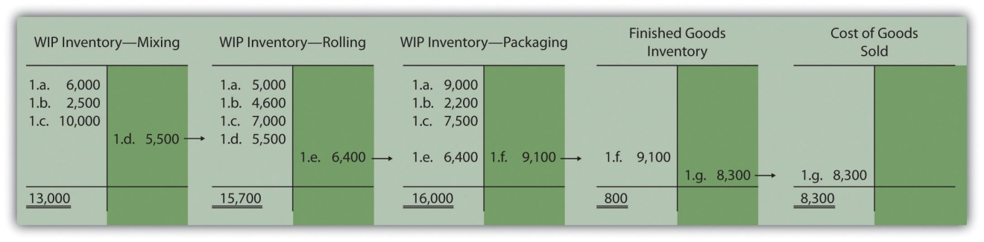

4.3 Determining Equivalent Units

LEARNING OBJECTIVE
- Understand the concept of an equivalent unit.

Question: The beginning of this chapter describes process costing and the flow of costs through accounts used in a process costing system. The challenge is determining the unit cost of products being transferred out of each departmental work-in-process inventory account. We start the process of determining unit cost information with an important concept, the concept of equivalent units.What are equivalent units, and how are equivalent units calculated?

Answer: Units of product in work-in-process inventory are assumed to bepartially completed; otherwise, the units would not be in work-in-process inventory. Process costing requires partially completed units in ending work-in-process inventory to be converted to the equivalent completed units (called equivalent units). Equivalent units are calculated by multiplying the number of physical (or actual) units on hand by the percentage of completion of the units. If the physical units are 100 percent complete, equivalent units will be the same as the physical units. However, if the physical units are not 100 percent complete, the equivalent units will be less than the physical units.

For example, if four physical units of product are 50 percent complete at the end of the period, an equivalent of two units has been completed (2 equivalent units = 4 physical units × 50 percent). The formula used to calculate equivalent units is as follows:

Equivalent units = Number of physical units × Percentage of completion

Figure 4.3 "Concept of Equivalent Units" provides an example of the equivalent unit concept in which four desks, 50 percent complete, are the equivalent of two completed desks.
Figure 4.3 Concept of Equivalent Units

Question: With the concept of equivalent units now in hand, we can calculate equivalent units for the three product costs—direct materials, direct labor, and manufacturing overhead. Why do we calculate equivalent units separately for direct materials, direct labor, and manufacturing overhead?

Answer: Equivalent units in work in process are often different for direct materials, direct labor, and manufacturing overhead because these three components of production may enter the process at varying stages. For example, in the Assembly department at Desk Products, Inc., direct materials enter production early in the process while direct labor and overhead are used throughout the process. (Imagine asking workers to assemble desks without materials!) Thus equivalent units must be calculated for each of the three production costs. (Note that direct labor and manufacturing overhead are sometimes combined in a category calledconversion costs, which assumes both are added to the process at the same time. In this text, we keep direct labor and manufacturing overhead separate.) The next section presents how we use the equivalent unit concept for product costing purposes. Be sure you understand the concept of equivalent units before moving on.

Business in Action 4.3
Calculating Full-Time Equivalent Students
The concept of an equivalent unit can be applied to determine the number of full-time equivalent students (FTES) at a school. Colleges use FTES data to plan and make decisions about course offerings, staffing, and facility needs. Although having information about the number of students enrolled (the headcount) is helpful, headcount data do not provide an indication of whether the students are full time or part time. Clearly, full-time students take more classes each term and generally use more resources than part-time students. Thus administrators often prefer to convert enrollment data to FTES.
Using a simple example to explain this concept, assume 30 students attend school and each takes half a full load of classes. The headcount is 30. However, this is the equivalent of 15 full-time students, or 15 FTES.
To apply this to the real world, let’s look at the enrollment data forSierra College, a community college located near Sacramento, California. During a recent semester, the student headcount in a specific department at Sierra College was 8,190. Because a large number of students in the department were part time, the full-time equivalent number of students totaled 3,240.
Source: Based on enrollment data from Sierra College.

KEY TAKEAWAYS
- When units of work-in-process (WIP) inventory exist at the end of the reporting period, process costing requires that these partially completed units be converted to the equivalent completed units (called equivalent units). The equation used to calculate equivalent completed units is as follows:
Equivalent units = Number of physical units × Percentage of completion
- Because direct materials, direct labor, and manufacturing overhead typically enter the production process at different stages, equivalent units must be calculated separately for each of these production costs.

REVIEW PROBLEM 4.3
Soap Production Company’s Mixing department shows the following information for the 1,000 units of product remaining in work in process at the end of the period. Assume there was no beginning inventory.
Direct materials | 90 percent complete
Direct labor | 30 percent complete
Overhead | 60 percent complete
Calculate the equivalent units for each of the three product costs—direct materials, direct labor, and overhead.
Solution to Review Problem 4.3
The formula used to calculate equivalent units is as follows:
Equivalent units = Number of partially completed units × Percentage of completion
Materials | 900 equivalent units = 1,000 partially completed units × 90 percent
Labor | 300 equivalent units = 1,000 partially completed units × 30 percent
Overhead | 600 equivalent units = 1,000 partially completed units × 60 percent

4.4 The Weighted Average Method

LEARNING OBJECTIVE
- Use four steps to assign costs to products using the weighted average method.

Most companies use either the weighted average or first-in-first-out (FIFO)method to assign costs to inventory in a process costing environment. Theweighted average method includes costs in beginning inventory and current period costs to establish an average cost per unit. The first-in-first-out (FIFO) method keeps beginning inventory costs separate from current period costs and assumes that beginning inventory units are completed and transferred out before the units started during the current period are completed and transferred out. We focus on the weighted average approach here and leave the discussion of the FIFO method to more advanced cost accounting textbooks.

Question: The primary goal stated in and , and continued in this chapter, is to assign product costs to products. In a process costing system,cost per equivalent unit is the term used to describe the average unit cost for each product. How is the concept of cost per equivalent unit used to assign costs to (1) completed units transferred out and (2) units still in work-in-process (WIP) inventory at the end of the period?

Answer: Costs are assigned to completed units transferred out and units in ending WIP inventory using a four-step process. We list the four steps in the following and then explain them in detail. Review these steps carefully.

Step 1. Summarize the physical flow of units and compute the equivalent units for direct materials, direct labor, and overhead.

Step 2. Summarize the costs to be accounted for (separated into direct materials, direct labor, and overhead).

Step 3. Calculate the cost per equivalent unit.

Step 4. Use the cost per equivalent unit to assign costs to (1) completed units transferred out and (2) units in ending WIP inventory.

The Four Key Steps of Assigning Costs

Recall that Desk Products, Inc., has two departments—Assembly and Finishing. Although this chapter focuses on the Assembly department, the Finishing department would also use the four steps to determine product costs for completed units transferred out and ending WIP inventory.presents information for the Assembly department at Desk Products for the month of May. Review this information carefully as it will be used to illustrate the four key steps.
Table 4.2 Production Information for Desk Products’ Assembly Department
Assembly Department—Month of May
- The company had 3,000 units in beginning WIP inventory; all were completed and transferred out during May.
- During May, 6,000 units were started. Of the 6,000 units started:
  - 1,000 units were completed and transferred out to the Finishing department (100 percent complete with respect to direct materials, direct labor, and overhead); thus 1,000 units werestarted and completed during May.
  - 5,000 units were partially completed and remained in ending WIP inventory on May 31 (60 percent complete for direct materials, 30 percent complete for direct labor, and 30 percent complete for overhead, which is applied based on direct labor hours).
- Costs in beginning WIP inventory totaled $161,000 (= $95,000 in direct materials + $40,000 in direct labor + $26,000 in overhead).
- Costs incurred during May totaled $225,000 (= $115,000 in direct materials + $70,000 in direct labor + $40,000 in overhead).

Question: Costs for the Assembly department totaled $386,000 for the month of May ($386,000 = $161,000 in beginning WIP inventory + $225,000 incurred during May). How much of the $386,000 should be assigned to (1) completed units transferred out to the Finishing department and (2) units remaining in the Assembly department ending WIP inventory?

Answer: Let’s use the four key steps as follows to answer this question.

Step 1. Summarize the physical flow of units and compute the equivalent units for direct materials, direct labor, and overhead.

This step uses the basic cost flow equation presented in to identify the physical flow of units (the basic cost flow equation applies to costs and tounits):
Beginning balance+Transfers in(BB)+(TI)Units to be accounted for==Transfers out + Ending balance(TO)+(EB)Units accounted for

Question: What are the two categories used to summarized the physical flow of units?

Answer: The first category, units to be accounted for, includes the beginning balance (BB) and transfers in (TI). The second category, units accounted for, includes the ending balance (EB) and transfers out (TO). As you can see from the previous equation, units to be accounted for must equal units accounted for. Here is how it looks for the Assembly department for the month of May:
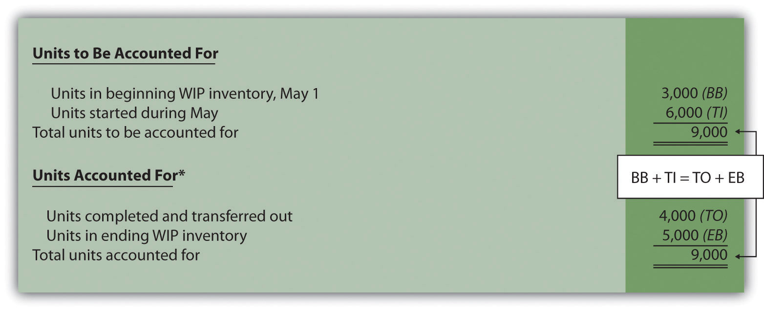
*This information is used in the physical units column of .

This step shows that 3,000 units were in WIP inventory on May 1 and 6,000 units were started during May. Thus 9,000 units must be accounted for. These 9,000 units will end up in one of two places, either completed and transferred out (to the Finishing department) or not completed and therefore in ending WIP inventory. The previous schedule shows that 4,000 units were completed and transferred out (3,000 from beginning WIP inventory and 1,000 from the units started and completed during the month), and 5,000 units remain in ending WIP inventory.
Question: Based on the previous information for Desk Products, Inc., we now know that 4,000 units were completed and transferred out, and 5,000 units were in ending WIP inventory at the end of May. How do we convert this information into equivalent units?

Answer: The units accounted for (4,000 transferred out and 5,000 in ending WIP inventory) must be converted into equivalent units for direct materials, direct labor, and overhead, as shown in . The 4,000 units transferred out are 100 percent complete for direct materials, direct labor, and overhead (otherwise, they would not be transferred out), which results in equivalent units matching the physical units. However, the 5,000 units in ending WIP inventory are at varying levels of completion for direct materials, direct labor, and overhead, and must be converted into equivalent units using the following formula (as described earlier in the chapter):
Equivalent units = Number of physical units × Percentage of completion

Later in step 3, we will use equivalent unit information for the Assembly department to calculate the cost per equivalent unit.
Figure 4.4 Flow of Units and Equivalent Unit Calculations for Desk Products’ Assembly Department
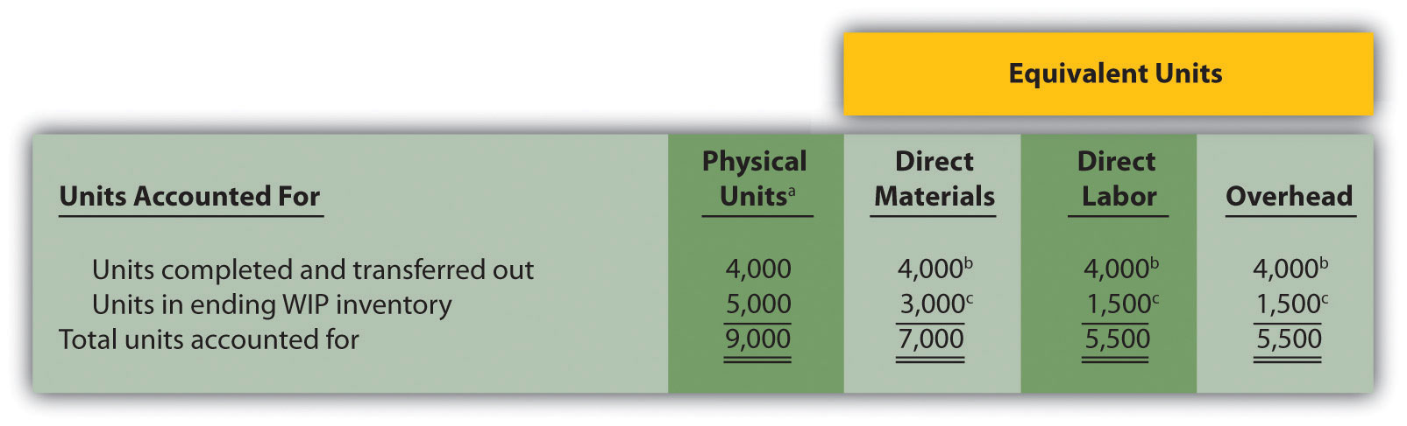
ª This column represents actual physical units accounted for before converting to equivalent units.
^{b} Equivalent units = Number of physical units × Percentage of completion. Units completed and transferred out are 100 percent complete. Thus equivalent units are the same as the physical units. (Information is from .)
^{c} Equivalent units = Number of physical units × Percentage of completion. For direct materials, 3,000 equivalent units = 5,000 physical units × 60 percent complete; for direct labor and overhead, 1,500 equivalent units = 5,000 physical units × 30 percent complete. (Information is from .)

Step 2. Summarize the costs to be accounted for (separated into direct materials, direct labor, and overhead).

Question: How do we summarize the costs that are used to calculate the cost per equivalent unit?

Answer: The total costs to be accounted for include the costs in beginning WIP inventory and the costs incurred during the period. shows these costs for the Assembly department. Notice that the costs are separated into direct materials, direct labor, and overhead.
Figure 4.5 Summary of Costs to Be Accounted for in Desk Products’ Assembly Department
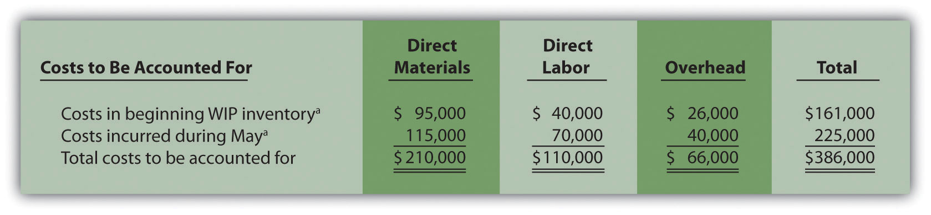
ª Information is from .

Shows that costs totaling $386,000 must be assigned to (1) completed units transferred out and (2) units in ending WIP inventory.

Step 3. Calculate the cost per equivalent unit.

Question: We now have the costs () and equivalent units () needed to determine the cost per equivalent unit for direct materials, direct labor, and overhead.How do we use this information to calculate the cost per equivalent unit?

Answer: The formula to calculate the cost per equivalent unit using the weighted average method is as follows:

Key Equation
Cost per equivalent unit=Costs in beginning WIP + Current period costsEquivalent units completed and transferred out + Equivalent units in ending WIP

In summary, the same formula is as follows:
Cost per equivalent unit=Total costs to be accounted for*Total equivalent units accounted for**
*From the bottom of .
**From the bottom of .

Presents the cost per equivalent unit calculation for Desk Products’ Assembly department.
Figure 4.6 Calculation of the Cost per Equivalent Unit for Desk Products’ Assembly Department
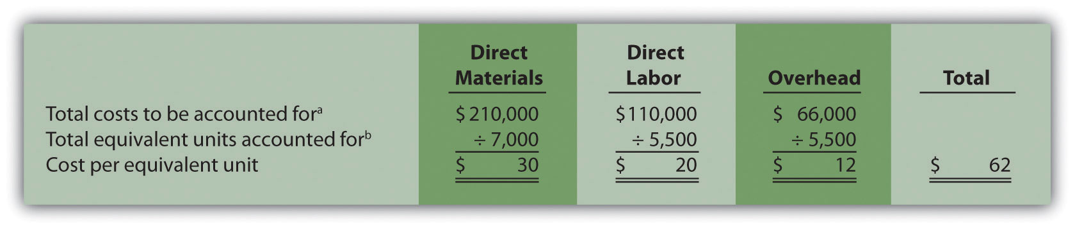
ª Information is from .
^{b} Information is from .

The cost per equivalent unit is calculated for direct materials, direct labor, and overhead. Simply divide total costs to be accounted for by total equivalent units accounted for. It is important to note that the information shown inallows managers to carefully assess the unit cost information in the Assembly department for direct materials, direct labor, and overhead. We discuss this further later in the chapter.
Step 4. Use the cost per equivalent unit to assign costs to (1) completed units transferred out and (2) units in ending WIP inventory.

Question: Recall our primary goal of assigning costs to completed units transferred out and to units in ending WIP inventory. How do we accomplish this goal?

Answer: Costs are assigned by multiplying the cost per equivalent unit (shown in ) by the number of equivalent units (shown in ) for direct materials, direct labor, and overhead. shows how this is done.
Figure 4.7 Assigning Costs to Products in Desk Products’ Assembly Department
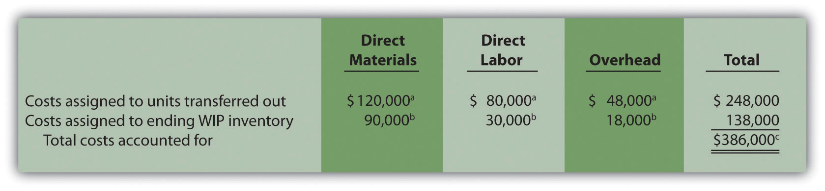
ª The total cost assigned to units transferred out equals the cost per equivalent unit times the number of equivalent units. For example, the cost assigned to direct materials of $120,000 = 4,000 equivalents units () × $30 per equivalent unit ().
^{b} The total cost assigned to units in ending inventory equals the cost per equivalent unit times the number of equivalent units. For example, the cost assigned to direct materials of $90,000 = 3,000 equivalent units () × $30 per equivalent unit ().
^{c} This must match total costs to be accounted for shown in . Although not an issue in this example, rounding the cost per equivalent unit may cause minor differences between the two amounts.

Shows that total costs of $248,000 are assigned to units completed and transferred out and that $138,000 in costs are assigned to ending WIP inventory.

On completion of step 4, it is important to reconcile the total costs to be accounted for shown at the bottom of with the total costs accounted for shown at the bottom of . The two balances must match (note that small discrepancies may exist due to rounding the cost per equivalent unit). This reconciliation relates back to the basic cost flow equation as follows:
Beginning balance+Transfers in(BB)+(TI)Costs to be accounted for($386,000*)==Transfers out + Ending balance(TO)+(EB)Costs accounted for($386,000**)
**From .
***From .

Although the examples in this chapter have been created in a way that minimizes rounding errors, always round the cost per equivalent unit calculations in step 3 to the nearest thousandth (e.g., if the cost per equivalent unit is $2.3739, round this to $2.374 rather than to $2). Although rounding differences still may occur, this will minimize the size of rounding errors when attempting to reconcile costs to be accounted for (step 2) with costs accounted for (step 4).

Journalizing Costs Assigned to Units Completed and Transferred

Question: Once the four-step process is complete, a journal entry must be made to record the transfer of costs out of the Assembly department and into the Finishing department. How do we record the costs associated with units completed and transferred out?

Answer: At Desk Products, Inc., 4,000 units were transferred from the Assembly department to the Finishing department. Costs totaling $248,000 were assigned to these units as shown in . The journal entry to record this at the end of May is as follows:

(Note that this was journal entry number four, presented without dollar amounts earlier in the chapter.)

Shows the flow of costs through the work-in-process inventory T-account for the Assembly department. Note that four key steps were performed for the Assembly department to determine the costs assigned to (1) completed units transferred out to the Finishing department ($248,000) and (2) units in Assembly’s WIP inventory ($138,000). Both amounts are highlighted.
Figure 4.8 Flow of Costs through the Work-in-Process Inventory T-Account of Desk Products’ Assembly Department
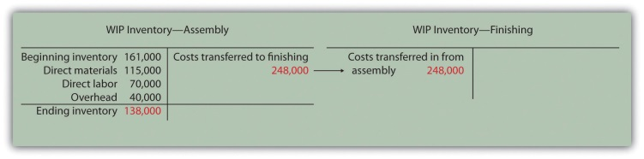

Business in Action 4.4
The Production Process for Hershey’s Chocolate
Hershey Foods Corp. is best known for its chocolate products, including brands like Almond Joy, Hershey’s Kisses, and Reese’s.Hershey’s products are sold in more than 90 countries worldwide. According to Hershey, more than 80 million Kiss-shaped products are made every day!
Several sequential stages of production are required to produce chocolate at Hershey:
- Fermentation. Cocoa beans are placed in large heaps for one week to allow the cocoa flavor to develop.
- Roasting. The cocoa beans are roasted at very high temperatures.
- Hulling. A hulling machine separates the shell from the inside of the bean (called the nib).
- Milling. The nibs are ground into chocolate liquor (a liquid with a pure chocolate flavor that contains no alcohol).
- Mixing. The chocolate liquor is mixed with cocoa butter, sugar, and milk. This mixture is dried into a brown powder, called chocolate crumb, and processed into chocolate paste.
- Molding. Machines are used to fill more than 1,000 molds per minute with chocolate. The chocolate is then chilled to form solid candy.
- Packaging. The candy is wrapped, packaged, and ready to be shipped.
Hershey likely uses a process costing system since it produces identical units of product in batches employing a consistent process. Process costing systems require the use of work-in-process inventory accounts for each process. Thus Hershey would track production costs using separate work-in-process inventory accounts for each stage of production.
Source: Hershey’s, “Home Page,” http://www.hersheys.com.

KEY TAKEAWAYS
- Four steps are used to assign product costs to (1) completed units transferred out and (2) units in work-in-process inventory at the end of the period.
- The four-step process must be performed for each processing department and results in a journal entry to record the costs assigned to units transferred out.

REVIEW PROBLEM 4.4
Kelley Paint Company uses the weighted average method to account for costs of production. Kelley manufactures base paint in two separate departments—Mixing and Packaging. The following information is for the Mixing department for the month of March.
- A total of 40,000 units (measured in gallons) were in beginning WIP inventory. All were completed and transferred out during March.
- A total of 70,000 units were started during March. Of the 70,000 units started,
  - 20,000 units were completed and transferred out to the Packaging department (100 percent complete with respect to direct materials, direct labor, and overhead), and
  - 50,000 units were partially completed and remained in ending WIP inventory on March 31 (90 percent complete for direct materials, 70 percent complete for direct labor, and 30 percent complete for overhead, which is applied based on machine hours).
- Costs in beginning WIP inventory totaled $229,000 (= $98,000 in direct materials + $41,000 in direct labor + $90,000 in overhead).
- Costs incurred during March totaled $165,000 (= $70,000 in direct materials + $35,000 in direct labor + $60,000 in overhead).
Required:
- Use the four key steps to assign costs to units completed and transferred out and to units in ending WIP inventory for the Mixing department.
- Prepare the journal entry necessary at the end of March to record the transfer of costs associated with units completed and transferred to the Packaging department.
Solution to Review Problem 4.4
- The four steps are as follows:
Step 1. Summarize the physical flow of units and compute the equivalent units for direct materials, direct labor, and overhead.
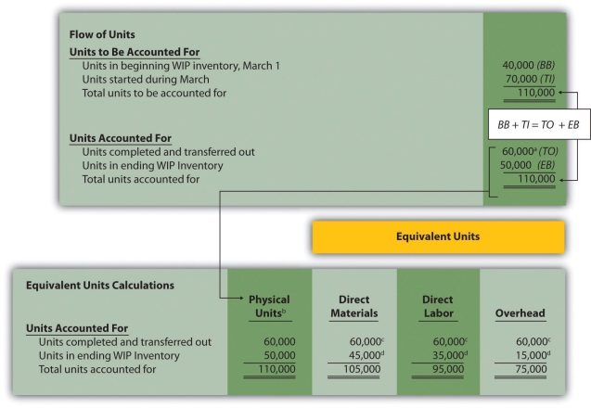
ª 60,000 units = 40,000 from beginning WIP inventory + 20,000 started and completed in March.
^{b} This column represents actual physical units accounted for beforeconverting to equivalent units.
^{c} Equivalent units = number of physical units × percentage of completion. Units completed and transferred out are 100 percent complete. Thus equivalent units are the same as the physical units.
^{d} Equivalent units = number of physical units × percentage of completion. For direct materials, 45,000 equivalent units = 50,000 physical units × 90 percent complete; for direct labor, 35,000 equivalent units = 50,000 physical units × 70 percent complete; for overhead, 15,000 equivalent units = 50,000 physical units × 30 percent complete.
Step 2. Summarize the costs to be accounted for (separated into direct materials, direct labor, and overhead).
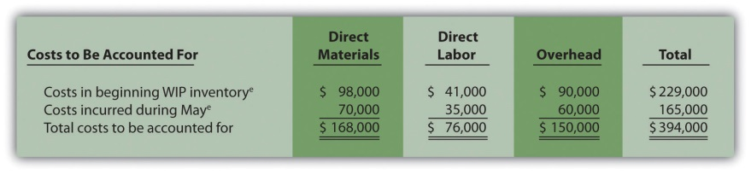
^{e} Information is given.
Step 3. Calculate the cost per equivalent unit.
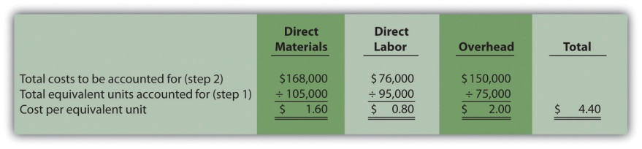
Step 4. Use the cost per equivalent unit to assign costs to (1) completed units transferred out and (2) units in ending WIP inventory.
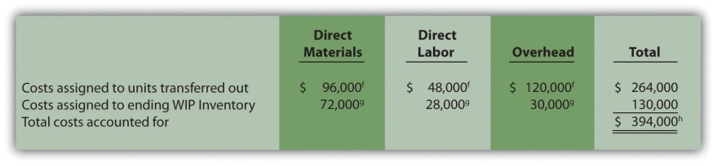
^{f} Total costs assigned to units transferred out equals the cost per equivalent unit times the number of equivalent units. For example, costs assigned for direct materials of $96,000 = 60,000 equivalents units (from step 1) × $1.60 per equivalent unit (from step 3).
^{g} Total costs assigned to ending WIP inventory equals the cost per equivalent unit times the number of equivalent units. For example, costs assigned for direct materials of $72,000 = 45,000 equivalent units (from step 1) × $1.60 per equivalent unit (from step 3).
^{h} This must match total costs to be accounted for in step 2, as shown in the following:
Beginning balance + Transfers in(BB)+(TI)Costs to be accounted for(394,000 from step 2)==Transfers out + Ending balance(TO)+(EB)Costs accounted for($394,000 from step 4)
- As shown in step 4, $264,000 in total costs are assigned to units completed and transferred out. The entry to record this is as follows:

4.5 Preparing a Production Cost Report

LEARNING OBJECTIVE
- Prepare a production cost report for a processing department.

Question: The results of the four key steps are typically presented in a production cost report. The production cost report summarizes the production and cost activity within a department for a reporting period. It is simply a formal summary of the four steps performed to assign costs to units transferred out and units in ending work-in-process (WIP) inventory. What does the production cost report look like for the Assembly department at Desk Products, Inc.?

Answer: The production cost report for the month of May for the Assembly department appears in Figure 4.9 "Production Cost Report for Desk Products’ Assembly Department". Notice that each section of this report corresponds with one of the four steps described earlier. We provide references to the following illustrations so you can review the detail supporting calculations.

Figure 4.9 Production Cost Report for Desk Products’ Assembly Department
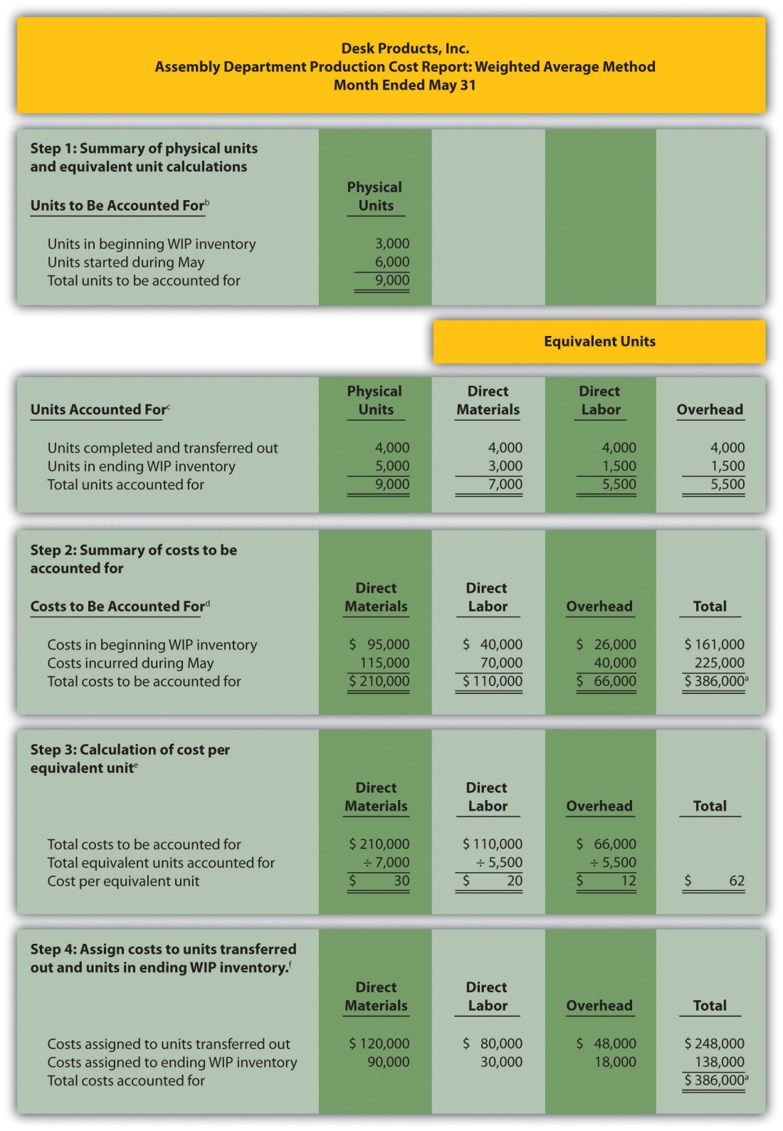
ª Total costs to be accounted for (step 2) must equal total costs accounted for (step 4).
^{b} Data are given.
^{c} This section comes from Figure 4.4 "Flow of Units and Equivalent Unit Calculations for Desk Products’ Assembly Department".
^{d} This section comes from Figure 4.5 "Summary of Costs to Be Accounted for in Desk Products’ Assembly Department".
^{e} This section comes from Figure 4.6 "Calculation of the Cost per Equivalent Unit for Desk Products’ Assembly Department".
^{f} This section comes from Figure 4.7 "Assigning Costs to Products in Desk Products’ Assembly Department".

How Do Managers Use Production Cost Report Information?

Question: Although the production cost report provides information needed to transfer costs from one account to another, managers also use this report for decision-making purposes. What important questions can be answered using the production cost report?

Answer: A production cost report helps managers answer several important questions:
- How much does it cost to produce each unit of product for each department?
- Which production cost is the highest—direct materials, direct labor, or overhead?
- Where are we having difficulties in the production process? In any particular departments?
- Are we seeing any significant changes in unit costs for direct materials, direct labor, or overhead? If so, why?
- How many units flow through each processing department each month?
- Are improvements in the production process being reflected in the cost per unit from one month to the next?
- Beware of Fixed Costs

Question: Why might the per unit cost data provided in the production cost report be misleading?

Answer: When using information from the production cost report, managers must be careful not to assume that all production costs are variable costs. The CEO of Desk Products, Inc., Ann Watkins, was told that the Assembly department cost for each desk totaled $62 for the month of May (from Figure 4.9 "Production Cost Report for Desk Products’ Assembly Department", step 3). However, if the company produces more or fewer units than were produced in May, the unit cost will change. This is because the $62 unit cost includes both variable and fixed costs (see Chapter 5 "How Do Organizations Identify Cost Behavior Patterns?" for a detailed discussion of fixed and variable costs).

Assume direct materials and direct labor are variable costs. In the Assembly department, the variable costs per unit associated with direct materials and direct labor of $50 (= $30 direct materials + $20 direct labor) will remain the same regardless of the level of production, within the relevant range. However, the remaining unit product cost of $12 associated with overhead must be analyzed further to determine the amount that is variable (e.g., indirect materials) and the amount that is fixed (e.g., factory rent). Managers must understand that fixed costs per unit will change depending on the level of production. More specifically, Ann Watkins must understand that the $62 unit cost in the Assembly department provided in the production cost report will change depending on the level of production.Chapter 5 "How Do Organizations Identify Cost Behavior Patterns?" provides a detailed presentation of how cost information can be separated into fixed and variable components for the purpose of providing managers with more useful information.

KEY TAKEAWAY
- The four key steps of assigning costs to units transferred out and units in ending WIP inventory are formally presented in a production cost report. The production cost report summarizes the production and cost activity within a processing department for a reporting period. A separate report is prepared for each processing department. Rounding the cost per equivalent unit to the nearest thousandth will minimize rounding differences when reconciling costs to be accounted for in step 2 with costs accounted for in step 4.

Computer Application
Using Excel to Prepare a Production Cost Report
Managers typically use computer software to prepare production cost reports. They do so for several reasons:
- Once the format is established, the template can be used from one period to the next.
- Formulas underlie all calculations, thereby minimizing the potential for math errors and speeding up the process.
- Changes can be made easily without having to redo the entire report.
- Reports can be easily combined to provide a side-by-side analysis from one period to the next.
Review Figure 4.9 "Production Cost Report for Desk Products’ Assembly Department" and then ask yourself: “How can I use Excel to help prepare this report?” Answers will vary widely depending on your experience with Excel. However, Excel has a few basic features that can make the job of creating a production cost report easier. For example, you can use formulas to sum numbers in a column (note that each of the four steps presented in Figure 4.9 "Production Cost Report for Desk Products’ Assembly Department" has column totals) and to calculate the cost per equivalent unit. Also you can establish a separate line to double-check that
- the units to be accounted for match the units accounted for; and
- the total costs to be accounted for match the total costs accounted for.
For those who want to add more complex features, the basic data (e.g., the data in Table 4.2 "Production Information for Desk Products’ Assembly Department") can be entered at the top of the spreadsheet and pulled down to the production cost report where necessary.
An example of how to use Excel to prepare a production cost report follows. Notice that the basic data are at the top of the spreadsheet, and the rest of the report is driven by formulas. Each month, the data at the top are changed to reflect the current month’s activity, and the production cost report takes care of itself.
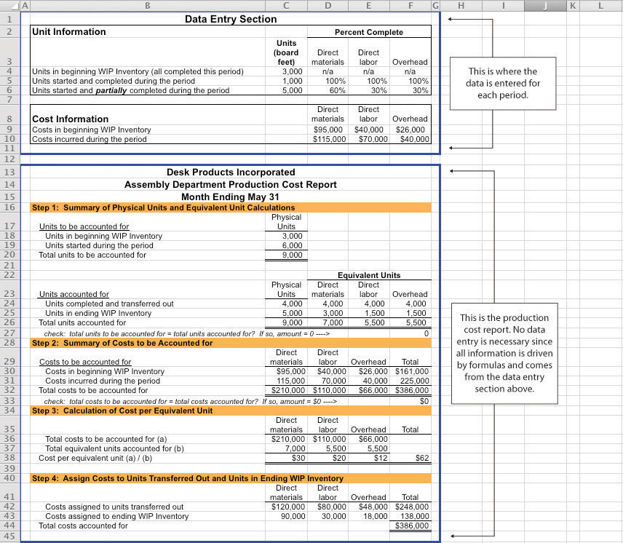

REVIEW PROBLEM 4.5
Using the information in Note 4.24 "Review Problem 4.4", prepare a production cost report for the Mixing department of Kelley Paint Company for the month ended March 31. (Hint: You have already completed the four key steps in Note 4.24 "Review Problem 4.4". Simply summarize the information in a production cost report as shown in Figure 4.9 "Production Cost Report for Desk Products’ Assembly Department".)
Solution to Review Problem 4.5
(See solutions to Note 4.24 "Review Problem 4.4" for detailed calculations.)
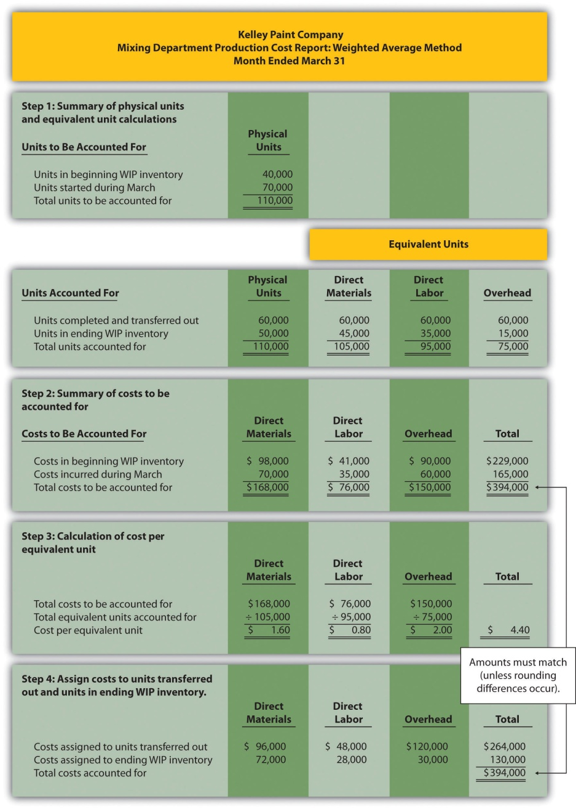

END-OF-CHAPTER EXERCISES
Questions
- Which types of companies use a process costing system to account for product costs? Provide at least three examples of products that would require the use of a process costing system.
- Describe the similarities between a process costing system and a job costing system.
- Describe the differences between a process costing system and a job costing system.
- Review Note 4.4 "Business in Action 4.1" What are the three stages of production at Coca-Cola, and what account is used to track production costs for each stage?
- What are transferred-in costs?
- Review Note 4.9 "Business in Action 4.2" Why is it likely that Wrigleyuses a process costing system rather than a job costing system?
- Explain the difference between physical units and equivalent units.
- Explain the concept of equivalent units assuming the weighted average method is used.
- Explain why direct materials, direct labor, and overhead might be at different stages of completion at the end of a reporting period.
- Review Note 4.14 "Business in Action 4.3" Why do colleges convert the actual number of students attending school to a full-time equivalent number of students?
- Describe the four key steps shown in a production cost report assuming the weighted average method is used.
- What two important amounts are determined in step 4 of the production cost report?
- Describe the basic cost flow equation and explain how it is used to reconcile units to be accounted for with units accounted for.
- Describe the basic cost flow equation and explain how it is used to reconcile costs to be accounted for with costs accounted for.
- Review Note 4.22 "Business in Action 4.4" Describe the last two stages of the production process at Hershey.
- How does a company determine the number of production cost reports to be prepared for each reporting period?
- What is a production cost report, and how is it used by management?
- Explain how the cost per equivalent unit might be misleading to managers, particularly when a significant change in production is anticipated.
Brief Exercises
- Product Costing at Desk Products, Inc. Refer to the dialogue presented at the beginning of the chapter.
Required:
  - Why was the owner of Desk Products, Inc., concerned about the Assembly department product cost of each desk?
  - What did the accountant, John Fuller, promise by the end of the week?
- Job Costing Versus Process Costing. For each firm listed in the following, identify whether it would use job costing or process costing.
  - Chewing gum manufacturer
  - Custom automobile restorer
  - Facial tissue manufacturer
  - Accounting services provider
  - Electrical services provider
  - Pool builder
  - Cereal producer
  - Architectural design provider
- Process Costing Journal Entries. Assume a company has two processing departments—Molding and Packaging. Transactions for the month are shown as follows.
  - The Molding department requisitioned direct materials totaling $2,000 to be used in production.
  - Direct labor costs totaling $3,500 were incurred in the Molding department, to be paid the next month.
  - Manufacturing overhead costs applied to products in the Molding department totaled $2,500.
  - The cost of goods transferred from the Molding department to the Packaging department totaled $10,000.
  - Manufacturing overhead costs applied to products in the Packaging department totaled $1,800.
Required:
Prepare journal entries to record transactions 1 through 5.
- Calculating Equivalent Units. Complete the requirements for each item in the following.
  - A university has 500 students enrolled in classes. Each student attends school on a part-time basis. On average, each student takes three-quarters of a full load of classes. Calculate the number of full-time equivalent students (i.e., calculate the number of equivalent units).
  - A total of 10,000 units of product remain in the Assembly department at the end of the year. Direct materials are 80 percent complete and direct labor is 40 percent complete. Calculate the equivalent units in the Assembly department for direct materials and direct labor.
  - A local hospital has 60 nurses working on a part-time basis. On average, each nurse works two-thirds of a full load. Calculate the number of full-time equivalent nurses (i.e., calculate the number of equivalent units).
  - A total of 6,000 units of product remain in the Quality Testing department at the end of the year. Direct materials are 75 percent complete and direct labor is 20 percent complete. Calculate the equivalent units in the Quality Testing department for direct materials and direct labor.
- Calculating Cost per Equivalent Unit. The following information pertains to the Finishing department for the month of June.
 | Direct Materials | Direct Labor | Overhead
Total costs to be accounted for | $100,000 | $200,000 | $300,000
Total equivalent units accounted for | 10,000 units | 8,000 units | 8,000 units
- Required:
- Calculate the cost per equivalent unit for direct materials, direct labor, overhead, and in total. Show your calculations.
- Assigning Costs to Completed Units and to Units in Ending WIP Inventory. The following information is for the Painting department for the month of January.
 | Direct Materials | Direct Labor | Overhead
Cost per equivalent unit | $2.10 | $1.50 | $3.80
Equivalent units completed and transferred out | 3,000 units | 3,000 units | 3,000 units
Equivalent units in ending WIP inventory | 1,000 units | 1,200 units | 1,200 units
- Required:
  - Calculate the costs assigned to units completed and transferred out of the Painting department for direct materials, direct labor, overhead, and in total.
  - Calculate the costs assigned to ending WIP inventory for the Painting department for direct materials, direct labor, overhead, and in total.
Exercises: Set A
- Assigning Costs to Products: Weighted Average Method. Sydney, Inc., uses the weighted average method for its process costing system. The Assembly department at Sydney, Inc., began April with 6,000 units in work-in-process inventory, all of which were completed and transferred out during April. An additional 8,000 units were started during the month, 3,000 of which were completed and transferred out during April. A total of 5,000 units remained in work-in-process inventory at the end of April and were at varying levels of completion, as shown in the following.
Direct materials | 40 percent complete
Direct labor | 30 percent complete
Overhead | 50 percent complete
- The following cost information is for the Assembly department at Sydney, Inc., for the month of April.
 | Direct Materials | Direct Labor | Overhead | Total
Beginning WIP inventory | $300,000 | $350,000 | $250,000 | $900,000
Incurred during the month | $180,000 | $200,000 | $170,000 | $550,000
- Required:
  - Determine the units to be accounted for and units accounted for; then calculate the equivalent units for direct materials, direct labor, and overhead. (Hint: This requires performing step 1 of the four-step process.)
  - Calculate the cost per equivalent unit for direct materials, direct labor, and overhead. (Hint: This requires performing step 2 and step 3 of the four-step process.)
  - Assign costs to units transferred out and to units in ending WIP inventory. (Hint: This requires performing step 4 of the four-step process.)
  - Confirm that total costs to be accounted for (from step 2) equals total costs accounted for (from step 4). Note that minor differences may occur due to rounding the cost per equivalent unit in step 3.
  - Explain the meaning of equivalent units.
- Production Cost Report: Weighted Average Method. Refer to Exercise 25. Prepare a production cost report for Sydney, Inc., for the month of April using the format shown in Figure 4.9 "Production Cost Report for Desk Products’ Assembly Department".
- Process Costing Journal Entries. Silva Piping Company produces PVC piping in two processing departments—Fabrication and Packaging. Transactions for the month of July are shown as follows.
  - Direct materials totaling $15,000 are requisitioned and placed into production—$7,000 for the Fabrication department and $8,000 for the Packaging department.
  - Direct labor costs (wages payable) are incurred by each department as follows:
Fabrication | $4,500
Packaging | $6,700
  - Manufacturing overhead costs are applied to each department as follows:
Fabrication | $20,000
Packaging | $14,000
  - Products with a cost of $22,000 are transferred from the Fabrication department to the Packaging department.
  - Products with a cost of $35,000 are completed and transferred from the Packaging department to the finished goods warehouse.
  - Products with a cost of $31,000 are sold to customers.
Required:
    - Prepare journal entries to record each of the previous transactions.
    - In general, how does the process costing system used here differ from a job costing system?
Exercises: Set B
- Assigning Costs to Products: Weighted Average Method. Varian Company uses the weighted average method for its process costing system. The Molding department at Varian began the month of January with 80,000 units in work-in-process inventory, all of which were completed and transferred out during January. An additional 90,000 units were started during the month, 30,000 of which were completed and transferred out during January. A total of 60,000 units remained in work-in-process inventory at the end of January and were at varying levels of completion, as shown in the following.
Direct materials | 80 percent complete
Direct labor | 90 percent complete
Overhead | 90 percent complete
- The following cost information is for the Molding department at Varian Company for the month of January.
 | Direct Materials | Direct Labor | Overhead | Total
Beginning WIP inventory | $1,400,000 | $1,100,000 | $1,700,000 | $4,200,000
Incurred during the month | $1,210,000 | $ 980,000 | $1,450,000 | $3,640,000
- Required:
  - Determine the units to be accounted for and units accounted for; then calculate the equivalent units for direct materials, direct labor, and overhead. (Hint: This requires performing step 1 of the four-step process.)
  - Calculate the cost per equivalent unit for direct materials, direct labor, and overhead. (Hint: This requires performing step 2 and step 3 of the four-step process.)
  - Assign costs to units transferred out and to units in ending WIP inventory. (Hint: This requires performing step 4 of the four-step process.)
  - Confirm that total costs to be accounted for (from step 2) equals total costs accounted for (from step 4). Note that minor differences may occur due to rounding the cost per equivalent unit in step 3.
  - Explain the meaning of equivalent units.
- Production Cost Report: Weighted Average Method. Refer to Exercise 28. Prepare a production cost report for Varian Company for the month of January using the format shown in Figure 4.9 "Production Cost Report for Desk Products’ Assembly Department".
- Process Costing Journal Entries. Westside Chemicals produces paint thinner in three processing departments—Mixing, Testing, and Packaging. Transactions for the month of September are shown as follows.
  - Direct materials totaling $80,000 are requisitioned and placed into production—$60,000 for the Mixing department, $11,000 for the Testing department, and $9,000 for the Packaging department.
  - Direct labor costs (wages payable) incurred by each department are as follows:
Mixing | $35,000
Testing | $25,000
Packaging | $18,000
  - Manufacturing overhead costs are applied to each department as follows:
Mixing | $17,500
Testing | $12,500
Packaging | $ 6,000
  - Products with a cost of $55,000 are transferred from the Mixing department to the Testing department.
  - Products with a cost of $86,000 are transferred from the Testing department to the Packaging department.
  - Products with a cost of $100,000 are completed and transferred from the Packaging department to the finished goods warehouse.
  - Products with a cost of $81,000 are sold to customers.
Required:
  - Prepare journal entries to record each of the previous transactions.
  - In general, how does the process costing system used here differ from a job costing system?
Problems
- Production Cost Report: Weighted Average Method. Calvin Chemical Company produces a chemical used in the production of silicon wafers. Calvin Chemical uses the weighted average method for its process costing system. The Mixing department at Calvin Chemical began the month of June with 5,000 units (gallons) in work-in-process inventory, all of which were completed and transferred out during June. An additional 15,000 units were started during the month, 11,000 of which were completed and transferred out during June. A total of 4,000 units remained in work-in-process inventory at the end of June and were at varying levels of completion, as shown in the following.
Direct materials | 60 percent complete
Direct labor | 40 percent complete
Overhead | 40 percent complete
- The cost information is as follows:

- Costs in beginning work-in-process inventory
Direct materials | $8,000
Direct labor | $3,000
Overhead | $2,800

- Costs incurred during the month
Direct materials | $21,000
Direct labor | $ 8,500
Overhead | $ 7,200
- Required:
  - Prepare a production cost report for the Mixing department at Calvin Chemical Company for the month of June.
  - Confirm that total costs to be accounted for (from step 2) equals total costs accounted for (from step 4). Note that minor differences may occur due to rounding the cost per equivalent unit in step 3.
  - According to the production cost report, what is the total cost per equivalent unit for the work performed in the Mixing department? Which of the three product cost components is the highest, and what percent of the total does this product cost represent?
- Production Cost Report: Weighted Average Method. Quality Confections Company manufactures chocolate bars in two processing departments, Mixing and Packaging, and uses the weighted average method for its process costing system. The table that follows shows information for the Mixing department for the month of March.
Unit Information (Measured in Pounds) | Mixing
Beginning work-in-process inventory | 8,000
Started or transferred in during the month | 230,000
Ending work-in-process inventory: 80 percent materials, 70 percent labor, and 60 percent overhead | 6,000
Cost Information
Beginning Work-in-Process Inventory
Direct materials | $ 3,000
Direct labor | $ 1,500
Overhead | $ 2,200
Costs Incurred during the Period
Direct materials | $103,000
Direct labor | $ 55,000
Overhead | $ 81,000
- Required:
  - Prepare a production cost report for the Mixing department for the month of March.
  - Confirm that total costs to be accounted for (from step 2) equals total costs accounted for (from step 4); minor differences may occur due to rounding the cost per equivalent unit in step 3.
  - According to the production cost report, what is the total cost per equivalent unit for the work performed in the Mixing department? Which of the three product cost components is the highest, and what percent of the total does this product cost represent?
- Production Cost Report and Journal Entries: Weighted Average Method. Wood Products, Inc., manufactures plywood in two processing departments, Milling and Sanding, and uses the weighted average method for its process costing system. The table that follows shows information for the Milling department for the month of April.
Unit Information (Measured in Feet) | Milling
Beginning work-in-process inventory | 24,000
Started or transferred in during the month | 110,000
Ending work-in-process inventory: 80 percent materials, 70 percent labor, and 60 percent overhead | 32,000
Cost Information
Beginning Work-in-Process Inventory
Direct materials | $ 9,000
Direct labor | $ 3,000
Overhead | $ 3,200
Costs Incurred during the Period
Direct materials | $45,000
Direct labor | $14,000
Overhead | $16,000
- Required:
  - Prepare a production cost report for the Milling department for the month of April.
  - Confirm that total costs to be accounted for (from step 2) equals total costs accounted for (from step 4); minor differences may occur due to rounding the cost per equivalent unit in step 3.
  - For the Milling department at Wood Products, Inc., prepare journal entries to record:
    - The cost of direct materials placed into production during the month (from step 2).
    - Direct labor costs incurred during the month but not yet paid (from step 2).
    - The application of overhead costs during the month (from step 2).
    - The transfer of costs from the Milling department to the Sanding department (from step 4).
One Step Further: Skill-Building Cases
- Internet Project: Production Company Plant Tour. Using the Internet, find a company that provides a virtual tour of its production processes. Document your findings by completing the following requirements.
Required:
  - Summarize each step in the production process.
  - Which type of costing system (job or process) would you expect the company to use? Why?
- Process Costing at Coca-Cola. Refer to Note 4.4 "Business in Action 4.1".
Required:
  - What type of costing system does Coca-Cola use? Explain.
  - What is the purpose of preparing a production cost report? What information results from preparing a production cost report for the mixing and blending department at Coca-Cola?
  - Based on the information provided, what is the minimum number of production cost reports that Coca-Cola prepares each reporting period? Explain.
- Process Costing at Wrigley. Refer to Note 4.9 "Business in Action 4.2".
Required:
  - What type of costing system does Wrigley use? Explain.
  - What is the purpose of preparing a production cost report? What information results from preparing a production cost report for Wrigley’s Packaging department?
  - Based on the information provided, what is the minimum number of production cost reports that Wrigley prepares each reporting period? Explain.
- Group Activity: Job or Process Costing? Form groups of two to four students. Each group should determine whether a process costing or job costing system is most likely used to calculate product costs for each item listed in the following and should be prepared to explain its answers.
  - Jetliners produced by Boeing
  - Gasoline produced by Shell Oil Company
  - Audit of Intel by Ernst & Young
  - Oreo cookies produced by Nabisco Brands, Inc.
  - Frosted Mini-Wheats produced by Kellogg Co.
  - Construction of suspension bridge in Puget Sound, Washington, by Bechtel Group, Inc.
  - Aluminum foil produced by Alcoa, Inc.
  - Potato chips produced by Frito-Lay, Inc.
Comprehensive Cases
- Ethics: Manipulating Percentage of Completion Estimates.Computer Tech Corporation produces computer keyboards, and its fiscal year ends on December 31. The weighted average method is used for the company’s process costing system. As the controller of Computer Tech, you present December’s production cost report for the Assembly department to the president of the company. The Assembly department is the last processing department before goods are transferred to finished goods inventory. All 160,000 units completed and transferred out during the month were sold by December 31.
The board of directors at Computer Tech established a compensation incentive plan that includes a substantial bonus for the president of the company if annual net income before taxes exceeds $2,000,000. Preliminary figures show current year net income before taxes totaling $1,970,000, which is short of the target by $30,000. The president approaches you and asks you to increase the percentage of completion for the 40,000 units in ending WIP inventory to 90 percent for direct materials and to 95 percent for direct labor and overhead. Even though you are confident in the percentages used to prepare the production cost report, which appears as follows, the president insists that his change is minor and will have little impact on how investors and creditors view the company.
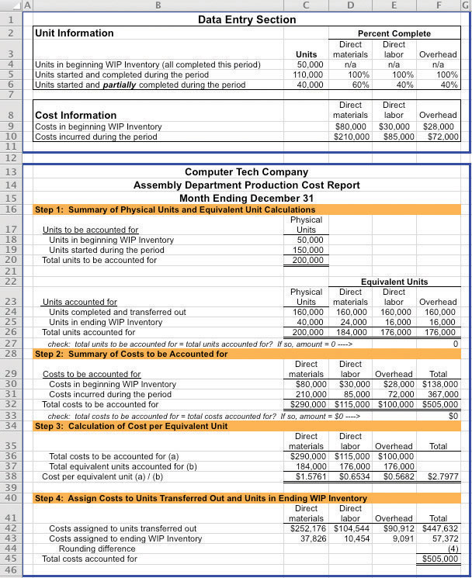
Required:
  - Why is the president asking you to increase the percentage of completion estimates?
  - Prepare another production cost report for Computer Tech Company that includes the president’s revisions. Indicate what impact the president’s request will have on cost of goods sold and on net income (ignore income taxes in your calculations).
  - As the controller of the company, how would you handle the president’s request? (If necessary, review the presentation of ethics in Chapter 1 "What Is Managerial Accounting?" for additional information.)
- Ethics: Increasing Production to Boost Profits. Pacific Siding, Inc., produces synthetic wood siding used in the construction of residential and commercial buildings. Pacific Siding’s fiscal year ends on March 31, and the weighted average method is used for the company’s process costing system.
Financial results for the first 11 months of the current fiscal year (through February 28) are well below expectations of management, owners, and creditors. Halfway through the month of March, the chief executive officer and chief financial officer asked the controller to estimate the production results for the month of March in the form of a production cost report (the company only has one production department). This report is shown as follows.
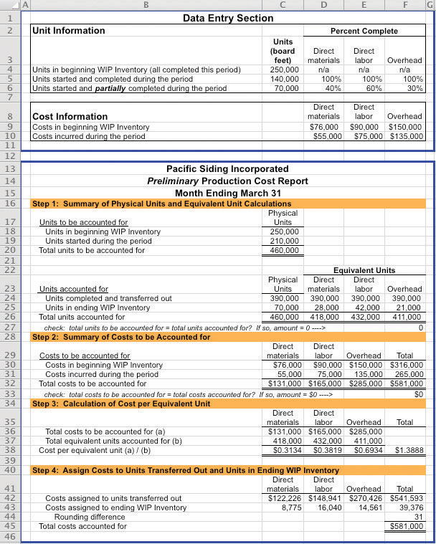
Armed with the preliminary production cost report for March, and knowing that the company’s production is well below capacity, the CEO and CFO decide to produce as many units as possible for the last half of March even though sales are notexpected to increase any time soon. The production manager is told to push his employees to get as far as possible with production, thereby increasing the percentage of completion for ending WIP inventory. However, since the production process takes three weeks to complete, all the units produced in the last half of March will be in WIP inventory at the end of March.
Required:
  - Explain how the CEO and CFO expect to increase profit (net income) for the year by boosting production at the end of March.
  - Using the following assumptions, prepare a revised estimate of production results in the form of a production cost report for the month of March.
Assumptions based on the CEO and CFO’s request to boost production
    - Units started and partially completed during the period will increase to 225,000 (from the initial estimate of 70,000). This is the projected ending WIP inventory at March 31.
    - Percentage of completion estimates for units in ending WIP inventory will increase to 80 percent for direct materials, 85 percent for direct labor, and 90 percent for overhead.
    - Costs incurred during the period will increase to $95,000 for direct materials, $102,000 for direct labor, and $150,000 for overhead (most overhead costs are fixed).
    - All units completed and transferred out during March are sold by March 31.
  - Compare your new production cost report with the one prepared by the controller. How much do you expect profit to increase as a result of increasing production during the last half of March? (Ignore income taxes in your calculations.)
  - Is the request made by the CEO and CFO ethical? Explain your answer.

Chapter 5
How Do Organizations Identify Cost Behavior Patterns?

Eric Mendez is the chief financial officer (CFO) of Bikes Unlimited, a company that produces mountain bikes and sells them to retail bicycle stores. Bikes Unlimited obtains the bulk of its parts from outside suppliers and assembles them into the mountain bikes prior to shipment. Last month (June), Bikes Unlimited sold 5,000 mountain bikes for $100 each. Last month’s income statement shows total revenue of $500,000 and operating profit of $50,000:
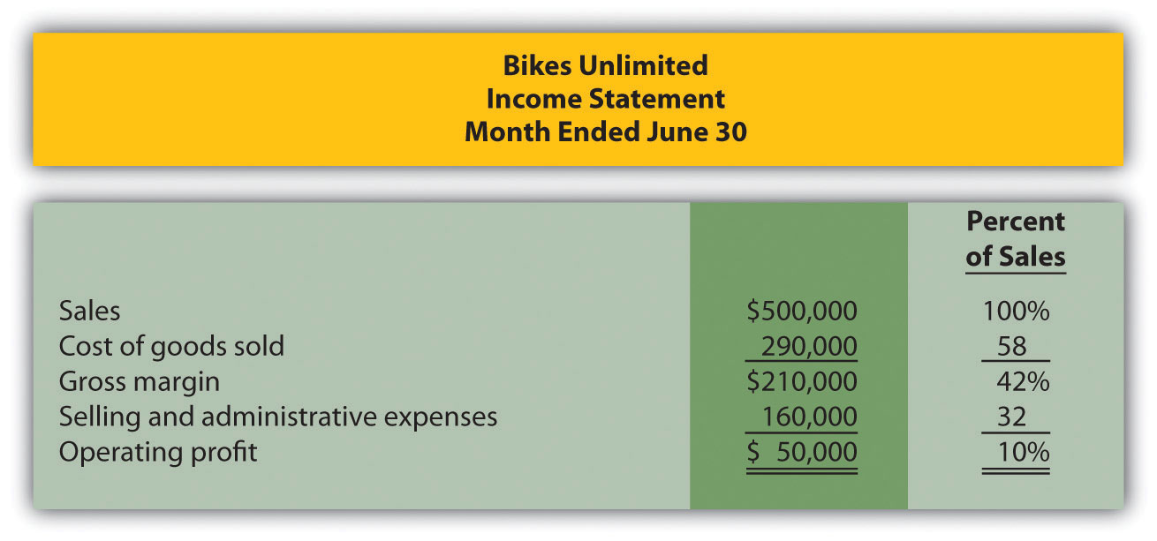

Susan Wesley is Bikes Unlimited’s cost accountant. Planning for July was completed during June. Senior management is now planning for next month (August) and has asked Eric, the CFO, to obtain some vital financial information for budgeting purposes. Eric arranged a meeting with Susan to discuss the August budget.
Eric: | As you know, we are in the middle of our planning for next month. The senior management group asked me to make some projections based on expected changes to our sales next month.
Susan: | Where do you think sales are headed?
Eric: | We expect unit sales to increase 10 percent, perhaps 20 percent if all goes well.
Susan: | If sales increase 10 percent, I would expect profit to increase by more than 10 percent since some costs are fixed.
Eric: | Sounds reasonable. What’s the next step to get a reasonable estimate of profit?
Susan: | First, we have to identify how costs behave with changes in sales and production—whether the costs are variable, fixed, or some other type. Then we can set up the income statement in a contribution margin format and determine if the numbers are within the relevant range.
Eric: | Perhaps you and your staff can discuss this and get me some accurate estimates.
Susan: | I’ll meet with them tomorrow and should have some information for you within a few days.

5.1 Cost Behavior Patterns

LEARNING OBJECTIVE
- Identify typical cost behavior patterns.

Question: To predict what will happen to profit in the future at Bikes Unlimited, we must understand how costs behave with changes in the number of units sold (sales volume). Some costs will not change at all with a change in sales volume (e.g., monthly rent for the production facility). Some costs will change with a change in sales volume (e.g., materials for the mountain bikes). What are the three cost behavior patterns that help organizations identify which costs will change and which will remain the same with changes in sales volume?

Answer: The three basic cost behavior patterns are known as variable, fixed, and mixed. Each of these cost patterns is described next.

Variable Costs

Question: We know that some costs vary with changes in activity. What do we call this type of cost behavior?

Answer: This cost behavior pattern is called a variable cost. A variable costdescribes a cost that varies in total with changes in volume of activity. The activity in this example is the number of bikes produced and sold. However, the activity can take many different forms depending on the organization. The two most common variable costs are direct materials and direct labor. Other examples include indirect materials and energy costs.

Assume the cost of direct materials (wheels, seats, frames, and so forth) for each bike at Bikes Unlimited is $40. If Bikes Unlimited produces one bike,total variable cost for direct materials amounts to $40. If Bikes Unlimited doubles its production to two bikes, total variable cost for direct materials also doubles to $80. Variable costs typically change in proportion to changes in volume of activity. If volume of activity doubles, total variable costs also double, while the cost per unit remains the same. It is important to note that the term variable refers to what happens to total costs with changes in activity, not to the cost per unit.

Taking it one step further for Bikes Unlimited, let’s consider all variable costs related to production. Assume direct materials, direct labor, and all other variable production costs amount to $60 per unit. Table 5.1 "Variable Cost Behavior for Bikes Unlimited" provides the total and per unit variable costs at three different levels of production, and Figure 5.1 "Total Variable Production Costs for Bikes Unlimited" graphs the relation of total variable costs (y-axis) to units produced (x-axis). Note that the slope of the line represents the variable cost per unit of $60 (slope = change in variable cost ÷ change in units produced).

Table 5.1 Variable Cost Behavior for Bikes Unlimited
Units Produced | Total Variable Costs | Per Unit Variable Cost
1 | $ 60 | $60
2,000 | 120,000 | 60
4,000 | 240,000 | 60
Figure 5.1 Total Variable Production Costs for Bikes Unlimited
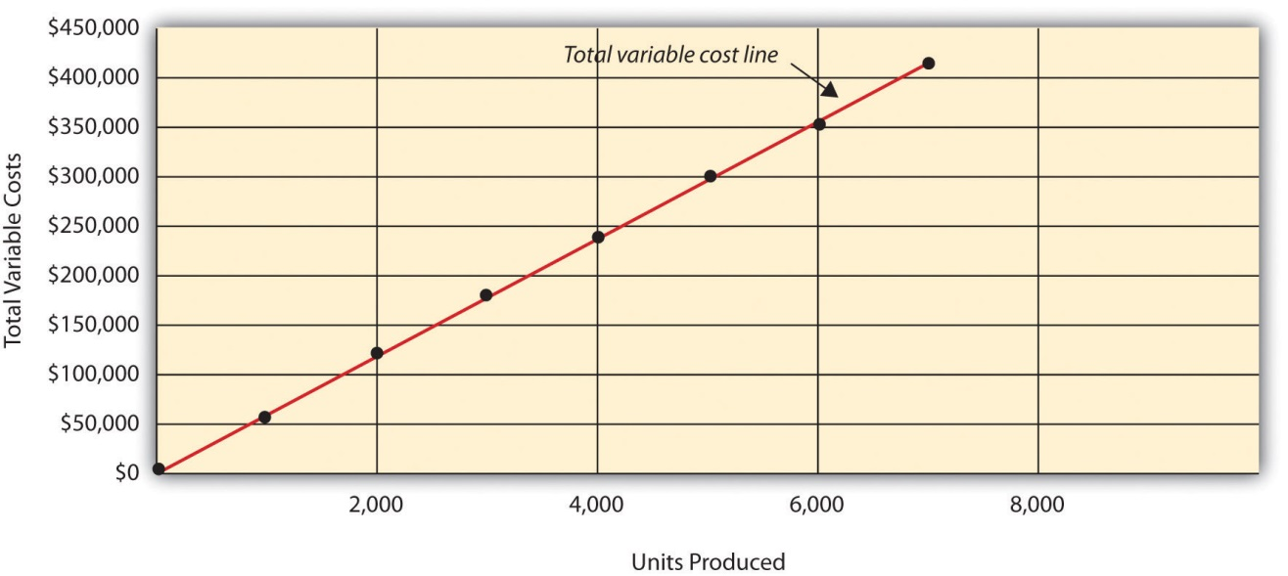

Using Different Activities to Measure Variable Costs

Question: At Bikes Unlimited, it is reasonable to assume that the activity, number of units produced, will affect total variable costs for direct materials and direct labor. However, companies often use a different activity to estimate total variable costs. What types of activities might be used to estimate variable costs?

Answer: The type of activity used to estimate variable costs depends on the cost. For example, a law firm might use the number of labor hours to estimate labor costs. An airline such as American Airlines might usehours of flying time to estimate fuel costs. A mail delivery service such asUPS might use the number of packages processed to estimate labor costs associated with sorting packages. A retail store such as Best Buy might usesales dollars to estimate cost of goods sold.

Variable costs are affected by different activities depending on the organization. The goal is to find the activity that causes the variable cost so that accurate cost estimates can be made.

Fixed Costs

Question: Costs that vary in total with changes in activity are called variable costs. What do we call costs that remain the same in total with changes in activity?

Answer: This cost behavior pattern is called a fixed cost. A fixed costdescribes a cost that is fixed (does not change) in total with changes in volume of activity. Assuming the activity is the number of bikes produced and sold, examples of fixed costs include salaried personnel, building rent, and insurance.

Assume Bikes Unlimited pays $8,000 per month in rent for its production facility. In addition, insurance for the same building is $2,000 per month and salaried production personnel are paid $6,000 per month. All other fixed production costs total $4,000. Thus Bikes Unlimited has total fixed costs of $20,000 per month related to its production facility (= $8,000 + $2,000 + $6,000 + $4,000). If only one bike is produced, Bikes Unlimited still must pay $20,000 per month. If 5,000 bikes are produced, Bikes Unlimited still pays $20,000 per month. The fixed costs remain unchanged in total as the level of activity changes.

Question: What happens to fixed costs on a per unit basis as production levels change?

Answer: If Bikes Unlimited only produces one bike, the fixed cost per unitwould amount to $20,000 (= $20,000 total fixed costs ÷ 1 bike). If Bikes Unlimited produces two bikes, the fixed cost per unit would be $10,000 (= $20,000 ÷ 2 bikes). As activity increases, the fixed costs are spread out over more units, which results in a lower cost per unit.

Table 5.2 "Fixed Cost Behavior for Bikes Unlimited" provides the total and per unit fixed costs at three different levels of production, and Figure 5.2 "Total Fixed Production Costs for Bikes Unlimited" graphs the relation of total fixed costs (y-axis) to units produced (x-axis). Note that regardless of the activity level, total fixed costs remain the same.
Table 5.2 Fixed Cost Behavior for Bikes Unlimited
Units Produced | Total Fixed Costs | Per Unit Fixed Cost
1 | $20,000 | $20,000
2,000 | 20,000 | 10
4,000 | 20,000 | 5
Figure 5.2 Total Fixed Production Costs for Bikes Unlimited
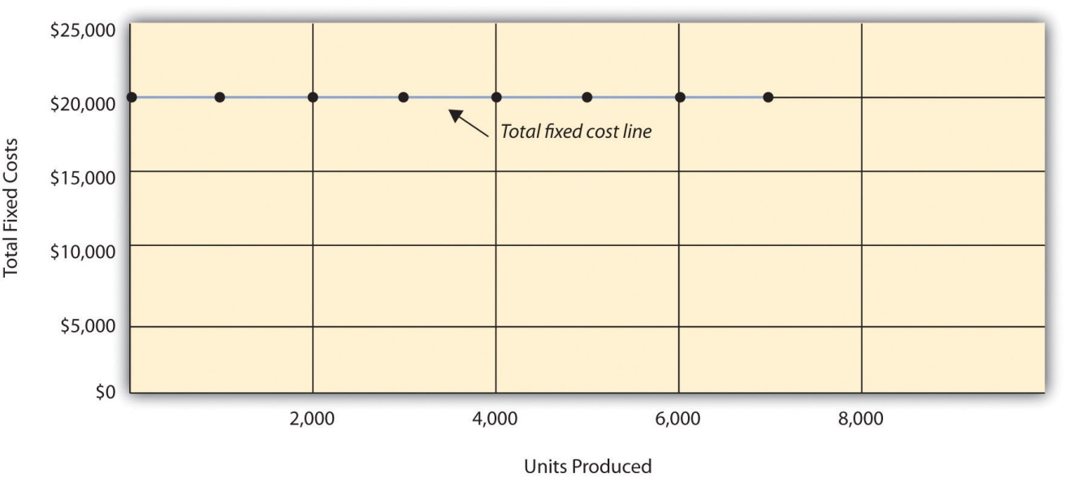

Business in Action 5.1
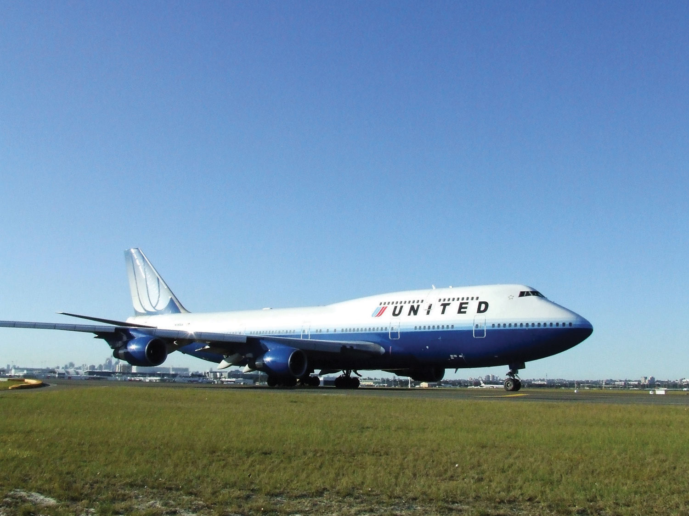
Source: Photo courtesy of Simon_sees,http://www.flickr.com/photos/39551170@N02/3696524201/.
United Airlines Struggles to Control Costs
United Airlines is the second largest air carrier in the world. It has hubs in Chicago, Denver, Los Angeles, San Francisco, and New York and flies to 109 destinations in 23 countries. Destinations include Tokyo, London, and Frankfurt.
Back in 2002, United filed for bankruptcy. Industry analysts reported that United had relatively high fixed costs, making it difficult for the company to cut costs quickly in line with its reduction in revenue. A few years later, United emerged from bankruptcy, and in 2010 merged with Continental Airlines. Although financial information was presented separately for each company (United and Continental) in 2010, both companies are now owned by United Continental Holdings, Inc. The following financial information for United Airlines is from the company’s income statement for the year ended December 31, 2010 (amounts are in millions). Review this information carefully. Which costs are likely to be fixed?
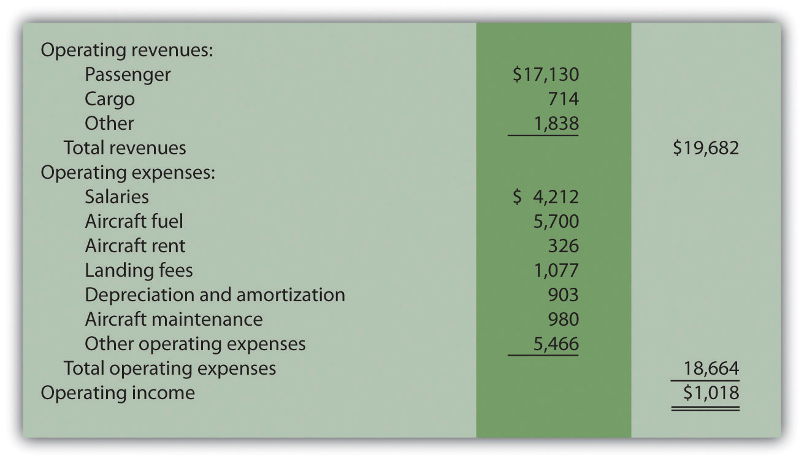
Although we cannot identify all fixed costs with certainty, several costs likely fall into this category: salaries (for union employees, such as pilots, flight crews, and mechanics); aircraft fuel (assuming flights are not easily canceled); aircraft rent; and depreciation. These costs total $11.1 billion, or 60 percent of total operating expenses (rounded). Fixed costs are clearly a large component of total operating expenses, which makes it difficult for airline companies like United Airlines to make short-term cuts in expenses when revenue declines.
Source: United Continental, Inc., form 10K for 2010.

Committed Versus Discretionary Fixed Costs

Question: Organizations often view fixed costs as either committed or discretionary. What is the difference between these two types of fixed costs?

Answer: A committed fixed cost is a fixed cost that cannot easily be changed in the short run without having a significant impact on the organization. For example, assume Bikes Unlimited has a five-year lease on the company’s production facility, which costs $8,000 per month. This is a committed fixed cost because the lease cannot easily be broken, and the company is committed to using this facility for years to come. Other examples of committed fixed costs include salaried employees with long-term contracts, depreciation on buildings, and insurance.

A discretionary fixed cost is a fixed cost that can be changed in the short run without having a significant impact on the organization. For example, assume Bikes Unlimited contributes $10,000 each year toward charitable organizations. Management has the option of changing this amount in the short run without causing a significant impact on the organization. Other examples of discretionary fixed costs include advertising, research and development, and training programs (although an argument can be made that reducing these expenditures could have a significant impact on the company depending on the amount of the cuts).

In general, management looks to cut discretionary fixed costs when sales and profits are declining, since cuts in this area tend not to have as significant an impact on the organization as cutting committed fixed costs. Difficulties arise when struggling organizations go beyond cutting discretionary fixed costs and begin looking at cutting committed fixed costs.

Mixed Costs

Question: We have now learned about two types of cost behavior patterns—variable costs and fixed costs. However, there is a third type of cost that behaves differently in that both total and per unit costs change with changes in activity. What do we call this type of cost?

Answer: This cost behavior pattern is called a mixed cost. The termmixed cost describes a cost that has a mix of fixed and variable costs. For example, assume sales personnel at Bikes Unlimited are paid a total of $10,000 in monthly salary plus a commission of $7 for every bike sold. This is a mixed cost because it has a fixed component of $10,000 per month and a variable component of $7 per unit.

Table 5.3 "Mixed Cost Behavior for Bikes Unlimited" provides the total and per unit fixed costs at three different levels of production, and Figure 5.3 "Total Mixed Sales Compensation Costs for Bikes Unlimited" graphs the relation of total mixed costs (y-axis) to units produced (x-axis). The point at which the line intersects the y-axis represents the total fixed cost ($10,000), and the slope of the line represents the variable cost per unit ($7).

Table 5.3 Mixed Cost Behavior for Bikes Unlimited
Units Sold | Total Mixed Costs | Per Unit Mixed Cost
1 | $10,007 | $10,007.00
2,000 | 24,000 | 12.00
4,000 | 38,000 | 9.50
Figure 5.3 Total Mixed Sales Compensation Costs for Bikes Unlimited
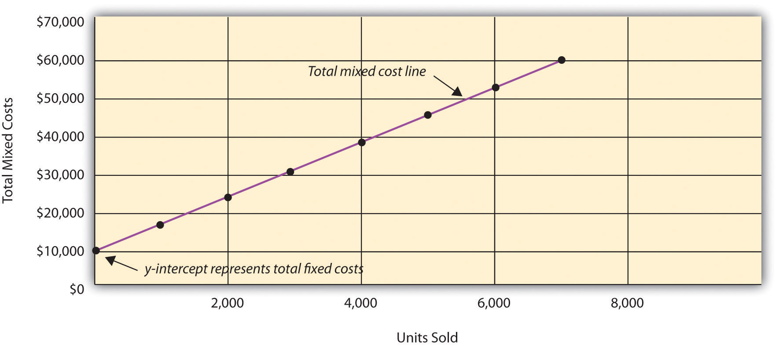

Because this cost is depicted with a straight line, we can use the equation for a straight line to describe a mixed cost:

Key Equation
Total mixed cost = Total fixed cost + (Unit variable cost × Number of units)
or
Y = f + vX
where
Y = total mixed costs (this is the y-axis in Figure 5.3 "Total Mixed Sales Compensation Costs for Bikes Unlimited")f = total fixed costsv = variable cost per unitX = level of activity (this is the x-axis in Figure 5.3 "Total Mixed Sales Compensation Costs for Bikes Unlimited")

For Bikes Unlimited, the mixed cost equation is Y = $10,000 + $7X. If Bikes Unlimited sells 4,000 bikes (X) in one month, the total mixed cost (Y) for sales personnel compensation would be $38,000 [= $10,000 + ($7 × 4,000 units)].

Short Term Versus Long Term and the Relevant Range

We now introduce two important concepts that must be considered when estimating costs: short term versus long term, and the relevant range.

Short Term Versus Long Term

Question: When identifying cost behavior patterns, we assume that management is using the cost information to make short-term decisions. Why is this short-term decision making assumption so important?

Answer: Variable, fixed, and mixed cost concepts are useful for short-term decision making and therefore apply to a specific period of time. This short-term period will vary depending on the company’s current production capacity and the time required to change capacity. In the long term, all cost behavior patterns will likely change.

For example, suppose Bikes Unlimited’s production capacity is 8,000 units per month, and management plans to expand capacity in two years by renting a new production facility and hiring additional personnel. This is a long-term decision that will change the cost behavior patterns identified earlier. Variable production costs will no longer be $60 per unit, fixed production costs will no longer be $20,000 per month, and mixed sales compensation costs will also change. All these costs will change because the estimates are accurate only in the short term.

The Relevant Range

Question: Another important concept we use when estimating costs is called the relevant range. What is the relevant range and why is it so important when estimating costs?

Answer: The relevant range is the range of activity for which cost behavior patterns are likely to be accurate. The variable, fixed, and mixed costs identified for Bikes Unlimited will only be accurate within a certain range of activity. Once the firm goes outside that range, cost estimates are not necessarily accurate and often must be reevaluated and recalculated.

For example, assume Bikes Unlimited’s mixed sales compensation costs of $10,000 per month plus $7 per unit is only valid up to 4,000 units per month. If unit sales increase beyond 4,000 units, management will hire additional salespeople and the total monthly base salary will increase beyond $10,000. Thus the relevant range for this mixed cost is from zero to 4,000 units. Once the company exceeds sales of 4,000 units per month, it is out of the relevant range, and the mixed cost must be recalculated.

We discuss the relevant range concept in more detail later in the chapter. For now, remember that the accuracy of cost behavior patterns is limited to a certain range of activity called the relevant range.

Computer Application
Using Excel to Create Charts
Managers typically use computer applications on a daily basis to perform a variety of functions. For example, they often use Excel to generate tables, graphs, and charts. You could use Excel to create the charts shown in Figure 5.1 "Total Variable Production Costs for Bikes Unlimited", Figure 5.2 "Total Fixed Production Costs for Bikes Unlimited", and Figure 5.3 "Total Mixed Sales Compensation Costs for Bikes Unlimited". Here’s how:
- Enter the data. Open a new Excel document and enter the data in two columns: one column for the x-axis (horizontal axis), and one column for the y-axis (vertical axis). Let’s suppose you want to create the chart shown in Figure 5.1 "Total Variable Production Costs for Bikes Unlimited". In that case, the x-axis represents units produced, and the y-axis represents total variable costs. An excerpt from your Excel document would appear as follows:
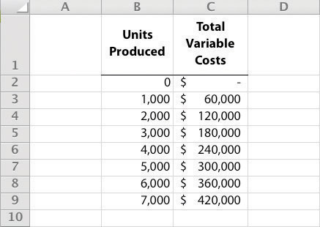
- Create the chart. After you have entered the data, highlight the appropriate data cells (including headings and labels) and click onInsert, Chart, Scatter. Choose Scatter with Smooth Lines and Markers. The chart that results is linked to your data points. If you change the data, the chart changes, too. (In earlier versions of Excel, the chart wizard walks you through the steps necessary to create the chart.)
- Format the chart. Now that you have created the chart, select it and use Chart Tools to format it with background shading, text inserts, font size, chart size, and other more advanced features. If you want to display the chart within some other document (e.g., a Word document), you can copy it (highlight the chart and selectEdit, Copy from the menu bar) and paste it into the document (selectEdit, Paste or Paste Special).
The Excel document created by following these three steps would look like the one shown in Figure 5.1 "Total Variable Production Costs for Bikes Unlimited".

How Cost Behavior Patterns Are Used

Question: How do managers use cost behavior patterns to make better decisions?

Answer: Accurately predicting what costs will be in the future can help managers answer several important questions. For example, managers at Bikes Unlimited might ask the following:
- We expect to see a 5 percent increase in unit sales next year. How will this affect revenues and costs?
- We are applying for a loan with a bank, and bank managers think our sales estimates are high. What happens to our revenues and costs if we lower estimates by 20 percent?
- What happens to revenues and costs if we add a racing bike to our product line?
- How will costs behave in the future if we increase automation in the production process?

The only way to accurately predict costs is to understand how costs behave given changes in activity. To make good decisions, managers must know how costs are structured (fixed, variable, or mixed). The next section explains how to estimate fixed and variable costs, and how to identify the fixed and variable components of mixed costs.

Business in Action 5.2
Budget Cuts at an Elementary School District
A school district outside Sacramento, California, was faced with making budget cuts because of a reduction in state funding. To reduce costs, the school district’s administration decided to consider closing one of the smaller elementary schools in the district. According to an initial estimate, closing this school would reduce costs by $500,000 to $1,000,000 per year. However, further analysis identified only $100,000 to $150,000 in cost savings.
Why did the analysis yield lower savings than the initial estimate? Most of the costs were committed fixed costs (e.g., teachers’ salaries and benefits) and could not be eliminated in the short term. In fact, teachers and students at the school being considered for closure were to be moved to other schools in the district, and so no savings on teachers’ salaries and benefits would result. The only real short-term cost savings would be in not having to maintain the classrooms, computer lab, and library (nonunion employees would be let go) and in utilities (heat and air conditioning would be turned off).
The school district ultimately decided not to close the school because of the large committed fixed costs involved, as well as a lack of community support, and budget cuts were made in other areas throughout the district.

REVIEW PROBLEM 5.1
Sierra Company is trying to identify the behavior of the three costs shown in the following table. The following cost information is provided for six months. Calculate the cost per unit, and then identify how each cost behaves (fixed, variable, or mixed). Explain your answers.
 |  | Cost 1 |  | Cost 2 |  | Cost 3
Month | Units Produced | Total Costs | Cost per Unit | Total Costs | Cost per Unit | Total Costs | Cost per Unit
1 | 50 | $100 | $2.00 | $100 | $2.00 | $100 | $2.00
2 | 100 | 200 | 2.00 | 100 | 1.00 | 150 | 1.50
3 | 150 | 300 | _____ | 100 | _____ | 200 | _____
4 | 200 | 400 | _____ | 100 | _____ | 250 | _____
5 | 250 | 500 | _____ | 100 | _____ | 300 | _____
6 | 300 | 600 | _____ | 100 | _____ | 350 | _____
Solution to Review Problem 5.1
As shown in the following table, cost 1 is a variable cost because as the number of units produced changes, total costs change (in proportion to changes in activity) and per unit cost remains the same. Cost 2 is a fixed cost because as the number of units produced changes, total costs remain the same and per unit costs change. Cost 3 is a mixed cost because as the number of units produced changes, total cost changes (but not in proportion to changes in activity) and per unit cost changes.
 |  | Cost 1 |  | Cost 2 |  | Cost 3
Month | Units Produced | Total Costs | Cost per Unit | Total Costs | Cost per Unit* | Total Costs | Cost per Unit*
1 | 50 | $100 | $2.00 | $100 | $2.00 | $100 | $2.00
2 | 100 | 200 | 2.00 | 100 | 1.00 | 150 | 1.50
3 | 150 | 300 | 2.00 | 100 | 0.67 | 200 | 1.33
4 | 200 | 400 | 2.00 | 100 | 0.50 | 250 | 1.25
5 | 250 | 500 | 2.00 | 100 | 0.40 | 300 | 1.20
6 | 300 | 600 | 2.00 | 100 | 0.33 | 350 | 1.17
*Rounded.

5.2 Cost Estimation Methods

LEARNING OBJECTIVE
- Estimate costs using account analysis, the high-low method, the scattergraph method, and regression analysis.

Question: Recall the conversation that Eric (CFO) and Susan (cost accountant) had about Bikes Unlimited’s budget for the next month, which is August. The company expects to increase sales by 10 to 20 percent, and Susan has been asked to estimate profit for August given this expected increase. Although examples of variable and fixed costs were provided in the previous sections, companies typically do not know exactly how much of their costs are fixed and how much are variable. (Financial accounting systems do not normally sort costs as fixed or variable.) Thus organizations must estimate their fixed and variable costs. What methods do organizations use to estimate fixed and variable costs?

Answer: Four common approaches are used to estimate fixed and variable costs:
- Account analysis
- High-low method
- Scattergraph method
- Regression analysis

All four methods are described next. The goal of each cost estimation method is to estimate fixed and variable costs and to describe this estimate in the form of Y = f + vX. That is, Total mixed cost = Total fixed cost + (Unit variable cost × Number of units). Note that the estimates presented next for Bikes Unlimited may differ from the dollar amounts used previously, which were for illustrative purposes only.

Account Analysis

Question: The account analysis approach is perhaps the most common starting point for estimating fixed and variable costs. How is the account analysis approach used to estimate fixed and variable costs?

Answer: This approach requires that an experienced employee or group of employees review the appropriate accounts and determine whether the costs in each account are fixed or variable. Totaling all costs identified as fixed provides the estimate of total fixed costs. To determine the variable cost per unit, all costs identified as variable are totaled and divided by the measure of activity (units produced is the measure of activity for Bikes Unlimited).

Let’s look at the account analysis approach using Bikes Unlimited as an example. Susan (the cost accountant) asked the financial accounting department to provide cost information for the production department for the month of June (July information is not yet available). Because the financial accounting department tracks information by department, it is able to produce this information. The production department information for June is as follows:
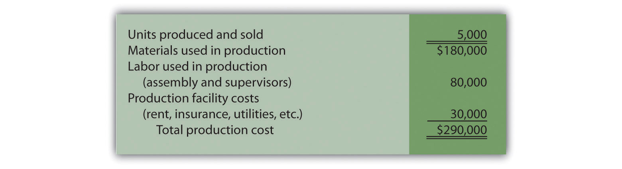

Susan reviewed this cost information with the production manager, Indira Bingham, who has worked as production manager at Bikes Unlimited for several years. After careful review, Indira and Susan came up with the following breakdown of variable and fixed costs for June:
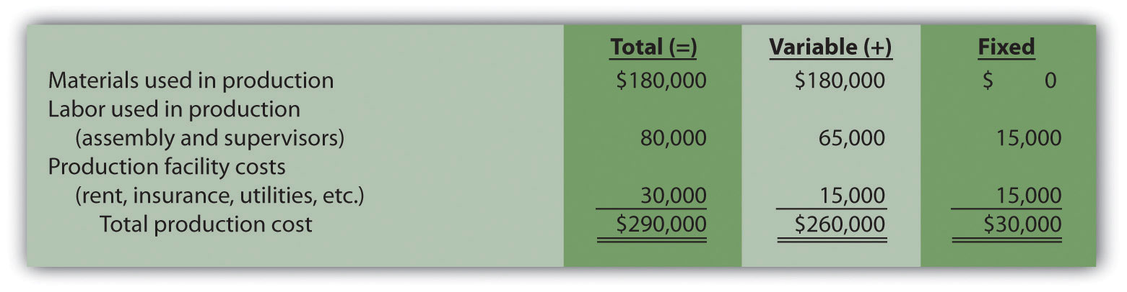

Total fixed cost is estimated to be $30,000, and variable cost per unit is estimated to be $52 (= $260,000 ÷ 5,000 units produced). Remember, the goal is to describe the mixed costs in the equation form Y = f + vX. Thus the mixed cost equation used to estimate future production costs is
Y = $30,000 + $52X

Now Susan can estimate monthly production costs (Y) if she knows how many units Bikes Unlimited plans to produce (X). For example, if Bikes Unlimited plans to produce 6,000 units for a particular month (a 20 percent increase over June) and this level of activity is within the relevant range, total production costs should be approximately $342,000 [= $30,000 + ($52 × 6,000 units)].

Question: Why should Susan be careful using hysterical data for one month (June) to estimate future costs?

Answer: June may not be a typical month for Bikes Unlimited. For example, utility costs may be low relative to those in the winter months, and production costs may be relatively high as the company prepares for increased demand in July and August. This might result in a lower materials cost per unit from quantity discounts offered by suppliers. To smooth out these fluctuations, companies often use data from the past quarter or past year to estimate costs.

REVIEW PROBLEM 5.2
Alta Production, Inc., is using the account analysis approach to identify the behavior of production costs for a month in which it produced 350 units. The production manager was asked to review these costs and provide her best guess as to how they should be categorized. She responded with the following information:
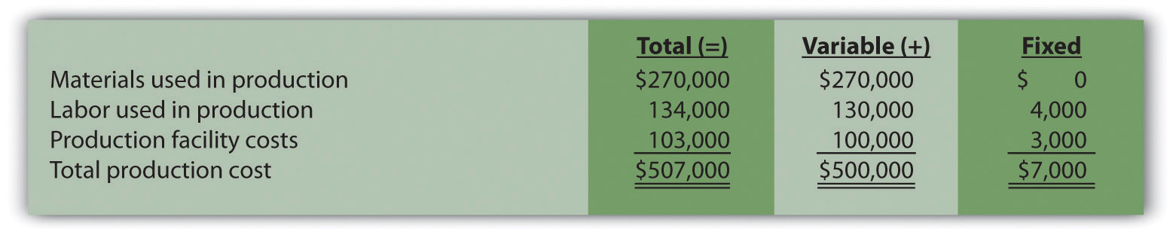
- Describe the production costs in the equation form Y = f + vX.
- Assume Alta intends to produce 400 units next month. Calculate total production costs for the month.
Solution to Review Problem 5.2
- Because f represents total fixed costs, and v represents variable cost per unit, the cost equation is: Y = $7,000 + $1,428.57X. (Variable cost per unit of $1,428.57 = $500,000 ÷ 350 units.)
- Using the previous equation, simply substitute 400 units for X, as follows:
YYY=$7,000+($1,428.57×400 units)=$7,000+$571,428=$578,428
Thus total production costs are expected to be $578,428 for next month.

High-Low Method

Question: Another approach to identifying fixed and variable costs for cost estimation purposes is the high-low method. Accountants who use this approach are looking for a quick and easy way to estimate costs, and will follow up their analysis with other more accurate techniques. How is the high-low method used to estimate fixed and variable costs?

Answer: The high-low method uses historical information from several reporting periods to estimate costs. Assume Susan Wesley obtains monthly production cost information from the financial accounting department for the last 12 months. This information appears in .
Table 5.4 Monthly Production Costs for Bikes Unlimited
Reporting Period (Month) | Total Production Costs | Level of Activity (Units Produced)
July | $230,000 | 3,500
August | 250,000 | 3,750
September | 260,000 | 3,800
October | 220,000 | 3,400
November | 340,000 | 5,800
December | 330,000 | 5,500
January | 200,000 | 2,900
February | 210,000 | 3,300
March | 240,000 | 3,600
April | 380,000 | 5,900
May | 350,000 | 5,600
June | 290,000 | 5,000

All of the data points from are plotted on the graph shown in . Although a graph is not required using the high-low method, it is a helpful visual tool. Susan then draws a straight line using the high (April) and low (January)activity levels from these data. The goal of the high-low method is to describe this line mathematically in the form of an equation stated as Y = f + vX, which requires calculating both the total fixed costs amount (f) and per unit variable cost amount (v). Four steps are required to achieve this using the high-low method:
Step 1. Identify the high and low activity levels from the data set.
Step 2. Calculate the variable cost per unit (v).
Step 3. Calculate the total fixed cost (f).
Step 4. State the results in equation form Y = f + vX.

Figure 5.4 Estimated Total Mixed Production Costs for Bikes Unlimited: High-Low Method
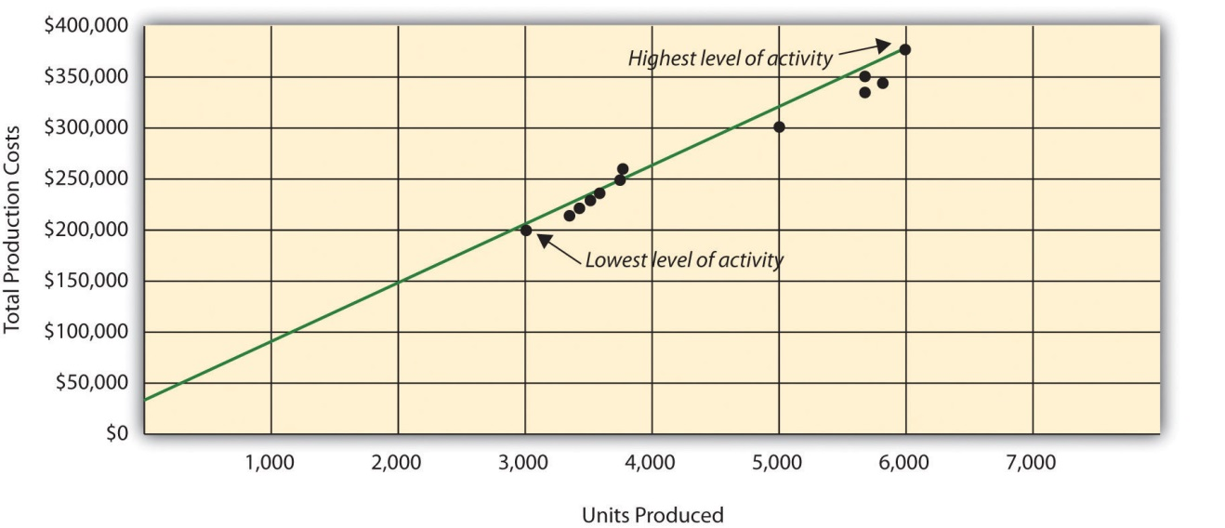

Question: How are the four steps of the high-low method used to estimate total fixed costs and per unit variable cost?

Answer: Each of the four steps is described next.

Step 1. Identify the high and low activity levels from the data set.

The highest level of activity (level of production) occurred in the month of April (5,900 units; $380,000 production costs), and the lowest level of activity occurred in the month of January (2,900 units; $200,000 production costs). Note that we are identifying the high and low activitylevels rather than the high and low dollar levels—choosing the high and low dollar levels can result in incorrect high and low points.

Step 2. Calculate the variable cost per unit (v).

Because the slope of the line shown in represents the variable cost per unit, the goal here is to calculate the slope of the line using the high and low points identified in step 1 (the slope calculation is often referred to as “rise over run” in math courses). The calculation of the variable cost per unit for Bikes Unlimited is shown as follows:
Unit variable cost (v)=Cost at highest level − Cost at lowest level Highest activity level − Lowest activity level =$380,000−$200,0005,900 units−2,900 units=$180,0003,000 units=$60
Step 3. Calculate the total fixed cost (f).

After completing step 2, the equation to describe the line is partially complete and stated as Y = f + $60X. The goal of step 3 is to calculate a value for total fixed cost (f). Simply select either the high or low activity level, and fill in the data to solve for f (total fixed costs), as shown.

Using the low activity level of 2,900 units and $200,000,
Y$200,000fff=f+vX=f+($60×2,900 units)=$200,000−($60×2,900 units)=$200,000−$174,000=$26,000

Thus total fixed costs total $26,000. (Try this using the high activity level of 5,900 units and $380,000. You will get the same result as long as the per unit variable cost is not rounded.)

Step 4. State the results in equation form Y = f + vX.

We know from step 2 that the variable cost per unit is $60, and from step 3 that total fixed cost is $26,000. Thus we can state the equation used to estimate total costs as
Y = $26,000 + $60X

Now it is possible to estimate total production costs given a certain level of production (X). For example, if Bikes Unlimited expects to produce 6,000 units during August, total production costs are estimated to be $386,000:
YYY=$26,000+($60×6,000 units)=$26,000+$360,000=$386,000

Question: Although the high-low method is relatively simple, it does have a potentially significant weakness. What is the potential weakness in using the high-low method?

Answer: In reviewing , you will notice that this approach only considers the high and low activity levels in establishing an estimate of fixed and variable costs. The high and low data points may not represent the data set as a whole, and using these points can result in distorted estimates.

For example, the $380,000 in production costs incurred in April may be higher than normal because several production machines broke down resulting in costly repairs. Or perhaps several key employees left the company, resulting in higher than normal labor costs for the month because the remaining employees were paid overtime. Cost accountants will often throw out the high and low points for this reason and use the next highest and lowest points to perform this analysis. While the high-low method is most often used as a quick and easy way to estimate fixed and variable costs, other more sophisticated methods are most often used to refine the estimates developed from the high-low method.

REVIEW PROBLEM 5.3
Alta Production, Inc., reported the following production costs for the 12 months January through December. (This is the same company featured in .)
Reporting Period (Month) | Total Production Costs | Level of Activity (Units Produced)
January | $460,000 | 300
February | 300,000 | 220
March | 480,000 | 330
April | 550,000 | 390
May | 570,000 | 410
June | 310,000 | 240
July | 440,000 | 290
August | 455,000 | 320
September | 530,000 | 380
October | 250,000 | 150
November | 700,000 | 450
December | 490,000 | 350
- Using this information, perform the four steps of the high-low method to estimate costs and state your results in cost equation form Y = f + vX.
- Assume Alta Production, Inc., will produce 400 units next month. Calculate total production costs for the month.
- What is the potential weakness in using this approach to estimate costs?
Solution to Review Problem 5.3
- The four steps are as follows:

Step 1. Identify the high and low activity levels from the data set.
The highest level of activity occurred in November (450 units; $700,000 production costs), and the lowest level of activity occurred in October (150 units; $250,000 production costs).

Step 2. Calculate the variable cost per unit (v).
Unit variable cost=Change in cost ÷ Change in activity=($700,000−$250,000)÷(450 units−150 units)=$1,500

Step 3. Calculate the total fixed cost (f).
After completing step 2, the equation to describe the line is partially complete and stated as Y = f + $1,500X. To calculate total fixed costs, simply select either the high or low activity level, and fill in the data to solve for f (total fixed costs), as shown.
Using the high activity level,
Y$700,000fff=f+vX=f+($1,500×450 units)=($1,500×450 units)=$700,000−$675,000=$25,000
Thus total fixed cost is $25,000.

Step 4. State the results in equation form Y = f + vX.
We know from step 2 that the variable cost per unit is $1,500, and from step 3 that total fixed costs are $25,000. Thus the equation used to estimate total production costs is
Y =$25,000+$1,500X
- Using the equation from part 1, simply substitute 400 units for X, as follows:
YYY=$25,000+($1,500×400 units)=$25,000+$600,000=$625,000
Thus total production costs are expected to be $625,000 for next month.
- This approach only considers the high and low activity levels in establishing an estimate of fixed and variable costs. The high and low data points may not represent the data set as a whole, and using these points can result in distorted estimates. In reviewing the set of data points for January through December, it appears that October and November are relatively extreme points when compared to the other 10 months. Because the cost equation is based solely on these two points, the resulting estimate of production costs for 400 units of production (in part 2) may not be accurate.

Scattergraph Method

Question: Many organizations prefer to use the scattergraph method to estimate costs. Accountants who use this approach are looking for an approach that does not simply use the highest and lowest data points. How is the scattergraph method used to estimate fixed and variable costs?

Answer: The scattergraph method considers all data points, not just the highest and lowest levels of activity. Again, the goal is to develop an estimate of fixed and variable costs stated in equation form Y = f + vX. Using the same data for Bikes Unlimited shown in , we will follow the five steps associated with the scattergraph method:
Step 1. Plot the data points for each period on a graph.

Step 2. Visually fit a line to the data points and be sure the line touches one data point.

Step 3. Estimate the total fixed costs (f).

Step 4. Calculate the variable cost per unit (v).

Step 5. State the results in equation form Y = f + vX.

Question: How are the five steps of the scattergraph method used to estimate total fixed costs and per unit variable cost?

Answer: Each of the five steps is described next.

Step 1. Plot the data points for each period on a graph.

This step requires that each data point be plotted on a graph. The x-axis (horizontal axis) reflects the level of activity (units produced in this example), and the y-axis (vertical axis) reflects the total production cost.shows a scattergraph for Bikes Unlimited using the data points for 12 months, July through June.
Figure 5.5 Scattergraph of Total Mixed Production Costs for Bikes Unlimited
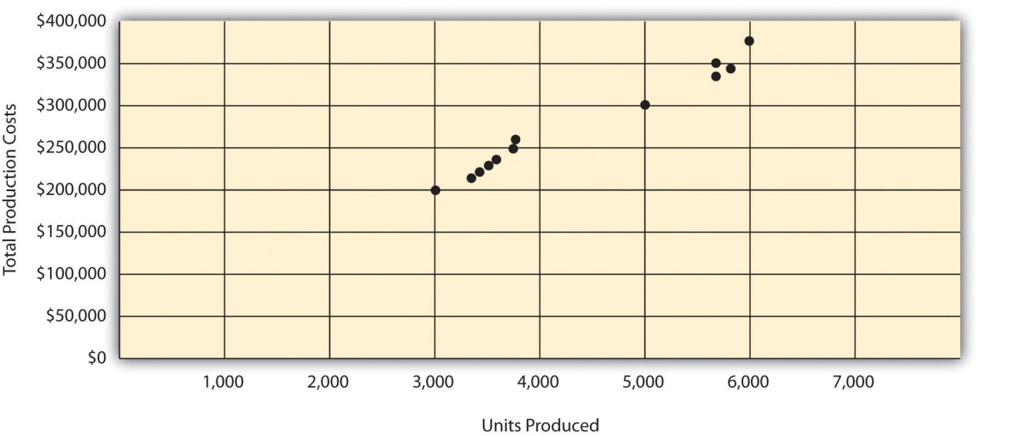

Step 2. Visually fit a line to the data points and be sure the line touches one data point.

Once the data points are plotted as described in step 1, draw a line through the points touching one data point and extending to the y-axis. The goal here is to minimize the distance from the data points to the line (i.e., to make the line as close to the data points as possible). shows the line through the data points. Notice that the line hits the data point for July (3,500 units produced and $230,000 total cost).
Figure 5.6 Estimated Total Mixed Production Costs for Bikes Unlimited: Scattergraph Method
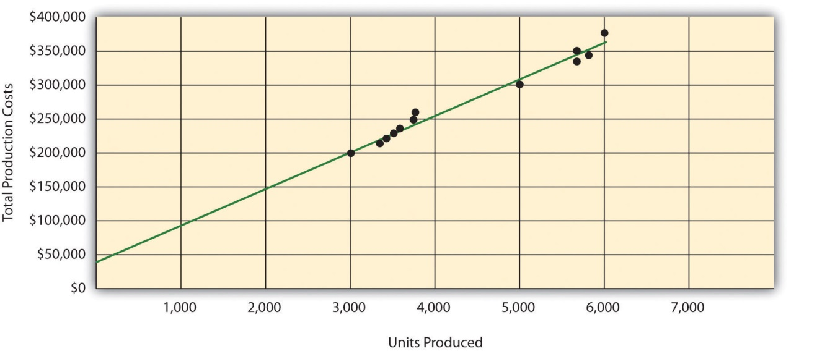

Step 3. Estimate the total fixed costs (f).

The total fixed costs are simply the point at which the line drawn in step 2 meets the y-axis. This is often called the y-intercept. Remember, the line meets the y-axis when the activity level (units produced in this example) is zero. Fixed costs remain the same in total regardless of level of production, and variable costs change in total with changes in levels of production. Since variable costs are zero when no units are produced, the costs reflected on the graph at the y-intercept must represent total fixed costs. The graph inindicates total fixed costs of approximately $45,000. (Note that the y-intercept will always be an approximation.)

Step 4. Calculate the variable cost per unit (v).

After completing step 3, the equation to describe the line is partially complete and stated as Y = $45,000 + vX. The goal of step 4 is to calculate a value for variable cost per unit (v). Simply use the data point the line intersects (July: 3,500 units produced and $230,000 total cost), and fill in the data to solve for v (variable cost per unit) as follows:
Y$230,000$230,000−$45,000$185,000vv=f+vX=$45,000+(v×3,500)=v×3,500=v×3,500=$185,000÷3,500=$52.86 (rounded)

Thus variable cost per unit is $52.86.

Step 5. State the results in equation form Y = f + vX.

We know from step 3 that the total fixed costs are $45,000, and from step 4 that the variable cost per unit is $52.86. Thus the equation used to estimate total costs looks like this:
Y = $45,000 + $52.86X

Now it is possible to estimate total production costs given a certain level of production (X). For example, if Bikes Unlimited expects to produce 6,000 units during August, total production costs are estimated to be $362,160:
YYY=$45,000+($52.86×6,000 units)=$45,000+$317,160=$362,160

Question: Remember that the key weakness of the high-low method discussed previously is that it considers only two data points in estimating fixed and variable costs. How does the scattergraph method mitigate this weakness?

Answer: The scattergraph method mitigates this weakness by considering all data points in estimating fixed and variable costs. The scattergraph method gives us an opportunity to review all data points in the data set when we plot these data points in a graph in step 1. If certain data points seem unusual (statistics books often call these points outliers), we can exclude them from the data set when drawing the best-fitting line. In fact, many organizations use a scattergraph to identify outliers and then useregression analysis to estimate the cost equation Y = f + vX. We discuss regression analysis in the next section.

Although the scattergraph method tends to yield more accurate results than the high-low method, the final cost equation is still based on estimates. The line is drawn using our best judgment and a bit of guesswork, and the resulting y-intercept (fixed cost estimate) is based on this line. This approach is not an exact science! However, the next approach to estimating fixed and variable costs—regression analysis—uses mathematical equations to find the best-fitting line.

REVIEW PROBLEM 5.4
Alta Production, Inc., reported the following production costs for the 12 months January through December. (These are the same data presented in .)
Reporting Period (Month) | Total Production Costs | Level of Activity (Units Produced)
January | $460,000 | 300
February | 300,000 | 220
March | 480,000 | 330
April | 550,000 | 390
May | 570,000 | 410
June | 310,000 | 240
July | 440,000 | 290
August | 455,000 | 320
September | 530,000 | 380
October | 250,000 | 150
November | 700,000 | 450
December | 490,000 | 350
- Using the information, perform the five steps of the scattergraph method to estimate costs and state your results in cost equation form Y = f + vX.
- Assume Alta Production, Inc., will produce 400 units next month. Calculate total production costs for the month.
- When is this approach likely to yield more accurate results than the high-low method?
Solution to Review Problem 5.4
- The five steps are as follows:

Step 1. Plot the data points for each period on a graph.
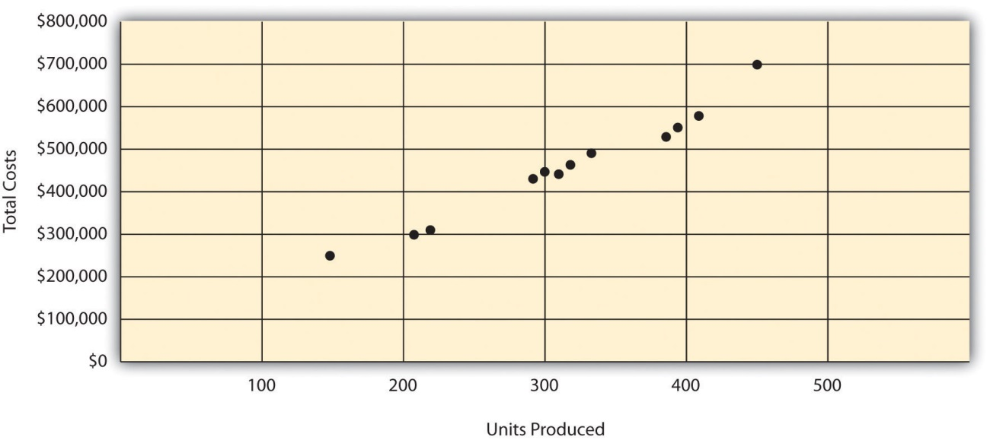

Step 2. Visually fit a line to the data points, and be sure the line touches one data point.
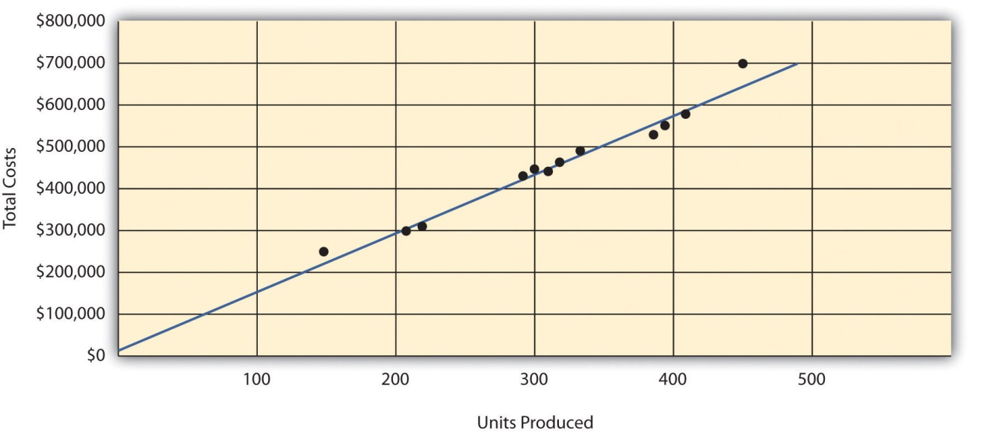

Step 3. Estimate the total fixed costs (f).
The y-intercept represents total fixed costs. This is where the line meets the y-axis. Total fixed costs in the graph appear to be approximately $5,000. You will likely get a different answer because the answer depends on the line that you visually fit to the data points. Remember you must draw the line through one data point. The line intersects the data point for March ($480,000 production costs; 330 units produced). This will be used in step 4.

Step 4. Calculate the variable cost per unit (v).
After completing step 3, the equation to describe the line is partially complete and stated as Y = $5,000 + vX. The goal of this step is to calculate a value for variable cost per unit (v). Use the data point the line intersects (for March, 330 units produced and $480,000 total costs), and fill in the data to solve for v (variable cost per unit):
Y$480,000$480,000−$5,000$475,000vv=f+vX=$5,000+(v×330)=v×330=v×330=$475,000÷330=$1,439.39 (rounded)

Step 5. State the results in equation form Y = f + vX.
We know from step 3 that the total fixed costs are $5,000, and from step 4 that variable cost per unit is $1,439.39. Thus the equation used to estimate total production costs is stated as:
Y=$5,000+$1,439.39X
It is evident from this information that this company has very little in fixed costs and relatively high variable costs. This is indicative of a company that uses a high level of labor and materials (both variable costs) and a low level of machinery (typically a fixed cost through depreciation or lease costs).
- Using the equation, simply substitute 400 units for X, as follows:
YYY=$5,000+($1,439.39×400 units)=$5,000+$575,756=$580,756
Thus total production costs are expected to be $580,756 for next month.
- This approach is likely to yield more accurate results than the high-low method when the high and low points are not representative of the entire set of data. Notice that fixed costs are much lower using the scattergraph method ($5,000) than the high-low method ($25,000).

Regression Analysis

Question: Regression analysis is similar to the scattergraph approach in that both fit a straight line to a set of data points to estimate fixed and variable costs.How does regression analysis differ from the scattergraph method for estimating costs?

Answer: Regression analysis uses a series of mathematical equations to find the best possible fit of the line to the data points and thus tends to provide more accurate results than the scattergraph approach. Rather than running these computations by hand, most companies use computer software, such as Excel, to perform regression analysis. Using the data for Bikes Unlimited shown back in , regression analysis in Excel provides the following output. (This is a small excerpt of the output; see the appendix to this chapter for an explanation of how to use Excel to perform regression analysis.)
 | Coefficients
y-intercept | 43,276
x variable | 53.42

Thus the equation used to estimate total production costs for Bikes Unlimited looks like this:
Y = $43,276 + $53.42X

Now it is possible to estimate total production costs given a certain level of production (X). For example, if Bikes Unlimited expects to produce 6,000 units during August, total production costs are estimated to be $363,796:
YYY=$43,276+($53.42×6,000 units)=$43,276+$320,520=$363,796

Regression analysis tends to yield the most accurate estimate of fixed and variable costs, assuming there are no unusual data points in the data set. It is important to review the data set first—perhaps in the form of a scattergraph—to confirm that no outliers exist.

REVIEW PROBLEM 5.5
Alta Production, Inc., reported the following production costs for the 12 months January through December. (These are the same data that appear in and .)
Reporting Period (Month) | Total Production Cost | Level of Activity (Units Produced)
January | $460,000 | 300
February | 300,000 | 220
March | 480,000 | 330
April | 550,000 | 390
May | 570,000 | 410
June | 310,000 | 240
July | 440,000 | 290
August | 455,000 | 320
September | 530,000 | 380
October | 250,000 | 150
November | 700,000 | 450
December | 490,000 | 350
Regression analysis performed using Excel resulted in the following output:
 | Coefficients
y-intercept | 703
x variable | 1,442.97
- Using this information, create the cost equation in the form Y = f + vX.
- Assume Alta Production, Inc., will produce 400 units next month. Calculate total production costs for the month.
Solution to Review Problem 5.5
- The cost equation using the data from regression analysis is:
Y=$703+$1,442.97X
- Using the equation, simply substitute 400 units for X, as follows:
YYY=$703+($1,442.97×400 units)=$703+$577,188=$577,891
Thus total production costs are expected to be $577,891 for next month.

Summary of Four Cost Estimation Methods

Question: You are now able to create the cost equation Y = f + vX to estimate costs using four approaches. What does the cost equation look like for each approach at Bikes Unlimited?

Answer: The results of these four approaches for Bikes Unlimited are summarized as follows:
- Account analysis: Y = $30,000 + $52.00X
- High-low method: Y = $26,000 + $60.00X
- Scattergraph method: Y = $45,000 + $52.86X
- Regression analysis: Y = $43,276 + $53.42X

Question: We have seen that different methods yield different results, so which method should be used?

Answer: Regression analysis tends to be most accurate because it provides a cost equation that best fits the line to the data points. However, the goal of most companies is to get close—the results do not need to be perfect. Some could reasonably argue that the account analysis approach is best because it relies on the knowledge of those who are familiar with the costs involved.

At Bikes Unlimited, Eric (CFO) and Susan (cost accountant) met several days later. After consulting with her staff, Susan agreed that regression analysis was the best approach to use in estimating total production costs (keep in mind nothing has been done yet with selling and administrative expenses). Account analysis was ruled out because no one on the accounting staff had been with the company long enough to review the accounts and determine which costs were variable, fixed, or mixed. The high-low method was ruled out because it only uses two data points and Eric would prefer a more accurate estimate. Susan did request that her staff prepare a scattergraph and review it for any unusual data points before performing regression analysis. Based on the scattergraph prepared, all agreed that the data was relatively uniform and no outlying data points were identified.
Susan: | My staff has been working hard to determine what will happen to profit if sales volume increases. So far, we’ve been able to identify cost behavior patterns for production costs, and we’re currently working on the cost behavior patterns for selling and administrative expenses.
Eric: | What do you have for production costs?
Susan: | The portion of production costs that are fixed—that won’t change with changes in production and sales—totals $43,276. The portion of production costs that are variable—that vary with changes in production and sales—totals $53.42 per unit.
Eric: | When do you expect to have further information for the selling and administrative costs?
Susan: | We should have those results by the end of the day tomorrow. At that point, I’ll put together an income statement projecting profit for August.
Eric: | Sounds good. Let’s meet when you have the information ready.

KEY TAKEAWAYS
- Account analysis requires that a knowledgeable employee (or group of employees) determine whether costs are fixed, variable, or mixed. If employees do not have enough experience to accurately estimate these costs, another method should be used.
- and show that total variable costs change with changes in activity, but per unit variable cost does not change with changes in activity.and show that total fixed costs do not change with changes in activity, but per unit fixed costs do change with changes in activity.and show that total mixed costs change with changes in activity, and per unit mixed cost also changes with changes in activity.
- The high-low method starts with the highest and lowest activity levels and uses four steps to estimate fixed and variable costs.
- The scattergraph method has five steps and starts with plotting all points on a graph and fitting a line through the points. This line represents costs throughout a range of activity levels and is used to estimate fixed and variable costs. The scattergraph is also used to identify any outlying or unusual data points.
- Regression analysis forms a mathematically determined line that best fits the data points. Software packages like Excel are available to perform regression analysis. As with the account analysis, high-low, and scattergraph methods, this line is described in the equation form Y = f + vX. This equation is used to estimate future costs.
- Four methods can be used to estimate fixed and variable costs. Each method has its advantages and disadvantages, and the choice of a method will depend on the situation at hand. Experienced employees may be able to effectively estimate fixed and variable costs by using the account analysis approach. If a quick estimate is needed, the high-low method may be appropriate. The scattergraph method helps with identifying any unusual data points, which can be thrown out when estimating costs. Finally, regression analysis can be run using computer software such as Excel and generally provides for more accurate cost estimates.

REVIEW PROBLEM 5.6
Use the solutions you prepared for , , , and to do the following:
- Show the four cost equations created for Alta Production, Inc., using account analysis (), the high-low method (), the scattergraph method (), and regression analysis ().
- Using the four equations listed in your answer to 1, calculate total production costs assuming Alta Production, Inc., will produce 400 units next month. Comment on your results.
Solution to Review Problem 5.6
- The cost equations for each of the four methods used in , , , and are shown here. Each of these cost equations was created using the same historical production cost data for Alta Production, Inc. The goal for you as a student is to understand how to develop a cost equation that will help in estimating costs for the future (based on past information).
  - Account analysis: Y = $7,000 + $1,428.57X
  - High-low method: Y = $25,000 + $1,500.00X
  - Scattergraph method: Y = $5,000 + $1,439.39X
  - Regression analysis: Y = $703 + $1,442.97X
- Total production costs assuming 400 units will be produced are calculated for each method given. Note that the equations presented previously are used for these calculations.

Account analysis
YYY=$7,000+($1,428.57×400 units)=$7,000+$571,428=$578,428

High-low method
YYY=$25,000+($1,500×400 units)=$25,000+$600,000=$625,000

Scattergraph method
YYY=$5,000+($1,439.39×400 units)=$5,000+$575,756=$580,756

Regression analysis
YYY=$703+($1,442.97×400 units)=$703+$577,188=$577,891
The account analysis ($578,428), scattergraph method ($580,756), and regression analysis ($577,891) all yield similar estimated production costs. The high-low method varies significantly from the other three approaches, likely because only two data points are used to estimate unit variable cost and total fixed costs.

5.3 The Contribution Margin Income Statement

LEARNING OBJECTIVE
- Prepare a contribution margin income statement.

After further work with her staff, Susan was able to break down the selling and administrative costs into their variable and fixed components. (This process is the same as the one we discussed earlier for production costs.) Susan then established the cost equations shown in Table 5.5.
Table 5.5 Cost Equations for Bikes Unlimited
Production costs | Y = $43,276 + $53.42X
Selling and administrative costs | Y = $110,000 + $9.00X

Question: The challenge now is to organize this information in a way that is helpful to management—specifically, to Eric Mendez. The traditional income statement format used for external financial reporting simply breaks costs down by functional area: cost of goods sold and selling and administrative costs. It does not show fixed and variable costs. Panel A of illustrates the traditional format. (We defer consideration of income taxes to the end of .) How can this information be presented in an income statement that shows fixed and variable costs separately?

Answer: Another income statement format, called thecontribution margin income statement, shows the fixed and variable components of cost information. This type of statement appears in panel B of. Note that operating profit is the same in both statements, but the organization of data differs. The contribution margin income statement organizes the data in a way that makes it easier for management to assess how changes in production and sales will affect operating profit. Thecontribution margin represents sales revenue left over after deducting variable costs from sales. It is the amount remaining that will contribute to covering fixed costs and to operating profit (hence, the name contribution margin).

Eric indicated that sales volume in August could increase by 20 percent over sales in June of 5,000 units, which would increase unit sales to 6,000 units [= 5,000 units + (5,000 × 20 percent)], and he asked Susan to come up with projected profit for August. Eric also mentioned that the sales price would remain the same at $100 per unit. Using this information and the cost estimate equations in , Susan prepared the contribution margin income statement in panel B of . Assume for now that 6,000 units is just within the relevant range for Bikes Unlimited. (We will discuss this assumption later in the chapter.)

Figure 5.7 Traditional and Contribution Margin Income Statements for Bikes Unlimited
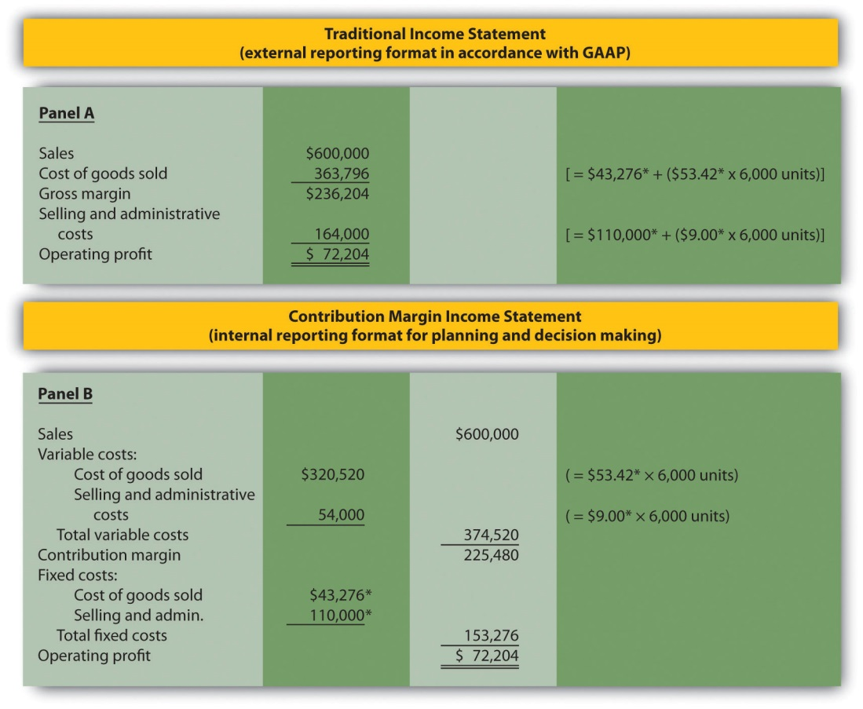
*From .

The contribution margin income statement shown in panel B of clearly indicates which costs are variable and which are fixed. Recall that the variable cost per unit remains constant, and variable costs in total change in proportion to changes in activity. Because 6,000 units are expected to be sold in August, total variable costs are calculated by multiplying 6,000 units by the cost per unit ($53.42 per unit for cost of goods sold, and $9.00 per unit for selling and administrative costs). Thus total variable cost of goods sold is $320,520, and total variable selling and administrative costs are $54,000. These two amounts are combined to calculate total variable costs of $374,520, as shown in panel B of .

The contribution margin of $225,480 represents the sales revenue left over after deducting variable costs from sales ($225,480 = $600,000 − $374,520). It is the amount remaining that will contribute to covering fixed costs and to operating profit.

Recall that total fixed costs remain constant regardless of the level of activity. Thus fixed cost of goods sold remains at $43,276, and fixed selling and administrative costs stay at $110,000. This holds true at both the 5,000 unit level of activity for June, and the 6,000 unit level of activity projected for August. Total fixed costs of $153,276 (= $43,276 + $110,000) are deducted from the contribution margin to calculate operating profit of $72,204.

Armed with this information, Susan meets with Eric the next day. Refer to panel B of as you read Susan’s comments about the contribution margin income statement.
Susan: | Eric, I have some numbers for you. My projection for August is complete, and I expect profit to be approximately $72,000 if sales volume increases 20 percent.
Eric: | Excellent! You were correct in figuring that profit would increase at a higher rate than sales because of our fixed costs.
Susan: | Here’s a copy of our projected income for August. This income statement format provides the variable and fixed costs. As you can see, our monthly fixed costs total approximately $153,000. Now that we have this information, we can easily make projections for different scenarios.
Eric: | This will be very helpful in making projections for future months. I’ll take your August projections to the management group this afternoon. Thanks for your help!

Business in Action 5.3
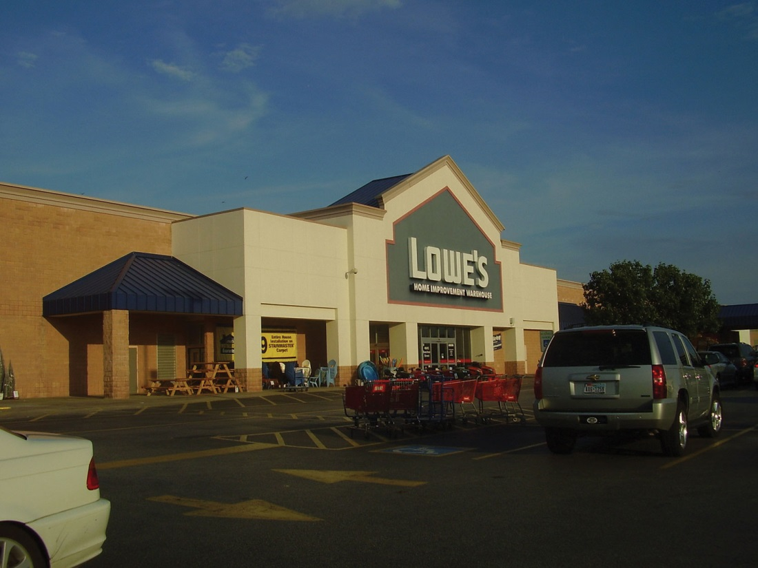
Source:http://commons.wikimedia.org/wiki/File:LowesMeyerlandHoustonTX.jpg
Costs at Lowe’s Companies, Inc.
Lowe’s is the world’s second largest home improvement retailer with more than 1,700 stores in the United States, Canada, and Mexico. The company has 234,000 employees. The following financial information is from Lowe’s income statement for the year ended January 28, 2011 (amounts are in millions). Which of the company’s costs are likely to be variable?
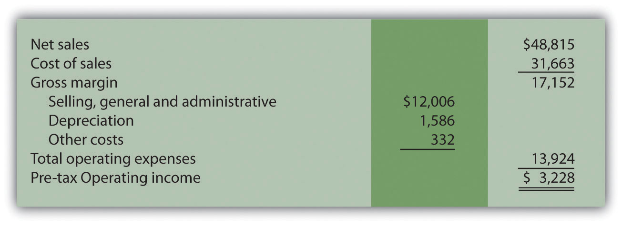
Variable costs probably include cost of sales (the cost of goods sold) and a portion of selling and general and administrative costs (e.g., the cost of hourly labor). Cost of sales alone represents 65 percent of net sales (rounded). Retail companies like Lowe’s tend to have higher variable costs than manufacturing companies like General Motors and Boeing.
Source: Lowe’s Web site (http://www.lowes.com).

KEY TAKEAWAY
- The contribution margin income statement shows fixed and variable components of cost information. Revenue minus variable costs equals the contribution margin. The contribution margin minus fixed costs equals operating profit. This statement provides a clearer picture of which costs change and which costs remain the same with changes in levels of activity.

REVIEW PROBLEM 5.7
Last month, Alta Production, Inc., sold its product for $2,500 per unit. Fixed production costs were $3,000, and variable production costs amounted to $1,400 per unit. Fixed selling and administrative costs totaled $50,000, and variable selling and administrative costs amounted to $200 per unit. Alta Production produced and sold 400 units last month.
Prepare a traditional income statement and a contribution margin income statement for Alta Production. Use as a guide.
Solution to Review Problem 5.7
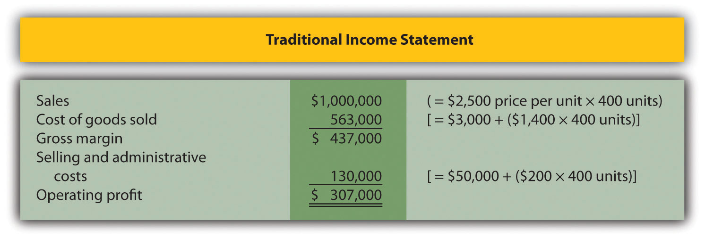
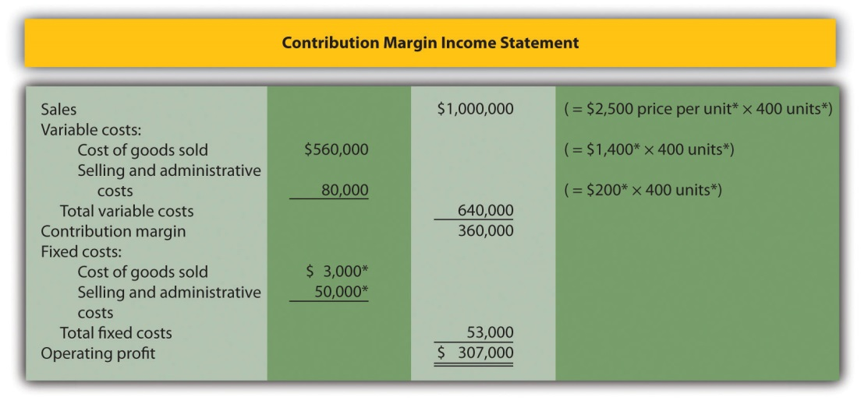
*Given.

5.4 The Relevant Range and Nonlinear Costs

LEARNING OBJECTIVE
- Understand the assumptions used to estimate costs.

Question: Bikes Unlimited is making an important assumption in estimating fixed and variable costs. What is this important assumption and why might it be misleading?

Answer: The assumption is that total fixed costs and per unit variable costs will always be at the levels shown in regardless of the level of production. This will not necessarily hold true under all circumstances.

For example, let’s say Bikes Unlimited picks up a large contract with a customer that requires producing an additional 30,000 units per month. Do you think the cost equations in would lead to accurate cost estimates? Probably not, because additional fixed costs would be incurred for facilities, salaried personnel, and other areas. Variable cost per unit would likely change also since additional direct labor would be required (either through overtime, which requires overtime pay, or by hiring more employees who are less efficient as they learn the process), and the volume of parts purchased from suppliers would increase, perhaps leading to reductions in per unit costs due to volume discounts for the parts.

As defined earlier, the relevant range is a term used to describe the range of activity (units of production in this example) for which cost behavior patterns are likely to be accurate. Because the historical data used to create these equations for Bikes Unlimited ranges from a low of 2,900 units in January to a high of 5,900 units in April (see ), management would investigate costs further when production levels fall outside of this range. The relevant range for total production costs at Bikes Unlimited is shown in . It is up to the cost accountant to determine the relevant range and make clear to management that estimates being made for activity outside of the relevant range must be analyzed carefully for accuracy.
Figure 5.8 Relevant Range for Total Production Costs at Bikes Unlimited
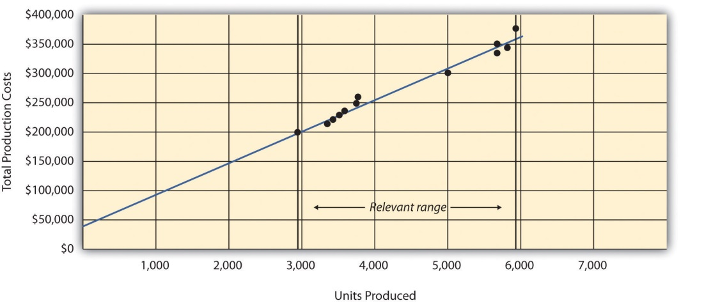

Recall that Bikes Unlimited estimated costs based on projected sales of 6,000 units for the month of August. Although this is slightly higher than the highest sales of 5,900 units in April, Susan (cost accountant) determined that Bikes Unlimited had the production capacity to produce 6,000 units without significantly affecting total fixed costs or per unit variable costs. Thus she determined that a sales level of 6,000 units was still within the relevant range. However, Susan also made Eric (CFO) aware that Bikes Unlimited was quickly approaching full capacity. If sales were expected to increase in the future, the company would have to increase capacity, and cost estimates would have to be revised.

Question: Another important assumption being made by Bikes Unlimited is that all costs behave in a linear manner. Variable, fixed, and mixed costs are all described and shown as a straight line. However, many costs are not linear and often take on a nonlinear pattern. Why do some costs behave in a nonlinear way?

Answer: Assume the pattern shown in is for total variable production costs. Consider this: Have you ever worked a job where you were very slow at first but improved rapidly with experience? If a company produces just a few units each month, workers (direct labor) do not gain the experience needed to work efficiently and may waste time and materials. This has the effect of driving up the per unit variable cost. Recall that the slope of the line represents the unit cost; thus, when the unit cost increases, so does the slope. If the company produces more units each month, workers gain experience resulting in improved efficiency, and the per unit cost decreases (both in materials and labor). This causes the total cost line to flatten out a bit as the slope decreases. This is fine until the company starts to reach its limit in how much it can produce (called capacity). Now the company must hire additional inexperienced employees or pay its current employees overtime, which once again drives up the cost per unit. Thus the slope begins to increase.
Figure 5.9 Nonlinear Variable Costs
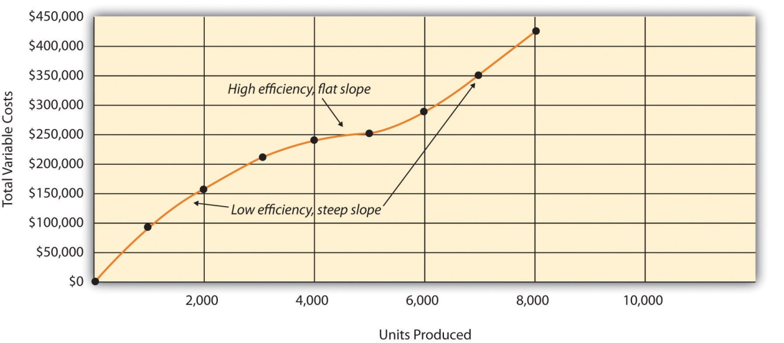

Although this is probably a more accurate description of how variable costs actually behave for most companies, it is much simpler to describe and estimate costs if you assume they are linear. As long as the relevant range is clearly identified, most companies can reasonably use the linearity assumption to estimate costs.

KEY TAKEAWAY
- Two important assumptions must be considered when estimating costs using the methods described in this chapter.
  - When costs are estimated for a specific level of activity, the assumption is that the activity level is within the relevant range.
  - Costs are estimated assuming that they are linear.
Both assumptions are reasonable as long as the relevant range is clearly identified, and the linearity assumption does not significantly distort the resulting cost estimate.

REVIEW PROBLEM 5.8
- Using the data in , identify the relevant range.
- Why is it important to determine the relevant range?
Solution to Review Problem 5.8
- The relevant range, the range of activity for which cost estimates are more likely to be accurate, is from 150 units (lowest activity level) to 450 units of production (highest activity level).
- Identifying the relevant range when estimating costs is important because if a cost estimate is being made for activity outside of the relevant range, total fixed costs and per unit variable costs may be different from those described in the cost equation. For example, if production is doubled, additional factory space may be needed, resulting in higher fixed costs.

5.5 Appendix: Performing Regression Analysis with Excel

LEARNING OBJECTIVE
- Perform regression analysis using Excel.

Question: Regression analysis is often performed to estimate fixed and variable costs. Many different software packages have the capability of performing regression analysis, including Excel. This appendix provides a basic illustration of how to use Excel to perform regression analysis. Statistics courses cover this topic in more depth. How is regression analysis used to estimate fixed and variable costs?

Answer: As noted in the chapter, regression analysis uses a series of mathematical equations to find the best possible fit of the line to the data points. For the purposes of this chapter, the end goal of regression analysis is to estimate fixed and variable costs, which are described in the equation form of Y = f + vX. Recall that the following Excel output was provided earlier in the chapter based on the data presented in for Bikes Unlimited.
 | Coefficients
y-intercept | 43,276
x variable | 53.42

The resulting equation to estimate production costs is Y = $43,276 + $53.42X. We now describe the steps to be performed in Excel to get this equation.

Step 1. Confirm that the Data Analysis package is installed.

Go to the Data tab on the top menu bar and look for Data Analysis. If Data Analysis appears, you are ready to perform regression analysis. If Data Analysis does not appear, go to the help button (denoted as a question mark in the upper right-hand corner of the screen) and type Analysis ToolPak. Look for the Load the Analysis ToolPak option and follow the instructions given.

Step 2. Enter the data in the spreadsheet.

Using a new Excel spreadsheet, enter the data points in two columns. The monthly data in includes Total Production Costs and Units Produced. Thus use one column (column A) to enter Total Production Costs data and another column (column B) to enter Units Produced data.
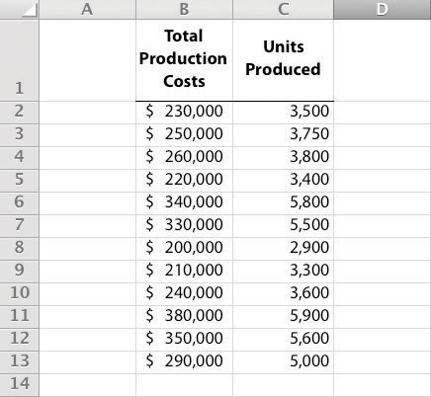

Step 3. Run the regression analysis.

Using the same spreadsheet set up in step 2, select Data, Data Analysis, andRegression. A box appears that requires the input of several items needed to perform regression. Input Y Range requires that you highlight the y-axis data, including the heading (cells B1 through B13 in the example shown in step 2). Input X Range requires that you highlight the x-axis data, including the heading (cells C1 through C13 in the example shown in step 2). Check the Labels box; this indicates that the top of each column has a heading (B1 and C1). Select New Workbook; this will put the regression results in a new workbook. Lastly, check the Line Fit Plots box, then select OK. The result is as follows (note that we made a few minor format changes to allow for a better presentation of the data).
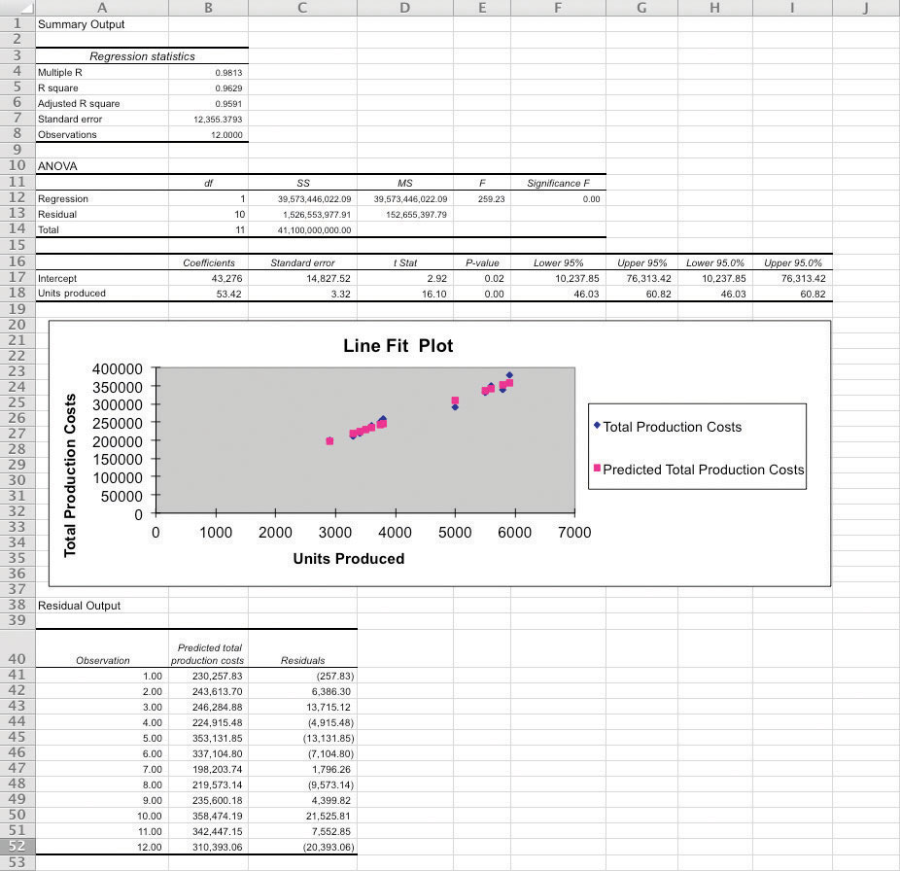
Step 4. Analyze the output.

Here, we discuss key items shown in the regression output provided in step 3.
- Cost Equation: The output shows that estimated fixed costs (shown as the Intercept coefficient in cell B17) total $43,276, and the estimated variable cost per unit (shown as the Units Produced coefficient in B18) is $53.42. Thus the cost equation is:
Y = $43,276 + $53.42XorTotal Production Costs = $43,276 + ($53.42 × Units Produced)
- Line Fit Plot and R-Squared: The plot shows that actual total production costs are very close to predicted total production costscalculated using the cost equation. Thus the cost equation created from the regression analysis is likely to be useful in predicting total production costs. Another way to assess the accuracy of the regression output is to review the R-squared statistic shown in cell B5. R-squaredmeasures the percent of the variance in the dependent variable (total production costs, in this example) explained by the independent variable (units produced, in this example). According to the output, 96.29 percent of the variance in total production costs is explained by the level of units produced—further evidence that the regression results will be useful in predicting total production costs.
The discussion of regression analysis in this chapter is meant to serve as an introduction to the topic. To further enhance your knowledge of regression analysis and to provide for a more thorough analysis of the data, you should pursue the topic in an introductory statistics course.

KEY TAKEAWAY
- Software applications, such as Excel, can use regression analysis to estimate fixed and variable costs.
  - Once the data analysis package is installed, historical data are entered in the spreadsheet, and the regression analysis is run.
  - The resulting data are used to determine the cost equation, which includes estimated fixed and variable costs.
The line fit plot and R-squared statistic are used to assess the usefulness of the cost equation in estimating costs.

REVIEW PROBLEM 5.9
Refer to the monthly production cost data for Alta Production, Inc., in . Use the four steps of regression analysis described in this appendix to estimate total fixed costs and variable cost per unit. State your results in the equation form Y = f + vX.
Solution to Review Problem 5.9
Regression analysis performed using Excel results in the following output:
 | Coefficients
y-intercept | 703
x variable | 1,442.97
Thus the total cost equation is:
Y = $703 + $1,442.97X

END-OF-CHAPTER EXERCISES
Questions
- What is a fixed cost? Provide two examples.
- What is the difference between a committed fixed cost and a discretionary fixed cost? Provide examples of each.
- What is a variable cost? Provide two examples.
- What is a mixed cost? Provide two examples.
- Describe the variables in the cost equation Y = f + vX.
- How is the cost equation Y = f + vX used to estimate future costs?
- Why is it important to identify how costs behave with changes in activity?
- Review Why was the school district’s administration surprised to find out that cost savings from closing a school would be much lower than initially anticipated?
- Explain how account analysis is used to estimate costs.
- Describe the four steps of the high-low method and how these steps are used to estimate costs.
- Why might the high-low method lead to inaccurate results?
- Describe the five steps of the scattergraph method and how these steps are used to estimate costs.
- How can the scattergraph method be used to identify unusual data points?
- Describe how regression analysis is used to estimate costs.
- How does the contribution margin income statement differ from the traditional income statement?
- Review Which costs at Lowe’s are likely to be variable costs?
- Describe the term relevant range. Why is it important to stay within the relevant range when estimating costs?
- Explain how some costs can behave in a nonlinear way.
Brief Exercises
- Planning at Bikes Unlimited. Refer to the dialogue at Bikes Unlimited presented at the beginning of the chapter. What is the first step to be taken by Susan and her accounting staff to help in estimating profit for August?
- Identifying Cost Behavior. Vasquez Incorporated is trying to identify the cost behavior of the three costs that follow. Cost information is provided for three months.
 |  | Cost A |  | Cost B |  | Cost C
Month | Units Produced | Total Costs | Cost per Unit | Total Costs | Cost per Unit | Total Costs | Cost per Unit
1 | 1,500 | $1,500 | _____ | $4,500 | _____ | $3,000 | _____
2 | 3,000 | 1,500 | _____ | 5,250 | _____ | 6,000 | _____
3 | 750 | 1,500 | _____ | 3,750 | _____ | 1,500 | _____
- Required:
  - Calculate the cost per unit, and then identify how the cost behaves for each of the three costs (fixed, variable, or mixed). Explain the reasoning for your answers.
  - How does identifying cost behavior patterns help managers?
- Account Analysis. Cordova Company would like to estimate production costs on an annual basis. Costs incurred for direct materials and direct labor are variable costs. The accounting records indicate that the following production costs were incurred last year for 50,000 units.
Direct materials | $100,000
Direct labor | $215,000
Manufacturing overhead | $300,000 (20 percent fixed; 80 percent variable)
- Required:
- Use account analysis to estimate the fixed costs per year, and the variable cost per unit.
- High-Low Method. The city of Rockville reported the following annual cost data for maintenance work performed on its fleet of trucks.
Reporting Period (Year) | Total Costs | Level of Activity (Miles Driven)
Year 1 | $ 750,000 | 225,000
Year 2 | 850,000 | 240,000
Year 3 | 1,100,000 | 430,000
Year 4 | 1,150,000 | 454,000
Year 5 | 1,250,000 | 560,000
Year 6 | 1,550,000 | 710,000
- Required:
  - Use the four steps of the high-low method to estimate total fixed costs per year and the variable cost per mile. State your results in the cost equation form Y = f + vX.
  - What would the estimated costs be if the trucks drove 500,000 miles in year 7?
- Scattergraph Method. Refer to the data in Brief Exercise 22 for the city of Rockville.
Required:
  - Use the five steps of the scattergraph method to estimate total fixed costs per year and the variable cost per mile. State your results in the cost equation form Y = f + vX by filling in the dollar amounts for f and v.
  - What would the estimated costs be if the trucks drove 500,000 miles in year 7?
- Regression Analysis. Regression analysis was run using the data in Brief Exercise 22 for the city of Rockville. The output is shown here:
 | Coefficients
y-intercept | 441,013
x variable | 1.53
- Required:
  - Use the regression output to develop the cost equation Y = f + vX by filling in the dollar amounts for f and v.
  - What would the city of Rockville’s estimated costs be if its trucks drove 500,000 miles in year 7?
- Contribution Margin Income Statement. Last year Pod Products, Inc., sold its product for $250 per unit. Production costs totaled $40,000 (25 percent fixed, 75 percent variable). Selling and administrative costs totaled $150,000 (10 percent fixed, 90 percent variable). Pod Products produced and sold 1,000 units last year.
Required:
Prepare a contribution margin income statement for Pod Products, Inc.
- Relevant Range. Jersey Company produces jerseys for athletic teams, and typically produces between 1,000 and 5,000 jerseys annually. The accountant is asked to estimate production costs for this coming year assuming 9,000 jerseys will be produced.
Required:
What is meant by the term relevant range, and why is the relevant range important for estimating production costs for this coming year at Jersey Company?
Exercises: Set A
- Identifying Cost Behavior. Zhang Corporation is trying to identify the cost behavior of the three costs shown. Cost information is provided for six months.
 |  | Cost 1 |  | Cost 2 |  | Cost 3
Month | Units Produced | Total Costs | Cost per Unit | Total Costs | Cost per Unit | Total Costs | Cost per Unit
1 | 18,000 | $36,000 | _____ | $19,800 | _____ | $5,000 | _____
2 | 16,000 | 32,000 | _____ | 19,200 | _____ | 5,000 | _____
3 | 14,000 | 28,000 | _____ | 18,200 | _____ | 5,000 | _____
4 | 12,000 | 24,000 | _____ | 16,800 | _____ | 5,000 | _____
5 | 10,000 | 20,000 | _____ | 14,500 | _____ | 5,000 | _____
6 | 8,000 | 16,000 | _____ | 12,000 | _____ | 5,000 | _____
- Required:
  - Calculate the cost per unit, and then identify how the cost behaves (fixed, variable, or mixed) for each of the three costs. Explain the reasoning behind your answers.
  - Why is it important to identify how costs behave with changes in activity?
- Account Analysis. Baker Advertising Incorporated would like to estimate costs associated with its clients on an annual basis. Assume costs for supplies and advertising staff are variable costs. The accounting records indicate the following costs were incurred last year for 100 clients:
Supplies | $ 20,000
Advertising staff wages (hourly employees) | $170,000
Manager salary | $ 90,000
Building rent | $ 56,000
- Required:
  - Use account analysis to estimate total fixed costs per year, and the variable cost per unit. State your results in the cost equation form Y = f + vX by filling in the dollar amounts for f and v.
  - Estimate the total costs for this coming year assuming 120 clients will be served.
- High-Low Method. Castanza Company produces computer printers. Management wants to estimate the cost of production equipment used to produce printers. The company reported the following monthly cost data related to production equipment:
Reporting Period (Month) | Total Costs | Machine Hours
January | $ 920,000 | 45,000
February | 600,000 | 25,000
March | 500,000 | 20,000
April | 1,100,000 | 90,000
May | 1,140,000 | 95,000
June | 620,000 | 30,000
July | 880,000 | 38,000
August | 910,000 | 48,000
September | 1,060,000 | 78,000
October | 960,000 | 51,000
November | 1,400,000 | 96,000
December | 980,000 | 54,000
- Required:
  - Use the four steps of the high-low method to estimate total fixed costs per month and the variable cost per machine hour. State your results in the cost equation form Y = f + vX by filling in the dollar amounts for f and v.
  - What would Castanza Company’s estimated costs be if it used 50,000 machine hours next month?
  - What would Castanza Company’s estimated costs be if it used 15,000 machine hours next month? Why should you feel uncomfortable estimating costs for 15,000 machine hours?
- Scattergraph Method. Castanza Company produces computer printers. Management wants to estimate the cost of production equipment used to produce printers. The company reported the following monthly cost data related to production equipment (this is the same data as the previous exercise):
Reporting Period (Month) | Costs | Machine Hours
January | $ 920,000 | 45,000
February | 600,000 | 25,000
March | 500,000 | 20,000
April | 1,100,000 | 90,000
May | 1,140,000 | 95,000
June | 620,000 | 30,000
July | 880,000 | 38,000
August | 910,000 | 48,000
September | 1,060,000 | 78,000
October | 960,000 | 51,000
November | 1,400,000 | 96,000
December | 980,000 | 54,000
- Required:
  - Use the five steps of the scattergraph method to estimate total fixed costs per month and the variable cost per machine hour. State your results in the cost equation form Y = f + vX by filling in the dollar amounts for f and v.
  - What would Castanza Company’s estimated costs be if it used 50,000 machine hours next month?
  - What would Castanza Company’s estimated costs be if it used 15,000 machine hours next month?
- Regression Analysis. Regression analysis was run for Castanza Company resulting in the following output (this is based on the same data as the previous two exercises):
 | Coefficients
y-intercept | 445,639
x variable | 8.54
- Required:
  - Use the regression output given to develop the cost equation Y = f + vX by filling in the dollar amounts for fand v.
  - What would Castanza Company’s estimated costs be if it used 50,000 machine hours next month?
  - What would Castanza Company’s estimated costs be if it used 15,000 machine hours next month?
- Contribution Margin Income Statement. Last month Kumar Production Company sold its product for $60 per unit. Fixed production costs were $40,000, and variable production costs amounted to $15 per unit. Fixed selling and administrative costs totaled $26,000, and variable selling and administrative costs amounted to $5 per unit. Kumar Production produced and sold 7,000 units last month.
Required:
  - Prepare a traditional income statement for Kumar Production Company.
  - Prepare a contribution margin income statement for Kumar Production Company.
  - Why do companies use the contribution margin income statement format?
- Regression Analysis Using Excel (Appendix). Walleye Company produces fishing reels. Management wants to estimate the cost of production equipment used to produce the reels. The company reported the following monthly cost data related to production equipment:
Reporting Period (Month) | Total Costs | Machine Hours
January | $1,104,000 | 54,000
February | 720,000 | 30,000
March | 600,000 | 24,000
April | 1,320,000 | 108,000
May | 1,368,000 | 114,000
June | 744,000 | 36,000
July | 1,056,000 | 45,600
August | 1,092,000 | 57,600
September | 1,272,000 | 93,600
October | 1,152,000 | 61,200
November | 1,680,000 | 115,200
December | 1,176,000 | 64,800
- Required:
  - Use Excel to perform regression analysis. Provide a printout of the results.
  - Use the regression output to develop the cost equation Y = f + vX by filling in the dollar amounts for f and v.
  - What would Walleye Company’s estimated costs be if it used 90,000 machine hours this month?
Exercises: Set B
- Identifying Cost Behavior. Ivanov, Inc., is trying to identify the cost behavior of the three costs shown. Cost information is provided for six months.
 |  | Cost 1 |  | Cost 2 |  | Cost 3
Month | Units Produced | Total Costs | Cost per Unit | Total Costs | Cost per Unit | Total Costs | Cost per Unit
1 | 8,000 | $10,000 | _____ | $24,000 | _____ | $32,000 | _____
2 | 10,000 | 10,000 | _____ | 29,000 | _____ | 40,000 | _____
3 | 12,000 | 10,000 | _____ | 33,600 | _____ | 48,000 | _____
4 | 14,000 | 10,000 | _____ | 36,400 | _____ | 56,000 | _____
5 | 16,000 | 10,000 | _____ | 38,400 | _____ | 64,000 | _____
6 | 18,000 | 10,000 | _____ | 39,600 | _____ | 72,000 | _____
- Required:
  - Calculate the cost per unit, and then identify how the cost behaves (fixed, variable, or mixed) for each of the three costs. Explain the reasoning behind your answers.
  - Why is it important to identify how costs behave with changes in activity?
- Account Analysis. Swim-Safe Company hires several instructors who provide weekly one-hour private swim lessons to individuals. The company would like to estimate costs associated with its swim lessons on a weekly basis. Assume costs for towels, snacks, drinks, and instructor wages are variable costs. The accounting records indicate the following costs were incurred last week for 250 customer lessons:
Towels, snacks, drinks | $1,250
Instructor wages (hourly employees) | $3,000
Manager (owner) salary | $1,500
Pool rental | $2,000
- Required:
  - Use account analysis to estimate total fixed costs per week, and the variable cost per lesson. State your results in the cost equation form Y = f + vX by filling in the dollar amounts for f and v.
  - Estimate the total costs for this coming week assuming 220 lessons will be provided.
- High-Low Method Quality Tools. Quality Tools Incorporated would like to estimate costs associated with its sales personnel. Salespeople are paid a salary plus commission. Commission rates vary among products and are based on sales dollars. The company reported the following monthly cost data related to sales personnel:
Reporting Period (Month) | Total Costs | Sales Amount
January | $710,000 | $13,800,000
February | 695,000 | 13,600,000
March | 765,000 | 15,100,000
April | 650,000 | 12,000,000
May | 775,000 | 15,500,000
June | 750,000 | 14,700,000
July | 715,000 | 14,500,000
August | 680,000 | 13,100,000
September | 830,000 | 16,500,000
October | 815,000 | 16,000,000
November | 800,000 | 15,600,000
December | 690,000 | 13,200,000
- Required:
  - Use the four steps of the high-low method to estimate total fixed costs per month and the variable cost per sales dollar. State your results in the cost equation form Y = f + vX by filling in the dollar amounts for f and v.
  - What would Quality Tools’ estimated costs be if it had sales of $12,500,000 next month?
  - What would Quality Tools’ estimated costs be if it had sales of $20,000,000 next month? Why should you feel uncomfortable estimating costs for $20,000,000 in sales?
- Scattergraph Method. Quality Tools Incorporated would like to estimate costs associated with its sales personnel. Salespeople are paid a salary plus commission. Commission rates vary among products and are based on sales dollars. The company reported the following monthly cost data related to sales personnel (this is the same data as the previous exercise):
Reporting Period (Month) | Total Costs | Sales Amount
January | $710,000 | $13,800,000
February | 695,000 | 13,600,000
March | 765,000 | 15,100,000
April | 650,000 | 12,000,000
May | 775,000 | 15,500,000
June | 750,000 | 14,700,000
July | 715,000 | 14,500,000
August | 680,000 | 13,100,000
September | 830,000 | 16,500,000
October | 815,000 | 16,000,000
November | 800,000 | 15,600,000
December | 690,000 | 13,200,000
- Required:
  - Use the five steps of the scattergraph method to estimate total fixed costs per month and the variable cost per sales dollar. State your results in the cost equation form Y = f + vX by filling in the dollar amounts for f and v.
  - What would Quality Tools’ estimated costs be if it had sales of $12,500,000 next month?
  - What would Quality Tools’ estimated costs be if it had sales of $20,000,000 next month?
- Regression Analysis. Regression analysis was run for Quality Tools Incorporated resulting in the following output (this is based on the same data as the previous two exercises):
 | Coefficients
y-intercept | 129,188
x variable | 0.04
- Required:
  - Use the regression output given to develop the cost equation Y = f + vX by filling in the dollar amounts for fand v.
  - What would Quality Tools’ estimated costs be if it had sales of $12,500,000 next month?
  - What would Quality Tools’ estimated costs be if it had sales of $20,000,000 next month?
- Contribution Margin Income Statement, Service Company. Last month Seafood Grill had total sales of $200,000. Food preparation and service costs totaled $90,000 (20 percent fixed, 80 percent variable). Selling and administrative costs totaled $30,000 (70 percent fixed, 30 percent variable).
Required:
  - Prepare a traditional income statement for Seafood Grill.
  - Prepare a contribution margin income statement for Seafood Grill.
  - Why do companies use the contribution margin income statement format?
- Regression Analysis Using Excel (Appendix). Cain Company produces calculators. Management wants to estimate the cost of production equipment used to produce the calculators. The company reported the following monthly cost data related to production equipment:
Reporting Period (Month) | Total Costs | Machine Hours
January | $1,250,000 | 59,000
February | 990,000 | 33,000
March | 850,000 | 28,000
April | 1,580,000 | 120,000
May | 1,670,000 | 126,000
June | 1,050,000 | 40,000
July | 1,360,000 | 51,000
August | 1,400,000 | 70,000
September | 1,550,000 | 105,000
October | 1,500,000 | 67,000
November | 1,860,000 | 128,000
December | 1,480,000 | 71,000
- Required:
  - Use Excel to perform regression analysis. Provide a printout of the results.
  - Use the regression output to develop the cost equation Y = f + vX by filling in the dollar amounts for f and v.
  - What would Cain Company’s estimated costs be if it used 110,000 machine hours this month?
Problems
- Cost Behavior. Assume you are a consultant performing work for two different companies. Each company has asked you to help them identify the behavior of certain costs.
Required:
  - Identify each of the following costs for Hwang Company, a producer of ski boats, as variable (V), fixed (F), or mixed (M):
    - _____Salary of production manager
    - _____Materials required for production
    - _____Monthly rent on factory building
    - _____Hourly wages for assembly workers
    - _____Straight-line depreciation for factory equipment
    - _____Annual insurance on factory building
    - _____Invoices sent to customers
    - _____Salaries and commissions of salespeople
    - _____Salary of chief executive officer
    - _____Company cell phones with first 50 hours free, then 10 cents per minute
  - Identify each of the following costs for Rainier Camping Products, a maker of backpacks, as variable (V), fixed (F), or mixed (M):
    - _____Hourly wages for assembly workers
    - _____Fabric required for production
    - _____Straight-line depreciation on factory building
    - _____Salaries and commissions of salespeople
    - _____Lease payments for factory equipment
    - _____Company cell phones with first 80 hours free, then 8 cents per minute
    - _____Invoices sent to customers
    - _____Salary of production manager
    - _____Salary of controller (accounting)
    - _____Electricity for factory building
  - How might the managers of these companies use the cost behavior information requested?
- Account Analysis and Contribution Margin Income Statement.Madden Company would like to estimate costs associated with its production of football helmets on a monthly basis. The accounting records indicate the following production costs were incurred last month for 4,000 helmets.
Assembly workers’ labor (hourly) | $70,000
Factory rent | 3,000
Plant manager’s salary | 5,000
Supplies | 20,000
Factory insurance | 12,000
Materials required for production | 20,000
Maintenance of production equipment (based on usage) | 18,000
- Required:
  - Use account analysis to estimate total fixed costs per month and the variable cost per unit. State your results in the cost equation form Y = f + vX by filling in the dollar amounts for f and v.
  - Estimate total production costs assuming 5,000 helmets will be produced and sold.
  - Prepare a contribution margin income statement assuming 5,000 helmets will be produced, and each helmet will be sold for $70. Fixed selling and administrative costs total $10,000. Variable selling and administrative costs are $8 per unit.
- High-Low, Scattergraph, and Regression Analysis; Manufacturing Company. Woodworks, Inc., produces cabinet doors. Manufacturing overhead costs tend to fluctuate from one month to the next, and management would like to accurately estimate these costs for planning and decision-making purposes.
The accounting staff at Woodworks recommends that costs be broken down into fixed and variable components. Because the production process is highly automated, most of the manufacturing overhead costs are related to machinery and equipment. The accounting staff believes the best starting point is to review historical data for costs and machine hours:
Reporting Period (Month) | Total Costs | Machine Hours
January | $278,000 | 1,550
February | 280,000 | 1,570
March | 266,000 | 1,115
April | 290,000 | 1,700
May | 262,000 | 1,110
June | 269,000 | 1,225
July | 275,000 | 1,335
August | 286,000 | 1,660
September | 250,000 | 1,000
October | 253,000 | 1,020
November | 260,000 | 1,025
December | 281,000 | 1,600
These data were entered into a computer regression program, which produced the following output:
 | Coefficients
y-intercept | 210,766
x variable | 45.31
Required:
  - Use the four steps of the high-low method to estimate total fixed costs per month and the variable cost per machine hour. State your results in the cost equation form Y = f + vX by filling in the dollar amounts for f and v.
  - Use the five steps of the scattergraph method to estimate total fixed costs per month, and the variable cost per machine hour. State your results in the cost equation form Y = f + vX by filling in the dollar amounts for f and v.
  - Use the regression output given to develop the cost equation Y = f + vX by filling in the dollar amounts for fand v.
  - Use the results of the high-low method (a), scattergraph method (b), and regression analysis (c), to estimate costs for 1,500 machine hours. (You will have three different answers—one for each method.) Which approach do you think is most accurate and why?
  - Management likes the regression analysis approach and asks you to estimate costs for 5,000 machine hours using this approach (the company plans to expand by opening another facility and hiring additional employees). Calculate your estimate, and explain why your estimate might be misleading.
- High-Low, Scattergraph, and Regression Analysis; Service Company.Sanchez Accounting Company prepares tax returns for individuals. Marie Sanchez, the owner, would like an accurate estimate of the company’s costs for planning and decision-making purposes. When Marie asks you to devise a way to estimate costs on a monthly basis, you recall the importance of breaking costs into fixed and variable components. Because the company’s costs are driven primarily by the number of tax returns prepared, you decide to use historical data for costs and tax returns prepared:
Reporting Period (Month) | Total Costs | Returns Prepared
January | $157,000 | 315
February | 145,000 | 300
March | 167,500 | 375
April | 163,000 | 325
May | 120,000 | 250
June | 112,000 | 210
July | 138,000 | 280
August | 100,000 | 190
September | 108,000 | 205
October | 115,000 | 245
November | 136,000 | 265
December | 126,000 | 255
- You enter these data into a computer regression program and get the following results:
 | Coefficients
y-intercept | 24,626
x variable | 401.86
- Required:
  - Use the four steps of the high-low method to estimate total fixed costs per month and the variable cost per tax return prepared. State your results in the cost equation form Y = f + vX by filling in the dollar amounts for f and v.
  - Use the five steps of the scattergraph method to estimate total fixed costs per month and the variable cost per tax return prepared. State your results in the cost equation form Y = f + vX by filling in the dollar amounts for f and v.
  - Use the regression output given to develop the cost equation Y = f + vX by filling in the dollar amounts for fand v.
  - Use the results of the high-low method (a), scattergraph method (b), and regression analysis (c) to estimate costs for 290 tax returns. (You will have three different answers—one for each method.) Which approach do you think is most accurate, and why?
  - Marie likes the regression analysis approach and asks you to estimate costs for 800 tax returns using this approach (she plans to expand by opening another office and hiring additional employees). Calculate your estimate, and explain why your estimate might be misleading.
- High-Low, Scattergraph, Regression Analysis, and Contribution Margin Income Statement. Eye Care, Inc., provides vision correction surgery for its patients. You are the accountant for Eye Care, and management has asked you to devise a way of accurately estimating company costs for planning and decision-making purposes. You believe that reviewing historical data for costs and number of surgeries is the best starting point. These data are as follows:
Reporting Period (Month) | Total Costs | Number of Surgeries
January | $208,000 | 54
February | 205,000 | 52
March | 217,000 | 55
April | 200,000 | 50
May | 232,000 | 62
June | 230,000 | 60
July | 226,000 | 57
August | 235,000 | 63
September | 252,000 | 71
October | 250,000 | 70
November | 245,000 | 66
December | 244,000 | 65
- You enter these data into a computer regression program and get the following results:
 | Coefficients
y-intercept | 75,403
x variable | 2,536.77
- Required:
  - Use the four steps of the high-low method to estimate total fixed costs per month, and the variable cost per surgery. State your results in the cost equation form Y = f +vX by filling in the dollar amounts for f and v.
  - Use the five steps of the scattergraph method to estimate total fixed costs per month, and the variable cost per surgery. State your results in the cost equation form Y = f +vX by filling in the dollar amounts for f and v.
  - Use the regression output given to develop the cost equation Y = f + vX by filling in the dollar amounts for fand v.
  - Use the results of the high-low method (a), scattergraph method (b), and regression analysis (c), to estimate costs for 70 surgeries. (You will have three different answers—one for each method.) Which approach do you think is most accurate and why?
  - Assume Eye Care charges $4,000 for each surgery performed. Use the regression analysis cost information (for 70 surgeries) to prepare a contribution margin income statement. (Hint: You will only have one line item for variable costs and one line item for fixed costs.)
- Regression Analysis Using Excel (Appendix). Metal Products, Inc., produces metal storage sheds. The company’s manufacturing overhead costs tend to fluctuate from one month to the next, and management would like an accurate estimate of these costs for planning and decision-making purposes.
The company’s accounting staff recommends that costs be broken down into fixed and variable components. Because the production process is highly automated, most of the manufacturing overhead costs are related to machinery and equipment. The accounting staff agrees that reviewing historical data for costs and machine hours is the best starting point. Data for the past 18 months follow.
Reporting Period (Month) | Total Overhead Costs | Total Machine Hours
January | $695,000 | 3,875
February | 700,000 | 3,925
March | 665,000 | 2,788
April | 725,000 | 4,250
May | 655,000 | 2,775
June | 672,500 | 3,063
July | 687,500 | 3,338
August | 715,000 | 4,150
September | 625,000 | 2,500
October | 632,500 | 2,550
November | 650,000 | 2,563
December | 702,500 | 4,000
January | 730,000 | 4,025
February | 735,000 | 4,088
March | 697,500 | 2,900
April | 762,500 | 4,425
May | 687,500 | 2,888
June | 705,000 | 3,188
Required:
  - Use Excel to perform regression analysis. Provide a printout of the results.
  - Use the regression output given to develop the cost equation Y = f + vX by filling in the dollar amounts for fand v.
  - Use the results of the regression analysis to estimate costs for 3,750 machine hours.
  - Management is considering plans to expand by opening several new facilities and asks you to estimate costs for 22,000 machine hours. Calculate your estimate, and explain why this estimate may be misleading.
  - What can be done to improve the estimate made in part d?
One Step Further: Skill-Building Cases
- Internet Project: Variable and Fixed Costs. Using the Internet, find the annual report of one retail company and one manufacturing company. Print out each company’s income statement. (Hint: The income statement is often called thestatement of operations or statement of earnings.)
Required:
  - Review each income statement, and provide an analysis of which operating costs are likely to be variable and which are likely to be fixed. Include copies of both income statements when submitting your answer.
  - How would you expect a retail company’s mix of variable and fixed operating costs to differ from that of a manufacturing company?
  - How might the managers of these companies use cost behavior information?
- Group Activity: Identifying Variable and Fixed Costs. To complete the following requirements, form groups of two to four students.
Required:
  - Each group should select a product that is easy to manufacture.
  - Prepare a list of materials, labor, and other resources needed to make the product.
  - Using the list prepared in requirement b, identify whether the costs associated with each item are variable, fixed, or mixed.
  - As a manager for this company, why would you want to know whether costs are variable, fixed, or mixed?
- Cost Behavior at Best Buy. The following condensed income statement is for Best Buy Co., Inc., a large retailer of consumer electronics.
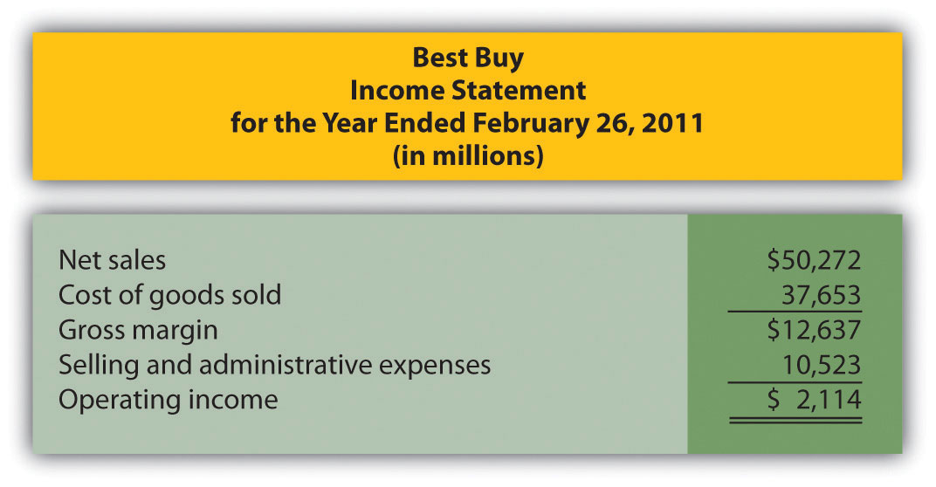
Required:
Assume that cost of goods sold comprises only variable costs, and selling and administrative expenses are all fixed costs. Also assume that Best Buy expects sales to grow by 10 percent for the year ended March 3, 2012.
  - Calculate expected operating income for the year ended March 3, 2012 assuming the company is still within the relevant range of activity.
  - Calculate the expected percent increase in operating income from the year ended February 26, 2011, to the year ended March 3, 2012.
  - Why is the percent increase in operating income higher than the percent increase in sales?
  - Is the assumption that all selling and administrative expenses are fixed a reasonable assumption? Explain.
- Fixed Costs at United Airlines. Review .
Required:
  - What is meant by the term fixed cost?
  - Which costs at United Airlines were identified as fixed costs?
  - How might United Airlines reduce its fixed costs? Be specific.
Comprehensive Case
- Ethics: Manipulating Data to Establish a Budget (Appendix).Healthy Bar, Inc., produces energy bars for sports enthusiasts. The company’s fiscal year ends on December 31. The production manager, Jim Wallace, is establishing a cost budget for the production department for each month of this coming quarter (January through March). At the end of March, Jim will be evaluated based on his ability to meet the budget for the three months ending March 31. In fact, Jim will receive a significant bonus if actual costs are below budgeted costs for the quarter.
The production budget is typically established based on data from the last 18 months. These data are as follows:
Reporting Period (Month) | Total Overhead Costs | Total Machine Hours
July | $695,000 | 3,410
August | 700,000 | 3,454
September | 665,000 | 2,453
October | 725,000 | 3,740
November | 655,000 | 2,442
December | 672,500 | 2,695
January | 687,500 | 2,937
February | 715,000 | 3,652
March | 625,000 | 2,200
April | 632,500 | 2,244
May | 650,000 | 2,255
June | 702,500 | 3,520
July | 730,000 | 3,542
August | 735,000 | 3,597
September | 697,500 | 2,552
October | 762,500 | 3,894
November | 687,500 | 2,541
December | 705,000 | 2,805
You are the accountant who assists Jim in preparing an estimate of production costs for the next three months. You intend to use regression analysis to estimate costs, as was done in the past. Jim expects that 3,100 machine hours will be used in January, 3,650 machine hours in February, and 2,850 machine hours in March.
Jim approaches you and asks that you add $100,000 to production costs for each of the past 18 months before running the regression analysis. As he puts it, “After all, management always takes my proposed budgets and reduces them by about 10 percent. This is my way of leveling the playing field!”
Required:
  - Use Excel to perform regression analysis using the historical data provided.
    - Submit a printout of the results.
    - Use the regression output to develop the cost equation Y = f + vX by filling in the dollar amounts for f and v.
    - Calculate estimated production costs for January, February, and March. Also provide a total for the three months.
  - Use Excel to perform regression analysis after adding $100,000 to production costs for each of the past 18 months, as Jim requested.
    - Submit a printout of the results.
    - Use the regression output to develop the cost equation Y = f + vX by filling in the dollar amounts for f and v.
    - Calculate estimated production costs for January, February, and March. Also provide a total for the three months.
  - Why did Jim ask you to add $100,000 to production costs for each of the past 18 months?
  - How should you handle Jim’s request? (If necessary, review the presentation of ethics in for additional information.)

Chapter 6

How Is Cost-Volume-Profit Analysis Used for Decision Making?

Recilia Vera is vice president of sales at Snowboard Company, a manufacturer of one model of snowboard. Lisa Donley is the company accountant. Recilia and Lisa are in their weekly meeting.
Recilia: | Lisa, I’m in the process of setting up an incentive system for my sales staff, and I’d like to get a better handle on our financial information.
Lisa: | No problem. How can I help?
Recilia: | I’ve reviewed our financial results for the past 12 months. It looks like we made a profit in some months, and had losses in other months. From what I can tell, we sell each snowboard for $250, our variable cost is $150 per unit, and our fixed cost is $75 per unit. It seems to me that if we sell just one snowboard each month, we should still show a profit of $25, and any additional units sold should increase total profit.
Lisa: | Your unit sales price of $250 and unit variable cost of $150 look accurate to me, but I’m not sure about your unit fixed cost of $75. Fixed costs total $50,000 a month regardless of the number of units we produce. Trying to express fixed costs on a per unit basis can be misleading because it depends on the number of units being produced and sold, which changes each month. I can tell you that each snowboard produced and sold provides $100 toward covering fixed costs—that is, $250, the sales price of one snowboard, minus $150 in variable cost.
Recilia: | The $75 per unit for fixed costs was my estimate based on last year’s sales, but I get your point. As you know, I’d like to avoid having losses. Is it possible to determine how many units we have to sell each month to at least cover our expenses? I’d also like to discuss what it will take to make a decent profit.
Lisa: | We can certainly calculate how many units have to be sold to cover expenses, and I’d be glad to discuss how many units must be sold to make a decent profit.
Recilia: | Excellent! Let’s meet again next week to go through this in detail.

Answering questions regarding break-even and target profit points requires an understanding of the relationship among costs, volume, and profit (often called CVP). This chapter discusses cost-volume-profit analysis, which identifies how changes in key assumptions (for example, assumptions related to cost, volume, or profit) may impact financial projections. We address Recilia’s questions in the next section.

6.1 Cost-Volume-Profit Analysis for Single-Product Companies

LEARNING OBJECTIVE
- Perform cost-volume-profit analysis for single-product companies.

Question: The profit equation shows that profit equals total revenues minus total variable costs and total fixed costs. This profit equation is used extensively in cost-volume-profit (CVP) analysis, and the information in the profit equation is typically presented in the form of a contribution margin income statement (first introduced in Chapter 5 "How Do Organizations Identify Cost Behavior Patterns?"). What is the relationship between the profit equation and the contribution margin income statement?

Answer: Recall that the contribution margin income statement starts with sales, deducts variable costs to determine the contribution margin, and deducts fixed costs to arrive at profit. We use the term “variable cost” because it describes a cost that varies in total with changes in volume of activity. We use the term “fixed cost” because it describes a cost that is fixed (does not change) in total with changes in volume of activity.

To allow for a mathematical approach to performing CVP analysis, the contribution margin income statement is converted to an equation using the following variables:

Key Equation
S = Selling price per unitV = Variable cost per unitF = Total fixed costsQ = Quantity of units produced and sold
Thus
ProfitProfit=Total sales−Total variable costs−Total fixed costs=(S×Q)−(V×Q)−F

Figure 6.1 "Comparison of Contribution Margin Income Statement with Profit Equation" clarifies the link between the contribution margin income statement presented in Chapter 5 "How Do Organizations Identify Cost Behavior Patterns?" and the profit equation stated previously. Study this figure carefully because you will encounter these concepts throughout the chapter.
Figure 6.1 Comparison of Contribution Margin Income Statement with Profit Equation

Recall that when identifying cost behavior patterns, we assume that management is using the cost information to make short-term decisions. Variable and fixed cost concepts are useful for short-term decision making. The short-term period varies, depending on a company’s current production capacity and the time required to change capacity. In the long term, all cost behavior patterns are likely to change.

Break-Even and Target Profit

Question: Companies such as Snowboard Company often want to know the sales required to break even, which is called the break-even point. What is meant by the term break-even point?

Answer: The break-even point can be described either in units or in sales dollars. The break-even point in units is the number of units that must be sold to achieve zero profit. The break-even point in sales dollars is the total sales measured in dollars required to achieve zero profit. If a company sells products or services easily measured in units (e.g., cars, computers, or mountain bikes), then the formula for break-even point in units is used. If a company sells products or services not easily measured in units (e.g., restaurants, law firms, or electricians), then the formula for break-even point in sales dollars is used.

Break-Even Point in Units

Question: How is the break-even point in units calculated, and what is the break-even point for Snowboard Company?

Answer: The break-even point in units is found by setting profit to zero using the profit equation. Once profit is set to zero, fill in the appropriate information for selling price per unit (S), variable cost per unit (V), and total fixed costs (F), and solve for the quantity of units produced and sold (Q).

Let’s calculate the break-even point in units for Snowboard Company. Recall that each snowboard sells for $250. Unit variable costs total $150, and total monthly fixed costs are $50,000. To find the break-even point in units for Snowboard Company, set the profit to zero, insert the unit sales price (S), insert the unit variable cost (V), insert the total fixed costs (F), and solve for the quantity of units produced and sold (Q):
Profit$0$0$50,000Q=(S×Q)−(V×Q)−F=$250Q−$150Q−$50,000=$100Q−$50,000=$100Q=500 units

Thus Snowboard Company must produce and sell 500 snowboards to break even. This answer is confirmed in the following contribution margin income statement.
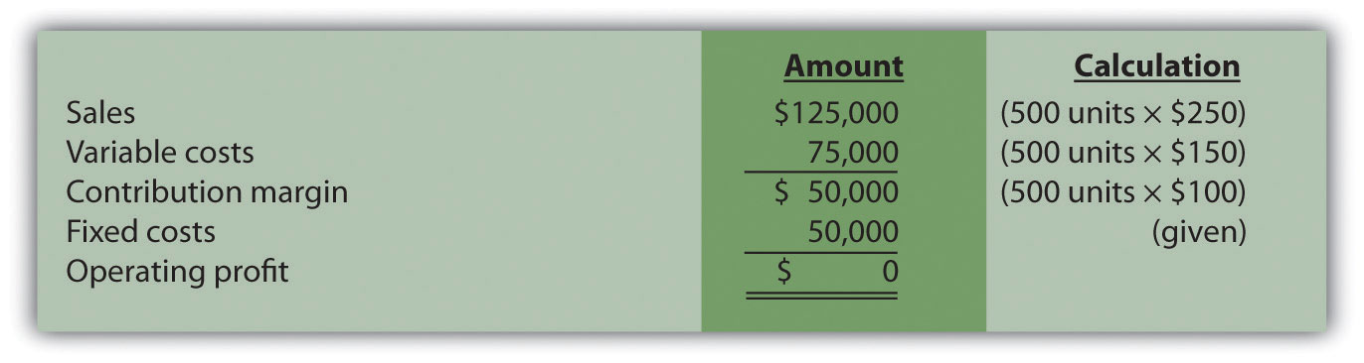

Target Profit in Units

Question: Although it is helpful for companies to know the break-even point, most organizations are more interested in determining the sales required to make a targeted amount of profit. How does finding the target profit in units help companies like Snowboard Company?

Answer: Finding a target profit in units simply means that a company would like to know how many units of product must be sold to achieve a certain profit. At Snowboard Company, Recilia (the vice president of sales) and Lisa (the accountant) are in their next weekly meeting.
Lisa: | Recilia, last week you asked how many units we have to sell to cover our expenses. This is called the break-even point. If each unit produced and sold provides $100 toward covering fixed costs, and if total monthly fixed costs are $50,000, we would have to sell 500 units to break even—that is, $50,000 divided by $100.
Recilia: | What happens once we sell enough units to cover all of our fixed costs for the month?
Lisa: | Good question! Once all fixed costs are covered for the month, each unit sold contributes $100 toward profit.
Recilia: | I think I’m getting the hang of this. It will take 500 units in sales to break even, and each unit sold above 500 results in a $100 increase in profit. So if we sell 503 units for a month, profit will total $300?
Lisa: | You’ve got it!
Recilia: | So if our goal is to make a profit of $30,000 per month (target profit), how many units must be sold?
Lisa: | It takes 500 units to break even. We also know each unit sold above and beyond 500 units contributes $100 toward profit. Thus we would have to sell an additional 300 units above the break-even point to earn a profit of $30,000. This means we would have to sell 800 units in total to make $30,000 in profit.
Recilia: | Wow, I’m not sure selling 800 units is realistic, but at least we have a better sense of what needs to be done to make a decent profit. Thanks for your help!

Profit Equation

Question: Let’s formalize this discussion by using the profit equation. How is the profit equation used to find a target profit amount in units?

Answer: Finding the target profit in units is similar to finding the break-even point in units except that profit is no longer set to zero. Instead, set the profit to the target profit the company would like to achieve. Then fill in the information for selling price per unit (S), variable cost per unit (V), and total fixed costs (F), and solve for the quantity of units produced and sold (Q):
Profit$30,000$30,000$80,000Q=(S×Q)−(V×Q)−F=$250Q−$150Q−$50,000=$100Q−$50,000=$100Q=800 units

Thus Snowboard Company must produce and sell 800 snowboards to achieve $30,000 in profit. This answer is confirmed in the following contribution margin income statement:
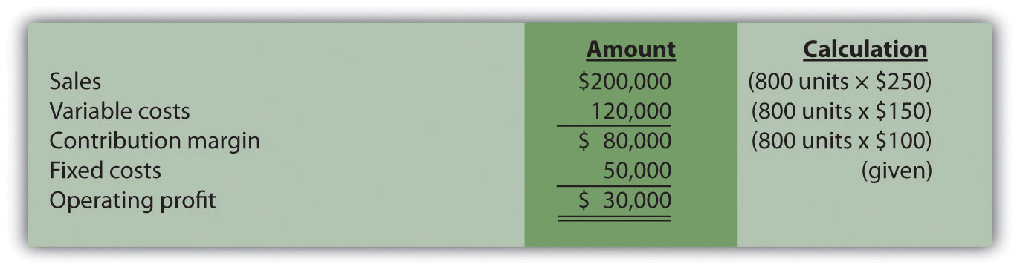

Shortcut Formula

Question: Although using the profit equation to solve for the break-even point or target profit in units tends to be the easiest approach, we can also use a shortcut formula derived from this equation. What is the shortcut formula, and how is it used to find the target profit in units for Snowboard Company?
Answer: The shortcut formula is as follows:

Key Equation
Q = (F + Target Profit) ÷ (S − V)

If you want to find the break-even point in units, set “Target Profit” in the equation to zero. If you want to find a target profit in units, set “Target Profit” in the equation to the appropriate amount. To confirm that this works, use the formula for Snowboard Company by finding the number of units produced and sold to achieve a target profit of $30,000:
QQQQ=(F+Target Profit)÷(S−V)=($50,000+$30,000)÷($250−$150)=$80,000÷$100=800 units

The result is the same as when we used the profit equation.

Break-Even Point in Sales Dollars

Question: Finding the break-even point in units works well for companies that have products easily measured in units, such as snowboard or bike manufacturers, but not so well for companies that have a variety of products not easily measured in units, such as law firms and restaurants. How do companies find the break-even point if they cannot easily measure sales in units?

Answer: For these types of companies, the break-even point is measured in sales dollars. That is, we determine the total revenue (total sales dollars) required to achieve zero profit for companies that cannot easily measure sales in units.

Finding the break-even point in sales dollars requires the introduction of two new terms: contribution margin per unit and contribution margin ratio.

Contribution Margin per Unit

The contribution margin per unit is the amount each unit soldcontributes to (1) covering fixed costs and (2) increasing profit. We calculate it by subtracting variable costs per unit (V) from the selling price per unit (S).

Key Equation
Contribution margin per unit = S − V

For Snowboard Company the contribution margin is $100:
Contribution margin per unit$100=S−V=$250−$150

Thus each unit sold contributes $100 to covering fixed costs and increasing profit.

Contribution Margin Ratio

The contribution margin ratio (often called contribution margin percent) is the contribution margin as a percentage of sales. It measures the amounteach sales dollar contributes to (1) covering fixed costs and (2) increasing profit. The contribution margin ratio is the contribution margin per unit divided by the selling price per unit. (Note that the contribution margin ratio can also be calculated using the total contribution margin and totalsales; the result is the same.)

Key Equation
Contribution margin ratio = (S − V) ÷ S

For Snowboard Company the contribution margin ratio is 40 percent:
Contribution margin ratio40%=(S−V)÷S=($250−$150)÷$250

Thus each dollar in sales contributes 40 cents ($0.40) to covering fixed costs and increasing profit.

Question: With an understanding of the contribution margin and contribution margin ratio, we can now calculate the break-even point in sales dollars. How do we calculate the break-even point in sales dollars for Snowboard Company?

Answer: The formula to find the break-even point in sales dollars is as follows.

Key Equation
Break-even point in sales dollars=Total fixed costs + Target profitContribution margin ratio

For Snowboard Company the break-even point in sales dollars is $125,000 per month:
Break-even point in sales dollars$125,000 in sales=$50,000+$00.40=$50,000+$00.40

Thus Snowboard Company must achieve $125,000 in total sales to break even. The following contribution margin income statement confirms this answer:
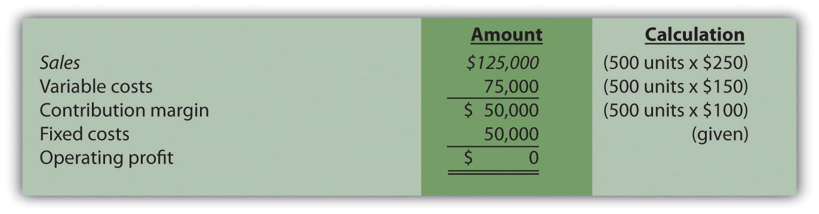

Target Profit in Sales Dollars

Key Equation
Target profit in sales dollars=Total fixed costs + Target profitContribution margin ratio

Question: Finding a target profit in sales dollars simply means that a company would like to know total sales measured in dollars required to achieve a certain profit. Finding the target profit in sales dollars is similar to finding the break-even point in sales dollars except that “target profit” is no longer set to zero. Instead, target profit is set to the profit the company would like to achieve. Recall that management of Snowboard Company asked the following question: What is the amount of total sales dollars required to earn a target profit of $30,000?

Answer: Use the break-even formula described in the previous section. Instead of setting the target profit to $0, set it to $30,000. This results in an answer of $200,000 in monthly sales:
Target profit in sales dollars$200,000 in sales=Total fixed costs + Target profitContribution margin ratio=$50,000+$30,0000.40

Thus Snowboard Company must achieve $200,000 in sales to make $30,000 in monthly profit. The following contribution margin income statement confirms this answer:
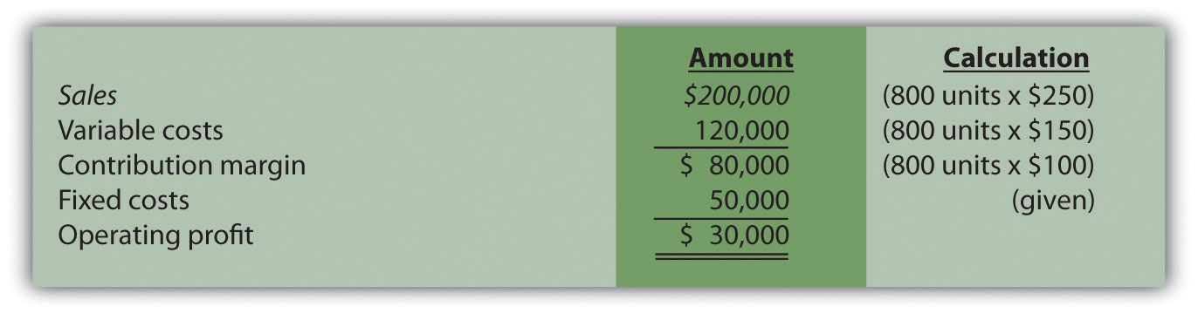

Business in Action 6.1
Measuring the Break-Even Point for Airlines
During the month of September 2001, United Airlines was losing $15 million per day. With $2.7 billion in cash, United had six months to return to profitability before facing a significant cash shortage. Many analysts believed United’s troubles resulted in part from a relatively high break-even point.
Airlines measure break-even points, also called load factors, in terms of the percentage of seats filled. At the end of 2001, one firm estimated thatUnited had to fill 96 percent of its seats just to break even. This is well above the figure for other major airlines, as you can see in the list that follows:
- American Airlines: 85 percent
- Delta Airlines: 85 percent
- Southwest Airlines: 65 percent
- Alaska Airlines:75 percent
United Airlines filed for bankruptcy at the end of 2002 and emerged from bankruptcy in 2006 after reducing costs by $7 billion a year. Other airlines continue to work on reducing their break-even points and maximizing the percentage of seats filled.
Source: Lisa DiCarlo, “Can This Airline Be Saved?” Forbes magazine’s Web site (http://www.forbes.com), November 2001; “United Airlines Emerges from Bankruptcy,” Reuters (http://www.foxnews.com), February 1, 2005.

CVP Graph

Question: The relationship of costs, volume, and profit can be displayed in the form of a graph. What does this graph look like for Snowboard Company, and how does it help management evaluate financial information related to the production of snowboards?

Answer: Figure 6.2 "CVP Graph for Snowboard Company" shows in graph form the relationship between cost, volume, and profit for Snowboard Company. The vertical axis represents dollar amounts for revenues, costs, and profits. The horizontal axis represents the volume of activity for a period, measured as units produced and sold for Snowboard.

There are three lines in the graph:
- Total revenue
- Total cost
- Profit

The total revenue line shows total revenue based on the number of units produced and sold. For example, if Snowboard produces and sells one unit, total revenue is $250 (= 1 × $250). If it produces and sells 2,000 units, total revenue is $500,000 (= 2,000 × $250).

The total cost line shows total cost based on the number of units produced and sold. For example, if Snowboard produces and sells one unit, total cost is $50,150 [= $50,000 + (1 × $150)]. If it produces and sells 2,000 units, total cost is $350,000 [= $50,000 + (2,000 × $150)].

The profit line shows profit or loss based on the number of units produced and sold. It is simply the difference between the total revenue and total cost lines. For example, if Snowboard produces and sells 2,000 units, the profit is $150,000 (= $500,000 − $350,000). If no units are sold, a loss is incurred equal to total fixed costs of $50,000.

Figure 6.2 CVP Graph for Snowboard Company
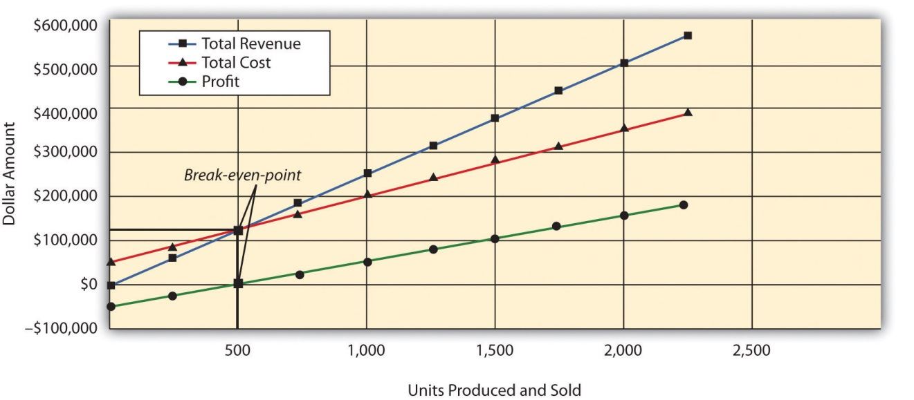

Margin of Safety

Question: Managers often like to know how close projected sales are to the break-even point. How is this information calculated and used by management?

Answer: The excess of projected sales over the break-even point is called themargin of safety. The margin of safety represents the amount by which sales can fall before the company incurs a loss.

Key Equation
Margin of safety (in units) = Projected sales (in units) − Break-even sales (in units)

Assume Snowboard Company expects to sell 700 snowboards and that its break-even point is 500 units; the margin of safety is 200 units. The calculation is
Margin of safety (in units)200=Projected sales (in units)−Break-even sales (in units)=700−500

Thus sales can drop by 200 units per month before the company begins to incur a loss.

The margin of safety can also be stated in sales dollars.

Key Equation
Margin of safety (in sales $) = Projected sales (in sales $) − Break-even sales (in sales $)

For Snowboard the margin of safety in sales dollars is $50,000:
Margin of safety (in sales $)$50,000=Projected sales (in sales $)−Break-even sales (in sales $)=(700 units×$250)−(500 units×$250)

Thus sales revenue can drop by $50,000 per month before the company begins to incur a loss.

KEY TAKEAWAY
- Cost-volume-profit analysis involves finding the break-even and target profit point in units and in sales dollars. The key formulas for an organization with a single product are summarized in the following list. Set the target profit to $0 for break-even calculations, or to the appropriate profit dollar amount for target profit calculations. The margin of safety formula is also shown:
  - Break-even or target profit point measured inunits:
Total fixed costs + Target profitSelling price per unit − Variable cost per unit
(The denominator is also called “contribution margin per unit.”)
  - Break-even or target profit point measured in sales dollars:
Total fixed costs + Target profitContribution margin ratio
  - Margin of safety in units or sales dollars:
Projected sales − Break-even sales

REVIEW PROBLEM 6.1
Star Symphony would like to perform for a neighboring city. Fixed costs for the performance total $5,000. Tickets will sell for $15 per person, and an outside organization responsible for processing ticket orders charges the symphony a fee of $2 per ticket. Star Symphony expects to sell 500 tickets.
- How many tickets must Star Symphony sell to break even?
- How many tickets must the symphony sell to earn a profit of $7,000?
- How much must Star Symphony have in sales dollars to break even?
- How much must Star Symphony have in sales dollars to earn a profit of $7,000?
- What is the symphony’s margin of safety in units and in sales dollars?
Solution to Review Problem 6.1
Note: All solutions are rounded.
- The symphony must sell 385 tickets to break even:
Total fixed costs + Target profitSelling price per unit − Variable cost per unit=$5,000+$0$15−$2=385 tickets (rounded)
- The symphony must sell 923 tickets to make a profit of $7,000:
Total fixed costs + Target profitSelling price per unit − Variable cost per unit=$5,000+$7,000$15−$2=923 tickets (rounded)
- The symphony must make $5,769 in sales to break even:
Total fixed costs + Target profitContribution margin ratio=$5,000+$0$(15−$2)÷$15=$5,769 (rounded)
- The symphony must make $13,846 in sales to earn a profit of $7,000:
Total fixed costs + Target profitContribution margin ratio=$5,000+$7,000$(15−$2)÷$15=$13,846 (rounded)
- The symphony’s margin of safety is 115 units or $1,725 in sales:
Margin of safety115 tickets$1,725 in sales=Projected sales − Break-even sales=500 tickets−385 tickets=(500×$15)−(385×$15)

6.2 Cost-Volume-Profit Analysis for Multiple-Product and Service Companies

LEARNING OBJECTIVE
- Perform cost-volume-profit analysis for multiple-product and service companies.

Question: Although the previous section illustrated cost-volume-profit (CVP) analysis for companies with a single product easily measured in units, most companies have more than one product or perhaps offer services not easily measured in units. Suppose you are the manager of a company called Kayaks-For-Fun that produces two kayak models, River and Sea. What information is needed to calculate the break-even point for this company?

Answer: The following information is required to find the break-even point:
- Monthly fixed costs total $24,000.
- The River model represents 60 percent of total sales volume and the Sea model accounts for 40 percent of total sales volume.
- The unit selling price and variable cost information for the two products follow:

Finding the Break-Even Point and Target Profit in Units for Multiple-Product Companies

Question: Given the information provided for Kayaks-For-Fun, how will the company calculate the break-even point?

Answer: First, we must expand the profit equation presented earlier to include multiple products. The following terms are used once again. However, subscript r identifies the River model, and subscript s identifies the Sea model (e.g., Sr stands for the River model’s selling price per unit). CM is new to this section and represents the contribution margin.

Key Equation
S = Selling price per unitV = Variable cost per unitF = Total fixed costsQ = Quantity of units produced and soldCM = Contribution margin
Thus
ProfitProfit==Total sales−Total variable costs−Total fixed costs[(Sr×Qr)+(Ss×Qs)]−[(Vr×Qr)+(Vs×Qs)]−F

Without going through a detailed derivation, this equation can be restated in a simplified manner for Kayaks-For-Fun, as follows:
ProfitProfit=(Unit CM for River×Quantity of River)+(Unit CM for Sea×Quantity of Sea)−F=$400Qr+$150Qs−$24,000

One manager at Kayaks-For-Fun believes the break-even point should be 60 units in total, and another manager believes the break-even point should be 160 units in total. Which manager is correct? The answer is both might be correct. If only the River kayak is produced and sold, 60 units is the break-even point. If only the Sea kayak is produced and sold, 160 units is the break-even point. There actually are many different break-even points, because the profit equation has two unknown variables, Q_{r} and Q_{s}.

Further evidence of multiple break-even points is provided as follows (allow for rounding to the nearest unit), and shown graphically in :
Profit ($0) = ($400 × 30 units of River) + ($150 × 80 units of Sea) − $24,000Profit ($0) = ($400 × 35 units of River) + ($150 × 67 units of Sea) − $24,000Profit ($0) = ($400 × 40 units of River) + ($150 × 53 units of Sea) − $24,000
Figure 6.3 Multiple Break-Even Points for Kayaks-For-Fun
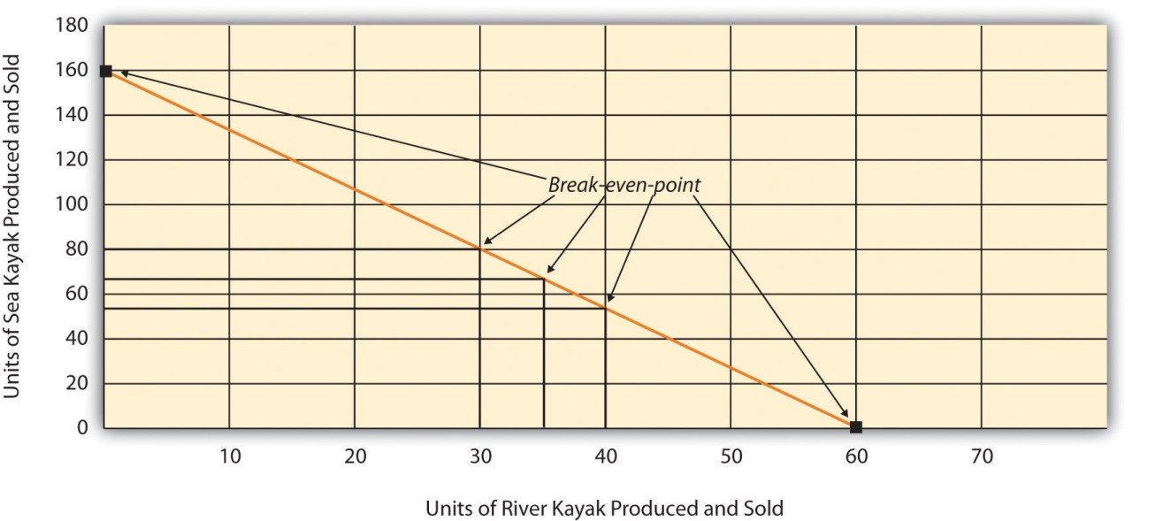

Break-Even Point in Units and the Weighted Average Contribution Margin per Unit

Question: Because most companies sell multiple products that have different selling prices and different variable costs, the break-even or target profit point depends on the sales mix. What is the sales mix, and how is it used to calculate the break-even point?

Answer: The sales mix is the proportion of one product’s sales to total sales. In the case of Kayaks-For-Fun, the River model accounts for 60 percent of total unit sales and the Sea model accounts for 40 percent of total unit sales.

In calculating the break-even point for Kayaks-For-Fun, we must assume the sales mix for the River and Sea models will remain at 60 percent and 40 percent, respectively, at all different sales levels. The formula used to solve for the break-even point in units for multiple-product companies is similar to the one used for a single-product company, with one change. Instead of using the contribution margin per unit in the denominator, multiple-product companies use a weighted average contribution margin per unit. The formula to find the break-even point in units is as follows.

Key Equation
Total fixed costs + Target profitWeighted average contribution margin per unit

When a company assumes a constant sales mix, aweighted average contribution margin per unit can be calculated by multiplying each product’s unit contribution margin by its proportion of total sales. The resulting weighted unit contribution margins for all products are then added together.

At Kayaks-For-Fun, the weighted average contribution margin per unit of $300 is
$300 = ($400 × 60 percent) + ($150 × 40 percent)

We can now determine the break-even point in units by using the following formula:
Break-even point in unitsBreak-even point in units=Total fixed costs + Target profitWeighted average contribution margin per unit=$24,000+$0$300=80 total kayaks

Kayaks-For-Fun must sell 48 River models (= 60 percent × 80 units) and 32 Sea models (= 40 percent × 80 units) to break even. Again, this assumes the sales mix remains the same at different levels of sales volume.

Target Profit in Units

Question: We now know how to calculate the break-even point in units for a company with multiple products. How do we extend this process to find the target profit in units for a company with multiple products?

Answer: Finding the target profit in units for a company with multiple products is similar to finding the break-even point in units except that profit is no longer set to zero. Instead, profit is set to the target profit the company would like to achieve.

Key Equation
Target profit in units=Total fixed costs + Target profitWeighted average contribution margin per unit

For example, assume Kayaks-For-Fun would like to know how many units it must sell to make a monthly profit of $96,000. Simply set the target profit to $96,000 and run the calculation:
Target profit in unitsTarget profit in units=Total fixed costs + Target profitWeighted average contribution margin per unit=$24,000+$96,000$300=400 total kayaks

Kayaks-For-Fun must sell 240 River models (= 60 percent × 400) and 160 Sea models (= 40 percent × 400) to make a profit of $96,000.

REVIEW PROBLEM 6.2
International Printer Machines (IPM) builds three computer printer models: Inkjet, Laser, and Color Laser. Information for these three products is as follows:
 | Inkjet | Laser | Color Laser | Total
Selling price per unit | $250 | $400 | $1,600
Variable cost per unit | $100 | $150 | $ 800
Expected unit sales (annual) | 12,000 | 6,000 | 2,000 | 20,000
Sales mix | 60 percent | 30 percent | 10 percent | 100 percent
Total annual fixed costs are $5,000,000. Assume the sales mix remains the same at all levels of sales.

  - How many printers in total must be sold to break even?
  - How many units of each printer must be sold to break even?

  - How many printers in total must be sold to earn an annual profit of $1,000,000?
  - How many units of each printer must be sold to earn an annual profit of $1,000,000?
Solution to Review Problem 6.2
Note: All solutions are rounded.

  - IPM must sell 20,408 printers to break even:
Total fixed costs + Target profitWeighted average contribution margin per unit
$5,000,000+$0($150×0.60)+($250×0.30)+($800×0.10)=$5,000,000$245=20,408 total units
  - As calculated previously, 20,408 printers must be sold to break even. Using the sales mix provided, the following number of units of each printer must be sold to break even:
    - Inkjet: 12,245 units=20,408×0.60
    - Laser: 6,122 units=20,408×0.30
    - Color laser: 2,041 units=20,408×0.10

  - IPM must sell 24,490 printers to earn $1,000,000 in profit:
Total fixed costs + Target profitWeighted average contribution margin per unit
$5,000,000+$1,000,000($150×0.60)+($250×0.30)+($800×0.10)=$6,000,000$245=24,490 total units
  - As calculated previously, 24,490 printers must be sold to earn $1,000,000 in profit. Using the sales mix provided, the following number of units for each printer must be sold to earn $1,000,000 in profit:
    - Inkjet:14,694 units=24,490×0.60
    - Laser:7,347 units=24,490×0.30
    - Color laser:2,449 units=24,490×0.10

Finding the Break-Even Point and Target Profit in Sales Dollars for Multiple-Product and Service Companies

A restaurant like Applebee’s, which serves chicken, steak, seafood, appetizers, and beverages, would find it difficult to measure a “unit” of product. Such companies need a different approach to finding the break-even point. illustrates this point by contrasting a company that has similar products easily measured in units (kayaks) with a company that has unique products (meals at a restaurant) not easily measured in units.

Break-Even Point in Sales Dollars and the Weighted Average Contribution Margin Ratio

Question: For companies that have unique products not easily measured in units, how do we find the break-even point?

Answer: Rather than measuring the break-even point in units, a more practical approach for these types of companies is to find the break-even point in sales dollars. We can use the formula that follows to find the break-even point in sales dollars for organizations with multiple products or services. Note that this formula is similar to the one used to find the break-even point in sales dollars for an organization with one product, except that the contribution margin ratio now becomes the weighted averagecontribution margin ratio.

Key Equation
Break-even point in sales dollars=Total fixed costs + Target profitWeighted average contribution margin ratio

For example, suppose Amy’s Accounting Service has three departments—tax, audit, and consulting—that provide services to the company’s clients.shows the company’s income statement for the year. Amy, the owner, would like to know what sales are required to break even. Note that fixed costs are known in total, but Amy does not allocate fixed costs to each department.

Figure 6.5 Income Statement for Amy’s Accounting Service
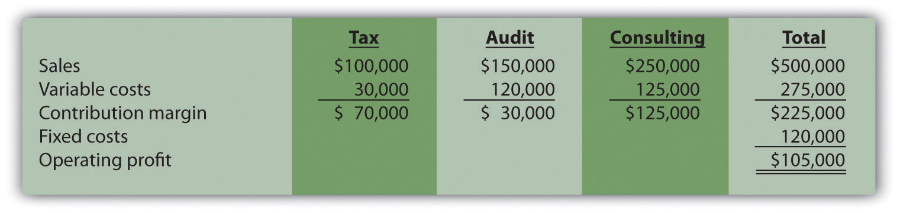

The contribution margin ratio differs for each department:
Tax | 70 percent (= $70,000 ÷ $100,000)
Audit | 20 percent (= $30,000 ÷ $150,000)
Consulting | 50 percent (= $125,000 ÷ $250,000)

Question: We have the contribution margin ratio for each department, but we need it for the company as a whole. How do we find the contribution margin ratio for all of the departments in the company combined?

Answer: The contribution margin ratio for the company as a whole is theweighted average contribution margin ratio. We calculate it by dividing the total contribution margin by total sales. For Amy’s Accounting Service, the weighted average contribution margin ratio is 45 percent (= $225,000 ÷ $500,000). For every dollar increase in sales, the company will generate an additional 45 cents ($0.45) in profit. This assumes that the sales mix remains the same at all levels of sales. (The sales mix here is measured in sales dollars for each department as a proportion of total sales dollars.)

Now that you know the weighted average contribution margin ratio for Amy’s Accounting Service, it is possible to calculate the break-even point in sales dollars:
Break-even point in sales dollarsBreak-even point in sales dollars=Total fixed costs + Target profitWeighted average contribution margin ratio=$120,000+$00.45=$266,667 (rounded)

Amy’s Accounting Service must achieve $266,667 in sales to break even.[1]

Target Profit in Sales Dollars

Question: How do we find the target profit in sales dollars for companies with products not easily measured in units?

Answer: Finding the target profit in sales dollars for a company with multiple products or services is similar to finding the break-even point in sales dollars except that profit is no longer set to zero. Instead, profit is set to the target profit the company would like to achieve.

Key Equation
Target profit in sales dollars=Total fixed costs + Target profitWeighted average contribution margin ratio

For example, assume Amy’s Accounting Service would like to know sales dollars required to make $250,000 in annual profit. Simply set the target profit to $250,000 and run the calculation:
Target profit in sales dollarsTarget profit in sales dollars=Total fixed costs + Target profitWeighted average contribution margin ratio=$120,000+$250,0000.45=$822,222 (rounded)

Amy’s Accounting Service must achieve $822,222 in sales to earn $250,000 in profit.

Important Assumptions

Question: Several assumptions are required to perform break-even and target profit calculations for companies with multiple products or services. What are these important assumptions?

Answer: These assumptions are as follows:
- Costs can be separated into fixed and variable components.
- Contribution margin ratio remains constant for each product, segment, or department.
- Sales mix remains constant with changes in total sales.

These assumptions simplify the CVP model and enable accountants to perform CVP analysis quickly and easily. However, these assumptions may not be realistic, particularly if significant changes are made to the organization’s operations. When performing CVP analysis, it is important to consider the accuracy of these simplifying assumptions. It is always possible to design a more accurate and complex CVP model. But the benefits of obtaining more accurate data from a complex CVP model must outweigh the costs of developing such a model.

Margin of Safety

Question: Managers often like to know how close expected sales are to the break-even point. As defined earlier, the excess of projected sales over the break-even point is called the margin of safety. How is the margin of safety calculated for multiple-product and service organizations?

Answer: Let’s return to Amy’s Accounting Service and assume that Amy expects annual sales of $822,222, which results in expected profit of $250,000. Given a break-even point of $266,667, the margin of safety in sales dollars is calculated as follows:
Margin of safety$555,555=Projected sales − Break-even sales=$822,222 − $266,667

Thus sales revenue can drop by $555,555 per year before the company begins to incur a loss.

KEY TAKEAWAYS
- The key formula used to calculate the break-even or target profit point in units for a company with multiple products is as follows. Simply set the target profit to $0 for break-even calculations, or to the appropriate profit dollar amount for target profit calculations.
Total fixed costs + Target profitWeighted average contribution margin per unit
- The formula used to find the break-even point or target profit in sales dollars for companies with multiple products or service is as follows. Simply set the “Target Profit” to $0 for break-even calculations, or to the appropriate profit dollar amount for target profit calculations:
Total fixed costs + Target profitWeighted Average contribution margin ratio

REVIEW PROBLEM 6.3
Ott Landscape Incorporated provides landscape maintenance services for three types of clients: commercial, residential, and sports fields. Financial projections for this coming year for the three segments are as follows:
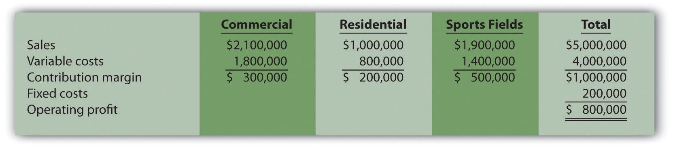
Assume the sales mix remains the same at all levels of sales.
- How much must Ott Landscape have in total sales dollars to break even?
- How much must Ott Landscape have in total sales dollars to earn an annual profit of $1,500,000?
- What is the margin of safety, assuming projected sales are $5,000,000 as shown previously?
Solution to Review Problem 6.3
- Sales of $1,000,000 are required to break even:
Total fixed costs + Target profitWeighted average contribution margin ratio*=$200,000+$00.20=$1,000,000 in sales
*Weighted average contribution margin ratio = $1,000,000 ÷ $5,000,000 = 20 percent or 0.20.
- Sales of $8,500,000 are required to make a profit of $1,500,000:
Total fixed costs + Target profitWeighted average contribution margin ratio=$200,000+$1,500,0000.20=$8,500,000 in sales
- The margin of safety is $4,000,000 in sales:
Margin of safety$4,000,000 in sales=Projected sales − Break-even sales=$5,000,000−$1,000,000
[1] The weighted average contribution margin ratio can also be found by multiplying each department’s contribution margin ratio by its proportion of total sales. The resulting weighted average contribution margin ratios for all departments are then added. The calculation for Amy’s Accounting Service is as follows:45 percent weighted average contribution margin ratio = (tax has 20 percent of total sales × 70 percent contribution margin ratio) + (audit has 30 percent of total sales × 20 percent contribution margin ratio) + (consulting has 50 percent of total sales × 50 percent contribution margin ratio)Thus 45 percent = 14 percent + 6 percent + 25 percent.

6.3 Using Cost-Volume-Profit Models for Sensitivity Analysis

LEARNING OBJECTIVE
- Use sensitivity analysis to determine how changes in the cost-volume-profit equation affect profit.

Question: We can use the cost-volume-profit (CVP) financial model described in this chapter for single-product, multiple-product, and service organizations to perform sensitivity analysis, also called what-if analysis. How is sensitivity analysis used to help managers make decisions?

Answer: Sensitivity analysis shows how the CVP model will change with changes in any of its variables (e.g., changes in fixed costs, variable costs, sales price, or sales mix). The focus is typically on how changes in variables will alter profit.

Sensitivity Analysis: An Example

To illustrate sensitivity analysis, let’s go back to Snowboard Company, a company that produces one snowboard model. The assumptions for Snowboard were as follows:
Sales price per unit | $ 250
Variable cost per unit | 150
Fixed costs per month | 50,000
Target profit | 30,000

Recall from earlier calculations that the break-even point is 500 units, and Snowboard must sell 800 units to achieve a target profit of $30,000. Management believes a goal of 800 units is overly optimistic and settles on a best guess of 700 units in monthly sales. This is called the “base case.” The base case is summarized as follows in contribution margin income statement format:
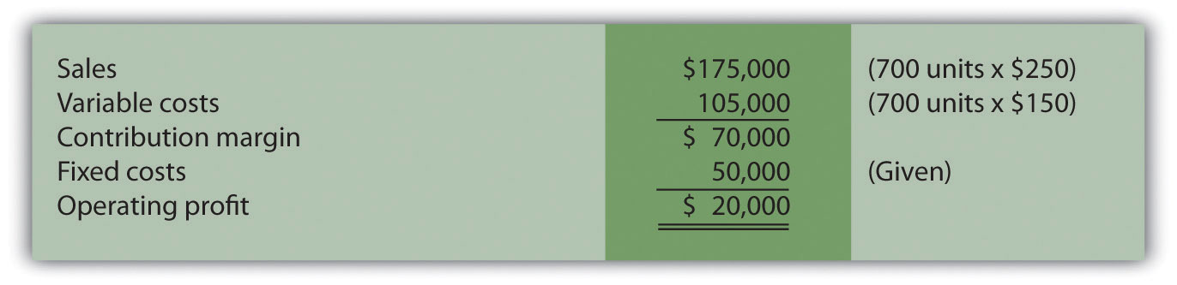

Question: Although management believes the base case is reasonably accurate, it is concerned about what will happen if certain variables change. As a result, you are asked to address the following questions from management (you are now performing sensitivity analysis!). Each scenario is independent of the others. Unless told otherwise, assume that the variables used in the base case remain the same. How do you answer the following questions for management?
- How will profit change if the sales price increases by $25 per unit (10 percent)?
- How will profit change if sales volume decreases by 70 units (10 percent)?
- How will profit change if fixed costs decrease by $15,000 (30 percent) and variable cost increases $15 per unit (10 percent)?

Answer: The CVP model shown in Figure 6.6 "Sensitivity Analysis for Snowboard Company" answers these questions. Each column represents a different scenario, with the first column showing the base case and the remaining columns providing answers to the three questions posed by management. The top part of Figure 6.6 "Sensitivity Analysis for Snowboard Company" shows the value of each variable based on the scenarios presented previously, and the bottom part presents the results in contribution margin income statement format.
Figure 6.6 Sensitivity Analysis for Snowboard Company
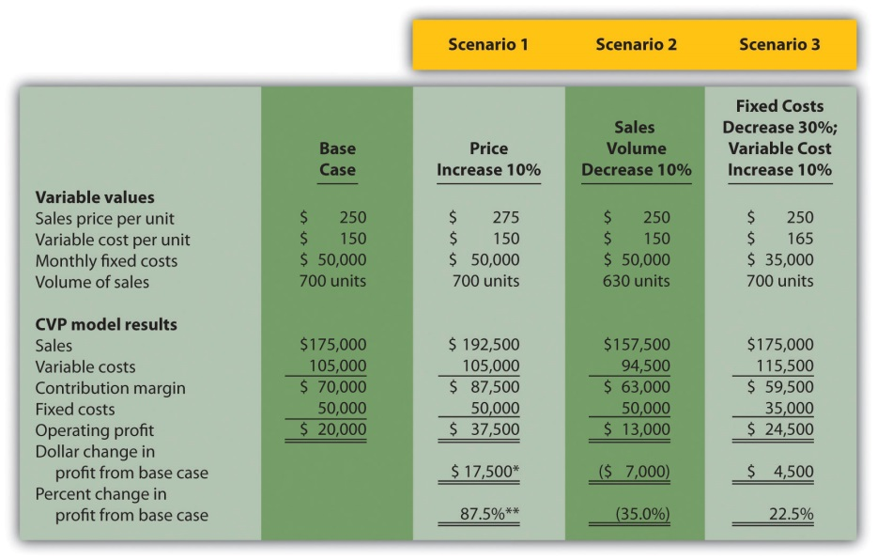
ª $17,500 = $37,500 − $20,000.
^{b} 87.5 percent = $17,500 ÷ $20,000.

Carefully review Figure 6.6 "Sensitivity Analysis for Snowboard Company". The column labeled Scenario 1 shows that increasing the price by 10 percent will increase profit 87.5 percent ($17,500). Thus profit is highly sensitive to changes in sales price. Another way to look at this is that for every one percent increase in sales price, profit will increase by 8.75 percent, or for every one percent decrease in sales price, profit will decrease by 8.75 percent.

The column labeled Scenario 2 shows that decreasing sales volume 10 percent will decrease profit 35 percent ($7,000). Thus profit is also highly sensitive to changes in sales volume. Stated another way, every one percentdecrease in sales volume will decrease profit by 3.5 percent; or every one percent increase in sales volume will increase profit by 3.5 percent.

When comparing Scenario 1 with Scenario 2, we see that Snowboard Company’s profit is more sensitive to changes in sales price than to changes in sales volume, although changes in either will significantly affect profit.

The column labeled Scenario 3 shows that decreasing fixed costs by 30 percent and increasing variable cost by 10 percent will increase profit 22.5 percent ($4,500). (Perhaps Snowboard Company is considering moving toward less automation and more direct labor!)

Computer Application
Using Excel to Perform Sensitivity Analysis
The accountants at Snowboard Company would likely use a spreadsheet program, such as Excel, to develop a CVP model for the sensitivity analysis shown in Figure 6.6 "Sensitivity Analysis for Snowboard Company". An example of how to use Excel to prepare the CVP model shown in Figure 6.6 "Sensitivity Analysis for Snowboard Company" is presented as follows. Notice that the basic data are entered at the top of the spreadsheet (data entry section), and the rest of the information is driven by formulas. This allows for quick sensitivity analysis of different scenarios.
Using the base case as an example, sales of $175,000 (cell D14) are calculated by multiplying the $250 sales price per unit (cell D5) by 700 units (cell D8). Variable costs of $105,000 (cell D15) are calculated by multiplying the $150 variable cost per unit (cell D6) by 700 units (cell D8). Fixed costs of $50,000 come from the top section (cell D7). The contribution margin of $70,000 is calculated by subtracting variable costs from sales, and profit of $20,000 is calculated by subtracting fixed costs from the contribution margin.
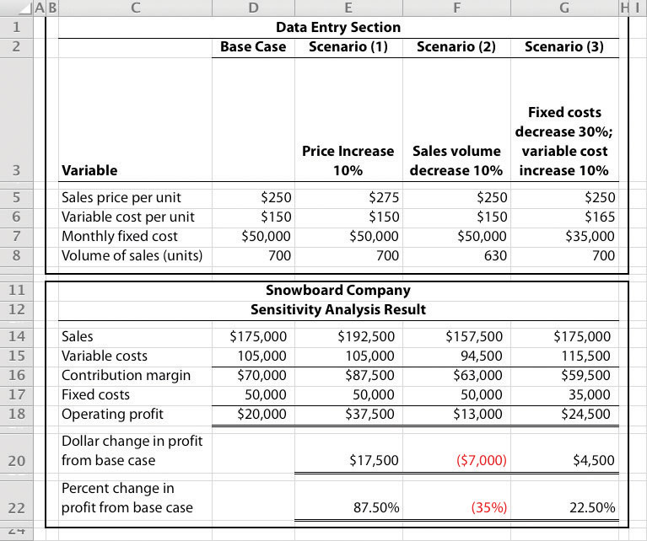

Expanding the Use of Sensitivity Analysis

Question: Although the focus of sensitivity analysis is typically on how changes in variables will affect profit (as shown in Figure 6.6 "Sensitivity Analysis for Snowboard Company"), accountants also use sensitivity analysis to determine the impact of changes in variables on the break-even point and target profit.How is sensitivity analysis used to evaluate the impact changes in variables will have on break-even and target profit points?

Answer: Let’s look at an example for Snowboard Company. Assume the company is able to charge $275 per unit, instead of $250 per unit. How many units must Snowboard Company sell to break even? The following calculation is based on the shortcut formula presented earlier in the chapter:
QQQQ=(F + Target Profit)÷(S − V)=($50,000+$0)÷($275−$150)=$50,000÷$125=400 units

Thus if the sales price per unit increases from $250 to $275, the break-even point decreases from 500 units (calculated earlier) to 400 units, which is a decrease of 100 units.

How would this same increase in sales price change the required number of units sold to achieve a profit of $30,000? We apply the same shortcut formula:
QQQQ=(F + Target Profit)÷(S − V)=($50,000+$30,000)÷($275−$150)=$80,000÷$125=640 units

Thus if the sales price per unit increases from $250 to $275, the number of units sold to achieve a profit of $30,000 decreases from 800 units (calculated earlier) to 640 units, which is a decrease of 160 units.

Business in Action 6.2
Performing Sensitivity Analysis for a Brewpub
Three entrepreneurs in California were looking for investors and banks to finance a new brewpub. Brewpubs focus on two segments: food from the restaurant segment, and freshly brewed beer from the beer production segment. All parties involved in the process of raising money—potential investors and banks, as well as the three entrepreneurs (i.e., the owners)—wanted to know what the new business’s projected profits would be. After months of research, the owners created a financial model that provided this information. Projected profits were slightly more than $300,000 for the first year (from sales of $1.95 million) and were expected to increase in each of the next four years.
One of the owners asked, “What if our projected revenues are too high? What will happen to profits if sales are lower than we expect? After all, we will have debt of well over $1 million, and I don’t want anyone coming after my personal assets if the business doesn’t have the money to pay!” Although all three owners felt the financial model was reasonably accurate, they decided to find the break-even point and the resulting margin of safety.
Because a brewpub does not sell “units” of a specific product, the owners found the break-even point in sales dollars. The owners knew the contribution margin ratio and all fixed costs from the financial model. With this information, they were able to calculate the break-even point and margin of safety. The worried owner was relieved to discover that sales could drop over 35 percent from initial projections before the brewpub incurred an operating loss.

KEY TAKEAWAY
- Sensitivity analysis shows how the cost-volume-profit model will change with changes in any of its variables. Although the focus is typically on how changes in variables affect profit, accountants often analyze the impact on the break-even point and target profit as well.

REVIEW PROBLEM 6.4
This problem is an extension of Note 6.28 "Review Problem 6.2". Recall that International Printer Machines (IPM) builds three computer printer models: Inkjet, Laser, and Color Laser. Base case information for these three products is as follows:
 | Inkjet | Laser | Color Laser | Total
Selling price per unit | $250 | $400 | $1,600
Variable cost per unit | $100 | $150 | $ 800
Expected unit sales (annual) | 12,000 | 6,000 | 2,000 | 20,000
Sales mix | 60 percent | 30 percent | 10 percent | 100 percent
Total annual fixed costs are $5,000,000. Assume that each scenario that follows is independent of the others. Unless stated otherwise, the variables are the same as in the base case.
- Prepare a contribution margin income statement for the base case. Use the format shown in Figure 6.5 "Income Statement for Amy’s Accounting Service".
- How will total profit change if the Laser sales price increases by 10 percent? (Hint: Use the format shown in Figure 6.5 "Income Statement for Amy’s Accounting Service", and compare your result with requirement 1.)
- How will total profit change if the Inkjet sales volume decreases by 4,000 units and the sales volume of other products remains the same?
- How will total profit change if fixed costs decrease by 20 percent?
Solution to Review Problem 6.4
- Base Case:
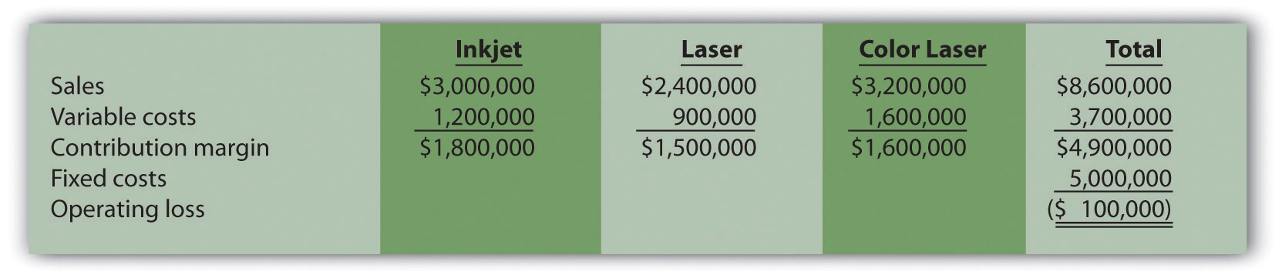
- Laser sales price increases 10 percent:
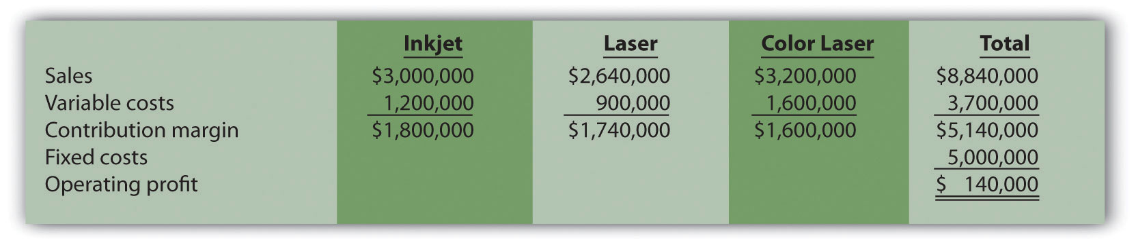
Total profit would increase $240,000 (from loss of $100,000 in base case to profit of $140,000 in this scenario).
- Inkjet sales volume decreases 4,000 units:
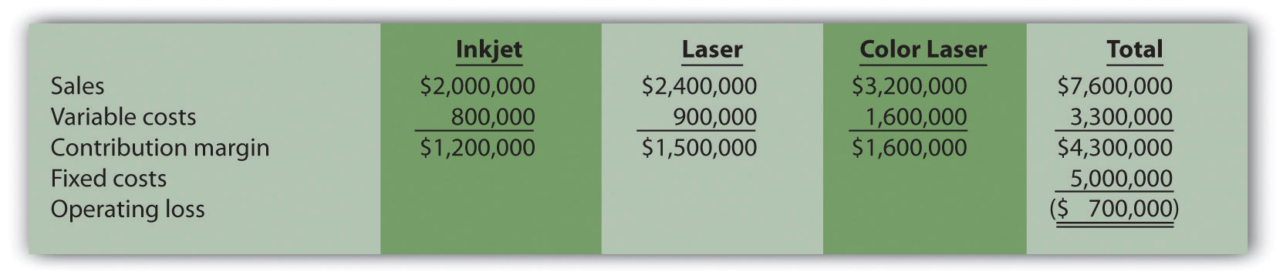
Total profit would decrease $600,000 (from loss of $100,000 in base case to loss of $700,000 in this scenario).
- Fixed costs decrease 20 percent:
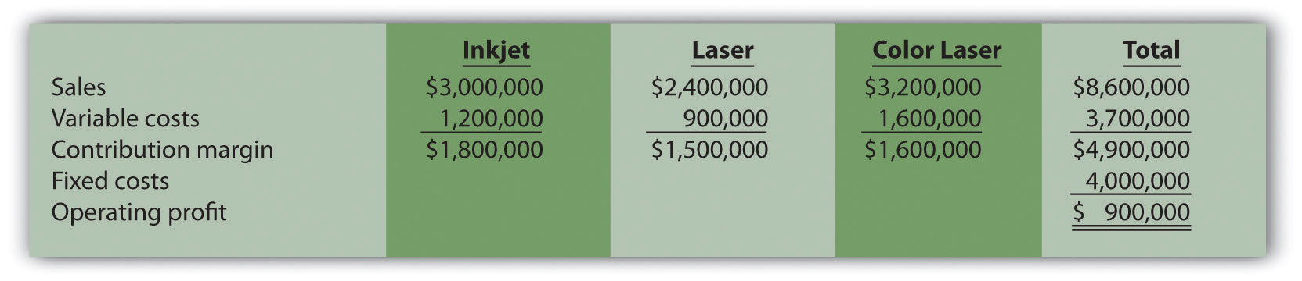
Total profit would increase $1,000,000 (from loss of $100,000 in base case to profit of $900,000 in this scenario).

6.4 Impact of Cost Structure on Cost-Volume-Profit Analysis

LEARNING OBJECTIVE
- Understand how cost structure affects cost-volume-profit sensitivity analysis.

Question: Describing an organization’s cost structure helps us to understand the amount of fixed and variable costs within the organization. What is meant by the term cost structure?

Answer: Cost structure is the term used to describe the proportion of fixed and variable costs to total costs. For example, if a company has $80,000 in fixed costs and $20,000 in variable costs, the cost structure is described as 80 percent fixed costs and 20 percent variable costs.

Question: Operating leverage refers to the level of fixed costs within an organization. How do we determine if a company has high operating leverage?

Answer: Companies with a relatively high proportion of fixed costs have high operating leverage. For example, companies that produce computer processors, such as NEC and Intel, tend to make large investments in production facilities and equipment and therefore have a cost structure with high fixed costs. Businesses that rely on direct labor and direct materials, such as auto repair shops, tend to have higher variable costs than fixed costs.

Operating leverage is an important concept because it affects how sensitive profits are to changes in sales volume. This is best illustrated by comparing two companies with identical sales and profits but with different cost structures, as we do in . High Operating Leverage Company (HOLC) has relatively high fixed costs, and Low Operating Leverage Company (LOLC) has relatively low fixed costs.
Figure 6.7 Operating Leverage Example
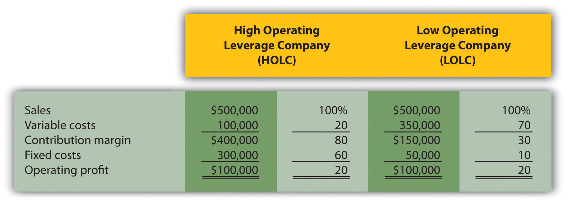

One way to observe the importance of operating leverage is to compare the break-even point in sales dollars for each company. HOLC needs sales of $375,000 to break even (= $300,000 ÷ 0.80), whereas LOLC needs sales of $166,667 to break even (= $50,000 ÷ 0.30).

Question: Why don’t all companies strive for low operating leverage to lower the break-even point?

Answer: In , LOLC looks better up to the sales point of $500,000 and profit of $100,000. However, once sales exceed $500,000, HOLC will have higher profit than LOLC. This is because every additional dollar in sales will provide $0.80 in profit for HOLC (80 percent contribution margin ratio), and only $0.30 in profit for LOLC (30 percent contribution margin ratio). If a company is relatively certain of increasing sales, then it makes sense to have higher operating leverage.

Financial advisers often say, “the higher the risk, the higher the potential profit,” which can also be stated as “the higher the risk, the higher the potential loss.” The same applies to operating leverage. Higher operating leverage can lead to higher profit. However, high operating leverage companies that encounter declining sales tend to feel the negative impact more than companies with low operating leverage.

To prove this point, let’s assume both companies in experience a 30 percentdecrease in sales. HOLC’s profit would decrease by $120,000 (= 30 percent × $400,000 contribution margin) and LOLC’s profit would decrease by $45,000 (= 30 percent × $150,000 contribution margin). HOLC would certainly feel the pain more than LOLC.

Now assume both companies in experience a 30 percent increase in sales. HOLC’s profit would increase by $120,000 (= 30 percent × $400,000 contribution margin) and LOLC’s profit would increase by $45,000 (= 30 percent × $150,000 contribution margin). HOLC benefits more from increased sales than LOLC.

KEY TAKEAWAY
- The cost structure of a firm describes the proportion of fixed and variable costs to total costs. Operating leverage refers to the level of fixed costs within an organization. The term “high operating leverage” is used to describe companies with relatively high fixed costs. Firms with high operating leverage tend to profit more from increasing sales, and lose more from decreasing sales than a similar firm with low operating leverage.

REVIEW PROBLEM 6.5
What are the characteristics of a company with high operating leverage, and how do these characteristics differ from those of a company with low operating leverage?
Solution to Review Problem 6.5
Companies with high operating leverage have a relatively high proportion of fixed costs to total costs, and their profits tend to be much more sensitive to changes in sales than their low operating leverage counterparts. Companies with low operating leverage have a relatively low proportion of fixed costs to total costs, and their profits tend to be much less sensitive to changes in sales than their high operating leverage counterparts.

6.5 Using a Contribution Margin When Faced with Resource Constraints

LEARNING OBJECTIVE
- Use an alternative form of contribution margin when faced with a resource constraint.

Question: Many companies have limited resources in such areas as labor hours, machine hours, facilities, and materials. These constraints will likely affect a company’s ability to produce goods or provide services. When a company that produces multiple products faces a constraint, managers often calculate the contribution margin per unit of constraint in addition to the contribution margin per unit. The contribution margin per unit of constraint is the contribution margin per unit divided by the units of constrained resource required to produce one unit of product. How is this measure used by managers to make decisions when faced with resource constraints?

Answer: Let’s examine the Kayaks-For-Fun example introduced earlier in the chapter. The company produces two kayak models, River and Sea. Based on the information shown, Kayaks-For-Fun would prefer to sell more of the River model because it has the highest contribution margin per unit.

Kayaks-For-Fun has a total of 320 labor hours available each month. The specialized skills required to build the kayaks makes it difficult for management to find additional workers. Assume the River model requires 4 labor hours per unit and the Sea model requires 1 labor hour per unit (most of the variable cost for the Sea model is related to expensive materials required for production). Kayaks-For-Fun sells everything it produces. Given its labor hours constraint, the company would prefer to maximize the contribution margin per labor hour.
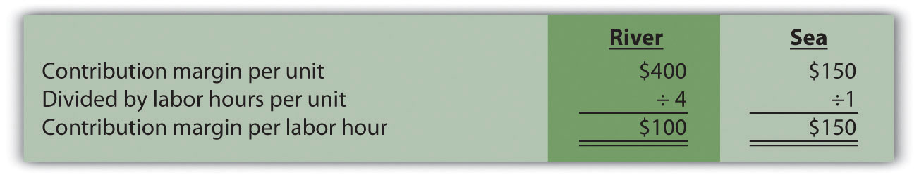

Based on this information, Kayaks-For-Fun would prefer to sell the Sea model because it provides a contribution margin per labor hour of $150 versus $100 for the River model. The company would prefer only to make the Sea model, which would yield a total contribution margin of $48,000 (= $150 × 320 hours). If the River model were the only model produced, the total contribution margin to the company would be $32,000 (= $100 × 320 hours).

Analysis such as this often leads to further investigation. It may be that Kayaks-For-Fun can find additional labor to alleviate this resource constraint. Or perhaps the production process can be modified in a way that reduces the labor required to build the River model (e.g., through increased automation). Whatever the outcome, companies with limited resources are wise to calculate the contribution margin per unit of constrained resource.

KEY TAKEAWAY
- Many organizations operate with limited resources in areas such as labor hours, machine hours, facilities, or materials. The contribution margin per unit of constraint is a helpful measure in determining how constrained resources should be utilized.

REVIEW PROBLEM 6.6
This review problem is based on the information for Kayaks-For-Fun presented previously. Assume Kayaks-For-Fun found additional labor, thereby eliminating this resource constraint. However, the company now faces limited available machine hours. It has a total of 3,000 machine hours available each month. The River model requires 16 machine hours per unit, and the Sea model requires 10 machine hours per unit.
- Calculate the contribution margin per unit of constrained resource for each model.
- Which model would Kayaks-For-Fun prefer to sell to maximize overall company profit?
Solution to Review Problem 6.6

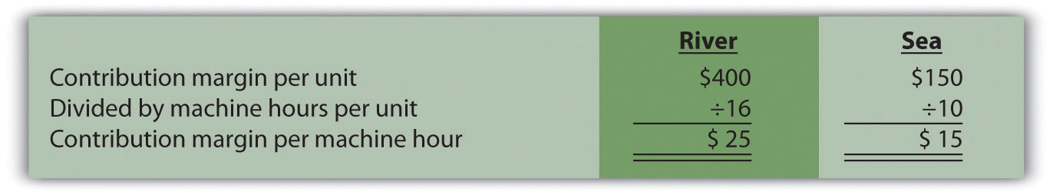
- Kayaks-For-Fun would prefer to sell the River model because it provides a contribution margin per machine hour of $25 compared to $15 for the Sea model. If only the River model were sold, the total contribution margin would be $75,000 (= $25 × 3,000 machine hours). If only the Sea model were sold, the total contribution margin would be $45,000 (= $15 × 3,000 machine hours).

6.6 Income Taxes and Cost-Volume-Profit Analysis

LEARNING OBJECTIVE
- Understand the effect of income taxes on cost-volume-profit analysis.

Question: Some organizations, such as not-for-profit entities and governmental agencies, are not required to pay income taxes. However, most for-profit organizations must pay income taxes on their profits. How do we find the target profit in units or sales dollars for organizations that pay income taxes?

Answer: Three steps are required:

Step 1. Determine the desired target profit after taxes (i.e., after accounting for income taxes).

Step 2. Convert the desired target profit after taxes to the target profit before taxes.

Step 3. Use the target profit before taxes in the appropriate formula to calculate the target profit in units or sales dollars.

Using Snowboard Company as an example, the assumptions are as follows:
Sales price per unit | $ 250
Variable cost per unit | 150
Fixed costs per month | 50,000
Target profit | 30,000

Assume also that the $30,000 target profit is the monthly profit desiredafter taxes and that Snowboard has a tax rate of 20 percent.

Step 1. Determine the desired target profit after taxes.

Snowboard’s management wants to know how many units must be sold to earn a profit of $30,000 after taxes. Target profit before taxes will be higher than $30,000, and we calculate it in the next step.

Step 2. Convert the desired target profit after taxes to the target profit before taxes.

The formula used to solve for target profit before taxes is as follows.

Key Equation
Target profit before taxes = Target profit after taxes ÷ (1 − tax rate)

Using Snowboard Company’s data, the formula would read as follows:
Target profit before taxesTarget profit before taxes=$30,000÷(1−0.20)=$37,500

Step 3. Use the target profit before taxes in the appropriate formula to calculate the target profit in units or sales dollars.

The formula used to solve for target profit in units is
Total fixed costs + Target profitSelling price per unit − Variable cost per unit

For Snowboard Company, it would read as follows:
Target profit in units=($50,000+$37,500)÷($250−$150)=$87,500÷$100=875 units

This answer is confirmed in the following contribution margin income statement.
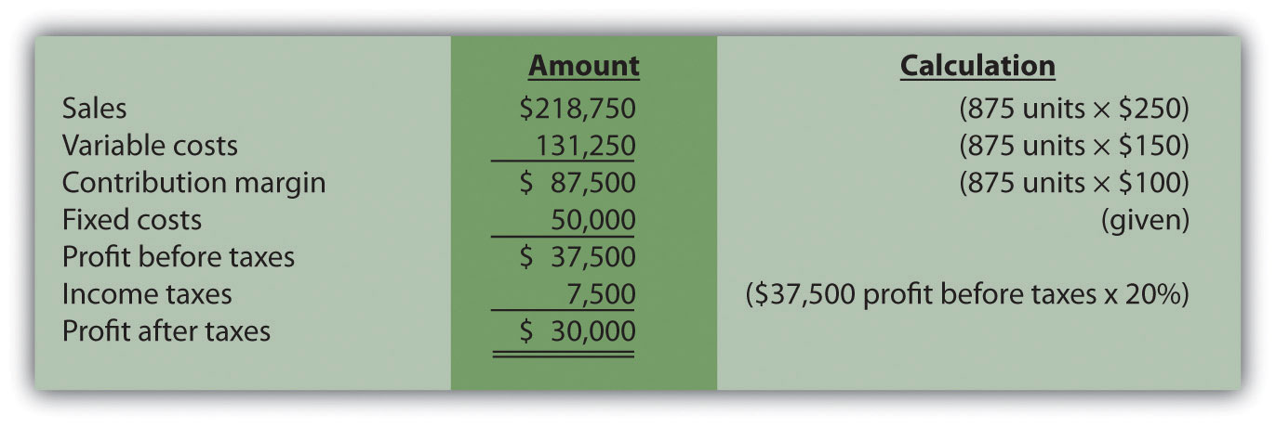

KEY TAKEAWAY
- Companies that incur income taxes must follow three steps to find the break-even point or target profit.

Step 1. Determine the desired target profit after taxes.

Step 2. Convert the desired target profit after taxes to target profit before taxes using the following formula:
Target profit before taxes = Target profit after taxes ÷ (1 − tax rate)

Step 3. Use the target profit before taxes from step 2 in the appropriate target profit formula to calculate the target profit in units or in sales dollars.

REVIEW PROBLEM 6.7
This review problem is based on the information for Snowboard Company. Assume Snowboard’s tax rate remains at 20 percent.
- Use the three steps described in this section to determine how manyunits Snowboard Company must sell to earn a monthly profit of $50,000 after taxes.
- Use the three steps to determine the sales dollars Snowboard needs to earn a monthly profit of $60,000 after taxes.
Solution to Review Problem 6.7
- The three steps to determine how many units must be sold to earn a target profit after taxes are as follows:

Step 1. Determine the desired target profit after taxes.
Management wants a profit of $50,000 after taxes and needs to know how many units must be sold to earn this profit.

Step 2. Convert the desired target profit after taxes to the target profit before taxes.
The formula used to solve for target profit before taxes is
Target profit before taxesTarget profit before taxesTarget profit before taxes=Target profit after taxes÷(1−tax rate)=$50,000÷(1−0.20)=$62,500

Step 3. Use the target profit before taxes in the appropriate formula to calculate the target profit in units.
The formula to solve for target profit in units is
Total fixed costs + Target profitSelling price per unit−Variable cost per unit
For Snowboard Company, it would read as follows:
Target profit in units=($50,000+$62,500)÷($250−$150)=$112,500÷$100=1,125 units
- The three steps to determine how many sales dollars are required to achieve a target profit after taxes are as follows:

Step 1. Determine the desired target profit after taxes.
Management wants a profit of $60,000 after taxes and needs to know the sales dollars required to earn this profit.

Step 2. Convert the desired target profit after taxes to target profitbefore taxes.
The formula used to solve for target profit before taxes is
Target profit before taxesTarget profit before taxesTarget profit before taxes=Target profit after taxes÷(1−tax rate)=$60,000÷(1−0.20)=$75,000

Step 3. Use the target profit before taxes in the appropriate formula to calculate the target profit in sales dollars.
The formula used to solve for target profit in sales dollars is
Total fixed costs + Target profitContribution margin ratio
Target profit in sales dollars=($50,000+$75,000)÷($100÷$250)=$125,000÷0.40=$312,500 in sales

6.7 Using Variable Costing to Make Decisions

LEARNING OBJECTIVE
- Understand how managers use variable costing to make decisions.

In , we discussed how to report manufacturing costs and nonmanufacturing costs following U.S. Generally Accepted Accounting Principles (U.S. GAAP). Under U.S. GAAP, all nonmanufacturing costs (selling and administrative costs) are treated as period costs because they are expensed on the income statement in the period in which they are incurred. All costs associated with production are treated as product costs, including direct materials, direct labor, and fixed and variable manufacturing overhead. These costs are attached to inventory as an asset on the balance sheet until the goods are sold, at which point the costs are transferred to cost of goods sold on the income statement as an expense. This method of accounting is calledabsorption costing because all manufacturing overhead costs (fixed and variable) are absorbed into inventory until the goods are sold. (The term full costing is also used to describe absorption costing.)

Question: Although absorption costing is used for external reporting, managers often prefer to use an alternative costing approach for internal reporting purposes called variable costing. What is variable costing, and how does it compare to absorption costing?

Answer: Variable costing requires that all variable production costs be included in inventory, and all fixed production costs (fixed manufacturing overhead) be reported as period costs. Thus all fixed production costs are expensed as incurred.

The only difference between absorption costing and variable costing is in the treatment of fixed manufacturing overhead. Using absorption costing, fixed manufacturing overhead is reported as a product cost. Using variable costing, fixed manufacturing overhead is reported as a period cost.summarizes the similarities and differences between absorption costing and variable costing.
Figure 6.8 Absorption Costing Versus Variable Costing
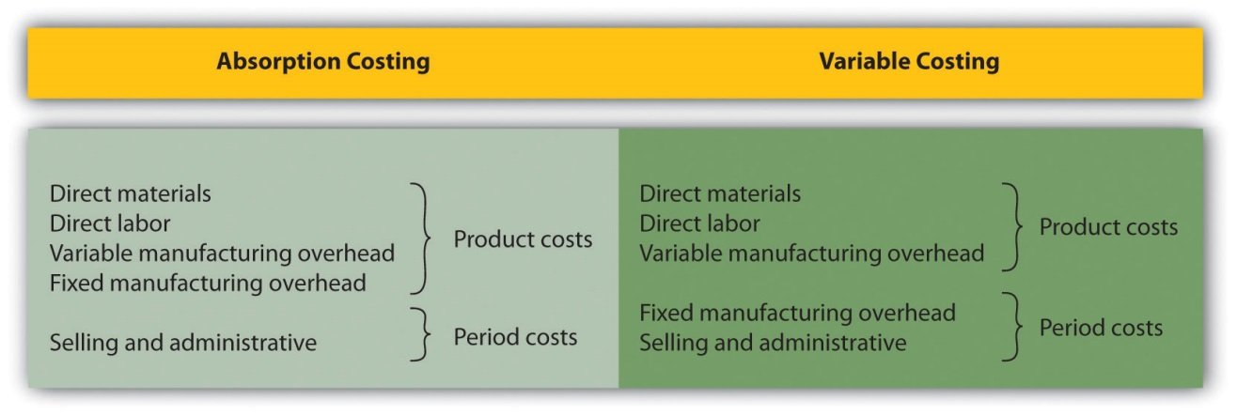

Impact of Absorption Costing and Variable Costing on Profit

Question: If a company uses just-in-time inventory, and therefore has no beginning or ending inventory, profit will be exactly the same regardless of the costing approach used. However, most companies have units of product in inventory at the end of the reporting period. How does the use of absorption costing affect the value of ending inventory?

Answer: Since absorption costing includes fixed manufacturing overhead as a product cost, all products that remain in ending inventory (i.e., are unsold at the end of the period) include a portion of fixed manufacturing overhead costs as an asset on the balance sheet. Since variable costing treats fixed manufacturing overhead costs as period costs, all fixed manufacturing overhead costs are expensed on the income statement when incurred. Thus if the quantity of units produced exceeds the quantity of units sold, absorption costing will result in higher profit.

We illustrate this concept with an example. The following information is for Bullard Company, a producer of clock radios:
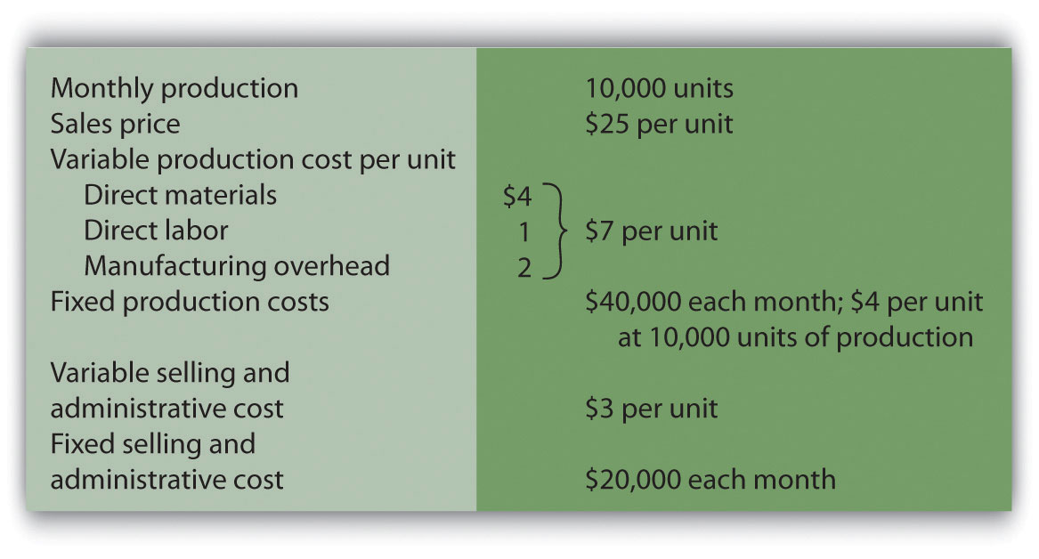

Assume Bullard has no finished goods inventory at the beginning of month 1. We will look at absorption costing versus variable costing for three different scenarios:
- Month 1 scenario: 10,000 units produced equals 10,000 units sold
- Month 2 scenario: 10,000 units produced is greater than 9,000 units sold
- Month 3 scenario: 10,000 units produced is less than 11,000 units sold

Month 1: Number of Units Produced Equals Number of Units Sold

Question: During month 1, Bullard Company sells all 10,000 units produced during the month. How does operating profit compare using absorption costing and variable costing when the number of units produced equals the number of units sold?

Answer: presents the results for each costing method. Notice that the absorption costing income statement is called a traditional income statement, and the variable costing income statement is called a contribution margin income statement.

As you review , notice that when the number of units produced equals the number sold, profit totaling $90,000 is identical for both costing methods. With absorption costing, fixed manufacturing overhead costs are fully expensed because all units produced are sold (there is no ending inventory). With variable costing, fixed manufacturing overhead costs are treated as period costs and therefore are always expensed in the period incurred. Because all other costs are treated the same regardless of the costing method used, profit is identical when the number of units produced and sold is the same.
Figure 6.9 Number of Units Produced Equals Number of Units Sold
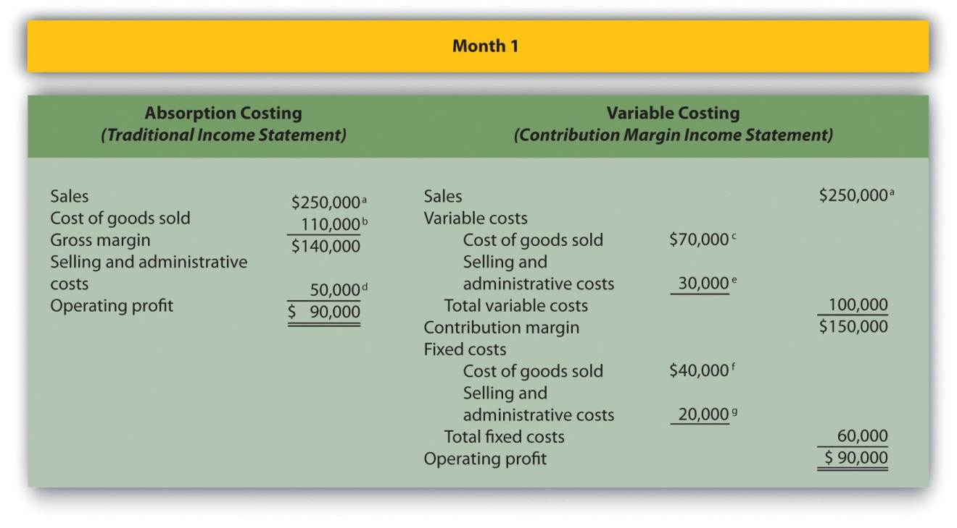
ª $250,000 = $25 × 10,000 units sold.
^{b} $110,000 = ($4 per unit fixed production cost × 10,000 units sold) + ($7 per unit variable production cost × 10,000 units sold).
^{c} $70,000 = $7 per unit variable production cost × 10,000 units sold.
^{d} $50,000 = $20,000 fixed selling and admin. cost + ($3 per unit variable selling and admin. cost × 10,000 units sold).
^{e} $30,000 = $3 per unit variable selling and admin. cost × 10,000 units sold.
^{f} Variable costing treats fixed manufacturing overhead as a period cost. Thus all fixed manufacturing overhead costs are expensed in the period incurred regardless of the level of sales.
^{g} Given.

Month 2: Number of Units Produced Is Greater Than Number of Units Sold

Question: During month 2, Bullard Company produces 10,000 units but sells only 9,000 units. How does operating profit compare using absorption costing and variable costing when the number of units produced is greater than the number of units sold?

Answer: presents the results for each costing method. Notice that absorption costing results in higher profit. When absorption costing is used, a portion of fixed manufacturing overhead costs remains in ending inventory as an asset on the balance sheet until the goods are sold. However, variable costing requires that all fixed manufacturing overhead costs be expensed as incurred regardless of the level of sales. Thus when more units are produced than are sold, variable costing results in higher costs and lower profit.

The difference in profit between the two methods of $4,000 (= $79,000 − $75,000) is attributed to the $4 per unit fixed manufacturing overhead cost assigned to the 1,000 units in ending inventory using absorption costing ($4,000 = $4 × 1,000 units).
Figure 6.10 Number of Units Produced Is Greater Than Number of Units Sold
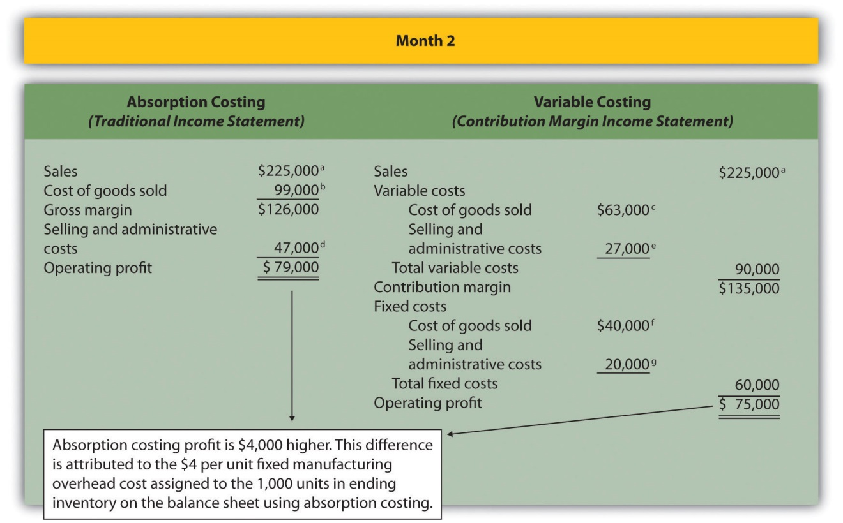
ª $225,000 = $25 × 9,000 units sold.
^{b} $99,000 = ($4 per unit fixed production cost × 9,000 units sold) + ($7 per unit variable production cost × 9,000 units sold).
^{c} $63,000 = $7 per unit variable production cost × 9,000 units sold.
^{d} $47,000 = $20,000 fixed selling and admin. cost + ($3 per unit variable selling and admin. cost × 9,000 units sold).
^{e} $27,000 = $3 per unit variable selling and admin. cost × 9,000 units sold.
^{f} Variable costing always treats fixed manufacturing overhead as a period cost. Thus all fixed manufacturing overhead costs are expensed in the period incurred regardless of the level of sales.
^{g} Given.

Month 3: Number of Units Produced Is Less Than Number of Units Sold

Question: During month 3, Bullard Company produces 10,000 units but sells 11,000 units (1,000 units were left over from month 2 and therefore were in inventory at the beginning of month 3). How does operating profit compare using absorption costing and variable costing when the number of units produced is less than the number of units sold?

Answer: presents the results for each costing method. Using variable costing, the $40,000 in fixed manufacturing overhead costs continues to be expensed when incurred. However, using absorption costing, the entire $40,000 is expensed because all 10,000 units produced were sold; an additional $4,000 related to the 1,000 units produced last month and pulled from inventory this month is also expensed. Thus when fewer units are produced than are sold, absorption costing results in higher costs and lower profit.

The difference in profit between the two methods of $4,000 (= $105,000 − $101,000) is attributed to the $4 per unit fixed manufacturing overhead cost assigned to the 1,000 units in inventory on the balance sheet at the end of month 2 and recorded as cost of goods sold during month 3 using absorption costing ($4,000 = $4 × 1,000 units).

Figure 6.11 Number of Units Produced Is Less Than Number of Units Sold
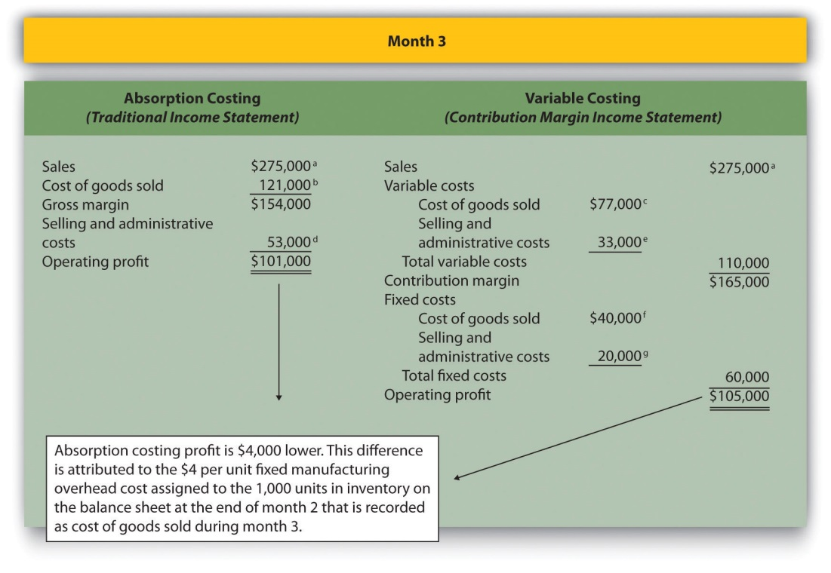
ª $275,000 = $25 × 11,000 units sold.
^{b} $121,000 = ($4 per unit fixed production cost × 11,000 units sold) + ($7 per unit variable production cost × 11,000 units sold).
^{c} $77,000 = $7 per unit variable production cost × 11,000 units sold.
^{d} $53,000 = $20,000 fixed selling and admin. cost + ($3 per unit variable selling and admin. cost × 11,000 units sold).
^{e} $33,000 = $3 per unit variable selling and admin. cost × 11,000 units sold.
^{f} Variable costing always treats fixed manufacturing overhead as a period cost. Thus all fixed manufacturing overhead costs are expensed in the period incurred regardless of the level of sales.
^{g} Given.

Advantages of Using Variable Costing

Question: Why do organizations use variable costing?

Answer: Variable costing provides managers with the information necessary to prepare a contribution margin income statement, which leads to more effective cost-volume-profit (CVP) analysis. By separating variable and fixed costs, managers are able to determine contribution margin ratios, break-even points, and target profit points, and to perform sensitivity analysis. Conversely, absorption costing meets the requirements of U.S. GAAP, but is not as useful for internal decision-making purposes.

Another advantage of using variable costing internally is that it prevents managers from increasing production solely for the purpose of inflating profit. For example, assume the manager at Bullard Company will receive a bonus for reaching a certain profit target but expects to be $15,000 short of the target. The company uses absorption costing, and the manager realizes increasing production (and therefore increasing inventory levels) will increase profit. The manager decides to produce 20,000 units in month 4, even though only 10,000 units will be sold. Half of the $40,000 in fixed production cost ($20,000) will be included in inventory at the end of the period, thereby lowering expenses on the income statement and increasing profit by $20,000. At some point, this will catch up to the manager because the company will have excess or obsolete inventory in future months. However, in the short run, the manager will increase profit by increasing production. This strategy does not work with variable costing because all fixed manufacturing overhead costs are expensed as incurred, regardless of the level of sales.

KEY TAKEAWAY
- As shown in , the only difference between absorption costing and variable costing is in the treatment of fixed manufacturing overhead costs. Absorption costing treats fixed manufacturing overhead as a product cost (included in inventory on the balance sheet until sold), while variable costing treats fixed manufacturing overhead as a period cost (expensed on the income statement as incurred).
When comparing absorption costing with variable costing, the following three rules apply: (1) When units produced equals units sold, profit is the same for both costing approaches. (2) When units produced is greater than units sold, absorption costing yields the highest profit. (3) When units produced is less than units sold, variable costing yields the highest profit.

REVIEW PROBLEM 6.8
Winter Sports, Inc., produces snowboards. The company has no finished goods inventory at the beginning of year 1. The following information pertains to Winter Sports, Inc.,:
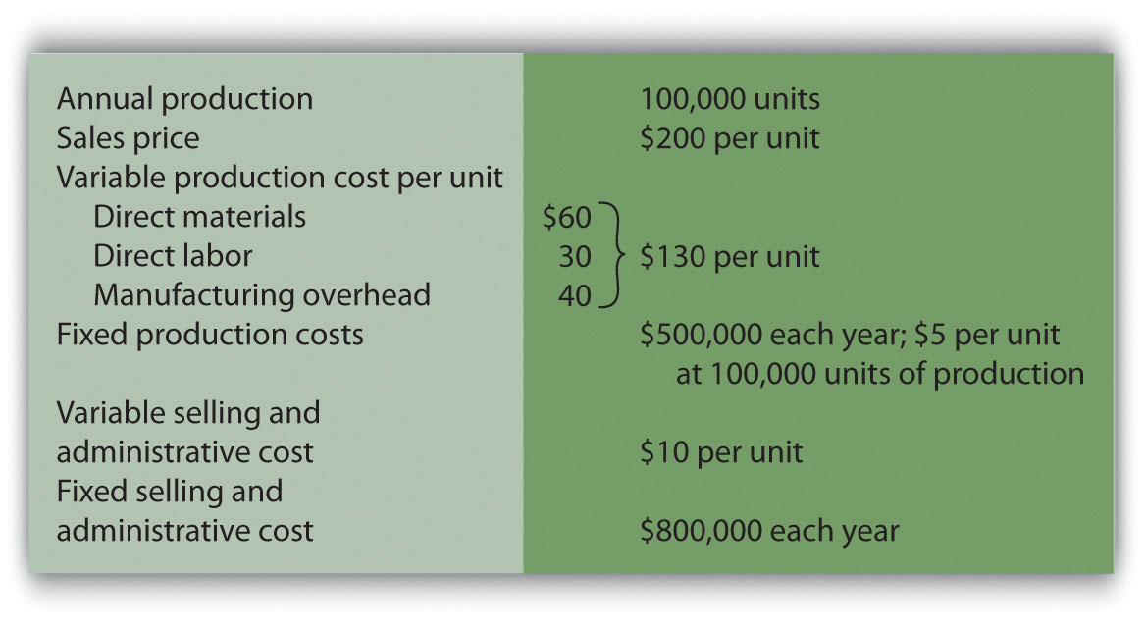
- All 100,000 units produced during year 1 are sold during year 1.
  - Prepare a traditional income statement assuming the company uses absorption costing.
  - Prepare a contribution margin income statement assuming the company uses variable costing.
- Although 100,000 units are produced during year 2, only 80,000 are sold during the year. The remaining 20,000 units are in finished goods inventory at the end of year 2.
  - Prepare a traditional income statement assuming the company uses absorption costing.
  - Prepare a contribution margin income statement assuming the company uses variable costing.
Solution to Review Problem 6.8

  - Traditional income statement (absorption costing), year 1:
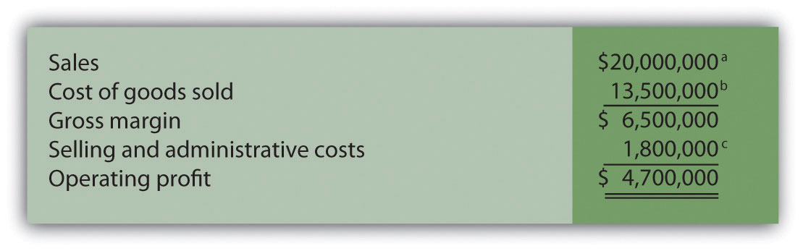
ª $20,000,000 = $200 × 100,000 units sold.
^{b} $13,500,000 = ($5 per unit fixed production cost × 100,000 units sold) + ($130 per unit variable production cost × 100,000 units sold).
^{c} $1,800,000 = $800,000 fixed selling and admin. cost + ($10 per unit variable selling and admin. cost × 100,000 units sold).
  - Contribution margin income statement (variable costing), year 1:
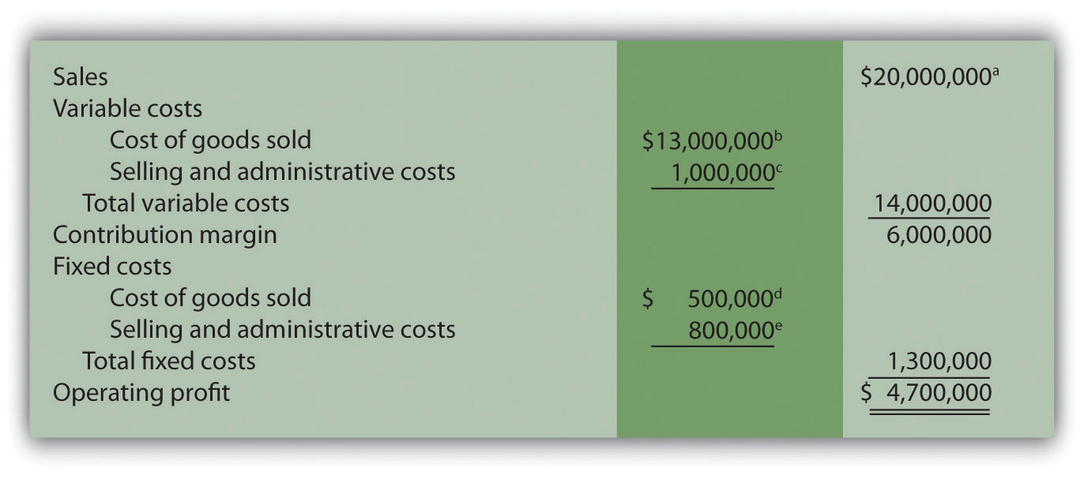
ª $20,000,000 = $200 × 100,000 units sold.
^{b} $13,000,000 = $130 per unit variable production cost × 100,000 units sold.
^{c} $1,000,000 = $10 per unit variable selling and admin. cost × 100,000 units sold.
^{d} Variable costing treats fixed manufacturing overhead as a period cost. Thus all fixed manufacturing overhead costs are expensed in the period incurred regardless of the level of sales.
^{e} Given.

  - Traditional income statement (absorption costing), year 2:
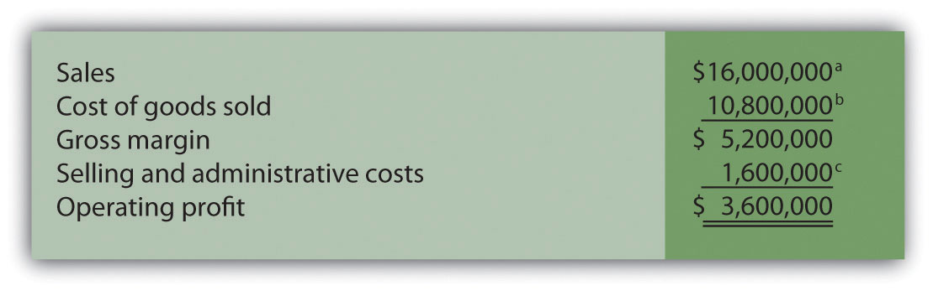
ª $16,000,000 = $200 × 80,000 units sold.
^{b} $10,800,000 = ($5 per unit fixed production cost × 80,000 units sold) + ($130 per unit variable production cost × 80,000 units sold).
  - Contribution margin income statement (variable costing), year 2:
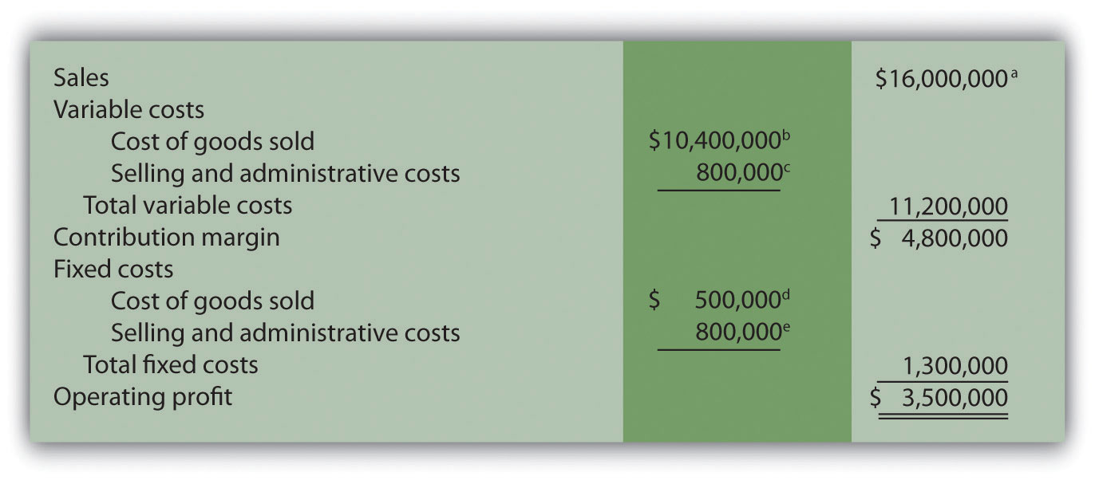
ª $16,000,000 = $200 × 80,000 units sold.
^{b} $10,400,000 = $130 per unit variable production cost × 80,000 units sold.
^{c} $800,000 = $10 per unit variable selling and admin. cost × 80,000 units sold.
^{d} Variable costing treats fixed manufacturing overhead as a period cost. Thus all fixed manufacturing overhead costs are expensed in the period incurred regardless of the level of sales.
^{e} Given.

END-OF-CHAPTER EXERCISES
Questions
- Describe the components of the profit equation.
- What is the difference between a variable cost and a fixed cost? Provide examples of each.
- You are asked to find the break-even point in units and in sales dollars. What does this mean?
- You are asked to find the target profit in units and in sales dollars. What does this mean?
- For a company with one product, describe the equation used to calculate the break-even point or target profit in (a) units, and (b) sales dollars.
- Distinguish between contribution margin per unit and contribution margin ratio.
- What does the term margin of safety mean? How might management use this information?
- Review How do airlines measure break-even points? In 2001, which airline had the lowest break-even point?
- How does the break-even point equation change for a company with multiple products or services compared to a single-product company?
- Describe the assumptions made to simplify the cost-volume-profit analysis described in the chapter.
- What is sensitivity analysis and how might it help those performing cost-volume-profit analysis?
- Review What were the owners concerned about with regards to projected profits? What were the results of the calculations made to address the owners’ concerns?
- If you are asked to review the cost structure of an organization, what are you being asked to do?
- When might the contribution margin per unit of constraint be more effective than the contribution margin per unit for making decisions?
- Describe the three steps used to calculate the target profit for companies that incur income tax costs.
- Describe the difference between absorption costing and variable costing.
- Why do some organizations use variable costing?
Brief Exercises
- Planning at Snowboard Company. Refer to the dialogue at Snowboard Company presented at the beginning of the chapter. What information is Recilia, vice president of sales, requesting from Lisa, the company accountant? How does Recilia plan on using this information?
- Contribution Margin Calculations. Ace Company sells lawn mowers for $200 per unit. Variable cost per unit is $40, and fixed costs total $4,000. Find (a) the contribution margin per unit, and (b) the contribution margin ratio.
- Weighted Average Contribution Margin Calculation. Radio Control, Inc., sells radio controlled cars for $300 per unit representing 80 percent of total sales, and radio controlled boats for $400 per unit representing 20 percent of total sales. Variable cost per unit is $150 for cars and $300 for boats. Find (a) the contribution margin per unit for each product, and (b) the weighted average contribution margin per unit.
- Sensitivity Analysis, Sales Price. Refer to the base case for Snowboard Company presented in the first column of . Assume the unit sales price decreases by 10 percent. Calculate (a) the new projected profit, (b) the dollar change in profit from the base case, and (c) the percent change in profit from the base case.
- Sensitivity Analysis, Unit Sales. Refer to the base case for Snowboard Company presented in the first column of . Assume the number of units sold increases by 10 percent. Calculate (a) the new projected profit, (b) the dollar change in profit from the base case, and (c) the percent change in profit from the base case.
- Operating Leverage. High operating leverage means:
  - The company has relatively low fixed costs.
  - The company has relatively high fixed costs.
  - The company will have to sell more units than a comparable company with low operating leverage to break even.
  - The company will have to sell fewer units than a comparable company with low operating leverage to break even.
  - Both (2) and (3) are correct.
  - Both (1) and (4) are correct.
- Contribution Margin per Unit of Constraint. Paint Toys Company sells paint ball guns for $100 per unit. Variable cost is $60 per unit. Each paint ball gun requires 1.25 machine hours and 2.00 direct labor hours to produce. Calculate the contribution margin (a) per unit, (b) per machine hour, and (c) per direct labor hour.
- Target Profit with Taxes. Management of Lakewood Company would like to achieve a target profit after taxes of $300,000. The company’s income tax rate is 40 percent. What target profit before taxes is required to achieve the $300,000 after-tax profit desired by management?
- Absorption Costing Versus Variable Costing. Describe the difference between absorption costing and variable costing. Which approach yields the highest profit when the units produced are greater than the units sold? Explain.
Exercises: Set A
- Break-Even Point and Target Profit Measured in Units (Single Product). Nellie Company has monthly fixed costs totaling $100,000 and variable costs of $20 per unit. Each unit of product is sold for $25.
Required:
  - Calculate the contribution margin per unit.
  - Find the break-even point in units.
  - How many units must be sold to earn a monthly profit of $40,000?
- Break-Even Point and Target Profit Measured in Sales Dollars (Single Product). Nellie Company has monthly fixed costs totaling $100,000 and variable costs of $20 per unit. Each unit of product is sold for $25 (these data are the same as the previous exercise):
Required:
  - Calculate the contribution margin ratio.
  - Find the break-even point in sales dollars.
  - What amount of sales dollars is required to earn a monthly profit of $60,000?
- Margin of Safety (Single Product). Nellie Company has monthly fixed costs totaling $100,000 and variable costs of $20 per unit. Each unit of product is sold for $25 (these data are the same as the previous exercise). Assume Nellie Company expects to sell 24,000 units of product this coming month.
Required:
  - Find the margin of safety in units.
  - Find the margin of safety in sales dollars.
- Break-Even Point and Target Profit Measured in Units (Multiple Products). Hi-Tech Incorporated produces two different products with the following monthly data.
 | Cell | GPS | Total
Selling price per unit | $100 | $400
Variable cost per unit | $ 40 | $240
Expected unit sales | 21,000 | 9,000 | 30,000
Sales mix | 70 percent | 30 percent | 100 percent
Fixed costs |  |  | $1,800,000
- Assume the sales mix remains the same at all levels of sales.
- Required:
  - Calculate the weighted average contribution margin per unit.
  - How many units in total must be sold to break even?
  - How many units of each product must be sold to break even?
  - How many units in total must be sold to earn a monthly profit of $180,000?
  - How many units of each product must be sold to earn a monthly profit of $180,000?
- Break-Even Point and Target Profit Measured in Sales Dollars (Multiple Products). Hi-Tech Incorporated produces two different products with the following monthly data (these data are the same as the previous exercise).
 | Cell | GPS | Total
Selling price per unit | $100 | $400
Variable cost per unit | $ 40 | $240
Expected unit sales | 21,000 | 9,000 | 30,000
Sales mix | 70 percent | 30 percent | 100 percent
Fixed costs |  |  | $1,800,000
- Assume the sales mix remains the same at all levels of sales.
- Required:
- Round your answers to the nearest hundredth of a percent and nearest dollar where appropriate. (An example for percentage calculations is 0.434532 = 0.4345 = 43.45 percent; an example for dollar calculations is $378.9787 = $379.)
  - Using the information provided, prepare a contribution margin income statement for the month similar to the one in .
  - Calculate the weighted average contribution margin ratio.
  - Find the break-even point in sales dollars.
  - What amount of sales dollars is required to earn a monthly profit of $540,000?
  - Assume the contribution margin income statement prepared in requirement a is the company’s base case. What is the margin of safety in sales dollars?
- Changes in Sales Mix. Hi-Tech Incorporated produces two different products with the following monthly data (these data are the same as the previous exercise).
 | Cell | GPS | Total
Selling price per unit | $100 | $400
Variable cost per unit | $ 40 | $240
Expected unit sales | 21,000 | 9,000 | 30,000
Sales mix | 70 percent | 30 percent | 100 percent
Fixed costs |  |  | $1,800,000
- Required:
  - If the sales mix shifts to 50 percent Cell and 50 percent GPS, would the break-even point in units increase or decrease? Explain. (Detailed calculations are not necessary but may be helpful in confirming your answer.)
  - Go back to the original projected sales mix. If the sales mix shifts to 80 percent Cell and 20 percent GPS, would the break-even point in units increase or decrease? Explain. (Detailed calculations are not necessary but may be helpful in confirming your answer.)
- CVP Sensitivity Analysis (Single Product). Bridgeport Company has monthly fixed costs totaling $200,000 and variable costs of $40 per unit. Each unit of product is sold for $50. Bridgeport expects to sell 30,000 units each month (this is the base case).
Required:
For each of the independent situations in requirements bthrough d, assume that the number of units sold remains at 30,000.
  - Prepare a contribution margin income statement for the base case.
  - Refer to the base case. What would the operating profit be if the unit sales price increases 10 percent?
  - Refer to the base case. What would the operating profit be if the unit variable cost decreases 20 percent?
  - Refer to the base case. What would the operating profit be if total fixed costs decrease 20 percent?
- CVP Sensitivity Analysis (Multiple Products). Gonzalez Company produces two different products that have the following monthly data (this is the base case).
 | Cruiser | Racer | Total
Selling price per unit | $300 | $1,200
Variable cost per unit | $120 | $ 720
Expected unit sales | 1,400 | 600 | 2,000
Sales mix | 70 percent | 30 percent | 100 percent
Fixed costs |  |  | $180,000
- Required:
- For each of the independent situations in requirements bthrough d, assume that total sales remains at 2,000 units.
  - Prepare a contribution margin income statement.
  - Refer to the base case. What would the operating profit be if the Cruiser sales price (1) increases 20 percent, or (2) decreases 20 percent?
  - Refer to the base case. What would the operating profit be if the Cruiser sales volume increases 400 units with a corresponding decrease of 400 units in Racer sales?
  - Refer to the base case. What would the operating profit be if total fixed costs increase five percent? Does this increase in fixed costs result in higher operating leverage or lower operating leverage? Explain.
- Contribution Margin with Resource Constraints. CyclePath Company produces two different products that have the following price and cost characteristics.
 | Bicycle | Tricycle
Selling price per unit | $200 | $100
Variable cost per unit | $120 | $ 50
- Management believes that pushing sales of the Bicycle product would maximize company profits because of the high contribution margin per unit for this product. However, only 50,000 labor hours are available each year, and the Bicycle product requires 4 labor hours per unit while the Tricycle model requires 2 labor hours per unit. The company sells everything it produces.
- Required:
  - Calculate the contribution margin per unit of constrained resource for each model.
  - Which model would CyclePath prefer to sell to maximize overall company profit? Explain.
- Target Profit Measured in Units (with Taxes). Optical Incorporated has annual fixed costs totaling $6,000,000 and variable costs of $350 per unit. Each unit of product is sold for $500. Assume a tax rate of 20 percent.
Required:
Use the three steps described in the chapter to determine how many units must be sold to earn an annual profit of $100,000 after taxes. (Round to the nearest unit.)
- Target Profit Measured in Sales Dollars (with Taxes). Optical Incorporated has annual fixed costs totaling $6,000,000 and variable costs of $350 per unit. Each unit of product is sold for $500. Assume a tax rate of 20 percent (these data are the same as the previous exercise).
Required:
Use the three steps described in the chapter to determine the sales dollars required to earn an annual profit of $150,000 after taxes.
- Absorption Costing Versus Variable Costing. Technic Company produces portable CD players. The company has no finished goods inventory at the beginning of year 1. The following information pertains to Technic Company.
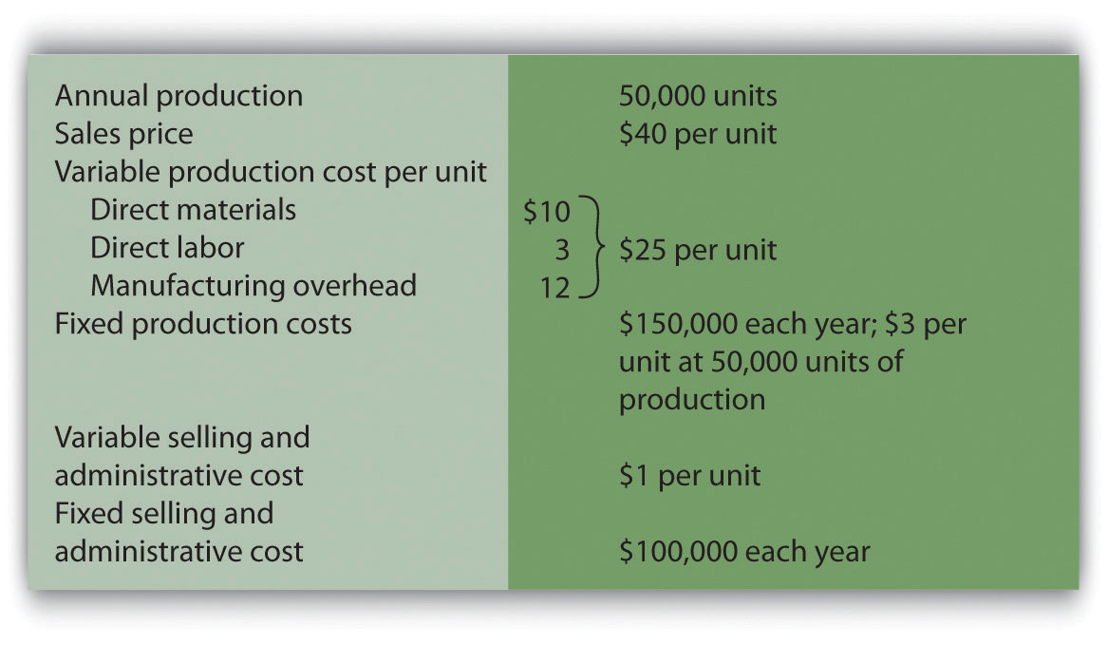
Required:
  - All 50,000 units produced during year 1 are sold during year 1.
    - Prepare a traditional income statement assuming the company uses absorption costing.
    - Prepare a contribution margin income statement assuming the company uses variable costing.
  - Although 50,000 units are produced during year 2, only 40,000 are sold during the year. The remaining 10,000 units are in finished goods inventory at the end of year 2.
    - Prepare a traditional income statement assuming the company uses absorption costing.
    - Prepare a contribution margin income statement assuming the company uses variable costing.
Exercises: Set B
- Break-Even Point and Target Profit Measured in Units (Single Product). Phan Incorporated has annual fixed costs totaling $6,000,000 and variable costs of $350 per unit. Each unit of product is sold for $500.
Required:
  - Calculate the contribution margin per unit.
  - Find the break-even point in units.
  - How many units must be sold to earn an annual profit of $750,000?
- Break-Even Point and Target Profit Measured in Sales Dollars (Single Product). Phan Incorporated has annual fixed costs totaling $6,000,000 and variable costs of $350 per unit. Each unit of product is sold for $500 (these data are the same as the previous exercise).
Required:
  - Calculate the contribution margin ratio.
  - Find the break-even point in sales dollars.
  - What amount of sales dollars is required to earn an annual profit of $300,000?
- Margin of Safety (Single Product). Phan Incorporated has annual fixed costs totaling $6,000,000 and variable costs of $350 per unit. Each unit of product is sold for $500 (these data are the same as the previous exercise). Assume Phan Incorporated expects to sell 51,000 units of product this coming year.
Required:
  - Find the margin of safety in units.
  - Find the margin of safety in sales dollars.
- Break-Even Point and Target Profit Measured in Units (Multiple Products). Advanced Products Company produces three different CDs with the following annual data.
 | Music | Data | DVD | Total
Selling price per unit | $10 | $4 | $12
Variable cost per unit | $ 3 | $1 | $ 3
Expected unit sales | 8,000 | 10,000 | 22,000 | 40,000
Sales mix | 20 percent | 25 percent | 55 percent | 100 percent
Fixed costs |  |  |  | $205,900
- Assume the sales mix remains the same at all levels of sales.
- Required:
- (Round all answers to the nearest cent and nearest unit where appropriate.)
  - Calculate the weighted average contribution margin per unit.
  - How many units in total must be sold to break even?
  - How many units of each product must be sold to break even?
  - How many units in total must be sold to earn an annual profit of $200,000?
  - How many units of each product must be sold to earn an annual profit of $200,000?
- Break-Even Point and Target Profit Measured in Sales Dollars (Multiple Products). Advanced Products Company produces three different CDs with the following annual data (these data are the same as the previous exercise).
 | Music | Data | DVD | Total
Selling price per unit | $10 | $4 | $12
Variable cost per unit | $ 3 | $1 | $ 3
Expected unit sales | 8,000 | 10,000 | 22,000 | 40,000
Sales mix | 20 percent | 25 percent | 55 percent | 100 percent
Fixed costs |  |  |  | $205,900
- Assume the sales mix remains the same at all levels of sales.
- Required:
- Round your answers to the nearest hundredth of a percent and nearest dollar where appropriate. (An example for percentage calculations is 0.434532 = 0.4345 = 43.45 percent; an example for dollar calculations is $378.9787 = $379.)
  - Using the information provided, prepare a contribution margin income statement similar to the one in .
  - Calculate the weighted average contribution margin ratio.
  - Find the break-even point in sales dollars.
  - What amount of sales dollars is required to earn an annual profit of $200,000?
  - Assume the contribution margin income statement prepared in requirement a is the company’s base case. What is the margin of safety in sales dollars?
- Changes in Sales Mix. Advanced Products Company produces three different CDs with the following annual data (these data are the same as the previous exercise).
 | Music | Data | DVD | Total
Selling price per unit | $10 | $4 | $12
Variable cost per unit | $ 3 | $1 | $ 3
Expected unit sales | 8,000 | 10,000 | 22,000 | 40,000
Sales mix | 20 percent | 25 percent | 55 percent | 100 percent
Fixed costs |  |  |  | $205,900
- Required:
- If the sales mix shifts more toward the Data product than the other two products, would the break-even point in units increase or decrease? Explain. (Detail calculations are not necessary, but may be helpful in confirming your answer.)
- CVP Sensitivity Analysis (Single Product). Skyler Incorporated has monthly fixed costs of $1,000,000 and variable costs of $24 per unit. Each unit of product is sold for $120. Skyler expects to sell 15,000 units each month (this is the base case).
Required:
For each of the independent situations in requirements bthrough d, assume that the number of units sold remains at 15,000. (Round to the nearest cent where appropriate.)
  - Prepare a contribution margin income statement for the base case.
  - Refer to the base case. What would the operating profit be if the unit sales price decreases 10 percent?
  - Refer to the base case. What would the operating profit be if the unit variable cost increases 10 percent?
  - Refer to the base case. What would the operating profit be if total fixed costs decrease 20 percent?
- CVP Sensitivity Analysis (Multiple Products). CyclePath Company produces two different products that have the following annual data (this is the base case).
 | Bicycle | Tricycle | Total
Selling price per unit | $200 | $100
Variable cost per unit | $120 | $ 50
Expected unit sales | 5,000 | 20,000 | 25,000
Sales mix | 20 percent | 80 percent | 100 percent
Fixed costs |  |  | $1,000,000
- Required:
- For each of the independent situations in requirements bthrough d, assume that total sales remains at 25,000 units.
  - Prepare a contribution margin income statement for the base case.
  - Refer to the base case. What would the operating profit be if the Tricycle sales price (1) increases 10 percent, or (2) decreases 10 percent?
  - Refer to the base case. What would the operating profit be if Bicycle sales volume decreases 500 units and there is a corresponding increase of 500 units in Tricycle sales?
  - Refer to the base case. What would the operating profit be if total fixed costs decrease 10 percent? Does this decrease in fixed costs result in higher operating leverage or lower operating leverage? Explain.
- Contribution Margin with Resource Constraints. CyclePath Company produces two different products that have the following price and cost characteristics.
 | Bicycle | Tricycle
Selling price per unit | $200 | $100
Variable cost per unit | $120 | $ 50
- Management believes that pushing sales of the Bicycle product would maximize company profits because of the high contribution margin per unit for this product. However, only 23,000 machine hours are available each year, and the Bicycle product requires 2 machine hours per unit while the Tricycle model requires 1 machine hour per unit. The company sells everything it produces.
- Required:
  - Calculate the contribution margin per unit of constrained resource for each model.
  - Which model would CyclePath prefer to sell to maximize overall company profit? Explain.
- Target Profit Measured in Units (with Taxes). Martis Company has annual fixed costs totaling $4,000,000 and variable costs of $300 per unit. Each unit of product is sold for $400. Assume a tax rate of 20 percent.
Required:
Use the three steps described in the chapter to determine how many units must be sold to earn an annual profit of $500,000 after taxes. (Round to the nearest unit.)
- Target Profit Measured in Sales Dollars (with Taxes). Martis Company has annual fixed costs totaling $4,000,000 and variable costs of $300 per unit. Each unit of product is sold for $400. Assume a tax rate of 20 percent (these data are the same as the previous exercise).
Required:
Use the three steps described in the chapter to determine the sales dollars required to earn an annual profit of $1,000,000 after taxes.
- Absorption Costing Versus Variable Costing. Photo Company produces digital cameras. The company has no finished goods inventory at the beginning of year 1. The following information pertains to Photo Company.
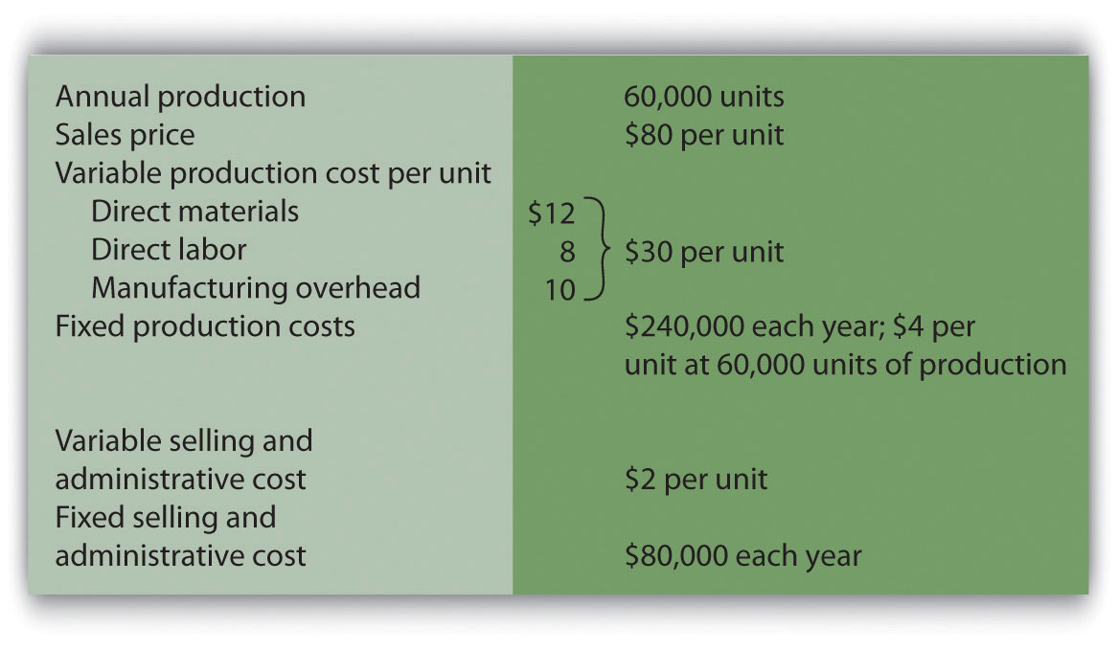
Required:
  - All 60,000 units produced during year 1 are sold during year 1.
    - Prepare a traditional income statement assuming the company uses absorption costing.
    - Prepare a contribution margin income statement assuming the company uses variable costing.
  - Although 60,000 units are produced during year 2, only 40,000 are sold during the year. The remaining 20,000 units are in finished goods inventory at the end of year 2.
    - Prepare a traditional income statement assuming the company uses absorption costing.
    - Prepare a contribution margin income statement assuming the company uses variable costing.
Problems
- CVP and Sensitivity Analysis (Single Product). Madera Company has annual fixed costs totaling $120,000 and variable costs of $3 per unit. Each unit of product is sold for $15. Madera expects to sell 12,000 units this year (this is the base case).
Required:
  - Find the break-even point in units.
  - How many units must be sold to earn an annual profit of $50,000? (Round to the nearest unit.)
  - Find the break-even point in sales dollars.
  - What amount of sales dollars is required to earn an annual profit of $70,000?
  - Find the margin of safety in units and in sales dollars.
  - Prepare a contribution margin income statement for the base case.
  - What will the operating profit (loss) be if the sales price decreases 30 percent? (Assume total sales remains at 12,000 units, and round to the nearest cent where appropriate.)
  - Go back to the base case. What will the operating profit (loss) be if the variable cost per unit increases 10 percent? (Assume total sales remains at 12,000 units, and round to the nearest cent where appropriate.)
- CVP Analysis and Cost Structure (Single Product). Riviera Incorporated produces flat panel televisions. The company has annual fixed costs totaling $10,000,000 and variable costs of $600 per unit. Each unit of product is sold for $1,000. Riviera expects to sell 70,000 units this year.
Required:
  - Find the break-even point in units.
  - How many units must be sold to earn an annual profit of $2,000,000?
  - Find the break-even point in sales dollars.
  - What amount of sales dollars is required to earn an annual profit of $500,000?
  - Find the margin of safety in units.
  - Find the margin of safety in sales dollars.
  - How much will operating profit change if fixed costs are 15 percent higher than anticipated? Would this increase in fixed costs result in higher or lower operating leverage? Explain.
- CVP Analysis with Taxes (Single Product). Riviera Incorporated produces flat panel televisions. The company has annual fixed costs totaling $10,000,000 and variable costs of $600 per unit. Each unit of product is sold for $1,000. Riviera expects to sell 70,000 units this year (this is the same data as the previous problem). Assume a tax rate of 30 percent.
Required:
Round all calculations to the nearest dollar and nearest unit where appropriate.
  - How many units must be sold to earn an annual profit of $2,000,000 after taxes?
  - What amount of sales dollars is required to earn an annual profit of $500,000 after taxes?
  - Refer to requirement a. What would happen to the number of units required to earn $2,000,000 in operating profit if the company were a non-profit organization that did not incur income taxes? Explain. (Detailed calculations are not necessary but may be helpful in confirming your answer.)
- CVP Analysis and Sales Mix (Multiple Products). Sierra Books Incorporated produces two different products with the following monthly data (this is the base case).
 | Text | Lecture Notes | Total
Selling price per unit | $100 | $12
Variable cost per unit | $ 60 | $ 3
Expected unit sales | 21,000 | 14,000 | 35,000
Sales mix | 60 percent | 40 percent | 100 percent
Fixed costs |  |  | $750,000
- Assume the sales mix remains the same at all levels of sales except for requirement i.
- Required:
- Round to the nearest unit of product, hundredth of a percent, and nearest cent where appropriate. (An example for unit calculations is 3,231.15 = 3,231; an example for percentage calculations is 0.434532 = 0.4345 = 43.45 percent; an example for dollar calculations is $378.9787 = $378.98.)
  - Calculate the weighted average contribution margin per unit.

    - How many units in total must be sold to break even?
    - How many units of each product must be sold to break even?

    - How many units in total must be sold to earn a monthly profit of $100,000?
    - How many units of each product must be sold to earn a monthly profit of $100,000?
  - Using the base case information, prepare a contribution margin income statement for the month similar to the one in .
  - Calculate the weighted average contribution margin ratio.
  - Find the break-even point in sales dollars.
  - What amount of sales dollars is required to earn a monthly profit of $80,000?
  - Assume the contribution margin income statement prepared in requirement d is the company’s base case. What is the margin of safety in sales dollars?
  - If the sales mix shifts more toward the Text product than the Lecture Notes product, would the break-even point in units increase or decrease? Explain. (Detail calculations are not necessary, but may be helpful in confirming your answer.)
- CVP Analysis and Cost Structure (Service Company). Conway Electrical Services provides services to two types of clients: residential and commercial. The company’s contribution margin income statement for the year is shown (this is the base case). Fixed costs are known in total, but Conway does not allocate fixed costs to each department.
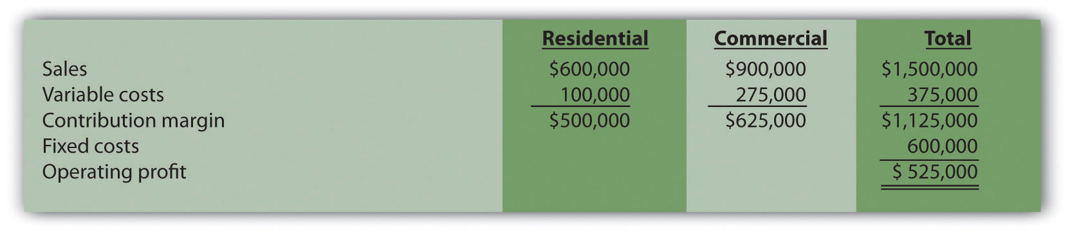
Required:
  - Find the break-even point in sales dollars.
  - What is the margin of safety in sales dollars?
  - What amount of sales dollars is required to earn an annual profit of $750,000?
  - Refer to the base case shown previously. What would the operating profit be if the Commercial variable costs are 20 percent higher than originally anticipated? How does this increase in Commercial variable costs impact the operating leverage of the company?
- CVP and Sensitivity Analysis, Resource Constraint (Multiple Products). Hobby Shop Incorporated produces three different models with the following annual data (this is the base case).
 | Plane | Car | Boat | Total
Selling price per unit | $20 | $14 | $24
Variable cost per unit | $ 5 | $ 7 | $ 8
Expected unit sales | 30,000 | 50,000 | 20,000 | 100,000
Sales mix | 30 percent | 50 percent | 20 percent | 100 percent
Fixed costs |  |  |  | $650,000
- Assume the sales mix remains the same at all levels of sales except for requirements i and j.
- Required:
- Round to the nearest unit of product, hundredth of a percent, and nearest cent where appropriate. (An example for unit calculations is 3,231.151 = 3,231; an example for percentage calculations is 0.434532 = 0.4345 = 43.45 percent; an example for dollar calculations is $378.9787 = $378.98.)
  - Calculate the weighted average contribution margin per unit.

    - How many units in total must be sold to break even?
    - How many units of each product must be sold to break even?

    - How many units in total must be sold to earn an annual profit of $500,000?
    - How many units of each product must be sold to earn an annual profit of $500,000?
  - Using the base case information, prepare a contribution margin income statement for the year similar to the one in .
  - Calculate the weighted average contribution margin ratio.
  - Find the break-even point in sales dollars.
  - What amount of sales dollars is required to earn an annual profit of $400,000?
  - Go back to the base case contribution margin income statement prepared in requirement d. What would the operating profit be if the Plane sales price (1) increases 10 percent, or (2) decreases 10 percent? (Assume total sales remains at 100,000 units.)
  - Go back to the base case contribution margin income statement prepared in requirement d. If the sales mix shifts more toward the Car product than to the other two products, would the break-even point in units increase or decrease? (Detailed calculations are not necessary.) Explain.
  - Assume the company has a limited number of labor hours available in production, and management would like to make efficient use of these labor hours. The Plane product requires 4 labor hours per unit, the Car product requires 3 labor hours per unit, and the Boat product requires 5 hours per unit. The company sells everything it produces. Based on this information, calculate the contribution margin per labor hour for each model (round to the nearest cent), and determine the top two models the company would prefer to sell to maximize overall company profit.
- Absorption Costing Versus Variable Costing. Wall Tech Company produces wood siding. The company has no finished goods inventory at the beginning of year 1. The following information pertains to Wall Tech Company.
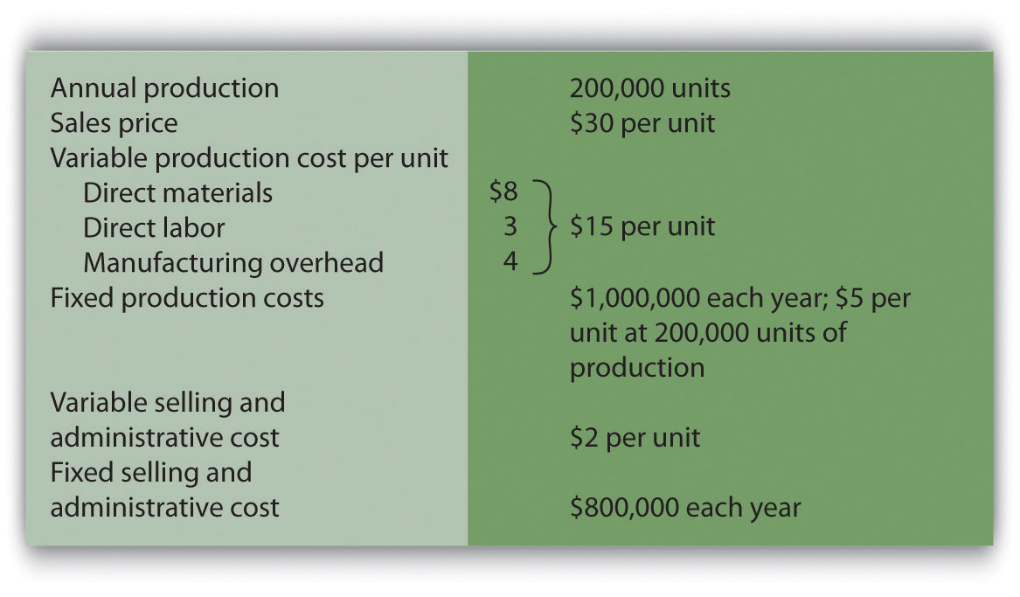
Required:
  - All 200,000 units produced during year 1 are sold during year 1.
    - Prepare a traditional income statement assuming the company uses absorption costing.
    - Prepare a contribution margin income statement assuming the company uses variable costing.
  - Although 200,000 units are produced during year 2, only 170,000 units are sold during the year. The remaining 30,000 units are in finished goods inventory at the end of year 2.
    - Prepare a traditional income statement assuming the company uses absorption costing.
    - Prepare a contribution margin income statement assuming the company uses variable costing.
  - Although 200,000 units are produced during year 3, a total of 230,000 units are sold during the year. The 30,000 units remaining in inventory at the end of year 2 are sold during year 3.
    - Prepare a traditional income statement assuming the company uses absorption costing.
    - Prepare a contribution margin income statement assuming the company uses variable costing.
  - Analyze the results in years 1 through 3 (requirements athrough c).
One Step Further: Skill-Building Cases
- Internet Project: CVP Analysis. Using the Internet, go to the Web site for Nordstrom, Inc. (http://www.nordstrom.com), and selectinvestor relations. Find the most recent annual report and print the income statement (called the consolidated statements of earnings).
Required:
  - Calculate the gross profit percentage (also called thegross margin percentage) by dividing the gross profit by net sales.
  - Explain how the gross profit percentage is different than the contribution margin ratio (no calculations are necessary)?
- Decision Making: Automated Versus Labor Intensive Production.Wood Furniture, Inc., builds high-quality wood desks. Management of the company is considering going from a labor-intensive process of building desks to an automated process that requires expensive machinery and equipment. If the company moves to an automated process, variable production costs will decrease (direct materials, direct labor, and variable manufacturing overhead) due to improved efficiency, and fixed production costs will increase as a result of additional depreciation costs. The costs predicted for the coming year are shown. The selling price is expected to be $900 per unit for both processes.
 | Labor-Intensive Process | Automated Process
Variable cost of goods sold | $490 per unit | $290 per unit
Fixed cost of goods sold (annual) | $1,000,000 | $2,600,000
Variable selling and administrative | $10 per unit | $10 per unit
Fixed selling and admin. (annual) | $400,000 | $400,000
- Required:
  - Calculate the break-even point in units assuming that (1) the labor-intensive process is used, and (2) the automated process is used.
  - Explain why there is such a significant difference in break-even points between the labor-intensive process and the automated process.
  - Assume Wood Furniture, Inc., expects to produce and sell 8,000 units this coming year and is certain sales will grow by at least 10 percent per year in future years. Calculate the expected operating profit assuming that (1) the labor intensive process is used, and (2) the automated process is used.
  - Using requirement c as a guide, explain whether management should stay with the labor-intensive process or switch to an automated process.
- Group Activity: Sensitivity Analysis and Decision Making.Performance Sports produces inflatable rafts used for river rafting. Sales have grown slowly over the years, and cost increases are causing Performance Sports to incur losses. Financial data for the most recent year are shown.
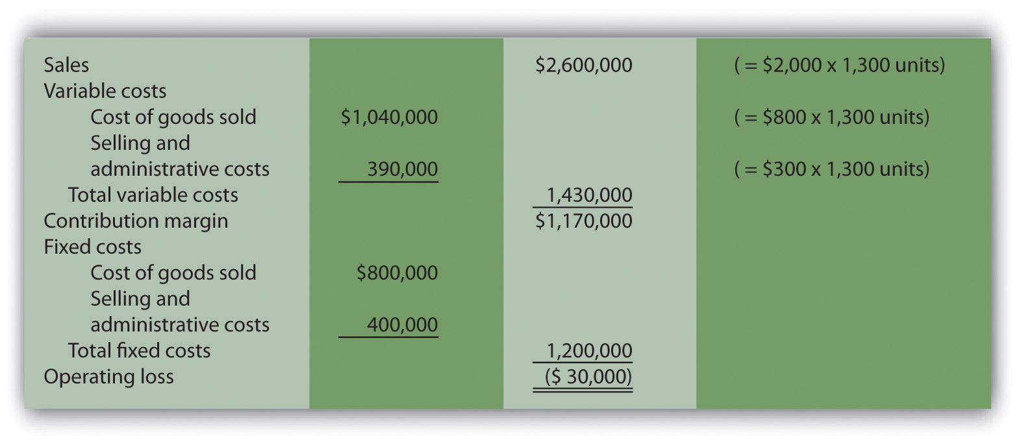
Members of the management group at Performance Sports arrived at these three possible courses of action to return the company to profitability (each scenario is independent of the others):
  - Increase the sales price for each raft by 10 percent, which will cause a 5 percent drop in sales volume. Although sales volume will drop 5 percent, the group believes the increased sales price will more than offset the drop in rafts sold.
  - Decrease the sales price for each raft by 10 percent, which will cause an 8 percent increase in sales volume. Although the sales price will drop by 10 percent, the group believes an increase in rafts sold will more than offset the sales price reduction.
  - Increase advertising costs by $200,000, which will increase sales volume by 15 percent. Although fixed selling and administrative costs will increase by $200,000, the group believes the increase in rafts sold will more than offset the increase in advertising costs.
Required:
Form groups of two to four students and assign one of the three options listed previously to each group. Each group must perform the following requirements:
  - Calculate the projected operating profit (loss) for the option assigned, and determine whether the option is acceptable.
  - Discuss and document the advantages and disadvantages of the option assigned.
  - As a class, discuss each option based on the findings of your group.
- Sensitivity Analysis Using Excel. Refer to the information for Performance Sports in Skill-Building Case 60. Prepare an Excel spreadsheet to calculate the operating profit (loss) for the base case and for each of the three scenarios presented in the case. Using the spreadsheet in the Computer Application box in this chapter as a guide, include “data entry” and “sensitivity analysis results” sections, and combine variable cost of goods sold and selling and administrative costs on one line and fixed cost of goods sold and selling and administrative costs on another line.
- Ethics: Increasing Production to Boost Profit. Hauser Company produces heavy machinery used for snow removal. Over half of the production costs incurred by Hauser are related to fixed manufacturing overhead. Although the company has maximum production capacity of 20,000 units per year, only 2,000 units were produced and sold during year 1, yielding $25 million in operating losses. As required by U.S. GAAP, the company uses absorption costing.
At the beginning of year 2, the board of directors fired the president of the company and began searching for a new president who was willing to make substantial changes to get the company turned around. One candidate, Paul Glezner, indicated he could turn the company around within a year. He felt the company was producing too few products, and could benefit from increased production. The members of the board of directors were impressed and considered Paul’s contract demands: $10,000 in base annual salary, plus 30 percent of operating profit. Paul made it clear he would help the company for year 2, but intended to move on after the year ended.
Management of Hauser Company approached you with Paul’s offer and asked you to determine whether the offer is reasonable.
Required:
  - Assume the company’s sales will remain close to 2,000 units in year 2. How does Paul intend to “turn the company around” during year 2?
  - Why do you think Paul insists on leaving the company after year 2?
  - What type of costing system would you recommend Hauser Company use during year 2? Explain.
Comprehensive Case
- CVP and Sensitivity Analysis for a Brewpub. As described in , three entrepreneurs were looking for private investors and financial institutions to fund a new brewpub near Sacramento, California. This brewpub was to be called Roseville Brewing Company (RBC).
Brewpubs provide two products to customers: food from the restaurant segment, and freshly brewed beer from the beer production segment. Both segments are typically in the same building, which allows customers to see the beer brewing process.
After months of research, the three entrepreneurs created a financial model that showed the following projections for the first year of operations:
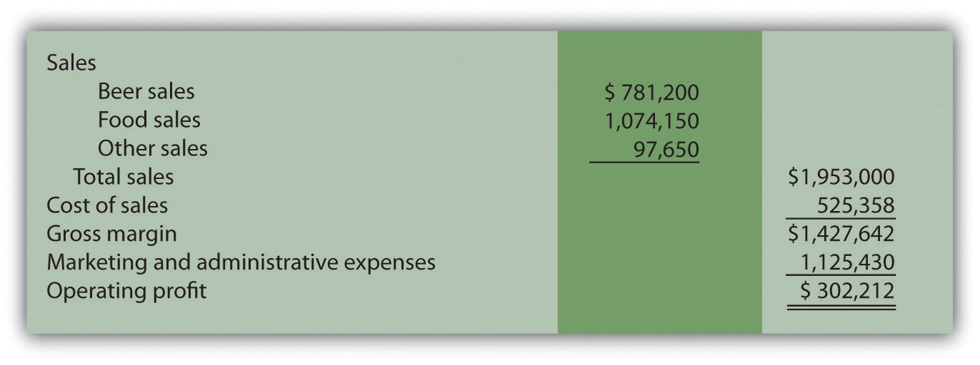
In the process of pursuing capital (cash) through private investors and financial institutions, they were asked several questions. The following is a sample of the questions most commonly asked:
  - What is the break-even point?
  - What sales dollars will be required to make $200,000? To make $500,000?
  - Is the product mix reasonable? (Beer tends to have a higher contribution margin ratio than food, and therefore product mix assumptions are critical to profit projections.)
  - What happens to operating profit if the product mix shifts?
  - How will changes in price affect operating profit?
  - How much does a pint of beer cost to produce?
It became clear that the initial financial model was not adequate for answering these questions. After further research, the entrepreneurs created another financial model that provided the following information for the first year of operations. (Notice that operating profit of $302,212 is the same as in the first model.)
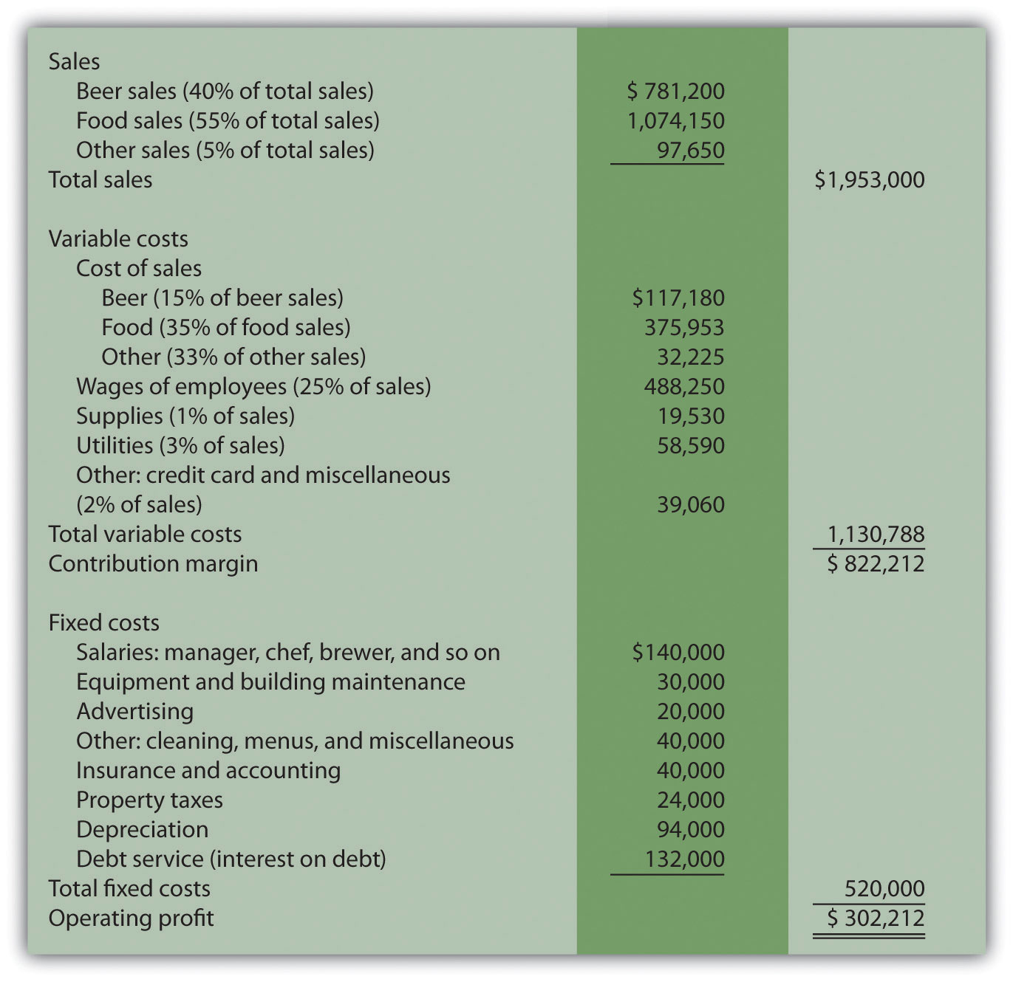
Required:
Round your answers to the nearest hundredth of a percent and nearest dollar where appropriate. (An example for percentage calculations is 0.434532 = 0.4345 = 43.45 percent; an example for dollar calculations is $378.9787 = $379.)
  - What were potential investors and financial institutions concerned about when asking the questions listed previously?
  - Why was the first financial model inappropriate for answering most of the questions asked by investors and bankers? Be specific.
  - Suppose you are deciding whether to invest in RBC. Which financial ratio would you use to check the reasonableness of RBC’s projected operating profit as compared with that of similar businesses?
  - Why is it difficult to answer the question “How much does a pint of beer cost to produce?” Which costs would you include in answering this question?
  - Perform CVP analysis by answering the following questions:
    - What is the break-even point in sales dollars for RBC?
    - What is the margin of safety in sales dollars for RBC?
    - Why is it not possible for RBC to find the break-even point in units?
    - What sales dollars would be required to achieve an operating profit of $200,000 and of $500,000? What assumptions are made in these calculations?
  - Assume total revenue remains the same, but the product mix changes so that each of the three revenue categories is weighted as follows: food 70 percent, beer 25 percent, other 5 percent. Prepare a contribution margin income statement to reflect these changes. How will this shift in product mix affect operating profit?
  - Although the financial model is important, what other strategic factors should RBC and its investors consider?

Chapter 7

How Are Relevant Revenues and Costs Used to Make Decisions?

Bob Lee is president of Best Boards, Inc., a manufacturer of wakeboards. In the face of stiff competition, Best Boards’ profits have declined steadily over the past few years. Bob is concerned about the decline in profits and has instructed Jim Muller, the vice president of operations, to do whatever it takes to reduce costs. In fact, Bob offered to pay Jim a bonus equal to 25 percent of any production cost savings the company achieves during the coming year.

Jim Muller thinks he has a way to cut costs and earn his bonus, and he approaches Bob Lee and Amy Eckstrom, the company’s accountant, to discuss his plan:
Jim: | Bob and Amy, I hope you’ve had a chance to review my proposal to outsource production. I think it could save the company thousands of dollars this coming year.
Bob: | I did review your proposal. Give me a quick summary of what you have in mind.
Jim: | Our staff accountants tell me that the average unit product cost for our wakeboards is about $110, and we make 10,000 wakeboards each year.
Amy: | Sounds about right.
Jim: | My thought is that we could save substantial amounts of money by having an outside supplier make our wakeboards rather than doing it ourselves. I contacted one reputable wakeboard manufacturer interested in producing the boards for us.
Bob: | What did you find?
Jim: | They told me the wakeboards could be purchased from them for $70 a board. This amounts to $40 in savings per unit, and $400,000 in total savings! Even after my 25 percent bonus of $100,000, Best Boards would save $300,000.
Amy: | Jim has an interesting idea, but there are some issues that should be considered. Jim, you are correct in stating the average unit product cost for our wakeboards is $110 given production of 10,000 units per year. However, it is not accurate to assume we will eliminate $1,100,000, which is $110 per unit cost times 10,000 units, in total production costs by outsourcing production. The average unit cost includes factory equipment lease payments, along with supervisors’ salaries, and factory rent. These costs don’t go away quickly if we stop production. The equipment lease is for several years, we are locked into a long-term lease for the factory building, and we would have to look at our supervisors’ contracts before letting them go.
Bob: | Can we get a better idea of which costs would be eliminated by outsourcing production, and which costs would remain?
Amy: | Sure. I’ll get a team working on this right away.

Best Boards is facing a decision common to many organizations: whether to build its own product or to have another company build the product. We will come back to this scenario after describing how companies facing such decisions can use differential analysis to make wise business decisions.

7.1 Using Differential Analysis to Make Decisions

LEARNING OBJECTIVE
- Describe the format used for differential analysis.

Differential revenues and costs (also called relevant revenues and costsor incremental revenues and costs) represent the difference in revenues and costs among alternative courses of action. Analyzing this difference is calleddifferential analysis (or incremental analysis). We begin with a relatively simple example to establish the format used to perform differential analysis and present more complicated examples later in the chapter. As you work through this example, notice that we also use the contribution margin income statement format presented.

Question: Assume Phillips Accountancy provides bookkeeping, tax, and audit services to its clients. Management believes Phillips Accountancy has several unprofitable customers and would like to perform differential analysis to find out how profits would change if Phillips dropped these customers. Alternative 1 includes the annual revenues, costs, and resulting profit if the company keeps all existing customers. Alternative 2 includes the annual revenues, costs, and resulting profit if the company drops what it believes are unprofitable customers. How should management decide whether to keep all existing customers or drop certain customers?

Answer: presents the format used by management to perform differential analysis. In this case, differential analysis is used to evaluate whether Phillips Accounting should keep all customers or drop unprofitable customers. The information in confirms that Phillips Accountancy would be better off dropping the unprofitable customers (Alternative 2), because company profits would increase by $20,000. The general rule is to select the alternative with the highest differential profit. Take a close look at before reading the description of this information that follows.

Figure 7.1 Differential Analysis for Phillips Accountancy
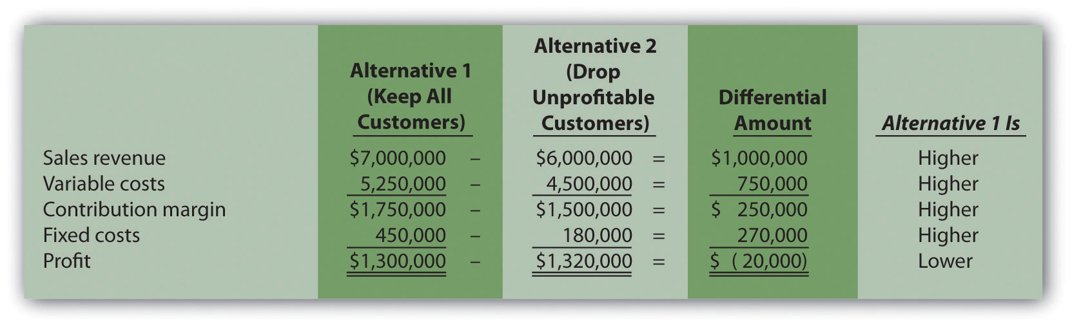

Notice that in the columns labeled Alternative 1 and Alternative 2 show revenues, costs, and profit for each alternative. The third column, labeledDifferential Amount, presents the differential revenues and costs and resulting differential profit. Positive amounts appearing in this column indicate Alternative 1 is higher than Alternative 2. Negative amounts appearing in the Differential Amount column indicate Alternative 1 is lower than Alternative 2. The fourth column shows whether Alternative 1 is higher or lower than Alternative 2 for each line item.

For example, the differential amount of $1,000,000 for revenue indicates Alternative 1 produces $1,000,000 more in revenue than Alternative 2. The differential amount of $750,000 for variable costs indicates variable costs are $750,000 higher for Alternative 1 than for Alternative 2. Move to the bottom of . Notice that the differential amount for profit is negative ($20,000). This indicates that Alternative 1 results in profits that are $20,000 lower than Alternative 2. Thus Alternative 2 (dropping unprofitable customers) is the desirable course of action.

Notice that the columns labeled Alternative 1 and Alternative 2 show information in summary form (i.e., no detail is provided for revenues, variable costs, or fixed costs). Some managers may want only this type of summary information, whereas others may prefer more detailed information. It is important to be flexible with the format, to best meet the needs of managers. We will build upon the differential analysis format shown in throughout this chapter, and show how more detail can easily be provided using the same format.

Next, this chapter focuses on how we use differential analysis to assist in making the following types of decisions:
- Make or buy products
- Keep or drop product lines
- Keep or drop customers
- Accept or reject special customer orders

KEY TAKEAWAY
- Differential revenues and costs represent the difference in revenues and costs among alternative courses of action. Analyzing this difference is called differential analysis. Differential analysis is useful in making managerial decisions related to making or buying products, keeping or dropping product lines, keeping or dropping customers, and accepting or rejecting special customer orders.

REVIEW PROBLEM 7.1
Coffee Express is a small coffee shop looking to expand its product offerings beyond coffee. The company is evaluating two alternatives—sandwiches and cookies. Annual projections for sales of sandwiches are as follows: sales, $18,000; variable costs, $13,000; and fixed costs, $500. Annual projections for sales of cookies are as follows: sales, $10,000; variable costs, $3,000; and no additional fixed costs.
Using the format in , perform differential analysis to determine which alternative is more profitable, and by how much. Assume adding sandwiches is Alternative 1 and adding cookies is Alternative 2.
Solution to Review Problem 7.1
As shown in the differential analysis given, selling cookies is the most profitable alternative. Selling cookies results in profits of $7,000 for the year, which is $2,500 higher than the sandwich alternative.
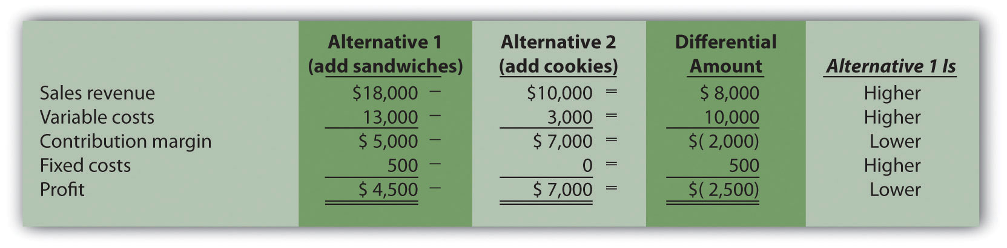

7.2 Make-or-Buy Decisions

LEARNING OBJECTIVE
- Use differential analysis for make-or-buy decisions.

Question: With the differential analysis format in hand, we can now go back to Best Boards, Inc., introduced at the beginning of the chapter. Recall that Best Boards produces each wakeboard for $110, and Jim Muller, vice president of operations, received a bid for $70 per board from an outside manufacturer. Best Boards’ president asked the company’s accountant, Amy Eckstrom, to investigate whether it makes sense for Best Boards to hire an outside company to produce the wakeboards. What information should Amy provide that will help management make this decision?

Answer: presents the costs that the vice president of operations at Best Boards must evaluate in deciding whether to make the wakeboards or buy them from an outside company. This is called a make-or-buy decision because the company must decide whether to make the product internally or buy the product from an outside firm (often called outsourcing).
Table 7.1 Make-or-Buy Decision
 | Costs to Make Wakeboard | Costs to Buy Wakeboard
Variable production costs | Direct materials | Wakeboards from supplier
 | Direct labor
 | Manufacturing overhead
Fixed production costs | Factory equipment lease | Factory equipment lease
 | Factory building rent | Factory building rent
 | Supervisor salaries | Supervisor salaries

Determining Differential Product Costs

Question: What information did Amy find to help Best Boards with the decision whether to make their own wakeboards or buy them from an outside supplier?

Answer: After further research, Amy identified the following product costs associated with wakeboard production at Best Boards:
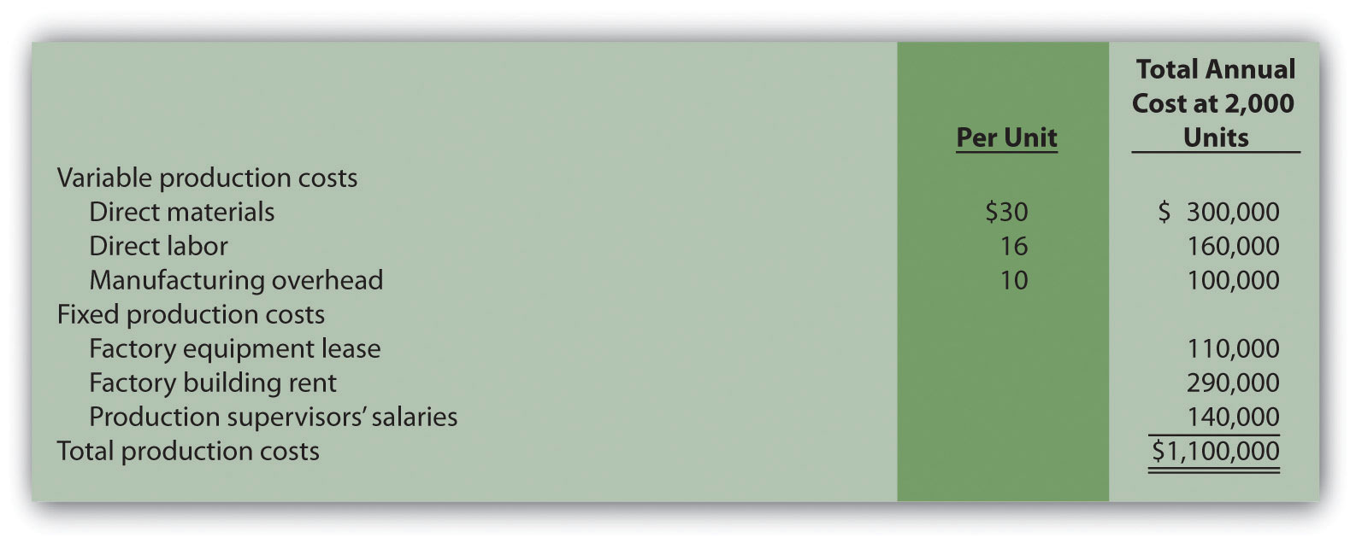

Since Best Boards produces 10,000 wakeboards each year, the product cost per unit is $110 (= $1,100,000 ÷ 10,000 units). However, Amy must identify which of the costs listed previously are differential costs if the company acquires the wakeboards from an outside producer. That is, Amy must determine which costs will change and which will remain the same. Here’s what she found:
- All variable production costs will be eliminated if Best Boards buys the wakeboards rather than making them. These are differential costs.
- The factory equipment lease will continue for several years whether Best Boards makes or buys the wakeboards. This is not a differential cost.
- The factory building lease covers several years, so this cost will continue whether Best Boards makes or buys the wakeboards. This is not a differential cost.
- One of Best Boards’ two production supervisors was hired recently, is paid $50,000 per year, and can be let go if needed. This is a differential cost.
- The other of Best Boards’ two production supervisors has been with the company for several years, is paid $90,000 per year, and has five years remaining on her contract. This is not a differential cost.

Question: Amy must now prepare a differential analysis to determine which alternative is best for the company. Her analysis appears in . Because the focus of make-or-buy decisions is on product costs, and because sales revenue is not differential to this decision, it is not necessary to include sales revenue in the analysis. This in turn eliminates the need to show the contribution margin or net income. (Even if sales revenue were included, the outcome would remain the same.) What does Amy’s analysis tell us?
Figure 7.2 Make-or-Buy Differential Analysis for Best Boards, Inc.
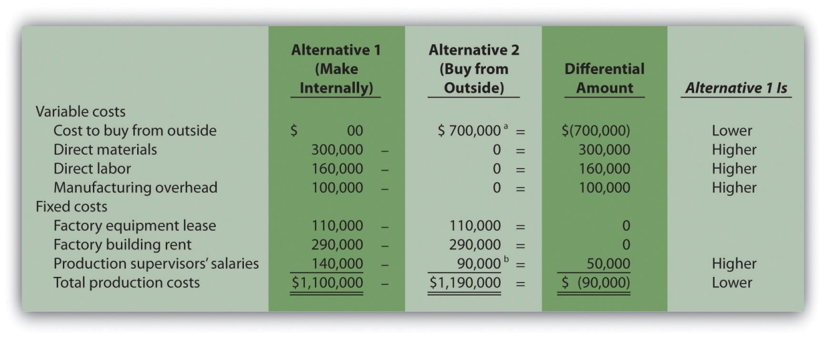
ª $700,000 = $70 per unit × 10,000 units.
^{b} One supervisor must be paid $90,000 per year even if the company buys the product. The other supervisor, who is paid $50,000 per year, can be let go if the company buys the product.

Answer: Realizing that the information shown in does not provide the savings initially hoped for, Amy presents the unfavorable analysis to Jim Muller and the company’s president, Bob Lee. Refer to as you follow Amy’s comments to Bob and Jim about her analysis.
Bob: | Hi, Amy, what have you got for us?
Amy: | As you can see from my analysis, outsourcing the production of our wakeboards does not reduce overall production costs.
Jim: | How can that be? I got a bid from an outside supplier for $70 per board, and our cost to produce the very same board is $110.
Amy: | As I mentioned before, the $110 includes costs that do not go away if we outsource production. Let’s look at my analysis. Alternative 1 represents the production costs we incur to make the board ourselves, and Alternative 2 represents the costs we incur if we buy the board from an outside supplier using Jim’s quote of $70 each.
Jim: | Well, this certainly explains where the $110 product cost per board comes from if we produce the boards ourselves. I see the total cost of $1,100,000. Divide this by 10,000 units produced annually, and the resulting cost per unit is $110.
Amy: | Exactly! Now let’s look at Alternative 2 more carefully. Although we eliminate all variable product costs such as direct materials and direct labor by outsourcing production, several fixed product costs remain. We still must lease the factory equipment at a rate of $110,000 per year, and the factory building lease of $290,000 per year is in effect for several more years. Also, one of our factory supervisors has a long-term contract for $90,000 per year and cannot be let go any time soon. None of these costs can be eliminated if we outsource production. Add these costs to the $700,000 cost incurred to purchase the boards from a supplier, and the total cost of $1,190,000 is $90,000 higher than if we produce the boards ourselves.
Bob: | Perhaps we should consider outsourcing in a few years as these long-term commitments expire. Jim, I commend you for your creative approach to reducing costs, but the numbers don’t make it feasible for us to discontinue production and buy the products elsewhere.

Using a Summary Format for Differential Analysis

Question: The Differential Amount column presented in indicates Best Boards would be better off producing wakeboards internally. However, management may want a more concise explanation of why production costs are $90,000 higher when outsourcing production. How can we present this information in a more concise format?

Answer: We show a more concise presentation in , which includes theDifferential Amount column shown in along with a brief description for each item. Look closely at to confirm that the Differential Amount column matches, and review the explanation of the difference for each line item. As you compare these two figures, notice that only differential costs are presented in , and therefore costs for the factory equipment lease, factory building rent, and a portion of supervisor salaries are excluded from . That is, costs that do not differ from one alternative to another are excluded from the summary differential analysis since this information is irrelevant to the decision. The amounts in parentheses in indicate a negative impact on profit, and amounts without parentheses indicate a positive impact on profit.

Figure 7.3 Summary of Differential Analysis for Best Boards, Inc.
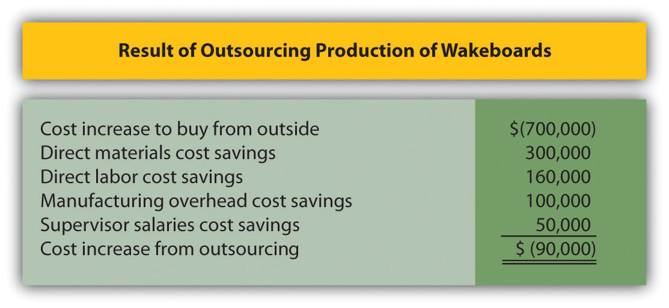

Note: Amounts shown in parentheses indicate a negative impact on profit, and amounts without parentheses indicate a positive impact on profit.

The analysis shown in is particularly useful if all costs are not easily identified, and differential costs can be determined. After all, the goal of differential analysis is to analyze the costs that differ from one alternative to the next.

We often use the term avoidable cost to describe a cost that can be avoided, or eliminated, if one alternative is chosen over another. If Best Boards chooses to buy the product from an outside producer, the company avoids such costs as direct materials, direct labor, manufacturing overhead, and the salary of one supervisor. In this context, avoidable cost is the same asdifferential cost.

Business in Action 7.1
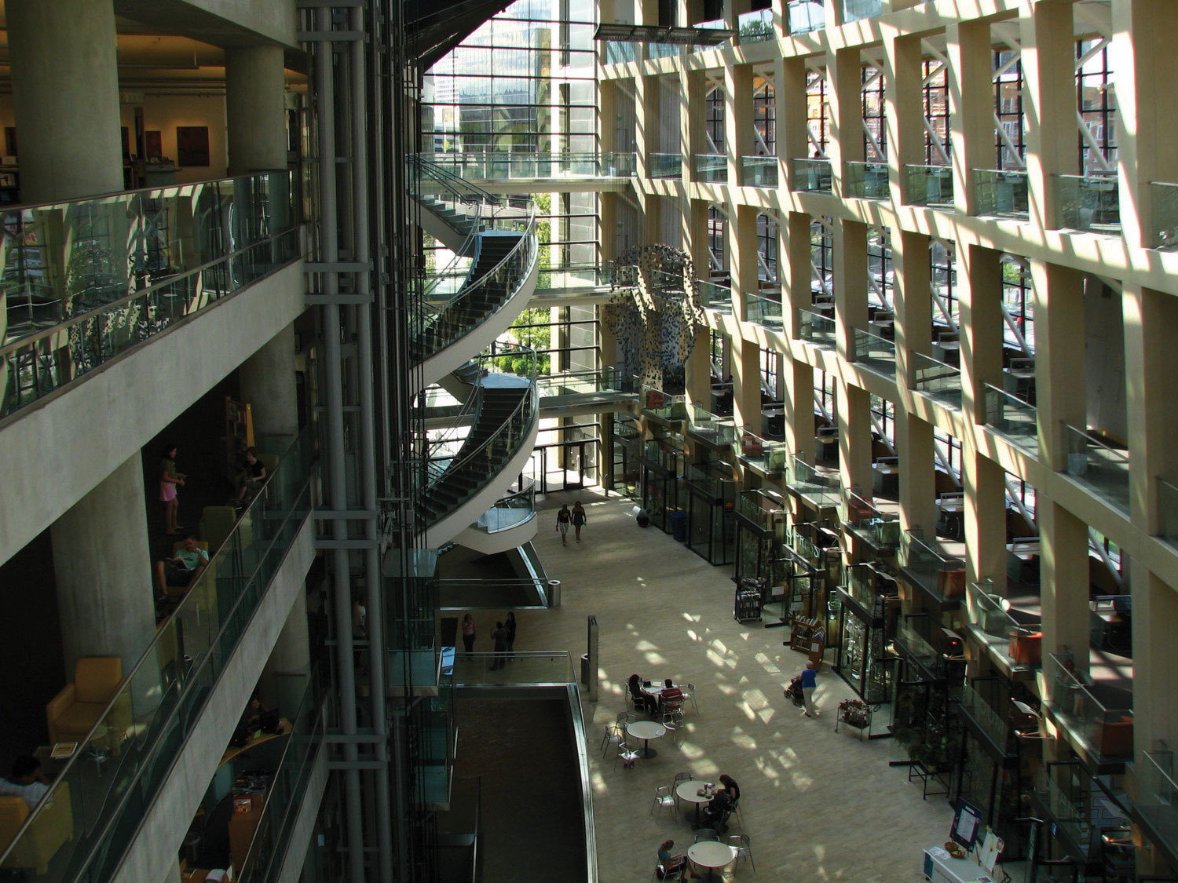
Source: Photo courtesy of C.G.P. Grey, http://www.cgpgrey.com/.
Outsourcing Construction
Salt Lake City, Utah, recently built a $65 million library. The library’s façade was assembled from precast concrete panels that a company called Pretecsa produced in a plant near Mexico City. Trucks hauled 140 truckloads of these panels—each truckload averaging 10 tons—2,350 miles from Mexico City to Salt Lake City. In all, four million pounds of concrete were shipped. As the director of Pretecsa noted, “The idea of manufacturing a building a couple of thousand miles away and then exporting it, well it was considered crazy.”
The manager in charge of the library construction had tried to obtain the concrete panels from sources in the United States. He stated, “We contacted precast contractors in Phoenix, Denver, and Las Vegas, but they didn’t feel they could do it cheaply enough, once you factored in their shipping costs. Pretecsa’s low-cost labor made up for the higher shipping costs, and they came in the cheapest.”
Pretecsa disclosed that it took 163,000 labor hours to produce the concrete panels and charged $2.5 million for all its services, including materials. Labor costs alone in the United States would have been $3 million.
Source: Joel Millman, “Blueprint for Outsourcing,” The Wall Street Journal, March 3, 2004.

KEY TAKEAWAY
- Differential analysis requires the identification of all revenues and costs that differ from one alternative to another. In general, managers select the alternative with the highest profit. If the only differences between the alternatives are with costs (as in the make-or-buy decision for Best Boards), decision makers would select the alternative with the lowest cost.

REVIEW PROBLEM 7.2
Quality Bikes, Inc., currently produces racing bikes. Management is interested in outsourcing production of these bikes to a reputable manufacturing company that can supply the bikes for $600 per unit. Quality Bikes incurs the following annual production costs to produce 2,000 racing bikes internally:
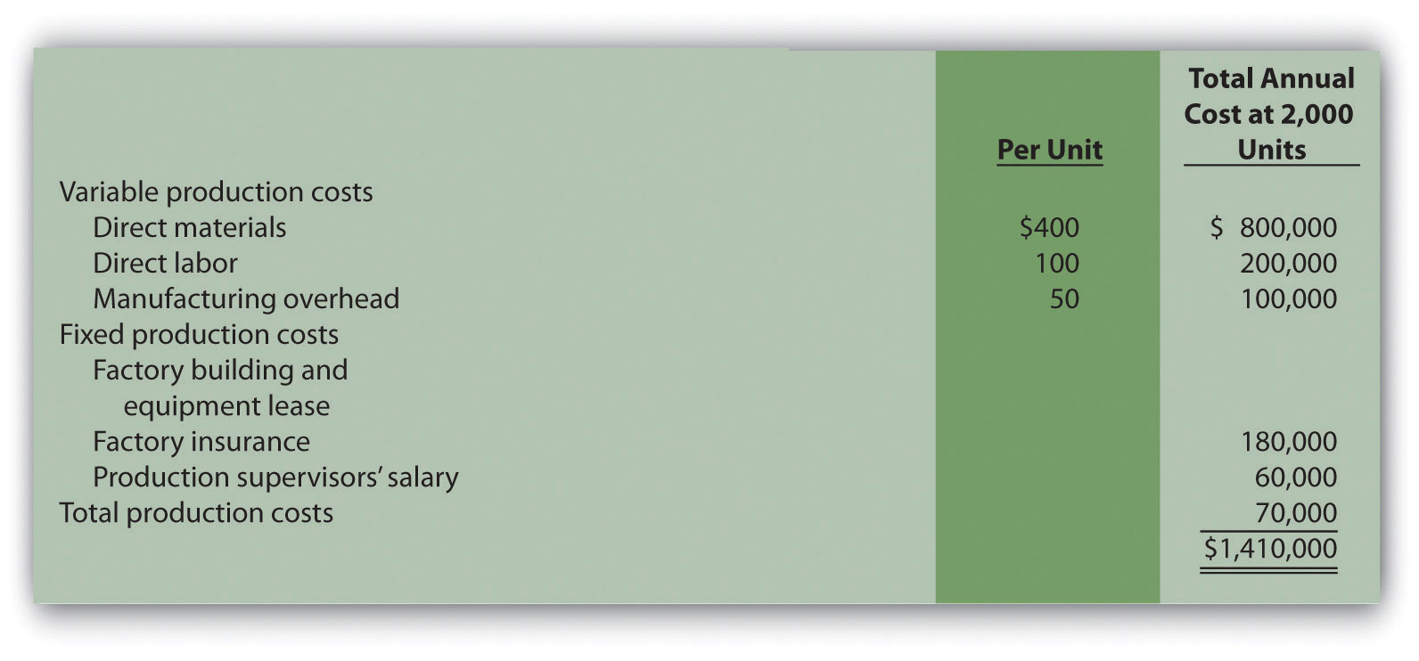
Outsourcing production eliminates all variable production costs, the production supervisor’s salary, and factory insurance costs. Factory building and equipment lease costs will remain the same regardless of the decision to outsource or to produce internally.
- Perform differential analysis using the format presented in . Assume making the bike internally is Alternative 1, and buying the bike from an outside manufacturer is Alternative 2.
- Which alternative is best? Explain.
- Summarize the result of outsourcing production using the format presented in .
Solution to Review Problem 7.2

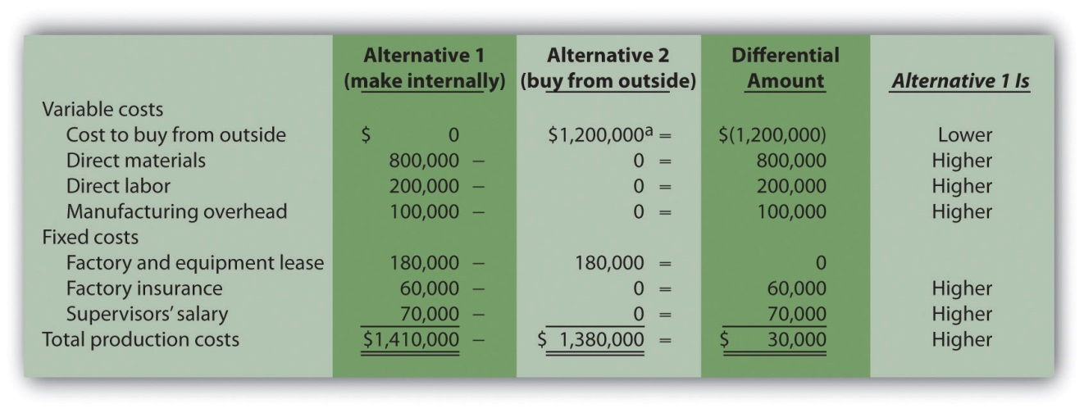
*$1,200,000 = $600 per unit × 2,000 units.
- Buying the bikes from an outside supplier is the best alternative. This alternative results in total costs of $1,380,000, providing $30,000 in savings compared to the $1,410,000 cost of producing bikes internally.

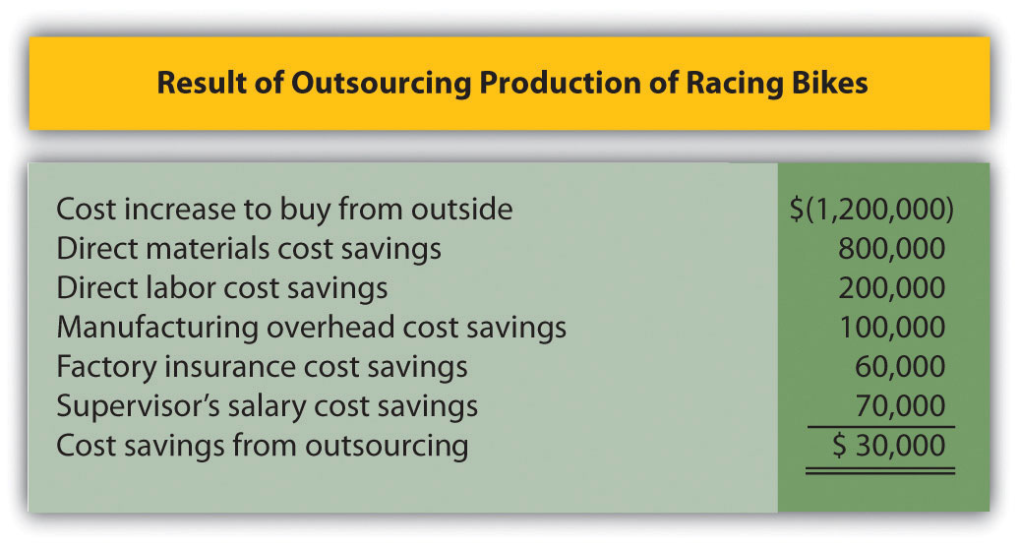
Note: Amounts shown in parentheses indicate a negative impact on profit, and amounts without parentheses indicate a positive impact on profit.

7.3 Product Line Decisions

LEARNING OBJECTIVE
- Use differential analysis for product line decisions.

Question: As competitors enter the market and as products go through life cycles, managers often must decide whether to keep or drop product lines. Aproduct line is a group of related products. The Home Depot, Inc., has many different product lines such as appliances, flooring, and paint products. Ford Motor Co. produces a variety of products such as compact cars, trucks, and tractors. Companies must continually assess whether they should add new product lines, and whether they should discontinue current product lines. Differential analysis provides a format for these types of decisions. How would differential analysis be used to make a product line decision?

Answer: Let’s look at an example of a product line decision. Assume Barbeque Company has three product lines: gas barbecues, charcoal barbecues, and barbecue accessories. Charcoal barbecue sales have declined in recent years, leading management to question whether this product line is worth keeping. Barbeque Company would like to consider two alternatives. Alternative 1 is to retain all three product lines, and Alternative 2 is to eliminate the charcoal barbecues product line. Figure 7.4 "Product Line Decision" shows the decision facing the manager at Barbeque Company: whether to eliminate or keep the charcoal barbecue product line.
Figure 7.4 Product Line Decision
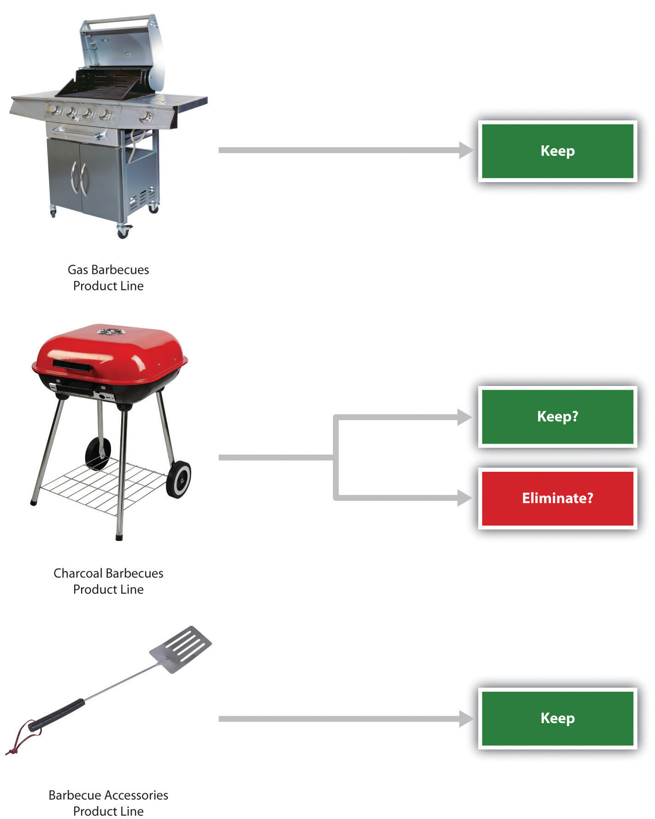

Figure 7.5 "Income Statement for Barbeque Company" presents the income statement for the past year, separated by product line (this is often referred to as a segmented income statement). Carefully examine Figure 7.5 "Income Statement for Barbeque Company". Notice that the charcoal barbecues product line shows a loss of $8,000 for the year. This is the reason management would like to consider dropping this product line.
Figure 7.5 Income Statement for Barbeque Company
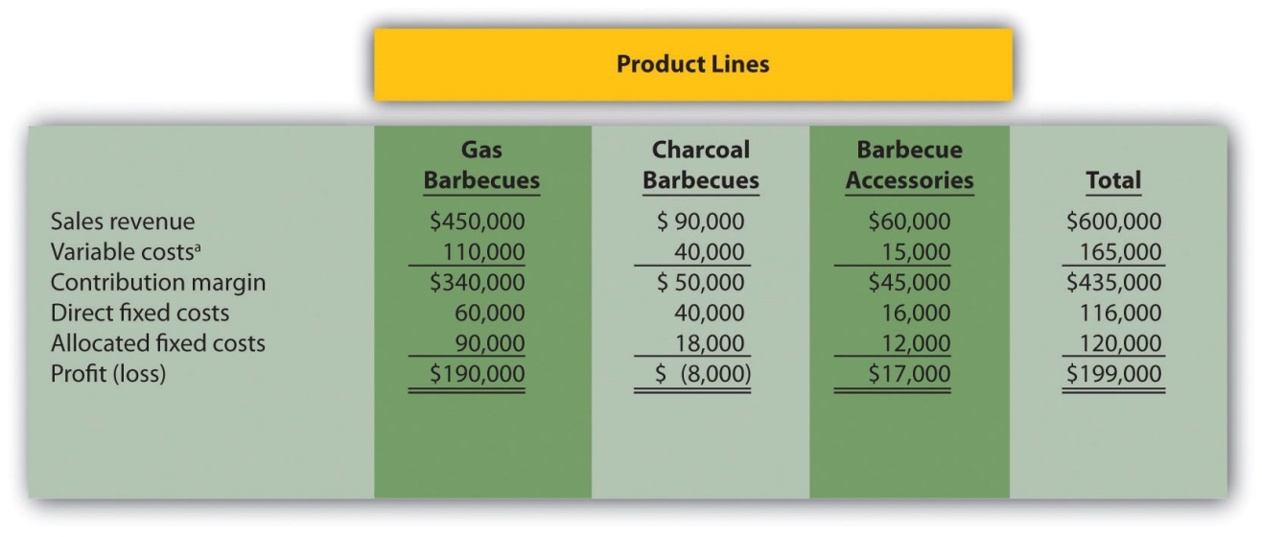
*Includes cost of goods sold and other variable costs.

The variable costs in Figure 7.5 "Income Statement for Barbeque Company"are related directly to each product line, and thus are eliminated if the product line is eliminated. That is, all variable costs are differential costs for the two alternatives facing Barbeque Company.

Question: Notice that two lines appear for fixed costs: direct fixed costs and allocated fixed costs. What is the difference between direct fixed costs and allocated fixed costs?

Answer: Direct fixed costs are fixed costs that can be traced directly to a product line. Direct fixed costs are often differential costs. For example, the salary of the manager responsible for charcoal barbecues is easily traced to the charcoal barbecues product line. If this product line is eliminated, the product line manager’s salary is also eliminated (unless the product line manager has a long-term employment contract).

Allocated fixed costs (also called common fixed costs) are fixed costs thatcannot be traced directly to a product line, and therefore are assigned to product lines using an allocation process. Allocated fixed costs are typicallynot differential costs. For example, rent paid for Barbeque Company’s retail store is allocated to all three product lines because it is not easily traced to each product line. However, the retail store rent likely will not decrease if the charcoal barbecues product line is eliminated (unless the company chooses to move to a smaller, less costly store). The charcoal barbecues’ allocation for rent would simply be reallocated to the other two products. Thus rent for the retail store is an example of an allocated fixed cost that isnot a differential cost for the two alternatives facing Barbeque Company.

Question: How are Barbeque Company’s allocated fixed costs assigned to individual product lines?

Answer: Barbeque Company’s total allocated fixed costs of $120,000 are allocated based on sales. Sales revenue for gas barbecues totals $450,000, which is 75 percent of total company sales (= $450,000 ÷ $600,000). Thus 75 percent of all allocated fixed costs are assigned to the gas barbecues product line. This amounts to $90,000 (= $120,000 × 0.75).

Question: Will dropping the charcoal barbecues product line result in higher company profit?

Answer: The differential analysis presented in Figure 7.6 "Product Line Differential Analysis for Barbeque Company" provides the answer. Panel A shows the income statement for Alternative 1: keeping all three product lines. Panel B shows the income statement for Alternative 2: dropping the charcoal barbecues product line. And panel C presents the differential analysis for the two alternatives. The differential analysis in panel C shows that overall profit will decrease by $10,000 if the charcoal barbecue product line is dropped.

Figure 7.6 Product Line Differential Analysis for Barbeque Company
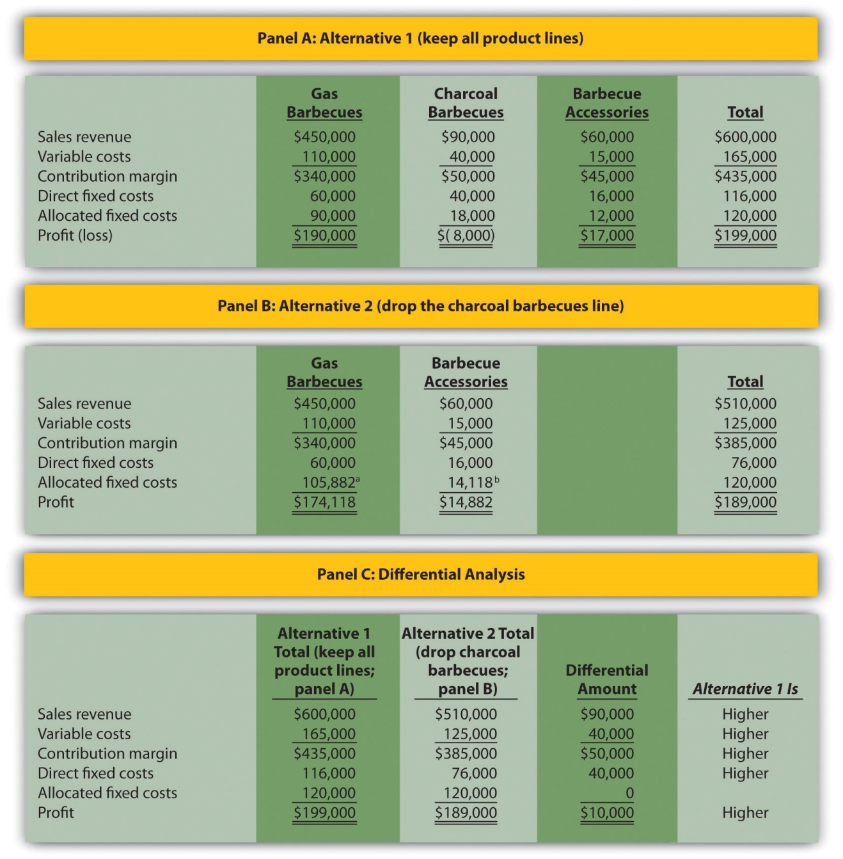
ª $105,882 = ($450,000 ÷ $510,000) × $120,000.
^{b} $14,118 = ($60,000 ÷ $510,000) × $120,000.

The Differential Amount column in panel C of Figure 7.6 "Product Line Differential Analysis for Barbeque Company" indicates the company would be better off continuing with all three product lines. However, management may want a more concise explanation of why profit is $10,000 higher when all three product lines are maintained. We provide such an explanation inFigure 7.7 "Summary of Differential Analysis for Barbeque Company", which presents the Differential Amount column shown in panel C of Figure 7.6 "Product Line Differential Analysis for Barbeque Company" along with a brief description for each item. Take a close look at panel C of Figure 7.6 "Product Line Differential Analysis for Barbeque Company", confirm that the Differential Amount column matches Figure 7.7 "Summary of Differential Analysis for Barbeque Company", and review the explanation of the difference.
Figure 7.7 Summary of Differential Analysis for Barbeque Company
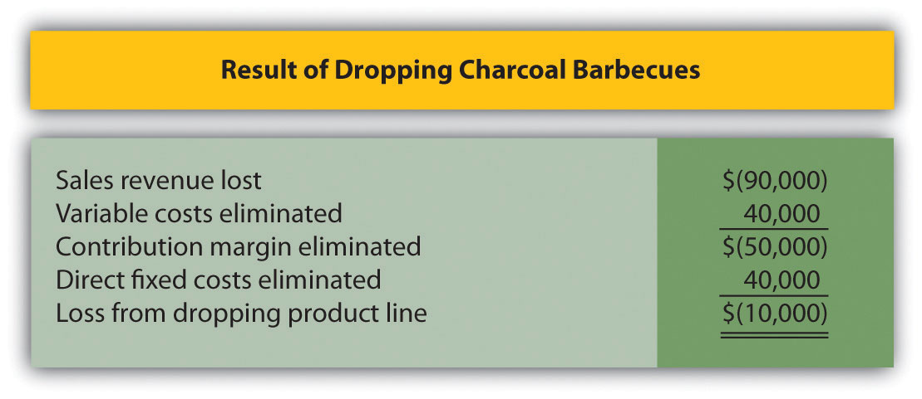
Note: Amounts shown in parentheses indicate a negative impact on profit, and amounts without parentheses indicate a positive impact on profit.

Figure 7.7 "Summary of Differential Analysis for Barbeque Company" shows that Barbeque Company will lose sales revenue of $90,000 if it drops the charcoal barbecues product line. However, it saves variable costs of $40,000 and direct fixed costs of $40,000 if it drops the charcoal barbecues product line. Because the $80,000 in cost savings is not enough to make up for the $90,000 loss in sales revenue, profit will decline by $10,000 (= $80,000 − $90,000).

Misleading Allocation of Fixed Costs

Question: How can the charcoal barbecues product line show a loss of $8,000 in Figure 7.6 "Product Line Differential Analysis for Barbeque Company", while the company as a whole is better off keeping this product line?

Answer: The answer lies within allocated fixed costs. Even though total allocated fixed costs of $120,000 cannot easily be traced to each product line, company management wants each product line manager to be aware of these costs. As a result, it uses an allocation process to assign the costs to product lines. Thus the charcoal barbecues product line is assigned $18,000 in allocated fixed costs even though these costs cannot be controlled by the product line. If the charcoal barbecues product line is eliminated, $18,000 in allocated fixed costs is not eliminated. Instead, $18,000 in costs is assigned to the other two product lines.

In many situations, this increased allocation to other product lines may cause other product lines to appear unprofitable. The message here is to be careful when analyzing segmented information containing cost allocations. Allocated costs are typically not differential costs, and therefore are typically not relevant to the decision.

An alternative view of the decision facing Barbeque Company—whether to keep or drop the charcoal barbecues product line—is simply to calculate profitability of this product line before deducting allocated fixed costs. Figure 7.6 "Product Line Differential Analysis for Barbeque Company" shows a contribution margin of $50,000 for charcoal barbecues. Deduct direct fixed costs of $40,000 and this product line has a remaining profit of $10,000. This explains why Barbeque Company’s overall profit would be $10,000 lower if the charcoal barbecues product line were eliminated. (As discussed previously, the allocated fixed costs are irrelevant to this decision.)

Including Opportunity Costs in Differential Analysis

Managers must often consider the impact of opportunity costs when making decisions. An opportunity cost is the benefit foregone when one alternative is selected over another. For example, assume you have the choice between going to school and working. The opportunity cost of attending school is the lost wages from working.

Question: In the case of Barbeque Company, assume the company can lease the space currently being used by the charcoal barbecues product line for $25,000 per year. Thus the opportunity cost (benefit foregone) of keeping the charcoal barbecues is $25,000. How does this affect Barbeque Company’s decision to keep or drop charcoal barbecues?

Answer: Figure 7.8 "Differential Analysis with Opportunity Cost for Barbeque Company" provides the answer by simply adding one item toFigure 7.7 "Summary of Differential Analysis for Barbeque Company". Barbeque Company would increase profits $15,000 by dropping the charcoal barbecues.
Figure 7.8 Differential Analysis with Opportunity Cost for Barbeque Company
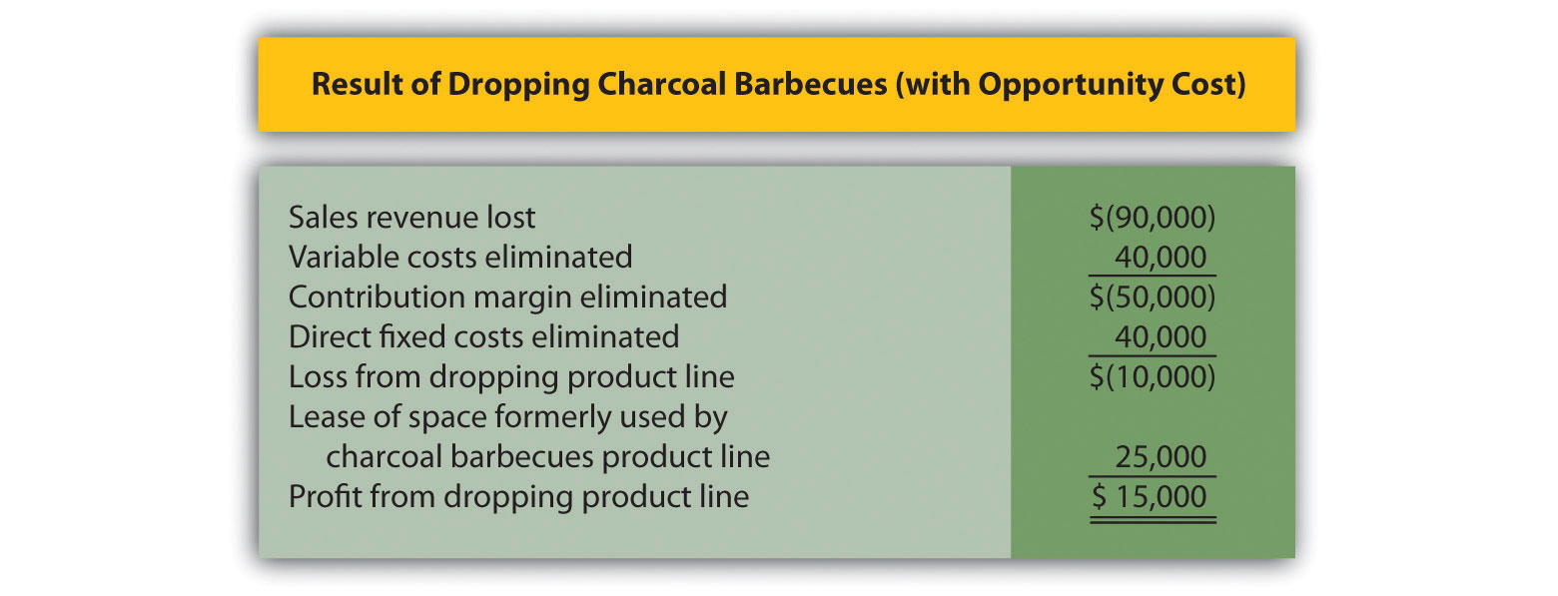
Note: Amounts shown in parentheses indicate a negative impact on profit, and amounts without parentheses indicate a positive impact on profit.

Opportunity costs can also be included in the differential analysis format presented in Figure 7.6 "Product Line Differential Analysis for Barbeque Company". Panel C of Figure 7.6 "Product Line Differential Analysis for Barbeque Company" is simply modified to reflect the opportunity cost, as shown.
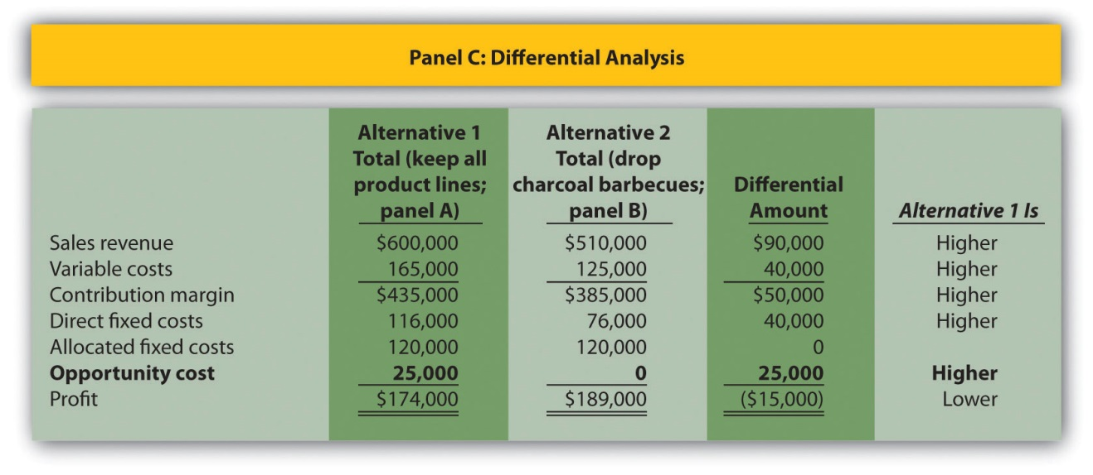

Sunk Costs and Differential Analysis

Question: What is a sunk cost, and how do sunk costs affect differential analysis?

Answer: A sunk cost is a cost incurred in the past that cannot be changed by future decisions. For example, suppose Barbeque Company must dispose of store equipment related to the charcoal barbecues product line if charcoal barbecues are eliminated. The original cost of this store equipment is a sunk cost and should have no bearing on the decision whether to eliminate charcoal barbecues. As a general rule, sunk costs are not differential costs.

Business in Action 7.2
Source: Photo courtesy of Paul Sableman,http://www.flickr.com/photos/pasa/5583935536/.
Kmart Sells Stores
The management of Kmart Corp., a mass merchandising company with more than 1,500 stores throughout the United States, agreed to sell 24 stores to Home Depot for $365 million in cash. Julian Day,Kmart’s president and chief executive officer, stated, “We will take advantage of opportunities to create value that include the sale of existing stores.”
In deciding whether to sell the stores, management likely considered the differential revenues and costs associated with keeping the stores versus selling them. Perhaps the stores were not profitable enough to exceed the $365 million in cash that Kmart received from the sale. Large retail companies with many widely dispersed stores commonly review their unprofitable stores on a regular basis and consider closing or selling stores that cannot turn a profit in the near future.
Source: Kmart Corp. press release, June 4, 2004 (http://www.kmartcorp.com).

KEY TAKEAWAY
- Managers often use differential analysis to determine whether to keep or drop a product line. Direct fixed costs are typically eliminated if a product line is eliminated, and are considered differential costs. Allocated fixed costs are typically not eliminated if a product line is eliminated, and are not differential costs. Managers compare sales revenue and costs for each alternative (keep or drop), and select the alternative with the highest profit.

REVIEW PROBLEM 7.3
The following annual income statement is for Austin Appliances, Inc., a maker of electrical appliances:
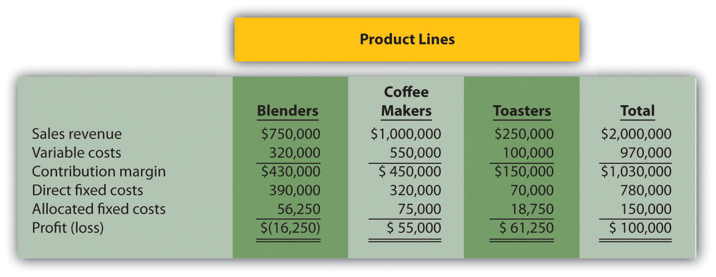
Austin Appliances is concerned about the losses associated with the blenders product line and is considering dropping this product line. Allocated fixed costs are assigned to product lines based on sales. For example, $56,250 in allocated fixed costs is allocated to the blenders product line based on the blenders product line sales as a percent of total sales [$56,250 = $150,000 × ($750,000 ÷ $2,000,000)]. If Austin Appliances eliminates a product line, total allocated fixed costs are assigned to the remaining product lines. All variable costs and direct fixed costs are differential costs.
- Using the differential analysis format presented in Figure 7.6 "Product Line Differential Analysis for Barbeque Company", determine whether Austin Appliances would be better off dropping the blenders product line or keeping the product line. Support your conclusion.
- Assume Austin Appliances can lease the warehouse space currently being used by the blenders product line for $15,000 per year. How does this affect the company’s decision to keep or drop the blenders product line?
- Summarize the result of dropping the blenders product line and leasing the warehouse space using the format presented in Figure 7.8 "Differential Analysis with Opportunity Cost for Barbeque Company".
Solution to Review Problem 7.3
- As shown in the differential analysis given here, Austin Appliances would be better off keeping the blenders product line. Dropping this product line would result in a drop in total profit of $40,000.
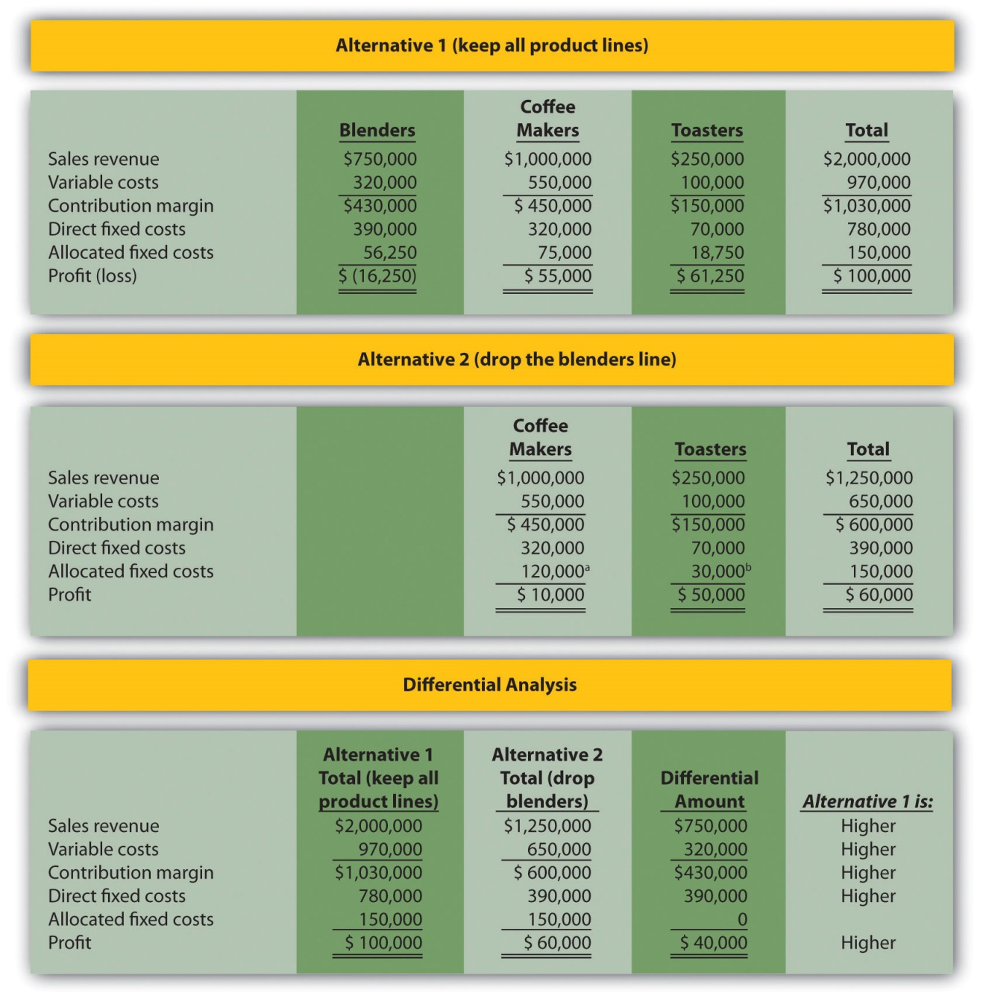
ª $120,000 = ($1,000,000 ÷ $1,250,000) × $150,000.
^{b} $30,000 = ($250,000 ÷ $1,250,000) × $150,000.
- The $15,000 opportunity cost of keeping all three product lines would not affect the company’s decision to keep the blenders product line. If the blenders are dropped, total profit will decrease by $40,000. Lease revenue of $15,000 is not enough to offset the $40,000 decrease in profit. In this scenario, total profit would decrease by $25,000 (= $40,000 − $15,000). This result is presented formally, as follows:
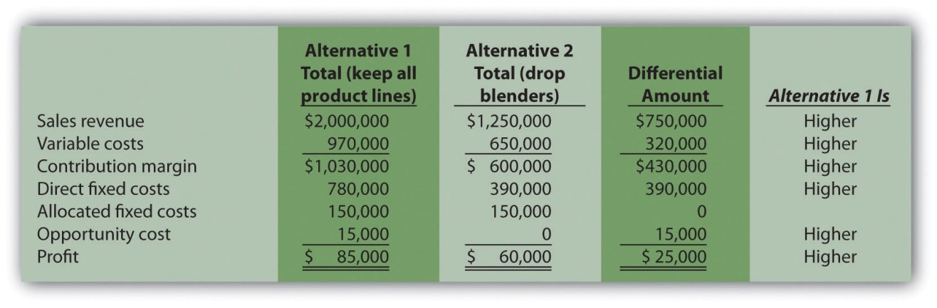

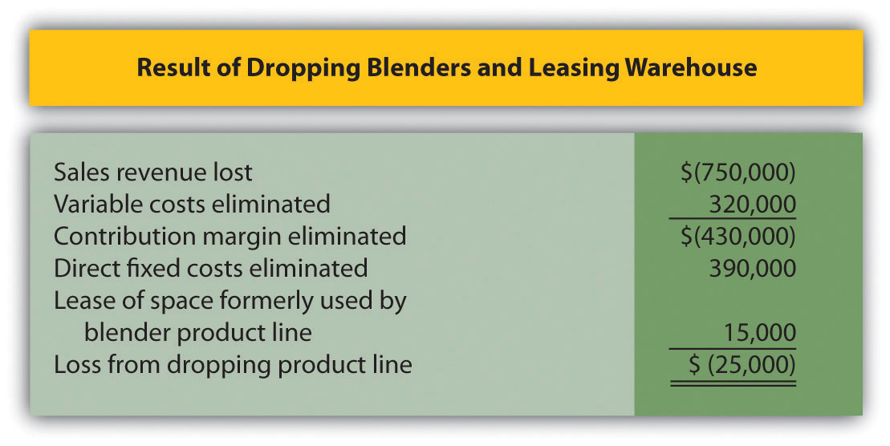
Note: Amounts shown in parentheses indicate a negative impact on profit, and amounts without parentheses indicate a positive impact on profit.

7.4 Customer Decisions

LEARNING OBJECTIVE
- Use differential analysis to decide whether to keep or drop customers.

Question: Much like product line decisions, managers often use profitability as a determining factor to decide whether to keep or drop customers. This is an issue for all types of organizations, including manufacturers, retailers, and service companies. How does the differential analysis format differ for customer decisions compared to product line decisions?

Answer: Instead of tracing revenues, variable costs, and fixed costs directly to product lines, we track this information by customer. Fixed costs that cannot be traced directly to customers are allocated to customers. Let’s look at an example for a company called Colony Landscape Maintenance to identify the similarities and differences between the two formats.

Evaluating Customer Information

Question: Colony Landscape Maintenance provides services to three large customers: Brumfield, Hodges, and Orth. The segmented income statement inFigure 7.9 "Income Statement for Colony Landscape Maintenance" provides annual revenue and cost information by customer. Notice that this information is formatted similarly to the product line information in Figure 7.8 "Differential Analysis with Opportunity Cost for Barbeque Company". However, instead of tracking information by product line, here we track information by customer. Examine Figure 7.9 "Income Statement for Colony Landscape Maintenance"carefully and notice that the Brumfield account shows a loss for the year of $15,000. Should Colony Landscape Maintenance drop the Brumfield account?

Answer: To answer this question we must take a closer look at the information in Figure 7.9 "Income Statement for Colony Landscape Maintenance". The variable costs and direct fixed costs are related directly to each customer, and thus are eliminated if Colony eliminates the Brumfield account. That is, all variable costs and direct fixed costs are differential costs for the two alternatives facing Colony. Colony assigns the allocated fixed costs of $20,000 to Brumfield based on sales revenue, and those costs will continue regardless of Colony’s decision. Thus allocated fixed costs are not differential costs.

Figure 7.9 Income Statement for Colony Landscape Maintenance
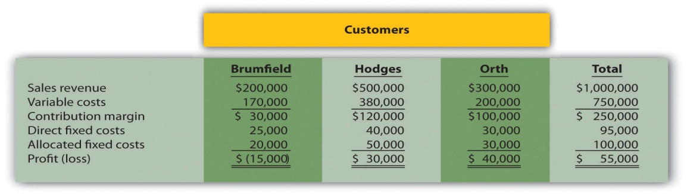

Management of Colony Landscape Maintenance would like to know if dropping the Brumfield account would increase overall company profit. The differential analysis presented in Figure 7.10 "Customer Differential Analysis for Colony Landscape Maintenance" provides the answer. Panel A shows the income statement for Alternative 1: keeping all three customers. Panel B shows the income statement for Alternative 2: dropping the Brumfield account. And panel C presents the differential analysis for both alternatives. The differential analysis presented in panel C shows that overall profit will decrease by $5,000 if Colony drops the Brumfield account.
Figure 7.10 Customer Differential Analysis for Colony Landscape Maintenance
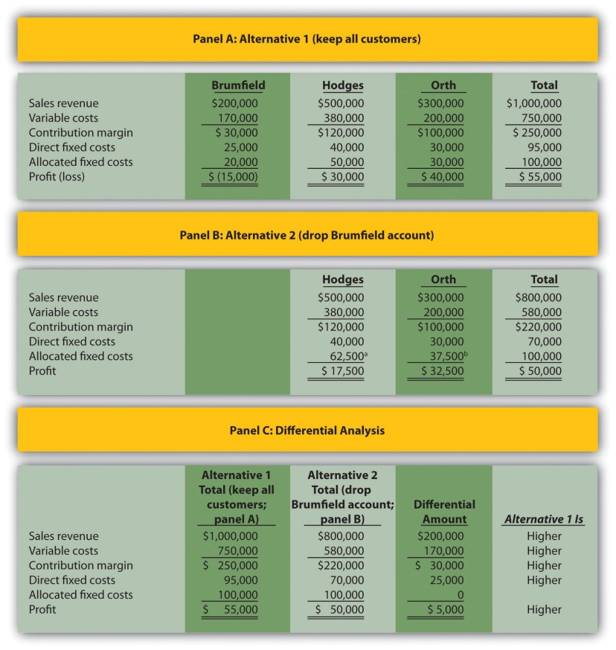

a $62,500 = ($500,000 ÷ $800,000) × $100,000.

b $37,500 = ($300,000 ÷ $800,000) × $100,000.

Figure 7.11 "Keep or Drop Customer" provides a bar chart summarizing how total profit will decrease if the Brumfield account is dropped. This information comes from the bottom of panels A and B in Figure 7.10 "Customer Differential Analysis for Colony Landscape Maintenance".
Figure 7.11 Keep or Drop Customer
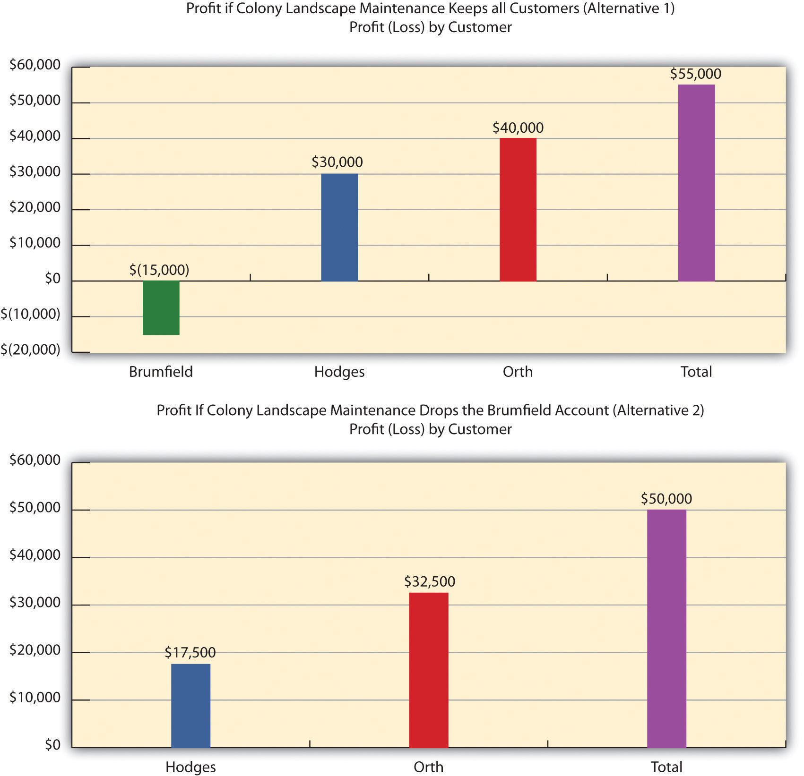

We show a more concise explanation in Figure 7.12 "Summary of Differential Analysis for Colony Landscape Maintenance", which presents the Differential Amount column shown in panel C of Figure 7.10 "Customer Differential Analysis for Colony Landscape Maintenance" along with a brief description of each item.

Figure 7.12 Summary of Differential Analysis for Colony Landscape Maintenance
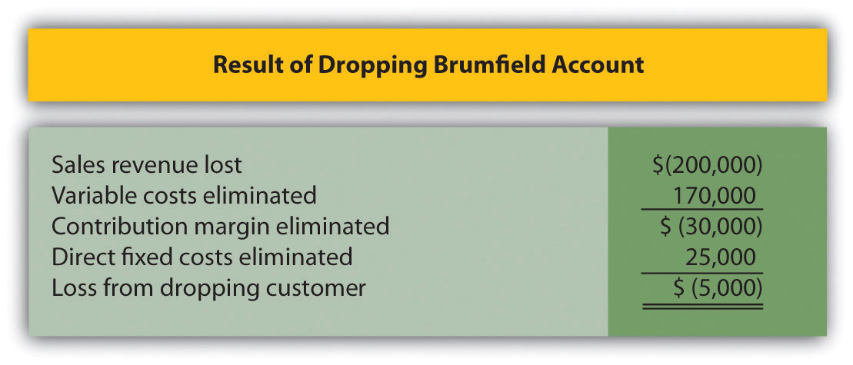

Note: Amounts shown in parentheses indicate a negative impact on profit, and amounts without parentheses indicate a positive impact on profit.

An alternative way of handling the decision facing Colony Landscape Maintenance is simply to calculate profitability of the Brumfield accountbefore deducting allocated fixed costs. Figure 7.12 "Summary of Differential Analysis for Colony Landscape Maintenance" shows a contribution margin of $30,000 for the Brumfield account. Deduct direct fixed costs of $25,000 and the customer has a remaining profit of $5,000. This explains why Colony’s overall profit would be $5,000 lower if it eliminated the Brumfield account.

Business in Action 7.3
Engineering Firm Fires Its Biggest Customer
The president of ABCO Automation, Inc., a 120-person engineering firm in North Carolina, decided it was time to fire the firm’s biggest client. Although the client provided close to 60 percent of the firm’s annual revenue, ABCO decided that firing this client was necessary. The president of ABCO stated, “We cannot be a great place to work without employees, and this client was bullying my employees. Its demands for turnaround were impossible to meet even with people working seven days a week. No client is worth losing my valued employees.”
The initial impact on revenues was significant. However, ABCO was able to cut costs and obtain new customers to fill the void. In addition, the fired client later gave ABCO two new projects on more equitable terms.
The lesson from this is that dropping customers is not always a financial decision. ABCO’s client was profitable, but in the long run, the firm was at risk of losing valuable employees. This was a risk ABCO was not willing to take.
Source: Roger Herman and Joyce Gioia, “Herman Trend Alert,” Strategic Business Futurists 2004 (http://www.hermangroup.com).

Using Activity-Based Costing to Assess Customer Profitability

Question: Activity-based costing, which we discussed in Chapter 3 "How Does an Organization Use Activity-Based Costing to Allocate Overhead Costs?", is a refined approach to allocating costs to products or customers. Activity-based costing first assigns costs to activities and then to products or customers based on their use of the activities. The cost information provided by activity-based costing is generally regarded as more accurate than most traditional costing methods. How can using activity-based costing information with differential analysis lead to better decisions in areas such as product lines and customer profitability?

Answer: Let’s look at a brief example of how activity-based costing can help with customer profitability. When assessing customer profitability, costs can be assigned to customers based on each customer’s use of activities. Consultants from PricewaterhouseCoopers suggest that customer costs are measurable across four categories of activities: [1]
- Cost to acquire customers: Consists of activities such as advertising and promotional materials.
- Cost to provide goods and services: Consists of activities such as processing customer orders and delivering goods.
- Cost to serve customers: Consists of activities such as technical support and processing customer payments.
- Cost to retain customers: Consists of activities such as offering discounts and building relationships.
- With the help of activity-based costing, costs can be assigned to activities within each category. These costs are then allocated to customers based on each customer’s use of activities. A significant advantage of using activity-based costing is having accurate data for decision-making purposes, particularly in the area of differential analysis.

KEY TAKEAWAY
- Managers use differential analysis to determine whether to keep or drop a customer. The format is similar to the differential analysis format used for making product line decisions. However, sales revenue, variable costs, and fixed costs are traced directly to customers rather than to product lines.

REVIEW PROBLEM 7.4
The following annual income statement is for Tatum & Associates, a firm that provides legal services to its customers.
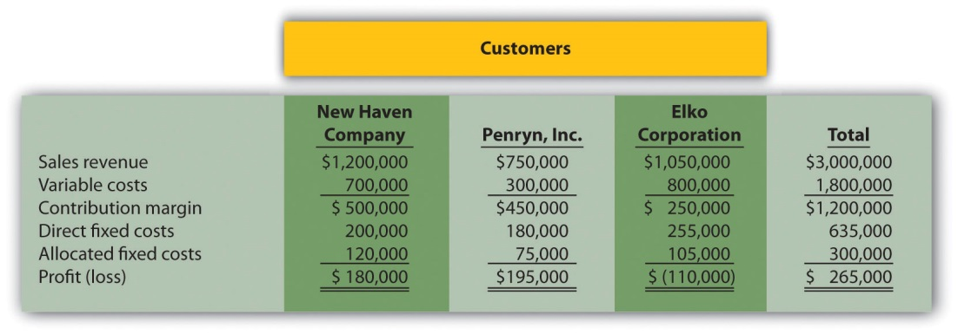
Tatum & Associates is concerned about the losses associated with the Elko Corporation account and is considering dropping this customer. Allocated fixed costs are assigned to customers based on sales. For example, $105,000 in allocated fixed costs is assigned to Elko based on this customer’s sales as a percent of total sales [$105,000 = $300,000 × ($1,050,000 ÷ $3,000,000)]. If a customer is dropped, total allocated fixed costs are assigned to the remaining customers. All variable costs and direct fixed costs are differential costs.
- Using the differential analysis format presented in Figure 7.10 "Customer Differential Analysis for Colony Landscape Maintenance", determine whether Tatum & Associates would be better off dropping the Elko Corporation account or keeping the account. Explain your conclusion.
- Summarize the result of dropping the Elko Corporation account using the differential analysis format presented in Figure 7.12 "Summary of Differential Analysis for Colony Landscape Maintenance".
Solution to Review Problem 7.4
- As shown in the differential analysis provided, Tatum & Associates would be better off dropping the Elko Corporation account. Profit is $5,000 lower if the Elko account is retained.
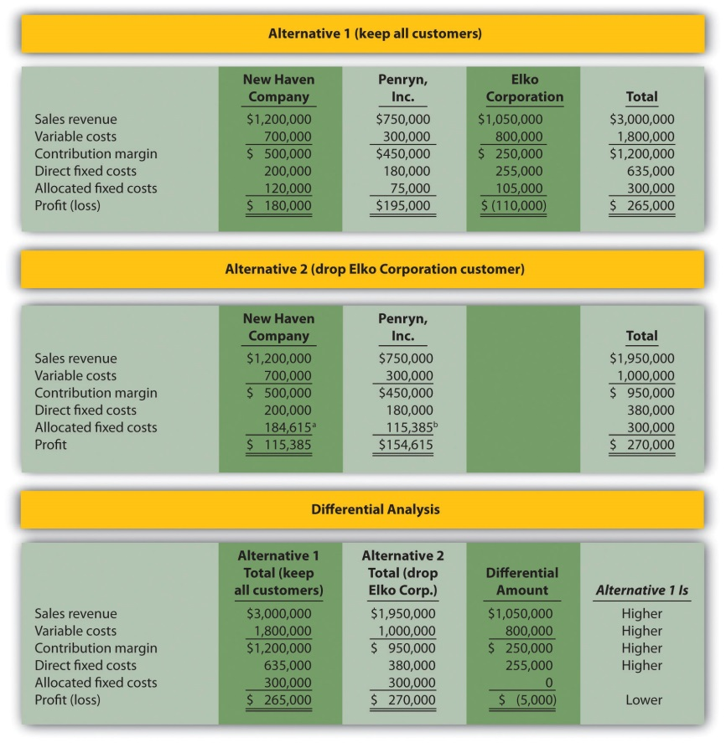
ª $184,615 rounded = ($1,200,000 ÷ $1,950,000) × $300,000.
^{b} $115,385 rounded = ($750,000 ÷ $1,950,000) × $300,000.

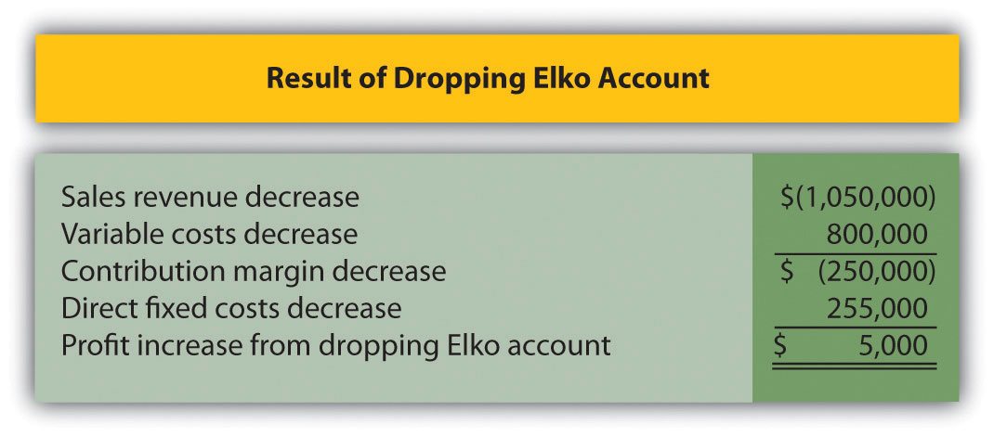
Note: Amounts shown in parentheses indicate a negative impact on profit, and amounts without parentheses indicate a positive impact on profit.
[1] Joseph A. Ness, Michael J. Schroeck, Rick A. Letendre, and Willmar J. Douglas,“The Role of ABM in Measuring Customer Value—Part 2,” Strategic Finance (April 2001): 44–49.

7.5 Review of Cost Terms Used in Differential Analysis

LEARNING OBJECTIVE
- Understand cost terms used in differential analysis.

Question: We’ve introduced many new terms in this chapter. What are these important terms, and how do they relate to differential analysis?

Answer: The important terms introduced in this chapter are outlined here:

Differential analysis requires that we consider all differential revenues and costs—costs that differ from one alternative to another—when deciding between alternative courses of action. Avoidable costs—costs that can be avoided by selecting a particular course of action—are always differential costs and must be considered when deciding between alternative courses of action.

Opportunity costs—the benefits foregone when one alternative is selected over another—are differential costs, and must be included when performing differential analysis. Sunk costs—costs incurred in the past that cannot be changed by future decisions—are not differential costs because they cannot be changed by future decisions.

Direct fixed costs—fixed costs that can be traced directly to a product line or customer—are differential costs and therefore pertinent to making decisions. However, we must review these costs on a case-by-case basis because some direct fixed costs may not be considered differential in spite of being traced directly to a product line. For example, a five-year lease on a warehouse used solely for one product line is a direct fixed cost but not a differential cost because the costs will continue even if the product line is eliminated.

Allocated fixed costs—fixed costs that cannot be traced directly to a product—are typically not differential costs. For example, if a product line is eliminated, these costs are simply allocated to the remaining product lines.

KEY TAKEAWAY
- When deciding between alternatives, only those revenues and costs that differ from one alternative course of action to another are relevant. Avoidable costs, opportunity costs, and direct fixed costs typically fall into this category. Revenues and costs that do not differ from one alternative course of action to another are irrelevant to the decision.

REVIEW PROBLEM 7.5
Match each of the following terms with the appropriate definition in the list given.
- Differential analysis
- Differential revenues and costs
- Avoidable costs
- Sunk costs
- Direct fixed costs
- Allocated fixed costs
- Opportunity costs
- The benefits forgone when one alternative is selected over another.
- Fixed costs that can be traced directly to a product line.
- Revenues and costs that differ from one alternative to another.
- Costs incurred in the past that cannot be changed by future decisions.
- Costs that can be avoided by selecting a particular course of action.
- Fixed costs that cannot be traced directly to a product line.
- Analyzing the difference in revenues and costs from one alternative course of action to another.
Solution to Review Problem 7.5
- g
- c
- e
- d
- b
- f
- a

7.6 Special Order Decisions

LEARNING OBJECTIVE
- Use differential analysis for special order decisions.

Question: We have already learned that managers use differential analysis for make-or-buy decisions, product line decisions, and customer decisions. Differential analysis also provides a format that helps managers decide whether to accept special orders made by customers. What is a special order, and how can differential analysis be used to make a special order decision?

Answer: A special order is a unique one-time order made by a customer. Differential analysis provides a format that helps managers decide whether to accept or reject special orders, as shown in the example that follows.

Special Order Considerations

Assume Tony’s T-shirts makes shirts for local soccer, baseball, basketball, and other sports teams. The owner, Tony, purchases the shirts and prints graphics on the shirts for each team. The graphics were designed several years ago, so design costs are no longer incurred. On average, Tony sells 1,000 shirts each month. Typical monthly financial data follow:
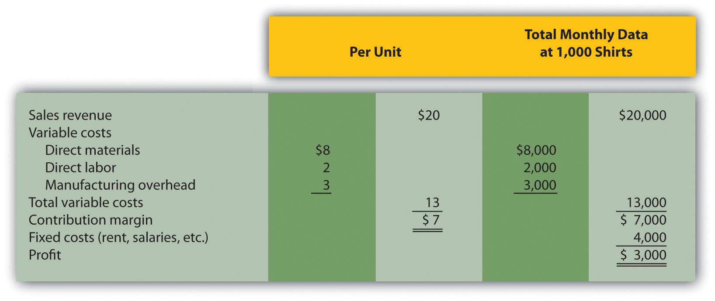

The monthly information provided relates to the company’s routine monthly operations. A representative of the local high school recently approached Tony to ask about a one-time special order. The high school will be hosting a statewide track and field event and is willing to pay Tony’s T-shirts $17 per shirt to make 200 custom T-shirts for the event. Because enough idle capacity exists to handle this order, it will not affect other sales. That is, Tony has the factory space and machinery available to produce more T-shirts.

Tony incurs the same variable costs of $13 per unit to produce the special order, and he will pay a firm $600 to design the graphics that will be printed on the shirts. This special order will have no other effect on Tony’s monthly fixed costs.

Question: Should Tony accept the special order?

Answer: Let’s use differential analysis to answer this question. As shown in , Alternative 1 assumes Tony rejects the special order, and Alternative 2 assumes he accepts the special order. The differential analysis in shows that Tony’s would be better off accepting the special order, as profit increases $200.

Figure 7.13 Special Order Differential Analysis for Tony’s T-Shirts
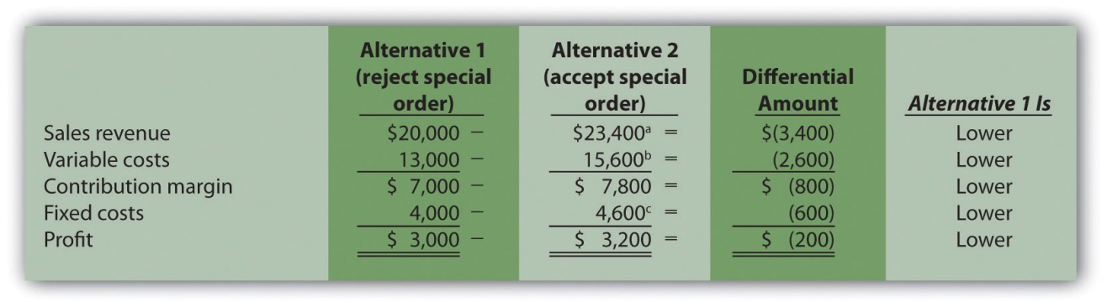

a $23,400 = $20,000 + ($17 per shirt × 200 shirts).

b $15,600 = $13,000 + ($13 × 200 shirts).

c $4,600 = $4,000 + $600 cost for special order design.

Provides an alternative presentation of differential analysis for Tony’s T-shirts. As discussed earlier in the chapter, this presentation summarizes the differential revenues and costs.

Figure 7.14 Summary of Differential Analysis for Tony’s T-Shirts
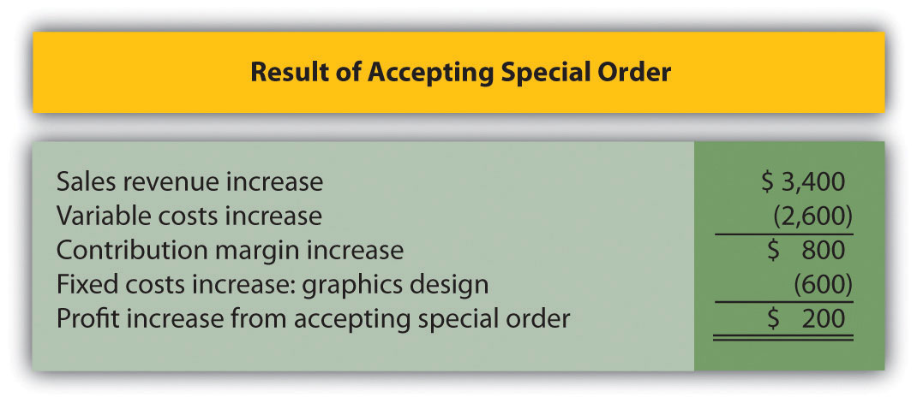

Note: Amounts shown in parentheses indicate a negative impact on profit, and amounts without parentheses indicate a positive impact on profit.

Shows the differential revenues and costs for the special order being considered. If Tony’s T-shirts accepts the special order, sales revenue will increase $3,400 with a corresponding increase in variable costs of $2,600. Fixed costs will increase by $600 because design work is required for the special order. Thus profit will increase by $200 (= $3,400 − $2,600 − $600).

Special Order Assumptions

Question: What assumptions were made with the differential analysis performed for Tony’s T-shirts?

Answer: We made two important assumptions in the Tony’s T-shirts special order example. The first assumption is that Tony’s has enough idle capacity to handle the order without disrupting regular customer orders. Suppose Tony’s T-shirts is operating at capacity and cannot produce any more T-shirts. Tony must turn away regular customers to make room for the special order. In this scenario, the opportunity cost of turning away existing customers must be considered in the differential analysis.

The second assumption is that this is a one-time order, and therefore represents a short-run pricing decision. If Tony’s T-shirts expects future orders from the high school at the $17 per shirt price, the company must consider the impact this might have on long-run pricing with other customers. That is, regular customers may hear of this special price and demand the same price, particularly those customers who have been loyal to Tony’s T-shirts for many years. Tony’s might be forced to lower prices for regular customers, thereby eroding the company’s profits over time. The key point is that companies evaluating special orders can drop prices in the short run to cover differential variable and fixed costs. But in the long run, prices must cover all variable and fixed costs.

Computer Application
Using Excel to Perform Differential Analysis
Managers often perform differential analysis with the help of computer software for several reasons:
- Once the format is established, the template can be used repeatedly for different scenarios.
- Formulas underlie all calculations, thereby minimizing the potential for math errors and speeding up the process.
- Changes can be made easily without having to redo the entire analysis.
An example of how to use Excel to perform differential analysis for the special order scenario presented in is shown here. Although many accounting courses do not require the use of computer spreadsheets, you are encouraged to use spreadsheet software like Excel when preparing homework or working review problems.
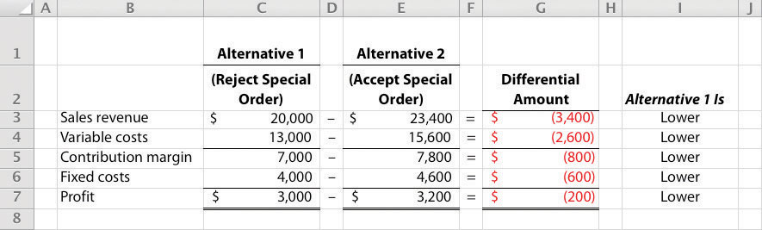

KEY TAKEAWAY
- Managers often use differential analysis to decide whether to accept a special one-time order made by a customer. Managers compare sales revenue and costs for each alternative (accept or reject the special order), and select the alternative with the highest profit. Organizations must be careful to consider the long-run implications of reducing prices for special orders.

REVIEW PROBLEM 7.6
The following monthly financial data are for Quicko’s, a company that makes photocopies for its customers. On average, Quicko’s makes 100,000 copies each month.
Quicko’s is approached by a local restaurant that would like to have 20,000 flyers copied. The restaurant asks Quicko’s to produce the flyers for 7 cents a copy rather than the standard price of 8 cents. Quicko’s can produce up to 130,000 copies a month, so the special order will not affect regular customer sales. Variable costs per copy will remain at 5 cents, but production of the restaurant flyers will require a special copy machine part that costs $250. This special order will have no other effect on monthly fixed costs.
- Using the differential analysis format presented in , determine whether Quicko’s would be better off accepting or rejecting the special order.
- Summarize the result of accepting the special order using the format presented in .
- Assume Quicko’s can only produce 100,000 copies per month, and that regular customer sales would decrease as a result of the special order. Using the differential analysis format presented in , determine whether Quicko’s would be better off accepting or rejecting the special order.
Solution to Review Problem 7.6

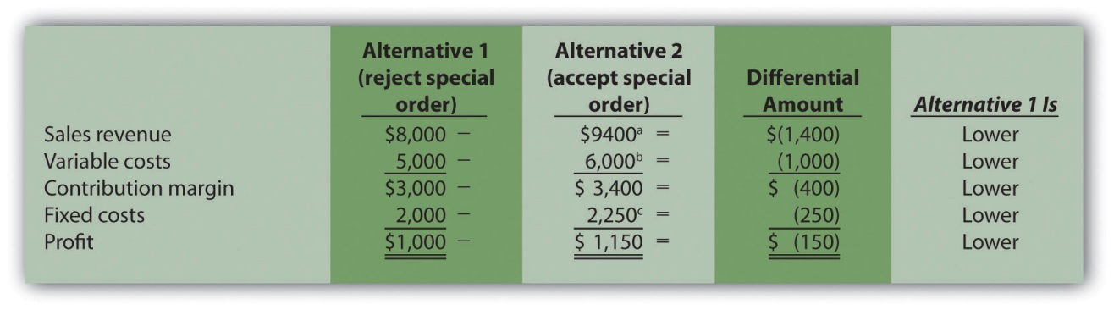
ª $9,400 = $8,000 + ($0.07 per copy × 20,000 copies);or alternative approach: ($0.08 per copy × 100,000 copies) + ($0.07 per copy × 20,000 copies).
^{b} $6,000 = $5,000 + ($0.05 per copy × 20,000 copies); or alternative approach: $0.05 × 120,000 copies.
^{c} $2,250 = $2,000 + $250 cost for copy machine part.
This analysis shows that Quicko’s would be better off accepting the special order because profit is $150 higher for Alternative 2.

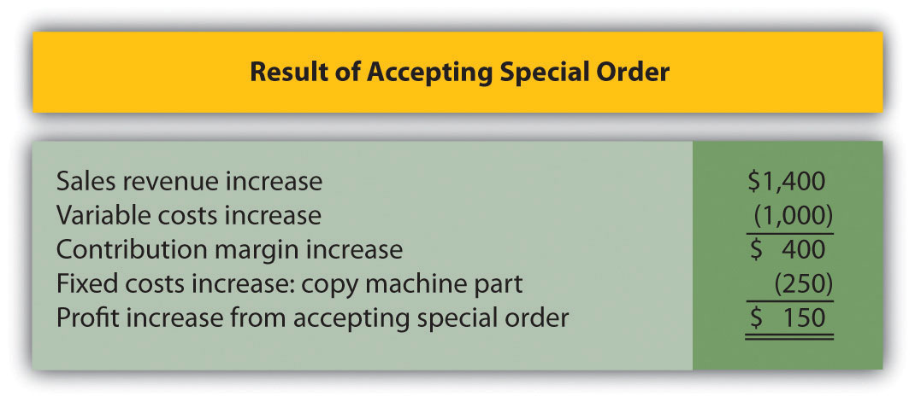
Note: Amounts shown in parentheses indicate a negative impact on profit, and amounts without parentheses indicate a positive impact on profit.
- Assuming Quicko’s has a capacity of 100,000 copies per month, the analysis shows the company would be better off rejecting the special order because profit is $450 higher for this alternative.
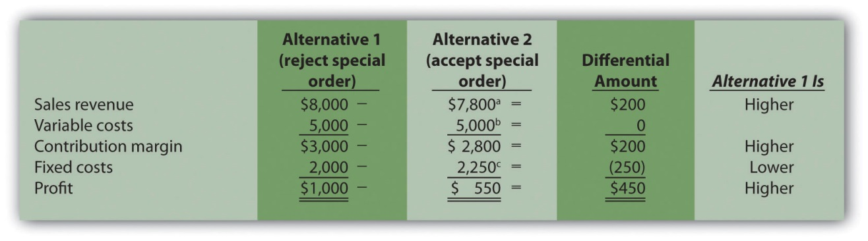
ª $7,800 = ($0.08 × 80,000 regular customer copies) + ($0.07 × 20,000 special order copies).
^{b} $2,250 = $2,000 + $250 cost for copy machine part.

7.7 Cost-Plus Pricing and Target Costing

LEARNING OBJECTIVE
- Understand how to use cost-plus pricing and target costing to establish prices.

The previous section focuses on using differential analysis to assess pricing for special orders. Organizations also use other approaches to establish prices, such as cost-plus pricing and target costing. We cover these two approaches next.

Cost-Plus Pricing

Questions: Companies that produce custom products, such as homes or landscaping for commercial buildings, often have a difficult time determining a reasonable market price. Prices for these products can be determined using cost-plus pricing. How is cost-plus pricing used to arrive at a reasonable price?

Answer: Cost-plus pricing starts with an estimate of the costs incurred to build a product or provide a service, and a certain profit percentage is added to establish the price. For example, a defense contractor working with the government assumes the cost to build a new fighter jet is $60 million. As there is no open market price for this product, the contractor must come up with an approach to establishing the price that does not rely on market pricing. Based on industry-wide standards and negotiations with the government, the contractor requests a 10 percent markup on cost. If the government accepts this proposal, the contractor will receive $66 million for each plane delivered [$66 million = $60 million + ($60 million × 10 percent)].

The concept of cost-plus pricing sounds simple. However, the difficulty is in determining which costs should be included. Are only variable product costs included? Should fixed manufacturing overhead be included? What about selling costs? The answers to these questions depend on the negotiations between buyer and seller, and should be clearly defined in the agreement. When using cost-plus pricing, it is important to establish in advance which costs are to be included for pricing purposes.

Target Costing

Question: Organizations are constantly trying to find ways to become more efficient and reduce costs. However, once manufacturing firms design a product and begin production, it is difficult to make significant changes that will reduce costs. How can target costing help with this issue?

Answer: Target costing is an approach that mitigates cost efficiency problems associated with introducing new products by integrating the product design, desired price, desired profit, and desired cost into one process beginning at the product development stage. Target costing has four steps:

Step 1. Design a product that provides the features and price demanded by customers.

Step 2. Determine the company’s desired profit.

Step 3. Derive the target cost by subtracting the desired profit (from step 2) from the desired price (from step 1).

Step 4. Engineer the product to achieve the target cost (from step 3). If the desired target cost cannot be achieved, the company must go back to step 1 and reevaluate the features and price.

For example, suppose Hewlett-Packard designs a laser printer with features that customers have requested and wants to sell it for $240; this is Step 1. Management requires a profit equal to 40 percent of the selling price, or $96 (= $240 × 40 percent); this is Step 2. The target cost is $144 (= $240 − $96); this is Step 3. The product engineers must now design this product in detail to achieve or beat the target cost of $144; this is Step 4.

KEY TAKEAWAY
- Cost-plus pricing starts with an estimate of the costs incurred to build a product, and a certain profit percentage is added to establish the price. Companies often use this method when it is difficult to determine a reasonable market price. Target costing integrates the product design, desired price, desired profit, and desired cost into one process beginning at the product development stage.

REVIEW PROBLEM 7.7
Suppose Nike, Inc., has developed a new shoe that can be sold for $140 a pair. Management requires a profit equal to 60 percent of the selling price. Determine the target cost of this product.
Solution to Review Problem 7.7
The target cost of $56 is found by subtracting the target profit from the target selling price. This calculation is as follows.

7.8 Identifying and Managing Bottlenecks

LEARNING OBJECTIVE
- Understand the theory of constraints.

Question: As we noted in , many companies have limited resources in such areas as labor hours, machine hours, facilities, and materials. These constraints will likely affect a company’s ability to produce goods or provide services. Companies facing constraints often use a variation of differential analysis to optimize the use of constrained resources called the theory of constraints. What are constrained resources, and how does the theory of constraints help managers make better use of these resources?

Answer: Constrained resources are often referred to as bottlenecks. Abottleneck is a process in which the work to be performed exceeds available capacity. The theory of constraints is a recently developed approach to managing bottlenecks.

We will look at an example to help explain how the theory of constraints works. Assume Computers, Inc., produces desktop computers using six departments as shown in . Computers are assembled in departments 1, 2, and 3 and are then sent to department 4 for quality testing. Once testing is complete, products are packaged in department 5. Department 6 is responsible for shipping the products.

Question: The theory of constraints provides five steps to help managers make efficient use of constrained resources. What are these five steps, and how will they help Computers, Inc.?

Answer: The five steps are described here, with a narrative indicating how Computers, Inc., would utilize each step.

Step 1. Find the constrained resource (bottleneck).

In this step, the process that limits production is identified. The management at Computers, Inc., has identified department 4, quality testing, as the bottleneck because assembled computers are backing up at department 4. Quality testing cannot be performed fast enough to keep up with the inflow of computers coming from departments 1, 2, and 3. A limitation of labor hours available to perform testing is causing this backlog.

Step 2. Optimize the use of the constrained resource.

The constrained resource has been identified as the number of labor hours available to perform testing. At this point, Computers, Inc., would like to optimize the labor hours used for quality testing. To assist in this goal, we will calculate the contribution margin per unit of constraint (the unit of constraint is labor hour in this example). Production will then focus on products with the highest contribution margin per labor hour. provides this information for each product. (We first introduced the concept of calculating a contribution margin per unit of constraint in .)

Figure 7.16 Contribution Margin per Unit of Constrained Resource for Computers, Inc.
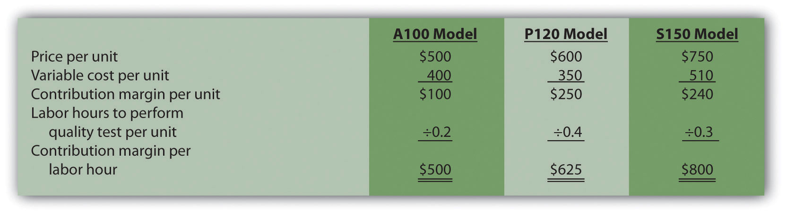

Based on the information presented in , and given that labor hours in department 4 is the constraint, Computers, Inc., would optimize the use of labor hours by producing the S150 model because it provides a contribution margin of $800 per labor hour versus $500 for the A100 model, and $625 for the P120 model.

Step 3. Subordinate all nonbottleneck resources to the bottleneck.

The goal in this step is to shift nonbottleneck resources to the bottleneck in department 4. At this point, improving efficiencies in other departments does little to alleviate the bottleneck in department 4. Thus Computers, Inc., must try to move resources from other areas to department 4 to reduce the backlog of computers to be tested.

Step 4. Increase bottleneck efficiency and capacity.

Management’s goal is to loosen the constraint by providing more labor hours to department 4. For example, management may decide to move employees from departments 1, 2, and 3 to the quality testing department. Another option is to authorize overtime for the workers in department 4. Perhaps management will consider hiring additional workers for department 4.

Step 5. Repeat steps 1 through 4 for the new bottleneck.

Once the bottleneck in department 4 is relieved, a new bottleneck will likely arise elsewhere. Going back to step 1 requires management to identify the new bottleneck and follow steps 2 through 4 to alleviate the bottleneck.

KEY TAKEAWAY
- Most companies have limited resources in areas such as labor hours, machine hours, facilities, and materials. The theory of constraints is an approach that enables companies to optimize the use of limited resources. Five steps are involved. First, find the constrained resource (or bottleneck). Second, optimize the use of the constrained resource. Third, subordinate all nonbottleneck resources to the bottleneck. Fourth, increase bottleneck efficiency and capacity. Fifth, repeat the first four steps for the new bottleneck.

REVIEW PROBLEM 7.8
Southside Company produces three types of baseball gloves: child, teen, and adult. The gloves are produced in separate departments and sent to the quality testing department before being packaged and shipped. A machine-hour bottleneck has been identified in the quality testing department. Southside would like to optimize its use of machine hours (step 2) by producing the two most profitable gloves. The machine hours required for each glove follow:
Child glove | 0.25 machine hours
Teen glove | 0.40 machine hours
Adult glove | 0.50 machine hours
Price and variable cost information is as follows:
 | Price | Variable Cost
Child glove | $15 | $ 5
Teen glove | 20 | 8
Adult glove | 35 | 22
- Calculate the contribution margin per unit of constrained resource for each glove.
- Which two gloves would Southside prefer to produce and sell to optimize the use of machine hours in the quality testing department?
Solution to Review Problem 7.8

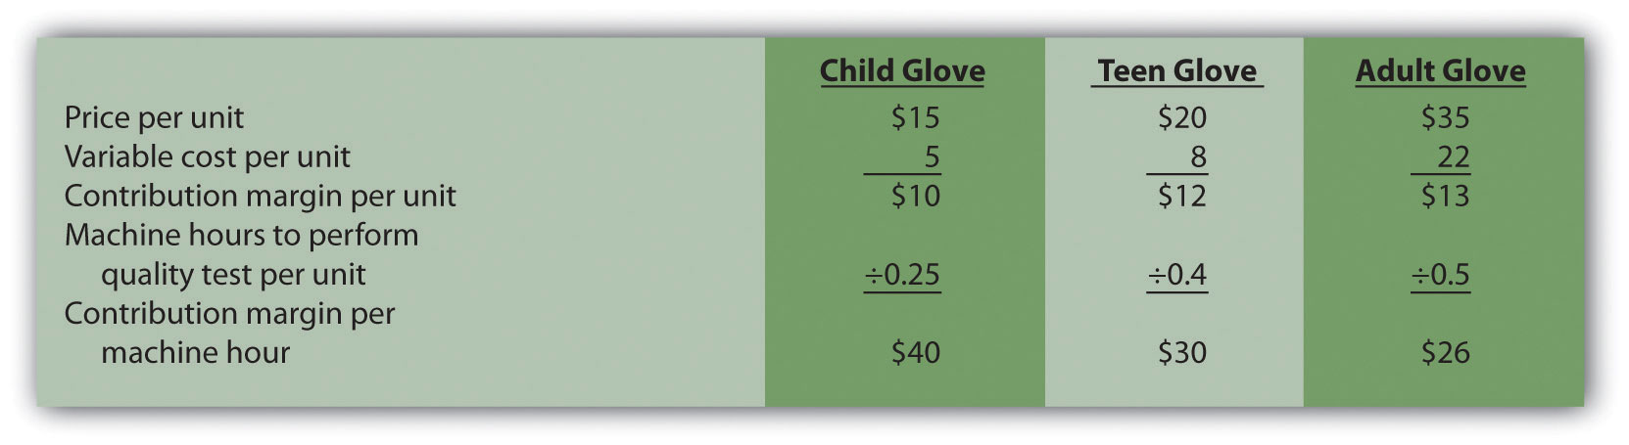
- The company would prefer to produce and sell the child and teen gloves, since these products have the highest contribution margin per machine hour.

7.9 Be Aware of Qualitative Factors

LEARNING OBJECTIVE
- Evaluate qualitative factors when using differential analysis.

Question: This chapter has focused on using relevant revenue and cost information to perform differential analysis. Using these quantitative factors to make decisions allows managers to support decisions with measurable data. For example, the idea of outsourcing production of wakeboards at Best Boards, Inc., presented at the beginning of the chapter, was rejected because it was more costly to outsource production of the boards than to produce them internally. Although using quantitative factors for decision making is important, management must also consider qualitative factors. How might the consideration of qualitative factors improve decisions made by managers?

Answer: Qualitative factors may outweigh the quantitative factors in making a decision. For example, assume management at Best Boards, Inc., believes there will be a decline in the market for wakeboards after next year. Outsourcing production makes it easier to quickly reduce costs in the face of a downturn by simply ordering fewer wakeboards from the supplier. Continuing to build the boards internally takes away this flexibility. The significant fixed costs often associated with manufacturing firms are difficult to reduce in the short run if production declines. Thus the qualitative factor of being able to reduce manufacturing costs quickly by outsourcing production may outweigh the quantitative factors shown inFigure 7.3 "Summary of Differential Analysis for Best Boards, Inc." andFigure 7.4 "Product Line Decision".

Question: What if the quantitative differential analysis for Best Boards had a different result, in that it showed the company should outsource? What qualitative factors should management consider before implementing this decision?

Answer: Management must consider whether product quality would remain the same. Financial stability of the producer must be considered as well. It does no good to outsource production and eliminate production facilities and employees if the producer being used suddenly shuts down. Also, employee morale tends to slide if employees in one segment of a company are fired. This can lead to an unhappy and inefficient workforce in other areas of the company, causing costs to rise. These are just a few of the qualitative factors that must be weighed against quantitative factors when performing differential analysis.

KEY TAKEAWAY
- Although accountants are responsible for providing relevant and objective financial information to help managers make decisions, qualitative factors also play a significant role in the decision-making process.

REVIEW PROBLEM 7.9
What qualitative factors should management consider when deciding whether to outsource production or keep production within the company?
Solution to Review Problem 7.9
The qualitative factors that management should consider when deciding whether to outsource production include the following:
- Will the quality of the products remain the same?
- Will shutting down the manufacturing facility have a negative impact on the morale of remaining employees?
- Is the producer that will be making the product financially stable and reliable?

7.10 Appendix: Making Decisions Involving Joint Costs

LEARNING OBJECTIVE
- Analyze the impact that joint costs have on decision making.

Question: When two or more products are produced from a single input, these products are called joint products. The cost of this single input and the related manufacturing process costs are called joint costs. For example, lumber companies often must deal with joint products (different types of lumber) resulting from one input (a log). How do the concepts of joint products and joint costs help a lumber company establish a cost for each of its products?

Answer: Suppose Oregon Lumber Company takes a log (the single input) and mills it into two types of products: high quality Grade A lumber, and lower quality Grade B lumber. Grade A lumber and Grade B lumber are examples of joint products, and the cost of the logs and related manufacturing process costs are examples of joint costs.

presents the information for Oregon Lumber for the month of June. Joint costs for the month total $250,000. Notice that the split-off point is the point at which identifiable products emerge from the production process. The issue is how to allocate joint costs—the $250,000 in production costs incurred prior to the split-off point—to the resulting joint products.

Two methods are commonly used to allocate these joint costs to the joint products: the physical quantities method and the sales value method. We discuss each of these methods next.

The Physical Quantities Method

Question: The physical quantities method allocates joint costs based on a physical measure of output. Assume Oregon Lumber produces 600,000 board feet of Grade A lumber and 200,000 board feet of Grade B lumber during June.How would Oregon Lumber use this information to allocate $250,000 in joint production costs to each grade of lumber?

Answer: Oregon Lumber would allocate 75 percent of the joint costs to Grade A lumber (75 percent = 600,000 Grade A board feet ÷ 800,000 total board feet), and 25 percent of the joint costs to Grade B lumber.

Grade A allocation:

$187,500 allocation = $250,000 joint costs × (600,000 Grade A board feet ÷ 800,000 total board feet)

Grade B allocation:

$62,500 allocation = $250,000 joint costs × (200,000 Grade B board feet ÷ 800,000 total board feet)

presents the profitability of each joint product for the month using the physical quantities method assuming Grade A lumber sells for $0.40 per board foot and Grade B lumber sells for $0.30 per board foot.

Figure 7.18 Joint Product Profitability for Oregon Lumber Company: Physical Quantities Method
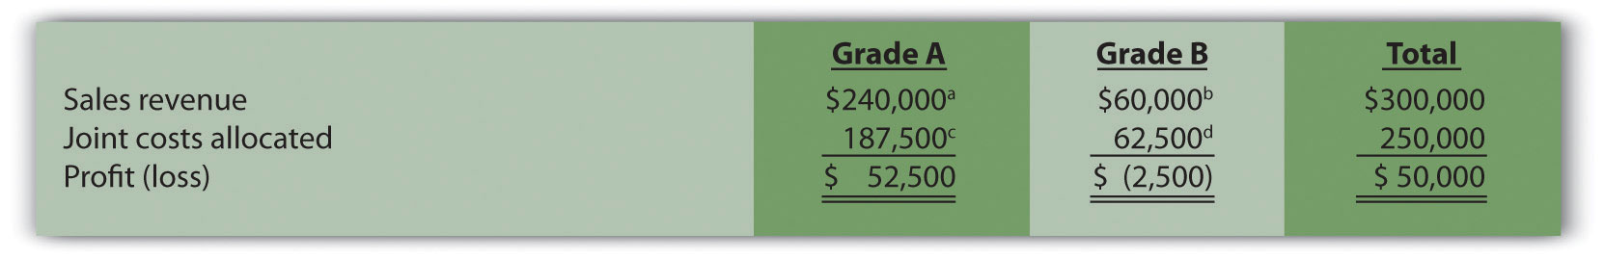

ª $240,000 = $0.40 per board foot × 600,000 Grade A board feet.

b $60,000 = $0.30 per board foot × 200,000 Grade B board feet.

c $187,500 = $250,000 joint costs × (600,000 Grade A board feet ÷ 800,000 total board feet).

d $62,500 = $250,000 joint costs × (200,000 Grade B board feet ÷ 800,000 total board feet).

Although Grade B lumber appears to be unprofitable, elimination of Grade B lumber sales would not increase overall profit for Oregon Lumber. Grade B lumber contributes $60,000 to covering joint costs. Thus elimination of Grade B lumber sales would result in a decrease in overall profit of $60,000. The $62,500 in joint cost allocated to Grade B lumber would simply be reallocated to Grade A lumber.

The Sales Value Method

Question: A different approach to allocating joint costs to joint products is thesales value method, which allocates joint costs based on the relative sales value of each product at the split-off point. How would Oregon Lumber allocate joint production costs using this method?

Answer: Because sales revenue totals $240,000 for Grade A lumber and $60,000 for Grade B lumber, 80 percent of the joint costs are allocated to Grade A lumber (80 percent = $240,000 Grade A revenue ÷ $300,000 total revenue), and 20 percent of the joint costs are allocated to Grade B lumber:

Grade A allocation:

$200,000 allocation = $250,000 joint costs × ($240,000 Grade A sales value ÷ $300,000 total sales value)

Grade B allocation:

$50,000 allocation = $250,000 joint costs × ($60,000 Grade B sales value ÷ $300,000 total sales value)

presents the profitability of each joint product for the month using the sales value method, again assuming Grade A lumber sells for $0.40 per board foot, and Grade B lumber sells for $0.30 per board foot.

Figure 7.19 Joint Product Profitability for Oregon Lumber Company: Sales
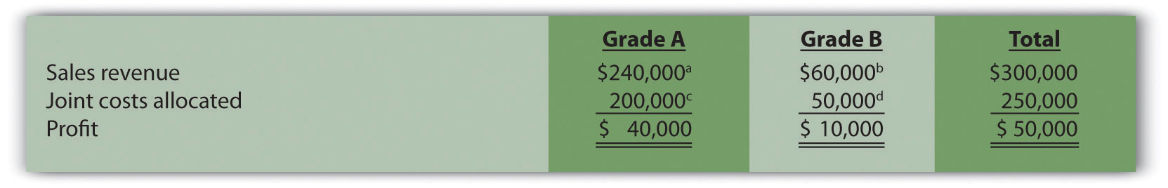

ª $240,000 = $0.40 per board foot × 600,000 Grade A board feet.

b $60,000 = $0.30 per board foot × 200,000 Grade B board feet.

c $200,000 = $250,000 joint costs × ($240,000 Grade A sales value ÷ $300,000 total sales value).

d $50,000 = $250,000 joint costs × ($60,000 Grade B sales value ÷ $300,000 total sales value).

The sales value method assumes that profit as a percent of sales will remain the same across all products. For example, shows that Grade A lumber has a profit margin ratio of 16.67 percent (= $40,000 profit ÷ $240,000 sales), as does Grade B lumber (= $10,000 profit ÷ $60,000 sales). This method also ensures that joint costs allocated to each product will not exceed sales revenue for each product (unless total joint costs are higher than total revenue).

As you review and , notice that the total column for both methods of joint cost allocation is the same. The issue is not with the overall results. The issue is how to allocate joint costs to each joint product.

Deciding Whether to Process Further

Question: Assume Oregon Lumber Company has the option of processing Grade B lumber further into a finished product by sanding the lumber and painting it with primer. This option is presented in . The sanded and painted Grade B lumber sells for $0.45 per board foot rather than $0.30 for the unfinished Grade B lumber. The additional cost to sand and paint the Grade B lumber is $0.05 per board foot. Should Oregon Lumber process Grade B lumber further into finished lumber?

Figure 7.20 Further Processing of Oregon Lumber Company’s Grade B Lumber

Answer: The answer depends on whether the additional revenue exceeds the additional cost of processing Grade B lumber further. Since the additional revenue of $0.15 per board foot (= $0.45 finished price − $0.30 unfinished price) is greater than the additional $0.05 per board foot processing cost, Oregon Lumber should process the Grade B lumber further into finished lumber. Profit increases $0.10 per board foot as a result of processing further (= $0.15 additional revenue − $0.05 additional cost).

Oregon Lumber will decide whether or not to process Grade B lumber further regardless of how joint costs are allocated to Grade A and Grade B lumber. In a sense, joint costs are sunk costs with respect to this decision, and will not influence future processing decisions. Thus joint costs incurredprior to the split-off point are irrelevant to the decision whether to process further after the split-off point.

KEY TAKEAWAY
- Two or more products made from a single input are called joint products. The costs of the single input and related manufacturing process costs must be allocated to each of the joint products. The physical quantities method allocates joint costs based on a physical measure of output (e.g., pounds or yards of material). The sales value method allocates joint costs based on the relative sales value for each of the joint products. Regardless of the allocation method used, total joint costs and total profit remain the same. Companies must often decide whether to process a joint product further. If as a result of processing the product further, additional sales revenue exceeds additional costs, the wise decision is to process further.

REVIEW PROBLEM 7.10.
Fresh Veggies, Inc., purchased 10,000 pounds of fresh apples from a local grower for $4,000. The apples were separated into high-quality Grade A apples (3,000 pounds) and lower-quality Grade B apples (7,000 pounds). Fresh Veggies sells Grade A apples for $0.80 per pound and Grade B apples for $0.50 per pound.
- Allocate joint costs to each product using the physical quantities method (pounds), and calculate the profit or loss for each product.
- Allocate joint costs to each product using the relative sales value method, and calculate the profit or loss for each product.
- Assume Grade B apples can be processed further into dried apple slices for an additional $0.20 per pound. Customers are willing to pay $0.65 per pound for dried apple slices. Should Fresh Veggies, Inc., process the Grade B apples further?
Solution to Review Problem 7.10.

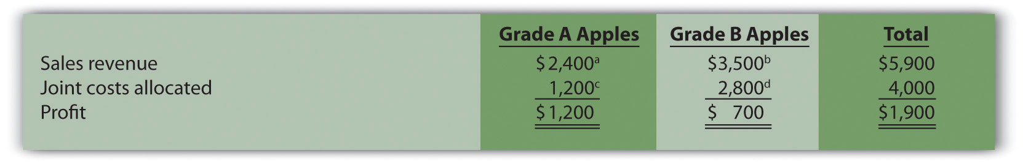
ª $2,400 = $0.80 per pound × 3,000 pounds of Grade A apples.
^{b} $3,500 = $0.50 per pound × 7,000 pounds of Grade B apples.
^{c} $1,200 = $4,000 joint costs × (3,000 pounds of Grade A apples ÷ 10,000 total pounds).
^{d} $2,800 = $4,000 joint costs × (7,000 pounds of Grade B apples ÷ 10,000 total pounds).

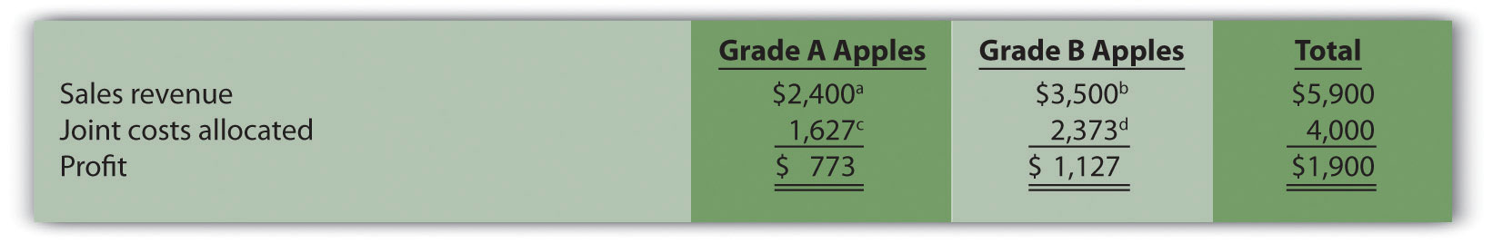
ª $2,400 = $0.80 per pound × 3,000 pounds of Grade A apples.
^{b} $3,500 = $0.50 per pound × 7,000 pounds of Grade B apples.
^{c} $1,627 (rounded) = $4,000 joint costs × ($2,400 Grade A sales value ÷ $5,900 total sales value).
^{d} $2,373 (rounded) = $4,000 joint costs × ($3,500 Grade B sales value ÷ $5,900 total sales value).
- Because the additional revenue of $0.15 per pound (= $0.65 price with further processing − $0.50 without further processing) is less than the additional $0.20 per pound processing cost, Fresh Veggies should notprocess the Grade B apples further into dried apples. Profit decreases $0.05 per pound (= $0.20 additional cost − $0.15 additional revenue) as a result of processing further.

END-OF-CHAPTER EXERCISES
Questions
- What are differential revenues and costs?
- What is differential analysis?
- Define what is meant by a “make-or-buy” decision. Describe how differential analysis can be used to assist in making this type of decision.
- and provide two different formats for presenting the same analysis. Describe the similarities and differences in these two formats.
- What is an avoidable cost?
- Review Why did Salt Lake City choose to outsource the concrete panels to a company in Mexico City even though the library was being constructed in Salt Lake City?
- How is differential analysis used in deciding whether to keep or drop product lines?
- Why are direct fixed costs typically differential costs?
- Why are allocated fixed costs typically not differential costs?
- What is an opportunity cost? Why is an opportunity cost a differential cost?
- Review What did Kmart do with 24 of its stores? Why might Kmarthave taken this action?
- How is differential analysis similar for customer decisions and product line decisions?
- Review Why did ABCO Automation, Inc., fire its biggest client even though the client provided close to 60 percent of ABCO’s annual revenue?
- What two important assumptions must be considered when evaluating special order scenarios?
- What is cost-plus pricing?
- Describe the four steps of target costing.
- Describe the five steps used to manage constraints according to the theory of constraints.
- What is a qualitative advantage of keeping unprofitable customers?
- What are joint products and joint costs?
- Describe the two methods of allocating joint costs.
Brief Exercises
- Cutting Costs at Best Boards, Inc. Refer to the dialogue at Best Boards, Inc., presented at the beginning of the chapter. How does the vice president of operations, Jim Muller, expect to reduce costs and earn his bonus? What was the flaw in his plan?
- Make-or-Buy Decision. Coffee Mugs, Inc., currently manufactures ceramic coffee mugs. Management is interested in outsourcing production to a reputable manufacturing company that can supply the cups for $2 per unit. Coffee Mugs produces 100,000 mugs each year. Variable production costs are $0.80 and annual fixed costs are $150,000. If production is outsourced, all variable costs and 40 percent of annual fixed costs will be eliminated.
Perform differential analysis using the format presented inand explain which alternative is best, Alternative 1 (producing internally) or Alternative 2 (outsourcing).
- Product Line Decision. The following segmented annual income statement is for Flash Drive, Inc.:
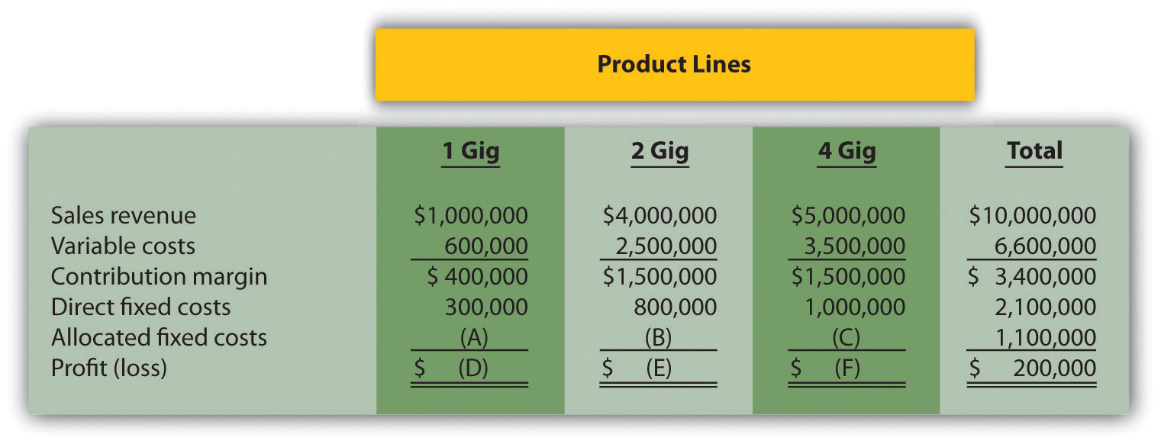
For items A, B, and C, assign allocated fixed costs to each product line based on sales revenue for each product line as a proportion of total sales revenue. For example, the 1 Gig product will be assigned 10 percent of allocated fixed costs (= $1,000,000 in 1 Gig sales revenue ÷ $10,000,000 total sales revenue), or $110,000 (=$1,100,000 total allocated fixed costs × 10 percent). For items D, E, and F, calculate the profit or loss for each product line.
- Customer Decision. Consulting Group LLC has two customers. Customer One generates $150,000 in income after direct fixed costs are deducted, and Customer Two generates $200,000 in income after direct fixed costs are deducted. Allocated fixed costs total $300,000 and are assigned 30 percent to Customer One and 70 percent to Customer Two based on several different cost drivers. Total allocated fixed costs remain the same regardless of how these costs are assigned to customers.
Calculate the amount of allocated fixed costs to be assigned to each customer, and determine the profit or loss for each customer. Should Consulting Group drop Customer Two? Explain.
- Special Order Decision: Operating with Idle Capacity. Jerseys, Inc., currently produces 10,000 jerseys a year for its regular customers and charges $10 per jersey. Jerseys, Inc., has capacity to produce an additional 5,000 jerseys if sales grow in the future. Variable costs total $6 per jersey and annual fixed costs total $15,000. The city of Rockville recently approached the company and proposed a one-time purchase of 3,000 jerseys for $8 each. Should Jerseys, Inc., accept the proposal? Explain.
- Cost-Plus Pricing. KJ Home Builders is bidding on a custom home for a potential customer. The company typically charges 15 percent above cost and estimates the home will cost $500,000 to build. Calculate the price bid by KJ Home Builders.
- Constrained Resources. Deal, Inc., produces two types of computers: Vortex and Zoom. The computers are produced in separate departments and sent to the quality testing department before being packaged and shipped. A labor-hour bottleneck has been identified in the quality testing department due to the high skill requirements of the job. Deal, Inc., would like to optimize its use of labor hours by producing the most profitable computer. Based on the information shown, calculate the contribution margin per quality testing labor hour for each product:
 | Quality Testing Labor Hours | Contribution Margin
Vortex | 0.50 | $600
Zoom | 0.40 | 500
- Evaluating Qualitative Factors. Assume your company is considering whether to outsource production. What qualitative factors should be considered before making this decision?
- Allocating Joint Costs (Appendix). Charlotte Company produces two joint chemical products, product A and B. Prior to the split-off point, the company incurred $100,000 in joint costs. Production totaled 12,000 gallons for product A and 8,000 gallons for product B. Allocate joint costs to each product using the physical quantities method (gallons).
Exercises: Set A
- Make-or-Buy Decision. Wheels, Inc., currently manufactures its own custom rims for automobiles. Management is interested in outsourcing production of these rims to a reputable manufacturing company that can supply the rims for $80 per unit. Wheels, Inc., incurs the following annual production costs to produce 10,000 rims internally.
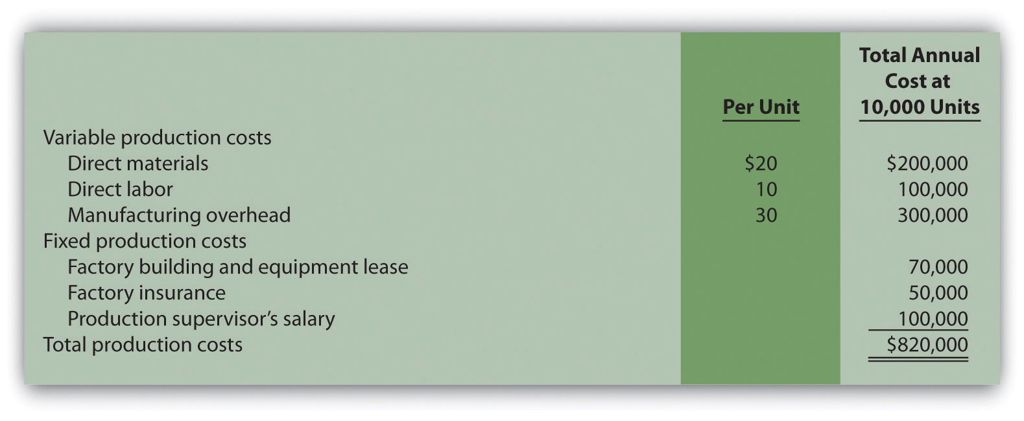
If production is outsourced, all variable production costs, factory building and equipment lease costs, and factory insurance costs will be eliminated. The production supervisor’s salary cost will remain regardless of the decision to outsource or to produce internally because the supervisor recently signed a long-term contract with Wheels, Inc.
Required:
  - Perform differential analysis using the format presented in . Assume making the rims internally is Alternative 1, and buying the rims from an outside manufacturer is Alternative 2.
  - Which alternative is best? Explain.
  - Summarize the result of outsourcing production using the format presented in .
  - Compare the format used in requirement a with that of requirement c.
- Product Line Decision. The following monthly segmented income statement is for Durango Company.
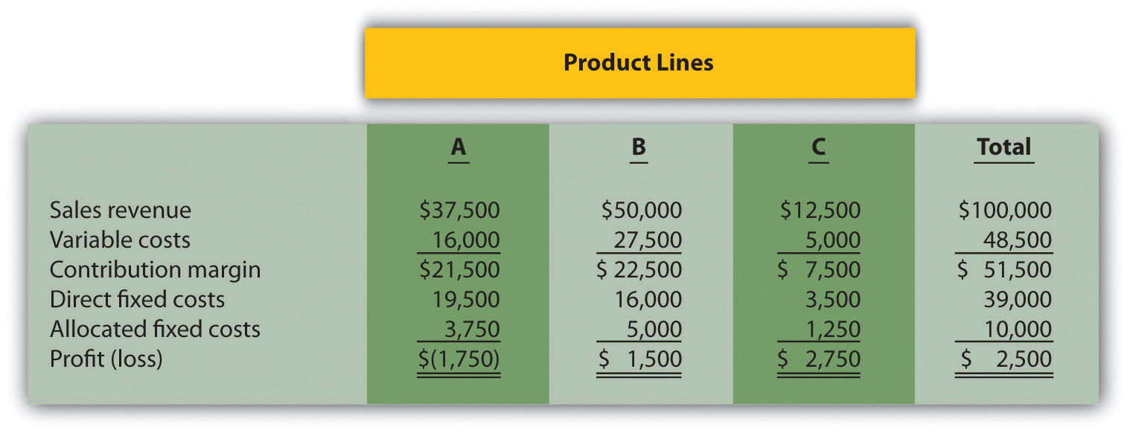
Management is concerned about the losses associated with product line A and is considering dropping this product line. Allocated fixed costs are assigned to product lines based on sales. If product line A is eliminated, total allocated fixed costs are assigned to the remaining product lines, and all variable and direct fixed costs for product line A will be eliminated.
Required:
  - Perform differential analysis using the format presented in . Assume keeping all product lines is Alternative 1, and dropping product line A is Alternative 2.
  - Which alternative is best? Explain.
  - Summarize the result of dropping product line A using the format presented in .
  - Explain why the loss shown for product line A in the segmented income statement might be misleading to management.
- Customer Decision. The following customer segmented quarterly income statement is for Accounting Associates.
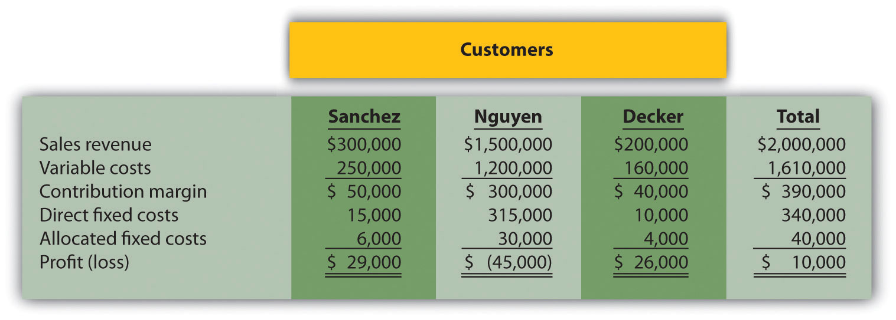
Management is concerned about the significant losses associated with the Nguyen account and would like to drop this customer. Allocated fixed costs are assigned to customers based on sales revenue. If Nguyen is dropped, total allocated fixed costs are assigned to the remaining customers, and all variable and direct fixed costs for the Nguyen account will be eliminated.
Required:
  - Perform differential analysis using the format presented in . Assume keeping all customers is Alternative 1, and dropping the Nguyen account is Alternative 2.
  - Which alternative is best? Explain.
  - Summarize the result of dropping the Nguyen account using the format presented in .
  - Explain what happened to the profitability of the other two customers as a result of dropping the Nguyen account.
- Special Order Decision: Operating with Idle Capacity. The following monthly financial data are for RadioCom, Inc., a maker of handheld VHF radios. RadioCom produces and sells 5,000 radios each month to regular customers.
RadioCom received an offer from the Coast Guard Auxiliary to purchase 1,000 radios next month for $75 per unit. RadioCom can produce up to 7,000 radios a month, so the special order would not affect regular customer sales. Variable costs per radio will remain at $60. This special order will have no effect on monthly fixed costs.
Required:
  - Using the differential analysis format presented in , determine whether RadioCom would be better off rejecting the special order (Alternative 1) or accepting the special order (Alternative 2).
  - Summarize the result of accepting the special order using the format presented in .
- Special Order Decision: Operating at Full Capacity. The following monthly financial data are for RadioCom, Inc., a maker of handheld VHF radios. RadioCom produces and sells 5,000 radios each month to regular customers.
RadioCom received an offer from the Coast Guard Auxiliary to purchase 1,000 radios next month for $75 per unit. RadioCom can only produce up to 5,000 radios a month, so the special order would result in reduced sales to regular customers. Variable costs per radio will remain at $60. This special order will have no effect on monthly fixed costs.
Required:
  - Using the differential analysis format presented in , determine whether RadioCom would be better off rejecting (Alternative 1) or accepting (Alternative 2) the offer received from the Coast Guard Auxiliary.
  - Summarize the result of accepting the special order using the format presented in .
- Target Costing. Quality Sounds, Inc., makes speakers and headphones for high-end sound systems. The marketing department has identified a market for a specific type of headphones that Quality Sounds does not currently produce, and expects to be able to sell each pair for $150. Management requires a profit of 45 percent of the selling price.
Required:
Determine the highest cost (target cost) management would be willing to accept to produce this product.
- Constrained Resources. Cycle, Inc., produces three types of bicycles: racer, cruiser, and climber. The bikes are produced in separate departments and sent to the quality testing department before being packaged and shipped. A labor-hour bottleneck has been identified in the quality testing department due to the high skill requirements of the job. Cycle, Inc., would like to optimize its use of labor hours by producing the two most profitable bikes. Information for each bike follows.
 | Quality Testing Labor Hours | Price | Variable Cost
Racer | 1.25 | $1,000 | $400
Cruiser | 1.00 | 500 | 300
Climber | 1.00 | 800 | 450
- Required:
  - Calculate the contribution margin per unit of constrained resource for each product.
  - Which two products would Cycle, Inc., prefer to produce and sell to optimize the use of labor hours in the quality testing department?
- Qualitative Factors. For each of the following independent scenarios, identify at least one qualitative factor that should be considered before making the decision.
  - A company sells three types of computers (laptops, desktops, and palmtops), all of which are profitable. The company faces a machine-hour bottleneck and plans to eliminate the palmtop product because it has the lowest contribution margin per machine hour.
  - A company plans to drop an unprofitable customer.
  - A maker of high-end stereo equipment would like to shut down its manufacturing facility and outsource production.
- Allocating Joint Costs (Appendix). Clemson Products produces two joint products, product Y and Z. Prior to the split-off point, the company incurred $60,000 in joint costs. Clemson Products produced 10,000 yards of product Y and 30,000 yards of product Z produced. Product Y sells for $4 per yard and product Z sells for $2 per yard.
Required:
  - Allocate joint costs to each product using the physical quantities method (yards), and calculate the profit or loss for each product.
  - Allocate joint costs to each product using the relative sales value method, and calculate the profit or loss for each product.
Exercises: Set B
- Make-or-Buy Decision. Quality Glass currently manufactures windshields for automobiles. Management is interested in outsourcing production of these windshields to a reputable manufacturing company that can supply the windshields for $45 per unit. Quality Glass incurs the following annual production costs to produce 15,000 windshields internally.
If production is outsourced, all variable production costs will be eliminated, and 80 percent of fixed production costs will be eliminated. Regardless of the decision to outsource or to produce internally, 20 percent of fixed production costs will remain .
Required:
  - Perform differential analysis using the format presented in . Assume making windshields internally is Alternative 1, and buying windshields from an outside manufacturer is Alternative 2.
  - Which alternative is best? Explain.
  - Summarize the result of outsourcing production using the format presented in .
  - Why might some managers prefer the format presented in requirement c?
- Product Line Decision. The following segmented annual income statement is for Office Express.
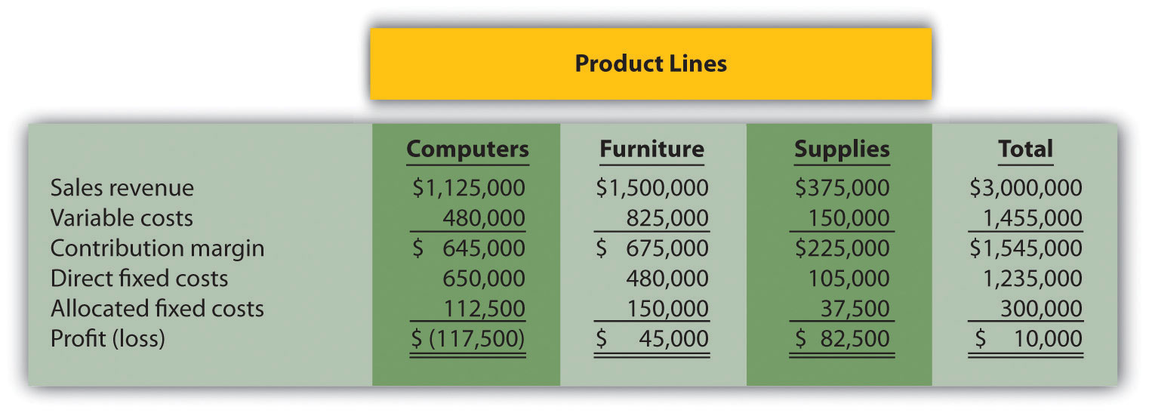
Management is concerned about the significant losses associated with the computers product line and would like to drop this product line. Allocated fixed costs are assigned to product lines based on sales. If the computers product line is eliminated, total allocated fixed costs are assigned to the remaining product lines, and all variable and direct fixed costs for the computers product line will be eliminated.
Required:
  - Perform differential analysis using the format presented in . Assume keeping all product lines is Alternative 1, and dropping the computers product line is Alternative 2.
  - Which alternative is best? Explain.
  - Summarize the result of dropping the computer product line using the format presented in .
  - Explain what happened to the profitability of the furniture product line as a result of dropping the computers product line.
- Customer Decision. The following customer segmented annual income statement is for Management Consulting, Inc.
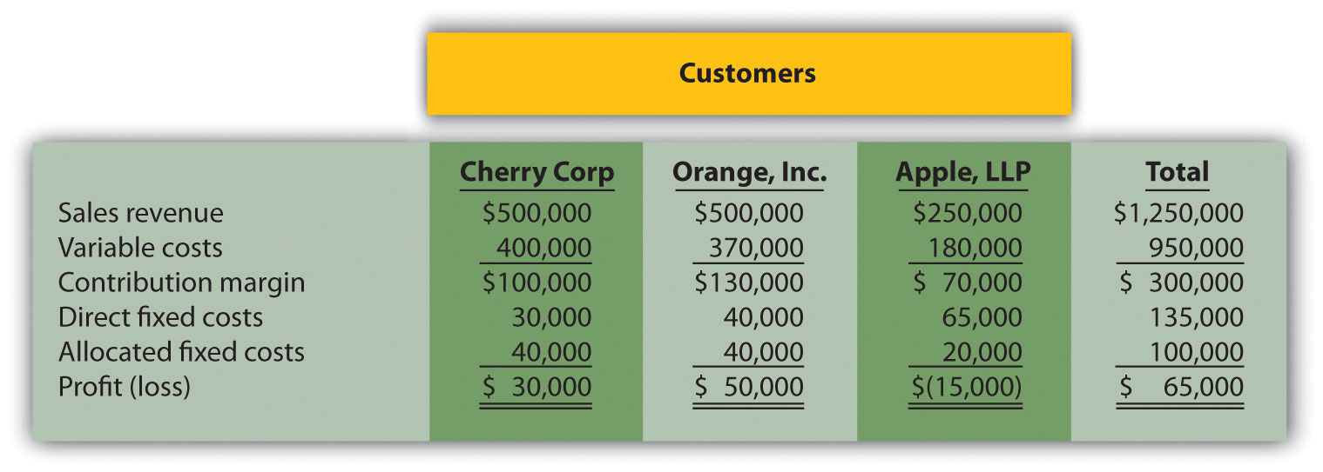
Management is concerned about the losses associated with the Apple LLP account and would like to drop this customer. Allocated fixed costs are assigned to customers based on sales revenue. If Apple LLP is dropped, total allocated fixed costs are assigned to the remaining customers, and all variable and direct fixed costs for the Apple LLP account will be eliminated.
Required:
  - Perform differential analysis using the format presented in . Assume keeping all customers is Alternative 1, and dropping the Apple LLP account is Alternative 2.
  - Which alternative is best? Explain.
  - Summarize the result of dropping the Apple LLP account using the format presented in .
  - Explain why the loss shown for the Apple LLP account in the segmented income statement might be misleading to management.
- Special Order Decision: Operating with Idle Capacity. The following monthly financial data are for Sport Socks, Inc., a maker of socks for runners. Sport Socks makes and sells 40,000 pairs each month to regular customers.
Sport Socks received an offer from a large sporting goods store to purchase 15,000 socks next month for $0.90 per pair. Sport Socks can produce up to 60,000 pairs of socks a month, so the special order would not affect regular customer sales. Variable costs per pair will remain at $0.70. This special order will cause fixed costs to increase by $6,000 for next month.
Required:
  - Using the differential analysis format presented in , determine whether Sport Socks would be better off rejecting the special order (Alternative 1) or accepting the special order (Alternative 2).
  - Summarize the result of accepting the special order using the format presented in .
- Special Order Decision: Operating at Full Capacity. The following monthly financial data are for Sport Socks, Inc., a maker of socks for runners. Sport Socks makes and sells 40,000 pairs each month to regular customers.
Sport Socks received an offer from a large sporting goods store to purchase 15,000 socks next month for $0.90 per pair. Assume Sport Socks can only produce up to 40,000 pairs of socks each month. Thus any special orders would result in reduced sales to regular customers. However, fixed costs willnot change as a result of the special order.
Required:
  - Using the differential analysis format presented in , determine whether Sport Socks would be better off rejecting the special order (Alternative 1) or accepting the special order (Alternative 2).
  - Summarize the result of accepting the special order using the format presented in .
- Target Costing. Nature Wood, Inc., makes wood tables for commercial use. The marketing department has identified a market for a specific table that the company does not currently produce, and it expects that each table could be sold for $1,000. Management requires a profit of 30 percent of the selling price.
Required:
Determine the highest cost (target cost) management would be willing to accept to produce this product.
- Constrained Resources. Ratcliff Enterprises produces three types of computers; laptop, desktop, and palmtop. A machine-hour bottleneck has been identified in the production department. Ratcliff would like to optimize its use of machine hours by producing the two most profitable computers. Information for each computer follows.
 | Production Machine Hours | Price | Variable Cost
Laptop | 2.00 | $1,200 | $900
Desktop | 1.00 | 800 | 700
Palmtop | 1.25 | 300 | 180
- Required:
  - Calculate the contribution margin per unit of constrained resource for each product.
  - Which two products would Ratcliff Enterprises prefer to produce and sell to optimize the use of machine hours in the production department?
- Qualitative Factors. For each of the following independent scenarios, identify at least one qualitative factor that should be considered before making the decision.
  - A company sells three types of chainsaws (light duty, medium duty, and heavy duty), all of which are profitable. The company faces a labor-hour bottleneck and plans to eliminate the light duty product because it has the lowest contribution margin per labor hour.
  - A company plans to drop an unprofitable customer.
  - A maker of farm equipment would like to shut down its manufacturing facility and outsource production.
- Allocating Joint Costs and Evaluating Overall Company Profit (Appendix). Elexor, Inc., produces two joint products, product A and product B. Prior to the split-off point, the company incurred $10,000 in joint costs. Production of product A totaled 400 pounds, and product B totaled 600 pounds. Product A sells for $60 per pound and product B sells for $10 per pound.
Required:
  - Allocate joint costs to each product using the physical quantities method (pounds), and calculate the profit or loss for each product.
  - Allocate joint costs to each product using the relative sales value method, and calculate the profit or loss for each product.
  - Using your answer to requirement a, describe what will happen to overall company profit if the least profitable product is eliminated.
Problems
- Make-or-Buy Decision. Vail Door Company currently manufactures doors used in the production of custom homes. Management is interested in outsourcing production of the doors to a reputable manufacturing company that can supply the doors for $90 per unit. Vail incurs the following annual production costs to produce 3,000 doors internally.
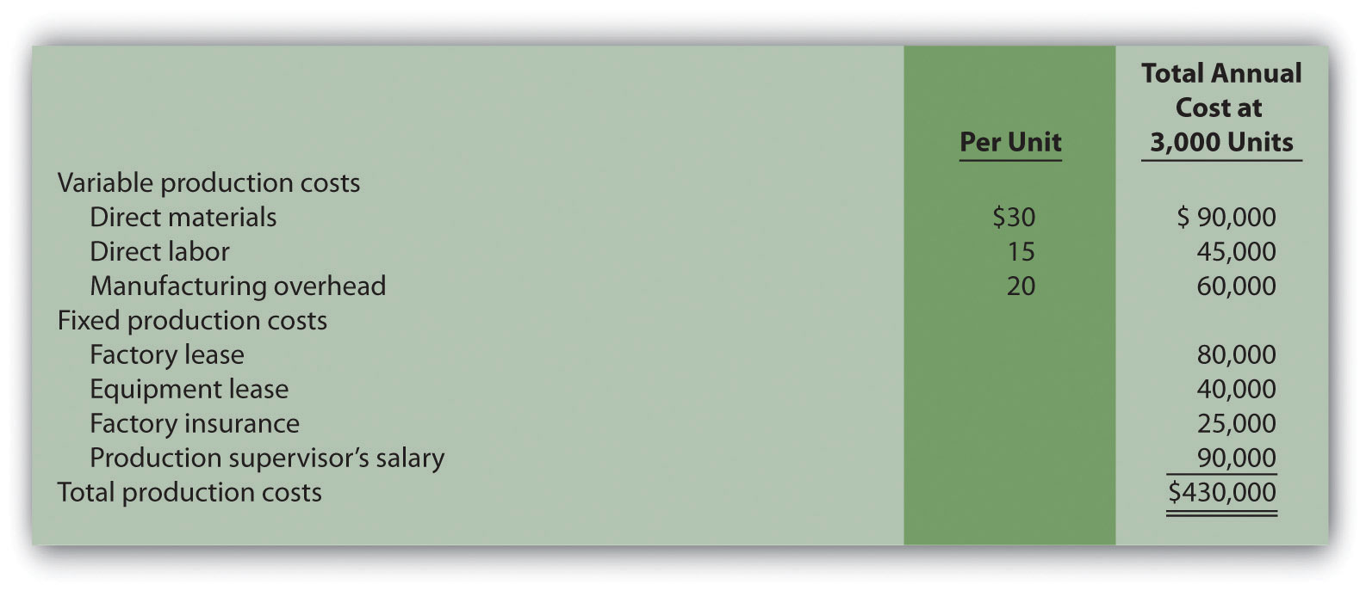
If production is outsourced, all variable production costs, equipment lease costs, and factory insurance costs will be eliminated. The production supervisor’s salary cost will remain regardless of the decision to outsource or to produce internally because the supervisor recently signed a long-term contract with the company. The factory lease has five years remaining and cannot be terminated before then.
Required:
  - Perform differential analysis using the format presented in . Assume making the product internally is Alternative 1, and buying the product from an outside manufacturer is Alternative 2.
  - Which alternative is best? Explain.
  - Summarize the result of outsourcing production using the format presented in .
  - Assume Vail Door Company can lease the space it currently uses to produce doors for $30,000 per year if production of doors is outsourced. Because the company subleasing this space would also pay for insurance, Vail would not be required to pay for factory insurance. Use the format presented in to determine if Vail would be better off outsourcing production. (Hint: $30,000 will appear in the analysis as an opportunity cost similar to .)
- Make-or-Buy Decision and Qualitative Factors. Soda Bottling, Inc., currently bottles its own soda drinks. Management is interested in outsourcing the production of bottles to a reputable manufacturing company that can supply the bottles for $0.04 each. Soda Bottling incurs the following monthly production costs to produce 1,000,000 bottles internally.
If production is outsourced, all variable production costs and 70 percent of fixed production costs will be eliminated.
Required:
  - Perform differential analysis using the format presented in . Assume making the product internally is Alternative 1, and buying the product from an outside manufacturer is Alternative 2.
  - Which alternative is best? Explain.
  - Summarize the result of outsourcing production using the format presented in .
  - Assume all the facts of this problem remain the same. However, management of Soda Bottling has an opportunity to lease the space it currently uses to produce bottles for $6,000 per month if production of bottles is outsourced. Use the format presented in to determine if Soda Bottling would be better off outsourcing production. (Hint: $6,000 will appear in the analysis as an opportunity cost similar to .)
  - Identify at least one qualitative factor that should be considered before management decides to outsource production.
- Product Line Decision. The following monthly segmented income statement is for Hal’s Hardware.
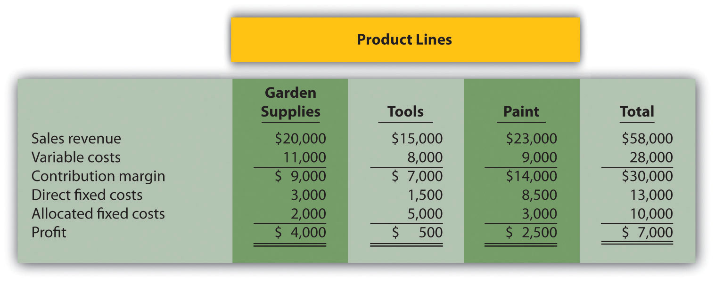
Management is concerned about the low profit associated with the tools product line and is considering dropping this product line. Allocated fixed costs are assigned to product lines based on floor space used by each product line (measured in square feet), resulting in the following percentages for garden supplies, tools, and paint, respectively: 20 percent, 50 percent, and 30 percent. If the tools product line is eliminated, total allocated fixed costs will be assigned as follows: 62.5 percent to garden supplies, and 37.5 percent to paint. All variable and direct fixed costs for the tools product line will be eliminated.
Required:
  - Perform differential analysis using the format presented in . Assume keeping all product lines is Alternative 1, and dropping the tools product line is Alternative 2.
  - Which alternative is best? Explain.
  - Summarize the result of dropping the tools product line using the format presented in .
  - Assume the space available from dropping the tools product line can be used by the paint product line, resulting in increased revenues for paint of $12,000 and increased variable costs for paint of $4,000. No additional direct fixed costs would be incurred, and 80 percent of allocated fixed costs would be assigned to paint and 20 percent assigned to garden supplies. Should Hal’s Hardware drop the tools product line and use the freed-up space to expand the paint product line? (Hint: Prepare a differential analysis using the format presented in to find the answer. Alternative 1 assumes all product lines are kept, and Alternative 2 assumes the tools product line is dropped with a corresponding expansion of the paint product line.)
- Product Line Decision and Qualitative Factors. The following annual segmented income statement is for Wax, Inc., a maker of wax for cars, boats, and floors.
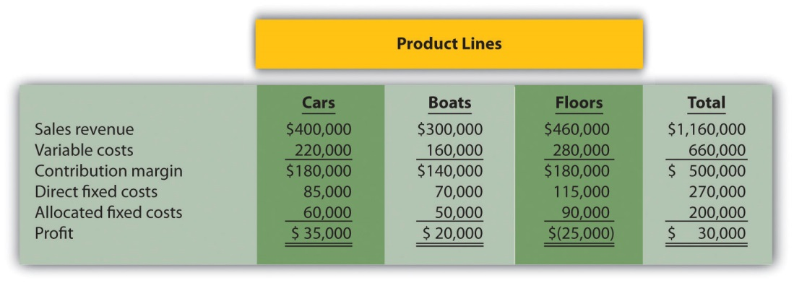
Management is concerned about the loss associated with the floors product line and is considering dropping this product line. Allocated fixed costs are assigned to product lines based on direct labor hours associated with each product line, resulting in the following percentages for cars, boats, and floors, respectively: 30 percent, 25 percent, and 45 percent. If the floors product line is eliminated, total allocated fixed costs will be assigned to the remaining products as follows: 55 percent to cars, and 45 percent to boats. All variable and direct fixed costs for the floors product line will be eliminated.
Required:
  - Perform differential analysis using the format presented in . Assume keeping all product lines is Alternative 1, and dropping the floors product line is Alternative 2.
  - Which alternative is best? Explain.
  - Summarize the result of dropping the floors product line using the format presented in .
  - Assume the space available from dropping the floors product line can be used by the boats product line, resulting in increased revenues for boats of $200,000 and increased variable costs for boats of $110,000. An additional $10,000 in direct fixed costs would be incurred for the boats product line. Allocated fixed costs would be assigned as follows: 40 percent to cars, and 60 percent to boats. Should Wax, Inc., drop the floors product line and use the freed-up space to expand the boats product line? (Hint: Prepare a differential analysis using the format presented in to find the answer. Alternative 1 assumes all product lines are kept, and Alternative 2 assumes the floors product line is dropped with a corresponding expansion of the boats product line.)
  - Identify at least one qualitative factor that should be considered before management decides to drop a product line.
- Customer Decision. The following customer segmented quarterly income statement is for Ciena and Associates, a firm that performs legal services.
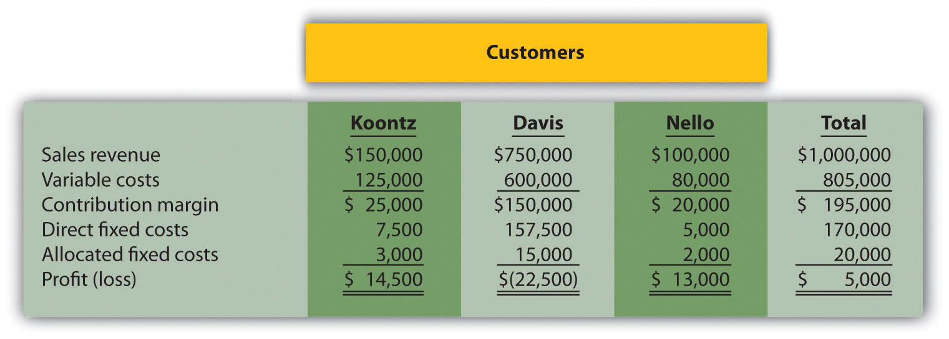
Management is concerned about the significant losses associated with the Davis account and would like to drop this customer. Allocated fixed costs are assigned to customers based on sales revenue. If Davis is dropped, total allocated fixed costs are assigned to the remaining customers, and all variable and direct fixed costs for the Davis account will be eliminated.
Required:
  - Perform differential analysis using the format presented in . Assume keeping all customers is Alternative 1, and dropping the Davis account is Alternative 2.
  - Which alternative is best? Explain.
  - Summarize the result of dropping the Davis account using the format presented in .
  - Explain what happened to the profitability of the other two customers as a result of dropping the Davis account.
  - Assume all the facts of this problem remain the same with one exception. As a result of dropping the Davis account, Ciena and Associates is only able to reduce thedirect fixed costs associated with the Davis account by 90 percent. The remaining 10 percent will not be eliminated for several more years. Does this change Ciena’s decision as to whether to drop the Davis customer? Explain. (Hint: Modify one line item in your answer to requirement c.)
- Customer Decision and Qualitative Factors. The following customer segmented monthly income statement is for Quality Web, Inc., a firm that provides Web site maintenance services.
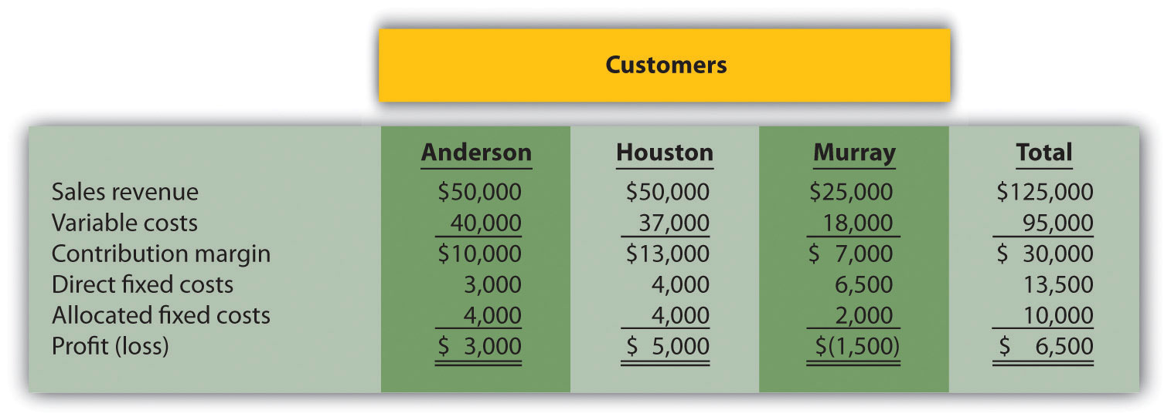
Management is concerned about the losses associated with the Murray account and would like to drop this customer. Allocated fixed costs are assigned to customers based on sales revenue. If Murray is dropped, total allocated fixed costs are assigned to the remaining customers, and all variable and direct fixed costs for the Murray account will be eliminated.
Required:
  - Perform differential analysis using the format presented in . Assume keeping all customers is Alternative 1, and dropping the Murray account is Alternative 2.
  - Which alternative is best? Explain.
  - Summarize the result of dropping the Murray account using the format presented in .
  - Explain what happened to the profitability of the other two customers as a result of dropping the Murray account.
  - Assume all the facts of this problem remain the same with one exception. As a result of dropping the Murray account, Quality Web, Inc., is able to reduce total allocatedfixed costs by 20 percent. The remaining 80 percent will be allocated to the other two products based on sales revenue. Does this change Quality Web’s decision as to whether to drop the Murray customer? Explain. (Hint: Add one line item in the requirement c analysis to reflect allocated fixed cost savings.)
  - Identify at least one qualitative factor that should be considered before deciding whether to drop the Murray account.
- Special Order Decision with Idle Capacity and at Full Capacity. The following quarterly financial data are for Pneumatic, Inc., a maker of compressors. On average, Pneumatic makes 20,000 compressors each quarter.
Pneumatic received an offer from a one-time customer to purchase 5,000 compressors this coming quarter for $275 per unit. Pneumatic can produce up to 30,000 units a quarter, so the special order would not affect regular customer sales. Variable costs per unit will remain at $100. This special order will have no effect on fixed costs.
Required:
  - Using the differential analysis format presented in , determine whether Pneumatic would be better off rejecting the special order (Alternative 1) or accepting the special order (Alternative 2).
  - Summarize the result of accepting the special order using the format presented in .
  - Assume Pneumatic is approached with the same special offer, but has limited capacity, and can only produce up to 20,000 units per quarter. Thus any special orders will result in reduced sales to regular customers. Using the differential analysis format presented in , determine whether Pneumatic would be better off rejecting (Alternative 1) or accepting (Alternative 2) the special order.
  - Summarize the result of accepting the special order in requirement c using the format presented in .
- Special Order Decision at Full Capacity. The following monthly financial data are for Green Mowers, Inc., a maker of electric lawn mowers. On average, Green Mowers makes 5,000 mowers each month.
Green Mowers received an offer from a one-time customer to purchase 1,000 mowers this coming month for $180 per unit. Green Mowers can produce up to 5,000 units a month, so the special order would reduce regular customer sales. Variable costs per unit will remain at $150. This special order will have no effect on fixed costs.
Required:
  - Using the differential analysis format presented in , determine whether Green Mowers would be better off rejecting the special order (Alternative 1) or accepting the special order (Alternative 2).
  - Summarize the result of accepting the special order using the format presented in .
  - Assume Green Mowers can increase capacity to accommodate the special order by paying an additional $20 in variable costs per unit (for overtime pay) for the additional 1,000 units. With this increased capacity, the special order would not affect regular customer sales. Using the differential analysis format presented in , determine whether Green Mowers would be better off rejecting (Alternative 1) or accepting (Alternative 2) the special order.
  - Summarize the result of accepting the special order in requirement c using the format presented in .
- Target Costing. Toolmakers, Inc., produces table saws. The marketing department has identified a market for a specific type of table saw that Toolmakers does not currently produce, and expects to be able to sell each saw for $800. Management requires a profit of 60 percent of the selling price.
Required:
  - Determine the highest cost (target cost) management would be willing to accept to produce this product.
  - Describe the four steps of target costing, and identify what Toolmakers would do next if it cannot make the product at or below the target cost.
- Constrained Resources. Instrumental Strings, Inc., produces three types of string instruments: violin, cello, and bass. The instruments are produced in separate departments and sent to the quality testing department before being packaged and shipped. A labor-hour bottleneck has been identified in the quality testing department due to the high skill requirements of the job. Instrumental Strings would like to optimize its use of labor hours by producing the two most profitable instruments. Information for each product follows.
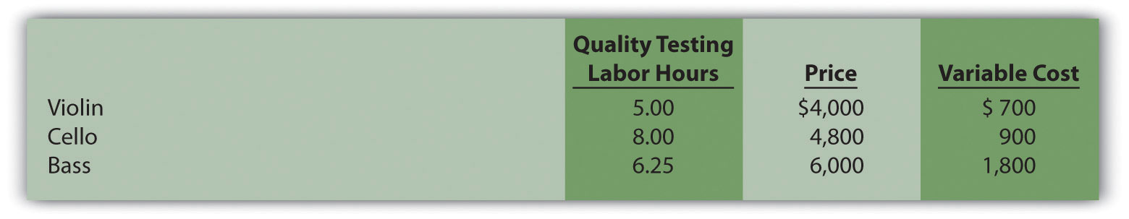
Required:
  - Calculate the contribution margin per unit of constrained resource for each product.
  - Which two products would Instrumental Strings prefer to produce and sell to optimize the use of labor hours in the quality testing department?
  - Assume additional employees are hired and trained for the quality testing department thereby alleviating this constraint. A labor-hour bottleneck has now been identified in the packaging department, which is recognized by management as a crucial department given the fine craftsmanship of each instrument. Of the three instruments produced by the company, identify which two products Instrumental Strings would prefer to produce and sell to optimize the use of labor hours in the packaging department. Assume the following labor hours are required to package each instrument:
Violin: | 4.00 hours
Cello: | 4.00 hours
Bass: | 6.00 hours
- Allocating Joint Costs and Product Profitability (Appendix). Fresh Catch, Inc., has a fleet of fishing boats. The most recent outing cost $90,000 and yielded 24,000 pounds of salmon and 8,000 pounds of halibut. Fresh Catch can sell salmon for $3 per pound and halibut for $6 per pound.
Required:
  - Allocate joint costs to each product using the physical quantities method, and calculate the profit or loss for each product.
  - Allocate joint costs to each product using the relative sales value method, and calculate the profit or loss for each product.
  - Explain what happened to the profitability of each product as the allocation method was changed from requirement a to requirement b. Why might management make bad decisions using the information from requirement a?
  - Assume salmon can be processed further into smoked salmon for an additional $2.50 per pound. Customers are willing to pay $7 per pound for smoked salmon. Should Fresh Catch process the salmon further? Explain.
- Allocating Joint Costs (Appendix). Fruit Tree Nursery (FTN) grows peach and apple trees in containers for its customers. This past year, FTN grew 3,000 peach trees and 7,000 apple trees at a cost of $100,000. FTN can sell peach trees for $20 each and apple trees for $11 each.
Required:
  - Allocate joint costs to each product using the physical quantities method, and calculate the profit or loss for each product.
  - Allocate joint costs to each product using the relative sales value method, and calculate the profit or loss for each product.
  - Assume peach trees can be processed further by allowing them to grow for another few months. The additional processing cost is $4 per tree, and customers are willing to pay $23 for the larger trees. Should FTN process the peach trees further? Explain.
One Step Further: Skill-Building Cases
- Outsourcing Building Materials. Review What qualitative factors did the manager of the library’s construction likely consider in deciding to have Pretecsa produce the concrete panels?
- Internet Project: Outsourcing. Accenture LLP is a global management consulting, technology services, and outsourcing company with more than $17 billion in annual revenues. Go to Accenture’s Web site (http://www.accenture.com) and select outsourcing, or type outsourcingin Accenture’s search feature. Review the information provided about outsourcing, select a specific outsourcing topic, and write a one-page report summarizing your findings.
- Sale of Stores at Kmart. Refer to What qualitative factors were likely considered by the company’s management in considering whether to keep the stores?
- Group Activity: Qualitative Factors. Each of the following scenarios is being considered at three separate companies.
  - A company sells three types of bicycles (racers, cruisers, and climbers), all of which are profitable. The company faces a labor-hour bottleneck and plans to eliminate the cruiser product because it has the lowest contribution margin per labor hour.
  - A company plans to accept a special order at a reduced price from a one-time customer.
  - A maker of car batteries plans to eliminate one of its unprofitable product lines.
Required:
Form groups of two to four students and assign one of the three independent scenarios listed previously to each group. Each group must perform the following requirements:
  - Identify at least two qualitative factors that should be considered before making the decision.
  - Discuss each option, based on the findings of your group, with the class.
- Special Order Decision Using Excel. The following monthly financial data are for Green Mowers, Inc., a maker of electric lawn mowers. Green Mowers makes and sells 5,000 mowers each month.
Green Mowers received an offer from a one-time customer to purchase 1,000 mowers this coming month for $180 per unit. Green Mowers can only produce up to 5,000 units a month, so the special order would reduce regular customer sales. Variable costs per unit will remain at $150. This special order will have no effect on fixed costs.
Required:
Prepare an Excel spreadsheet, similar to the one shown in the Computer Application box, to determine whether Green Mowers would be better off rejecting the special order (Alternative 1) or accepting the special order (Alternative 2). Make a recommendation as to which alternative should be accepted and explain the reasoning for your recommendation.
- Ethics: Cost-Plus Pricing. JR Engineering recently negotiated a cost-plus contract with Pineville City to provide engineering services at a rate equal to direct labor costs plus 30 percent. On a separate note, the partners at JR Engineering discovered that one of its customers filed for bankruptcy last month and will not be able to pay the $200,000 owed to the firm.
The two partners at JR Engineering, Julie and Ron, decided to include some of the direct labor costs incurred working on the bankrupt company with the direct labor costs associated with Pineville City. As Ron stated, “After all, customers fail from time to time, and it’s only fair that our other customers shoulder some of the burden. This enables us to provide the high-quality service we know is so important to our customers.”
Are JR Engineering’s actions ethical? What are the long-term implications of JR’s actions? Explain.
Comprehensive Cases
- Make-or-Buy Decision. Keyboard, Inc., a manufacturer of pianos, typically sells each of its pianos for $1,480. The cost of manufacturing and marketing one piano at the company’s usual monthly volume of 6,000 units is shown.
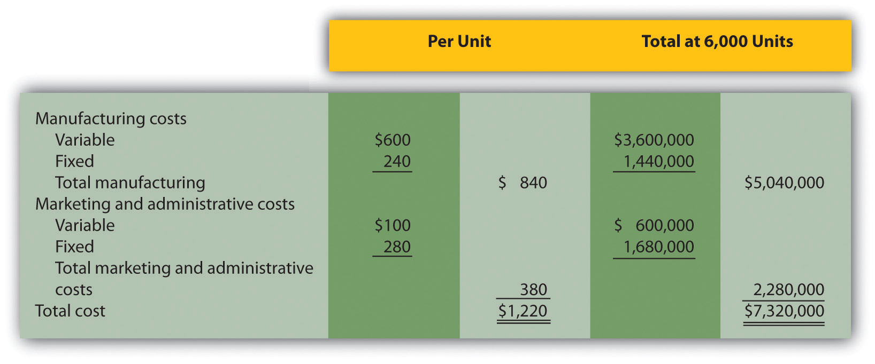
Required:
  - Keyboard, Inc., received a proposal from an independent piano manufacturer that will produce and ship 2,000 pianos each month directly to Keyboard’s customers as requested by Keyboard’s salespeople, at a cost of $900 each. This will have the effect of reducing total fixed marketing and administrative costs by 5 percent. As a result of reducing production capacity, Keyboard’s total fixed manufacturing costs will decrease 30 percent. Total variable manufacturing costs will decrease since only 4,000 pianos will be produced rather than 6,000. Total variable marketing and administrative costs will remain unchanged.
Perform differential analysis using the format presented in to determine if Keyboard should accept the proposal from the outside supplier. Assume making all 6,000 pianos internally is Alternative 1, and outsourcing the production of 2,000 pianos and producing 4,000 pianos internally is Alternative 2. Explain which alternative is best.
  - Assume the same facts as in requirement a, with one additional point. If production of 2,000 pianos is outsourced and 4,000 pianos are produced internally, Keyboard can use the idle capacity to produce an additional 1,400 beginner pianos that can be sold for $1,100 each. Fixed marketing and administrative costs would be unchanged (the 5 percent reduction described in requirement a no longer applies). Fixed manufacturing costs would decrease by 10 percent (rather than the 30 percent described in requirement a). Per unit variable cost information for the beginner pianos would be as follows:
Variable manufacturing costs | $400
Variable marketing and administrative costs | $ 80
  - Perform differential analysis using the format presented in to determine if Keyboard should accept the proposal from the independent supplier. Assume making all 6,000 pianos internally is Alternative 1. Alternative 2 consists of outsourcing the production of 2,000 pianos and producing 5,400 pianos internally (= 4,000 regular pianos + 1,400 beginner pianos). Explain which alternative is best. (Hint: Include a line item forsales revenue in your analysis to determine the best alternative.)
- Product Line Decision. The following monthly segmented income statement is for Thirst Quench, a maker of soda, sports drink, and lemonade.
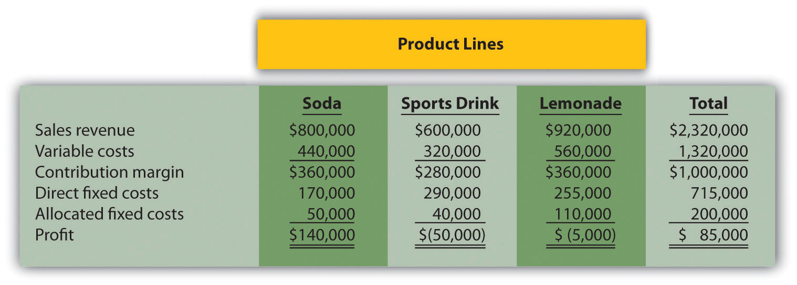
Management is concerned about the losses associated with the sports drink and lemonade product lines and is considering dropping all product lines except soda. Allocated fixed costs are assigned to product lines based on direct labor hours associated with each product line resulting in the following percentages for soda, sports drink, and lemonade, respectively: 25 percent, 20 percent, and 55 percent. If the sports drink and lemonade product lines are eliminated, total allocated fixed costs will decrease by $40,000, and variable costs and direct fixed costs for these two product lines will be eliminated. (No allocated fixed cost savings occur if only one product line is dropped.)
Required:
  - Perform differential analysis using the format presented in . Assume keeping all product lines is Alternative 1, and keeping only the soda product line is Alternative 2.
  - Which alternative is best? Explain.
  - Summarize the result of keeping only the soda product line using the format presented in .
  - Management has asked you to look at the numbers for each product line and make a recommendation on how to increase overall company profit. What course of action would you recommend? Based on your recommendation, describe the qualitative factors that should be considered.

Chapter 8

How Is Capital Budgeting Used to Make Decisions?

Julie Jackson is the president and owner of Jackson’s Quality Copies, a store that makes photocopies for its customers and that has several copy machines. Julie has the following discussion with Mike Haley, the company’s accountant:
Julie: | Mike, I think it’s time to buy a new copy machine. Our volume of copies has increased dramatically over the last year, and we need a copier that does a better job of handling the big jobs.
Mike: | Do you have any idea how much the new machine will cost?
Julie: | We can purchase a new copier for $50,000, maintenance costs will total $1,000 a year, and the copier is expected to last 7 years. Since the new machine is quicker and will require less attention by our employees, we should save about $11,000 a year in labor costs.
Mike: | Will it have any salvage value at the end of seven years?
Julie: | Yes. The salvage value should be about $5,000.
Mike: | How soon do you want to do this?
Julie: | As soon as possible. From what I can tell, this is a winning proposition. The cash inflows of $82,000 that we will get from the labor cost savings and the salvage value exceed the cash outflows of $57,000 that we expect to spend on the machine and annual maintenance costs. What do you think?
Mike: | Let me take a look at the numbers before we jump into this. We have to consider more than just total cash inflows and outflows. I’ll get back to you by the end of the week.
Julie: | Okay, thanks for your help!

Jackson’s Quality Copies is facing a decision common to many organizations: whether to invest in equipment that will last for many years or to continue with existing equipment. This type of decision differs from the decisions covered in the previous chapter because long-term investment decisions affect organizations for several years. We will return to Julie’s plan to purchase a new copier after we provide background information on long-term investment decisions.

8.1 Capital Budgeting and Decision Making

LEARNING OBJECTIVE
- Apply the concept of the time value of money to capital budgeting decisions.

Question: What is the difference between management decisions made in and management decisions made in this chapter?

Answer: The types of decisions covered in this chapter and are similar in that they require an analysis of differential revenues and costs. However,involves short-run operating decisions (e.g., special orders from customers), while this chapter focuses on long-run capacity decisions (e.g., purchasing long-lived assets to increase capacity for many years).

Organizations make a variety of long-run investment decisions. The San Francisco Symphony invests in stage risers for its orchestra members.McDonald’s invests in new restaurants. Honda Motor Co. invests in new manufacturing facilities. Bank of America invests in new branches. These examples have one common feature: all of these companies are investing in assets that will affect the organization for several years.

Question: The process of analyzing and deciding which long-term investments to make is called a capital budgeting decision, also known as a capital expenditure decision. Capital budgeting decisions involve using company funds (capital) to invest in long-term assets. How does the evaluation of these types of capital budgeting decisions differ from short-term operating decisions discussed in ?

Answer: When looking at capital budgeting decisions that affect future years, we must consider the time value of money. The time value of money concept is the premise that a dollar received today is worth more than a dollar received in the future. To clarify this point, suppose a friend owes you $100. Would you prefer to receive $100 today or 3 years from today? The money is worth more to you if you receive it today because you can invest the $100 for 3 years.

For capital budgeting decisions, the issue is how to value future cash flows in today’s dollars. The term cash flow refers to the amount of cash received or paid at a specific point in time. The term present value describes the value of future cash flows (both in and out) in today’s dollars.

Business in Action 8.1
Capital Budgeting Decisions at JCPenney and Kohl’s
JCPenney Company has over 1,000 department stores in the United States, and Kohl’s Corporation has over 800. Both companies cater to a “middle market.” In October 2006, Kohl’s announced plans to open 65 new stores. At about the same time, JCPenney announced plans to open 20 new stores, 17 of which would be stand-alone stores. This was a departure from JCPenney’s typical approach of serving as an anchor store for regional shopping malls.
The decision to open new stores is an example of a capital budgeting decision because management must analyze the cash flows associated with the new stores over the long term.
Source: James Covert, “Chasing Mr. and Mrs. Middle Market: J.C. Penney, Kohl’s Open 85 New Stores,” The Wall Street Journal, October 6, 2006.

When managers evaluate investments in long-term assets, they want to know how much cash would be spent on the investment and how much cash would be received as a result of the investment. The investment proposal is likely rejected if cash inflows do not exceed cash outflows. (Think about a personal investment. If you would receive only $700 in the future from an investment of $1,000 today, you undoubtedly would not make the investment because you would lose $300!) If cash inflows are expected to exceed cash outflows, managers must consider when the cash inflows and outflows occur before taking on the investment. (Again, consider an investment of $1,000 today. If you expect to receive $1,050 in 20 years rather than at the end of 1 year, you would probably think twice before investing because it would take 20 years to make $50!)

Question: We use two methods to evaluate long-term investments, both of which consider the time value of money. What are these two methods?

Answer: The first is called the net present value (NPV) method, and the second is called the internal rate of return method. Before presenting these two methods, let’s discuss the time value of money (present value) concepts.

The Present Value Formula

Question: Suppose you invest $1,000 for 1 year at an interest rate of 5 percent per year, as shown in the following timeline. How much will you have at the end of 1 year (or what is the future value of the investment)?
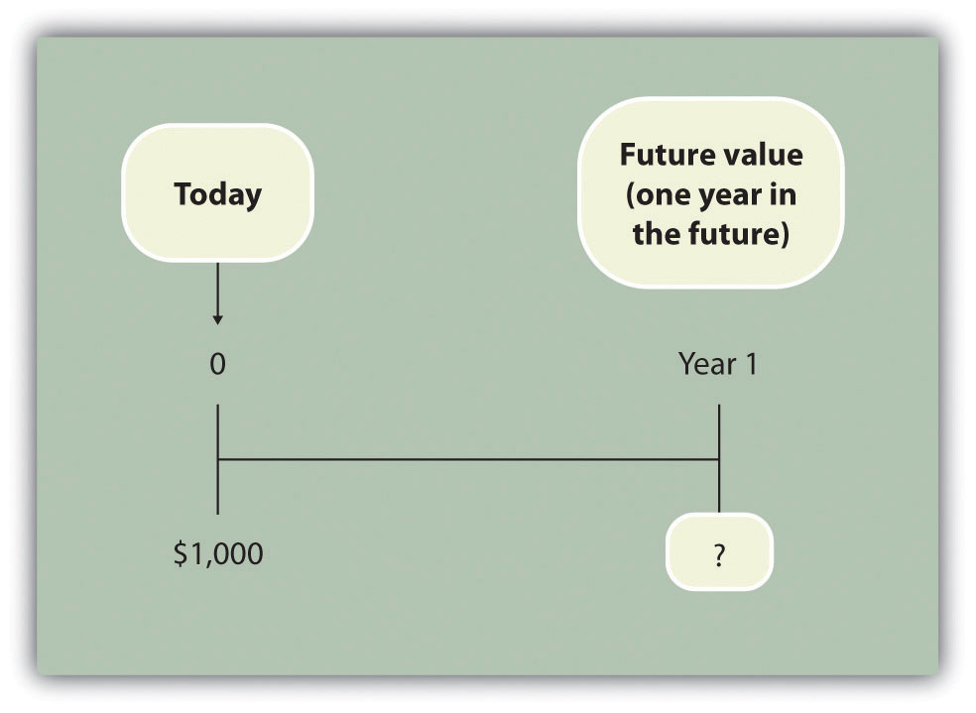

Answer: You will have $1,050:

$1,050 = $1,000 × (1 + .05)

Question: Let’s change course and find the present value of the same future cash flow. If you receive $1,050 in 1 year, how much is that worth in today’s dollars assuming an annual interest rate of 5 percent?
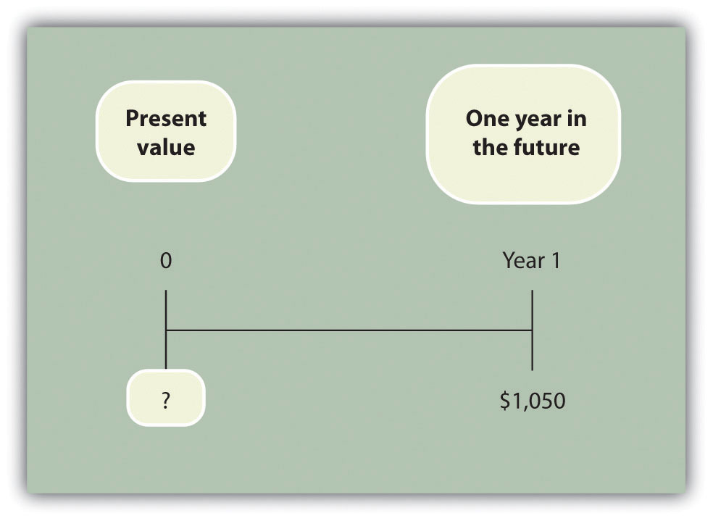

Answer: The present value is $1,000, calculated as follows:

$1,000=$1,050(1+.05)

Question: Let’s go back to finding a future value. Assume you invest $1,000 today at an annual rate of 5 percent for 2 years. How much will you have at the end of 2 years?
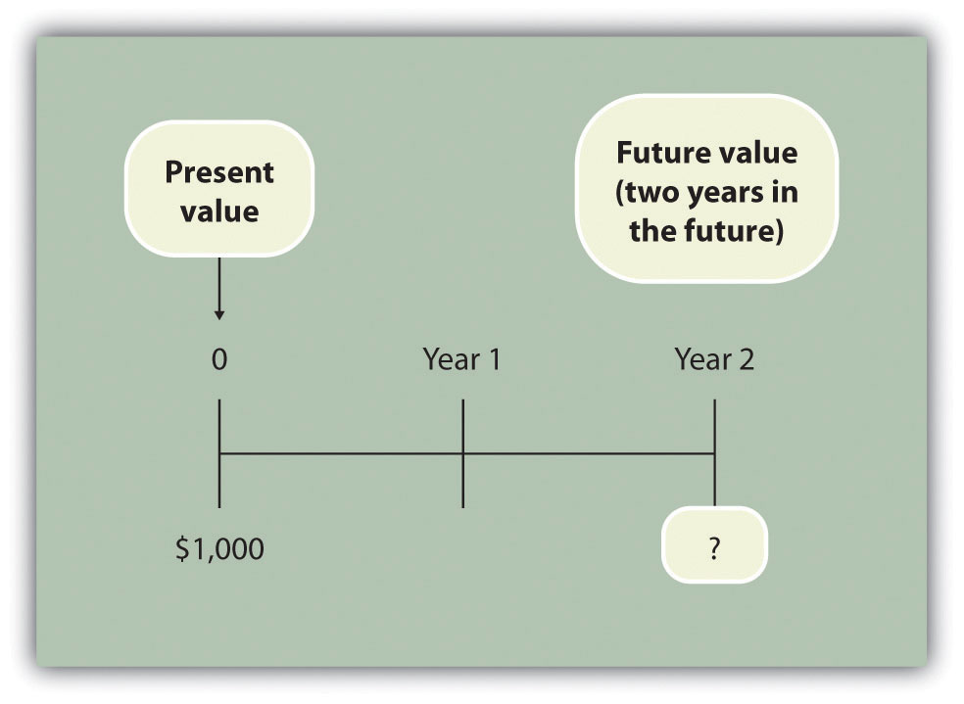

Answer: At the end of 1 year, you will have $1,050 (= $1,000 × [1 + .05]). At the end of the second year, you will have $1,102.50, which is $1,050 × (1 + .05). The equation is

$1,102.50 = $1,000 × (1 + .05) × (1 + .05)or$1,102.50 = $1,000 × (1 + .05)2

Question: Again, let’s change course and find the present value of the same future cash flow. If you receive $1,102.50 in 2 years, how much is that worth in today’s dollars assuming an annual interest rate of 5 percent?
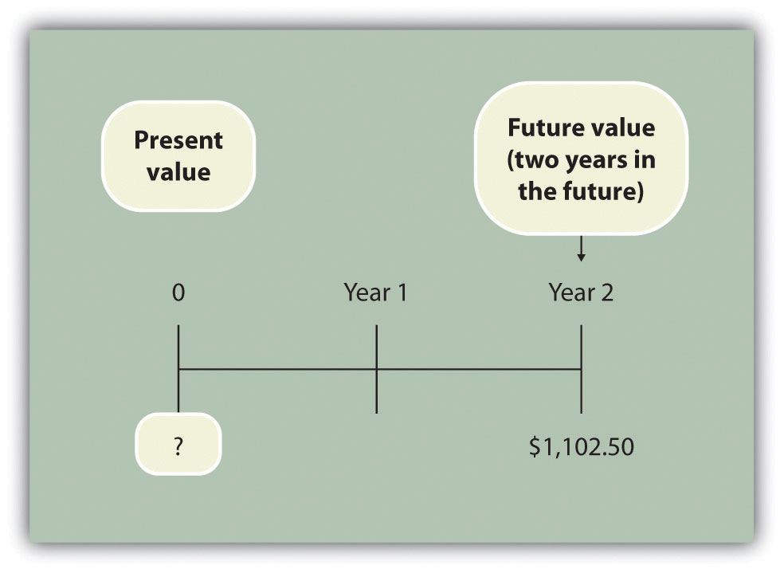

Answer: The present value is $1,000, calculated as follows:

$1,000=$1,102.50(1+.05)2

These examples show that one equation can be used to find the present valueof a future cash flow. The equation is

Key Equation
P=Fn(1+r)n
where
P = Present value of an amountFn = Amount received n years in the futurer = Annual interest raten = Number of years

Question: Let’s use this formula to solve for the following: Assume $500 will be received 4 years from today, and the annual interest rate is 10 percent. What is the present value of this cash flow?
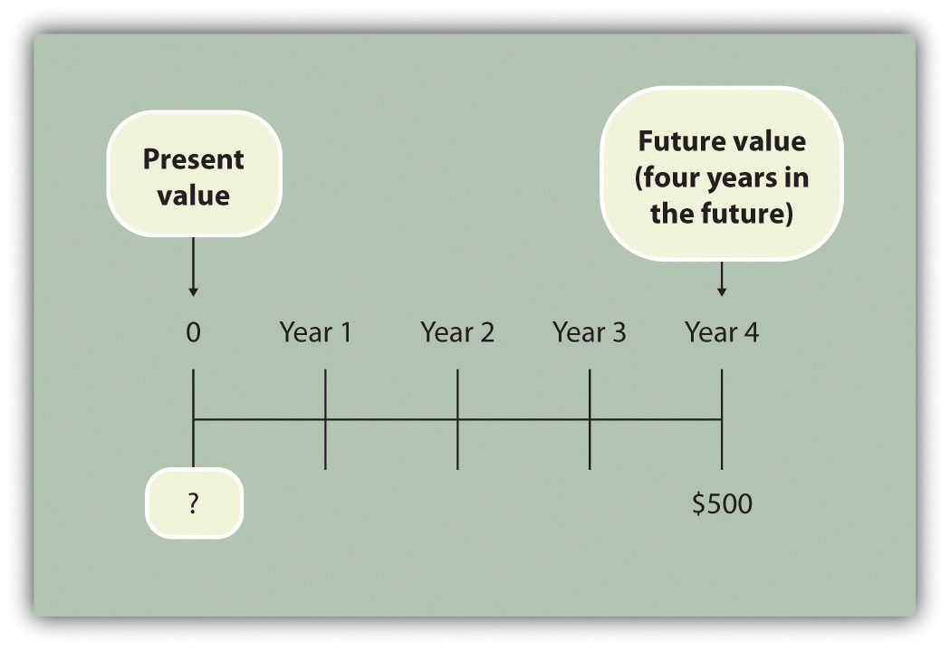

Answer: The present value is $341.51, calculated as follows:

P=Fn(1+r)n=$500(1+.10)4=$5001.4641=$341.51

Present Value Tables

Question: Although most managers use spreadsheets, such as Excel, to perform present value calculations (discussed later in this chapter), you can also use the present value tables in the appendix to this chapter, labeled and , for these calculations. simply provides the present value of $1 (i.e., F = $1) given the number of years (n) and the interest rate (r). How are these tables used to calculate present value amounts?

Answer: Let’s look at an example to see how these tables work. Assume $1 will be received 4 years from today (n = 4), and the interest rate is 10 percent (r = 10 percent). What is the present value of this cash flow? Look atin the appendix. Find the column labeled 10 percent and the row labeled 4. The present value is $0.6830, or $0.68 rounded. The table amount given is often called a factor. The factor in this example is 0.6830 (note that the formula to find this factor is shown at the top of ).

Now assume all the same facts, except that $500 rather than $1 will be received in 4 years. To find the present value, simply multiply the factor found in by $500, as follows:

Present value=Amount received in the future × Present value factor=$500×0.6830=$341.50

Notice that this present value is the same as the one we calculated using the formula P = Fn ÷ (1 + r)n, with the exception of a small difference due to rounding the factor in . Next, we use present value concepts to evaluate projects with the NPV method.

KEY TAKEAWAY
- Present value calculations tell us the value of future cash flows in today’s dollars. The present value of a cash flow can be calculated by using the formula P = Fn ÷ (1 + r)n. It can also be calculated by using the tables in the appendix of this chapter. Simply find the factor in given the number of years (n) and annual interest rate (r). Then multiply the factor by the future cash flow, as follows:
Present value = Amount received in the future × Present value factor

REVIEW PROBLEM 8.1
For each of the following independent scenarios, calculate the present value of the cash flow described. Round to the nearest dollar.
- You will receive $5,000, 5 years from today, and the interest rate is 8 percent.
- You will receive $80,000, 9 years from today, and the interest rate is 10 percent.
- You will receive $400,000, 20 years from today, and the interest rate is 20 percent.
- You will receive $250,000, 10 years from today, and the interest rate is 15 percent.
Solution to Review Problem 8.1
Two approaches can be used to find the present value of a cash flow. The first requires using the formula P = Fn ÷ (1 + r)n. The second requires usingin the appendix to find the present value factor and inserting it in the following formula:
Present value = Amount received in the future × Present value factor (from )
We show both approaches in the following solutions.
- Using the formula P = Fn ÷ (1 + r)n, we get
$3,403=$5,000÷(1+.08)5
Using , we get
Present value$3,403=Future value × Present value factor=$5,000×0.6806
- Using the formula P = Fn ÷ (1 + r)n, we get
$33,928=$80,000÷(1+.10)9
Using , we get
Present value$33,928=Future value × Present value factor=$80,000×0.4241
- The small difference between the two approaches is due to rounding the factor in .
Using the formula P = Fn ÷ (1 + r)n, we get
10,434=$400,000÷(1+.20)20
Using , we get
Present value$10,440=Future value × Present value factor=$400,000×0.0261
- The small difference between the two approaches is due to rounding the factor .
Using the formula P = Fn ÷ (1 + r)n, we get
$61,796=$250,000÷(1+.15)10
Using , we get
Present value$61,800=Future value × Present value factor=$250,000×0.2472

8.2 Net Present Value

LEARNING OBJECTIVE
- Evaluate investments using the net present value (NPV) approach.

Question: Now that we have the tools to calculate the present value of future cash flows, we can use this information to make decisions about long-term investment opportunities. How does this information help companies to evaluate long-term investments?

Answer: The net present value (NPV) method of evaluating investments adds the present value of all cash inflows and subtracts the present value of all cash outflows. The term discounted cash flows is also used to describe the NPV method. In the previous section, we described how to find the present value of a cash flow. The term net in net present value means to combine the present value of all cash flows related to an investment (both positive and negative).

Recall the problem facing Jackson’s Quality Copies at the beginning of the chapter. The company’s president and owner, Julie Jackson, would like to purchase a new copy machine. Julie feels the investment is worthwhile because the cash inflows over the copier’s life total $82,000, and the cash outflows total $57,000, resulting in net cash inflows of $25,000 (= $82,000 – $57,000). However, this approach ignores the timing of the cash flows. We know from the previous section that the further into the future the cash flows occur, the lower the value in today’s dollars.

Question: How do managers adjust for the timing differences related to future cash flows?

Answer: Most managers use the NPV approach. This approach requires three steps to evaluate an investment:

Step 1. Identify the amount and timing of the cash flows required over the life of the investment.

Step 2. Establish an appropriate interest rate to be used for evaluating the investment, typically called therequired rate of return. (This rate is also called the discount rate or hurdle rate.)

Step 3. Calculate and evaluate the NPV of the investment.

Let’s use Jackson’s Quality Copies as an example to see how this process works.

Step 1. Identify the amount and timing of the cash flows required over the life of the investment.

Question: What are the cash flows associated with the copy machine that Jackson’s Quality Copies would like to buy?

Answer: Jackson’s Quality Copies will pay $50,000 for the new copier, which is expected to last 7 years. Annual maintenance costs will total $1,000 a year, labor cost savings will total $11,000 a year, and the company will sell the copier for $5,000 at the end of 7 years. Figure 8.1 "Cash Flows for Copy Machine Investment by Jackson’s Quality Copies"summarizes the cash flows related to this investment. Amounts in parentheses are cash outflows. All other amounts are cash inflows.
Figure 8.1 Cash Flows for Copy Machine Investment by Jackson’s Quality Copies
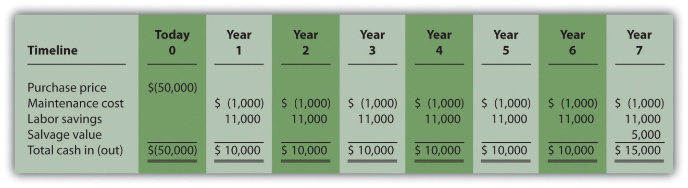

Step 2. Establish an appropriate interest rate to be used for evaluating the investment.

Question: How do managers establish the interest rate to be used for evaluating an investment?

Answer: Although managers often estimate the interest rate, this estimate is typically based on the organization’s cost of capital. The cost of capital is the weighted average costs associated with debt and equity used to fund long-term investments. The cost of debt is simply the interest rate associated with the debt (e.g., interest for bank loans or bonds issued). The cost of equity is more difficult to determine and represents the return required by owners of the organization. The weighted average of these two sources of capital represents the cost of capital (finance textbooks address the complexities of this calculation in more detail).

The general rule is the higher the risk of the investment, the higher the required rate of return (assume required rate of return is synonymous withinterest rate for the purpose of calculating the NPV). A firm evaluating a long-term investment with risk similar to the firm’s average risk will typically use the cost of capital. However, if a long-term investment carries higher than average risk for the firm, the firm will use a required rate of return higher than the cost of capital.

The accountant at Jackson’s Quality Copies, Mike Haley, has established the cost of capital for the firm at 10 percent. Since the proposed purchase of a copy machine is of average risk to the company, Mike will use 10 percent as the required rate of return.

Step 3. Calculate and evaluate the NPV of the investment.

Question: How do managers calculate the NPV of an investment?

Answer: Figure 8.2 "NPV Calculation for Copy Machine Investment by Jackson’s Quality Copies" shows the NPV calculation for Jackson’s Quality Copies. Examine this table carefully. The cash flows come from Figure 8.1 "Cash Flows for Copy Machine Investment by Jackson’s Quality Copies". The present value factors come from Figure 8.9 "Present Value of $1 Received at the End of " in the appendix (r = 10 percent; n = year). The bottom row, labeled present value is calculated by multiplying the total cash in (out) × present value factor, and it represents total cash flows for each time period in today’s dollars. The bottom right of Figure 8.2 "NPV Calculation for Copy Machine Investment by Jackson’s Quality Copies" shows the NPV for the investment, which is the sum of the bottom row labeled present value.

Figure 8.2 NPV Calculation for Copy Machine Investment by Jackson’s Quality Copies
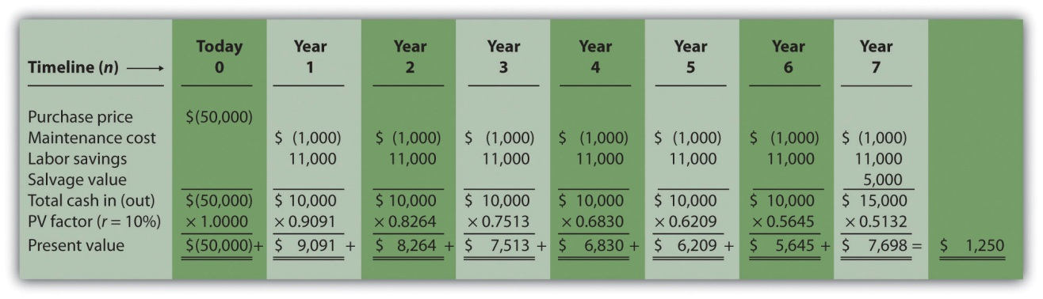

The NPV is $1,250. Because NPV is > 0, accept the investment. (The investment provides a return greater than 10 percent.)

The NPV Rule

Question: Once the NPV is calculated, how do managers use this information to evaluate a long-term investment?

Answer: Managers apply the following rule to decide whether to proceed with the investment:

NPV Rule: If the NPV is greater than or equal to zero, accept the investment; otherwise, reject the investment.

As summarized in Figure 8.3 "The NPV Rule", if the NPV is greater than zero, the rate of return from the investment is higher than the required rate of return. If the NPV is zero, the rate of return from the investment equals the required rate of return. If the NPV is less than zero, the rate of return from the investment is less than the required rate of return. Since the NPV is greater than zero for Jackson’s Quality Copies, the investment is generating a return greater than the company’s required rate of return of 10 percent.

Figure 8.3 The NPV Rule
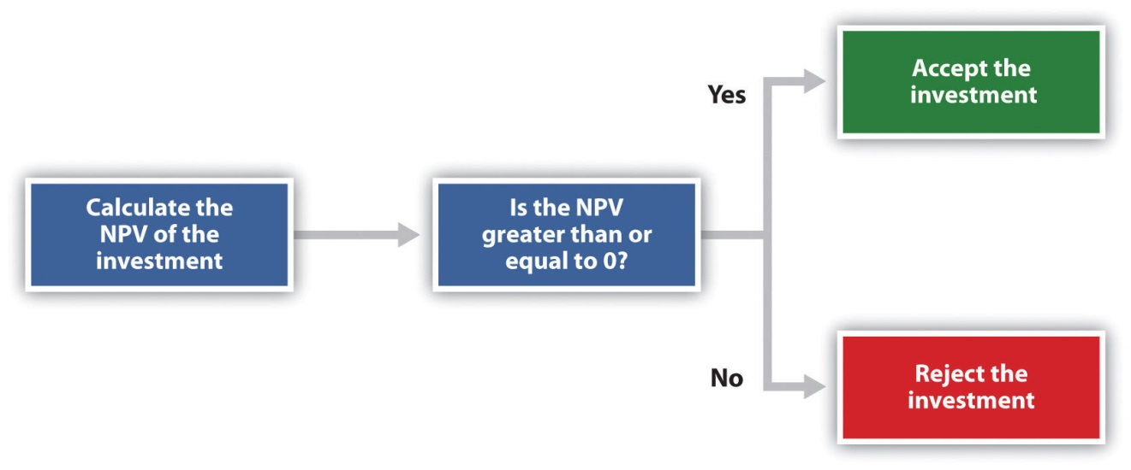
Note that the present value calculations in Figure 8.3 "The NPV Rule"assume that the cash flows for years 1 through 7 occur at the end of each year. In reality, these cash flows occur throughout each year. The impact of this assumption on the NPV calculation is typically negligible.

Business in Action 8.2
Cost of Capital by Industry
Cost of capital can be estimated for a single company or for entire industries. New York University’s Stern School of Businessmaintains cost of capital figures by industry. Almost 7,000 firms were included in accumulating this information. The following sampling of industries compares the cost of capital across industries. Notice that high-risk industries (e.g., computer, e-commerce, Internet, and semiconductor) have relatively high costs of capital.
Air transportation | 11.48 percent
Auto and truck | 11.04 percent
Auto parts | 9.56 percent
Beverage (soft drinks) | 8.16 percent
Computer | 14.49 percent
E-commerce | 15.65 percent
Grocery | 9.79 percent
Internet | 15.98 percent
Retail store | 9.30 percent
Semiconductor | 19.03 percent
Source: New York University’s Stern Business School, “Home Page,”http://pages.stern.nyu.edu.

Annuity Tables

Question: Notice in Figure 8.1 "Cash Flows for Copy Machine Investment by Jackson’s Quality Copies" that the rows labeled maintenance cost and labor savings have identical cash flows from one year to the next. Identical cash flows that occur in regular intervals, such as these at Jackson’s Quality Copies, are called an annuity. How can we use annuities in an alternate format to calculate the NPV?

Answer: In Figure 8.4 "Alternative NPV Calculation for Jackson’s Quality Copies", we demonstrate an alternative approach to calculating the NPV.

Figure 8.4 Alternative NPV Calculation for Jackson’s Quality Copies
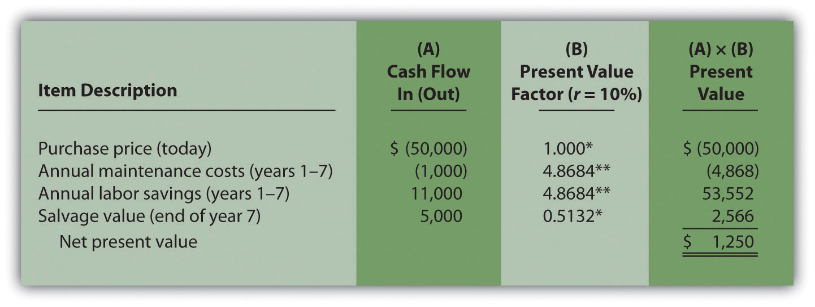

*Because this is not an annuity, use Figure 8.9 "Present Value of $1 Received at the End of " in the appendix.

**Because this is an annuity, use Figure 8.10 "Present Value of a $1 Annuity Received at the End of Each Period for " in the appendix. The number of years (n) equals seven since identical cash flows occur each year for seven years.

Note: the NPV of $1,250 is the same as the NPV in Figure 8.2 "NPV Calculation for Copy Machine Investment by Jackson’s Quality Copies".

The purchase price and salvage value rows in Figure 8.4 "Alternative NPV Calculation for Jackson’s Quality Copies" represent one-time cash flows, and thus we use Figure 8.9 "Present Value of $1 Received at the End of " in the appendix to find the present value factor for these items (these are notannuities). The annual maintenance costs and annual labor savings rows represent cash flows that occur each year for seven years (these are annuities). We use Figure 8.10 "Present Value of a $1 Annuity Received at the End of Each Period for " in the appendix to find the present value factor for these items (note that the number of years, n, equals seven since the cash flows occur each year for seven years). Simply multiply the cash flow shown in column (A) by the present value factor shown in column (B) to find the present value for each line item. Then sum the present value column to find the NPV. This alternative approach results in the same NPV shown inFigure 8.2 "NPV Calculation for Copy Machine Investment by Jackson’s Quality Copies".

Business in Action 8.3
Winning the Lottery
Like many other states, California pays out lottery winnings in installments over several years. For example, a $1,000,000 lottery winner in California will receive $50,000 each year for 20 years.
Does this mean that the State of California must have $1,000,000 on the day the winner claims the prize? No. In fact, California has approximately $550,000 in cash to pay $1,000,000 over 20 years. This $550,000 in cash represents the present value of a $50,000 annuity lasting 20 years, and the state invests it so that it can provide $1,000,000 to the winner over 20 years.
Source: California State Lottery, “California State Lottery Home Page,”http://www.calottery.com.

KEY TAKEAWAY
- Present value calculations tell us the value of cash flows in today’s dollars. The NPV method adds the present value of all cash inflows and subtracts the present value of all cash outflows related to a long-term investment. If the NPV is greater than or equal to zero, accept the investment; otherwise, reject the investment.

REVIEW PROBLEM 8.2
The management of Chip Manufacturing, Inc., would like to purchase a specialized production machine for $700,000. The machine is expected to have a life of 4 years, and a salvage value of $100,000. Annual maintenance costs will total $30,000. Annual labor and material savings are predicted to be $250,000. The company’s required rate of return is 15 percent.
- Ignoring the time value of money, calculate the net cash inflow or outflow resulting from this investment opportunity.
- Find the NPV of this investment using the format presented in Figure 8.2 "NPV Calculation for Copy Machine Investment by Jackson’s Quality Copies".
- Find the NPV of this investment using the format presented in Figure 8.4 "Alternative NPV Calculation for Jackson’s Quality Copies".
- Should Chip Manufacturing, Inc., purchase the specialized production machine? Explain.
Solution to Review Problem 8.2
- The net cash inflow, ignoring the time value of money, is $280,000, calculated as follows:
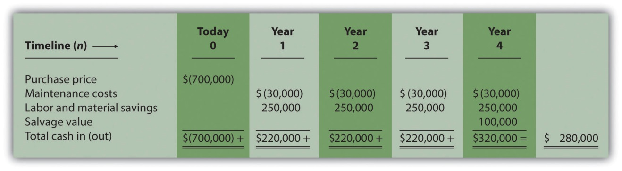
- The NPV is $(14,720), calculated as follows:
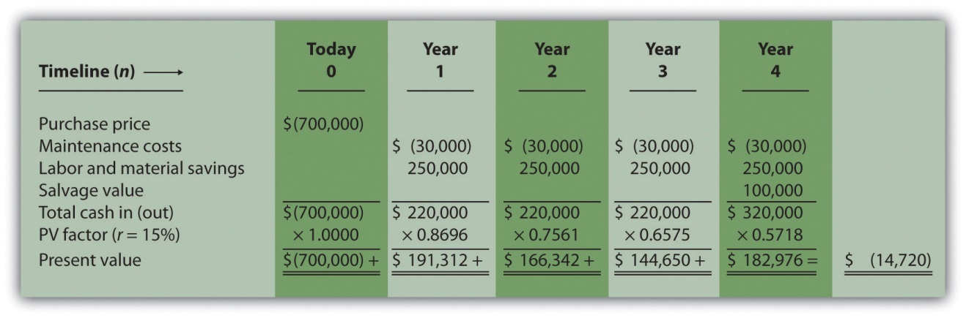
- The alternative format used for calculating the NPV is shown as follows. Note that the NPV here is identical to the NPV calculated previously in part 2.
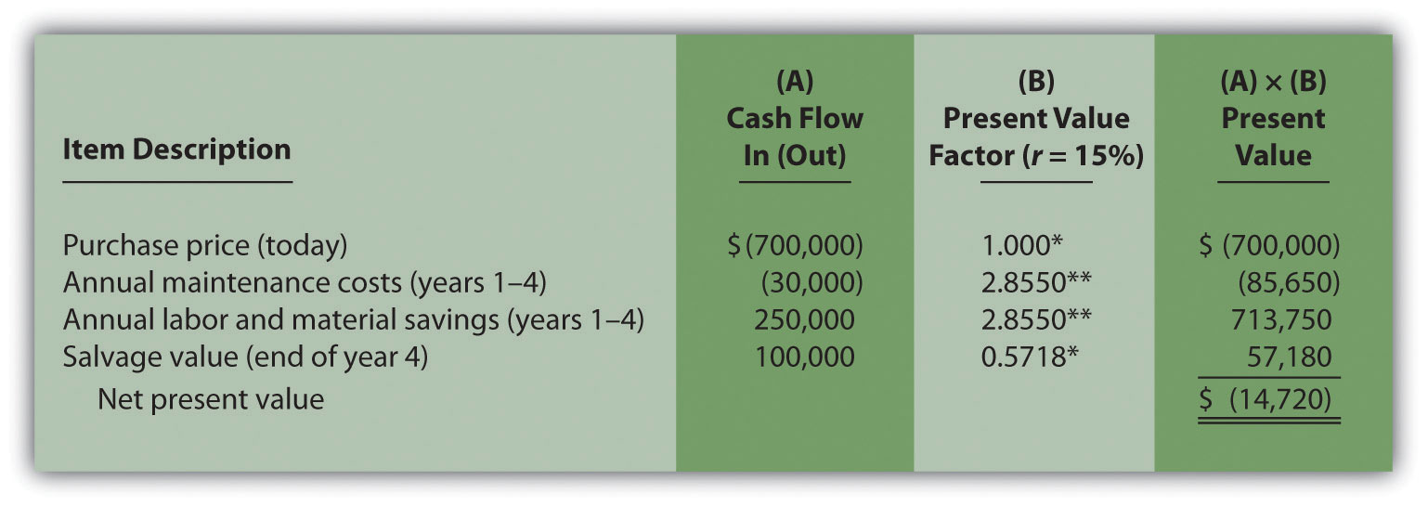
*Because this is not an annuity, use Figure 8.9 "Present Value of $1 Received at the End of " in the appendix.
**Because this is an annuity, use Figure 8.10 "Present Value of a $1 Annuity Received at the End of Each Period for " in the appendix. The number of years (n) equals four since identical cash flows occur each year for four years.
- Because the NPV is less than 0, the return generated by this investment is less than the company’s required rate of return of 15 percent. Thus Chip Manufacturing, Inc., should not purchase the specialized production machine.

8.3 The Internal Rate of Return

LEARNING OBJECTIVE
- Evaluate investments using the internal rate of return (IRR) approach.

Question: Using the internal rate of return (IRR) to evaluate investments is similar to using the net present value (NPV) in that both methods consider the time value of money. However, the IRR provides additional information that helps companies evaluate long-term investments. What is the IRR, and how does it help managers make decisions related to long-term investments?

Answer: The internal rate of return (IRR) is the rate required (r) to get an NPV of zero for a series of cash flows. The IRR represents the time-adjusted rate of return for the investment being considered. The IRR decision rulestates that if the IRR is greater than or equal to the company’s required rate of return (recall that this is often called the hurdle rate), the investment is accepted; otherwise, the investment is rejected.

Most managers use a spreadsheet, such as Excel, to calculate the IRR for an investment (we discuss this later in the chapter). However, we can also use trial and error to approximate the IRR. The goal is simply to find the rate that generates an NPV of zero. Let’s go back to the Jackson’s Quality Copies example. provides the projected cash flows for a new copy machine and the NPV calculation using a rate of 10 percent. Recall that the NPV was $1,250, indicating the investment generates a return greater than the company’s required rate of return of 10 percent.

Although it is useful to know that the investment’s return is greater than the company’s required rate of return, managers often want to know the exact return generated by the investment. (It is often not enough to state that the exact return is something higher than 10 percent!) Managers also like to rank investment opportunities by the return each investment is expected to generate. Our goal now is to determine the exact return—that is, to determine the IRR. We know from that the copy machine investment generates a return greater than 10 percent. summarizes this calculation with the 2 columns under the 10 percent heading.

The far right side of shows that the NPV is $(2,100) if the rate is increased to 12 percent (recall our goal is to find the rate that yields an NPV of 0). Thus the IRR is between 10 and 12 percent. Next, we try 11 percent. As shown in the middle of , 11 percent provides an NPV of $(469). Thus the IRR is between 10 and 11 percent; it is closer to 11 percent because $(469) is closer to 0 than $1,250. (Note that as the rate increases, the NPV decreases, and as the rate decreases, the NPV increases.)

Figure 8.5 Finding the IRR for Jackson’s Quality Copies
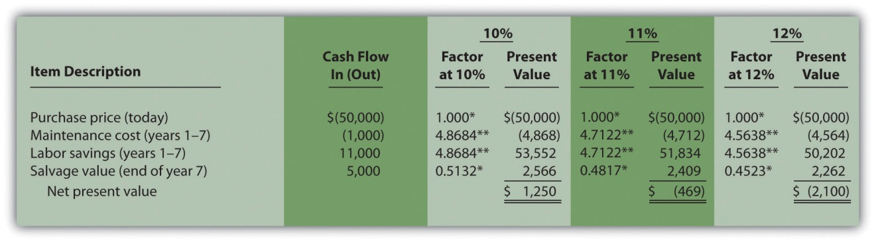

*Because this is not an annuity, use in the appendix.

**Because this is an annuity, use in the appendix. The number of years (n) equals seven since identical cash flows occur each year for seven years.

Note: the NPV of $(469) is closest to 0. Thus the IRR is close to 11 percent.

This trial and error approach allows us to approximate the IRR. As stated earlier, if the IRR is greater than or equal to the company’s required rate of return, the investment is accepted; otherwise, the investment is rejected. For Jackson’s Quality Copies, the IRR of approximately 11 percent is greater than the company’s required rate of return of 10 percent. Thus the investment should be accepted.

Computer Application
Using Excel to Calculate NPV and IRR
Let’s use the Jackson’s Quality Copies example presented at the beginning of the chapter to illustrate how Excel can be used to calculate the NPV and IRR. Two steps are required to calculate the NPV and IRR using Excel. All cell references are to the following spreadsheet shown.
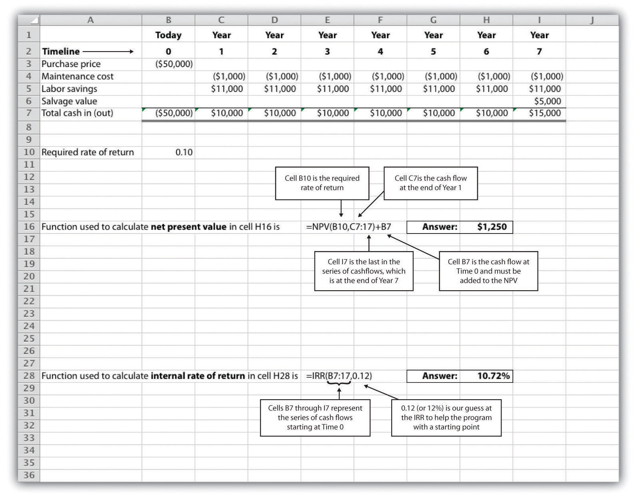
Step 1. Enter the data in the spreadsheet.
Rows 1 through 7 in the spreadsheet show the cash flows associated with the proposal to purchase a new copy machine at Jackson’s Quality Copies (first presented in ).
Step 2. Input the functions to calculate NPV and IRR.
We selected cell H16 to calculate the NPV, so this is where the NPV function is input. Cell E16 shows the function in detail with dialogue boxes provided for clarification. Notice that the resulting NPV of $1,250 shown in cell H16 is the same as the NPV calculated in and .
We selected cell H28 to calculate the IRR, so this is where the IRR function is input. Cell E28 shows the function in detail. Notice that the resulting IRR of 10.72 percent shown in cell H28 is very close to our approximation of slightly less than 11 percent shown in .
As an alternative to entering a function directly into the spreadsheet, the NPV function under the Formulas menu in Excel can be used. Simply select the cell in the spreadsheet where you would like the answer to appear (H16 in this case), and go to the Formulas menu. Click on the fxsymbol or Insert Function on the formula bar. Search for the function by typing in NPV, select NPV where it appears in the box, then select OK. When asked for the Rate, enter the cell where the rate appears (B10). Then under Value 1 enter the cells containing the series of cash flows, starting with year 1 (shown as C7:I7, which means C7 through I7). Select OK. Now go back and add the cash flow at time 0 (B7) to the end of the NPV function. The resulting formula will look like the formula shown in E16, and the answer will appear in the cell where the function is entered (H16).
The IRR function can be inserted into a cell using the same process presented previously. Select the cell in the spreadsheet where you would like the answer to appear (H28), and go to the Formulas menu. Click on the fx symbol or Insert Function on the formula bar. Search for the function by typing in IRR, select IRR where it appears in the box below, then select OK. When asked for Values, enter the cells containing the series of cash flows, starting with time 0 (shown as B7:I7, which means B7 through I7). When asked for a Guess, enter your best guess as to what the IRR might be (this provides the system with a starting point), then select OK. The resulting formula will look like the formula shown in E28, and the answer will appear in the cell where the function is entered (H28).

KEY TAKEAWAY
- The IRR is the rate required (r) to get an NPV of zero for a series of cash flows and represents the time-adjusted rate of return for an investment. If the IRR is greater than or equal to the company’s required rate of return (often called the hurdle rate), the investment is accepted; otherwise, the investment is rejected.

REVIEW PROBLEM 8.3
This review problem is a continuation of , and uses the same information. The management of Chip Manufacturing, Inc., would like to purchase a specialized production machine for $700,000. The machine is expected to have a life of 4 years, and a salvage value of $100,000. Annual maintenance costs will total $30,000. Annual labor and material savings are predicted to be $250,000. The company’s required rate of return is 15 percent.
- Based on your answer to , use trial and error to approximate the IRR for this investment proposal.
- Should Chip Manufacturing, Inc., purchase the specialized production machine? Explain.
Solution to Review Problem 8.3
- In , the NPV was calculated using 15 percent (the company’s required rate of return). Knowing that 15 percent results in an NPV of $(14,720), and therefore seeing the return is less than 15 percent, we decreased the rate to 13 percent. As shown in the following figure, this resulted in an NPV of $15,720, which indicates the return is higher than 13 percent. Using a rate of 14 percent results in an NPV very close to 0 at $224. Thus the IRR is close to 14 percent.
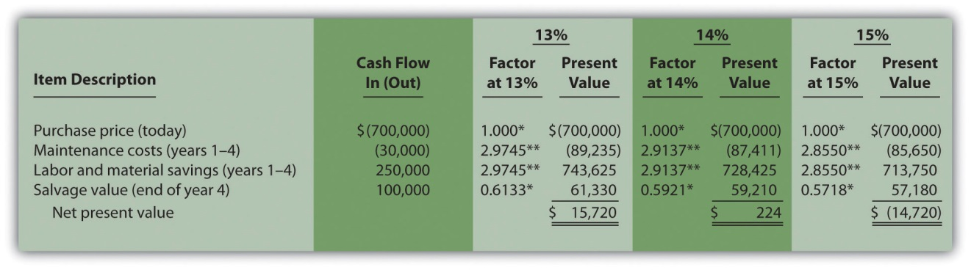
*Because this is not an annuity, use in the appendix.
**Because this is an annuity, use in the appendix. The number of years (n) equals four since identical cash flows occur each year for four years.
- Because the IRR of 14 percent is less than the company’s required rate of return of 15 percent, Chip Manufacturing, Inc., should notpurchase the specialized production machine.

8.4 Other Factors Affecting NPV and IRR Analysis

LEARNING OBJECTIVE
- Understand the impact of cash flows, qualitative factors, and ethical issues on long-term investment decisions.

Question: We have described the net present value (NPV) and internal rate of return (IRR) approaches to evaluating long-term investments. With both of these approaches, there are several important issues that must be considered.What are these important issues?

Answer: These issues include focusing on cash flows, factoring in inflation, assessing qualitative factors, and ethical considerations. All are described next.

Focusing on Cash Flows

Question: Which basis of accounting is used to calculate the NPV and IRR for long-term investments, cash or accrual?

Answer: Both methods of evaluating long-term investments, NPV and IRR, focus on the amount of cash flows and when the cash flows occur. Note that the timing of revenues and costs in financial accounting using the accrual basis is often not the same as when the cash inflows and outflows occur. A sale can be recorded in one period, and the cash be collected in a future period. Costs can occur in one period, and the cash be paid in a future period. For the purpose of making NPV and IRR calculations, managers typically use the time period when the cash flow occurs.

When a company invests in a long-term asset, such as a production building, the cash outflow for the asset is included in the NPV and IRR analyses. The depreciation taken on the asset in future periods is not a cash flow and is not included in the NPV and IRR calculations. However, there is a cash benefit related to depreciation (often called a depreciation tax shield) since income taxes paid are reduced as a result of recording depreciation expense. We explore the impact of income taxes on NPV and IRR calculations later in the chapter.

Factoring in Inflation

Question: Is inflation included in cash flow projections when calculating the NPV and IRR?

Answer: Most managers make cash flow projections that include an adjustment for inflation. When this is done, a rate must be used that also factors in inflation over the life of the investment. As discussed earlier in the chapter, the required rate of return used for NPV calculations is based on the firm’s cost of capital, which is the weighted average cost of debt and equity. Since the cost of debt and equity already includes the effect of inflation, no inflation adjustment is necessary when establishing the required rate of return.

The important point here is that cash flow projections must include adjustments for inflation to match the required rate of return, which already factors in inflation. If cash flows are not adjusted for inflation, managers are likely underestimating future cash flows and therefore underestimating the NPV of the investment opportunity. This is particularly pronounced for economies that have relatively high rates of inflation.

For the purposes of this chapter, assume all cash flows and required rates of return are adjusted for inflation.

Be Aware of Qualitative Factors

Question: So far, this chapter has focused on using cash flow projections and the time value of money to evaluate long-term investments. Using these quantitative factors to make decisions allows managers to support decisions with measurable data. For example, the investment opportunity at Jackson’s Quality Copies presented at the beginning of the chapter was accepted because the NPV of $1,250 was greater than 0, and the IRR of 11 percent was greater than the company’s required rate of return of 10 percent. Why do most companies also consider nonfinancial factors, often called qualitative factors, when making a long-term investment decision?

Answer: Although using quantitative factors for decision making is important, qualitative factors may outweigh the quantitative factors in making a decision. For example, a large manufacturer of medical devices recently invested several million dollars in a small start-up medical device firm. When asked about the NPV analysis, the manager responsible for the investment indicated, “My staff did a quick and dirty NPV analysis, which indicated we should not invest in the company. However, the technology they were using for their device was of such strategic importance to us, we could not pass up the investment.” This is an example of qualitative factors (strategic importance to the company) outweighing quantitative factors (negative NPV).

Similar situations often arise when companies must invest in long-term assets even though NPV and IRR analyses indicate otherwise. Here are a few examples:
- Investing in new production facilities may be essential to maintaining a reputation as the industry leader in innovation, even though the quantitative analysis (NPV and IRR) points to rejecting the investment. (It is difficult to quantify the benefits of being the “industry leader in innovation.”)
- Investing in pollution control devices for an oil refinery may provide social benefits even though the quantitative analysis (NPV and IRR) points to rejecting the investment. (Although a reduction in fines and legal costs may be quantifiable and included in the analyses, it is difficult to quantify the social benefits.)
- Investing in a new product line of entry-level automobiles may increase foot traffic at the showroom, resulting in increased sales of other products, even though the quantitative analysis (NPV and IRR) points to rejecting the investment. (It is difficult to quantify the impact of the new product line on sales of existing product lines.)
- Clearly, managers must look at the financial information and analysis when considering whether to invest in long-term assets. However, the analysis does not stop with financial information. Managers and decision makers must also consider qualitative factors.

Ethical Issues

Question: Our discussion of NPV and IRR methods implies that managers can easily make capital budgeting decisions once NPV and IRR analyses are completed and qualitative factors have been considered. However, managers sometimes make decisions that are not in the best interest of the company. Why might managers make decisions that are not in the best interest of the company?

Answer: Several examples are provided next.

Short-Term Incentives Affect Long-Term Decisions

Managers are often evaluated and compensated based on annual financial results. The financial results are typically measured using financial accounting data prepared on an accrual basis.

Suppose you are a manager considering an investment opportunity to start a new product line that has a positive NPV. Because the NPV is positive, you should accept the investment proposal. However, revenues and related cash inflows are not significant until after the second year. In the first two years, revenues are low and depreciation charges are high, resulting in significantly lower overall company net income than if the project were rejected. Assuming you are evaluated and compensated based on annual net income, you may be inclined to reject the new product line regardless of the NPV analysis.

Many companies are aware of this conflict between the manager’s incentive to improve short-term results and the company’s goal to improve long-term results. To mitigate this conflict, some companies offer managers part ownership in the company (e.g., through stock options), creating an incentive to increase the value of the company over the long run.

Modifying Cash Flow Estimates to Get Approval

Managers often have a vested interest in getting proposals approved regardless of NPV and IRR results. For example, assume a manager spent several years developing a plan to construct a new production facility. Because of the significant work involved, and the projected benefits of building a new facility, the manager wants to see the proposal approved. However, the NPV analysis indicates the production facility proposal does not meet the company’s minimum required rate of return. As a result, the manager decides to inflate projected cash inflows to get a positive NPV, and the project is approved.

Clearly, a conflict exists between the company’s desire to accept projects that meet or exceed the required rate of return and the manager’s desire to get approval for a “pet” project regardless of its profitability. Again, having part ownership in a company provides an incentive for managers to reject proposals that will not increase the value of the company.

Another way to mitigate this conflict is to conduct a postaudit, which compares the original capital budget with the actual results. Managers who provide misleading capital budget analyses are identified through this process. Postaudits provide an incentive for managers to provide accurate estimates.

KEY TAKEAWAY
- Although accountants are responsible for providing relevant and objective financial information to help managers make decisions, several important factors play a significant role in the decision-making process as described here:
  - NPV and IRR analyses use cash flows to evaluate long-term investments rather than the accrual basis of accounting.
  - Cash flow projections must include adjustments for inflation to match the required rate of return, which already factor in inflation.
  - Using quantitative factors to make decisions allows managers to support decisions with measurable data. However, nonfinancial factors (often called qualitative factors) must be considered as well.
  - Circumstances sometimes exist that cause managers to make decisions that are not in the best interest of the company. For example, managers may be evaluated on short-term financial results even though it is in the best interest of the company to invest in projects that are profitable in the long term. Thus projects that reduce short-term profitability in lieu of significant long-term profits may be rejected.

REVIEW PROBLEM 8.4
- Why must cash flow projections include adjustments for inflation?
- Why is it important for organizations to consider qualitative factors when making capital budgeting decisions?
- Assume the manager of Best Electronics earns an annual bonus based on meeting a certain level of net income. The company is currently considering expanding by adding a second retail store. The second store is expected to become profitable three years after opening. The manager is responsible for making the final decision as to whether the second store should be opened and would be in charge of both stores.
  - Why might the manager refuse to invest in the new store even though the investment is projected to achieve a return greater than the company’s required rate of return?
  - What can the company do to mitigate the conflict between the manager’s interest of achieving the bonus and the company’s desire to accept investments that exceed the required rate of return?
Solution to Review Problem 8.4
- Projected cash flows must include an adjustment for inflation to match the required rate of return. The required rate of return is based on the company’s weighted average cost of debt and equity. The cost of debt and equity already factors in inflation. Thus the cash flows must also factor in inflation to be consistent with the required rate of return.
- Although managers prefer to make capital budgeting decisions based on quantifiable data (e.g., using NPV or IRR), nonfinancial factors may outweigh financial factors. For example, maintaining a reputation as the industry leader may require investing in long-term assets, even though the investment does not meet the minimum required rate of return. The management believes the qualitative factor of being the industry leader is critical to the company’s future success and decides to make the investment.
- Best Electronics is considering opening a second store.
  - The manager’s bonus is based on achieving a certain level of net income each year, and the new store will likely cause net income to decrease in the first two years. Thus the manager may not be able to achieve the net income necessary to qualify for the bonus if the company invests in the new store.
  - To mitigate this conflict, Best Electronics can offer the manager part ownership in the company (perhaps through stock options). This would provide an incentive for the manager to increase profit—and therefore company value—over many years. The company may also adjust the net income required to earn a bonus to account for the losses expected in the new store for the first two years.

8.5 The Payback Method

LEARNING OBJECTIVE
- Evaluate investments using the payback method.

Question: Although the net present value (NPV) and internal rate of return (IRR) methods are the most commonly used approaches to evaluating investments, some managers also use the payback method. What is the payback method, and how does it help managers make decisions related to long-term investments?

Answer: The payback method evaluates how long it will take to “pay back” or recover the initial investment. The payback period, typically stated in years, is the time it takes to generate enough cash receipts from an investment to cover the cash outflows for the investment.

Managers who are concerned about cash flow want to know how long it will take to recover the initial investment. The payback method provides this information. Managers may also require a payback period equal to or less than some specified time period. For example, Julie Jackson, the owner of Jackson’s Quality Copies, may require a payback period of no more than five years, regardless of the NPV or IRR.

Note that the payback method has two significant weaknesses. First, it doesnot consider the time value of money. Second, it only considers the cash inflows until the investment cash outflows are recovered; cash inflows after the payback period are not part of the analysis. Both of these weaknesses require that managers use care when applying the payback method.

Payback Method Example

Question: What is the payback period for the proposed purchase of a copy machine at Jackson’s Quality Copies?

Answer: The payback period is five years. Here’s how we calculate it. Figure 8.6 "Summary of Cash Flows for Copy Machine Investment by Jackson’s Quality Copies" repeats the cash flow estimates for Julie Jackson’s planned purchase of a copy machine for Jackson’s Quality Copies, the example presented at the beginning of the chapter.

Figure 8.6 Summary of Cash Flows for Copy Machine Investment by Jackson’s Quality Copies
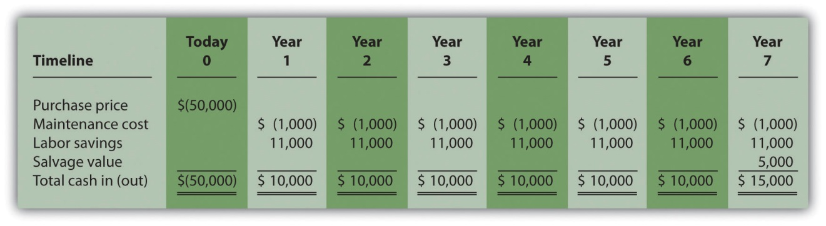

The payback method answers the question “how long will it take to recover my initial $50,000 investment?” With annual cash inflows of $10,000 starting in year 1, the payback period for this investment is 5 years (= $50,000 initial investment ÷ $10,000 annual cash receipts). This calculation is relatively simple when one investment is made at the beginning, and annual cash inflows are identical. However, some investments require cash outflows at different points throughout the life of the asset, and cash inflows can vary from one year to the next. Table 8.1 "Calculating the Payback Period for Jackson’s Quality Copies" provides a format to help calculate the payback period for these more complex investments. Note that the review problem at the end of this segment provides an example of how to calculate the payback period to the nearest month when uneven cash flows are expected.

Table 8.1 Calculating the Payback Period for Jackson’s Quality Copies
 | Investment (Cash Outflow) | Cash Inflow | Unrecovered Investment Balance
Year 0 | $(50,000) | - | $(50,000)ª
Year 1 | - | $10,000 | (40,000)^{b}
Year 2 | - | 10,000 | (30,000)^{c}
Year 3 | - | 10,000 | (20,000)
Year 4 | - | 10,000 | (10,000)
Year 5 | - | 10,000 | 0
Year 6 | - | 10,000 | 0
Year 7 | - | 15,000 | 0

ª $(50,000) = $(50,000) initial investment.

^{b} $(40,000) = $(50,000) unrecovered investment balance + $10,000 year 1 cash inflow.

^{c} $(30,000) = $(40,000) unrecovered investment balance at end of year 1 + $10,000 year 2 cash inflow.

Weaknesses of the Payback Method

Question: Why is it a problem to ignore the time value of money when calculating the payback period?

Answer: Suppose you have 2 investments of $10,000 to choose from. The first investment generates cash inflows of $8,000 in year 1, $2,000 in year 2, and $1,000 in year 3. The second investment generates cash inflows of $2,000 in year 1, $8,000 in year 2, and $1,000 in year 3. The two investments are summarized here:
 | Investment I | Investment II
Year 0 | $(10,000) | $(10,000)
Year 1 | 8,000 | 2,000
Year 2 | 2,000 | 8,000
Year 3 | 1,000 | 1,000

Both investments have a payback period of two years. Does this mean both investments are of equal value? No because the first investment generates far more cash in year 1 than the second investment. In fact, it would be preferable to calculate the IRR to compare these two investments. The IRR for the first investment is 6 percent, and the IRR for the second investment is 5 percent.

Question: Why is it a problem to ignore the cash flows after the payback period?

Answer: Suppose $50,000 can be invested in 2 separate investments with the following cash flows:
 | Investment I | Investment II
Year 0 | $(50,000) | $(50,000)
Year 1 | 25,000 | 2,000
Year 2 | 25,000 | 2,000
Year 3 | 3,000 | 46,000
Year 4 | 0 | 35,000

The first investment has a payback period of two years, and the second investment has a payback period of three years. If the company requires a payback period of two years or less, the first investment is preferable. However, the first investment generates only $3,000 in cash after its payback period while the second investment generates $35,000 after its payback period. The payback method ignores both of these amounts even though the second investment generates significant cash inflows after year 3. Again, it would be preferable to calculate the IRR to compare these two investments. The IRR for the first investment is 4 percent, and the IRR for the second investment is 18 percent.

Although the payback method is useful in certain situations where companies are concerned about recovering investments as quickly as possible (e.g., companies on the verge of bankruptcy), it is not a measure of profitability. The NPV and IRR methods compare the profitability of each investment by considering the time value of money for all cash flows related to the investment.

Wrap-Up of Chapter Example

In the Jackson’s Quality Copies example featured throughout this chapter, the company is considering whether to purchase a new copy machine for $50,000. A week has passed since Mike Haley, accountant, discussed this investment with Julie Jackson, president and owner. Refer to Figure 8.2 "NPV Calculation for Copy Machine Investment by Jackson’s Quality Copies", Figure 8.4 "Alternative NPV Calculation for Jackson’s Quality Copies", and Figure 8.5 "Finding the IRR for Jackson’s Quality Copies", andTable 8.1 "Calculating the Payback Period for Jackson’s Quality Copies" as you learn what Mike’s findings are.
Julie: | Hi Mike, any news on the copy machine proposal?
Mike: | I ran the numbers for the new copy machine, and I think you’ll like the results. It’s not as simple as looking at the difference between cash outflows of $57,000 and cash inflows of $82,000 over the life of the asset. We also have to see when the cash flows occur and convert them into today’s dollars.
Julie: | OK. What did you find?
Mike: | The NPV is $1,250 using a required rate of return of 10 percent. This means the investment will generate a return of more than 10 percent after converting the cash flows into today’s dollars.
Julie: | Great! I realize the return is expected to be above 10 percent. Do you have a sense of how far above 10 percent?
Mike: | Yes. The IRR is about 11 percent. I also calculated the payback period to give you an idea of how long it will take to recover our initial $50,000 investment.
Julie: | Good idea. My hope is that we won’t be waiting too long to recover the original investment.
Mike: | It will take 5 years to fully recover the $50,000 investment.
Julie: | Wow! That seems like a long time.
Mike: | It is. But realize we bring in an additional $25,000 after the payback period. Also, the payback method does not measure the profitability of the investment, it simply tells us how long before the initial investment is recovered. Unless we anticipate cash flow problems, I wouldn’t place too much importance on the payback period. The NPV and IRR calculations are the best for evaluating this investment.
Julie: | Good point. We don’t expect to have cash flow problems. We have plenty of capital, and the business has generated positive cash flow for the past 10 years. Let’s order the new machine!

Business in Action 8.4
Capital Budgeting at Fortune 1000 Companies
Studies completed over the past 40 years have indicated that managers prefer to use IRR and payback methods over NPV when evaluating long-term investments. However, a recent survey of Fortune 1000 chief financial officers indicates that NPV is now the most preferred method. According to this survey, the percentage of firms that always or oftenuse each method is as follows:
NPV | 85 percent
IRR | 77 percent
Payback | 53 percent
This survey also shows that companies with capital budgets exceeding $500,000,000 are more likely to use these methods than are companies with smaller capital budgets. This is probably because larger companies have more specialized personnel in their finance and accounting departments, which enables them to use more sophisticated approaches in evaluating long-term investments.
Source: Patricia A. Ryan and Glenn P. Ryan, “Capital Budgeting Practices of the Fortune 1000: How Have Things Changed?” Journal of Business and Management 8, no. 4 (2002).

KEY TAKEAWAY
- The payback method evaluates how long it will take to “pay back” or recover the initial investment. The payback period, typically stated in years, is the time it takes to generate enough cash receipts from an investment to cover the cash outflow(s) for the investment. Although this method is useful for managers concerned about cash flow, the major weaknesses of this method are that it ignores the time value of money, and it ignores cash flows after the payback period.

REVIEW PROBLEM 8.5
This review problem is a continuation of Note 8.22 "Review Problem 8.3"and Note 8.26 "Review Problem 8.4" and uses the same information. The management of Chip Manufacturing, Inc., would like to purchase a specialized production machine for $700,000. The machine is expected to have a life of 4 years and a salvage value of $100,000. Annual maintenance costs will total $30,000. Annual labor and material savings are predicted to be $250,000.
- Use the format in Table 8.1 "Calculating the Payback Period for Jackson’s Quality Copies" to calculate the payback period. Clearly state your conclusion.
- Describe the two major weaknesses of the payback method.
Solution to Review Problem 8.5
- The payback period is slightly more than three years since only $40,000 is left to be recovered after three years, as shown in the following table.
 | Investment (Cash Outflow) | Cash Inflow | Unrecovered Investment Balance
Year 0 | $(700,000) | - | $(700,000)
Year 1 | - | $220,000ª | (480,000)
Year 2 | - | 220,000ª | (260,000)
Year 3 | - | 220,000ª | (40,000)
Year 4 | - | 320,000^{b} | 0
ª $220,000 = $250,000 annual savings – $30,000 annual costs.
^{b} $320,000 = $250,000 annual savings – $30,000 annual costs + $100,000 salvage value.
- A more precise calculation can be performed assuming the $220,000 cash inflow for year 4 occurs evenly throughout the year and the $100,000 salvage value cash inflow occurs at the end of year 4. With these assumptions, we simply need to calculate how many months are required in year 4 to recover the remaining $40,000. $40,000 divided by $220,000 equals 0.18 (rounded). Thus 0.18 of a year, or approximately 2 months (= 0.18 × 12 months), is required to recover the remaining $40,000. This more precise calculation results in a payback period of three years and two months. Note that the salvage value is ignored as this cash inflow occurs at the end of year 4 when the machine is sold.
- First, the payback method does not consider the time value of money (no present value or IRR calculations are performed). Second, it only considers the cash inflows until the investment cash outflows are recovered; cash inflows after the payback period are not part of the analysis. For Chip Manufacturing, Inc., the payback period is three years and two months. However, significant cash inflows totaling $280,000 occur after the payback period and therefore are ignored ($280,000 = $320,000 year 4 cash inflows – $40,000 remaining investment recovered in the first 2 months of year 4).

8.6 Additional Complexities of Estimating Cash Flows

LEARNING OBJECTIVE
- Evaluate investments with multiple investment and working capital cash flows.

Question: The examples in this chapter are intended to help you learn the basics of evaluating investments using the net present value (NPV), internal rate of return (IRR), and payback methods. However, there are two additional items related to estimating cash flows that must be considered: investment cash outflows and working capital. How do these two items impact long-term investment decisions?

Answer: These items impact the analysis of long-term investments as described next.

Investment Cash Outflows

The examples thus far have assumed that cash outflows for the investment occur only at the beginning of the investment. However, some investments require cash outflows at varying points throughout the life of the project. For example, suppose the JCPenney Company plans to open a new store, which requires a $10,000,000 investment at the beginning of the project for construction of the building. However, the building will be expanded at the end of year 4, at a cost of $2,000,000, to meet an expected increase in demand. The $2,000,000 cash outflow must be included in the cash flows of the project for year 4 when calculating the NPV, IRR, and payback period.

Working Capital

Working capital is defined as current assets (cash, accounts receivable, inventory, and the like) minus current liabilities (accounts payable, wages payable, and accrued liabilities, for instance). Many long-term investments require working capital. For example, JCPenney will need cash in its registers when it opens the new store. Working capital is also required to fund inventory and accounts receivable. Working capital necessary for long-term investments should be included as a cash outflow, typically at the beginning of the project.

Some long-term investments have an expected life, at the end of which working capital is returned to the company for investment elsewhere. When this happens, the working capital is included in the cash flow analysis as a cash outflow at the beginning of the project and a cash inflow at the end of the project.

KEY TAKEAWAY
- Investment proposals often include investment cash outflows at varying points throughout the life of the project. These cash flows must be included when evaluating investment proposals using NPV, IRR, and payback period methods. Many investments include working capital cash flows required to fund items such as inventory and accounts receivable. Working capital is included as a cash outflow, typically at the beginning of the project, and is often returned back to the company as a cash inflow later in the project.

REVIEW PROBLEM 8.6
The management of Environmental Engineering, Inc. (EEI), would like to open an office for 6 years in a high-growth area of Las Vegas. The initial investment required to purchase an office building is $250,000, and EEI needs $50,000 in working capital for the new office. Working capital will be returned to EEI at the end of 6 years. EEI expects to remodel the office at the end of 3 years at a cost of $200,000. Annual net cash receipts from daily operations (cash receipts minus cash payments) are expected to be as follows:
Year 1 | $ 60,000
Year 2 | $ 80,000
Year 3 | $120,000
Year 4 | $150,000
Year 5 | $160,000
Year 6 | $110,000
Although the company’s cost of capital is 8 percent, management set a required rate of return of 12 percent due to the high risk associated with this project.
- Find the NPV of this investment using the format presented in .
- Use trial and error to approximate the IRR for this investment proposal.
- Based on your answers to 1 and 2, should EEI open the new office? Explain.
- Use the format in to calculate the payback period.
Solution to Review Problem 8.6
- The NPV is $27,571, as shown in the following figure.
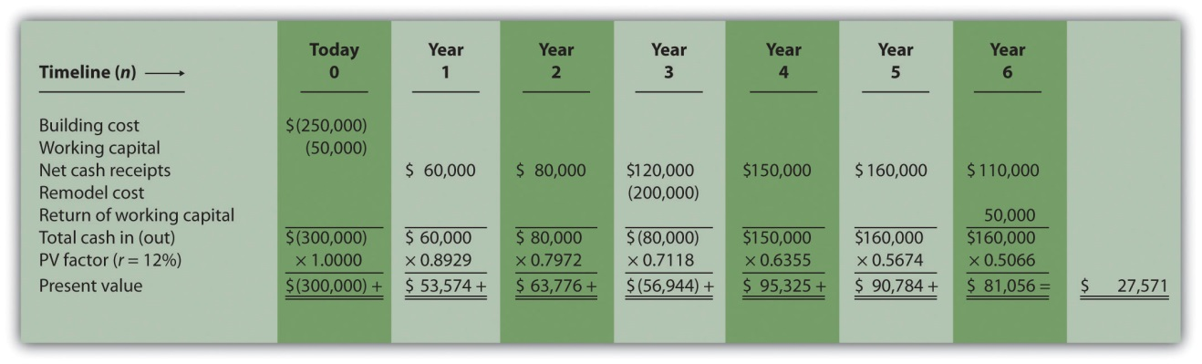
Note: The NPV is $27,571. Because NPV is > 0, accept the investment. (The investment provides a return greater than 12 percent.)
- The IRR is between 14 and 15 percent (approximately 14.5 percent). The IRR is the rate that generates a NPV of zero. Because the NPV is positive at 12 percent, the return is higher than 12 percent. The NPV is calculated as follows using a rate of 14 percent, NPV = $5,007, and 15 percent, NPV = $(5,446). Thus the IRR is between 14 and 15 percent.

NPV at 14 percent is
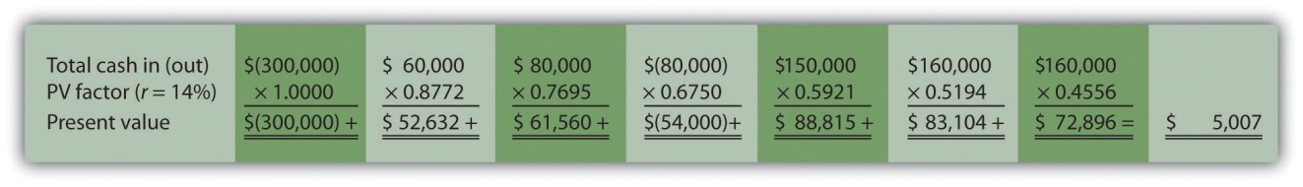

NPV at 15 percent is
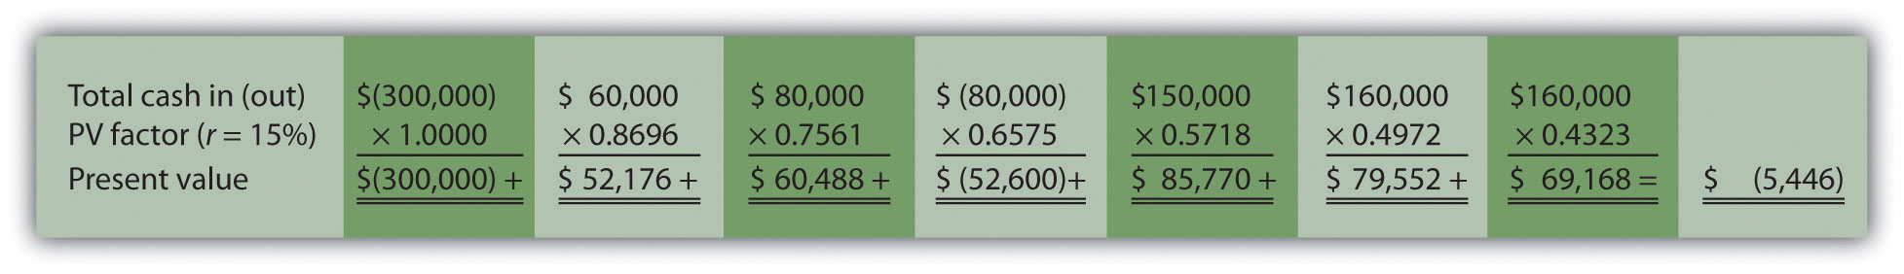
- Yes. The NPV is positive at $27,571, and the IRR of 14.5 percent is higher than the company’s required rate of return of 12 percent. Thus EEI should open the office in Las Vegas.
- The payback period is approximately 4.5 years. This approximation assumes the $90,000 unrecovered investment at the end of year 4 will be recovered about halfway through year 5.
 | Investment (Cash Outflow) | Cash Inflow | Unrecovered Investment Balance
Year 0 | $(300,000) | - | $(300,000)
Year 1 | - | $ 60,000 | (240,000)ª
Year 2 | - | 80,000 | (160,000)^{b}
Year 3 | (200,000) | 120,000 | (240,000)^{c}
Year 4 | - | 150,000 | (90,000)
Year 5 | - | 160,000 | 0
Year 6 | - | 160,000 | 0
ª $(240,000) = $(300,000) unrecovered investment + $60,000 year 1 cash inflow.
^{b} $(160,000) = $(240,000) unrecovered investment at end of year 1 + $80,000 year 2 cash inflow.
^{c} $(240,000) = $(160,000) unrecovered investment at end of year 2 – $200,000 year 3 investment + $120,000 year 3 cash inflow.
- A more precise calculation can be performed assuming the $160,000 cash inflow for year 5 occurs evenly throughout the year. Simply calculate how many months are required in year 5 to recover the remaining $90,000. $90,000 divided by $160,000 equals 0.56 (rounded). Thus 0.56 of a year, or approximately 7 months (= 0.56 × 12 months), is required to recover the remaining $90,000. This more precise calculation results in a payback period of four years and seven months.

8.7 The Effect of Income Taxes on Capital Budgeting Decisions

LEARNING OBJECTIVE
- Understand the impact that income taxes have on capital budgeting decisions.

Question: Throughout the chapter, we assumed no income taxes were involved. This is a reasonable assumption for not-for-profit entities and governmental agencies. However, firms that pay income taxes must consider the impact income taxes have on cash flows for long-term investments. How do for-profit organizations include income taxes in their analysis when making long-term investment decisions?

Answer: Let’s look at an example to help explain how this works. The management of Scientific Products, Inc. (SPI), is considering a five-year contract to build scientific instruments for a large school district. The initial investment required to purchase production equipment is $400,000 (to be depreciated over 5 years using the straight-line method, with no salvage value). An additional $50,000 in working capital is required for the contract. Working capital will be returned to SPI at the end of five years. Annual net cash receipts from daily operations (cash receipts minus cash payments) are shown as follows. Since depreciation expense is not a cash outflow, it is not included in these amounts.
Year 1 | $ 50,000
Year 2 | $ 60,000
Year 3 | $120,000
Year 4 | $200,000
Year 5 | $130,000

Management established a required rate of return of 10 percent for this proposal. The company’s tax rate is 40 percent. (The complexities of government tax codes have a significant impact on the tax rate used. For simplicity, we use a tax rate of 40 percent for this example.)

When taxes are involved, it is important to understand which cash flows are affected by the tax rate and which are not. We look at this by addressing the following capital budgeting items:
- Investment cash outflows
- Working capital cash outflows and inflows
- Revenue cash inflows and expense cash outflows
- Depreciation

Provides a detailed example of how companies adjust for income taxes when evaluating long-term investments. Examine carefully, including the footnotes, as we explain each of these items.

Figure 8.7 NPV Calculation with Income Taxes for Scientific Products, Inc.
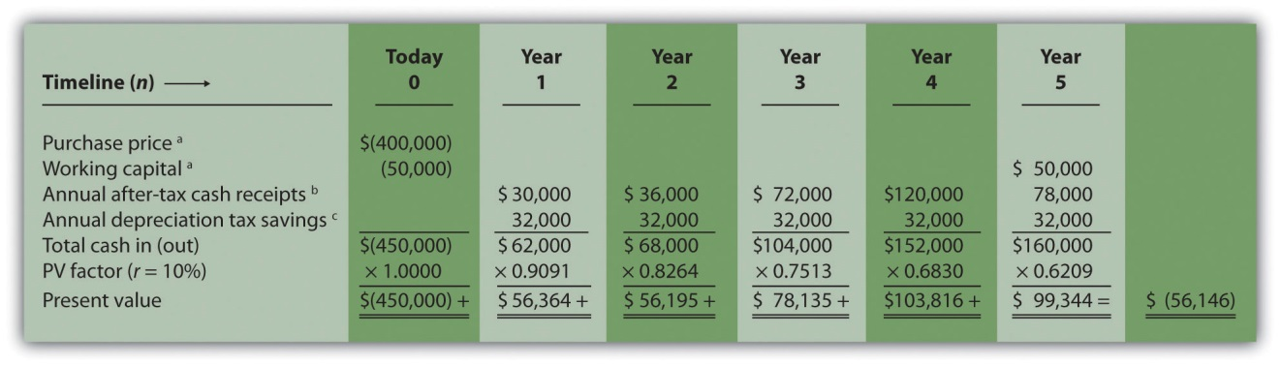

Note: the NPV is $(56,146).

Since NPV is < 0, reject the investment. (The investment provides a return less than 10 percent.)

a Initial investment purchase price and working capital do not directly affect net income and therefore are not adjusted for income taxes.

b Amount equals net cash receipts before taxes × (1 – tax rate). For year 1, $30,000 = $50,000 × (1 – 0.40); for year 2, $36,000 = $60,000 × (1 – 0.40); and so forth.

c Depreciation tax savings = Depreciation expense × Tax rate. Depreciation expense is $80,000 (= $400,000 cost ÷ 5 year useful life). Thus annual depreciation tax savings is $32,000 (= $80,000 depreciation expense × 0.40 tax rate).
- Investment Cash Outflows. The initial investment in production equipment of $400,000 is not adjusted for income taxes because it does not directly affect net income. Thus this amount is included in full in .
- Working Capital Cash Outflows and Inflows. Working capital of $50,000 is not adjusted for income taxes since it does not affect net income. Thus this amount is included in full as a cash outflow at the beginning of the project and again in full when returned to the company at the end of the project, as shown in .
- Revenues and Expenses. When a company must pay income taxes, all revenue cash inflows and expense cash outflows affect net income and therefore affect income taxes paid. The goal is to determine the after-taxcash flow. This is calculated in the equation that follows.The tax rate for Scientific Products, Inc., is 40 percent. Thus net cash receipts (revenue cash inflows minus expense cash outflows) are multiplied by 0.60 (= 1 – 0.40). This results in an after-tax cash flow, as shown in .

Key Equation
After-tax revenue cash inflow = Before-tax cash inflow × (1 – tax rate)After-tax expense cash outflow = Before-tax cash outflow × (1 – tax rate)
- Depreciation. Although depreciation expense is not a cash outflow, it does reduce taxable income and thereby reduces taxes that are paid (recall that the entry to record depreciation for financial accounting purposes does not affect cash; debit depreciation expense and credit accumulated depreciation). The term used to describe this tax savings isdepreciation tax shield. The tax savings resulting from depreciation are calculated as follows:

Key Equation
Depreciation tax savings cash inflow = Depreciation expense × Tax rate

The production equipment, which has a purchase price of $400,000, has a useful life of 5 years and no salvage value. SPI uses the straight-line method, which depreciates the original cost evenly over the useful life of the asset. Thus depreciation expense is $80,000 (= $400,000 ÷ 5 years). This is multiplied by the tax rate of 40 percent to get the annual tax savings of $32,000 (= $80,000 × 0.40), as shown in .

Question: Based on the information presented in , should SPI accept the investment proposal?

Answer: As you can see in , the NPV is negative ($[56,146]), so SPI’s management should reject the investment proposal. provides a summary of how income taxes influence cash flows for long-term investments. (Note that this section is intended to give you a general overview of how income taxes effect capital budgeting decisions. Finance textbooks provide more detail regarding how to adjust cash flows for income taxes in more complex situations.)

Figure 8.8 How Income Taxes Affect Capital Budgeting Cash Flows
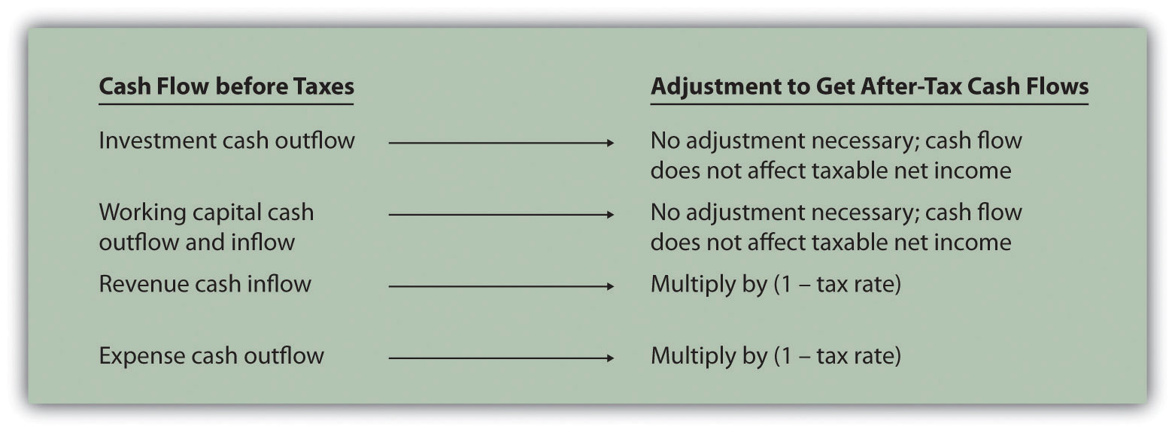

KEY TAKEAWAY
- Companies that pay income taxes must consider the impact income taxes have on cash flows for long-term investments, and make the necessary adjustments. Investment and working capital cash flows are not adjusted because these cash flows do not affect taxable income. Revenue cash inflows and expense cash outflows are adjusted by multiplying the cash flow by (1 – tax rate). Although depreciation expense is not a cash outflow, it provides tax savings. The tax savings is calculated by multiplying depreciation expense by the tax rate. Once these adjustments are made, we can calculate the NPV and IRR.

REVIEW PROBLEM 8.7
Car Repair, Inc., would like to purchase a new machine for $400,000. The machine will have a life of 4 years with no salvage value, and is expected to generate annual cash revenue of $180,000. Annual cash expenses, excluding depreciation, will total $20,000. The company uses the straight-line depreciation method, has a tax rate of 30 percent, and requires a 10 percent rate of return.
- Find the NPV of this investment using the format presented in .
- Should the company purchase the machine? Explain.
Solution to Review Problem 8.7
- The NPV is $50,112 as shown in the following figure.
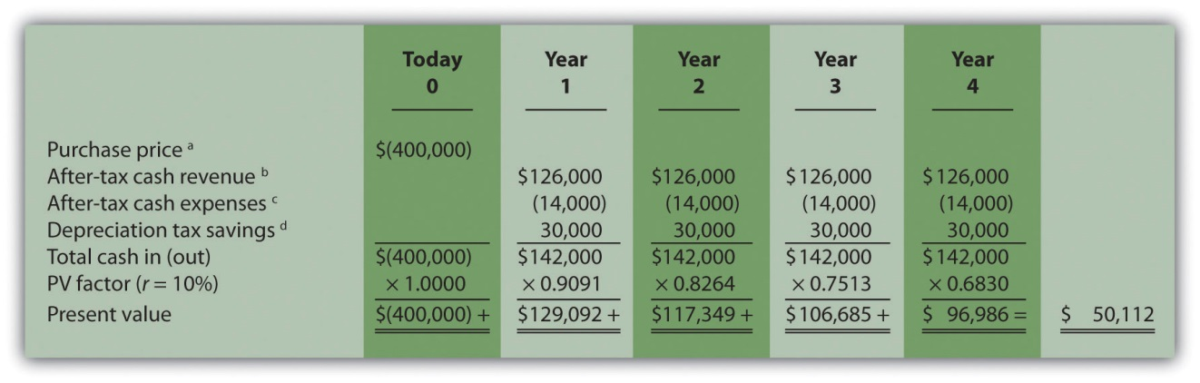

ª Initial investment purchase price does not directly affect net income and therefore is not adjusted for income taxes.
^{b} Amount equals cash revenue before taxes × (1 – tax rate); $126,000 = $180,000 × (1 – 0.30).
^{c} Amount equals cash expense before taxes × (1 – tax rate); $14,000 = $20,000 × (1 – 0.30).
^{d} Depreciation tax savings = Depreciation expense × Tax rate. Depreciation expense is $100,000 (= $400,000 cost ÷ 4 year useful life). Thus annual depreciation tax savings is $30,000 (= $100,000 depreciation expense × 0.30 tax rate).
- Yes, the company should purchase the machine. The positive NPV of $50,112 shows the return of this proposal is above the company’s required rate of return of 10 percent.

8.8 Appendix: Present Value Tables
Figure 8.9 Present Value of $1 Received at the End of n Periods
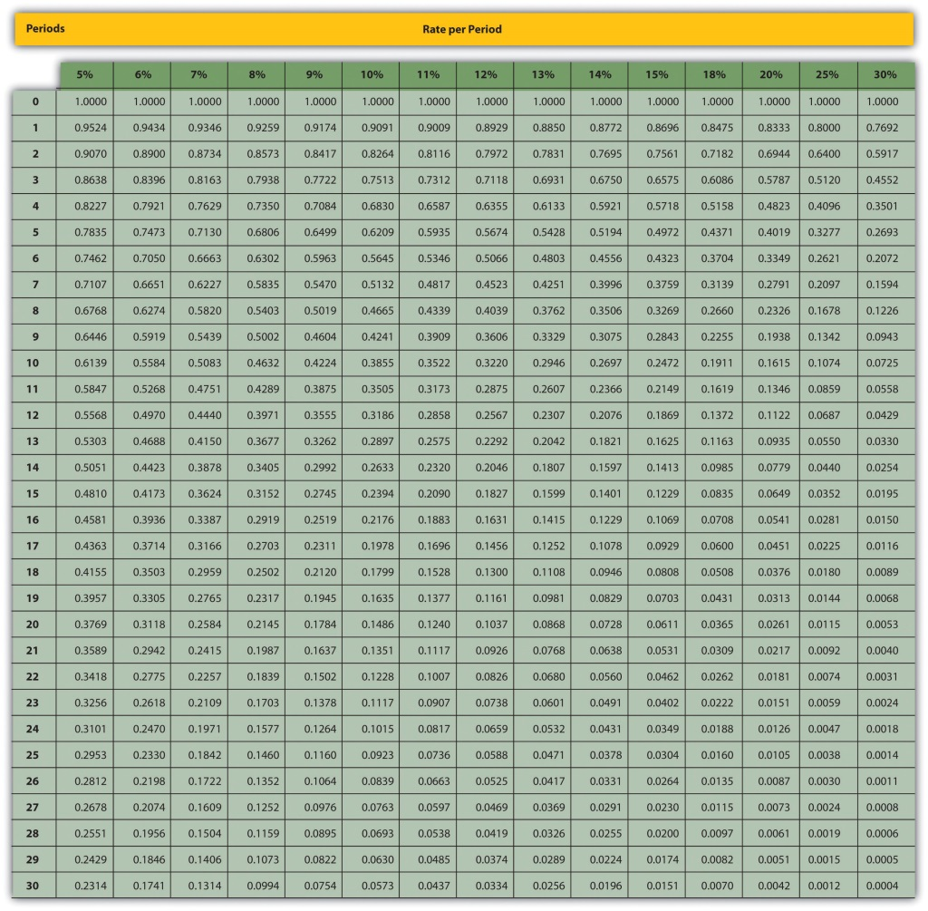
Note: Factor=1(1+r)n
Figure 8.10 Present Value of a $1 Annuity Received at the End of Each Period for n Periods
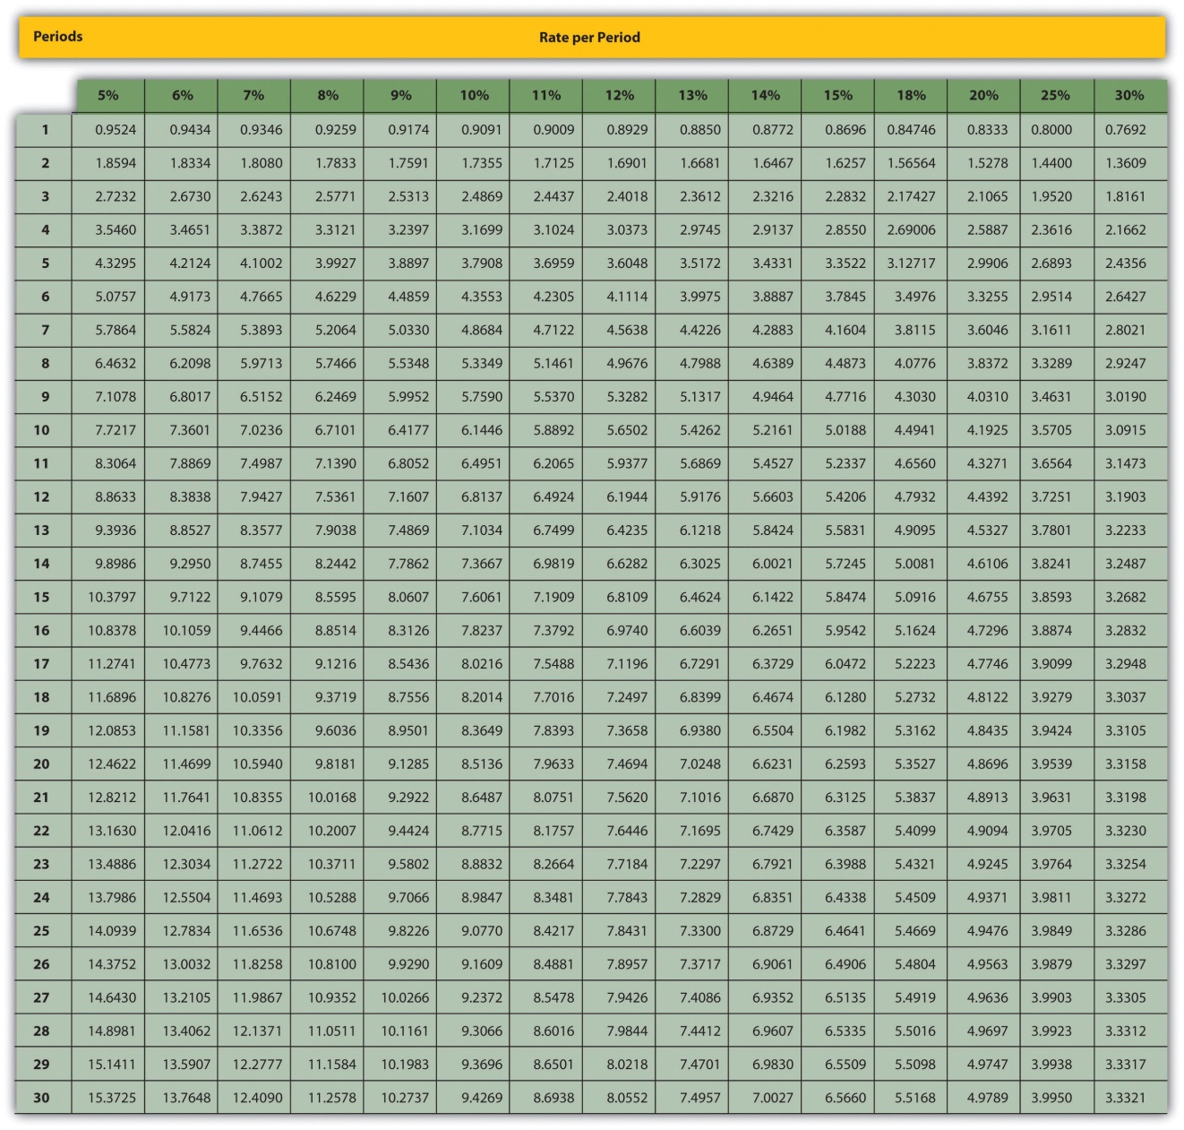
Note: Factor=1−(1+r)−nr

END-OF-CHAPTER EXERCISES
Questions
- What is the difference between capital budgeting decisions covered in this chapter and management decisions covered in ?
- What concept must be considered when looking at cash flows over several years for a long-term investment? Explain.
- What is meant by the term present value?
- What is the formula used to calculate the present value of a future cash flow? Describe each component.
- Describe the three steps required to evaluate investments using the net present value method.
- How do most firms establish the required rate of return used to calculate the net present value?
- What is meant by the term internal rate of return? Explain the IRR decision rule?
- For the purpose of calculating net present value and internal rate of return, do companies use the accrual basis of accounting? Explain.
- Why might a firm choose to accept a long-term investment even if the net present value is below zero?
- What might cause a manager to reject a long-term investment even though the net present value is positive?
- Describe the two steps required to calculate net present value and internal rate of return when using Excel.
- What is the payback method, and why do managers use this method?
- What are the two weaknesses associated with the payback method?
- Refer to What method of evaluating long-term investments is most popular? Why do you think the payback method is the least-used method?
- What does the term working capital refer to, and how does working capital affect the evaluation of long-term investments?
- Assume a company pays income taxes. How are revenue and expense cash flows adjusted for income taxes when calculating the net present value?
- Assume a company pays income taxes. How does depreciation expense affect cash flows even though it is a noncash expense?
Brief Exercises
- Investment Decision at Jackson’s Quality Copies. Refer to the dialogue at Jackson’s Quality Copies presented at the beginning of the chapter. What is Julie Jackson proposing? What information did Mike, the accountant, get from Julie to evaluate the proposal?
- Present Value Calculations. For each of the following independent scenarios, use in the appendix to calculate the present value of the cash flow described.
  - $10,000 will be received 4 years from today. The rate is 10 percent.
  - $10,000 will be received 4 years from today. The rate is 20 percent.
  - $50,000 will be received 15 years from today. The rate is 12 percent.
  - $50,000 will be received 15 years from today. The rate is 6 percent.
- Present Value Calculations (Annuities). For each of the following independent scenarios, use in the appendix to calculate the present value of the cash flow described. Round to the nearest dollar.
  - $1,000 will be received at the end of each year for 6 years. The rate is 12 percent.
  - $1,000 will be received at the end of each year for 6 years. The rate is 15 percent.
  - $10,000 will be received at the end of each year for 6 years. The rate is 7 percent.
  - $250,000 will be received at the end of each year for 4 years. The rate is 10 percent.
- Net Present Value Calculations. Freefall, Inc., has two independent investment opportunities, each requiring an initial investment of $65,000. The company’s required rate of return is 8 percent. The cash inflows for each investment are provided as follows.
Required:
  - Without resorting to calculations, which investment will have the highest net present value? Explain.
  - Calculate the net present value for each investment (remember to include the initial investment cash outflow in your calculation). Should the company invest in either investment? Round to the nearest dollar.
- Internal Rate of Return Calculation. An investment costing $50,000 today will result in cash savings of $5,000 per year for 15 years. Use trial and error to approximate the internal rate of return for this investment proposal.
- Evaluating Qualitative Factors. Chem, Inc., produces chemical products. The company recently decided to invest in expensive pollution control devices even though the negative net present value pointed toward rejecting this investment. What qualitative factor likely led the company to make the investment in spite of the negative net present value?
- Ethical Issues in Making a Capital Budgeting Decision. Assume the manager of a store earns an annual bonus based on meeting a certain level of net income, which has been achieved consistently over the past five years. The company is currently considering the addition of a second store, which is expected to become profitable after two years. The manager is responsible for making the final decision whether the second store should be opened and would receive an annual bonus only if a certain level of net income were achieved for both stores combined.
Why might the manager refuse to invest in the new store even though the investment is projected to achieve a return greater than the company’s required rate of return?
- Net Present Value Calculation Using Excel. An investment costing $200,000 today will result in cash savings of $85,000 per year for 3 years. The company’s required rate of return is 11 percent. Use Excel to calculate the net present value of this investment in a format similar to the one in the Computer Application box in the chapter.
- Payback Period Calculation. Textile Services, Inc., plans to invest $80,000 in a new machine. Annual cash inflows from this investment will be $25,000, and annual cash outflows will be $5,000. Determine the payback period for this investment.
- Net Present Value Analysis with Multiple Investments. A project requiring an investment of $20,000 today and $10,000 one year from today, will result in cash savings of $4,000 per year for 15 years. Find the net present value of this investment using a rate of 10 percent. Round to the nearest dollar.
- Net Present Value Calculation with Taxes. An investment costing $200,000 today will result in cash savings of $85,000 per year for 3 years. The company has a tax rate of 40 percent, and requires an 11 percent rate of return. Find the net present value of this investment using the format shown in . Round to the nearest dollar.
Exercises: Set A
- Net Present Value Analysis. Architect Services, Inc., would like to purchase a blueprint machine for $50,000. The machine is expected to have a life of 4 years, and a salvage value of $10,000. Annual maintenance costs will total $14,000. Annual savings are predicted to be $30,000. The company’s required rate of return is 11 percent.
Required:
  - Ignoring the time value of money, calculate the net cash inflow or outflow resulting from this investment opportunity.
  - Find the net present value of this investment using the format presented in .
  - Should the company purchase the blueprint machine? Explain.
- Internal Rate of Return Analysis. Architect Services, Inc., would like to purchase a blueprint machine for $50,000. The machine is expected to have a life of 4 years, and a salvage value of $10,000. Annual maintenance costs will total $14,000. Annual savings are predicted to be $30,000. The company’s required rate of return is 11 percent (this is the same data as the previous exercise).
Required:
  - Use trial and error to approximate the internal rate of return for this investment proposal. Round to the nearest dollar.
  - Should the company purchase the blueprint machine? Explain.
- Payback Period Calculation. Architect Services, Inc., would like to purchase a blueprint machine for $50,000. The machine is expected to have a life of 4 years, and a salvage value of $10,000. Annual maintenance costs will total $14,000. Annual savings are predicted to be $30,000 (this is the same data as the previous exercise). Determine the payback period for this investment using the format shown in .
- Net Present Value Analysis with Multiple Investments, Alternative Format. Conway Construction Corporation would like to purchase a fleet of trucks at a cost of $260,000. Additional equipment needed to maintain the fleet of trucks will be purchased at the end of year 2 for $40,000. The trucks are expected to have a life of 8 years, and a salvage value of $20,000. Annual costs for maintenance, insurance, and other cash expenses will total $42,000. Annual net cash receipts resulting from this purchase are predicted to be $135,000. The company’s required rate of return is 14 percent.
Required:
  - Find the net present value of this investment using the format presented in .
  - Should the company purchase the new fleet of trucks? Explain.
- Calculating NPV and IRR Using Excel. Wood Products Company would like to purchase a computerized wood lathe for $100,000. The machine is expected to have a life of 5 years, and a salvage value of $5,000. Annual maintenance costs will total $20,000. Annual net cash receipts resulting from this machine are predicted to be $45,000. The company’s required rate of return is 15 percent.
Required:
  - Use Excel to calculate the net present value and internal rate of return in a format similar to the Computer Application spreadsheet shown in the chapter.
  - Should the company purchase the wood lathe? Explain.
- Net Present Value Analysis with Taxes. Timberline Company would like to purchase a new machine for $100,000. The machine will have a life of 5 years with no salvage value, and is expected to generate annual cash revenue of $50,000. Annual cash expenses, excluding depreciation, will total $24,000. The company uses the straight-line depreciation method, has a tax rate of 40 percent, and requires a 12 percent rate of return.
Required:
  - Find the net present value of this investment using the format presented in . Round to the nearest dollar.
  - Should the company purchase the machine? Explain.
Exercises: Set B
- Net Present Value Analysis. Wood Products Company would like to purchase a computerized wood lathe for $100,000. The machine is expected to have a life of 5 years, and a salvage value of $5,000. Annual maintenance costs will total $20,000. Annual net cash receipts resulting from this machine are predicted to be $45,000. The company’s required rate of return is 15 percent.
Required:
  - Ignoring the time value of money, calculate the net cash inflow or outflow resulting from this investment opportunity.
  - Find the net present value of this investment using the format presented in . Round to the nearest dollar.
  - Should the company purchase the wood lathe? Explain.
- Internal Rate of Return Analysis. Wood Products Company would like to purchase a computerized wood lathe for $100,000. The machine is expected to have a life of 5 years, and a salvage value of $5,000. Annual maintenance costs will total $20,000. Annual net cash receipts resulting from this machine are predicted to be $45,000. The company’s required rate of return is 15 percent (this is the same data as the previous exercise).
Required:
  - Use trial and error to approximate the internal rate of return for this investment proposal.
  - Should the company purchase the wood lathe? Explain.
- Payback Period Calculation. Wood Products Company would like to purchase a computerized wood lathe for $100,000. The machine is expected to have a life of 5 years, and a salvage value of $5,000. Annual maintenance costs will total $20,000. Annual net cash receipts resulting from this machine are predicted to be $45,000. The company’s required rate of return is 15 percent (this is the same data as the previous exercise). Determine the payback period for this investment using the format shown in .
- Net Present Value Analysis and Qualitative Factors, Alternative Format. Pete’s Plumbing Supplies would like to expand into a new warehouse at a cost of $500,000. The warehouse is expected to have a life of 20 years, and a salvage value of $100,000. Annual costs for maintenance, insurance, and other cash expenses will total $60,000. Annual net cash receipts resulting from this expansion are predicted to be $115,000. The company’s required rate of return is 12 percent.
Required:
  - Find the net present value of this investment using the format presented in . Round to the nearest dollar.
  - Should the company purchase the new warehouse? Explain.
  - Provide one qualitative factor that might cause the company to reach a different conclusion than the one reached in requirement b.
- Calculating NPV and IRR Using Excel. Pete’s Plumbing Supplies would like to expand into a new warehouse at a cost of $500,000. The warehouse is expected to have a life of 20 years, and a salvage value of $100,000. Annual costs for maintenance, insurance, and other cash expenses will total $60,000. Annual net cash receipts resulting from this expansion are predicted to be $115,000. The company’s required rate of return is 12 percent.
Required:
  - Use Excel to calculate the net present value and internal rate of return in a format similar to the Computer Application spreadsheet shown in the chapter.
  - Should the company purchase the warehouse? Explain.
- Net Present Value Analysis with Taxes. Quality Chocolate, Inc., would like to purchase a new machine for $200,000. The machine will have a life of 4 years with no salvage value, and is expected to generate annual cash revenue of $90,000. Annual cash expenses, excluding depreciation, will total $10,000. The company uses the straight-line depreciation method, has a tax rate of 30 percent, and requires a 14 percent rate of return.
Required:
  - Find the net present value of this investment using the format presented in . Round to the nearest dollar.
  - Should the company purchase the machine? Explain.
Problems
- Evaluating Alternative Investments. Washington Brewery has two independent investment opportunities to purchase brewing equipment so the company can meet growing customer demand. The first option (equipment A) requires an initial investment of $230,000 for equipment with an expected life of 5 years and a salvage value of $20,000. The second option (equipment B) requires an initial investment of $120,000 for equipment with an expected life of 4 years and a salvage value of $15,000. The company’s required rate of return is 10 percent. Additional cash flow information for each investment is provided as follows.
 | Year 1 | Year 2 | Year 3 | Year 4 | Year 5
Equipment A
Utility savings | $ 12,000 | $ 14,000 | $ 15,000 | $ 16,000 | $ 17,000
Additional revenue | 45,000 | 48,000 | 50,000 | 55,000 | 60,000
Maintenance costs | (5,000) | (8,000) | (10,000) | (13,000) | (16,000)
Equipment B
Utility savings | $ 8,000 | $ 9,000 | $ 10,000 | $ 10,000 | -
Additional revenue | 35,000 | 36,000 | 38,000 | 42,000 | -
Maintenance costs | (6,000) | (8,000) | (9,000) | (11,000) | -
- Required:
  - Calculate the net present value for each investment using the format presented in . (Remember to include the initial investment cash outflow and salvage value in your calculation.) Round to the nearest dollar.
  - Which, if any, investment is preferable? Explain.
- Net Present Value, Internal Rate of Return, and Payback Period Analyses. Sherwin Moore Paint Company would like to further automate its production process by purchasing production equipment for $660,000. The equipment is expected to have a useful life of 8 years, and will be sold at the end of 8 years for $40,000. The equipment requires significant maintenance work at an annual cost of $75,000. Labor and material cost savings, shown in the table, are also expected to be significant.
Year 1 | $160,000
Year 2 | $190,000
Year 3 | $200,000
Year 4 | $240,000
Year 5 | $280,000
Year 6 | $220,000
Year 7 | $180,000
Year 8 | $155,000
- The company’s required rate of return is 11 percent. Assume the company requires all investments to be recovered within five years.
- Required:
  - Find the net present value of this investment using the format presented in . Round to the nearest dollar.
  - Use trial and error to approximate the internal rate of return for this investment proposal.
  - Determine the payback period for this investment using the format shown in .
  - Based on your findings in requirements a, b, and c, should the company purchase the production equipment? Explain.
- Calculating NPV and IRR Using Excel. Sherwin Moore Paint Company would like to further automate its production process by purchasing production equipment for $660,000. The equipment is expected to have a useful life of 8 years, and will be sold at the end of 8 years for $40,000. The equipment requires significant maintenance work at an annual cost of $75,000. Labor and material cost savings, shown in the table, are also expected to be significant.
Year 1 | $160,000
Year 2 | $190,000
Year 3 | $200,000
Year 4 | $240,000
Year 5 | $280,000
Year 6 | $220,000
Year 7 | $180,000
Year 8 | $155,000
- The company’s required rate of return is 11 percent.
- Required:
  - Use Excel to calculate the net present value and internal rate of return in a format similar to the Computer Application spreadsheet shown in the chapter.
  - Should the company purchase the production equipment? Explain.
- Net Present Value Analysis, Multiple Investments, and Qualitative Factors. Oil Production, Inc., would like to drill oil from land the company already owns. The equipment is expected to cost $4,000,000, has a useful life of 5 years, and will be sold at the end of 5 years for $400,000. Annual costs for maintenance and other cash expenses will total $550,000. Annual net cash receipts resulting from the sale of oil are predicted to be $1,900,000. Working capital of $270,000 is required at the beginning of the project and will be returned at the end of 5 years. The equipment will require refurbishing at the end of year 3 at a cost of $300,000. Although the company’s cost of capital is 15 percent, management established a required rate of return of 20 percent due to the high risk associated with this project.
Required:
  - Find the net present value of this investment using the format presented in . Round to the nearest dollar.
  - Use trial and error to approximate the internal rate of return for this investment proposal.
  - Should the company accept the proposal? Explain.
  - What qualitative factors might improve management’s view of this proposal?
- Calculating NPV and IRR Using Excel. Oil Production, Inc., would like to drill oil from land the company already owns. The equipment is expected to cost $4,000,000, has a useful life of 5 years, and will be sold at the end of 5 years for $400,000. Annual costs for maintenance and other cash expenses will total $550,000. Annual net cash receipts resulting from the sale of oil are predicted to be $1,900,000. Working capital of $270,000 is required at the beginning of the project and will be returned at the end of 5 years. The equipment will require refurbishing at the end of year 3 at a cost of $300,000. Although the company’s cost of capital is 15 percent, management established a required rate of return of 20 percent due to the high risk associated with this project.
Required:
  - Use Excel to calculate the net present value and internal rate of return in a format similar to the Computer Application spreadsheet shown in the chapter.
  - Should the company accept the proposal? Explain.
- Net Present Value, Internal Rate of Return, and Payback Period Analyses; Ethical Issues. Tower CD Stores would like to open a retail store in Houston. The initial investment to purchase the building is $420,000, and an additional $50,000 in working capital is required. Since this store will be operating for many years, the working capital will not be returned in the near future. Tower expects to remodel the store at the end of 3 years at a cost of $100,000. Annual net cash receipts from daily operations (cash receipts minus cash payments) are expected to be as follows.
Year 1 | $ 80,000
Year 2 | $115,000
Year 3 | $118,000
Year 4 | $140,000
Year 5 | $155,000
Year 6 | $167,000
Year 7 | $175,000
- The company’s required rate of return is 13 percent. Assume management decided to limit the analysis to 7 years.
- Required:
  - Find the net present value of this investment using the format presented in . Round to the nearest dollar.
  - Use trial and error to approximate the internal rate of return for this investment proposal.
  - Based on your answer to requirements a and b, should Tower open the new store? Explain.
  - Use the format presented in to calculate the payback period (include working capital in the initial investment). Assuming management requires all investments to be recovered within three years, should Tower CD Store open the new store?
  - What is the weakness of using the payback period method to evaluate long-term investments?
  - Assume the manager of the company wanted to live in Houston and intentionally inflated the projected annual cash receipts so that the proposal would be accepted. The proposal would otherwise have been rejected. Explain how the company’s use of a postaudit would help to prevent this type of unethical behavior.
- Net Present Value with Taxes. Refer to the Tower CD Stores information presented in the previous problem. Assume the costs associated with the purchase of the building are depreciated over 20 years using the straight-line method, with no salvage value. Costs associated with the building remodel are depreciated over 10 years with no salvage value, starting with year 4. The company’s tax rate is 40 percent. Again, management will limit the analysis to seven years.
Required:
  - Find the net present value of this investment using the format presented in . Round to the nearest dollar.
  - Should Tower open the new store? Explain.
  - How did income taxes affect the decision being made by Tower CD Stores?
One Step Further: Skill-Building Cases
- Opening New Retail Stores. Refer to Provide two examples of cash outflows and one example of cash inflows resulting from the decision to open a new store.
- Determining the Cost of Capital by Industry. Refer to the Why do you think the cost of capital in the beverage industry is low relative to the cost of capital in other industries?
- The California Lottery and Present Value Concepts. Refer to the Why does the State of California need only $550,000 to pay a $1,000,000 lottery winner?
- Internet Project: Capital Expenditures at Intel. Go to Intel’s Web site (http://www.intel.com) and enter “annual report” or “10K report” in the search feature. Find the most recent annual report or 10K report and review the Consolidated Statements of Cash Flows portion of the company’s financial statements. Find the Additions to property, plant and equipment line item in the Investing Activities section of the statement, and answer the following questions. Be sure to submit a printed copy of the consolidated statements of cash flows with your answers.
  - How much cash did Intel spend on additions to property, plant, and equipment in the most current year? How does this amount compare with amounts spent in the previous two years?
  - Describe two capital budgeting decision techniques that were likely used by Intel to make long-term investment decisions.
- Group Activity: Qualitative Factors. Each of the following scenarios is being considered at three separate companies.
  - A large regional energy company uses coal to produce electricity that is sold to local power companies. Although government regulations will not require a cleaner process for at least five years, the company is considering spending millions of dollars on equipment that will reduce pollutants from its production process. However, the net present value analysis indicates this proposal should be rejected.
  - A producer of mountain bikes known for its expensive, high-quality bikes would like to introduce a less expensive entry-level line of mountain bikes. However, the projected internal rate of return for this proposal is lower than the company’s minimum required rate of return.
  - A maker of computer chips with a reputation of staying on the cutting edge of technology would like to invest in a new production facility. However, the net present value analysis indicates this proposal should be rejected.
Required:
Your instructor will divide the class into groups of two to four students, and assign one of the three independent scenarios listed previously to each group. Each group must perform the requirements listed here:
    - Identify at least two qualitative factors that may lead to accepting the proposal.
    - Discuss each option, based on the findings of your group, with the class.
Comprehensive Cases
- Ethical Issues in Capital Budgeting. Loomis Nursery grows a variety of plants for wholesale distribution. The company would like to expand its operations and is considering a move to one of two locations. The first location, Wyatville, is one hour from the ocean and therefore attractive for employees who like to travel on weekends. The second location, Kenton, is not as close to the ocean, and much further from desirable vacation destinations.
The company’s controller, Lisa Lennox, created a net present value analysis for each location. The Kenton location had a positive net present value, and the Wyatville location had a negative net present value. Upon providing this information to the chief financial officer of the company, Max Madden, Lisa was asked to “review the numbers carefully and make sure all the benefits of moving to Wyatville were included in the analysis.” Lisa knew that Max preferred vacationing near the ocean and had a strong desire to move operations to Wyatville. However, she was unable to find any errors in her analysis and could not identify any additional benefits.
Lisa approached Max with this information. Max responded, “There is no way Kenton should have a higher net present value than Wyatville. Redo your analysis to show that Wyatville has the highest net present value, and have it on my desk by the end of the week.”
Required:
  - Is Max Madden’s request ethical? Explain.
  - How should Lisa handle this situation? (It may be helpful to review the presentation of ethics in .)
- Ethical Issues in Capital Budgeting. Toyonda Motor Company produces a variety of products including motorcycles, all-terrain vehicles, marine engines, automobiles, light trucks, and heavy-duty trucks. Each division manager at Toyonda Motor Company is paid a base salary and is given an annual cash bonus if the division achieves profits of at least 10 percent of the value of assets invested in the division (this is called return on investment).
Peggy Parkins, manager of the Light Truck Division, is considering investing in new production equipment. The net present value of the proposal is positive, and Peggy is convinced the new equipment will provide a competitive edge in future years. However, because of the significant up-front cost and related depreciation, short-term profits will be negatively affected by this investment. In fact, the new equipment will reduce return on investment below the 10 percent threshold for at least 3 years, which will prevent Peggy from receiving her annual bonuses for at least 3 years. However, profits are expected to increase significantly after the three-year period. Peggy is planning to retire in two years and therefore would prefer to reject the proposal to invest in new production equipment.
Required:
  - Describe the ethical conflict facing Peggy Parkins.
  - What type of employee compensation system might prevent this type of conflict?

Chapter 9

How Are Operating Budgets Created?

Jerry Feltz is the president and owner of Jerry’s Ice Cream, a producer of high-quality ice cream sold to specialty grocery stores. Jerry is holding a meeting with the company’s managers to discuss plans for this coming year. Managers at the meeting are Tom Benson, the sales manager; Lynn Young, the production manager; and Michelle Hopkins, the treasurer and controller.
Jerry: | It looks as if we are having another great year. Customers love our ice cream, and sales are up. It’s time to begin the budgeting process for next year. Tom, do you have any thoughts on what our sales will look like for next year?
Tom: | I think we will continue to see significant sales growth. But it’s difficult to predict exactly how much growth. On the low end, I would expect about 10 percent; on the high end, perhaps 25 percent.
Lynn: | Wow! I knew sales were going well, but I had no idea we were expecting to grow 10 percent to 25 percent next year. It will take some serious planning to produce enough ice cream to handle this growth.
Michelle: | I agree. We need to make sure production has enough capacity to handle the growth, and cash flow planning will be critical to ensure we don’t run out of cash in the process of ramping up production.
Jerry: | Tom, talk with our salespeople and industry contacts so we can get a solid estimate of quarterly sales for next year. If sales really are expected to grow as you say, we will face a huge challenge!
Tom: | I’ll have something for you by the end of next week.
Michelle: | I’ll start the budgeting process once we have the sales information from Tom.
Lynn: | The sooner we start the budgeting process, the better, particularly if I have to hire more employees and find more production space.
Jerry: | Let’s meet in two weeks to discuss the results of Tom’s research and to set up a plan to handle the growth. Thanks for your help!
Many companies encounter the same issue of growing sales that is facing Jerry’s Ice Cream. Those that plan for growth have a better chance of succeeding than those that sit idle and hope it all works out. Operating budgets are used to (1) plan operations and (2) control operations. We describe both of these objectives next and then devote the remainder of this chapter to the planning phase by creating an operating budget for Jerry’s Ice Cream. We cover the control phase in Chapter 10 "How Do Managers Evaluate Performance Using Cost Variance Analysis?".

9.1 Planning and Controlling Operations

LEARNING OBJECTIVE
- Understand how operating budgets are used for planning and control.

Question: If you have established a personal budget, you know the importance of planning to achieve your goals. Assume one of your goals is to purchase a new car. It is not enough to simply state, “I want to buy a new car next year.” If you do not plan ahead for a big expense like this, you may find that you don’t have enough money for a reasonable down payment or that you have very large monthly payments. If you plan ahead, you may see that working some additional hours, cutting back on entertainment, or a combination of both, allows you to buy the car and avoid these problems. Organizations are no different, except their needs tend to be more involved. How do organizations formally plan for the future?

Answer: Let’s look at Jerry’s Ice Cream to answer this question. The company wants to increase sales next year, but will have difficulty doing this without some type of plan, often called a budget. A budget is a plan of the resources needed to achieve the organization’s goals. Anoperating budget is a short-term budget (typically one year) that focuses on the daily operations of the organization. Before presenting the detailed schedules of an operating budget, we first discuss how organizations use budgets to plan and control their activities.

The Planning Phase

Question: How are budgets used to help organizations plan future activities?

Answer: Budgets are established in advance to help organizations communicate their plans to employees and to help employees coordinate activities across the entire organization. Imagine Jerry’s Ice Cream operating without a budget. If production has no forewarning of an increase in customer demand, Lynn Young, production manager, has no opportunity to plan for an increase in production. Inefficiencies will occur as Lynn struggles to keep pace with demand (e.g., employees working overtime or materials purchased at the last minute at a premium). Cash flow may suffer as spending initially outpaces cash receipts, which would force the company to borrow money quickly at a high interest rate. In the worst case, the company would run out of product, miss out on sales, and perhaps run out of cash.

Turn the example around and assume Jerry’s Ice Cream does have a budget in place for the coming year. The budget communicates the organization’s plans to Lynn, production manager, and Michelle, treasurer and controller, showing that sales are expected to increase. Lynn can then plan accordingly by hiring additional employees, arranging for the purchase of additional materials, and finding more space for production. Michelle can also plan accordingly by arranging for a short-term loan at a reasonable interest rate to meet short-term cash needs. As described here, the planning phase uses the budget to communicate plans to employees and to help employees coordinate activities across the organization.

The Control Phase

Question: How do organizations use budgets to control operations?

Answer: Organizations use budgets to evaluate performance. By comparing the budget with actual results, companies can determine whether employees, and the company as a whole, have performed as expected.

For example, assume Jerry’s Ice Cream estimates sales for the first quarter of next year will be 40,000 units at $6 per unit. Actual sales turn out to be 38,000 units at $6.20 per unit. The company can evaluate sales manager Tom Benson’s performance by comparing the budget to actual results. For unit sales, Tom did not perform as well as expected (38,000 units actually sold versus 40,000 in budgeted unit sales). However, Tom exceeded expectations for sales price ($6.20 per unit actual sales price versus budgeted sales price of $6).

The next chapter covers the control phase of budgeting in depth. We now turn to the process of creating an operating budget to plan a company’s operations for the coming year. Creating an operating budget is an essential part of business. Depending on the type of product offered and the size of the company, operating budgets vary widely in complexity. International companies in particular face difficult hurdles when it comes to budgeting, as described in .

Business in Action 9.1
Challenges of Budgeting for International Operations
Companies with operations in several different countries, calledmultinational companies, face numerous challenges in establishing operating budgets. Most experts agree that foreign exchange rates have the biggest impact on budgeting for multinationals. Specific exchange rates are used when the budget is established. However, these rates can fluctuate significantly and are likely to differ when companies compare actual results with the initial budget. This makes the budget control process difficult because exchange rate variations might cause the differences between actual results and the budget.
Exchange rate fluctuations, along with other market characteristics—such as economic uncertainty and unpredictable government activities—make budgeting for multinational companies a challenging task.
Source: Ken Milani and Juan Rivera, “The Rigorous Business of Budgeting for International Operations,” Management Accounting Quarterly 5, no. 2 (2004): 38–50.

KEY TAKEAWAY
- Organizations establish budgets to communicate their plans to employees and to coordinate the activities of employees across the entire organization. Budgets are often compared with actual results to evaluate employee and organizational performance.

REVIEW PROBLEM 9.1
Why do most organizations prepare an operating budget?
Solution to Review Problem 9.1
Most organizations prepare an operating budget for two reasons. First, budgets help managers communicate plans to employees, which in turn helps employees coordinate activities across the entire organization. Second, budgets are often compared to actual results to evaluate employee and organizational performance.

9.2 The Budgeting Process

LEARNING OBJECTIVE
- Understand the process used to establish budgets.

Question: Some companies prefer to take a “top-down” approach to budgeting, in which upper management establishes the budget with little input from other employees. These budgets are imposed on the organization and do little to motivate employees or to gain acceptance by employees. What method of budgeting is more effective than the top-down approach?

Answer: Successful companies approach budgeting from the bottom up. This requires the involvement of various employees within the organization, not just upper management. Lower-level employees often know more about their functional areas than upper management, and they can be an excellent source of information for budgeting purposes. Although getting input from employees throughout the organization can be time consuming, this approach tends to increase employee motivation and acceptance of the budget.

Most organizations have a budget committee that supervises the budgeting process. A budget committee is a group within the organization responsible for overseeing and approving the master budget. Amaster budget is a series of budget schedules outlining the organization’s plans for the upcoming period (typically for a year and presented in monthly or quarterly time periods). The master budget can take many different forms but often includes schedules that provide planning for sales, production, selling and administrative expenses, and capital expenditures. These schedules lead to the budgeted income statement, cash flows, and balance sheet (also part of the master budget).

shows the components of the master budget with references to the figure in which we present each component for Jerry’s Ice Cream.

Figure 9.1 Master Budget Schedules
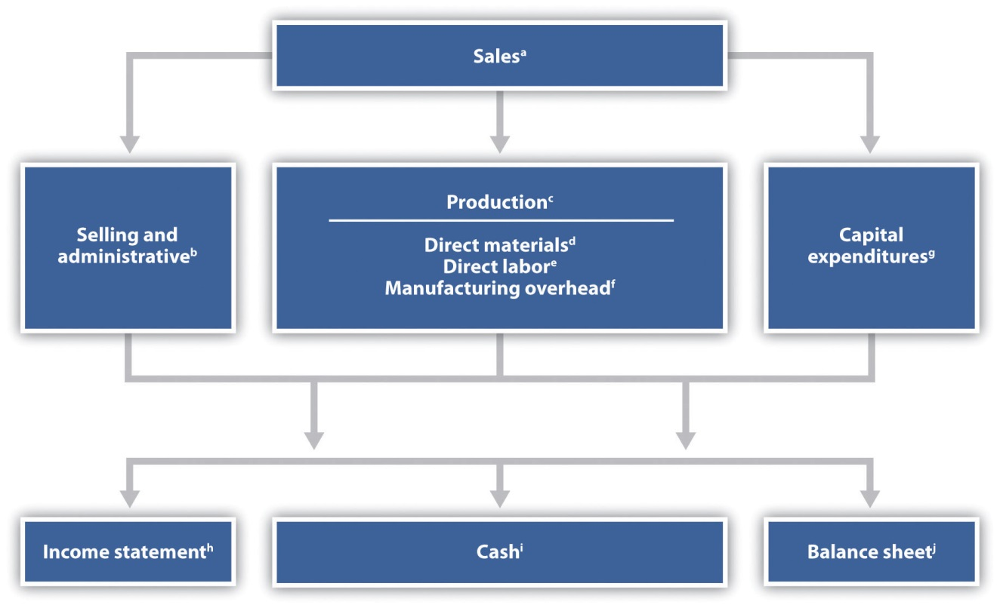

ª See for the sales budget.
^{b} See for the selling and administrative budget.
^{c} See for the production budget.
^{d} See for the direct materials purchases budget.
^{e} See for the direct labor budget.
^{f} See for the manufacturing overhead budget.
^{g} See for the capital expenditures budget.
^{h} See for the budgeted income statement.
^{i} See for the cash budget.
^{j} See for the budgeted balance sheet.

KEY TAKEAWAY
- Some companies take a top-down approach to budgeting (upper management establishes the budget with little input from others), while other companies take a bottom-up approach (lower level employees are involved in the budgeting process). The bottom-up approach tends to be more effective as employees are more inclined to accept the budget. Regardless of the approach used, the budget committee (made up of a group within the organization) is responsible for overseeing and approving the master budget.

REVIEW PROBLEM 9.2
- What is a master budget?
- Why do successful companies tend to use the bottom-up approach to establish a master budget?
Solution to Review Problem 9.2
- A master budget is a series of budget schedules outlining the organization’s plans for the upcoming period, typically prepared monthly, quarterly, or annually. The master budget includes budgets for sales, production, operating expenses, and capital expenditures. Managers use this information to create budgeted financial statements (income statement, cash flows, and balance sheet).
- The bottom-up approach requires involvement of employees throughout the organization, not just upper management, to create the operating budget. Successful companies use this approach because lower-level employees tend to know more about their functional areas than upper management, providing for more accurate budget information. Also, employee involvement in the budget process increases the likelihood employees will accept the budget.

9.3 The Master Budget

LEARNING OBJECTIVE
- Develop the components of a master budget.

Question: Developing a master budget is a lengthy process. Where do companies start when preparing a master budget?

Answer: Study Figure 9.1 "Master Budget Schedules" carefully, as it serves as the road map for the master budget presented throughout this chapter for Jerry’s Ice Cream. Notice that the budgeting process starts with the sales budget. Also, note that the budgets described next are for a manufacturing company. Manufacturing companies tend to have more budget schedules than other types of organizations because their operations are more complex. Once you understand budgeting in a manufacturing environment, you can easily modify the process to perform budgeting in other organizations, as discussed later in the chapter. As we work through the master budget for Jerry’s Ice Cream, assume the company prepares quarterly budgets.

Sales Budget

Question: The sales budget is the starting point for the master budget, as shown in Figure 9.1 "Master Budget Schedules". What is a sales budget, and how is it prepared?

Answer: The sales budget is an estimate of units of product the organization expects to sell times the expected sales price per unit. This is perhaps the most important budget as it drives most of the other budgets. For example, the production budget and related materials, labor, and overhead budgets are based on expected sales.

Forecasting sales often involves extensive research and numerous sources. Companies, such as Jerry’s Ice Cream, typically start with their sales staff since salespeople have daily contact with customers and direct information about customer demand. Some companies pay for market trend data to learn about industry and product trends. Many organizations hire market research consultants to obtain and review industry data and ultimately to predict customer demand. Larger companies sometimes employ economists to develop sophisticated models used to project sales. Smaller, less sophisticated organizations simply base their estimates on past trends.Figure 9.2 "Estimating Sales" shows how companies obtain sales information from sales people, market research consultants, and economists.

Figure 9.2 Estimating Sales

Tom Benson, sales manager at Jerry’s Ice Cream, talked with his salespeople and reviewed market trends for ice cream using data obtained from a market research firm. His estimate, shown in Figure 9.3 "Sales Budget for Jerry’s Ice Cream", assumes the company will increase sales 15 percent this coming year. Thus, to get projected sales for quarter 1, Tom simply multiplied last year’s first quarter sales by 1.15. The average price per unit last year was $6 (1 unit = 1 gallon), and Tom does not expect any change in this price. The sales budget is presented in Figure 9.3 "Sales Budget for Jerry’s Ice Cream".

Figure 9.3 Sales Budget for Jerry’s Ice Cream
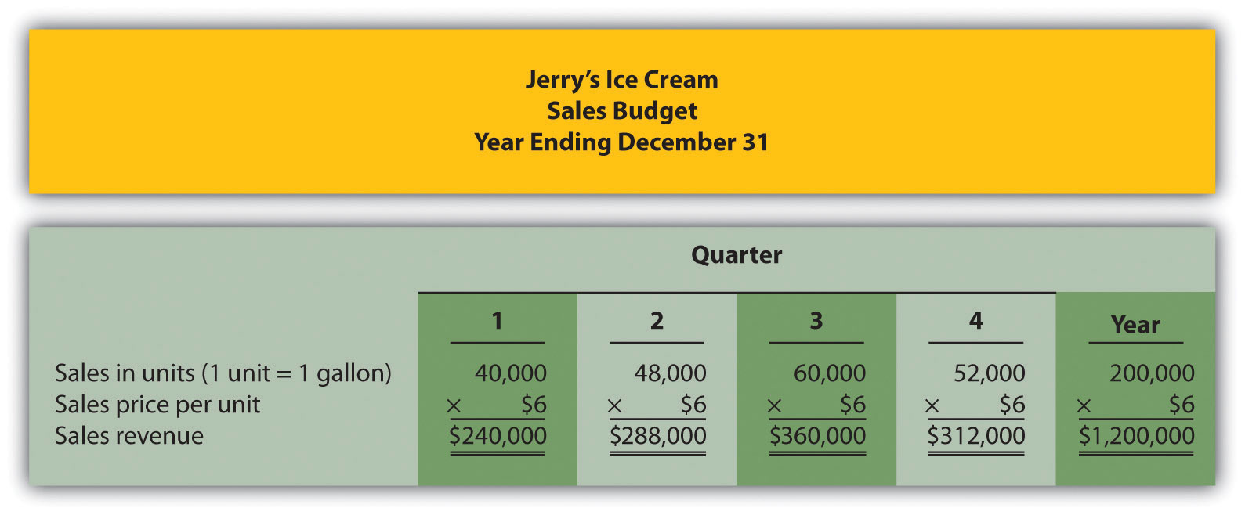

Production Budget

Question: The production budget is developed next and is based on sales budget projections. What is a production budget, and how is it prepared?

Answer: If the organization uses a just-in-time production system, where production occurs just in time to ship the products to the customer, units produced each quarter would be exactly the same as projected sales. However, most companies, including Jerry’s Ice Cream, maintain a certain level of finished goods inventory. Thus production is typically not the same as projected sales. The production budget is an estimate of units to be produced and is based on sales projections plus an estimate of desired ending finished goods inventory less beginning finished goods inventory, as summarized in the following:

Key Equation
Units to beproduced=Expected salesin units+Desired unitsof ending inventory−Units inbeginning inventory

Jerry’s Ice Cream plans to sell 40,000 units in the first quarter, as shown inFigure 9.3 "Sales Budget for Jerry’s Ice Cream". For the sake of simplicity, assume work-in-process inventory is insignificant, and therefore beginning and ending work-in-process inventory is zero. (We assume beginning and ending work-in-process inventory is zero throughout this chapter.) The management prefers to maintain 10 percent of next quarter’s sales in ending inventory. Thus 4,800 units will be in inventory at the end of the first quarter (= 48,000 unit sales in second quarter × 10 percent). Units needed for the first quarter total 44,800 (= 40,000 unit sales + 4,800 units desired ending inventory). However, Jerry’s will not produce 44,800 units because inventory will be left over from the fourth quarter of last year. This beginning inventory will be 4,000 units (= 40,000 unit sales in first quarter × 10 percent). Thus actual production will total 40,800 units:

40,800Units to beproduced==40,000Expected salesin units++4,800Desired units ofending inventory−−4,000Units inbeginning inventory

Figure 9.4 "Production Budget for Jerry’s Ice Cream" presents the production budget for each of the 4 quarters of the coming year. Examine this figure carefully, particularly the last line labeled units to be produced. Lynn Young, the production manager, will be concerned about the spike in production during the third quarter of 59,200 units. The third quarter, from July 1 through September 30, is the peak sales season for ice cream. It will be difficult for Lynn to plan for this increase in production from the first and second quarters to the third quarter. However, this is exactly why companies prepare budgets—to plan for the future!

Figure 9.4 Production Budget for Jerry’s Ice Cream
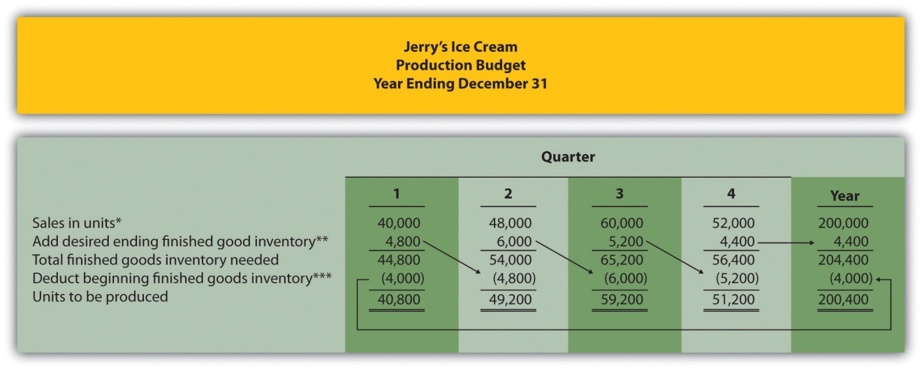

*Information from Figure 9.3 "Sales Budget for Jerry’s Ice Cream".

**Desired ending inventory = 10 percent × Next quarter sales; for the first quarter, 4,800 = 0.10 × 48,000. Fourth quarter desired ending inventory of 4,400 units is based on an estimate of sales in the first quarter of next year.

***Beginning inventory = Inventory at end of previous quarter; for example, second quarter beginning inventory = First quarter ending inventory.

Once Jerry’s Ice Cream knows how many units it must produce each quarter, budgets are established for the individual components of production: direct materials, direct labor, and manufacturing overhead. We present these budgets next.

REVIEW PROBLEM 9.3
Carol’s Cookies produces cookies for resale at grocery stores throughout North America. The company is currently in the process of establishing a master budget on a quarterly basis for this coming fiscal year, which ends December 31. Prior year quarterly sales were as follows (1 unit = 1 batch):
First quarter | 64,000 units
Second quarter | 76,800 units
Third quarter | 96,000 units
Fourth quarter | 83,200 units
Unit sales are expected to increase 25 percent, and each unit is expected to sell for $8. The management prefers to maintain ending finished goods inventory equal to 10 percent of next quarter’s sales. Assume finished goods inventory at the end of the fourth quarter budget period is estimated to be 9,000 units.
- Prepare a sales budget for Carol’s Cookies using a format similar toFigure 9.3 "Sales Budget for Jerry’s Ice Cream". (Hint: be sure to increase last year’s unit sales by 25 percent.)
- Prepare a production budget for Carol’s Cookies using the format shown in Figure 9.4 "Production Budget for Jerry’s Ice Cream".
Solution to Review Problem 9.3
- The following is a sales budget:
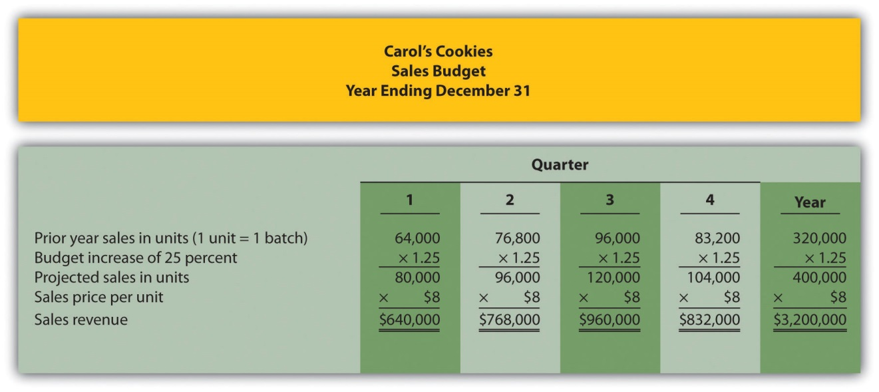
- The following is a production budget:
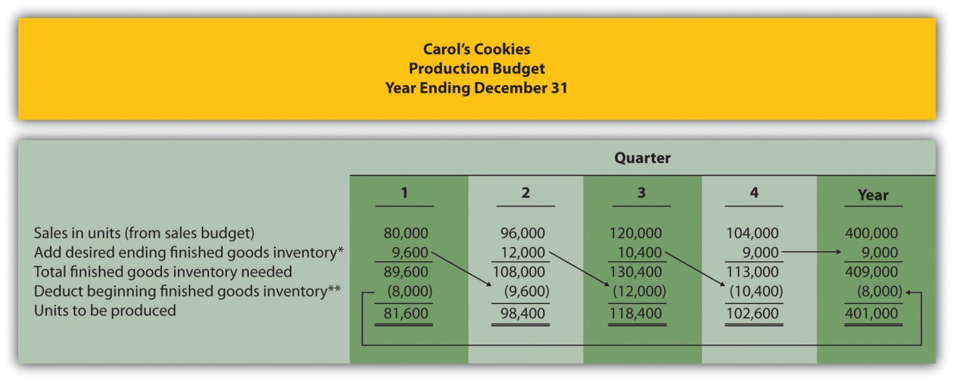
*Desired ending inventory = 10 percent × Next quarter sales; for the first quarter, 9,600 = 0.10 × 96,000. Fourth quarter desired ending inventory of 9,000 units is given.
**Beginning inventory = Inventory at end of previous quarter; for example, Second quarter beginning inventory = First quarter ending inventory.

Direct Materials Purchases Budget

Question: The number of units of finished goods to be produced each quarter from the production budget is the starting point for the direct materials purchases budget. What is a direct materials purchases budget, and how is it prepared?

Answer: The direct materials purchases budget is an estimate of raw materials needed to achieve a desired level of production. Figure 9.4 "Production Budget for Jerry’s Ice Cream", the production budget, shows that 40,800 finished units will be produced in the first quarter. We will now establish a direct materials purchases budget that answers the questions: how many pounds of material must be purchased during the first quarter to achieve this production, and what is the cost of these materials?

Assume two pounds of material are required to produce one unit of product. Thus the amount of materials required to produce 40,800 units of ice cream is 81,600 pounds (= 40,800 units × 2 pounds per unit). This amount is labeled as materials needed in production in the direct materials purchases budget shown in Figure 9.5 "Direct Materials Purchases Budget for Jerry’s Ice Cream". (To simplify this example, assume sugar is the only material used. However, other materials, such as cream and vanilla, are typically required to produce ice cream.)

Figure 9.5 Direct Materials Purchases Budget for Jerry’s Ice Cream
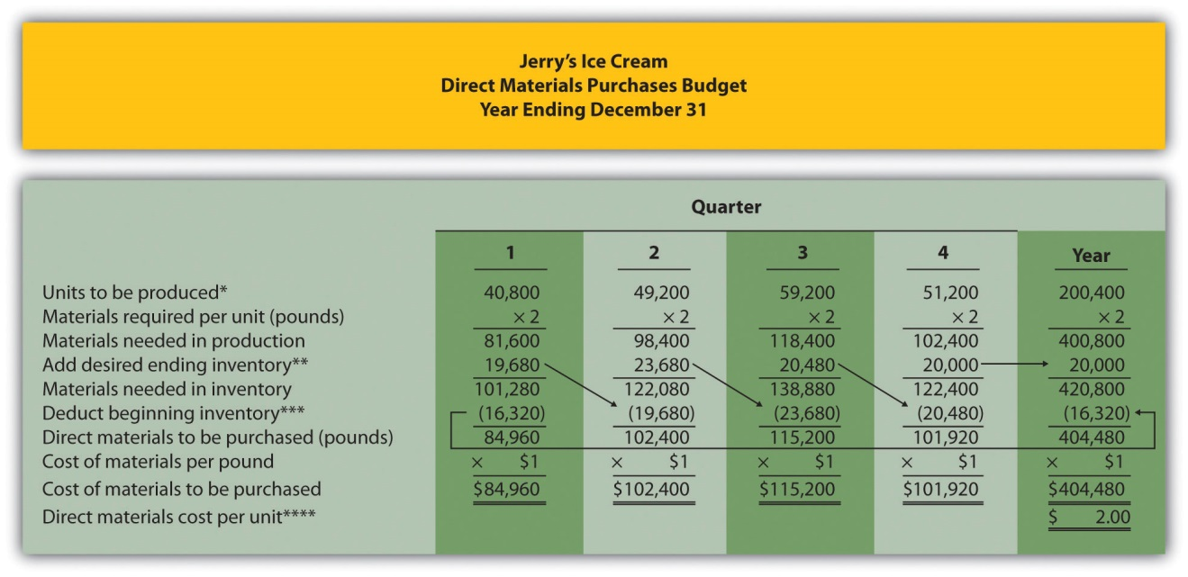

*Information from Figure 9.4 "Production Budget for Jerry’s Ice Cream".

**Desired ending inventory = 20 percent × Next quarter production needs; for the first quarter, 19,680 = 0.20 × 98,400. Fourth quarter desired ending inventory of 20,000 pounds is based on an estimate of materials needed in production first quarter of next year.

***Beginning inventory = Inventory at end of previous quarter; for example, Second quarter beginning inventory = First quarter ending inventory.

****$2 direct materials cost per unit = 2 pounds of materials required per unit × $1 per pound.

Will the company buy 81,600 pounds of material in the first quarter? Probably not. Jerry’s will have materials in beginning raw materials inventory and prefers to maintain a certain level of ending raw materials inventory. Thus direct materials purchased is based on materials needed in production plus an estimate of desired ending raw materials inventory less beginning raw materials inventory. We summarize this in the following equation. Notice the similarity of this equation to the inventory equation presented earlier for the production budget.

Key Equation

Materials tobe purchased=Materials neededin production+Desired materialsin ending inventory−Materials inbeginning inventory

Assume the management prefers to maintain raw materials ending inventory equal to 20 percent of next quarter’s materials needed in production. Thus 19,680 pounds of material will be in inventory at the end of the first quarter (= 98,400 pounds of materials needed in production in second quarter × 20 percent). Materials needed in inventory total 101,280 pounds (= 81,600 pounds of materials needed in production + 19,680 pounds of material in desired ending inventory). However, Jerry’s will not purchase 101,280 pounds of materials because inventory will be left over from the fourth quarter of last year. This beginning inventory will be 16,320 pounds (= 81,600 pounds of material needed in production in first quarter × 20 percent). Thus direct materials purchased in the first quarter will total 84,960 pounds:

84,960Materials==81,600Materials neededin production++19,680Desired materialsin ending inventory−−16,320Materials inbeginning inventory

To estimate the cost of purchasing 84,960 pounds of material, multiply the number of pounds to be purchased by the cost per pound. Assume the cost per pound of material for Jerry’s is $1. This results in a cost of $84,960 for materials to be purchased during the first quarter, as shown at the bottom ofFigure 9.5 "Direct Materials Purchases Budget for Jerry’s Ice Cream" (= 84,960 pounds to be purchased × $1 per pound).

Review the direct materials purchases budget shown in Figure 9.5 "Direct Materials Purchases Budget for Jerry’s Ice Cream" carefully, particularly the line labeled direct materials to be purchased. The purchasing manager at Jerry’s Ice Cream uses this information, along with the price per pound, to negotiate the purchase of materials with suppliers.

Direct Labor Budget

Question: The direct materials purchases budget is the first of three supporting budgets for production. The second is the direct labor budget. What is the direct labor budget, and how is it prepared?

Answer: The direct labor budget is an estimate of direct labor hours, and related costs, necessary to achieve a desired level of production. Knowing Jerry’s Ice Cream plans to produce 40,800 units of ice cream during the first quarter, this budget answers the questions: how many direct labor hours will be necessary to achieve this production, and what will this labor cost?

Assume it takes 0.10 direct labor hours (or 6 minutes) to produce 1 unit of product. Thus 4,080 hours of direct labor will be required to produce 40,800 units of product (= 40,800 finished units produced × 0.10 direct labor hours per unit). Given an average hourly rate of $13, the direct labor cost for the first quarter totals $53,040 (= 4,080 hours × $13 per hour). This information is shown in the direct labor budget presented in Figure 9.6 "Direct Labor Budget for Jerry’s Ice Cream".

Figure 9.6 Direct Labor Budget for Jerry’s Ice Cream
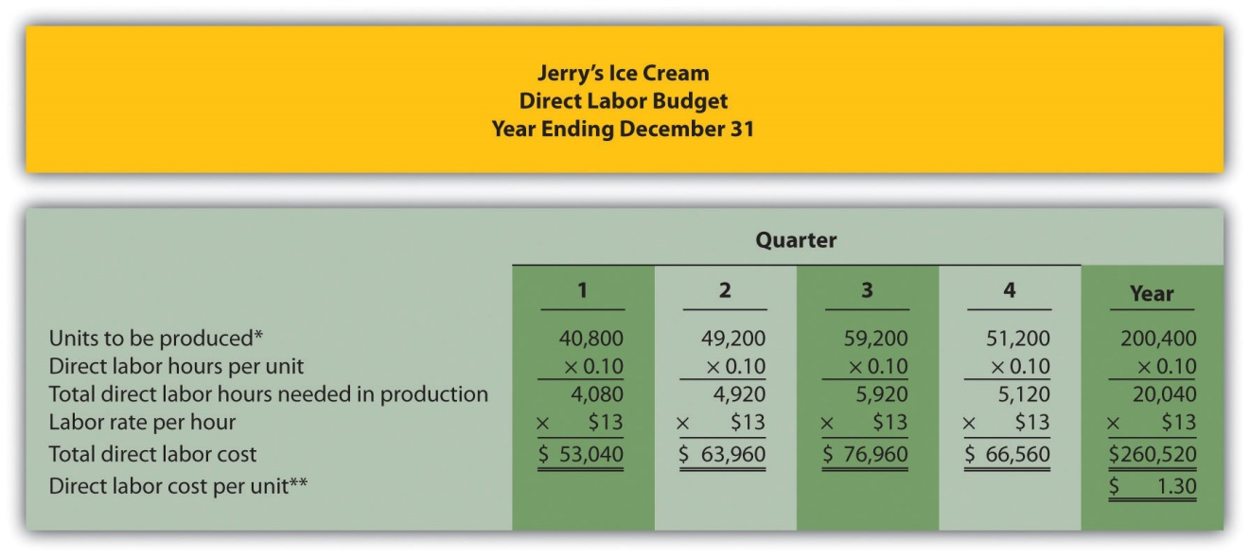

*From Figure 9.4 "Production Budget for Jerry’s Ice Cream".

**$1.30 direct labor cost per unit = 0.10 direct labor hours per unit × $13 per hour.

Carefully review the direct labor budget shown in Figure 9.6 "Direct Labor Budget for Jerry’s Ice Cream". The production manager at Jerry’s Ice Cream, Lynn Young, uses this information to ensure the appropriate number of employees is available to meet production goals. Notice that the number of direct labor hours needed in production for the third quarter is significantly higher than each of the two previous quarters. Again, this is why organizations prepare budgets: to plan for these types of events. Lynn will have to start planning for this spike in direct labor hours, either by asking employees to work overtime or by hiring additional employees.

Manufacturing Overhead Budget

Question: The manufacturing overhead budget is the third of three supporting production budgets. What is a manufacturing overhead budget, and how is it prepared?

Answer: The manufacturing overhead budget is an estimate of all production costs, other than direct materials and direct labor, necessary to achieve a desired level of production. This budget is presented in Figure 9.7 "Manufacturing Overhead Budget for Jerry’s Ice Cream". Notice that overhead costs are separated into variable and fixed components.

Figure 9.7 Manufacturing Overhead Budget for Jerry’s Ice Cream
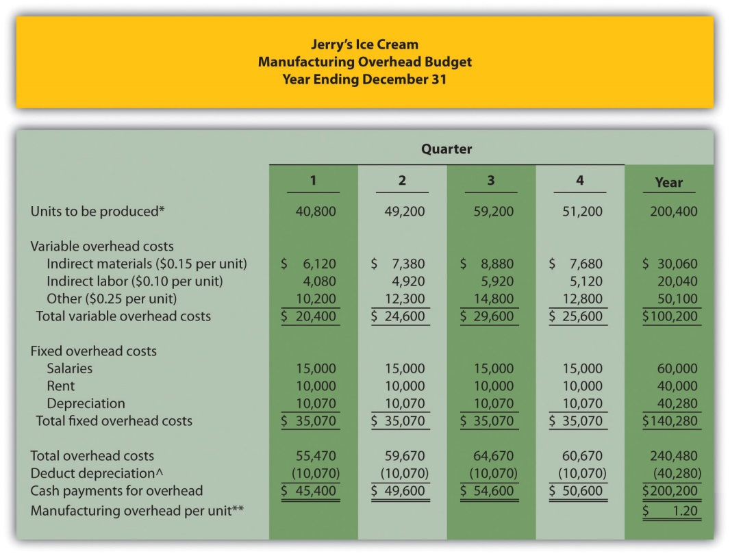

*From Figure 9.4 "Production Budget for Jerry’s Ice Cream".

**$1.20 = $240,480 total overhead cost ÷ 200,400 units to be produced for the year.

^Deduct depreciation to get the actual cash payment for overhead. This information is needed for the cash budget presented in Figure 9.11 "Cash Budget for Jerry’s Ice Cream".

By definition, total variable overhead costs change with changes in production and are calculated by multiplying units to be produced by the cost per unit. For example, indirect materials cost for the first quarter of $6,120 is calculated by taking 40,800 units to be produced × $0.15 cost per unit. Fixed costs generally do not change with changes in production and therefore remain the same each quarter. (Note: In some situations, fixed overhead costs can change from one quarter to the next. For example, hiring additional salaried personnel during the year would increase fixed overhead costs, and purchasing equipment during the year would increase depreciation costs. In this example, we assume fixed overhead costs do not change during the year.)

Depreciation is deducted at the bottom of the manufacturing overhead budget to determine cash payments for overhead because depreciation is not a cash transaction. We use this information later in the chapter for the cash budget.

REVIEW PROBLEM 9.4
Carol’s Cookies, the company featured in the last review problem and in the next three, is now preparing the budget for direct materials purchases, direct labor, and manufacturing overhead.
Direct Materials Purchases Budget Information
Each unit of product requires 1.5 pounds of direct materials per unit, and the cost of direct materials is $2 per pound. Management prefers to maintain ending raw materials inventory equal to 30 percent of next quarter’s materials needed in production. Assume raw materials inventory at the end of the fourth quarter budget period is estimated to be 41,000 pounds.
Direct Labor Budget Information
Each unit of product requires 0.20 direct labor hours at a cost of $12 per hour.
Manufacturing Overhead Budget Information
Variable overhead costs are:
Indirect materials | $0.20 per unit
Indirect labor | $0.15 per unit
Other | $0.35 per unit
Fixed overhead costs each quarter are:
Salaries | $28,000
Rent | $22,000
Depreciation | $16,165
- Prepare a direct materials purchases budget for Carol’s Cookies using the format shown in Figure 9.5 "Direct Materials Purchases Budget for Jerry’s Ice Cream".
- Prepare a direct labor budget for Carol’s Cookies using the format shown in Figure 9.6 "Direct Labor Budget for Jerry’s Ice Cream".
- Prepare a manufacturing overhead budget for Carol’s Cookies using the format shown in Figure 9.7 "Manufacturing Overhead Budget for Jerry’s Ice Cream".
Solution to Review Problem 9.4

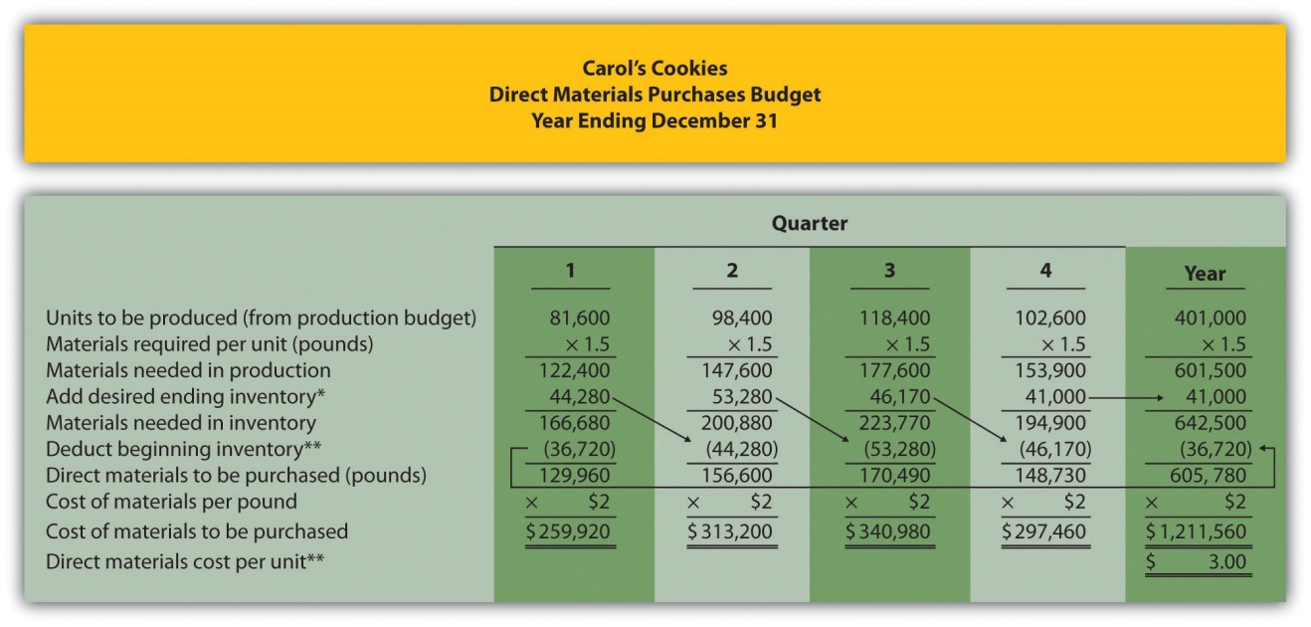
*Desired ending inventory = 30 percent × Next quarter production needs; for the first quarter, 44,280 = 0.30 × 147,600 pounds. Fourth quarter desired ending inventory of 41,000 pounds is given.
**Beginning inventory = Inventory at end of previous quarter; for example, Second quarter beginning inventory = First quarter ending inventory.
***$3 direct materials cost per unit = 1.5 pounds of materials required per unit × $2 per pound.

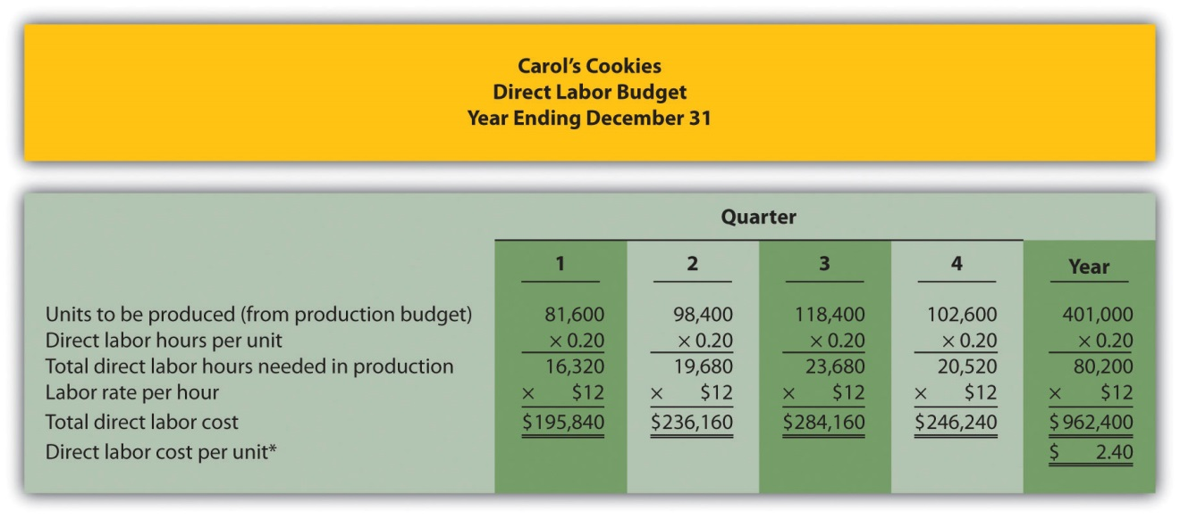
*$2.40 direct labor cost per unit = 0.20 direct labor hours per unit × $12 per hour.

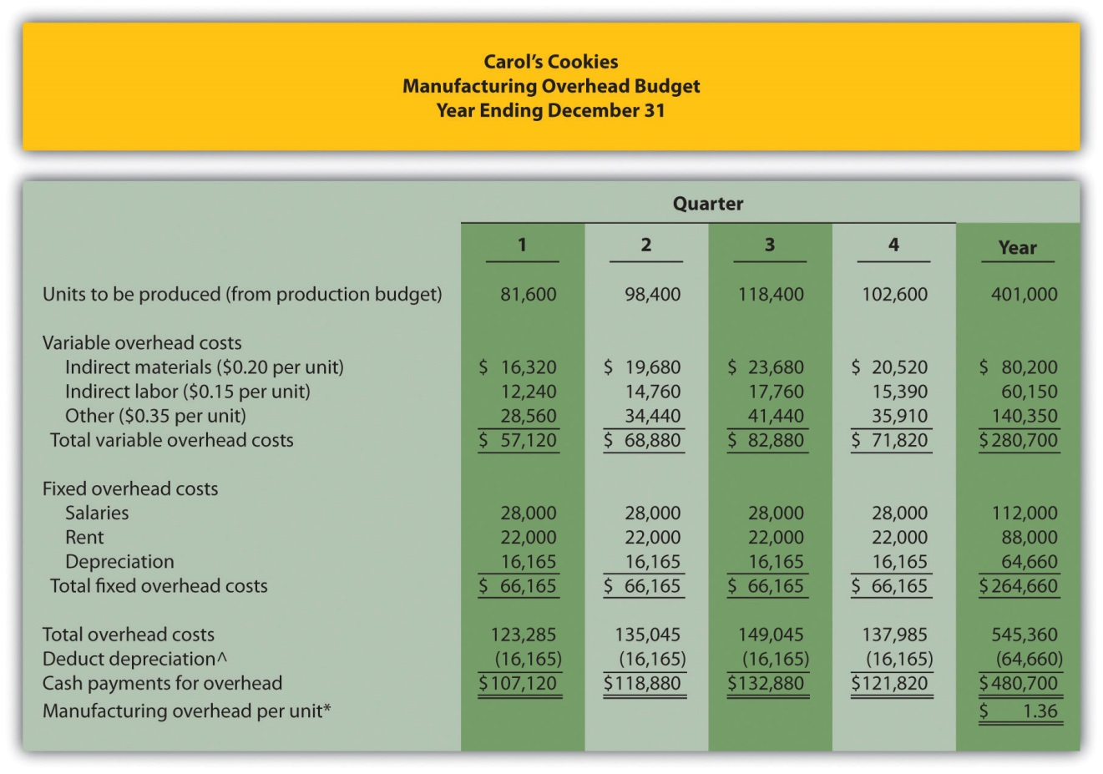
*$1.36 = $545,360 total overhead cost ÷ 401,000 units to be produced for the year.
^Deduct depreciation to get the actual cash payment for overhead. This information is needed for the cash budget prepared later.

Selling and Administrative Budget

Question: Now that the sales and production-related budgets are complete, it is time to estimate selling and administrative costs. What is a selling and administrative budget, and how is it prepared?

Answer: The selling and administrative budget is an estimate of all operating costs other than production. This budget is presented in Figure 9.8 "Selling and Administrative Budget for Jerry’s Ice Cream".

Although many organizations may have variable and fixed costs in this budget, Jerry’s Ice Cream treats all selling and administrative costs as fixed costs. Once again, depreciation is deducted at the bottom of this budget to determine cash payments for selling and administrative costs, which we use later in the chapter for the cash budget.

Figure 9.8 Selling and Administrative Budget for Jerry’s Ice Cream
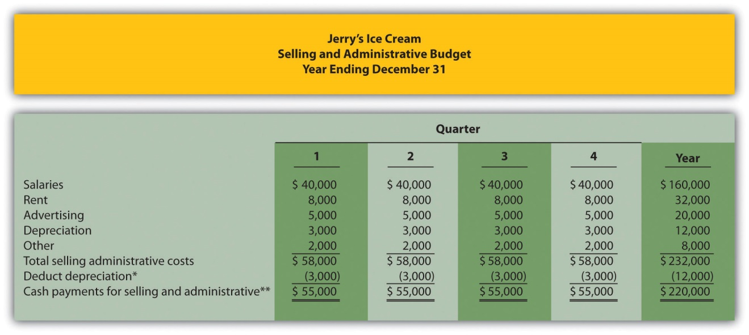

*Deduct depreciation to get the actual cash payment for selling and administrative costs.

**This information is needed for the cash budget presented in Figure 9.11 "Cash Budget for Jerry’s Ice Cream".

Budgeted Income Statement

Question: Budgets completed to this point include sales (Figure 9.3 "Sales Budget for Jerry’s Ice Cream"), production (Figure 9.4 "Production Budget for Jerry’s Ice Cream"), direct materials (Figure 9.5 "Direct Materials Purchases Budget for Jerry’s Ice Cream"), direct labor (Figure 9.6 "Direct Labor Budget for Jerry’s Ice Cream"), manufacturing overhead (Figure 9.7 "Manufacturing Overhead Budget for Jerry’s Ice Cream"), and selling and administrative (Figure 9.8 "Selling and Administrative Budget for Jerry’s Ice Cream"). Jerry’s Ice Cream now has enough information to prepare the budgeted income statement. What is a budgeted income statement, and how is it prepared?

Answer: The budgeted income statement is an estimate of the organization’s profit for a given budget period. Most organizations, including Jerry’s Ice Cream, prepare the budgeted income statement using the accrual basis of accounting: revenues are recorded when earned and expenses are recorded when incurred. The budgeted income statement for Jerry’s Ice Cream is presented in Figure 9.9 "Budgeted Income Statement for Jerry’s Ice Cream". The cash budget we prepare later in the chapter will show when cash is received and paid.

Figure 9.9 Budgeted Income Statement for Jerry’s Ice Cream
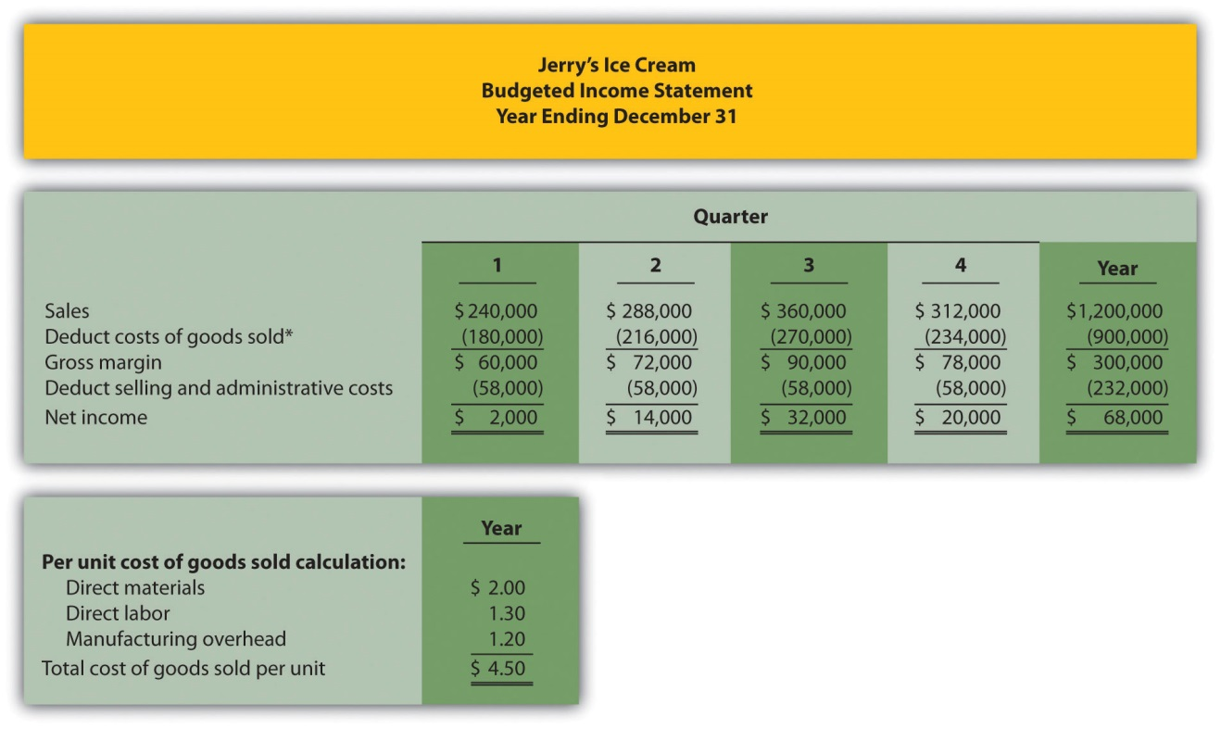

*Cost of goods sold = Per unit cost of $4.50 (see above) × Units sold (fromFigure 9.3 "Sales Budget for Jerry’s Ice Cream"); for the first quarter, $180,000 cost of goods sold = $4.50 unit cost × 40,000 units.

The first line in the budgeted income statement, sales, comes from the sales budget in Figure 9.3 "Sales Budget for Jerry’s Ice Cream". The next line, cost of goods sold, is calculated by multiplying unit sales from Figure 9.3 "Sales Budget for Jerry’s Ice Cream" by the cost per unit. The cost per unit calculation is shown at the bottom of Figure 9.9 "Budgeted Income Statement for Jerry’s Ice Cream". Carefully review this calculation. Since Jerry’s Ice Cream uses full-absorption costing, all manufacturing costs related to goods sold are included (or fully absorbed) in cost of goods sold.Figure 9.5 "Direct Materials Purchases Budget for Jerry’s Ice Cream", Figure 9.6 "Direct Labor Budget for Jerry’s Ice Cream", and Figure 9.7 "Manufacturing Overhead Budget for Jerry’s Ice Cream" provide this information on a per unit basis for direct materials, direct labor, and manufacturing overhead, respectively.

The third line, gross margin, is simply sales minus cost of goods sold. The fourth line, selling and administrative costs, comes from the selling and administrative budget in Figure 9.8 "Selling and Administrative Budget for Jerry’s Ice Cream". The bottom line of the budgeted income statement, net income, is gross margin minus selling and administrative costs. Income tax expense is not included in this example for the sake of simplicity. However, income taxes can significantly reduce projected net income and cash flows.

Question: How do companies use the budgeted income statement to improve operations?

Answer: The budgeted income statement is perhaps the most carefully scrutinized component of the master budget. The management and employees throughout the organization use this information for planning purposes and to evaluate company performance. The board of directors and budget committee are responsible for approving the budget and often review periodic reports comparing actual net income to budgeted net income to determine if profit goals are being achieved. Lenders and owners often review the budget to ensure the organization is on track to meet its goals. The budgeted income statement answers the question: what profits does the organization expect to achieve?

After completing the budgeted income statement, only three budgets remain: the capital expenditures budget, the cash budget, and the budgeted balance sheet. We discuss the capital expenditures budget next.

REVIEW PROBLEM 9.5
Carol’s Cookies estimates that all selling and administrative costs are fixed. Quarterly selling and administrative cost estimates for the coming year are
Salaries | $60,000
Rent | $ 7,000
Advertising | $10,000
Depreciation | $ 8,000
Other | $ 1,000
- Prepare a selling and administrative budget for Carol’s Cookies using the format shown in Figure 9.8 "Selling and Administrative Budget for Jerry’s Ice Cream".
- Prepare a budgeted income statement for Carol’s Cookies using the format shown in Figure 9.9 "Budgeted Income Statement for Jerry’s Ice Cream".
Solution to Review Problem 9.5

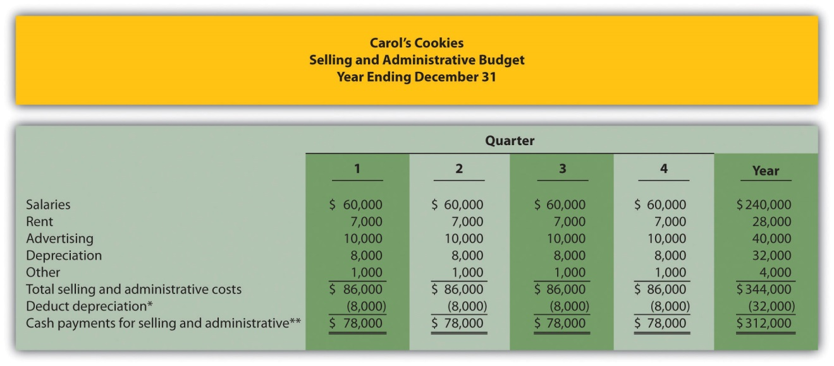
*Deduct depreciation to get the actual cash payment for selling and administrative costs.
**This information is needed for the cash budget prepared later.

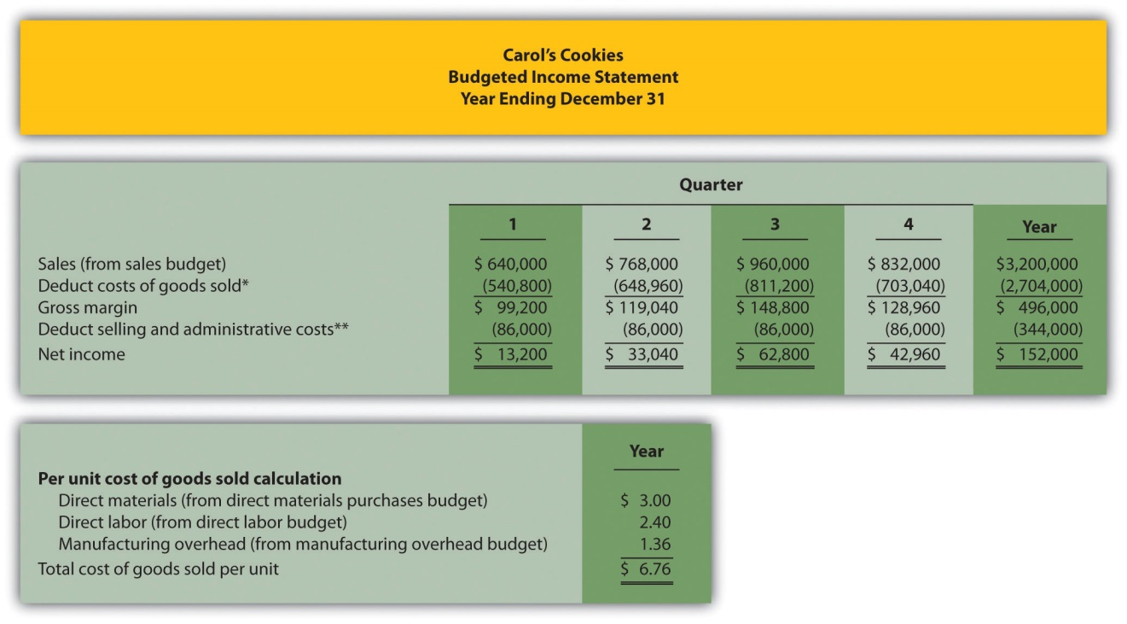
*Cost of goods sold = Per unit cost of $6.76 (see above) × Units sold (from sales budget); for first quarter, $540,800 cost of goods sold = $6.76 unit cost × 80,000 units.
**From selling and administrative budget.

Capital Expenditures Budget

Question: What is a capital expenditures budget, and how is it prepared?

Answer: The capital expenditures budget is an estimate of the long-term assets to be purchased during the budget period. This includes purchases of tangible long-term assets such as property, plant, and equipment, and intangible assets, such as patents, copyrights, and trademarks. This budget can have a significant impact on cash flow and requires careful planning and analysis (Chapter 8 "How Is Capital Budgeting Used to Make Decisions?"presents a detailed discussion of capital budgeting). As shown in Figure 9.10 "Capital Expenditures Budget for Jerry’s Ice Cream", Jerry’s Ice Cream plans to purchase computers and production equipment at the end of the fourth quarter.

Figure 9.10 Capital Expenditures Budget for Jerry’s Ice Cream
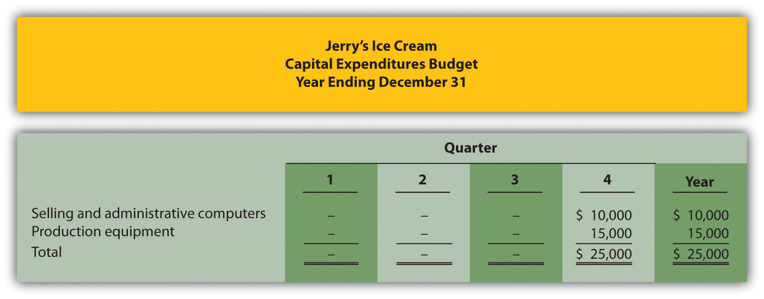

Note: These acquisitions will have no effect on depreciation expense in the fourth quarter. Items will be purchased at the end of the year. Thus depreciation begins the following year.

Because long-term asset purchases occur at the end of the year, depreciation will begin the following year. Thus depreciation shown in the manufacturing overhead and selling and administrative budgets will not be affected until the following year. The cash outlay required to make these purchases is reflected in the cash budget presented next.

Cash Budget

Question: What is a cash budget, and how is it prepared?

Answer: The cash budget is an estimate of the amount and timing of cash inflows and outflows for the budget period. Although the budgeted income statement provides an estimate of profitability, it stops short of providing cash flow information. For example, some of the $240,000 in first quarter sales revenue will be collected during the first quarter and some will be collected the following quarter. A section of the cash budget will show when cash from sales will be received.

The cash budget has the following sections, each of which is described afterFigure 9.11 "Cash Budget for Jerry’s Ice Cream":
- Cash collections from sales
- Cash payments for purchases of materials
- Other cash collections and payments

Figure 9.11 "Cash Budget for Jerry’s Ice Cream" shows the cash budget for Jerry’s Ice Cream. Amounts shown in parentheses represent cash outflows; amounts without parentheses represent cash inflows.

Figure 9.11 Cash Budget for Jerry’s Ice Cream
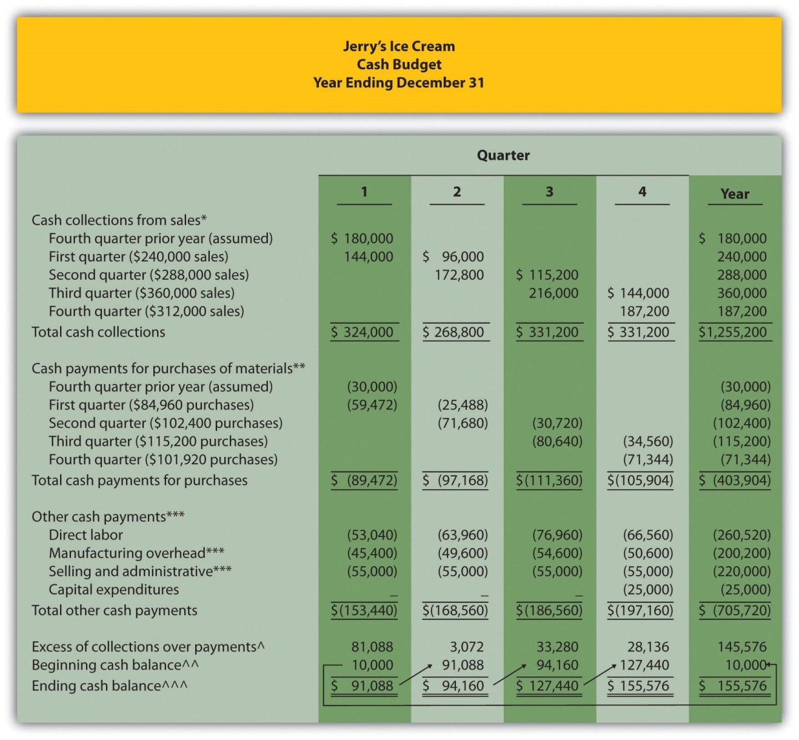

*Based on sales budget shown in Figure 9.3 "Sales Budget for Jerry’s Ice Cream". All sales are on credit: 60 percent collected in the quarter of sale and 40 percent collected the following quarter.

**Based on purchases budget shown in Figure 9.5 "Direct Materials Purchases Budget for Jerry’s Ice Cream". All purchases are on credit: 70 percent paid in the quarter of purchase and 30 percent paid the following quarter.

***Does not include depreciation since depreciation expense does not involve a cash payment. See related figures for calculations.

^Excess of collections over payments = Cash collections from sales – Cash payments for materials purchases – Other cash payments.

^^ Beginning cash balance = Cash balance at end of previous period. Balance for first quarter is given.

^^^ Ending cash balance = Excess of collections over payments for the quarter + Beginning cash balance.

Cash Collections from Sales

Question: Assume all sales at Jerry’s Ice Cream are on credit. How long does it take, on average, for Jerry’s to collect on credit sales?

Answer: On average, 60 percent of credit sales are collected in the quarter sold and the remaining 40 percent is collected the following quarter. These percentage estimates are based on previous experience and take into consideration credit terms offered to customers. Since Jerry’s Ice Cream only sells to customers with an excellent credit record, it anticipates no bad debts.

As you examine the cash collections from sales section of Jerry’s cash budget, notice that $180,000 in cash will be collected in the first quarter related to credit sales made in the previous quarter (this amount is given). Next, you will see $144,000 in cash collected in the first quarter related to first quarter sales (= 60 percent collected in quarter of sale × $240,000 first quarter sales). The remaining $96,000 will be collected in the second quarter, as shown in Figure 9.11 "Cash Budget for Jerry’s Ice Cream" (= 40 percent × $240,000 first quarter sales).

Cash Payments for Purchases of Materials

Question: Assume all purchases at Jerry’s Ice Cream are on credit. How long does it take, on average, for Jerry’s to pay for these credit purchases?

Answer: On average, 70 percent of purchases are paid in the quarter purchased and the remaining 30 percent is paid the following quarter. These percentage estimates are based on previous experience and take into account credit terms offered by suppliers.

As you look at the cash payments for purchases of materials section of Jerry’s cash budget, notice that $30,000 in cash will be paid in the first quarter related to purchases made in the previous quarter (this amount is given). Next, you will see $59,472 in cash paid in the first quarter related to first quarter purchases (= 70 percent paid in quarter purchased × $84,960 first quarter purchases). The remaining $25,488 will be paid in the second quarter, as shown in Figure 9.11 "Cash Budget for Jerry’s Ice Cream" (= 30 percent × $84,960 first quarter purchases). Figure 9.5 "Direct Materials Purchases Budget for Jerry’s Ice Cream" shows how cash flows into the company for customer sales and out of the company for purchases of materials.

Other Cash Collections and Payments

Question: What other cash collections and cash payments must be considered at Jerry’s Ice Cream?

Answer: Assume Jerry’s Ice Cream has other cash payments but no other cash collections. Direct labor cash payments are from Figure 9.6 "Direct Labor Budget for Jerry’s Ice Cream". Manufacturing overhead cash payments are from Figure 9.7 "Manufacturing Overhead Budget for Jerry’s Ice Cream". Recall that depreciation was subtracted from total overhead costs in Figure 9.7 "Manufacturing Overhead Budget for Jerry’s Ice Cream"to calculate the cash payments for overhead. Selling and administrative cash payments are from Figure 9.8 "Selling and Administrative Budget for Jerry’s Ice Cream", where a similar depreciation adjustment was made. Capital expenditure cash payments are from Figure 9.10 "Capital Expenditures Budget for Jerry’s Ice Cream".

The other cash collections and payments section is also where organizations include financing activities such as cash collections from the sale of bonds or cash payments for the repayment of bank loans. Jerry’s Ice Cream does not have any of these financing activities.

The bottom section of the cash budget is where the ending cash balance is calculated for each budget period. The manager responsible for cash planning, typically the treasurer, scrutinizes this section carefully. Some organizations must borrow cash to fund the timing difference between when cash is used for production and when cash is received from sales. The cash budget will signal when short-term borrowing is necessary and allows time for the treasurer to arrange for financing. The cash budget presented inFigure 9.11 "Cash Budget for Jerry’s Ice Cream" shows that Jerry’s will not need to borrow cash in any of the four quarters. In fact, Jerry’s Ice Cream will have a hefty reserve of cash totaling $155,576 at the end of the fourth quarter.

REVIEW PROBLEM 9.6
Carol’s Cookies has the following information pertaining to the capital expenditures and cash budgets.
Capital Expenditures
The company plans to purchase selling and administrative equipment totaling $20,000 and production equipment totaling $28,000. Both will be purchased at the end of the fourth quarter and will not affect depreciation expense for the coming year.
Cash Budget
All sales are on credit. The company expects to collect 70 percent of sales in the quarter of sale, 25 percent of sales in the quarter following the sale, and 5 percent will not be collected (bad debt). Accounts receivable at the end of last year totaled $200,000, all of which will be collected in the first quarter of this coming year.
All direct materials purchases are on credit. The company expects to pay 80 percent of purchases in the quarter of purchase and 20 percent the following quarter. Accounts payable at the end of last year totaled $50,000, all of which will be paid in the first quarter of this coming year.
The cash balance at the end of last year totaled $20,000.
- Prepare a capital expenditures budget for Carol’s Cookies using the format shown in Figure 9.10 "Capital Expenditures Budget for Jerry’s Ice Cream".
- Prepare a cash budget for Carol’s Cookies using the format shown inFigure 9.11 "Cash Budget for Jerry’s Ice Cream".
Solution to Review Problem 9.6

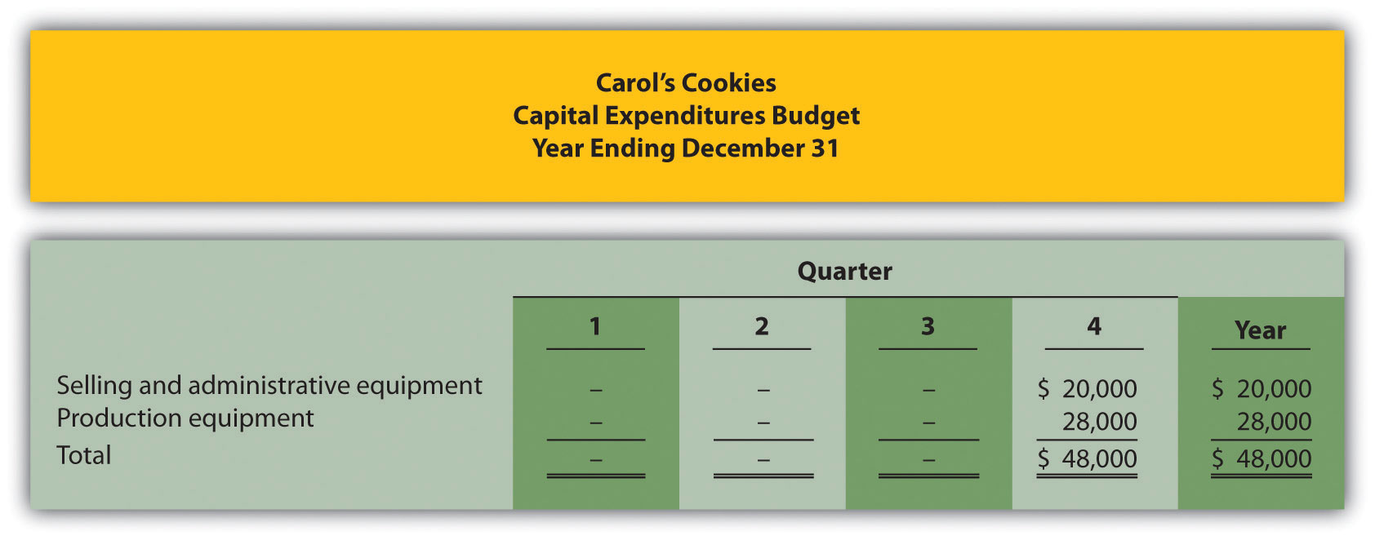
Note: These acquisitions will have no effect on depreciation expense in the fourth quarter. Items will be purchased at the end of the year. Thus depreciation begins the following year.

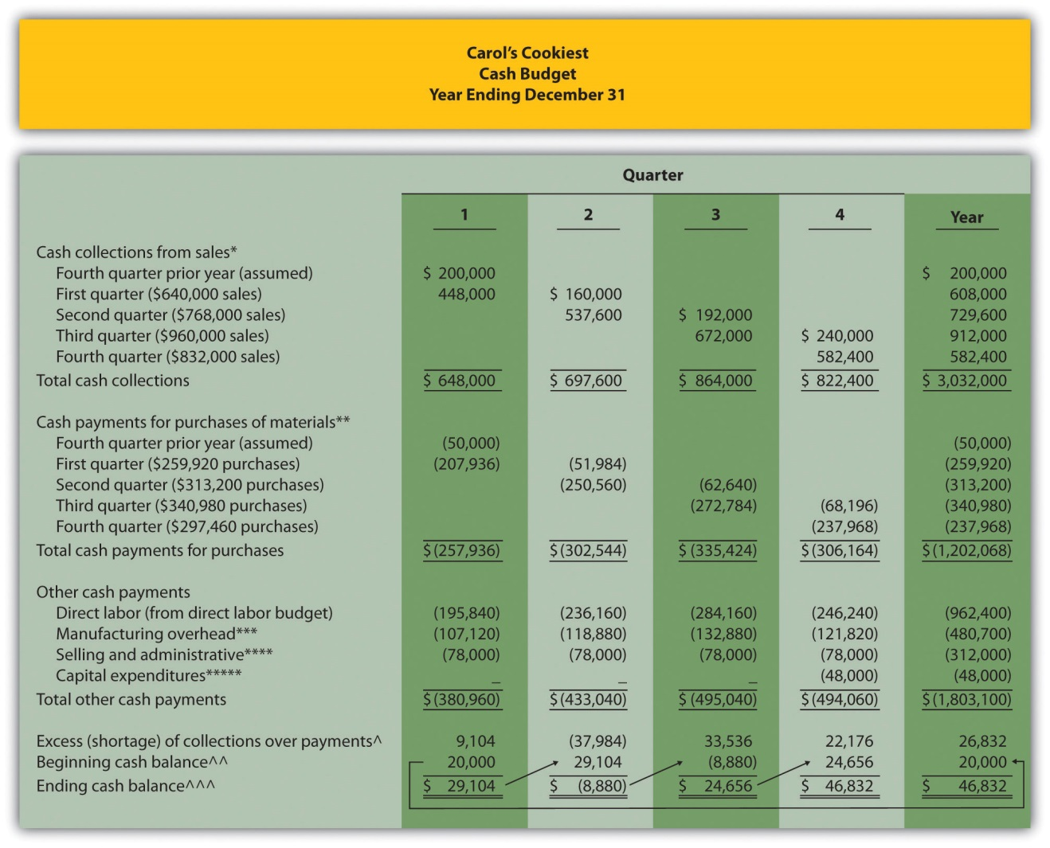
*Based on sales budget. All sales are on credit: 70 percent collected in the quarter of sale, 25 percent collected the following quarter, and 5 percent bad debt.
**Based on purchases budget. All purchases are on credit: 80 percent paid in the quarter of purchase and 20 percent paid the following quarter.
***From manufacturing overhead budget. Amount does not include depreciation.
****From selling and administrative budget. Amount does not include depreciation.
*****From capital expenditures budget.
^Excess of collections over payments = Cash collections from sales – Cash payments for materials purchases – other cash payments.
^^ Beginning cash balance = Cash balance at end of previous period. Balance for first quarter is given.
^^^ Ending cash balance = Excess of collections over payments for the quarter + Beginning cash balance.

Budgeted Balance Sheet

Question: The budgeted balance sheet is the last piece of the budget process.What is the budgeted balance sheet, and how is it prepared?

Answer: The budgeted balance sheet is an estimate of the ending balances for all balance sheet accounts. Managers use this to assess the impact that budgeted sales and costs will have on the financial condition of the organization. We present the budgeted balance sheet for Jerry’s Ice Cream inFigure 9.12 "Budgeted Balance Sheet for Jerry’s Ice Cream".

Information needed to prepare the budgeted balance sheet for Jerry’s Ice Cream is shown throughout the chapter and is referenced in Figure 9.12 "Budgeted Balance Sheet for Jerry’s Ice Cream". Additional information is provided here:

Plant and equipment (net) expected at the end of the budget period (December 31) is $530,000.

Common stock issued and outstanding at the end of the budget period (December 31) is expected to be $650,000.

Actual retained earnings at the end of last year totaled $101,600, and no cash dividends will be paid during the current budget period ending December 31.

Figure 9.12 Budgeted Balance Sheet for Jerry’s Ice Cream
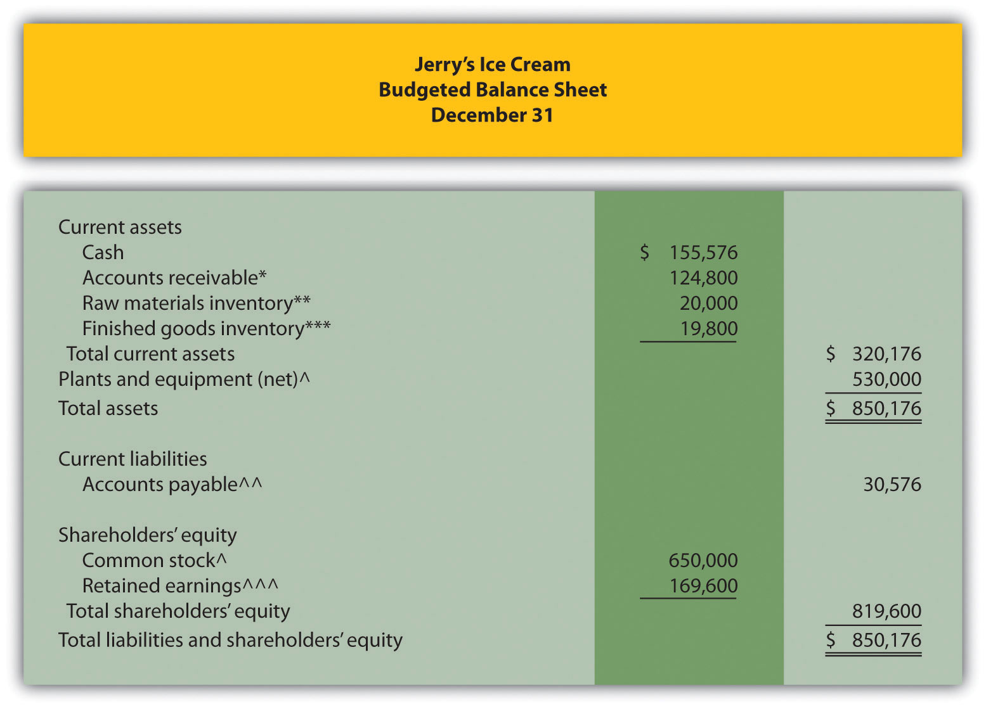
*$124,800 = $312,000 in fourth quarter sales (Figure 9.3 "Sales Budget for Jerry’s Ice Cream") × 40 percent to be collected next quarter (Figure 9.11 "Cash Budget for Jerry’s Ice Cream").
**$20,000 = 20,000 pounds (Figure 9.5 "Direct Materials Purchases Budget for Jerry’s Ice Cream") × $1 per pound (Figure 9.5 "Direct Materials Purchases Budget for Jerry’s Ice Cream").
***$19,800 = 4,400 units (Figure 9.4 "Production Budget for Jerry’s Ice Cream") × $4.50 (Figure 9.9 "Budgeted Income Statement for Jerry’s Ice Cream").
^Given.
^^ $30,576 = $101,920 in fourth quarter purchases (Figure 9.5 "Direct Materials Purchases Budget for Jerry’s Ice Cream") × 30 percent to be paid next quarter (Figure 9.11 "Cash Budget for Jerry’s Ice Cream").
^^^$169,600 = $101,600 in retained earnings at end of last year (given) + $68,000 budgeted net income for the year (Figure 9.9 "Budgeted Income Statement for Jerry’s Ice Cream").

Computer Application
Using Excel to Develop an Operating Budget
Managers often use spreadsheets to develop operating budgets. Spreadsheets help managers perform what-if analysis by linking the components of the master budget and automatically making changes to budget schedules when certain estimates are revised. For example, if managers at Jerry’s Ice Cream wanted to see what would happen if sales in units were decreased by 10 percent from the initial projection shown in Figure 9.3 "Sales Budget for Jerry’s Ice Cream", they would simply reduce sales by 10 percent, and all budget schedules affected by this change would automatically be updated in the spreadsheet.
An example of how to use Excel to develop an operating budget for Jerry’s Ice Cream follows. Notice the tabs at the bottom of the spreadsheet. The first tab is for the sales budget worksheet, the second tab is for the production budget worksheet, the next tab is for the direct materials purchases budget worksheet, and so on. All these worksheets are linked so changes to certain estimates are reflected in the appropriate budget schedules.
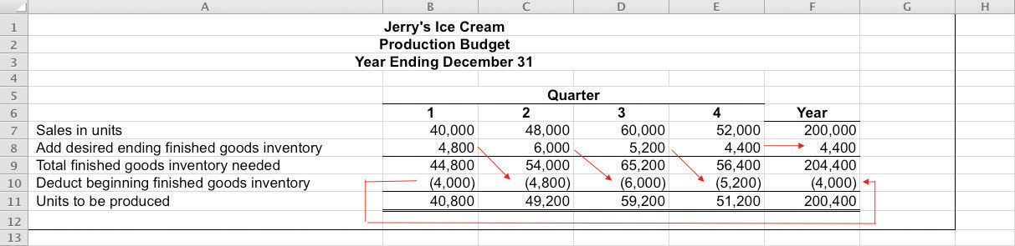
Spreadsheet programs are not the only way managers use technology to facilitate the budgeting process. As indicated in Note 9.30 "Business in Action 9.2" the Web is also a useful tool when it comes to efficient budgeting.

Business in Action 9.2
Moving from Spreadsheets to Intranet Budgeting
The Pacific Northwest National Laboratory (PNNL) is one of nine multiprogram national laboratories of the U.S. Department of Energy.PNNL is operated by Battelle Science and Technology International, a global science and technology enterprise that conducts $3,000,000,000 worth of research and development annually.
The Facilities & Operations (F&O) Business Office at PNNL has over 130 budget activities, each of which requires an annual budget. The total annual budget is $70,000,000. Prior to 2000, activity managers were required to use Excel to process budget information. The F&O Business Office then uploaded this information to formulate the division’s budget.
As the F&O Business Office began the budget process for 2001, management decided to build a Web-based, or intranet, budget and planning system. The new system allowed managers to use the Web to input budget information directly, thus eliminating the need to upload initial budgets and subsequent budget changes.
Moving to intranet budgeting benefited PNNL’s F&O Business Office in several ways. Activity managers no longer had to use Excel to enter budget information, which saved 450 hours. The F&O Business Office saved 60 hours by no longer having to upload Excel budget information. Budget reports are easy to create, and the system provides real-time reports for analysis and project management.
Many organizations are adopting intranet budgeting as the primary source of planning and control. As the financial specialist at PNNLstated, intranet budgeting provides “a tool that is easy to use, accurate, and simple and will continue to save us time and money.”
Sources: Mary F. Astley, “Intranet Budgeting,” Strategic Finance, May 2003; Pacific Northwest National Laboratory, “Home Page,”http://www.pnl.gov.

REVIEW PROBLEM 9.7
Assume Carol’s Cookies will collect 25 percent of fourth quarter budgeted sales in full next year (this represents accounts receivable at the end of the fourth quarter). The following account balances are expected at the end of the fourth quarter:
- Property, plant, and equipment (net): $320,000
- Common stock: $450,000
Retained earnings at the end of last year totaled $56,180, and no cash dividends are anticipated for the budget period ending December 31.
Prepare a budgeted balance sheet for Carol’s Cookies using the format shown in Figure 9.12 "Budgeted Balance Sheet for Jerry’s Ice Cream".
Solution to Review Problem 9.7
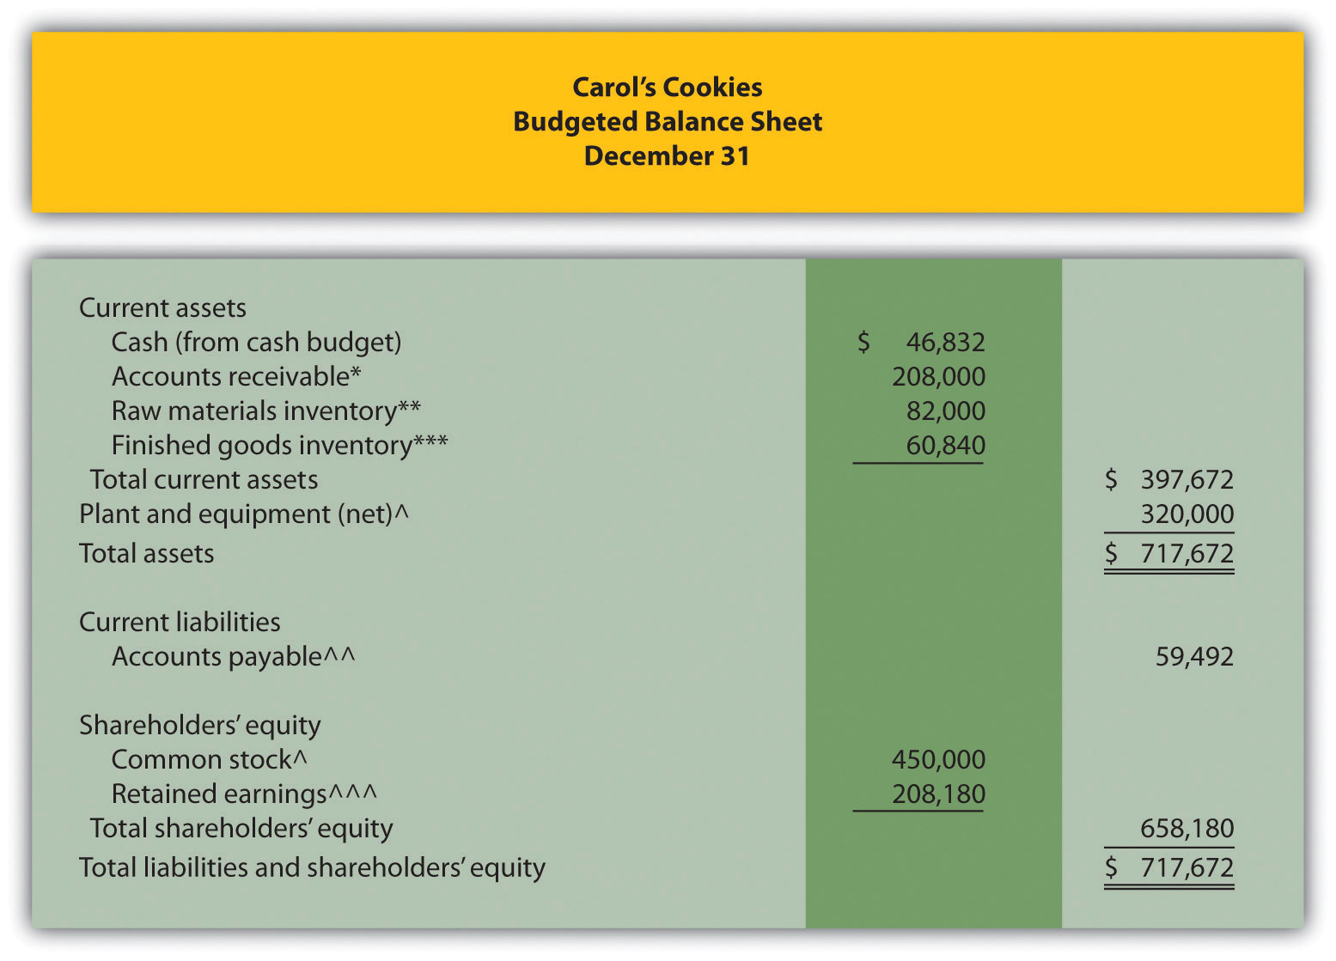
*$208,000 = $832,000 in fourth quarter sales (from sales budget) × 25 percent to be collected next quarter (given).
**$82,000 = 41,000 pounds × $2 per pound (from direct materials budget).
***$60,840 = 9,000 units (from production budget) × $6.76 cost per unit (from budgeted income statement).
^Given.
^^ $59,492 = $297,460 in fourth quarter purchases (from direct materials budget) × 20 percent to be paid next quarter (given).
^^^ $208,180 = $56,180 in retained earnings end of last year (given) + $152,000 budgeted net income (from budgeted income statement).

Wrap-Up of Chapter Example

The management group at Jerry’s Ice Cream is reconvening to discuss sales growth anticipated for the next budget period.
Jerry: | Tom, I recall you saying we should expect growth between 10 percent and 25 percent next year. Have you been able to narrow this down a bit?
Tom: | Yes, I’ve talked with our salespeople and industry contacts. We also obtained trend data from a market research firm. Based on this information, sales should increase about 15 percent this coming year. Most agree this growth is a result of our high-quality product and our ability to quickly adjust flavors to accommodate consumer tastes.
Jerry: | This is great news. It looks like our ice cream is really catching on!
Michelle: | I received Tom’s projection a few days ago and already have a preliminary budget for next year. Lynn, you will have to do some serious planning to guarantee we have enough materials and employees for the third quarter spike in sales.
Lynn: | Yes, I realize we have some work to do to ensure we have enough resources to meet budgeted production levels.
Jerry: | Can’t we just hire a few more employees and let our suppliers know we will need more materials?
Lynn: | The problem is that we have a spike in production during the third quarter. Production goes from 49,200 units in the second quarter to 59,200 units in the third quarter and back down to 51,200 units in the fourth quarter. I don’t think materials will be an issue—our supplier has already assured me this will not be a problem. But I can’t just hire new employees in the third quarter and fire them in the fourth quarter.
Jerry: | Perhaps our existing employees can work overtime, or we can hire temporary employees.
Lynn: | Hiring temporary employees would be my preference, particularly since college students are looking for part-time work during the summer months. Working overtime would really cause problems with our budgeted hourly rate of $13.
Jerry: | Michelle, do we have any cash flow problems with the anticipated growth?
Michelle: | Fortunately not. If all goes as planned, we should have more than $90,000 in the bank at the end of each quarter.
Jerry: | Excellent! Let’s do our best to stay on track. Michelle, I’d like an update at the end of the first quarter to see if actual profit meets or exceeds budgeted profit.
Michelle: | No problem. I’ll have it for you as soon as the books are closed for the first quarter.
Jerry: | Now that we all have some idea of what to expect this coming year, we can make sure the resources are in place to make it happen. This should be an exciting and challenging year for us. Let’s meet again next month to discuss our progress in preparing for next year.

This narrative provides an example of how the master budget is used for planning purposes. It is much more efficient to plan in advance for significant increases in sales and production than to wait and deal with production issues as they occur. The master budget can also be used for control purposes by evaluating company performance. We discuss the control phase of budgeting further in Chapter 10 "How Do Managers Evaluate Performance Using Cost Variance Analysis?".

KEY TAKEAWAY
- The master budget for a manufacturing company includes budget schedules for sales, production, direct materials, direct labor, manufacturing overhead, selling and administrative, the income statement, capital expenditures, cash, and the balance sheet. The sales budget is most important because sales projections drive the other budgets.

9.4 Budgeting in Nonmanufacturing Organizations

LEARNING OBJECTIVE
- Describe operating budgets for merchandising, service, and not-for-profit organizations.

The examples used thus far to describe a master budget have been limited to manufacturing companies. Manufacturing companies tend to have comprehensive operating budgets and therefore serve as a good starting point in learning how to develop a master budget. However, all types of organizations use operating budgets.

Merchandising Organizations

Question: What do operating budgets look like for merchandising organizations?

Answer: Merchandising organizations typically purchase finished goods and sell them to retail or wholesale customers. Because merchandisers do not produce goods, they do not use production or production-related budgets.

provides an overview of the master budget schedules for a merchandising organization. If you compare this diagram with (master budget schedules for a manufacturing company), you will notice that production and production-related budgets are not applicable to merchandising organizations. Direct materials are not needed, and all labor and overhead costs are included in the selling and administrative budget.

Figure 9.13 Master Budget Schedules for a Merchandising Organization
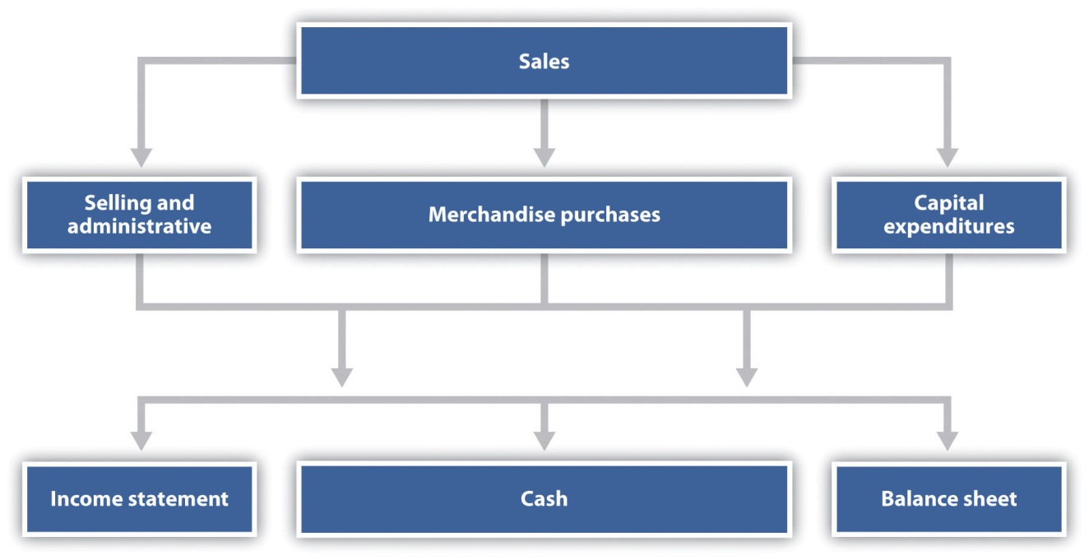

The most important aspect of budgeting for merchandising organizations is the merchandise purchases budget. The merchandise purchases budgetestimates the units of merchandise to be purchased and the cost per unit. Much like the production budget for a manufacturing company, the merchandise purchases budget estimates units to be purchased (instead of units to be produced) and is based on sales projections, as well as an estimate of desired ending merchandise inventory less beginning merchandise inventory.

Service Organizations

Question: What do operating budgets look like for service organizations?

Answer: Service organizations, such as architectural and accounting firms, provide services rather than tangible goods. These organizations do not have raw materials, finished goods, or merchandise inventories, and therefore they do not have production or merchandise purchases budgets. Instead, the focus is on projected sales revenue from services provided and the labor necessary to achieve sales revenue projections. Service organizations must constantly estimate services to be provided and make sure labor force resources are available to meet customer demand.

Not-for-Profit Organizations

Question: Not-for-profit organizations, such as school districts and charitable organizations, also use budgets for planning and control purposes. The budgeting process in most not-for-profit organizations is critical because the approved budget often serves as the legal authority for expenditures. What do operating budgets look like for not-for-profit organizations?

Answer: Because not-for-profit organizations are very diverse in nature—for example, some provide a service, while others collect money to help victims of natural disasters or to promote medical research—it is difficult to generalize about which master budget components apply and which do not. However, with an understanding of the budget components used by manufacturing, merchandising, and service organizations, one can establish a budgeting process for virtually any not-for-profit organization. For an example of how one not-for-profit organization goes about the budgeting process, read .

Business in Action 9.3
Budgeting at a Not-for-Profit Organization
Yearly, a small not-for-profit symphony in California establishes an operating budget with revenues totaling $200,000. The symphony’s treasurer oversees the budget committee, which is made up of three board members. The budget committee is responsible for creating, approving, and monitoring the budget.
The budget committee begins the budgeting process by reviewing information from the year before. All board members and office staff are given spreadsheets showing last year’s results and are asked to provide input for the next budget period. For example, the committee responsible for ticket sales estimates sales revenue based on expected ticket sales times the average sales price. Anticipated increases in sales price are considered in the sales budget.
Expenses are also budgeted based on last year’s actual results. Those requesting increases in budgeted expenditures must justify them. Once revenues and expenses are established for the next budget period, the bookkeeper enters the information using QuickBooks software and prints a preliminary budget report, which the budget committee reviews. Once the budget committee has balanced the budget, reviewed it for reasonableness, and approved it, it goes to the board of directors for approval.
The control phase of the budgeting process requires that all expenditures be in accordance with the budget. Any expenditure exceeding the budget by more than $25 must be approved by the board of directors. A financial report comparing actual revenues and expenditures withbudgeted revenues and expenditures (produced using QuickBooks software) is submitted to the board of directors monthly.

KEY TAKEAWAY
- Merchandising organizations do not produce goods, and therefore do not have production or production-related budgets. Instead, merchandisers prepare a merchandise purchases budget. Service companies do not have production or merchandise purchases budgets. Instead, service organizations focus on projected sales and labor costs. Not-for-profit organizations also use budgets for planning and control purposes. The format depends on the service being provided.

REVIEW PROBLEM 9.8
Patel and Company performs accounting services for its customers. The company had the following net income for the most recent year:
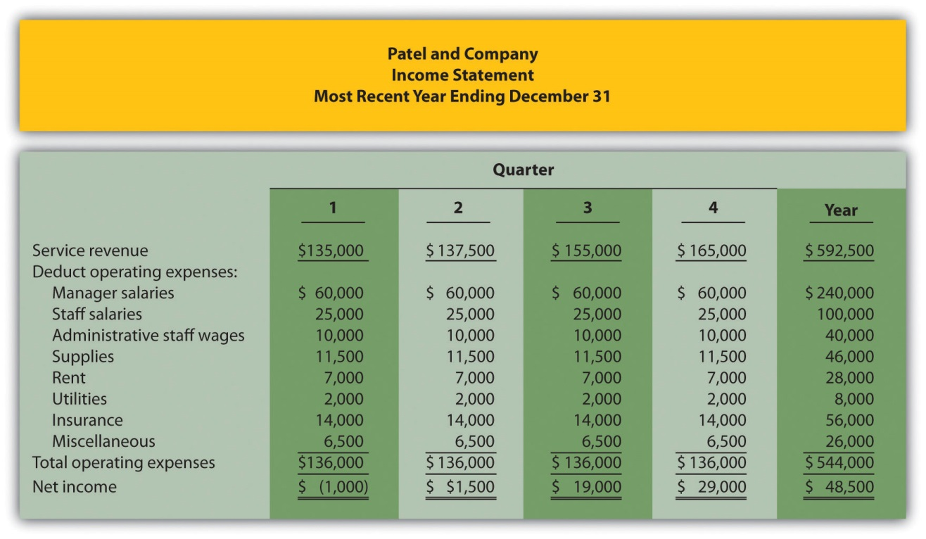
The following information was gathered to help prepare next year’s budgeted income statement:
- Service revenue will increase 10 percent (e.g., first quarter service revenue for next year will be 10 percent higher than the first quarter shown previously).
- Manager and staff salaries will increase 5 percent, and a new staff accountant will be hired at the beginning of the second quarter at a quarterly salary of $12,000.
- Administrative staff wages will increase 10 percent.
- Supplies and rent will remain the same.
- Utilities will increase 5 percent.
- Insurance will increase 25 percent.
- Miscellaneous expenses will decrease 10 percent.
Prepare a quarterly budgeted income statement for Patel and Company; include a column summarizing the year.
Solution to Review Problem 9.8
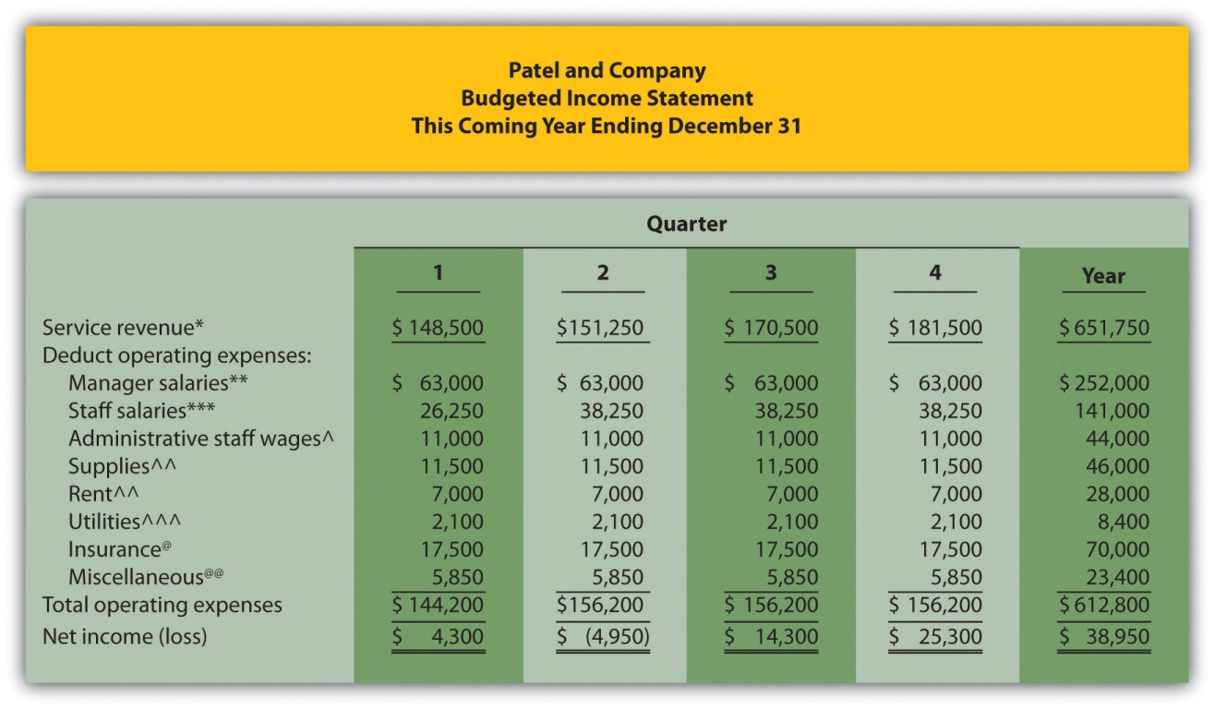
*First quarter budget of $148,500 = $135,000 in last year’s first quarter revenue × (1 + .10).
**Quarterly budget of $63,000 = $60,000 in last year’s quarterly salaries × (1 + .05).
***First quarter budget of $26,250 = $25,000 in last year’s first quarter salaries × (1 + .05). Second, third, and fourth quarter budgets include newly hired staff at $12,000 a quarter.
^Quarterly budget of $11,000 = $10,000 in last year’s quarterly budget × (1 + .10).
^^ No change from last year.
^^^ Quarterly budget of $2,100 = $2,000 in last year’s quarterly budget × (1 + .05).
@ Quarterly budget of $17,500 = $14,000 in last year’s quarterly budget × (1 + .25).
@@ Quarterly budget of $5,850 = $6,500 in last year’s quarterly budget × (1 – .10).

9.5 Ethical Issues in Creating Operating Budgets

LEARNING OBJECTIVE
- Understand ethical issues associated with budgeting.

Question: Although bottom-up budgeting, in which management elicits input from employees throughout the company, is effective in actively engaging those who have to achieve the budgeted goals, this type of budgeting is not free from problems. Ethical issues often arise in the budgeting process, particularly when employees and managers are evaluated by comparing their actual results to the budget. How might ethical issues arise in the budgeting process?

Answer: To demonstrate how ethical dilemmas might arise, assume you are a manager and you help upper management establish the master budget (this is the planning phase). Furthermore, you are evaluated based on achieving budgeted profit on a quarterly basis (this is the control phase). In fact, you will receive a $10,000 quarterly bonus, in addition to your base salary, if you meet or exceed budgeted profit. There is an inherent conflict between the planning and control phases of this process. You are helping the company plan, but you also want to be sure budgeted profit is as low as possible so you can get the $10,000 bonus.

Establishing a sales and profit budget that is considerably lower than what will likely happen causes problems for the entire organization. Production may be short of materials and labor, causing inefficiencies in the production process. Selling and administrative support may be lacking due to underestimating sales. Customers will not be satisfied if they must wait for the product. The dilemma you face as a manager in this situation is whether to do what is best for you (set a low profit estimate to earn the bonus) or do what is best for the company (estimate accurately so the budget reflects true sales and production needs).

Organizations must recognize this conflict and have processes in place to ensure both the interests of individual employees and the interests of the organization as a whole are served. For example, employees can be rewarded not just for meeting goals but also for providing accurate estimates. Perhaps a long-term stock option incentive system would provide motivation to do what is best for the organization, thereby increasing shareholder value. Whatever incentive system is implemented, organizations must promote honest employee input and beware of fraudulent reporting to achieve financial targets.

KEY TAKEAWAY
- An inherent conflict often exists between the planning and control phases of budgeting. During the planning phase, organizations are most concerned about getting accurate estimates that lead to positive results. The control phase requires evaluating performance of employees by comparing actual results to the operating budget. Employees often must decide between doing what is best for the individual employee and what is best for the organization.

REVIEW PROBLEM 9.9
Assume you are the manager of the computer division of High Tech Retail, Inc. You are asked to help the company prepare a budgeted income statement for the computer division before the start of each fiscal year. At the completion of each fiscal year, division managers receive a bonus equal to 10 percent of actual net income in excess of budgeted net income.
Describe the ethical conflict facing you as division manager when asked to help create the budgeted income statement for your division.
Solution to Review Problem 9.9
Employees who are evaluated in the control phase by comparing actual results to budgeted information have an incentive to create a budget that is easy to achieve, and perhaps unrealistic. This can create problems for the organization as a whole since inventory purchases are made based on budgeted sales. If each of the division managers submits a sales budget that significantly underestimates sales, the company will likely have a shortage of inventory and lose out on sales as customers go elsewhere to find the product. Although the managers will have an easier time achieving sales and profit goals, the company as a whole will suffer. The ethical dilemma of choosing between doing what is best for the division manager and what is best for the organization can ultimately lead to lower sales and dissatisfied customers.

END-OF-CHAPTER EXERCISES
Questions
- Describe the planning phase of budgeting.
- Describe the control phase of budgeting.
- Refer to Describe two characteristics that make budgeting difficult for multinational companies.
- Why do successful companies tend to use the bottom-up approach to budgeting?
- Briefly describe the components of a master budget for a manufacturing organization.
- Why is the sales budget the most important component of the master budget?
- Describe the information used by companies to estimate sales.
- Describe how units to be produced is calculated in the production budget.
- How does a production budget help the production manager plan for the future?
- Why is depreciation deducted at the bottom of the manufacturing overhead budget?
- Why do companies that prepare a budgeted income statement also prepare a cash budget?
- Refer to Business in Action 9.2 titled “Moving from Spreadsheets to Intranet Budgeting.” What are the advantages of using intranet budgeting? What are some possible disadvantages?
- How does the master budget for a merchandising organization differ from the master budget for a manufacturing organization?
- Describe the difference between service organization budgets and manufacturing organization budgets.
- Refer to Describe the two procedures that the symphony uses in the control phase of budgeting.
- Describe the ethical conflict that can occur between the planning and control phases of the budgeting process.
- Why might a sales budget that intentionally underestimates sales have a negative impact on the organization?
Brief Exercises
- Budgeting at Jerry’s Ice Cream. Refer to the dialogue for Jerry’s Ice Cream presented at the beginning of the chapter and the follow-up dialogue after .
Required:
  - In the opening dialogue, why is Jerry Feltz concerned about the sales growth expected for the coming year?
  - In the follow-up dialogue, why is the company’s treasurer and controller concerned about the third quarter?
- Budget Sequence. Indicate the order in which the following budget schedules are prepared.
  - Direct materials purchases
  - Manufacturing overhead
  - Income statement
  - Direct labor
  - Selling and administrative
  - Cash
  - Production
  - Balance sheet
  - Sales
  - Capital expenditures
- Sales Budget. Schwartz and Company expects to sell 100 units in the first quarter, 90 units in the second quarter, 150 units in the third quarter, and 160 units in the fourth quarter. The average sales price per unit is expected to be $3,000. Prepare a sales budget for each quarter and include a column for the year ending December 31.
- Production Budget. Schwartz and Company expects to sell 100 units in the first quarter and 90 units in the second quarter. Assuming the company prefers to maintain finished goods inventory equal to 10 percent of the next quarter’s sales, prepare a production budget for the first quarter using as a guide. (Hint: you are preparing a production budget for the first quarter only.)
- Direct Materials Purchases Budget. The production budget for Kaminski Products shows the company expects to produce 500 units in the first quarter and 600 units in the second quarter. Each unit requires 10 pounds of direct materials at a cost of $2 per pound. The company prefers to maintain raw materials inventory equal to 20 percent of next quarter’s materials needed in production. Prepare a direct materials purchases budget using as a guide. (Hint: you are preparing a direct materials purchases budget for the first quarter only.)
- Direct Labor Budget. The production budget for Kaminski Products shows the company expects to produce 500 units in the first quarter. Assuming each unit of product requires 3 direct labor hours at a cost of $13 per hour, prepare a direct labor budget for the first quarter using as a guide. (Hint: you are preparing a direct labor budget for the first quarter only.)
- Manufacturing Overhead Budget. The production budget for Kaminski Products shows the company expects to produce 500 units in the first quarter. Assume variable overhead cost per unit is $5 for indirect materials, $8 for indirect labor, and $3 for other items. Fixed overhead cost per quarter is $30,000 for salaries, $20,000 for rent, and $8,000 for depreciation. Prepare a manufacturing overhead budget for the first quarter using as a guide (Hint: you are preparing a manufacturing overhead budget for the first quarter only.)
- Sales Cash Collections Budget. All sales for Malik and Associates are on credit. Accounts receivable at the end of last quarter totaled $100,000. Credit sales for the first quarter of the upcoming period are expected to be $300,000. The company expects to collect 70 percent of sales in the quarter of the sale, and 30 percent the quarter following the sale. Prepare a sales cash collections budget for the first quarter of the upcoming period using the top of as a guide. (Hint: you are preparing a sales cash collections budget for the first quarter only.)
- Purchases Cash Payments Budget. All direct material purchases made by Keen and Company are on credit. Accounts payable at the end of last quarter totaled $50,000. Purchases for the first quarter of the upcoming period are expected to be $200,000. The company expects to pay 40 percent of purchases in the quarter of purchase and 60 percent the quarter following the purchase. Prepare a purchases cash payments budget for the first quarter of the upcoming period using the middle of as a guide. (Hint: you are preparing a purchases cash payments budget for the first quarter only.)
- Sales Budget for Service Organization; Ethical Issues. Rami and Associates is an accounting firm that estimates revenues based on billable hours. The company expects to charge 8,000 hours to clients in the first quarter, 9,000 hours in the second quarter, 7,000 hours in the third quarter and 8,500 hours in the fourth quarter. The average hourly billing rate is expected to be $100.
Required:
  - Prepare a services revenue budget for each quarter and include a column for the year ending December 31. (Hint: this is similar to a sales budget except sales are measured in labor hours rather than in units, and revenue is measured as an average hourly billing rate rather than a sales price per unit.)
  - Since the manager of the company is given a bonus if actual billable hours exceed budgeted billable hours, the manager intentionally underestimated the number of expected billable hours for each quarter. How might this underestimate affect the company?
Exercises: Set A
- Sales and Production Budgets. Templeton Corporation produces windows used in residential construction. Unit sales last year, ending December 31, are as follow:
First quarter | 40,000
Second quarter | 50,000
Third quarter | 52,000
Fourth quarter | 48,000
- Unit sales are expected to increase 10 percent this coming year over the same quarter last year. Average sales price per window will remain at $200.
- Assume finished goods inventory is maintained at a level equal to 5 percent of the next quarter’s sales. Finished goods inventory at the end of the fourth quarter budget period is estimated to be 2,300 units.
- Required:
  - Prepare a sales budget for Templeton Corporation using a format similar to . (Hint: be sure to increase last year’s unit sales by 10 percent.)
  - Prepare a production budget for Templeton Corporation using a format similar to .
- Direct Materials Purchases and Direct Labor Budgets. Templeton Corporation produces windows used in residential construction. The company expects to produce 44,550 units in the first quarter, 55,110 units in the second quarter, 56,980 units in the third quarter, and 52,460 units in the fourth quarter. (This information is derived from the previous exercise for Templeton Corporation.)
With regards to direct materials, each unit of product requires 12 square feet of glass at a cost of $1.50 per square foot. Management prefers to maintain ending raw materials inventory equal to 10 percent of next quarter’s materials needed in production. Raw materials inventory at the end of the fourth quarter budget period is estimated to be 65,000 square feet.
With regards to direct labor, each unit of product requires 2 labor hours at a cost of $15 per hour.
Required:
  - Prepare a direct materials purchases budget for Templeton Corporation using a format similar to .
  - Prepare a direct labor budget for Templeton Corporation using a format similar to .
- Manufacturing Overhead Budget. Templeton Corporation produces windows used in residential construction. The company expects to produce 44,550 units in the first quarter, 55,110 units in the second quarter, 56,980 units in the third quarter, and 52,460 units in the fourth quarter. (This information is the same as in the previous exercise for Templeton Corporation.) The following information relates to the manufacturing overhead budget.
Variable Overhead Costs
Indirect materials | $2.50 per unit
Indirect labor | $3.20 per unit
Other | $1.70 per unit
Fixed Overhead Costs per Quarter
Salaries | $50,000
Rent | $60,000
Depreciation | $36,370
- Required:
- Prepare a manufacturing overhead budget for Templeton Corporation using a format similar to .
- Budgets for Cash Collections from Sales and Cash Payments for Purchases. Templeton Corporation produces windows used in residential construction. The dollar amount of the company’s quarterly sales and direct materials purchases are projected to be as follows (this information is derived from the previous exercises for Templeton Corporation):
 | 1st | 2nd | 3rd | 4th
Sales | $8,800,000 | $11,000,000 | $11,440,000 | $10,560,000
Direct materials purchases | $ 820,908 | $ 995,346 | $ 1,017,504 | $ 947,352
- Assume all sales are made on credit. The company expects to collect 60 percent of sales in the quarter of sale and 40 percent the quarter following the sale. Accounts receivable at the end of last year totaled $3,000,000, all of which will be collected in the first quarter of the coming year.
- Assume all direct materials purchases are on credit. The company expects to pay 70 percent of purchases in the quarter of purchase and 30 percent the following quarter. Accounts payable at the end of last year totaled $325,000, all of which will be paid in the first quarter of this coming year.
- Required:
  - Prepare a budget for cash collections from sales. Use a format similar to the top section of .
  - Prepare a budget for cash payments for purchases of materials. Use a format similar to the middle section of . Round to the nearest dollar.
- Service Company Budgeted Income Statement and Ethical Issues.Lawn Care, Inc., has two owners who maintain lawns for residential customers. The company had the following net income for the most current year.
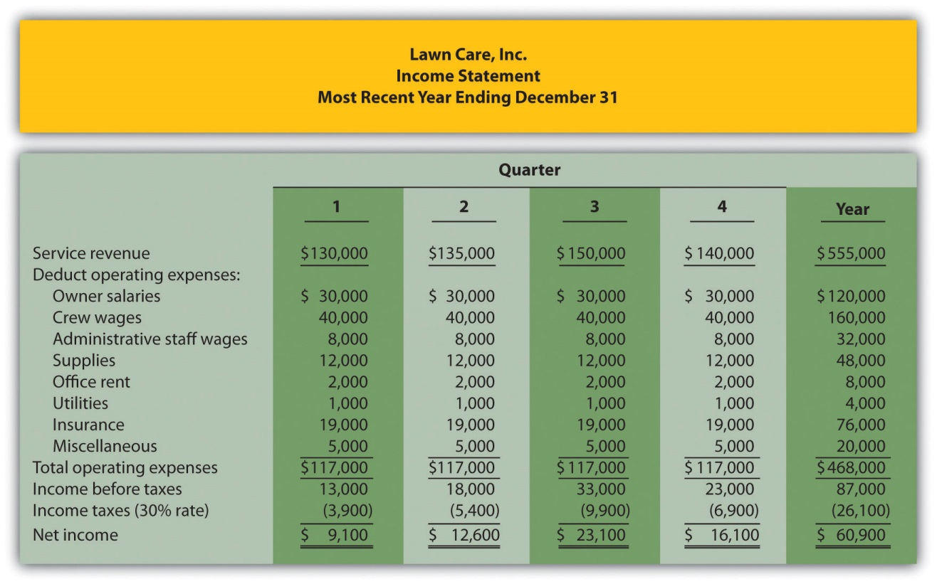
The following information was gathered from the owners to help prepare this coming year’s budgeted income statement:
  - Service revenue will increase 15 percent (e.g., first quarter service revenue for this coming year will be 15 percent higher than the first quarter shown previously).
  - Owner salaries will increase 8 percent.
  - Crew wages will increase 12 percent.
  - Administrative staff wages will increase 5 percent, and a new staff member will be hired at the beginning of the third quarter at a quarterly rate of $7,000.
  - Supplies will increase 9 percent.
  - Office rent, utilities, and miscellaneous expenses will remain the same.
  - Insurance will increase 18 percent.
  - The tax rate will remain at 30 percent.
Required:
  - Prepare a quarterly budgeted income statement for Lawn Care, Inc., and include a column summarizing the year.
  - The owners of Lawn Care, Inc., have decided to expand and are in need of additional cash to expand operations. Unknown to the owners, the company’s accountant intentionally inflated the revenue projections for this coming year to make the company look better when applying for a loan. Is this behavior ethical? Explain. (It may be helpful to review the presentation of ethics in .)
Exercises: Set B
- Sales and Production Budgets. Catalina, Inc., produces tents used for camping. Unit sales last year, ending December 31, follow.
First quarter | 6,000
Second quarter | 10,000
Third quarter | 12,000
Fourth quarter | 8,000
- Unit sales are expected to increase 30 percent this coming year over the same quarter last year. Average sales price per tent will remain at $300.
- Assume finished goods inventory is maintained at a level equal to 10 percent of the next quarter’s sales. Finished goods inventory at the end of the fourth quarter budget period is estimated to be 1,900 units.
- Required:
  - Prepare a sales budget for Catalina, Inc., using a format similar to . (Hint: be sure to increase last year’s unit sales by 30 percent.)
  - Prepare a production budget for Catalina, Inc., using a format similar to .
- Direct Materials Purchases and Direct Labor Budgets. Catalina, Inc., produces tents used for camping. The company expects to produce 8,320 units in the first quarter, 13,260 units in the second quarter, 15,080 units in the third quarter, and 11,260 units in the fourth quarter (this information is derived from the previous exercise for Catalina, Inc.).
With regards to direct materials, each unit of product requires 8 yards of material, at a cost of $4 per yard. Management prefers to maintain ending raw materials inventory equal to 15 percent of next quarter’s materials needed in production. Raw materials inventory at the end of the fourth quarter budget period is estimated to be 14,000 yards.
With regards to direct labor, each unit of product requires 3 labor hours at a cost of $16 per hour.
Required:
  - Prepare a direct materials purchases budget for Catalina, Inc., using a format similar to .
  - Prepare a direct labor budget for Catalina, Inc., using a format similar to .
- Manufacturing Overhead Budget. Catalina, Inc., produces tents used for camping. The company expects to produce 8,320 units in the first quarter, 13,260 units in the second quarter, 15,080 units in the third quarter, and 11,260 units in the fourth quarter. (This information is the same as in the previous exercise for Catalina, Inc.) The following information relates to the manufacturing overhead budget.
Variable Overhead Costs
Indirect materials | $0.20 per unit
Indirect labor | $4.20 per unit
Other | $2.70 per unit
Fixed Overhead Costs per Quarter
Salaries | $100,000
Rent | $ 30,000
Depreciation | $ 44,908
- Required:
- Prepare a manufacturing overhead budget for Catalina, Inc., using a format similar to .
- Budgets for Cash Collections from Sales and Cash Payments for Purchases. Catalina, Inc., produces tents used for camping. The dollar amount of the company’s quarterly sales and direct materials purchases are projected to be as follows (this information is derived from the previous exercises for Catalina, Inc.):
 | 1st | 2nd | 3rd | 4th
Sales | $2,340,000 | $3,900,000 | $4,680,000 | $3,120,000
Direct materials purchases | $ 289,952 | $ 433,056 | $ 464,224 | $ 362,272
- Assume all sales are made on credit. The company expects to collect 80 percent of sales in the quarter of sale and 20 percent the quarter following the sale. Accounts receivable at the end of last year totaled $400,000, all of which will be collected in the first quarter of the coming year.
- Assume all direct materials purchases are on credit. The company expects to pay 90 percent of purchases in the quarter of purchase and 10 percent the following quarter. Accounts payable at the end of last year totaled $30,000, all of which will be paid in the first quarter of this coming year.
- Required:
  - Prepare a budget for cash collections from sales. Use a format similar to the top section of .
  - Prepare a budget for cash payments for purchases of materials. Use a format similar to the middle section of . Round to the nearest dollar.
- Service Company Budgeted Income Statement. Civil Engineers, LLC, has five engineers who design and maintain wetlands. The company had the following net income for the most current year.
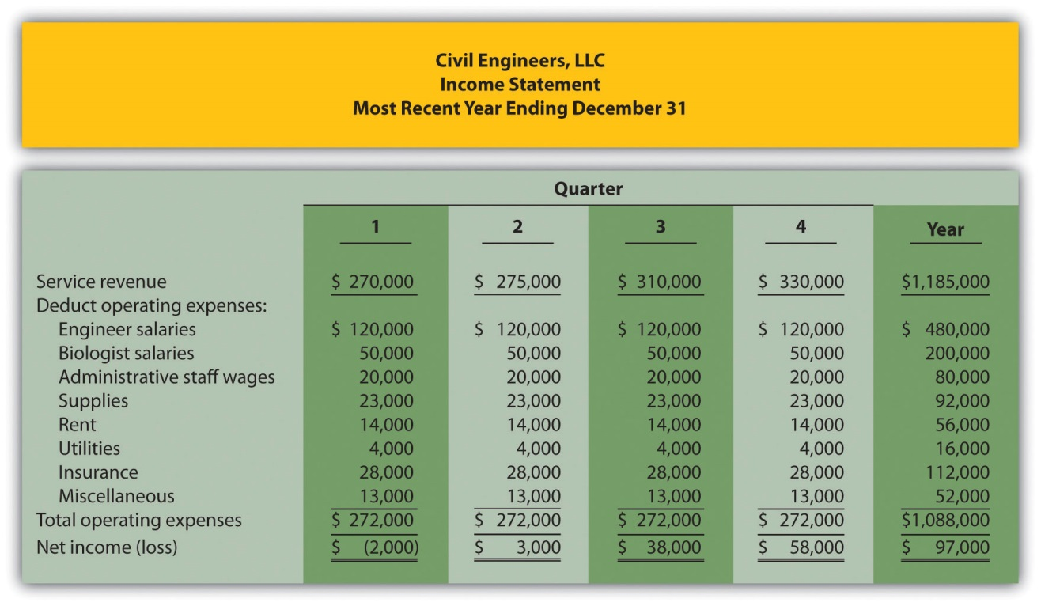
The following information was gathered from management to help prepare this coming year’s budgeted income statement:
  - Service revenue will increase 3 percent (e.g., first quarter service revenue for this coming year will be 3 percent higher than the first quarter shown previously).
  - Existing engineer and biologist salaries will increase 5 percent, and a new biologist will be hired at the beginning of the second quarter at a quarterly salary of $10,000.
  - Administrative staff wages will increase 15 percent.
  - Supplies and rent will remain the same.
  - Utilities will increase 8 percent.
  - Insurance will increase 20 percent.
  - Miscellaneous expenses will decrease 5 percent.
Required:
Prepare a quarterly budgeted income statement for Civil Engineers, LLC, and include a column summarizing the year.
Problems
- Budgeting for Sales, Production, Direct Materials, Direct Labor, and Manufacturing Overhead; Ethical Issues. Sanders Swimwear, Inc., produces swimsuits. The following information is to be used for the operating budget this coming year.
  - Average sales price for each swimsuit is estimated to be $50. Unit sales for this coming year ending December 31 are expected to be as follows:
First quarter | 3,000
Second quarter | 5,000
Third quarter | 20,000
Fourth quarter | 6,000
  - Finished goods inventory is maintained at a level equal to 10 percent of the next quarter’s sales. Finished goods inventory at the end of the fourth quarter budget period is estimated to be 400 units.
  - Each unit of product requires 3 yards of direct materials, at a cost of $4 per yard. Management prefers to maintain ending raw materials inventory equal to 20 percent of next quarter’s materials needed in production. Raw materials inventory at the end of the fourth quarter budget period is estimated to be 9,500 yards.
  - Each unit of product requires 0.5 direct labor hours at a cost of $12 per hour.
  - Variable manufacturing overhead costs are
Indirect materials | $0.60 per unit
Indirect labor | $3.50 per unit
Other | $2.80 per unit
  - Fixed manufacturing overhead costs per quarter are
Salaries | $30,000
Other | $ 5,000
Depreciation | $ 9,330
- Required:
  - Prepare a sales budget using the format shown in .
  - Prepare a production budget using the format shown in .
  - Prepare a direct materials purchases budget using the format shown in .
  - Prepare a direct labor budget using the format shown in .
  - Prepare a manufacturing overhead budget using the format shown in .
  - As the production manager, what concerns, if any, do you have about production requirements for each of the four quarters?
  - Assume the sales budget was developed based on input provided by the company’s vice president of sales. The vice president is paid a base salary plus a bonus if actual sales exceed budgeted sales. How might this influence the vice president’s estimate of quarterly sales? What effect might this have on the company?
- Budgeting for Sales, Production, Direct Materials, Direct Labor, and Manufacturing Overhead. Hershel’s Chocolate produces chocolate bars and sells them by the case (1 unit = 1 case). Information to be used for the operating budget this coming year follows:
  - Average sales price for each case is estimated to be $25. Unit sales for this coming year, ending December 31, are expected to be as follows:
First quarter | 80,000
Second quarter | 84,000
Third quarter | 88,000
Fourth quarter | 97,000
  - Finished goods inventory is maintained at a level equal to 15 percent of the next quarter’s sales. Finished goods inventory at the end of the fourth quarter budget period is estimated to be 13,000 units.
  - Each unit of product requires 5 pounds of cocoa beans for direct materials, at a cost of $3 per pound. Management prefers to maintain ending raw materials inventory equal to 10 percent of next quarter’s materials needed in production. Raw materials inventory at the end of the fourth quarter budget period is estimated to be 43,000 pounds.
  - Each unit of product requires 0.10 direct labor hours at a cost of $14 per hour.
  - Variable manufacturing overhead costs are
Indirect materials | $0.20 per unit
Indirect labor | $0.15 per unit
Other | $0.10 per unit
  - Fixed manufacturing overhead costs per quarter are
Salaries | $80,000
Other | $70,000
Depreciation | $55,625
- Required:
  - Prepare a sales budget using the format shown in .
  - Prepare a production budget using the format shown in .
  - Prepare a direct materials purchases budget using the format shown in .
  - Prepare a direct labor budget using the format shown in .
  - Prepare a manufacturing overhead budget using the format shown in . Round to the nearest dollar.
  - As the production manager, what concerns, if any, do you have about production requirements for each of the four quarters?
- Selling and Administrative Budget and Budgeted Income Statement.(The previous problem must be completed before working this problem.) Hershel’s Chocolate produces chocolate bars. Management estimates all selling and administrative costs are fixed. Quarterly selling and administrative cost estimates for the coming year follow.
Salaries | $170,000
Rent | $ 65,000
Advertising | $120,000
Depreciation | $ 75,000
Other | $ 36,000
- Required:
  - Use the information presented previously to prepare a selling and administrative budget. Refer to the format shown in .
  - Use the information from the previous problem and from requirement a of this problem to prepare a budgeted income statement. Refer to the format shown in .
  - How will management use the information presented in the budgeted income statement?
- Budgeting for Cash Collections and Cash Payments. Hershel’s Chocolate produces chocolate bars. The treasurer at Hershel’s Chocolate is preparing the cash budget and would like to know when cash collections from sales and cash payments for materials will occur. The dollar amount of the company’s quarterly sales and direct materials purchases are projected to be as follows (this information is the result of working the previous problems for Hershel’s Chocolate):
 | 1st | 2nd | 3rd | 4th
Sales | $2,000,000 | $2,100,000 | $2,200,000 | $2,425,000
Direct materials purchases | $1,215,000 | $1,276,125 | $1,349,400 | $1,417,575
  - All sales are made on credit. The company expects to collect 60 percent of sales in the quarter of sale and 40 percent the quarter following the sale. Accounts receivable at the end of last year totaled $770,000, all of which will be collected during the first quarter of this coming year.
  - All direct materials purchases are on credit. The company expects to pay 80 percent of purchases in the quarter of purchase and 20 percent the following quarter. Accounts payable at the end of last year totaled $257,000, all of which will be paid during the first quarter of this coming year.
Required:
  - Prepare a budget for cash collections from sales. Refer to the format shown at the top of .
  - Prepare a budget for cash payments for purchases of materials. Refer to the format shown in the middle section of .
  - How will the treasurer use this information?
- Services Revenue and Direct Labor Budgets for Service Organization; Ethical Issues. Engineering, Inc., provides structural engineering services for its clients. Billable hours for each month of the first quarter of this coming budget period are expected to be as follows:
January | 2,000
February | 2,200
March | 3,000
- The average hourly billing rate is estimated to be $150.
- Required:
  - Prepare a services revenue budget for Engineering, Inc., for each month of the first quarter and include a total column for the quarter. (Hint: this is similar to a sales budget except sales are measured in labor hours rather than in units, and revenue is measured as an average hourly billing rate rather than a sales price per unit.)
  - The average cost for each hour of direct labor is expected to be $50. Assume total direct labor hours are expected to be 20 percent higher than billable direct labor hours presented previously. This is caused by employees working on projects that are not billable to clients (e.g., recruiting and community work). Prepare a direct labor budget for each month of the first quarter and include a total column for the quarter. (Hint: this budget will have three lines: projected direct labor hours, labor rate per hour, and total direct labor cost.)
  - Assume the manager of the company is given a monthly bonus if actual billable hours exceed budgeted billable hours. How might this influence the manager’s estimate of monthly billable hours for budgeting purposes? What effect might this have on the company?
- Merchandising Company Master Budget. Big Apple Sporting Goods is a retail store that sells a variety of sports equipment. The company’s fiscal year ends on December 31. Information to be used for the operating budget this coming year follows.
Sales and Merchandise Purchases Budget Information
  - Sales for this coming year ending December 31 are expected to be as follows:
First quarter | $600,000
Second quarter | $650,000
Third quarter | $660,000
Fourth quarter | $800,000
  - Cost of goods sold is 40 percent of sales (this is the first line of the merchandise purchases budget). Merchandise inventory is maintained at a level equal to 20 percent of the next quarter’s cost of goods sold. Merchandise inventory at the end of the fourth quarter budget period is estimated to be $55,000.
Selling and Administrative Budget Information
  - Management estimates all selling and administrative costs are fixed.
  - Quarterly selling and administrative cost estimates for the coming year are
Salaries | $150,000
Rent | $ 25,000
Advertising | $ 40,000
Depreciation | $ 18,000
Other | $ 12,000
Capital Expenditure and Cash Budget Information
  - The company plans to pay cash for property, plant, and equipment totaling $35,000 at the end of the fourth quarter. This purchase will not affect depreciation expense for the coming year.
  - The company expects to collect 70 percent of sales in the quarter of sale and 30 percent the quarter following the sale. Accounts receivable at the end of last year totaled $200,000, all of which will be collected during the first quarter of this coming year.
  - All inventory purchases are on credit. The company expects to pay 80 percent of inventory purchases in the quarter of purchase and 20 percent the following quarter. Accounts payable at the end of last year totaled $68,000, all of which will be paid during the first quarter of this coming year.
  - The cash balance at the beginning of this coming year is expected to be $90,000.
Budgeted Balance Sheet Information
  - Assume 30 percent of fourth quarter budgeted sales will be collected in full the following year (this represents accounts receivable at the end of the fourth quarter).
  - Expected account balances at the end of the fourth quarter are
Property, plant, and equipment (net) | $120,000
Common stock | $175,000
  - Actual retained earnings at the end of the last year totaled $252,000, and no cash dividends will be paid during the current budget period ending December 31.
Required:
  - Prepare a quarterly sales budget. (Hint: this budget will not have any units of product, only total sales revenue.)
  - Prepare a quarterly merchandise purchases budget using the following format. All amounts are in dollars.
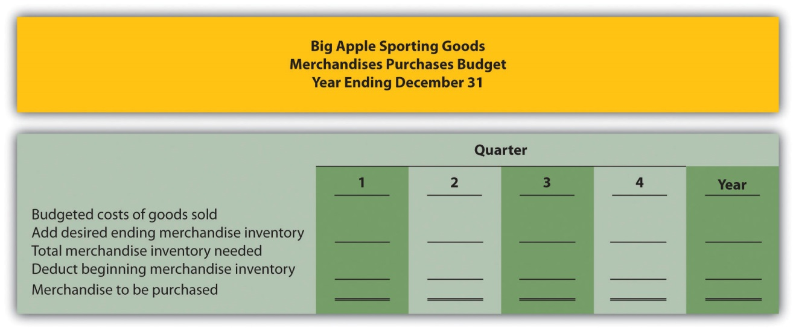
  - Prepare a quarterly selling and administrative budget using the format shown in .
  - Prepare a quarterly budgeted income statement using the format shown in . (Hint: cost of goods sold will be based on a percent of sales rather than a cost per unit.)
  - Prepare a quarterly capital expenditure budget using the format shown in .
  - Prepare a quarterly cash budget using the format shown in . (Hint: Merchandising companies have merchandise purchases rather than direct materials purchases. Merchandising companies do not have direct labor or manufacturing overhead.)
  - Prepare a budgeted balance sheet at December 31 using the format shown in . (Hint: merchandising companies have merchandise inventory rather than raw materials inventory or finished goods inventory.)
One Step Further: Skill-Building Cases
- Ethics in Budgeting. SportsMax sells sporting goods equipment at 100 stores throughout North America. Robert Manning is the manager of one SportsMax retail store in Chicago. The company is in the planning phase of establishing its operating budget for this coming year and has asked that all store managers submit their estimates of sales revenue, costs, and resulting profit. During the control phase, each store manager is evaluated by comparing budgeted profit with actual profit. Store managers who exceed budgeted profit are given a bonus equal to 10 percent of actual profit in excess of budgeted profit.
Required:
  - Describe the ethical conflict that Robert Manning is facing.
  - As the president and CEO of SportsMax, how might you motivate Robert Manning to provide an accurate operating budget?
- Group Activity: Creating a Budget. Form groups of two to four students. Each group is to complete the following requirements.
Required:
  - Assume you are a full-time student living in an apartment near your college campus. Create a personal budget that includes the typical monthly expenses you would expect to incur.
  - Explain how the control phase of budgeting would be implemented for the personal budget created in requirement a.
  - Discuss the findings of your group with the class. (Optional: your instructor may ask you to submit your findings in writing.)
- Creating a Sales Budget and Production Budget Using Excel. Review the information for Templeton Corporation in Exercise 28. Prepare an Excel spreadsheet similar to and showing Templeton’s sales budget and production budget.
- Internet Project: Budgeting. Go to The New York Times’ Web site (http://www.nytimes.com), or a similar reputable Internet source, and find an article about budgeting. Summarize the article in a one-page report, and indicate how the budget described in the article is used for planning purposes. Submit a printed copy of the article with your report.
Comprehensive Cases
- Comprehensive Master Budget. Creative Shirts, Inc., produces T-shirts. The company’s fiscal year ends on December 31. Information to be used for the operating budget this coming year follows.
Sales and Production-Related Budget Information
  - Average sales price for each T-shirt is estimated to be $15. Unit sales for this coming year, ending December 31, are expected to be as follows:
First quarter | 20,000
Second quarter | 24,000
Third quarter | 28,000
Fourth quarter | 18,000
  - Finished goods inventory is maintained at a level equal to 10 percent of the next quarter’s sales. Finished goods inventory at the end of the fourth quarter budget period is estimated to be 2,000 units.
  - Each unit of product requires 3 yards of direct materials, at a cost of $2 per yard. Management prefers to maintain ending raw materials inventory equal to 20 percent of next quarter’s materials needed in production. Raw materials inventory at the end of the fourth quarter budget period is estimated to be 12,200 yards.
  - Each unit of product requires 0.1 direct labor hours at a cost of $14 per hour.
  - Variable manufacturing overhead costs are
Indirect materials | $0.70 per unit
Indirect labor | $0.90 per unit
Other | $0.50 per unit
  - Fixed manufacturing overhead costs per quarter are
Salaries | $18,000
Other | $20,000
Depreciation | $11,950
Selling and Administrative Budget Information
  - Management estimates all selling and administrative costs are fixed.
  - Quarterly selling and administrative cost estimates for the coming year are
Salaries | $15,000
Rent | $ 5,000
Advertising | $ 4,000
Depreciation | $ 9,000
Other | $10,000
Capital Expenditures and Cash Budget Information
  - The company plans to pay cash for selling and administrative equipment totaling $15,000 and production equipment totaling $9,000. Both will be purchased at the end of the fourth quarter and will not affect depreciation expense for the coming year.
  - All sales are made on credit. The company expects to collect 70 percent of sales in the quarter of sale and 30 percent the quarter following the sale. Accounts receivable at the end of last year totaled $80,000, all of which will be collected during the first quarter of this coming year.
  - All direct materials purchases are on credit. The company expects to pay 80 percent of purchases in the quarter of purchase and 20 percent the following quarter. Accounts payable at the end of last year totaled $25,000, all of which will be paid during the first quarter of this coming year.
  - The cash balance at the beginning of this coming year is expected to be $30,000.
Budgeted Balance Sheet Information
  - Assume 30 percent of fourth quarter budgeted sales will be collected in full the following year (this represents accounts receivable at the end of the fourth quarter).
  - Expected account balances at the end of the fourth quarter are
Property, plant, and equipment (net) | $100,000
Common stock | $250,000
  - Actual retained earnings at the end of last year totaled $42,720, and no cash dividends will be paid during the current budget period ending December 31.
Required:
  - Prepare the quarterly sales and production-related budgets using the figure formats referenced here:
    - Sales budget ()
    - Production budget ()
    - Direct materials purchases budget ()
    - Direct labor budget ()
    - Manufacturing overhead budget ()
  - Prepare a quarterly selling and administrative budget using the format shown in .
  - Prepare a quarterly budgeted income statement using the format shown in .
  - Prepare a quarterly capital expenditures budget using the format shown in .
  - Prepare a quarterly cash budget using the format shown in .
  - Prepare a budgeted balance sheet at December 31 using the format shown in .
  - Why does management at Creative Shirts, Inc., prepare a master budget? Explain.
- Comprehensive Master Budget with Cash Flow Issues. Air Boats, Inc., produces small inflatable boats. The company’s fiscal year ends on December 31. Information to be used for the operating budget this coming year follows.
Sales and Production-Related Budget Information
  - Average sales price for each boat is estimated to be $150. Unit sales for this coming year, ending December 31, are expected to be as follows:
First quarter | 100,000
Second quarter | 110,000
Third quarter | 125,000
Fourth quarter | 90,000
  - Finished goods inventory is maintained at a level equal to 15 percent of the next quarter’s sales. Finished goods inventory at the end of the fourth quarter budget period is estimated to be 13,000 units.
  - Each unit of product requires 4 pounds of direct materials, at a cost of $5 per pound. The management prefers to maintain ending raw materials inventory equal to 8 percent of next quarter’s materials needed in production. Raw materials inventory at the end of the fourth quarter budget period is estimated to be 30,000 pounds.
  - Each unit of product requires 0.5 direct labor hours at a cost of $15 per hour.
  - Variable manufacturing overhead costs are
Indirect materials | $2.10 per unit
Indirect labor | $1.10 per unit
Other | $1.70 per unit
  - Fixed manufacturing overhead costs per quarter are
Salaries | $250,000
Other | $300,000
Depreciation | $613,250
Selling and Administrative Budget Information
  - Management estimates all selling and administrative costs are fixed.
  - Quarterly selling and administrative cost estimates for the coming year are
Salaries | $3,000,000
Rent | $1,000,000
Advertising | $ 900,000
Depreciation | $1,200,000
Other | $1,600,000
Capital Expenditures and Cash Budget Information
  - The company plans to pay cash for selling and administrative equipment totaling $5,000,000 and production equipment totaling $20,000,000 (management plans to fully automate production with new machinery). Both will be purchased at the end of the fourth quarter and will not affect depreciation expense for the coming year.
  - All sales are made on credit. The company expects to collect 90 percent of sales in the quarter of sale and 10 percent the quarter following the sale. Accounts receivable at the end of last year totaled $1,400,000, all of which will be collected during the first quarter of this coming year.
  - All direct materials purchases are on credit. The company expects to pay 80 percent of purchases in the quarter of purchase and 20 percent the following quarter. Accounts payable at the end of last year totaled $400,000, all of which will be paid during the first quarter of this coming year.
  - The cash balance at the beginning of this coming year is expected to be $75,000.
Budgeted Balance Sheet Information
  - Assume 10 percent of fourth quarter budgeted sales will be collected in full the following year (this represents accounts receivable at the end of the fourth quarter).
  - Expected account balances at the end of the fourth quarter are
Property, plant, and equipment (net) | $32,000,000
Common stock | $13,500,000
  - Actual retained earnings at the end of last year totaled $2,641,400, and no cash dividends will be paid during the current budget period ending December 31.
Required:
  - Prepare the quarterly sales and production-related budgets using the figure formats referenced here:
    - Sales budget ()
    - Production budget ()
    - Direct materials purchases budget ()
    - Direct labor budget ()
    - Manufacturing overhead budget ()
  - Prepare a quarterly selling and administrative budget using the format shown in .
  - Prepare a quarterly budgeted income statement using the format shown in .
  - Prepare a quarterly capital expenditures budget using the format shown in .
  - Prepare a quarterly cash budget using the format shown in .
  - Prepare a budgeted balance sheet at December 31 using the format shown in . (Hint: cash will have a negative balance.)
  - Review the cash budget for Air Boats, Inc. What issue is facing the treasurer, and how might this issue be resolved?
- Ethics in Budgeting. Carol Chadwick is the manager of the toys division at Matteler, Inc. Carol is in the process of establishing the budgeted income statement for this coming year, which will be submitted to the company president for approval. The division’s current year actual results were slightly higher than the 5 percent growth Carol had anticipated. These results are shown as follows.
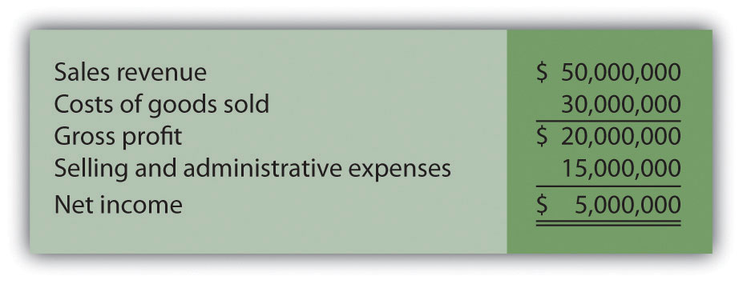
Division managers receive a 20 percent bonus for actual net income in excess of budgeted net income. Carol believes growth in sales this year will be approximately 12 percent. She is considering submitting a budget showing an increase of 5 percent, which will increase her chances of receiving a significant bonus at the end of this coming year. Assume cost of goods sold are variable costs and will increase in proportion with sales revenue. That is, cost of goods sold will always be 60 percent of sales revenue. Assume selling and administrative expenses are fixed costs.
Required:
  - Prepare a budgeted income statement for the toys division assuming sales revenue will increase 5 percent.
  - Prepare a budgeted income statement for the toys division assuming sales revenue will increase 12 percent.
  - How much will Carol potentially have to gain in bonus compensation by submitting a budget showing a 5 percent increase in sales revenue if actual growth turns out to be 12 percent?
  - As the president and CEO of Matteler, how might you motivate Carol Chadwick to provide an accurate budgeted income statement?

Chapter 10

How Do Managers Evaluate Performance Using Cost Variance Analysis?

Jerry Feltz, president and owner of Jerry’s Ice Cream, is discussing the results of operations for the year with the company’s management group: Tom, the sales manager; Lynn, the production manager; and Michelle, the treasurer and controller.
Jerry: | Good work, everyone! It looks as if our sales this past year exceeded the budget! We were expecting to sell 200,000 gallons of ice cream, but it turns out we sold 210,000 gallons. Credit goes to our sales staff for their hard work!
Tom: | Thanks, Jerry. We have a great group of salespeople and a terrific product.
Jerry: | I agree. I am concerned, however, about our direct labor and direct materials costs. We expected a 5 percent increase in these costs over the original budget since sales were 5 percent higher than anticipated. However, our cost overruns far exceeded the 5 percent increase. We’ve got to get a handle on both of these costs.
Lynn: | This doesn’t sound right. My production crew used fewer materials than was budgeted, and the average time it took to make each unit was also less than expected. This should cause materials and labor costs to be lower than expected, not higher.
Jerry: | Michelle, are you sure we have the right information here?
Michelle: | Absolutely. Total costs for direct labor and direct materials were higher than budgeted, even after considering the increase in sales.
Jerry: | Can you give me more detail as to how this happened? I want to know what caused the increase in costs and how to prevent this from taking place in the future.
Michelle: | Can I have a week to pull the information together?
Jerry: | You’ve got it.
Jerry is evaluating the performance of his company by comparing actual costs to budgeted costs. This is the control phase of budgeting. We covered theplanning phase of budgeting in Chapter 9 "How Are Operating Budgets Created?" by showing how Jerry’s Ice Cream prepared a master budget. The focus of this chapter is on the control phase and how to calculate and analyze cost variances.

10.1 Flexible Budgets

LEARNING OBJECTIVE
- Understand how flexible budgets are used to evaluate performance.

Question: The master budget in Chapter 9 "How Are Operating Budgets Created?" was prepared for only one level of activity (activity was measured by the number of units sold, which was budgeted at 200,000 units). Although this works well in the planning phase of budgeting, it is not appropriate for the control phase. Actual sales rarely match budgeted sales. When actual sales differ from budgeted sales, it is inappropriate and perhaps unfair to evaluate employee performance by comparing actual results to the master budget. If actual sales volume is higher than the master budget, variable costs should be higher than the master budget. The opposite is true as well. How do organizations modify the master budget to adjust for actual sales?

Answer: Organizations use a modified budget called a flexible budget. Aflexible budget is simply a revised master budget based on the actualactivity level. It represents what costs should be given a certain level of activity. The master budget at Jerry’s Ice Cream was based on sales of 200,000 units and production of 200,400 units. Because actual sales totaled 210,000 units, the flexible budget should be based on 210,000 units of activity. (It should be noted that in Chapter 9 "How Are Operating Budgets Created?", we presented an example with budgeted sales of 200,000 units and budgeted production of 200,400 units resulting from differing beginning and ending finished goods inventory amounts. In this chapter, we assume beginning and ending finished goods inventory are the same, and therefore units produced and sold will be the same. Thus we assume actual sales and actual production total 210,000 units.)

Question: Imagine being the production manager at Jerry’s Ice Cream, and you are evaluated based on the quantity of direct materials used in production.Would it be fair to compare the materials used to produce 210,000 units with the master budget showing the materials that should have been used to produce 200,400 units?

Answer: Probably not. The budget should be adjusted upward to reflect the actual number of units produced before a comparison is made, thus the termflexible budget. As we develop the process of cost variance analysis, we will use flexible budget information. That is, we will revise the master budget for direct materials, direct labor, and variable manufacturing overhead to reflect actual sales volume of 210,000 units. However, we must first describe the concept of standard cost.

KEY TAKEAWAY
- A flexible budget is a revised master budget that represents expected costs given actual sales. Costs in the flexible budget are compared to actual costs to evaluate performance.

REVIEW PROBLEM 10.1
What is a flexible budget, and why do companies use a flexible budget to evaluate production managers?
Solution to Review Problem 10.1
A flexible budget is a revised master budget based on the actual activity level achieved for a period. The master budget is established before the period begins for planning purposes, and the flexible budget is established after the period ends for control and evaluation purposes. Production managers are evaluated using the flexible budget because the usage of direct materials, direct labor, and manufacturing overhead will depend on the actual number of units produced.

10.2 Standard Costs

LEARNING OBJECTIVE
- Explain how standard costs are established.

Question: Companies often use standard costs for planning and control purposes. What are standard costs?

Answer: Standard costs are costs that management expects to incur to provide a good or service. They serve as the “standard” by which performance will be evaluated. For example, fast-food restaurants have a standard for the length of time it should take to serve a drive-through-window customer. Phone directory operators have a standard length of time it should take to provide a phone number to a customer. Manufacturing companies have a standard quantity of direct materials to be used to produce one unit of product.

The Difference between Standard Costs and Budgeted Costs

Question: What is the difference between standard costs and budgeted costs?

Answer: The term standard cost refers to a specific cost per unit. Budgeted cost refers to costs in total given a certain level of activity. Standard variable production costs at Jerry’s Ice Cream are shown in .

Figure 10.1 Standard Costs at Jerry’s Ice Cream
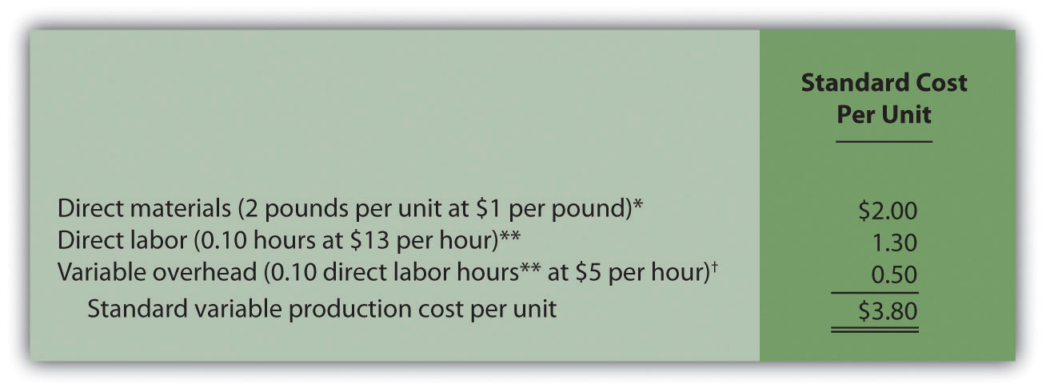

*Direct materials standards come from the direct materials purchases budget presented in .

**Direct labor standards come from the direct labor budget presented in .

† Variable overhead costs are applied to products based on direct labor hours. Variable overhead cost per direct labor hour is calculated by dividing total variable overhead costs of $100,200 (from the manufacturing overhead budget in ) by 20,040 total direct labor hours (from the direct labor budget in ), which results in a standard variable overhead rate of $5 per direct labor hour.

These standard costs can then be used to establish a flexible budget based on a given level of activity. For example, let’s use Jerry’s actual sales of 210,000 units. The variable production costs expected to produce these units are shown in the flexible budget in .

Figure 10.2 Flexible Budget for Variable Production Costs at Jerry’s Ice Cream
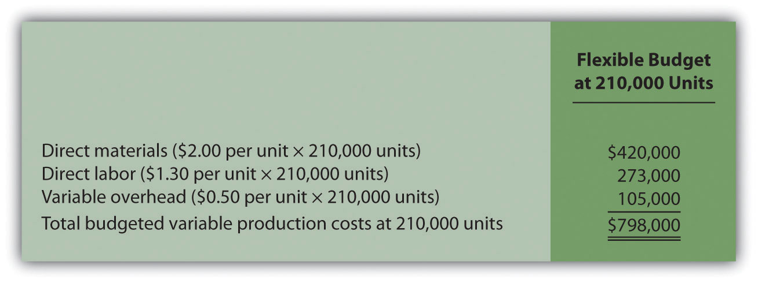

The standard cost presented in shows the variable production costs expected to produce one unit. The flexible budget in uses the standard cost information to show the variable production costs expected in total given a certain level of activity (210,000 units in this example). Later in the chapter, we compare the flexible budget presented in to actual results and analyze the difference. The flexible budget graph presented in shows that direct materials have the highest variable production cost at $420,000, followed by direct labor at $273,000 and variable overhead at $105,000.

Figure 10.3 Flexible Budget
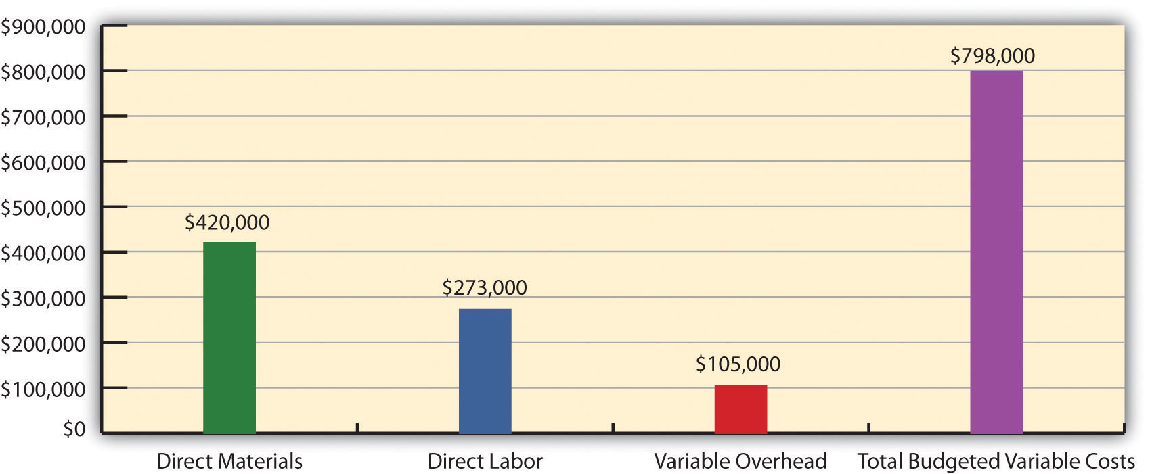

Establishing Standard Cost

Question: What are the components needed to establish a standard cost for direct materials, direct labor, and variable manufacturing overhead?

Answer: Notice in that direct materials has two separate standards necessary to calculate the standard cost: standard quantity to produce 1 unit of product (2 pounds) and standard price ($1 per pound). Direct labor has two separate standards as well: standard hours to produce 1 unit of product (0.10 hours) and standard rate ($13 per hour). Variable manufacturing overhead also has 2 separate standards: standard hours to produce 1 unit of product (0.10 direct labor hours) and standard rate ($5 per hour). Thus there are two separate standards necessary to establish each standard cost or six standards in total to establish a standard cost for direct materials, direct labor, and variable manufacturing overhead.

As we explain next, there are many approaches to establishing these six standards for direct materials, direct labor, and variable manufacturing overhead (we discuss fixed manufacturing overhead at the end of this chapter).

Direct Materials Standard Quantity and Standard Price

Question: How do organizations determine the standard quantity and standard price for direct materials?

Answer: The standard quantity for direct materials represents the materials required to complete one good unit of product (i.e., a product with no defects), and it includes an allowance for waste and spoilage. For Jerry’s Ice Cream, the standard quantity of materials needed for each gallon of product is given in the recipe. Jerry’s adds a certain amount to the recipe quantity for waste and spoilage. Similar to this approach, companies might find the standard quantity in the product specifications outlined by product engineers. Some companies review historical production information to determine quantities used in the past and use this information to set standard quantities for the future.

The standard price for direct materials represents the final delivered cost of the materials and includes items such as shipping and insurance. The standard price for materials at Jerry’s comes from the purchase contract negotiated with the company’s supplier. As an alternative to this approach, companies might use historical data or look at price trends in the marketplace.

As shown in , for Jerry’s Ice Cream, the standard quantity of direct materials is 2 pounds per unit, and the standard price is $1 per pound. Thus the standard cost per unit for direct materials is $2, calculated as follows:

$2 standard cost per unit = 2 pounds per unit × $1 per pound

Direct Labor Standard Hours and Standard Rate

Question: How do organizations determine the standard hours and standard rate for direct labor?

Answer: The standard hours for direct labor represents the direct labor time required to complete one good unit of product and includes an allowance for breaks and production inefficiencies such as machine downtime. Jerry’s Ice Cream established this standard using historical information. In addition to this approach, companies might use time and motion studies performed by engineers who observe production workers and analyze the time required to perform production activities.

The standard rate for direct labor represents the average cost of wages and benefits for each hour of direct labor work performed. Jerry’s Ice Cream looked at past payroll records to determine this standard. Companies also review labor contracts to estimate the costs associated with direct labor.

As shown in , for Jerry’s Ice Cream, the standard hours for direct labor is 0.10, and the standard rate is $13 per hour. Thus the standard cost per unit for direct labor is $1.30, calculated as follows:

$1.30 standard cost per unit = 0.10 direct labor hours per unit × $13 per hour

Variable Manufacturing Overhead Standard Quantity and Standard Rate

Question: How do organizations determine the standard quantity and standard rate for variable manufacturing overhead?

Answer: Thestandard quantity for variable manufacturing overhead represents the time required to complete one unit of product. This time is often measured in direct labor hours or machine hours, depending on how the company chooses to allocate overhead (recall that we covered the choice of allocation base at length in ). Jerry’s Ice Cream uses direct labor hours to allocate variable manufacturing overhead, so we apply the same standard quantity used for direct labor.

The standard rate for variable manufacturing overhead represents the variable portion of the predetermined overhead rate used to allocate overhead costs to products (see for further discussion of predetermined overhead rates).

As shown in , for Jerry’s Ice Cream, the standard quantity of direct labor hours is 0.10, and the standard rate (predetermined overhead rate) is $5 per direct labor hour. Thus the standard cost per unit for variable manufacturing overhead is $0.50, calculated as follows:

$0.50 standard cost per unit = 0.10 direct labor hours per unit × $5 per hour

Ideal Standards and Attainable Standards

Question: In the process of establishing standards, managers must decide between using ideal standards or attainable standards. What is the difference between these two standards?

Answer: Ideal standards are set assuming production conditions are perfect. For example, ideal standards assume machines never break down, employees are never ill, and materials are never wasted. Although ideal standards may provide motivation for workers to strive for excellence, these standards can also have a negative impact because they may be impossible to achieve.

As an alternative to ideal standards, most managers use attainable standards. Attainable standards take into consideration the likelihood of encountering problems in production such as machine downtime, electricity outages, materials waste, and employee illnesses. Most managers feel attainable standards have a positive behavioral impact on workers because the standards are reasonable and attainable under normal production conditions. We assume the use of attainable standards throughout this chapter.

Controlling Operations through Standards

Question: How are standards used to control operations?

Answer: Companies typically use standards to analyze the difference between budgeted costs and actual costs. The process of analyzing differences between standard costs and actual costs is called variance analysis. Managerial accountants perform variance analysis for costs including direct materials, direct labor, and manufacturing overhead.

Standard costs are also used to determine product costs. Companies using standard costing systems are able to estimate product costs without having to wait for actual product cost data, and they often record transactions using standard cost information. The appendix shows how this process works using journal entries.

Business in Action 10.1
Source: Photo courtesy of Keith Allison,http://www.flickr.com/photos/keithallison/2310444991/.
Controlling Costs in the NBA
The National Basketball Association (NBA) imposes a “salary cap” that dictates a maximum dollar amount each team can pay its players collectively in one season. The salary cap is based on a percentage of basketball-related income and was set at $57,700,000 per team for the 2009–10 season. This serves as the cost budget for player payroll. However, “salary exceptions” allow many teams to exceed the salary cap.
Annual salaries for some of the highest paid players for the 2009–10 season are shown as follows:
- Kevin Garnett, Boston: $24,800,000
- Jason Kidd, Dallas: $21,400,000
- Kobe Bryant, Los Angeles: $21,300,000
- Shaquille O’Neal, Phoenix: $21,000,000
- Tim Duncan, San Antonio: $20,600,000
- Ray Allen, Boston: $18,400,000
Imagine being the manager of the Boston Celtics and having to pay one player almost half of your entire budget! Clearly, controlling costs in this type of business environment is a challenge, and budgeting is a crucial element in achieving financial success.
Source: InsideHoops.com, “Home Page,” http://www.insidehoops.com.

KEY TAKEAWAY
- Standard costs are costs management expects to incur to provide a good or service. Manufacturing companies often establish standard costs for direct labor, direct materials, and manufacturing overhead. Standard cost information comes from a number of sources such as historical data, product specifications outlined by product engineers, contracts with suppliers, and labor union contracts.

REVIEW PROBLEM 10.2
Recall from the review problems in that Carol’s Cookies produces cookies for resale at grocery stores throughout North America. We established a master budget indicating Carol expects to use 1.5 pounds of direct materials for each unit produced at a cost of $2 per pound (1 unit = 1 batch of cookies). Each unit produced will require 0.20 direct labor hours at a cost of $12 per hour. Variable manufacturing overhead is applied based on direct labor hours at a rate of $3.50 per hour. Last year’s sales were expected to total 400,000 units.
Carol just received last year’s actual results showing sales of 390,000 units.
- Calculate the standard cost per unit for direct materials, direct labor, and variable manufacturing overhead using the format shown in .
- Prepare a flexible budget based on actual sales for direct materials, direct labor, and variable manufacturing overhead using the format shown in .
Solution to Review Problem 10.2

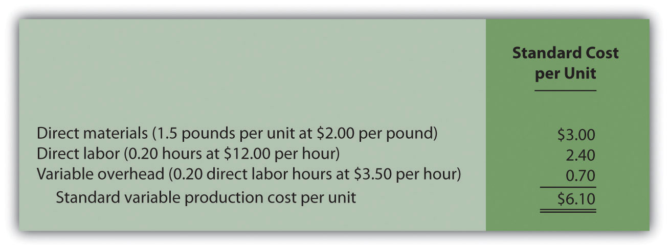

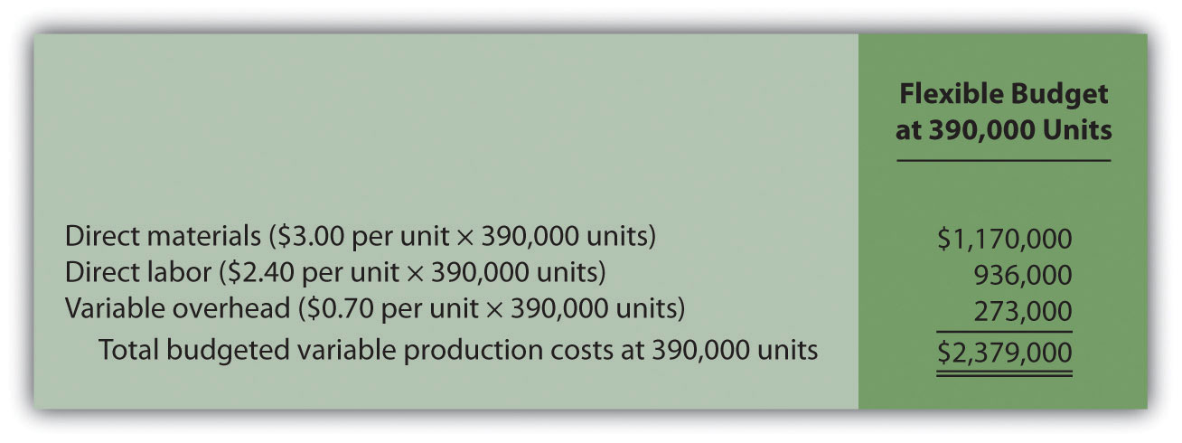

10.3 Direct Materials Variance Analysis

LEARNING OBJECTIVE
- Calculate and analyze direct materials variances.

Question: In the dialogue at the beginning of the chapter, the president of Jerry’s Ice Cream was concerned about significant cost overruns for direct materials. We cannot simply explain these costs by saying that “we paid too much for materials” or “too many materials were used in production.” Variances must be calculated to identify the exact cause of the cost overrun. What variances are used to analyze the difference between actual direct material costs and standard direct material costs?

Answer: The difference between actual costs and standard (or budgeted) costs is typically explained by two separate variances: the materials price variance and materials quantity variance. The materials price variance is the difference between actual costs for materials purchased and budgeted costs based on the standards. The materials quantity variance is the difference between the actual quantity of materials used in production and budgeted materials that should have been used in production based on the standards.

To this point, we have provided the data for Jerry’s Ice Cream necessary to calculate standard costs. However, you must also have the actual materials cost and materials quantity data to calculate the variances described previously. The actual data for the year are as follows:
Sales volume | 210,000 units
Direct materials purchased | 440,000 pounds
Cost of direct materials purchased | $1.20 per pound
Direct materials used in production | 399,000 pounds

Recall from that the direct materials standard price for Jerry’s is $1 per pound, and the standard quantity of direct materials is 2 pounds per unit.shows how to calculate the materials price and quantity variances given the actual results and standards information. Review this figure carefully before moving on to the next section where these calculations are explained in detail.

Figure 10.4 Direct Materials Variance Analysis for Jerry’s Ice Cream
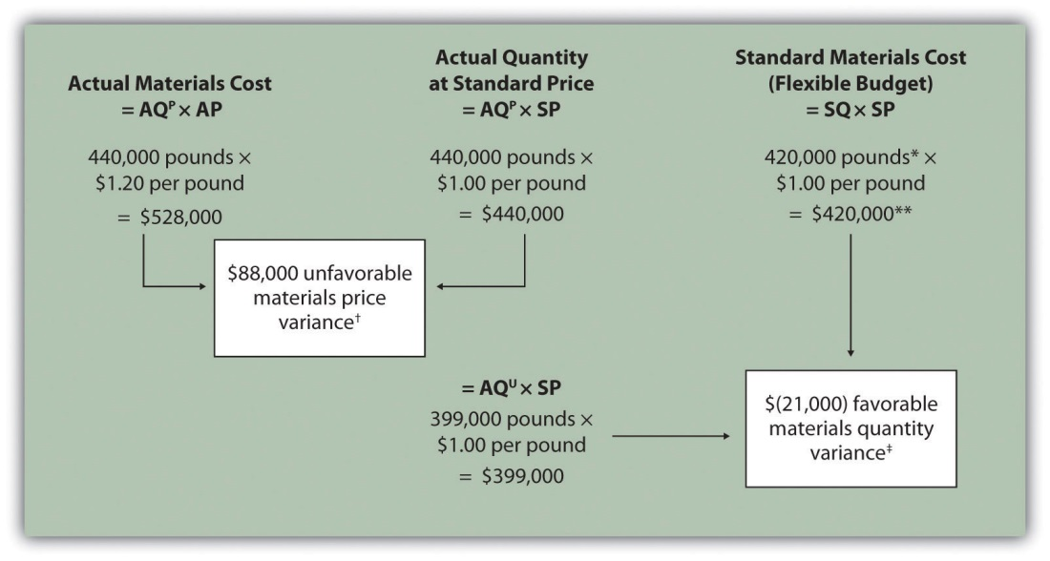

Note: AQP = Actual quantity of materials purchased. AP = Actual price of materials. AQU = Actual quantity of materials used in production. SP = Standard price of materials. SQ = Standard quantity of materials for actual level of activity.

*Standard quantity of 420,000 pounds = Standard of 2 pounds per unit × 210,000 actual units produced and sold.

**$420,000 standard direct materials cost matches the flexible budget presented in .

† $88,000 unfavorable materials price variance = $528,000 – $440,000. Variance is unfavorable because the actual price of $1.20 is higher than the expected (budgeted) price of $1.

‡ $(21,000) favorable materials quantity variance = $399,000 – $420,000. Variance is favorable because the actual quantity of materials used in production of 399,000 pounds is lower than the expected (budgeted) quantity of 420,000 pounds.

Direct Materials Price Variance Calculation

Question: The materials price variance answers the question, did we spend more or less on direct materials than expected? If the variance is unfavorable, we spent more than expected. If the variance is favorable, we spent less than expected. How is the materials price variance calculated?

Answer: As shown in , the materials price variance is the difference between the actual quantity of materials purchased at the actual price and the actual quantity of materials purchased at the standard price:

Key Equation
Materials price variance = (AQ^{P} × AP) – (AQ^{P} × SP)

Materials price variance=(AQP×AP)−(AQP×SP)=(440,000×$1.20)−(440,000×$1.00)=$88,000 unfavorable

Alternative Calculation. Since we are holding the actual quantityconstant and evaluating the difference between actual price and standard price, the materials price variance calculation can be simplified as follows:

Key Equation
Materials price variance = (AP – SP) × AQ^{P}

Materials price variance=(AP−SP)×AQP=($1.20−$1.00)×440,000=$88,000 unfavorable

Note that both approaches—the direct materials price variance calculation and the alternative calculation—yield the same result.

When labeling the variances calculated in this chapter, notice that all positive variances are unfavorable and all negative variances are favorable (i.e., unfavorable cost variances increase expected costs and favorable cost variances decrease expected costs). As you calculate variances, you should think through the variance to confirm whether it is favorable or unfavorable. For example, the materials price variance calculation presented previously shows the actual price paid for materials was $1.20 per pound and the standard price was $1. Clearly, this is unfavorable because the actual price was higher than the expected (budgeted) price.

Direct Materials Quantity Variance Calculation

Question: The materials quantity variance answers the question, did we use more or fewer direct materials in production than expected? If the variance is unfavorable, we used more than expected. If the variance is favorable, we used fewer than expected. How is the materials quantity variance calculated?

Answer: As shown in , the materials quantity variance is the difference between the actual quantity of materials used in production at the standard price and the standard quantity of materials allowed at the standard price:

Key Equation
Materials quantity variance = (AQ^{U} × SP) – (SQ × SP)

Materials quantity variance=(AQU×SP)−(SQ×SP)=(399,000×$1.00)−(420,000×$1.00)=($21,000) favorable

The standard quantity of 420,000 pounds is the quantity of materials allowed given actual production. For Jerry’s Ice Cream, the standard quantity of materials per unit of production is 2 pounds per unit. Thus the standard quantity (SQ) of 420,000 pounds is 2 pounds per unit × 210,000 units produced and sold.

Alternative Calculation. Since we are holding the standard price constant and evaluating the difference between actual quantity used and standard quantity, the materials quantity variance calculation can be simplified as follows:

Key Equation
Materials quantity variance = (AQ^{U} – SQ) × SP

Materials quantity variance=(AQU−SQ)×SP=(399,000−420,000)×$1.00=($21,000) favorable

Note that both approaches—the direct materials quantity variance calculation and the alternative calculation—yield the same result.

The materials quantity variance calculation presented previously shows the actual quantity used in production of 399,000 pounds is lower than the expected (budgeted) quantity of 420,000 pounds. Clearly, this is favorablebecause the actual quantity used was lower than the expected (budgeted) quantity.

Possible Causes of Direct Materials Variances

Question: The managerial accountant at Jerry’s Ice Cream will likely investigate the cause of the unfavorable materials price variance of $88,000. This will lead to discussions with the purchasing department. What might have caused the $88,000 unfavorable materials price variance?

Answer: The left panel of contains some possible explanations for this variance.

Figure 10.5 Possible Causes of Direct Materials Variances for Jerry’s Ice Cream
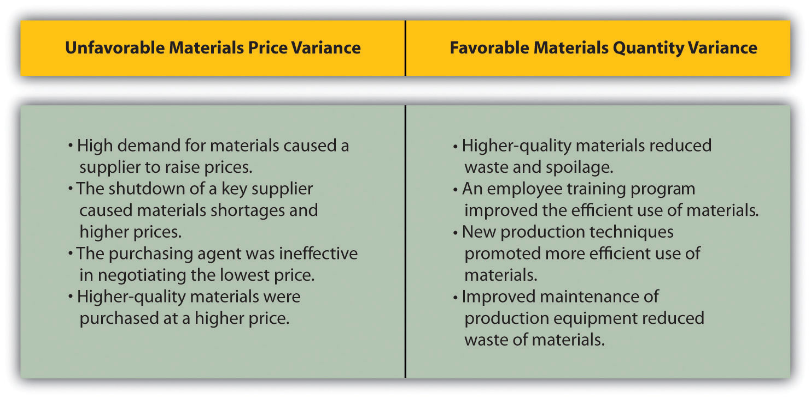

Whatever the cause of this unfavorable variance, Jerry’s Ice Cream will likely take action to improve the cost problem identified in the materials price variance analysis. This is why we use the term control phase of budgeting to describe variance analysis. Through variance analysis, companies are able to identify problem areas (material costs for Jerry’s) and consider alternatives to controlling costs in the future.

Question: Jerry’s Ice Cream might also choose to investigate the $21,000 favorable materials quantity variance. Although this could be viewed as good news for the company, management may want to know why this favorable variance occurred. What might have caused the $21,000 favorable materials quantity variance?

Answer: The right panel of contains some possible explanations for this variance.

Notice how the cause of one variance might influence another variance. For example, the unfavorable price variance at Jerry’s Ice Cream might have been a result of purchasing high-quality materials, which in turn led to less waste in production and a favorable quantity variance. This also might have a positive impact on direct labor, as less time will be spent dealing with materials waste.

Illustrates just how important it is to track direct materials variances accurately.

Business in Action 10.2
The Effect of Rising Materials Costs on Auto Suppliers
In the first six months of 2004, steel prices increased 76 percent, from $350 a ton to $617 a ton. For auto suppliers that use hundreds of tons of steel each year, this had the unexpected effect of increasing expenses and reducing profits. For example, a major producer of automotive wheels had to reduce its annual earnings forecast by $10,000,000 to $15,000,000 as a result of the increase in steel prices.
Most auto part suppliers operate with very small margins. GR Spring and Stamping, Inc., a supplier of stampings to automotive companies, was generating pretax profit margins of about 3 percent prior to the increase in steel prices. Profit margins have been cut in half since steel prices began rising.
These thin margins are the reason auto suppliers examine direct materials variances so carefully. Any unexpected increase in steel prices will likely cause significant unfavorable materials price variances, which will lead to lower profits. Auto part suppliers that rely on steel will continue to scrutinize materials price variances and materials quantity variances to control costs, particularly in a period of rising steel prices.
Source: Brett Clanton, “Steel Costs Slam Auto Suppliers,” The Detroit News, June 29, 2004, http://www.detnews.com.

Clarification of Favorable Versus Unfavorable

Question: Why are variances labeled favorable or unfavorable?

Answer: The terms favorable and unfavorable relate to the impact the variance has on budgeted operating profit. A favorable variance has a positive impact on operating profit. An unfavorable variance has a negative impact on operating profit. Companies using a standard cost system ultimately credit favorable variances and debit unfavorable variances to income statement accounts. The appendix to this chapter describes this process in further detail.

KEY TAKEAWAY
- Standard costs are used to establish the flexible budget for direct materials. The flexible budget is compared to actual costs, and the difference is shown in the form of two variances. The materials price variance focuses on the price paid for materials, and it is defined as the difference between the actual quantity of materials purchased at the actual price and the actual quantity of materials purchased at the standard price. The materials quantity variance focuses on the quantity of materials used in production. It is defined as the difference between the actual quantity of materials used in production and budgeted materials that should have been used in production based on the standards.

REVIEW PROBLEM 10.3
Carol’s Cookies expected to use 1.5 pounds of direct materials to produce 1 unit (batch) of product at a cost of $2 per pound. Actual results are in for last year, which indicates 390,000 batches of cookies were sold. The company purchased 640,000 pounds of materials at $1.80 per pound and used 624,000 pounds in production.
- Calculate the materials price and quantity variances using the format shown in .
- Use the alternative approach to calculating the materials price and quantity variances, and compare the result to the result in part 1. (Hint: the variances should match.)
- Suggest several possible reasons for the materials price and quantity variances.
Solution to Review Problem 10.3
- As shown in the following, the materials price variance is $(128,000) favorable, and the materials quantity variance is $78,000 unfavorable.
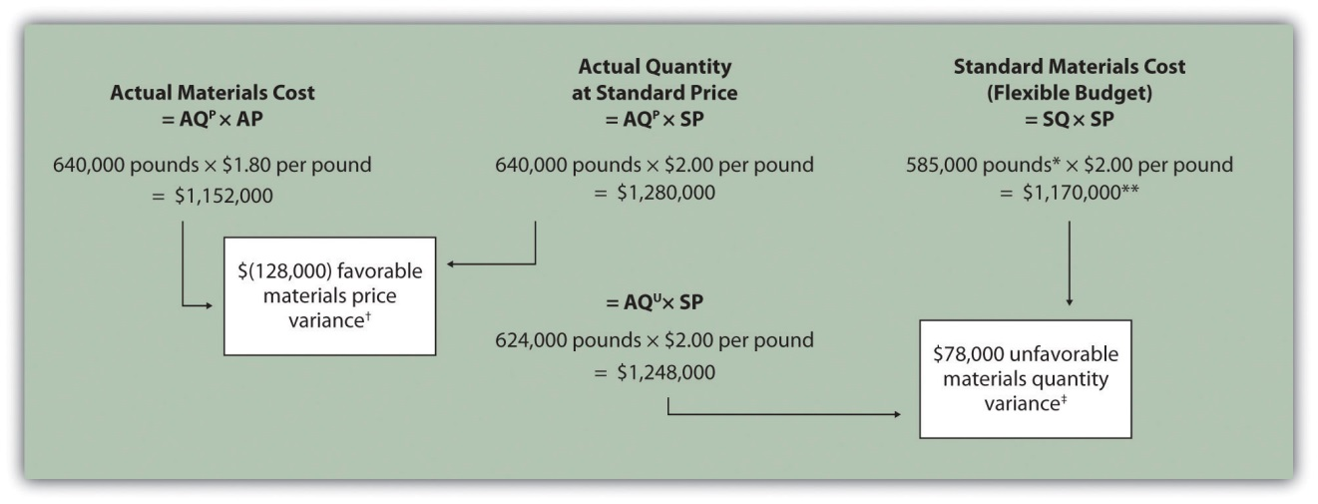

Note: AQ^{P} = Actual quantity of materials purchased. AP = Actual price of materials. AQ^{U} = Actual quantity of materials used in production. SP = Standard price of materials. SQ = Standard quantity of materials for actual level of activity.
*Standard quantity of 585,000 pounds = Standard of 1.5 pounds per unit × 390,000 actual units produced and sold.
**$1,170,000 standard direct materials cost matches the flexible budget presented in , part 2.
† $(128,000) favorable materials price variance = $1,152,000 – $1,280,000. Variance is favorable because the actual price of $1.80 is lower than the expected (budgeted) price of $2
‡ $78,000 unfavorable materials quantity variance = $1,248,000 – $1,170,000. Variance is unfavorable because the actual quantity of materials used in production of 624,000 pounds is higher than the expected (budgeted) quantity of 585,000 pounds.
- Alternative direct materials variance calculations:
Materials price variance=(AP−SP)×AQP=($1.80−$2.00)×640,000=($128,000) favorable (same as part 1)
Materials quantity variance=(AQU− SQ)×SP=(624,000− 585,000)×$2.00=$78,000 unfavorable (same as part 1)
- Possible causes of favorable materials price variance are
  - The supplier had excess materials on hand and lowered prices to sell off inventory;
  - New suppliers entered the market, which resulted in an excess supply of materials and lower prices;
  - Carol’s Cookies’ purchasing agent is a strong negotiator and was able to negotiate lower prices than anticipated;
  - Lower-quality materials were purchased at a lower price.
Possible causes of unfavorable materials quantity variance are
1. Lower-quality materials resulted in more waste and spoilage;
2. New, inexperienced employees were hired, resulting in more waste;
3. Old equipment breaking down caused an increased amount of waste.

10.4 Direct Labor Variance Analysis

LEARNING OBJECTIVE
- Calculate and analyze direct labor variances.

Question: In addition to investigating the causes of cost overruns for direct materials, the president of Jerry’s Ice Cream wants to know why there were cost overruns for direct labor. What variances are used to analyze these types of direct labor cost overruns?

Answer: Similar to direct materials variances, direct labor variance analysis involves two separate variances: the labor rate variance and labor efficiency variance. The labor rate variance is the difference between actual costs for direct labor and budgeted costs based on the standards. Thelabor efficiency variance is the difference between the actual number of direct labor hours worked and budgeted direct labor hours that should have been worked based on the standards.

At Jerry’s Ice Cream, the actual data for the year are as follows:
Sales volume | 210,000 units
Direct labor hours worked | 18,900 hours
Cost of direct labor | $15 per hour

Recall from that the standard rate for Jerry’s is $13 per direct labor hour and the standard direct labor hours is 0.10 per unit. shows how to calculate the labor rate and efficiency variances given the actual results and standards information. Review this figure carefully before moving on to the next section where these calculations are explained in detail.

Figure 10.6 Direct Labor Variance Analysis for Jerry’s Ice Cream
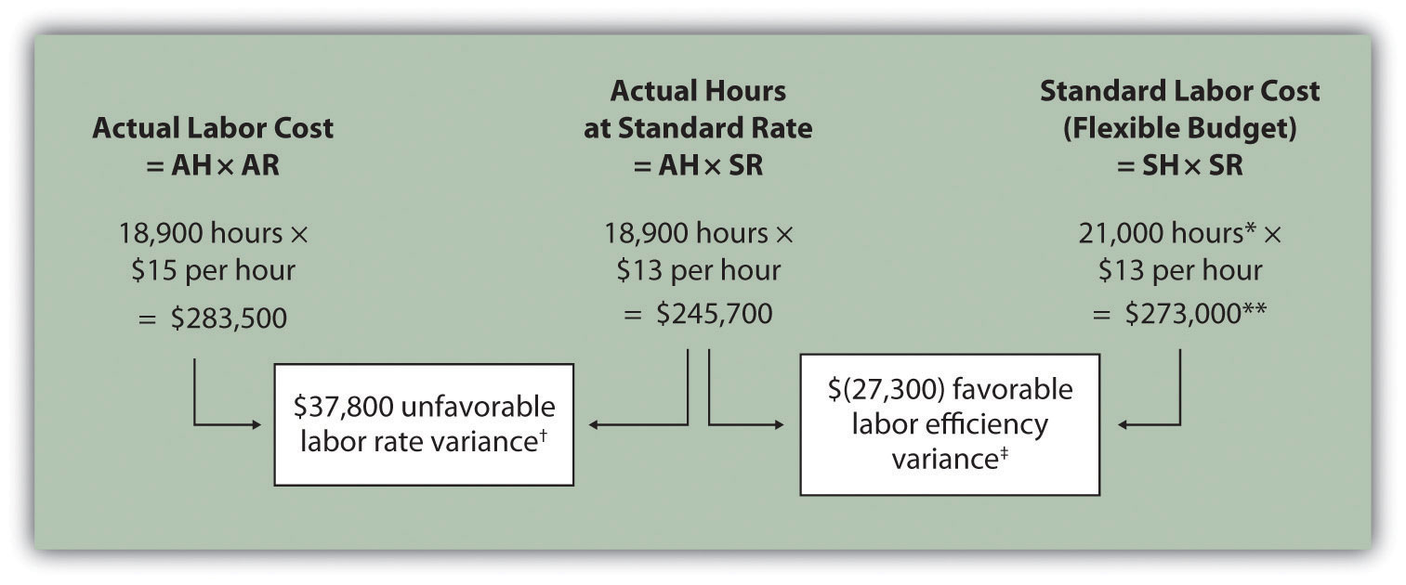

Note: AH = Actual hours of direct labor. AR = Actual rate incurred for direct labor. SR = Standard rate for direct labor. SH = Standard hours of direct labor for actual level of activity.

*Standard hours of 21,000 = Standard of 0.10 hours per unit × 210,000 actual units produced and sold.

**$273,000 standard direct labor cost matches the flexible budget presented in .

† $37,800 unfavorable labor rate variance = $283,500 – $245,700. Variance is unfavorable because the actual rate of $15 is higher than the expected (budgeted) rate of $13.

‡ $(27,300) favorable labor efficiency variance = $245,700 – $273,000. Variance is favorable because the actual hours of 18,900 are lower than the expected (budgeted) hours of 21,000.

Direct Labor Rate Variance Calculation

Question: The direct labor rate variance answers the question, did we spend more or less on direct labor than expected? If the variance is unfavorable, we spent more than expected. If the variance is favorable, we spent less than expected. How is the labor rate variance calculated?

Answer: As shown in , the labor rate variance is the difference between the actual hours worked at the actual rate and the actual hours worked at the standard rate:

Key Equation
Labor rate variance = (AH × AR) − (AH × SR)

Labor rate variance=(AH×AR)−(AH×SR)=(18,900×$15)−(18,900×$13)= $37,800 unfavorable

Alternative Calculation. Because we are holding the actual hoursconstant and evaluating the difference between actual rate and standard rate, the labor rate variance calculation can be simplified as follows:

Key Equation
Labor rate variance = (AR − SR) × AH
Labor rate variance=(AR−SR)×AH=($15−$13)×18,900= $37,800 unfavorable

Note that both approaches—direct labor rate variance calculation and the alternative calculation—yield the same result.

As with direct materials variances, all positive variances are unfavorable, and all negative variances are favorable. The labor rate variance calculation presented previously shows the actual rate paid for labor was $15 per hour and the standard rate was $13. This results in an unfavorablevariance since the actual rate was higher than the expected (budgeted) rate.

Direct Labor Efficiency Variance Calculation

Question: The direct labor efficiency variance answers the question, did we use more or less direct labor hours in production than expected? If the variance is unfavorable, we used more than expected. If the variance is favorable, we used less than expected. How is the labor efficiency variance calculated?

Answer: As shown in , the labor efficiency variance is the difference between the actual hours worked at the standard rate and the standard hours at the standard rate:

Key Equation
Labor efficiency variance = (AH × SR) − (SH × SR)
Labor efficiency variance=(AH×SR)−(SH×SR)=(18,900×$13)−(21,000×$13)=($27,300) favorable

The 21,000 standard hours are the hours allowed given actual production. For Jerry’s Ice Cream, the standard allows for 0.10 labor hours per unit of production. Thus the 21,000 standard hours (SH) is 0.10 hours per unit × 210,000 units produced.

Alternative Calculation. Because we are holding the standard rateconstant and evaluating the difference between actual hours worked and standard hours, the labor efficiency variance calculation can be simplified as follows:

Key Equation
Labor efficiency variance = (AH − SH) × SR
Labor efficiency variance=(AH−SH)× SR=(18,900−21,000)×$13=($27,300) favorable

Note that both approaches—the direct labor efficiency variance calculation and the alternative calculation—yield the same result.

The labor efficiency variance calculation presented previously shows that 18,900 in actual hours worked is lower than the 21,000 budgeted hours. Clearly, this is favorable since the actual hours worked was lower than the expected (budgeted) hours.

Possible Causes of Direct Labor Variances

Question: The managerial accountant at Jerry’s Ice Cream is interested in finding the cause of the unfavorable labor rate variance of $37,800. Jerry’s Ice Cream might also choose to investigate the $27,300 favorable labor efficiencyvariance. Although this could be viewed as good news for the company, management may want to know why this favorable variance occurred. What might have caused the $37,800 unfavorable labor rate variance and $27,300 favorable labor efficiency variance?

Answer: contains some possible explanations for the labor rate variance (left panel) and labor efficiency variance (right panel).

Figure 10.7 Possible Causes of Direct Labor Variances for Jerry’s Ice Cream
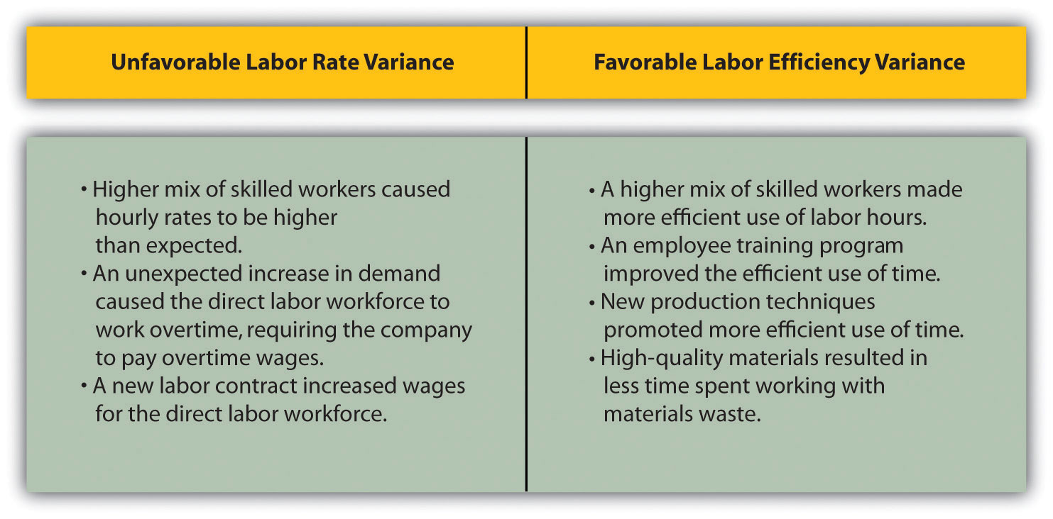

As mentioned earlier, the cause of one variance might influence another variance. For example, many of the explanations shown in might also apply to the favorable materials quantity variance.

We have demonstrated how important it is for managers to be aware not only of the cost of labor, but also of the differences between budgeted labor costs and actual labor costs. This awareness helps managers make decisions that protect the financial health of their companies.

Business in Action 10.3
Labor Costs in the Airline Industry
United Airlines asked a bankruptcy court to allow a one-time 4 percent pay cut for pilots, flight attendants, mechanics, flight controllers, and ticket agents. The pay cut was proposed to last as long as the company remained in bankruptcy and was expected to provide savings of approximately $620,000,000. How would this unforeseen pay cut affect United’s direct labor rate variance? The direct labor rate variance would likely be favorable, perhaps totaling close to $620,000,000, depending on how much of these savings management anticipated when the budget was first established.
After filing for Chapter 11 bankruptcy in December 2002, United cut close to $5,000,000,000 in annual expenditures. As a result of these cost cuts, United was able to emerge from bankruptcy in 2006.
Source: Associated Press, “United May Seek End to Union Contracts,”USA Today, November 25, 2004.

Follow-Up Meeting at Jerry’s Ice Cream

Jerry (president and owner), Tom (sales manager), Lynn (production manager), and Michelle (treasurer and controller) were at the meeting described at the opening of this chapter. Michelle was asked to find out why direct labor and direct materials costs were higher than budgeted, even after factoring in the 5 percent increase in sales over the initial budget. Lynn was surprised to learn that direct labor and direct materials costs were so high, particularly since actual materials used and actual direct labor hours worked were below budget.

The group met again a week later to discuss the issue.
Jerry: | Michelle, what do you have for us?
Michelle: | My staff has been working hard to identify why direct materials and direct labor costs were higher than expected. First, I would like to confirm that these costs were indeed higher than anticipated.
Lynn: | I still don’t see how this can be. My production crew was as efficient with their time and materials as they’ve ever been.
Michelle: | You’re right, Lynn. Our variance analysis shows a favorable direct materials quantity variance, which relates directly to the amount of materials used, and a favorable direct labor efficiency variance, which relates directly to the efficiency of our production workers. Both variances are good news.
Jerry: | Then why are our direct labor and direct materials costs so high?
Michelle: | The answer relates directly to the price we paid for materials, and the hourly rates we paid for labor. Both were higher than expected. We expected to pay $1 per pound for direct materials, but actually paid $1.20 per pound. In addition, we expected to pay $13 an hour for direct labor when in fact we actually paid $15 an hour. This means we paid 20 percent more than expected for direct materials, which is $0.20 divided by $1, and 15 percent more than expected for direct labor, which is $2 divided by $13.
Lynn: | I do recall Tony over in purchasing telling me he obtained some premium materials for our ice cream, and I know we hired some relatively experienced workers who were paid a bit more than the normal starting rate.
Tom: | This might explain why our customers were thrilled about our product. The materials were high quality and the production workers really knew their stuff!
Jerry: | While I like the end result of a higher-quality product and increased sales, we must do a better job of controlling costs. Perhaps Tony can negotiate a better price for materials. I don’t mind paying our employees a higher wage based on their experience, but let’s make sure we get some efficiency savings in the process to help offset the higher wages. Michelle, can we continue to monitor material and labor costs?
Michelle: | Yes. I’ll have my staff analyze material and labor variances monthly, and I’ll have a report ready at the end of each month for you and Lynn.
Jerry: | Excellent! Lynn, let our production crew know they are doing a fine job, and continue to encourage them to find ways to improve the efficiency of production. I’ll talk with Tony about the possibility of getting a better deal on materials.

As stated earlier, variance analysis is the control phase of budgeting. Using variance analysis for direct materials and direct labor, Jerry’s Ice Cream was able to identify strong points in its operations (quantity of materials used and efficiency of direct labor workforce), and perhaps more important, Jerry’s was able to identify problem areas (price paid for materials and wages paid to employees). This information gives the management a way to monitor and control production costs. Next, we calculate and analyze variable manufacturing overhead cost variances.

KEY TAKEAWAY
- Standard costs are used to establish the flexible budget for direct labor. The flexible budget is compared to actual costs, and the difference is shown in the form of two variances. The labor rate variance focuses on the wages paid for labor and is defined as the difference between actual costs for direct labor and budgeted costs based on the standards. The labor efficiency variance focuses on the quantity of labor hours used in production. It is defined as the difference between the actual number of direct labor hours worked and budgeted direct labor hours that should have been worked based on the standards.

REVIEW PROBLEM 10.4
Carol’s Cookies expected to use 0.20 direct labor hours to produce 1 unit (batch) of product at a cost of $12 per hour. Actual results are in for last year, which indicates 390,000 batches of cookies were sold. The company’s direct labor workforce worked 97,500 hours at $11 per hour.
- Calculate the labor rate and efficiency variances using the format shown in .
- Use the alternative approach to calculating the labor rate and efficiency variances, and compare the result to the result in part 1. (Hint: the variances should match.)
- Suggest several possible reasons for the labor rate and efficiency variances.
Solution to Review Problem 10.4
- As shown in the following, the labor rate variance is $(97,500) favorable, and the labor efficiency variance is $234,000 unfavorable.
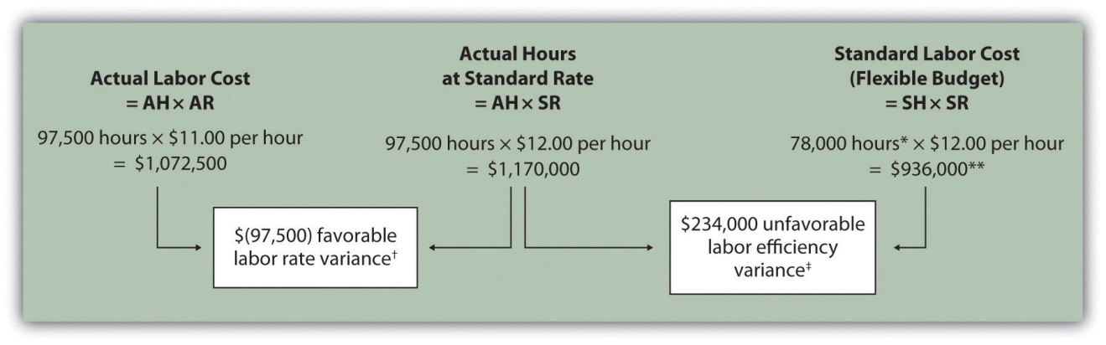
Note: AH = Actual hours of direct labor. AR = Actual rate incurred for direct labor. SR = Standard rate for direct labor. SH = Standard hours of direct labor for actual level of activity.
*Standard hours of 78,000 = Standard of 0.20 hours per unit × 390,000 actual units produced and sold.
**$936,000 standard direct labor cost matches the flexible budget presented in , part 2.
† $(97,500) favorable labor rate variance = $1,072,500 – $1,170,000. Variance is favorable because the actual rate of $11 is lower than the expected (budgeted) rate of $12.
‡ $234,000 unfavorable labor efficiency variance = $1,170,000 – $936,000. Variance is unfavorable because the actual hours of 97,500 are higher than the expected (budgeted) hours of 78,000.
- The following are alternative direct labor variance calculations:
Labor rate variance=(AR−SR)×AH=($11−$12)×97,500=($97,500) favorable (same as part 1)
Labor efficiency variance=(AH−SH)×SR=(97,500−78,000)×$12=$234,000 unfavorable (same as part 1)
- Possible causes of favorable labor rate variance are
  - A higher mix of newly hired and unskilled workers caused hourly rates to be lower than anticipated;
  - Product demand was lower than expected, thereby reducing the amount of overtime initially anticipated;
  - A new labor contract was negotiated at lower pay rates than anticipated.
Possible causes of unfavorable labor efficiency variance are
1. A higher mix of unskilled workers than anticipated caused inefficiencies;
2. Cutbacks in training reduced the expected efficiency of direct labor workers;
3. Old equipment breaking down caused workers to waste time waiting for repairs.

10.5 Variable Manufacturing Overhead Variance Analysis

LEARNING OBJECTIVE
- Calculate and analyze variable manufacturing overhead variances.

Question: Similar to direct materials and direct labor variances, variable manufacturing overhead variance analysis involves two separate variances.What are the two variances used to analyze the difference between actual variable overhead costs and standard variable overhead costs?

Answer: The two variances used to analyze this difference are the spending variance and efficiency variance. Thevariable overhead spending variance is the difference between actual costs for variable overhead and budgeted costs based on the standards. For a company that allocates variable manufacturing overhead to products based on direct labor hours, the variable overhead efficiency variance is the difference between the number of direct labor hours actually worked and what should have been worked based on the standards.

At Jerry’s Ice Cream, the actual data for the year are as follows:
Sales volume | 210,000 units
Direct labor hours worked | 18,900 hours
Total cost of variable overhead | $100,000

Recall from that the variable overhead standard rate for Jerry’s is $5 per direct labor hour and the standard direct labor hours is 0.10 per unit. shows how to calculate the variable overhead spending and efficiency variances given the actual results and standards information. Review this figure carefully before moving on to the next section where these calculations are explained in detail.

Figure 10.8 Variable Manufacturing Overhead Variance Analysis for Jerry’s Ice Cream
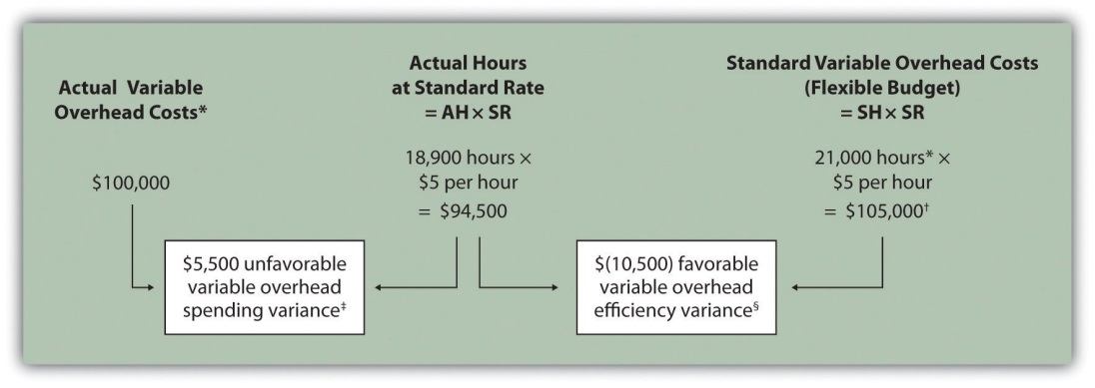

Note: AH = Actual hours of direct labor. (This measure will depend on the allocation base that the company uses. Jerry’s uses direct labor hours to allocate variable manufacturing overhead, so AH refers to actual direct labor hours.) SR = Standard variable manufacturing overhead rate per direct labor hour. SH = Standard hours of direct labor for actual level of activity.

*Since variable overhead is not purchased per direct labor hour, the actual rate (AR) is not used in this calculation. Simply use the total cost of variable manufacturing overhead instead.

**Standard hours of 21,000 = Standard of 0.10 hours per unit × 210,000 actual units produced and sold.

† $105,000 standard variable overhead costs matches the flexible budget presented in .

‡ $5,500 unfavorable variable overhead spending variance = $100,000 – $94,500. Variance is unfavorable because the actual variable overhead costs are higher than the expected costs given actual hours of 18,900.

§ $(10,500) favorable variable overhead efficiency variance = $94,500 – $105,000. Variance is favorable because the actual hours of 18,900 are lower than the expected (budgeted) hours of 21,000.

Variable Overhead Spending Variance Calculation

Question: How is the variable overhead spending variance calculated?

Answer: As shown in , the variable overhead spending variance is the difference between what is actually paid for variable overhead and what should have been paid according to the standards:

Key Equation
Variable overhead spending variance = Actual costs − (AH × SR)
Variable overhead spending variance=Actual costs−(AH×SR)=$100,000−(18,900×$5)= $5,500 unfavorable

As with direct materials and direct labor variances, all positive variances are unfavorable, and all negative variances are favorable. Note that there is no alternative calculation for the variable overhead spending variance because variable overhead costs are not purchased per direct labor hour. Thus actual rate (AR) is not used for this variance.

This variance is unfavorable for Jerry’s Ice Cream because actual costs of $100,000 are higher than expected costs of $94,500.

Variable Overhead Efficiency Variance Calculation

Question: How is the variable overhead efficiency variance calculated?

Answer: As shown in , the variable overhead efficiency variance is the difference between the actual hours worked at the standard rate and the standard hours at the standard rate:

Key Equation
Variable overhead efficiency variance = (AH × SR) − (SH × SR)
Variable overhead efficiency variance=(AH×SR)−(SH×SR)=(18,900×$5)−(21,000×$5)=($10,500) favorable

The 21,000 standard hours are the hours allowed given actual production (= 0.10 standard hours allowed per unit × 210,000 units produced). Since actual direct labor hours worked total 18,900, the variable manufacturing overhead costs should be lower than initially anticipated at 21,000 standard hours. (This assumes variable overhead costs are truly driven by direct labor hours!) This results in a favorable variable overhead efficiency variance.

Alternative Calculation. Since we are holding the standard rate constant and evaluating the difference between actual hours worked and standard hours, the variable overhead efficiency variance calculation can be simplified as follows:

Key Equation
Variable overhead efficiency variance = (AH − SH) × SR

Variable overhead efficiency variance=(AH−SH)×SR=(18,900−21,000)×$5=($10,500) favorable

Note that both approaches—the variable overhead efficiency variance calculation and the alternative calculation—yield the same result.

The variable overhead efficiency variance calculation presented previously shows that 18,900 in actual hours worked is lower than the 21,000 budgeted hours. Again, this variance is favorable because working fewer hours than expected should result in lower variable manufacturing overhead costs.

Possible Causes of Variable Manufacturing Overhead Variances

Question: The managerial accountant at Jerry’s Ice Cream is interested in finding the cause of the unfavorable variable overhead spending variance of $5,500. The spending variance can result from variances in the cost of variable overhead items and the usage of these items. What might have caused the $5,500 unfavorable variable overhead spending variance?

Answer: The left panel of contains some possible explanations for Jerry’s unfavorable overhead spending variance.

Figure 10.9 Possible Causes of Variable Manufacturing Overhead Variances for Jerry’s Ice Cream
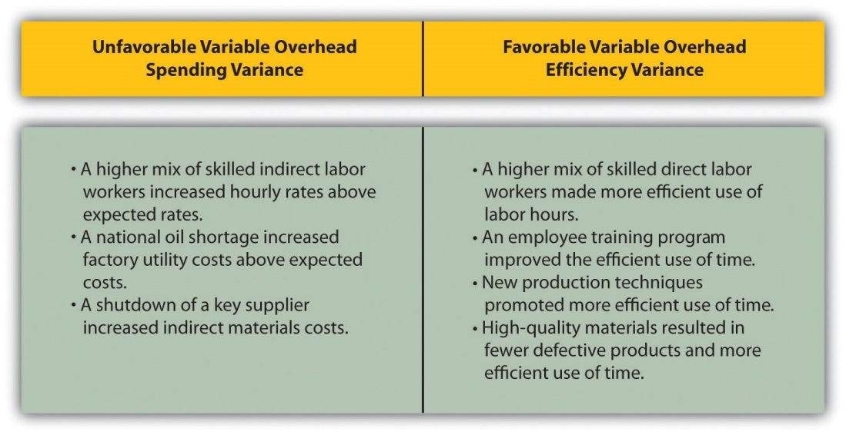

Question: Jerry’s Ice Cream might also choose to investigate the $10,500 favorable variable overhead efficiency variance. What might have caused the $10,500 favorable variable overhead efficiency variance?

Answer: The focus here is on the activity base used to allocate overhead. Since Jerry’s uses direct labor hours as the activity base, the possible explanations for this variance are linked to efficiencies or inefficiencies in the use of direct labor. The right panel of contains some possible explanations for this variance.

Again, this analysis is appropriate assuming direct labor hours truly drives the use of variable overhead activities. That is, we assume that an increase in direct labor hours will increase variable overhead costs and that a decrease in direct labor hours will decrease variable overhead costs.

Business in Action 10.4
Hiding Fraud in Overhead Accounts
The controller of a small, closely held manufacturing company embezzled close to $1,000,000 over a 3-year period. With annual revenues of $30,000,000 and less than 100 employees, the company certainly felt the impact of losing $1,000,000.
The forensic accountant who investigated the fraud identified several suspicious transactions, all of which were charged to the manufacturing overhead account. To prevent this type of fraud in the future, the forensic accountant recommended that “significant manufacturing overhead variances be analyzed both within and across time periods to identify anomalies.” Apparently, the company was not closely monitoring manufacturing overhead variances when the fraud occurred.
Source: John B. MacArthur, Bobby E. Waldrup, and Gary R. Fane, “Caution: Fraud Overhead,” Strategic Finance, October 2004, 28–32.

KEY TAKEAWAY
- Standard costs are used to establish the flexible budget for variable manufacturing overhead. The flexible budget is compared to actual costs, and the difference is shown in the form of two variances. Thevariable overhead spending variance represents the difference between actual costs for variable overhead and budgeted costs based on the standards. The variable overhead efficiency variance is the difference between the actual activity level in the allocation base (often direct labor hours or machine hours) and the budgeted activity level in the allocation base according to the standards.

REVIEW PROBLEM 10.5
Carol’s Cookies expected to use 0.20 direct labor hours to produce 1 unit (batch) of product, and the variable overhead rate is $3.50 per hour. Actual results are in for last year, which indicates 390,000 batches of cookies were produced and sold. The company’s direct labor workforce worked 97,500 hours, and variable overhead costs totaled $360,000.
- Calculate the variable overhead spending and efficiency variances using the format shown in .
- Suggest several possible reasons for the variable overhead spending and efficiency variances.
Solution to Review Problem 10.5
- As shown in the following, the variable overhead spending variance is $18,750 unfavorable, and the variable overhead efficiency variance is $68,250 unfavorable.
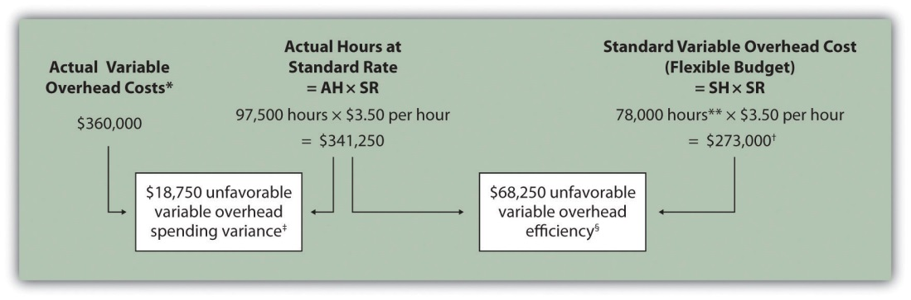
AH = Actual hours of direct labor. SR = Standard variable manufacturing overhead rate per direct labor hour. SH = Standard hours of direct labor for actual level of activity.
*Since variable overhead is not purchased per direct labor hour, the actual rate (AR) is not used in this calculation. Simply use the total cost of variable manufacturing overhead instead.
**Standard hours of 78,000 = Standard of 0.20 hours per unit × 390,000 actual units produced and sold.
† $273,000 standard variable overhead costs match the flexible budget presented in , part 2.
‡ $18,750 unfavorable variable overhead spending variance = $360,000 – $341,250. Variance is unfavorable because the actual variable overhead costs are higher than the expected costs given actual hours of 97,500.
§ $68,250 unfavorable variable overhead efficiency variance = $341,250 – $273,000. Variance is unfavorable because the actual hours of 97,500 are higher than the expected (budgeted) hours of 78,000.
- Possible causes of unfavorable variable overhead spending variance are
  - A higher mix of skilled indirect labor workers caused hourly rates to be higher than anticipated;
  - Utility costs to run the machines were higher than anticipated due to a nationwide increase in energy costs;
  - A shortage in available indirect materials caused costs to increase unexpectedly.
Possible causes of unfavorable variable overhead efficiency variance are
1. A higher mix of unskilled workers than anticipated caused inefficiencies;
2. Cutbacks in training reduced the expected efficiency of direct labor workers;
3. Old equipment breaking down caused workers to waste time waiting for repairs.

10.6 Determining Which Cost Variances to Investigate

LEARNING OBJECTIVE
- Determine which variances to investigate.

Question: Companies rarely investigate all variances because there is a cost associated with identifying the causes of variances. This cost involves employees who spend time talking with personnel from areas including purchasing and production to determine why variances occurred and how to control costs in the future. What can managers do to reduce the cost of investigating variances?

Answer: Managers typically establish criteria to determine which variances to focus on rather than simply investigating all variances. This is calledmanagement by exception. Management by exception describes managers who focus solely on variances that are significant.

Question: summarizes the cost variances calculated for Jerry’s Ice Cream. If you were in charge of investigating variances at Jerry’s Ice Cream, how would you determine which variances to focus on and which to ignore?

Figure 10.10 Summary of Cost Variances at Jerry’s Ice Cream
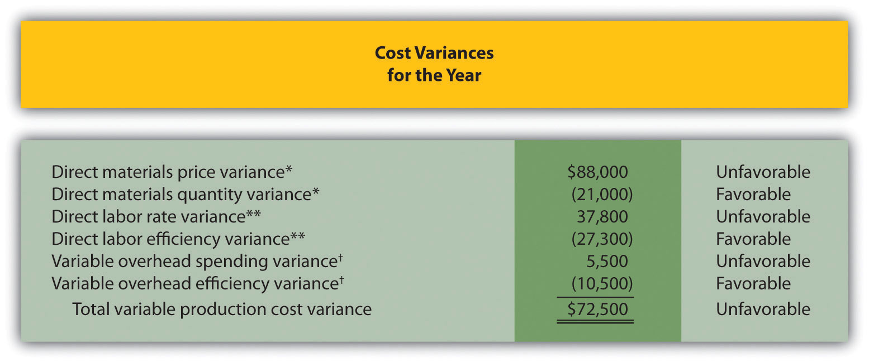

*From .

**From .

† From .

Answer: Some managers might review all unfavorable variances. However, the variable overhead spending variance of $5,500 is not very significant relative to the other variances and may not be worth investigating. Also, by focusing solely on unfavorable variances, managers might overlook problems that may result from favorable variances.

Another approach might be to investigate all favorable and unfavorable variances above a certain minimum level, calculated as a percent of the flexible budget amount. For example, management could establish a policy to investigate all variances at or above 10 percent of the flexible budget amount for each cost. At Jerry’s Ice Cream, this would mean investigating all variances at or above $42,000 for direct materials (= 10 percent × $420,000), $27,300 for direct labor (= 10 percent × $273,000), and $10,500 for variable overhead (= 10 percent × $105,000). Based on this policy, the following variances would be investigated:
- Unfavorable direct materials price variance of $88,000 (≥ $42,000 minimum)
- Unfavorable direct labor rate variance of $37,800 (≥ $27,300 minimum)
- Favorable direct labor efficiency variance of $(27,300) (≥ $27,300 minimum)
- Favorable variable overhead efficiency variance of $(10,500) (≥ $10,500 minimum)

Many companies calculate and investigate variances weekly, monthly, or quarterly and focus on trends. In this case, they may only investigate variances that are unfavorable and increasing over time.

Whatever the approach, managers understand that investigating variances requires resources. Thus managers must establish an efficient and cost-effective approach to analyzing variances by weighing the benefits derived from investigating variances against the costs incurred to perform the analysis.

Business in Action 10.5
Using Cost Variances to Detect Fraud
Variance analysis is not only an effective way to control costs; some companies, including The Dow Chemical Company, have found that investigating variances can also help them detect fraudulent activities.Dow, which provides chemical, plastic, and agricultural products to customers in 180 countries, has annual sales of $33,000,000,000 and approximately 46,000 employees. In 1998, the company created a department called Fraud Investigative Services (FIS) whose mission is to “deter and prevent incidents of fraud and financial abuse through detection, investigation, and education.”
The most common types of fraud allegations reviewed by Dow’s FIS include expense report fraud, kickback schemes, and embezzlement. Paul Zikmund, the director of FIS, states that “unexplainable cost variances between budget and actual amounts” are among the warning signs he looks for in identifying fraud.
For example, suppose the actual cost for direct materials is significantly higher than the budgeted cost. The cost accountant at Dow would begin investigating the cause of the variance by talking with the company’s purchasing agent. The purchasing agent might be unable (or unwilling) to explain why actual costs are so high. Further investigation might indicate that the purchasing agent was intentionally overbilling the vendor and receiving a kickback from the vendor.
Zikmund states that for every $1 that Dow spends on investigating fraud, the company recovers nearly $4. He also notes that Dow’s loss per employee is far below the industry average of $9 per employee per day. For a company with 46,000 employees, every dollar in savings per employee adds up to a significant amount.
Sources: Paul Zikmund, “Ferreting out Fraud,” Strategic Finance, April 2003, 1–4; Dow Chemical Company, “Home Page,”http://www.dow.com.

KEY TAKEAWAY
- Companies often establish criteria to use in determining which variances to investigate. Some might investigate all variances above a certain dollar amount. Others might investigate variances that are above a certain percentage of the flexible budget. Or management might combine the two and investigate variances above a certain dollar amount and above a certain percentage of the flexible budget.

REVIEW PROBLEM 10.6
Use the solutions to , , and to complete the following:
- Calculate the total variable production cost variance for Carol’s Cookies using the format shown in .
- Assume management investigates all variances at or above 15 percent of the flexible budget amount (e.g., all direct materials variances at or above 15 percent of the direct materials flexible budget are investigated). Identify which of the six variances calculated for direct materials, direct labor, and variable manufacturing overhead management should investigate.
Solution to Review Problem 10.6
- See the following figure.
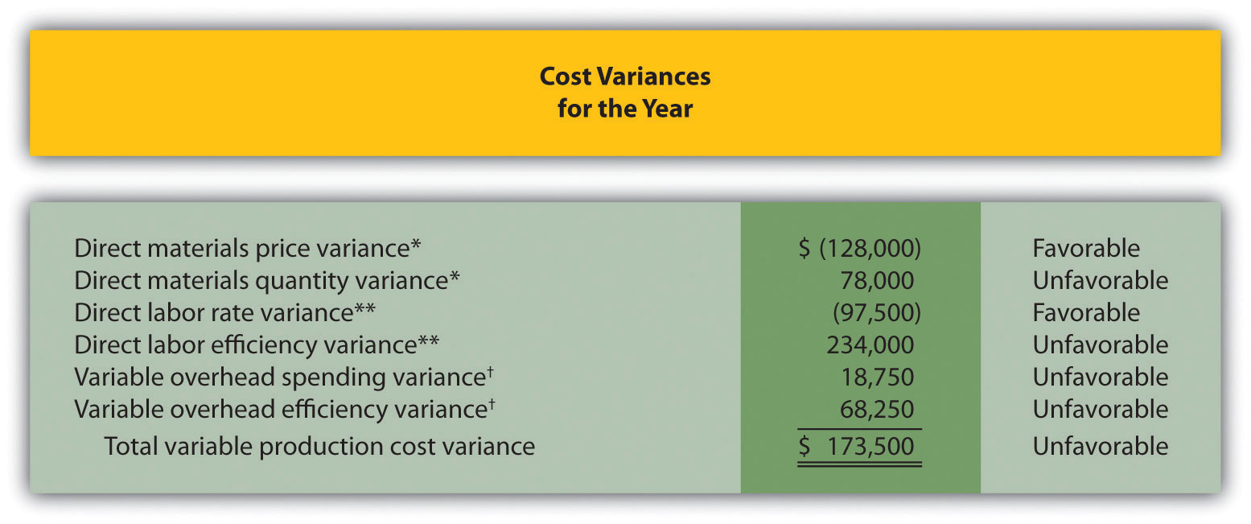
*From .
**From .
† From .
- Based on this policy, the following variances would be investigated:
  - Direct Materials. Neither variance would be investigated as both variances fall below $175,500 (= 15 percent of $1,170,000 standard cost).
  - Direct Labor. The unfavorable direct labor efficiency variance of $234,000 would be investigated because it falls above $140,400 (= 15 percent of $936,000 standard cost).
  - Variable Overhead. The unfavorable variable overhead efficiency variance of $68,250 would be investigated because it falls above $40,950 (= 15 percent of $273,000 standard cost).

10.7 Using Variance Analysis with Activity-Based Costing

LEARNING OBJECTIVE
- Explain how to use cost variance analysis with activity-based costing.

Question: As discussed in , activity-based costing focuses on identifying activities required to make a product, forming cost pools for each activity, and allocating overhead costs to products based on the products’ use of each activity. Rather than establishing one standard variable overhead rate and standard quantity based on one cost driver, activity-based costing establishes several standard variable overhead rates and quantities, each having its own cost driver. How would variance analysis be implemented for a company that uses activity-based costing?

Answer: Regardless of whether a company uses the traditional costing approach or an activity-based costing approach, the process of performing variance analysis is the same. Similar to the traditional costing approach, the variable overhead spending variance for activity-based costing is calculated for each activity as follows:

Key Equation
Variable overhead spending variance = Actual cost − (AQ × SR)

The variable overhead efficiency variance is calculated for each activity using activity-based costing as follows:

Key Equation
Variable overhead efficiency variance = (AQ × SR) − (SQ × SR)

Instead of using AH and SH to represent actual hours and standard hours as we did earlier in the chapter, we use AQ and SQ to represent actual quantity and standard quantity for various activities used in activity-based costing.

Let’s work through an example of variance analysis using activity-based costing. Suppose Jerry’s Ice Cream identified three significant activities and established three standard rates to allocate variable manufacturing overhead instead of one rate based on direct labor hours. Information for the three activities for last year is:
Activity | Standard Rate | Standard Quantity per Unit Produced | Actual Costs | Actual Quantity
Purchase orders | $25 per purchase order | 0.01 orders per unit | $42,000 | 1,600 purchase orders
Product testing | $0.20 per test minute | 1 minute per unit | $31,000 | 180,000 test minutes
Energy | $0.05 per minute of machine time | 2 minutes per unit | $27,000 | 575,000 minutes of machine time

Recall that Jerry’s produced 210,000 units for the year. shows the resulting variable overhead variance analysis. Notice that the format for is the same as for . The variance calculations are also the same except variances are calculated for three activities rather than one. Note that total actual variable overhead costs remain at $100,000, but they are simply broken out into 3 activities ($100,000 = $42,000 for purchase orders + $31,000 for product testing + $27,000 for energy costs). Also, the flexible budget presented in , totaling $115,500, differs from the flexible budget presented earlier since Jerry’s is using a different cost system in this example, which often results in different budgeted amounts ($115,500 = $52,500 purchase orders + $42,000 product testing + $21,000 energy).

Figure 10.11 Variable Overhead Variance Analysis for Jerry’s Ice Cream Using Activity-Based Costing
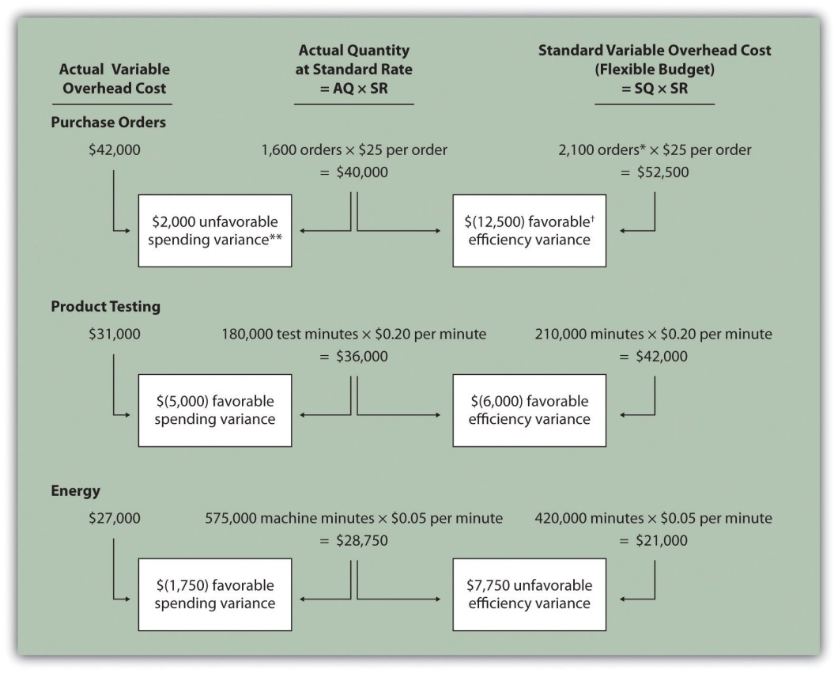

Note: AQ = Actual quantity of activity. SR = Standard variable manufacturing overhead rate per unit of activity. SQ = Standard quantity of activity given actual production of 210,000 units.

*Standard quantity of 2,100 purchase orders = Standard of 0.01 purchase orders per unit × 210,000 actual units produced.

**$2,000 unfavorable variable overhead spending variance = $42,000 −$40,000. Variance is unfavorable because the actual variable overhead cost is higher than the expected cost given actual quantity of 1,600 purchase orders.

† $(12,500) favorable variable overhead efficiency variance = $40,000 – $52,500. Variance is favorable because the 1,600 actual purchase orders are lower than the 2,100 expected (budgeted) purchase orders.

This type of costing system and resulting variance analysis provides management with further information regarding variable overhead costs and variances. As discussed earlier, management often establishes criteria to decide which variances to investigate. Assume that management of Jerry’s Ice Cream chooses to investigate the $7,750 unfavorable efficiency variance associated with energy. The management would like to know why 575,000 minutes of actual machine time were used instead of the expected 420,000 minutes. Perhaps the machines were operating poorly due to cutbacks in maintenance, or maybe new employees were not as efficient using the machines. Whatever the cause, Jerry’s has identified the issue by integrating its activity-based costing system with the cost variance analysis concepts discussed in this chapter.

KEY TAKEAWAY
- Using cost variance analysis with activity-based costing is much like using cost variance analysis with traditional costing. Both utilize a spending variance and an efficiency variance. However, activity-based costing requires calculating a spending and efficiency variance for each activity rather than only one activity base typically used in traditional costing.

REVIEW PROBLEM 10.7
Assume Carol’s Cookies uses activity-based costing to allocate variable manufacturing overhead costs instead of one rate based on direct labor hours. Carol identified three activities with the following information for last year.
Activity | Standard Rate | Standard Quantity per Unit Produced | Actual Costs | Actual Quantity
Indirect materials | $0.60 per pound | 0.5 pounds per unit | $130,000 | 220,000 pounds
Product testing | $0.10 per test minute | 2 minutes per unit | $ 60,000 | 750,000 test minutes
Energy | $0.12 per minute of machine time | 4 minutes per unit | $170,000 | 1,400,000 minutes of machine time
Recall that Carol’s Cookies produced and sold 390,000 units for the year. Prepare a variance analysis for Carol’s Cookies using the format shown in.
Solution to Review Problem 10.7
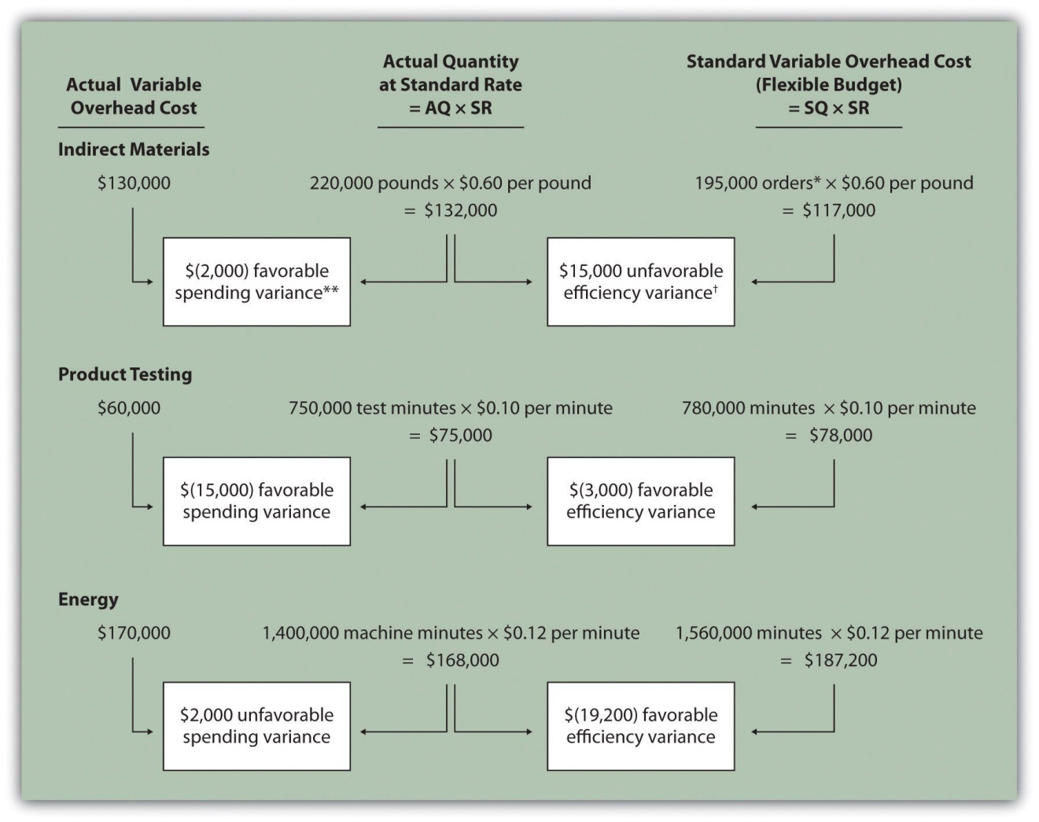
Note: AQ = Actual quantity of activity. SR = Standard variable manufacturing overhead rate per unit of activity. SQ = Standard quantity of activity given actual production of 210,000 units.
*Standard quantity of 195,000 pounds = Standard of 0.5 pounds per unit × 390,000 actual units produced.
**$(2,000) favorable variable overhead spending variance = $130,000 – $132,000. Variance is favorable because the actual variable overhead cost is lower than the expected cost given actual quantity of 220,000 pounds.
† $15,000 unfavorable variable overhead efficiency variance = $132,000 – $117,000. Variance is unfavorable because the 220,000 actual pounds is higher than the 195,000 expected (budgeted) pounds.

10.8 Fixed Manufacturing Overhead Variance Analysis

LEARNING OBJECTIVE
- Calculate and analyze fixed manufacturing overhead variances.

Question: Many organizations also analyze fixed manufacturing overhead variances. Recall from earlier chapters that manufacturing companies are required to assign fixed manufacturing overhead costs to products for financial reporting purposes (this is called absorption costing). It is common for companies such as Jerry’s Ice Cream to apply fixed manufacturing overhead costs to products based on direct labor hours, machine hours, or some other activity. Companies using a standard costing system apply fixed overhead based on a standard dollar amount per unit produced (this calculation is shown in the footnote to ). Assume Jerry’s uses direct labor hours to assign fixed overhead costs to products shown in . How is this information used to perform fixed overhead cost variance analysis?

Answer: It is important to start by noting that fixed overhead in the master budget is the same as fixed overhead in the flexible budget because, by definition, fixed costs do not change with changes in units produced. Thus budgeted fixed overhead costs of $140,280 shown in will remain the same even though Jerry’s actually produced 210,000 units instead of the master budget expectation of 200,400 units.

Figure 10.12 Fixed Manufacturing Overhead Information for Jerry’s Ice Cream
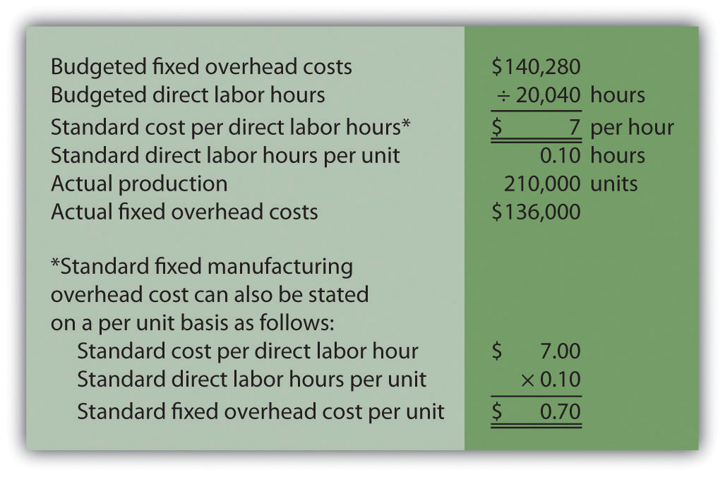

Fixed manufacturing overhead variance analysis involves two separate variances: the spending variance and the production volume variance. We show both variances in , and provide further detail following the figure.

Figure 10.13 Fixed Manufacturing Overhead Variance Analysis for Jerry’s Ice Cream
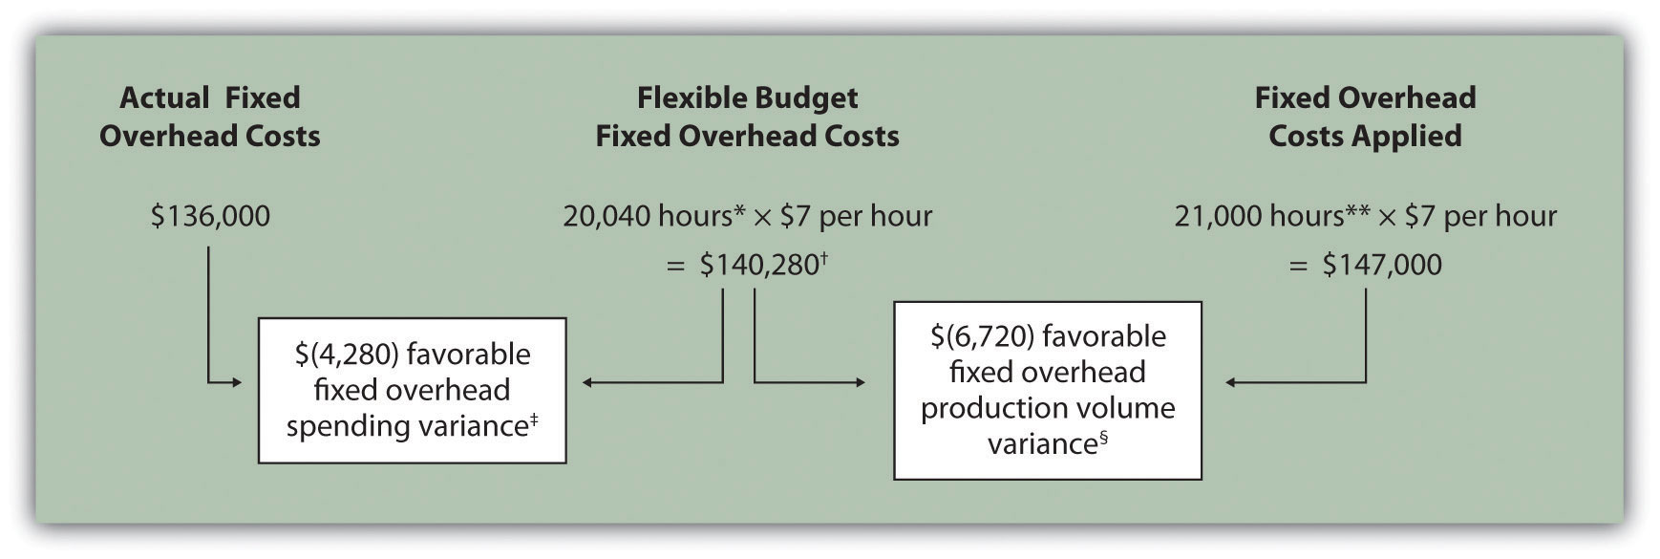

*From , the direct labor budget is 20,040 budgeted direct labor hours = 200,400 units budgeted to be produced × 0.10 direct labor hours per unit.

**Standard hours of 21,000 = 210,000 actual units produced and sold × Standard of 0.10 hours per unit.

† $140,280 is the original budget presented in the manufacturing overhead budget shown in . The flexible budget amount for fixed overhead does not change with changes in production, so this amount remains the same regardless of actual production.

‡ $(4,280) favorable fixed overhead spending variance = $136,000 – $140,280. Variance is favorable because the actual fixed overhead costs are lower than the budgeted costs.

§ $(6,720) favorable fixed overhead volume variance = $140,280 – $147,000. Variance is favorable because the volume of goods produced and sold was higher than expected.

Fixed Overhead Spending Variance Calculation

Question: How is the fixed overhead spending variance calculated?

Answer: The fixed overhead spending variance is the difference between actual and budgeted fixed overhead costs. As shown in , Jerry’s Ice Cream incurred $136,000 in fixed overhead costs for the year. Budgeted fixed overhead costs totaled $140,280. Thus the spending variance is calculated as follows:

Key Equation
Fixed overhead spending variance = Actual costs − Budgeted costs
Fixed overhead spending variance=Actual costs − Budgeted costs=$136,000−$140,280=($4,280) favorable

Because fixed overhead costs are not typically driven by activity, Jerry’s cannot attribute any part of this variance to the efficient (or inefficient) use of labor. In fact, there is no efficiency variance for fixed overhead. Instead, Jerry’s must review the detail of actual and budgeted costs to determine why the favorable variance occurred. For example, factory rent, supervisor salaries, or factory insurance may have been lower than anticipated. Further investigation of detailed costs is necessary to determine the exact cause of the fixed overhead spending variance.

Fixed Overhead Production Volume Variance Calculation

Question: How is the fixed overhead production volume variance calculated?

Answer: Before discussing the production volume variance, a word of caution: do not equate the fixed overhead production volume variance with the variable overhead efficiency variance. There is no efficiency variance for fixed manufacturing overhead because, by definition, fixed costs do not change with changes in the activity base. The fixed overhead volume variance is solely a result of the difference in budgeted production and actual production. The fixed overhead production volume variance is the difference between the budgeted and applied fixed overhead costs. As shown in , Jerry’s Ice Cream budgeted $140,280 in fixed overhead costs for the year. Fixed overhead costs applied totaled $147,000. Thus the production volume variance is calculated as follows:

Key Equation
Fixed overhead production volume variance = Budgeted costs − Applied costs
Fixed overhead production volume variance=Budgeted costs − Applied costs=$140,280−$147,000=($6,720) favorable

The fixed overhead production volume variance is a direct result of the difference in volume (units) between budgeted production and actual production. All other variables are held constant including standard direct labor hours per unit (0.10) and standard rate per direct labor hour ($7). Thus an alternative approach to this calculation can be used assuming the standard fixed overhead cost per unit is $0.70 (= 0.10 direct labor hours per unit × $7 per direct labor hour):

Key Equation
Fixed overhead productionvolume variance=Standard fixed overheadcost per unit×(Budgeted unitsproduced−Actual unitsproduced)
Fixed overhead productionvolume variance($6,720) favorable=Standard fixed overheadcost per unit=$0.70××(Budgeted unitsproduced(200,400budgeted units−−Actual unitsproduced)210,000actual units)

The fixed overhead production volume variance is favorable because the company produced and sold more units than anticipated.

Comparison of Fixed and Variable Overhead Variances

Question: What are the similarities and differences between the fixed and variable overhead variances?

Answer: summarizes the similarities and differences between variable and fixed overhead variances. Notice that the efficiency variance is not applicable to the fixed overhead variance analysis.

Figure 10.14 Comparison of Variable and Fixed Manufacturing Overhead Variance Analysis for Jerry’s Ice Cream
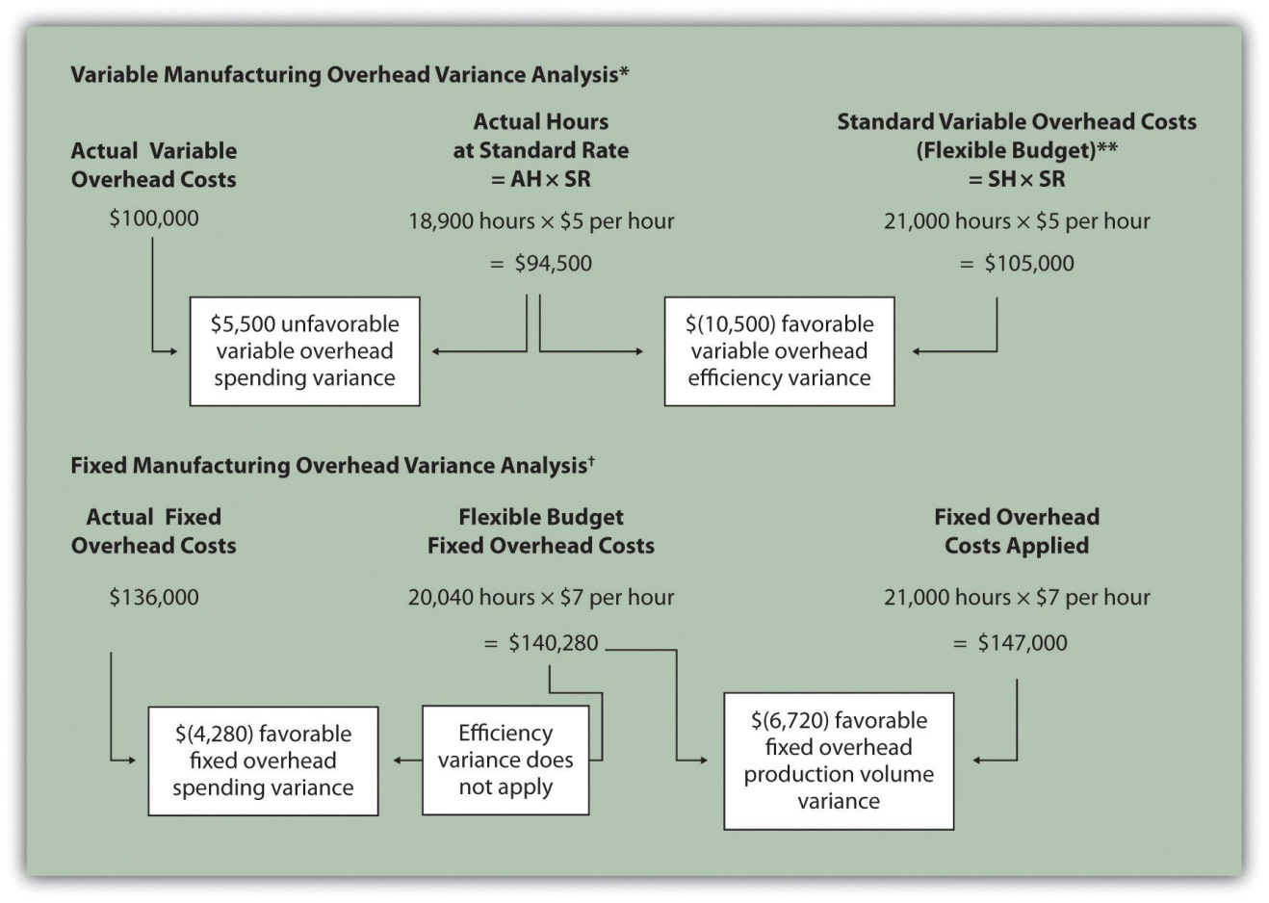

*Information is from .

**For variable manufacturing overhead, the flexible budget is the same as variable overhead applied to production.

† Information is from .

KEY TAKEAWAY
- Two variances are calculated and analyzed when evaluating fixed manufacturing overhead. The fixed overhead spending variance is the difference between actual and budgeted fixed overhead costs. Thefixed overhead production volume variance is the difference between budgeted and applied fixed overhead costs. There is no efficiency variance for fixed manufacturing overhead.

REVIEW PROBLEM 10.8
This review problem is based on the budget information presented inreview problems and variance analysis information presented in review problems. The following information is for Carol’s Cookies:
Calculate the fixed overhead spending and production volume variances using the format shown in .
Solution to Review Problem 10.8
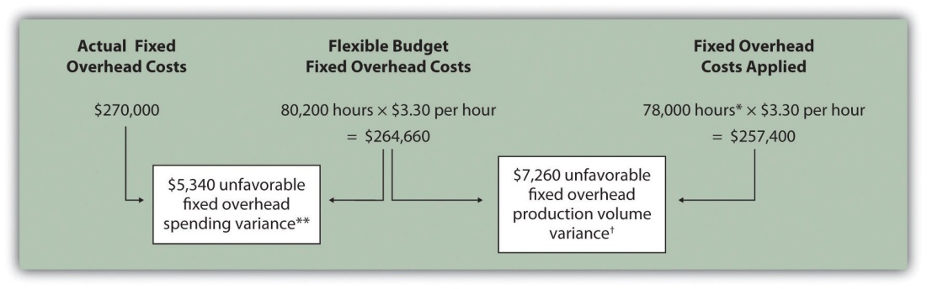
*Standard hours of 78,000 = 390,000 actual units produced and sold x standard of 0.20 hours per unit.
**$5,340 unfavorable fixed overhead spending variance = $270,000 – $264,660. Variance is unfavorable because the actual fixed overhead costs are higher than the budgeted costs.
† $7,260 unfavorable fixed overhead volume variance = $264,660 – $257,400. Variance is unfavorable because the volume of goods produced and sold was lower than expected.

10.9 Appendix: Recording Standard Costs and Variances

LEARNING OBJECTIVE
- Explain how to record standard costs and variances using journal entries.

This chapter has focused on performing variance analysis to evaluate and control operations. Standard costing systems assist in this process and often involve recording transactions using standard cost information. When accountants use a standard costing system to record transactions, companies are able to quickly identify variances. In addition, inventory and related cost of goods sold are valued using standard cost information, which simplifies the bookkeeping process.

Recording Direct Materials Transactions

Question: In Figure 10.4 "Direct Materials Variance Analysis for Jerry’s Ice Cream", we calculated two variances for direct materials at Jerry’s Ice Cream: materials price variance and materials quantity variance. How are these variances recorded for transactions related to direct materials?

Answer: Two journal entries are needed to record direct materials transactions that include these variances. An example of each is shown next. (Typically, many more journal entries would be made throughout the year for direct materials. For the purposes of this example, we will make one journal entry for each variance to summarize the activity for the year.)

Materials Price Variance

The entry to record the purchase of direct materials and related price variance shown in Figure 10.4 "Direct Materials Variance Analysis for Jerry’s Ice Cream" is
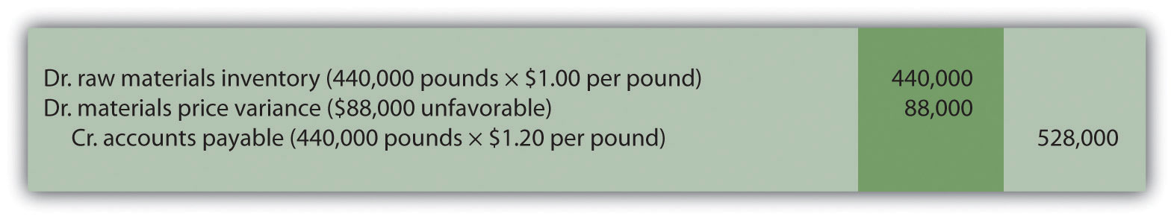
Notice that the raw materials inventory account contains the actual quantity of direct materials purchased at the standard price. Accounts payable reflects the actual cost, and the materials price variance account shows the unfavorable variance. Unfavorable variances are recorded as debits and favorable variances are recorded as credits. Variance accounts are temporary accounts that are closed out at the end of the financial reporting period. We show the process of closing out variance accounts at the end of this appendix.

Materials Quantity Variance

The entry to record the use of direct materials in production and related quantity variance shown in Figure 10.4 "Direct Materials Variance Analysis for Jerry’s Ice Cream" is
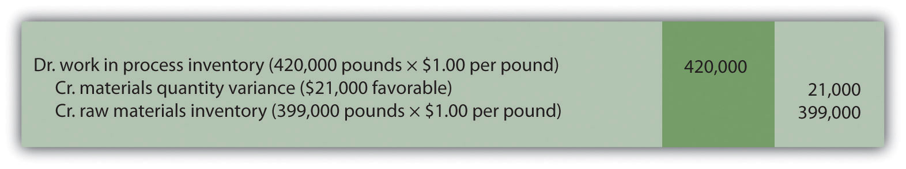

Work-in-process inventory reflects the standard quantity of direct materials allowed at the standard price. The reduction in raw materials inventory reflects the actual quantity used at the standard price, and the materials quantity variance account shows the favorable variance.

Recording Direct Labor Transactions

Question: In Figure 10.6 "Direct Labor Variance Analysis for Jerry’s Ice Cream", we calculated two variances for direct labor at Jerry’s Ice Cream: labor rate variance and labor efficiency variance. How are these variances recorded for transactions related to direct labor?

Answer: Because labor is not inventoried for later use like materials, only one journal entry is needed to record direct labor transactions that include these variances. (Again, many more journal entries would typically be made throughout the year for direct labor. For the purposes of this example, we will make one journal entry to summarize the activity for the year.)

Labor Rate and Efficiency Variances

The entry to record the cost of direct labor and related variances shown inFigure 10.6 "Direct Labor Variance Analysis for Jerry’s Ice Cream" is
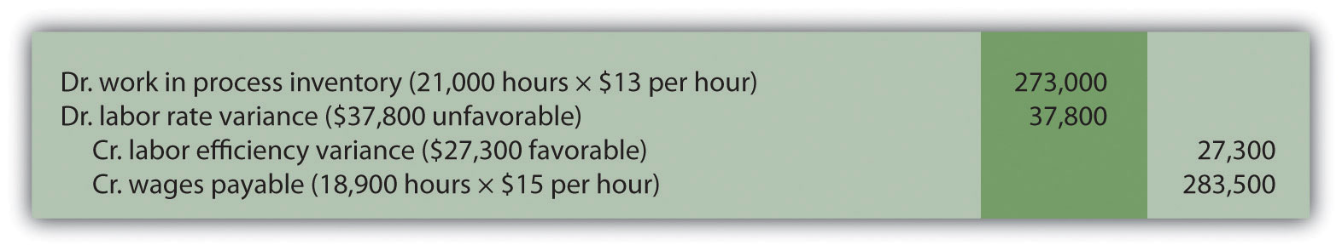

Work-in-process inventory reflects the standard hours of direct labor allowed at the standard rate. The labor rate and efficiency variances represent the difference between work-in-process inventory (at the standard cost) and actual costs recorded in wages payable.

Recording Manufacturing Overhead Transactions

Question: As discussed in Chapter 2 "How Is Job Costing Used to Track Production Costs?", the manufacturing overhead account is debited for all actual overhead expenditures and credited when overhead is applied to products. At the end of the period, the balance in manufacturing overhead, representing overapplied or underapplied overhead, is closed out to cost of goods sold. This overapplied or underapplied balance can be explained by combining the four overhead variances summarized in this chapter in Figure 10.14 "Comparison of Variable and Fixed Manufacturing Overhead Variance Analysis for Jerry’s Ice Cream". How are these variances recorded for transactions related to manufacturing overhead?

Answer: Based on the information at the left side of Figure 10.14 "Comparison of Variable and Fixed Manufacturing Overhead Variance Analysis for Jerry’s Ice Cream", the entry to record actual overhead expenditures is
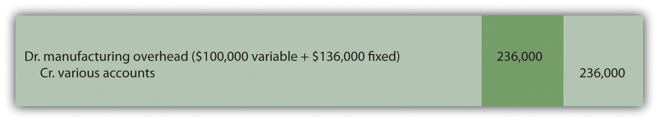

The credit goes to several different accounts depending on the nature of the expenditure. For example, if the expenditure is for indirect materials, the credit goes to accounts payable. If the expenditure is for indirect labor, the credit goes to wages payable.

The next entry reflects overhead applied to products. This information comes from the right side of Figure 10.14 "Comparison of Variable and Fixed Manufacturing Overhead Variance Analysis for Jerry’s Ice Cream".
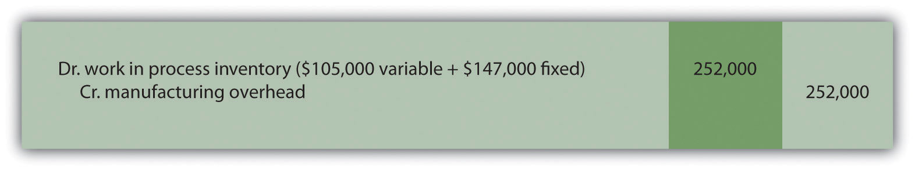

At this point, manufacturing overhead has a $16,000 credit balance, which represents overapplied overhead ($16,000 = $252,000 applied overhead – $236,000 actual overhead). The following summary of fixed and variable overhead variances shown in Figure 10.14 "Comparison of Variable and Fixed Manufacturing Overhead Variance Analysis for Jerry’s Ice Cream"explains the overapplied amount of $16,000:
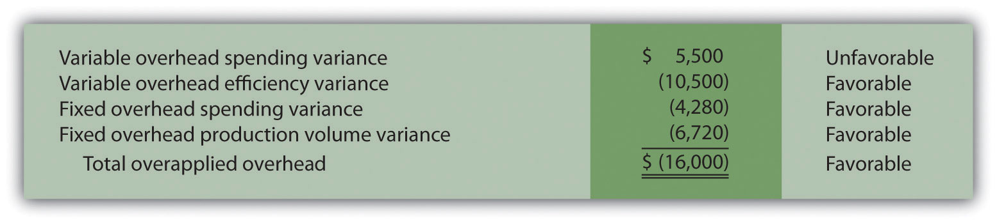

Recording Finished Goods Transactions

Question: Review all the debits to work-in-process inventory throughout this appendix and you will see the following costs (all recorded at standard cost):

How are these costs transferred from work-in-process inventory to finished good inventory when the goods are completed?

Answer: When the 210,000 units are completed, the following entry is made to transfer the costs out of work-in-process inventory and into finished goods inventory.

Note that the standard cost per unit was established at $4.50, which includes variable manufacturing costs of $3.80 (see Figure 10.1 "Standard Costs at Jerry’s Ice Cream") and fixed manufacturing costs of $0.70 (see footnote to Figure 10.12 "Fixed Manufacturing Overhead Information for Jerry’s Ice Cream"). Total production of 210,000 units × Standard cost of $4.50 per unit equals $945,000; the same amount you see in the entry presented previously.

Recording Cost of Goods Sold Transactions

Question: How do we record the costs associated with products that are sold?

Answer: When finished product is sold, the following entry is made:

Note that the entry shown previously uses standard costs, which means cost of goods sold is stated at standard cost until the next entry is made.

Closing Manufacturing Overhead and Variance Accounts

Question: At the end of the period, Jerry’s Ice Cream has balances remaining in manufacturing overhead along with all the variance accounts. These accounts must be closed out at the end of the period. How is this accomplished?

Answer: These accounts are closed out to cost of goods sold, after which point cost of goods sold will reflect actual manufacturing costs for the products sold during the period. The following entry is made to accomplish this goal:
*$61,500 = $88,000 + $37,800 – $21,000 – $27,300 – $16,000.

KEY TAKEAWAY
- In a standard costing system, all inventory accounts reflect standard cost information. The difference between standard and actual data are recorded in the variance accounts and the manufacturing overhead account, which are ultimately closed out to cost of goods sold at the end of the period.

REVIEW PROBLEM 10.9
- Using the solution to Note 10.30 "Review Problem 10.3", prepare a journal entry to record the purchase of raw materials.
- Using the solution to Note 10.30 "Review Problem 10.3", prepare a journal entry to record the use of raw materials.
- Using the solution to Note 10.40 "Review Problem 10.4", prepare a journal entry to record direct labor costs.
- Using the solutions to Note 10.49 "Review Problem 10.5" and Note 10.67 "Review Problem 10.8", prepare a journal entry to record actual variable and fixed manufacturing overhead expenditures.
- Using the solutions to Note 10.49 "Review Problem 10.5" and Note 10.67 "Review Problem 10.8", prepare a journal entry to record variable and fixed manufacturing overhead applied to products.
- Based on the entries shown in items 1 through 5, prepare a journal entry to transfer all work-in-process inventory costs to finished goods inventory.
- Assume all finished goods are sold during the period. Prepare a journal entry to transfer all finished goods inventory costs to cost of goods sold.
- Based on the entries shown in items 1 through 7, close manufacturing overhead and all variance accounts to cost of goods sold.
Solution to Review Problem 10.9
- The following is a journal entry to record purchase of raw materials:
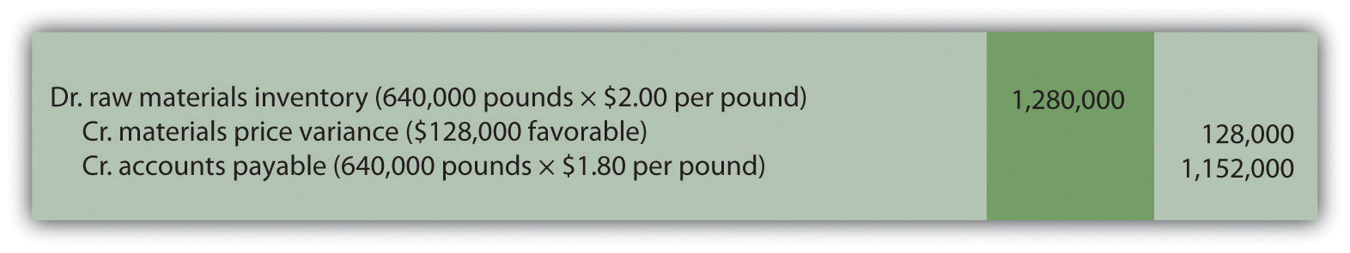
- The following is a journal entry to record usage of raw materials:
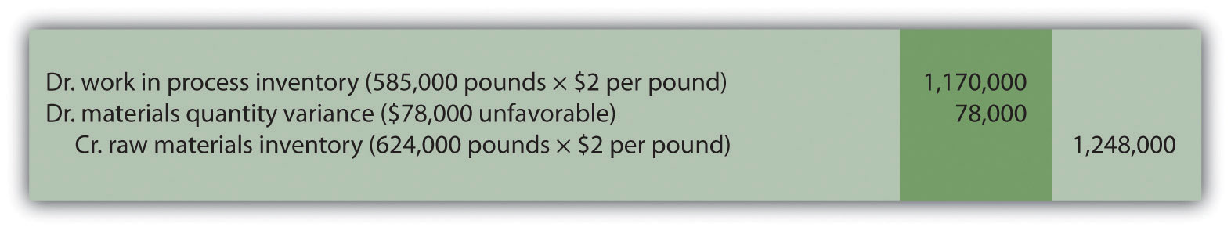
- The following is a journal entry to record direct labor costs:
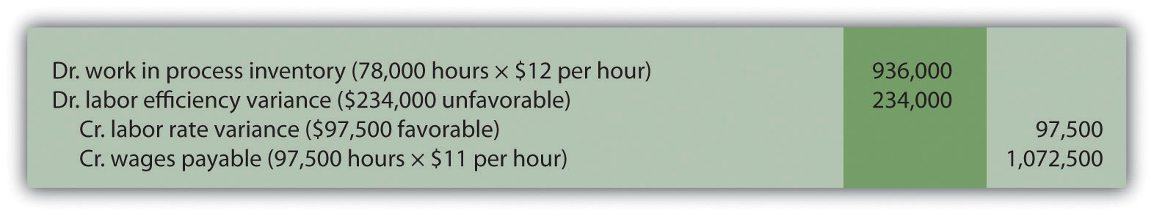
- The following is a journal entry to record actual overhead expenditures:
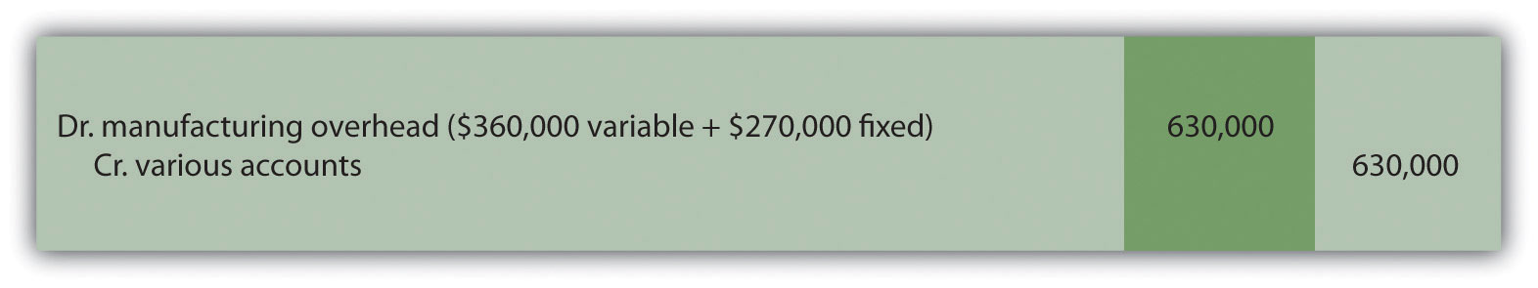
- The following is a journal entry to record overhead applied to production:
]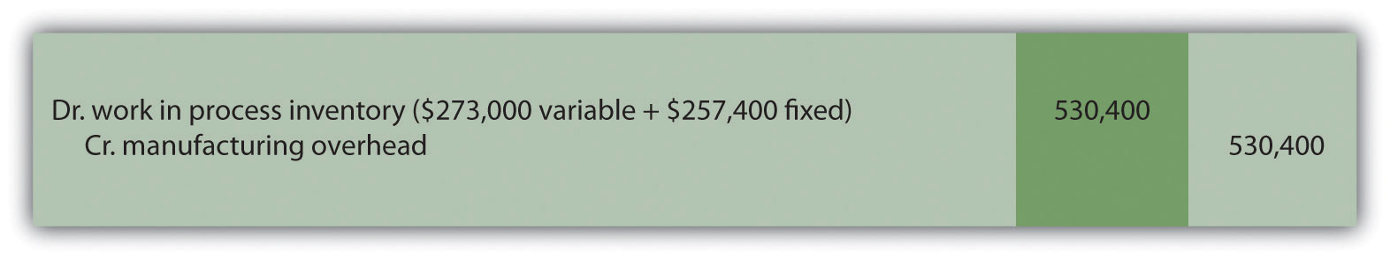
- The product cost data recorded in work-in-process inventory for the period is as follows:
Thus the journal entry to transfer these production costs from work in process to finished goods is:
- The following is a journal entry to record transfer of finished goods to cost of goods sold:
- The following is a journal entry to close out manufacturing overhead and all variance accounts:
*$186,100 = $78,000 + $234,000 + $99,600 – $128,000 – $97,500.
**$99,600 underapplied overhead = $630,000 actual overhead costs – $530,400 applied overhead. Because this represents a debit balance in manufacturing overhead, the account must be credited to close it. To further prove this is accurate, the sum of all overhead variances must equal $99,600 unfavorable as shown in the following:
Variable overhead spending variance | $18,750 unfavorable (fromNote 10.49 "Review Problem 10.5")
Variable overhead efficiency variance | $68,250 unfavorable (fromNote 10.49 "Review Problem 10.5")
Fixed overhead spending variance | $5,340 unfavorable (from Note 10.67 "Review Problem 10.8")
Fixed overhead production volume variance | $7,260 unfavorable (from Note 10.67 "Review Problem 10.8")
Total manufacturing overhead variance | $99,600 unfavorable

END-OF-CHAPTER EXERCISES
Questions
- Explain how a flexible budget differs from a master budget.
- Assume you are the production manager for a manufacturing company that anticipated selling 40,000 units of product for the master budget and actually sold 50,000 units. Why would you prefer to be evaluated using a flexible budget for direct labor rather than the master budget?
- What is a standard cost, and how does it differ from a budgeted cost?
- How are standards established for direct materials, direct labor, and variable manufacturing overhead?
- Explain what management is trying to evaluate in reviewing the materials price variance and materials quantity variance. Be sure to include the formula for each variance in your explanation.
- Explain what management is trying to evaluate in reviewing the labor rate variance and labor efficiency variance. Be sure to include the formula for each variance in your explanation.
- Explain how an unfavorable labor rate variance might cause a favorable labor efficiency variance and favorable materials quantity variance.
- The production manager just received a report indicating an unfavorable labor rate variance. Further investigation reveals that the sales department accepted a large rush order. Who should be held responsible for the unfavorable variance? Explain.
- Refer to Note 10.38 "Business in Action 10.3" Why is direct labor variance analysis particularly important for United Airlines?
- Are favorable variances always a result of good management decisions? Explain.
- Do most companies investigate all variances? Explain.
- How is variable overhead variance analysis similar for companies using activity-based costing and companies using traditional costing?
- What causes the fixed overhead production volume variance?
- (Appendix). Why are direct materials and direct labor variance accounts needed in a standard costing system? What happens to these accounts at the end of the period?
Brief Exercises
- Analyzing Costs at Jerry’s Ice Cream. Refer to the dialogue at Jerry’s Ice Cream presented at the beginning of the chapter. What happened with direct labor and direct materials costs at Jerry’s Ice Cream? What did Jerry, the owner, ask Michelle to do?
- Direct Materials Standard Cost and Flexible Budget. Manhattan Company produces high-quality chairs. Each chair requires a standard quantity of 10 board feet of wood at $5 per board foot. Production for July totaled 3,000 units. Calculate (a) standard cost per unit for direct materials and (b) flexible budget amount for direct materials for the month of July.
- Direct Labor Standard Cost and Flexible Budget. Manhattan Company produces high-quality chairs. Each chair requires a standard quantity of 8 direct labor hours at $15 per hour. Production for July totaled 3,000 units. Calculate (a) standard cost per unit for direct labor and (b) flexible budget amount for direct labor for the month of July.
- Variable Overhead Standard Cost and Flexible Budget. Manhattan Company produces high-quality chairs. Variable manufacturing overhead is applied at a standard rate of $10 per machine hour. Each chair requires a standard quantity of three machine hours. Production for July totaled 3,000 units. Calculate (a) standard cost per unit for variable overhead and (b) flexible budget amount for variable overhead for the month of July.
- Materials Price Variance. Sweets Company produces boxes of chocolate. The company expects to pay $5 a pound for chocolate. Sweets purchased 4,000 pounds of chocolate during the month of April for $4.80 per pound. Calculate the materials price variance for the month of April.
- Materials Quantity Variance. Sweets Company produces boxes of chocolate. A standard of 2 pounds of material is expected to be used for each box produced, at a cost of $5 per pound. Sweets produced 1,000 boxes of chocolate during the month of April and used 2,200 pounds of chocolate. Calculate the materials quantity variance for the month of April.
- Labor Rate Variance. Tech Company produces computer servers. The company’s standards show an expected direct labor rate of $20 per hour. Tech’s direct labor workforce worked 3,200 hours to produce 300 units during the month of August and was paid $22 per direct labor hour. Calculate the labor rate variance for the month of August.
- Labor Efficiency Variance. Tech Company produces computer servers. The company’s standards show that each server will require 10 hours of direct labor at $20 per hour. Tech produced 300 units during the month of August and direct labor hours totaled 3,200 for the month. Calculate the labor efficiency variance for the month of August.
- Variable Overhead Spending Variance. Tech Company produces computer servers. Variable overhead is allocated to each server based on a standard of $100 per machine hour. A total of 850 machine hours were used during the month of August and variable overhead costs totaled $96,000. Calculate the variable overhead spending variance for the month of August.
- Variable Overhead Efficiency Variance. Tech Company produces computer servers. Variable overhead is allocated to each server based on a standard of $100 per machine hour and 3 machine hours per server. A total of 850 machine hours were used during the month of August to produce 300 servers. Calculate the variable overhead efficiency variance for the month of August.
- Investigating Variances. Fiber Optic, Inc., investigates all variances above 10 percent of the flexible budget. The flexible budget for direct materials is $50,000. The direct materials price variance is $4,000 unfavorable and the direct materials quantity variance is $(6,000) favorable. Which variances should be investigated according to company policy? Show calculations to support your answer.
- Spending Variance Using Activity-Based Costing. Albany, Inc., uses activity-based costing to allocate variable manufacturing overhead costs to products. One of the activities used to allocate these costs is product testing. The standard rate is $15 per test hour. The cost for this activity during June totaled $2,000, and actual test time during June totaled 120 hours. Calculate the spending variance for this activity for the month of June, and clearly label whether the variance is favorable or unfavorable.
- Fixed Overhead Spending Variance. Sampson Company applies fixed manufacturing overhead costs to products based on direct labor hours. Budgeted direct labor hours for the month of January totaled 30,000 hours, with a standard cost per direct labor hour of $12. Actual fixed overhead costs totaled $350,000 for January. Calculate the fixed overhead spending variance for January, and clearly label whether the variance is favorable or unfavorable.
- (Appendix) Journalizing the Purchase of Raw Materials. Mill Company purchased 40,000 pounds of raw materials on account for $3.40 per pound. The standard price is $3 per pound. Prepare a journal entry to record this transaction assuming the company uses a standard costing system.
Exercises: Set A
- Standard Cost and Flexible Budget. Hal’s Heating produces furnaces for commercial buildings. The company’s master budget shows the following standards information.
Expected production for January | 300 furnaces
Direct materials | 3 heating elements at $40 per element
Direct labor | 35 hours per furnace at $18 per hour
Variable manufacturing overhead | 35 direct labor hours per furnace at $15 per hour
- Required:
  - Calculate the standard cost per unit for direct materials, direct labor, and variable manufacturing overhead using the format shown in Figure 10.1 "Standard Costs at Jerry’s Ice Cream".
  - Assume Hal’s Heating produced 320 furnaces during January. Prepare a flexible budget for direct materials, direct labor, and variable manufacturing overhead using the format shown in Figure 10.2 "Flexible Budget for Variable Production Costs at Jerry’s Ice Cream".
- Materials and Labor Variances. Hal’s Heating produces furnaces for commercial buildings. (This is the same company as the previous exercise. This exercise can be assigned independently.)
For direct materials, the standard price for a heating element part is $40. A standard quantity of 3 heating elements is expected to be used in each furnace produced. During January, Hal’s Heating purchased 1,000 heating elements for $38,000 and used 980 heating elements to produce 320 furnaces.
For direct labor, Hal’s Heating established a standard number of direct labor hours at 35 hours per furnace. The standard rate is $18 per hour. A total of 10,000 direct labor hours were worked during January, at a cost of $190,000, to produce 320 furnaces.
Required:
  - Calculate the materials price variance and materials quantity variance using the format shown in Figure 10.4 "Direct Materials Variance Analysis for Jerry’s Ice Cream". Clearly label each variance as favorable or unfavorable.
  - Calculate the labor rate variance and labor efficiency variance using the format shown in Figure 10.6 "Direct Labor Variance Analysis for Jerry’s Ice Cream". Clearly label each variance as favorable or unfavorable.
- Variable Overhead Variances. Hal’s Heating produces furnaces for commercial buildings. (This is the same company as the previous exercises. This exercise can be assigned independently.) The company applies variable manufacturing overhead at a standard rate of $15 per direct labor hour. The standard quantity of direct labor is 35 hours per unit. Variable overhead costs totaled $190,000 for the month of January. A total of 10,000 direct labor hours were worked during January to produce 320 furnaces.
Required:
Calculate the variable overhead spending variance and variable overhead efficiency variance using the format shown in Figure 10.8 "Variable Manufacturing Overhead Variance Analysis for Jerry’s Ice Cream". Clearly label each variance as favorable or unfavorable.
- Fixed Overhead Variance Analysis. Hal’s Heating produces furnaces for commercial buildings. (This is the same company as the previous exercises. This exercise can be assigned independently.) The company applies fixed manufacturing overhead costs to products based on direct labor hours. Information for the month of January appears as follows. Hal’s expected to produce and sell 300 units for the month.
Required:
Calculate the fixed overhead spending variance and production volume variance using the format shown in Figure 10.13 "Fixed Manufacturing Overhead Variance Analysis for Jerry’s Ice Cream". Clearly label each variance as favorable or unfavorable.
- Journalizing Direct Materials and Direct Labor Transactions (Appendix). Hal’s Heating produces furnaces for commercial buildings. (This is the same company as the previous exercises. This exercise can be assigned independently.)
Direct materials and direct labor variances for the month of January are shown as follows.
Materials price variance | $(2,000) favorable
Materials quantity variance | $ 800 unfavorable
Labor rate variance | $ 10,000 unfavorable
Labor efficiency variance | $(21,600) favorable
Required:
  - The company purchased 1,000 elements during the month for $38 each. Assuming a standard price of $40 per element, prepare a journal entry to record the purchase of raw materials for the month.
  - The company used 980 elements in production for the month, and the flexible budget shows the company expected to use 960 elements. Assuming a standard price of $40 per element, prepare a journal entry to record the usage of raw materials in production for the month.
  - The company used 10,000 direct labor hours during the month with an actual rate of $19 per hour. The flexible budget shows the company expected to use 11,200 direct labor hours at a standard rate of $18 per hour. Prepare a journal entry to record direct labor costs for the month.
- Investigating Variances. Quality Tables, Inc., produces high-end coffee tables. Standard cost information for each table is presented as follows.
Quality Tables produced and sold 2,000 tables for the year and encountered the following production variances:
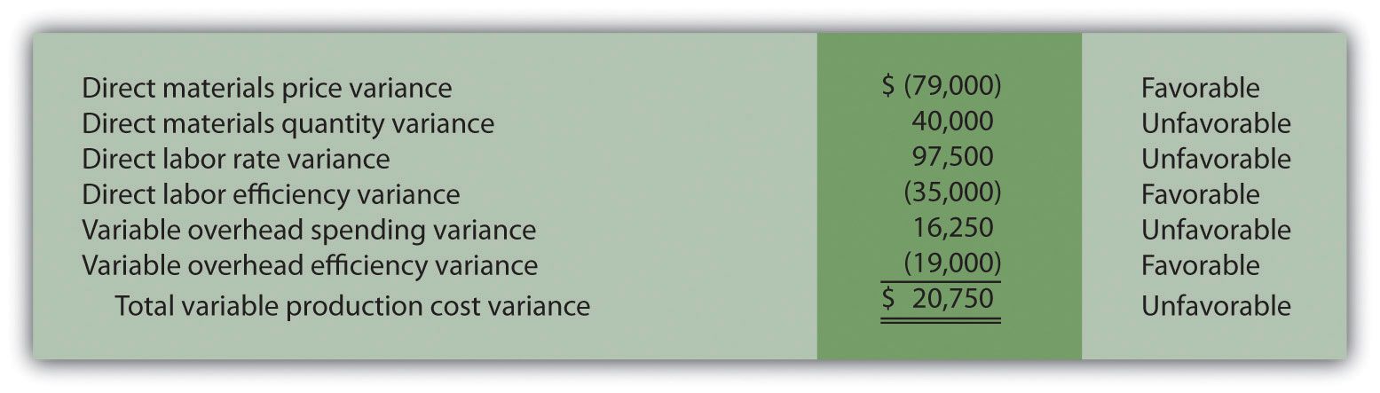
Required:
Company policy is to investigate all unfavorable variances above 10 percent of the flexible budget amount for direct materials, direct labor, and variable overhead.
  - Identify the variances that should be investigated according to company policy. Show calculations to support your answer.
  - What potential weakness exists in the company’s current policy?
- Variance Analysis with Activity-Based Costing. Assume Mammoth Company uses activity-based costing to allocate variable manufacturing overhead costs to products. The company identified three activities with the following information for last quarter.
Activity | Standard Rate | Standard Quantity per Unit Produced | Actual Costs | Actual Quantity
Indirect materials | $2.40 per yard | 7 yards per unit | $691,650 | 265,000 yards
Product testing | $1.50 per test minute | 5 minutes per unit | $301,000 | 215,000 test minutes
Indirect labor | $4.50 per direct labor hour | 4 hours per unit | $930,000 | 180,000 direct labor hours
- Required:
- Assume Mammoth Company produced 40,000 units last quarter. Prepare a variance analysis using the format shown in Figure 10.11 "Variable Overhead Variance Analysis for Jerry’s Ice Cream Using Activity-Based Costing". Clearly label each variance as favorable or unfavorable.
- Closing Variance and Overhead Accounts (Appendix). Gonzaga Products had the following balances at the end of its fiscal year.
 | Debit | Credit
Materials price variance | $10,000
Materials quantity variance |  | $8,000
Labor rate variance |  | 6,000
Labor efficiency variance | 5,000
Manufacturing overhead | 14,000
- Required:
  - Prepare a journal entry to close the variance and manufacturing overhead accounts. Assume the balances are not significant and thus are closed to cost of goods sold.
  - Assume all products were sold and the company has no ending inventories. After making the entry in requirementa, does the balance of cost of goods sold on the income statement reflect standard costs or actual costs? Explain.
Exercises: Set B
- Standard Cost and Flexible Budget. Outdoor Products, Inc., produces extreme-weather sleeping bags. The company’s master budget shows the following standards information.
Expected production for September | 5,000 units
Direct materials | 8 yards per unit at $5 per yard
Direct labor | 3 hours per unit at $16 per hour
Variable manufacturing overhead | 3 direct labor hours per unit at $2 per hour
- Required:
  - Calculate the standard cost per unit for direct materials, direct labor, and variable manufacturing overhead using the format shown in Figure 10.1 "Standard Costs at Jerry’s Ice Cream".
  - Assume Outdoor Products produced 5,100 sleeping bags during the month of September. Prepare a flexible budget for direct materials, direct labor, and variable manufacturing overhead using the format shown in Figure 10.2 "Flexible Budget for Variable Production Costs at Jerry’s Ice Cream".
- Materials and Labor Variances. Outdoor Products, Inc., produces extreme-weather sleeping bags. (This is the same company as the previous exercise. This exercise can be assigned independently.)
For direct materials, the standard price for 1 yard of material is $5 per yard. A standard quantity of 8 yards of material is expected to be used for each sleeping bag produced. During September, Outdoor Products, Inc., purchased 45,000 yards of material for $238,500 and used 39,000 yards to produce 5,100 sleeping bags.
For direct labor, Outdoor Products, Inc., established a standard number of direct labor hours at three hours per sleeping bag. The standard rate is $16 per hour. A total of 14,700 direct labor hours were worked during September, at a cost of $238,140, to produce 5,100 sleeping bags.
Required:
  - Calculate the materials price variance and materials quantity variance using the format shown in Figure 10.4 "Direct Materials Variance Analysis for Jerry’s Ice Cream". Clearly label each variance as favorable or unfavorable.
  - Calculate the labor rate variance and labor efficiency variance using the format shown in Figure 10.6 "Direct Labor Variance Analysis for Jerry’s Ice Cream". Clearly label each variance as favorable or unfavorable.
- Variable Overhead Variances. Outdoor Products, Inc., produces extreme-weather sleeping bags. (This is the same company as the previous exercises. This exercise can be assigned independently.) The company applies variable manufacturing overhead at a standard rate of $2 per direct labor hour. The standard quantity of direct labor is three hours per unit. Variable overhead costs totaled $32,000 for the month of September. A total of 14,700 direct labor hours were worked during September to produce 5,100 sleeping bags.
Required:
Calculate the variable overhead spending variance and variable overhead efficiency variance using the format shown in Figure 10.8 "Variable Manufacturing Overhead Variance Analysis for Jerry’s Ice Cream". Clearly label each variance as favorable or unfavorable.
- Fixed Overhead Variance Analysis. Outdoor Products, Inc., produces extreme-weather sleeping bags. (This is the same company as the previous exercises. This exercise can be assigned independently.) The company applies fixed manufacturing overhead costs to products based on direct labor hours. Information for the month of September appears as follows. Outdoor Products expected to produce and sell 5,000 units for the month.
Required:
Calculate the fixed overhead spending variance and production volume variance using the format shown in Figure 10.13 "Fixed Manufacturing Overhead Variance Analysis for Jerry’s Ice Cream". Clearly label each variance as favorable or unfavorable.
- Journalizing Direct Materials and Direct Labor Transactions (Appendix). Outdoor Products, Inc., produces extreme-weather sleeping bags. (This is the same company as the previous exercises. This exercise can be assigned independently.)
Direct materials and direct labor variances for the month of September are shown as follows.
Materials price variance | $13,500 unfavorable
Materials quantity variance | $(9,000) favorable
Labor rate variance | $ 2,940 unfavorable
Labor efficiency variance | $(9,600) favorable
Required:
  - The company purchased 45,000 yards of material during the month for $5.30 per yard. Assuming a standard price of $5 per yard, prepare a journal entry to record the purchase of raw materials for the month.
  - The company used 39,000 yards of material in production for the month, and the flexible budget shows the company expected to use 40,800 yards. Assuming a standard price of $5 per yard, prepare a journal entry to record the usage of raw materials in production for the month.
  - The company used 14,700 direct labor hours during the month with an actual rate of $16.20 per hour. The flexible budget shows the company expected to use 15,300 direct labor hours at a standard rate of $16 per hour. Prepare a journal entry to record direct labor costs for the month.
- Investigating Variances. Tool Box, Inc., produces tool boxes sold at a variety of retail stores throughout the world. Standard cost information for each toolbox is presented as follows.
Tool Box produced and sold 100,000 toolboxes for the year and encountered the following production variances:
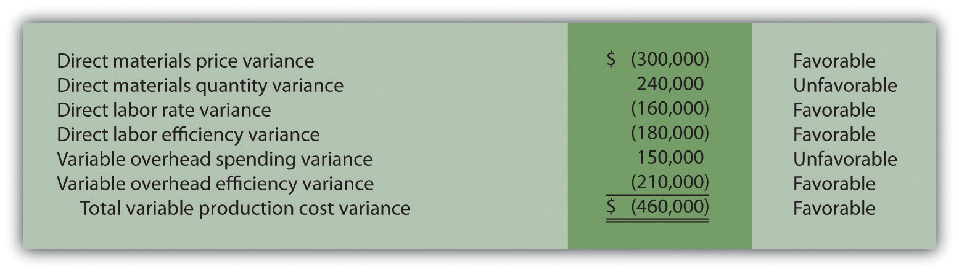
Required:
Company policy is to investigate all unfavorable variances above 5 percent of the flexible budget amount for direct materials, direct labor, and variable overhead.
  - Identify the variances that should be investigated according to company policy. Show calculations to support your answer.
  - What recommendations would you make for the company’s current policy?
- Variance Analysis with Activity-Based Costing. Assume Hillside Hats, LLC, uses activity-based costing to allocate variable manufacturing overhead costs to products. The company identified three activities with the following information for last month.
Activity | Standard Rate | Standard Quantity per Unit Produced | Actual Costs | Actual Quantity
Purchase orders | $50 per order | 0.10 order per unit | $65,000 | 1,600 orders
Product testing | $2 per test minute | 0.50 minutes per unit | $17,000 | 8,000 test minutes
Indirect labor | $3 per direct labor hour | 1 hour per unit | $43,000 | 13,000 direct labor hours
- Required:
- Assume Hillside Hats produced 15,000 units last month. Prepare a variance analysis using the format shown in Figure 10.11 "Variable Overhead Variance Analysis for Jerry’s Ice Cream Using Activity-Based Costing". Clearly label each variance as favorable or unfavorable.
- Closing Variance and Overhead Accounts (Appendix). Shasta Company had the following balances at the end of its fiscal year.
 | Debit | Credit
Materials price variance |  | $8,000
Materials quantity variance |  | 2,000
Labor rate variance | $12,000
Labor efficiency variance |  | 5,000
Manufacturing overhead |  | 4,000
- Required:
  - Prepare a journal entry to close the variance and manufacturing overhead accounts. Assume the balances are not significant and thus are closed to cost of goods sold.
  - Assume all products were sold and the company has no ending inventories. After making the entry in requirementa, does the balance of cost of goods sold on the income statement reflect standard costs or actual costs? Explain.
Problems
- Variance Analysis for Direct Materials, Direct Labor, and Variable Overhead. Rain Gear, Inc., produces rain jackets. The master budget shows the following standards information and indicates the company expected to produce and sell 28,000 units for the year.
Direct materials | 4 yards per unit at $3 per yard
Direct labor | 2 hours per unit at $10 per hour
Variable manufacturing overhead | 2 direct labor hours per unit at $4 per hour
- Rain Gear actually produced and sold 30,000 units for the year. During the year, the company purchased 130,000 yards of material for $429,000 and used 118,000 yards in production. A total of 65,000 labor hours were worked during the year at a cost of $637,000. Variable overhead costs totaled $231,000 for the year.
- Required:
  - Calculate the materials price variance and materials quantity variance using the format shown in Figure 10.4 "Direct Materials Variance Analysis for Jerry’s Ice Cream". Clearly label each variance as favorable or unfavorable.
  - Calculate the labor rate variance and labor efficiency variance using the format shown in Figure 10.6 "Direct Labor Variance Analysis for Jerry’s Ice Cream". Clearly label each variance as favorable or unfavorable.
  - Calculate the variable overhead spending variance and variable overhead efficiency variance using the format shown in Figure 10.8 "Variable Manufacturing Overhead Variance Analysis for Jerry’s Ice Cream". Clearly label each variance as favorable or unfavorable.
  - Company policy is to investigate all variances greater than 10 percent of the flexible budget amount for each of the three variable production costs: direct materials, direct labor, and variable overhead. Identify which of the six variances calculated in requirements a through cshould be investigated.
  - Provide two possible explanations for each variance identified in requirement d.
- Fixed Overhead Variance Analysis. (This problem is a continuation of the previous problem but can also be worked independently.) Rain Gear, Inc., produces rain jackets and applies fixed manufacturing overhead costs to products based on direct labor hours. Information for the year appears as follows. Rain Gear expected to produce and sell 28,000 units for the year.
Required:
  - Calculate the fixed overhead spending variance and production volume variance using the format shown inFigure 10.13 "Fixed Manufacturing Overhead Variance Analysis for Jerry’s Ice Cream". Clearly label each variance as favorable or unfavorable.
  - Company policy is to investigate all variances greater than 5 percent of the flexible budget amount. Identify whether either of the two fixed overhead variances calculated in requirement a should be investigated.
  - Provide one possible explanation for variance(s) identified in requirement b.
- Journalizing Direct Materials, Direct Labor, and Overhead Transactions (Appendix). Complete the following requirements for Rain Gear, Inc., using your solutions to the previous two problems.
Required:
  - Prepare a journal entry to record the purchase of raw materials.
  - Prepare a journal entry to record the use of raw materials.
  - Prepare a journal entry to record direct labor costs.
  - Prepare a journal entry to record actual variable and fixed manufacturing overhead expenditures.
  - Prepare a journal entry to record variable and fixed manufacturing overhead applied to products.
  - Based on the entries shown in requirements a through e, prepare a journal entry to transfer all work-in-process inventory costs to finished goods inventory.
  - Assume all finished goods are sold during the period. Prepare a journal entry to transfer all finished goods inventory costs to cost of goods sold.
  - Based on the entries shown in requirements a through g, close manufacturing overhead and all variance accounts to cost of goods sold.
- Variance Analysis for Direct Materials, Direct Labor, and Variable Overhead; Journalizing Direct Materials and Direct Labor Transactions (Includes Appendix). Prefab Pools Company produces large prefabricated in-ground swimming pools made of a specialized plastic material. The master budget shows the following standards information and indicates the company expected to produce and sell 600 units for the month of April.
Direct materials | 500 pounds per unit at $7 per pound
Direct labor | 46 hours per unit at $12 per hour
Variable manufacturing overhead | 46 direct labor hours per unit at $30 per hour
- Prefab Pools actually produced and sold 580 units for the month. During the month, the company purchased 330,000 pounds of material for $2,277,000 and used 295,800 pounds in production. A total of 25,520 labor hours were worked during the month at a cost of $313,896. Variable overhead costs totaled $790,000 for the month.
- Required:
  - Calculate the materials price variance and materials quantity variance using the format shown in Figure 10.4 "Direct Materials Variance Analysis for Jerry’s Ice Cream". Clearly label each variance as favorable or unfavorable.
  - Calculate the labor rate variance and labor efficiency variance using the format shown in Figure 10.6 "Direct Labor Variance Analysis for Jerry’s Ice Cream". Clearly label each variance as favorable or unfavorable.
  - Calculate the variable overhead spending variance and variable overhead efficiency variance using the format shown in Figure 10.8 "Variable Manufacturing Overhead Variance Analysis for Jerry’s Ice Cream". Clearly label each variance as favorable or unfavorable.
  - Company policy is to investigate all variances at or above 2 percent of the flexible budget for direct materials and 4 percent for direct labor and variable overhead. Identify which of the six variances calculated in requirements athrough c should be investigated.
  - Provide two possible explanations for each variance identified in requirement d.
  - Based on your answer to requirement a, prepare a journal entry to record the purchase of raw materials.
  - Based on your answer to requirement a, prepare a journal entry to record the usage of raw materials.
  - Based on your answer to requirement b, prepare a journal entry to record direct labor costs.
- Fixed Overhead Variance Analysis. (This problem is a continuation of the previous problem but can be worked independently.) Prefab Pools Company produces prefabricated in-ground swimming pools and applies fixed manufacturing overhead costs to products based on direct labor hours. Information for the month of April appears as follows. Prefab Pools expected to produce and sell 600 units for the month.
Required:
  - Calculate the fixed overhead spending variance and production volume variance using the format shown inFigure 10.13 "Fixed Manufacturing Overhead Variance Analysis for Jerry’s Ice Cream". Clearly label each variance as favorable or unfavorable.
  - Company management has asked you to investigate the cause of the fixed overhead spending variance calculated in requirement a. Provide one possible explanation for this variance.
- Variance Analysis for Direct Materials, Direct Labor, Variable Overhead, and Fixed Overhead. Equipment Products, Inc., produces large ladders made of a specialized metal material. The master budget shows the following standards information and indicates the company expected to produce and sell 4,000 units for the month of May.
Direct materials | 60 pounds per unit at $3 per pound
Direct labor | 8 hours per unit at $14 per hour
Variable manufacturing overhead | 8 direct labor hours per unit at $6 per hour
- Equipment Products actually produced and sold 4,400 units for the month. During the month, the company purchased 300,000 pounds of material for $960,000 and used 286,000 pounds in production. A total of 30,800 labor hours were worked during the month at a cost of $462,000. Variable overhead costs totaled $195,000 for the month.
- With regards to fixed manufacturing overhead, the company also applies these overhead costs to products based on direct labor hours. Fixed manufacturing overhead information for the month of May appears as follows.
- Required:
  - Calculate the materials price variance and materials quantity variance using the format shown in Figure 10.4 "Direct Materials Variance Analysis for Jerry’s Ice Cream". Clearly label each variance as favorable or unfavorable.
  - Calculate the labor rate variance and labor efficiency variance using the format shown in Figure 10.6 "Direct Labor Variance Analysis for Jerry’s Ice Cream". Clearly label each variance as favorable or unfavorable.
  - Calculate the variable overhead spending variance and variable overhead efficiency variance using the format shown in Figure 10.8 "Variable Manufacturing Overhead Variance Analysis for Jerry’s Ice Cream". Clearly label each variance as favorable or unfavorable.
  - Company policy is to investigate all variances greater than 10 percent of the flexible budget amount for each of the 3 variable production costs: direct materials, direct labor, and variable overhead. Identify which of the six variances calculated in requirements a through c should be investigated.
  - Provide two possible explanations for each variance identified in requirement d.
  - Calculate the fixed overhead spending variance and production volume variance using the format shown inFigure 10.13 "Fixed Manufacturing Overhead Variance Analysis for Jerry’s Ice Cream". Clearly label each variance as favorable or unfavorable.
- Journalizing Direct Labor and Overhead Transactions (Appendix).Complete the following requirements for Equipment Products, Inc., using your solutions to the previous problem.
Required:
  - Prepare a journal entry to record direct labor costs.
  - Prepare a journal entry to record actual variable and fixed manufacturing overhead expenditures.
  - Prepare a journal entry to record variable and fixed manufacturing overhead applied to products.
- Variance Analysis with Activity-Based Costing. Assume Spindle Company uses activity-based costing to allocate variable manufacturing overhead costs to products. The company identified three activities with the following information for last quarter.
Activity | Standard Rate | Standard Quantity per Unit Produced | Actual Costs | Actual Quantity
Indirect materials | $5 per yard | 14 yards per unit | $4,850,000 | 990,000 yards
Product testing | $3 per test minute | 10 minutes per unit | $2,000,000 | 650,000 test minutes
Indirect labor | $9 per direct labor hour | 6 hours per unit | $3,800,000 | 410,000 direct labor hours
- Required:
  - Assume Spindle Company produced 70,000 units last quarter. Prepare a variance analysis using the format shown in Figure 10.11 "Variable Overhead Variance Analysis for Jerry’s Ice Cream Using Activity-Based Costing". Clearly label each variance as favorable or unfavorable.
  - Company policy is to investigate all variances above 5 percent of the flexible budget amount for each activity. Identify the variances that should be investigated according to company policy. Show calculations to support your answer.
One Step Further: Skill-Building Cases
- Variance Analysis and Fraud. Refer to Note 10.47 "Business in Action 10.4" and to Note 10.52 "Business in Action 10.5" Explain how cost variance analysis might help detect fraud.
- Group Activity: Setting Standards. Form groups of two to four students. Each group is to complete the following requirements.
Required:
  - Define and discuss the differences between ideal standards and attainable standards.
  - Assume your group works for a company that produces wood desks and you are in the process of creating attainable direct material and direct labor standards. Provide specific examples of the items that might be included in (1) the standard quantity and standard price for direct materials and (2) the standard hours and standard rate for direct labor. Explain where this information might be obtained, and identify specific production inefficiencies your group included in creating these standards that would not be included in ideal standards.
  - Discuss the findings of your group with the class. (Optional: your instructor may ask you to submit your findings in writing.)
- Internet Project: Standard Costs and Cost Variances. Systems Applications and Products (SAP) is the world’s largest business software company with 38,000 customers worldwide. Go to the SAP Web site athttp://www.sap.com and find the search feature. Type in “standard costing” or “cost variance” and find an article that discusses standard costs and/or cost variances (there are several articles to choose from). Summarize the article in a one-page report, and submit a printed copy of the article with your report.
- Ethics and Setting Standards. Wilkes Golf, Inc., produces golf carts that are sold throughout the world. The company’s management is in the process of establishing the standard hours of direct labor required to complete one golf cart. Assume you are the production supervisor, and you receive a bonus for each quarter that shows a favorable labor efficiency variance. That is, you receive a bonus for each quarter showing actual direct labor hours that are fewer than budgeted direct labor hours.
The management has asked for your input in establishing the standard number of direct labor hours required to complete one golf cart.
Required:
  - As the production supervisor, describe the ethical conflict you face when asked to help with establishing direct labor hour standards.
  - How might the management of Wilkes Golf, Inc., avoid this conflict and still achieve the goal of obtaining reliable direct labor hour information?
- Using Excel to Perform Budget Versus Actual Analysis. The management of Home Products, Inc., prepared the following budgeted income statement for the year ending December 31, 2012.
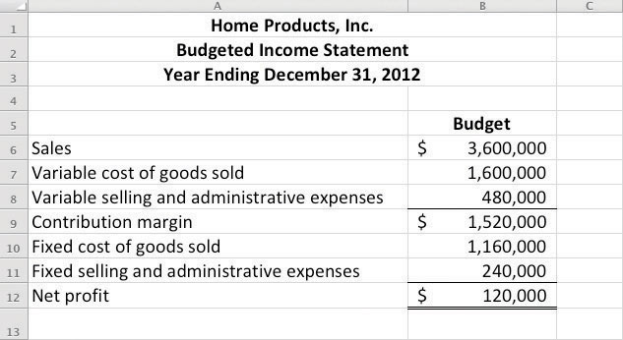
At the end of 2012, the company prepared the following income statement showing actual results:
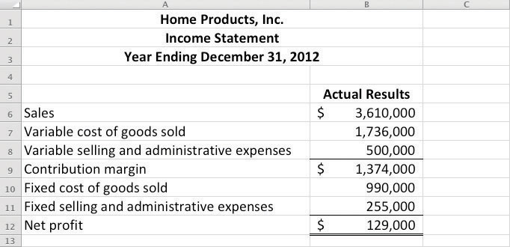
Required:
Prepare an Excel spreadsheet comparing the actual results to budgeted amounts using the format shown as follows, and comment on the results.
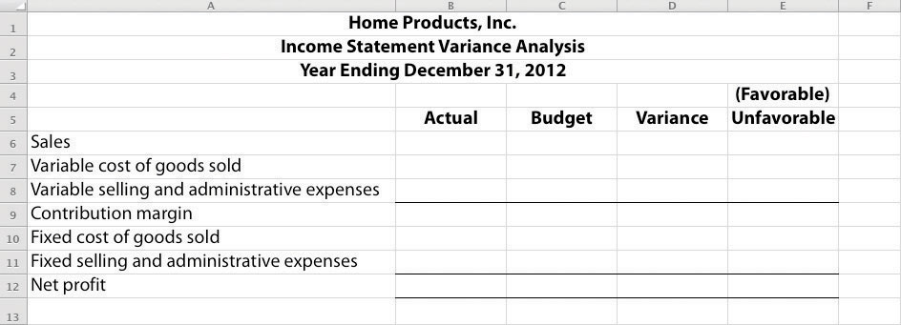
Comprehensive Cases
- Variable Production Cost Variance Analysis. Iron Products, Inc., produces prefabricated iron fencing used in commercial construction. Variable overhead is applied to products based on direct labor hours. The company uses a just-in-time production system and thus has insignificant inventory levels at the end of each month. The income statement for the month of November comparing actual results with the flexible budget based on actual sales of 2,000 units is shown as follows.
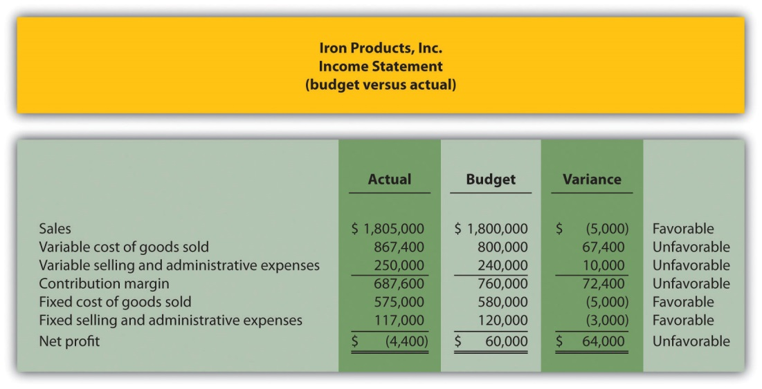
Iron Products is disappointed with the actual results and has hired you as a consultant to provide further information as to why the company has been struggling to meet budgeted net profit. Your review of the previously presented budget versus actual analysis identifies variable cost of goods sold as the main culprit. The unfavorable variance for this line item is $67,400.
After further research, you are able to track down the following standard cost information for variable production costs:
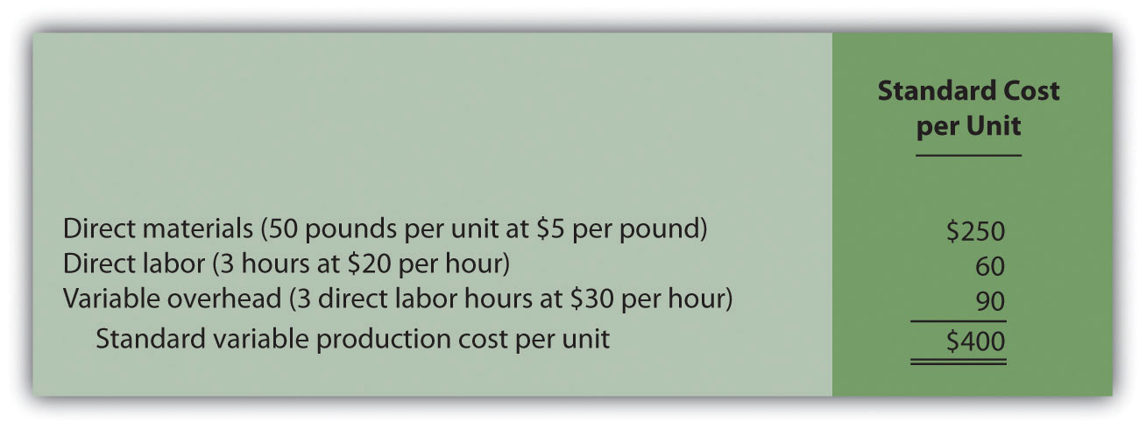
Actual production information related to variable cost of goods sold for the month of November is as follows:
  - 2,000 units were produced and sold.
  - 110,000 pounds of material were purchased and used at a total cost of $528,000.
  - 5,600 direct labor hours were used during the month at a total cost of $134,400.
  - Variable overhead costs totaled $205,000.
Required:
  - Calculate the materials price variance and materials quantity variance using the format shown in Figure 10.4 "Direct Materials Variance Analysis for Jerry’s Ice Cream". Clearly label each variance as favorable or unfavorable.
  - Calculate the labor rate variance and labor efficiency variance using the format shown in Figure 10.6 "Direct Labor Variance Analysis for Jerry’s Ice Cream". Clearly label each variance as favorable or unfavorable.
  - Calculate the variable overhead spending variance and variable overhead efficiency variance using the format shown in Figure 10.8 "Variable Manufacturing Overhead Variance Analysis for Jerry’s Ice Cream". Clearly label each variance as favorable or unfavorable.
  - List each of the six variances calculated in requirementsa, b, and c, and total the variances to show one net variance. Clearly label the net variance as favorable or unfavorable. Explain how this net variance relates to variable cost of goods sold on the income statement.
  - Identify the highest favorable variance and highest unfavorable variance from the six listed in requirement d, and provide one possible cause of each variance.
- Variable Production Cost Variance Analysis and Performance Evaluation. Fast Sleds, Inc., produces snow sleds used for winter recreation. Variable overhead is applied to products based on machine hours. The company uses a just-in-time production system, and thus has insignificant inventory levels at the end of each month. The income statement for the month of January comparing actual results with the flexible budget is shown in the following based on actual sales of 10,000 units.
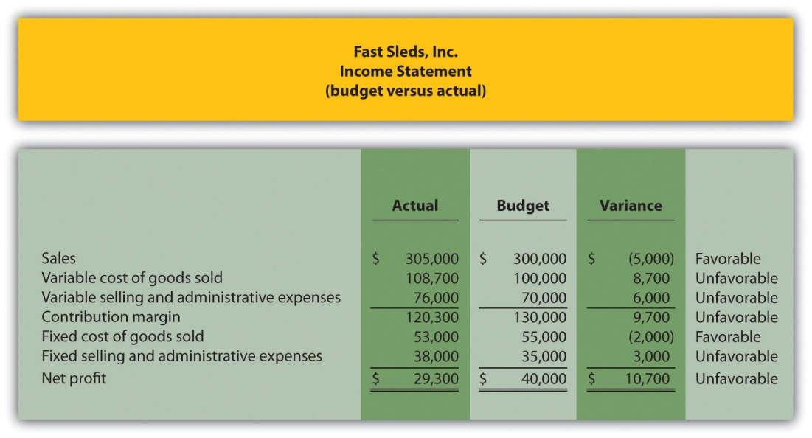
Fast Sleds is disappointed with the actual results and has hired you as a consultant to provide further information as to why the company has been struggling to meet budgeted net income. Your review of the budget presented previously versus actual analysis identifies variable cost of goods sold as the main culprit. The unfavorable variance for this line item is $8,700.
After further research, you are able to track down the standard cost information for variable production costs:
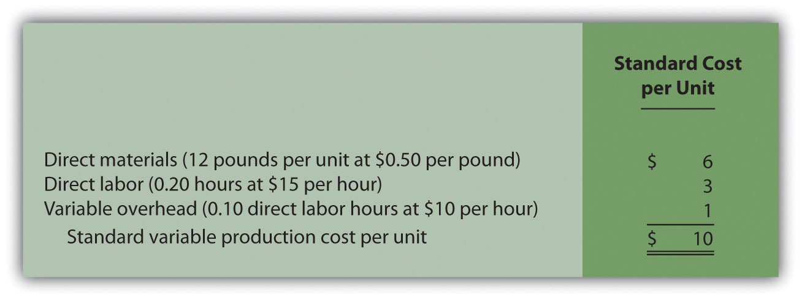
Actual production information related to variable cost of goods sold for the month of January is as follows:
  - 10,000 units were produced and sold.
  - 150,000 pounds of material was purchased and used at a total cost of $67,500.
  - 1,900 direct labor hours were used during the month at a total cost of $30,400.
  - 1,200 machine hours were used during the month.
  - Variable overhead costs totaled $10,800.
Required:
  - Calculate the materials price variance and materials quantity variance using the format shown in Figure 10.4 "Direct Materials Variance Analysis for Jerry’s Ice Cream". Clearly label each variance as favorable or unfavorable.
  - Calculate the labor rate variance and labor efficiency variance using the format shown in Figure 10.6 "Direct Labor Variance Analysis for Jerry’s Ice Cream". Clearly label each variance as favorable or unfavorable.
  - Calculate the variable overhead spending variance and variable overhead efficiency variance using the format shown in Figure 10.8 "Variable Manufacturing Overhead Variance Analysis for Jerry’s Ice Cream". Clearly label each variance as favorable or unfavorable.
  - List each of the six variances calculated in requirementsa, b, and c, and total the variances to show one net variance. Clearly label the net variance as favorable or unfavorable. Explain how this net variance relates to variable cost of goods sold on the income statement.
  - Identify the highest favorable variance and highest unfavorable variance from the six listed in requirement d, and provide one possible cause of each variance.
  - Sue Mays, the manager at Fast Sleds, Inc., reviewed the company’s variance analysis report for the month of January. The materials price variance of $(7,500) was the most significant favorable variance for the month, and the materials quantity variance of $15,000 was the most significant unfavorable variance. Sue would like to reward the company’s purchasing agent for achieving such substantial savings by giving him a $2,000 bonus while not providing any bonus for the production manager.
  - Do you agree with Sue’s approach to awarding bonuses? Explain.
  - What circumstances might lead to the conclusion that the purchasing agent should not receive a bonus for the month of January?

Chapter 11

How Do Managers Evaluate Performance in Decentralized Organizations?

Mandy Dwyer is the president and CEO of Game Products, Inc., a producer of games and sporting goods sold to a variety of retail stores. Game Products, Inc., has three divisions: Sporting Goods, Board Games, and Computer Games. Each division is relatively autonomous with a separate manager, who independently oversees each division. Mandy Dwyer is reviewing the results of the most recent fiscal year with Larry Meske, the company’s CFO:
Mandy: | In reviewing our segmented income statement, it looks like the Board Games division had a terrific year. Profits increased substantially over last year, more than either of the other two divisions, and overall profit for this division is well above the other two. Carla Klesko, the Board Games division manager, is to be commended for her fine work! We should consider revising her compensation plan to increase her annual bonus based on these results.
Larry: | Not so quick, Mandy. I agree that the Board Games division has successfully increased profits, but we must consider more than just the bottom line (profits) in determining how substantial the increase is in comparison to the other divisions.
Mandy: | What do you have in mind?
Larry: | For starters, we should consider what resources were invested in the Board Games division, and determine the return produced from these resources. As you recall, Carla made a significant investment in her division, whereas the other division managers did not. So naturally, we would expect Board Games division profits to increase by more than the other divisions.
Mandy: | I’ve always focused on the bottom line for each division. What performance measures do you propose we use?
Larry: | We have several options. Return on investment (ROI), residual income (RI), and economic value added (EVA) are three commonly used measures. Perhaps we can discuss this further next month once I’ve had a chance to pull some information together.
Mandy: | Excellent idea. I look forward to getting your ideas on this issue next month.
Mandy and Larry are looking for ways to evaluate the performance of the company’s three division managers. Since each division is responsible for more than just the cost of production, as was the case in Chapter 10 "How Do Managers Evaluate Performance Using Cost Variance Analysis?", top management must evaluate how productively each division manager is using assets to produce profits. The focus of this chapter is on how to evaluate the performance of division managers within a decentralized organization.

11.1 Using Decentralized Organizations to Control Operations

LEARNING OBJECTIVE
- Define the term decentralized organization and explain advantages and disadvantages of decentralizing.

Question: Many types of organizations decentralize operations to better manage each segment of the organization. What does it mean to decentralize operations?

Answer: The term used to describe this type of organizational structure isdecentralized organizations. Decentralized organizations delegate decision-making and operational responsibilities to the managers of each segment of the organization. (Segments are often called divisions or subunits.) For example, universities are often segmented by discipline with one manager, or dean, responsible for each discipline (physical education, social sciences, business, etc.). Retail companies are often segmented by region, with one manager responsible for each region. Service companies are often segmented by service category, with one manager responsible for each category (e.g., an accounting firm divided into audit and tax). Decentralization is not limited to a particular type of organization, and most organizations that have grown in size and complexity decentralize to some extent.

Reasons to Decentralize

Question: Why do organizations decentralize operations?

Answer: Organizations often decentralize out of necessity as they expand. The responsibility of one manager, or group of managers, to run the entire organization can become overwhelming as the number of products offered increases.

For example, Game Products, Inc., began by selling two board games to several retail stores in the northeast United States. The company did not need to decentralize at that point because it offered only two products and the geographic region in which it sold those products was limited.

A few years later, Game Products expanded sales to Canada and the southeast Unites States, while also venturing into the computer games industry by purchasing a small maker of computer games. Although operations were not decentralized at this time—all decisions were still made at headquarters—top management was beginning to feel the strain of trying to manage two segments of the company. The decision-making process was cumbersome and slow, and the company began to miss market opportunities that would have increased sales and profits.

Two years later, Game Products decided to enter the sporting goods market, and top management and the board of directors agreed that decentralization was critical to the future success of the company. As a result, they assigned a manager to run each division. This change allowed top management to concentrate on high-level issues. such as long-range strategic planning, and it placed the decision making in the hands of managers who were intimately familiar with the operations of their individual divisions.

Although Game Products ultimately decided to decentralize operations, there are advantages and disadvantages to decentralizing. illustrates how operations would look at Game Products, Inc., if operations were decentralized or if they remained centralized.

Figure 11.1 Decentralized Versus Centralized Organizations

Advantages of Decentralizing Operations

Question: What are the advantages of decentralizing operations for companies like Game Products, Inc.?

Answer: Organizations like Game Products tend to decentralize as their operations grow and become more complex. The advantages of decentralizing are as follows:
- Increased Expertise. Rather than having one manager, or a group of managers, trying to make decisions for a wide range of products, decentralized organizations delegate decision-making authority to local managers who have expertise in specific products.
- Quicker Decisions. By having increased expertise and decision-making authority, local managers are able to make decisions quickly without having to wait for the approval of the organization’s top management.
- Refocus of Top Management Responsibilities. With local managers focusing on issues important to the specific segment, top management is able to delegate the day-to-day decision-making responsibilities and focus on broader companywide issues, such as long-range strategic planning.
- Motivation of Local Managers. Managers who are given more responsibility, and the control necessary to manage their responsibility, tend to be more motivated than those who simply follow the orders issued by top management. In addition, a decentralized structure provides a means to train local managers for promotion to the next level of management.

Provides a real-life example of an organization that benefitted from decentralizing.

Business in Action 11.1
Advantages of Decentralizing at a Community College
Sierra College is located in one of the fastest growing counties in California. Student enrollment has increased from 5 percent to 10 percent per year over the last decade. Prior to this rapid growth, the college held each division dean responsible for most administrative duties. For example, the dean of business and technology was responsible for administrative duties, such as hiring faculty members and developing the schedule of classes to be offered each semester.
As student enrollment increased, course offerings expanded, and faculty headcount grew into the hundreds, the administrative duties became overwhelming for each division dean. As a result, management decided to decentralize further by creating department chair positions to help with the administrative duties related directly to each department. This change gave each department (business, music, computer science, etc.) more control over day-to-day activities, and it allowed the deans to focus on larger college issues, such as strategic planning and community relations. It also allowed for quicker responses to issues, such as faculty teaching assignments and classroom space utilization.
Source: Based on the author’s experience.

Disadvantages of Decentralizing Operations

Question: What are the disadvantages of decentralizing operations for organizations, such as Game Products?

Answer: The results of decentralizing operations are not always positive. Three disadvantages of decentralizing are as follows:
- Duplication of Services. Organizations that decentralize often duplicate administrative services, such as accounting and computer support. That is, each segment may have its own accounting department and computer support department when these services might be provided more efficiently through one companywide department.
- Conflict of Interest. Managers who are evaluated solely with respect to their divisions have no incentive to make a decision that benefits the organization as a whole at the expense of the manager’s division. For example, a local manager may decide to purchase raw materials from an outside supplier even though another division within the company can produce the same materials at a lower cost. (To make matters worse, the other division’s manager may refuse to sell the materials at a reduced price because she is evaluated based on her division’s profits!) The appendix to this chapter discusses this issue in greater detail.
- Loss of Control. Perhaps one of the most difficult decisions facing small, fast-growing organizations is whether to continue to expand and decentralize or to limit growth and remain highly centralized. Decentralization will lead to a loss of control at top management levels, which can have negative consequences for the organization’s reputation if local managers struggle to maintain the level of quality that customers expect. Decentralized organizations are only as good as the local managers who are given decision-making authority.

Business in Action 11.2
Disadvantage of Decentralizing an Accounting Firm
Arthur Andersen was a large, decentralized accounting firm with offices located throughout the world. One or more partners operated each office independently. In 2002, Arthur Andersen had 85,000 employees worldwide. The firm was indicted in March 2002, and later found guilty, for obstructing justice by shredding tons of documents related to its audit work for Enron Corporation. As a result, Arthur Andersen agreed to cease its accounting practice in the United States in August 2002. By 2005, only 200 employees remained at Arthur Andersen to wrap up the dissolution of the firm.
Although the entire firm was indicted and found guilty of obstruction of justice, the decision to shred documents was made at the Houston office, where the bulk of the shredding took place. This serves as an extreme example of the disadvantage of decentralizing an organization. Decisions left to the division managers (“partners” in this case) can have a negative effect on the entire organization.
Note that the U.S. Supreme Court overturned the guilty verdict of the U.S. District Court in June 2005, but the damage was done and the firm did not survive.
Source: Charles Lane, “Justices Overturn Andersen Conviction,”Washington Post, June 1, 2005, http://www.washingtonpost.com.

KEY TAKEAWAY
- Decentralized organizations delegate decision-making and operational responsibilities to the managers of each segment, or division, of the organization. Advantages of decentralized organizations include increased expertise at each division, quicker decisions, better use of time at top management levels, and increased motivation of division managers. Disadvantages include duplication of services, such as accounting and computer support; potential increase in conflicts between division manager goals and companywide goals; and loss of control at the top management level.

REVIEW PROBLEM 11.1
Landscaping Services, Inc., founded and operated by Ed Barnes, has seen revenues double each year for the past three years. Although Ed has hired several laborers to ease the workload, he is still working seven days a week, 10 hours a day. Ed would like to hire a manager to assist in managing landscaping projects and has asked for your advice.
- What concerns might you have about Ed’s plan to decentralize operations?
- How might decentralizing operations benefit Landscaping Services, Inc.?
Solution to Review Problem 11.1
- There are several potential disadvantages to decentralizing. Two examples follow:
  - For a relatively small company, such as Landscaping Services, Inc., the biggest concern is losing control over quality. Presumably Ed is successful because he provides excellent service. He must instill the importance of maintaining quality to the new manager.
  - Ed must establish a compensation system that encourages the new manager to make decisions in the best interest of the organization. For example, if the new manager encounters an opportunity to pick up a new customer, there must be an incentive to pursue this opportunity. If the new manager is simply given a monthly salary, there is no incentive to increase the workload! One approach is to offer part ownership in the company and therefore rights to a percentage of the company’s profits.
- There are several potential advantages to decentralizing. A few examples follow:
  - Ed can hire a manager with expertise in an area outside of Ed’s expertise, which can lead to additional business and a higher level of quality.
  - Clients will no longer have to wait for Ed to arrive before a decision is made on how to proceed with the work.
  - Ed can put more time into obtaining new customers.

11.2 Maintaining Control over Decentralized Organizations

LEARNING OBJECTIVE
- Define three types of responsibility centers.

Question: To evaluate performance, organizations often divide operations into segments. Segments responsible for revenues, costs, and investments in assets are called responsibility centers. Responsibility centers can be based on such attributes as sales regions, product lines, or services offered. Why do organizations establish responsibility centers?

Answer: The purpose of establishing responsibility centers within organizations is to hold managers responsible for only the assets, revenues, and costs they can control. For example, a factory manager typically has control over production costs, but not sales. This manager’s responsibility center would only include production costs. A retail store manager typically has control over sales prices and costs. This manager’s responsibility center would only include revenues and costs. The level of control a manager has over a segment’s assets, revenues, and costs will help determine the type of responsibility center used for each manager.

Figure 11.2 "Three Types of Responsibility Centers" illustrates the three types of responsibility centers commonly used to evaluate segments: cost centers, profit centers, and investment centers. Each type is described in the following sections.

Figure 11.2 Three Types of Responsibility Centers

Cost Center

Question: What is a cost center, and what measures are used to evaluate this type of responsibility center?

Answer: A cost center is an organizational segment that is responsible for costs, but not revenue or investments in assets. Service departments, such as accounting, marketing, computer support, and human resources, are cost centers. Managers of these departments are evaluated based on providing a certain level of services for the company at a reasonable cost.

Production departments within a manufacturing firm are also treated as cost centers. Production managers are evaluated based on meeting cost budgets for producing a certain level of goods. Chapter 10 "How Do Managers Evaluate Performance Using Cost Variance Analysis?" describes the use of cost variance analysis to evaluate cost centers within a manufacturing firm.

Profit Center

Question: What is a profit center, and what measures are used to evaluate this type of responsibility center?

Answer: A profit center is an organizational segment that is responsible for costs and revenues (and therefore, profit), but not investments in assets. Retail stores for companies, such as Macy’s or Kmart, are treated as profit centers. Individual fast food restaurants for McDonald’s or Kentucky Fried Chicken are also examples of profit centers. Managers of profit centers are responsible for revenues, costs, and resulting profits. (Some individual retail stores and fast food restaurants may be considered investment centers if the store manager is also responsible for large investment decisions, such as enlarging the building and purchasing more equipment to accommodate additional customers. Profit center determination must be made on a case-by-case basis, and it depends on the level of responsibility assigned to the store manager.)

Methods of performance evaluation for profit centers vary. Some organizations compare actual profit to budgeted profit. Others compare one profit center to another. Also, some organizations use segmented income statement ratios, such as gross margin or operating profit, to compare current profit center performance to prior periods and to other profit centers. Chapter 13 "How Do Managers Use Financial and Nonfinancial Performance Measures?" explains how companies can use financial ratios to evaluate profit center performance.

Investment Center

Question: What is an investment center, and what measures are used to evaluate this type of responsibility center?

Answer: An investment center is an organizational segment that is responsible for costs, revenues, and investments in assets. Investment center managers have control over asset investment decisions. In many cases, investment centers are treated as stand-alone businesses. Examples of investment centers include the Chevrolet division of General Motors and the printer division of Hewlett Packard.

Several measures can be used to evaluate the performance of investment center managers, including segmented net income, ROI, RI, and economic value added (EVA). The remainder of this chapter will focus on these measures using Game Products, Inc., as the example company. Before turning to these topics, however, look at Note 11.12 "Business in Action 11.3"which indicates the challenges that accountants and managers at Hewlett-Packard face when preparing the company’s annual report.

Business in Action 11.3
Segment Reporting at Hewlett-Packard Company
Hewlett-Packard Company provides financial information for seven segments in its annual report. Examples of segments and related revenues (in millions) include HP Services ($15,617), Personal Systems Group ($29,166), and Imaging and Printing Group ($26,786). These segments are likely treated as investment centers where segment managers are responsible for costs, revenues, and investments in assets.
Source: Hewlett-Packard Company, “2006 Annual Report,”http://www.hp.com.

KEY TAKEAWAY
- Responsibility centers are categorized depending on the level of control over revenues, costs, or investments. A segment responsible only for costs is called a cost center. A segment responsible for costs and revenues is called a profit center. A segment responsible for costs, revenues, and investment in assets is called an investment center. Performance measures used to evaluate managers depend on the type of responsibility center being managed.

REVIEW PROBLEM 11.2
For each of the organizational segments listed, determine whether it is a cost center, profit center, or investment center. Explain your answer.
- Individual retail store at Home Depot
- Accounting department at Ford Motor Company
- Saturn division of General Motors
- Human resources department at IBM
- Production department at Sony
- Jet engine division of General Electric
- Computer support department at Nike
Solution to Review Problem 11.2
- Profit center. The manager is responsible for costs and revenues, but not investments in assets. (A case might be made that if the manager has control over significant purchases of assets for the store, this would be an investment center.)
- Cost center. The manager is responsible for costs only, not revenues or investments in assets.
- Investment center. The manager is responsible for costs, revenues, and investment decisions.
- Cost center. The manager is responsible for costs only, not revenues or investments in assets.
- Cost center. The manager is responsible for costs only, not revenues or investments in assets.
- Investment center. The manager is responsible for costs, revenues, and investment decisions.
- Cost center. The manager is responsible for costs only, not revenues or investments in assets.

11.3 Comparing Segmented Income for Investment Centers

LEARNING OBJECTIVE
- Calculate and interpret segmented net income to evaluate performance.

Question: Now that we know an investment center is an organizational segment responsible for costs, revenues, and investments in assets, where do we start in trying to evaluate the performance of investment centers?

Answer: The starting point for evaluating investment centers is typically with reviewing segmented income for each investment center (or division).Segmented income is segment revenues minus segment expenses. Top management is interested in the level of profit that each division generates, and segmented income gives them this information.

Revisiting Game Products, Inc.

Question: In the dialogue at the beginning of the chapter, Mandy Dwyer, president and CEO, said she would like to increase the annual bonus for Carla Klesko, manager of the Board Games division, based on the division’s level of profit relative to the other divisions. How does the Board Games division profits compare with the other divisions?

Answer: Profit for the Board Games division is higher than either of the other two, as shown in Figure 11.3 "Segmented Income Statements (Game Products, Inc.)".

Figure 11.3 Segmented Income Statements (Game Products, Inc.)
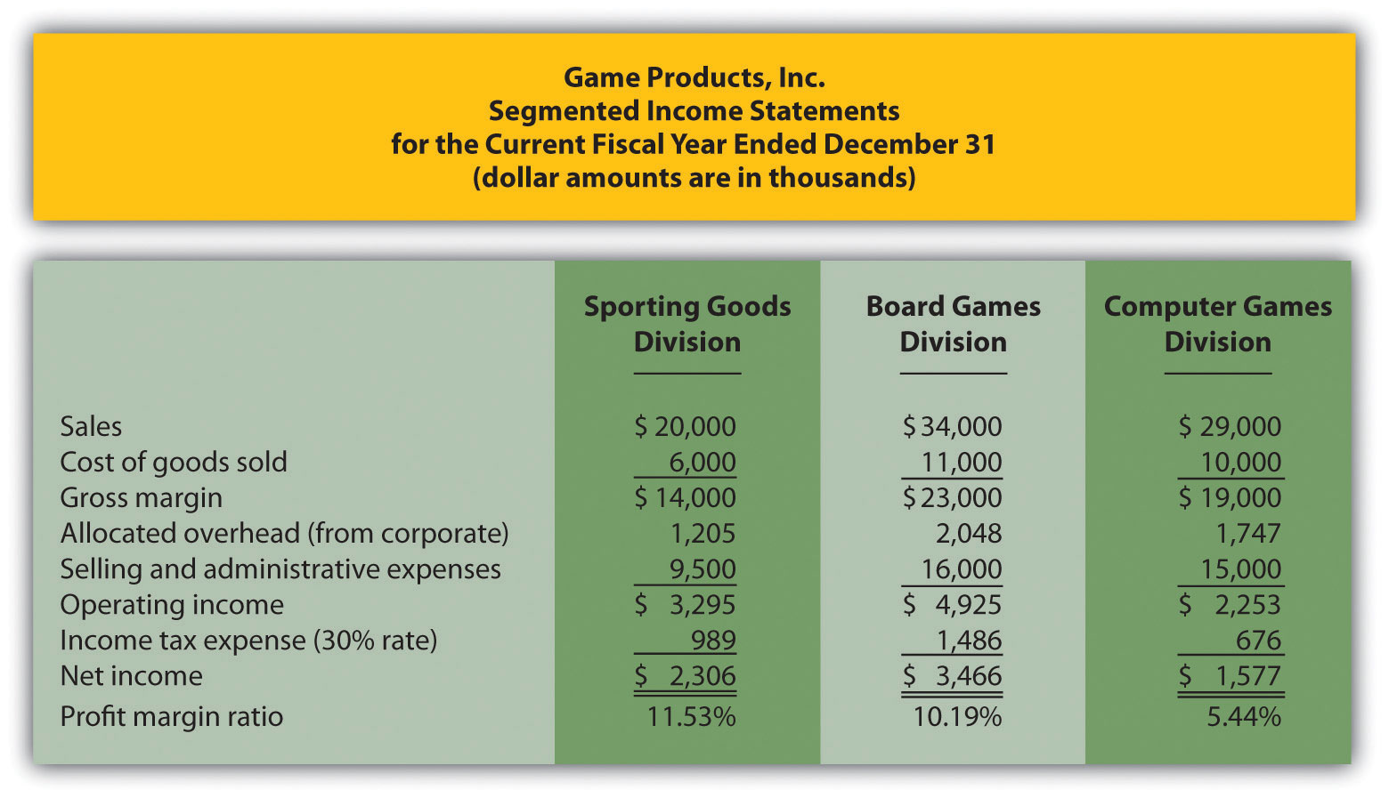

Although this income statement looks much like a financial accounting income statement prepared for outside users, it is for internal use and therefore, need not comply with U.S. Generally Accepted Accounting Principles (U.S. GAAP). In fact, organizations can define income or profit many different ways when evaluating performance. For example, some might only look at operating income, others might exclude allocated overhead from operating income. Another alternative is to focus on gross margin. The point is that managerial accountants must be flexible in designing reports that best meet the needs of managers.

The president of Game Products, Inc., referred to net income when she indicated that the Board Games division performed very well for the year. Solely based on this measure, Mandy’s statement is accurate as the Board Games division has net income of $3,466,000 versus $2,306,000 for the Sporting Goods division and $1,577,000 for the Computer Games division.

Limitations of Using Segmented Income to Measure Performance

Question: Although using net income for each division as a performance measure is relatively simple, there are two significant weaknesses. What are these weaknesses?

Answer: First, not all divisions are of equal size. Naturally, larger divisions should produce larger profits. It is unfair to compare net income for a smaller division with net income for a larger division for the purpose of evaluating division manager performance. With $34,000,000 in sales, the Board Games division should be expected to have higher net income than the other divisions, each of which has sales of less than $30,000,000.

One solution is to compare profit margin ratios for each division (net income ÷ sales). As shown at the bottom of Figure 11.3 "Segmented Income Statements (Game Products, Inc.)", the Sporting Goods division has the highest profit margin ratio at 11.53 percent, compared to 10.19 percent for Board Games, and 5.44 percent for Computer Games. (Chapter 13 "How Do Managers Use Financial and Nonfinancial Performance Measures?" presents several additional financial ratios used to evaluate performance.)

Because each division manager has control over revenues, costs, and investments in assets, each division is considered an investment center. Thus a second weakness in using segmented net income information to evaluate division manager performance is that net income as the sole measure of performance ignores the assets used to produce net income.

For example, suppose the Sporting Goods division only invested approximately $29,000,000 in assets to produce $2,306,000 in income, while the Board Games division invested $55,000,000 in assets to produce $3,466,000 in income. Which division had the best performance? We need a measure to evaluate how well each division performed relative to the investments made. We discuss three such measures next.

KEY TAKEAWAY
- Investment center managers are often evaluated using segment net income, which is segment revenues minus segment expenses. However, two weaknesses are that this measure does not consider the revenues required to produce segment net income, and this measure ignores the assets used to produce segment net income.

REVIEW PROBLEM 11.3
Kitchen Appliances has two divisions—a Southern division and a Northern division. The following segmented financial information is for the most recent fiscal year ended December 31 (dollar amounts are in thousands).
 | Southern Division | Northern Division
Sales | $5,000 | $30,000
Cost of goods sold | 1,500 | 13,000
Allocated overhead | 286 | 1,714
Selling and administrative expenses | 2,100 | 12,000
Assume the tax rate is 30 percent.
- Prepare a segmented income statement using the format presented in Figure 11.3 "Segmented Income Statements (Game Products, Inc.)".
- Using net income as the measure, which division is most profitable? Explain why this conclusion might be misleading.
- Calculate the profit margin ratio and explain why organizations often use this ratio rather than simply using net income?
Solution to Review Problem 11.3
- The segmented income statements are shown as follows.
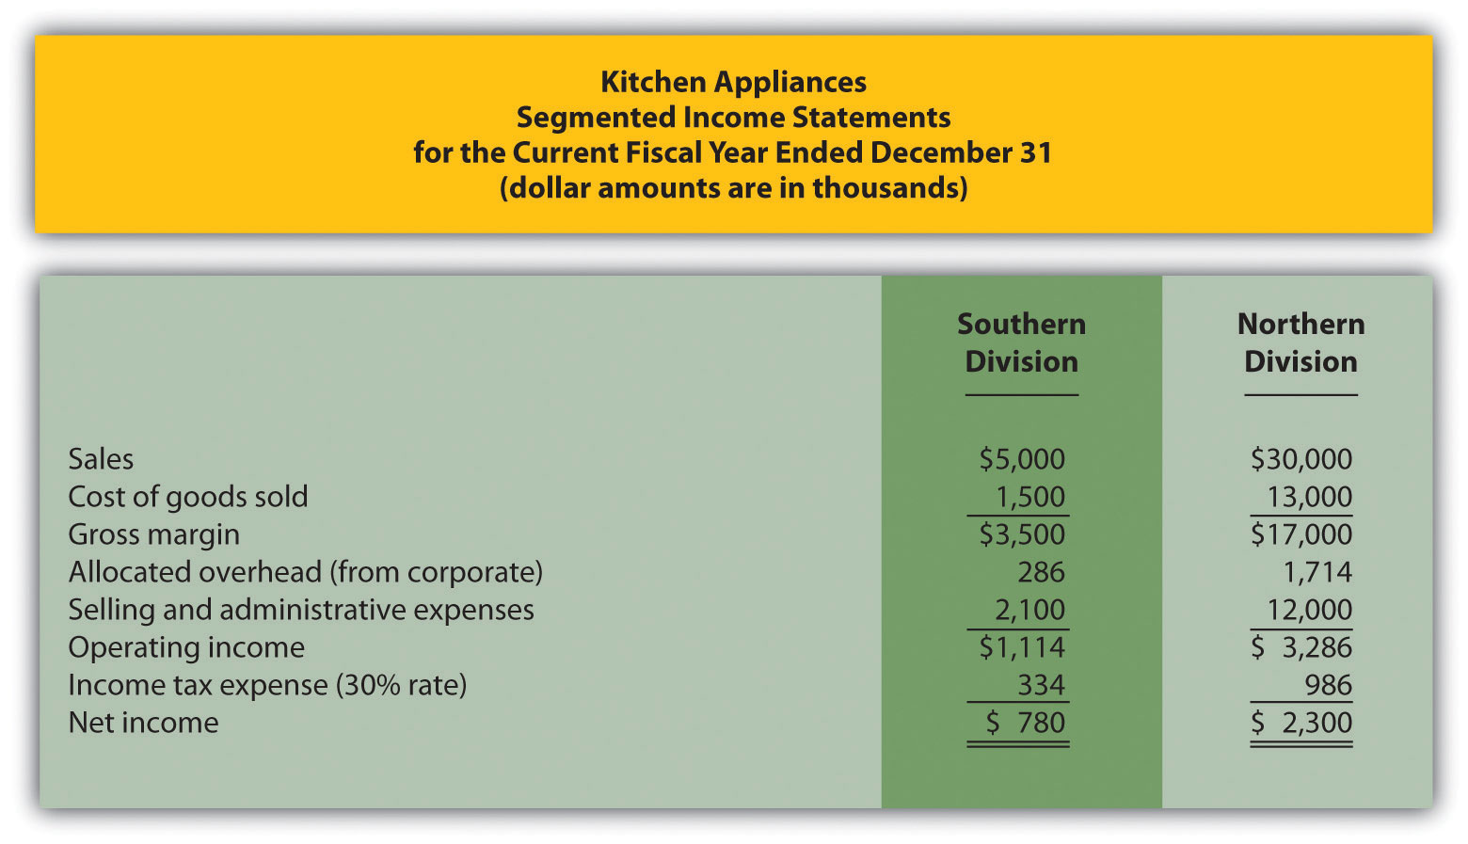
- The Northern division is most profitable with net income of $2,300,000 versus net income of $780,000 in the Southern division. Using net income to evaluate which division is most profitable can be misleading because it does not consider the amount of assets needed to produce income. For example, the Northern division may have invested considerably less in assets to produce net income of $780,000.
Another reason this may be misleading is no consideration is given to the dollar amount of sales required to produce the net income for each division. Clearly the Northern division has significantly higher sales ($30,000,000 versus $5,000,000 for the Southern division) and therefore should have significantly higher net income.
- The profit margin ratio for the Southern division is 15.60 percent (= $780,000 net income ÷ $5,000,000 sales), and the profit margin ratio for the Northern division is 7.67 percent (= $2,300,000 net income ÷ $30,000,000). This shows that each dollar in sales at the Southern division generates more net income (15.60 cents) than at the Northern division (7.67 cents).
Organizations prefer to use the profit margin ratio when comparing segments because it serves as an equalizer in comparing divisions with significantly different levels of sales revenue.

11.4 Using Return on Investment (ROI) to Evaluate Performance

LEARNING OBJECTIVE
- Calculate and interpret return on investment (ROI) to evaluate performance.

Question: Perhaps the most common measure of performance for managers responsible for investment centers is return on investment (ROI). What is ROI, and how is it used to evaluate investment centers?

Answer: ROI is defined as operating income divided by average operating assets:

Key Equation
Return on investment=Operating incomeAverage operating assets

Note that different organizations use different measures to calculate ROI. Our goal in this discussion is to introduce one common approach, but keep in mind that organizations often make adjustments to this formula to better suit their needs.

The advantage of ROI as a performance measure is that it includes the use of assets. For example, assume 2 divisions have $10,000 in operating income. Both divisions appear to have performed equally well based on operating income. However, further review shows that Division 1 invested $200,000 in average operating assets to produce this income while Division 2 invested $400,000. Clearly, the division that invested half the amount in assets to produce the same amount of income had the best performance of the two. Comparing the ROI for each division proves this:
ROI for Division 1ROI for Division 2=$10,000$200,000=5%=$10,000$400,000=2.5%

Let’s take a closer look at the components of the ROI calculation, operating income and average operating assets.

Operating Income and Average Operating Assets

Question: What is operating income, and how does it differ from net income?

Answer: Operating income is the income produced by the division from its daily activities. It excludes items used in the calculation of net income, such as income tax expense, interest income, interest expense, and any unusual gains or losses. The focus is on how well the division performed relative to its core business operations, which does not include one-time gains or losses from the sale of property, plant, and equipment for example.

Question: What are average operating assets, and how is this amount calculated?

Answer: Average operating assets are the assets that the division has in place to run the daily operations of the business, and this value is calculated by adding beginning period balances and ending period balances and dividing by two. Examples of operating assets include cash, accounts receivable, prepaid assets, buildings, and equipment. As long as the division uses the assets to produce operating income, they are included in the operating assets category. Examples of nonoperating assets—assets not included in this calculation—include land held for investment purposes and office buildings leased to other companies.

An average of operating assets is taken over the period being evaluated for two reasons. First, operating assets are often purchased and sold during an accounting period, and simply taking the ending balance might produce distorted, if not inaccurate, results. Second, operating income represents information for a period of time (income statements always present information for a period of time), while operating assets are presented at a point in time (balance sheets always present information for a point in time). If both of these items are to be included in one ratio (ROI), it is best to use average balance information for balance sheet items. In fact, if the information is readily available, it would be best to take an average of daily operating asset balances for the period being evaluated.

Computing ROI at Game Products, Inc.

Question: Using ROI as the measure, how do the divisions at Game Products, Inc., compare with each other?

Answer: Figure 11.3 "Segmented Income Statements (Game Products, Inc.)"shows segmented income statement information for each of Game Products’ three divisions. The operating income line of this income statement provides information needed for the numerator of the ROI calculation. Figure 11.4 "Segmented Balance Sheets (Game Products, Inc.)" presents the segmented balance sheets for each division needed to calculate average operating assets.

Figure 11.4 Segmented Balance Sheets (Game Products, Inc.)
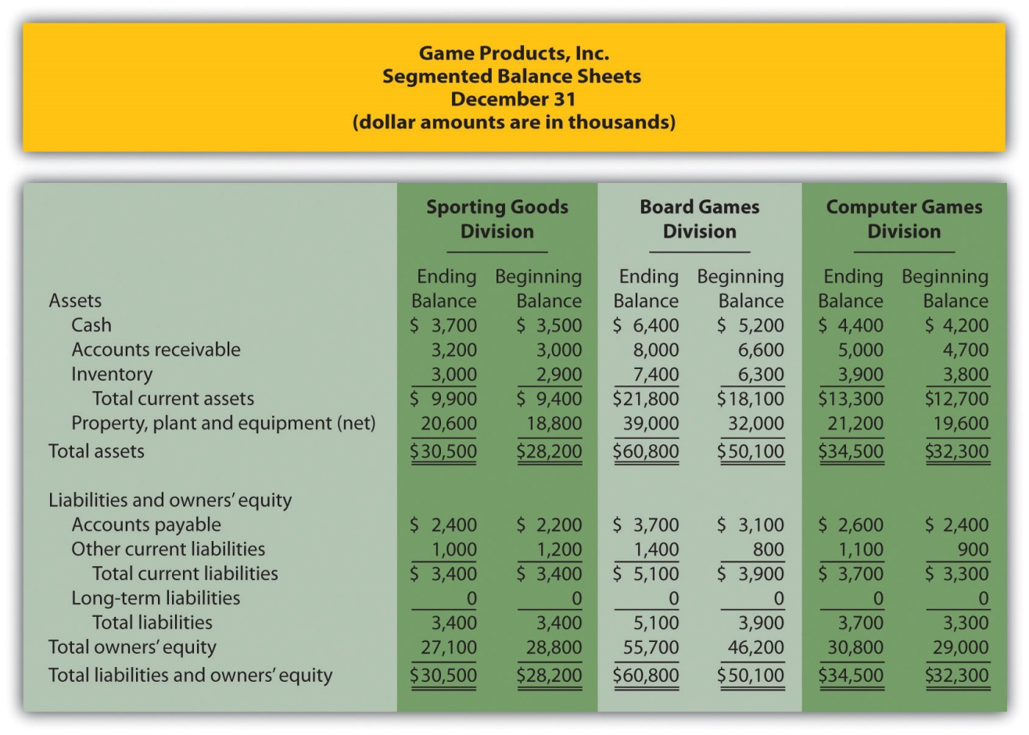

Let’s see how each division ranks using ROI. Assume all assets at Game Products, Inc., are operating assets. We use the information in Figure 11.3 "Segmented Income Statements (Game Products, Inc.)" and Figure 11.4 "Segmented Balance Sheets (Game Products, Inc.)" to calculate the ROI for each division in Figure 11.5 "ROI Calculations (Game Products, Inc.)".

Figure 11.5 ROI Calculations (Game Products, Inc.)
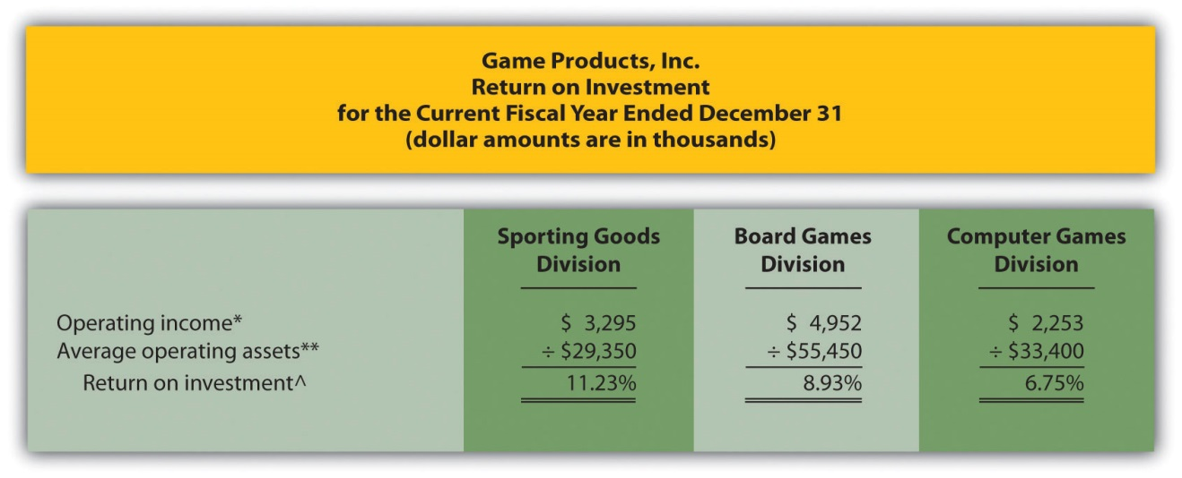

*Operating income amount is from segmented income statements presented inFigure 11.3 "Segmented Income Statements (Game Products, Inc.)".

**Average operating assets are calculated using the balance sheet information in Figure 11.4 "Segmented Balance Sheets (Game Products, Inc.)". Since all assets at Game Products, Inc., are operating assets, total asset amounts are used in this calculation. The calculation of average operating assets for each division is (Beginning balance of total assets + Ending balance of total assets) ÷ 2. Average operating assets for the Sporting Goods division is $29,350 (= [$30,500 + $28,200] ÷ 2).

^ROI = Operating income ÷ Average operating assets. For Sporting Goods division, 11.23 percent = $3,295 ÷ $29,350.

The ROI measures presented in Figure 11.5 "ROI Calculations (Game Products, Inc.)" show that although the Board Games division has the highest operating income, its ROI ranks in the middle of the three divisions. The Sporting Goods division has the highest ROI at 11.23 percent, Board Games is second at 8.93 percent, and Computer Games is the lowest at 6.75 percent. Since managers of each division are responsible for maximizing profit based on investments they make in assets, ROI is a reasonable approach to evaluating each manager. The Sporting Goods division manager appears to be outperforming the other two managers based on this measure.

Issues with ROI as a Performance Measure

Like most financial measures of performance, ROI can be calculated in several different ways. The components of this calculation often vary from one organization to the next. These variations are discussed next.

Operating Income Calculation—A Closer Look

Question: For the purposes of the Game Products, Inc., example, we use the same definition of operating income that is used for financial reporting purposes in accordance with U.S. GAAP. However, organizations often create their own unique calculation of operating income for internal evaluation purposes. How might the internal calculation of operating income vary from U.S. GAAP?

Answer: There are several variations that organizations use when calculating operating income. Two of the more common variations are discussed next.

Excluding Allocated Overhead

The segmented income statements for Game Products, Inc., are presented again in Figure 11.6 "Segmented Income Statements (Game Products, Inc.)"(these are the same segmented income statements as in Figure 11.3 "Segmented Income Statements (Game Products, Inc.)"). Notice the expense line item labeled allocated overhead (from corporate). Although we include this expense in calculating operating income, many organizations do not, particularly if division managers have no control over allocated overhead. Excluding allocated overhead has the effect of increasing ROI for each division manager and holds each division manager responsible only for expense amounts that are controllable.

Figure 11.6 Segmented Income Statements (Game Products, Inc.)
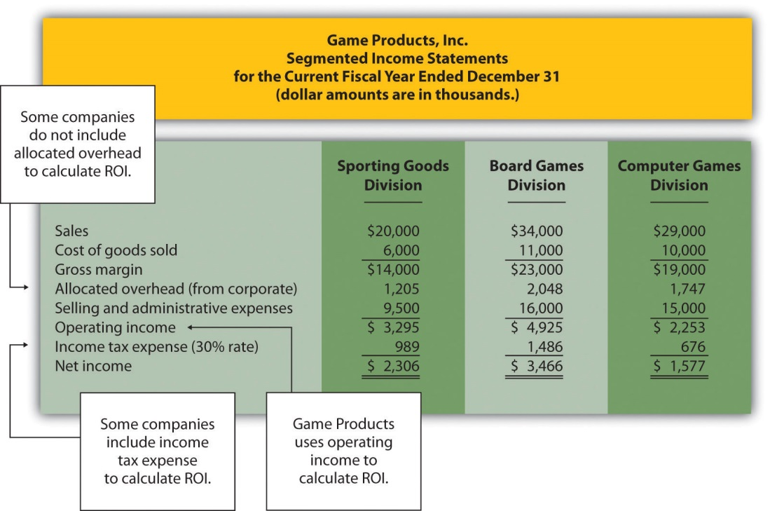

Including Income Tax Expense

Review Figure 11.6 "Segmented Income Statements (Game Products, Inc.)"and notice the line item labeled income tax expense. Although we do not include income tax expense in the operating income calculation, some organizations prefer to include this item. Including after-tax expense reduces ROI for each division manager (assuming each division is profitable).

The point here is that the needs of management determine how to define operating income. We will use the U.S. GAAP definition, presented as operating income in Figure 11.6 "Segmented Income Statements (Game Products, Inc.)", throughout this chapter unless indicated otherwise.

Average Operating Assets Calculation—A Closer Look

Question: For Game Products, Inc., we assume all assets are operating assets. That is, all assets are used in the daily operations of the business. As discussed earlier, assets that are not used in the daily operations of the business, such as land held for investment or buildings sublet to other companies, are not included in this calculation. The average is found by taking the beginning balance plus ending balance and dividing by two. The issue in this calculation focuses on long-term assets that are depreciated over time. What options exist in valuing long-term assets for the purpose of calculating ROI?

Answer: There are two common approaches to valuing long-term assets when calculating ROI. Each approach is discussed next.

Using Net Book Value to Calculate ROI

In the Game Products, Inc., example, we use the net book value of long-term assets to calculate operating assets. That is, accumulated depreciation is subtracted from the original cost on the segmented balance sheet in accordance with U.S. GAAP. The balance sheet presented in Figure 11.4 "Segmented Balance Sheets (Game Products, Inc.)" shows this in the line item labeled property, plant, and equipment, net. The advantage of using net book value is that the information is easily obtained from the financial records.

The problem with this approach is division managers with older assets that have been substantially depreciated have an advantage over division managers with newer assets that have not been significantly depreciated. Older assets have a lower net book value (cost – accumulated depreciation) than newer assets, which reduces average operating assets in the denominator and increases ROI.

For example, assume two divisions have identical operating income for the year and identical assets. However, Division 1 has been in operation for many more years than Division 2 and thus has far more accumulated depreciation on long-term assets. This results in a lower net book value on long-term assets for Division 1 as shown in the following:
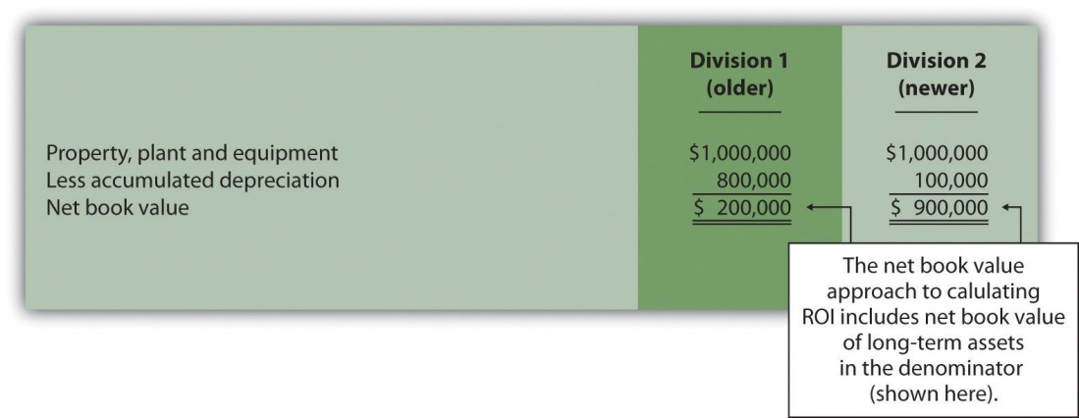

Assuming all other assets are identical, and both divisions have identical operating income, Division 1 will have a higher ROI simply because long-term assets are older and have more accumulated depreciation, thereby reducing average operating assets in the denominator. (Reducing the denominator increases the ratio.)

An additional weakness in using net book value to calculate average operating assets is the disincentive it creates for division managers to replace old and inefficient long-term assets, such as equipment and machinery. Although new equipment purchases may be needed to improve efficiency and to remain competitive, the short-term impact is to reduce ROI. (Older equipment will have a lower net book value than identical newer equipment. Thus replacing old equipment will decrease ROI.)

If division managers are evaluated based on ROI, using net book value tends to discourage investments in long-term assets, often at the expense of the organization’s long-term profitability.

Using Gross Book Value to Calculate ROI

An alternative approach in calculating ROI is to use gross book value in the average operating assets calculation. Gross book value simply refers to the original cost of long-term assets and ignores accumulated depreciation.

In our example of two divisions with identical assets and identical operating income, the same original cost amount is used in calculating average operating assets. Division 2 is not penalized in the denominator for having newer assets and less accumulated depreciation.
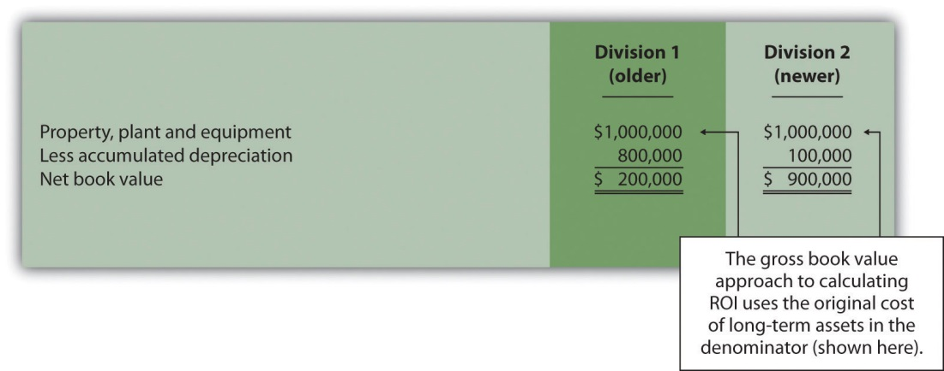

Although both net book value and gross book value are used in practice, we will use net book value throughout this chapter unless indicated otherwise. “Key Equation: Variations of ROI Calculation” summarizes the issues surrounding the calculation of ROI.

Key Equation
Variations of ROI Calculation
Return on investment=Operating income*Average operating assets**
*The U.S. GAAP definition of operating income is used for the numerator. However, organizations often calculate operating income differently. Some exclude allocated overhead while others may include income tax expense to get after-tax operating income.
**Average operating assets includes only those assets used in the daily operations of the business. Long-term assets are valued at net book value. However, valuation of long-term assets varies from one organization to the next. Some use gross book value rather than net book value.

Business in Action 11.4
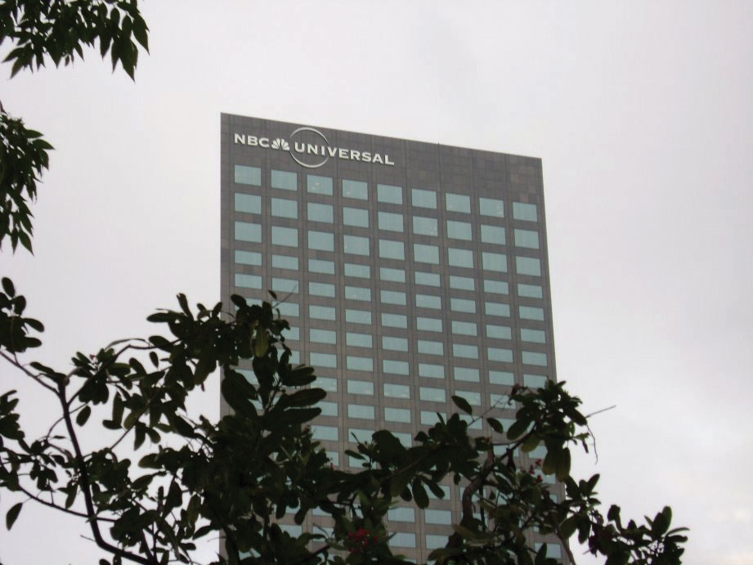
Source: Photo courtesy of Rod Ramsey,http://www.flickr.com/photos/rdrcollection/2078536386/
Internal Performance Measures at General Electric
General Electric Company provides financial information for six segments in its annual report. Segments include Infrastructure, Commercial Finance, GE Money, Healthcare, NBC Universal, and Industrial. The company’s annual report indicates that “segment profit is determined based on internal performance measures used by the Chief Executive Officer to assess the performance of each business in a given period. Segment profit excludes or includes interest and other financial charges and segment income taxes according to how a particular segment’s management is measured.”
This statement reaffirms the point that companies tailor performance measures to meet the needs of each individual segment. For example,General Electric excludes interest and other financial charges in measuring segment net income for some segments, such as Healthcare, NBC Universal, and Industrial, while including interest and financial charges for other segments, such as Commercial Finance and GE Money.
Source: General Electric, “2006 Annual Report,” http://www.ge.com.

REVIEW PROBLEM 11.4
This is a continuation of Note 11.18 "Review Problem 11.3" for Kitchen Appliances. Recall that Kitchen Appliances has two divisions broken out by region—a Southern division and a Northern division. The following segmented income statement is for the most recent fiscal year ended December 31 (you were asked to prepare this income statement in Note 11.18 "Review Problem 11.3").
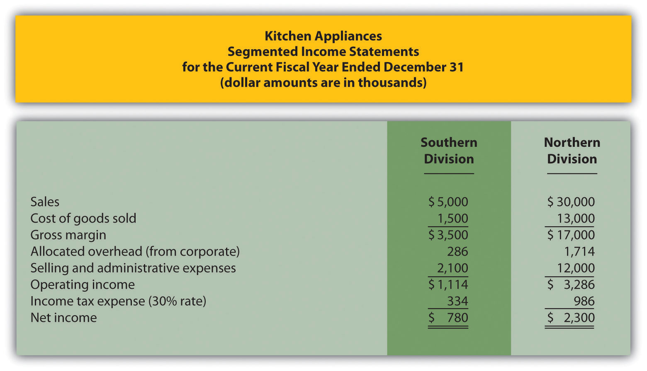
Segmented balance sheets for Kitchen Appliances appear as follows.
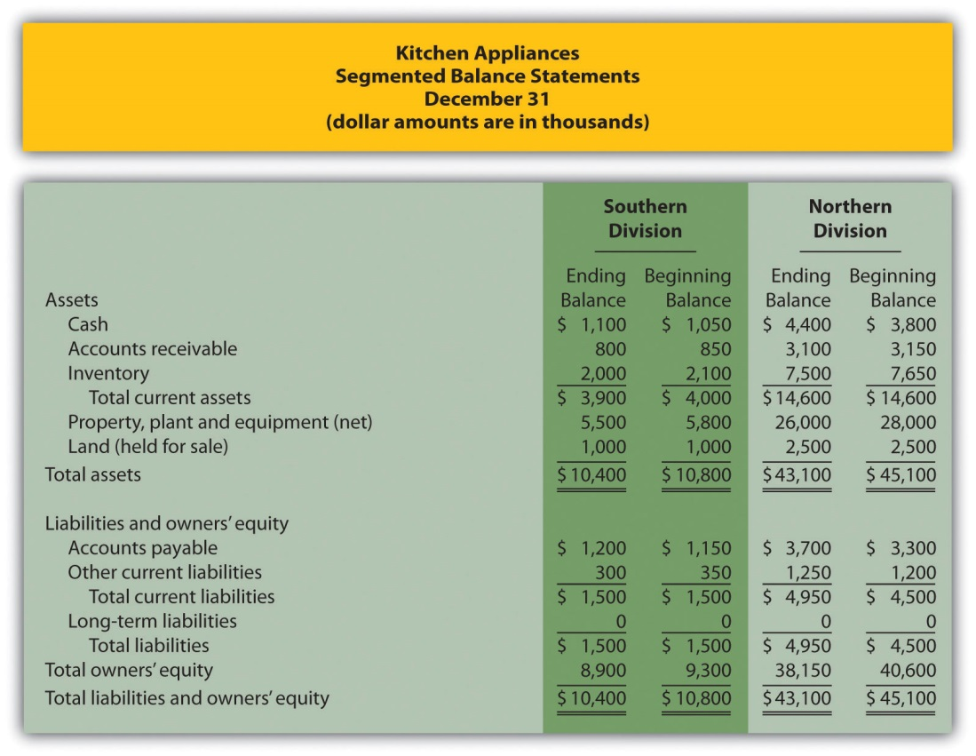
- Calculate average operating assets for each division. (Hint: land held for sale is not an operating asset.)
- Calculate ROI for each division.
- What does the ROI tell you about each division at Kitchen Appliances?
Solution to Review Problem 11.4
(All dollar amounts are in thousands.)
- Average operating assets are calculated in the following. Note that land held for sale is not an operating asset and thus must be deducted from total assets to find operating assets.
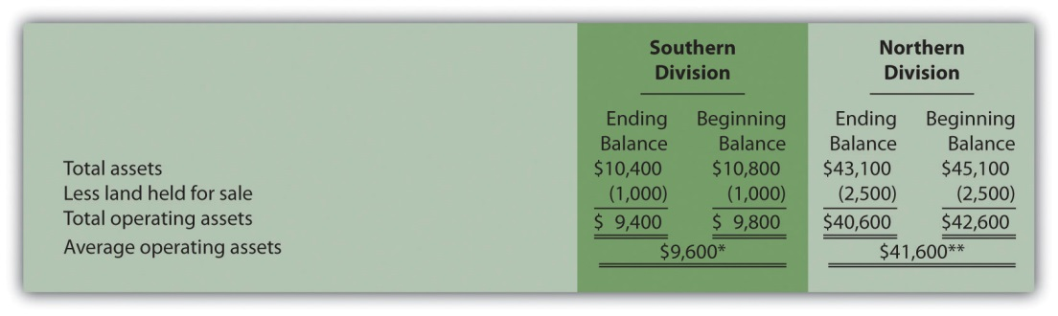
*$9,600 = ($9,400 ending balance + $9,800 beginning balance) ÷ 2.
**$41,600 = ($40,600 ending balance + $42,600 beginning balance) ÷ 2.
- ROI is calculated as follows:
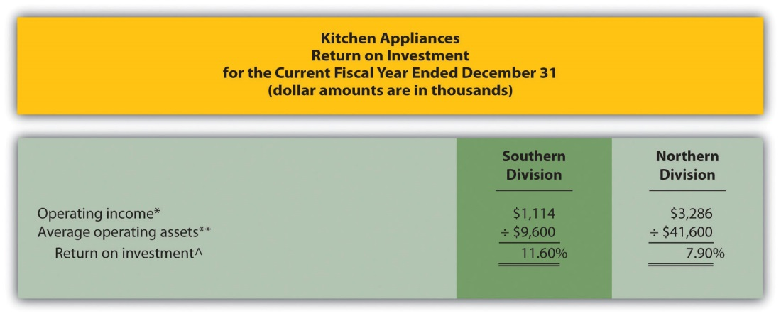
*Operating income is provided in the segmented income statement.
**Average operating assets is calculated in requirement 1.
^ROI = Operating income ÷ Average operating assets. For Southern division, 11.60 percent = $1,114 ÷ $9,600.
- The Southern division of Kitchen Appliances has the highest ROI at 11.60 percent. The Northern division’s ROI is 7.90 percent. This measure indicates the Southern division is making more profitable use of its assets than the Northern division.

Further Analysis of ROI

Question: How does breaking ROI down into two separate measures help division managers improve their division’s ROI?

Answer: Many companies break ROI down into two ratios; operating profit margin and asset turnover. Each of these measures can be used to evaluate strengths and weaknesses of ROI within each division.

Key Equation
Operating profit margin=Operating incomeSales

Key Equation
Asset turnover=SalesAverage operating assets

Operating profit margin is the ratio of operating income to sales. It provides information about how much operating profit is being produced for each dollar of sales. Asset turnover is the ratio of sales to average operating assets. It provides information about how much revenue each dollar invested in average operating assets produces.

These two ratios can be multiplied by each other to find the ROI as follows:

Key Equation
Return onInvestment=ROIOperating incomeAverage operating assets==Operatingprofit marginOperating incomeSales××AssetturnoverSalesAverage operating assets

Breaking out ROI into these two ratios provides information that helps division managers identify areas for improvement. ROI can be improved by increasing the operating profit margin, which focuses solely on income statement information. ROI can also be improved by increasing asset turnover, which focuses on the division’s use of operating assets to produce sales.

Question: How are these ratios used to evaluate the three divisions at Game Products, Inc.?

Answer: Operating profit margin, asset turnover, and ROI calculations for Game Products, Inc., are shown in Figure 11.7 "Operating Profit Margin, Asset Turnover, and ROI for Game Products, Inc.". Notice the resulting ROI for each division is the same as the ROI shown in Figure 11.5 "ROI Calculations (Game Products, Inc.)" except for slight differences attributed to rounding.

Figure 11.7 Operating Profit Margin, Asset Turnover, and ROI for Game Products, Inc.
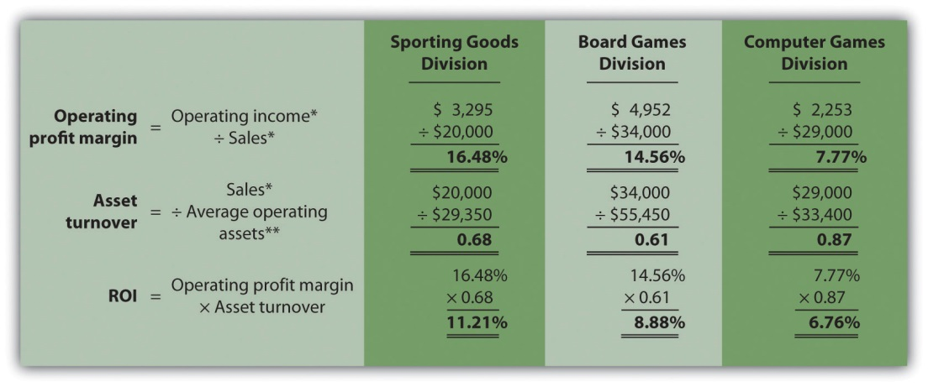

*From Figure 11.3 "Segmented Income Statements (Game Products, Inc.)".

**From Figure 11.5 "ROI Calculations (Game Products, Inc.)".

Figure 11.7 "Operating Profit Margin, Asset Turnover, and ROI for Game Products, Inc." shows that Sporting Goods has the highest operating profit margin at 16.48 percent compared to Board Games (14.56 percent) and Computer Games (7.77 percent). However, Computer Games has the highest asset turnover at 0.87 compared to Sporting Goods (0.68) and Board Games (0.61).

This information helps each division manager identify strengths and weaknesses. For example, the Computer Games division has excellent asset turnover relative to other divisions, but has a very low profit margin. The manager of this division must look for ways to improve the profit margin for its products (e.g., increase prices, reduce operating expenses, or both).

Another example is the Sporting Goods division, which has an excellent profit margin, but relatively low asset turnover. The manager of this division must look at ways to improve the utilization of assets to increase turnover.

KEY TAKEAWAY
- ROI is defined as operating income divided by average operating assets as shown in the following equation:
Return on investment=Operating incomeAverage operating assets
This measure provides an assessment of how effectively each division is using operating assets to produce operating income. ROI can also be broken into two separate ratios, operating profit margin and asset turnover, which are multiplied together to get ROI as follows:
Return onInvestment=Operating incomeAverage operating assets=Operatingprofit marginOperating incomeSales××AssetturnoverSalesAverage operating assets
Many variations of the ROI calculation are used in practice depending on the nature of the organization.

REVIEW PROBLEM 11.5
Use the information in Note 11.26 "Review Problem 11.4" for Kitchen Appliances to complete the following requirements.
- Calculate the operating profit margin, asset turnover, and ROI.
- Which division has the highest ROI? Explain how the two ratios—operating profit margin and asset turnover—influenced the ROI for each division.
Solution to Review Problem 11.5
(All dollar amounts are in thousands.)

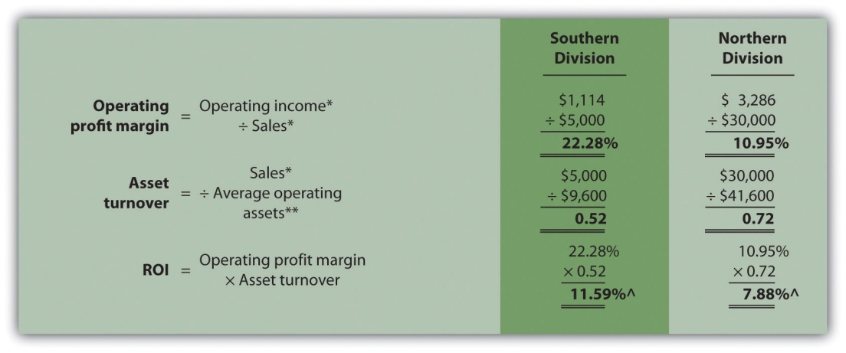
*From Note 11.26 "Review Problem 11.4" data.
**From Note 11.26 "Review Problem 11.4" solutions, part 1.
^Due to rounding, ROI percent is slightly different than when computed inNote 11.26 "Review Problem 11.4".
- The Southern division has the highest ROI (11.59 percent versus 7.88 percent at the Northern division), largely attributed to the high operating profit margin (22.28 percent versus 10.95 percent at the Northern division). However, the Southern division has the lowest asset turnover at 0.52 compared to 0.72 at the Northern division. The manager of the Northern division must look for ways to improve the profit margin for its products (e.g., increasing prices and/or reducing operating expenses). Conversely, the manager of the Southern division must look at ways to improve the utilization of assets to increase turnover.

11.5 Using Residual Income (RI) to Evaluate Performance

LEARNING OBJECTIVE
- Calculate and interpret residual income (RI) to evaluate performance.

Question: Although ROI is commonly used as a divisional performance measure, some division managers dislike this measure. Why do some division managers prefer not to use ROI as a performance measure?

Answer: Some managers dislike ROI because it can lead to decisions that benefit the division but hurt the organization as a whole. Division managers have an incentive to turn down investments that exceed the company’s minimum required rate of return but are below the division’s current ROI, mainly because ROI trends are often used to evaluate managers. For example, assume the manager of a division is evaluated based on ROI, and the division currently has an ROI of 20 percent:

ROI before new investment=Operating incomeAverage operating assets=$20,000$100,000=20%

The company’s minimum required rate of return is 10 percent, and the division manager is presented with an investment opportunity expected to yield an ROI of 15 percent. This investment totals $70,000 and annual operating profit will be $10,500 (15 percent ROI = $10,500 ÷ $70,000). Although this investment is well above the company’s minimum required rate of return, the division manager will likely not make the investment since the division’s overall ROI will decline from 20 percent to 17.9 percent:

ROI after new investment= $20,000 + $10,500$100,000 + $70,000=$30,500$170,000=17.9%

If evaluated solely based on ROI, the division manager would prefer to invest only in projects that increase the division’s ROI above 20 percent. In fact, the division manager has an incentive to shed all investments yielding less than 20 percent, even if the investments are producing a return above the company’s minimum requirement of 10 percent. An alternative measure to ROI, called residual income (RI), helps to mitigate this apparent conflict.

Calculating RI

Question: What is RI, and how does it help to prevent the conflict associated with ROI?

Answer: RI is the dollar amount of division operating profit in excess of the division’s cost of acquiring capital to purchase operating assets. The calculation is as follows:

Key Equation
Residualincome=Operatingincome−(Percent costof capital × Averageoperating assets)

Rather than using a ratio to evaluate performance, RI uses a dollar amount. As long as an investment yields operating profit higher than the division’s cost of acquiring capital, managers evaluated with RI have an incentive to accept the investment. The manager’s goal is to increase RI from one period to the next.

Notice that operating income and average operating assets used here to calculate RI are the same measures used in the ROI calculation presented earlier. The one new item, percent cost of capital, is the company’s percentage cost to obtain investment funds (often called capital). For example, a company that raises funds by issuing bonds would use the interest rate associated with the bonds in establishing its percent cost of capital. We will always provide the percent cost of capital in this chapter, leaving detailed discussions of its calculation to more advanced courses. Note that several sources provide cost of capital information by industry. One source is the Leonard N. Stern School of Business at New York University (http://pages.stern.nyu.edu/~adamodar/New_Home_Page/datafile/wacc.htm).

Let’s take another look at the division that rejected an investment yielding an ROI higher than the company’s minimum required rate of return of 10 percent but lower than the division’s current ROI of 20 percent. Assume the company’s percent cost of capital is the same as its minimum required rate of return of 10 percent. Three RI calculations are provided as follows, (1) RIbefore the new investment, (2) RI from the new investment, and (3) RI afterthe new investment. (Note that some organizations make adjustments to the cost of capital to determine the minimum required rate of return. Throughout this chapter, assume percent cost of capital is the same asminimum required rate of return unless stated otherwise.)

Residual income before new investment=$20,000−(10%×$100,000)=$20,000−$10,000=$10,000

Residual income from new investment=$10,500−(10%×$70,000)=$10,500−$7,000= $3,500

Residual income after new investment=$30,500−(10%×$170,000)=$30,500−$17,000=$13,500

Since the manager’s goal is to continually increase RI, the proposed investment would be accepted resulting in an increase of $3,500 in RI (= $13,500 − $10,000). As shown in this example, using RI as a performance measure is an effective way to minimize the conflict between company goals and division goals that arise using ROI. Rather than maximizing ROI, division managers focus on increasing RI. Managers are more likely to accept investment proposals that have a return greater than the company’s minimum required rate of return, regardless of the impact on the division’s ROI.

Limitation of RI

Question: Although RI resolves some of the problems of using ROI as a performance measure, it does not provide an efficient means for comparing divisions. What is the problem with using RI to compare divisions?

Answer: Similar to the problem encountered with using segmented net income to compare divisions, RI is stated in dollars (or some other currency) rather than as a ratio. One division may have high RI simply because it has a larger asset base, which produces higher revenues. Thus division managers should be evaluated based on how effectively they increase RI from one period to the next, perhaps in percentage growth, and not on how their RI compares to other divisions.

Most organizations that use RI also use ROI. Using both measures has the benefit of comparing one division to another by using ROI and minimizes the conflict between company goals and division goals by using RI.

Computing RI at Game Products, Inc.

Question: Let’s revisit Game Products, Inc., and calculate RI for each of the three divisions. How did the three divisions perform using RI as the measure?

Answer: Figure 11.8 "RI Calculations (Game Products, Inc.)" shows the RI calculation for each division at Game Products, Inc., assuming a cost of capital of 8 percent. Notice that Sporting Goods and Board Games have positive RI, which indicates both divisions are producing operating income above and beyond the minimum required rate of return. Since the Computer Games division has negative RI, this division is not producing enough operating income to achieve the minimum required rate of return.

Having positive RI is reasonable for Sporting Goods and Board Games since both divisions have an ROI above the 8 percent minimum required rate of return (as shown back in Figure 11.7 "Operating Profit Margin, Asset Turnover, and ROI for Game Products, Inc."). It is also reasonable that Computer Games has negative RI since the division’s ROI is less than 8 percent.

Figure 11.8 RI Calculations (Game Products, Inc.)
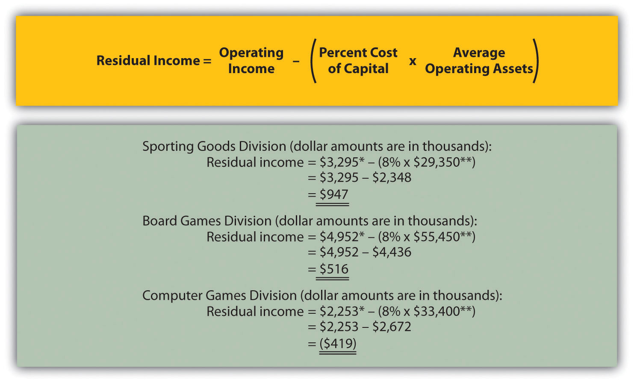

*From Figure 11.3 "Segmented Income Statements (Game Products, Inc.)".

**From Figure 11.5 "ROI Calculations (Game Products, Inc.)".

KEY TAKEAWAY
- RI is the dollar amount of division operating profit in excess of the division’s cost of acquiring capital to purchase its operating assets. The calculation is as follows:
Residualincome=Operatingincome−(Percent costof capital × Averageoperating assets)
Operating income and average operating assets used to calculate ROI are also used here to calculate RI. The percent cost of capital is new and represents the company’s percentage cost to obtain investment funds. The goal is for each division manager to increase RI over time.

REVIEW PROBLEM 11.6
This is a continuation of the Kitchen Appliances example presented inNote 11.18 "Review Problem 11.3", Note 11.26 "Review Problem 11.4", andNote 11.33 "Review Problem 11.5". Financial information for Kitchen Appliances is provided again as follows. Assume the cost of capital rate is 6 percent.
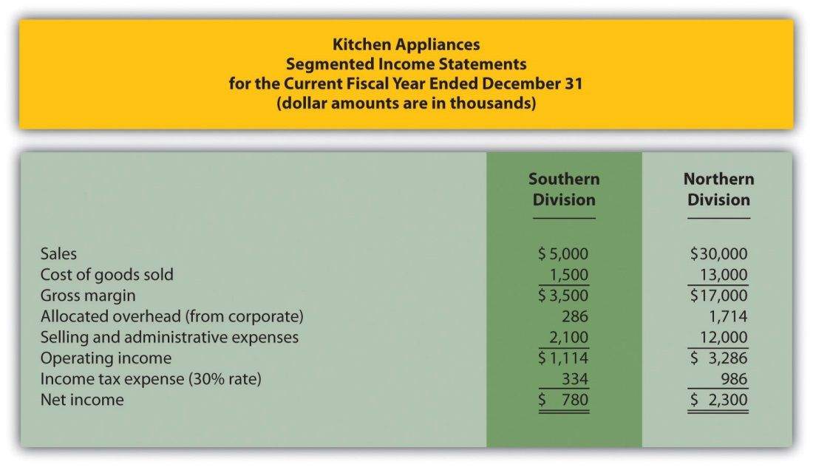
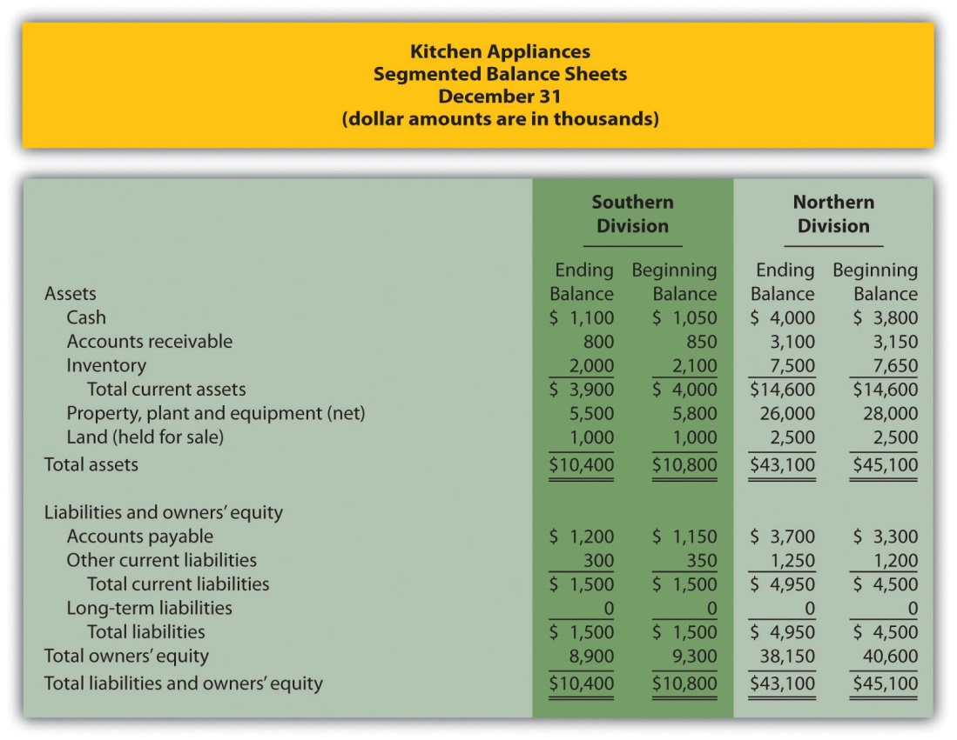
- Calculate RI for each division.
- How should this information be used to evaluate each division manager?
Solution to Review Problem 11.6
- All dollar amounts are in thousands.
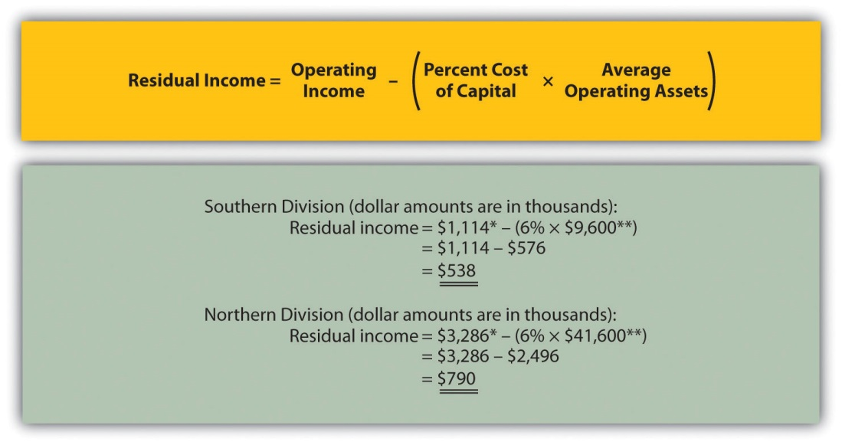
*From Note 11.26 "Review Problem 11.4" data.
**From Note 11.26 "Review Problem 11.4" solutions, part 1.
- Although the Northern division has higher RI ($790,000) than the Southern division ($538,000), it is not enough to simply conclude that the Northern division manager is performing better than the Southern division manager. The goal for each manager is to continually increase RI over time. Thus Kitchen Appliances should compare RI for each division to prior periods and reward division managers for significant increases from one period to the next.

11.6 Using Economic Value Added (EVA) to Evaluate Performance

LEARNING OBJECTIVE
- Calculate and interpret economic value added (EVA) to evaluate performance.
Question: Another measure of performance similar to residual income (RI) is called economic value added. What is economic value added, and how is it used to evaluate divisions?

Answer: Economic value added (EVA) was created and trademarked byStern Stewart & Company, a management consulting firm, and is defined as follows (additional information can be found at Stern Stewart & Company’s Web site: http://www.sternstewart.com).

Key Equation
Economicvalue added=Net operating profitafter taxesadjusted−(Percent costof capital × Average operatingassetsadjusted)
Although the calculation is similar to RI, adjustments are made to the financial information to better reflect the economic results of the division.Stern Stewart & Company created EVA to provide financial information without the “anomalies” that result from following U.S. GAAP. One example of an anomaly is the expensing of research and development (R&D) costs even though R&D breakthroughs often benefit companies in future years.
There are two distinct differences in calculating EVA compared to RI. First, operating profit is calculated net of income taxes. Finding operating incomeafter taxes simply requires deducting income taxes from operating income. Second, adjustments are made to operating income and average operating assets. Although more than 150 possible adjustments can be made, most firms limit adjustments to 15 or less.
Three examples of adjustments to be considered when using EVA are related to research and development (R&D), advertising, and noninterest bearing current liabilities.
- Research and development. U.S. GAAP requires that R&D costs be expensed as incurred. However, R&D work typically benefits the company in future periods. EVA capitalizes R&D costs (that is, records these costs as a long-term asset) and amortizes these costs over the estimated useful life of R&D activities.
- Advertising. U.S. GAAP also requires that advertising costs be expensed as incurred. Since marketing efforts typically benefit the company in future periods, EVA capitalizes these costs and amortizes them over a period of time.
- Noninterest bearing current liabilities. EVA requires deducting noninterest bearing current liabilities from average operating assets. This is because current liabilities that do not require an interest payment are a free source of capital. For example, a company purchasing large amounts of inventory (an asset) on account has a free source of capital, which is presented as a noninterest bearing current liability on the balance sheet.
These three items are provided as examples of adjustments proposed by EVA advocates. However, the adjustments made depend on the organization since EVA calculations are modified to fit the needs of the organization.

Computing EVA for Game Products, Inc.
Question: How is EVA calculated for the divisions at Game Products, Inc.?

Answer: provides the segmented income statements and segmented balance sheet information for each division. These amounts were used earlier in the chapter to calculate segmented net income, ROI, and RI. Notice that research and development costs are now shown as a separate line item on the income statement, and average balances are shown on the balance sheet rather than beginning and ending balances. (Average balances are simply beginning balances plus ending balances divided by two.)
To simplify our analysis, we make only two adjustments—one for research and development and one for noninterest bearing current liabilities. The management believes research and development activities benefit future periods and would like to capitalize R&D costs and amortize these costs over several years. In addition, all current liabilities are noninterest bearing liabilities and as such will be deducted from average operating assets.
The impact of these two adjustments that must be made to the financial information presented in , described as follows, is shown in .
- Adjustment 1. On the balance sheet, capitalized R&D costs will increase average operating assets by the unamortized amount of $400,000 for Sporting Goods, $1,200,000 for Board Games, and $2,400,000 for Computer Games. On the income statement, R&D expense for the year shown in is added back to operating income; R&D amortization expense for one year will be deducted as an expense. R&D amortization expense for the year is $100,000 for Sporting Goods, $300,000 for Board Games, and $600,000 for Computer Games. (Note for the purposes of this chapter, amortization expense amounts will be given. Detailed calculations are left to more advanced cost accounting textbooks.)
Since net operating profit after taxes (NOPAT) is used in the EVA calculation, we must remember to calculate NOPAT after making the R&D adjustments. Also, assume this is the first year calculating EVA. Thus Game Products has decided not to make any adjustments related to previous years’ R&D expenditures.
- Adjustment 2. All current liabilities are noninterest bearing and thus are deducted from average operating assets. (Recall that all assets are considered operating assets at Game Products, Inc.)

Figure 11.9 Income Statement and Balance Sheet Information (Game Products, Inc.)
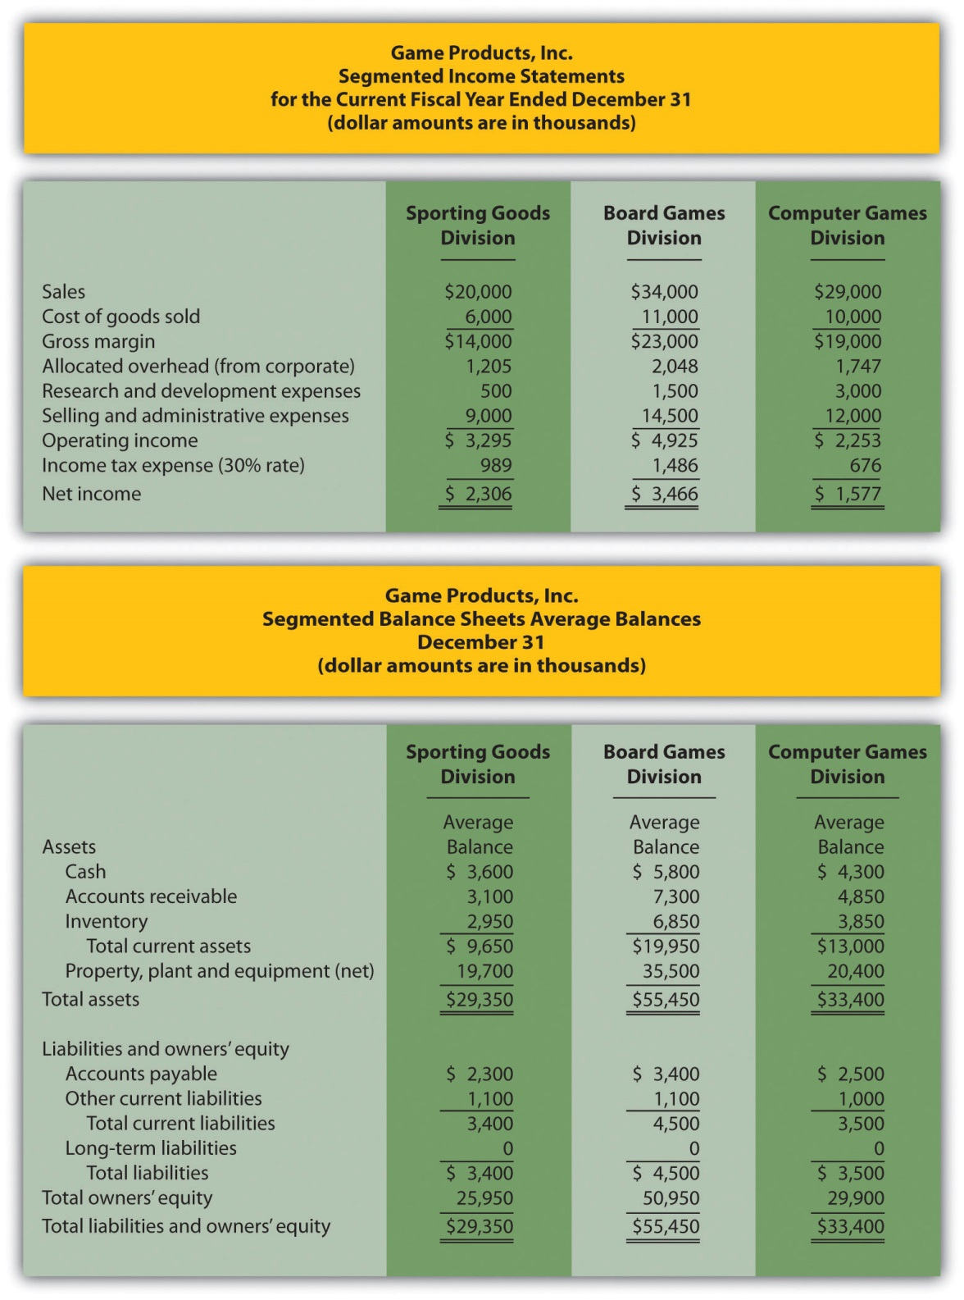
shows the adjustments, and the resulting EVA calculation for each division. Assume the company’s cost of capital rate is 8 percent. This is the same rate that was used for calculating RI.
Figure 11.10 EVA Calculations (Game Products, Inc.)
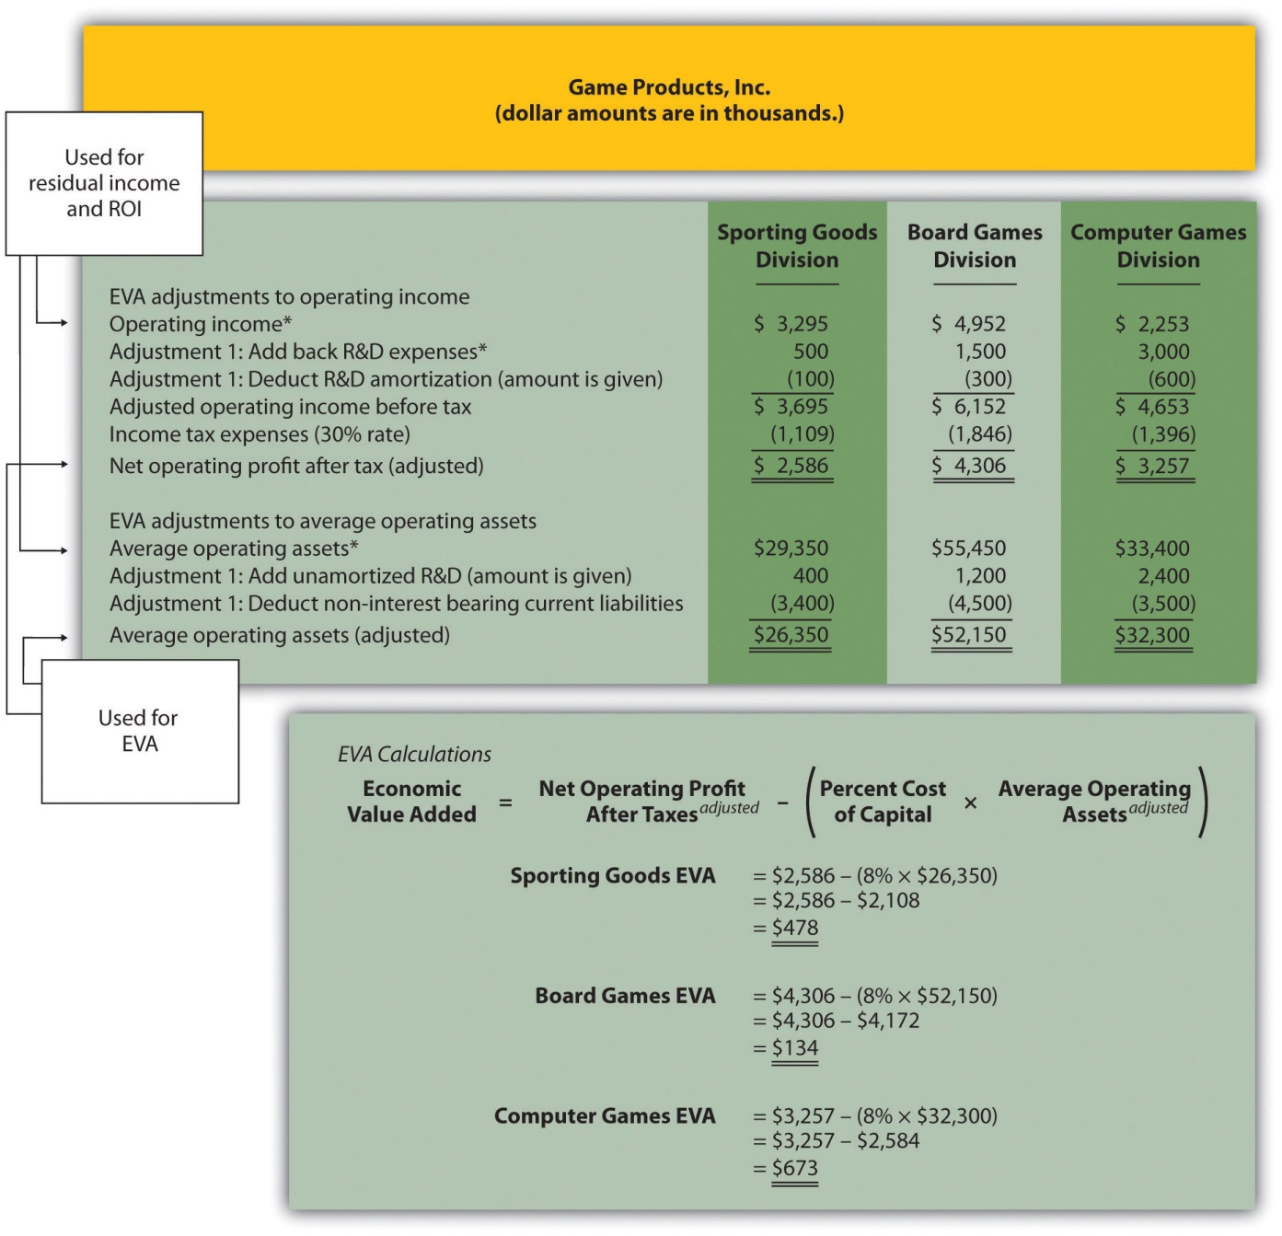
*From .

Question: How did each of the three divisions perform using EVA as the measure?

Answer: As shown at the bottom of , all three divisions have positive EVA amounts, which indicates all three have NOPAT (adjusted) in excess of each division’s cost of investment funds (adjusted).
Recall from the example in that Computer Games was the only division with negative RI. This negative amount turns to a positive amount using EVA mainly because research and development costs are capitalized and amortized over future years rather than expensed as incurred. Because the Computer Games division had significant research and development costs, and these costs were backed out and recorded as an asset using EVA, NOPAT (adjusted) increased significantly. This caused the EVA amount for Computer Games to become positive.

Weaknesses with EVA
Question: While EVA is no doubt a popular method for evaluating investment centers, and companies as a whole, there are weaknesses in its approach.What are these weaknesses?

Answer: As stated earlier, EVA is similar to RI except adjustments are made to operating income and average operating assets to offset accounting anomalies created by U.S. GAAP. Critics of EVA argue that U.S. GAAP was established for a variety of reasons, one of which was to provide a set of reasonable and objective accounting rules to be followed when recording economic events. Modifying U.S. GAAP to calculate EVA strays from the objectivity provided by U.S. GAAP.
For example, U.S. GAAP requires R&D and advertising costs to be expensed in the period incurred because it is very difficult and subjective to estimate the future benefit these activities may provide. EVA adjustments described earlier for R&D and advertising costs depart from U.S. GAAP. EVA recommends that these costs be capitalized and amortized over the useful life of the activity. This leads to different interpretations of what the useful life should be. Managers now have an incentive to stretch useful lives out as far as possible to minimize amortization expense taken each period.
As with any performance measure, EVA has advantages and disadvantages. The key is to develop a measure that promotes behavior desired by top management and to provide consistency in evaluating managers.

KEY TAKEAWAY
- EVA is simply an extension of RI. Adjustments are made to operating income and average operating assets. EVA is calculated as follows:
Economicvalue added=Net operating profitafter taxesadjusted−(Percent costof capital × Average operatingassetsadjusted)

REVIEW PROBLEM 11.7
This is a continuation of the Kitchen Appliances example used in previous review problems. Top management of Kitchen Appliances has decided to use EVA as a performance measure for its division managers. The cost of capital rate is 6 percent.
Assume management will make three adjustments to calculate EVA as follows:
- Adjustment 1. Marketing costs will be capitalized and amortized over several years. On the balance sheet, average operating assets will increase by the unamortized amount of $70,000 for the Southern division and $2,800,000 for the Northern division. On the income statement, marketing expense for the year will be added back to operating income; marketing amortization expense for one year will be deducted. Assume marketing amortization expense for the year is $30,000 for the Southern division and $1,200,000 for the Northern division. No adjustments will be made for previous years’ marketing expenditures.
- Adjustment 2. Land held for sale is not an operating asset and thus is deducted from average operating assets.
- Adjustment 3. All current liabilities are noninterest bearing and thus are deducted from average operating assets.
Segmented income statements and balance sheet average amounts are presented next.
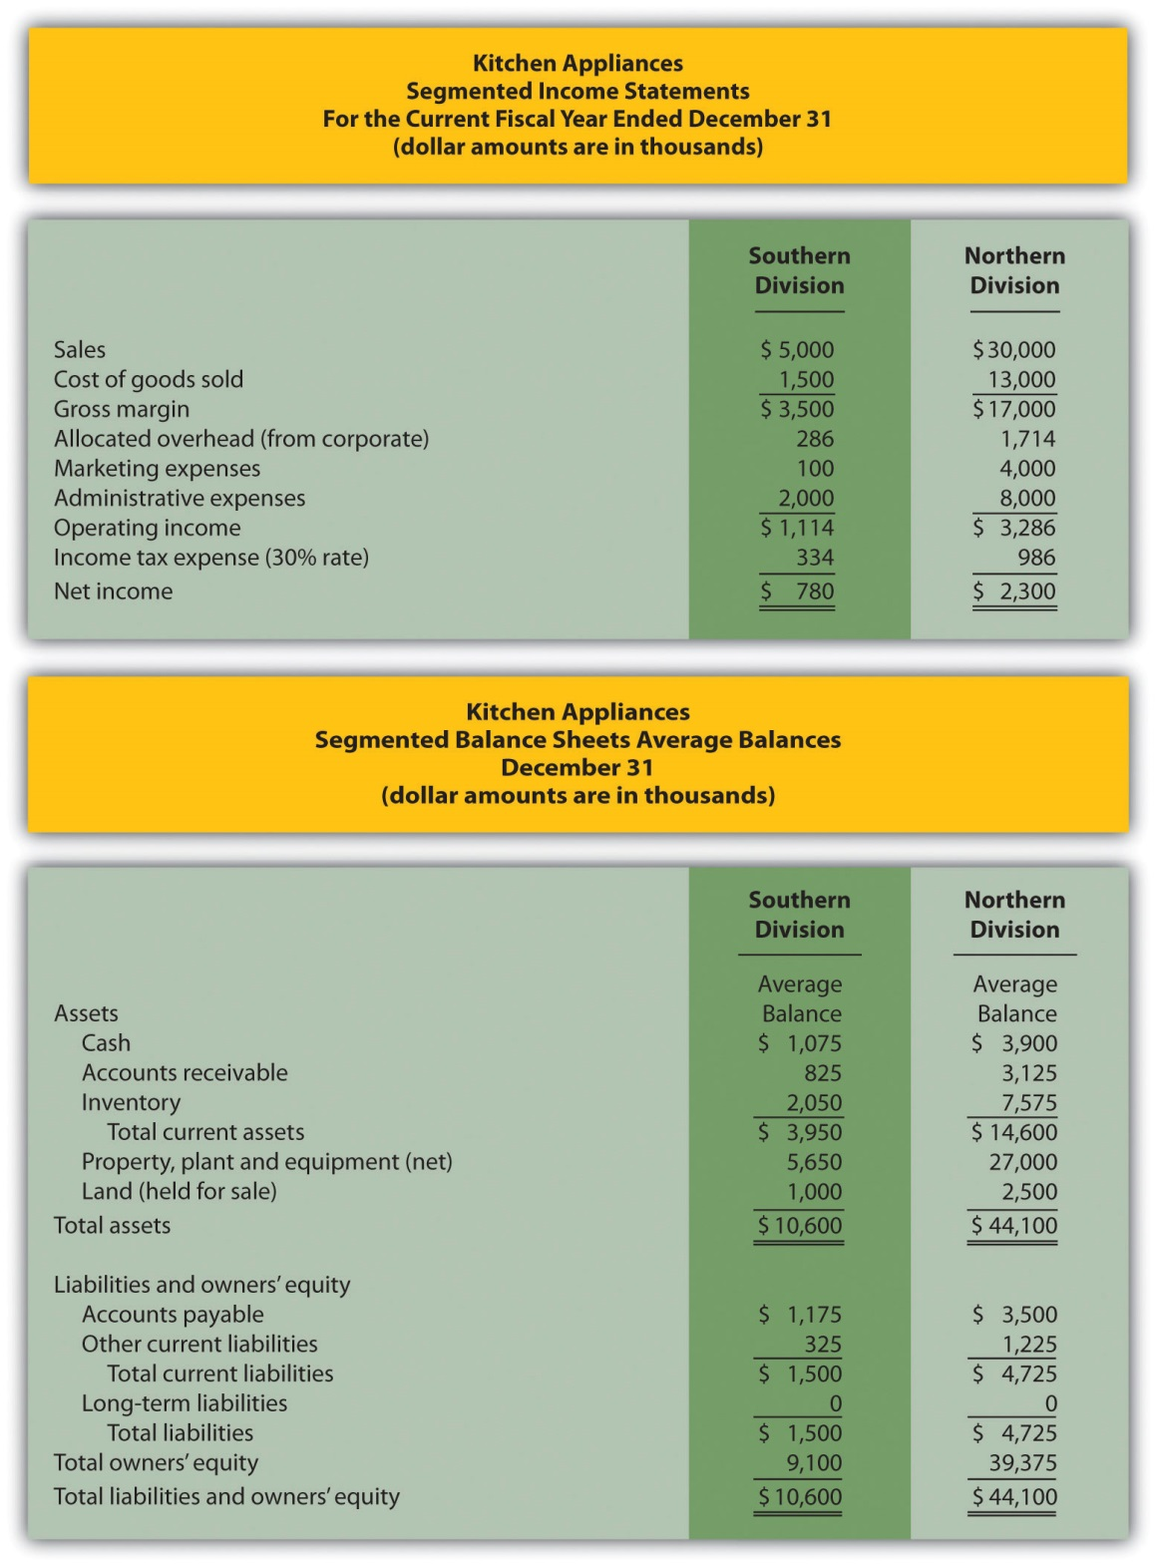
- Calculate EVA for each division.
- What does the EVA show for each division?
Solution to Review Problem 11.7
- The EVA calculation is as follows:
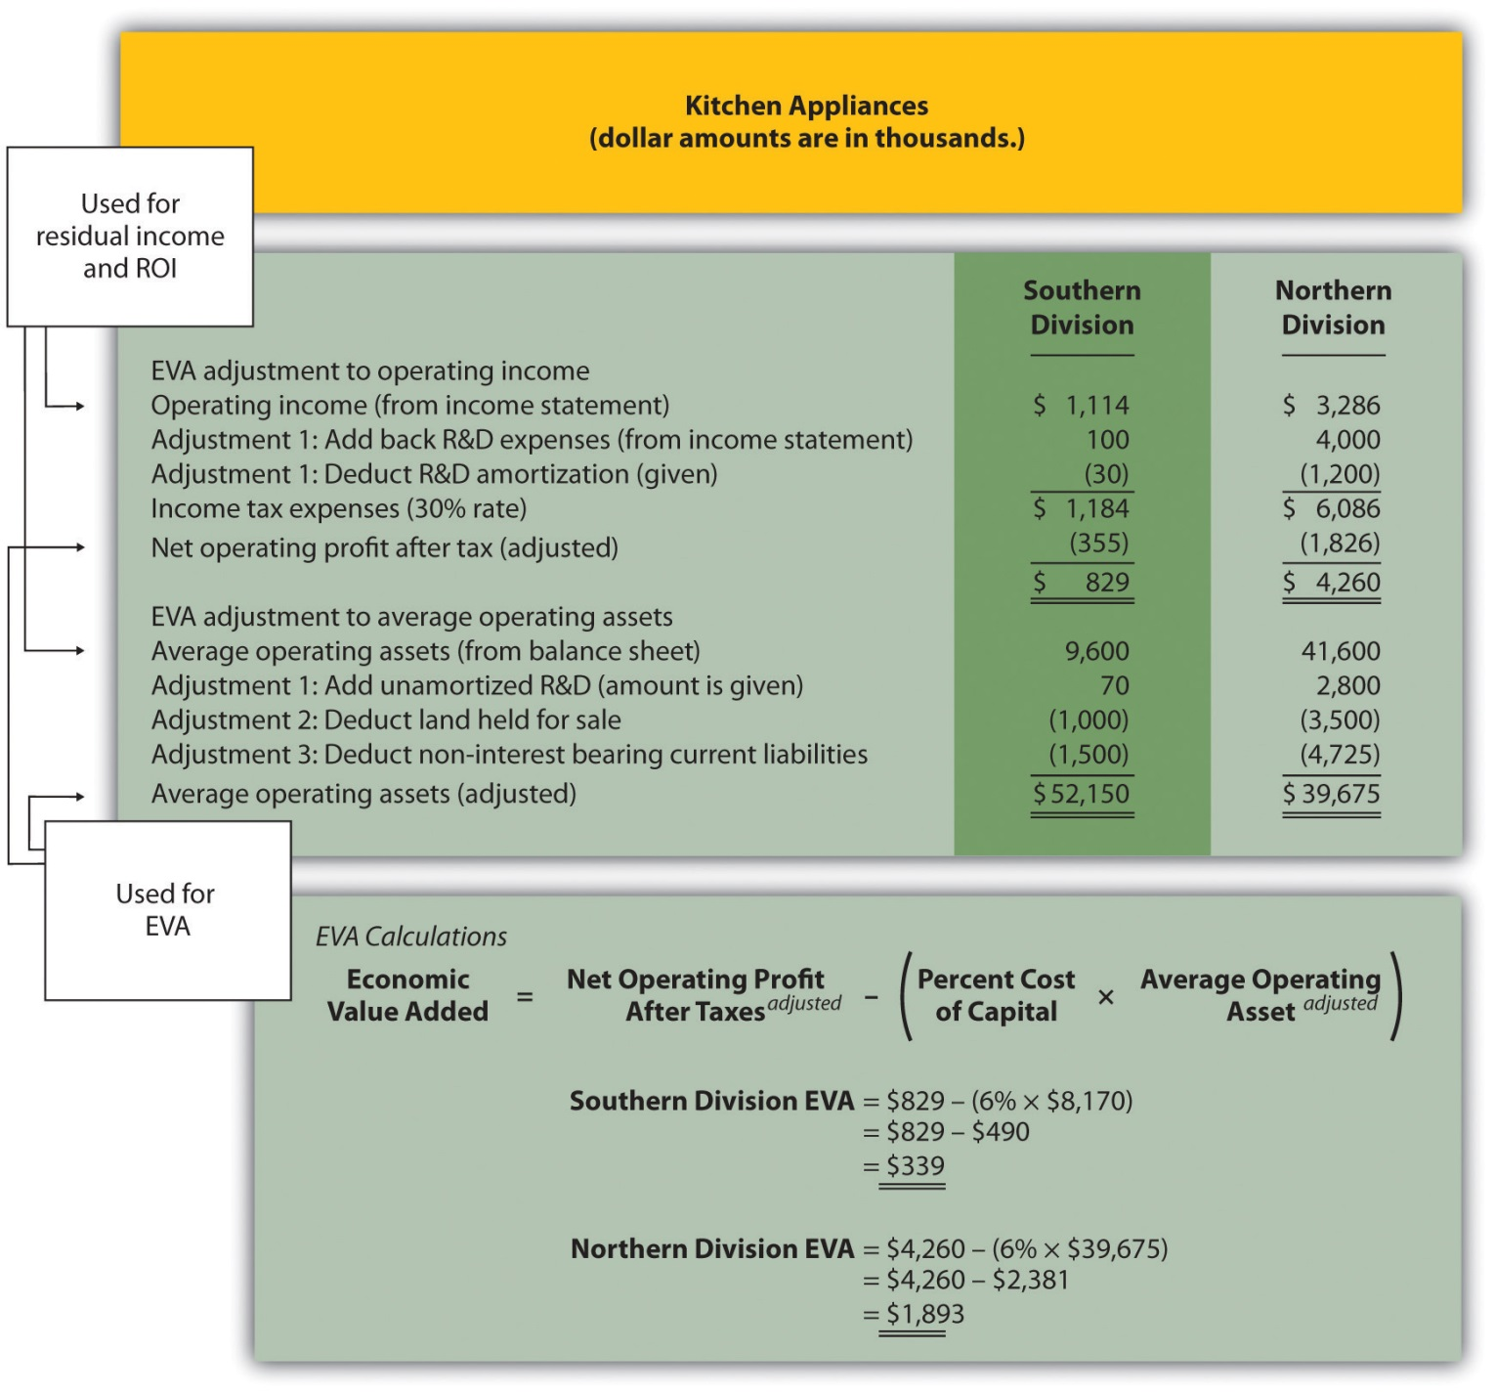
- Both divisions have positive EVA amounts, indicating both have NOPAT (adjusted) above and beyond the cost of investment funds (adjusted). It is interesting to note that when compared to RI amounts calculated in , EVA results in a significantly higher amount for the Northern division. This can be attributed to the large amount of marketing expenditures at the Northern division that were expensed using RI, but capitalized and amortized using EVA. Deferring significant amounts of marketing expenses to future years has the impact of increasing NOPAT in the year of the expenditure, thereby increasing EVA.

11.7 Wrap-Up of Game Products, Inc.

Question: At the meeting described at the beginning of the chapter between Mandy Dwyer (president and CEO) and Larry Meske (CFO), Mandy wanted to revise the compensation plan for the manager of the Board Games division to increase her bonus because profits had increased significantly compared to prior years. Larry suggested using measures other than segmented net income to evaluate each division and asked for time to gather additional information.What information did Larry gather, and how does this additional information help Mandy evaluate each division?

Answer: Larry assembled the information using the five methods of evaluating investment centers presented in this chapter: (1) segmented net income, (2) profit margin ratio, (3) return on investment (ROI), (4) residual income (RI), and (5) economic value added (EVA). These five measures have been calculated for each division of Game Products, Inc., and are summarized in Figure 11.11 "Five Performance Measures at Game Products, Inc.".

Figure 11.11 Five Performance Measures at Game Products, Inc.
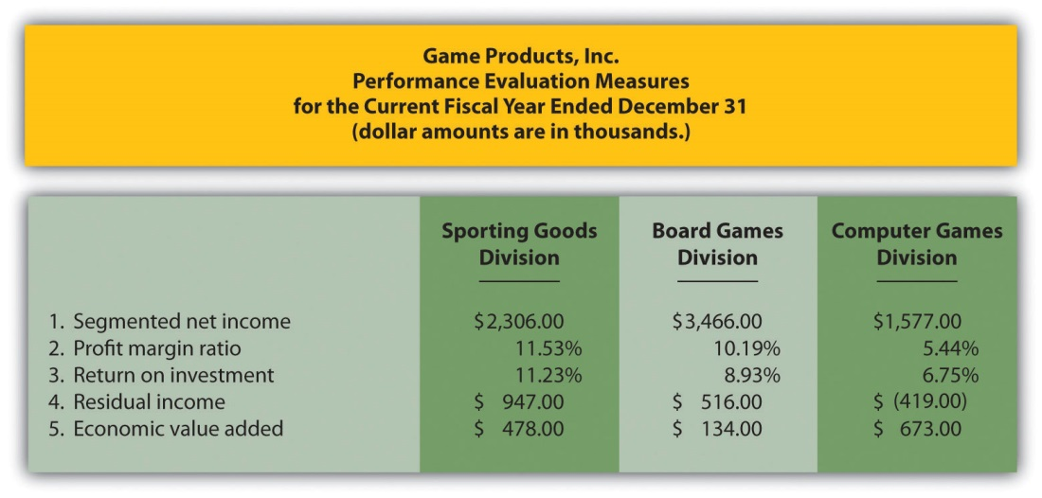

Figure 11.12 "Comparison of Income Performance Measures for Each Division at Game Products, Inc." shows a comparison of the three divisions for segmented income, RI, and economic value added. Figure 11.13 "Comparison of Profit Margin Ratio and Return Investment for Each Division at Game Products, Inc." shows a comparison of the three divisions for the profit margin ratio and ROI.

Figure 11.12 Comparison of Income Performance Measures for Each Division at Game Products, Inc.
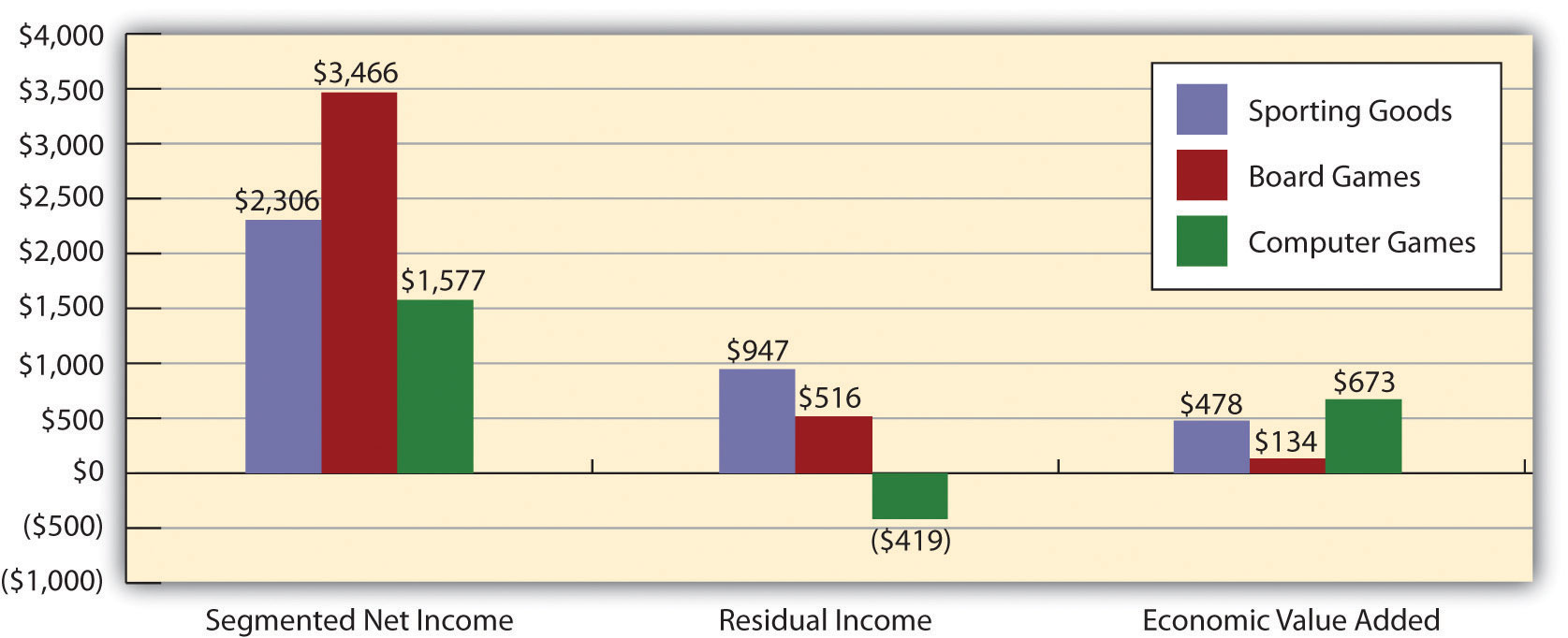
Figure 11.13 Comparison of Profit Margin Ratio and Return Investment for Each Division at Game Products, Inc.
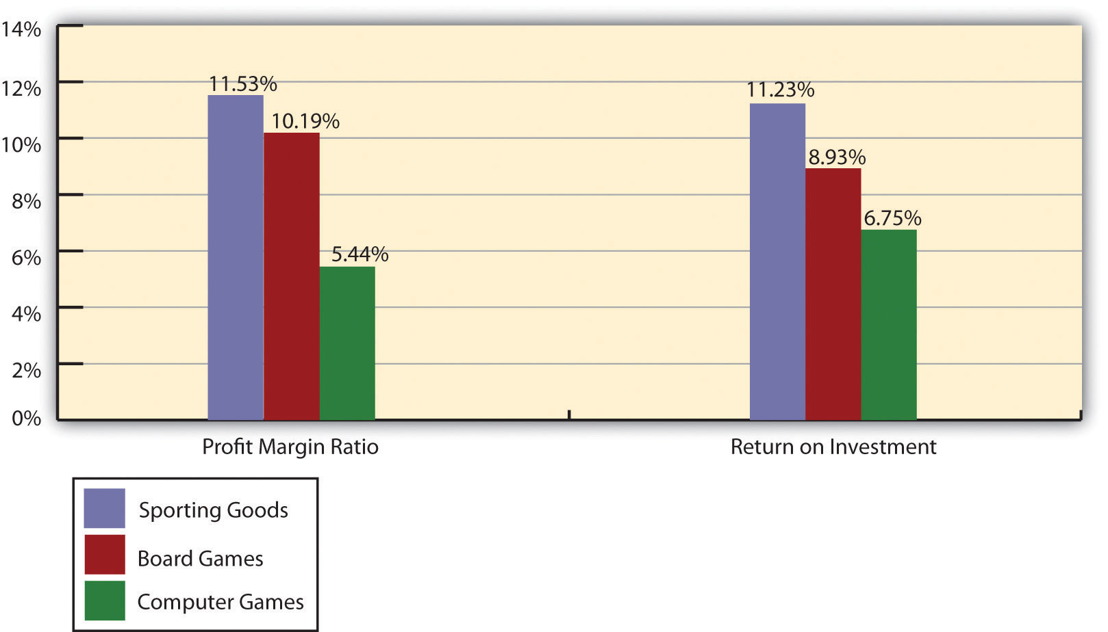

When Mandy and Larry meet again a month later, Larry has the difficult task of explaining the information to Mandy and recommending a course of action.
Mandy (president and CEO): | Larry, let’s begin where we left off at our last meeting. What do you have for me with regard to performance evaluation measures we might use for our division managers?
Larry (CFO): | Here is a summary of five measures I think can be useful if used correctly (see Figure 11.11 "Five Performance Measures at Game Products, Inc."). As you suggested, Mandy, the starting point is segmented net income, which is shown on line one. The Board Games division has the highest net income and looks to be a strong performer in this regard.
Mandy: | What is the ratio shown on line two?
Larry: | This is the profit margin ratio. It is a much better measure to evaluate the profitability of each division relative to sales. This measure shows the Sporting Goods division produced the highest profit for each dollar in sales with a ratio of 11.53 percent. Board Games is second at 10.19 percent and Computer Games is last at 5.44 percent.
Mandy: | I see. What about the use of assets? Each division is responsible for investments in assets and we would like to know how effective each division is in producing income with these assets. Is this where ROI comes in?
Larry: | Yes. As shown on line three, the Sporting Goods division is making the best use of its operating assets with an ROI of 11.23 percent. Board Games is second at 8.93 percent, and Computer Games is last at 6.75 percent.
Mandy: | So you’re telling me Sporting Goods is doing better than the other two divisions, even though Board Games has the highest net income?
Larry: | Yes, Sporting Goods is the most effective at using assets to produce profit.
Mandy: | What are the last two measures you show here?
Larry: | Both of these last two measures also consider asset use in the calculation. As shown on line four, Sporting Goods had the best performance by producing $947,000 in RI compared to $516,000 at Board Games and $(419,000) at Computer Games.
Mandy: | Computer Games has negative RI?
Larry: | Yes. However, you will notice that EVA shown on line five presents a different picture.
Mandy: | Why?
Larry: | Computer Games has high research and development costs each year—it’s the nature of the industry. U.S. GAAP requires these costs to be expensed when incurred. EVA suggests recording R&D costs as an asset and amortizing the costs over the useful life of R&D activities. Since Computer Games has much higher R&D costs than the other divisions, the numbers changed dramatically relative to the other divisions. Also, after-tax income is used rather than operating income, and average assets are adjusted as well.
Mandy: | Seems as if there is an awful lot of subjectivity in using EVA.
Larry: | Yes, there is. If we choose to use EVA as one of our measures, management must meet to discuss and agree upon the adjustments to be made.
Mandy: | Larry, thanks for your analysis. I’m beginning to understand the importance of including asset use in our performance measures. Where do we go from here?
Larry: | I like the first three measures—net income, profit margin ratio, and ROI. They are widely used in industry, and managers tend to understand the nature of these measures. The last two measures are also useful and should not be overlooked. My recommendation is to meet with the division managers to develop a comprehensive incentive compensation plan. The key is to develop a plan that motivates our managers to achieve company goals.
Mandy: | I like the idea! Let’s meet next week.

11.8 Appendix: Transfer Prices between Divisions

LEARNING OBJECTIVE
- Explain how transfer pricing can affect performance evaluation measures.

Question: Many companies have independent divisions that transfer goods or services from one division to another. If division managers are evaluated based only on division results using measures, such as segmented net income, profit margin ratio, or return on investment (ROI), conflicts can arise causing managers to take a course of action that benefits the division but hurts the company as a whole. For example, a division manager may decide to purchase raw materials from an outside supplier even though the same materials can be produced at a lower cost by another division within the company (the other division’s manager refuses to sell the materials at a reduced price because she is evaluated based on her division’s profits!). How should a company establish transfer pricing to avoid this kind of conflict?

Answer: The price used to value the transfer of goods or services between divisions within the same company is called a transfer price. Several different approaches can be used to establish transfer prices between divisions. The goal is to establish a transfer pricing policy that encourages managers to do what is in the best interest of the company while also doing what is in the best interest of the division manager (this is called goal congruence). Several common approaches are presented next.

Using the General Economic Transfer Pricing Rule

Question: How does the general economic transfer pricing rule help organizations to establish an appropriate transfer price?

Answer: The general economic transfer pricing rule attempts to establish guidelines for divisions to maximize overall company profit. This rule states the transfer price should be set at differential cost to the selling division (normally variable cost), plus the opportunity cost of making the sale internally (none if the seller has idle capacity or selling price minus differential cost if the seller is at capacity). This rule is summarized in “Key Equation: Economic Transfer Pricing Rule.”

Key Equation
Economic Transfer Pricing Rule
Transfer price=Differential costto selling division+Opportunity cost ofselling internally

Let’s look at an example illustrating how to establish a reasonable transfer price using the economic transfer pricing rule. Umbrellas, Inc., has two divisions—Assembly and Marketing. In the past, all transfers of umbrellas from Assembly to Marketing were valued at the variable cost of $6 each. However, the Assembly division manager would like to raise the price to $9 per unit.

Which transfer price should be used to maximize company profit, $6 or $9? The answer depends on whether the selling division (Assembly) is below capacity or at capacity.

Transfer Pricing When Selling Division Is below Capacity

Question: Assume Assembly is below capacity. This means there is no opportunity cost of selling internally since no outside sales are forgone as a result of the transaction. What is the appropriate transfer price in this scenario?

Answer: Given this set of circumstances, the Assembly division should set the transfer price at its variable cost of $6 per unit as shown in “Key Equation: Transfer Pricing When below Capacity (Umbrellas, Inc.).” This ensures Marketing does not purchase the umbrellas from another supplier at an amount greater than Umbrella, Inc.’s variable cost.

Key Equation
Transfer Pricing When below Capacity (Umbrellas, Inc.)
Transfer price$6==Differential costto selling division$6*++Opportunity cost ofselling internally$0**
*This is the variable cost for Assembly to produce each umbrella.
**Opportunity cost is zero since no outside sales are forgone as a result of making this internal sale.

If Assembly sets the transfer price higher than $6 per unit ($9 for example), thereby violating the economic transfer pricing rule, the risk is that Marketing might find another company willing to provide the umbrellas for an amount less than $9 and higher than $6. If Marketing chooses to buy umbrellas from an outside supplier for $7, for example, profit declines at Umbrella, Inc., because the company paid $1 more than necessary for each umbrella ($1 = $7 outside supplier price − $6 Umbrella, Inc.’s variable cost). Although Marketing looks better as an investment center buying from the outside for $7 because the cost is $2 less than the internal transfer price, the overall company is worse off because the $7 cost is $1 higher than if the umbrellas were produced internally.

Transfer Pricing When Selling Division Is at Capacity

Question: Now assume Assembly is at capacity. This creates an opportunity cost of selling internally, since outside sales must be forgone as a result of the transaction. What is the appropriate transfer price in this scenario?

Answer: Given this new set of circumstances for Umbrellas, Inc., the Assembly division should set the transfer price at its variable cost of $6 per unit plus the opportunity cost of selling internally. Assume the Assembly division sells the umbrellas to outside customers for $10 each. The opportunity cost of selling internally is $4 (= $10 market price − $6 variable cost). Thus the transfer price that maximizes company profit is $10 as shown in “Key Equation: Transfer Pricing When at Capacity (Umbrellas, Inc.).” Assembly is indifferent whether it sells internally for $10 or to outside customers for $10.

Key Equation
Transfer Pricing When at Capacity (Umbrellas, Inc.)
Transfer price$10==Differential costto selling division$6*++Opportunity cost ofselling internally$4**
*This is the variable cost for Assembly to produce each umbrella.
**Opportunity cost is the revenue forgone of $4 by selling internally. Revenue forgone of $4 = $10 market price – $6 variable cost.

The economic transfer pricing rule works well when outside market prices are available (see ). However, not all goods or services transferred from one division to another have a readily available outside market price. Thus other methods of establishing transfer pricing must be considered.

Business in Action 11.5
Transfer Pricing at General Electric
A review of the notes to General Electric’s annual report reveals the amount of “intersegment revenues” recorded for each of the company’s six segments. This is referring to revenue derived from transferring goods and services between divisions. The note also states that “sales from one component (segment) to another generally are priced at equivalent commercial selling prices.” It appears from this note thatGeneral Electric uses market price to establish transfer prices.
Source: General Electric, “2006 Annual Report,” http://www.ge.com.

Using Cost to Set Transfer Price

Question: Another approach to establishing a transfer price is to use the cost of the goods or services being transferred. How are these costs determined?

Answer: Transfer prices can be based on variable cost, full absorption cost, or cost-plus. Each approach is described next.

Variable Cost

Some companies simply use the selling division’s variable cost as the transfer price. However, the weakness in this approach is the selling division will not be able to mark up its products or services, and as a result, will not be able to generate a profit. This is not a problem for selling divisions treated as cost centers, but profit center and investment center managers will not be satisfied with such an approach.

Full Absorption Cost

Companies sometimes set the transfer price at the selling division’s full absorption cost. The selling division manager prefers to cover all costs rather than only variable costs, and using full-absorption cost accomplishes this goal. However, the company’s concern is the buying division might choose to purchase from an outside provider at a higher price than the differential cost plus opportunity cost but lower than the selling division’s full absorption cost. The result is a decision that does not maximize company profit.

Cost-Plus

Companies often add a markup to the selling division’s variable cost or full absorption cost to set the transfer price. This enables the selling division to earn a profit on internal transfers. Again, the risk is that the buying division might buy from an outside supplier at a higher price than differential cost plus opportunity cost, resulting in lower company profit.

Negotiating Transfer Prices

Question: If the general economic transfer pricing rule is not used, and the cost approach is not used, another alternative is to simply negotiate the transfer price. What are the potential weaknesses in negotiating a transfer price?

Answer: Investment center division managers are often expected to act independent of each other. In fact, many companies treat investment centers as separate businesses. To promote the autonomy of each division manager, companies often require the buying and selling divisions to negotiate a transfer price. This sounds reasonable in concept, but the same weakness exists here as with using costs to set a transfer price. The buying division may choose to purchase the goods or services from an outside supplier if negotiations break down, which may lead to a suboptimal decision for the company as a whole.

An additional weakness is the time required to negotiate a transfer price. Managers can spend significant amounts of time in negotiations when the time might be better spent more productively elsewhere in the division.

Choosing the Best Approach to Establish a Transfer Price

Question: Which transfer pricing approach is best?

Answer: There is no one “best” approach to establishing transfer prices. No two companies are identical, and the choice of a transfer pricing policy depends largely on the nature of the company. The most common approaches used in industry are presented in this appendix. The goal is to establish a transfer pricing policy that encourages managers to do what is in the best interest of the company while also serving the best interest of the division manager.

KEY TAKEAWAY
- The price used to value the transfer of goods or services between divisions within the same company is called a transfer price. Although there are different approaches for establishing a transfer price, the general economic transfer pricing rule states the transfer price should be set at differential cost to the selling division (normally variable cost) plus the opportunity cost of making the sale internally (none if the seller has idle capacity or selling price minus variable cost if the seller is at capacity). The goal is to establish a transfer pricing policy that encourages managers to do what is in the best interest of the company while also doing what is in the best interest of the division manager.

REVIEW PROBLEM 11.8
Maine Products, LLP, has two divisions—Chocolate and Mint. The Chocolate division typically sells its chocolate to the Mint division for $3 per pound, which covers variable costs. The Chocolate division sells to outside customers for $5 per pound. Use the general economic transfer pricing rule to address the following requirements:
- Calculate the optimal transfer price assuming the Chocolate division is below capacity.
- Calculate the optimal transfer price assuming the Chocolate division is at capacity.
Solution to Review Problem 11.8
- Because the Chocolate division is below capacity, no outside customer sales are forgone as a result of selling internally. Thus the opportunity cost of selling internally is zero. The optimal transfer price is $3, calculated as follows:
Transfer price$3==Differential costto selling division$3*++Opportunity cost ofselling internally$0**

*This is the variable cost per pound.
**Opportunity cost is zero since no outside sales are forgone as a result of selling internally.
- Since the Chocolate division is at capacity, outside customer sales are forgone as a result of selling internally. Thus there is an opportunity cost of selling internally. The optimal transfer price is $5, calculated as follows:
Transfer price$5==Differential costto selling division$3*++Opportunity cost ofselling internally$2**

*This is the variable cost per pound.
**Opportunity cost is the revenue forgone of $2 by selling internally (= $5 market price − $3 variable cost).

END-OF-CHAPTER EXERCISES
Questions
- What is meant by the term decentralized organization?
- What are the advantages and disadvantages of decentralizing operations?
- Refer to Why would a growing college, such as Sierra College, decentralize operations?
- Refer to How did decentralization at Arthur Andersen contribute to the company’s downfall?
- Describe the three types of responsibility centers presented in the chapter.
- Describe at least three measures used to evaluate performance of investment center division managers.
- What are the two weaknesses of using segmented net income to evaluate managers of investment centers? What performance measures would you use to overcome these weaknesses?
- What is the primary advantage of using ROI rather than segmented net income or profit margin ratio to evaluate investment center managers?
- Describe operating profit margin and asset turnover, and explain how each of these ratios can be used to help division managers improve ROI.
- Describe the potential conflict that can occur between division manager goals and overall company goals when evaluating divisions using ROI.
- Refer to How did General Electric modify net income to evaluate each segment?
- Describe residual income (RI), and explain how RI can resolve the conflict between division manager goals and company goals often created by using ROI.
- Explain the difference between RI and economic value added.
- Refer to the Game Products, Inc., performance measures presented in. Identify which measures you would recommend to the CEO of Game Products, and explain the reasoning behind your recommendation.
- Appendix. Describe the general economic transfer pricing rule.
Brief Exercises
- Evaluating Division Managers at Game Products, Inc. Refer to the dialogue at Game Products, Inc., presented at the beginning of the chapter. Why does the president want to give Carla Klesko, the Board Games division manager, a bonus? Does the CFO agree that Carla deserves a larger bonus than the other division managers? What performance measures would the CFO like to consider before awarding Carla a larger bonus?
- Decentralizing Operations. Burton Electronics produces radios, computers, and navigation systems. Although all high level decisions are made at company headquarters by top management, rapid expansion and increasingly specialized products have caused the company to consider decentralizing into three divisions. Each division manager would be responsible for costs, revenues, and investments in assets.
Required:
  - How should the company classify each division, as a cost center, profit center, or investment center? Explain.
  - What are the potential advantages of decentralizing?
  - What are the potential disadvantages of decentralizing?
- Responsibility Centers. Aviation Products, Inc., operates primarily in the United States and has several segments:
  - Accounting and finance: responsible for recording financial information and preparing financial reports.
  - Human resources: responsible for hiring employees and maintaining personnel records.
  - Retail stores: responsible for sales prices and all costs within each store.
  - Advertising: responsible for promotional materials.
  - Production: responsible for manufacturing company products.
  - International operations: acts as an independent segment responsible for all facets of the business outside of the United States.
Required:
For each of the preceding segments, identify whether it is a cost center, profit center, or investment center. Explain your answer.
- Segmented Net Income. Franklin Bikes has two divisions—Road Bikes and Mountain Bikes. Using the segmented income statements presented in the following, determine the profit margin ratio for each division.
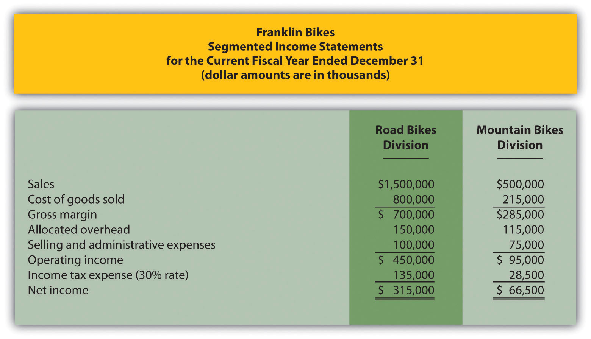
- Return on Investment (ROI). The segmented income statements presented as follows are for the two divisions of Franklin Bikes. (This is the same company as the previous exercise. This exercise can be assigned independently.) Assume the Road Bikes division had average operating assets totaling $4,500,000 for the year, and the Mountain Bikes division had average operating assets of $800,000. Calculate ROI for each division.
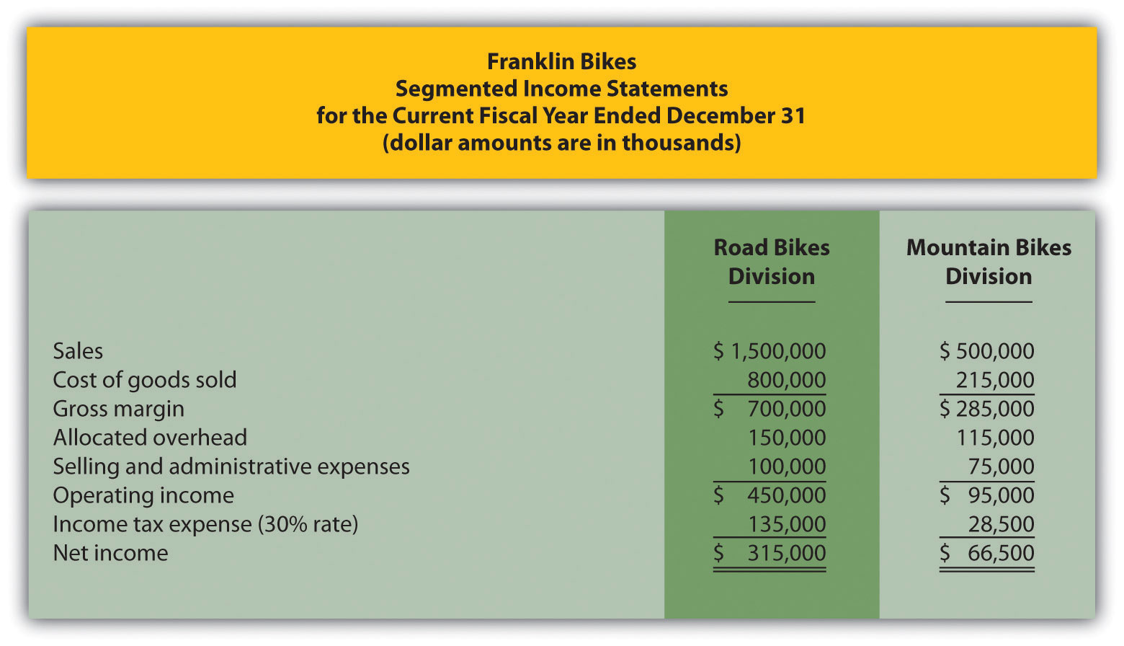
- Residual Income (RI). The segmented income statements presented as follows are for the two divisions of Franklin Bikes. (This is the same company as the previous exercises. This exercise can be assigned independently.) Assume the Road Bikes division had average operating assets totaling $4,500,000 for the year, and the Mountain Bikes division had average operating assets of $800,000. The company’s cost of capital rate is 8 percent. Calculate RI for each division.
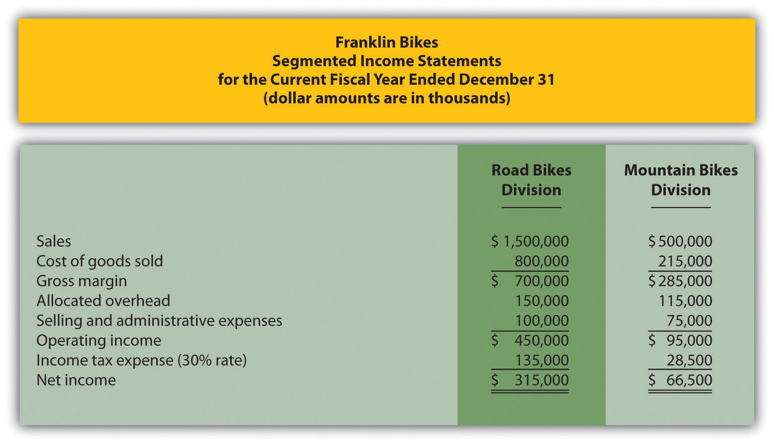
- Economic Value Added (EVA). Computer Tech Company has two divisions—Hardware and Software. Adjustments have already been made to net operating profit after taxes (NOPAT) andaverage operating assets for the purposes of calculating EVA for each division. This adjusted information is shown as follows. Assume the company’s cost of capital is 12 percent. Calculate EVA for each division.
 | Hardware Division | Software Division
NOPAT—adjusted | $ 810,000 | $ 980,000
Average operating assets—adjusted | 3,500,000 | 3,200,000
- (Appendix). What is the primary goal for an organization establishing a transfer pricing policy?
Exercises: Set A
- Segmented Net Income. Pool Accessories, Inc., has two divisions—Furniture and Supplies. The following segmented financial information is for the most recent fiscal year ended December 31.
 | Furniture Division | Supplies Division
Sales | $3,000,000 | $1,000,000
Cost of goods sold | 1,600,000 | 430,000
Allocated overhead | 375,000 | 125,000
Selling and administrative expenses | 250,000 | 200,000
- Assume the tax rate is 30 percent.
- Required:
  - Prepare a segmented income statement using the format presented in . Include the profit margin ratio for each division at the bottom of the segmented income statement.
  - Using net income as the measure, which division is most profitable? Explain why this conclusion might be misleading.
  - What does the profit margin ratio tell us about each division? Why do organizations often use profit margin ratio to evaluate division performance rather than simply using net income?
- ROI. Pool Accessories, Inc., has two divisions—Furniture and Supplies. (This is the same company as the previous exercise. This exercise can be assigned independently.) Segmented income statement information for the most recent fiscal year ended December 31 is shown as follows. Assume the Furniture division had average operating assets totaling $6,500,000 for the year, and the Supplies division had average operating assets of $1,750,000.
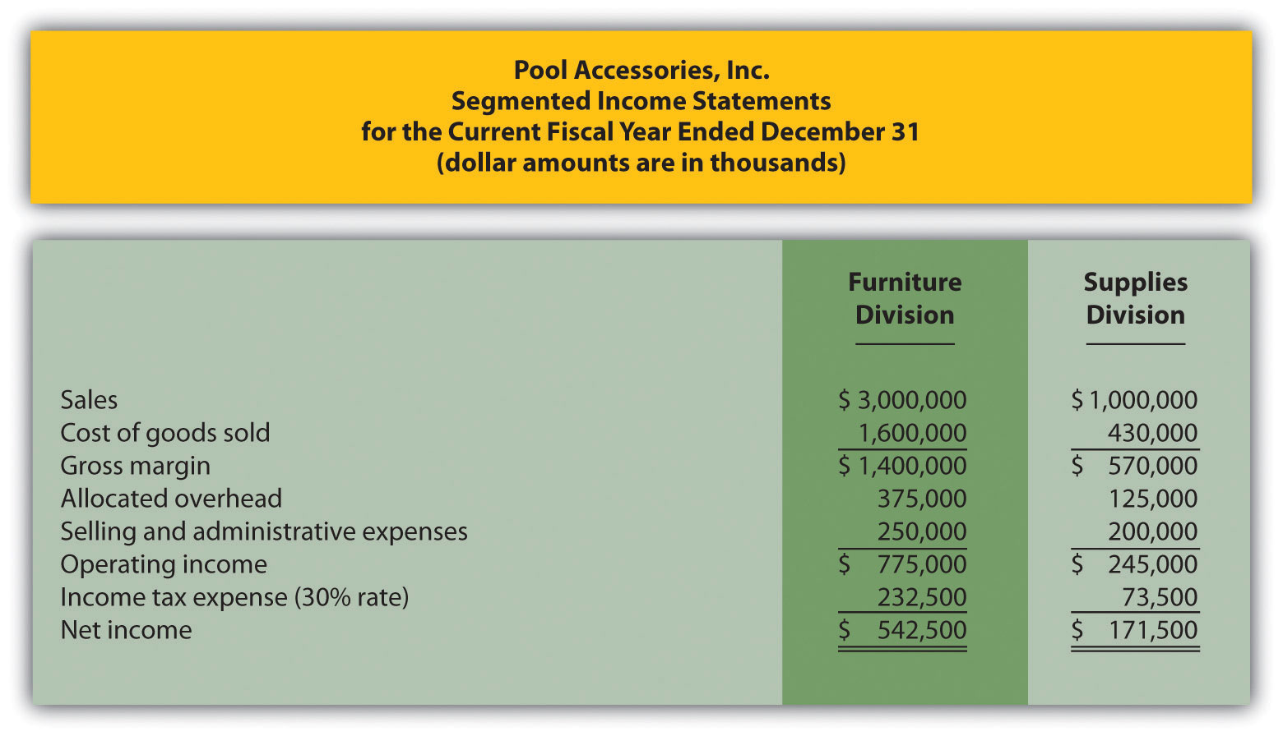
Required:
  - Calculate ROI for each division.
  - What does ROI tell us about each division? Indicate why this measure is useful in evaluating investment centers.
- ROI Using Operating Profit Margin and Asset Turnover. Pool Accessories, Inc., has two divisions—Furniture and Supplies. (This is the same company as the previous exercises. This exercise can be assigned independently.) Segmented income statement information for the most recent fiscal year ended December 31 is shown as follows. Assume the Furniture division had average operating assets totaling $6,500,000 for the year, and the Supplies division had average operating assets of $1,750,000.
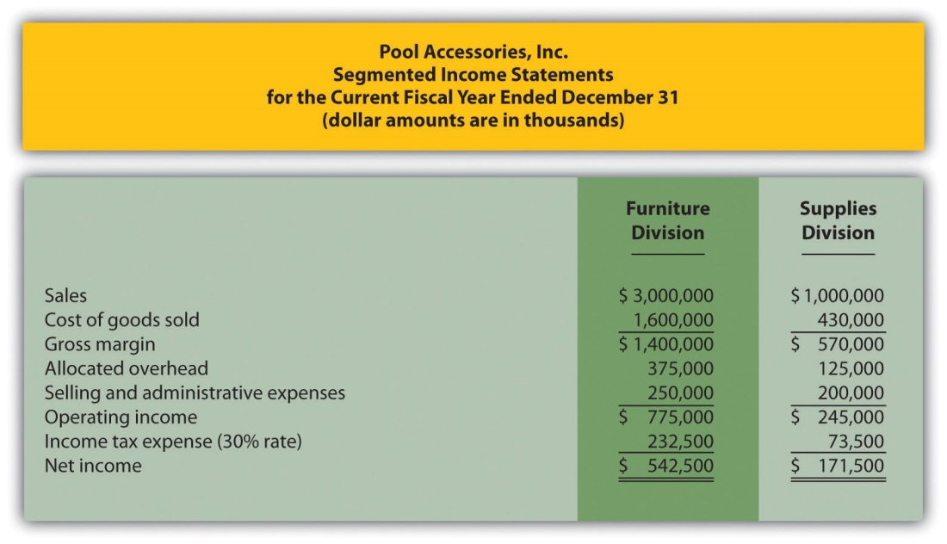
Required:
  - For each division, calculate operating profit margin, asset turnover, and resulting ROI.
  - Which division has the highest ROI? For the division that has the lowest ROI, what can be done to improve this ratio?
- RI. Pool Accessories, Inc., has two divisions—Furniture and Supplies. (This is the same company as the previous exercises. This exercise can be assigned independently.) Segmented income statement information for the most recent fiscal year ended December 31 is shown as follows. Assume the Furniture division had average operating assets totaling $6,500,000 for the year, and the Supplies division had average operating assets of $1,750,000. Assume the cost of capital rate is 10 percent.
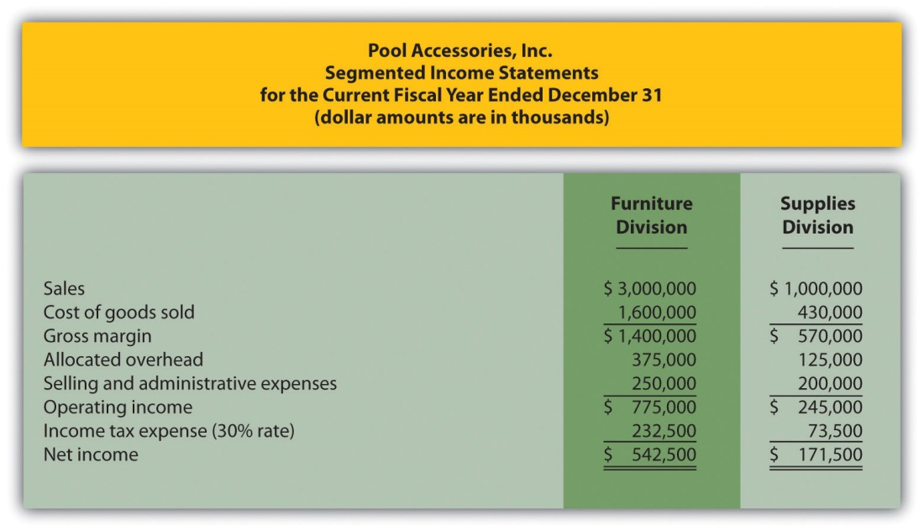
Required:
  - Calculate RI for each division.
  - What does RI tell us about each division?
- Solving Unknowns for ROI. The following information is for two divisions at Kayak Company.
 | Lake Division | Ocean Division
Sales | ? | $900,000
Operating income | ? | $108,000
Operating profit margin | 8.0 percent | ?
Average operating assets | $150,000 | $600,000
Asset turnover | 1.7 | ?
ROI | ? | ?
- Required:
- Find the missing information for each division.
- EVA. Links Company produces golf clubs and other sporting goods accessories. The following information is for each division at Links for the most recent fiscal year.
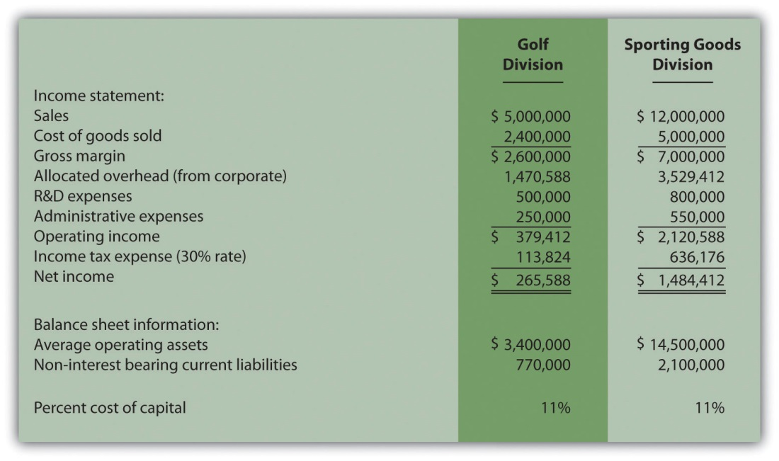
To calculate EVA, the management requires adjustments for R&D and noninterest bearing current liabilities as outlined in the following.
Research and development will be capitalized and amortized over several years resulting in an increase to average operating assets of $400,000 for the Golf division and $650,000 for the Sporting Goods division. On the income statement, R&D expense for the year will be added back to operating income; then R&D amortization expense for one year will be deducted. The current year amortization expense will total $100,000 for the Golf division and $150,000 for the Sporting Goods division.
Noninterest bearing liabilities will be deducted from average operating assets.
Required:
Calculate EVA for each division and comment on your results.
- (Appendix) Transfer Pricing. Creative Colors, Inc., a producer of paint, has two divisions—Paint division and Can division. Each division manager is evaluated based on profit produced by each division.
The Can division sells its cans to the Paint division for $2 per case to cover variable costs. The Can division also sells to outside customers for $3 per case.
Required:
  - Using the general economic transfer pricing rule, calculate the optimal transfer price assuming the Can division is below capacity.
  - Using the general economic transfer pricing rule, calculate the optimal transfer price assuming the Can division is at capacity.
Exercises: Set B
- Segmented Net Income. Photo Products, Inc., has three divisions—Digital, Film, and Video. The following segmented financial information is for the most recent fiscal year ended December 31.
 | Digital Division | Film Division | Video Division
Sales | $22,000,000 | $8,000,000 | $18,000,000
Cost of goods sold | 10,000,000 | 2,000,000 | 7,000,000
Allocated overhead | 4,125,000 | 1,500,000 | 3,375,000
Selling and administrative expenses | 5,000,000 | 3,200,000 | 5,000,000
- Assume the tax rate is 35 percent.
- Required:
  - Prepare a segmented income statement using the format presented in . Include the profit margin ratio for each division at the bottom of the segmented income statement.
  - Using net income as the measure, which division is most profitable? Explain why this conclusion might be misleading.
  - What does the profit margin ratio tell us about each division? Why do organizations often use profit margin ratio to evaluate division performance rather than simply using net income?
- ROI. Photo Products, Inc., has three divisions—Digital, Film, and Video. (This is the same company as the previous exercise. This exercise can be assigned independently.) Segmented income statement information for the most recent fiscal year ended December 31 is shown as follows. Assume average operating assets totaled $15,000,000 for the Digital division, $6,500,000 for the Film division, and $17,500,000 for the Video division.
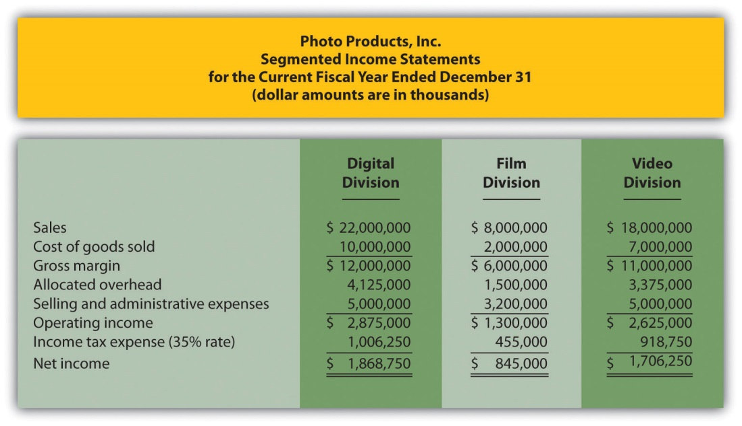
Required:
  - Calculate ROI for each division.
  - What does ROI tell us about each division? Indicate why this measure is useful in evaluating investment centers.
- ROI Using Operating Profit Margin and Asset Turnover. Photo Products, Inc., has three divisions—Digital, Film, and Video. (This is the same company as the previous exercises. This exercise can be assigned independently.) Segmented income statement information for the most recent fiscal year ended December 31 is shown as follows. Assume average operating assets totaled $15,000,000 for the Digital division, $6,500,000 for the Film division, and $17,500,000 for the Video division.
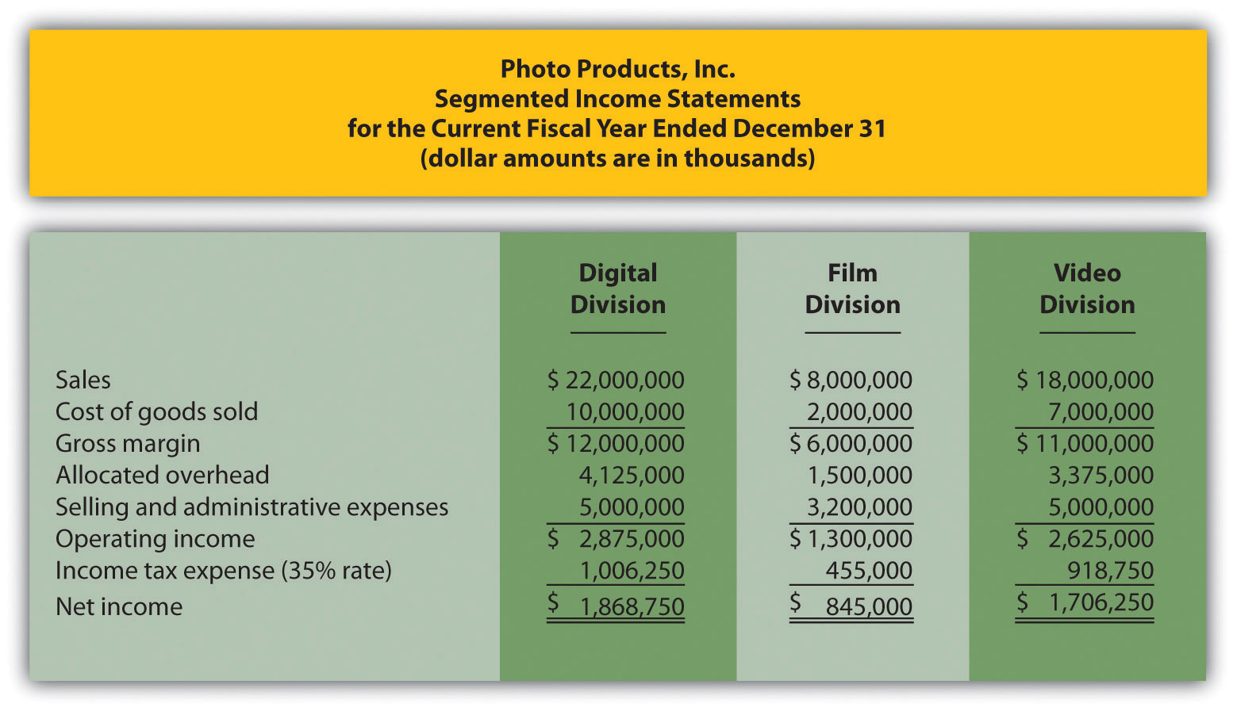
Required:
  - For each division, calculate operating profit margin, asset turnover, and resulting ROI.
  - Which division has the highest ROI? For the division that has the lowest ROI, what can be done to improve this ratio?
- RI. Photo Products, Inc., has three divisions—Digital, Film, and Video. (This is the same company as the previous exercises. This exercise can be assigned independently.) Segmented income statement information for the most recent fiscal year ended December 31 is shown as follows. Assume average operating assets totaled $15,000,000 for the Digital division, $6,500,000 for the Film division, and $17,500,000 for the Video division. Assume the cost of capital rate is 16 percent.
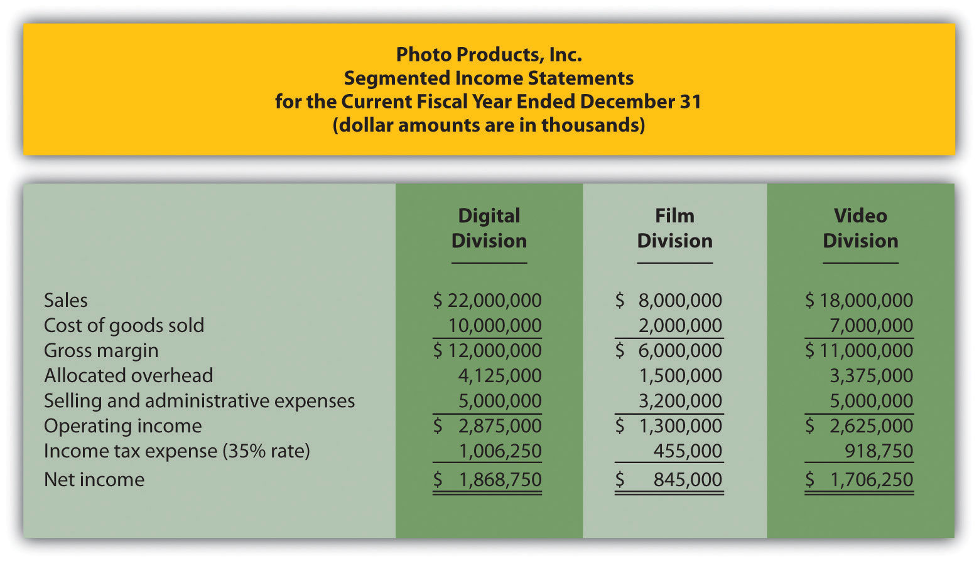
Required:
  - Calculate RI for each division.
  - What does RI tell us about each division?
- Solving Unknowns for ROI. The following information is for two divisions at Arrowhead, Inc.
 | North Division | South Division
Sales | $1,200,000 | $400,000
Operating income | $ 132,000 | $ 40,000
Operating profit margin | ? | ?
Average operating assets | $1,000,000 | ?
Asset turnover | ? | ?
ROI | ? | 8.0 percent
- Required:
- Find the missing information for each division.
- EVA. Sailboats, Inc., sells sailboat parts and accessories and provides rigging services. The following information is for each division at Sailboats, Inc., for the most recent fiscal year.
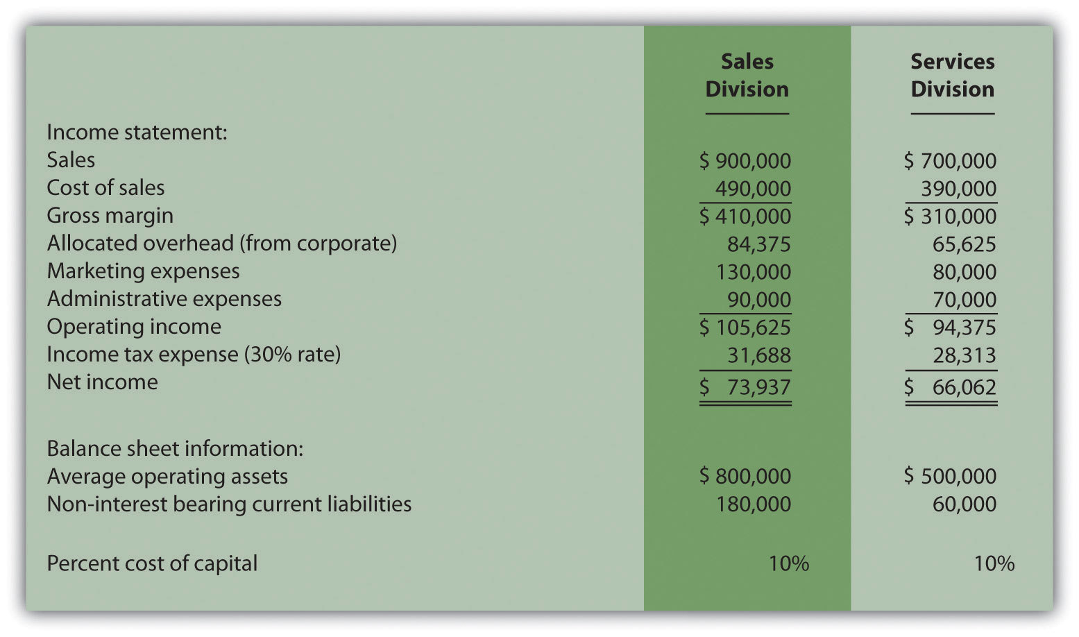
To calculate EVA, management requires adjustments for marketing and noninterest bearing current liabilities as outlined in the following.
Marketing will be capitalized and amortized over several years resulting in an increase to average operating assets of $100,000 for the Sales division and $65,000 for the Services division. On the income statement, marketing expense for the year will be added back to operating income; marketing amortization expense for one year will be deducted. The current year amortization expense will total $30,000 for the Sales division and $15,000 for the Services division.
Noninterest bearing liabilities will be deducted from average operating assets.
Required:
Calculate EVA for each division and comment on your results.
- (Appendix) Transfer Pricing. Gail’s Gardening has two divisions—Retail and Nursery. The Retail division sells plants and supplies. The Nursery division takes tree seedlings and grows them to healthy young plants before selling the trees internally to the Retail division and to outside customers. Each division manager is evaluated based on profit produced by each division.
The Nursery division sells its trees to the Retail division for $4 per tree to cover its variable costs. The Nursery division also sells to outside customers for $6 per tree.
Required:
  - Using the general economic transfer pricing rule, calculate the optimal transfer price assuming the Nursery division is below capacity.
  - Using the general economic transfer pricing rule, calculate the optimal transfer price assuming the Nursery division is at capacity.
Problems
- Segmented Net Income, ROI, and RI. Custom Auto Company has two divisions—East and West. The following segmented financial information is for the most recent fiscal year:
 | East Division | West Division
Sales | $2,000,000 | $4,000,000
Cost of goods sold | 800,000 | 2,040,000
Allocated overhead | 600,000 | 1,200,000
Selling and administrative expenses | 360,000 | 380,000
- The East division had average operating assets totaling $1,800,000 for the year, and the West division had average operating assets of $2,600,000. Assume the cost of capital rate is 8 percent, and the company’s tax rate is 30 percent. Division managers are responsible for sales, costs, and investments in assets.
- Required:
  - What type of responsibility center is each division at Custom Auto Company? Explain.
  - Prepare a segmented income statement using the format presented in . Include the profit margin ratio for each division at the bottom of the segmented income statement.
  - Calculate ROI for each division.
  - Calculate RI for each division.
  - Summarize the answers to parts a, b, and c using the format presented in . What does this information tell us about each division?
- Investment Decisions Using ROI and RI. (Note: the previous problem must be completed before working this problem.) Assume each division of Custom Auto Company is considering separate investment opportunities expected to yield a return of 10 percent, well above the company’s minimum required rate of return of 8 percent. Each investment opportunity will require $1,000,000 in average operating assets and yield operating income of $100,000.
Required:
  - Using the information presented in the previous problem, and the new investment proposal information presented previously, calculate each division’s overall ROI assuming the new investment is accepted.
  - Compare your results in part a to each division’s ROI prior to the new investment (calculated in the previous problem). Which division(s) will likely accept the proposal and which will likely reject the proposal using ROI as the measure? Explain.
  - Using the information presented in the previous problem, and the new investment proposal information presented previously, calculate each division’s overall RI assuming the new investment is accepted.
  - Compare your results in part c to each division’s RI prior to the new investment (calculated in the previous problem). Which division(s) will likely accept the proposal and which will likely reject the proposal using RI as the measure? Explain.
  - Assume the goal is to maximize company profit. Which measure do you think is best in deciding whether to accept a new investment proposal, ROI or RI? Explain.
- Segmented Net Income, ROI, and RI; Making Investment Decisions.Quality Cycles, Inc., has two divisions—Cruisers and Racers. The following segmented financial information is for the most recent fiscal year:
 | Cruisers Division | Racers Division
Sales | $6,000,000 | $10,000,000
Cost of goods sold | 2,500,000 | 4,000,000
Allocated overhead | 375,000 | 625,000
Selling and administrative expenses | 2,100,000 | 3,950,000
- The Cruisers division had average operating assets totaling $5,700,000 for the year, and the Racers division had average operating assets of $9,600,000. Assume the cost of capital rate is 10 percent, and the company’s tax rate is 30 percent.
- Required:
  - Prepare a segmented income statement using the format presented in . Include the profit margin ratio for each division at the bottom of the segmented income statement.
  - Calculate ROI for each division.
  - Calculate RI for each division.
  - Summarize the answers to parts a, b, and c using the format presented in . What does this information tell us about each division?
  - Assume each division of Quality Cycles, Inc., is considering separate investment opportunities expected to yield a return of 16 percent, well above the company’s minimum required rate of return of 10 percent. Each investment opportunity will require $4,000,000 in average operating assets and yield operating income of $640,000.
  - Using the information presented at the beginning of this problem, and the new investment proposal information presented previously, calculate each division’s overall ROI assuming the new investment is accepted.
  - Compare your results in requirement e.1 to each division’s ROI prior to the new investment (calculated in requirement b). Which division(s) will likely accept the proposal and which will likely reject the proposal using ROI as the measure? Explain.
  - Using the information presented at the beginning of this problem, and the new investment proposal information presented previously, calculate each division’s overall RI assuming the new investment is accepted.
  - Compare your results in requirement e.3 to each division’s RI prior to the new investment (calculated in requirement c). Which division(s) will likely accept the proposal and which will likely reject the proposal using RI as the measure? Explain.
  - Assume the goal is to maximize company profit. Which measure do you think is best in deciding whether to accept a new investment proposal, ROI or RI? Explain.
- Operating Profit Margin, Asset Turnover, and ROI. Financial information for Computer Systems, Inc., for the most recent fiscal year appears as follows. All dollar amounts are in thousands.
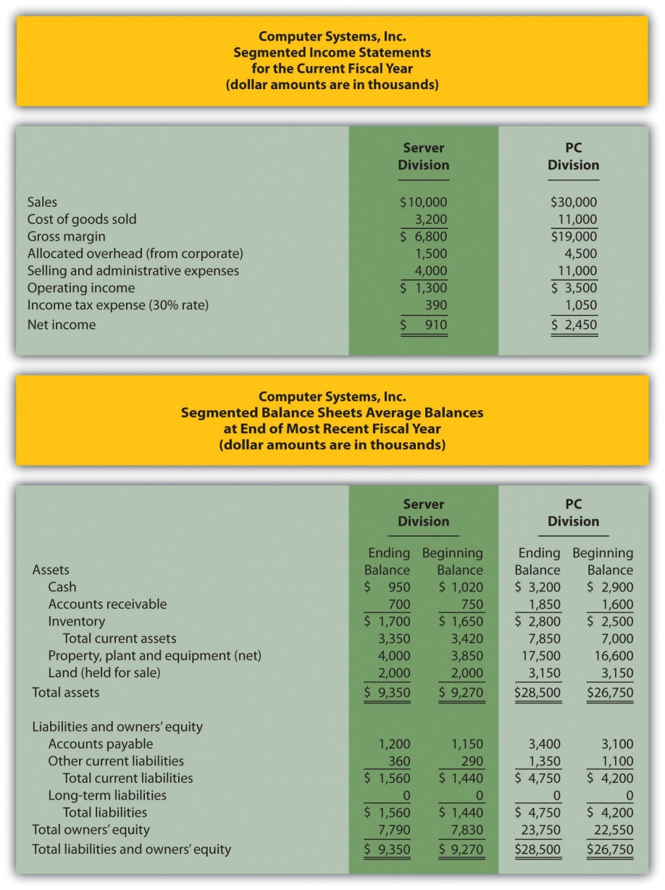
Required:
  - Calculate average operating assets for each division. (Hint: land held for sale is not an operating asset.)
  - Calculate operating profit margin, asset turnover, and ROI for each division.
  - What does this information tell us about each division?
- Operating Profit Margin, Asset Turnover, ROI, and RI. Financial information for Web Design, LLP, for the most recent fiscal year appears as follows. All dollar amounts are in thousands.
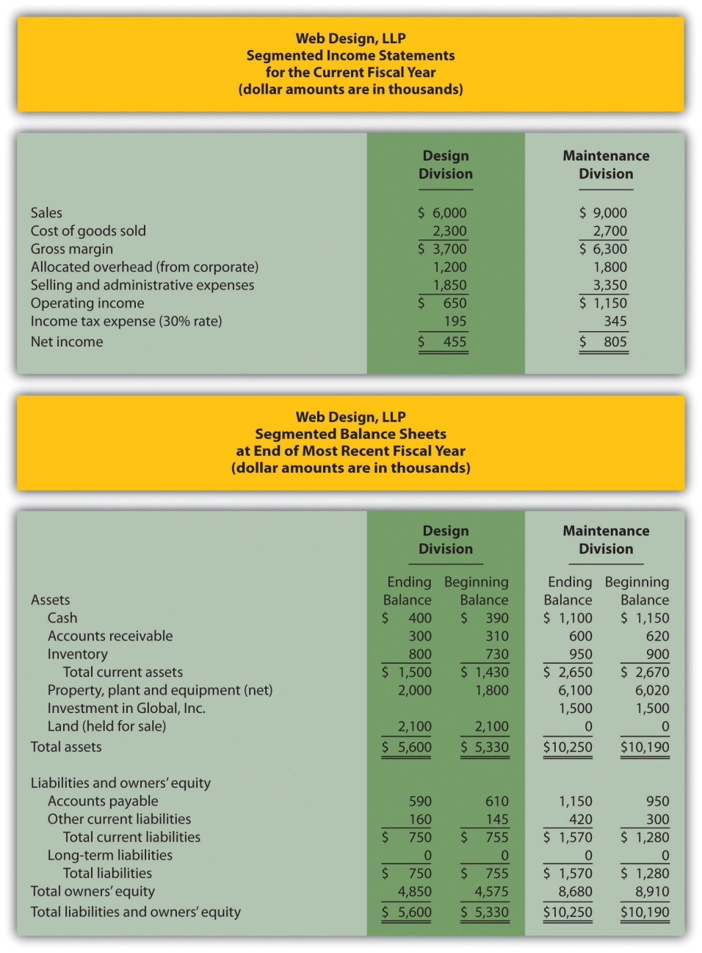
Required:
  - Calculate average operating assets for each division. (Hint: land held for sale and investments in Global, Inc., arenot operating assets.)
  - Calculate operating profit margin, asset turnover, and ROI for each division.
  - Calculate RI for each division assuming a cost of capital rate of 12 percent.
  - What does the information from requirements b and c tell us about each division?
- EVA. Conner, Inc., produces brass and woodwind music instruments. The following information is for each division at Conner for the most recent fiscal year.
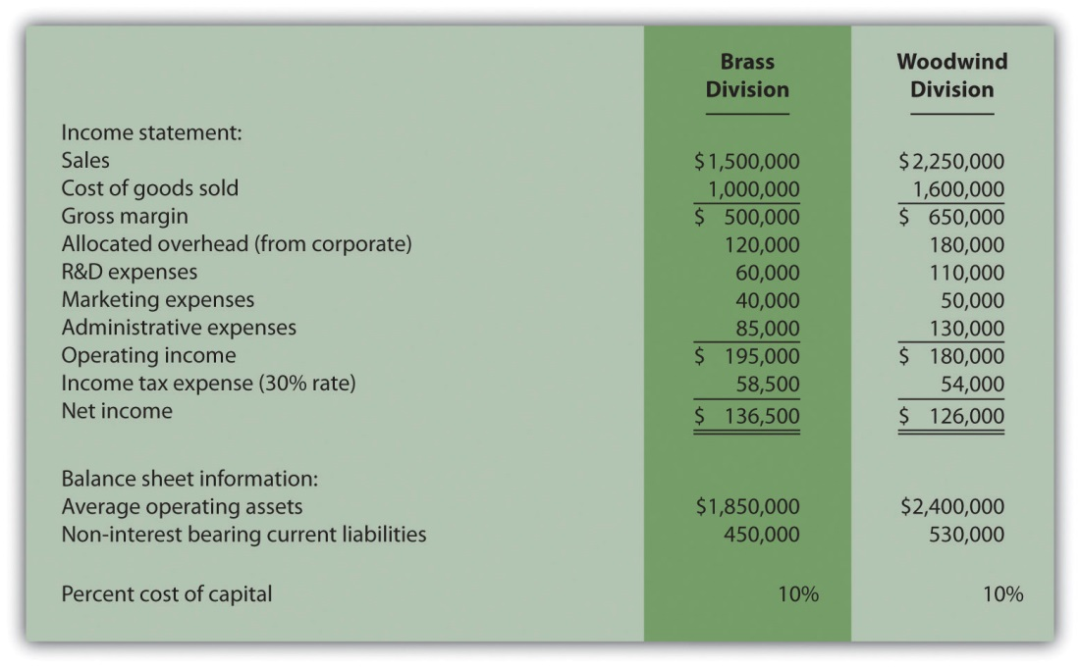
To calculate EVA, management requires adjustments for R&D expenses, marketing expenses, and noninterest bearing current liabilities as outlined in the following.
Research and development will be capitalized and amortized over several years resulting in an increase to average operating assets of $40,000 for the Brass division and $80,000 for the Woodwind division. On the income statement, R&D expenses for the year will be added back to operating income; R&D amortization expense for one year will be deducted. The current year amortization expense will total $20,000 for the Brass division and $30,000 for the Woodwind division.
Marketing will be capitalized and amortized over several years resulting in an increase to average operating assets of $30,000 for the Brass division and $38,000 for the Woodwind division. On the income statement, marketing expenses for the year will be added back to operating income; marketing amortization expense for one year will be deducted. The current year amortization expense will total $10,000 for the Brass division and $12,000 for the Woodwind division.
Noninterest bearing current liabilities will be deducted from average operating assets.
Required:
  - Calculate EVA for each division. What do the results show us for each division?
  - Why does EVA typically require adjustments to operating income and average operating assets?
- (Appendix) Transfer Pricing, Service Company. Kathy Kraven is the CEO and president of Legal Solutions, Inc. She oversees the company’s two divisions—Human Resources and Litigation. The Human Resources division provides legal services to personnel departments at various clients who need help creating personnel policies and manuals. The Litigation division provides legal services to support clients in litigation. Litigation often asks for help from Human Resources when faced with issues surrounding personnel policies but also has the option of seeking help outside the firm. Currently, Human Resources is below capacity and uses variable cost as its price for providing services to Litigation.
Since each division is evaluated by how much profit it generates, Human Resources would like to increase the price charged to Litigation. Litigation is steadfast against any such change. Kathy Kraven has stepped in and established the following policy: effective immediately, Human Resources will charge Litigation variable costs plus 20 percent for any services rendered internally.
Required:
  - Why is the Human Resources division manager concerned about the price it charges to Litigation?
  - Why is the Litigation division manager concerned about an increase in price charged by the Human Resources division?
  - Do you think Kathy’s plan is effective? Explain.
  - What other options are available for establishing transfer pricing?
- (Appendix) Transfer Pricing, Retail Company. Fred’s Fishing Supplies has two divisions, Lake and Deep Sea. Each division manager is evaluated based on profit produced by each division. The Lake division often sells a certain graphite fishing rod internally to the Deep Sea division for $50 per rod to cover variable costs. The Lake division also sells the same graphite rod to outside customers for $60 per rod. The Deep Sea division manager has the option of purchasing a similar rod from an outside supplier for $56.
Required:
  - Using the general economic transfer pricing rule, calculate the optimal transfer price assuming the Lake division is below capacity.
  - Using the general economic transfer pricing rule, calculate the optimal transfer price assuming the Lake division is at capacity.
  - The company’s CEO recently established the following policy: all internal transfers will be made at variable cost plus 20 percent. Assume the Lake division is operating below capacity. As the Deep Sea division manager, what would you do: purchase internally or purchase from an outside supplier? Why? How will your decision impact overall company profit?
One Step Further: Skill-Building Cases
- Segments at Hewlett-Packard. Refer to Why do you think Hewlett-Packardseparates its operations into seven segments?
- Transfer Pricing at General Electric (Appendix). Refer to How does General Electric establish transfer prices? What does this approach imply with regards to the products and services being provided?
- Group Activity—Decentralizing Operations. Each of the following scenarios is being considered at two separate companies.
  - Walker Wood Products manufactures custom garage doors and custom furniture. The company recently experienced significant growth and top management would like to separate the company into two divisions—Garage and Furniture.
  - Iron Manufacturing produces iron fencing for residential and commercial properties. The company recently experienced significant growth and top management would like to separate the company into two divisions—Residential and Commercial.
Required:
Form groups of two to four students. Each group is to perform the following requirements for the scenario assigned:
  - Identify the potential advantages and disadvantages of decentralizing into two divisions and allowing the manager of each division to have complete control over operations.
  - Discuss the findings of your group with the class.
- Internet Project—Economic Value Added. Stern Stewart & Company is a global consulting firm that pioneered the development of the EVA concept. Go to the Stern Stewart & Company Web site athttp://www.sternstewart.com. Review the information provided at this Web site and write a one-page report summarizing the information you found to be most interesting. Also submit a printed copy of the information from the Web site with your report.
- Creating a Segmented Income Statement Using Excel. Pool Accessories, Inc., has two divisions—Furniture and Supplies. The following segmented financial information is for the most recent fiscal year ended December 31.
 | Furniture Division | Supplies Division
Sales | $3,000,000 | $1,000,000
Cost of goods sold | 1,600,000 | 430,000
Allocated overhead | 375,000 | 125,000
Selling and administrative expenses | 250,000 | 200,000
- Assume the tax rate is 30 percent.
- Required:
  - Prepare an Excel spreadsheet similar to showing Pool Accessories’ segmented income statement and profit margin ratio for each division.
Comprehensive Case
- Ethics and ROI. Computer chip makers incur significant costs for research and development. Some research and development projects result in technologies used in new computer chips. Other research and development projects do not result in a useable technology. Because of the unpredictable nature of R&D activities, U.S. GAAP require that R&D costs be expensed in the period incurred.
Integrated Circuits, Inc. (ICI), produces computer chips and invests heavily in R&D. The firm has been struggling in recent years, and as a result, the board of directors hired a new top management group with the clear purpose of improving profitability. The board proposed a compensation package providing top managers with an annual bonus if the company’s operating income this coming year (year 2) increases 10 percent compared to year 1 and ROI remains above the 11 percent level achieved in year 1.
The new top management group is willing to accept this proposal, but only if costs related to successful R&D activities are capitalized and amortized over five years for internal reporting purposes. Their argument is most R&D activities benefit future years, and U.S. GAAP unfairly requires all R&D costs to be expensed in the period incurred, regardless of whether the activities are successful. This treatment by U.S. GAAP provides a disincentive for managers to invest in R&D projects that are vital to the company’s future survival. The board of directors agrees with this assertion and grants the new management group their request to capitalize costs for successful R&D activities over five years.
One year has passed with the new management group in place, and their financial results are presented as follows (for year two), along with last year’s information (year one). The entire $10,000,000 spent on R&D in year 2 was for unsuccessful projects since management decided to go a different direction with the company’s technology at the end of year 2. Nevertheless, top management capitalized the entire $10,000,000 and amortized these costs over 5 years as reflected in the year 2 financial results. (Note: of this amount, $2,000,000 is included in depreciation and amortization expensefor year 2, and $8,000,000 is included in average operating assetsfor year 2.)
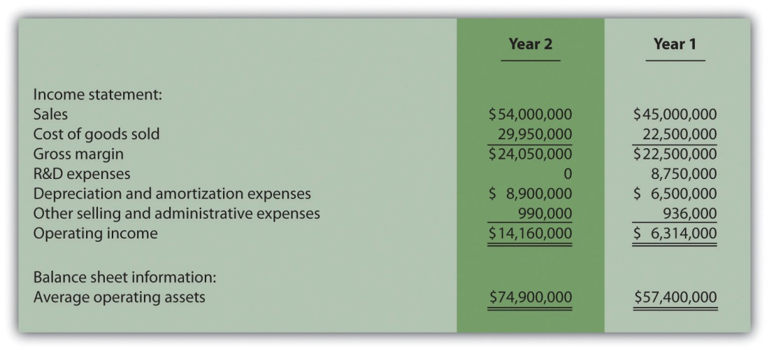
Required:
  - Based on the financial data presented, calculate ROI for each year and the percent change in operating income from year 1 to year 2. Does the new management group qualify for the bonus?
  - Prepare revised financial information in the same format as presented previously assuming none of the $10,000,000 in year 2 R&D costs are capitalized and amortized. (Hint: Amounts for year 1 will remain the same. Income statement and balance sheet amounts for year 2 will change.) Calculate the revised ROI for year two, and the revised percent change in operating income from year one to year two. Based on your results, would the new management group qualify for the bonus?
  - Is the new management group’s treatment of R&D costs for year 2 ethical?
  - How should the board of directors respond to the new management group’s assertion that $10,000,000 in R&D costs should be capitalized in year 2?
- Performance Evaluation Methods. Casey Fashions, Inc., sells clothing throughout North America. The company’s compensation committee, made up of five members from the board of directors, is meeting to discuss the CEO’s contract, which expires next month. The committee is currently reviewing financial information for the three most recent fiscal years: year 3 (most recent), year 2, and year 1 (shown as follows).
The income statement indicates sales increased 30 percent from year 1 to year 2 and 35 percent from year 2 to year 3. Net income increased 14 percent from year 1 to year 2, and 18 percent from year 2 to year 3. One member on the committee, Chris Carson, would like to offer the CEO a multiyear extension with a significant bump in salary and thousands of shares of stock options. When questioned why, Chris pointed to the positive results reflected on the income statement.
Another committee member, Mary Nichols, agrees with Chris that income statement trends look great, but she would like to review other measures of performance as well. Mary has asked you to come up with two measures of performance that go beyond simply looking at the income statement.
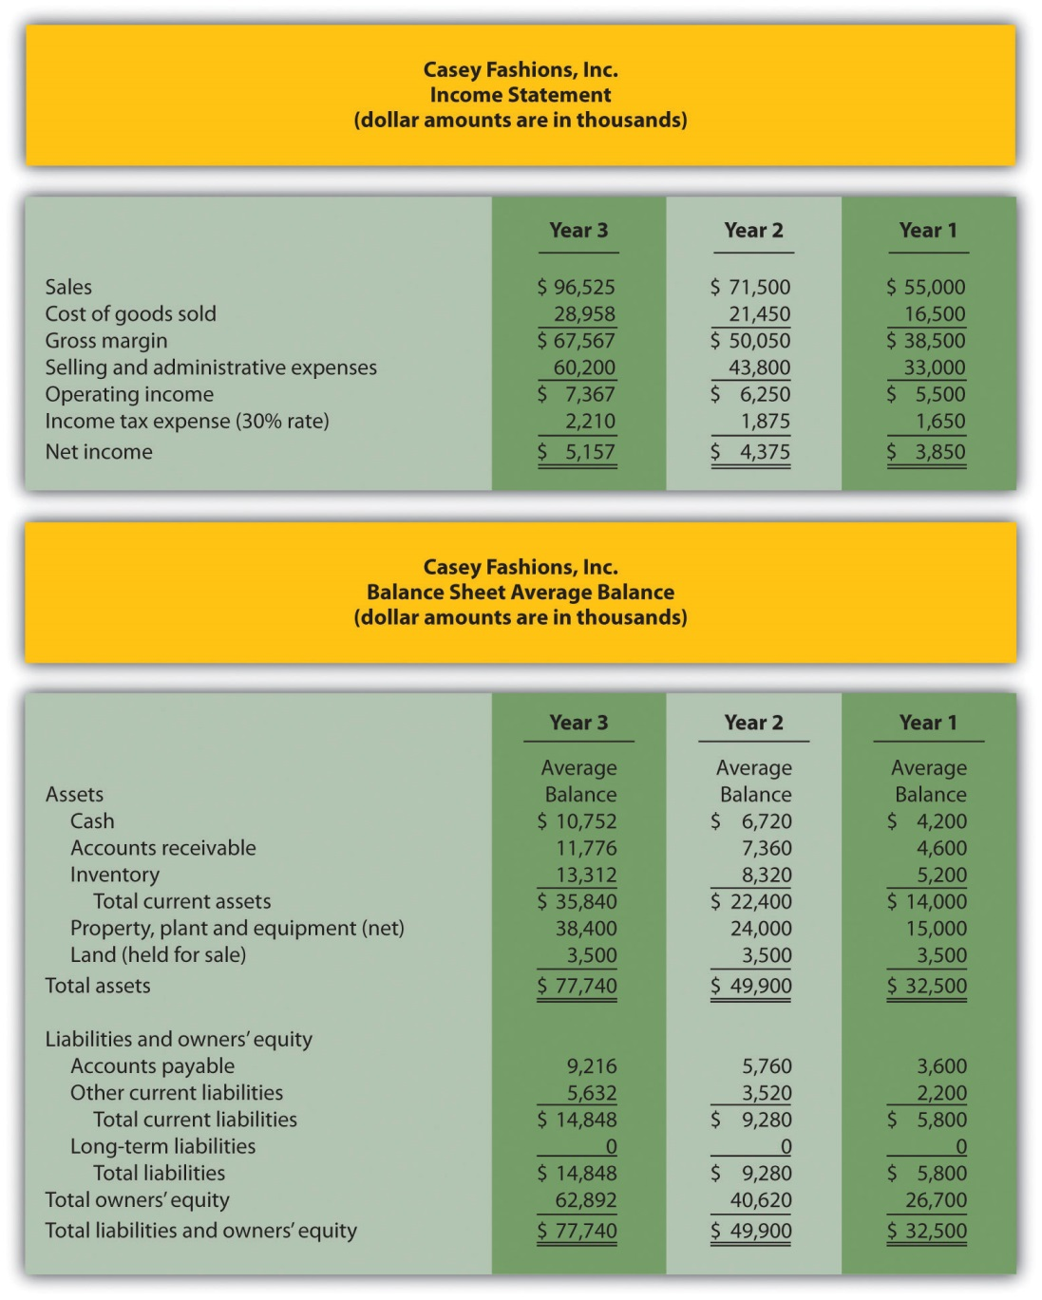
Required:
  - Calculate ROI for each of the three years. Note that balance sheet amounts presented for each year are already average balances (i.e., no need to calculate average balances). Assume land held for sale is not an operating asset.
  - Calculate RI for each of the 3 years assuming the company’s cost of capital rate is 12 percent.
  - Prepare a written report to the compensation committee summarizing and explaining your findings in part a and b.

Chapter 12

How Is the Statement of Cash Flows Prepared and Used?

John Huston, CEO and founder of Home Store, Inc., has reviewed the company’s income statement and balance sheet for the most recent fiscal year ended December 31, 2012. Home Store has grown rapidly this past year, with sales and net income showing significant gains compared to 2011. Although John is satisfied with the increase in profitability, he notices a significant decline in cash. John decides to pursue this with Linda Nash (CFO) and Steve Bauer (treasurer) in their weekly meeting:
John: | I just received the income statement and balance sheet for 2012. Profits look great, but our cash position seems to have deteriorated. We had $130,000 in cash to start the year and ended with only $32,000. I noticed cash was declining throughout the year when I reviewed our monthly financial statements, but I’m concerned about how far our cash balance has dropped.
Steve: | You’re right, John. We encountered cash flow problems several times throughout the year in spite of increased sales and profits. On several occasions, I had to delay payments to creditors because of cash flow issues.
John: | Seems to me we shouldn’t have this problem. Where is our cash going?
Linda: | Good question. Let me round up our cash flow information for the year. I’ll have something for you by next week.
John: | Great! I’d like to start next week’s meeting by discussing how much cash we generated in 2012 from our daily operations. I realize net income is shown on an accrual basis, but I’d like to know how much net income was received in the form of cash.
Linda: | No problem. I’ll have it for you next week.

Home Store, Inc., has cash flow problems that are common to many fast growing companies. Although the income statement and balance sheet provide important information concerning financial performance and financial condition, neither statement provides information regarding cash activity for a period of time. The focus of this chapter is on preparing a statement that provides cash flow information. This statement is appropriately called the statement of cash flows.

12.1 Purpose of the Statement of Cash Flows

LEARNING OBJECTIVE
- Define the purpose of the statement of cash flows.

Question: Most organizations prepare four financial statements for external reporting purposes: income statement, balance sheet, statement of owners’ equity, and statement of cash flows. Financial accounting courses cover the first three statements in detail and often provide an overview of the statement of cash flows. This chapter will focus on preparing the statement of cash flows and on using the resulting cash flow information for analytical purposes. What information is provided in the statement of cash flows?

Answer: The statement of cash flows provides cash receipt and cash payment information and reconciles the change in cash for a period of time. Cash receipts and cash payments are summarized and categorized as operating, investing, or financing activities. Simply put, the statement of cash flows indicates where cash came from and where cash went for a period of time.

Assume you keep track of your individual cash transactions for an entire year in a check register (e.g., checks written and paycheck deposits) and suppose you have hundreds of transactions for the year. Rather than showing every single transaction in a formal report, the statement of cash flows summarizes these transactions. For example, all cash receipts from paychecks are added together and shown as one line item, all cash payments for rent are added together and shown as one line item, all cash payments for food are added together and shown as one line item, and so on. The goal is to start with the beginning of the year cash balance, add all cash receipts for the year, subtract all cash payments for the year, and find the resulting end-of-year cash balance. Although the formal statement of cash flows is not quite this simple, the concept is the same.

Question: Why did the Financial Accounting Standards Board (FASB) create the statement of cash flows in 1987?

Answer: The statement of cash flows was created due to a lack of cash flow information on the income statement, balance sheet, and statement of owners’ equity. The income statement shows revenues and expenses using the accrual basis of accounting, but it does not indicate how much cash was received for revenues or paid for expenses. The balance sheet shows assets, liabilities, and owners’ equity at a point in time, but it does not show how much cash was received or paid for these items. The only cash information provided on these statements is the change in cash from the end of last period to the end of the current period derived from the cash line item on the balance sheet (often called cash and cash equivalents).

Owners, creditors, and managers wanted more cash flow information. They often asked such questions as: Why did cash go down? How much cash was received related to net income? How much cash was paid for the purchase of equipment? How much cash was received from issuing bonds? As a result of the demand for more cash flow information, the FASB formally created the statement of cash flows in 1987 (Statement of Financial Accounting Standard No. 95, which can be found at http://www.fasb.org). Most companies are now required to prepare the statement of cash flows along with the other three statements. We begin the process of explaining how to prepare this statement in the next section.

Business in Action 12.1
Cash Flows at Southwest Airlines
Southwest Airlines was in the enviable position of generating $1,600,000,000 in cash from operating activities for the year ended December 31, 2010. However, cash on the balance sheet only increased $147,000,000 for the same period. Why did total cash go up by such a small amount compared to the $1,600,000,000 increase in cash from operating activities? The statement of cash flows provides the information necessary to answer this question. Southwest spent $493,000,000 on property and equipment (planes, parts, etc.) and $155,000,000 to pay off long-term debt. Southwest also purchased $772,000,000 in short-term investments.
Source: Southwest Airlines, “2010 Annual Report,”http://www.southwest.com.

KEY TAKEAWAY
- The statement of cash flows provides cash receipt and cash payment information and reconciles the change in cash for a period of time. The primary purpose of the statement is to show what caused the change in cash from the beginning of the period to the end of the period.

REVIEW PROBLEM 12.1
- Describe the purpose of the statement of cash flows.
- Why did the FASB create the statement of cash flows?
Solution to Review Problem 12.1
- The purpose of the statement of cash flows is to provide a summary of cash receipt and cash payment information for a period of time and to reconcile the difference between beginning and ending cash balances shown on the balance sheet. The statement of cash flows clarifies how cash was generated and how cash was used for a period of time.
- The FASB created the statement of cash flows because owners, creditors, managers, and other stakeholders wanted more information regarding cash receipts and cash expenditures. Although the balance sheet shows cash balances at the end of each period, no further information is provided on the balance sheet, income statement, or statement of owners’ equity regarding cash flow activities. The statement of cash flows takes care of this problem.

12.2 Three Types of Cash Flow Activities

LEARNING OBJECTIVE
- Describe the three categories of cash flows.

Question: What are the three types of cash flows presented on the statement of cash flows?

Answer: Cash flows are classified as operating, investing, or financing activities on the statement of cash flows, depending on the nature of the transaction. Each of these three classifications is defined as follows.
- Operating activities include cash activities related to net income. For example, cash generated from the sale of goods (revenue) and cash paid for merchandise (expense) are operating activities because revenues and expenses are included in net income.
- Investing activities include cash activities related to noncurrent assets. Noncurrent assets include (1) long-term investments; (2) property, plant, and equipment; and (3) the principal amount of loans made to other entities. For example, cash generated from the sale of land and cash paid for an investment in another company are included in this category. (Note that interest received from loans is included in operating activities.)
- Financing activities include cash activities related to noncurrent liabilities and owners’ equity. Noncurrent liabilities and owners’ equity items include (1) the principal amount of long-term debt, (2) stock sales and repurchases, and (3) dividend payments. (Note that interest paid on long-term debt is included in operating activities.)

Shows examples of cash flow activities that generate cash or require cash outflows within a period. presents a more comprehensive list of examples of items typically included in operating, investing, and financing sections of the statement of cash flows.
Figure 12.2 Examples of Cash Flow Activity by Category
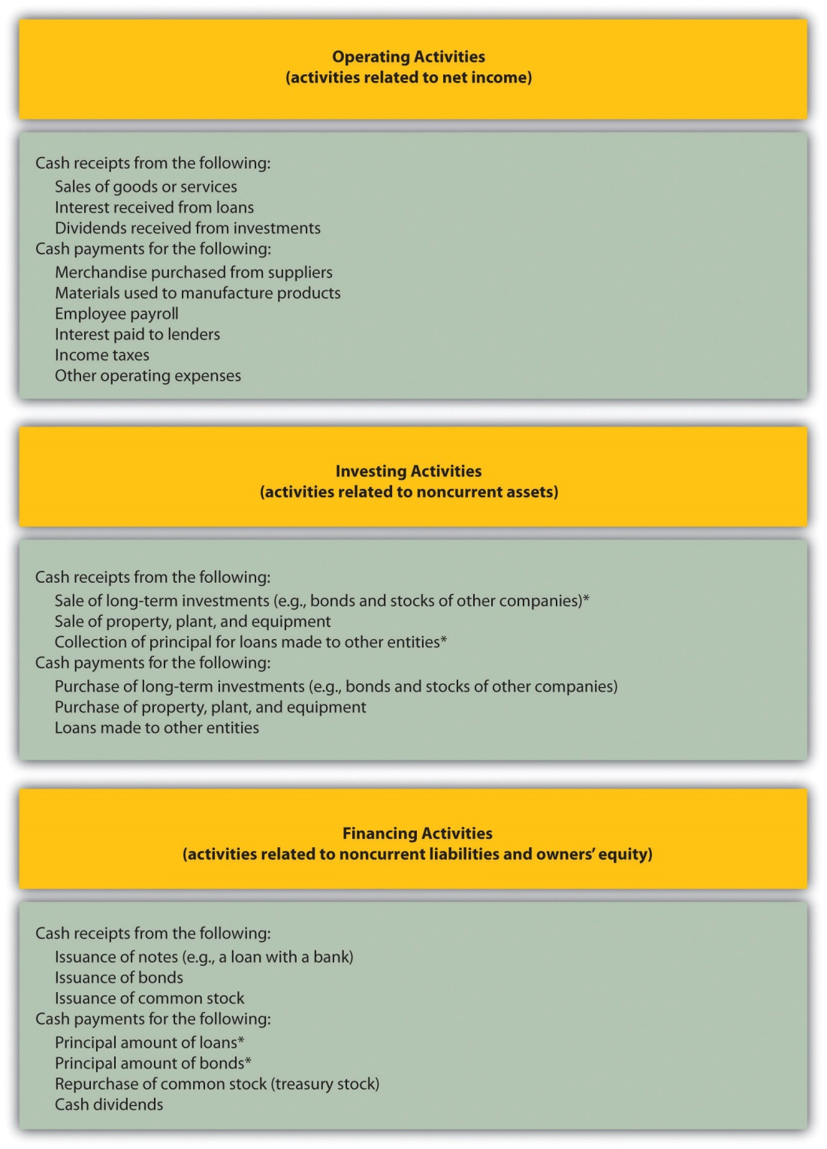

*Receipts of cash for dividends from investments and for interest on loans made to other entities are included in operating activities since both items relate to net income. Likewise, payments of cash for interest on loans with a bank or on bonds issued are also included in operating activities because these items also relate to net income.

Question: Which section of the statement of cash flows is regarded by most financial experts to be most important?

Answer: The operating activities section of the statement of cash flows is generally regarded as the most important section since it provides cash flow information related to the daily operations of the business. This section answers the question, “how much cash did we generate from the daily activities of our core business?” Owners, creditors, and managers are most interested in cash flow generated from daily activities rather than from a one-time issuance of stock or a one-time sale of land. The operating activities section allows stakeholders to assess the ongoing viability of the company. We discuss how to use cash flow information to evaluate organizations later in the chapter.

Business in Action 12.2
Cash Activity at Home Depot and Lowe’s
The Home Depot. Inc., and Lowe’s Companies, Inc., are large home improvement retail companies with stores throughout North America. A review of the statements of cash flows for both companies reveals the following cash activity. Positive amounts are cash inflows, and negative amounts are cash outflows.
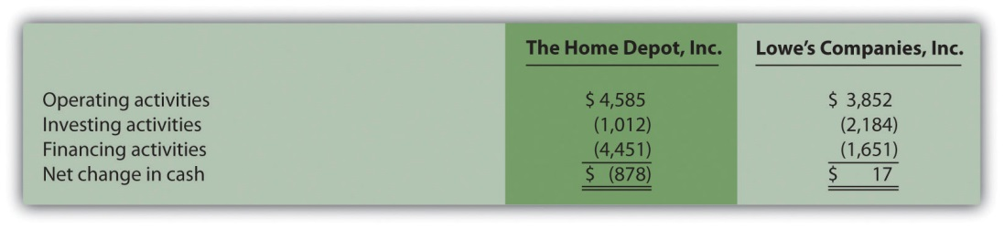
Amounts are in millions.
This information shows both companies generated significant amounts of cash from daily operating activities; $4,600,000,000 for The Home Depot and $3,900,000,000 for Lowe’s. It is interesting to note both companies spent significant amounts of cash to acquire property and equipment and long-term investments as reflected in the negativeinvesting activities amounts. For both companies, a significant amount of cash outflows from financing activities were for the repurchase of common stock. Apparently, both companies chose to return cash to owners by repurchasing stock.
Source: The Home Depot Inc., “2010 Annual Report,”http://www.homedepot.com; Lowe’s Companies Inc., “2010 Annual Report,” http://www.lowes.com.

KEY TAKEAWAY
- The three categories of cash flows are operating activities, investing activities, and financing activities. Operating activities include cash activities related to net income. Investing activities include cash activities related to noncurrent assets. Financing activities include cash activities related to noncurrent liabilities and owners’ equity.

REVIEW PROBLEM 12.2
Identify whether each of the following items would appear in the operating, investing, or financing activities section of the statement of cash flows. Explain your answer for each item.
- Cash payments for purchases of merchandise
- Cash receipts from sale of common stock
- Cash payments for equipment
- Cash receipts from sales of goods
- Cash dividends paid to shareholders
- Cash payments to employees
- Cash payments to lenders for interest on loans
- Cash receipts from collection of principal for loans made to other entities
- Cash receipts from issuance of bonds
- Cash receipts from collection of interest on loans made to other entities
Solution to Review Problem 12.2
- It would appear as operating activity because merchandise activity impacts net income as an expense (merchandise costs ultimately flow through cost of goods sold on the income statement).
- It would appear as financing activity because sale of common stock impacts owners’ equity.
- It would appear as investing activity because purchase of equipment impacts noncurrent assets.
- It would appear as operating activity because sales activity impacts net income as revenue.
- It would appear as financing activity because dividend payments impact owners’ equity.
- It would appear as operating activity because employee payroll activity impacts net income as an expense.
- It would appear as operating activity because interest payments impact net income as an expense.
- It would appear as investing activity because principal collections impact noncurrent assets.
- It would appear as financing activity because bond issuance activity impacts noncurrent liabilities.
- It would appear as operating activity because interest received impacts net income as revenue.

12.3 Four Key Steps to Preparing the Statement of Cash Flows

LEARNING OBJECTIVE
- Describe the four steps used to prepare the statement of cash flows.

Question: Recall from your financial accounting course that the accrual basis of accounting recognizes revenue when earned and expenses when incurred, regardless of when cash is exchanged. Conversely, the cash basis of accounting recognizes revenue when cash is received and expenses when cash is paid, regardless of when goods or services are exchanged. The income statement, balance sheet, and statement of owners’ equity are all created using the accrual basis of accounting. However, the statement of cash flows is based on cash flows only, and thus adjustments must be made to convert accrual basis information to a cash basis. What information is necessary to make these adjustments?

Answer: Several pieces of information are required to make these adjustments in preparing the statement of cash flows:
- Balance sheets for the end of last year and end of the current year are needed to calculate the amount of change in each balance sheet account. These changes in balance sheet accounts are needed to prepare certain parts of the statement of cash flows.
- Income statement information for the current year is needed as the starting point for converting net income from an accrual basis to a cash basis, which is shown in the operating activities section of the statement of cash flows.
- Other information is needed to complete the statement of cash flows, such as cash dividends paid and the original cost of long-term investments sold.

Question: With this information in hand, four steps are required to prepare the statement of cash flows. What are these four steps?

Answer: The four steps required to prepare the statement of cash flows are described as follows:

Step 1. Prepare the operating activities section by converting net income from an accrual basis to a cash basis.

This step can be done using one of two methods—the direct method or theindirect method. Because more than 98 percent of companies surveyed use the indirect method (see ), we will use the indirect method throughout this chapter. The appendix describes the direct method.

The indirect method begins with net income from the income statement and makes several adjustments related to changes in current assets, current liabilities, and other items to arrive at cash provided by operating activities(or used by operating activities if the result is a cash outflow). Cash provided by operating activities represents net income on a cash basis. It tells the reader how much cash was received from the daily operations of the business.

Step 2. Prepare the investing activities section by presenting cash activity for noncurrent assets.

This step focuses on the effect changes in noncurrent assets have on cash. Noncurrent asset balances found on the balance sheet, coupled with other information (e.g., cash proceeds from sale of equipment) are used to perform this step.

Step 3. Prepare the financing activities section by presenting cash activity for noncurrent liabilities and owners’ equity.

This step focuses on the effect changes in noncurrent liabilities and owners’ equity have on cash. Noncurrent liabilities and owners’ equity balances found on the balance sheet, coupled with other information (e.g., cash dividends paid) are used to perform this step.

Step 4. Reconcile the change in cash.

Each section of the statement of cash flows described in steps 1, 2, and 3, will show the total cash provided by (increase) or used by (decrease) the activity. Step 4 simply confirms that the net of these changes equates to the change in cash on the balance sheet.

For example, assume the balance sheet shows cash totaled $100 at the end of last year and $140 at the end of the current year. Thus cash increased $40 over the course of the current year. Step 4 reconciles this change with the changes shown in the three sections of the statement of cash flows. Suppose operating activities provided cash of $170, investing activities used cash of $160, and financing activities provided cash of $30. These 3 amounts netted together reconcile to the $40 increase in cash shown on the balance sheet (= $170 − $160 + $30).

Business in Action 12.3
Indirect Method Is Most Popular
Most companies prefer to use the indirect method to prepare the operating activities section of the statement of cash flows. A survey taken in 2001 showed more than 98 percent of the 600 companies surveyed used the indirect method. Reasons for this preference vary, but several possibilities are as follows:
- The indirect method links net income to cash flows from operating activities by reconciling the two amounts.
- Accounting systems do not easily generate information needed to use the direct method.
- Those using the direct method are also required to provide a supplemental schedule using the indirect method. It is less costly to simply prepare the statement using the indirect method.
Source: American Institute of Certified Accountants, Accounting Trends and Techniques (Washington, D.C.: American Institute of Certified Public Accountants, 2001).

KEY TAKEAWAY
- The four steps required to prepare the statement of cash flows are described as follows:

Step 1. Prepare the operating activities section by converting net income from an accrual basis to a cash basis.
Step 2. Prepare the investing activities section by presenting cash activities for noncurrent assets.
Step 3. Prepare the financing activities section by presenting cash activities for noncurrent liabilities and owners’ equity.
Step 4. Reconcile the change in cash from the beginning of the period to the end of the period.

REVIEW PROBLEM 12.3
Describe the four steps necessary to prepare the statement of cash flows.
Solution to Review Problem 12.3
The four steps required to prepare the statement of cash flows are as follows:
Step 1. Prepare the operating activities section by converting net income from an accrual basis to a cash basis.
This step starts with net income on an accrual basis (from the income statement) and makes adjustments related to changes in current assets, current liabilities, and other items to find net income on a cash basis. The resulting cash basis net income is called cash provided by operating activities.
Step 2. Prepare the investing activities section by presenting cash activity for noncurrent assets.
This step focuses on the effect changes in noncurrent assets have on cash.
Step 3. Prepare the financing activities section by presenting cash activity for noncurrent liabilities and owners’ equity.
This step focuses on the effect changes in noncurrent liabilities and owners’ equity have on cash.
Step 4. Reconcile the change in cash.
Each section of the statement of cash flows described in steps 1, 2, and 3 will show the total cash provided by or used by each activity. Step 4 confirms that the net of these changes equates to the change in cash derived from the balance sheet.

12.4 Using the Indirect Method to Prepare the Statement of Cash Flows

LEARNING OBJECTIVE
- Prepare a statement of cash flows using the indirect method.

Question: Now that you are familiar with the four key steps, let’s take a look at the statement of cash flows for Home Store, Inc. Where do we start in preparing Home Store, Inc.’s statement of cash flows?

Answer: As stated earlier, the information needed to prepare the statement of cash flows includes the balance sheet, income statement, and other selected data. This information is presented in . Other pertinent data for 2012 are as follows:
- Sold equipment with a book value of $11,000 (= $21,000 cost − $10,000 accumulated depreciation) for $5,000 cash
- Purchased equipment for $67,000 cash
- Long-term investments were purchased for $12,000 cash. There were no sales of long-term investments
- Bonds were paid with a principal amount of $18,000
- Issued common stock for $4,000 cash
- Declared and paid $32,000 in cash dividends

With these data and the information provided in , we can start preparing the statement of cash flows. It is important to note that all positive amounts shown in the statement of cash flows denote an increase in cash, and all negative amounts denote a decrease in cash.

Figure 12.3 Balance Sheet and Income Statement for Home Store, Inc.
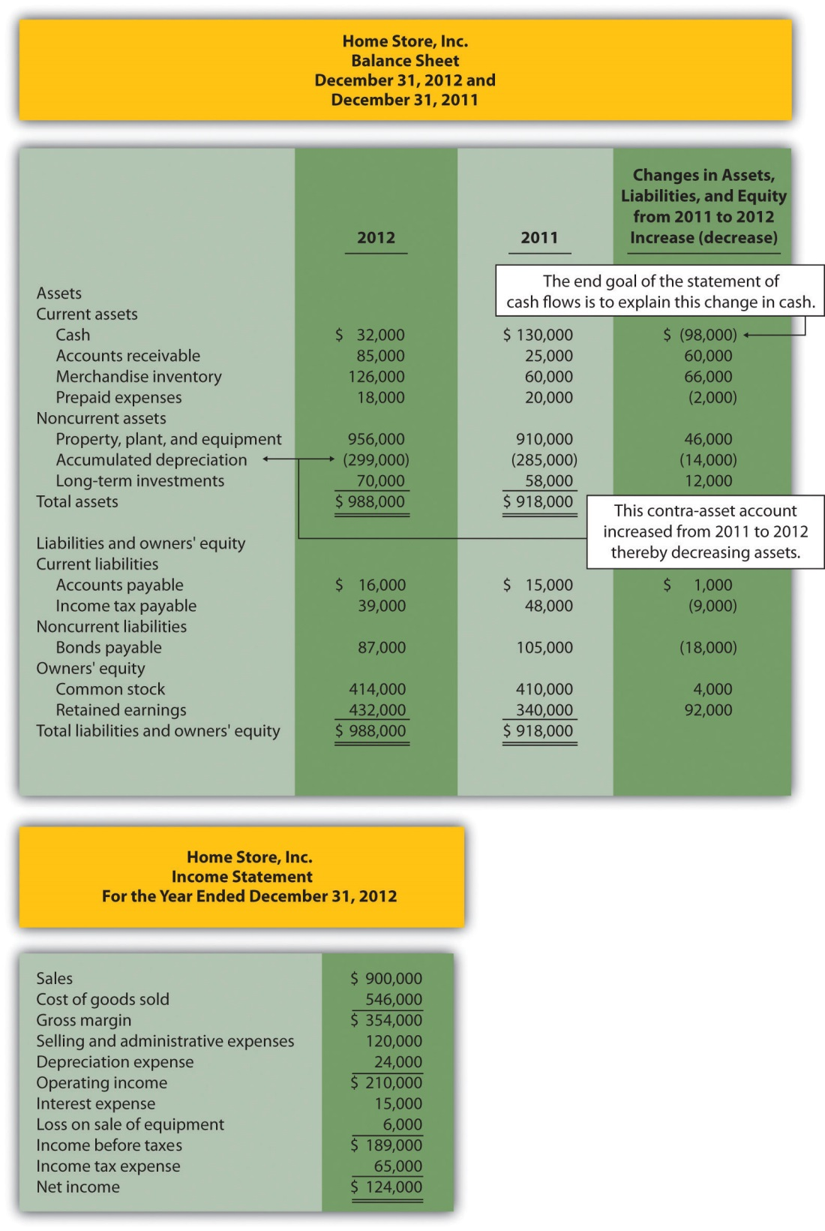

Step 1: Prepare the Operating Activities Section

Question: We will be using the indirect method to prepare the operating activities section. (The direct method is covered in the appendix.) The starting point using the indirect method is net income. Home Store, Inc., had net income of $124,000 in 2012. This amount comes from the income statement, which was prepared using the accrual basis of accounting. How do we convert this amount to a cash basis?

Answer: Several adjustments are necessary to convert this amount to a cash basis and to provide an amount related only to daily operating activities of the business. If the resulting adjusted amount is a cash inflow, it is calledcash provided by operating activities; if it is a cash outflow, it is called cash used by operating activities.

Three general types of adjustments are necessary to convert net income tocash provided by operating activities. These three types of adjustments are shown in , which also displays the format used for the operating activities section of the statement of cash flows. Examine this figure carefully.

Figure 12.4 Operating Activities Format and Adjustments
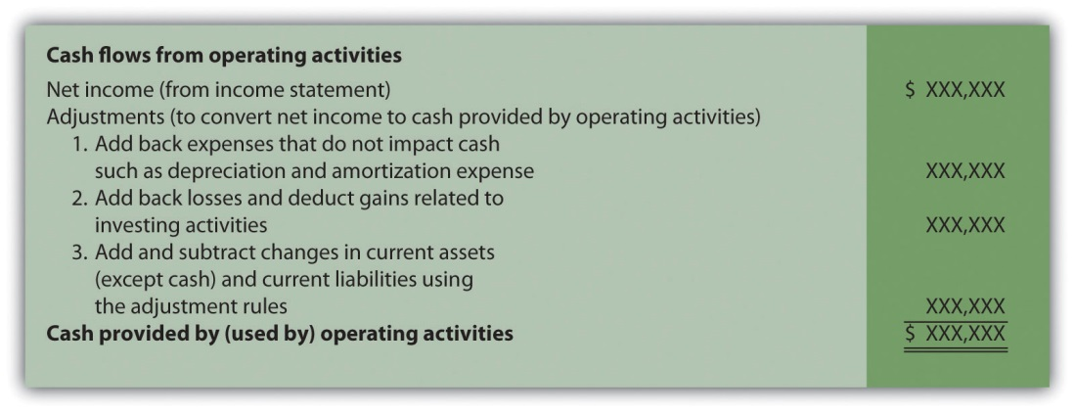

Adjustment One: Adding Back Noncash Expenses

Question: What is the first type of adjustment necessary to convert net income to a cash basis?

Answer: The first adjustment to net income involves adding back expenses that do not affect cash (often called noncash expenses). For example, the accrual basis of accounting deducts depreciation expense in calculating net income, even though depreciation expense does not involve cash. (Recall the financial accounting entry to record depreciation expense: debit depreciation expense and credit accumulated depreciation. Notice cash is not involved.) Thus to convert net income to a cash basis, depreciation expense is added back to net income. In effect, we are reversing depreciation expense because it is not an expense using the cash basis of accounting. The end result is as though depreciation expense was never deducted as an expense.

Next, we show how the first adjustment to net income appears in the operating activities section of the statement of cash flows for Home Store, Inc. (net income and depreciation expense come from the income statement shown in ):
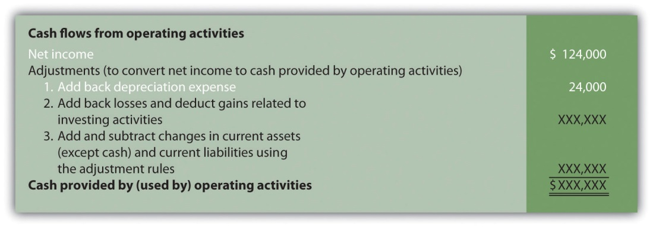

The income statement for Home Store, Inc., shows $24,000 in depreciation expense for the year. As shown previously, this amount is added back to the net income of $124,000.

Adjustment Two: Adding Back Losses and Deducting Gains Related to Investing Activities

Question: What is the second type of adjustment necessary to convert net income to a cash basis?

Answer: The second adjustment to net income involves adding back losses and deducting gains related to investing activities. For example, Home Store, Inc., realized a $6,000 loss on the sale of equipment. This loss is shown on the income statement as a deduction in calculating net income (see ). However, this loss is not related to the daily operations of the business. That is, Home Store, Inc., is not in the business of buying and selling equipment daily. Remember, we are trying to find the cash provided by operating activities in this section of the statement of cash flows.

Since equipment is a noncurrent asset, cash activity related to the disposal of equipment should be included in the investment activities section of the statement of cash flows. Thus the $6,000 loss shown as a deduction on the income statement is added back to net income, and it will be included later in the investing activities section as part of the proceeds from the sale of equipment. In effect, we are reversing the $6,000 loss because it is not an operating expense.

Here’s how the second adjustment to net income appears in the operating activities section of the statement of cash flows for Home Store, Inc.:
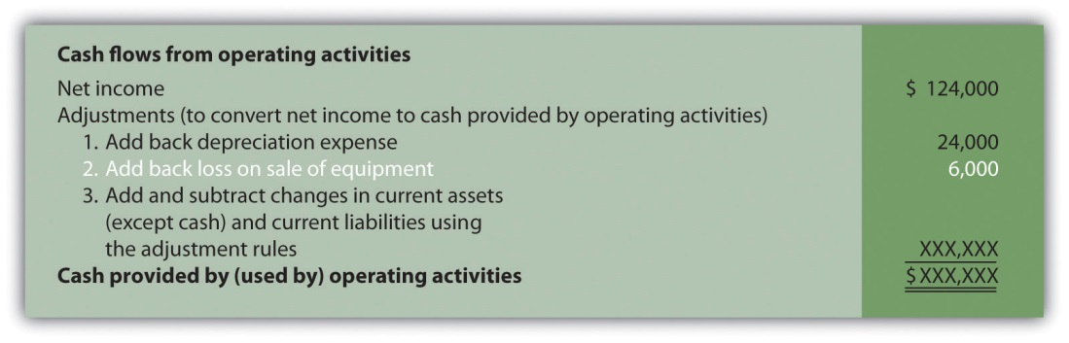

Adjustment Three: Adding and Subtracting Changes in Current Assets and Current Liabilities

Question: What is the third type of adjustment necessary to convert net income to a cash basis?

Answer: The third type of adjustment to net income involves analyzing the changes in all current assets (except cash) and current liabilities from the beginning of the period to the end of the period. These changes are already shown in the far right column of the balance sheet portion of . Two important rules must be followed to determine how the change is reflected as an adjustment to net income. Study these two rules carefully:
- Current assets. Increases in current assets are deducted from net income; decreases in current assets are added to net income. (There is aninverse relationship between the change in a current asset account and how it is shown as an adjustment.)
- Current liabilities. Increases in current liabilities are added to net income; decreases in current liabilities are deducted from net income. (There is a direct relationship between the change in a current liability account and how it is shown as an adjustment.)

Now let’s work through each current asset and current liability line item shown in the balance sheet () and use these rules to determine how each item fits into the operating activities section as an adjustment to net income.

The first current asset line item, cash, shows the change in cash from the beginning of the year to the end of year. Cash decreased by $98,000. The goal of the statement of cash flows is to show what caused this $98,000 decrease. This amount will appear in step 4 when we reconcile the beginning cash balance to the ending cash balance. The next line item is accounts receivable.

Accounts receivable (current asset) increased by $60,000. The current asset rule states that increases in current assets are deducted from net income. Thus $60,000 is deducted from net income in the operating activities section of the statement of cash flows. Here’s why.

Assume all Home Store’s sales shown on the income statement are credit sales (each sale required a debit to accounts receivable and a credit to sales). The beginning accounts receivable balance of $25,000 is increased by $900,000 for credit sales made during the year, resulting in $925,000 in total receivables to be collected. Since $85,000 in accounts receivable remains at the end of the year, $840,000 in cash was collected (= $925,000 − $85,000). On a cash basis, Home Store, Inc., should show $840,000 in revenue rather than $900,000. Thus net income must be reduced by $60,000 (= $900,000 revenue using accrual basis − $840,000 revenue using cash basis). The accounts receivable T-account shown in the following provides further clarification.
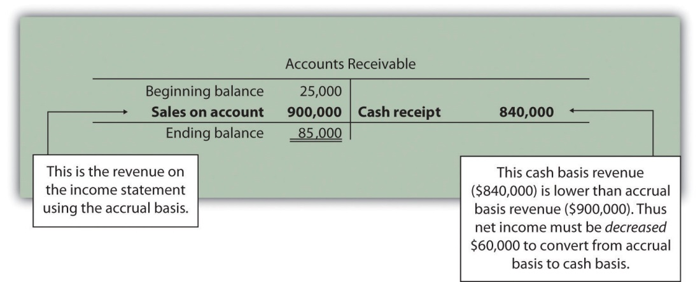

Here’s how the accounts receivable adjustment to net income appears in the operating activities section of the statement of cash flows for Home Store, Inc.:
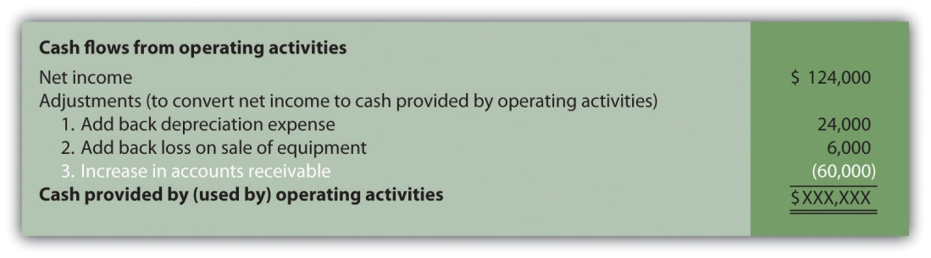

We will continue analyzing each current asset and current liability item in the balance sheet shown in and present the resulting adjustments and completed operating activities section at the end of our analysis in .

Merchandise inventory (current asset) increased by $66,000.Because the current asset rule states that increases in current assets are deducted from net income, $66,000 is deducted from net income in the operating activities section of the statement of cash flows. To explain why, let’s assume Home Store, Inc., pays cash for all purchases of merchandise inventory. If the merchandise inventory account increases over time, more goods are purchased than are sold. Because merchandise inventory at Home Store, Inc., increased $66,000 and cost of goods sold totaled $546,000 (as shown in ), the company must have purchased inventory with a cost of $612,000 during the period (= $66,000 + $546,000). Thus more cash was paid for merchandise ($612,000) than was reflected on the income statement as cost of goods sold ($546,000). If expenses are higher using a cash basis, the adjustment must decrease net income. Therefore $66,000 is deducted from net income in the operating activities section of the statement of cash flows. This information is summarized in the merchandise inventory T-account in the following.
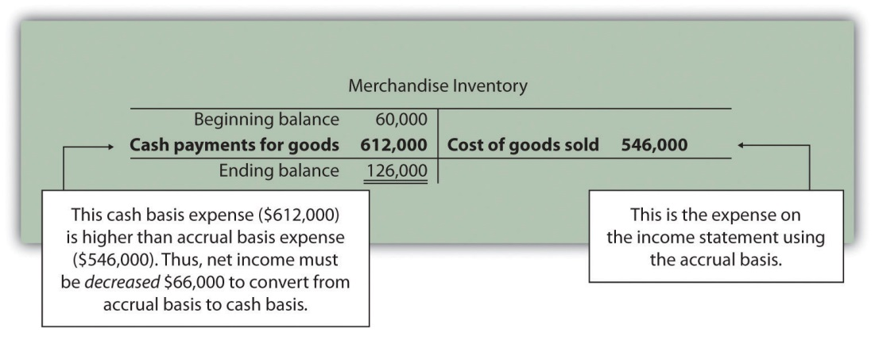

Prepaid expenses (current asset) decreased by $2,000. Because the current asset rule states that decreases in current assets are added to net income, $2,000 is added to net income in the operating activities section of the statement of cash flows. This is because cash paid for these expenses was lower than the expenses recognized on the income statement using the accrual basis. Since expenses are $2,000 lower using the cash basis, net income must be increased by $2,000.

Key Point
Important Current Asset Rule
When preparing the operating activities section of the statement of cash flows, increases in current assets are deducted from net income; decreases in current assets are added to net income.

Question: Now that we know how to handle the change in current assets when preparing the operating activities section of the statement of cash flows, what do we do with current liabilities?

Answer: The current liability rule is a bit different than the current asset rule as described next.

Accounts payable (current liability) increased by $1,000. Because the current liability rule states that increases in current liabilities are added to net income, $1,000 is added to net income in the operating activities section of the statement of cash flows. An increase in accounts payable signifies that Home Store, Inc., recorded more as an expense on the income statement (accrual basis) than the company paid in cash (cash basis). Since expenses are lower using the cash basis, net income must beincreased by $1,000.

Income tax payable (current liability) decreased by $9,000. Because the current liability rule states that decreases in current liabilities are deducted from net income, $9,000 is deducted from net income in the operating activities section of the statement of cash flows. A decrease in income tax payable signifies that Home Store, Inc., paid more for income taxes (cash basis) than the company recorded as an expense on the income statement (accrual basis). Since expenses are higher using the cash basis, net income must be decreased by $9,000.

Key Point
Important Current Liability Rule
When preparing the operating activities section of the statement of cash flows, increases in current liabilities are added to net income; decreases in current liabilities are deducted from net income.

Question: What does the operating activities section of the statement of cash flows look like for Home Store, Inc.?

Answer: shows the completed operating activities section of the statement of cash flows for Home Store. Inc. The most important line is at the bottom, which shows cash of $22,000 was generated during the year from daily operations of the business. Notice this amount is significantly lower than the net income amount of $124,000 reported on the income statement. Studycarefully noting the three types of adjustments made to net income.

Figure 12.5 Operating Activities Section of Statement of Cash Flows (Home Store, Inc.)
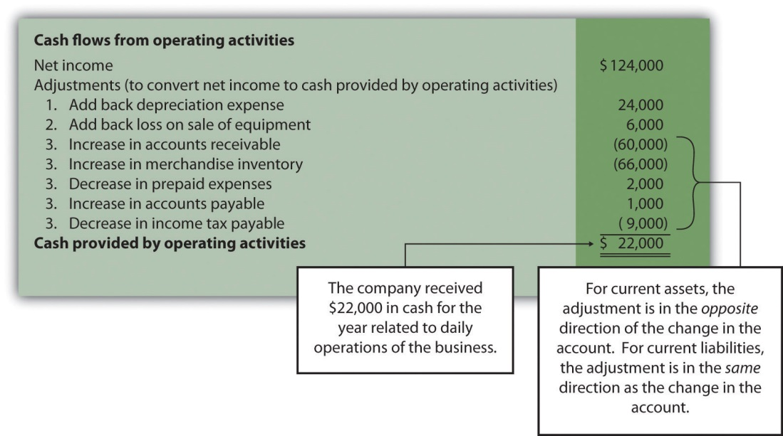

REVIEW PROBLEM 12.4
through will use the data presented as follows for Phantom Books. Each review problem corresponds to the four steps required to prepare a statement of cash flows.
Phantom Books is a retail store that sells new and used books. Phantom’s most recent balance sheet, income statement, and other important information for 2012 are presented in the following.
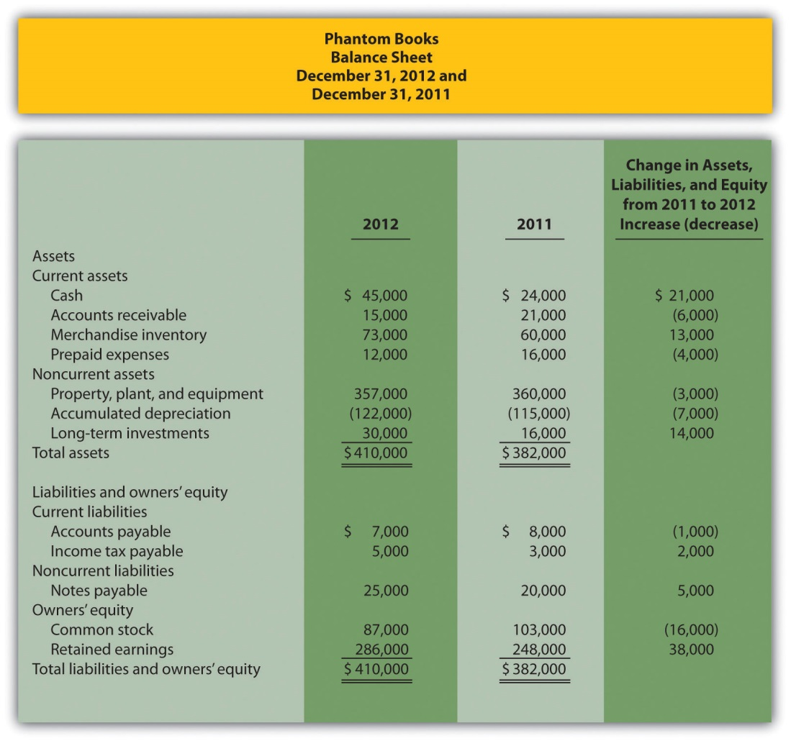
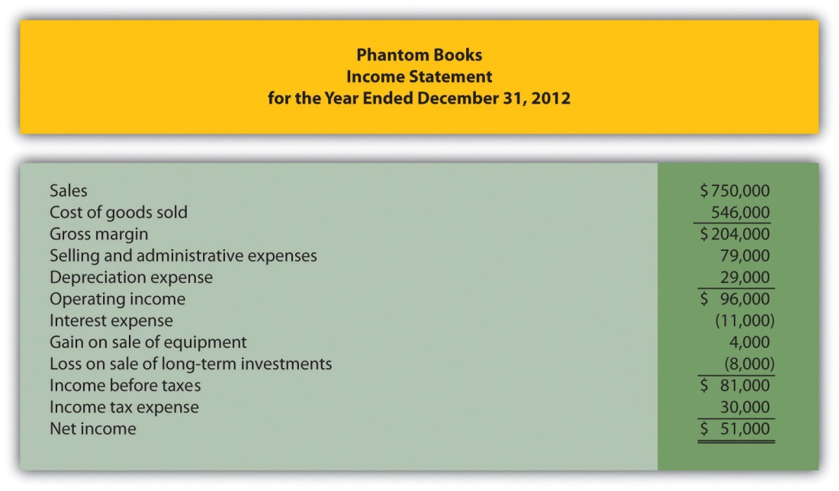
Additional data for 2012 include the following:
- Sold equipment with a book value of $8,000 (= $30,000 cost − $22,000 accumulated depreciation) for $12,000 cash
- Purchased equipment for $27,000 cash
- Sold long-term investments with an original cost of $11,000 for $3,000 cash
- Purchased long-term investments for $25,000 cash
- Signed a note with the bank for $5,000 cash. No principal amounts were paid during the year
- Repurchased common stock (treasury stock) for $16,000 cash. No new common stock was issued
- Declared and paid $13,000 in cash dividends
- Prepare the operating activities section of the statement of cash flows for Phantom Books using the indirect method. Follow the format presented in .
- How much cash did Phantom Books generate from operating activities for the year?
Solution to Review Problem 12.4
- Start with net income from the income statement; make the appropriate adjustments for (1) noncash expenses, such as depreciation and amortization; (2) gains and losses related to investing activities; and (3) changes in current assets other than cash and current liabilities. The operating activities section of the statement of cash flows for Phantom Books appears as follows.
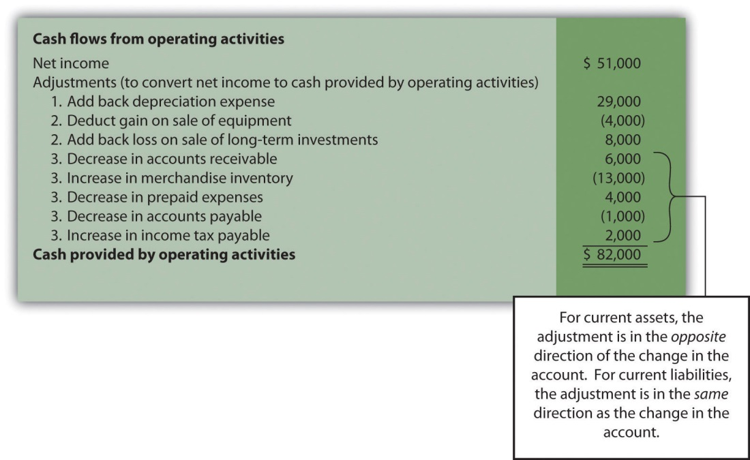
- Cash totaling $82,000 was generated from the company’s operating activities during the year.

Before moving on to step 2, note that investing and financing activities sections always use the same format whether the operating activities section is presented using the direct method or indirect method.

Step 2: Prepare the Investing Activities Section

Question: Now that we have completed the operating activities section for Home Store, Inc., the next step is to prepare the investing activities section.What information is used for this section, and how is it prepared?

Answer: The investing activities section of the statement of cash flows focuses on cash activities related to noncurrent assets. Review the noncurrent asset section of Home Store, Inc.’s balance sheet presented in . Three noncurrent asset line items must be analyzed to determine how to present cash flow information in the investing activities section.

Property, plant, and equipment increased by $46,000. The additional information provided for 2012 indicates two types of transactions caused this increase. First, the company purchased equipment for $67,000 cash. Home Store, Inc., made the following journal entry for this transaction:

Second, the company sold equipment for $5,000 cash (often called a disposalof equipment). This equipment was on the books at an original cost of $21,000 with accumulated depreciation of $10,000. Home Store, Inc., made the following journal entry for this transaction:

Notice the two entries to property, plant, and equipment shown previously. The net effect of these 2 entries is an increase of $46,000 (= $67,000 − $21,000). This is summarized in the following T-account:
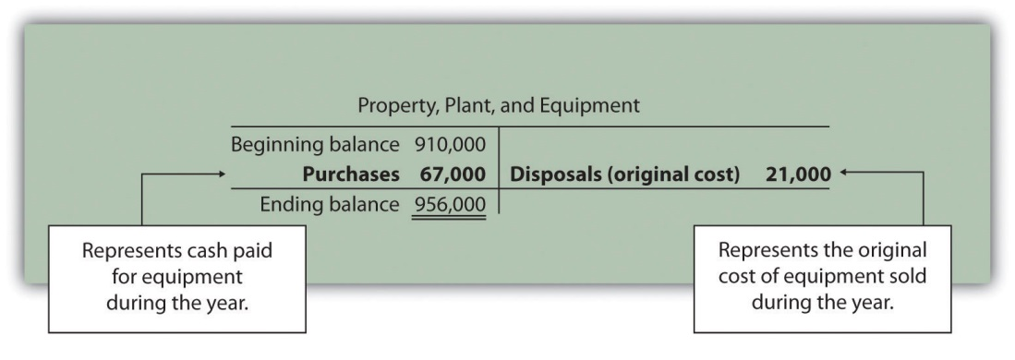

Question: How is this property, plant, and equipment information used in the investing activities section of the statement of cash flows for Home Store, Inc.?

Answer: First, the purchase of equipment for $67,000 cash is shown as adecrease in cash. Second, the sale of equipment for $5,000 is shown as anincrease in cash. It is not enough to simply show a cash outflow of $62,000 in the investing activities section of the statement of cash flows (= $67,000 − $5,000). Instead, Home Store, Inc., must show the components of this cash outflow as separate line items in the statement of cash flows as required by U.S. GAAP. The formal presentation of this information in the investing activities section is shown later in .

Accumulated depreciation decreased noncurrent assets by $14,000.This contra asset account is not typical of the other asset accounts shown on Home Store, Inc.’s balance sheet since contra asset accounts have the effect of reducing assets. Thus as this accumulated depreciation account increases, it further reduces overall assets. Terminology can get confusing, so here is a simple way to look at it. The higher the account goes; the more it reduces assets. This is why the change column shows this account as decreasing assets.

Two items caused the change in the accumulated depreciation account. First, the sale of equipment during the year caused the company to take $10,000 in accumulated depreciation off the books. Second, $24,000 in depreciation expense was recorded during the year (with a corresponding entry to accumulated depreciation). This information is summarized in the following T-account:
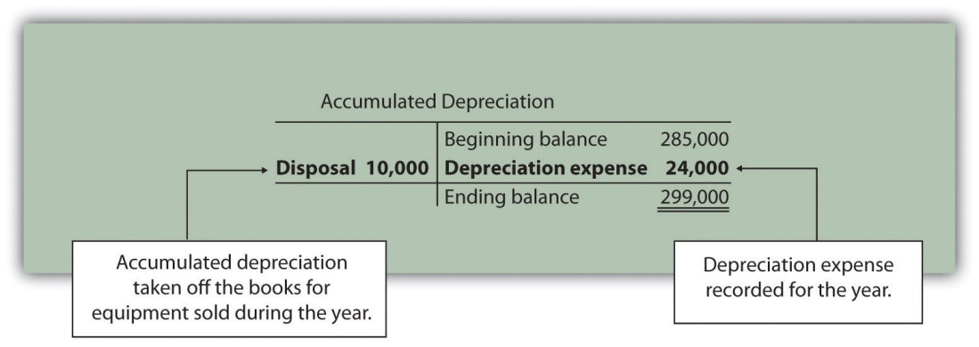

Question: How is accumulated depreciation information used in the statement of cash flows for Home Store, Inc.?

Answer: This information is already reflected in two places (the work has already been done!). First, depreciation expense is a noncash expense and is added back to net income in the operating activities section of the statement of cash flows (see ). Second, $10,000 of accumulated depreciation related to disposals is included as part of the $5,000 proceeds from the sale of equipment in the investing activities section of the statement of cash flows (see ). Here are the components of the equipment sale that support the $5,000 in cash proceeds shown in the investing activities section:
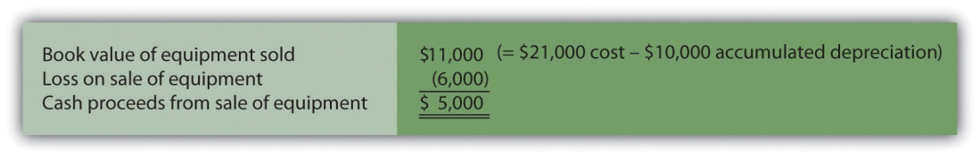

Long-term investments increased by $12,000. The additional information provided for 2012 indicates there were no sales of long-term investments during the year. The increase of $12,000 is solely from purchasing long-term investments with cash. Thus the purchase of long-term investments for $12,000 is shown as a decrease in cash in the investing activities section.

Shows the three investing activities described previously: (1) a $67,000 decrease in cash from the purchase of equipment, (2) a $5,000 increase in cash from the sale of equipment, and (3) a $12,000 decrease in cash from the purchase of long-term investments. Examine carefully noting the impact these three items have on cash and the resulting cash used by investing activities of $74,000.

Figure 12.6 Investing Activities Section of Statement of Cash Flows (Home Store, Inc.)

REVIEW PROBLEM 12.5
Using the information presented in :
- Prepare the investing activities section of the statement of cash flows for Phantom Books. Follow the format presented in .
- How much cash did Phantom Books use for investing activities during the year?
Solution to Review Problem 12.5
- Start by analyzing changes in noncurrent assets on the balance sheet. Then prepare the investing activities section of the statement of cash flows. The cash flows related to each noncurrent asset account are underlined as follows.
Property, plant, and equipment decreased by $3,000. Additional data provided indicate 2 items caused this change: (1) equipment was purchased for $27,000 cash, causing a $27,000 increase in the account; and (2) equipment with an original cost of $30,000 was sold for $12,000 cash, causing a $30,000 decrease in the account. The net effect of these 2 items on the property, plant, and equipment account is a decrease of $3,000 (= $27,000 purchase − $30,000 original cost of equipment sold). The impact these items have on cash is reflected in the investing activities section of the statement of cash flows by showing a $27,000 cash outflow for the purchase of equipment and a $12,000 cash inflow from the sale of equipment.
Accumulated depreciation decreased assets by $7,000. Two items caused this change: (1) the sale of equipment caused the company to take $22,000 in accumulated depreciation off the books—this was the accumulated depreciation on the books for the equipment sold, and (2) $29,000 in depreciation expense was recorded during the year, with a corresponding entry to accumulated depreciation. Neither of these entries to accumulated depreciation impacts the investing activities section. However, $29,000 in depreciation expense is a noncash expense and is added back to net income in the operating activities section (see solution to ).
Long-term investments increased by $14,000. Additional data provided indicate 2 items caused this change: (1) long-term investments with an original cost of $11,000 were sold for $3,000 cash, and (2) long-term investments were purchased for $25,000 cash. The net effect of these 2 items on the long-term investments account is an increase of $14,000 (= $25,000 purchase − $11,000 original cost of investments sold). The impact these items have on cash is reflected in the investing activities section of the statement of cash flows by showing a$25,000 cash outflow for the purchase of investments, and a$3,000 cash inflow from the sale of investments.
The investing activities section of the statement of cash flows for Phantom Books is shown as follows:
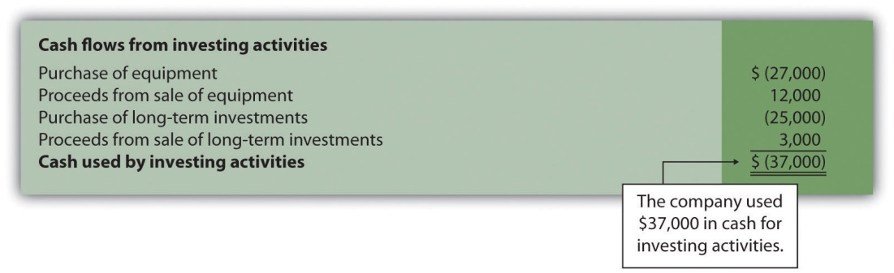
- Cash totaling $37,000 was used for investing activities during the year.

Step 3: Prepare the Financing Activities Section

Question: Now that we have completed the operating and investing activities sections for Home Store, Inc., the next step is to prepare the financing activities section. What information is used for this section, and how is it prepared?

Answer: The financing activities section of the statement of cash flows focuses on cash activities related to noncurrent liabilities and owners’ equity (i.e., cash activities related to long-term company financing). Review the noncurrent liability and owners’ equity sections of Home Store, Inc.’s balance sheet presented in . One noncurrent liability item (bonds payable) and two owners’ equity items (common stock and retained earnings) must be analyzed to determine how to present cash flow information in the financing activities section. The formal presentation of this information in the financing activities section is shown later in .

Bonds payable decreased by $18,000. The additional information provided for 2012 indicates Home Store, Inc., paid off bonds during the year with a principal amount of $18,000. This is reflected in the financing activities section of the statement of cash flows as an $18,000 decrease in cash.

Common stock increased by $4,000. The additional information provided for 2012 indicates the company issued common stock for $4,000 cash. This is reflected in the financing activities section of the statement of cash flows as $4,000 increase in cash.

Retained earnings increased by $92,000. Two items caused this increase: (1) net income of $124,000 increased retained earnings, and (2) cash dividends paid totaling $32,000 decreased retained earnings. The net effect of these two entries is an increase of $92,000 (= $124,000 net income − $32,000 cash dividends).

Question: How is this information used in the statement of cash flows?

Answer: Net income is already included at the top of the operating activities section as shown in . Cash dividends are included in the financing activities section as a $32,000 decrease in cash.

shows the three financing activities described previously: (1) an $18,000 decrease in cash from paying off the principal amount of bonds, (2) a $4,000 increase in cash from the issuance of common stock, and (3) a $32,000 decrease in cash from the payment of cash dividends. Examine carefully noting the impact these three items have on cash and the resulting cash used by financing activities of $46,000.

Figure 12.7 Financing Activities Section of Statement of Cash Flows (Home Store, Inc.)
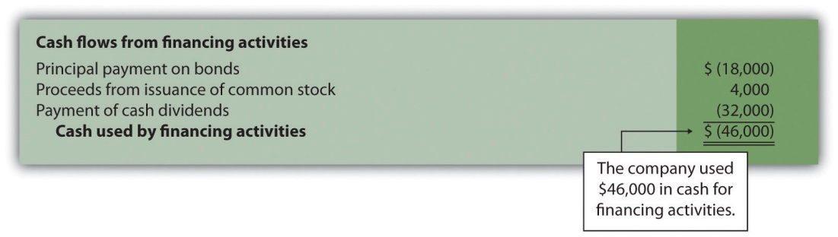

Business in Action 12.4
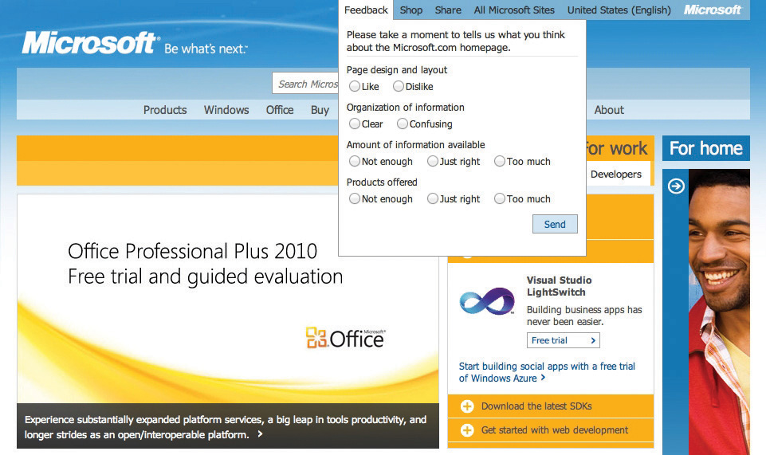
Source: Photo courtesy of Rob Enslin,http://www.flickr.com/photos/doos/6086236471/.
Dividend Payments at Microsoft Corporation
By fiscal year ended June 30, 2004, Microsoft was sitting on more than $60,000,000,000 in cash and short-term investments. After reviewing its options, the company chose to give much of this cash back to shareholders in the form of cash dividends. A one-time increase in cash dividends resulted in $33,500,000,000 paid to the owners of the company during the second quarter of fiscal year 2005 (three months ended December 31, 2004). This information is found in the financing activities section of Microsoft’s statement of cash flows.
Source: Microsoft Corporation, “2004 Annual Report,”http://www.microsoft.com; Microsoft Corporation, “2005 Second Quarter Statement of Cash Flows,” http://www.microsoft.com.

Significant Noncash Investing and Financing Activities

Question: Some organizations have noncash activities involving the exchange of one noncurrent or owners’ equity balance sheet item for another (e.g., the issuance of common stock for a building; or the issuance of common stock in exchange for bonds held by creditors). Do these types of transactions appear in the statement of cash flows?

Answer: These exchanges do not involve cash and thus do not appear directly on the statement of cash flows. However, if the amount is significant, this type of exchange must be disclosed as a separate note below the statement of cash flows or in the notes to the financial statements.

REVIEW PROBLEM 12.6
Using the information presented in do the following:
- Prepare the financing activities section of the statement of cash flows for Phantom Books. Follow the format presented in .
- How much cash did Phantom Books use for financing activities during the year?
Solution to Review Problem 12.6
- Start by analyzing changes in noncurrent liabilities and owners’ equity on the balance sheet. Then prepare the financing activities section of the statement of cash flows. The cash flows related to each noncurrent liability and owners’ equity account are underlined as follows.
Note payable increased by $5,000. Additional data provided indicate the company signed a note with the bank and received $5,000 cash. This is reflected in the financing activities section as a $5,000 cash inflow.
Common stock decreased by $16,000. Additional data provided indicate the company repurchased common stock for $16,000 cash. This is reflected in the financing activities section as a$16,000 cash outflow.
Retained earnings increased by $38,000. Two items caused this increase: (1) net income of $51,000 increased retained earnings and (2) cash dividends paid totaling $13,000 (provided as additional data) decreased retained earnings. The net effect of these 2 items is an increase of $38,000 (= $51,000 net income − $13,000 cash dividends). Net income is already included at the top of the operating activities section as shown in the solution to . Cash dividends are included in the financing activities section as a $13,000 cash outflow.
The financing activities section of the statement of cash flows for Phantom Books is shown as follows:
- Cash totaling $24,000 was used for financing activities during the year.

Step 4: Reconcile the Change in Cash

Question: We’re almost done with Home Store, Inc.’s statement of cash flows.What is the fourth and final step needed to complete the statement of cash flows?

Answer: The final step is to show that the change in cash on the statement of cash flows agrees with the change in cash on the balance sheet. As shown at the bottom of the completed statement of cash flows for Home Store, Inc., in , the net decrease in cash of $98,000 shown on this statement (= $22,000 increase from operating activities − $74,000 decrease from investing activities − $46,000 decrease from financing activities) agrees with the change in cash shown on the balance sheet (= $32,000 ending cash balance − $130,000 beginning balance).

Figure 12.8 Statement of Cash Flows (Home Store, Inc.)
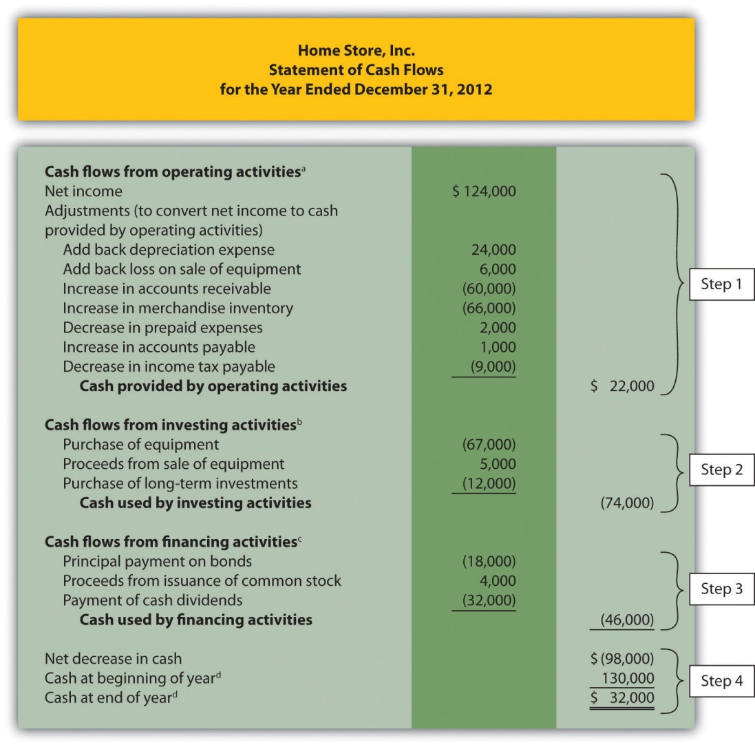

a From .

b From .

c From .

d From .

provides a summary of cash flows for operating activities, investing activities, and financing activities for Home Store, Inc., along with the resulting total decrease in cash of $98,000.

Figure 12.9 Cash Flows at Home Store, Inc.
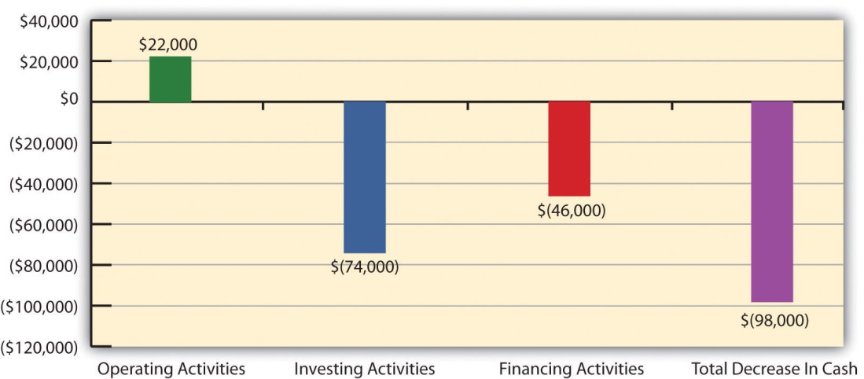

REVIEW PROBLEM 12.7
Using the information presented in and the solutions to , , and , prepare a complete statement of cash flows for Phantom Books. Follow the format presented in .
Solution to Review Problem 12.7
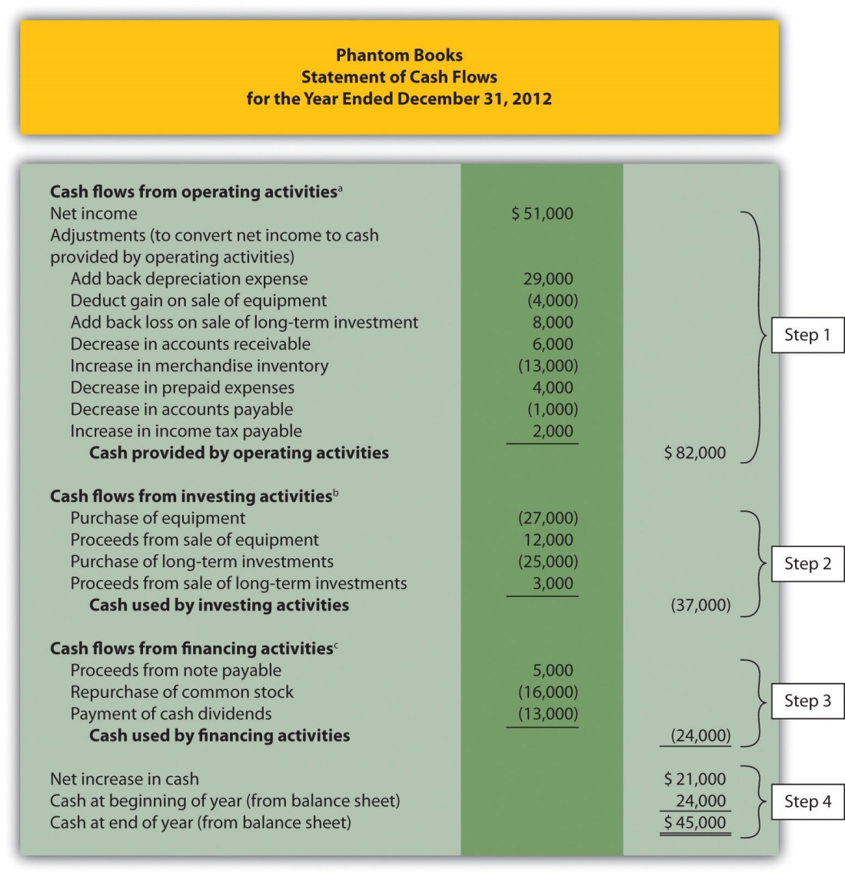
ª From .
^{b} From .
^{c} From .

Home Store, Inc., Update

Recall the dialogue at Home Store, Inc., between John (CEO), Steve (treasurer), and Linda (CFO). John was concerned about the company’s drop in cash from $130,000 at the beginning of the year to $32,000 at the end of the year. He asked Linda to investigate and wanted to know how much cash was generated from daily operations during the year. The group reconvened the following week. As you read the dialogue that follows, refer to ; it is the statement of cash flows that Linda prepared for the meeting.
John (CEO): | Welcome, everyone. Linda, what information do you have for us regarding the company’s cash flow?
Linda (CFO): | I’ve completed a statement of cash flows for the year—here are copies for your review (see ). This statement tells us about the company’s cash activities during the year and ultimately explains why cash decreased by $98,000.
John: | How much cash did we generate from ongoing operations for the year?
Linda: | That can be found in the top portion of the statement under “cash flows from operating activities.” We generated $22,000 from operating activities.
Steve (Treasurer): | You’re kidding! We had net income totaling $124,000 but only generated $22,000 in cash?
John: | That does seem like a huge disparity. Linda, are you sure this is correct?
Linda: | Yes! The reason cash from operating activities is so much lower than net income is that accounts receivable and merchandise inventory increased significantly from the beginning of the year to the end of the year. In fact, both accounts more than doubled.
Steve: | The cash tied up in these two areas is definitely hurting our cash flow. We really struggled to meet our cash budgets for accounts receivable collections and inventory purchases.
John: | Clearly, we’ve got to get a handle on receivables and inventory. But even with this huge difference between net income and cash flows from operating activities, we generated $22,000 in cash. This does not explain why cash decreased by $98,000.
Linda: | You’re right, John. Operating activities produced positive cash flow in spite of these receivables and inventory issues. Let’s look further down the statement. Notice we spent $67,000 on equipment and purchased $12,000 in long-term investments.
Steve: | Yes, I recall purchasing a new forklift—the old one was a safety hazard—and purchasing long-term investments at the beginning of the year when our cash balance was on the high side.
Linda: | Once we factor in the cash proceeds from the old equipment, you can see we spent $74,000 in cash for equipment and investments.
John: | Looking back, we probably should have financed the equipment rather than having paid for it all at once. What else can you tell us, Linda?
Linda: | Bonds totaling $18,000 came due during the year, as shown toward the bottom of the statement, and we paid $32,000 in dividends.
Steve: | I realize the board felt cash levels were high enough during 2011 to warrant a large dividend payment in 2012, but we need to cut way back on these dividends in the future.
Linda: | I agree. To answer your question, John, the $98,000 decrease in cash came primarily from the purchase of equipment and long-term investments and payments for bonds and cash dividends.
John: | Thank you, Linda. This provides the information we need to improve cash flow going forward.

As you can see from this dialogue, the statement of cash flows is not only a reporting requirement for most companies, it is also a useful tool for analytical and planning purposes. Next, we will discuss how to use cash flow information to assess performance and help in planning for the future.

KEY TAKEAWAY
- The statement of cash flows is prepared using the four steps described in the previous segment. In step 1, the indirect method starts with net income in the operating activities section and makes three types of adjustments to convert net income to a cash basis. The first adjustment is adding back expenses that do not affect cash, such as depreciation. The second adjustment is adding back losses and deducting gains related to investing activities. The third adjustment is adding and subtracting changes in current assets (except cash) and current liabilities using the adjustment rules. Steps 2 and 3 are done by analyzing and presenting cash activities associated with noncurrent assets (investing activities) and noncurrent liabilities and owners’ equity (financing activities). Step 4 shows that the change in cash on the statement of cash flows agrees with the change in cash on the balance sheet.

12.5 Analyzing Cash Flow Information

LEARNING OBJECTIVE
- Analyze cash flow information.

Question: Companies and analysts tend to use income statement and balance sheet information to evaluate financial performance. In fact, financial results presented to the investing public typically focus on earnings per share (Chapter 13 "How Do Managers Use Financial and Nonfinancial Performance Measures?" discusses earnings per share in detail). However, analysis of cash flow information is becoming increasingly important to managers, auditors, and outside analysts. What measures are commonly used to evaluate performance related to cash flows?

Answer: Three common cash flow measures used to evaluate organizations are (1) operating cash flow ratio, (2) capital expenditure ratio, and (3) free cash flow. (Further coverage of these measures can be found in the following article: John R. Mills and Jeanne H. Yamamura, “The Power of Cash Flow Ratios,” Journal of Accountancy, October 1998.) We will use two large home improvement retail companies, The Home Depot, Inc., and Lowe’s Companies, Inc., to illustrate these measures.

Operating Cash Flow Ratio

Question: The operating cash flow ratio is cash provided by operating activities divided by current liabilities. What does this ratio tell us, and how is it calculated?

Answer: This ratio measures the company’s ability to generate enough cash from daily operations over the course of a year to cover current obligations. Although similar to the commonly used current ratio, this ratio replaces current assets in the numerator with cash provided by operating activities. The operating cash flow ratio is as follows:

Key Equation
Operating cash flow ratio= Cash provided by operating activitiesCurrent liabilities

The numerator, cash provided by operating activities, comes from the bottom of the operating activities section of the statement of cash flows. The denominator, current liabilities, comes from the liabilities section of the balance sheet. (Note that if current liabilities vary significantly from one period to the next, some analysts prefer to use average current liabilities. We will use ending current liabilities unless noted otherwise.)

As with most financial measures, the resulting ratio must be compared to similar companies in the industry to determine whether the ratio is reasonable. Some industries have a large operating cash flow relative to current liabilities (e.g., mature computer chip makers, such as Intel Corporation), while others do not (e.g., startup medical device companies).

The operating cash flow ratio is calculated for Home Depot and Lowe’s in the following using information from each company’s balance sheet and statement of cash flows.
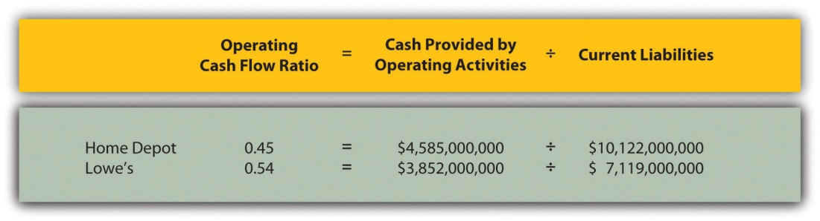

Home Depot and Lowe’s are in the same industry and have comparable ratios, which is what we would expect for similar companies.

Capital Expenditure Ratio

Question: The capital expenditure ratio is cash provided by operating activities divided by capital expenditures. What does this ratio tell us, and how is it calculated?

Answer: This ratio measures the company’s ability to generate enough cash from daily operations to cover capital expenditures. A ratio in excess of 1.0, for example, indicates the company was able to generate enough operating cash to cover investments in property, plant, and equipment. The capital expenditure ratio is as follows:

Key Equation
Capital expenditure ratio=Cash provided by operating activitiesCapital expenditures

The numerator, cash provided by operating activities, comes from the bottom of the operating activities section of the statement of cash flows. The denominator, capital expenditures, comes from information within the investing activities section of the statement of cash flows.

The capital expenditure ratio is calculated for Home Depot and Lowe’s in the following using information from each company’s statement of cash flows.
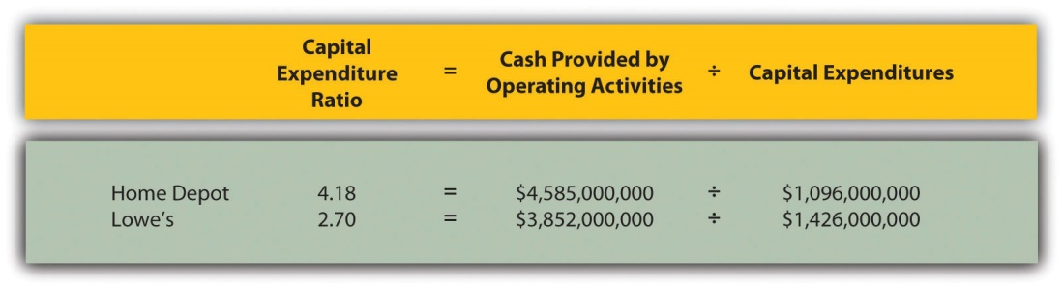

Since the capital expenditure ratio for each company is above 1.0, both companies were able to generate enough cash from operating activities to cover investments in property, plant, and equipment (also called fixed assets).

Free Cash Flow

Question: Another measure used to evaluate organizations, called free cash flow, is simply a variation of the capital expenditure ratio described previously.What does this measure tell us, and how is it calculated?

Answer: Rather than using a ratio to determine whether the company generates enough cash from daily operations to cover capital expenditures, free cash flow is measured in dollars. Free cash flow is cash provided by operating activities minus capital expenditures. The idea is that companies must continue to invest in fixed assets to remain competitive. Free cash flow provides information regarding how much cash generated from daily operations is left over after investing in fixed assets. Many organizations, such as Amazon.com, consider this measure to be one of the most important in evaluating financial performance (see Note 12.34 "Business in Action 12.5"). The free cash flow formula is as follows:

Key Equation
Free cash flow = Cash provided by operating activities − Capital expenditures

The cash provided by operating activities comes from the bottom of the operating activities section of the statement of cash flows. The capital expenditures amount comes from information within the investing activities section of the statement of cash flows.

The free cash flow amount is calculated for Home Depot and Lowe’s as follows using information from each company’s statement of cash flows.
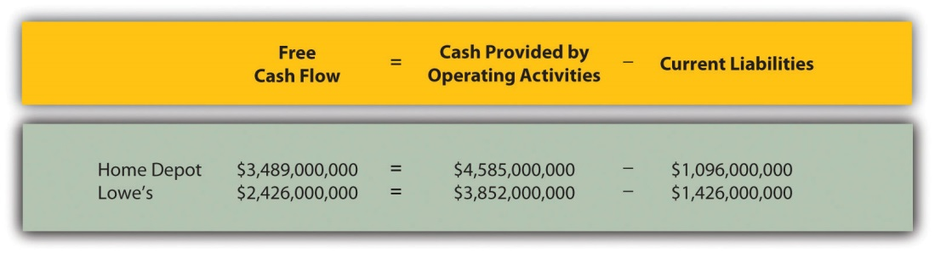

Because free cash flow for each company is above zero, both companies were able to generate enough cash from operating activities to cover investments in fixed assets and have some left over to invest elsewhere. This conclusion is consistent with the capital expenditure ratio analysis, which uses the same information to assess the company’s ability to cover fixed asset expenditures.

Formulas for the cash flow performance measures presented in this chapter are summarized in Table 12.1 "Summary of Cash Flow Performance Measures".

Table 12.1 Summary of Cash Flow Performance Measures
Operating cash flow ratio= Cash provided by operating activitiesCurrent liabilities
Capital expenditure ratio=Cash provided by operating activitiesCapital expenditures
Free cash flow=Cash provided by operating activities − Capital expenditures

Business in Action 12.5
Source: Photo courtesy of James Duncan Davidson,http://www.flickr.com/photos/oreilly/6629275/
Free Cash Flow at Amazon.com
Amazon.com is an online retailer that began selling books in 1996 and has since expanded into other areas of retail sales. The founder and CEO (Jeff Bezos) believes free cash flow is so important, the annual report included a letter from Mr. Bezos to the shareholders, which began with this statement, “Our ultimate financial measure, and the one we want to drive over the long-term, is free cash flow per share.”
The company justifies this focus on free cash flow by making the point that earnings presented on the income statement do not translate into cash flows, and shares are valued based on the present value of future cash flows. This implies shareholders should be most interested in free cash flow per share rather than earnings per share. Mr. Bezos goes on to state, “Cash flow statements often don’t receive as much attention as they deserve. Discerning investors don’t stop with the income statement.”
Amazon.com’s free cash flow for 2010 totaled $2,164,000,000, compared to $2,880,000,000 in 2009. Net income for 2010 totaled $1,152,000,000, compared to $902,000,000 in 2009. It is interesting to note that free cash flow is significantly higher than net income for 2010 and 2009.
Source: Amazon.com, Inc., “2010 Annual Report,”http://www.amazon.com.

KEY TAKEAWAY
- Three measures are often used to evaluate cash flow. The operating cash flow ratio measures the company’s ability to generate enough cash from daily operations over the course of a year to cover current obligations. The formula is as follows:
Operating cash flow ratio=Cash provided by operating activitiesCurrent liabilities
The capital expenditure ratio measures the company’s ability to generate enough cash from daily operations to cover capital expenditures. The formula is as follows:
Capital expenditure ratio=Cash provided by operating activitiesCapital expenditures
Free cash flow measures the company’s ability to generate enough cash from daily operations to cover capital expenditures and determines how much cash is remaining to invest elsewhere in the company. The formula is as follows:
Free cash flow = Cash provided by operating activities − Capital expenditures

REVIEW PROBLEM 12.8
The following financial information is for PepsiCo Inc. and Coca-Cola Company for fiscal year 2010.
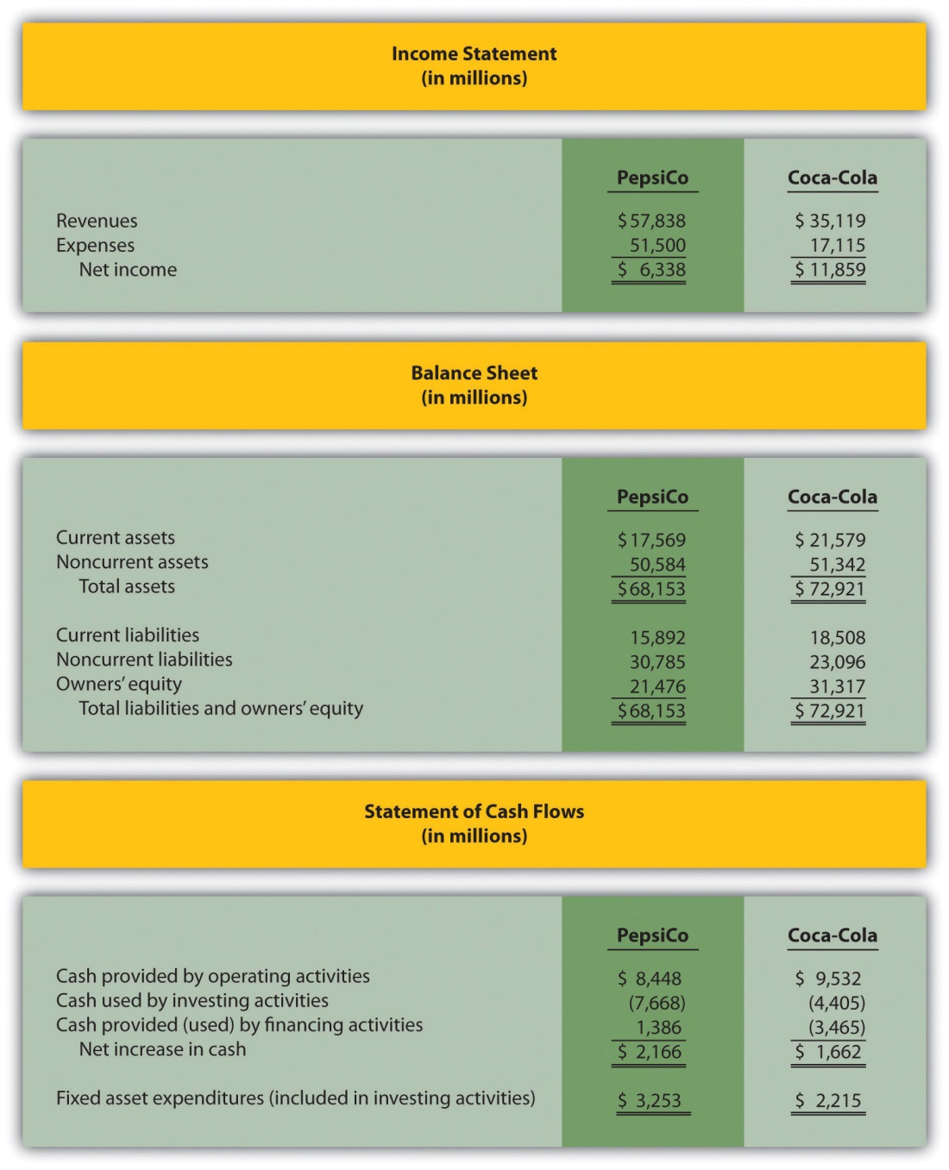
For PepsiCo and Coca-Cola, calculate the following measures and comment on your results:
- Operating cash flow ratio
- Capital expenditure ratio (Hint: fixed asset expenditures are the same as capital expenditures.)
- Free cash flow
Solution to Review Problem 12.8
All dollar amounts are in millions.
- The formula for calculating the operating cash flow ratio is as follows:
Operating Cash Flow Ratio=Cash provided by operating activitiesCurrent liabilities
PepsiCo operating cash flow ratio=$8,448÷$15,892=0.53
Coca-Cola operating cash flow ratio=$9,532÷$18,508=0.52
PepsiCo generated slightly more cash from operating activities to cover current liabilities than Coca-Cola.
- The formula for calculating the capital expenditure ratio is as follows:
Capital Expenditure Ratio=Cash provided by operating activitiesCapital expenditures
PepsiCo capital expenditure ratio=$8,448÷$3,253=2.60
Coca-Cola capital expenditure ratio=$9,532÷$2,215=4.30
Both companies generated more than enough cash from operating activities to cover capital expenditures.
- The formula to calculate free cash flow is as follows:
Free cash flow = Cash provided by operating activities − Capital expenditures
PepsiCo free cash flow=$8,448−$3,253=$5,195
Coca-Cola free cash flow=$9,532−$2,215=$7,317
The conclusion reached in requirement two is confirmed here. Both companies generated more than enough cash from operating activities to cover capital expenditures. In fact,PepsiCo had $5,195,000,000 remaining from operating activities after investing in fixed assets, and Coca-Cola had $7,317,000,000 remaining.

12.6 Appendix: Using the Direct Method to Prepare the Statement of Cash Flows

LEARNING OBJECTIVE
- Prepare a statement of cash flows using the direct method.

Question: The same four steps apply to preparing a statement of cash flows using the direct method as with the indirect method. The only difference is how the operating activities section is presented in step 1; all other steps are the same as presented in the chapter. Although presentation of the operating activities section using the direct method differs from the indirect method, the end result is exactly the same. How does step 1 differ using the direct method?

Answer: Rather than adjusting net income from an accrual basis to a cash basis using the indirect method, the direct method simply presents the income statement on a cash basis. The format of the operating activities section using the direct method is presented in .

Figure 12.10 Operating Activities Format Using the Direct Method
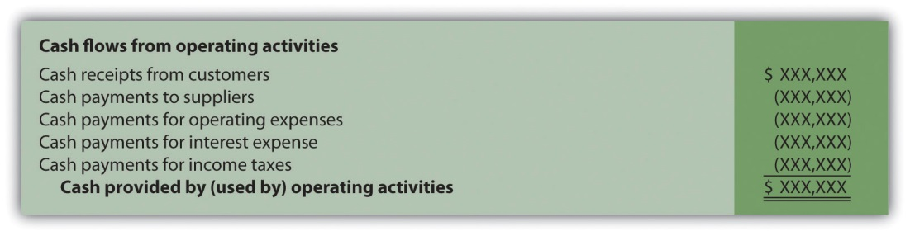

The first item shown in , cash receipts from customers, is revenue (or sales) on a cash basis. The second item, cash payments to suppliers, is cost of goods sold on a cash basis. The third item, cash payments for operating expenses(also called selling and administrative expenses), is operating expenses on a cash basis. The fourth item, cash payments for interest expense, is interest expense on a cash basis. And the fifth item, cash payments for income taxes, is income tax expense on a cash basis. Cash receipts minus cash payments results in cash provided by operating activities.

Adjustments must be made to each income statement item to convert income statement information from an accrual basis to a cash basis. These adjustments will be described next using the same information for Home Store, Inc., presented earlier in the chapter. The income statement and balance sheet for Home Store, Inc., are presented again in . We will start at the top of the income statement with sales and work our way down item-by-item making adjustments to convert each item to a cash basis.

Figure 12.11 Income Statement and Balance Sheet (Home Store, Inc.)
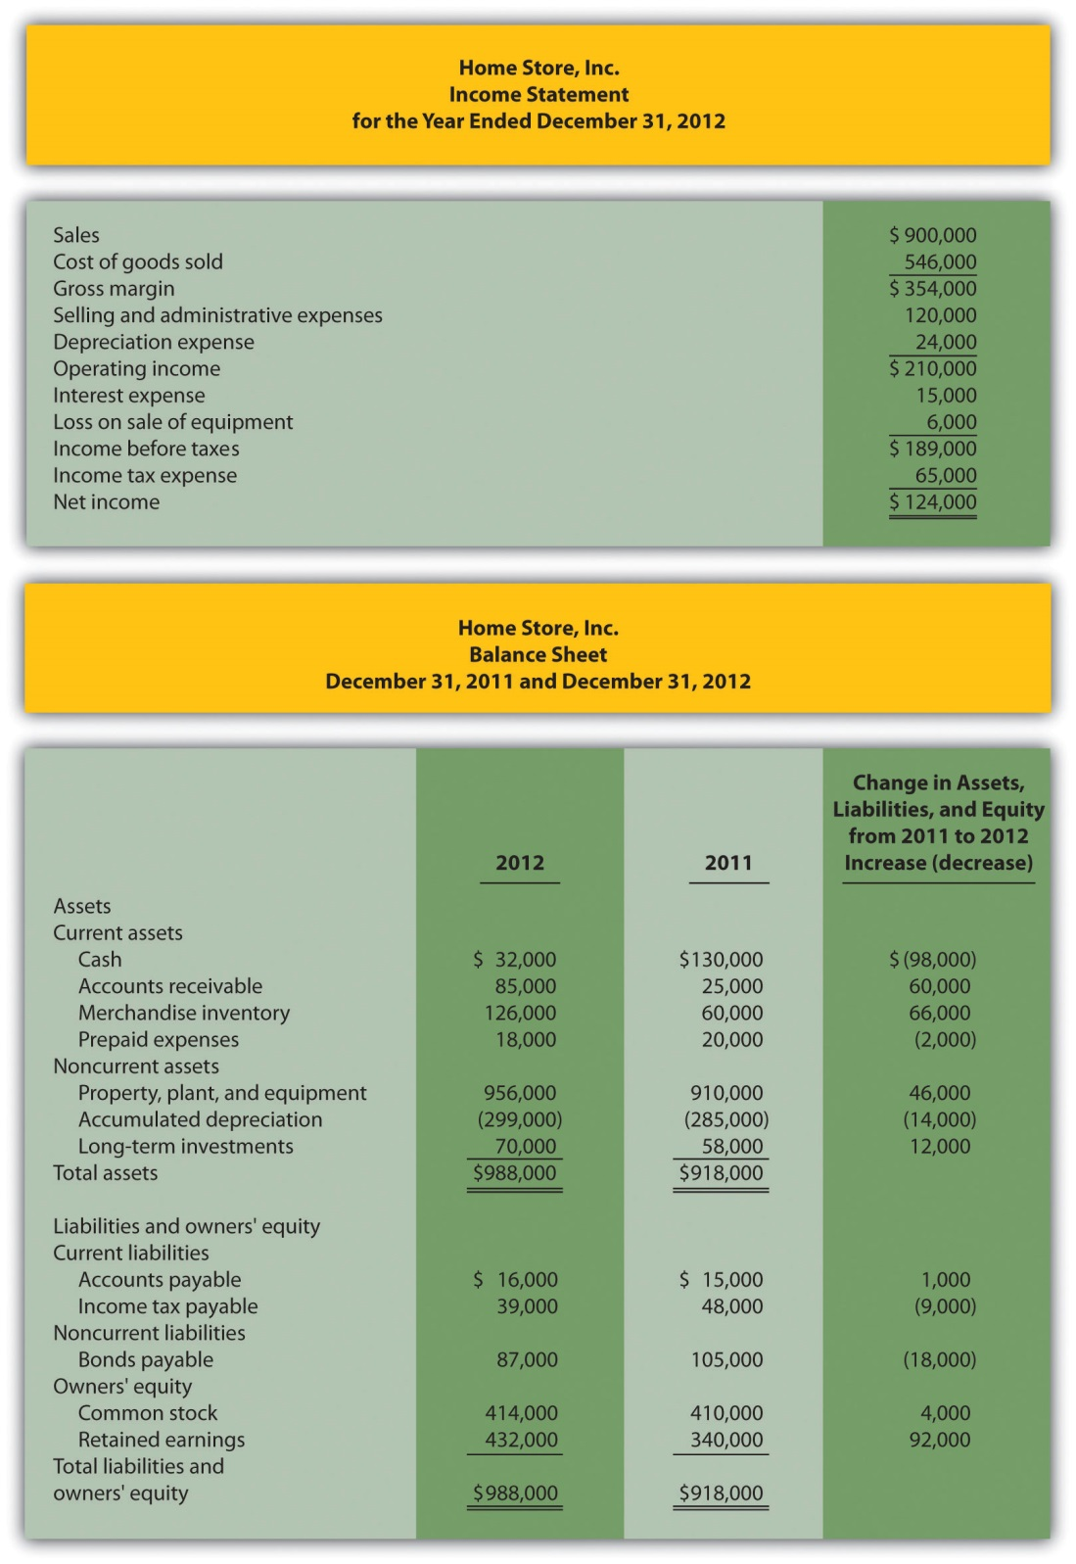

Converting Sales to Cash Receipts

Question: How are sales on an accrual basis converted to sales on a cash basis?

Answer: Sales of $900,000 shown on the income statement do not represent cash collected from sales. The adjustment rule used to convert sales to cash receipts from customers is as follows: increases in accounts receivable arededucted from sales revenue, and conversely, decreases in accounts receivable are added to sales revenue. Since accounts receivable for Home Store, Inc., increased $60,000, a deduction of $60,000 from sales revenue must be taken to find cash receipts from customers. Thus cash receipts from customers totaled $840,000 (= $900,000 sales − $60,000 increase in accounts receivable). The accounts receivable T-account shown in the following further clarifies this concept.
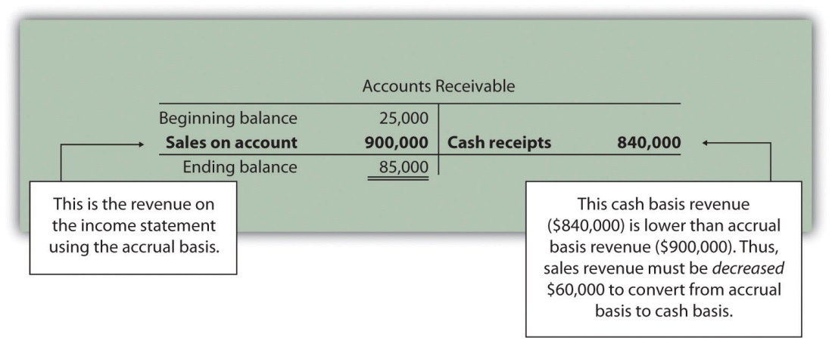
Here’s how sales revenue on a cash basis appears in the operating activities section of the statement of cash flows for Home Store, Inc.:

Converting Cost of Goods Sold to a Cash Basis

Question: How is cost of goods sold on an accrual basis converted to cost of goods sold on a cash basis?

Answer: Two adjustments must be made to cost of goods sold to calculate cash paid to suppliers. First, increases in inventory are added to cost of goods sold, and conversely, decreases in inventory are deducted from cost of goods sold. Since inventory for Home Store, Inc., increased $66,000, cost of goods sold is increased $66,000. Second, increases in accounts payable arededucted from cost of goods sold, and conversely, decreases in accounts payable are added to cost of goods sold. Since accounts payable increased $1,000, cost of goods sold is decreased $1,000. These 2 adjustments result in cash paid to suppliers of $611,000 (= $546,000 cost of goods sold + $66,000 increase in inventory − $1,000 increase in accounts payable).

Here’s how cost of goods sold on a cash basis appears in the operating activities section of the statement of cash flows for Home Store, Inc.:

Converting Operating Expenses to a Cash Basis

Question: How are operating expenses on an accrual basis converted to operating expenses on a cash basis?

Answer: Two adjustments must be made to operating expenses (also calledselling and administrative expenses) to calculate cash payments for operating expenses. First, increases in prepaid expenses are added to operating expenses, and conversely, decreases in prepaid expenses are deducted from operating expenses. Since prepaid expenses for Home Store, Inc., decreased $2,000, operating expenses are decreased $2,000. Second, increases in accrued liabilities are deducted from operating expenses, and conversely, decreases in accrued liabilities are added to operating expenses. Home Store, Inc., does not have any accrued liabilities and, therefore, no adjustment is necessary for accrued liabilities. The 1 adjustment to operating expenses at Home Store, Inc., results in cash payments for operating expenses of $118,000 (= $120,000 selling and administrative expenses − $2,000 decrease in prepaid expenses).

Here’s how operating expenses on a cash basis appears in the operating activities section of the statement of cash flows for Home Store, Inc.:

Depreciation Expense

Question: How is depreciation expense handled when using the direct method?

Answer: Since depreciation is a noncash expense, it is not included in the statement of cash flows using the direct method.

Converting Interest Expense to a Cash Basis

Question: How is interest expense on an accrual basis converted to interest expense on a cash basis?

Answer: Interest expense of $15,000 shown on the income statement does not necessarily represent cash paid for interest expense. The adjustment rule used to convert interest expense to cash payments for interest expense is as follows: increases in interest payable are deducted from interest expense, and conversely, decreases in interest payable are added to interest expense. Since Home Store, Inc., had no interest payable this year or last year, no adjustment to interest expense is necessary.

Here’s how interest expense on a cash basis appears in the operating activities section of the statement of cash flows for Home Store, Inc.:

Loss on Sale of Equipment

Question: How is the loss on sale of equipment handled when using the direct method?

Answer: Because the loss on sale of equipment is included as part of the proceeds from the sale of equipment in the investing activities section, this item is not included in the operating activities section. This holds true for both the direct and indirect methods.

Converting Income Tax Expense to a Cash Basis

Question: How is income tax expense on an accrual basis converted to income tax expense on a cash basis?

Answer: Income tax expense of $65,000 shown on the income statement does not represent cash paid for income taxes. The adjustment rule used to convert income tax expense to cash payments for income taxes is: Increases in income taxes payable are deducted from income tax expense, and conversely, decreases in income taxes payable are added to income tax expense. (The same rules apply to companies that have deferred income taxes.) Since income taxes payable decreased $9,000, income tax expense is increased $9,000. Thus cash payments for income taxes totaled $74,000 (= $65,000 income tax expense + $9,000 decrease in income taxes payable).

Here’s how income tax expense on a cash basis appears in the operating activities section of the statement of cash flows for Home Store, Inc.:
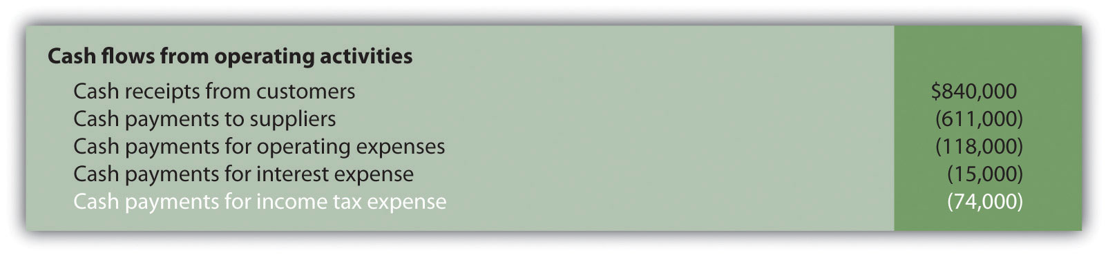

Question: What does the completed operating activities section for Home Store, Inc., look like using the direct method?

Answer: The operating activities section for Home Store, Inc., is shown in . Notice that cash provided by operating activities of $22,000 in (using the direct method) matches cash provided by operating activities in (using the indirect method). The direct and indirect methods of presenting the operating activities section of the statement of cash flows yield the exact same results. Also note that the investing and financing activities do not change using the direct method.

Figure 12.12 Operating Activities Section Using the Direct Method (Home Store, Inc.)
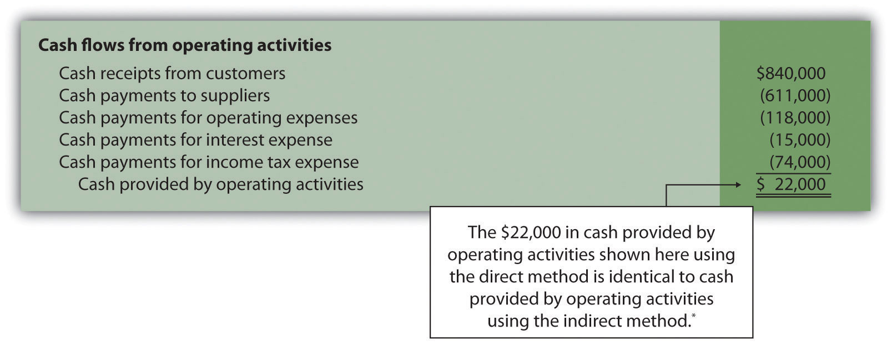

*As shown in .

Summarizes the rules used to convert income statement line items to a cash basis. Review these rules carefully before working .

Figure 12.13 Adjustment Rules for the Direct Method
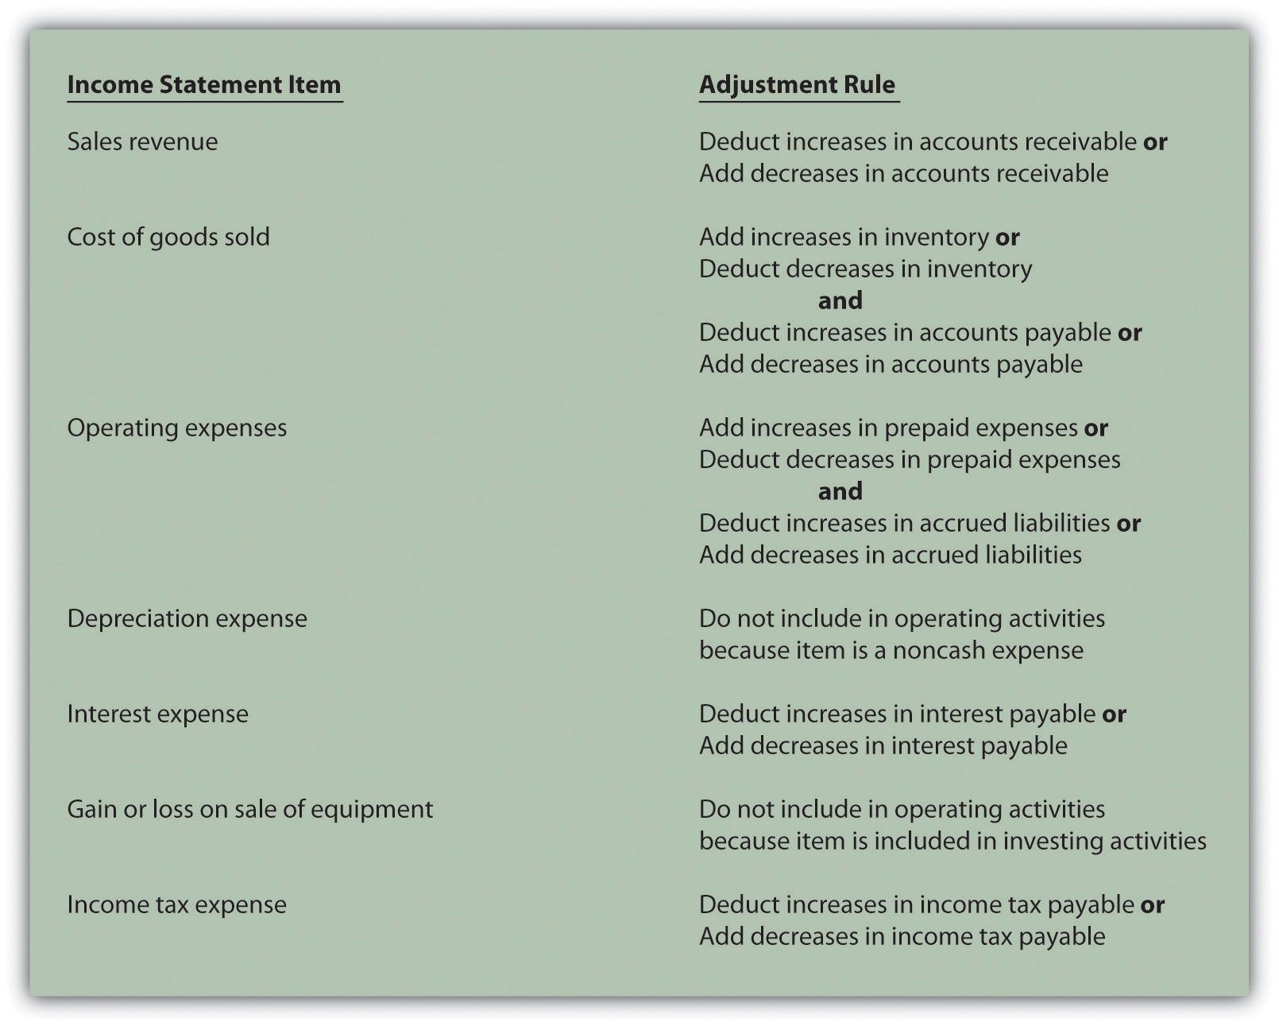

KEY TAKEAWAY
- The same four steps apply to preparing the statement of cash flows using the direct method as with the indirect method. The difference is in the operating activities section of step 1. In step 1, the indirect method starts with net income and makes adjustments to convert net income to a cash basis. The direct method makes adjustments directly to each income statement revenue and expense line item, thereby converting each line item to a cash basis. The resulting cash provided by (used by) operating activities is identical in both approaches.

REVIEW PROBLEM 12.9
Using the information presented for Phantom Books in , prepare the operating activities section of the statement of cash flows using the direct method. Follow the format presented in , and refer to the adjustment rules in .
Solution to Review Problem 12.9
The operating activities section of the statement of cash flows for Phantom Books using the direct method is presented as follows. Notice that cash provided by operating activities of $82,000 shown here using the direct method is identical to cash provided by operating activities using the indirect method (shown in the solution to ).
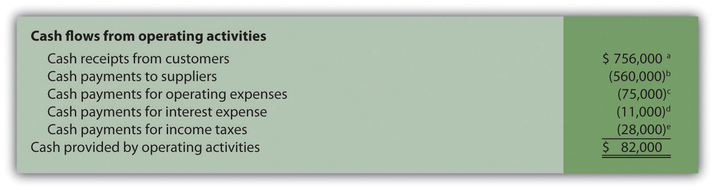
ª $756,000 = $750,000 sales revenue + $6,000 decrease in accounts receivable.
^{b} $560,000 = $546,000 cost of goods sold + $13,000 increase in inventory + $1,000 decrease in accounts payable.
^{c} $75,000 = $79,000 operating expenses − $4,000 decrease in prepaid expenses.
^{d} Since no interest payable balances exist this year or last year, the interest expense of $11,000 is the same as cash payments for interest expense.
^{e} $28,000 = $30,000 income tax expense − $2,000 increase in income tax payable.

END-OF-CHAPTER EXERCISES
Questions
- Why was the statement of cash flows created by the Financial Accounting Standards Board (FASB)?
- Describe the three classifications of cash flows, and provide examples of activities that would appear in each classification.
- Which section of the statement of cash flows is widely regarded as the most important? Why?
- Briefly describe the four steps required to prepare the statement of cash flows using the indirect method.
- Refer to the Why is the indirect method used by most companies?
- Describe the three adjustments necessary to convert net income to a cash basis using the indirect method. Provide an example for each adjustment.
- Why is depreciation expense added back to net income using the indirect method of preparing the statement of cash flows?
- Assume you are using the indirect method to prepare the operating activities section of the statement of cash flows. Describe the adjustment rules for current assets and current liabilities, and provide one example for each rule.
- You have just completed the statement of cash flows for a company, and the bottom of the statement shows a net increase in cash of $250,000. Describe where this increase should be shown elsewhere in the financial statements.
- Provide an example of a noncash investing or financing activity. Describe how these transactions are disclosed in the financial statements.
- How is the operating cash flow ratio calculated, and what does it tell the user?
- How is the capital expenditure ratio calculated, and what does it tell the user?
- How is free cash flow calculated, and what does it tell the user?
- Appendix. Describe how the indirect method differs from the direct method.
- Appendix. Assume you are using the direct method to prepare the operating activities section of the statement of cash flows. Describe the adjustment rule used to convert sales revenue to cash receipts from customers.
- Appendix. Assume you are using the direct method to prepare the operating activities section of the statement of cash flows. Describe the adjustment rules used to convert cost of goods sold to cash payments to suppliers.
Brief Exercises
- Evaluating Cash Flows at Home Store, Inc. Refer to the dialogue at Home Store, Inc., presented at the beginning of the chapter and the follow-up dialogue after .
Required:
  - Why was the CEO concerned about the company’s cash flow?
  - Why did the CEO state, “We probably should have financed the equipment rather than having paid for it all at once”?
- Classifying Cash Flows. Identify whether each of the following items would appear in the operating, investing, or financing activities section of the statement of cash flows. Briefly explain your answer for each item.
  - Cash receipts from the sale of common stock
  - Cash receipts from the sale of a building
  - Cash payments for income taxes
  - Cash receipts from issuance of bonds
  - Cash payments for the purchase of equipment
- Operating Activities Section Using the Indirect Method. The following income statement and current sections of the balance sheet are for Donzi, Inc.
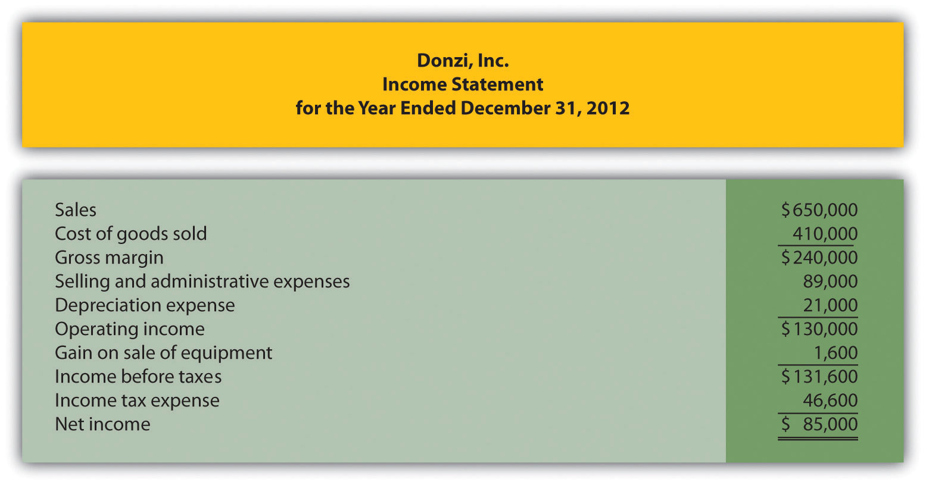
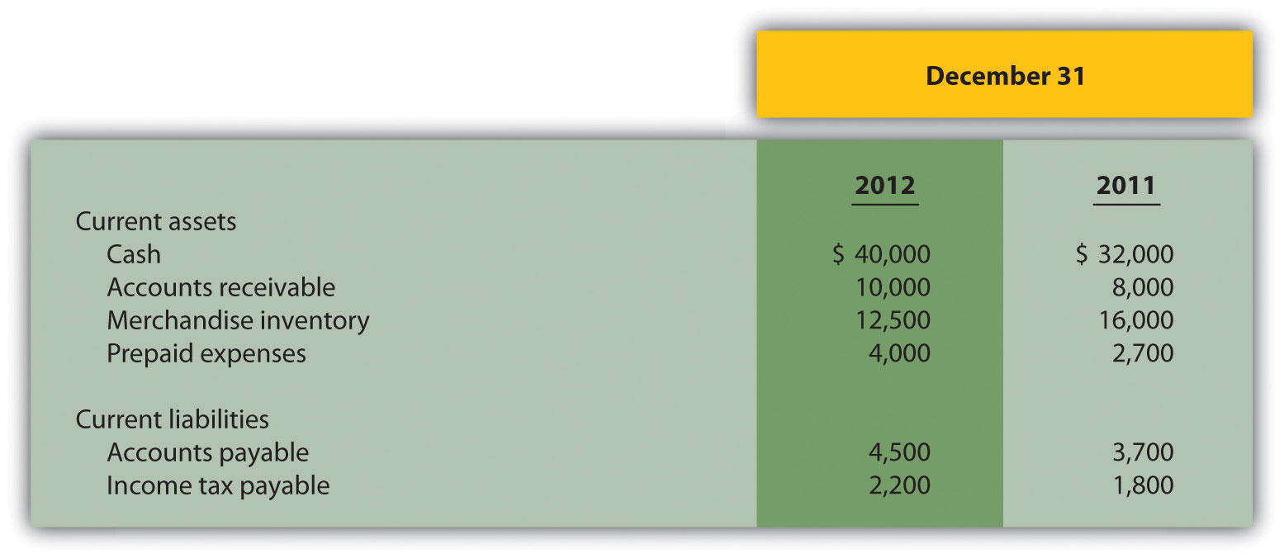
Required:
Using the indirect method, prepare the operating activities section of the statement of cash flows for Donzi, Inc., for the year ended December 31, 2012. Use the format presented in .
- (Appendix) Operating Activities Section Using the Direct Method.The following income statement and current sections of the balance sheet are for Donzi, Inc. (this is the same information as the previous brief exercise).
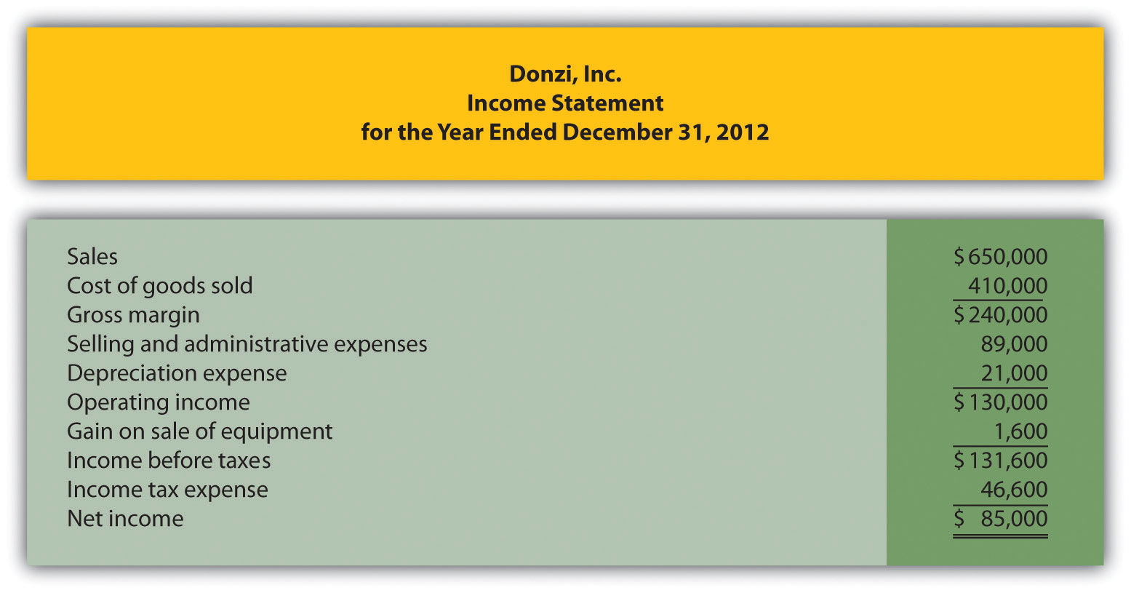
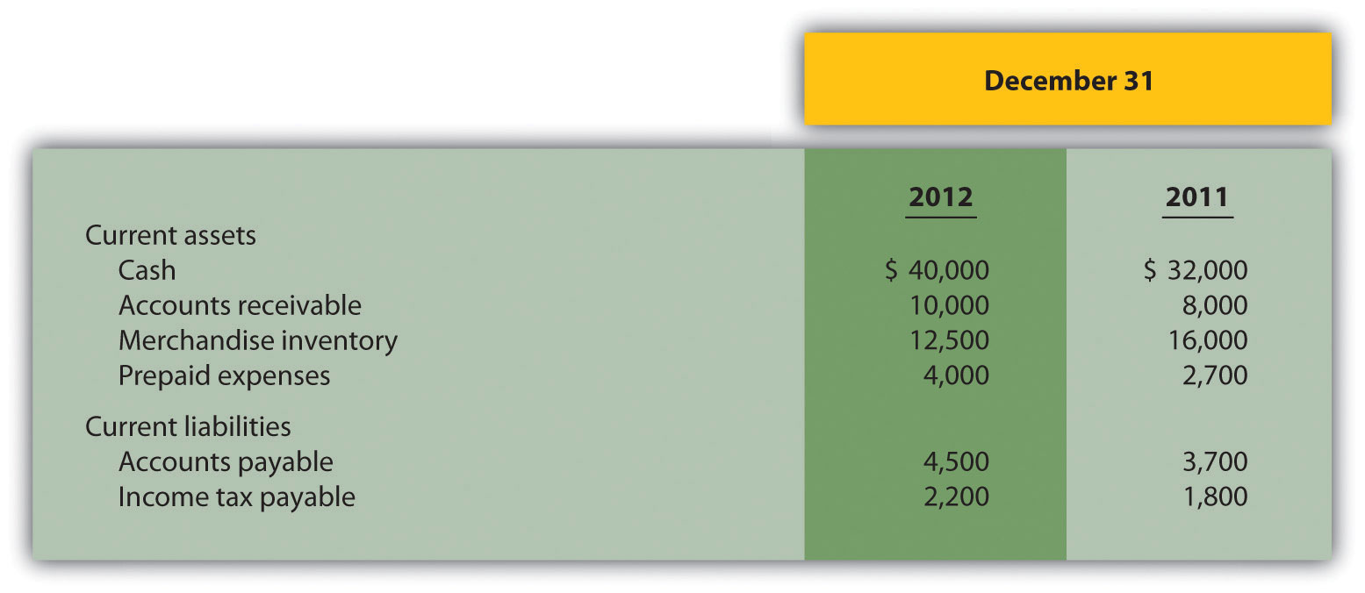
Required:
Using the direct method, prepare the operating activities section of the statement of cash flows for Donzi, Inc., for the year ended December 31, 2012. Use the format presented in .
- Investing Activities Section. The following information is from the noncurrent asset portion of Santana, Inc.’s balance sheet.
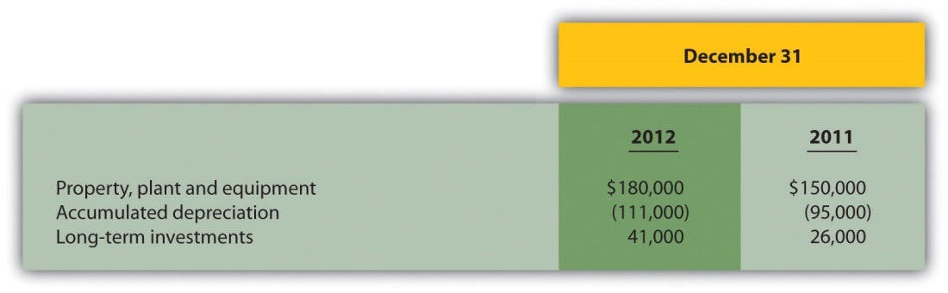
The following activities occurred during 2012:
  - Sold equipment with a book value of $3,000 (= $13,000 cost − $10,000 accumulated depreciation) for $4,000 cash and depreciation expense for the year totaled $26,000
  - Purchased property for $43,000 cash
  - Purchased long-term investments for $15,000 cash
Required:
Prepare the investing activities section of the statement of cash flows for Santana, Inc., for the year ended December 31, 2012. Use the format presented in .
- Financing Activities Section. The following information is from the noncurrent liabilities and owners’ equity portions of Canton Company’s balance sheet.
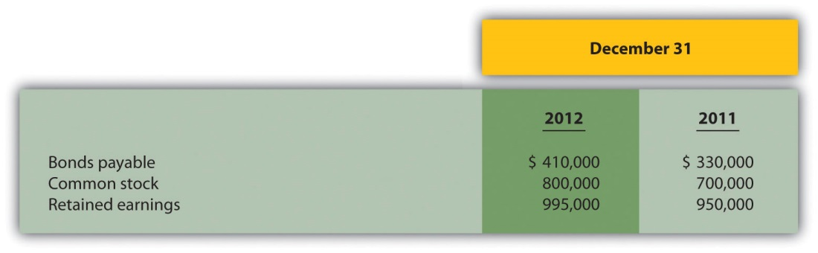
The following activities occurred during 2012:
  - Issued bonds for $80,000 cash
  - Issued common stock for $100,000 cash
  - Earned net income totaling $60,000
  - Paid cash dividends totaling $15,000
Required:
Prepare the financing activities section of the statement of cash flows for Canton Company for the year ended December 31, 2012. Use the format presented in .
- Cash Flow Measures. The selected information in the following is from Diaz Company’s financial records for the most recent fiscal year.
Current assets | $600,000
Current liabilities | $250,000
Cash provided by operating activities | $700,000
Net income | $300,000
Capital expenditures | $550,000
- Required:
- Calculate Diaz Company’s
  - Operating cash flow ratio;
  - Capital expenditure ratio; and
  - Free cash flow.
Exercises: Set A
- Classifying Cash Flows. Identify whether each of the following items would appear in the operating, investing, or financing activities section of the statement of cash flows. Briefly explain your answer for each item.
  - Cash payments for the repurchase of common stock
  - Cash payments for the purchases of merchandise
  - Cash receipts from the collection of interest on loans made to other entities
  - Cash receipts from the collection of principal on loans made to other entities
  - Cash payments to shareholders for dividends
  - Cash payments for the purchase of equipment
- Operating Activities Section Using the Indirect Method. The following income statement and current sections of the balance sheet are for Capstone, Inc.
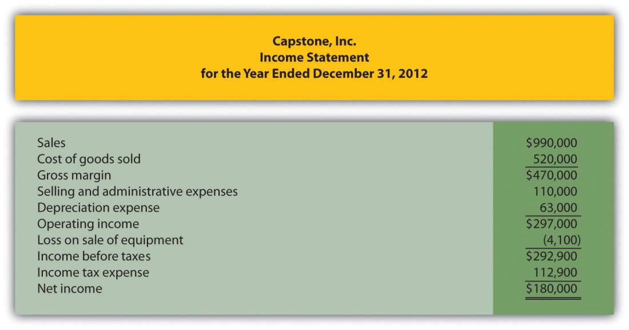
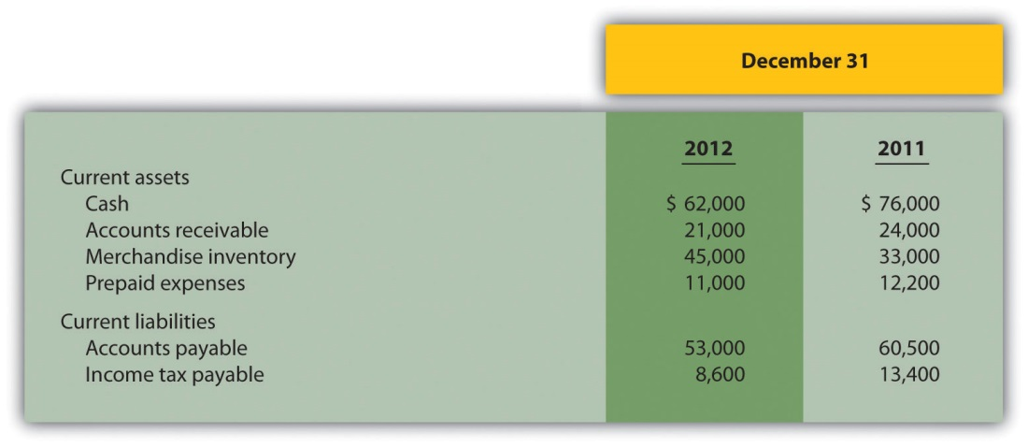
Required:
  - Using the indirect method, prepare the operating activities section of the statement of cash flows for Capstone, Inc., for the year ended December 31, 2012. Use the format presented in .
  - How much cash was provided by (used by) operating activities? Briefly describe what this amount tells us about the company.
- (Appendix) Operating Activities Section Using the Direct Method.The following income statement and current sections of the balance sheet are for Capstone, Inc. (this is the same information as the previous exercise).
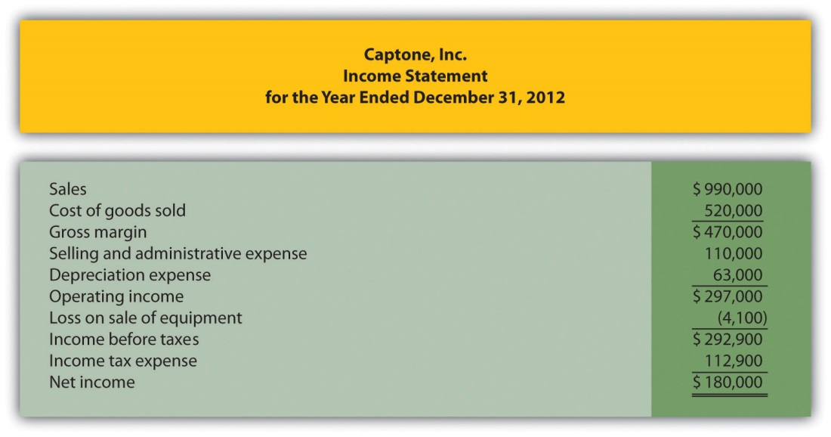
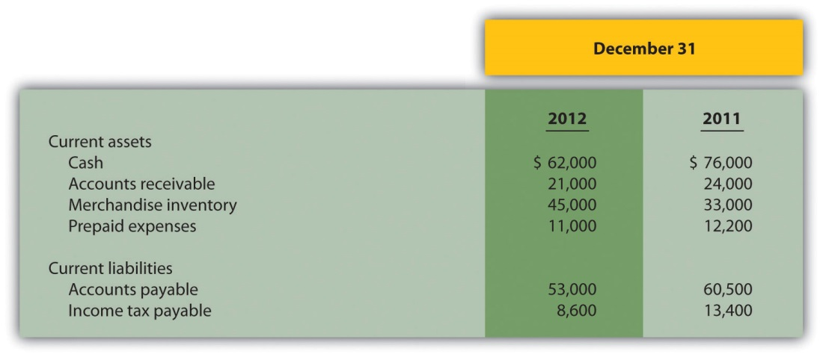
Required:
  - Using the direct method, prepare the operating activities section of the statement of cash flows for Capstone, Inc., for the year ended December 31, 2012. Use the format presented in .
  - How much cash was provided by (used by) operating activities? Briefly describe what this amount tells us about the company.
- Investing Activities Section. The following information is from the noncurrent asset portion of Caldera, Inc.’s balance sheet.
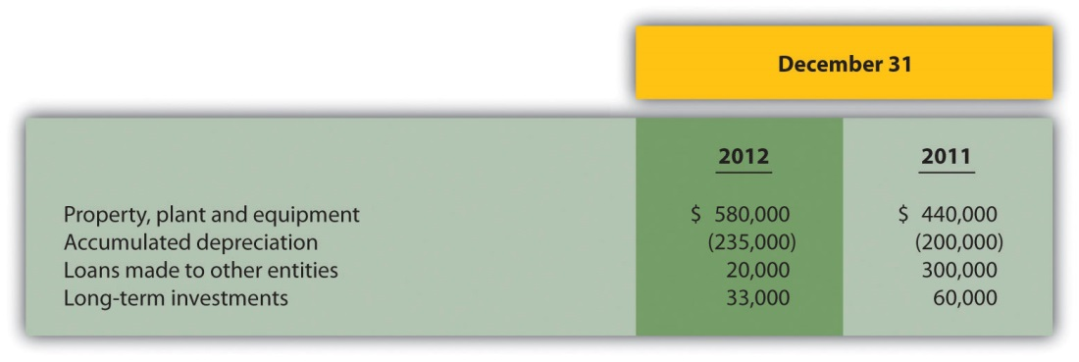
The following activities occurred during 2012:
  - Sold equipment with a book value of $46,000 (= $170,000 cost − $124,000 accumulated depreciation) for $37,000 cash and depreciation expense for the year totaled $159,000
  - Purchased equipment for $310,000 cash
  - No additional loans to other entities were made during the year (Hint: Solve for the principal amount on loans collected during the year.)
  - Sold long-term investments with an original cost of $27,000 for $33,000 cash
Required:
  - Prepare the investing activities section of the statement of cash flows for Caldera, Inc., for the year ended December 31, 2012. Use the format presented in .
  - How much cash was provided by (used by) investing activities? Briefly describe what this amount tells us about the company.
- Financing Activities Section. The following information is from the noncurrent liabilities and owners’ equity portions of Flash, Inc.’s balance sheet.
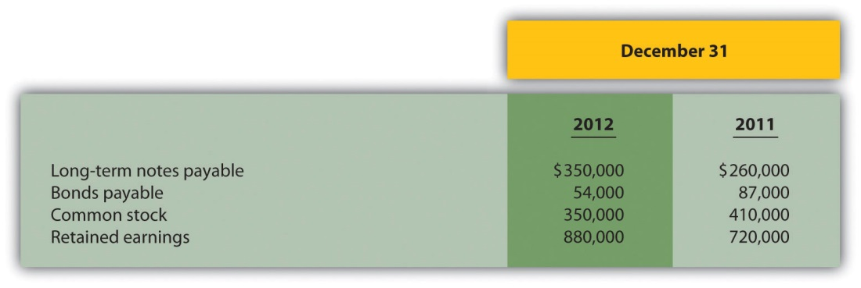
The following activities occurred during 2012:
  - Paid principal amount of $20,000 for long-term notes payable
  - Received $110,000 for long-term notes payable
  - Paid principal amount on bonds totaling $33,000
  - Repurchased common stock for $60,000 cash
  - Earned net income totaling $200,000
  - Paid cash dividends totaling $40,000
Required:
  - Prepare the financing activities section of the statement of cash flows for Flash, Inc., for the year ended December 31, 2012. Use the format presented in .
  - How much cash was provided by (used by) financing activities? Briefly describe what this amount tells us about the company.
- Operating Activities Section Using the Indirect Method and Cash Ratios. The following data are for Cycle Company.
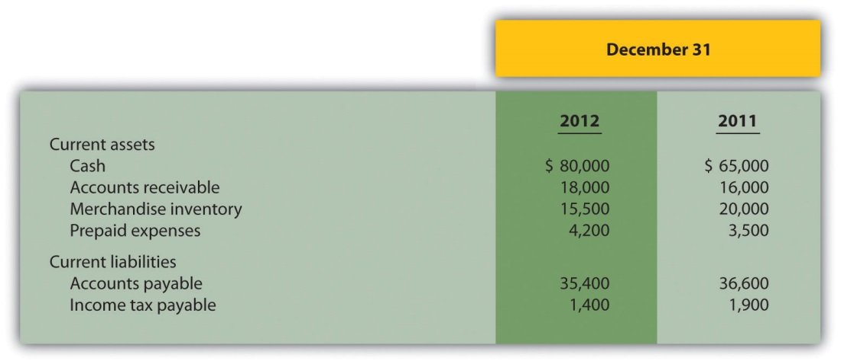
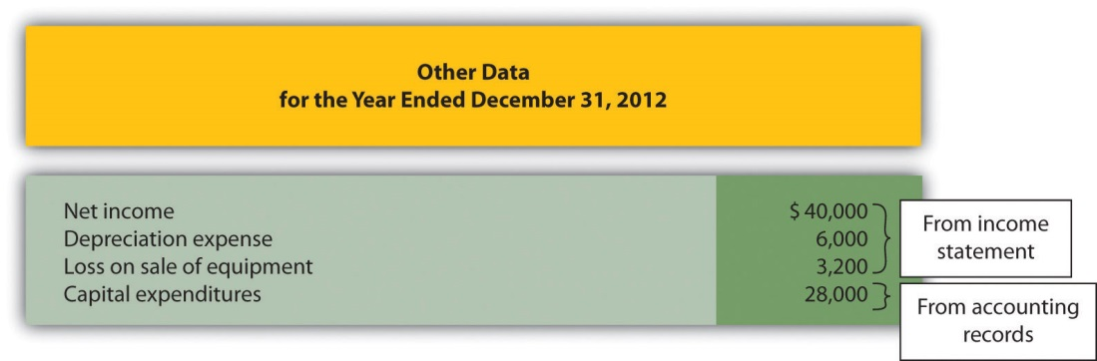
Required:
  - Using the indirect method, prepare the operating activities section of the statement of cash flows for Cycle Company for the year ended December 31, 2012. Use the format presented in .
  - Calculate the following cash measures:
    - Operating cash flow ratio
    - Capital expenditure ratio
    - Free cash flow
Exercises: Set B
- Classifying Cash Flows. Identify whether each of the following items would appear in the operating, investing, or financing activities section of the statement of cash flows. Briefly explain your answer for each item.
  - Cash receipts from the sale of goods
  - Cash payments for the purchases of merchandise
  - Cash receipts from the issuance of bonds
  - Cash payments to shareholders for dividends
  - Cash payments to employees
  - Cash receipts from the sale of equipment
- Operating Activities Section Using the Indirect Method. The following income statement and current sections of the balance sheet are for Manor Company.
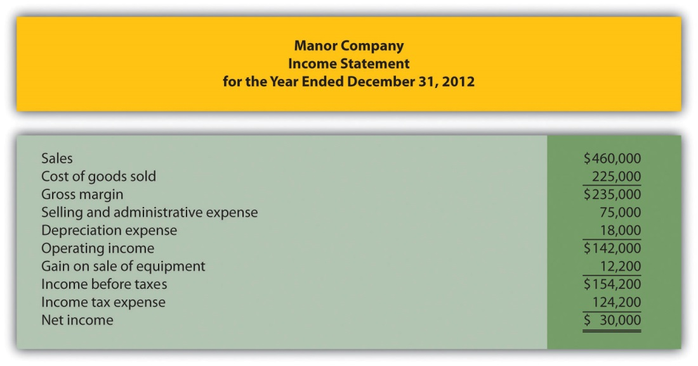
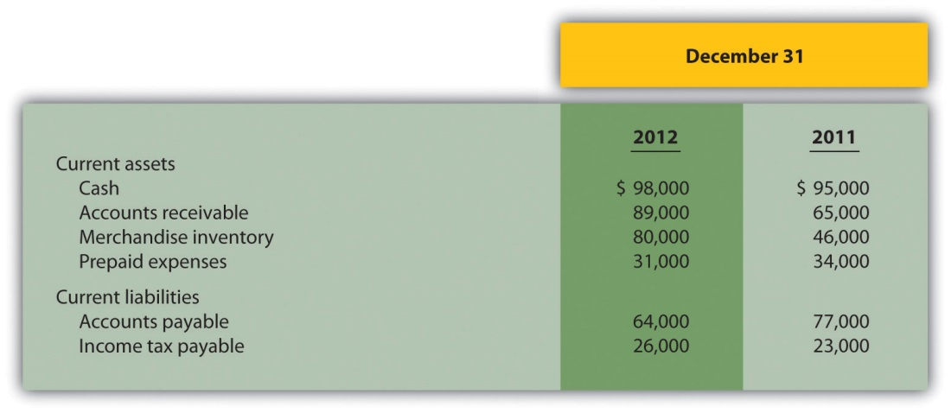
Required:
  - Using the indirect method, prepare the operating activities section of the statement of cash flows for Manor Company for the year ended December 31, 2012. Use the format presented in .
  - How much cash was provided by (used by) operating activities? Briefly describe what this amount tells us about the company.
- (Appendix) Operating Activities Section Using the Direct Method.The following income statement and current sections of the balance sheet are for Manor Company (this is the same information as the previous exercise).
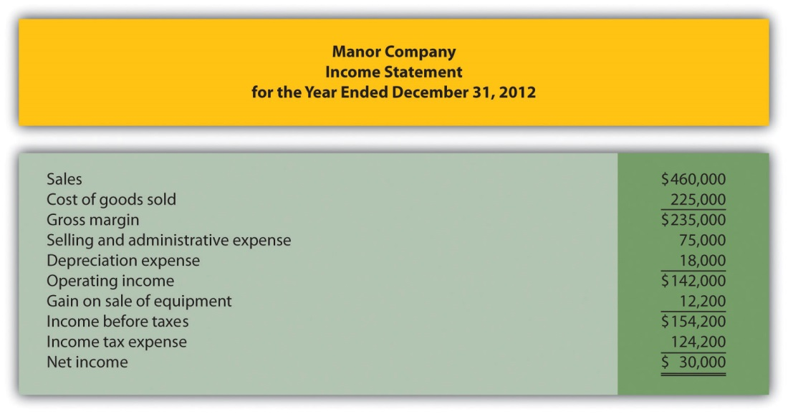
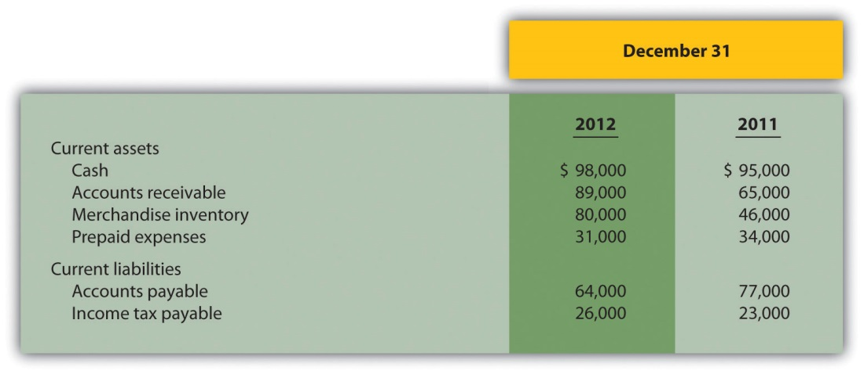
Required:
  - Using the direct method, prepare the operating activities section of the statement of cash flows for Manor Company for the year ended December 31, 2012. Use the format presented in .
  - How much cash was provided by (used by) operating activities? Briefly describe what this amount tells us about the company.
- Investing Activities Section. The following information is from the noncurrent asset portion of Gebhardt Company’s balance sheet.
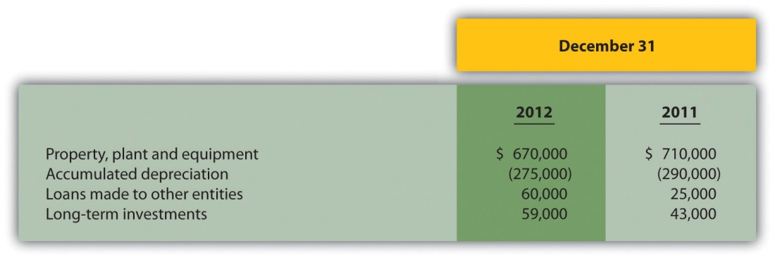
The following activities occurred during 2012:
  - Sold equipment with a book value of $4,000 (= $90,000 cost − $86,000 accumulated depreciation) for $9,000 cash and depreciation expense for the year totaled $71,000
  - Purchased equipment for $50,000 cash
  - Loans totaling $62,000 were made to other entities during the year (Hint: Solve for the principal amount on loans collected during the year.)
  - Purchased long-term investments for $16,000 cash
Required:
  - Prepare the investing activities section of the statement of cash flows for Gebhardt, Inc., for the year ended December 31, 2012. Use the format presented in .
  - How much cash was provided by (used by) investing activities? Briefly describe what this amount tells us about the company.
- Financing Activities Section. The following information is from the noncurrent liabilities and owners’ equity portions of System, Inc.’s balance sheet.
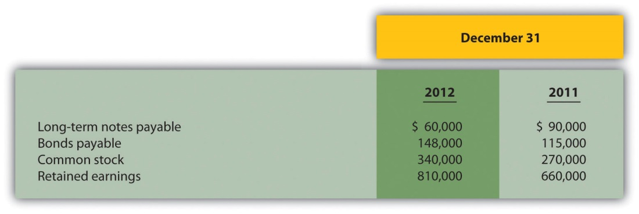
The following activities occurred during 2012:
  - Paid principal amount of $70,000 for long-term notes payable
  - Received $40,000 for long-term notes payable
  - Paid principal amount on bonds totaling $15,000 (Hint: Solve for the proceeds received from the issuance of bonds.)
  - Issued common stock for $100,000 cash (Hint: Solve for the amount paid for the repurchase of stock.)
  - Earned net income totaling $170,000
  - Paid cash dividends totaling $20,000
Required:
  - Prepare the financing activities section of the statement of cash flows for System, Inc., for the year ended December 31, 2012. Use the format presented in .
  - How much cash was provided by (used by) financing activities? Briefly describe what this amount tells us about the company.
- Operating Activities Section Using the Indirect Method and Cash Ratios. The following data are for Mills Company.
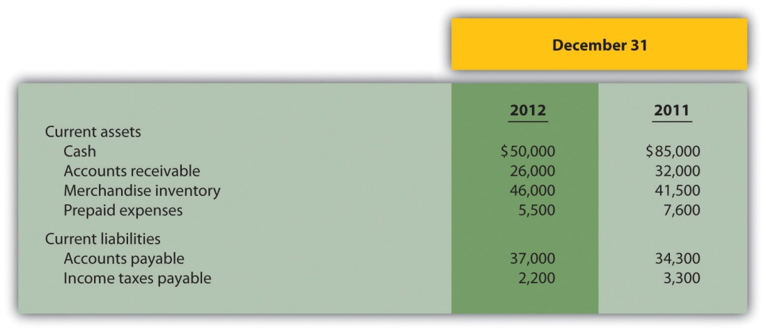
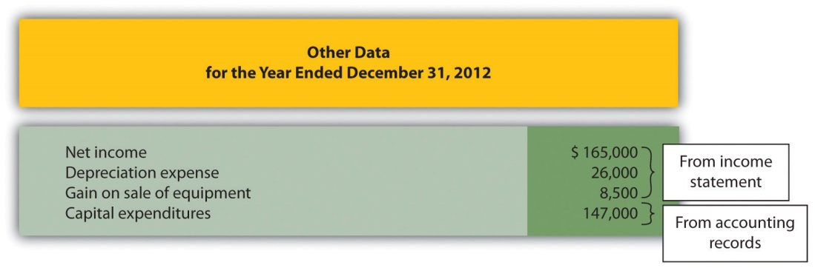
Required:
  - Using the indirect method, prepare the operating activities section of the statement of cash flows for Mills Company for the year ended December 31, 2012. Use the format presented in .
  - Calculate the following cash measures:
    - Operating cash flow ratio
    - Capital expenditure ratio
    - Free cash flow
Problems
- Classifying Cash Flows. Big Sky, Inc., had the following transactions during 2012:
  - Issued common stock for $150,000 cash
  - Paid $25,000 in principal on previously issued bonds
  - Paid $300,000 in salaries and wages to employees
  - Sold property for $45,000 cash
  - Paid $3,000 in cash dividends
  - Received $600,000 from customers for cash sales
  - Paid $350,000 cash for merchandise
  - Converted bonds into common stock
  - Purchased a building for $850,000 cash
  - Paid $310,000 for operating expenses
  - Received $200,000 cash for the sale of long-term investments
  - Issued bonds for $87,000 cash
  - Repurchased common stock for $35,000 cash
  - Issued common stock to purchase land valued at $450,000
  - Paid $10,000 cash for interest on notes payable
Required:
Classify each transaction as one of the following: operating activity, investing activity, financing activity, or noncash transaction. Briefly explain your answer for each item.
- Prepare a Statement of Cash Flows, Indirect Method. Glenbrook Company’s most recent balance sheet, income statement, and other important information for 2012 are presented as follows.
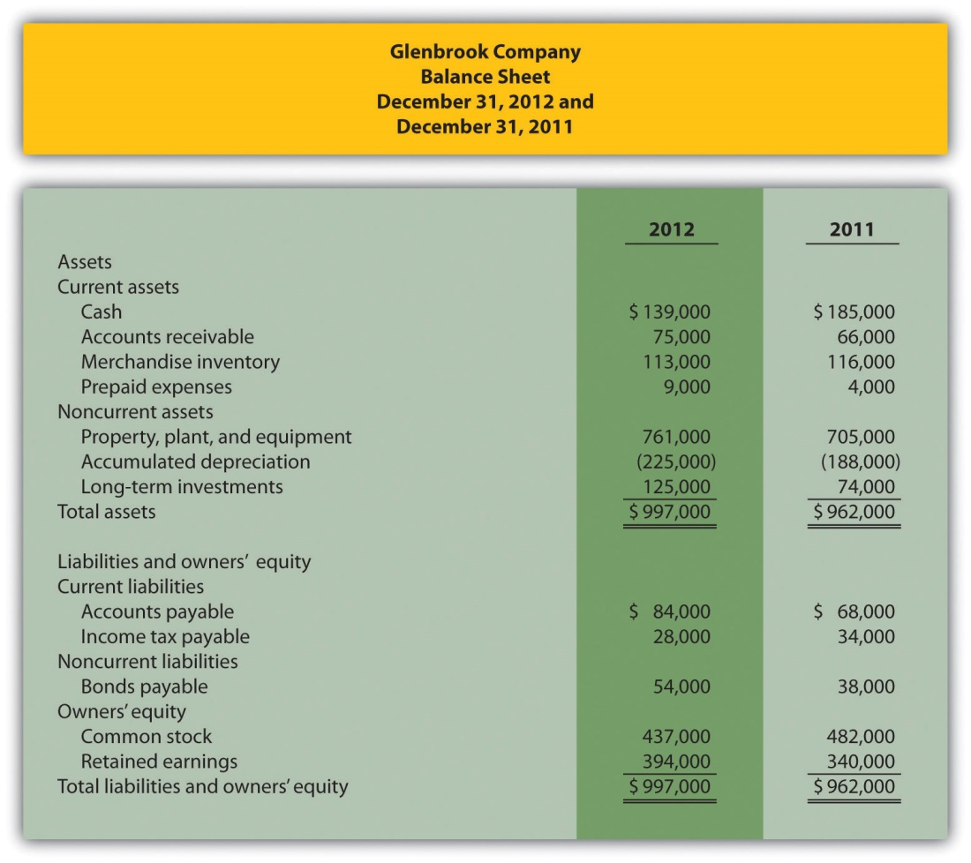
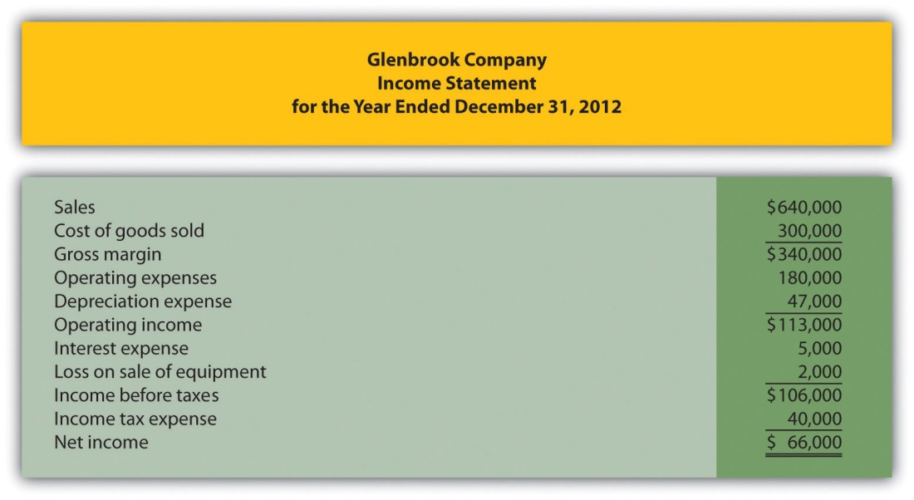
Additional data for 2012 are as follows:
  - Sold equipment with a book value of $30,000 (= $40,000 cost − $10,000 accumulated depreciation) for $28,000 cash
  - Purchased equipment for $96,000 cash
  - There were no sales of long-term investments (Hint: Solve for the purchase of long-term investments.)
  - Issued bonds for $16,000 cash
  - Repurchased common stock (treasury shares) for $45,000 cash
  - Declared and paid $12,000 in cash dividends
Required:
  - Use the four steps described in the chapter to prepare a statement of cash flows for the year ended December 31, 2012, using the indirect method. Refer to the format presented in .
  - Briefly describe the major changes in cash identified in the statement of cash flows.
- (Appendix) Prepare a Statement of Cash Flows, Direct Method.Refer to the information for Glenbrook Company presented in the previous problem.
Required:
  - Use the four steps described in the chapter, including the appendix, to prepare a statement of cash flows for the year ended December 31, 2012, using the direct method. Refer to the operating activities section format using the direct method presented in and the adjustment rules for the direct method presented in .
  - Briefly describe the major changes in cash identified in the statement of cash flows.
- Prepare and Analyze a Statement of Cash Flows, Indirect Method.Travel Supply, Inc.’s most recent balance sheet, income statement, and other important information for 2012 are presented as follows.
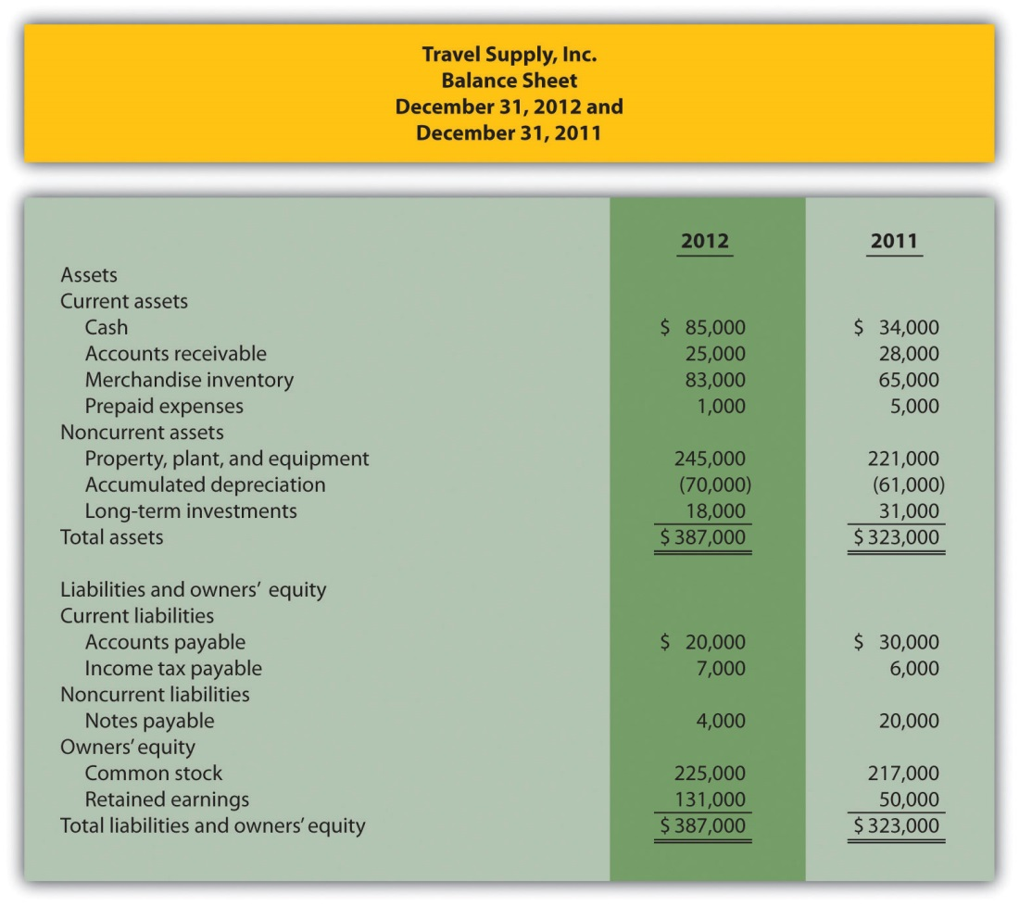
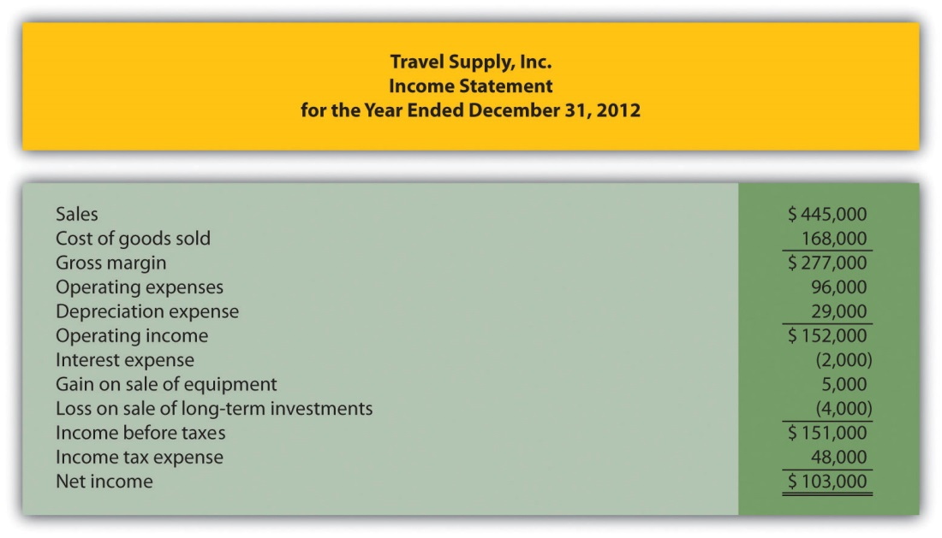
Additional data for 2012 are as follows:
  - Sold equipment with a book value of $3,000 (= $23,000 cost − $20,000 accumulated depreciation) for $8,000 cash
  - Purchased equipment for $47,000 cash
  - Sold long-term investments for $9,000 cash and these investments had an original cost of $13,000
  - Paid $16,000 cash for principal amount on notes payable
  - Issued common stock for $8,000 cash
  - Declared and paid $22,000 in cash dividends
Required:
  - Use the four steps described in the chapter to prepare a statement of cash flows for the year ended December 31, 2012, using the indirect method. Refer to the format presented in .
  - The owner of Travel Supply, Inc., wants to know why cash only increased $51,000 even though the company had net income of $103,000, issued common stock for $8,000, and sold long-term investments for $9,000. Use the information in the statement of cash flows to briefly explain why cash only increased $51,000.
- Prepare a Statement of Cash Flows, Indirect Method; Analyze Using Cash Ratios. Nolan Company’s most recent balance sheet, income statement, and other important information for 2012 are presented as follows.
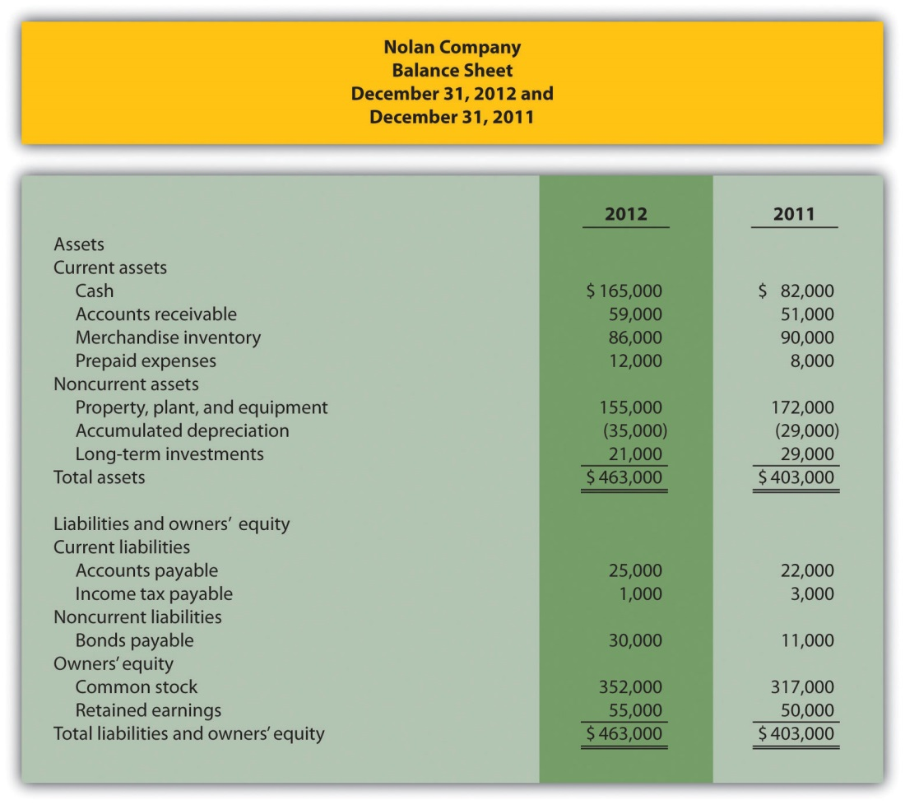
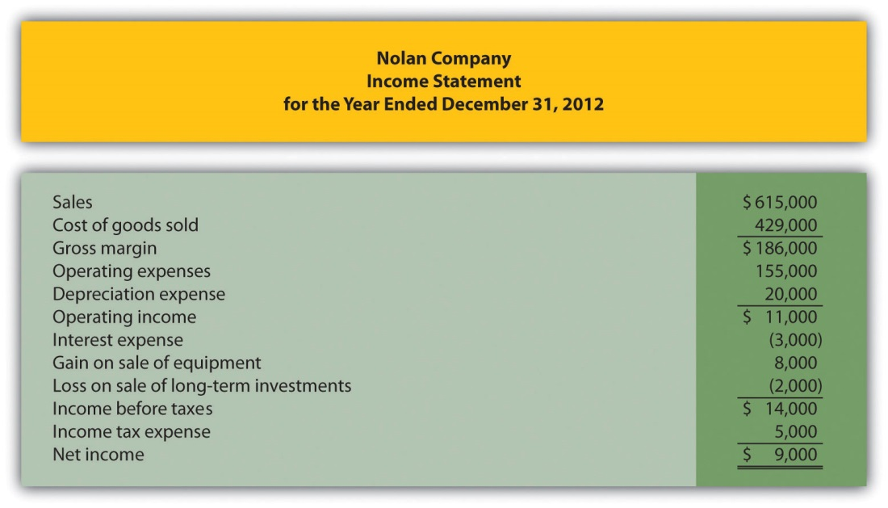
Additional data for 2012 are as follows:
  - Sold equipment with a book value of $13,000 (= $27,000 cost − $14,000 accumulated depreciation) for $21,000 cash
  - Purchased equipment for $10,000 cash
  - Sold long-term investments for $6,000 cash and these investments had an original cost of $8,000
  - Received $19,000 cash related to notes payable
  - Issued common stock for $35,000 cash
  - Declared and paid $4,000 in cash dividends
Required:
  - Use the four steps described in the chapter to prepare a statement of cash flows for the year ended December 31, 2012, using the indirect method. Refer to the format presented in .
  - The owner of Nolan Company wants to know how cash more than doubled, from $82,000 to $165,000, given the company’s modest net income of $9,000. Use the information in the statement of cash flows to briefly explain why cash more than doubled.
  - Calculate the following cash measures:
    - Operating cash flow ratio
    - Capital expenditure ratio (Hint: Capital expenditures can be found in the investing activities section of the statement of cash flows prepared in part a.)
    - Free cash flow
- (Appendix) Prepare a Statement of Cash Flows (Direct Method); Analyze Using Cash Ratios. Refer to the information for Nolan Company presented in the previous problem.
Required:
  - Use the four steps described in the chapter, including the appendix, to prepare a statement of cash flows for the year ended December 31, 2012, using the direct method. Refer to the operating activities section format using the direct method presented in , and the adjustment rules for the direct method presented in .
  - Briefly describe the major changes in cash identified in the statement of cash flows.
  - Calculate the following cash measures:
    - Operating cash flow ratio
    - Capital expenditure ratio (Hint: Capital expenditures can be found in the investing activities section of the statement of cash flows prepared in part a.)
    - Free cash flow
- Prepare and Analyze a Statement of Cash Flows, Indirect Method and Direct Method. Ritz Company’s most recent balance sheet, income statement, and other important information for 2012 are presented as follows.
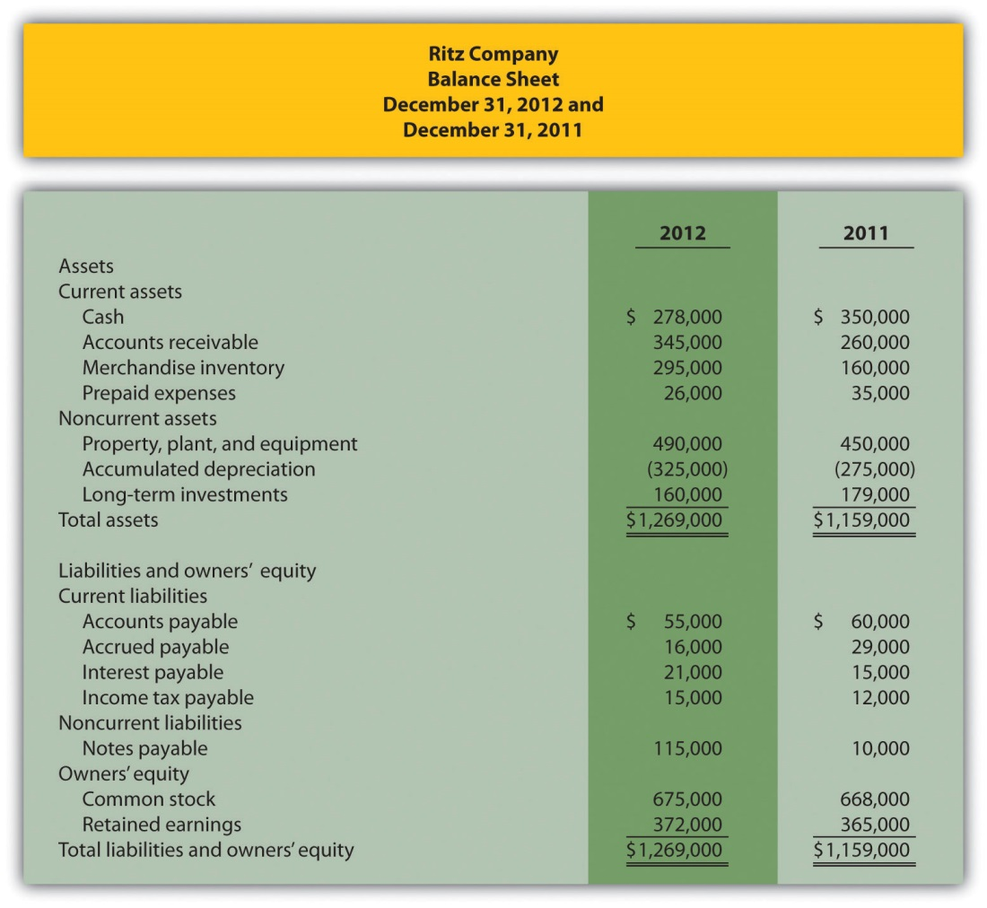
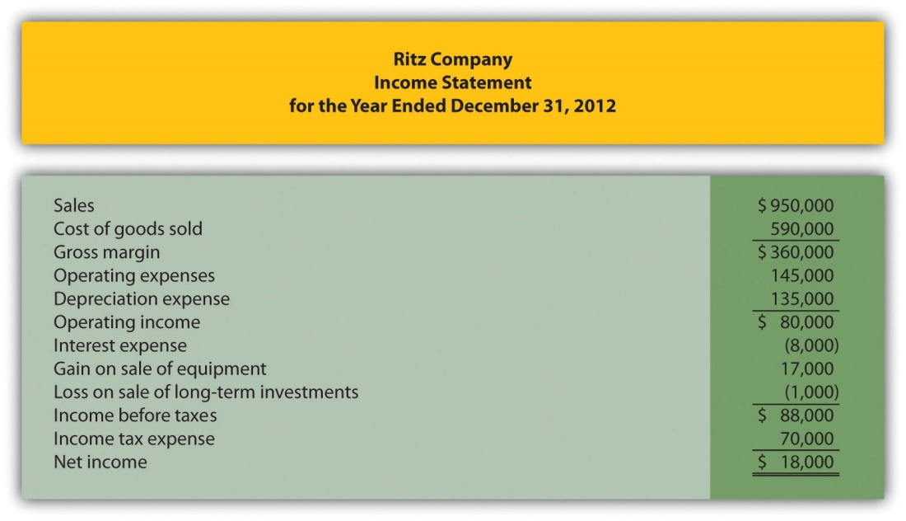
Additional data for 2012 are as follows:
  - Sold equipment with a book value of $15,000 (= $100,000 cost − $85,000 accumulated depreciation) for $32,000 cash
  - Purchased equipment for $140,000 cash
  - Sold long-term investments for $23,000 cash and these investments had an original cost of $24,000
  - Purchased long-term investments for $5,000 cash
  - Issued bonds for $105,000 cash
  - Issued common stock for $7,000 cash
  - Declared and paid $11,000 in cash dividends
Required:
  - Use the four steps described in the chapter to prepare a statement of cash flows for the year ended December 31, 2012, using the indirect method. Refer to the format presented in .
  - The owner of Ritz Company wants to know why cash decreased from $350,000 to $278,000 given the company’s net income of $18,000. Use the information in the statement of cash flows to briefly explain why cash decreased.
  - Use the four steps described in the chapter, as well as in the appendix, to prepare a statement of cash flows for the year ended December 31, 2012, using the directmethod. Refer to the operating activities section format using the direct method presented in and the adjustment rules for the direct method presented in .
One Step Further: Skill-Building Cases
- Southwest Airlines Statement of Cash Flows. Refer to the How couldSouthwest’s cash balance increase by $147,000,000 even though the company generated $1,600,000,000 in cash from operating activities?
- Home Depot and Lowe’s Statement of Cash Flows. Refer to the How much cash was generated from daily activities for each company? Where was the bulk of this cash spent for each company?
- Internet Project: Statement of Cash Flows. Using the Internet, find the most recent annual report for a company of your choice. Print the statement of cash flows and include it with your response to the following requirements.
Required:
  - How much cash was provided by (used by) operatingactivities? Compare this amount to net income (often called net earnings) and explain why the two are different.
  - What method did the company use to prepare theoperating activities section, direct or indirect? Explain.
  - How much cash was provided by (used by) investingactivities? Which activity in this section had the biggest impact on investing cash flows?
  - How much cash was provided by (used by) financingactivities? Which activity in this section had the biggest impact on financing cash flows?
  - Calculate free cash flow. Did the company generate enough cash from operating activities to cover capital expenditures? Explain.
- Dividend Cash Flow at Microsoft. Refer to the How much did Microsoftpay in dividends during the second quarter of 2005? Why did Microsoftpay such a large dividend to shareholders?
- Cash Flows at Amazon.com. Refer to the Why does Amazon.com prefer to use free cash flow per share rather than earnings per share to evaluate the company?
- Group Activity: Analyzing General Motors Statement of Cash Flows.The following information is from the consolidated statement of cash flows for General Motors (GM) for the year ended December 31, 2005 (in millions).
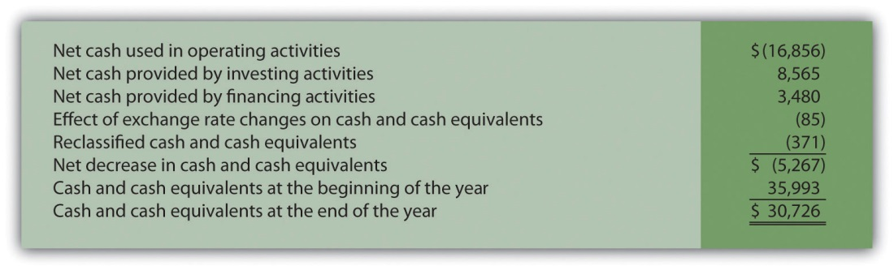
Required:
An investment advisor recently reviewed GM’s statement of cash flows and balance sheet and stated: “GM is doing great! They are sitting on cash of more than $30,000,000,000. There is no cash flow problem with this company!” In groups of two to four students, decide whether you agree with this statement. Support your conclusion with an analysis of GM’s cash flows.
Comprehensive Case
- Ethics: Manipulating Data to Reach Target Cash Flow. Country Market, Inc., sells food and beverage products at its five retail stores. The company’s fiscal year ends on December 31. The company’s president and CEO, Jean Williams, just received a draft of the statement of cash flows from the controller, Stan Walker. Jean is very interested in the results since a significant part of her annual bonus depends on generating at least $400,000 in cash from operating activities. A summary of the statement is provided in the following:
Becky Swanson, the chief financial officer (CFO) for Country Market, is approached by Jean:
Jean: | Becky, have you seen the statement of cash flows?
Becky: | No, not yet. Last I heard Stan was just about done with it.
Jean: | He just dropped off a copy for my review.
Becky: | Excellent. How does it look?
Jean: | Overall it looks fine, but something must be wrong with the operating activities number. I assumed it would be well above $400,000. Can you take a look at it and make sure we exceed $400,000?
Becky: | I’ll do what I can.
Jean: | Great. I knew I could depend on you.
Shortly after this discussion, Becky returned with revised numbers:
Becky: | Jean, here is the corrected statement of cash flows (see as follows). I was able to reclassify a portion of cash received from the sale of long-term investments to the operating activities section to get to $403,000.
Jean: | Excellent! Thanks, Becky, I knew you could do it!
Required:
  - What impact did the reclassification of cash flows have on the total net increase in cash? Explain.
  - Are Becky’s actions ethical? Explain.
  - If you were the CFO, how would you handle Jean’s request? (If necessary, review the presentation of ethics in for additional information.)

Chapter 13

How Do Managers Use Financial and Nonfinancial Performance Measures?

Source: Photo courtesy of Jon Seidman,http://www.flickr.com/photos/jonseidman1988/4481833335/.

Sandy Masako is the CEO of a fast-food restaurant called Chicken Deluxe. The company operates hundreds of restaurants throughout North America and is choosing between two suppliers of soft drinks: Deep Fizz Company and Extreme Fizz, Inc. Consumer surveys indicate no significant preference between the two. Sandy is meeting with Dave Roberts, the CFO, and Karen Kraft, the purchasing manager, to discuss the company’s options.
Sandy (CEO): | We have a big decision to make. Our soft drink contract is up at the end of this year, and we need to decide on a supplier for next year.
Karen (Purchasing Manager): | I’ve had preliminary discussions with both Deep Fizz and Extreme Fizz, and the costs of their products are about the same.
Dave (CFO): | Based on extensive surveys with our customers, they are not particularly concerned about which supplier we choose, as long as it’s either Deep Fizz or Extreme Fizz.
Karen: | Both companies would like our business. This is a big contract for either of them!
Sandy: | OK, so we have two companies offering the same terms, and customers who would be satisfied with either company’s products. Are there any other criteria we should consider?
Dave: | We must have a supplier that is on solid financial ground. If our supplier were to have financial difficulties that jeopardized product quality or timing of deliveries, we would be in a bind.
Karen: | I agree. We need to determine whether these companies are in good financial shape.
Dave: | I suggest we have our accounting staff evaluate their financial information by analyzing and comparing certain key financial measures.
Sandy: | What do you have in mind?
Dave: | My staff can look at financial trends and calculate several different ratios to evaluate the strength of each company’s income statement and balance sheet. We can compare these ratios for both companies and also compare them to industry standards. This analysis should give us a better idea about the financial stability of each company.
Sandy: | Excellent! We have a few months to make our decision. How much time do you need?
Dave: | We can have it ready within a few weeks.
Sandy: | Great, let’s plan on reviewing your analysis next month.

Chicken Deluxe is facing a supplier decision common to many companies. Financial stability is an important factor in deciding on a supplier, along with the quality of product and reliability of service. Chicken Deluxe must analyze financial information for Deep Fizz and Extreme Fizz to determine the financial condition of each company.

The analysis of a company’s financial information typically follows a three-pronged approach. First, trends within a company’s own financial information are analyzed, such as sales and earnings from one year to the next, using two methods—trend analysis and common-size analysis. Second, financial measures are compared between competitors. Finally, financial ratios are compared to industry averages. We discuss these three approaches next using Coca-Cola as an example. We will revisit the decision facing Chicken Deluxe later in the chapter.

13.1 Trend Analysis of Financial Statements

LEARNING OBJECTIVE
- Perform trend analysis to evaluate financial statement information.

Question: How is trend analysis used to evaluate the financial health of an organization?

Answer: Trend analysis evaluates an organization’s financial information over a period of time. Periods may be measured in months, quarters, or years, depending on the circumstances. The goal is to calculate and analyze the amount change and percent change from one period to the next.

For example, in fiscal years 2010 and 2009, Coca-Cola had the operating income shown as follows. (Amounts are in millions. To convert to the actual amount, simply multiply the amount given times one million. For example, $8,449 × 1,000,000 = $8,449,000,000. Thus Coca-Cola had operating income of $8,449,000,000 in 2010.)
 | Amount 2010 | Amount 2009 | Amount Change | Percent Change
Operating income | $8,449 | $8,231 | ? | ?
Although readers of the financial information can see that operating income increased from 2009 to 2010, the exact dollar amount of the change and the percent change is more helpful in evaluating the company’s performance. The dollar amount of change is calculated as follows:

Key Equation
Amount of change = Current year amount – Base year amount
Amount of change$218==Current year amount$8,449−−Base year amount$8,231

Question: As you can see, operating income increased by $218,000,000 from 2009 to 2010. Is this a significant increase for Coca-Cola?

Answer: Most of us consider $218,000,000 to be a huge amount, but the only way to gauge the true significance of this amount for Coca-Cola is to calculate the percent change from 2009 to 2010. The percent change is calculated as the current year amount minus the base year amount, divided by the base year amount.

Key Equation
Percent change = (Current year amount – Base year amount) ÷ Base year amount

The calculation that follows shows operating income increased 2.6 percent from 2009 to 2010. Although not an extraordinarily significant increase, this does represent positive results for Coca-Cola.

Percent change2.6%=(Current year amount−Base year amount)÷Base year amount=($8,449−$8,231)÷$8,231

Trend Analysis for the Income Statement and Balance Sheet

Question: Trend analysis is often used to evaluate each line item on the income statement and balance sheet. How is this analysis prepared?

Answer: Figure 13.1 "Income Statement Trend Analysis for " shows Coca-Cola’s income statement trend analysis, and Figure 13.2 "Balance Sheet Trend Analysis for " shows Coca-Cola’s balance sheet trend analysis. Carefully examine each of these figures, including the comments.

Figure 13.1 Income Statement Trend Analysis for Coca-Cola
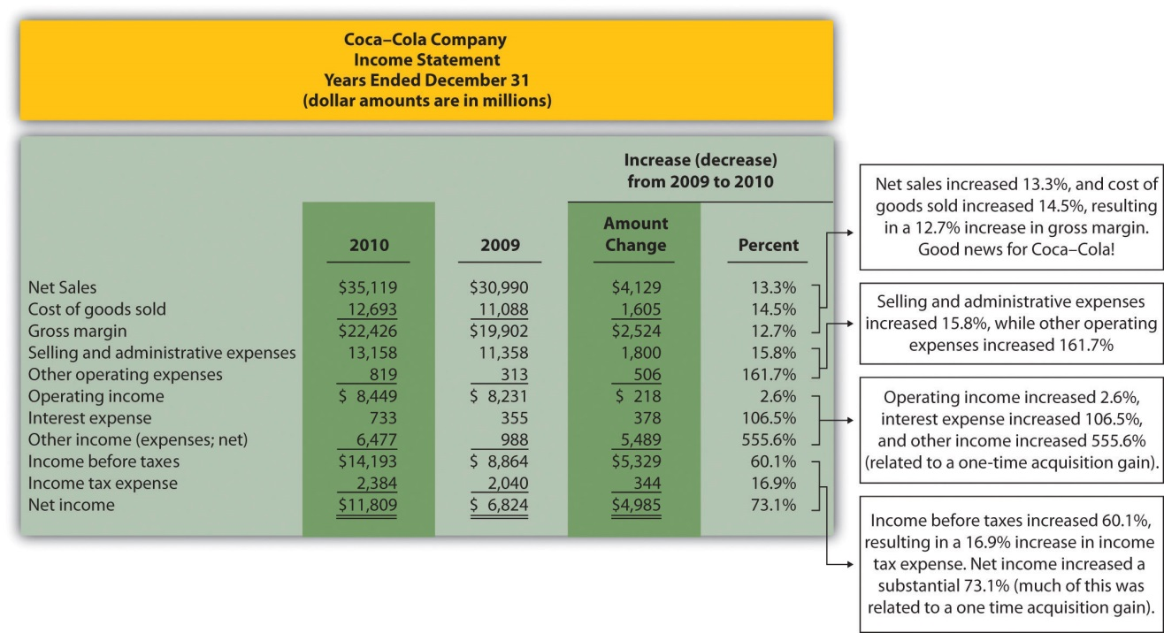

Note: Percent change for each line item is found by dividing the increase (decrease) amount by the 2009 amount. For example, net sales 13.3 percent increase equals $4,129 ÷ $30,990.

Figure 13.1 "Income Statement Trend Analysis for " shows that net sales increased by $4,129,000,000, or 13.3 percent. Cost of goods sold had a corresponding increase of $1,605,000,000, or 14.5 percent. The increase in net sales and related increase in cost of goods sold resulted in an increase in gross margin of $2,524,000,000, or 12.7 percent. The increase in selling and administrative expenses of $1,800,000,000, or 15.8 percent, outpaced the increase in net sales, resulting in a relatively small increase in operating income of $218,000,000, or 2.6 percent. The significant increase in other income (expenses), net of 555.6 percent relates to a one-time gain of $4,978,000,000 resulting from Coca-Cola’s acquisition of Coca-Cola Enterprises, Inc., in 2010 (this information comes from the notes to the financial statements). This one-time gain caused an unusually large increase in net income for 2010. This is important as we continue our analysis of Coca-Cola Company throughout the chapter. Net income will appear to have an unusually large increase as we cover various measures of performance, but keep in mind that the one-time gain in 2010 of $4,978,000,000 caused most of the increase from 2009 to 2010.

Figure 13.2 Balance Sheet Trend Analysis for Coca-Cola
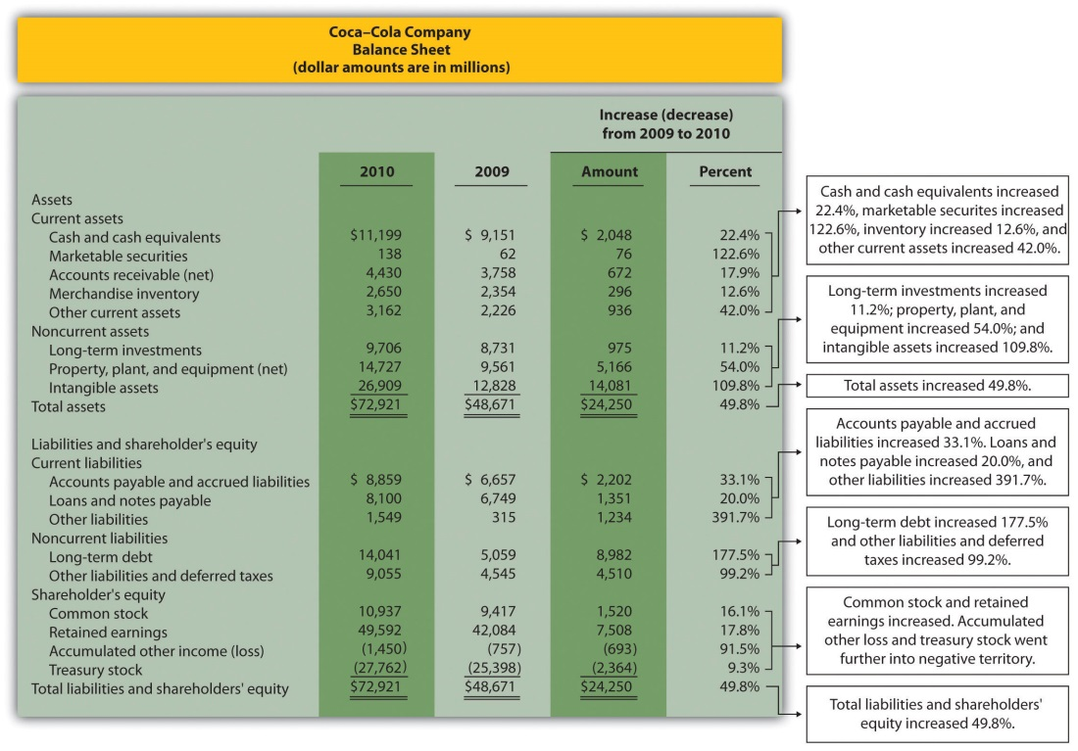

Note: Percent change for each line item is found by dividing the increase (decrease) amount by the 2009 amount. For example, cash and cash equivalents 22.4 percent increase equals $2,048 ÷ $9,151.

Current Assets and Current Liabilities

Question: What does the balance sheet trend analysis in Figure 13.2 "Balance Sheet Trend Analysis for " tell us about current assets and current liabilities forCoca-Cola?

Answer: Figure 13.2 "Balance Sheet Trend Analysis for " shows that cash and cash equivalents increased by $2,048,000,000, or 22.4 percent. Coca-Cola’s statement of cash flows would provide detailed information regarding this increase. (Chapter 12 "How Is the Statement of Cash Flows Prepared and Used?" covers the statement of cash flows.) Marketable securities increased 122.6 percent, accounts receivable increased 17.9 percent, and merchandise inventory increased 12.6 percent. Other current assets increased 42.0 percent.

Moving to current liabilities, accounts payable and accrued liabilities increased by 33.1 percent, loans and notes payable increased 20.0 percent, and other current liabilities decreased 391.7 percent (mostly attributable to a significant increase in the current portion of long-term debt).

Noncurrent Assets and Noncurrent Liabilities

Question: What does the balance sheet trend analysis in Figure 13.2 "Balance Sheet Trend Analysis for " tell us about noncurrent assets and noncurrent liabilities for Coca-Cola?

Answer: Figure 13.2 "Balance Sheet Trend Analysis for " shows that long-term investments increased 11.2 percent. Property, plant, and equipment increased 54.0 percent, and intangible assets increased by a significant 109.8 percent. Both items appearing under noncurrent liabilities increased, with a 177.5 percent increase in long-term debt and a 99.2 percent increase in other liabilities and deferred taxes.

Shareholders’ Equity

Question: What does the balance sheet trend analysis in Figure 13.2 "Balance Sheet Trend Analysis for " tell us about shareholders’ equity for Coca-Cola?

Answer: Common stock increased 16.1 percent, and retained earnings increased 17.8 percent. Accumulated other income (loss) went further into negative territory by 91.5 percent, and treasury stock increased 9.3 percent.

Big Picture Balance Sheet Trend Analysis

Question: What are some of the key big picture items identified in the balance sheet trend analysis shown in Figure 13.2 "Balance Sheet Trend Analysis for "?

Answer: Overall, total assets increased by $24,250,000,000, or 49.8 percent. Of course, total liabilities and shareholders’ equity also increased by the same amount. The increases identified in almost every asset, liability, and shareholders’ equity line item are significant. From reading the notes to the financial statements, the authors were able to identify the main source of these increases. In 2010, Coca-Cola acquired the remaining 67 percent of Coca-Cola Enterprises, Inc.’s (CCE) North America business thatCoca-Cola did not already own. This resulted in significant increases in noncurrent assets and noncurrent liabilities, which were acquired as part of this transaction. It also resulted in the reporting of a one-time gain on the income statement of $4,978,000,000, which came from Coca-Colaremeasuring its equity interest in CCE to fair value upon close of the transaction in 2010.

This analysis points to the reason we perform trend analysis—to identify the increases and decreases in dollar amounts from one year to the next and to take a close look at unusual trends.

Trend Analysis over Several Years

Question: The trend analysis just described works well when comparing financial data for two years. However, many prefer to review trends over more than two years. How might a trend analysis for several years be prepared?

Answer: A common approach is to establish the oldest year as the base year and compute future years as a percentage of the base year. For example,Coca-Cola had the following net sales and operating income for each of the past five years (in millions):
 | 2010 | 2009 | 2008 | 2007 | 2006
Net sales | $35,119 | $30,990 | $31,944 | $28,857 | $24,088
Operating income | $ 8,449 | $ 8,231 | $ 8,446 | $ 7,252 | $ 6,308

Assuming 2006 is the base year, the trend percentage is calculated for each year using the following formula:

Key Equation
Trend percentage = Current year ÷ Base year

Figure 13.3 "Percentage Trend Analysis for " shows Coca-Cola’s trend percentages for net sales and operating income. Most analysts would expand this analysis to include most, if not all, of the income statement line items.

Figure 13.3 Percentage Trend Analysis for Coca-Cola
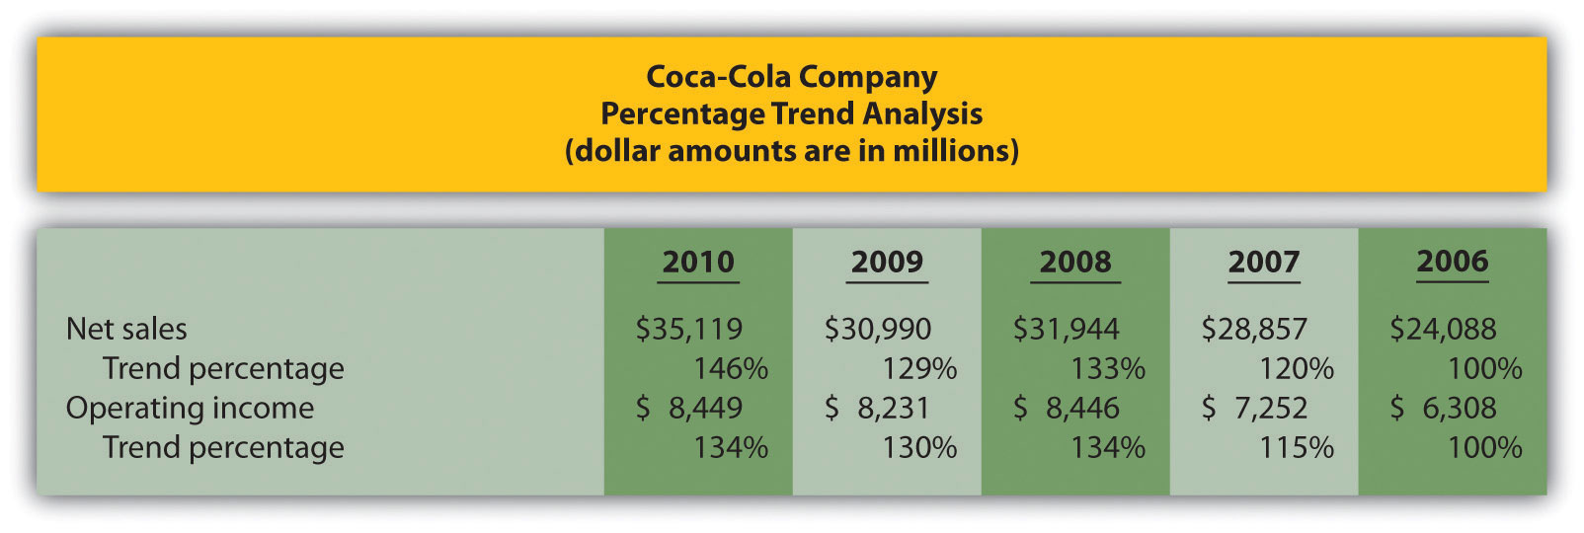

Note: Trend percentages are calculated as the current year divided by the base year (2006). For example, the net sales 2010 trend percentage of 146 percent equals $35,119 (net sales for 2010) divided by $24,088 (net sales for the base year 2006).

All percentages shown in Figure 13.3 "Percentage Trend Analysis for " are relative to the base year, which is fiscal year 2006. Notice that the increase in operating income of 34 percent (= 134 percent – 100 percent) from 2006 to 2010 was less than the increase in net sales of 46 percent for the same period. This signals that the increase in Coca-Cola’s operating expenses outpaced the increase in net sales during this period. Figure 13.4 "Five-Year Percentage Trend in Operating Income for " shows the trend percentages inCoca-Cola’s operating income from 2006 to 2010.

Figure 13.4 Five-Year Percentage Trend in Operating Income for Coca-Cola
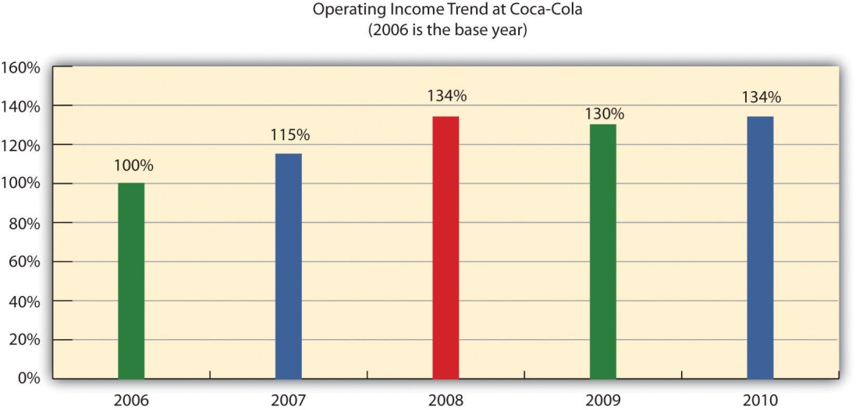

KEY TAKEAWAY
- Trend analysis provides a means to analyze company data over a period of time by focusing on the change in specific line items within the income statement and balance sheet. Changes are typically measured in dollars and percentages. Trends over several years can be evaluated by calculating the trend percentage as the current year divided by the base year.

Business in Action 13.1
Trends Presented in Annual Reports
Most public companies present trend information in their annual reports. For example, Intel shows net revenues, gross margin, research and development costs, operating income, and net income for the past five years. Nike and PepsiCo both show the percent change in selected income statement line items for the past two years. Costco Wholesale Corporation presents selected income statement information for the past five years. The fact that these financial data are provided in the annual report confirms the importance of presenting trend information to shareholders.
Sources: Intel, “Annual Report, 2010,” http://www.intel.com; Nike, “Annual Report, 2010,” http://www.nike.com; PepsiCo, “Annual Report, 2010,” http://www.pepsico.com; Costco Wholesale Corporation, “Annual Report, 2010,” http://www.costco.com.

REVIEW PROBLEM 13.1
The following income statements and balance sheets are for PepsiCo, Inc.We use this information in review problems throughout the chapter.
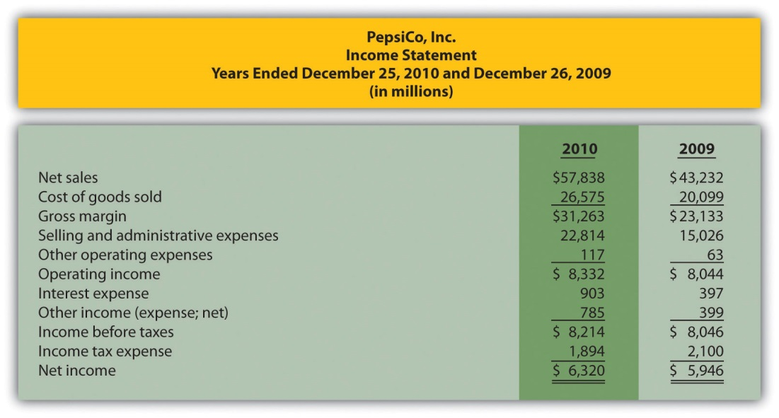
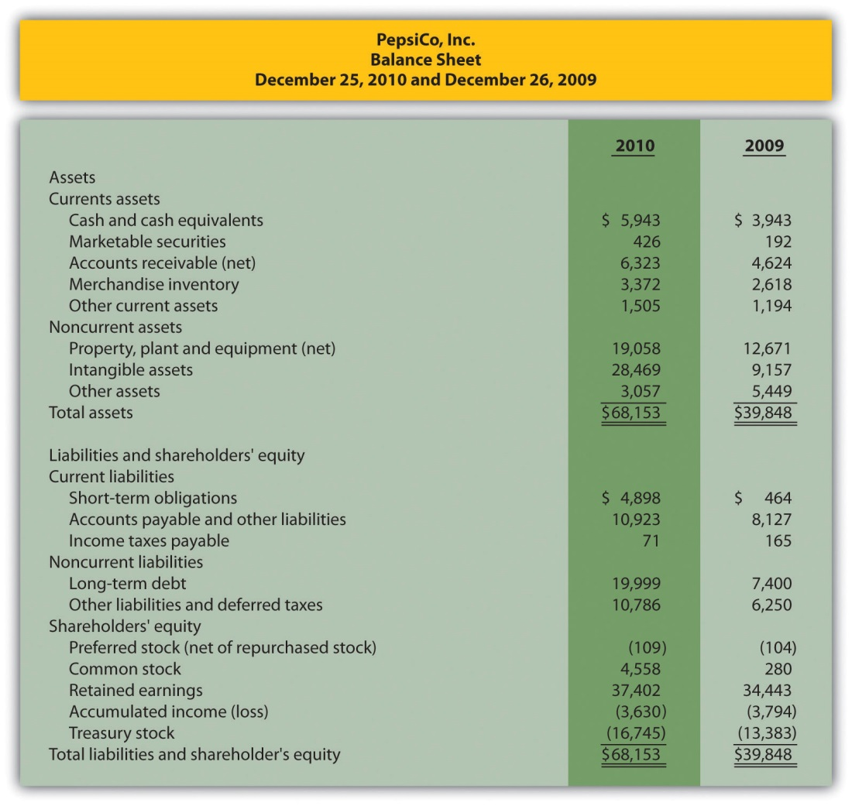
- Prepare a trend analysis for PepsiCo‘s income statement using the format shown in Figure 13.1 "Income Statement Trend Analysis for ".
- Prepare a trend analysis for PepsiCo’s balance sheet using the format shown in Figure 13.2 "Balance Sheet Trend Analysis for ".
- Compare PepsiCo’s increase in net income from 2009 to 2010 to Coca-Cola’s increase shown in Figure 13.1 "Income Statement Trend Analysis for ". Which company has the highest percentage growth in net income?
- Compare PepsiCo’s increase in total assets from 2009 to 2010 to Coca-Cola’s increase shown in Figure 13.2 "Balance Sheet Trend Analysis for ". Which company has the highest percentage growth in total assets?
Solution to Review Problem 13.1

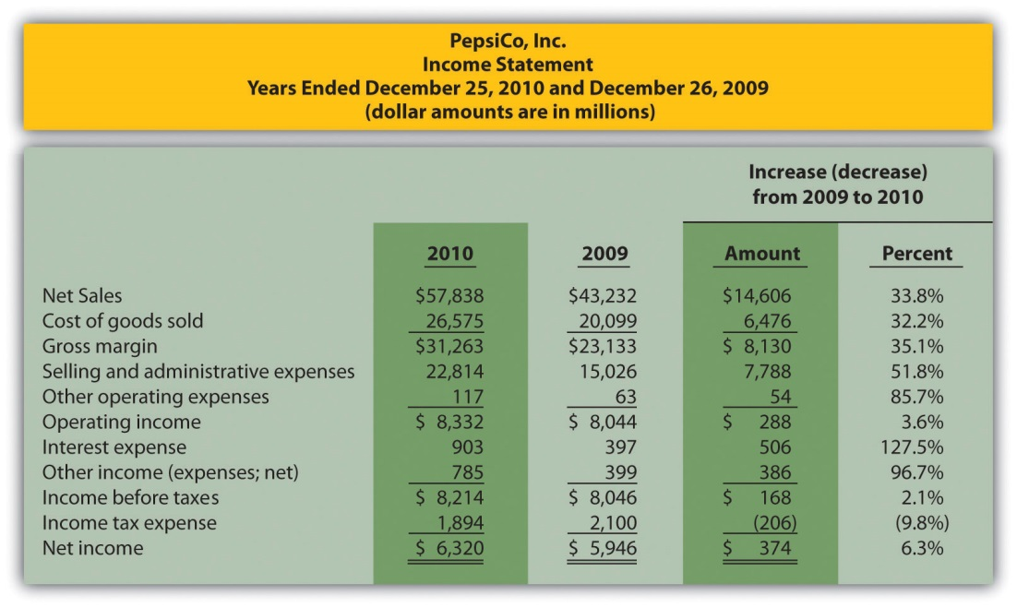
Note: Percent change for each line item is found by dividing the increase (decrease) amount by the 2009 amount. For example, net sales 33.8 percent increase equals $14,606 ÷ $43,232.

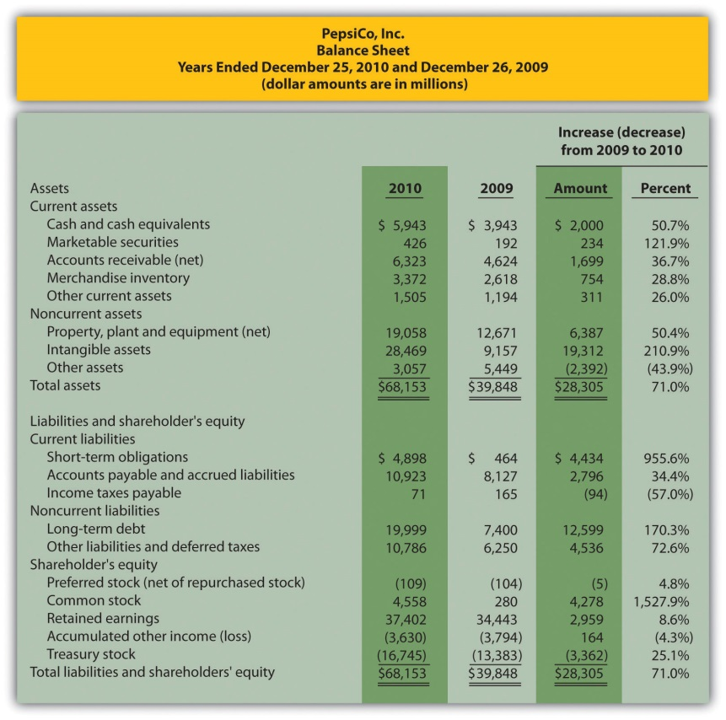
Note: Percent change for each line item is found by dividing the increase (decrease) amount by the 2009 amount. For example, cash and cash equivalents 50.7 percent increase equals $2,000 ÷ $3,943.
- Net income at PepsiCo increased $374,000,000, or 6.3 percent, while net income at Coca-Cola increased $4,985,000,000, or 73.1 percent (as shown in Figure 13.1 "Income Statement Trend Analysis for "). ThusCoca-Cola’s growth in net income far exceeded that of PepsiCo. As mentioned earlier, this huge increase in Coca-Cola’s net income is largely attributable to a one-time gain in 2010 of $4,978,000,000.
- Total assets at PepsiCo increased $28,305,000,000, or 71.0 percent, while total assets at Coca-Cola increased $24,250,000,000, or 49.8 percent (as shown in Figure 13.2 "Balance Sheet Trend Analysis for "). Thus PepsiCo’s growth in total assets far exceeded that of Coca-Cola.

13.2 Common-Size Analysis of Financial Statements

LEARNING OBJECTIVE
- Perform common-size analysis to evaluate financial statement information.

Question: How is common-size analysis used to evaluate the financial health of an organization?

Answer: Common-size analysis (also called vertical analysis) converts each line of financial statement data to an easily comparable, or common-size, amount measured as a percent. This is done by stating income statement items as a percent of net sales and balance sheet items as a percent of total assets (or total liabilities and shareholders’ equity). For example, Coca-Cola had net income of $11,809,000,000 and net sales of $35,119,000,000 for 2010. The common-size percent is simply net income divided by net sales, or 33.6 percent (= $11,809 ÷ $35,119).

There are two reasons to use common-size analysis: (1) to evaluate information from one period to the next within a company and (2) to evaluate a company relative to its competitors. Common-size analysis answers such questions as “how do our current assets as a percent of total assets compare with last year?” and “how does our net income as a percent of net sales compare with that of our competitors?”

Using Common-Size Analysis to Evaluate Trends within a Company

Question: How is a formal common-size analysis prepared, and what does it tell us for Coca-Cola?

Answer: Figure 13.5 "Common-Size Income Statement Analysis for " presents the common-size analysis for Coca-Cola’s income statement, and Figure 13.6 "Common-Size Balance Sheet Analysis for " shows the common-size analysis for Coca-Cola’s balance sheet. As you look at these figures, notice that net sales are used as the base for the income statement, and total assets (or total liabilities and shareholders’ equity) are used as the base for the balance sheet. That is, for the income statement, each item is measured as a percent of net sales, and for the balance sheet, each item is measured as a percent of total assets (or total liabilities and shareholders’ equity).

Figure 13.5 Common-Size Income Statement Analysis for Coca-Cola
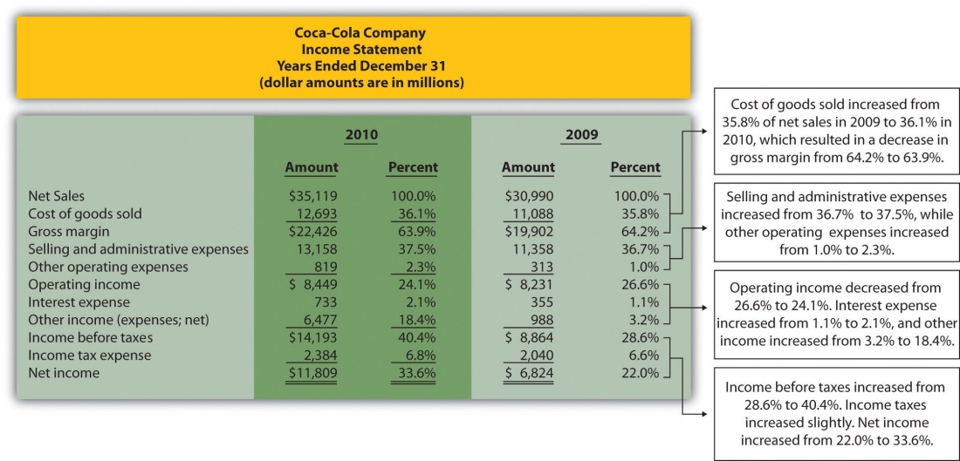

Note: All percentages use net sales as the base. For example, 2010 cost of goods sold percent of 36.1 percent equals $12,693 cost of goods sold ÷ $35,119 net sales. Note that rounding issues sometimes cause subtotals in the percent column to be off by a small amount.

In general, managers prefer expenses as a percent of net sales to decreaseover time, and profit figures as a percent of net sales to increase over time. As you can see in Figure 13.5 "Common-Size Income Statement Analysis for ", Coca-Cola’s gross margin as a percent of net sales decreased from 2009 to 2010 (64.2 percent versus 63.9 percent). Operating income declined as well (26.6 percent versus 24.1 percent). Income before taxes increased significantly from 28.6 percent in 2009 to 40.4 percent in 2010, again mainly due to a one-time gain of $4,978,000,000 in 2010. This caused net income to increase as well, from 22.0 percent in 2009 to 33.6 percent in 2010. In the expense category, cost of goods sold as a percent of net sales increased, as did other operating expenses, interest expense, and income tax expense. Selling and administrative expenses increased from 36.7 percent in 2009 to 37.5 percent in 2010.

Figure 13.6 Common-Size Balance Sheet Analysis for Coca-Cola
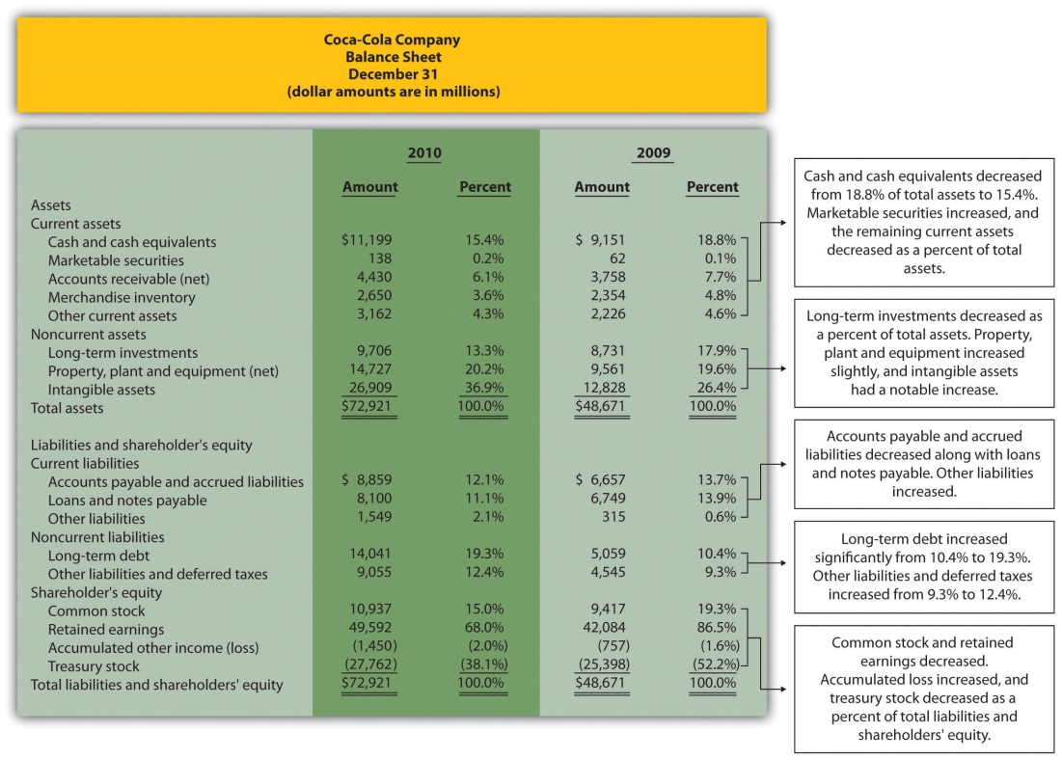

As you can see from Figure 13.6 "Common-Size Balance Sheet Analysis for ", the composition of assets, liabilities, and shareholders’ equity accounts changed from 2009 to 2010. Notable changes occurred for intangible assets (26.4 percent in 2009 versus 36.9 percent in 2010), long-term debt (10.4 percent in 2009 versus 19.3 percent in 2010), retained earnings (86.5 percent in 2009 versus 68.0 percent in 2010), and treasury stock (52.2 percent in 2009 versus 38.1 percent in 2010).

Using Common-Size Analysis to Evaluate Competitors

Question: To this point, we have used common-size analysis to evaluate just one company, Coca-Cola. Common-size analysis is, however, also an effective way of comparing two companies with different levels of revenues and assets. For example, suppose one company has operating income of $100,000, and a competing company has operating income of $2,000,000. If both companies have similar levels of net sales and total assets, it is reasonable to assume that the more profitable company is the better performer. However, most companies are not the same size. How do we compare companies of different sizes?

Answer: This is where common-size analysis can help. Figure 13.7 "Common-Size Income Statement Analysis for " shows an income statement comparison for Coca-Cola and PepsiCo using common-size analysis. (The information for Coca-Cola comes from Figure 13.5 "Common-Size Income Statement Analysis for ", and the information for PepsiCo comes from the solution to part 1 of Note 13.15 "Review Problem 13.2" at the end of this segment.)

Figure 13.7 Common-Size Income Statement Analysis for Coca-Cola andPepsiCo
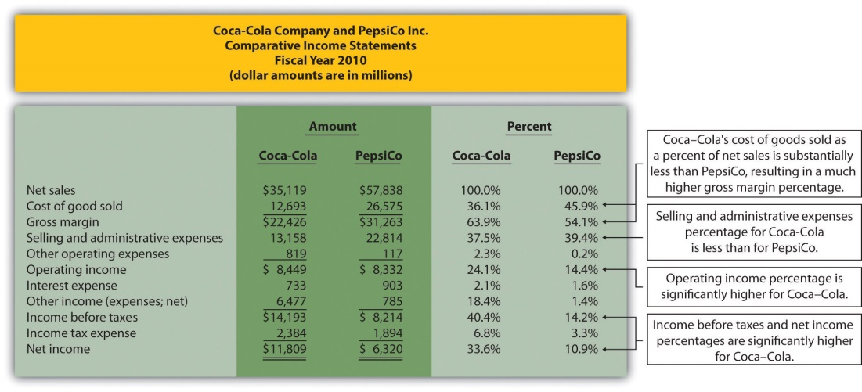

Note that rounding issues sometimes cause subtotals in the percent column to be off by a small amount.

Notice that PepsiCo has the highest net sales at $57,838,000,000 versusCoca-Cola at $35,119,000,000. Once converted to common-size percentages, however, we see that Coca-Cola outperforms PepsiCo in virtually every income statement category. Coca-Cola’s cost of goods sold is 36.1 percent of net sales compared to 45.9 percent at PepsiCo. Coca-Cola’sgross margin is 63.9 percent of net sales compared to 54.1 percent atPepsiCo. Coca-Cola’s operating income is 24.1 percent of sales compared to 14.4 percent at PepsiCo. Figure 13.8 "Comparison of Common-Size Gross Margin and Operating Income for " compares common-size gross margin and operating income for Coca-Cola and PepsiCo.

Figure 13.8 Comparison of Common-Size Gross Margin and Operating Income for Coca-Cola and PepsiCo
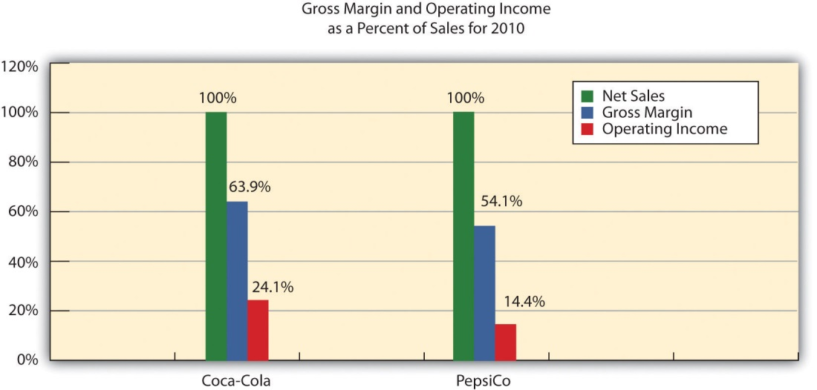

Common-size analysis enables us to compare companies on equal ground, and as this analysis shows, Coca-Cola is outperforming PepsiCo in terms of income statement information. However, as you will learn in this chapter, there are many other measures to consider before concluding that Coca-Cola is winning the financial performance battle.

Common-size analysis is obviously crucial to comparative analysis. In fact, some sources of industry data present the information exclusively in a common-size format, and most of the accounting software available today has been engineered to facilitate this type of analysis.

Business in Action 13.2
Common-Size Analysis Using Accounting Software
Most accounting computer programs, including QuickBooks, Peachtree, and MAS 90, provide common-size analysis reports. You simply select the appropriate report format and financial statement date, and the system prints the report. Thus accountants using this type of software can focus more on analyzing common-size information than on preparing it.

KEY TAKEAWAY
- Common-size analysis converts each line of financial statement data to an easily comparable amount measured as a percent. Income statement items are stated as a percent of net sales and balance sheet items are stated as a percent of total assets (or total liabilities and shareholders’ equity). Common-size analysis allows for the evaluation of information from one period to the next within a company and between competing companies.

REVIEW PROBLEM 13.2
Refer to the information presented in Note 13.10 "Review Problem 13.1"for PepsiCo, and perform the following:
- Prepare a common-size analysis for PepsiCo’s income statement using the format shown in Figure 13.5 "Common-Size Income Statement Analysis for ".
- Prepare a common-size analysis for PepsiCo’s balance sheet using the format shown in Figure 13.6 "Common-Size Balance Sheet Analysis for ".
- Briefly describe any significant changes from 2009 to 2010 identified in parts 1 and 2.
Solution to Review Problem 13.2

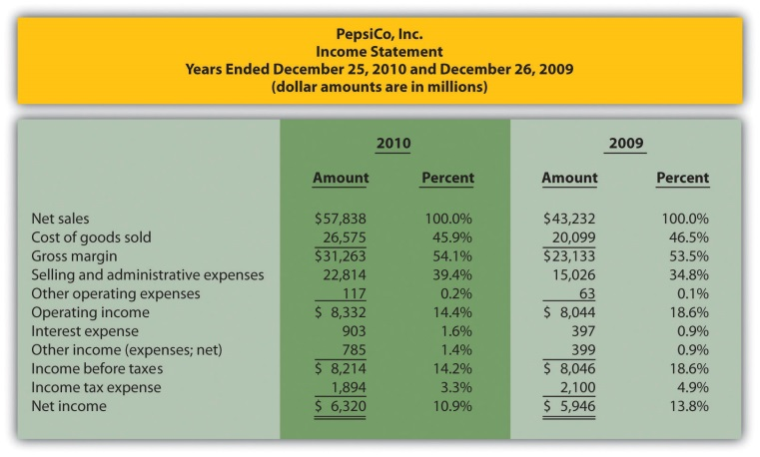
Note: All percentages use net sales as the base. For example, 2010 cost of goods sold percent of 45.9 percent equals $26,575 cost of goods sold ÷ $57,838 net sales. Note that rounding issues sometimes cause subtotals in the percent column to be off by a small amount.

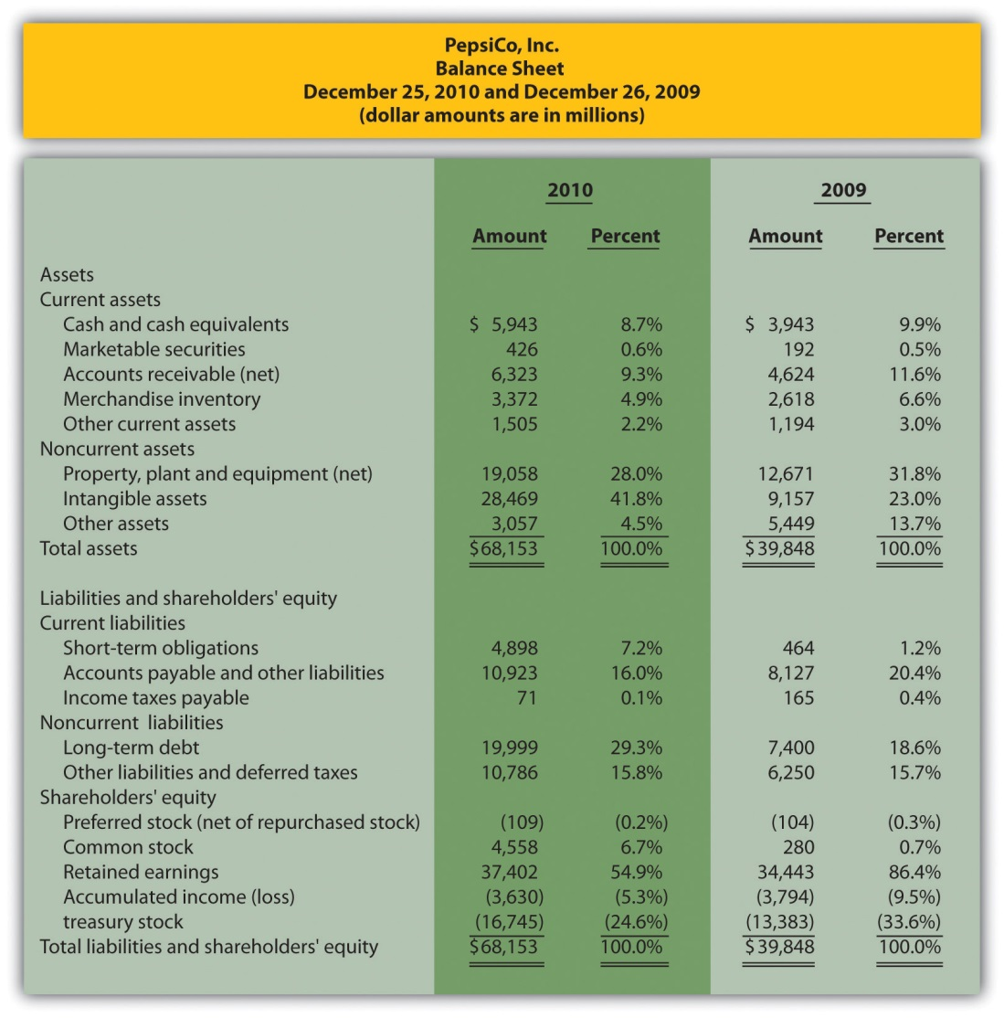
Note: All percentages use total assets or total liabilities and shareholders’ equity as the base. For example, 2010 cash and cash equivalents percent of 8.7 percent equals $5,943 ÷ $68,153. Note that rounding issues sometimes cause subtotals in the percent column to be off by a small amount.
- The composition of PepsiCo’s income statement remained relatively consistent from 2009 to 2010. The most notable change occurred with selling and administrative expenses, which increased from 34.8 percent of sales in 2009 to 39.4 percent of sales in 2010. This in turn drove down operating income from 18.6 percent in 2009 to 14.4 percent in 2010. This also likely caused the decrease in income before taxes, income tax expense, and net income.
The composition of PepsiCo’s balance sheet had some significant changes from 2009 to 2010. The most notable changes occurred with intangible assets (23.0 percent in 2009 versus 41.8 percent in 2010), other assets (13.7 percent in 2009 versus 4.5 percent in 2010), short-term obligations (1.2 percent in 2009 versus 7.2 percent in 2010), long-term debt (18.6 percent in 2009 versus 29.3 percent in 2010), common stock (0.7 percent in 2009 versus 6.7 percent in 2010), and retained earnings (86.4 percent in 2009 versus 54.9 percent in 2010).

13.3 Ratio Analysis of Financial Information

LEARNING OBJECTIVE
- Use ratio analysis to measure profitability, short-term liquidity, long-term solvency, and market valuation.

Question: Although reviewing trends and using common-size analysis provides an excellent starting point for analyzing financial information, managers, investors, and other stakeholders also use various ratios to assess the financial performance and financial condition of organizations. What are the four categories of ratios used to evaluate the financial health of an organization?

Answer: The four categories of ratios presented in this chapter are as follows (in order of presentation):
- Ratios used to measure profitability (focus is on the income statement)
- Ratios used to measure short-term liquidity (focus is on short-term liabilities)
- Ratios used to measure long-term solvency (focus is on long-term liabilities)
- Ratios used to measure market valuation (focus is on market value of the company)

For each ratio, we (1) explain the meaning, (2) provide the formula, (3) calculate the ratio for Coca-Cola for two years, and (4) compare the ratio for Coca-Cola to PepsiCo’s ratio and industry averages. (Note: All industry averages throughout this chapter were obtained fromhttp://moneycentral.msn.com. Some averages are not available or not applicable and will be noted as such.)

Table 13.1 "Financial Ratio Formulas" summarizes the formulas for all the ratios presented in this section, and Table 13.2 "Summary of Financial Ratios for " shows the ratio results for Coca-Cola, PepsiCo, and the industry averages that will be covered throughout this section.

Table 13.1 Financial Ratio Formulas
Profitability Measures
Gross margin ratio=Gross marginNet sales
Indicates the gross margin generated for each dollar in net sales.

Profit margin ratio=Net incomeNet sales
Indicates the profit generated for each dollar in net sales.

Return on assets=Net incomeAverage total assets
Indicates how much net income was generated from each dollar in average assets invested.

Return on common shareholders’ equity=Net income − Preferred dividendsAverage common shareholders’ equity
Indicates how much net income was generated from each dollar of common shareholders’ equity.

Earnings per share=Net income − Preferred dividendsWeighted average common shares outstanding
Indicates how much net income was earned for each share of common stock outstanding.
Short-Term Liquidity Measures
Current ratio=Current assetsCurrent liabilities
Indicates whether a company has sufficient current assets to cover current liabilities.

Quick ratio=Cash + Marketable securities + Short-term receivablesCurrent liabilities
Indicates whether a company has sufficient quick assets to cover current liabilities.

Receivables turnover ratio=Credit salesAverage accounts receivable
Indicates how many times receivables are collected in a given period.

Average collection period=365 daysReceivables turnover ratio
Indicates how many days it takes on average to collect on credit sales.

Inventory turnover ratio=Cost of goods soldAverage inventory
Indicates how many times inventory is sold and restocked in a given period.

Average sale period=365 daysInventory turnover ratio
Indicates how many days it takes on average to sell the company’s inventory.
Long-Term Solvency Measures
Debt to assets=Total liabilitiesTotal assets
Indicates the percentage of assets funded by creditors.

Debt to equity=Total liabilitiesTotal shareholders’ equity
Indicates the amount of debt incurred for each dollar that owners provide.

Times interest earned=Net income + Income tax expense + Interest expenseInterest expense
Indicates the company’s ability to cover its interest expense related to long-term debt with current period earnings.
Market Valuation Measures
Market capitalization=Market price per share×Number of shares outstanding
Indicates the value of a company at a point in time.

Price-earnings ratio=Market price per shareEarnings per share
Indicates the premium investors are willing to pay for shares of stock relative to the company’s earnings.
Table 13.2 Summary of Financial Ratios for Coca-Cola, PepsiCo, and the Industry Average
 |  | Coca-Cola 2010 | PepsiCo 2010 | Industry Average 2010
Profitability Measures
1. | Gross margin ratio | 63.9 percent | 54.1 percent | 56.1 percent
2. | Profit margin ratio | 33.6 percent | 10.9 percent | 19.2 percent
3. | Return on assets | 19.4 percent | 11.7 percent | 14.2 percent
4. | Return on common shareholders’ equity | 41.7 percent | 32.3 percent | 34.7 percent
5. | Earnings per share | $5.12 | $3.97 | Not applicable
Short-Term Liquidity Measures
6. | Current ratio | 1.17 to 1 | 1.11 to 1 | 1.20 to 1
7. | Quick ratio | 0.85 to 1 | 0.80 to 1 | 1.10 to 1
8. | Receivables turnover ratio | 8.58 times | 10.57 times | 9.70 times
9. | Average collection period | 42.54 days | 34.53 days | 37.63 days
10. | Inventory turnover ratio | 5.07 times | 8.87 times | 7.50 times
11. | Average sale period | 71.99 days | 41.15 days | 48.67 days
Long-Term Solvency Measures
12. | Debt to assets | 0.57 to 1 | 0.68 to 1 | 0.48 to 1
13. | Debt to equity | 1.33 to 1 | 2.17 to 1 | 0.94 to 1
14. | Times interest earned | 20.36 times | 10.10 times | 10.70 times
Market Valuation Measures
15. | Market capitalization | $146,500,000,000 | $100,700,000,000 | $87,500,000,000
16. | Price-earnings ratio | 12.48 times | 16.04 times | 14.60 times

Before we discuss the various ratios, it is important to note that different terms are often used in financial statements to describe the same item. For example, some companies use the term net revenues instead of net sales, and the income statement is often called the statement of earnings, orconsolidated statement of earnings. Also be sure to review the income statement and balance sheet information for Coca-Cola shown in Figure 13.5 "Common-Size Income Statement Analysis for " and Figure 13.6 "Common-Size Balance Sheet Analysis for ". We refer to these figures throughout this section. (All the dollar amounts given for Coca-Cola are in millions unless stated otherwise.)

Profitability Ratios

Question: Analysts, shareholders, suppliers, and other stakeholders often want to evaluate profit trends within a company and compare a company’s profits with competitors’ profits. What are the five common ratios used to evaluate company profitability?

Answer: The five ratios used to evaluate profitability are as follows:
- Gross margin ratio
- Profit margin ratio
- Return on assets
- Return on common shareholders’ equity
- Earnings per share

Gross Margin Ratio

Question: How is the gross margin ratio calculated, and what does it tell us about Coca-Cola relative to PepsiCo and the industry average?

Answer: The gross margin ratio indicates the gross margin generated for each dollar in net sales and is calculated as gross margin (which is net sales minus cost of goods sold) divided by net sales:

Key Equation
Gross margin ratio=Gross marginNet sales

The gross margin ratio for Coca-Cola using 2010 information is calculated as follows, with PepsiCo and industry average information following it:

Gross margin ratio=$22,426$35,119=63.9%
 | Coca-Cola 2010 | Coca-Cola 2009 | PepsiCo 2010 | Industry Average 2010
Gross margin ratio | 63.9 percent | 64.2 percent | 54.1 percent | 56.1 percent

The gross margin ratio indicates Coca-Cola generated 63.9 cents in gross margin for every dollar in net sales. This ratio decreased slightly from 2009 to 2010 and is substantially higher than PepsiCo’s 54.1 percent. Coca-Cola is also higher than the industry average of 56.1 percent. (Alternative terms: Gross margin is often called gross profit, net sales is often called net revenues, and cost of goods sold is often called cost of sales.)

Profit Margin Ratio

Question: How is the profit margin ratio calculated, and what does it tell us about Coca-Cola relative to PepsiCo and the industry average?

Answer: The profit margin ratio shows the profit generated for each dollar in net sales. It is calculated as net income divided by net sales:

Key Equation
Profit margin ratio=Net incomeNet sales

The profit margin ratio for Coca-Cola using 2010 information is calculated as follows, with PepsiCo and industry average information following it:

Profit margin ratio=$11,809$35,119=33.6%
 | Coca-Cola 2010 | Coca-Cola 2009 | PepsiCo 2010 | Industry Average 2010
Profit margin ratio | 33.6 percent | 22.0 percent | 10.9 percent | 19.2 percent

The profit margin ratio indicates Coca-Cola generated 33.6 cents in net income for every dollar in net sales. This ratio increased significantly from 2009 to 2010 and is substantially higher than PepsiCo’s 10.9 percent.Coca-Cola is also higher than the industry average of 19.2 percent. (Alternative term: Net income is often called net earnings.)

Return on Assets

Question: The gross margin ratio and profit margin ratio focus solely on income statement information. Analysts also want to know what size asset base generated the net income. For example, a company with assets of $100,000 and net income of $15,000 is likely performing better than a company with assets of $300,000 and identical net income of $15,000. A measure that considers the assets required to generate net income is called return on assets. How is return on assets calculated, and what does it tell us about Coca-Cola relative toPepsiCo and the industry average?

Answer: The return on assets ratio is used to evaluate how much net income was generated from each dollar in average assets invested. Return on assets is net income divided by average total assets:

Key Equation
Return on assets=Net incomeAverage total assets

The average total assets amount is found by adding together total assets at the end of the current year and previous year (2010 and 2009 for this example) and dividing by two. The return on assets ratio for Coca-Cola for 2010 is calculated as follows, with PepsiCo and industry average information following it:
Return on assets=$11,809($72,921+$48,671)÷2=$11,809$60,796=19.4%
 | Coca-Cola 2010 | Coca-Cola 2009 | PepsiCo 2010 | Industry Average 2010
Return on assets | 19.4 percent | 15.3 percent | 11.7 percent | 14.2 percent

The return on assets ratio indicates Coca-Cola generated 19.4 cents in net income for every dollar in average assets. This ratio increased from 2009 to 2010 and is higher than PepsiCo’s 11.7 percent. Coca-Cola exceeded the industry average of 14.2 percent.

(Note: There are several variations on the return on assets calculation. Some prefer to use average operating assets in the denominator. Others adjust net income in the numerator by adding back interest expense net of the interest expense tax benefit. We leave these variations to advanced cost and intermediate accounting textbooks.)

Return on Common Shareholders’ Equity

Question: How is the return on common shareholders’ equity ratio calculated, and what does it tell us about Coca-Cola relative to PepsiCo and the industry average?

Answer: Common shareholders are interested in thereturn on common shareholders’ equity ratio because this ratio tells them how much net income was generated from each dollar of common shareholders’ equity. The return on common shareholders’ equity ratio is calculated as follows:

Key Equation
Return on common shareholders’ equity=Net income − Preferred dividendsAverage common shareholders’ equity

Note that preferred dividends are deducted from net income in the numerator. If the company does not have any outstanding preferred stock, as is the case with Coca-Cola, the preferred dividends amount is zero.

Average common shareholders’ equity in the denominator is found by adding together all items in the shareholders’ equity section of the balance sheet at the end of the current year and previous year (2010 and 2009 for this example), except preferred stock items, and dividing by two.

Because Coca-Cola does not have preferred stock, an average of all items in the shareholders’ equity section is in the denominator. The return on common shareholders’ equity ratio for Coca-Cola for 2010 is calculated as follows, with PepsiCo and industry average information following it:
Return on commonshareholders’ equity=$11,809−$0[($10,937+$49,592−$1,450−$27,762)+($9,417+$42,084−$757−$25,398)]÷2=$11,809$28,332=41.7%
 | Coca-Cola 2010 | Coca-Cola 2009 | PepsiCo 2010 | Industry Average 2010
Return on common shareholders’ equity | 41.7 percent | 29.5 percent | 32.3 percent | 34.7 percent

The return on common shareholders’ equity ratio indicates Coca-Colagenerated 41.7 cents in net income for every dollar in average common shareholders’ equity. This ratio increased significantly from 2009 to 2010 and is higher than PepsiCo’s 32.3 percent. Coca-Cola exceeded the industry average of 34.7 percent.

Coca-Cola’s return on common shareholders’ equity of 41.7 percent is higher than its return on assets of 19.4 percent, indicating that the company has positive financial leverage. Financial leverage describes a company’s ability to leverage common shareholders’ equity by taking on debt at an interest rate lower than the company’s return on assets. For example, assume a company has equity of $10,000 earning 10 percent. The company can leverage this equity by borrowing $8,000 with a 6 percent interest rate. Assuming the company uses this $8,000 to purchase assets that earn 10 percent, the company has created positive financial leverage since the cost of borrowing is lower than the return on assets. This results in a return on equity that is higher than the return on assets. (Note: For a one-year period, the return on assets is $1,800 [= $18,000 × 10 percent] less the cost of debt of $480 [= 6 percent × $8,000], or $1,320. This results in a return on assets of 7.3 percent [= $1,320 ÷ $18,000]. Positive financial leverage causes the return on equity to be much higher at 13.2 percent [= $1,320 ÷ $10,000 equity].)

Although some level of financial leverage is generally regarded as healthy, companies that are highly leveraged tend to be riskier than similar companies with less leverage. Analysts and shareholders should avoid drawing quick conclusions that increases in return on common shareholders’ equity are always better than decreases without thoroughly reviewing the rest of the data.

Figure 13.9 "Return on Assets and Return on Equity for " shows the return on assets and return on equity for Coca-Cola, PepsiCo, and the industry average.

Figure 13.9 Return on Assets and Return on Equity for Coca-Cola,PepsiCo, and the Industry Average
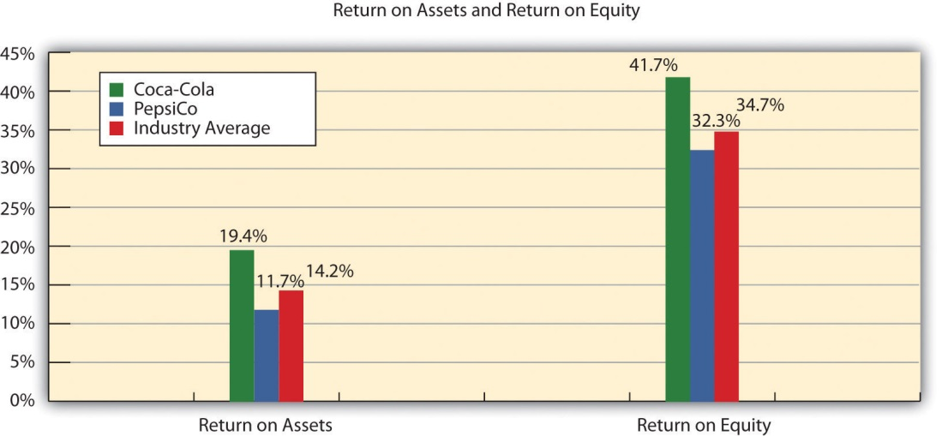

Earnings per Share

Question: How is earnings per share calculated, and what does it tell us aboutCoca-Cola relative to PepsiCo and the industry average?

Answer: Earnings per share indicates how much net income was earned for each share of common stock outstanding. The earnings per share ratio states net income on a per share basis and is calculated as the following:

Key Equation
Earnings per share=Net income−Preferred dividendsWeighted average common shares outstanding

Note that preferred dividends are deducted from net income in the numerator. If the company does not have any outstanding preferred stock, as is the case with Coca-Cola, the preferred dividends amount is zero. The weighted average common shares outstanding amount used in the denominator is typically provided in the financial statements, either on the income statement or in the notes to the financial statements. (More advanced intermediate accounting textbooks discuss this calculation in detail. Throughout this chapter, we provide the number of weighted average common shares outstanding.)

Earnings per share for Coca-Cola using 2010 information is calculated as follows, with PepsiCo and industry average information following it (dollar amount and shares are in millions, except per share amount):
Earnings per share=$11,809−$02,308 shares=$5.12 per share
 | Coca-Cola 2010 | Coca-Cola 2009 | PepsiCo 2010 | Industry Average 2010
Earnings per share | $5.12 | $2.95 | $3.97 | Not applicable

The earnings per share amount at Coca-Cola indicates the company earned $5.12 for each share of common stock outstanding. This ratio increased from 2009 to 2010. Although earnings per share is useful for looking at trends over time within a company, it cannot be compared in any meaningful way from one company to another because different companies have different numbers of shares outstanding.

For example, assume two identical companies earn $10,000 for the year. One company has one share of common stock outstanding, and the other has two shares outstanding. Thus one company has earnings per share of $10,000 (= $10,000 ÷ 1 share) and the other company has earnings per share of $5,000 (= $10,000 ÷ 2 shares). The second company is not performing any worse; it simply has more shares outstanding. This is why you should not compare earnings per share across companies. (Alternative terms: Earnings per share are often called EPS or income per share.)

Business in Action 13.3
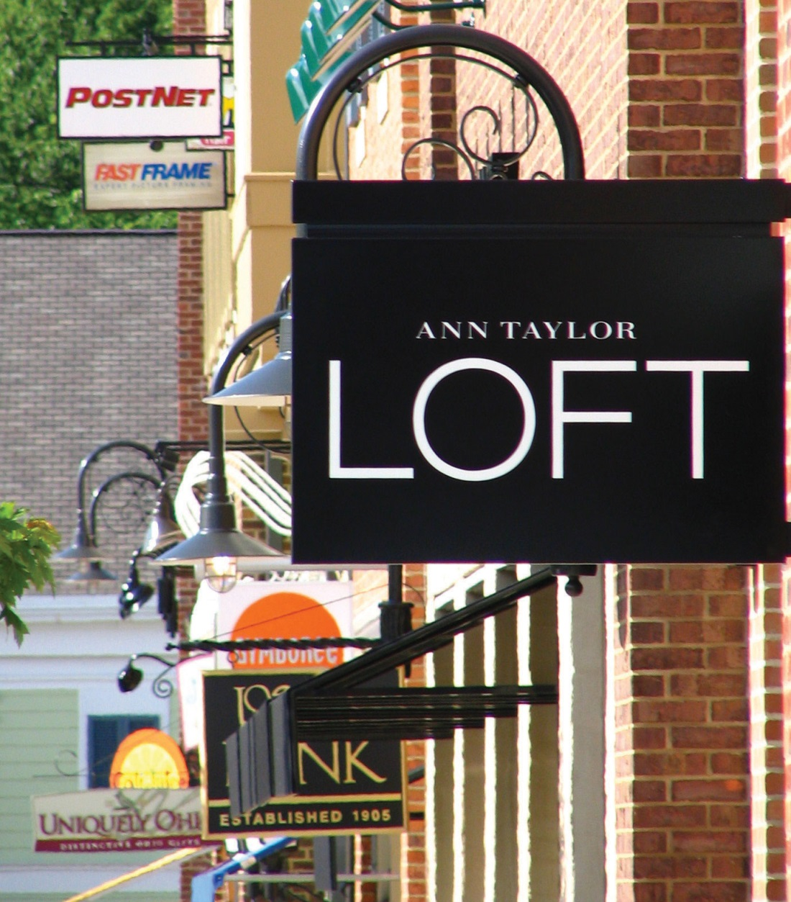
Source: Photo courtesy of DangApricot,http://commons.wikimedia.org/wiki/File:AnnTaylorLoftSign.JPG.
The Importance of Earnings per Share
The business press often uses earnings per share to announce a company’s earnings. For example, the Associated Press addressed earnings at AnnTaylor Stores Corporation, a retailer of women’s clothing, as follows: “Quarterly income fell to $7,100,000, or 10 cents per share, from $30,100,000, or 41 cents, the year before. Setting aside relocation costs, adjusted earnings were 18 cents per share, a penny higher than the average estimate from analysts polled by Thomson Financial.”
This quote demonstrates not only that earnings per share data are important when announcing a company’s earnings but also that analysts use these data when making predictions about a company’s performance. A quick perusal of any business publication, such as The Wall Street Journal, or a review of online business press releases at sites like http://finance.yahoo.com will confirm that earnings per share data are commonly used to announce a company’s financial results.
Source: Associated Press, “AnnTaylor’s 2Q Profit Plummets on Charge,” August 19, 2005.

REVIEW PROBLEM 13.3
Refer to the information presented in Note 13.10 "Review Problem 13.1"for PepsiCo, and perform the following for 2010:
- Calculate the gross margin ratio, and briefly describe what it means for PepsiCo.
- Calculate the profit margin ratio, and briefly describe what it means for PepsiCo.
- Calculate return on assets, and briefly describe what it means forPepsiCo.
- Calculate return on common shareholders’ equity, and briefly describe what it means for PepsiCo. Assume PepsiCo recorded preferred dividends of $6,000,000 in 2010.
- Calculate earnings per share, and briefly describe what it means forPepsiCo. Assume weighted average common shares outstanding totaled 1,590,000,000 shares.
Solutions to Review Problem 13.3

Gross margin ratio=Gross marginNet sales=$31,263$57,838=54.1%
For every dollar in net sales, PepsiCo generated 54.1 cents in gross margin.

Profit margin ratio=Net incomeNet sales=$6,320$57,838=10.9%
For every dollar in net sales, PepsiCo generated 10.9 cents in net income.

Return on assets=Net incomeAverage total assets=$6,320($68,153+$39,848)÷2=$6,320$54,001=11.7%
For every dollar in average assets, PepsiCo generated 11.7 cents in net income.

Return on commonshareholders’ equity=Net income − Preferred dividendsAverage common shareholders’ equity=$6,320−$6[($4,558+$37,402−$3,630−$16,745)+($280+$34,443−$3,794−$13,383)]÷2=$6,314$19,566=32.3%
For every dollar in average common shareholders’ equity,PepsiCo generated 32.3 cents in net income (after deducting preferred dividends).

Earnings per share=Net income − Preferred dividendsWeighted average common shares outstanding=$6,320−$61,590 shares=$3.97 per share
For each common share outstanding, PepsiCo generated $3.97 in net income (after deducting preferred dividends).

Short-Term Liquidity Ratios

Question: Suppliers and other short-term lenders often want to evaluate whether companies can meet short-term obligations. What are the four common ratios used to evaluate short-term liquidity?

Answer: The four ratios used to evaluate short-term liquidity are as follows:
- Current ratio
- Quick ratio
- Receivables turnover ratio (often converted to average collection period)
- Inventory turnover ratio (often converted to average sale period)

Current Ratio

Question: How is the current ratio calculated, and what does it tell us aboutCoca-Cola relative to PepsiCo and the industry average?

Answer: The current ratio indicates whether a company has sufficient current assets to cover current liabilities. It is found by dividing current assets by current liabilities:

Key Equation
Current ratio=Current assetsCurrent liabilities

The current ratio for Coca-Cola for 2010 is calculated as follows, withPepsiCo and industry average information following it:
Current ratio=$11,199+$138+$4,430+$2,650+$3,162$8,859+$8,100+$1,549=$21,579$18,508=1.17 to 1
 | Coca-Cola 2010 | Coca-Cola 2009 | PepsiCo 2010 | Industry Average 2010
Current ratio | 1.17 to 1 | 1.28 to 1 | 1.11 to 1 | 1.20 to 1

The current ratio indicates Coca-Cola had $1.17 in current assets for every dollar in current liabilities. This ratio decreased from 2009 to 2010 and is slightly higher than PepsiCo’s 1.11 to 1 ratio. Coca-Cola is close to the industry average of 1.20 to 1. In general, a current ratio above 1 to 1 is preferable, which indicates the company has sufficient current assets to cover current liabilities. However, finding the ideal minimum current ratio is dependent on many factors, such as the industry, the overall financial condition of the company, and the composition of the company’s current assets and current liabilities. Because of variations in these factors from one company to the next, a more stringent measure of short-term liquidity is often used. We present this measure, called the quick ratio, next.

Quick Ratio

Question: How is the quick ratio calculated, and what does it tell us aboutCoca-Cola relative to PepsiCo and the industry average?

Answer: The quick ratio (also called acid-test ratio) indicates whether a company has sufficient quick, or highly liquid, assets to cover current liabilities. The quick ratio is quick assets divided by current liabilities:

Key Equation
Quick ratio=Cash + Marketable securities+Short-term receivablesCurrent liabilities

Notice the numerator excludes current assets that are not easily and quickly converted to cash. Although inventory is typically excluded from the numerator, further analysis is needed to evaluate whether inventory should be included. For example, grocery stores turn inventory over very quickly, typically within a couple of weeks, and should consider including inventory in the quick ratio. Producers of wine, on the other hand, turn inventory over very slowly, and should consider excluding inventory in the numerator of the quick ratio. For the sake of consistency, you should exclude inventory from the numerator in this chapter, unless told otherwise. (Note: Many companies provide two quick ratio calculations, one that includes inventory in the numerator and one that excludes inventory in the numerator. If two ratios are presented, it is important to label each ratio to indicate whether inventory has been included or excluded.)

It is helpful when reviewing a company’s balance sheet to remember that current assets are presented in order of liquidity, with the most liquid current asset appearing first and the least liquid appearing last. This helps in determining whether a particular current asset should be included or excluded in the numerator of the quick ratio. The quick ratio for Coca-Colafor 2010 is calculated as follows, with PepsiCo and industry average information following it:
Quick ratio=$11,199+$138+$4,430$8,859+$8,100+$1,549=$15,767$18,508=0.85 to 1
 | Coca-Cola 2010 | Coca-Cola 2009 | PepsiCo 2010 | Industry Average 2010
Quick ratio | 0.85 to 1 | 0.95 to 1 | 0.80 to 1 | 1.10 to 1

The quick ratio indicates Coca-Cola had $0.85 in quick assets for every dollar in current liabilities. This ratio decreased from 2009 to 2010 and is slightly higher than PepsiCo’s 0.80 to 1 ratio. Coca-Cola is below the industry average of 1.10 to 1.

Receivables Turnover Ratio

Question: How is the receivables turnover ratio calculated, and what does it tell us about Coca-Cola relative to PepsiCo and the industry average?

Answer: The receivables turnover ratio indicates how many times receivables are collected in a given period and is found by dividing credit sales by average accounts receivable:

Key Equation
Receivables turnover ratio=Credit salesAverage accounts receivable

Assume all net sales presented on the income statement are on account, and therefore will be used in the numerator. The average accounts receivable amount in the denominator is found by adding together accounts receivable at the end of the current year and previous year (2010 and 2009 for this example) and dividing by two. The receivables turnover ratio for Coca-Cola for 2010 is calculated as follows, with PepsiCo and industry average information following it:
Receivables turnover ratio=$35,119($4,430+$3,758)÷2=$35,119$4,094=8.58 times
 | Coca-Cola 2010 | Coca-Cola 2009 | PepsiCo 2010 | Industry Average 2010
Receivables turnover ratio | 8.58 times | 9.05 times | 10.57 times | 9.70 times

The receivables turnover ratio indicates Coca-Cola collected receivables 8.58 times during 2010. This ratio decreased from 2009 to 2010 and is lower than PepsiCo’s 10.57 times. Coca-Cola is below the industry average of 9.70 times.

Question: How is the receivables turnover ratio converted to average collection period?

Answer: The receivables turnover ratio can be converted to theaverage collection period, which indicates how many days it takes on average to collect on credit sales, as follows:

Key Equation
Average collection period=365 daysReceivables turnover ratio

This ratio is typically compared to the company’s credit terms to evaluate how effectively receivables are being collected. The average collection period for Coca-Cola for 2010 is calculated as follows, with PepsiCo and industry average information following it:
Average collection period=365 days8.58 times=42.54 days
 | Coca-Cola 2010 | Coca-Cola 2009 | PepsiCo 2010 | Industry Average 2010
Average collection period | 42.54 days | 40.33 days | 34.53 days | 37.63 days

The average collection period indicates Coca-Cola collected credit sales in 42.54 days, on average. The number of days increased slightly from 2009 to 2010 and is higher than PepsiCo’s 34.53 days. Coca-Cola is also above the industry average of 37.63 days and therefore is slower at collecting accounts receivable than the industry as a whole.

Inventory Turnover Ratio

Question: How is the inventory turnover ratio calculated, and what does it tell us about Coca-Cola relative to PepsiCo and the industry average?

Answer: The inventory turnover ratio indicates how many times inventory is sold and restocked in a given period. It is calculated as cost of goods sold divided by average inventory:

Key Equation
Inventory turnover ratio=Cost of goods soldAverage inventory

The average inventory amount in the denominator is found by adding together inventory at the end of the current year and previous year (2010 and 2009 for this example) and dividing by two. The inventory turnover ratio for Coca-Cola for 2010 is calculated as follows, with PepsiCo and industry average information following it:
Inventory turnover ratio=$12,693($2,650+$2,354)÷2=$12,693$2,502=5.07 times
 | Coca-Cola 2010 | Coca-Cola 2009 | PepsiCo 2010 | Industry Average 2010
Inventory turnover ratio | 5.07 times | 4.88 times | 8.87 times | 7.50 times

The inventory turnover ratio indicates Coca-Cola sold and restocked inventory 5.07 times during 2010. This ratio increased slightly from 2009 to 2010 and is substantially lower than PepsiCo’s 8.87 times. Coca-Cola is well below the industry average of 7.50 times.

Question: How is the inventory turnover ratio converted to average sale period?

Answer: The inventory turnover ratio can be converted to theaverage sale period, which indicates how many days it takes on average to sell the company’s inventory, as follows:

Key Equation
Average sale period=365 daysInventory turnover ratio

The average sale period for Coca-Cola for 2009 is calculated as follows, withPepsiCo and industry average information following it:
Average sale period=365 days5.07 times=71.99 days
 | Coca-Cola 2010 | Coca-Cola 2009 | PepsiCo 2010 | Industry Average 2010
Average sale period | 71.99 days | 74.80 days | 41.15 days | 48.67 days

The average sale period indicates Coca-Cola sold its inventory in 71.99 days, on average. The number of days decreased from 2009 to 2010 and is substantially higher than PepsiCo’s 41.15 days. Coca-Cola is also above the industry average of 48.67 days and therefore is slower at selling inventory than the industry as a whole.

Business in Action 13.4
Industry Variations in Inventory and Receivable Turnover
Retail grocery stores turn inventory over every 22 days, meaning that shelves are emptied and restocked about every three weeks. In addition to extremely fast inventory turnover, retail grocery stores collect credit sales in seven days. Thus it takes 29 days, on average, to convert freshly stocked inventory to cash. Very few industries are able to convert inventory to cash as quickly. Examples of inventory and receivable turnover for several industries are shown in the following.

 | Receivables Turnover | Inventory Turnover
Auto manufacturers | 39 days | 41 days
Chemical manufacturing | 51 days | 61 days
Forestry and wood products | 46 days | 53 days
Computer systems | 78 days | 18 days
Source: Industry averages found at MSN Money, Home Page,”http://moneycentral.msn.com.

REVIEW PROBLEM 13.4
Refer to the information presented in Note 13.10 "Review Problem 13.1"for PepsiCo, and perform the following requirements for 2010:
- Calculate the current ratio, and briefly describe what it means forPepsiCo.
- Calculate the quick ratio, and briefly describe what it means forPepsiCo.
- Calculate the receivables turnover ratio and average collection period, and briefly describe what these measures mean for PepsiCo. Assume all sales are on account.
- Calculate the inventory turnover ratio and average sale period, and briefly describe what these measures mean for PepsiCo.
Solution to Review Problem 13.4

Current ratio=Current assetsCurrent liabilities=$5,943+$426+$6,323+$3,372+1,505$4,898+$10,923+$71=$17,569$15,892=1.11 to 1
For every dollar in current liabilities, PepsiCo had $1.11 in current assets.

Quick ratio=Cash + Marketable securities + Short-term receivablesCurrent liabilities=$5,943+$426+$6,323$4,898+$10,923+$71=$12,692$15,892=0.80 to 1
For every dollar in current liabilities, PepsiCo had $0.80 in quick assets.

Receivables turnover ratio=Credit salesAverage accounts receivable=$57,838($6,323+$4,624)÷2=$57,838$5,474=10.57 times
PepsiCo collected receivables 10.57 times during 2010.
Average collection period=365 daysReceivables turnover ratio=365 days10.57 times=34.53 days
PepsiCo collected credit sales in 34.53 days, on average.

Inventory turnover ratio=Cost of goods soldAverage inventory=$26,575($3,372+$2,618)÷2=$26,575$2,995=8.87 times
PepsiCo sold and restocked inventory 8.87 times during 2010.
Average sale period=365 daysInventory turnover ratio=365 days8.87 times=41.15 days
PepsiCo sold its inventory in 41.15 days, on average.

Long-Term Solvency Ratios

Question: Banks, bondholders, and other long-term lenders often want to evaluate whether companies can meet long-term obligations. What are the three common ratios used to evaluate long-term solvency?

Answer: The three ratios used to evaluate long-term solvency are as follows:
- Debt to assets
- Debt to equity
- Times interest earned

Debt to Assets

Question: How is the debt to assets ratio calculated, and what does it tell us about Coca-Cola relative to PepsiCo and the industry average?

Answer: The debt to assets ratio indicates the percentage of assets funded by creditors and is used to evaluate the financial leverage of a company. Debt to assets is found by dividing total liabilities by total assets:

Key Equation
Debt to assets=Total liabilitiesTotal assets

The higher the percentage, the higher the financial leverage. The debt to assets ratio for Coca-Cola for 2010 is calculated as follows, with PepsiCoand industry average information following it:
Debt to assets=$8,859+$8,100+$1,549+$14,041+$9,055$72,921=$41,604$72,921=0.57 to 1
 | Coca-Cola 2010 | Coca-Cola 2009 | PepsiCo 2010 | Industry Average 2010
Debt to assets | 0.57 to 1 | 0.48 to 1 | 0.68 to 1 | 0.48 to 1

The debt to assets ratio indicates that creditors funded 57 percent of Coca-Cola’s assets at the end of 2010. This ratio increased from 2009 to 2010 and is lower than PepsiCo’s 0.68 to 1. Coca-Cola is higher than the industry average of 0.48 to 1.

A review of the basic balance sheet equation shows that the complement of the debt to assets ratio provides the percentage of assets funded byshareholders. Thus for every dollar Coca-Cola has in assets, creditors fund $0.57 and shareholders fund $0.43 (= $1 – $0.57):
Assets$1.00=Liabilities +Shareholders’ equity =$0.57+$0.43

The debt to assets ratio reveals Coca-Cola (0.57 to 1) and PepsiCo (0.68 to 1) are more highly leveraged than the industry average of 0.48 to 1.

Debt to Equity

Question: How is the debt to assets ratio calculated, and what does it tell us about Coca-Cola relative to PepsiCo and the industry average?

Answer: A variation of the debt to assets ratio is the debt to equity ratio, which measures the balance of liabilities and shareholders’ equity used to fund assets. The debt to equity ratio is total liabilities divided by total shareholders’ equity:

Key Equation
Debt to equity=Total liabilitiesTotal shareholders’ equity

This ratio indicates the amount of debt incurred for each dollar that owners provide. The debt to equity ratio for Coca-Cola for 2010 is calculated as follows, with PepsiCo and industry average information following it:
Debt to equity=$8,859+$8,100+$1,549+$14,041+$9,055$10,937+$49,592−$1,450−$27,762=$41,604$31,317=1.33 to 1
 | Coca-Cola 2010 | Coca-Cola 2009 | PepsiCo 2010 | Industry Average 2010
Debt to equity | 1.33 to 1 | 0.92 to 1 | 2.17 to 1 | 0.94 to 1

The debt to equity ratio indicates that Coca-Cola had $1.33 in liabilities for each dollar in shareholders’ equity. This ratio increased from 2009 to 2010 and is substantially lower than PepsiCo’s 2.17 to 1. However, Coca-Cola is higher than the industry average of 0.94 to 1.

Business in Action 13.5
Source: Photo courtesy of spechtenhauser,http://www.flickr.com/photos/usinside/2931437356/.
Financial Leverage at General Motors and Toyota
Prior to the company’s bankruptcy filing in 2009, General Motors (GM) was the largest manufacturer of automobiles and trucks in the world (ranked by revenues). However, GM took on substantial amounts of debt over several years. With an average debt to equity ratio of 2.5 to 1, the automobile industry is relatively highly leveraged, but GM’sratio was substantially higher at 11.3 to 1. This means that GM had $11.30 in debt for every $1 in shareholders’ equity.
Toyota Motor Corporation, on the other hand, was not highly leveraged; it had a debt to equity ratio of 1 to 1. Thus Toyota had $1 in debt for every $1 in shareholders’ equity. It is important to review other financial ratios before concluding that Toyota was in better financial shape than GM, but the fact that GM was much more highly leveraged than Toyota likely played a big role in GM’s downfall!
Source: Industry averages found at MSN Money, Home Page,”http://moneycentral.msn.com and Yahoo! Finance, “Home Page,”http://biz.yahoo.com.

Times Interest Earned

Question: How is times interest earned calculated, and what does it tell us aboutCoca-Cola relative to PepsiCo and the industry average?

Answer: The times interest earned ratio (also called interest coverage ratio) measures the company’s ability to cover its interest expense related to long-term debt with current period earnings. The times interest earned ratio is net income before income tax expense and interest expense divided by interest expense:

Key Equation
Times interest earned=Net income + Income tax expense + Interest expenseInterest expense
Notice that income tax expense and interest expense are added back in the numerator to find net income available to cover interest expense. The times interest earned ratio for Coca-Cola for 2010 is calculated as follows, withPepsiCo and industry average information following it:
Times interest earned=$11,809+$2,384+$733$733=$14,926$733=20.36 times
 | Coca-Cola 2010 | Coca-Cola 2009 | PepsiCo 2010 | Industry Average 2010
Times interest earned | 20.36 times | 25.97 times | 10.10 times | 10.70 times
The times interest earned ratio indicates Coca-Cola had earnings to cover interest expense 20.36 times. This ratio decreased from 2009 to 2010 and is much higher than PepsiCo’s 10.10 times. Coca-Cola is also higher than the industry average of 10.70 times. It appears that Coca-Cola has plenty of earnings to cover interest expense.

REVIEW PROBLEM 13.5
Refer to the information presented in Note 13.10 "Review Problem 13.1"for PepsiCo, and perform the following requirements for 2010:
- Calculate the debt to assets ratio, and briefly describe what it means for PepsiCo.
- Calculate the debt to equity ratio, and briefly describe what it means for PepsiCo.
- Calculate the times interest earned ratio, and briefly describe what it means for PepsiCo.
Solution to Review Problem 13.5

Debt to assets=Total liabilitiesTotal assets=$4,898+$10,923+$71+$19,999+$10,786$68,153=$46,677$68,153=0.68 to 1
Creditors funded 68 percent of PepsiCo’s assets. Owners funded the remaining 32 percent.

Debt to equity=Total liabilitiesTotal shareholders’ equity=$4,898+$10,923+$71+$19,999+$10,786($109)+$4,558+$37,402−$3,630−$16,745=$46,677$21,476=2.17 to 1
For every dollar in shareholders’ equity, PepsiCo had $2.17 in liabilities.

Times interest earned=Net income + Income tax expense +Interest expenseInterest expense=$6,320+$1,894+$903$903=$9,117$903=10.10 times
PepsiCo had earnings to cover interest expense 10.10 times.

Market Valuation Measures

Question: Existing and potential shareholders are often interested in a company’s market value. What are the two common measures used to evaluate market value?

Answer: The two measures used to determine and evaluate the market valueof a company are as follows:
- Market capitalization
- Price-earnings ratio

Market Capitalization

Question: How is market capitalization calculated, and what does it tell us about Coca-Cola relative to PepsiCo and the industry average?

Answer: Market capitalization (also called market cap) measures the value of a company at a point in time. It is determined by multiplying market price per share times the number of shares outstanding:

Key Equation
Market capitalization = Market price per share × Number of shares outstanding

Coca-Cola’s market capitalization for 2010 is calculated as follows, withPepsiCo information following it. The number of shares outstanding atCoca-Cola’s fiscal year ended December 31, 2010, totaled 2,292,000,000 (= 3,520,000,000 shares issued – 1,228,000,000 treasury shares). The market price per share at that time was $63.92.
Market capitalization = $63.92 per share × 2,292,000,000 shares = $146,500,000,000
 | Coca-Cola 2010 | Coca-Cola 2009 | PepsiCo 2010 | Industry Average 2010
Market capitalization | $146,500,000,000 | $123,200,000,000 | $100,700,000,000 | $87,500,000,000

Coca-Cola’s market capitalization indicates that the company’s shares outstanding had a market value totaling $146,500,000,000 at the end of 2010. This amount increased significantly from 2009 to 2010 and is higher than PepsiCo’s $100,700,000,000. Both Coca-Cola and PepsiCo are above the industry average of $87,500,000.

(Note that the number of shares outstanding is typically found in the shareholders’ equity section of the balance sheet or in the notes to the financial statements. We provide the number of shares outstanding throughout this chapter, unless noted otherwise. This number is different than the weighted average shares outstanding used to calculate earnings per share earlier in the chapter. Also note that the price per share amount is from Yahoo’s finance Web site at http://finance.yahoo.com. We provide this information throughout the chapter, unless noted otherwise.)

Looking at a company’s market capitalization is a quick way of gauging its aggregate value. But what does a number like Coca-Cola’s$146,500,000,000 market capitalization really tell us about how a company compares to others? Note 13.54 "Business in Action 13.6" has the answer.

Business in Action 13.6
Three Categories of Market Capitalization
Most investors refer to market capitalization as market cap. Companies are typically classified into one of three market cap categories: small-cap, midcap, and large-cap. In general, small-cap companies have a market value of less than $1,000,000,000, midcap companies have a market value between $1,000,000,000 and $12,000,000,000, and large-cap companies have a market value greater than $12,000,000,000.
Thus small-cap mutual funds are stock funds that invest in companies with a market value of less than $1,000,000,000. Midcap mutual funds are stock funds that invest in companies with a market value between $1,000,000,000 and $12,000,000,000, and so on. These categories are important to investors because the stocks of small-cap companies tend to be more volatile than those of mid- or large-cap companies.
Source: Definitions are from the Web site of Vanguard, one of the world’s largest investment management firms (http://www.vanguard.com).

Price-Earnings Ratio

Question: How is the price-earnings ratio calculated, and what does it tell us about Coca-Cola relative to PepsiCo and the industry average?

Answer: The price-earnings ratio (also called P/E ratio) measures the premium investors are willing to pay for shares of stock relative to the company’s earnings. The price-earnings ratio is found by dividing market price per share by earnings per share:

Key Equation
Price-earnings ratio=Market price per shareEarnings per share

In general, a relatively high price-earnings ratio indicates investors expect favorable future earnings, whereas a relatively low price-earnings ratio indicates investors expect moderate future earnings. The price-earnings ratio for Coca-Cola for 2010 is calculated as follows, with PepsiCo and industry average information following it. The market price information was given in the market capitalization example, and we calculated earnings per share earlier in the chapter.
Price-earnings ratio=$63.92$5.12=12.48 times
 | Coca-Cola 2010 | Coca-Cola 2009 | PepsiCo 2010 | Industry Average 2010
Price-earnings ratio | 12.48 times | 18.21 times | 16.04 times | 14.60 times

The price-earnings ratio indicates investors were willing to pay 12.48 times the earnings for Coca-Cola’s stock. This ratio decreased from 2009 to 2010 and is lower than PepsiCo’s 16.04 times. Coca-Cola is also lower than the industry average of 14.60 times.

KEY TAKEAWAY
- Shareholders, creditors, and analysts often evaluate a company’s profitability. Five ratios used to evaluate profitability are the gross margin ratio, the profit margin ratio, return on assets, return on common shareholders’ equity, and earnings per share. Suppliers and other short-term creditors often evaluate whether a company can meet short-term obligations. Four ratios used to evaluate short-term liquidity are the current ratio, the quick ratio, the receivables turnover ratio (often converted to average collection period), and the inventory turnover ratio (often converted to average sale period). Banks, bondholders, and other long-term lenders often evaluate whether companies can meet long-term obligations. Three ratios used to evaluate long-term solvency are debt to assets, debt to equity, and times interest earned. Shareholders are particularly interested in a company’s market value. Two measures used to determine and evaluate the market value of a company are market capitalization and the price-earnings ratio.

REVIEW PROBLEM 13.6
Perform the following requirements for PepsiCo for 2010:
- Calculate the market capitalization, and briefly describe what it means for PepsiCo. Assume PepsiCo had 1,581,000,000 shares outstanding at the end of 2010, and the market price per share was $63.68.
- Calculate the price-earnings ratio, and briefly describe what it means for PepsiCo. (Hint: Earnings per share was calculated for PepsiCo inNote 13.29 "Review Problem 13.3".)
Solution to Review Problem 13.6

Market capitalization=Market price per share×Number of shares outstanding=$63.68×1,581,000,000=$100.7 billion (rounded)
PepsiCo’s shares outstanding had a market value of $100,700,000,000 at the end of 2010.

Price-earnings ratio=Market price per shareEarnings per share=$63.68$3.97=16.04 times
Investors were willing to pay 16.04 times earnings forPepsiCo’s stock.

13.4 Wrap-Up of Chapter Example

Recall the dialogue at Chicken Deluxe between Sandy Masako, the CEO; Dave Roberts, the CFO; and Karen Kraft, the purchasing manager. Chicken Deluxe must choose between Deep Fizz Company and Extreme Fizz, Inc., as the supplier of the company’s beverages. Dave was asked to evaluate the financial condition of each company and report back to the group. The group reconvenes the following month, where Dave presents the financial measures for each company. As you read the dialogue, refer to Table 13.3 "Summary of Financial Ratios for Deep Fizz Company; Extreme Fizz, Inc.; and the Industry Average"; it is the summary of financial measures that Dave provides to the group.

Table 13.3 Summary of Financial Ratios for Deep Fizz Company; Extreme Fizz, Inc.; and the Industry Average
 |  | Deep Fizz | Extreme Fizz | Industry Average
Profitability Measures
1. | Gross margin ratio | 63.1 percent | 54.1 percent | 53.1 percent
2. | Profit margin ratio | 22.1 percent | 23.2 percent | 19.2 percent
3. | Return on assets | 15.1 percent | 17.3 percent | 14.2 percent
4. | Return on common shareholders’ equity | 36.5 percent | 34.9 percent | 34.7 percent
5. | Earnings per share | $2.01 | $3.76 | Not applicable
Short-Term Liquidity Measures
6. | Current ratio | 0.85 to 1 | 1.25 to 1 | 1.20 to 1
7. | Quick ratio | 0.62 to 1 | 0.87 to 1 | 1.10 to 1
8. | Receivables turnover ratio | 9.10 times | 10.18 times | 9.70 times
9. | Average collection period | 40.11 days | 35.85 days | 37.63 days
10. | Inventory turnover ratio | 5.12 times | 7.86 times | 7.50 times
11. | Average sale period | 72.29 days | 46.44 days | 48.67 days
Long-Term Solvency Measures
12. | Debt to assets | 0.34 to 1 | 0.38 to 1 | 0.48 to 1
13. | Debt to equity | 0.67 to 1 | 0.86 to 1 | 0.94 to 1
14. | Times interest earned | 31.60 times | 38.93 times | 10.70 times
Market Valuation Measures
15. | Market capitalization | $91,800,000,000 | $86,500,000,000 | $87,500,000,000
16. | Price-earnings ratio | 19.34 times | 20.31 times | 14.60 times
Sandy: | Let’s get started! Dave, what do you have for us?
Dave: | I used several different financial ratios to evaluate profitability, short-term liquidity, long-term solvency, and market valuation for Deep Fizz Company and Extreme Fizz, Inc., Here is a summary of the results. Items 1 through 4 show that both companies are doing very well with regard to profitability, and exceed the industry average in all four categories. Earnings per share are not relevant for comparative purposes because different companies have different amounts of shares outstanding.
Sandy: | The profitability measures look good for both companies. What about the balance sheet?
Dave: | For the most part, Extreme Fizz has the edge on short-term liquidity, with top marks for all short-term liquidity measures. However, Deep Fizz is not far behind. Based on items 6 through 11, I consider both companies to have strong short-term liquidity. The only concern is with Deep Fizz’s slow inventory turnover, which is well below Extreme Fizz and the industry average.
Sandy: | What about long-term solvency? Given both companies have strong profitability and excellent short-term liquidity, my biggest concern is whether these companies are able to meet long-term obligations.
Dave: | The short answer is both companies will be able to meet long-term obligations as indicated in the debt to assets, debt to equity, and times interest earned ratios. Also notice that both companies have large market capitalizations, and price-earnings ratios are strong across the board!
Sandy: | So what do we get from all this information?
Dave: | Both companies are solid. We shouldn’t have to worry about either company having financial difficulties in the near future.
Karen: | Looks like we’ll have to review other factors in deciding which company to use as our supplier.
Sandy: | I agree. Thanks, Dave, for your analysis. If nothing else, this puts my mind at ease about whichever company we ultimately select as our supplier.

As you can see from the Chicken Deluxe example, analysts use many different financial measures to evaluate financial performance. In the case of Deep Fizz and Extreme Fizz, both companies appear to be strong performers. Armed with this information, management can confidently choose either company knowing the winner will be on solid financial ground for years to come.

13.5 Nonfinancial Performance Measures: The Balanced Scorecard

LEARNING OBJECTIVE
- Develop and analyze nonfinancial performance measures using a balanced scorecard.

Question: Although financial measures are important for evaluation purposes, many organizations use a mix of financial and nonfinancial measures to evaluate performance. For example, airlines track on-time arrival percentages carefully, and delivery companies like Federal Express (FedEx) and United Parcel Service (UPS) monitor percentages of on-time deliveries. The balanced scorecard uses several alternative measures to evaluate performance. What is a balanced scorecard and how does it help companies to evaluate performance?

Answer: The balanced scorecard is a balanced set of measures that organizations use to motivate employees and evaluate performance. These measures are typically separated into four perspectives outlined in the following. (Dr. Robert S. Kaplan and Dr. David P. Norton created the balanced scorecard, and it is actively promoted through their company, Balanced Scorecard Collaborative. More information can be found at the company’s Web site at http://www.bscol.com.)
- Financial. Measures that shareholders, creditors, and other stakeholders use to evaluate financial performance.
- Internal business process. Measures that management uses to evaluate efficiency of existing business processes.
- Learning and growth. Measures that management uses to evaluate effectiveness of employee training.
- Customer. Measures that management uses to evaluate whether the organization is meeting customer expectations.

The goal is to link these four perspectives to the company’s strategies and goals. For example, a high percentage of on-time arrivals is likely an important goal from the perspective of the customer of an airline. A high percentage of defect-free computer chips is likely an important goal from theinternal business process perspective of a computer chip maker. A high number of continuing education hours is likely an important goal from thelearning and growth perspective for tax personnel at an accounting firm. Measures from a financial perspective were covered earlier in this chapter.

Companies that use the balanced scorecard typically establish several measures for each perspective. lists several examples of these measures.

Table 13.4 Balanced Scorecard Measures
Financial | Internal Business Process | Learning and Growth | Customer
Gross margin ratio | Defect-free rate | Hours of employee training | Customer satisfaction (survey)
Return on assets | Customer response time | Employee satisfaction (survey) | Number of customer complaints
Receivables turnover | Capacity utilization | Employee turnover | Market share
Inventory turnover | New product development time | Number of employee accidents | Number of returned products

Measures established across the four perspectives of the balanced scorecard are linked in a way that motivates employees to achieve company goals. For example, if the company wants to increase the defect-free rate and reduce product returns, effective employee training and low employee turnover will help in achieving this goal. The idea is to establish company goals first, then create measures that motivate employees to reach company goals.

KEY TAKEAWAY
- Most organizations use a mix of financial and nonfinancial measures to evaluate performance. The balanced scorecard approach uses a balanced set of measures separated into four perspectives—financial, internal business process, learning and growth, and customer. The last three perspectives tend to include nonfinancial measures, such as hours of employee training or number of customer complaints, to evaluate performance. The goal is to link financial and nonfinancial measures to the company’s strategies and goals.

REVIEW PROBLEM 13.7
Assume Chicken Deluxe, the fast-food restaurant franchise featured in this chapter, uses a balanced scorecard. Provide at least two examples of measures that Chicken Deluxe might use for each of the following perspectives of the balanced scorecard:
- Financial
- Internal business process
- Learning and growth
- Customer
Solution to Review Problem 13.7
- Answers will vary. Several examples of financial measures are as follows:
  - Gross margin ratio
  - Profit margin ratio
  - Return on assets
  - Receivables turnover
  - Inventory turnover
- Answers will vary. Several examples of internal business process measures are as follows:
  - Capacity utilization
  - Amount of food spoilage
  - Order response time
- Answers will vary. Several examples of learning and growth measures are as follows:
  - Hours of employee training
  - Employee satisfaction
  - Employee turnover
  - Number of employee accidents
- Answers will vary. Several examples of customer perspective measures are as follows:
  - Customer satisfaction
  - Number of customer complaints
  - Market share
  - Amount of food returned

END-OF-CHAPTER EXERCISES
Questions
- What is trend analysis? Explain how the percent change from one period to the next is calculated.
- What is common-size analysis? How is common-size analysis information used?
- Explain the difference between trend analysis and common-size analysis.
- Name the ratios used to evaluate profitability. Explain what the statement “evaluate profitability” means.
- Coca-Cola’s return on assets was 19.4 percent, and return on common shareholders’ equity was 41.7 percent. Briefly explain why these two percentages are different.
- Coca-Cola had earnings per share of $5.12, and PepsiCo had earnings per share of $3.97. Is it accurate to conclude PepsiCo was more profitable? Explain your reasoning.
- Name the ratios used to evaluate short-term liquidity. Explain what the statement “evaluate short-term liquidity” means.
- Explain the difference between the current ratio and the quick ratio.
- Coca-Cola had an inventory turnover ratio of 5.07 times (every 71.99 days), and PepsiCo had an inventory turnover ratio of 8.87 times (every 41.15 days). Which company had the best inventory turnover? Explain your reasoning.
- Name the ratios used to evaluate long-term solvency. Explain what the term “long-term solvency” means.
- Name the measures used to determine and evaluate the market value of a company. Briefly describe the meaning of each measure.
- What is the balanced scorecard? Briefly describe the four perspectives of the balanced scorecard.
Brief Exercises
- Evaluating Suppliers at Chicken Deluxe. Refer to the dialogue at Chicken Deluxe presented at the beginning of the chapter and the follow-up dialogue immediately following .
Required:
  - What is the big decision that Chicken Deluxe is facing?
  - Briefly describe the results of Dave’s analysis of the two suppliers.
- Trend Analysis. The following condensed income statement is for Apple, Inc.
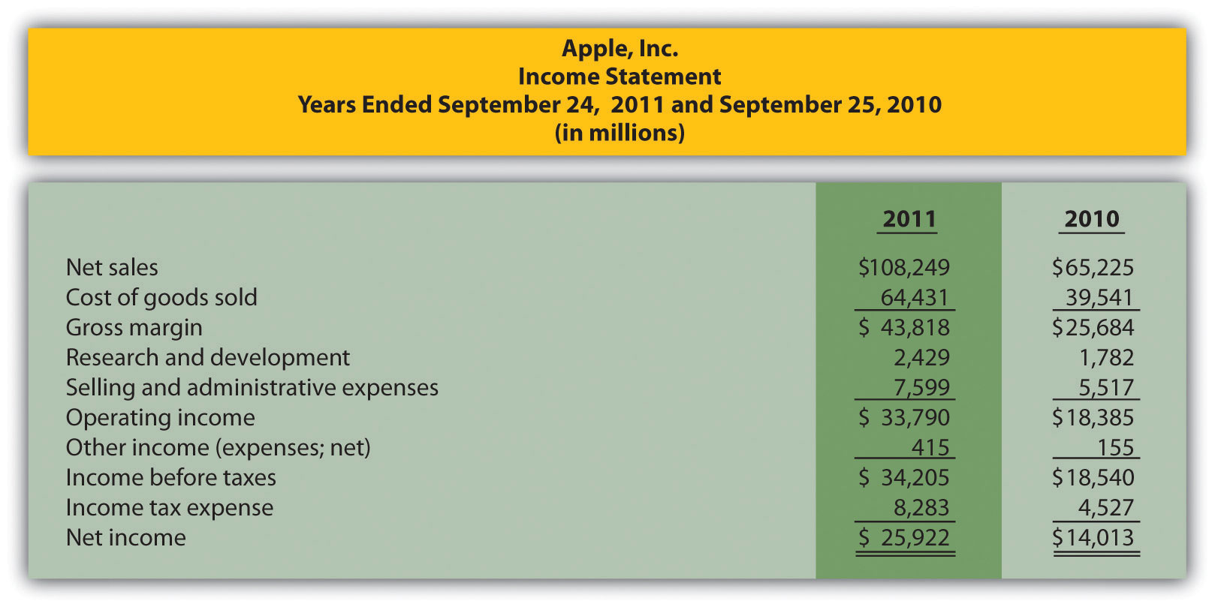
Required:
Prepare a trend analysis of the income statements from 2010 to 2011. Use the format shown in as a guide. (Round percent computations to one decimal place.)
- Common-Size Analysis. Refer to the condensed income statement for Apple, Inc., in Brief Exercise 14.
Required:
Prepare a common-size analysis of the income statements for 2010 and 2011. Use the format shown in as a guide. (Round percent computations to one decimal place.)
- Gross Margin and Profit Margin Ratios. Refer to the condensed income statement for Apple, Inc., in Brief Exercise 14.
Required:
Compute the following profitability ratios for 2011, and provide a brief explanation after each ratio (round computations to one decimal place):
  - Gross margin ratio
  - Profit margin ratio
- Current and Quick Ratios. A condensed balance sheet for Apple, Inc., appears in the following.
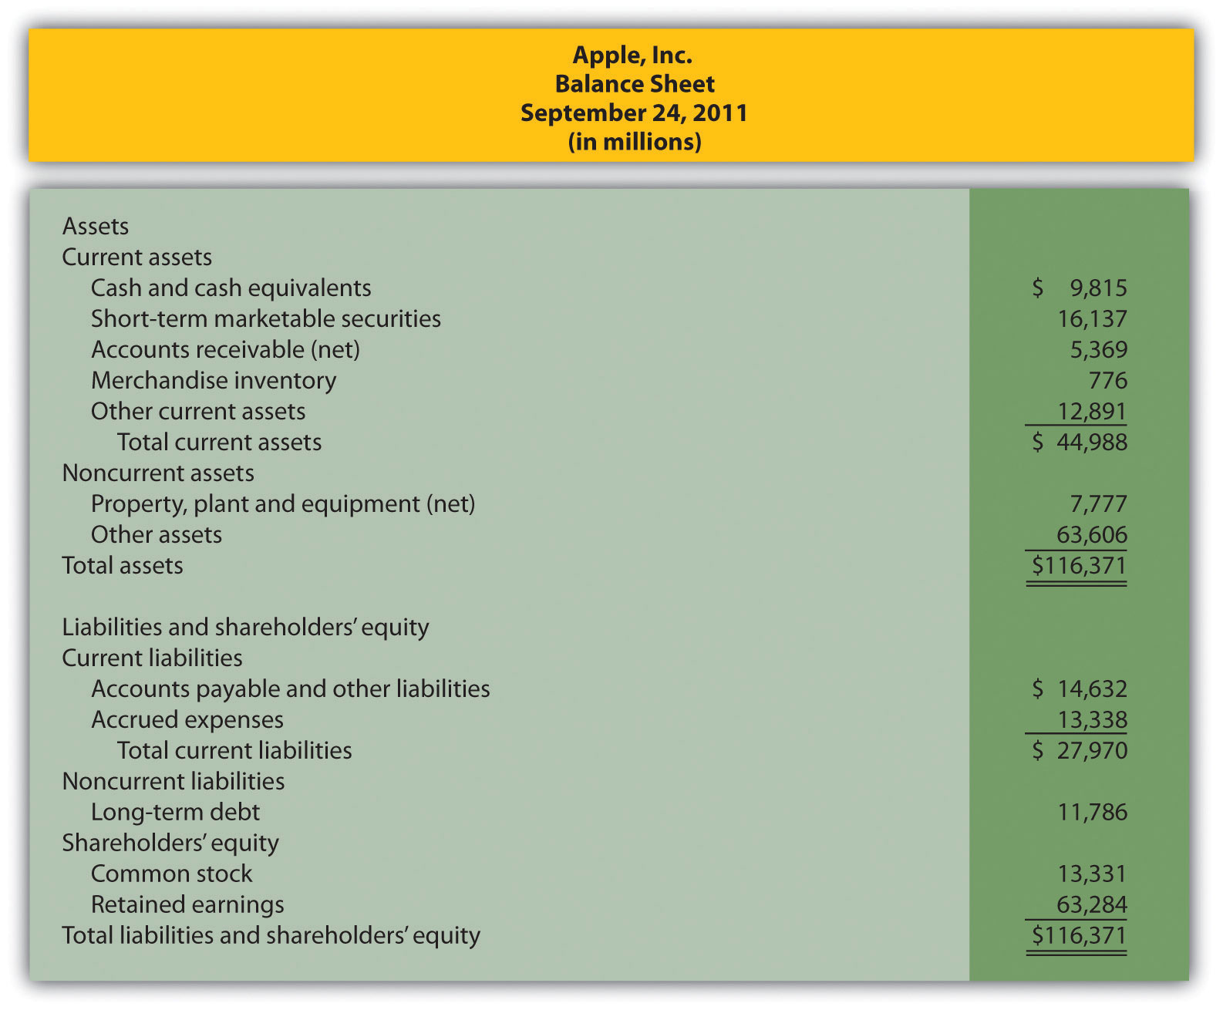
Required:
Compute the following short-term liquidity ratios for 2011, and provide a brief explanation after each ratio (round computations to two decimal places):
  - Current ratio
  - Quick ratio
- Long-Term Solvency Ratios. Refer to the condensed balance sheet for Apple, Inc., in Brief Exercise 17.
Required:
Compute the following long-term solvency ratios for 2011, and provide a brief explanation after each ratio (round computations to two decimal places):
  - Debt to assets
  - Debt to equity
- Market Capitalization. On September 24, 2011, Apple, Inc., had 929,277,000 shares of common stock issued and outstanding, and the market price per share on that date was $403.33.
Required:
Compute Apple’s market capitalization at September 24, 2011, and provide a brief explanation of what this measures represents (state the answer in billions).
- Balanced Scorecard. Provide two nonfinancial measures likely used by delivery companies like FedEx and UPS.
Exercises: Set A
- Trend Analysis. The following condensed income statement is for CarMax, Inc., a large retailer of used vehicles.
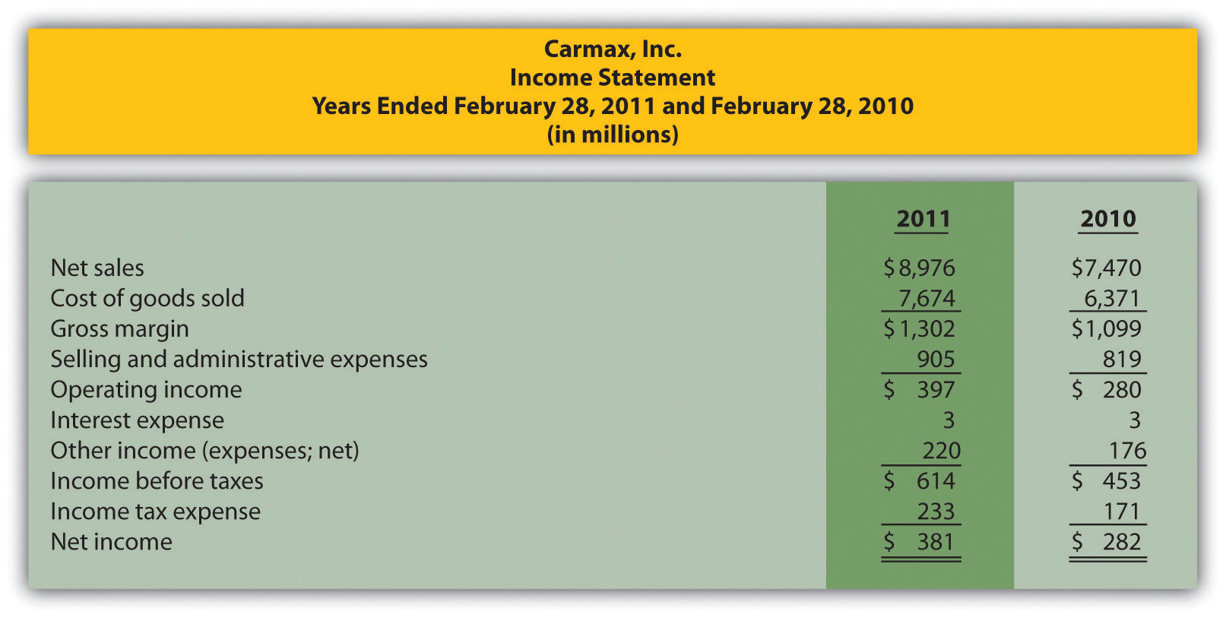
Required:
  - Prepare a trend analysis of the income statements from 2010 to 2011. Use the format shown in as a guide. (Round computations to one decimal place.)
  - What does the trend analysis prepared in requirement atell you about the company?
- Common-Size Analysis. Refer to the condensed income statement for CarMax, Inc., in Exercise 21.
Required:
  - Prepare a common-size analysis of the income statements for 2011 and 2010. Use the format shown in as a guide. (Round computations to one decimal place.)
  - What does the common-size analysis in requirement atell you about the company?
- Profitability Ratios. Refer to the condensed income statement for CarMax, Inc., in Exercise 21 and to the company’s balance sheet shown as follows.
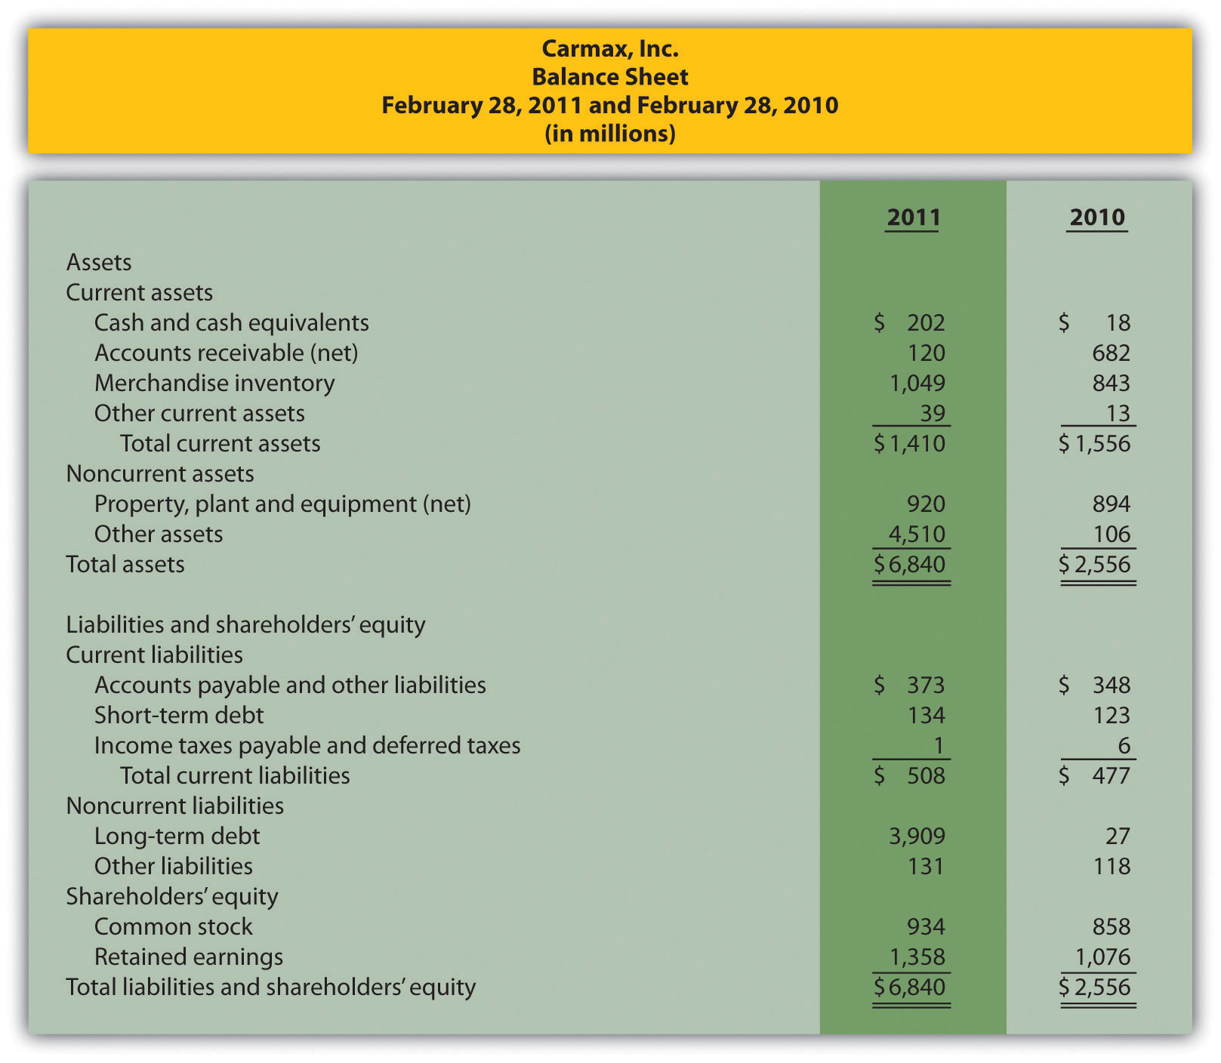
Required:
Compute the following profitability ratios for 2011, and provide a brief explanation after each ratio (round percentage computations to one decimal place and earnings per share to two decimal places):
  - Gross margin ratio
  - Profit margin ratio
  - Return on assets
  - Return on common shareholders’ equity
  - Earnings per share (assume weighted average shares outstanding totaled 223,449,000 shares)
- Short-Term Liquidity Ratios. Refer to the condensed income statement for CarMax, Inc., in Exercise 21 and to the company’s balance sheet in Exercise 23.
Required:
Compute the following short-term liquidity ratios for 2011, and provide a brief explanation after each ratio (round computations to two decimal places):
  - Current ratio
  - Quick ratio
  - Receivables turnover ratio and average collection period (assume all sales are on account)
  - Inventory turnover ratio and average sale period
- Long-Term Solvency Ratios. Refer to the condensed income statement for CarMax, Inc., in Exercise 21 and to the company’s balance sheet in Exercise 23.
Required:
Compute the following long-term solvency ratios for 2011, and provide a brief explanation after each ratio (round computations to two decimal places):
  - Debt to assets
  - Debt to equity
  - Times interest earned
- Market Valuation Measures. The following requirements are forCarMax, Inc., as of February 28, 2011.
Required:
  - Compute the following market valuation measures for 2011, and provide a brief explanation after each measure (state market capitalization in billions, and round price-earnings ratio to two decimal places):
    - Market capitalization (assume 225,885,693 shares were issued and outstanding at February 28, 2011, and the market price was $35.37 per share)
    - Price-earnings ratio (assume earnings per share was $1.71)
  - Refer to In which category does CarMax belong? Explain.
- Balanced Scorecard Customer Measures. Tech University has more than 10,000 students enrolling in courses each term. The management would like to develop a balanced scorecard to assess performance.
Required:
Provide at least three customer measures Tech University can use on its balanced scorecard. Assume students are the customers.
Exercises: Set B
- Trend Analysis. The following condensed income statement is for Colgate-Palmolive Company, a large retailer of personal and home care products.
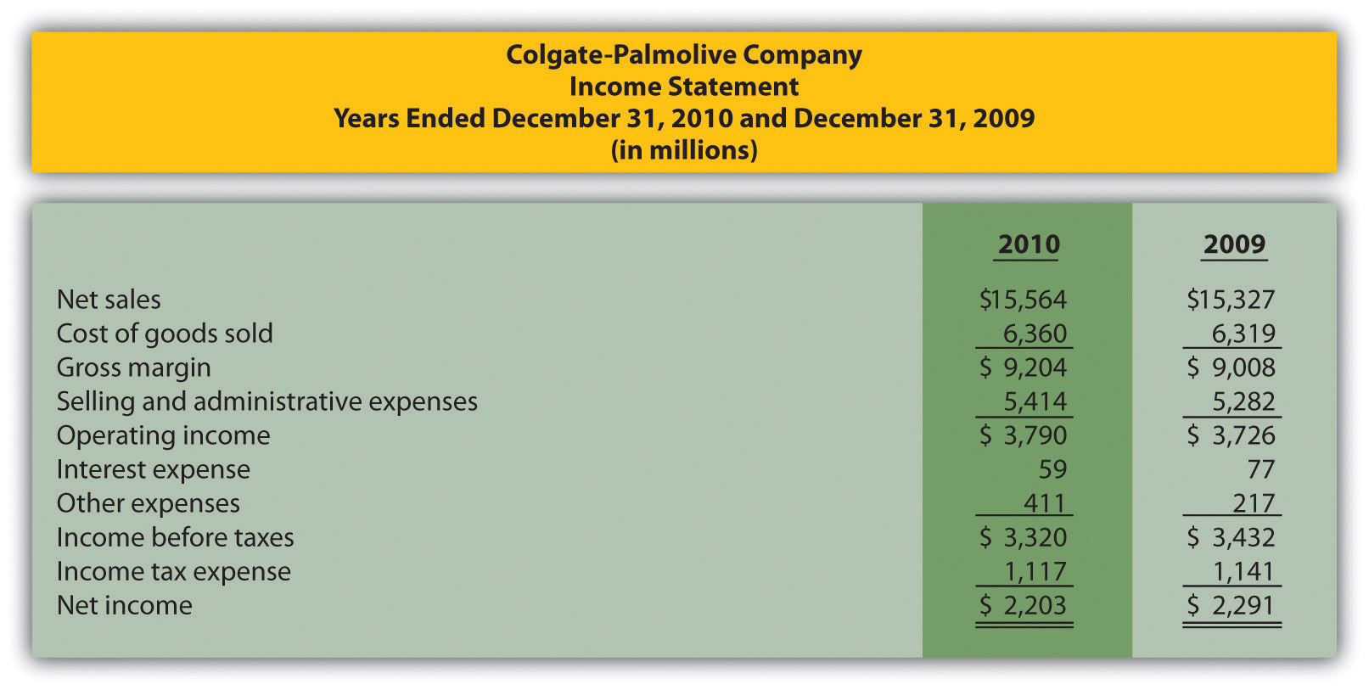
Required:
  - Prepare a trend analysis of the income statements from 2009 to 2010. Use the format shown in as a guide. (Round computations to one decimal place.)
  - What does the trend analysis prepared in requirement atell you about the company?
- Common-Size Analysis. Refer to the condensed income statement for Colgate-Palmolive Company in Exercise 28.
Required:
  - Prepare a common-size analysis of the income statements for 2010 and 2009. Use the format shown in as a guide. (Round computations to one decimal place.)
  - What does the common-size analysis in requirement atell you about the company?
- Profitability Ratios. Refer to the condensed income statement for Colgate-Palmolive Company in Exercise 28. Assume the company paid preferred dividends totaling $34,000,000 during 2010. (The company had preferred stock outstanding during 2010, but eliminated all preferred stock by the end of 2010. This is why preferred stock has a zero balance as of December 31, 2010.)
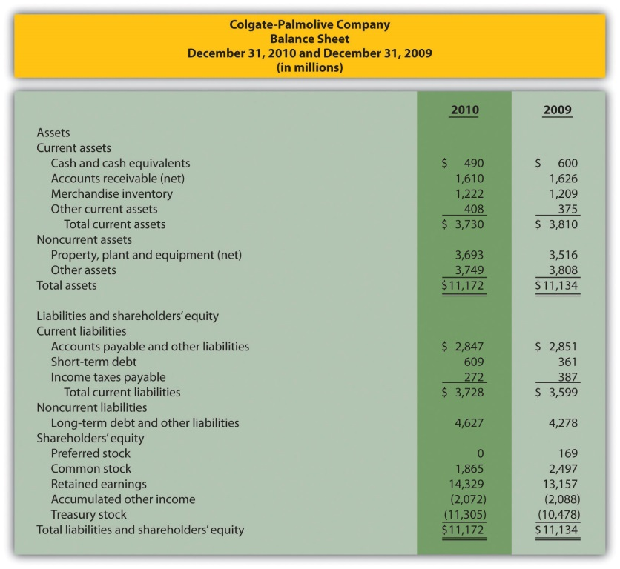
Required:
Compute the following profitability ratios for 2010, and provide a brief explanation after each ratio (round percentage computations to one decimal place and earnings per share to two decimal places):
  - Gross margin ratio
  - Profit margin ratio
  - Return on assets
  - Return on common shareholders’ equity
  - Earnings per share (assume weighted average shares outstanding totaled 487,800,000 shares)
- Short-Term Liquidity Ratios. Refer to the condensed income statement for Colgate-Palmolive Company in Exercise 28 and to the company’s balance sheet in Exercise 30.
Required:
Compute the following short-term liquidity ratios for 2010, and provide a brief explanation after each ratio (round computations to two decimal places):
  - Current ratio
  - Quick ratio
  - Receivables turnover ratio and average collection period (assume all sales are on account)
  - Inventory turnover ratio and average sale period
- Long-Term Solvency Ratios. Refer to the condensed income statement for Colgate-Palmolive Company in Exercise 28 and to the company’s balance sheet in Exercise 30.
Required:
Compute the following long-term solvency ratios for 2010, and provide a brief explanation after each ratio (round computations to two decimal places):
  - Debt to assets
  - Debt to equity
  - Times interest earned
- Market Valuation Measures. The following requirements are forColgate-Palmolive Company as of December 31, 2010.
Required:
  - Compute the following market valuation measures for 2010, and provide a brief explanation after each measure (state market capitalization in billions, and round price-earnings ratio to two decimal places):
    - Market capitalization (assume 494,850,467 shares were issued and outstanding at December 31, 2010, and the market price was $77.74 per share)
    - Price-earnings ratio (assume earnings per share was $4.45)
  - Refer to In which category does Colgate-Palmolive belong? Explain.
- Balanced Scorecard Internal Business Process Measures. Tony’s Pizzeria serves pizzas at its restaurants and provides delivery services to customers. The management would like to develop a balanced scorecard to assess performance.
Required:
Provide at least three internal business process measures Tony’s Pizzeria can use on its balanced scorecard.
Problems
- Trend Analysis and Common-Size Analysis. The following condensed income statement and balance sheet are forNordstrom, Inc., a large retailer of apparel. (Note thatNordstrom’s 2010 fiscal year ends on January 29, 2011. This is called the 2010 fiscal year because only one month is in 2011, the other 11 months of the fiscal year are in 2010, and the company has chosen to refer to this as the 2010 fiscal year. This same concept applies to fiscal year 2009.)
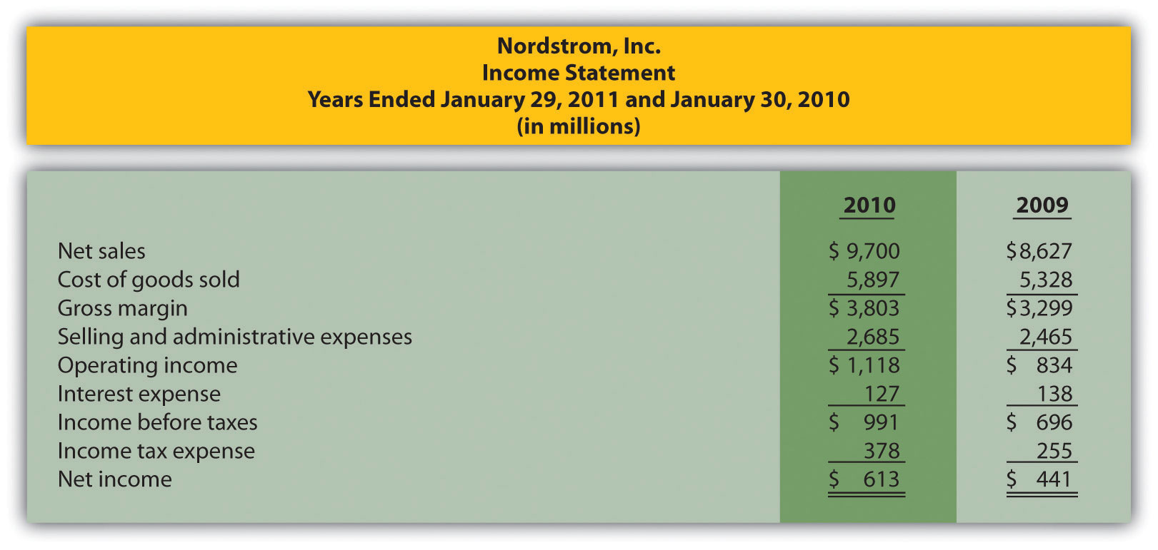
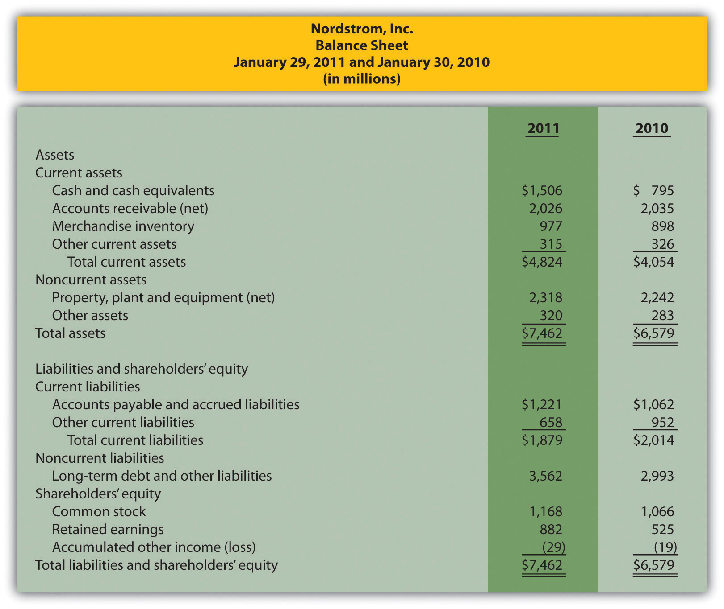
Required:
  - Prepare a trend analysis of the income statements from 2009 to 2010. Use the format shown in as a guide. (Round computations to one decimal place.)
  - Prepare a trend analysis of the balance sheets from 2009 to 2010. Use the format shown in as a guide. (Round computations to one decimal place.)
  - Identify all items that changed by more than 20 percent in the trend analyses prepared in requirements a and b, and briefly comment on the results.
  - Prepare a common-size analysis of the income statements for 2010 and 2009. Use the format shown in as a guide. (Round computations to one decimal place.)
  - Prepare a common-size analysis of the balance sheets for 2010 and 2009. Use the format shown in as a guide. (Round computations to one decimal place.)
  - What does the common-size analysis prepared in requirements d and e tell you about the company?
- Profitability and Short-Term Liquidity Ratios. Refer to the information presented in Problem 35 for Nordstrom.
Required:
  - Compute the following profitability ratios for 2010, and provide a brief explanation after each ratio (round percentage computations to one decimal place and earnings per share to two decimal places):
    - Gross margin ratio
    - Profit margin ratio
    - Return on assets
    - Return on common shareholders’ equity
    - Earnings per share (weighted average shares outstanding totaled 218,800,000 shares)
  - Compute the following short-term liquidity ratios for 2010, and provide a brief explanation after each ratio (round computations to two decimal places):
    - Current ratio
    - Quick ratio
    - Receivables turnover ratio and average collection period (assume all sales are on account)
    - Inventory turnover ratio and average sale period
- Long-Term Solvency Ratios and Market Valuation Measures. Refer to the information presented in Problem 35 for Nordstrom.
Required:
  - Compute the following long-term solvency ratios for 2010, and provide a brief explanation after each ratio (round computations to two decimal places):
    - Debt to assets
    - Debt to equity
    - Times interest earned
  - Compute the following market valuation measures for 2010, and provide a brief explanation after each measure (state market capitalization in billions, and round price-earnings ratio to two decimal places):
    - Market capitalization (assume 218,000,000 shares were issued and outstanding at January 29, 2011, and the market price was $40.08 per share)
    - Price-earnings ratio (assume the earnings per share amount was $2.80)
- Income Statement Trend, Common-Size, and Profitability Analysis.The following condensed income statement and balance sheet are for Starbucks Corporation, a large retailer of specialty coffee with stores throughout the world.
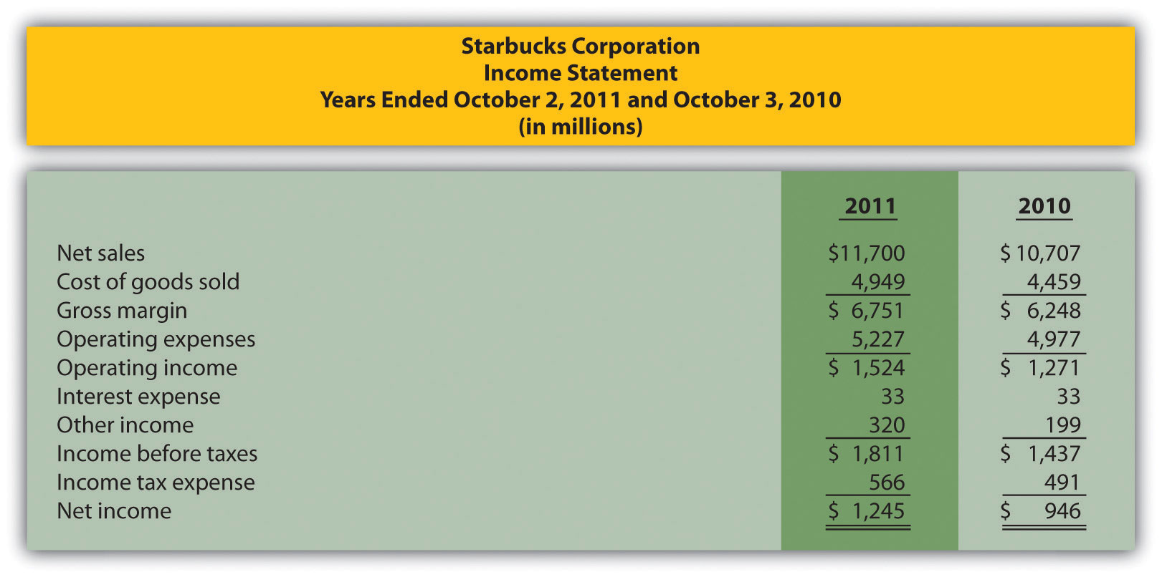
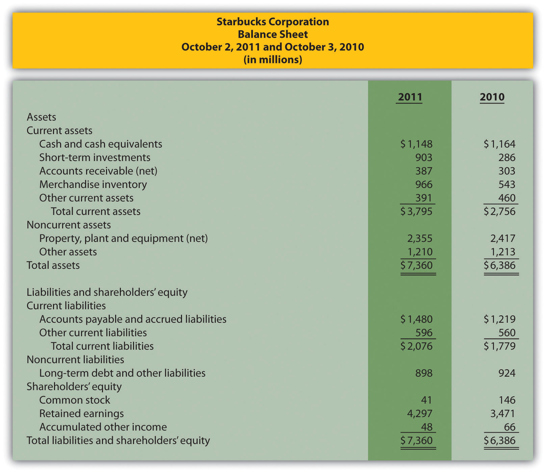
Required:
  - Prepare a trend analysis of the income statements from 2010 to 2011. Use the format shown in as a guide. (Round computations to one decimal place.)
  - Identify all items that changed by more than 20 percent in the trend analysis prepared in requirement a, and briefly comment on the results.
  - Prepare a common-size analysis of the income statements for 2011 and 2010. Use the format shown in as a guide. (Round computations to one decimal place.)
  - What does the common-size analysis prepared in requirement c tell you about the company?
  - Compute the following profitability ratios for 2011, and provide a brief explanation after each ratio (round percentage computations to one decimal place and earnings per share to two decimal places):
    - Gross margin ratio
    - Profit margin ratio
    - Return on assets
    - Return on common shareholders’ equity
    - Earnings per share (assume weighted average shares outstanding totaled 748,300,000 shares)
- Short-Term Liquidity, Long-Term Solvency, and Market Valuation.Refer to the information presented in Problem 38 forStarbucks.
Required:
  - Compute the following short-term liquidity ratios for 2011, and provide a brief explanation after each ratio (round computations to two decimal places):
    - Current ratio
    - Quick ratio
    - Receivables turnover ratio and average collection period (assume all sales are on account)
    - Inventory turnover ratio and average sale period
  - Compute the following long-term solvency ratios for 2011, and provide a brief explanation after each ratio (round computations to two decimal places):
    - Debt to assets
    - Debt to equity
    - Times interest earned
  - Compute the following market valuation measures for 2011, and provide a brief explanation after each measure (state market capitalization in billions, and round price-earnings ratio to two decimal places):
    - Market capitalization (assume 744,800,000 shares were issued and outstanding at October 2, 2011, and the market price was $37.14 per share)
    - Price-earnings ratio (assume the earnings per share amount was $1.66)
- Balance Sheet Trend and Common-Size Analysis. The following condensed income statement and balance sheet are for Wal-Mart Stores, Inc. (note that Wal-Mart’s 2010 fiscal year ends on January 31, 2011. This is called the 2010 fiscal year because only one month is in 2011, the other 11 months of the fiscal year are in 2010, and the company has chosen to refer to this as the 2010 fiscal year. This same concept applies to fiscal year 2009.)
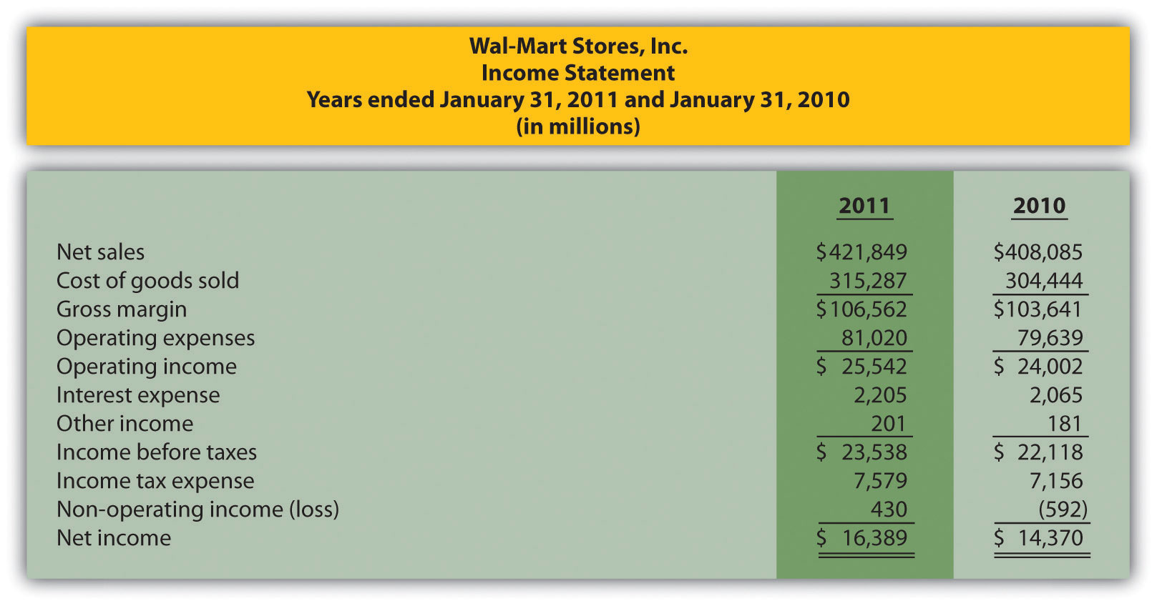
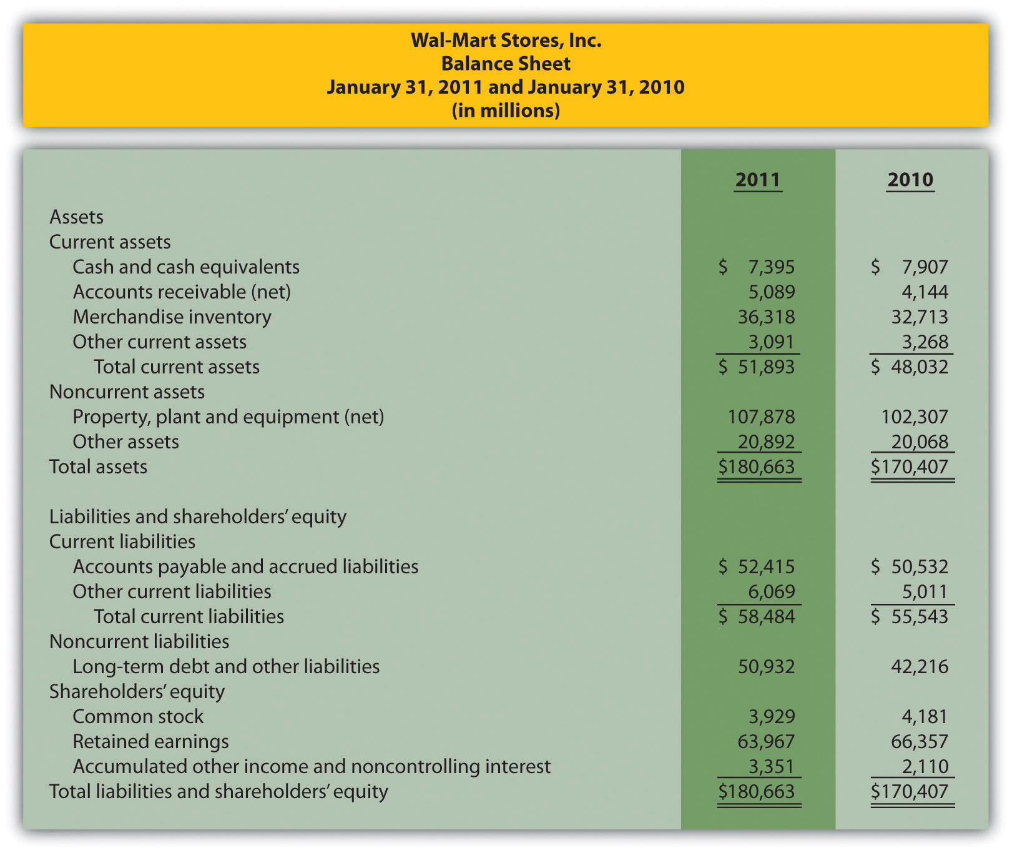
Required:
  - Prepare a trend analysis of the balance sheets from 2009 to 2010. Use the format shown in as a guide. (Round computations to one decimal place.)
  - Prepare a common-size analysis of the balance sheets for 2010 and 2009. Use the format shown in as a guide. (Round computations to one decimal place.)
  - What does the balance sheet common-size analysis prepared in requirement b tell you about the company?
- Income Statement Trend and Common-Size Analysis; Profitability Ratios. Refer to the information presented in Problem 40 forWal-Mart.
Required:
  - Prepare a trend analysis of the income statements from 2009 to 2010. Use the format shown in as a guide. (Round computations to one decimal place.)
  - Based on the income statement trend analysis prepared in requirement a, describe what caused the increase in operating income from 2009 to 2010.
  - Prepare a common-size analysis of the income statements for 2010 and 2009. Use the format shown in as a guide. (Round computations to one decimal place.)
  - What does the income statement common-size analysis prepared in requirement c tell you about the company?
  - Compute the following profitability ratios for 2010, and provide a brief explanation after each ratio (round percentage computations to one decimal place and earnings per share to two decimal places):
    - Gross margin ratio
    - Profit margin ratio
    - Return on assets
    - Return on common shareholders’ equity
    - Earnings per share (assume weighted average shares outstanding totaled 3,656,000,000 shares)
- Short-Term Liquidity, Long-Term Solvency, Market Valuation, and Balanced Scorecard. Refer to the information presented in Problem 40 for Wal-Mart.
Required:
  - Compute the following short-term liquidity ratios for 2010, and provide a brief explanation after each ratio (round computations to two decimal places):
    - Current ratio
    - Quick ratio
    - Receivables turnover ratio and average collection period (assume all sales are on account)
    - Inventory turnover ratio and average sale period
  - Compute the following long-term solvency ratios for 2010, and provide a brief explanation after each ratio (round computations to two decimal places):
    - Debt to assets
    - Debt to equity
    - Times interest earned
  - Compute the following market valuation measures for 2010, and provide a brief explanation after each measure (state market capitalization in billions, and round price-earnings ratio to two decimal places):
    - Market capitalization (assume 3,516,000,000 shares were issued and outstanding at January 31, 2011, and the market price was $54.58 per share)
    - Price-earnings ratio (assume the earnings per share amount was $4.48)
  - Assume Wal-Mart uses a balanced scorecard to assess performance. Provide at least two learning and growth measures the company can use on its balanced scorecard.
One Step Further: Skill-Building Cases
- Trend Information in Annual Reports. Refer to Why is trend information important to shareholders?
- Earnings per Share. Refer to Was AnnTaylor Stores’ earnings per share higher or lower than analysts expected? Explain whether you would expect the company’s stock price to increase or decrease as a result of the press release.
- Inventory Turnover in the Computer Industry. Refer to Why do you think inventory turnover for the computer hardware industry is so quick?
- Financial Leverage in the Auto Industry. Refer to Why do most investors consider GM to be highly leveraged?
- Market Capitalization Categories. Refer to Define what is meant by small-cap, midcap, and large-cap. In which category does Coca-Colabelong? Explain.
- Internet Project: Financial Statement Analysis. Using the Internet, find the most recent annual report (or form 10K) for a manufacturing or retail company of your choice. Most companies have links to the information at their Web sites under titles, such as investor relations or financial reports. Print the income statement and balance sheet for the company selected and include these documents with your response to the following requirements.
Required:
  - Compute the following profitability ratios for the most current year, and provide a brief explanation after each ratio (round percentage computations to one decimal place):
    - Gross margin ratio
    - Profit margin ratio
    - Return on assets
    - Return on common shareholders’ equity
  - Compute the following short-term liquidity ratios for the most current year, and provide a brief explanation after each ratio (round computations to two decimal places):
    - Current ratio
    - Quick ratio
    - Receivables turnover ratio and average collection period (assume all sales are on account)
    - Inventory turnover ratio and average sale period
  - Compute the following long-term solvency ratios for the most current year, and provide a brief explanation after each ratio (round computations to two decimal places):
    - Debt to assets
    - Debt to equity
  - Provide a one-page written report summarizing your results in requirements a, b, and c. Identify any areas of concern as well as areas of strength for the company.
- Group Activity: Analyzing Lowe’s Companies, Inc. The condensed income statement and balance sheet information provided as follows is for Lowe’s Companies, Inc., a large retail company that sells building materials and supplies. Lowe’s had 1,354,000,000 shares issued and outstanding at January 28, 2011, and the market price per share on that date was $24.83. (Note that Lowe’s 2010 fiscal year ends on January 28, 2011. This is called the 2010 fiscal year because only one month is in 2011, the other 11 months of the fiscal year are in 2010, and the company has chosen to refer to this as the 2010 fiscal year. This same concept applies to fiscal year 2009.)
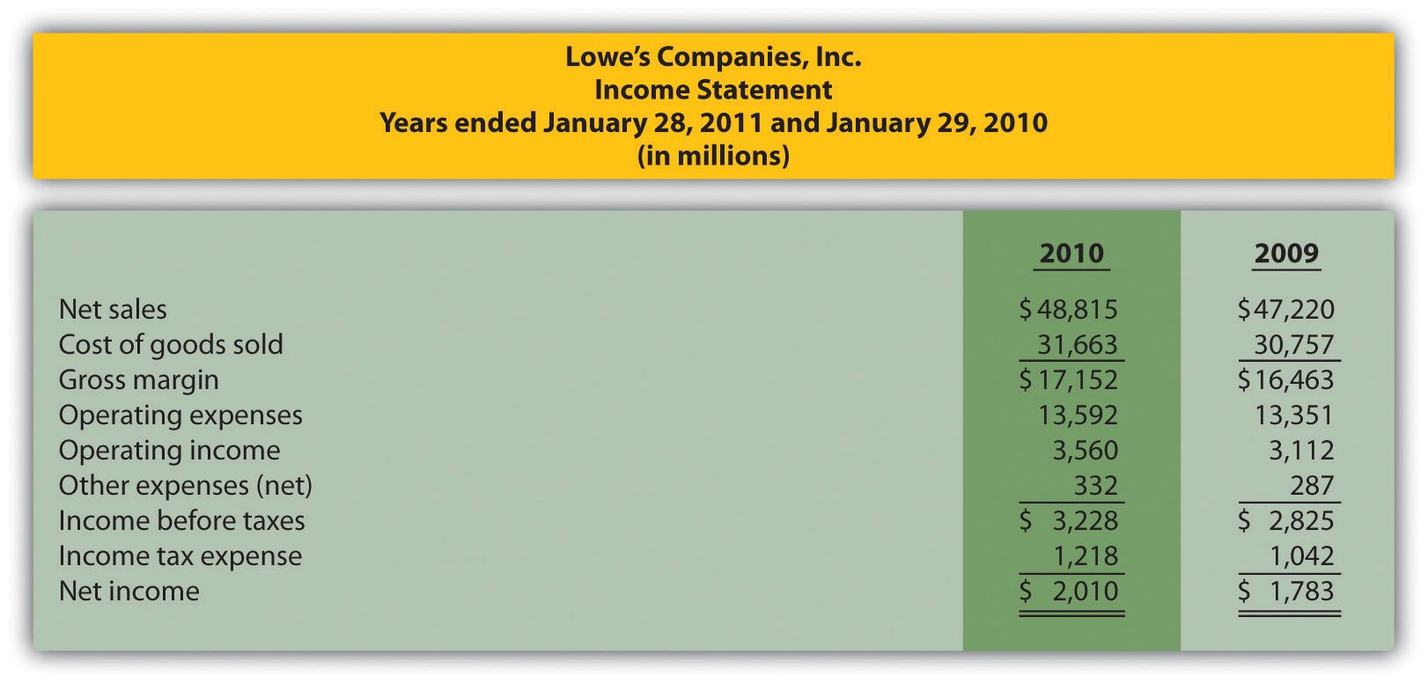
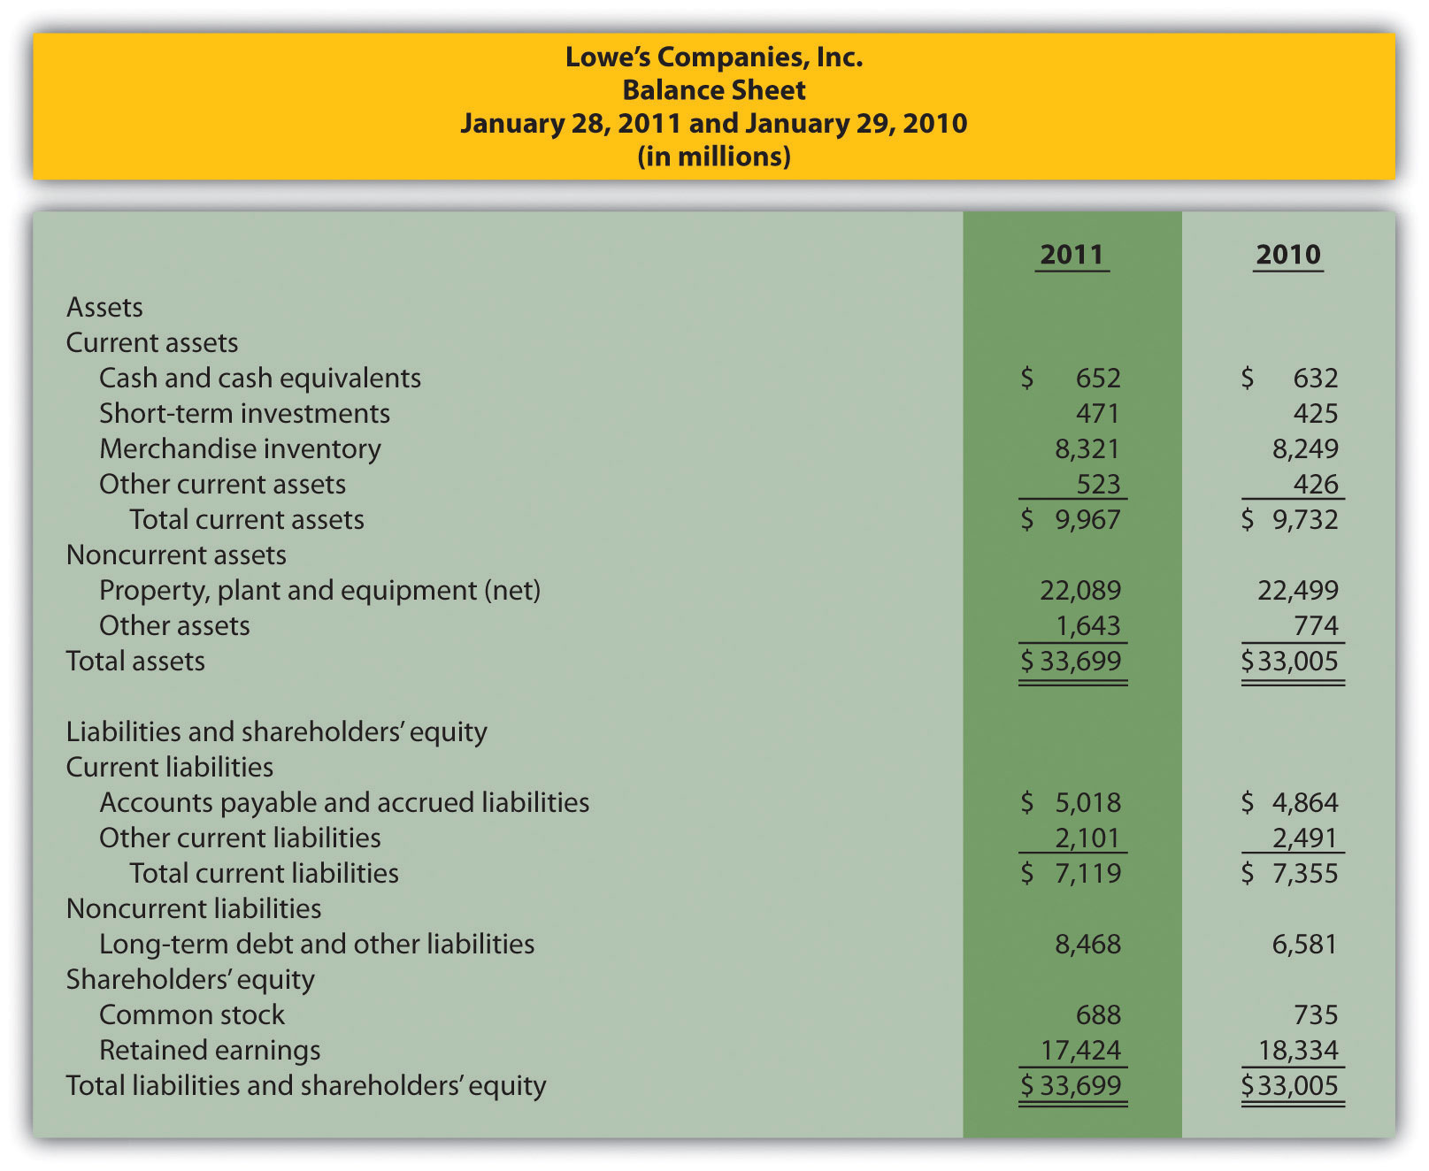
Form groups of two to four students. Each group is to be assigned one of the following three categories of financial measures:
  - Profitability measures
    - Gross margin ratio
    - Profit margin ratio
    - Return on assets
    - Return on common shareholders’ equity
  - Short-term liquidity measures
    - Current ratio
    - Quick ratio
    - Inventory turnover ratio and average sales period
  - Long-term solvency and market valuation measures
    - Debt to assets
    - Debt to equity
    - Market capitalization
Required:
  - Calculate the financial measures assigned to your group. Round all computations to two decimal places, except the market capitalization measure, which can be rounded to the nearest billion dollars.
  - Provide a brief explanation of each measure your group calculated in requirement a.
  - Discuss the results of your group with the class.
- Performing Income Statement Trend Analysis Using Excel. Review the information for Apple, Inc., in Brief Exercise 14.
Required:
Perform income statement trend analysis for Apple, Inc., using an Excel spreadsheet. The format should be similar to the one in . Round percent computations to one decimal place.
Comprehensive Cases
- Financial Statement Analysis and Industry Standards; Manufacturing Company. Susan Hartford is the president and CEO of Computer Makers, Inc. The company is in the process of looking for a supplier of computer chips, and Susan has asked her staff to review the financial stability of Intel Corporation, the world’s largest maker of computer chips. Susan’s staff began by collecting industry average information, which is shown as follows, and would like your help in calculating and evaluating these measures for Intel.
Measure | Industry Average | Intel
Gross margin | 57.7 percent | ?
Profit margin | 21.9 percent | ?
Return on assets | 17.7 percent | ?
Return on common shareholders’ equity | 21.5 percent | ?
Current ratio | 2.3 to 1 | ?
Quick ratio | 1.9 to 1 | ?
Receivables turnover | 12.8 times | ?
Inventory turnover | 4.8 times | ?
Debt to assets | 0.21 to 1 | ?
Debt to equity | 0.26 to 1 | ?
Market capitalization | $80,000,000,000 | ?
- Intel’s income statement and balance sheet are provided as follows. The price for 1 share of common stock at December 25, 2010, the end of Intel’s fiscal year, was $20.13. The number of shares issued and outstanding at December 25, 2010, totaled 5,581,000,000. Assume all sales were on account.
- 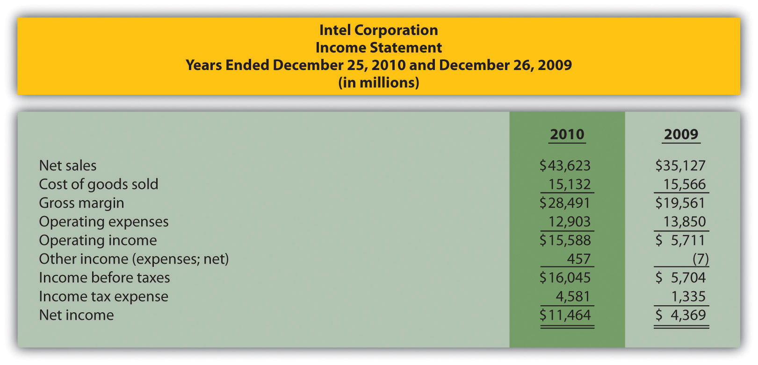
- 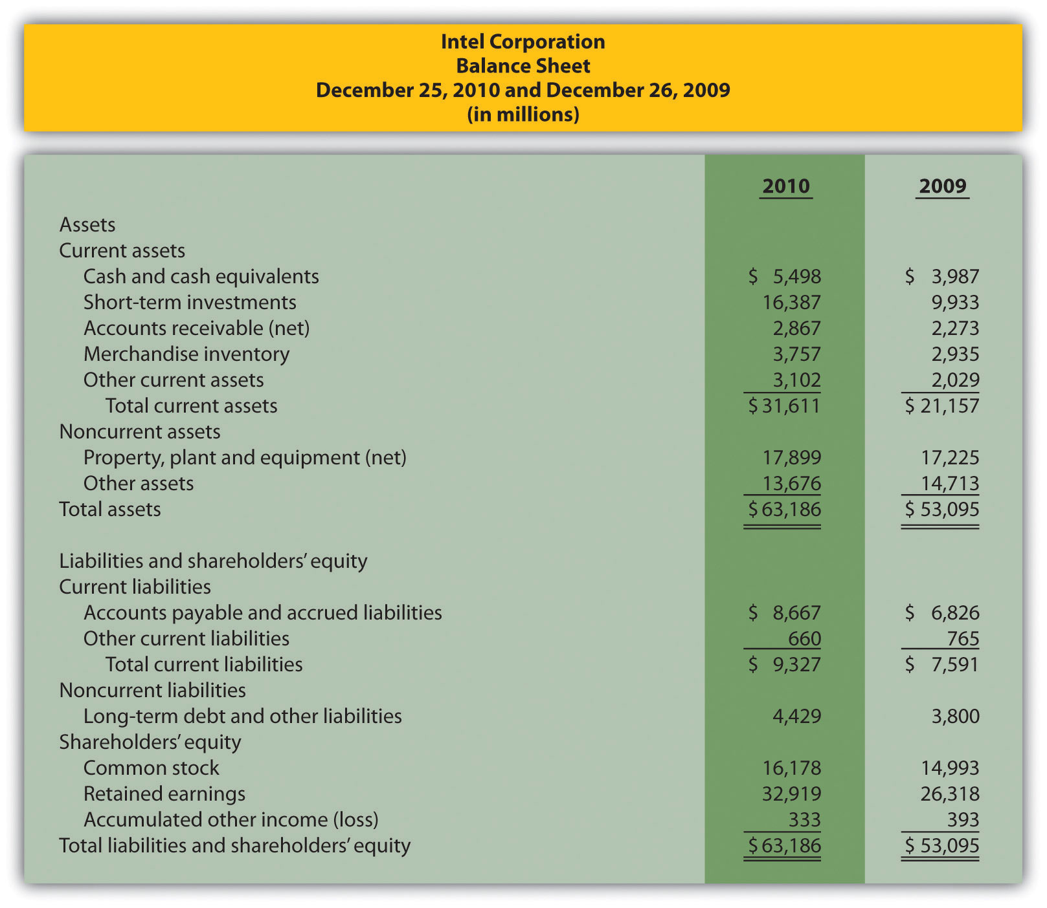
- Required:
  - Using the industry average measures provided, compute the same measures for Intel for its fiscal year ended December 25, 2010. (State your results in the same format used for industry averages.)
  - Summarize your results in requirement a by completing a table using the following headings:
Measure | Industry Average | Intel Corporation
  - Immediately following each measure, indicate whether Intel’s financial condition is better or worse than the industry average.
  - Using your answers to requirements a and b to support your position, determine whether Intel is financially stable.
- Ethics: Manipulating Data to Meet Loan Requirements. Custom Tech, Inc., designs and produces computers for a variety of customers. The company has encountered a cash shortage resulting from collection problems with several customers. If Custom Tech is unable to collect a significant portion of its receivables relatively soon, the company will not be able to pay suppliers and employees next quarter. As a result, Custom Tech’s president, Don Lardner, began discussions with a local bank about obtaining a short-term loan. Don did not mention the cause of the cash flow shortage other than to say, “This happens the same time every year due to the cyclical nature of our business.”
In a meeting with the bank’s loan officer, Jan Johnson, Don was told the loan should not be a problem as long as Custom Tech maintains a profit margin ratio above 10 percent, quick ratio above 1.0 to 1, and debt to equity ratio below 1.4 to 1. Don indicated this was in line with his company’s performance and agreed to provide financial statements for the most recent year at their next meeting.
The financial statements shown as follows are for Custom Tech’s most recent year ended December 31. This information has not yet been provided to the bank.
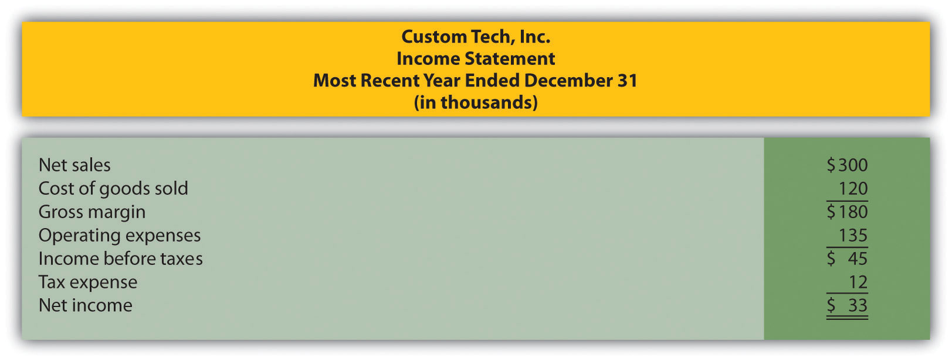
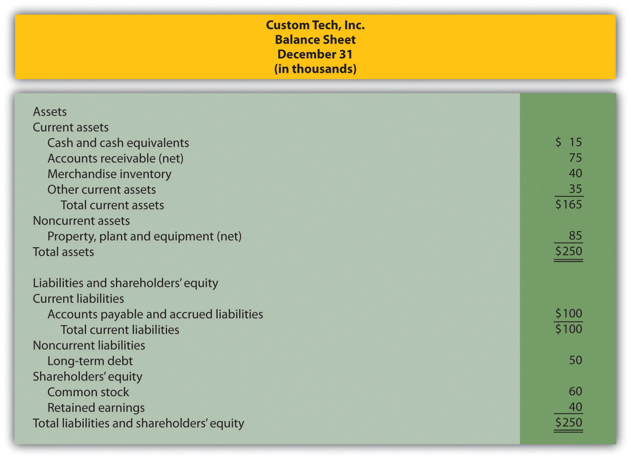
Required:
  - Calculate the ratios required by the bank and determine whether Custom Tech will qualify for the loan.
  - Assume you are the CFO for Custom Tech. Don Lardner asks you to reclassify $30,000 in current liabilities to common stock. Don states, “We owe it to our shareholders and employees to do whatever it takes to get this loan! Without it, we may have to file for bankruptcy and let our employees go. Once we get this loan and collect our outstanding receivables we’ll be in good shape.” Prepare a revised balance sheet after making the $30,000 reclassification, recalculate the ratios required by the bank, and determine whether Custom Tech will qualify for the loan with the revised numbers.
  - Are the president’s actions ethical? If you were the CFO, how would you handle the president’s request? (To answer these questions, you may want to review the presentation of ethics in .)

